Original Research Article
COMPREHENSIVE CHARACTERIZATION OF AVOCADO PEAR (Persea americana) SEED POWDER FOR APPLICATION IN BIODEGRADABLE POLYMER COMPOSITES AND FUNCTIONAL MATERIALS

ABSTRACT
This study investigated the physicochemical, structural, and thermal characteristics of avocado seed powder for its potential as a bio-based material for composite and other applications. It was observed that the seed powder exhibited a mildly acidic pH of 5.3, with limited levels of solubility in different solvents emphasizing its viability in vastly insoluble biopolymers. FTIR analysis confirmed the presence of carbonyl, hydroxyl, aromatic, and aliphatic functional groups characteristic of lignocellulosic biomass. TGA/DTA results showed major mass loss occurring between 380–550 °C and approximately 20% residual mass at 950 °C which is an indication of thermal stability and char-forming potential. SEM imaging showed irregular, fibrous, and porous particles with rough surfaces and micro-fractures, which creates viable interfacial adhesion in composite matrices. EDX results demonstrated a carbon-rich surface with trace mineral elements. Taken together, these results highlight the potential of avocado seed waste as a possibly viable additive in biodegradable composites, heat-resistant materials, and sustainable bio-products.

Keywords: Avocado, Persea americana, Biopolymers, Valorisation, Agro-waste, Lignocellulose

INTRODUCTION
As the attention on sustainability and the circular economy keeps increasing globally, the research into innovative uses of agro-waste and underutilized biomaterials has intensified.^{1,2} Among these, avocado (Persea americana) seeds represent a significant quantity of wastes generated during fruit processing, which are normally disposed despite being rich in bioactive compounds and theoretically possible fillers for structurally reinforced biopolymers.^{3,4} With the continuous increase in global production of avocados due to its growing demand in food, cosmetic, and nutraceutical industries, managing the resulting seed waste has led to both environmental and economic concerns.^{1,4} Turning this lignocellulosic-rich waste into high-value materials is in line with waste valorisation strategies and sustainable development goals.^{2,5} Effective utilization of these seed in biopolymer production requires a detailed understanding of their physicochemical, thermal, and morphological properties to aid efficient formulation design and performance predictability in end-use applications.^{6,7}
This research contains the following analyses on the avocado seed powder, pH level, solubility analysis, functional group characterization using FTIR spectroscopy, thermal analysis using TGA/DTA, morphology study using SEM, and elemental composition using EDX. This shows its viability, chemical reactivity, mechanical strength, and thermal stability which provides insight its effect when incorporated in biodegradable composites.⁸⁻¹⁰

MATERIALS AND METHODS
Sample Preparation
Avocado pear was sourced from Ekwulobia, Nigeria. The seeds were then extracted, washed, sliced, and oven-dried at 60 °C for about 72 hours. The dried slices were pulverized, sieved to a particle size of 250 µm, and stored in airtight containers.
pH Measurement
The pH of the avocado seed powder was determined following procedures adapted from ISO 10390, which specifies a potentiometric method using a suspension in water. 10 g sample of avocado seed powder was weighed into a 100 mL beaker; 50 mL of distilled water was then added to maintain a solid-to-liquid ratio of 1:5 (w/v). The mixture was agitated with a glass rod for 60 seconds, and was then allowed to stand at room temperature for 60 minutes to equilibrate. After equilibration, the pH of the mixture was then measured using a calibrated digital pH meter having a glass combination electrode. The pH meter was standardized using pH buffer solutions (pH 4.00 and 7.00) before use. This analyses were done in triplicates, and the mean pH value was recorded.^{11,12}
Solubility Test
One gram (0.5 g) of avocado seed powder was measured into six separate 250 mL conical flasks, each containing 10 mL of one of the following solvents: 95% acetone, 95% ethanol, 2 M HCl, 2 M H₂SO₄, distilled water at 23.5 °C, and distilled water at 50 °C. Each mixture was agitated continuously on a mechanical shaker at 150 rpm for 60 minutes. After agitation, the solutions were allowed to stand undisturbed for 10 minutes to settle undissolved particles. The solutions were then observed for the presence of sediment to assess the extent of dissolution in each solvent.
FTIR Analysis
FTIR analysis followed ASTM E1252. About 1 mg of seed powder was blended with 100 mg of KBr and then pressed into a pellet. Spectra were recorded using a PerkinElmer Spectrum Two spectrometer. Key absorption peaks were interpreted using reference spectra to identify functional groups. Analyses were run in triplicate and the average taken.¹³⁻¹⁵
SEM–EDX Analysis
Combined SEM and EDX analyses were performed in accordance with ASTM E1508 to assess surface morphology and elemental composition of the avocado seed powder. Micrographs was acquired at magnification of ×2000 using secondary electron mode to visualize surface texture, porosity, and particle structure. This was done alongside EDX spectroscopy which was used to identify and quantify the elemental constituents.¹⁶
TGA/DTA
Thermal analysis of avocado seed powder was conducted using simultaneous TGA/DTA in line with ASTM E1131. Approximately 12.2 mg of the sample was heated from 30 °C to 950 °C at 10 °C/min under nitrogen to prevent oxidation. Mass loss corresponding to moisture evaporation and organic decomposition was recorded via TGA, while DTA recorded the thermal transitions such as endothermic and exothermic changes. All runs were done in triplicates to ensure reproducibility.¹⁷

RESULTS AND DISCUSSION
pH Test
The aqueous suspension of avocado seed powder exhibited a mildly acidic pH of 5.3, suggesting the presence of weak organic acids, polyphenols, and other naturally occurring acidic compounds.^{11,12,18} The pH level is consistent with that of plant-based biomaterials.^{16,19} Also its mildly acidic level confers on it antimicrobial properties and enhanced compatibility with mildly acidic environments, this its suitability in food packaging and cosmetics applications.^{20,21}
In terms of polymer composite application, the mild acidity of the seed powder influences the interfacial adhesion in pH-sensitive bio-based polymer matrices when used as the reinforcing filler.^{22,23} This has significant effect on the dispersion stability, curing behaviour, and long-term performance of the composite system. Also compatibilizers and surface modifiers are more efficient due to the acid-base surface characters, which ultimately enhances adhesion between the filler and matrix, leading to improved mechanical properties of the composites.^{4,12}
Solubility Test
The solubility behaviour of avocado seed powder varied in the different solvents. Slight dissolution was observed in 23.5 °C distilled water, 2 M HCl, 2 M H₂SO₄, and 95% ethanol, indicating limited interaction between the seed constituents and these polar or mildly acidic media.^{4,12,18} In contrast, no visible dissolution occurred in 50 °C distilled water or 95% acetone, suggesting that higher temperature may not improve aqueous solubility and that the seed’s composition has low affinity for nonpolar organic solvents.^{16,20} These results indicate that while the seed contains some extractable polar compounds, overall solubility is restricted, probably due to a high proportion of insoluble structural polymers.^{19,21}
FTIR Analysis
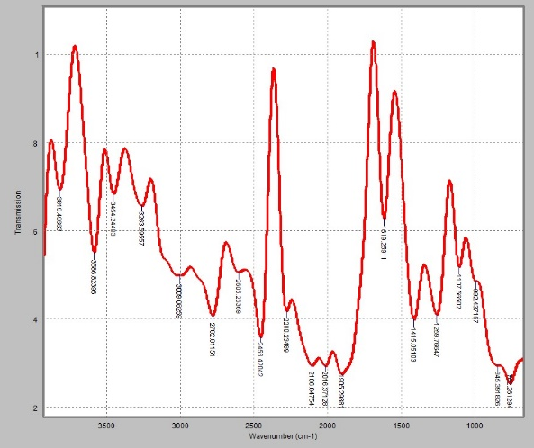
Figure 1: FTIR spectrum of avocado seed powder
The FTIR spectrum of avocado seed powder exhibited broad and well-defined absorption bands characteristic of a lignocellulosic biomaterial.^{4,15} Strong peaks in the range of 3263–3586 cm⁻¹ were attributed to O–H stretching, with the possibility of N–H stretching vibrations, indicative of the presence of hydroxyl-rich compounds such as cellulose, hemicellulose, and phenolics.^{19,21} A sharp absorption at 3009 cm⁻¹ suggested unsaturated C–H stretching, typically associated with alkenes or plant wax residues.^{14,15}
C–H stretching and bending vibrations were detected between 2605 and 2782 cm⁻¹, supporting the presence of aliphatic chains, likely from lipid components.^{12,18} Aromatic skeletal vibrations were evidenced by a pronounced peak at 1619 cm⁻¹ (C=C stretching), along with bands at 762 cm⁻¹ and 1259 cm⁻¹, which corresponds to C–H bending and C–O or O–H deformations, respectively—features commonly linked to lignin and polyphenolic structures.^{13,20}
The region around 1107 cm⁻¹ displayed strong C–O stretching, typical of alcohols and polysaccharides.^{4,15} Additional weak bands between 1905 and 2456 cm⁻¹ may represent overtone or combination bands or trace structural features.^{14,21} This result which confirms the presence of aromatics, carbohydrates, and lipids reinforces its viability for bio-composite applications.^{12,23}
EDX Analysis
The elemental composition, which was characterized using EDX revealed an abundant weight percentage of iron (83.21 wt.%), which is an indicator of either high mineral content of probable contamination during pulverization.^{24,25} The next most abundant element was carbon (14.18 wt.%) which confirmed the organic nature of the biomass, leading to the probable presence of lignocellulosic and phenolic compounds which was earlier posited by the FTIR analysis.^{16,26} The was also recorded trace amounts of silicon, aluminium, potassium, calcium, magnesium, sodium, phosphorus, chlorine, manganese, and sulphur. This is characteristic of plant-based materials.²⁵ Based on these results, the high iron content enhances magnetic or thermal properties, while the abundance of carbon makes it viable as a reinforcement bio-filler.¹⁶
SEM Analysis
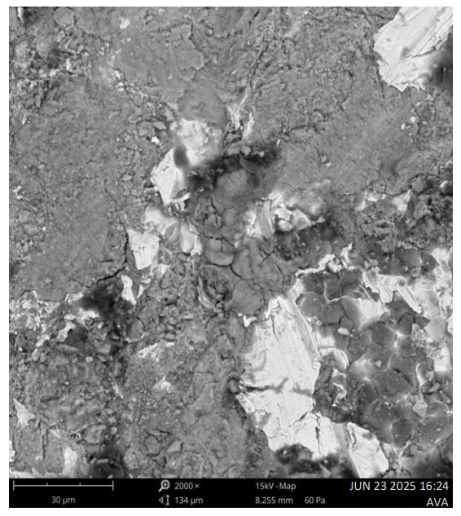
Figure 2: SEM image of avocado seed powder
The SEM analysis was done at 2000× magnification, the results revealed that the particles exhibited irregular, angular shapes having heterogeneous size distribution, which is characteristic of mechanical fragmentation during grinding.¹⁷ Surface textures were notably rough and fibrous, with observable wrinkles and striations across most particles. This surface roughness enhances the potential for mechanical interlocking in composite applications.
Microscopic fractures, edge cracks, and internal voids were also evident, indicating brittle behaviour likely induced during drying or grinding. These morphological defects, while potentially reducing particle strength, may increase surface area and reactivity.^{17,25} Additionally, some particles displayed visible porosity, which could be advantageous for moisture uptake or active-site loading in functional applications.²⁶
Mild agglomeration was noted in some regions, where smaller particles adhered to larger fragments. This may affect dispersion uniformity in composite matrices, although surface modification strategies could mitigate such limitations.¹⁷ Overall, the SEM results highlight a lignocellulosic powder with promising filler characteristics for polymer reinforcement.
TGA/DTA Analysis
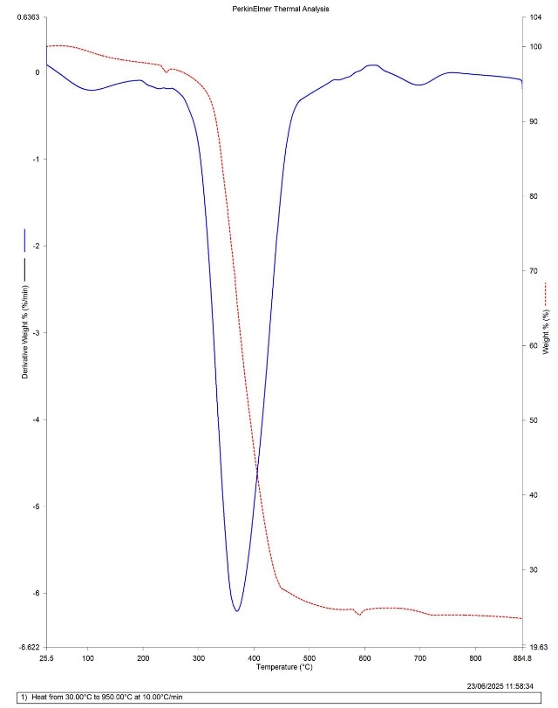
Figure 3: TGA/DTA curve of avocado seed powder
The thermal behaviour of avocado seed powder was assessed using simultaneous TGA/DTA analysis under nitrogen from 30 °C to 950 °C. The TGA profile revealed a multi-phase degradation pattern typical of lignocellulosic biomass.¹⁷ The initial mass loss between 30–150 °C (~5–8%) corresponded to moisture evaporation and light volatile release, an endothermic change indicated by a gentle dip in the DTA curve. This was followed by a gradual decomposition between 150–380 °C, attributed to the breakdown of hemicellulose.^{16,17}
The most significant degradation occurred between 380–550 °C, marked by a steep drop in the TGA curve due to the thermal decomposition of cellulose which is the primary structural component of the seed. The DTA trace exhibited overlapping endothermic and exothermic features in this region, suggesting a combination of energy-absorbing bond cleavage and heat-releasing char formation.²⁶ Beyond 550 °C, the rate of weight loss slowed noticeably, indicating carbonization of residual matter.
By 950 °C, the sample stabilized with approximately 20% residual mass, likely consisting of inorganic ash and thermally stable mineral content.²⁷ This residue, along with the observed thermal transitions, highlights the avocado seed’s potential for thermoset polymer reinforcement, pyrolytic conversion to bio-char, and other heat-stable composite applications. The thermal profile confirms a complex organic matrix with staged degradation behaviour, supporting its viability as a bio-based filler in thermally processed materials.

CONCLUSION
The comprehensive physicochemical, structural, and thermal analyses of avocado seed powder confirm its potential as a multifunctional bio-based material. The mildly acidic pH (5.3) indicates the presence of organic acids and phenolics, thus its viability in pH-sensitive formulations and reinforcing its compatibility with biodegradable polymer matrices.^{24,27} Solubility results indicate limited dissolution in most polar solvents and no interaction with acetone or hot water, suggesting a matrix dominated by insoluble biopolymers such as cellulose, hemicellulose, and lignin.^{16,17}
FTIR spectra revealed characteristic functional groups including hydroxyls, aromatics, and aliphatic chains, indicative of a complex lignocellulosic structure.^{27,28} TGA/DTA analysis showed a distinct multi-stage thermal degradation profile, with major mass loss between 380–550 °C, corresponding to cellulose and lignin decomposition, and a residual mass (~20%) at 950 °C proving thermal resilience and potential for bio-char or filler applications.¹⁷ SEM micrographs displayed angular, porous, and fibrous particles with fracture lines and rough textures, supporting strong mechanical interlocking in polymer composites.^{23,29} EDX analysis confirmed the material’s carbon-rich nature with trace minerals typical of plant residues; notably, high surface iron content could lead to expanded applications.^{24,25}
Altogether, the avocado seed powder exhibits a robust combination of chemical complexity, thermal stability, and morphological traits suitable for value-added applications such as biodegradable composite reinforcement, adsorbents, or thermally processed biomaterials.

REFERENCES
- M. Mujtaba, L. F. Fraceto, M. Fazeli, S. Mukherjee, S. M. Savassa, G. A. Medeiros, A. E. S. Pereira, S. D. Mancini, J. Lipponen, & F. Vilaplana, Journal of Cleaner Production, 2023, 402, 136815, DOI: 10.1016/j.jclepro.2023.136815
- B. Segers, P. Nimmegeers, M. Spiller, G. Tofani, E. Jasiukaitytė-Grojzdek, E. Dace, T. Kikas, J. M. Marchetti, M. Rajić, G. Yildiz, & P. Billen, RSC Sustainability, 2024, 2(3730), DOI: 10.1039/d4su00342j
- A. Féliz-Jiménez, & R. Sanchez-Rosario, Applied Sciences, 2024, 14(21), 10070, DOI: 10.3390/app142110070
- D. Merino, L. Bertolacci, U. C. Paul, R. Simonutti, & A. Athanassiou, ACS Applied Materials & Interfaces, 2021, 13(33), 38688–38699, DOI: 10.1021/acsami.1c09433
- S. Barua, G. Shome, S. Dolai, & J. Sarwar, Springer, 2025, 295–334, DOI: 10.1007/978-981-96-2786-8_12
- F. J. Stadler, & L. Du, (Eds.). Polymers, 2021, 13(11), 1737, DOI: 10.3390/polym13111737
- M. T. Hayajneh, M. M. Al-Shrida, & F. M. AL-Oqla, e-Polymers, 2022, 22(1), DOI: 10.1515/epoly-2022-0062
- G. Torğut, & N. Gürler, Journal of Polymer Research, 2021, 28, 452, DOI: 10.1007/s10965-021-02816-3
- Y. Hu, T. Hong, S. Zhou, C. He, H. He, & S. Wang, Buildings, 2024, 14(12), 4020, DOI: 10.3390/buildings14124020
- M. Ates, & P. Kuz, Journal of Sustainable Construction Materials and Technologies, 2020, 5(1), 399–406, DOI: 10.29187/jscmt.2020.44
- C. O. Nyakang’i, E. Marete, R. A. Ebere, J. M. Arimi, & others. International Journal of Food Science, 2023, 6860806, DOI: 10.1155/2023/6860806
- M. Siol, & A. Sadowska, Agriculture, 2023, 13(2), 316, DOI: 10.3390/agriculture13020316
- S. A. Khan, S. B. Khan, L. U. Khan, A. Farooq, K. Akhtar, & A. M. Asiri, Springer, 2019, 317–350, DOI: 10.1007/978-3-319-92955-2_9
- M. Dev, & M. Mukadam, World Journal of Biology Pharmacy and Health Sciences, 2025, 21(1), 243–249, DOI: 10.30574/wjbphs.2025.21.1.0039
- I. M. Siddique, Chemistry Research Journal, 2024, 9(2), 70–76, https://chemrj.org/download/vol-9-iss-2-2024/chemrj-2024-09-02-70-76.pdf
- A. Molina-Balmaceda, V. Rojas-Candia, D. Arismendi, & P. Richter, Analytical and Bioanalytical Chemistry, 2024, 416, 2399–2409, DOI: 10.1007/s00216-024-05203-1
- E. Schnitzler, C. D. Bet, L. H. Waiga, C. S. Oliveira, & L. G. Lacerda, Chemistry Journal of Moldova, 2017, 12(2), 13–18, DOI: 10.19261/cjm.2017.438
- G. A. Chel, & D. Christianti, IOP Conference Series: Earth and Environmental Science, 2021, 733(1), 012090, DOI: 10.1088/1755-1315/733/1/012090
- H. Y. Setyawan, S. Sukardi, & C. A. Puriwangi, IOP Conference Series: Earth and Environmental Science, 2021, 733(1), 012090, DOI: 10.1088/1755-1315/733/1/012090
- N. C. Thanh, N. B. A. Duy, H. T. H. Xuyen, N. T. Huy, B. P. Dong, & T. Q. Giang, Polymer Science, Series A, 2024, 66(4), 376–386, DOI: 10.1134/S0965545X23600485
- S. Wang, & G. Song, Nature Sustainability, 2023, 6, 1295–1296, DOI: 10.1038/s41893-023-01191-9
- Y. Köse, E. Suvacı, & B. Atlı, Journal of the Australian Ceramic Society, 2023, 59, 245–257, DOI: 10.1007/s41779-022-00830-2
- Ş. Yıldızhan, A. Çalık, M. Özcanlı, & H. Serin, European Mechanical Science, 2018, 2(3), 83–91, DOI: 10.26701/ems.369005
- S. N. Wanjiru, S. A. Opiyo, P. W. Njoroge, & B. Mugendi, IOSR Journal of Applied Chemistry, 2025, 18(1), 13–20, https://www.iosrjournals.org/iosr-jac/papers/vol18-issue1/Ser-1/D1801011320.pdf
- A. S. M. Ogbuagu, C. E. Ukachukwu, & C. I. Okoye, Journal of Bio Innovation, 2021, 10(4), 1035–1043, DOI: 10.46344/JBINO.2021.v10i04.10
- D. I. Mendoza-Castillo, H. E. Reynel-Ávila, A. Bonilla-Petriciolet, C. Pastore, & L. di Bitonto, Bulgarian Chemical Communications, 2019, 51(B), 124–127
- A. Kamdem Tamo, I. Doench, G. Deffo, S. L. Z. Jiokenge, G. Doungmof, C. G. Fotsop, R. C. T. Temgoua, A. Montembault, A. Serghei, E. Njanja, I. K. Tonle, & A. Osorio-Madrazo, Journal of Materials Chemistry A, 2025, DOI: 10.1039/D5TA02900G
- O. D. Enadeghe, S. O. Eraga, & J. A. Obarisiagbon, Journal of Science and Practice of Pharmacy, 2022, 9(1), 447–458, DOI: 10.47227/jsppharm.v9i1.1
- B. Castro-Dominguez, J. R. Gröls, S. Alkandari, L. Perge, C. Sierra-Avila, H. Z. Ramirez, M. L. Fontes, C. Yamada, S. C. Lazarini, J. M. Silva, W. R. Lustri, & H. S. Barud, Biotechnology for Sustainable Materials, 2025, 2(8), DOI: 10.1186/s44316-025-00029-y

