Evaluation of Phosphogypsum Application Rates on Sodic Soil Reclamation and Haricot Bean Performance

Abstract
The effect of phosphogypsum (PG) on sodic soils has been extensively studied in the laboratory or in small-scale trials. However, there is little/no information available on the influence of PG on haricot performance on sodic soils. Thus, we evaluated the effects of PG amendment on the performance of haricot beans on sodic soils in two successive years (2020 and 2021). The pot trials were arranged as a completely randomised design with four replications. Five PG levels (0, 50, 100, 150 and 200% GR) were randomly used as treatments. Results showed that the soil pH and ESP obtained from 0%GR decreased 22.55% (2020) and 22.60% (2021), and 56.29% (2020) and 62.98% (2021), respectively, over 200% GR. Application of the highest PG rate (200% GR) increased available P contents by 63.70% (2020) and 82.80% (2021) over control. Similarly, the application of the highest PG (200% GR) rate boosted the grain yield of haricot bean by 100% in both 2020 and 2021 compared with the control. Grain yields of the crop were significantly (P<0.01) decreased in 2021 compared with 2020 due to the reduction in available P under rotations. However, the growth of the plant and yield continuously increased with PG levels without reaching the optimum curve, indicating the need for using higher levels of PG. Thus, repeating the experiment using higher levels of PG and in fields on sodic or saline-sodic soil is recommended to draw sound conclusions.
Keywords: Grain Yield; Leaching; Reclamation; Sodic Soils.

Introduction
The typical characteristics of sodic soil include the accumulation of excess Na, CO₃²⁻ and HCO₃⁻, as well as high pH and ESP at the soil surface [1], which eventually affect crop growth and grain yield; they must be taken into consideration for effective, cheap and environmentally friendly soil amelioration in reclaiming sodic soils [2]. Gypsum (CaSO₄.2H₂O) is the most utilised chemical amendment for the reclamation of sodic soil [3,4]. Gypsum offers a supply of Ca²⁺ to replace soluble or exchangeable Na⁺, improving the characteristics of sodic soil and increasing wheat productivity [5]. However, gypsum has rarely been used because of its high cost of exploitation, transportation, crushing, and slow reaction [3].

More than 92% of PG contains CaSO₄.2H₂O, a great source of Ca²⁺ for reclaiming sodic soils with trace quantities of impurities [6]. Applying PG to sodic soils decreased the soil pH and ESP [7]. The residual effect of strong H₂SO₄ acid released from PG also accelerates the reduction of soil pH. The higher contents of Ca²⁺ from PG replace exchangeable Na⁺ in the soil, whereby the replaced Na⁺ leaches below the root zone or with drainage water after irrigation [8].
Haricot bean (Phaseolus Vulgaris L) is one of the main cash crops and protein sources for farmers in many lowlands and mid-altitude zones of Ethiopia [9]. It is cultivated as a sole crop in rotation with cereals and intercropped under row-planted crops like maize and sorghum [10]. The national average yield of HB in Ethiopia is 1.69 t ha⁻¹ [11], which is low compared to the 2.5-3.6 t ha⁻¹ yield at research centres [10]. Haricot bean (HB) improves soil fertility through the symbiotic association with rhizobia, which fixes the atmospheric nitrogen and makes nitrogen available to the host and other crops [12]. The Central Rift Valley of Ethiopia is one of the potential areas for HB production [13] under both irrigation and rainfed conditions. However, soil sodicity is one of the major factors for expanding the production of HB in the Central Rift Valley of Ethiopia in general, in Alage in particular. In order to exploit the beneficial effects of PG amendment, it is crucial to determine the appropriate optimum level of PG application to increase crop yield and yield components. Therefore, the primary goals of the study were to evaluate the effect of PG rates on the performance of haricot beans on sodic soils in pot experiments over two consecutive planting years.
Materials and Methods
Experimental Site and Soil Sampling
Bulk sodic soil samples were collected at 20 cm depth from Alage Agricultural Technical Vocational Educational and Training College campus, Central Rift Valley of Ethiopia. The site is found at 217 km south of Addis Ababa and 38 km west of Bulbula town in the vicinity of Rift Valley Lakes (Abijata and Shaalla). It is located in the Tepid Semi-Arid Mid-Highlands SA3 [14] agroecology zone at 07° 34`59``N latitude and 38° 25` 33``E longitude.

Experimental Procedures and Treatments
Pot experiments were set up in the greenhouse of the College of Agriculture, Hawassa University. Nine kilograms of composite sodic soil samples were treated with increasing rates of PG amendment (0, 50, 100, 150 and 200% GR) 30 days before sowing the seeds and placed in plastic pots with a capacity of 10 kg in a completely randomised design with four replications. The bottom of each plastic bottle was poured small hole to facilitate leaching.
Haricot bean variety “Hawassa Dume” was sown at rates of 6 seeds in a 10 kg capacity. Urea was applied to all pots at the recommended rate of 18 kg ha⁻¹ N during both planting times for haricot bean. Irrigation water was applied two times per week to all pots until the plants reached physiological maturity. The experiment was repeated on pots without applying any additional PG but applying N at the recommended rate during the second planting. Hand weeding was used to control weeds. Other management practices were carried out uniformly in all experimental units. After harvest, soil samples were collected from each pot and subjected to chemical analysis.
Laboratory Analyses of the Soil Samples
Soil pH was measured using a glass combination electrode inserted in the filtered supernatant solution prepared by a 1:2.5 soil-to-water ratio. Available P was determined using the Olsen extraction method [15]. The exchangeable basic cations (K⁺, Ca²⁺, Mg²⁺ and Na⁺) were extracted with 1M NH₄OAc at pH 7.0 [16]. The concentrations of Ca²⁺ and Mg²⁺ ions were measured using an Atomic Absorption Spectrophotometer, while those of K⁺ and Na⁺ ions were measured using a Flame Spectrophotometer. The CEC of the soil was estimated by measuring the sum of exchangeable cations from the NH₄OAc extracted sample [17]. The value of exchangeable sodium percentage (ESP) was computed as:
$$ESP(\%)=\frac{Exchangeable Na}{CEC}x100$$

Data collection and measurements
Above-ground biomass yields of the test plants were harvested and weighed using an electronic balance after drying the biomass in the sun, and the weights were recorded as g pot⁻¹. The grain yields of the plants were measured and recorded as g pot⁻¹ after threshing and weighing using an electronic balance. The straw yield of the crop was calculated as the difference between the total aboveground plant biomass and grain yield.

Statistical analysis
Before the analysis of ANOVA, normality of the data was checked using the Shapiro-Wilk normality test. Statistical analysis was performed using the SAS 9.3 software package [18]. Means comparison was done using the Least Significant Difference at a 5% probability level.

Results and Discussion

Effects of PG amendment on chemical properties of sodic soils
Soil pH
The soil pH consistently decreased with increasing rates of PG application. The soil pH value obtained from the control treatment (0% GR) was higher by 7.38, 14.52, 19.80 and 22.55% over that of the 50, 100, 150 and 200% GR treatments, respectively in 2020 while it was higher than the respective values of the treatments by 13.53, 14.19, 20.87 and 22.60% in 2021 from pot experiment (Fig.1).
After PG application, high amounts of Ca²⁺ were released into soil and replaced exchangeable Na⁺ on the soil colloids and reacted with the soluble HCO₃⁻ + CO₃²⁻, resulting in changing sodic salt (NaHCO₃/Na₂CO₃) to neutral salt (Na₂SO₄), and making soil pH value below 8.5 [4,19]. In addition, the residual effect of H₂SO₄ and H₃PO₄ from PG [20] and decaying wheat and weed roots [21] released higher amounts of H⁺ ions into the soil solution, thereby accelerating the reduction of soil pH within a short period.

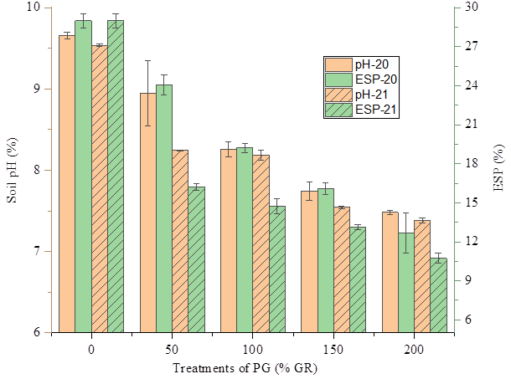
Fig 1. Effects of increasing PG level on soil pH and ESP in two successive (2020 and 2021) experiments.

Exchangeable Na
The exchangeable Na content of the soil consistently decreased with increasing rates of PG application. The exchangeable value obtained from the control treatment (0% GR) was higher by 17.56, 22.23, 29.55 and 37.36% over that of the 50, 100, 150 and 200% GR treatments, respectively, in 2020, while it was higher than the respective values of the treatments by 10.86, 22.71, 31.13 and 44.64% in 2021 from pot experiment. Results showed consistent reductions in exchangeable Na values with increasing levels of PG application, and relatively higher reduction was observed in 2021 (second harvest) compared with 2020 (first harvest) (Fig. 2). Following PG application during first harvest, the higher reduction in exchangeable Na in 2021 compared to 2020 can be attributed to crop uptake, continued reaction between PG and the soil, leaching, and improved soil structure. Similar findings showed that more exchangeable Na was reduced by leaching with continued irrigation in flue gas desulfurization gypsum-treated saline-sodic soils during the paddy rice growth season [4].

Exchangeable Ca
The exchangeable Ca content of the soil consistently increased with increasing rates of PG application. Application of the highest PG rate (200% GR) increased Ca contents by 42.21, 32.61, 19.16 and 8.36 % over that of the 0, 50, 100 and 150% GR treatments, respectively, in 2020, while the respective increments in 2021 were by 68.19, 40.49, 10.78 and 4.89% from the pot experiment. Under the crop system, higher values of exchangeable Ca were recorded in 2021 compared to the 2020 harvest (Fig. 2). It is possible that the PG applied in 2020 did not fully react with the soil, and the reaction continued in 2021, leading to an increase in exchangeable Ca contents. Moreover, the application of PG on sodic soils improves soil structure and increases the flow of water and air into the soil. This can lead to a more effective reaction between PG and soils in 2021, resulting in increasing exchangeable Ca contents.
Exchangeable K and Mg
The exchangeable K and Mg contents were consistently decreased with increasing rates of PG application. The exchangeable K value obtained from the control treatment (0% GR) was higher by 25.26, 36.37, 48.32 and 56.89% compared to the 50, 100, 150 and 200% GR rates in 2020 harvest while it was higher than the respective values of the treatments by 15.45, 33.29, 49.33 and 52.25% in 2021 from pot experiment (Fig. 2). However, this result is in contrast to previous findings that showed that PG application reduced exchangeable Mg in soil profile [22]. However, low contents of K and Mg in PG could also be the cause for the nonsignificant change observed in K and Mg contents after PG application in both cropping seasons.
Exchangeable Sodium Percentage
Exchangeable sodium percentage (ESP) was constantly decreased with increasing rates of PG application. Results showed that the ESP value obtained from the control treatment (0% GR) was higher by 16.99, 33.72, 44.46 and 56.29% over that of the 50, 100, 150 and 200% GR treatments, respectively in 2020 while it was higher than the respective values of the treatments by 44.07, 49.22, 54.69 and 62.98% in 2021 from pot experiment. Over the two years, consistent decreases in ESP levels were observed at experimental sites, and the ESP levels were lower after the second harvest (2021) than after the first harvest (2020) (Fig. 2). The continued irrigation and drainage during the haricot bean growth increase the reduction of exchangeable Na, thereby decreasing the ESP level of the soil in 2021 over 2020 planting year.
The release of high Ca²⁺ concentrations from the PG increases the Ca: Na ratio in soil solution, enhancing the reduction of ESP [23,24]. This finding is consistent with the results presented by Haile et al. [20], which indicated that application of PG increases water-soluble Ca to the soil, resulting in a reduction in the amount of exchangeable Na present on soil colloids. During the ion exchange process, a large amount of water-soluble Na is generated, which is removed via drainage, causing a huge reduction in ESP value. This reduction improves the properties of the sodic soil and creates a conducive environment for growing crops.
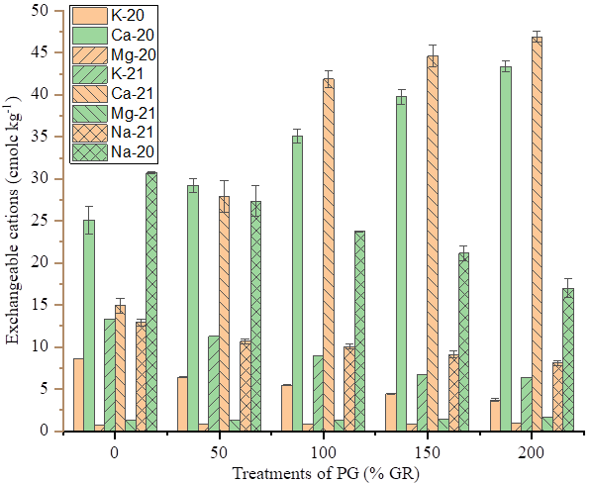
Fig 2. Effects of increasing PG level on exchangeable cations in two successive (2020 and 2021) experiments.
Available P
Soil available P contents were increased with increasing levels of PG application. Application of the highest PG rate (200% GR) increased available P contents by 63.70, 55.79, 29.79 and 13.54% compared to the control, 50, 100, and 150% GR rates, respectively, in 2020, and the respective increments in 2021 were by 82.80, 36.77, 21.95 and 9.57%.
However, soil P availability was significantly reduced in 2021 compared with the 2020 harvest in both pot conditions (Fig.3). Our results are in line with previous findings [20, 25-27], which indicated increments in soil available P with application of increasing P rates. These increments showed that PG material is a rich source of available P, which can improve plant growth.
The concentration of available P in the soils at the 2021 harvest was much lower than that of the 2020 harvest, which could be due to mixing of the PG-treated soils with a large volume of soil during land preparation. These results also agree with the previous report made by Chhabra and Thakur [28], which indicated that high concentrations of Ca in the soil solutions increased the insoluble calcium phosphate for a short time and decreased P availability. Similarly, P uptake by grain and straw might have also decreased P availability in soils [29].
Increases in soil P availability from high PG rates can improve the uptake of phosphorus by plants [30]. As a result, better crop growth and production have been observed at the high PG rate in sodic soils in 2020. These results agree with previous findings [26,27]. Generally, the results revealed that the levels of PG application significantly influence the availability of nutrients and the performance of the crops on sodic soil.
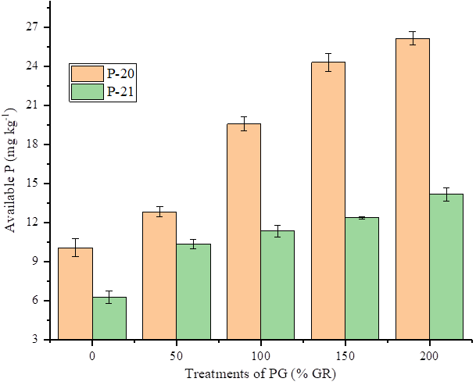
Fig 3. Effects of increasing PG level on available P in two successive (2020 and 2021) experiments.

Influence of PG amendments on haricot bean yields
Grain and straw yield of haricot bean (HB) was highly significantly (P<0.001) affected by PG levels, but an insignificant effect (P≥0.05) was observed on planting time. The highest PG (200% GR) rate gave grain yields that were higher by 100, 60.56, 37.32 and 27.01% in the first (2020) and by 100, 76.17, 50.15 and 7.67% in the second (2021) seeding compared to the control, 50, 100 and 150% GR treatments, respectively (Table 1).

Furthermore, the highest PG (200% GR) rate gave straw yields that were higher by 100, 38.88, 32.62 and 23.86% in the first (2020) and 100, 26.29, 25.28 and 22.51% in the second (2021) seeding compared to the control, 50, 100 and 150% GR treatments, respectively (Table 1). The continuous increments recorded till the highest level of PG indicate that PG levels over 200% GR should be applied to obtain an optimum yield of the crop. However, the grain and straw yields of HB decreased during the second (2021) planting as compared to those from the first (2020) planting, and yield reduction showed similar decreasing trends at all PG levels (Table 1).

The increases in grain and straw yields observed with PG amendments compared to the control might have been due to the acidity of the PG material and its Ca, SO₄^{2-,} and P contents. Following the application of PG amendments, soil pH and ESP decreased while the contents of Ca and P increased in pot trials (Fig. 1-3). Application of PG during irrigation increased the loss of displaced Na⁺ from the soil solution and improved the properties of sodic soil resulted in increased crop yields [31]. The findings corroborated Outbakat et al. [32], who reported that PG application increased grain and straw yield of Faba bean in pot trials. Fast nutrient dissolution and increased nutrient availability caused by PG boost grain and straw yields of chickpeas and lentils [34]. These results corroborate with Gifole et al. [29] and Mesfin et al. [33], who stated that application of P increases HB yields.
However, grain and straw yield of HB was lower during the second planting (2021) compared to the first (2020) planting at all level PG applications. This might be due to the reduction of available P during the second (2021) planting compared to the first (2020). These findings are consistent with those of Mohamed and Jean (2021), who reported that grain and straw yields of HB were dramatically reduced when the amount of available P in the soil was reduced.

Table 1. Effects of PG application and planting years on yield and yield components of HB.
Amendments  (% GR) | Planting year | Grain yield | Straw yield
Amendments  (% GR) | Planting year | g pot⁻¹
0 | 2020 | 0.0^{h} | 0.0^{d}
0 | 2021 | 0.0^{h} | 0.0^{d}
50 | 2020 | 6.50^{f} | 10.34^{b}
50 | 2021 | 4.01^{g} | 7.71^{c}
100 | 2020 | 10.33^{d} | 9.15^{bc}
100 | 2021 | 8.39e | 7.99^{c}
150 | 2020 | 12.03^{c} | 8.30^{c}
150 | 2021 | 15.54^{b} | 7.6c^{c}
200 | 2020 | 16.48ª | 13.58ª
200 | 2021 | 16.83ª | 10.31^{b}
LSD _{0.05} |  | 0.69 | 1.69
CV (%) |  | 5.32 | 15.54
LSD, List Significant Differences; CV, Coefficient of Variation; GR, Gypsum Requirement. Means within a column followed by the same letter(s) are not significantly different at P<0.05.

Conclusion
Phosphogypsum application on sodic soils consistently boosted grain and straw yields of haricot bean with increasing PG levels in both planting years (2020 and 2021). Higher exchangeable Ca, available P, and extractable SO₄²⁻ levels in PG-treated soils boosted haricot bean yields compared to controls. General results revealed that PG on sodic soils had the dual benefit of reclaiming sodic soils and meeting nutritional requirements for growing crops without the use of external sources of P and SO₄²⁻ fertiliser in both planting years. However, grain and straw yields of the test crop continuously increased up to the maximum PG rates (200% GR) without reaching the optimal rate, indicating that higher PG rates (>200% GR) are required to achieve optimum rates. Thus, a comparative experiment was required to evaluate the influence of PG amendments on grain and straw yields of the crop using diverse agroecology on sodic and saline-sodic soils and other test crops for a more general assessment, recommendation, and adoption of the technology.

Abbreviations
ANOVA | Analysis Of Variance
CEC | Cation Exchange Capacity
CV | Coefficient of Variation;
ESP | Exchangeable Sodium Percentage
GR | Gypsum Requirement
GR | Gypsum Requirement
HB | Haricot Bean
LSD | List Significant Differences
PG | Phosphogypsum
SAS | Statistical Analysis System

Data availability
All datasets generated for this study are included in the article and in the supplementary data file.
Declarations
Ethics approval and consent to participate
Not applicable.
Consent for publication
Not applicable.
Competing interests
The authors declare no competing interests.
Clinical trial number
Not applicable

References
- Li B, Wang ZC, Chi CM. Parameters and characteristics of alkalization of sodic soil in Da'an City. J. Ecol. Rural Environ. 2006; 22 (1): 20–23.
- Kumar P, Sharma PK. Soil Salinity and Food Security in India. Frontiers Sustai. Food Systems. 2020; 4:533781.
- Wang SJ, Chen Q, Li Y, Zhuo YQ, Xu LZ. Research on saline-alkali soil amelioration with flue gas desulfurization gypsum. Resour. Conserv. Recycl. 2017;121: 82–92.
- Zhao Y, Wang S, Li Y, Liu J, Zhuo Y, Chen H, Wange J, Xu L, Sun Z. Extensive reclamation of saline-sodic soils with flue gas desulfurization gypsum on the Songnen Plain, Northeast China. Geoderma. 2018;321:52–60.
- Aboelsoud H, Engel B, Gad K. Effect of planting methods and gypsum application on yield and water productivity of wheat under salinity conditions in north Nile Delta. Agronomy. 2020;10: 853.
- Nayak AK, Mishra VK, Sharma DK, Jha SK, Singh CS, Shahabuddin M, Shahid M. The efficiency of phosphogypsum and mined gypsum in reclamation and the productivity of the rice-wheat cropping system in sodic soil. Communi. Soil Sci. Plant Analy. 2013;44: 909-921.
- Yu Q, Ning P, Yang Y. Discussion about pretreatment and resource recovery of phosphogypsum. Acta Agricu. Jiangxi. 2008; 20(2):109-111.
- Guizani M, Fujii T, Hijikata N, Funamizu N. Salt removal from the soil during the rainy season of a semi-arid climate following an assumed salt accumulation from previous cultivations fertilised with urine. Euro-Mediterranean J. Envir. Integration. 2016;1(1):1-11.
- EIAR. (Ethiopian Institute of Agricultural Research). Coordination of the National Agricultural Research System, Ethiopia. EIAR, Addis Ababa. 2011
- Awoke W, Berehanu A, Walelign W. Response of Haricot Bean (Phaseolus Vulgaris L.) Varieties to Drought Stress at Different Growth Stages. J. Bio. Agricu. Healthcare. 2019;9(1).
- C.S.A. (Central Statistical Authority). Agricultural sample survey 2008/2009 E.C. Report on area and production for major crops. Statistical bullet in Addis Ababa, Ethiopia. 2016
- Kabahuma MK. Enhancing biological nitrogen fixation in common bean (Phaseolus vulgaris L), Graduate Theses and Dissertations, Iowa State University, Iowa, USA. 2013
- Ketema T, Gobena D, Tilahun H, Tatek W, Abera T, Gebeyehu A, Tigist W, Aynalem G. Effect of Optimal Irrigation Scheduling on Yield and Water Productivity of Haricot Bean at Melkassa, Central Rift Valley of Ethiopia. J. Natur. Scie. Research. 2022;13:5.
- MoARD. Ministry of Agriculture and Rural Development.Major agro-ecological zones of Ethiopia. Forestry, Land Use and Soil Conservation Department. Addis Ababa, Ethiopia. 2005
- Olsen SR, Cole CV, Watanabe FS, Dean LA. Estimation of available phosphorus in soil by extraction with sodium bicarbonate. USDA cir. 1954; No. 939.
- van Reeuwijk. Procedures for soil analysis. 4thed. International Soil Reference and Information Centre, Netherlands. 1993.
- McKenzie NJ, Jacquier DJ, Isbell RF, Brown KL.Australian soils and landscapes: an illustrated compendium. CSIRO Publishing, Collingwood, Victoria. 2004.
- SAS. (Statistical Analysis System), SAS/STAT Software Syntax, Version 9.0, p. 751, SAS Institute, Cary, NC, USA. 2004.
- Wang J, Bai Z, Yang P. Effect of byproducts of flue gas desulfurization on the soluble salts composition and chemical properties of sodic soils. PLoS ONE. 2013;8(8): e71011.
- Haile H, Sheleme B, Alemayehu K, Selamyihun K. Effect of phosphogypsum amendment on chemical properties of sodic soils at different incubation periods. Envir. Soil Sci. 2022;11.
- Ng JF, Ahmed OH, Jalloh MB, Omar L, Kwan YM, Musah AA, Poong K H. Soil nutrient retention and ph buffering capacity are enhanced by calciprill and sodium silicate. Agron. 2022; 12: 219.
- Haile H, Sheleme B, Alemayehu K. Influence of Phosphogypsum Amendments on the Performance of Wheat (Triticum Aestivum L.) and Chemical Properties of Sodic Soil of Alage, Central Rift Valley of Ethiopia. J. Soil Sci. Plant Nutr. 2023.
- Nan J, Chen X, Wang X, Lashari MS, Wang Y, Guo Z, Du Z. Effects of applying flue gas desulfurization gypsum and humic acid on soil physicochemical properties and rapeseed yield of saline-sodic cropland in the eastern coastal area of China. J. Soil. Sediment. 2016; 16: 38–50.
- Yaduvanshi NP, Sharma DR. Tillage and residual organic manures/chemical amendment effects on soil organic matter and yield of wheat under sodic water irrigation. Soil till. Resea. 2017; 98: 11–16.
- Bossolani JW, Crusciol CA, Garcia A, Moretti LG, Portugal JR, Rodrigues VA, Fonseca M, Calonego JC. Long-Term Lime and Phosphogypsum Amended-Soils Alleviate the Field Drought Effects on Carbon and Antioxidative Metabolism of Maize by Improving Soil Fertility and Root Growth. Front. Plant Scie. 2021;12:650296.
- Kim Y, Cho J, Young Y, Young-Eun C, Hyoen J, Cheong MS, Lee M, Kim K, Lee YB. Effects of Phosphogypsum Application on Field Soil Properties and Yield and Quality of Garlic (Allium sativum L.). Korean J. Enviro. Agricu. 2021; 40(1):33-39.
- Mahmood M, Tian Y, Ma Q, Ahmed W, Mehmood S, Hui X, Wang Z. Changes in phosphorus fractions and their availability status about long-term P fertilisation in Loess Plateau of China. Agronomy. 2021;10: 1818.
- Chhabra R, Thakur NP. Long-term study on phosphorus fertilisation for rice-wheat cropping system in alkali soils in the Indo-Gangetic plains. In: Long-term Soil Fertility Experiments in Rice-Wheat Cropping Systems (Rice-Wheat Consortium). 2000; 31–39.
- Gifole G, Sheleme B, Walelign W. Response of haricot bean to phosphorus application on Ultisols at Areka, Southern Ethiopia. J. Biol. Agric. Healthcare. 2011;1.
- Caires EF, Maschietto EHG, Garbuio FJ, Churka S, Joris HAW. Surface application of gypsum in low acidic oxisol under a no-till cropping system. Scientia Agrico. 2011c; 68:209–216.
- Ghafoor A, Murtaza G, Ahmad B, Boers TM. Evaluation of amelioration treatments and economic aspects of using saline-sodic water for rice and wheat production on salt‐affected soils under arid land conditions. Irrigation Drainage. 2008; 57: 424–434.
- Outbakat MB, El Gharous M, El Omari K, El Mejahed K. Effect of phosphogypsum on Faba Bean yield and heavy metals content under saline conditions. Envir. Scie. Proc. 2022; 16:16.
- Mesfin K, Belay Y, Abera H. The Response of Haricot Bean Varieties to Phosphorus Levels on Nitosols at Wolaita Zone, Ethiopia. J. Biol. Agric. Healthcare. 2014; 4(17).
- El Mejahed K, Zeroual Y. Valorisation of phosphogypsum as fertiliser—Results of agronomic field trials: Morocco. In Phosphogypsum Leadership Innovation Partnership, Hiltonno. J. Ed. IFA: Paris, France. 2020; 54–59.

