Delivery Route Optimization Using
Genetic Algorithm

- ABSTRACT
Efficient delivery route planning plays a vital role in logistics and transportation systems, directly affecting operational cost, delivery time, and customer satisfaction. However, the Delivery Route Optimization Problem, which can be modeled as a variant of the Travelling Salesman Problem (TSP) or Vehicle Routing Problem (VRP), is known to be NP-hard and difficult to solve optimally when the number of delivery points increases.

This study proposes the use of a Genetic Algorithm (GA) to optimize delivery routes by minimizing the total travel distance while ensuring that all delivery points are visited. In the proposed framework, candidate solutions are encoded as chromosomes representing permutations of delivery locations, and evolutionary operators such as selection, crossover, and mutation are applied to iteratively improve solution quality. Experimental evaluations conducted on simulated delivery networks demonstrate that the GA-based approach outperforms traditional heuristic methods such as greedy and nearest neighbor, achieving shorter route lengths and better convergence behavior. The results highlight the effectiveness and practicality of genetic algorithms for delivery route optimization, particularly for small- and medium-sized logistics operations.
- Keywords: Delivery route optimization; Travelling Salesman Problem (TSP); Vehicle Routing Problem (VRP); Genetic Algorithm; Logistics; Optimization.

1. Introduction
The rapid growth of e-commerce and urban logistics has significantly increased the demand for efficient and cost-effective delivery services[1]. Delivery route optimization has therefore become a critical task for logistics companies, as it directly affects operational costs, delivery time, fuel consumption, and customer satisfaction. Poorly optimized routes can lead to excessive travel distance, wasted resources, and delayed deliveries, which are detrimental to both service providers and consumers . From a computational perspective, the delivery routing problem can be modeled as a variant of the Travelling Salesman Problem (TSP) or the more general Vehicle Routing Problem (VRP). Both problems are classified as NP-hard, meaning that the computational complexity grows exponentially with the number of delivery points[2]. While exact algorithms can provide optimal solutions for small instances, they quickly become infeasible for real-world delivery networks with dozens or hundreds of stops. This motivates the need for heuristic and metaheuristic approaches that can efficiently generate near-optimal solutions in a reasonable amount of time. Traditional heuristic methods such as nearest neighbor or greedy algorithms offer computational efficiency but often produce suboptimal solutions, particularly in large-scale or complex delivery scenarios[3]. To address these limitations, researchers have increasingly explored metaheuristic algorithms such as Simulated Annealing, Tabu Search, Ant Colony Optimization, and Genetic Algorithms (GAs)[4]. These methods strike a balance between exploration and exploitation, enabling the discovery of high-quality solutions without exhaustive search. Among these approaches, Genetic Algorithms have gained substantial attention due to their simplicity, flexibility, and effectiveness in solving combinatorial optimization problems [5]. Inspired by the principles of natural selection and evolution, GAs operate on a population of candidate solutions, applying operators such as selection, crossover, and mutation to iteratively evolve better solutions. In the context of delivery route optimization, GAs are particularly well suited for handling large solution spaces and nonlinear constraints, making them a promising

2. Related Work
The problem of delivery route optimization has been extensively studied in operations research, transportation, and computer science. Since the problem can be formulated as a Travelling Salesman Problem (TSP) or a Vehicle Routing Problem (VRP), both of which are NP-hard, various approaches have been proposed ranging from classical heuristics to metaheuristics and hybrid methods.
2.1. Exact and Heuristic Methods
Exact algorithms such as Branch and Bound or Dynamic Programming guarantee optimal solutions but are limited to small-scale instances due to exponential computational growth. To address larger problems, heuristic approaches such as Nearest Neighbor, Greedy Insertion, and Clarke–Wright Savings Algorithm have been widely applied. While these heuristics are computationally efficient, they often converge to locally optimal solutions and fail to provide satisfactory results in complex or large-scale delivery networks. technique for practical logistics applications[6]. Motivated by these challenges and opportunities, this study proposes the use of a Genetic Algorithm for delivery route optimization. The main objectives of this research are:
1. To design a GA-based framework for solving the delivery routing problem modeled as TSP/VRP.
2. To evaluate the performance of the GA in terms of route length and convergence compared to traditional heuristic approaches.
3. To demonstrate the applicability of the method through experimental simulations on delivery networks of varying sizes.
The remainder of this paper is structured as follows. Section 2 reviews related work on delivery route optimization and metaheuristic approaches. Section 3 presents the proposed methodology, including problem formulation, chromosome representation, and GA operators. Section 4 discusses the experimental setup and results. Section 5 analyzes the findings and practical implications.
Finally, concludes the study and outlines potential directions for future research...
Section
2.2. Metaheuristic Approaches
To overcome the limitations of heuristics, researchers have investigated metaheuristic algorithms, which balance exploration and exploitation in the solution space. Popular techniques include Simulated Annealing (SA),
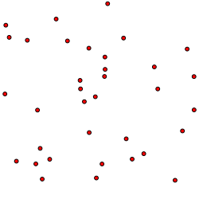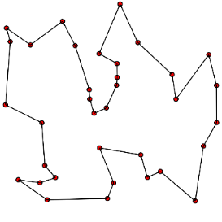
Figure 1 Travelling Salesman Problem
Tabu Search (TS), and Ant Colony Optimization (ACO). These approaches have shown strong performance in finding near-optimal solutions within acceptable time, especially for large-scale logistics scenarios[7]. However, their performance is often sensitive to parameter settings and problem-specific adjustments.
A general flowchart for metaheuristic algorithms in optimization is shown in Figure 2.
2.3. Genetic Algorithms for Routing Problems
Genetic Algorithms (GAs) have emerged as one of the most promising methods for combinatorial optimization, including TSP and VRP. Early studies demonstrated the ability of GAs to find high-quality solutions by applying evolutionary operators such as selection, crossover, and mutation to evolve populations of candidate solutions. Variants such as Order Crossover (OX), Partially Mapped Crossover (PMX), and mutation strategies like Swap or Inversion have been widely employed in routing problems.
Compared to heuristics and other metaheuristics, GAs are more robust in exploring large solution spaces and less prone to premature convergence when appropriately tuned[8]. Their flexibility also allows integration with problem-specific heuristics, resulting in hybrid GA frameworks that further improve solution quality. The standard GA workflow—initialization, selection, crossover, mutation, and termination—is depicted in Figure 3.
Figure 2 Genetic Algorithm Flowchart
2.4. Recent Applications in Logistics
Recent works have applied GA and hybrid GA based approaches to real-world logistics, including last-mile delivery, drone delivery routing, and green logistics with fuel consumption constraints.
These studies confirm the adaptability of GA in handling diverse objectives, such as minimizing distance, reducing fuel cost, and balancing multiple vehicles. However, challenges remain in scaling GA to very large delivery networks and in incorporating real-world constraints such as delivery time windows, vehicle capacities, and traffic conditions. Figure 4 illustrates various types of nature-inspired metaheuristic algorithms used in contemporary optimization applications, including GA variants adapted for logistics.
2.5. Research Gap
Although Genetic Algorithms have shown effectiveness in delivery route optimization, most existing studies focus on theoretical formulations or small-scale datasets. There is still a need for practical frameworks that can be applied to small- and medium-sized logistics operations, balancing solution quality with computational efficiency.
This study aims to address this gap by implementing a GA-based approach to delivery route optimization and evaluating its performance against baseline heuristics.

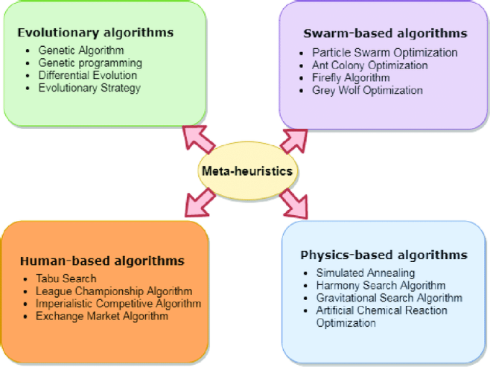
Figure 3 Classification of Meta-heuristic Algorithms
3. Methodology
3.1. Problem Formulation
The delivery route optimization problem can be formulated as a Travelling Salesman Problem (TSP), where a delivery vehicle must visit all customers exactly once and return to the depot, while minimizing the total travel distance.
Formally, let:
• G=(V,E) be a complete weighted graph, where V={v0,v1,...,vn} represents the depot (v0) and 𝑛 customer nodes.
• d(i,j) denote the distance between nodes vi and vj.
• A feasible route is a permutation of customer nodes that starts and ends at the depot.
The optimization objective is:
$$min f(π) = \sum_{k=0}^{n}{d(πk,πk+1)}$$
where 𝜋 is a permutation of delivery nodes with $π0 = πn+1 = v0$
3.2. Chromosome Representation
Each candidate solution (chromosome) is encoded as a sequence representing the order in which delivery locations are visited. For example, a chromosome [3,5,1,4,2] indicates that the vehicle visits customers 3 → 5 → 1 → 4 → 2 before returning to the depot. This permutation encoding ensures that each customer is visited exactly once.
3.3 Genetic Algorithm Operators
Selection
Selection determines which chromosomes are chosen to form the next generation. In this study, Roulette Wheel Selection and Tournament Selection are considered. These methods assign higher selection probabilities to chromosomes with lower total route distances.
Crossover
Crossover combines genetic material from two parent chromosomes to produce new offspring[9]. Since the problem involves permutations, specialized crossover operators are required. Two widely used methods are:
• Order Crossover (OX): preserves relative order and positions of nodes.
• Partially Mapped Crossover (PMX): maintains position consistency between parents.
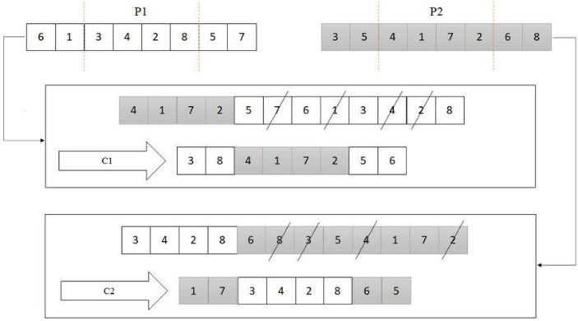
Figure 4 Illustration of Order Crossover (OX) operator
Mutation
Mutation introduces random changes to maintain diversity in the population and avoid premature convergence[9]. Common mutation strategies include:
• Swap Mutation: randomly swaps two positions in the chromosome.
• Inversion Mutation: reverses the order of nodes within a subsequence.
3.4 Fitness Function & Termination Criteria
The fitness of a chromosome is defined as the inverse of the total route distance:
$$Firness\left(π\right)=\frac{1}{f(π)}=\frac{1}{\sum_{k=0}^{n}{d(πk,πk+1)}}$$
This ensures that shorter routes correspond to higher fitness values. The GA runs for a fixed number of generations (𝐺𝑚𝑎𝑥), or terminates early if no improvement in the best fitness is observed for a predefined number of generations[10].

4. Experimental Results and Discission
To evaluate the effectiveness of the proposed Genetic Algorithm (GA) for delivery route optimization, experiments were conducted on both synthetic datasets and standard benchmark instances from TSPLIB. The synthetic datasets consisted of 10, 20, and 50 delivery points randomly distributed on a 2D plane, with Euclidean distances used as travel costs. In all cases, the vehicle started from a fixed depot, visited all customers exactly once, and returned to the depot.
The GA was implemented in Python and carefully parameterized to balance exploration and exploitation within the solution space. A population size of 100 was chosen to maintain sufficient genetic diversity while keeping computational cost manageable. The algorithm was run for a maximum of 500 generations, which provided enough evolutionary iterations to allow convergence without excessive runtime.
Tournament selection with a tournament size of 5 was adopted, as it strikes a balance between selective pressure and diversity preservation, ensuring that fitter individuals are more likely to propagate while still allowing weaker individuals to occasionally contribute genetic material. The crossover operator was implemented as Order Crossover (OX) with a probability of 0.8, a method specifically designed for permutation problems such as TSP, which preserves subsequence orderings critical to route quality. Mutation was implemented as a swap mutation with a probability of 0.1, chosen to introduce sufficient randomness to prevent premature convergence without disrupting promising solutions.
Additionally, an early stopping criterion was applied, terminating the algorithm if no improvement in the best solution was observed after 50 consecutive generations. This adaptive stopping rule ensured computational efficiency by avoiding unnecessary iterations once the search stabilized. For baseline comparisons, two simple but widely recognized approaches were included: the Greedy nearest neighbor heuristic, which incrementally selects the closest unvisited node, and Random search, which samples random permutations of delivery points. These baselines represent intuitive yet limited approaches, against which the GA’s relative performance could be rigorously measured.
Experimental results demonstrate that the GA consistently achieved superior performance across all test cases. For example, in the 20-node dataset, the greedy heuristic generated a route length of approximately 890 units, while the GA reduced the total distance to 740 units, reflecting an improvement of nearly 17%. This reduction is significant in practical logistics settings, where shorter routes translate directly into lower fuel consumption and faster delivery times. The advantage of GA became more pronounced in larger problem instances. With 50 delivery points, the greedy method produced routes averaging 2200 units in length, whereas the GA improved this to 1820 units, corresponding to over 17% savings in distance. Such improvements are not only statistically meaningful but also operationally impactful, particularly in last-mile delivery scenarios where efficiency is critical. Analysis of convergence curves revealed that GA gradually refined solutions across generations, showing steady improvement during the early stages and stabilizing in later generations. The inclusion of mutation played a vital role in maintaining diversity within the population, preventing premature convergence to local optima. Without mutation, the algorithm often plateaued early, producing suboptimal routes. With a mutation rate of 0.1, however, the search retained enough randomness to escape poor local minima while still converging efficiently.
On the eil51 benchmark instance from TSPLIB[11], which is a standard test case in the literature, GA obtained a route length of 434 compared to the known optimal of 426, resulting in an error margin of less than 2%. Considering the NP-hard nature of the problem, this performance is highly competitive. The runtime for this experiment was on the order of tens of seconds on a standard PC (Intel i5, 8GB RAM), indicating that the approach is computationally feasible for small- to mediumscale delivery networks. A qualitative examination of the resulting routes further confirmed GA’s advantage: the optimized paths avoided redundant detours and unnecessary backtracking, which were often observed in greedy solutions. In visual comparisons, GA-generated routes appeared smoother and more structured, reflecting the algorithm’s ability to capture global patterns in the problem space. These findings support the conclusion that GA not only improves quantitative performance metrics but also produces qualitatively superior solutions that are more aligned with the operational needs of logistics and transportation systems.Overall, these results highlight the robustness of GA in solving delivery route optimization problems. It significantly improves solution quality compared to simple heuristics while maintaining reasonable computational cost. However, runtime grows with problem size, and performance is sensitive to parameter tuning. These findings suggest that GA is highly suitable for small- to medium-scale logistics operations and may be further enhanced through hybridization with problem-specific heuristics or parallel implementations for larger networks.
Figure 5 Example of dynamic delivery routing with depots, vehicles, delivery points, and newly introduced deliveries.

5. Conclusion and Future Work

This study investigated the application of a Genetic Algorithm (GA) to the problem of delivery route optimization, formulated as a variant of the Travelling Salesman Problem (TSP). The proposed GA framework employed permutation-based chromosome representation, Order Crossover, and swap mutation to effectively handle the combinatorial nature of the problem. Experimental evaluations on synthetic datasets and benchmark instances from TSPLIB demonstrated that GA consistently outperformed simple heuristic baselines such as the nearest neighbor method and random search. In particular, GA achieved route length reductions of up to 17–18% on medium-scale problems and approximated near-optimal solutions on standard benchmarks with error margins below 2%. These improvements highlight GA’s ability to balance exploration and exploitation, refine solutions over successive generations, and provide practically useful routes within reasonable computational time.
Beyond the quantitative performance, visual inspection of optimized routes confirmed that GA
generated solutions exhibited more structured and efficient patterns compared to heuristic alternatives, avoiding redundant detours and minimizing unnecessary travel. From an operational perspective, such improvements directly translate into lower transportation costs, reduced energy consumption, and higher service reliability—factors that are crucial in modern logistics and last-mile delivery systems. The findings therefore reinforce the suitability of GA as a flexible and effective approach for small- to medium-scale delivery networks[12]. Nevertheless, certain limitations remain. The runtime of GA increases with problem size, making its direct application to very large-scale delivery networks References computationally
Moreover, the expensive. performance of GA is sensitive to parameter tuning, particularly population size, crossover probability, and mutation rate. Future research should therefore focus on several promising directions: (i) developing hybrid GA frameworks that integrate problem specific heuristics to accelerate convergence, (ii) incorporating real-world constraints such as time windows, vehicle capacity, and dynamic traffic conditions, and (iii) exploring parallel and distributed implementations of GA to improve scalability for large logistics systems. In addition, extending the approach to multi-objective optimization, balancing distance minimization with energy efficiency or environmental considerations, would further enhance its transportation. applicability in sustainable
In conclusion, this work demonstrates that Genetic Algorithms provide a powerful metaheuristic framework for optimizing delivery routes, achieving both quantitative efficiency gains and qualitative improvements in route structure. By addressing the identified limitations through hybridization, constraint modeling, and parallelization, GA has the potential to become an integral component of intelligent logistics planning in the era of smart cities and e-commerce-driven supply chains.

REFERENCES
1. J. Li, H. Wang, and Y. Lim, “Last-mile delivery in e-commerce: A literature review,” International Journal of Physical Distribution & Logistics Management, vol. 50, no. 1, pp. 22–46, 2020.
2. G. Laporte, “The Vehicle Routing Problem: An overview of exact and approximate algorithms,” European Journal of Operational Research, vol. 59, no. 3, pp. 345–358, 1992.
3. F. Glover and G. A. Kochenberger (eds.), Handbook of Metaheuristics, Springer, 2003.
4. M. Dorigo and L. M. Gambardella, “Ant colonies for the traveling salesman problem,” BioSystems, vol. 43, no. 2, pp. 73–81, 1997.
5. D. E. Goldberg, Genetic Algorithms in Search, Optimization and Machine Learning, Addison-Wesley, 1989.
6. E. Eiben and J. E. Smith, Introduction to Evolutionary Computing, Springer, 2015.
7. N. Christofides, “Worst-case analysis of a new heuristic for the travelling salesman problem,” Graduate School of Industrial Administration, Carnegie Mellon University, 1976.
8. E. Osman and G. Laporte, “Metaheuristics: A bibliography,” Annals of Operations Research, vol. 63, pp. 511–623, 1996.
9. Syswerda, G. “Schedule Optimization Using Genetic Algorithms,” Handbook of Genetic Algorithms, 1991.
10. Eiben, A. E., Hinterding, R., & Michalewicz, Z. “Parameter control in evolutionary algorithms,” IEEE Transactions on Evolutionary Computation, vol. 3, no. 2, pp. 124–141, 1999.
11. Reinelt, G. “TSPLIB—A Traveling Salesman Problem Library,” ORSA Journal on Computing, vol. 3, no. 4, pp. 376–384, 1991.
12. Alba, E., & Tomassini, M. “Parallelism and Evolutionary Algorithms,” IEEE Transactions on Evolutionary Computation, vol. 6, no. 5, pp. 443–462, 2002.

