Original Research Article

Clinical Supervision: A Little-Known yet Impactful Supervision Practice that Improves Early Childhood Development (ECD) Teachers’ Pedagogical Practices in Uganda

Abstract:
This multi-case study examined the perceptions of Early Childhood Education (ECD) centre administrators on the utilization of clinical supervision to improve teachers’ pedagogical practices. It was conducted in three selected ECD schools in Rubaga Division, Kampala Capital City Authority (KCCA), Uganda. Data was collected using interview guides, lesson observations and document review analysis from six school administrators recruited from three ECD centers. Eighteen lessons were observed clinically from six teachers as an illustration on how clinical supervision contributes to improvement of teachers’ pedagogical practices. Findings indicate that although the school administrators were ignorant about clinical supervision, they acknowledged supervision gaps in the methods of instructional supervision used in their respective schools. Additionally, through lesson observations and conferences done with teachers as an illustration of how clinical supervision is done, ECD school administrators acknowledged an improvement in teachers’ pedagogical practices and expressed willingness to embrace clinical supervision if trained on how to use it. It was therefore concluded that ECD school administrators need orientation and training on how to employ clinical supervision to improve ECD teacher pedagogical practices in ECD centres.

Keywords: clinical supervision, perceptions, pedagogical practices, school administrators.
Introduction
Quality Early Childhood Care and Education (ECCE) play a crucial role in shaping children’s development and preparing them for lifelong learning. In Uganda, where the importance of Early Childhood Care and Education is increasingly getting recognized, there is a growing need to enhance the pedagogical practices of teachers in this field (Smith, 2020). Effective supervision of teachers has been identified as a key factor in improving teaching quality and learner outcomes (Jones & Johnson, 2018). While various forms of supervision exist, one approach that holds promise for enhancing teachers’ pedagogical practices is clinical supervision.
Clinical supervision is a collaborative and reflective practice that focuses on improving teaching effectiveness through on-going observation, feedback, and support (Brown et al., 2019). Unlike traditional forms of supervision, clinical supervision emphasizes the professional growth and development of teachers, with a particular emphasis on enhancing their instructional strategies, classroom management skills and overall teaching competence (Johnson, 2021).
Despite its potential benefits, clinical supervision remains relatively an unknown practice in Ugandan context. Limited research has been conducted on its application and impact in early childhood development settings in Uganda (Kamara & Otim,2017) and therefore, this research was conducted to find out the perceptions of early childhood school administrators on utilization of clinical supervision to improve ECD teachers’ pedagogical practices.
Review of related literature
The perceptions of school administrators regarding clinical supervision have been studied by a number of authors. Kaykc, Ylmaz, & Sahin (2017) for example carried out a study in the Turkish province of Antalya with the intention of determining how current teacher supervision in Turkey was carried out in accordance with the views of educational supervisors and to ascertain the general attitudes and evaluations of educational supervisors regarding clinical supervision. According to the study's findings, the stages before entering the school setting, pre-observation, observation, and post-observation, were to be utilized to classify current supervision. It was discovered that the educational supervisors had positive views on the value of clinical supervision. The majority of participants underlined the necessity of clinical supervision training for supervisors as well as the distinction between supervisory and investigative responsibilities. This study was conducted in the Turkish province of Antalya, and hence we cannot conclusively say, the same findings could be got in Uganda’s Early Childhood Development (ECD) centers which was the concern for this study.
In addition, Abakan, Ozrecberoglu, Isiktas, & Gunduz (2021) show how primary school principals, senior assistants felt about the functions of guidance and counseling. The results of the content analysis application revealed that, in general, inspectors treated teachers with tolerance, respect, and moderation. Teachers also expressed their desire for more regular inspections of schools by inspectors. Furthermore, it's evident that school administrators, whose expectations in terms of career advice were previously modest, are now expected to share educational innovations with colleagues and provide critical feedback. Similar to the study conducted by Kaykc, Ylmaz, & Sahin (2017), the study by Abakan, Ozrecberoglu, Isiktas, & Gunduz (2021) was not conducted in the context of Early Child Development Centers, which was a problem for this study.
In a district-wide implementation program, Bourgeois (2006) conducted a study that examined the superintendents' perceptions of clinical supervision methods. The results from this 28-of-49-superintendent study show that there was a strong correlation between the school superintendents' opinions of the clinical supervision procedure and the length of time the method had been used at the school. However, Bourgeois (2006) employed a cross-sectional, non-experimental quantitative survey that was carried out via a questionnaire, raising the question of whether the researcher could determine direct causality. Since the results of the quantitative study were based on numerical replies, they might not have provided us with a complete picture of the thoughts, motives, and drivers of superintendents.
In another study, Bulunuza et al., (2014) described the five cyclical stages that made up the clinical supervision model that was developed from the Department of Early Childhood Education at Georgia State University (ECEGSU). These stages are: pre-conference, observation and data gathering, data analysis, post-conference and reflection. Bulunuza et al., (2014) go on to note that at the pre-observation meeting, the supervisor and the teacher trainers go through the objectives, pursuits, and procedures of supervisee evaluation. They discuss the topics that the supervisee wants to concentrate on in class as well. The supervisor's observations are built upon these key ideas. Following the observation phase, the supervisor evaluates the lesson using the standards that have already been decided upon and the talking points that have been developed at the pre- observation meeting. The clinical supervisor only collects data on the already acknowledged points and does not concentrate on other areas during the observation because the clinical supervision approach depends on mutual confidence. The supervisor starts data analysis at the third stage using information gathered during the observation (Bulunuza et al., 2014). This data is analyzed by the supervisor, who then creates the proper feedback to share with the supervisee. In the post-conference phase, the gathered data is disseminated. Data is then reviewed together in the fourth phase and they discuss the strengths and flaws. The supervisor and the supervisee decide on areas that need development and create a strategy for improvement. This strategy forms the cornerstone on which the supervisee builds his or her practice improvement efforts. The improvement plan serves as the model for the following observation, during which the supervisor will evaluate the progress made, making this stage cyclical in nature. The reflection phase is the last stage. Here, the supervisor evaluates how well they observed the supervisee and develops a strategy for improvement. However, Bulunuza et al., (2014)'s study focused on the supervisors and the teacher trainees who were just getting started in the practice of teaching rather than people who had already attained professional status in teaching as well as school-based administrators. Hence, we set out to establish whether school administrators apply clinical supervision as they offer pedagogical leadership in the ECD centers they manage.
Context of the study.
The study examined the perceptions of school administrators about clinical supervision and its contribution towards improvement of ECD teachers’ pedagogical practices in a small sample of selected Early Childhood Development Centers (ECD) in Kampala. The quality of learning in ECD centers around Kampala is still wanting despite the introduction of teaching guidelines by the Ministry of Education and Sports (2016.) These teaching guidelines according to NCDC (2016) include focus on observable and measurable skills, competences and values acquired and also guides on how to assess the child and record progress. According to early childhood development policy (2007), ECD centers struggle with uncertainty of frameworks, they struggle to organize their own objectives and thus, schools are marked by instability and unpredictability because almost each ECD center follows their own learning objectives and in most cases lack of competent leadership significantly affects the capacity of schools to enhance teaching and learning. Ministry of Education and Sports (2016) asserts that most ECD centers recruit untrained teachers, have limited resources, teachers are poorly paid and hence demotivated. This affects the implementation of ECD learning framework. Moreover, ECD proprietors place a lot of emphasis on making a strong first impression in order to entice parents and children to join their schools. However, because of their inadequate training, lack of expertise, and lack of director motivation, teachers in ECD centers are ineffective. Each of these factors raised the issue of whether things would improve if clinical supervision was provided in these institutions. Although internal supervision is carried out by the head teacher, heads of department, academic boards and teachers, it typically seems like a scolding and is not intended to assist teachers to improve (Sharma & Kannan, 2012). Such pertinent issues suggested that clinical supervision was inadequate, leading one to wonder whether and how clinical supervision would affect teachers’ professional development and lead to effective teacher performance, which necessitated more research.
Purpose of the study
The of purpose this study was to find out the perceptions of ECD school administrators towards utilization of clinical supervision practices to improve teachers’ pedagogical practices and guidance in ECD centers.
Method
The study employed a qualitative approach where one on one interviews with school administrators were conducted to understand their perceptions. This could not be understood unless they had an experience of clinical supervision. Eighteen lesson observations were made from six teachers, two at each ECD centre as an illustration to the school administrators on how clinical supervision is conducted in order to have a comparison between clinical supervision and other supervision practices.
Sample
Three ECD school administrators from three ECD schools and six teachers, two from each school participated in this study giving a total of 12 participants from three ECD centers. School administrators participated in a one-on-one interview in order to get an in depth understanding of their perceptions on use of clinical supervision as a method of instructional supervision to improve teacher pedagogical practices in their schools. School administrators were chosen becuase they are entrusted with the duty to supervise teachers and ensure proper teaching and learning.
At the same time, 18 lessons from six teachers were observed clinically as a demonstration to the school administrators on how clinical supervision is done in order to have comparison between clinical supervision and other supervisory techniques used in ECD centers. The teachers selected to participate were purposively selected. These were majorly teachers with less than five years of experience. Such teachers are still new in the profession and hence are open to guidance unlike their counter parts who have been in the field of teaching longer. The schools that participated were majorly of the low-income earners.The choice of such schools was due to the fact that they pay low wages and hence hardly get experienced teachers. Data was analyzed based on the perceptions of school administration on utilization of clinical supervision to improve ECD teacher pedagogical practices.
Data collection process
Three heads of the ECD centers were interviewed in order to understand their perceptions of clinical supervision. Their interviews were recorded so that no information is left out in the time of transcribing. These heads were also asked to avail documents pertaining to supervision and what was seen had no relationship with clinical supervision. For purposes of finding out the impact of clinical supervision, base line and endline studies were conducted where three teachers were supervised administratively, while the other three were supervised clinically to establish what difference will be made after clinical supervision was done.
Ethical considerations
After getting ethical clearances, we introduced ourselves to participants and informed them of the purpose of the study. We ensured justice by remaining committed to fairness and equity in selection of the participants. We briefed them to ensure they understand the purpose of the study. Informed consent was obtained and assured participants that the study findings will remain confidential. Participants were assigned codes in order to record data in a way that it cannot be linked to them. We also made it known that participation was voluntary and that they can choose to from the study without any repercussions. We listened to their fears and concerns and we explained that the study will not affect them in anyway. All sources of information and literature in this manuscript have been acknowledged.

Results
This study sought to establish whether school administrators think clinical supervision brings about effective teacher performance among ECD teachers. In a one-on-one interview with the school administrators and a demonstration by a series of lesson observations and conferencing with the teachers, the following themes emerged. These themes were attained inductively as they emerged organically from the data collected without preconceived notions.
- School administrators are ignorant about clinical supervision.
- There are supervision gaps in the current school supervision practices.
- School administrators are willing to incorporate clinical supervision into the supervision practices of their schools.
- School administrators need training on how to use clinical supervision.
- The supervision practices in these schools do not take care of the aspects of clinical supervision.

School administrators are ignorant about clinical supervision
While teacher supervision is practiced in schools, H1 had no idea of what clinical supervision is and what it is all about. This agrees with Halima, Strugala & Monika (2020) where they note that school supervisors need adequate knowledge and skills to provide effective supervision. According to H1, the teachers in her school are supervised but not very often. They are supervised through checking learner’s books at the end of every month to find out teachers’ progress in terms of following schemes and how far they have gone with the syllabus coverage. Once in a while, they supervise lessons to observe how teachers teach to ensure they are on the right track. From such supervision, reports are compiled at the end of the month. When asked if she has ever used clinical supervision before, here is what she had to say;
I have never heard of clinical supervision, it’s a new term to me. Why is it even called clinical supervision?
This implies that H1 has completely no idea what clinical supervision is and what its purpose is. She has never heard of it and so she has never used it as a supervision practice at her school.
Similarly, H2 had no idea what clinical supervision is. While supervision was done at his school, it was largely administrative supervision which he believed improved teacher performance because according to him, administrative supervision keeps teachers aware that any time is time for supervision hence they are always prepared for it. This is what he said;
When the teachers are aware that a supervisor will bump into their class at any time, they make sure they are always ready for supervision. However, there are some who do not mind whether the supervisor will drop in any time or not, they do not bother to prepare.
The above statement implies that the method of supervision used in this school can have a positive impact on preparedness and performance of a teacher. Knowing that the supervisor may visit anytime can motivate teachers to be attentive to their teaching practices, be better prepared for their lessons and be more focused to improve their instructional goals. Nonetheless, this may not be effective for all teachers. Some teachers may not respond to the presence of a supervisor and may not feel motivated to improve their teaching practices due to many factors. Clinical supervision on the other hand may bring in a change by focusing on professional development of the individual teacher through on-going feedback and support so that the teacher does not feel that he or she is being evaluated but supported to improve hence addressing such a challenge of teachers who do not bother to prepare even when they are aware that a supervisor may drop in any time.
H3 was not any different from the other respondents., In her school, supervision was done fortnightly, however, this was largely in the primary section, and the ECD section was rarely supervised. She had entrusted the supervision of the ECD with the head of section but she was not sure whether she was doing the right thing. This means it is likely that there was no supervision going on in the ECD section since she did not know what was going on. Like H1 and H2, she had no idea what clinical supervision was but after observing how the researcher worked with the teachers, she thinks clinical supervision would help teachers improve in their performance and hence it would be good to incorporate it in the teacher supervision practices.
She noted that;
Some teachers do not want to scheme so the departments sit every year to scheme and distribute schemes to all departmental members. This has created laziness among teachers so they do not prepare for lessons. Clinical supervision would help such teachers to make their own schemes of work and also lesson plans and they prepare to teach.
Although working together to write schemes of work is a good idea and would actually help teachers who are challenged to learn from their colleagues, this approach has created laziness among teachers because if just a few of the teachers do write the schemes and distribute them to others, then the others never get to learn hence highlighting a challenge with planning for lessons at her school. This system ensures that every member of the department has the same information, but encourages laziness and the teachers who have challenges with planning never get to learn. She agrees that clinical supervision would be helpful to such teachers that have challenges with planning and lesson delivery.
There are supervision gaps in the current school supervision practices:
Since the school administrators did not have any knowledge about clinical supervision, they were asked if they find any gaps and challenges in their current supervision practices, they all confirmed that they find challenges especially with planning for lessons and here is what they had to say;
H1 noted that some teachers have challenges in planning and preparing lessons, they just go to class and teach without bothering to prepare. As a school, they sit and prepare the schemes of work jointly and print for everyone, but even then, some do not make lesson plans. She had this to say;
Some teachers do have challenges with planning actually so, we sit as a team and do the schemes of work and print them and distribute to all, the ones we have now are not up to date because our system has been down so we have not updated them. And yes, I think clinical supervision would help those who have challenges to improve since I see you guiding these teachers on what to do. If well guided, they can do it.
The implication here is that the means of supervision used in her school identifies specific areas where teachers may be struggling. They then provide support in form of planning at departmental level. However, this approach may not be very effective in helping the individual teacher who is challenged with planning because the planning work is done for them. Yet clinical supervision identifies specific areas where the teacher is struggling through observation and feedback and trains them to do it on their own through providing guidance and support and encouraging collaboration. Therefore, if the teachers that are challenged are guided, they are able to overcome such challenges and become effective in their performance.

On the same issue, H2 had this to say;
Some teachers fear supervision and so they prepare adequately when they know they are going to be supervised and after that they relax and get back to the way they usually do their things before supervision. Secondly, checking books may not give information about how the teacher prepares for the lessons and how she actually delivers that lesson.
This implies that some teachers feel pressured to prepare for supervision in order to present their best work but once supervision is over, they revert to their normal practices. This may indicate that the supervision process here is not fully effective in changing the teachers’ behavior which is intended to improve performance.

After explaining to H2 about what clinical supervision is and how it works, she agreed that if clinical supervision was incorporated in the supervision practices of schools, teachers would perform better. She was quoted saying…

Some teachers have been hesitant on doing some things. You have taken them back to those days when they are just out of college and yet they know they have to go to class with everything the teacher is supposed to have for example instructional materials. Some teachers have been introducing a lesson as if they are teaching old people yet these are babies whose attention needs to be captured before the lesson begins, but with this supervision, I have seen them change, look for instructional materials, so I think if clinical supervision is introduced in schools, teachers can teach much better and learners will also enjoy learning.

This implies that the teacher receiving feedback and support through clinical supervision gets motivated to work harder and prepare more thoroughly for their lessons. This suggests that clinical supervision is viewed positively by teachers and is perceived as a valuable resource for improving their teaching practices. By providing teachers with ongoing support and feedback, clinical supervision can help them create a culture of continuous improvement and professional growth. This could lead to better learner outcomes and a more positive learning environment

H3 also noted that there are supervision gaps in this kind of supervision because;

Sometimes we plan to supervise, but we do not do it, the director of studies who also has lessons to teach is the same supervisor, sometimes, since supervisors are teachers also, they cover up the mistakes of their friends, sometimes if the supervisors are not reminded, they don’t really supervise. And most times when you drop in a class without alerting the teacher, you find the teacher was not ready for supervision and was busy teaching when inadequately prepared. With this supervision you have done, I think it can cover these gaps identified and help teachers do the right thing and improve performance.

This suggests that the supervisors are not prioritizing supervision as an important part of their job responsibilities. This could be due to lack of understanding of the importance of supervision or lack of training in effective supervision practices. This could also indicate that the supervisors are overwhelmed with other responsibilities and therefore have no time to carry out supervision or lack accountability or consequences for not providing supervision and hence, highlighting the gaps in administrative supervision.

School administrators are willing to incorporate clinical supervision into the supervision practices of their schools.

After explaining to the school administrators what clinical supervision is and its intention, coupled with their observations of how it was implemented, they were asked about what they think of it and whether they would like to try it. This is what they had to say.

H1 said that,

The way you have done this supervision; I have seen teachers become positive towards supervision because you have been positive. You have pointed out their weak areas positively and that has changed their attitude towards supervision and that’s how supervision should be. So, I think, clinical supervision would help them improve in their ability to plan and teach better, hence improve performance.

The implication here is that if clinical supervision is implemented effectively, teachers can be more positive about supervision because they feel that they are receiving support and guidance to help them become effective performers rather than being evaluated. They may feel more comfortable sharing their challenges and seeking feedback to improve their teaching practices. This can lead to a more positive and productive relationship between the teachers and supervisors and ultimately bringing about effective teaching.

H2 was also quoted saying;

If we inculcate the clinical supervision routine here, I am very sure they can do it. We have just made them lazy by providing for them everything like lesson notes, schemes of work and so they do not see any need to repeat them. The school has spoon fed the teachers but if it is a new system, I am very sure they can change.

This means that the respondent believes that clinical supervision can be successfully utilized to help teachers to improve on lesson planning, schemes of work and all aspects of teaching.

H3 also added that;

Although I don’t know how we can do it, from this experience I see the teachers have been working hard to prepare every day. I don’t know whether we can hire you to train us on how to do it. It would be a good idea to incorporate clinical supervision if the schools design a program for it.

This implies that after understanding what clinical supervision is, they see it as a resourceful way of improving effectiveness among teachers and hence, they are willing to incorporate it.

School administrators need training to be able to use clinical supervision

After noting that the school administrators did not know much about clinical supervision, we had to find out what could be done to help them incorporate clinical supervision into their supervision practices. This is because it was evident that they liked the way teachers became engaged in the preparation for lessons, delivery of the lessons, guidance of learners and everything else that had been brought about by clinical supervision. This is what H3 had to say;

I think if supervisors are trained on how to do it, we can do it. We don’t do it now because we are not sensitized and trained to do it.

This shows the willingness to try it but they are limited by the knowledge and experience and thus if trained, they can effectively implement it to ensure the teachers continue in the habit of thorough preparation of lessons, delivery of lessons, assessment of learning as well as guidance and counseling of learners. On the same note, H1 had this to say;

Clinical supervision is really good but we don’t have any knowledge about it. I don’t know whether we can hire you to train us on how to do it.

The implication here is that this school administrator is willing to invest money into training on how to use clinical supervision in her school. This could be a representation of other school administrators’ opinion about the willingness to actually invest in such a training in order to improve the effectiveness of their teachers in their pedagogical practices.

The supervision practices do not facilitate aspects of clinical supervision

Apart from improving teacher pedagogical practices, clinical supervision is intended to bring about a supportive relationship between the teacher and supervisor, bring about experiential learning, promote teachers’ organization and professional ethics, help in problem identification and understanding one’s abilities, develop skills development, have a supportive relationship as well as counselling and mentoring the teachers.

In trying to find out whether the supervision practices in these schools improve teacher performance and facilitate the tenets of clinical supervision, using documentary review method, it was discovered that all the three schools did not have any supervision files for ECD. The available ones were all for primary sections as shown in the Figure 1below.
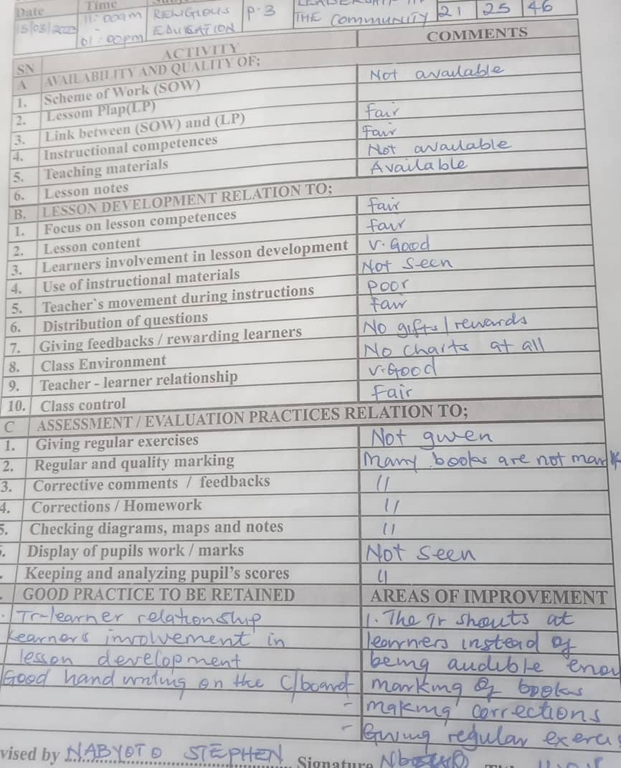
Figure 1 showing a lesson observation tool used in the primary section in one of the participating schools

Gauging from the comments section, it is evident that this teacher has a lot of challenges in preparation for teaching, delivery of the lessons and assessment of learning. The comments reveal that there seems to be a lot of areas that need improvements apart from having a good handwriting on the chalkboard. The method of supervision used in this lesson has been the regular method used to supervise him but it is evident that it has not helped him to improve. Therefore, a friendly supervision approach which would create a supportive relationship would help such a teacher to improve on their performance.

Another supervision sheet was looked at to see if it was any better than the previous one, and the findings were not much different as shown in Figure 2 below.

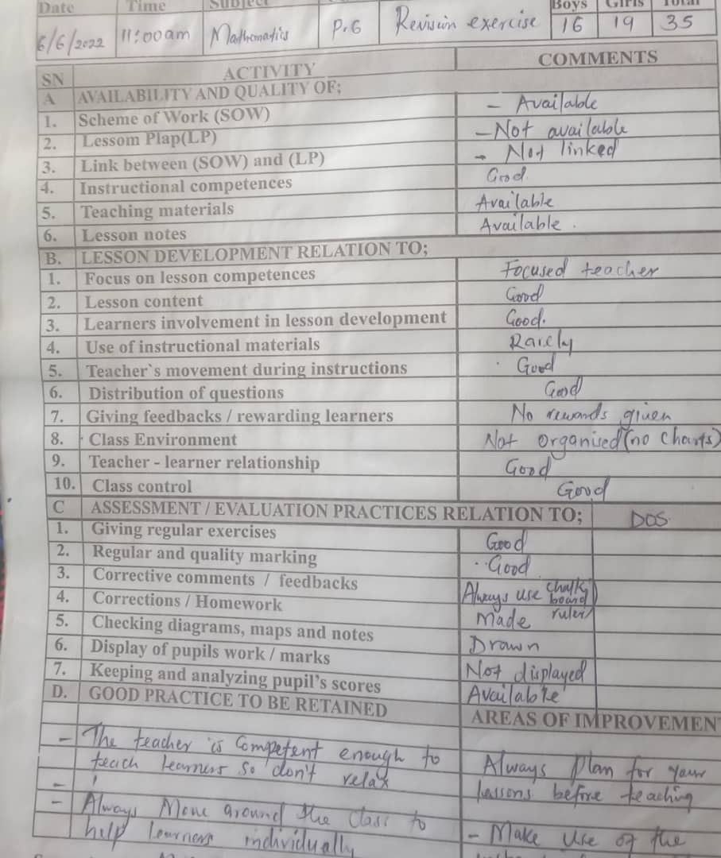
Figure 2 showing a lesson observation tool used in the primary section in one of the participating schools.

It is evident also that the teacher above still has challenges in some areas of planning such as making of lesson plans, linking the scheme with the lesson plans, making and using instructional materials, giving feedback to the learners and managing the classroom environment hence the supervision practices have not helped this teacher to improve.
It is important to note that the supervision documents reviewed were only for the primary section because all the three ECD schools considered for this study had no supervision records and the head teachers were quoted saying;
“I am always with my teachers in class daily., When I see a mistake, I tell them to correct it there and then” (H2)
According to H2, this was justification enough for not keeping records of supervision. As long she is always in class with the teachers and, always corrects them when they make mistakes, there is no need of even having a supervision schedule.

H3 was also quoted saying;
We have not put a lot of emphasis on teacher supervision for ECD., In fact I have entrusted the head of section to oversee what goes on in that section. We are lucky that you have come to supervise them. I will be glad to see what you find out about them.

This statement shows the laxity with which they handle supervision of ECD teachers. While the head teacher has entrusted the head of section to do supervision of ECD teachers, she is not sure whether the head of section is doing the right thing and she saw our coming as a way of gaining information on what actually transpires in that section.

H1 had this to say,

We usually supervise the teachers by checking the learners’ books to see how far they have gone in terms of syllabus coverage. From what we find in the books, we write monthly reports about our findings and encourage them to improve where they are lagging behind.

From such supervision in H1’s school, it is difficult to determine whether such supervision practice brings about effective teacher performance because it does not look at how the teacher prepares for the lesson and deliver the lesson. It only looks at what has been covered without minding whether the learners understood or not which leaves a lot to be desired.

Conclusively, the findings show that although clinical supervision is not used in ECD centers, even the little supervision used if any leaves a lot to be desired. It was largely agreed that if clinical supervision is incorporated into the teacher supervision practices in ECD, it would greatly improve teachers’ ability to plan, prepare, deliver lessons and also be in a better position to guide and counsel learners. All school administrators agreed that they have not used clinical supervision at their schools because they are not conversant with it. However, if trained on how to use it, they would incorporate it into the teacher supervision practices.
Discussion
Findings reveal that all the ECD school administrators that participated in this study were not conversant with clinical supervision. Although they recognized its importance, they lacked sufficient knowledge to effectively implement it. This concurs with what Hamed et al., (2022) noted in their study where they found out that many school administrators had limited understanding of clinical supervision and its purpose in teacher professional development. Some school administrators were un sure of how to provide meaningful feedback to teachers based on their observations hence suggesting that they were ignorant about clinical supervision. Additionally, Aruho Felix et al.,(2025) state that teacher supervision practices in Uganda face challenges such as variation in supervison strategies, limited knowledge of variuos supervison practices, and insuffiecient feedback mechanisms. Therefore, limited knowledge about use of clinical supersion can be a significant barrier to its effective implementation. Although each school administrator employed different methods of supervision, they all acknowledged that their supervision practices had various gaps that limited effective teacher performance, as noted by Kim (2023). Kim (2023) notes gaps like lack of clarity in the expectations of teachers when supervisors fail to provide clear guidance and instruction, teachers not sure of what is expected of them. In addition, Nurdin et al., (2025) note that inadequate supervision and mentoring hinder teacher professional deeveloppment, hhighlighting that effective supervision is crucial for improving teacher quality and students outcomes. Consquently, inadequate supervision and limited feedback in administrative supervision makes teachers feel un supported and failure to recognize teachers’ strengths leads to feelings of being undervalued and demotivated. However, when school administrators understood what clinical supervision is, how it is done and its intention during the study, they appreciated the practice. One administarator asked if they could be trained on how to use it, while others wished to have external supervisors to do it in their ECD centers. This confirms what Kaykc, Ylmaz & Sahin (2017) found out in their study. In addition, in his study, Ozcan, 2023 noted the desire by school administrators to be trained in supervison practices that identify weaknesses and strength, provide guidance and support continuous improvement.
According to Kaykc, Ylmaz & Sahin (2017), education supervisors had positive views on the value of clinical supervision. The majority of administrators underlined the necessity of clinical supervision training for supervisors as well as distinction between supervisory and investigative responsibilities. Hamed et al., (2022) also suggest that more training and support is needed to help school administrators understand the purpose and benefits of clinical supervision and to develop the necessary skills to implement it effectively. This indicates a positive attitude school administrators have towards clinical supervision, and the desire to be trained on how to use it so that they can incorporate it as supervision practice. This is a green light that if implemented, there will be effective teacher performance in ECD centers.

Conclusion
It was revealed that clinical supervision was not known among school administrators. This implies that there were no pre observation meetings before the actual supervision that would be important for the teachers to understand the expectations of the supervisor and therefore, teachers hardly knew the area in which the supervisors were interested in. However, after having an experience of how clinical supervision works and its intention, the school administrators expressed willingness to incorporate it into their supervision practices if they get adequate training on how it is done and how to use it so that they help their teachers to become effective performers in their pedagogical practice. This shows that clinical supervision has been perceived as a valuable tool that could potentially improve teacher pedagogical practices and enhance the quality of education in ECD centers. It also emphasizes the importance of training in order to effectively integrate clinical supervision into the school supervision practice.
Implications
There is need to increase awareness and understanding of clinical supervision in ECD centers by providing the necessary support and resources that can help to promote its adoption and use. This can be done by inspectors of schools and education officers through organizing workshops and trainings for school administrators. Consquently, skills in how to use clinical supervision to bring out effective teacher performance will be acquired. With clinical supervision, teachers’ pedagogical practices are expected to improve. This will improve the overall quality of teacher performance and the quality education system as a whole. It will also pave way for effective and efficient learning for the learners through new learning experiences from clinically supervised teachers.

Disclaimer (Artificial intelligence)

Author(s) hereby declare that NO generative AI technologies such as Large Language Models (ChatGPT, COPILOT, etc.) and text-to-image generators have been used during the writing or editing of this manuscript.

References
Aruho, F.,Nkwasibwe, I., Arishaba, E., Ampumuza, D, S., Kasajja,J.,(2025) Lectures clinical activities during
school practice; Uganda’s context.
Brown, A., Wilson, A., & Jones, B. (2019) Clinical Supervision in Education” Challenges,
Opportunities. Journal of Education Supervision. 5 (2).87-102
Halima, O. Strugala and Monika. (2020) Clinical supervision: A Tool for Professional Learning and Development for in Service Teachers.
Emily, D. (2023): Exploring the Limits of Clinical Supervision in Addressing Trauma- Informed Teaching Practices.
Emily. D (2012); The Role of Professional Development in Enhancing Teachers Preparation for Technology Integration.
Hasan, O., (2023); Supervisory Practices of School Heads : Teachers’ perspectives.
Howard, B. L. (2021). Examining the Impact of Restorative Practices on Supervision Skill Development in Student Affairs. College Student Affairs Journal, Volume 39(2), 136 - 149.
Jones & Johnson. M. (2018). The Impact of Teacher Supervision on Student Outcomes: A Meta
analysis. Educational Psychology Review, 30(40), 879-902
Kamara, P., Otim, J. (2017) An Assessment of Supervision Practices in Early Childhood Education
in Uganda. Journal of Early Childhood Education Research, 6(1).15-28
Kothari, C. R. (2004). Research Methodology Methods and Techniques (2nd Ed.). New Age International Publishers, New Delhi.
Lawrence, N. (2020). Supervision in Education: Healthier Schools for All. Barnardo’s Scotland report on the use of Professional or Reflective Supervision in Education. Barnardos, Scotland.
Malunda, P., Onen, D., Musaazi, J. C. S. & Oonyu, J. (2016). Instructional Supervision and the Pedagogical Practices of Secondary School Teachers in Uganda. Journal of Education and Practice, 7, (30), 177-187.
Marika, E. K., Jagero, N. O., & Gitari, E. M. (2021). The Influence of Teacher Professional Knowledge on Service Delivery in Public Secondary Schools in Kitui County, Kenya. International Journal of Education and Research. 9 (3), 67-76.
Martins, N., and Ledimo, O. (2015). The Perceptions and Nature of Service Delivery Innovation among Government Employees: An Exploratory Study. Journal of Governance and Regulation, 4 (4), 575-580.
Mataiti, H. C. (2008). Clinical Supervisor Characteristics Valued by Practising Speech Language Therapists. Unpublished Master Thesis from the University of Canterbury. New Zealand.
Mohamad. M. Saab & Caroline. K. (2020). Peer Group Clinical Supervision: Qualitative Perspectives from Nurse Supervisees, Managers and Supervisors
Mugenda, O. M., & Mugenda, A. G. (2003). Research methods: Quantitative and qualitative approaches. Africa centre for technology Studies (ACTS) press, Nairobi, Kenya.
Nabunya, K., Mukwenda, H.T., and Kyaligonza, R. (2019). Professional Development Practices and Service Delivery of Academic Staff at Kampala International University and Kyambogo University. Makerere Journal of Higher Education, 10 (2), 133 – 143.
National Council for Curriculum and Assessment. (2022). Preparation for Teaching and Learning - Guidance for All Primary and Special Schools. Dublin, Ireland.
Natchaba, N. (2020). Evaluating the Effectiveness of Clinical Supervision in the Care Coordination Workforce. Unpublished PHD thesis from School of Education St. John Fisher College. New York, USA.
Nurdin., Maria, V, B., Lilim, N., Asep, S., (2025). Improving rural teachers ‘pedagogical competence through peer couching approach: A transformational Approach in Academic Supervision.
Oliver. M & Tichaoma. M. (2021). Clinical Supervision and Teacher Professional Development: An overview of Clinical Supervision and its Importance for Teacher Professional Development.
Paker, O. T., and Yadim, C. U. (1995). Clinical Supervision as in-Service Teacher Development. Çukurova Ünİversİtesİ, Eğİtİm Fakültesİ Dergİsi Cİlt, 1(11), 35-53.
Sekaran, U. (2003) Research Methods for Business: A Skill-Building Approach. 4th Edition, John Wiley & Sons, New York.
Scanlon, D. (1964). Education in Uganda. Education Resource Information Center. U.S.A.
Slowan, G. W. H. (2016). Mental Health as Well Being in Learning and Teaching Environment. Mick Fleming, Hugh Smith.
Sloan G. W. H. (2002). Clinical Supervision Models for Nursing: Structure, Research and Limitations. Nursing Standard, 17 (4), 41-46.
Smith, A. (2020). Enhancing Pedagogical Practices in Early Childhood Education in Uganda.
International Journal of Early Childhood Education, 12 (2), 45 -58
Snowdon, D. A., Leggat, S. G., and Taylor, F. T. (2017). Does Clinical Supervision of Healthcare Professionals Improve Effectiveness of Care and Patient Experience? A Systematic Review. BMC Health Services Research, 1(17), 1-11. DOI: 10.1186/s12913-017-2739-5
Ssekiziyivu, J. S. (2009). Challenges/Dilemmas of Private Secondary School Management and Leadership in Uganda: A Case of Selected Schools in Mukono District. Unpublished master Thesis, School of Religion, Education and Intercultural Studies. Bergen, Norway.
Tuck, J. (2017). A New Approach to Team Clinical Supervision on an Acute Admissions Unit. Mental Health Practice. Mental Health Practice. 20, (5), 24-27.
Udida, L. A., Igbineweka, P. O., & Ekpenyong, D. A. (2015). Repositioning Teachers for Quality Service Delivery in Public. Education for Today, 1(1), 2-6.
Veloo, A., Komuji, M. M. A., and Khalid, R. (2013). The Effects of Clinical Supervision on the Teaching Performance of Secondary School Teachers. Procedia - Social and Behavioral Sciences 93 (1), 35 – 39.

