Original Research Article

Road Elevation Strategy for Vehicular Mobility under Kapila River Flash Flood Risks near Mallanamule Mutt of Nanjangud, India

.
Abstract

Background: NH-766, a critical inter-state corridor in southern Karnataka, experiences recurrent flooding along a 1-km stretch near Mallanamule Mutt due to Kapila River overflows triggered by Kabini Dam releases. This repeated inundation disrupts commuter movement and industrial logistics, underscoring the need for targeted, flood-resilient road infrastructure interventions.
Objective: The study aims to identify low-lying regions along the NH-766 near Mallanamule Mutt and assess the feasibility of raising the land and road surface to mitigate future flash flood impacts.
Methods: Field visits were conducted to document flood conditions and identify the inundated 1-km road stretch through photographic evidence. Additionally, Google Earth Imagery was used to analyze ground conditions and flood extents during flashflood events recorded between 2017 and 2021.
Results: Flooding of 3-5 ft occurred along the road section during Kabini Dam discharges as low as 50,000 cusecs, causing recurrent traffic disruption. Results show that elevating the road by at least 9 ft above observed flood levels along the 1-km stretch between South India Paper Mills Ltd and Mallanamule Mutt is the most cost-effective measure to ensure uninterrupted transport.
Conclusion: Raising the road surface along the vulnerable stretch of NH-766 can significantly reduce future flood-related disruptions and enhance transport resilience. The findings provide a practical basis for policymakers and planners to formulate effective flood management and infrastructure adaptation strategies for sustainable inter-state connectivity.

Keywords: Flashflood; Google Earth; Kapila River; Mallanamule Mutt; Rising Road levels.

1. Introduction

Flash floods constitute one of the most severe and rapidly evolving natural hazards worldwide, producing substantial social, economic, and environmental consequences (FFGS-WMO, 2020). They are characterized by the sudden inundation of low-lying areas, typically occurring within six hours of intense precipitation, and may be triggered by multiple drivers, including extreme rainfall events, sudden dam releases, or accelerated snowmelt (Nicholls et al, 2015). Despite advances in early warning systems and disaster risk reduction strategies, flash floods continue to result in significant human and economic losses. Global mortality associated with flash floods is estimated to exceed 5,000 fatalities annually, underscoring their persistent threat to human safety (FFGS-WMO, 2020). Developing countries in Asia require an estimated annual investment of approximately USD 100 billion equivalent to about 0.36% of GDP to mitigate flood-related risks. Securing these investments necessitates sustained governmental commitment through long-term disaster risk reduction (DRR) strategies integrated into national development planning frameworks (Ishiwatari, 2025). Economically, cumulative flood-related losses amount to billions of dollars each year, adversely affecting local communities as well as regional and national economies (FAO, 2025).
Recent global assessments indicate that reductions in flood-related impacts have remained limited over the past two decades, despite increasing investments in flood mitigation and adaptation measures (Sauer et al, 2024). Vulnerability to flash flooding is particularly pronounced in less-developed regions, where rapid urbanization and socioeconomic development have not kept pace with escalating flood risks (Sauer et al, 2024). Conversely, regions with stronger infrastructure systems, governance frameworks and adaptive capacity demonstrate comparatively lower flood risk, suggesting that targeted investments in infrastructure resilience and institutional capacity can substantially reduce adverse flood impacts (Sauer et al, 2024).
In India, floods remain among the most destructive natural disasters, affecting approximately 5.4 million people in 2020, with comparable large-scale displacements reported again in 2023, particularly in northern states such as Himachal Pradesh and Punjab (NRSC-ISRO, 2023). Flash floods are responsible for an estimated 1,600 fatalities annually, making them one of the deadliest hydro-meteorological hazards in the country (Angelakis et al, 2023). According to the National Disaster Management Authority (NDMA), at least 60 flood-related deaths were reported in northern India during the first half of 2023 along (NRSC-ISRO, 2023). Beyond loss of life, flash floods frequently disrupt transportation networks, causing travel delays, reduced connectivity between economic hubs, and broader impacts on regional economic activity.
Transportation systems are particularly vulnerable to flash flood events, as inundation can severely disrupt the movement of goods, services, and people. Flood-induced damage to roads, bridges, and railways significantly impairs logistics and supply chains, leading to increased fuel consumption, extended travel distances, and higher operational costs (Katopodis et al, 2019; Abegaz et al, 2024). Previous studies indicate that more than 40% of road networks may become inundated or impassable during extreme flash flood events, while over 80% of river crossings, including bridges, are affected (NRSC-ISRO, 2023). Such disruptions result in substantial increases in travel time and congestion, delaying freight movement and economic transactions (Pregnolato et al, 2017).
In urban and metropolitan settings, flooding further exacerbates public transportation inefficiencies by causing service interruptions, routine diversions, and increased headways, thereby prolonging commuter travel times and freight delivery schedules (He et al, 2021). These disruptions impose considerable economic costs, including increased logistics expenditures, production losses, and reduced market accessibility. Flash floods can also interrupt supply chains by restricting access to warehouses, distribution centers, and retail outlets, leading to shortages, delayed deliveries, and price volatility (He et al, 2021). World Bank assessments highlight that flooding reduces transportation network capacity and intensifies congestion, producing cascading effects across local and regional supply chains (He et al, 2021). For small and local businesses, repeated flood disruptions may prevent timely procurement of inputs or delivery of outputs, resulting in income losses and, in extreme cases, business closure. Such impacts extend beyond immediate losses, weakening local economies through reduced employment and economic activity.
Additionally, flash floods often transport debris, sediments, and pollutants, further compromising road safety and hindering post-flood recovery. Accumulated debris on roadways creates hazardous driving conditions and increases the likelihood of traffic accidents (Tetoncountywy.gov. 2025). Contaminated floodwaters may also disrupt potable water supplies, posing public health risks and prolonging recovery processes. Notably, more than half of flash flood-related fatalities occur when individuals attempt to drive through flooded roadways, highlighting the extreme danger posed to vehicles and road users (Gissing et al, 2023). Even shallow flood depths approximately 0.61 m (2 ft) can sweep away most vehicles, including sport utility vehicles, a risk amplified by the sudden onset of flash floods.
Within this broader context, the Kapila River in Karnataka poses a recurring flash flood hazard, particularly along the NH-766 stretch near Mallanamule Mutt, where annual overflow events are frequently reported (Manjunatha & Basavarajappa, 2022). Repeated inundation has caused damage to the historic Mallanamule Mutt temple and disrupted traffic along this critical national highway corridor, necessitating costly repairs, traffic diversions, and extended travel times (He et al, 2021). Such flood-induced mobility disruptions generate cascading effects across local and regional transportation networks. World Bank studies suggest that indirect flood impacts such as prolonged travel delays and increased route distances often outweigh the direct physical damage to infrastructure (Nicholls et al, 2015). In this context, the present study proposes raising road levels along the NH-766 stretch near Mallanamule Mutt as a structural adaptation measure to enhance transportation resilience and ensure continuity of local, industrial, and regional vehicular movement during future extreme flash flood events.

  - Nanjangud Industrial Area
Nanjangud, located in the Mysuru district of Karnataka, has evolved into a prominent industrial hub over recent decades (Naseeba, 2024). Its industrial development reflects a blend of historical context, strategic planning, and economic growth. The town’s industrialization began in 1978 with the establishment of Sujata Textile Mills, marking a transition from its traditional identity centered on cultural heritage, notably the Sri Kanteshwara Temple (Manjunatha & Basavarajappa, 2022). The Nanjangud industrial area spans approximately 534 acres (2.16 km²) and accommodates a diversified industrial base comprising 36 large, 12 medium, and 35 small-scale industries (Manjunatha & Basavarajappa, 2021; 2022).
The industrial cluster significantly contributes to the local economy through large-scale employment generation and improved living standards. Nanjangud ranks as Karnataka’s second-highest tax-paying taluk, generating annual sales tax revenues of about ₹400 crores, largely driven by industrial activity (Manjunatha & Basavarajappa, 2022). Industrial expansion has also strengthened local infrastructure, including transport, utilities, and public services, while stimulating ancillary industries and broader economic resilience (Kaiser & Barstow, 2022). Ongoing initiatives, such as proposed industrial corridors, aim to enhance connectivity, attract investment, and promote sustainable industrial growth by leveraging existing resources and infrastructure.

2. methodology

Google Earth Pro imagery was integrated with field photographs captured during the 2019 flash flood to accurately represent ground conditions and inundation patterns (Vahid et al, 2016). Field observations identified low-lying zones along the meandering perennial Kapila River and delineated a flood-prone1-km stretch of NH-766 near Mallanamule Mutt, where elevated water levels recur during high-discharge events (Manjunatha & Basavarajappa, 2022). Repeated field visits and systematic photographic documentation were conducted to assess flood impacts on road infrastructure and adjacent structures. Figure 2 synthesizes these observations, illustrating inundation extend and associated on-ground damage. The A-B elevation profile of figure 3 was extracted from Google Earth Pro which coincides with mapped floodplain extents, explaining recurrent overtopping during high-discharge events. This figure 3 also integrates spatial inundation extent, floodplain interaction, and road elevation variability, providing a robust basis for identifying critical intervention zones.

3. results
  - Traffic Diversions during Flashflood Events

In 2018, a 1-km stretch of NH-766 near Mallanamule Mutt was closed to traffic after the swollen Kapila River overtopped the roadway with water depths exceeding 3 ft (Manjunatha & Basavarajappa, 2022). Intense rainfall in Kerala’s Wayanad district during the southwest monsoon (8–10 August 2019) led to substantial inflows into Karnataka’s Kabini Dam (Table 1). Consequently, during the 2019 monsoon, excess discharge from the dam—reaching 80,000 cusecs for the third time—caused the Kapila River to overflow, triggering a flash flood on 9 August 2019 (Manjunatha & Basavarajappa, 2022). This event submerged a critical section of the Mysuru–Nanjangud corridor (NH-766) between Mallanamule Mutt and the South India Paper Mill at Thandavapura for three days (9–11 August 2019).
During this period, water depths of approximately 3–5 ft along the 1-km stretch near Mallanamule Mutt rendered the road impassable, forcing authorities to suspend all vehicular movement (Manjunatha & Basavarajappa, 2022). Traffic was diverted through alternative routes via K.S. Hundi, Himmavu, Basavanapura, Kanakanagara, Kallahalli, Maralur, and Thandavapura, while longer detours through the Kadakola industrial area were used to maintain connectivity to Nanjangud and onward routes to Kerala and Tamil Nadu. A similar disruption occurred in July 2024, when heavy outflows from the Kabini reservoir again inundated the same low-lying highway section near Mallanamule Mutt, with floodwaters exceeding 4 ft in depth and severely affecting traffic flow during the monsoon season.

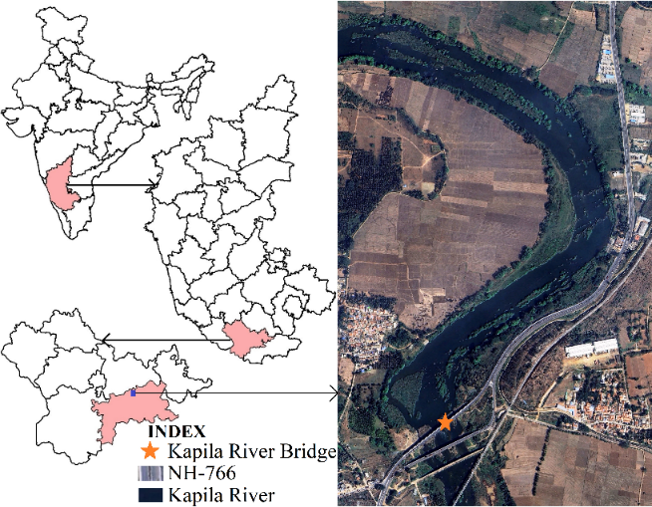
Fig.1. Location and Google Earth Image of the study area

Table 1. Total Cusecs of Water released to Kapila River from Kabini Dam of H.D Kote taluk in various flood like events

Year | Date & Month | Total Cusecs of Water released | Remark
2025 | 28th July | 48,000 | --
 | 27th July | 45,000 | --
 | 19th July | 25,000 | --
 | 17th July | 20,000 | --
2024 | 1st August | 50,000 | Traffic diverted
 | 31st July | 50,000 | Traffic diverted
 | 30th July | 80,000 | Traffic diverted
 | 18th July | 70,000 | Traffic diverted
 | 17th July | 50,000 | Traffic diverted
 | 16th July | 25,000 | --
 | 15th July | 30,000 | --
 | 14th July | 20,000 | --
 | 13th July | 20,000 | --
 | 11th Feb | 13,000 | --
2020 | 9th August | -- | Traffic diverted
 | 8th August | 88,000 | Traffic diverted
 | 7th August | 70,600 | Traffic diverted
 | 6th August | 35,000 | --
 | 5th August | 50,000 | --
 | 4th August | 50,000 | --
 | 3rd August | 16,000 | --
2019 | 10th August | 1.3 Lakh | Traffic diverted
 | 8th August | 60,000 | Traffic diverted
 | 7th August | 90,000 | Traffic diverted
2018 | 13th December | 80,000 | Traffic diverted
 | 16th November | 80,000 | Traffic diverted
 | 15th August | 70,000 | Traffic diverted
 | 10th August | 80,000 | Traffic diverted
 | 9th August | 71,100 | Traffic diverted
 | 16th July | 35,000 | --
 | 14th July | 35,000 | --
 | 12th July | 55,000 | Traffic diverted
 | 16th June | 35,000 | --
 | 15th June | 36,000 | --
2013 | 4th July | 50,000 | --
 | 3rd July | 15,000 | --
 | 29th June | 50,000 | --
 | 28th June | 40,000 | --
 | 25th June | 10,000 | --
 | 4th February | 55,000 | --
2012 | 15th May | 70,000 | Traffic diverted
2009 | -- | 68,000 | --
2002 | 17th July | 10,000 | --
1992 | -- | 70,200 | --

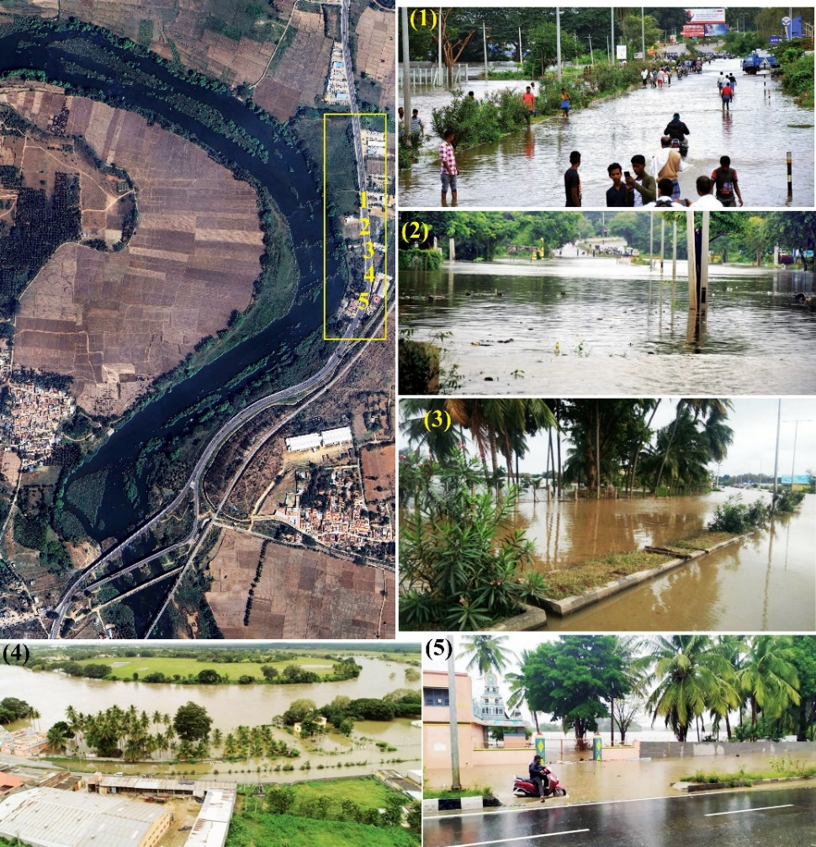
Fig.2. Kapila River Flashflood event during 2019 near Mallanamule Mutt of Nanjangud

  - Disruption of Supply Chains

Prolonged highway closures exceeding three days severely restrict access to industrial zones, disrupting the timely delivery of raw materials and components and causing operational delays (Rahman et al., 2017). Flooded road conditions also create hazardous driving environments, significantly increasing accident risk (Gissing et al., 2023). Many industries rely on just-in-time (JIT) inventory systems to minimize storage costs; consequently, supply interruptions can lead to immediate material shortages, halted production lines, and financial losses due to idle resources (Spieske et al., 2022).
Traffic diversions further exacerbate disruptions by extending travel distances and delivery times, complicating logistics planning and reducing inventory management efficiency. Rerouting shipments increases transportation costs as carriers account for additional distance, time, fuel consumption, vehicle wear, and driver overtime. These rising operational costs place pressure on profit margins and may result in industrial downtime when critical inputs are unavailable (Khedr & Rani, 2024). Beyond individual firms, delayed supplies can trigger cascading effects across supply chains, affecting suppliers and downstream businesses and generating wider regional economic impacts (Guo et al., 2024). Prolonged disruptions may also undermine firms’ ability to meet customer demand, increasing the risk of lost market share to competitors with more resilient supply chains (Huo et al., 2024).

  - Emergency Response Challenges

Heavy rainfall coupled with releases from the Kabini Dam has intensified flooding, resulting in substantial disruptions to transportation networks and local infrastructure. Flooding is typically triggered when reservoir outflows exceed 50,000 cusecs, a threshold that has been surpassed in recent monsoon seasons, with discharges reaching approximately 70,000 cusecs (Manjunatha & Basavarajappa, 2022). Traffic diversions during such events impede emergency response operations, delaying rescue efforts and restricting the safe evacuation of affected populations. Inadequate public awareness and preparedness further constrain effective disaster response, both during and after flood events (Torani et al., 2019). These challenges underscore the need for strengthened flood preparedness and early warning strategies that enable scenario prediction and proactive risk mitigation.

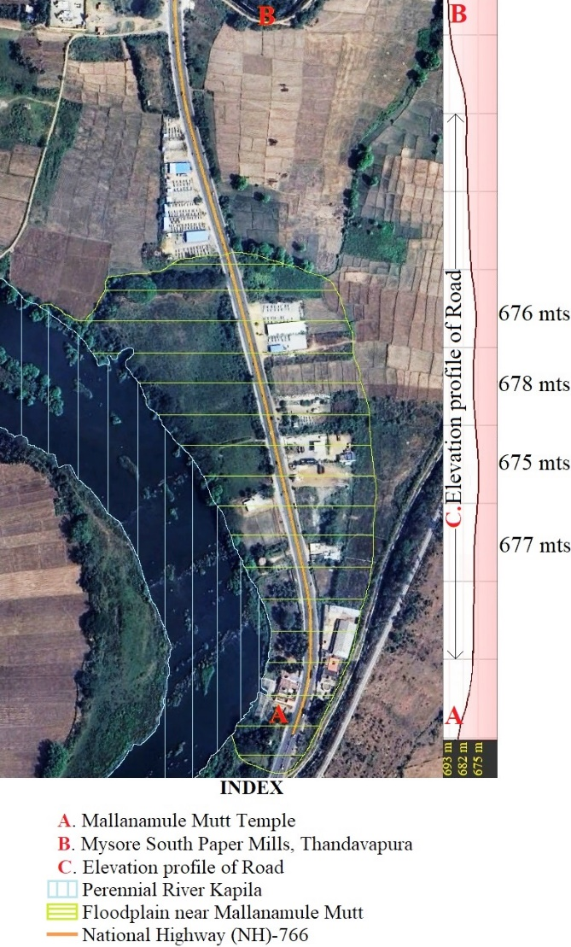
Fig.3. Google Earth map depicting the floodplains and Elevated profile of Road

4. Discussion

The recurrent flash floods of the Kapila River at Mallanamule Mutt highlight the urgent need for strengthened flood management measures, timely risk communication by authorities, and enhanced community awareness programs (Owusu et al, 2021; Manjunatha & Basavarajappa, 2022). Addressing these gaps is essential to minimize the impacts of future flood events and to ensure effective emergency response mechanisms. Nanjangud’s transformation into a major industrial hub reflects the interplay of historical significance and contemporary economic policies, and with its established industrial base and ongoing development initiatives, the town remains pivotal to Karnataka’s economic growth (Naseeba, 2024). However, the highway becomes highly vulnerable whenever Kabini reservoir outflows exceed 50,000 cusecs, repeatedly triggering flood conditions along NH-766 (Manjunatha & Basavarajappa, 2022).
These flash floods pose substantial challenges to Nanjangud’s industrial sector through transportation disruptions, increased operational costs, and potential long-term economic losses (welch et al., 2022). During the 2019 monsoon, Nanjangud ranked among Karnataka’s most flood-prone taluks, with additional inflows from the Nugu and Taraka dams in H.D Kote exacerbating flood severity (Manjunatha & Basavarajappa, 2022). Flash floods significantly hinder vehicular movement, elevate safety risks, and disrupt regional transportation networks (Borowska-Stefańska & Wiśniewski, 2022). The traffic diversion at Mallanamule Mutt along the Mysuru–Nanjangud Highway (NH-766) is particularly critical, as this corridor connects Mysuru, Ooty, Gundlupet–Kerala, and Chamarajanagar–Tamil Nadu (Manjunatha & Basavarajappa, 2022).
This 1-km highway stretch and several low-lying areas of Nanjangud town are repeatedly inundated during high dam outflows, leading to road closures, prolonged detours, and increased travel time and costs for inter-state commuters and freight services (Manjunatha & Basavarajappa, 2022; Pan et al., 2013). Flooding has also adversely affected local commerce and tourism in this temple town, restricting access to heritage sites and reducing visitor inflows, with consequent economic losses from delayed goods movement and rising operational expenses (Li & Song, 2013). Moreover, repeated flash floods have damaged historical structures such as the Mallanamule Mutt temple, as well as roads and ancillary infrastructure, necessitating frequent repairs and disrupting local livelihoods (Manjunatha & Basavarajappa, 2022).
These recurring impacts underscore the importance of robust flood mitigation and contingency planning to enhance the resilience of transportation infrastructure in flood-prone areas. Structural interventions, such as raising the road surface by at least 9 ft along the 1.2-km stretch between south India paper mills and the Kapila river bridge, could provide a long-term solution to recurring inundation and associated disruptions.

5. Conclusion

A three-day blockade caused by flash floods can severely disrupt the supply of goods to industrial zones by increasing travel times and transportation costs, heightening safety risks, triggering inventory shortages, and causing production downtime, thereby undermining economic stability and generating wider regional impacts. In Nanjangud, flash flooding of the Kapila river has repeatedly affected transportation networks, local infrastructure, and community safety. Using the 2019 flash flood as a benchmark, raising the road elevation by approximately 9 ft above observed flood levels would significantly improve vehicular mobility and ensure the timely movement of goods and industrial inputs, thereby enhancing overall transport resilience.

6. Limitations
The proposed road elevation strategy has several limitations. Reliance on the 2019 flash flood as a benchmark may not fully capture future extremes under climate change. While elevation enhances mobility along the affected stretch, it does not address upstream hydrological controls such as dam release operations. Localized elevation may also alter drainage and increase flood risk in adjacent low-lying areas if not supported by adequate cross-drainage measures. Furthermore, indirect economic losses, long-term maintenance costs, and potential social and environmental impacts were not explicitly assessed and warrant further investigation.

Disclaimer (Artificial intelligence)

Author(s) hereby declare that NO generative AI technologies such as Large Language Models (ChatGPT, COPILOT, etc.) and text-to-image generators have been used during the writing or editing of this manuscript.

References

- FFGS-WMO (2020). Flash Flood Guidance System: Response to one of the deadliest hazards. World Meteorological Organization. https://wmo.int/media/magazine-article/flash-flood-guidance-system-response-one-of-deadliest-hazards.
- Fao, 2025. Fao.org https://openknowledge.fao.org/server/api/core/bitstreams/0f03a24f-8d37-4700-aef4-fc436ff32021/content
- Sauer, I.J., Mester, B., Frieler, K. et al. Limited progress in global reduction of vulnerability to flood impacts over the past two decades. Commun Earth Environ 5, 239 (2024). https://doi.org/10.1038/s43247-024-01401-y
- Angelakis AN, Capodaglio AG, Valipour M, Krasilnikoff J, Ahmed AT, Mandi L, Tzanakakis VA, Baba A, Kumar R, Zheng X, et al. Evolution of Floods: From Ancient Times to the Present Times (ca 7600 BC to the Present) and the Future. Land. 2023; 12(6):1211. https://doi.org/10.3390/land12061211
- NRSC-ISRO, 2023. Flood Affected Area Atlas of India (1998-2022)- Satellite based study, Version-1, Department of Space, Govt. of India. https://www.nrsc.gov.in/sites/default/files/pdf/DMSP/FloodAffectedAreaAtlas_Digital.pdf
- Katopodis T, Sfetsos A. A Review of Climate Change Impacts to Oil Sector Critical Services and Suggested Recommendations for Industry Uptake. Infrastructures. 2019; 4(4):74. https://doi.org/10.3390/infrastructures4040074
- Abegaz, R., Xu, J., Wang, F., & Huang, J. (2024). Impact of flooding events on buried infrastructures: a review. Frontiers in Built Environment, 10. https://doi:10.3389/fbuil.2024.1357741
- Pregnolato, M., Ford, A., Wilkinson, S. M., & Dawson, R. J. (2017). The impact of flooding on road transport: A depth-disruption function. Transportation Research. Part D, Transport and Environment, 55, 67–81. https://doi:10.1016/j.trd.2017.06.020
- He, Y., Thies, S., Avner, P., & Rentschler, J. (2021). Flood impacts on urban transit and accessibility—A case study of Kinshasa. Transportation Research. Part D, Transport and Environment, 96(102889), 102889. https://doi:10.1016/j.trd.2021.102889
- Tetoncountywy.gov 2025. Impacts of a flash flood. https://www.tetoncountywy.gov/412/Impacts-of-a-Flash-Flood
- Gissing, A., Hamilton, K., Smith, G., & Peden, A. E. (2023). Vehicle-related causes of flood fatalities. In Oxford Research Encyclopedia of Natural Hazard Science. Oxford University Press. https://doi.org/10.1093/acrefore/9780199389407.013.438
- Manjunatha, M. C., & Basavarajappa, H. T. (2022). 2019-Flashflood impacts of Kapila River on Temple Town of Nanjangud, Karnataka, India. International Advanced Research Journal in Science, Engineering and Technology. 9(7): 359-368. https://doi.org/10.17148/iarjset.2022.9761
- Nicholls, R., Zanuttigh, B., Vanderlinden, J. P., Weisse, R., Silva, R., Hanson, S., … Koundouri, P. (2015). Developing a holistic approach to assessing and managing coastal flood risk. In Coastal Risk Management in a Changing Climate (pp. 9–53). Elsevier. https://doi.org/10.1016/B978-0-12-397310-8.00002-6
- Naseeba, U. (2024). Study of Urban Development in Nanjangud City, Mysuru district, Karnataka, India. Geo-Eye. 13(1): 27-29. https://doi.org/10.53989/bu.ge.v13i1.naseeba
- Venkataramana, G. V., & Sandhya Rani, P. N. (2023). Heavy Metal Concentrations in Certain Edible Freshwater Fishes and Sediments from Kapila River in Mysore District, Karnataka. Shanlax International Journal of Arts Science and Humanities, 10(4): 29–38. https://doi.org/10.34293/sijash.v10i4.6132
- Kaiser, N., & Barstow, C. K. (2022). Rural Transportation Infrastructure in Low- and Middle-Income Countries: A Review of Impacts, Implications, and Interventions. Sustainability, 14(4), 2149. https://doi.org/10.3390/su14042149
- Manjunatha, M. C., & Basavarajappa, H. T. (2021). Land classification analysis using geospatial approach in Nanjangud taluk of Karnataka State, India. International Advanced Research Journal in Science, Engineering and Technology. 8(6): 629-638. https://doi.org/10.17148/iarjset.2021.86108
- Vahid Sharifi, Srikantaswamy. S., Manjunatha, M. C., & Basavarajappa, H. T. (2016). Delineation of Groundwater Potential Zones in Mysuru district, Karnataka, India using Geoinformatics technique. Journal of International Academic Research for Multidisciplinary. 4(2): 315-328. https://www.researchgate.net/publication/299645586_delineation_of_groundwater_potential_zones_in_mysuru_district_karnataka_india_using_geoinformatics_technique
- Rahman, M. M., Yap, Y. H., Ramli, N. R., Dullah, M. A., & Shamsuddin, M. S. W. (2017). Causes of shortage and delay in material supply: a preliminary study. IOP Conference Series. Materials Science and Engineering, 271, 012037. https://doi.org/10.1088/1757-899x/271/1/012037
- Spieske, A., Gebhardt, M., Kopyto, M., & Birkel, H. (2022). Improving resilience of the healthcare supply chain in a pandemic: Evidence from Europe during the COVID-19 crisis. Journal of Purchasing and Supply Management, 28(5), 100748. https://doi.org/10.1016/j.pursup.2022.100748
- Khedr, A. M., & Rani, S. (2024). Enhancing supply chain management with deep learning and machine learning techniques: A review. Journal of Open Innovation Technology Market and Complexity, 10(4), 100379. https://doi.org/10.1016/j.joitmc.2024.100379
- Guo, Y., Liu, F., Song, J.-S., & Wang, S. (2024). Supply chain resilience: A review from the inventory management perspective. Fundamental Research. https://doi.org/10.1016/j.fmre.2024.08.002
- Huo, B., Li, D., & Gu, M. (2024). The impact of supply chain resilience on customer satisfaction and financial performance: A combination of contingency and configuration approaches. Journal of Management Science and Engineering, 9(1), 38–52. https://doi.org/10.1016/j.jmse.2023.10.002
- Torani, S., Majd, P. M., Maroufi, S. S., Dowlati, M., & Sheikhi, R. A. (2019). The importance of education on disasters and emergencies: A review article. Journal of Education and Health Promotion, 8(1), 85. https://doi.org/10.4103/jehp.jehp_262_18
- Welch, K., Lambert, L. H., Lambert, D. M., & Kenkel, P. (2022). Flood-induced disruption of an inland waterway transportation system and regional economic impacts. Water, 14(5), 753. https://doi.org/10.3390/w14050753
- Pan, J., Popa, I. S., Zeitouni, K., & Borcea, C. (2013). Proactive vehicular traffic rerouting for lower travel time. IEEE Transactions on Vehicular Technology, 62(8), 3551–3568. https://doi.org/10.1109/tvt.2013.2260422
- Li, S., & Song, H. (2013). Economic impacts of visa restrictions on tourism: A case of two events in China. Annals of Tourism Research, 43, 251–271. https://doi.org/10.1016/j.annals.2013.07.007
- Owusu, E., Antwi, J., & Kendie, S. B. (2021). Disaster risk management: The exercise of power, legitimacy and urgency in stakeholder role in Ghana. International Journal of Environment and Climate Change, 17–33. https://doi:10.9734/ijecc/2021/v11i730436
- Ishiwatari, M. (2025). Disaster risk reduction. In Handbook of Climate Change Mitigation and Adaptation (pp. 3679–3705). Cham: Springer Nature Switzerland.

