Helicobacter pylori Seroprevalence among Hostel-Resident Students of Rivers State University, Nigeria.

ABSTRACT
Helicobacter pylori is a Gram-negative bacterium implicated in chronic gastritis, peptic ulcer disease, and gastric malignancies. This study evaluated the seroprevalence of H. pylori infection and associated risk factors among students of Rivers State University, Port Harcourt. A total of 100 students were randomly recruited for the study. Whole blood samples were collected and screened using a rapid H. pylori antibody test kit, while socio-demographic characteristics and potential risk factors were obtained using structured questionnaires. The overall seroprevalence of H. pylori infection was 54%. A slightly higher prevalence was observed among females (56.36%) compared to males (51.11%); however, this difference was not statistically significant (p > 0.05). Chi-square analysis further revealed no significant association between H. pylori seropositivity and gender or age (p > 0.05). Although infection was most frequent among students aged 16–20 years, H. pylori was broadly distributed across all demographic categories, suggesting relatively uniform exposure within the study population. These findings highlight the need for improved hygiene practices, sanitation, and targeted awareness programs, particularly within university hostel environments, to reduce H. pylori transmission. In conclusion, the high seroprevalence indicates that H. pylori infection remains a significant public health concern among university students, warranting proactive preventive and educational interventions.

Keywords: Helicobacter pylori, Seroprevalence, Peptic ulcer, Rapid antibody test

INTRODUCTION
The discovery of Helicobacter pylori (H. pylori) as the causative organism of chronic gastritis and peptic ulcer disease marked a major turning point in gastroenterology. Although the bacterium was first reported in 1983 in gastric biopsy specimens from patients with gastritis and peptic ulcer disease, recent scientific advances have further clarified its epidemiology, pathogenic mechanisms, and clinical management (Elbehiry et al., 2023). Helicobacter pylori is a Gram-negative, microaerophilic bacterium that colonizes the human gastric mucosa and represents one of the most prevalent chronic infections worldwide. Recent global analyses estimate that approximately 43.9% of the world’s population is currently infected, reflecting a gradual decline over recent decades but still constituting a significant public health concern (Chen et al., 2024). Among children and adolescents, a comprehensive meta-analysis reported a pooled prevalence of approximately 32.3%, with higher rates in low- and middle-income settings and older age groups (Yuan et al., 2022). H. pylori is a well-established etiological agent of chronic gastritis, peptic ulcer disease, gastric adenocarcinoma, and gastric mucosa-associated lymphoid tissue (MALT) lymphoma. The pathogenicity of Helicobacter pylori is largely determined by a suite of virulence factors that enable persistent colonization of the harsh gastric environment and promote mucosal damage. A key factor is urease, which hydrolyzes urea to produce ammonia, thereby neutralizing gastric acid and facilitating bacterial survival. Flagella-mediated motility allows the bacterium to navigate the gastric mucus layer, while adhesins such as BabA and SabA promote attachment to gastric epithelial cells (Cambridge et al., 2023). Of particular clinical significance are the cytotoxin-associated gene A (cagA) and vacuolating cytotoxin A (vacA). Strains carrying cagA are associated with heightened inflammatory responses and an increased risk of peptic ulcer disease and gastric cancer, whereas vacA induces epithelial cell injury, apoptosis, and modulation of host immunity (Cambridge et al., 2023). Recent studies have also highlighted the contribution of biofilm formation and immune evasion strategies to the persistence of chronic infection and resistance to antimicrobial therapy (Gut Pathogens, 2025). The mode of transmission of H. pylori continues to be investigated; however, current evidence strongly supports person-to-person spread, particularly within households. Oro-oral and fecal-oral routes are considered the most plausible pathways, especially in settings characterized by poor sanitation and limited access to safe drinking water. Family clustering is frequently reported, with infected mothers and siblings acting as significant reservoirs of infection. Since H. pylori infection is typically acquired during childhood, variations in prevalence across populations are closely linked to early-life living conditions. Recent studies consistently identify low socioeconomic status, overcrowded housing, inadequate sanitation, unsafe water supply, low maternal education, and poor hygiene practices as major risk factors for infection. These findings underscore the central role of environmental and social determinants in shaping infection patterns globally (Yuan et al., 2022). The prevalence of H. pylori infection remains substantially higher in developing countries compared with developed regions. Recent global analyses indicate that while infection rates have declined worldwide, prevalence often exceeds 50% in low- and middle-income countries, compared with approximately 35% in high-income settings. This disparity has been attributed to differences in sanitation infrastructure, population density, access to clean water, and early-life environmental exposures. Improvements in hygiene and living standards have been closely associated with the marked decline in H. pylori prevalence observed in developed nations over the past three decades (Chen et al., 2024). In Nigeria, H. pylori infection remains highly prevalent. A recent synthesis of studies conducted between 2010 and 2023 reported national prevalence estimates ranging from 20% to 80%, with most studies documenting rates above 50%, particularly among adults presenting with dyspeptic symptoms (Ndukwu et al., 2024). These findings emphasize the ongoing public health challenge posed by H. pylori in Nigeria. The management of H. pylori infection relies primarily on antimicrobial eradication therapy. Current treatment guidelines recommend combination regimens, most commonly proton pump inhibitor (PPI)-based triple therapy or bismuth-containing quadruple therapy. However, the effectiveness of standard triple therapy has declined in many regions due to rising resistance to commonly used antibiotics such as clarithromycin, metronidazole, and levofloxacin. Recent studies emphasize the need for region-specific treatment strategies, antibiotic susceptibility testing, and adherence to optimized regimens to improve eradication rates. The growing challenge of antimicrobial resistance has renewed interest in alternative therapies, including sequential and concomitant regimens, as well as adjunctive use of probiotics (Ndubuisi et al., 2025). Diagnostic approaches for Helicobacter pylori infection are broadly classified into invasive and non-invasive methods. Invasive techniques — including culture, histology, rapid urease testing, and polymerase chain reaction (PCR) — require upper gastrointestinal endoscopy with gastric biopsy and provide direct assessment of the mucosa, offering high diagnostic accuracy but limited utility due to cost, technical demands, and patient discomfort (Fontenot & Barber, 2024). Non-invasive methods include the urea breath test (UBT), stool antigen tests, and serological assays; these are easier to perform and better suited for epidemiological screening (Fontenot & Barber, 2024). Serological testing detects H. pylori-specific antibodies and is particularly useful for large-scale epidemiological surveys, although it cannot reliably distinguish active from past infection (Fontenot & Barber, 2024). The choice of diagnostic modality is influenced by the clinical context, resource availability, and study objectives, with some settings recommending combinations of non-invasive tests to improve accuracy (Ekesiobi et al., 2022). Previous studies on H. pylori seroprevalence have largely focused on children or symptomatic adult populations. However, recent evidence from Nigeria indicates that seroprevalence among asymptomatic individuals remains substantial. For instance, a 2024 survey in urban communities of Port Harcourt reported a seroprevalence of 34.6% among adults (Ndukwu et al., 2024), while a community-based study in a semi-urban setting documented a prevalence of 26.0% among apparently healthy residents (Ndubuisi et al., 2025). These findings suggest the existence of a significant reservoir of silent or subclinical infection. In view of the increasing incidence of gastritis and peptic ulcer disease in Nigeria and the established role of H. pylori in gastroduodenal pathology, it is timely to reassess its seroprevalence among asymptomatic adults. Accordingly, this study aims to determine the seroprevalence of H. pylori infection and associated risk factors among asymptomatic adult individuals, using students of Rivers State University as a representative cohort. The findings are expected to provide baseline data to inform future large-scale population studies across different age, sex, and socioeconomic groups.

MATERIALS AND METHODS
Study Area
The study was carried out at the Rivers State University, Port Harcourt.

Study Population
The study population comprised students of Rivers State University, Port Harcourt.

Study Design
This study was a case series study.

Sample Size Determination
To determine the minimum sample size of the subjects recruited in the study, the prevalence of H. pylori in Nigeria as reported by the Statistics published by Smith et al., 2022, which revealed a prevalence of 87.7% was used to calculate the minimum sample size as follows.
Using the formula:
n = $\frac{Zα^{2}pq}{d^{2}}$ (Naing et al. 2006)
Where n= Minimum sample size
Z = Standard normal deviation corresponding to 95% confidence level set at 1.96
p =87.7% = 0.877
q = 1-p = 0.123
d = desired precision, 5% (0.05)
So, n = $\frac{1.96 (0.877X 0.123)}{0.0025}$ = 84.5= 85
Therefore, the minimum sample size is 85. However, an additional fifteen subjects were recruited. Thus, one hundred (100) samples were collected for this study.

Ethical Considerations
The permission for this study and approval was received from the ethical committee of Rivers State University, Port Harcourt. The participants of this study gave full consent and agreement to the study without any form of coercion or pressure.

Eligibility of Subjects
Inclusion Criteria
Only students of Rivers State University who provided informed oral consent were eligible to participate in the study.

Exclusion Criteria
Individuals who declined to provide informed consent, those who had taken triple antibiotic therapy previously as well as persons who were not currently enrolled as students of the Rivers State University were excluded from the study. This in in accordance with the international ethical standards for human-subject research; which states that only participants who voluntarily provide informed consent should be enrolled; refusal to consent disqualifies them from the study (World Medical Association, 2024). Selection of participants must also ensure a clearly defined source population and eligibility criteria, consistent with accepted practices for inclusion/exclusion in observational research (Nikolopoulou, 2022).

Sample Collection and Processing
A volume of 5 mL of blood was aseptically obtained from each participant via venipuncture of the cubital vein using sterile, disposable Vacutainer needles and collection tubes. Blood samples were transferred into ethylenediaminetetraacetic acid (EDTA) tubes and mixed thoroughly to prevent clotting.
For the detection of Helicobacter pylori antibodies, whole blood samples were analyzed using a commercially available H. pylori Antibody Test Cassette, following the manufacturer’s protocol. Before testing, the cassettes were removed from their foil packaging and placed on a clean, level surface. Blood samples were gently mixed, and two drops were applied to the specimen well of the test cassette. Test results were interpreted after 10–15 minutes, according to the manufacturer’s instructions.

Data Analysis
Data generated from this study were expressed as mean ± standard deviation (SD) where appropriate. Comparative analyses were performed using an unpaired t-test, chi square to compare percentages and two-tailed p-values were calculated. All statistical analyses were conducted using GraphPad Prism, version 9.4.1. A p-value of less than 0.05 was considered statistically significant, corresponding to a 95% confidence interval.

RESULTS
Study Population Characteristics
A total of 100 undergraduate students of Rivers State University, Port Harcourt, were enrolled in this study, comprising 45 males (45%) and 55 females (55%). Participants were aged between 17 and 23 years, with a mean age of 20 ± 2.16 years. All participants were asymptomatic at the time of sampling (Table 1).

Table 1: Socio-Demographic Characteristics

Characteristics of the Population | Number of Participants (%)
Gender
Male | 45
Female | 55
Age
17 | 21
18 | 16
19 | 29
20 | 18
21 | 7
22 | 5
23 | 4
Mean age = 20 ± 2.16
Previous H. Pylori Infection | 12
Family History of H. Pylori Infection | 25
Previous Treatment for H. Pylori | 15
Alcohol Consumers | 38
Cigarette Smokers | 4
Those That Consume Food from Vendors | 57
History of Ulcer | 59
Pepper Consumers | 67
Those that Drink Filtered or Boiled Water | 43

Overall Seroprevalence of Helicobacter pylori
Serological screening revealed that 54 out of 100 participants were positive for H. pylori antibodies, resulting in an overall seroprevalence of 54%. Forty-six participants (46%) tested negative (Table 2).

Table 2: Prevalence of H. Pylori Among Study Population
Location | Number Examined | Positive n (%) | Negative n (%)
RSU | 100 | 54 (54%) | 46 (46%)

Gender-Based Distribution of H. pylori Infection
Among male participants, 23 of 45 (51.11%) were seropositive, while 31 of 55 female participants (56.36%) tested positive for H. pylori antibodies (Table 3, Figure 1). A chi-square test of independence showed no statistically significant association between gender and H. pylori seropositivity (χ² = 0.27, df = 1, p = 0.6044). This indicates that the distribution of infection was comparable between male and female students.

Table 3: Gender-Based Prevalence
Gender | Number Examined | Number Positive (%) | P-Value | Remark
Male | 45 | 23 (51.11) | 0.6044 | Not Significant
Female | 55 | 31 (56.36)
Total | 100 | 54

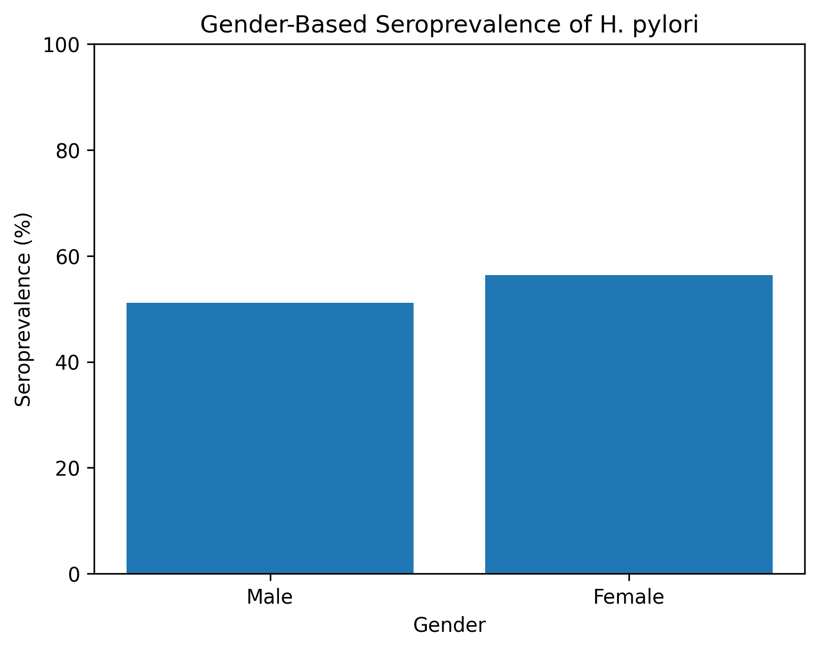
Figure 1: Gender-based seroprevalence of Helicobacter pylori infection among Rivers State University students. No statistically significant difference was observed between males and females (χ² = 0.27, p = 0.6044).
Age-Based Distribution of H. pylori Infection
Participants were categorized into two age groups for statistical analysis: 16–20 years and 21–25 years. Among students aged 16–20 years, 47 out of 84 (55.95%) were seropositive, whereas 7 out of 16 students (43.75%) aged 21–25 years tested positive (Table 4, Figure 2). Chi-square analysis demonstrated no statistically significant association between age group and H. pylori infection (χ² = 0.58, df = 1, p = 0.45), despite a higher proportion of positive cases observed in the younger age group.

Table 4: Age-Based Prevalence
Age (Years) | Number Examined | Number Positive (%) | P-Value | Remark
16-20 | 84 | 47 (55.95) | 0.45 | Not Significant
21-25 | 16 | 7 (43.75)
Total | 100 | 54

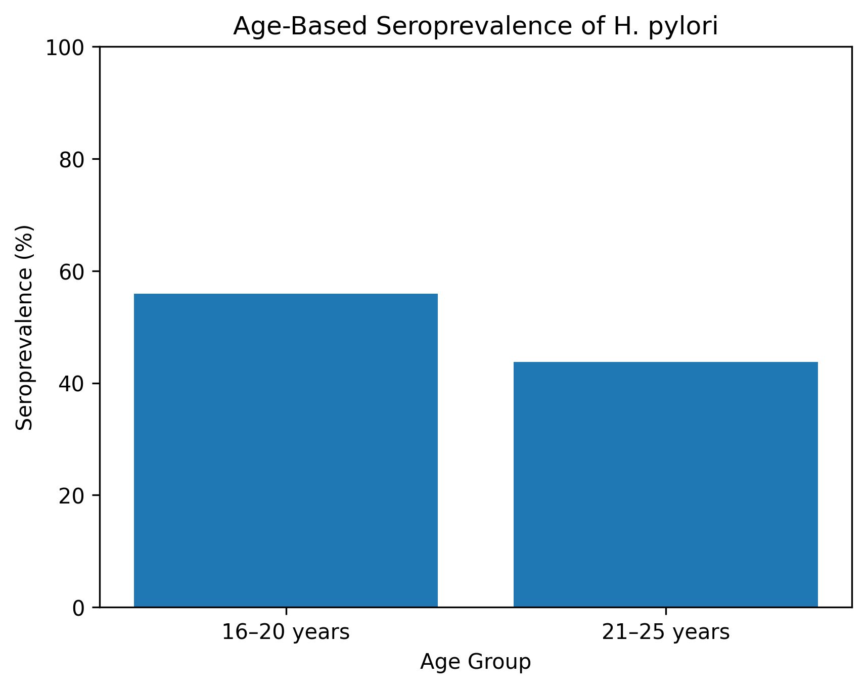
Figure 2: Age-based seroprevalence of Helicobacter pylori infection among Rivers State University students. Although a higher prevalence was observed among students aged 16–20 years, the difference was not statistically significant (χ² = 0.58, p = 0.45).

Overall, chi-square analyses revealed no significant associations between H. pylori seropositivity and gender or age among the study participants (p > 0.05). The infection was widely distributed across demographic categories, indicating a relatively uniform exposure within the study population.

DISCUSSION
Helicobacter pylori is a highly prevalent gastrointestinal pathogen, estimated to colonize nearly two-thirds of the global population, with disproportionately higher burdens in developing regions. This study assessed the seroprevalence of H. pylori infection among undergraduate students of Rivers State University, Port Harcourt, and revealed that 54% of the sampled population was seropositive. This finding indicates a substantial level of exposure to H. pylori within this apparently healthy young adult population and underscores the continued public health relevance of the organism in Nigeria. When compared with recent local and regional studies, the seroprevalence observed in the present study is notably higher than the 34.6% reported among urban community residents in Port Harcourt (Ndukwu et al., 2024) and the 26.0% documented in a semi-urban community survey (Ndubuisi et al., 2025). It also exceeds the 32.4% prevalence recorded in a retrospective study of symptomatic adults in Southwestern Nigeria (Oluwole et al., 2024). These differences may be partly attributable to variations in study populations, diagnostic approaches, living conditions, and environmental exposures. Unlike community-based surveys that include a broad age range and household-level sanitation differences, university students often live in densely populated hostels, share sanitary facilities, and engage in close social interactions, all of which may increase the risk of H. pylori transmission. Additionally, serological assays detect previous exposure rather than active infection, which may contribute to higher prevalence estimates when compared with diagnostic methods such as stool antigen testing or endoscopy.
Although the prevalence in this study was high, it remained slightly lower than the 58.9% reported in a five-year seroprevalence trend analysis conducted in Gombe State between 2015 and 2019 (Ibrahim et al., 2022). The higher prevalence reported in that study may reflect the inclusion of symptomatic individuals or a mixed population with broader age distribution and different socioeconomic characteristics. Nonetheless, the proximity of these prevalence estimates highlights the persistent endemicity of H. pylori across diverse Nigerian populations. The high seropositivity among asymptomatic students in the present study suggests a considerable reservoir of silent or subclinical infection, which may predispose individuals to future gastrointestinal complications such as peptic ulcer disease or gastric malignancy if left undetected. Age-related analysis revealed no statistically significant association between age and H. pylori infection (p > 0.05); however, the highest prevalence was observed among students aged 16–20 years. This pattern contrasts with findings from several epidemiological studies that report increasing prevalence with advancing age, often attributed to cumulative lifetime exposure. In the context of the present study, the elevated prevalence among younger students may be explained by recent exposure to shared living environments, particularly during the early years of university life when students are newly introduced to communal hostels. Overcrowding, inadequate water supply, poor waste disposal, and inconsistent hygiene practices commonly associated with student residences may facilitate both fecal–oral and oral–oral transmission of H. pylori. Furthermore, the lack of a statistically significant association between gender and H. pylori infection (p > 0.05), with comparable seroprevalence observed among males and females, suggests that exposure risks are similar across sexes within this population. This finding supports the notion that H. pylori transmission is primarily driven by environmental and behavioral factors rather than biological sex. Given that male and female students often share similar accommodation types, dietary habits, and social environments within university settings, the observed gender neutrality in infection rates is not unexpected. Overall, the findings of this study emphasize the high burden of H. pylori infection among university students in Port Harcourt and highlight the role of communal living conditions in sustaining transmission. The presence of high seroprevalence among asymptomatic individuals underscores the need for targeted health education, improved sanitation in student hostels, and consideration of routine screening or risk-based surveillance in tertiary institutions. Such measures may contribute to early detection, timely intervention, and long-term reduction of H. pylori–associated morbidity within this vulnerable population.

CONCLUSION
This study assessed the prevalence of H. pylori infection among students at the Rivers State University. The overall seroprevalence was relatively high, with a slightly higher rate observed among females compared to males, and the highest prevalence noted in students aged 16–20 years. These findings underscore the need for targeted interventions to reduce transmission, particularly in environments characterized by overcrowding and suboptimal hygiene. Mitigation of H. pylori infection among students requires a multifaceted approach. Education on personal hygiene and preventive measures is critical, particularly for students residing in hostels. Improvements to sanitary infrastructure, coupled with adherence to appropriate handwashing and food-handling practices, can significantly reduce infection rates. Given that many students purchase meals from vendors, ensuring that food handlers maintain high hygiene standards is essential to prevent transmission via contaminated food or water. Furthermore, public health campaigns should be implemented to raise awareness of H. pylori infection, its modes of transmission, and strategies for prevention, thereby fostering a more informed student population and contributing to long-term disease control.

Disclaimer (Artificial intelligence)
Author(s) hereby declare that NO generative AI technologies such as Large Language Models (ChatGPT, COPILOT, etc.) and text-to-image generators have been used during the writing or editing of this manuscript.

REFERENCES
- Adekunle, T. S., & Abdullahi, M. M. (2010). Helicobacter Pylori Infection Among Dyspeptic Patients At A Tertiary Hospital In Northern Nigeria. Internet Scientific Publications.
- Amoah, K. A., Mensah, J., & Owusu, E. (2024). Global prevalence of Helicobacter pylori infection: A systematic review and meta-analysis of regional disparities. Systematic Reviews, 13(1), 100. https://doi.org/10.1186/s13643-024-02490-x

- Cambridge et al., (2023). Helicobacter pylori virulence factors: Subversion of the host immune system and development of various clinical outcomes. Expert Reviews in Molecular Medicine, 25, e23. https://doi.org/10.1017/erm.2023.17 Cambridge University Press & Assessment

- Chen, Y.-C., Malfertheiner, P., Yu, H.-T., Kuo, C.-L., Chang, Y.-Y., Meng, F.-T., Wu, Y.-X., Hsiao, J.-L., Chen, M.-J., Lin, K.-P., Wu, C.-Y., Lin, J.-T., O’Morain, C., Megraud, F., Lee, W.-C., & El-Omar, E. M. (2024). Global prevalence of Helicobacter pylori infection and incidence of gastric cancer between 1980 and 2022. Gastroenterology, 166(4), 605–619. falkfoundation.org
- Ekesiobi, S. U., Azike, C. A., Agi, V. N., Nwoka, E. G., Nyenke, C. U., & Wachukwu, C. K. (2022). Evaluation of invasive and non-invasive methods of diagnosing Helicobacter pylori infection in Port Harcourt, Nigeria. Journal of Advances in Microbiology, 22(12), 74–82. https://doi.org/10.9734/jamb/2022/v22i12695

- Elbehiry, A., Marzouk, E., Aldubaib, M., Abalkhail, A., Anagreyyah, S., Anajirih, N., Almuzaini, A. M., Rawway, M., Alfadhel, A., Draz, A., & Abu-Okail, A. (2023). Helicobacter pylori infection: Current status and future prospects on diagnostic, therapeutic and control challenges. Antibiotics, 12(2), 191. https://doi.org/10.3390/antibiotics12020191

- Fontenot, T., & Barber, A. (2024). Invasive and non-invasive methods of diagnosing H. pylori infection: A review of current practice. In Towards the Eradication of Helicobacter pylori Infection – Rapid Diagnosis and Precision Treatment. IntechOpen. https://doi.org/10.5772/intechopen.1004779 Mendeley
- Gut Pathogens. (2025). Anti-urease therapy: A targeted approach to mitigating antibiotic resistance in Helicobacter pylori while preserving the gut microflora. Gut Pathogens. https://doi.org/10.1186/s13099-025-00708-1
- Ibrahim, Y., Famoriyo, L., Sani, F. M., Basri, N. I., Jamil, A. A. M., Abdurrahman, M. S., & Abdullahi, I. N. (2022). The seroprevalence trend of Helicobacter pylori infection in Gombe, Nigeria: A 5-year retrospective study. Microbes and Infectious Diseases. https://doi.org/10.21608/MID.2022.120290.1245

- Ndubuisi, O. F., Okorie, C. A., & Nwankwo, B. O. (2025). Community-based seroprevalence of Helicobacter pylori infection in a semi-urban Nigerian population. Nigerian Journal of Medical Microbiology, 39(1), 45–52.
- Ndukwu, C. B., Eze, J. N., & Wogu, M. D. (2024). Seroprevalence of Helicobacter pylori infection among adults in urban Port Harcourt, Nigeria. West African Journal of Medicine, 41(3), 221–228.

- Mohammed, O. A. (2024). Prevalence of Helicobacter pylori in Nigeria (2010–2023). Nigerian Journal of Microbiology, 38(2), 7284–7290.

- Naing, L., Winn, T., & Rusli, B. N. (2006). Practical issues in calculating the sample size for prevalence studies. Archives of Orofacial Sciences, 1, 9–14. http://www.kck.usm.my/ppsg/aos/Vol_1/09_14_Ayub.pdf

- Ndubuisi, N. O., Okoronkwo, U. C., Unegbu, N. V., & Owanta, I. J. (2025). Seroprevalence of Helicobacter pylori and its related factors in a semi urban community in Nigeria. African Journal of Biomedical Research, 28(1S), 43–47. https://doi.org/10.53555/AJBR.v28i1S.3331

- Ndukwu, C. L., Amadi-Wali, O., & Ikpeama, R. A. (2024). Seroprevalence of Helicobacter pylori infection among adults in Port Harcourt metropolis, Nigeria. International Research Journal of Gastroenterology and Hepatology, 7(1), 97–104. https://journalirjgh.com/index.php/IRJGH/article/view/102

- Nikolopoulou, K. (2022, September 17). Inclusion and exclusion criteria – Examples & definition. Scribbr. https://www.scribbr.com/methodology/inclsion-exclusion-criteria

- Smith, S. I., Ajayi, A., Jolaiya, T. F., & Essiet, U. (2022). Prevalence, diagnosis and treatment of Helicobacter pylori infection in Nigeria. Nigerian Journal of Gastroenterology and Hepatology, 14(1), 2-10. https://doi.org/10.4103/njgh.njgh_10_22

- World Medical Association. (2024). Declaration of Helsinki: Ethical principles for medical research involving human participants. https://www.wma.net/what-we-do/medical-ethics/declaration-of-helsinki

- Yuan, C., Adeloye, D., Luk, T. T., et al. (2022). The global prevalence of and factors associated with Helicobacter pylori infection in children: A systematic review and meta-analysis. The Lancet Child & Adolescent Health, 6(3), 185–194. https://doi.org/10.1016/S2352-4642(21)00400-4

