Original Research Paper
Histopathological Responses of Intestinal Tissues to Foodborne Microorganisms from Street-Vended Foods in Anambra State, Nigeria
Abstract
This study was aimed at histologically evaluating microorganisms associated with food vending in selected towns in Anambra State and their implications in food-borne diseases. Randomly selected towns (Agulu, Nnewi, Oba, Awka, Mbaukwu and Nise) were chosen. Descriptive cross-sectional study and multistage sampling technique were adopted. Sample size was determined using the standard Fisher’s formula and a total of 128 food vendors were sampled. Using sterile swab sticks, the vendors’ hands (palms), aprons, plates and spoons were aseptically swabbed. Microbial isolation was done using standard microbiolgical techniques method. Microbial isolates were identified using biochemical and gene sequencing methods. Using rat model, histopathological studies were done by staining tissue sections using haematoxylin and eosin stain to assess pathogenicity of the isolates. A test of statistical significance was carried out using one-way Analysis of Variance (ANOVA) using SPSS version 21.0. Differences were considered statistically significant when the p-value was < 0.05. Results showed varying percentage prevalence with Escherichia coli (23.27%), Staphylococcus aureus (21.01%), Pseudomonas aeruginosa (16.89%), Salmonella enteric (13.03%), Bacillus cereus (11.84%), Klebsiella pneumonia (10.90%) and Serratia marcescens (3.06%), Candida albicans (25.42%), Aspergillus niger(23.73%), Microsporium canis (14.41%), Aspergillus flavus (13.56%), Mucor circinelloides (12.71%) and Penicillium chrysogenum (10.17%). All the isolates except Candida albicans showed wide resistance to conventional antibiotics especially beta-lactams, nitrofuran, griseofulvin and azoles. Histopathological results revealed varying effects in the small intestine of the orally infected Wister rats. Effects such as intestinal distortion of muscularis, submucosa and mucosa were observed. This study observed the importance of food vendors as potential vehicles for transmitting food-borne pathogens and recommends adequate hygiene monitoring and food safety measures to be adopted.
Keywords: Food vending, Pathogenic, Histopathology, Food-borne diseases, Anambra State

Introduction
Food vending is currently growing from its low class image to a booming industry which involves peddling, hawking, selling or offering of food ready-to eat products for sale. It has become an important public health issue and of great concern to the world due to widespread of food-borne diseases, mostly as a result of food vendors who lack adequate understanding of the basic food safety measures (Sharmila, 2011). Low-income countries are particularly vulnerable to the risk of foodborne illness due to unsafe food preparation, poor individual and collective hygiene, inadequate production, handling, and storage conditions, low levels of literacy and education, and a lack or insufficient implementation of food safety legislation (Salamandane et al., 2023; Singh & Singh, 2024). The risk of food getting contaminated depends largely on the health status of the food vendors, their personal hygiene, knowledge, attitude and practices (Prabhu and Shah, 2014).
Street foods are ready-to-eat foods and beverages prepared and sold by vendors and hawkers in streets and public places (Nurudeen et al., 2014).They include snacks, main meals, or beverages (Tavonga, 2014). Street foods are perceived to be a major public health risk due to lack of basic infrastructure and services, difficulty in controlling the large numbers of street food vending operations because of their diversity, mobility and temporary nature (Ghosh et al., 2007; DeSousa, 2008).
Food-borne diseases represent a persistent global health burden, and food handlers play a major role in their transmission (Simsek et al., 2009). Sources of food contamination are diverse. Food handlers serve as important sources of food contamination either as carriers of pathogens or through poor hygienic practices (Kaferstein, 2013). Mishandling of food and the disregard of hygienic measures enable pathogens to come into contact with food and this allows them to survive and multiply in sufficient numbers to cause illness in consumers (Assefa et al., 2015). Some Food-borne diseases have been included in Global Burden of Disease Assessments produced by the WHO and the Institute for Health Metrics and Evaluation. These reports indicate high burdens for the diseases included, such as cysticercosis caused by the tapeworm Taenia solium in pork (Grace, 2023).
This study is therefore aimed at histologically evaluating microorganisms associated with food vending in selected towns in Anambra State and their implications in food-borne diseases.

Materials and Methods
Study Area
The study was carried out in Awka, Anambra State, Nigeria known for their high population, busy schedules and high dependence on vended foods. Selected towns include
Agulu (Anaocha LGA), Nnewi (Nnewi-North LGA), Oba (Idemili-South LGA) and Awka, Mbaukwu and Nise (Awka-South LGA).
Study Design
Descriptive cross-sectional designs that utilized quantitative method to describe hygiene practices of the vendors were used.
Sample Collection
A total of four hundred and thirty two (432) swabs were aseptically collected in duplicates from hands (palms), plates, spoons and aprons of food vendors sampled from the six selected towns. Using sterile normal saline moistened swab sticks, one hundred and twenty-eight (128) swabs in duplicates were collected from hands (palms), plates and spoons, respectively while 48 swabs in duplicates were collected from aprons. After collection, the swab sticks were packed in sterile ice bags and conveyed to the Department of Applied Microbiology and Brewing laboratory for analysis.
Eighteen albino rats of 170-220 grams in weight were obtained from faculty of Veterinary Medicine, University of Nigeria, Nsukka, Nigeria. They were house in the animal house of the Department of Applied Biochemistry, Nnamdi Azikiwe University, Awka taken care of in conformity with American Physiological Society (2002) as described by Onyeanusi et al. (2009).
Ethical Approval
Ethical approval was obtained from Ethical and Ethics Committee of Nnamdi Azikiwe University Teaching Hospital, Nnewi, AnambraState, Nigeria.
Preparation of Culture Media
The culture media used were prepared according to manufacturer’s instructions. They were sterilized by autoclaving at 121°C, 15psi and for 15 min and allowed to cool to 45°C before dispensing into sterile Petri-dishes and test tubes as broths.
Isolation of Microorganisms
Rinse method as described by Lambrechts et al. (2014) was adopted. Each swab stick was aseptically rinsed into freshly prepared nutrient broth for bacteria and Sabouraud dextrose broth for fungi in test tubes (5ml per test tube and plugged). The test tubes were incubated at 37°C for 24 h and 72h respectively for growth, which was detected through turbidity. Loopful of each broth with turbidity was streaked to obtain discrete colonies on different selective media (Nutrient Agar, Blood Agar, MacConkey Agar, Mannitol Salt Agar, Salmonella-Shigella Agar, Cetrimide Agar). All the media used were fortified to inhibit fungal growth using 50mg/L of nystatin. Sabouraud dextrose agar fortified with 50mg/L chloramphenicol to inhibit bacterial was used to isolate fungi. After inoculation, the plates were incubated at 25°C for 5 days. Un-inoculated plates of different media were used as controls. They were incubated appropriately and examined for any growth at the end of incubation. The isolates were transferred aseptically to Bijou slants of appropriate media, incubated appropriately and stored in the refrigerator at 4°C.

Identification of the Isolates
Macroscopic examinations of the plates were done to examine the culture morphology after which gram staining and other biochemical tests were used to characterize the isolates.
In-vivo inoculation of the test isolates in experimental animals
Experimental procedures were conducted in conformity with American Physiological Society (2002) as described by Onyeanusi et al. (2009). The animals were grouped into A-F each having three animals. Before inoculation of the isolates, 1ml of blood was collected from each rat to establish base-line systemic colony forming unit if any (Oruganti and Gaidhani, 2015). Group A served as control while B-F were orally administered 0.2 ml (corresponding to 0.5µl McFarland standard concentration equivalent to 1.5x10⁸ CFU/ml) of Aspergillus flavus, Bacillus cereus, Escherichia coli, Salmonella enterica and Staphylococcus aureus respectively. The test isolates were chosen based on high resistance to conventional antibiotics during antibiogram studies. The rats were monitored for 2 weeks.
Sacrifice and histopathology studies
The rats were sacrificed through cervical dislocation after anaesthesia using chloroform. The liver, kidneys, small intestine and large intestine were quickly removed from sacrificed rats after which the kidneys were decapsulated. They were cleansed of blood using 0.25M sucrose solution and fixed separately in 10% formal saline solution as described by Jimoh and Odutuga (2004) before being taken to the Faculty of Veterinary Medicine, University of Nigeria Nsukka, where histopathology tests were carried out.
Histological procedures
Tissue samples from small intestine and large intestine were processed for sectioning as described by Jimoh and Odutuga (2004). Fixed tissues were processed using Histokinette tissue processor. The processed tissues were embedded in paraffin wax and 5µ thick sections cut using Rotary microtome.
Staining using Haematoxylin and Eosin Staining (H&E)
Sections were freed from wax and brought to distilled water through descending grades of etheyl alcohol. They were stained with Erhlich’s haematoxylin for 30 minutes and rinsed in running tap water. They were differentiated with 1% acid alcohol until only nuclei were stained, rinsed in running tap water and ‘blued’ in Scott's tap water substitute for 3 minutes. Furthermore, the sections were rinsed in tap water, stained with Eosin for 2 minutes, dehydrated, cleared and mounted in DPX.
Microscopy and taking Photomicrograph
Stained slides were examined under optical microscope and photomicrograph of sections taken. The photomicrographs were printed at a total magnification of x400.
Statistical Analysis
Test of statistical significance was carried out using one way Analysis of Variance (ANOVA) using SPSS version 21.0. Students-Newman-Keuls (SNK), Alpha and Duncan multiple range tests were used to sort out the difference between means, and differences were considered statistically significant when the p value was < 0.05 as done by Duncan et al.(1977).

RESULTS AND DISCUSSION
Table 1: Percentage Number of Respondents to Variables used in the Study Questionnaire
S/N | Variables | Yes  N = % | No  N = %
1 | Food vendors with clean surrounding environment | 38 = 29.69 | 90 = 70.31
2 | Food vendors with food handlers medical certificate | 8 = 6.25 | 120 = 93.75
3 | Food vendors wearing protective clothing “apron” | 48 = 37.50 | 80 = 62.50
4 | Food vendors preparing food under hygienic conditions | 20 = 15.63 | 108 = 84.38
5 | Food vendors with protective hair covering/cover | 58 = 45.31 | 70 = 54.69
6 | Food vendors with any training on food hygiene | 22 = 17.19 | 106 = 82.81
7 | Food vendors who have attended any Govt or NGO’s training | 18 = 14.06 | 110 = 85.94
8 | Food vendors that have seen Govt agencies inspect their premises | 26 = 20.31 | 102 = 79.69
9 | Food vendors that serve water for hand washing | 98 = 76.60 | 30 = 23.40
10 | Food vendors who encounter pests and rodents in their vending facility | 104=81.25 | 24 = 18.75
11 | Food vendors that have access to sanitary facilities | 23 = 17.97 | 105 = 82.03

N = number, % = Percentage, Total number of vendors = 128

Table 1 indicates the percentage breakdown of respondents for variables in the study questionnaire.

Table 2: The Colony Morphologies and Microscopic Features of the Fungal Isolates
Isolates | Colony  Description | Microscopic Features | Organism
1a  1b | Age: 5 days  Texture: cottony  Surface pigment: colony  appeared white after 48 hours of culture but turned brown to black with maturation.  Topography: flat  Reverse pigment: pale yellow  Age: 5  Texture: cottony and powdery  Topography: flat  Surface pigment: yellow-green  Reverse pigment: pale yellow | They had Septate, hyaline hyphae. Conidiophores were long with spherical vesicles at the apex. Conidia were globose and had rough surface.  They had Septate, hyaline hyphae. Conidiophores were long with spherical/elongate vesicles at the apex. Conidia were globose to sub-globose with smooth to roughened surface. | Aspergillus niger  Aspergillus flavus
2 | Age: 7 days  Texture: cottony  Topography: flat  Surface pigment: white  Reverse pigment: deep yellow | They had septate hyphae that produced numerous macroconidia.  The macroconidia were truncated, thick-walled and spindle shaped with snout. It also produced microconidia which were small. | Microsporium canis
3 | Age: 5 days  Texture: cottony/woolly  Topography: heaped  Surface pigment: colony  appeared white after 48 hours of culture but later turned greyish-brown with aging.  Reverse pigment: pale white | They had non-septate hyphae called the sporangiophores. The sporangiophores  werelong, in some branched andterminated in a round spore-filled sporangia. | Mucor circinelloides
4 | Age: 5 days  Texture: cottony  Topography: flat  Surface pigment: grey-green  Reverse pigment: yellowish-  Grey | The entire structure, the conidiophores and extending conidia resembled a “brush”. Conidiophores were erect, distinct, and branched. | Penicillum  Chrysogenum
5 | Age: 3 days  Texture: creamy/glabrous  Topography: raised  Surface pigment: white  Reverse pigment: white | They showed spherical to sub-spherical budding blastoconidia. They were germ tube positive when subjected to germ tube test and ferments glucose and maltose sugars. | Candida albicans
Total number of isolates = 752

Table 2 indicates the colony morphologies and microscopic features of the fungal isolates.

Table 3: Morphological and Biochemical Characteristics of Bacterial Isolates
S/No | Colony  Morphology | Gram Stain/  Shape | Catalase Test | Coagulase Test | Motility Test | Indole Test | Urease Test | V-P Test | Methyl Red Test | Citrate Test | Oxidase Test | Starch Hydrolysis | Spore Test | Glucose utili. | Lactose Utili. | Maltose Utili. | MannitolUtili. | Sucrose Utili. | Organism
1 | Circular, raised,  smooth and cream  Coloured. | +  Cocci in  Clusters | + | + | - | - | V | + | + | + | - | - | - | + | + | + | + | + | Staphylococcus aureus
2 | Oval, Opaque  and Pinkish | -  Rods | + | - | + | + | - | - | + | - | - | - | - | + | + | - | + | V | Escherichia coli
3 | Black centered  on SS Agar | -  Rods | + | - | + | - | - | - | + | - | - | - | - | + | - | + | + | - | Salmonella enterica
4 | Bluish-Green on  Cetrimide Agar | -  Rods | + | - | + | - | - | - | - | + | + | - | - | - | - | - | + | - | Pseudomonas aeruginosa
5 | Creamy, Flat | +  Rods | + | - | + | - | - | + | - | V | - | + | + | + | - | + | - | + | Bacillus cereus
6 | Pinkish-red, mucoid | -  Rods | + | - | - | - | + | + | - | + | - | - | - | + | + | + | + | + | Klebsiella pneumoniae
7 | Red coloured on Nutrient Agar | -  Rods | + | - | + | - | - | + | - | + | - | - | - | + | - | + | + | + | Serratia marcescens
Key: + = Positive, V-P = Voges-Proskauer, V = varied
- =Negative, Utili=Utilization
In Table 3, the bacterial isolates and their respective morphological and biochemical characteristics have been outlined.
Table 4: Prevalence of Bacterial Isolates from the swab samples collected
Isolates | Hands | Plates | Spoons | Aprons | Frequency | Percentage prevalence (%)
Staphylococcus aureus | 76 | 42 | 30 | 10 | 158 | 21.01
Escherichia coli | 82 | 45 | 32 | 16 | 175 | 23.27
Salmonella enterica | 38 | 27 | 24 | 9 | 98 | 13.03
Pseudomonas aeruginosa | 67 | 28 | 20 | 12 | 127 | 16.89
Bacillus cereus | 41 | 23 | 17 | 8 | 89 | 11.84
Klebsiella pneumoniae | 48 | 17 | 11 | 6 | 82 | 10.90
Serratia marcescens | 14 | 5 | 2 | 2 | 23 | 3.06
Total number of isolates = 752
In Table 4, the prevalence of bacterial isolates from the collected swab samples has been presented in percentage.
Table 5: Prevalence of Fungal Isolates from the swab samples collected
Isolates | Hands | Plates | Spoons | Aprons | Frequency | Percentage prevalence (%)
Aspegillus niger | 18 | 4 | 2 | 4 | 28 | 23.73
Aspergillus flavus | 10 | 3 | 2 | 1 | 16 | 13.56
Microsporium canis | 15 | - | - | 2 | 17 | 14.41
Mucor circinelloides | 12 | - | 1 | 2 | 15 | 12.71
Penicillium chrysogenum | 7 | 2 | - | 3 | 12 | 10.17
Candida albicans | 20 | 3 | 2 | 5 | 30 | 25.42
Total number of isolates = 118

In Table 5, the prevalence of fungal isolates from the collected swab samples has been presented.
Histopathological Effects of the Test Isolates on the Experimental Rats
Plates BS, CS, DS, ES and FS show photomicrographs of histopathological effects of the test isolates on small intestine of infected rats. The small intestine showed varying degrees of distortion of the mucosa, muscularis and submucosa.
.
Small Intestine: Experimental Group B (Plate BS)
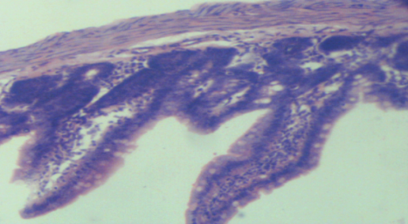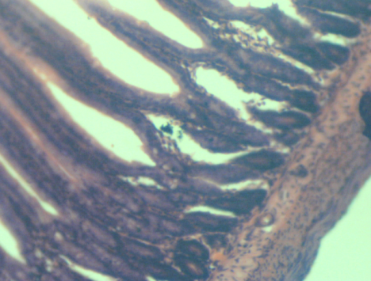
BS₁
AS
Plate AS (Control) Plate BS₁
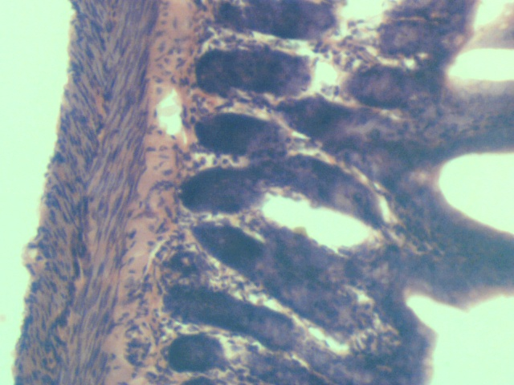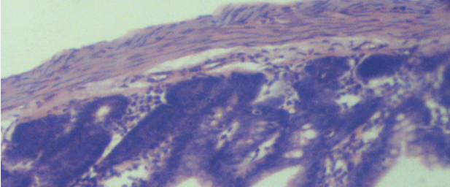
BS₃
BS₂
Plate BS₂ Plate BS₃
Plate 1 BS: Sections of small intestine infected with Aspergilus flavus showing mild distortion of the mucosa with normal histology of the muscularis and sub mucosa (BS₁ and BS₃) while (BS₂) appeared normal like control AS. (H and E x100).
Small Intestine: Experimental Group C (Plate CS)
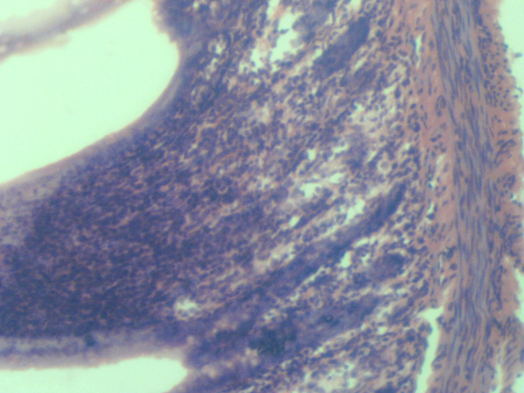Plate CS₁ Plate CS₂
CS₂
CS₁
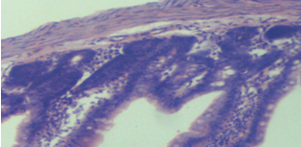
CS₃
Plate CS₃
Plate 2CS: Sections of small intestine infected with Bacillus cereus showing normal histology of the muscularis, sub mucosa and mucosa. (H and E x100).
Small Intestine: Experimental Group D (Plate DS)
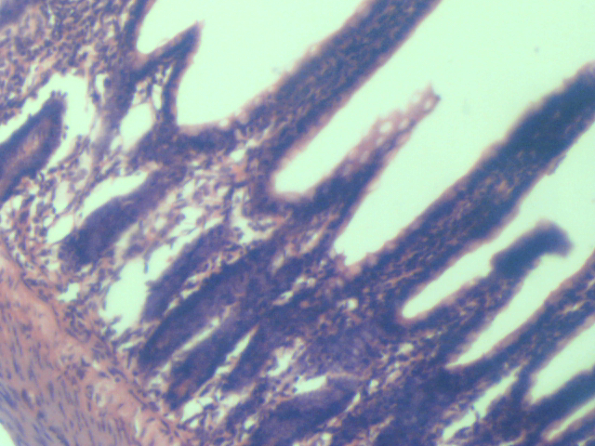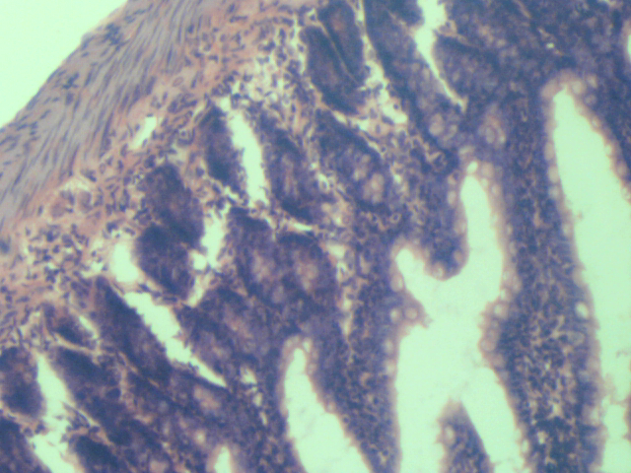
DS₁
DS₂
Plate DS₁ Plate DS₂
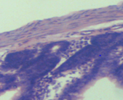
DS₃
Plate DS₃
Plate 3 DS: Sections of small intestine infected with E coli showing normal histology of the muscularis and sub mucosa but mild degeneration of the mucosa (DS₁).(H and E x100).

Small Intestine: Experimental Group E (Plate ES)
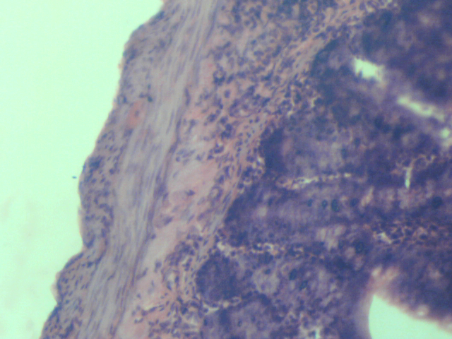
ES₂
ES₁
Plate ES₁Plate ES₂
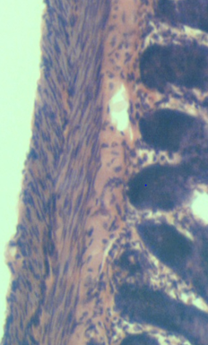
ES₃
Plate ES₃
Plate 4 ES: Sections of small intestine infected with Salmonella enterica showing normal histology of the muscularis, sub mucosa and mucosa but with moderate lymphocytic infiltration within the sub mucosa of (ES₁) (H and E x100).
Small Intestine: Experimental Group F (Plate FS)
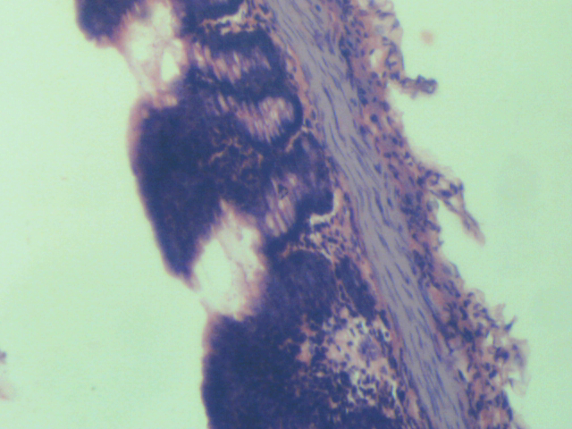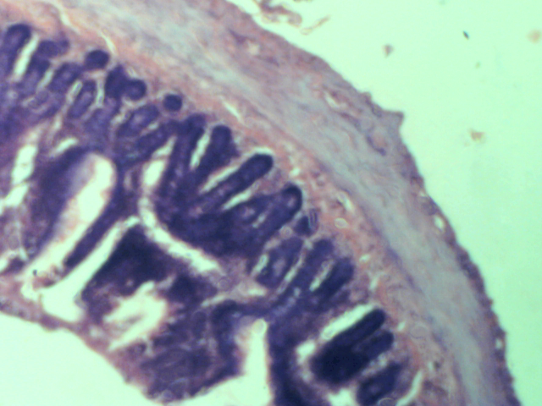
FS₂
FS₁
Plate FS₁ Plate FS₂
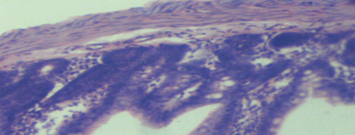
FS₃
Plate 5 FS: Sections of small intestine infected with Staphylococcus aureus showing distorted muscularis, sub mucosa and mucosa (FS₁) while (FS₂ and FS₃) appears normal (H and E x100).

Food handlers are important vehicle for microorganisms, and improper handling practices may cause food contamination and consequently food-borne diseases which pose a potential risk to public health (Assefa, et al., 2015). In this research, pathogenic microorganisms were isolated from the vendors which indicated that they are carriers of pathogenic microorganisms, and this agrees with Isara and Isah (2009) that food vendors play an important role in transmission of food-borne disease.
The percentage respondents to the hygiene practices survey questionnaire observed that 84.38% of the vendors prepared food in unhygienic conditions. Personal hygiene in food vending is important because according to Ackah et al. (2011), human beings are the largest sources of food contamination and handling with bare hands may result in cross contamination, hence introduction of microbes on safe food.
Microorganisms of importance isolated include bacteria (752) and fungi (118) isolates. Their percentage prevalence were high viz:, Staphylococcus aureus (21.01%), Escherichia coli (23.27%), Salmonella enteric (13.03%), Pseudomonas aeruginosa (16.89%), Bacillus cereus (11.84%), Klebsiella pneumonia (10.90%), Serratia marcescens (3.06%), Aspergillus niger (23.3%), Aspergillus flavus (13.56%), Microsporium canis (14.41%), Mucor circinelloides (12.71%), Penicillium chrysogenum (10.17%) and Candida albicans (25.42%). Escherichia coli and Candida albicans showed the highest prevalence (23.27%, 25.42%) respectively while Serracia marcescens and Penicillium chrysogenum has the least percentage prevalence (3.06%, 10.17%) respectively for both bacteria and fungi isolates. Thus, putting the ubiquity of microorganisms into consideration, a line cannot and should not be drawn that only these genera are associated with vended foods, some other factors which could be attributed to chance might have hindered the possibility of isolation of other existing floras (Ogu and Madukwe, 2021). Similar microbial contaminants and prevalence were identified in previous studies in Benin City, Ogun State and Ondo State, Nigeria (Okareh and Erhahon, 2015; Bankole et al., 2009; Ibrahim et al., 2013). Furthermore, the isolates from this study also agrees with findings of other researchers in regions like Gondar and Jimma, Ethiopia (Andargie, 2008; Assefa, et al., 2015); Saudi Arabia (Zaglool et al., 2011); Egypt (Fadel and Ismail, 2009); Puerto Rico (Dharod et al., 2009) and Brazil (Souza and Santos, 2009).
The histopathological results as seen in Plates BS, CS, DS, ES and FS showed Sections of small intestine from different experimental groups respectively showing varying degrees of distortion of the mucosa, muscularis and submucosa. The various distortions observed in the small intestine showed the pathogenic nature of the isolates and were in line with the findings by Anibijuwon et al. (2017).
CONCLUSION
This study has shown that most food vendors within the sampled localities in Anambra State are carriers of wide variety of potentially pathogenic microorganisms and could be a source of infection to their customers. The findings of this work call for caution in patronizing food vendors as the study revealed that pathogenic isolates from food vendors can aggravate ill health of consumers if proper care and caution is not taken.
Disclaimer (Artificial intelligence)
Option 1:
Author(s) hereby declare that NO generative AI technologies such as Large Language Models (ChatGPT, COPILOT, etc.) and text-to-image generators have been used during the writing or editing of this manuscript.
Option 2:
Author(s) hereby declare that generative AI technologies such as Large Language Models, etc. have been used during the writing or editing of manuscripts. This explanation will include the name, version, model, and source of the generative AI technology and as well as all input prompts provided to the generative AI technology
Details of the AI usage are given below:
1.
2.
3.

REFERENCES
- Ackah, M., Gyamfi, E.T., Anim, A.K., Osei, J., Hansen, J.K. and Agyemang, O.(2011).Socio- Economic Profile, Knowledge of Hygiene and Food Safety Practices among Street-Food Vendors in some parts of Accra-Ghana. International Journal of Food Safety,13: 191-197.
- Andargie, G. (2008). Prevalence of Bacteria and Intestinal Parasites among Food-handlers in Gondar Town, Northwest Ethiopia. Journal of Health and Population Nutrition, 26: 451-455. 10.3329/jhpn.v26i4.1887
- Anibijuwon, I. I., Onifade, A. K. and Oladumoye, M. K. (2017).Effects of Food Borne Pathogens on the Internal Organs of Albino Rats (Rattus norvegicus).Sikkim Mainipal University (SMU) Medical Journal,4(1): 53-65.
- Assefa, T., Tasew, H., Wondafrash, B. and Beker, J. (2015).Assessment of Bacterial
Hand Contamination and Associated Factors among Food Handlers Working in
the Student Cafeterias of Jimma University Main Campus, Jimma, South West
Ethiopia. Journal of Community Medicine and Health Education, 5: 345. 10.4172/2161-0711.1000345
- Bankole, M. O., Omemu, A. M. and Oladimeji, D. S. (2009).Microorganisms Associated with the Palmsof Fast-Food Handlers in Abeokuta, Nigeria. Journal of National Science and Engineering Technology, 8(2): 77-85.. 10.51406/jnset.v8i2.1046
- DeSousa, C.P. (2008). The Impact of Food Manufacturing Practices on Food Borne Diseases.Brazillian Archives of Biology and Technology,51(4): 815–823. 10.1590/S1516-89132008000400020
- Dharod, J. M., Stefania, P. S., Bermúdez-Millán, A. and Venkitanarayanan, K. (2009).Bacterial Contamination of Hands Increases Risk of Cross contamination
among Low-income Puerto Rican Meal Preparers. Journal of Nutritional Education Behaviour,41: 389-397. 10.1016/j.jneb.2008.11.001
- Duncan, R. C., Knapp, R. G. and Miller, M. C. (1977). Test of Hypothesis in Population Means: Introductory Biostatistics for Health Sciences. New York: John Wiley and Son Incorporation. Pp. 71-76.
- Egwuim, T.C., Umeh, S.O. and Izuegunam, L.C. (2018). Prevalence and Antibiogram of Bacteria Associated with Food vending in Awka-South L.G.A, Anambra State, Nigeria. International Journal of trend in Scientific Research and Development, 3(1):1034-1042. 10.31142/IJTSRD19174
- Fadel, H. M. and Ismail, J. (2009).Prevalence and Signifiance of Staphylococcus aureus and Enterobacteriaceae species in Selected Dairy Products and Handlers.International Journal of Dairy Science, 4: 100-108 10.3923/ijds.2009.100.108
- Ghosh, M., Wahi, S., Kumar, M. and Ganguli, A. (2007).Prevalence of Enterotoxigenic Staphylococcusaureus and Shigellaspp in some Raw Street Vended Indian Foods. International Journal of Environmental Health Research, 17(2): 151–157. 10.1080/09603120701219204
- Ibrahim, T. A., Akenroye, O. M. and Osabiya, O. J. (2013).Bacteriological Analysis and Hygiene Level of Food Outlets within Rufus Giwa Polytechnic, Owo, Ondo State, Nigeria. Journal of Microbiology and Biotechnology, 2(4): 2347-2286.
- Isara, A. R. and Isah, E. C. (2009).Knowledge and Practice of Food Hygiene and Safety among Food Handlers in Fast Food Restaurants in Benin City, Edo State. Niger Post Graduate Medical Journal, 16(3): 207-212. 10.4103/1117-1936.181340
- Jimoh, F. O. and Odutuga, A. A.(2004). Histological Changes of Selected Rat Tissues Following the Ingestion of Thermally Oxidized Groundnut Oil. Journal of Nigerian Society for Experimental Biology, 16(1): 1-10.
- Kaferstein, F. K. (2003). Food Safety the Fourth Pillar in the Strategy to Prevent Infant Diarrhea. Bulletin of the World Health Organization, 81: 842-843.
- Lambrechts, A. A., Human, I. S., Doughari, J. H. and Lues, J. R. (2014).Bacterial Contamination of the Hands of Food Handlers as Indicator of Hand Washing Efficacy in some Convenient Food Industries in South Africa. Pakistan Journal of Medical Sciences,30(4): 755-758. 10.12669/pjms.304.4400
- Lindqvist, R., Andersson, Y., Lindbäck, J., Wegscheider, M., Eriksson, Y., Tideström, L., Lagerqvist-Widh, A., et al. (2001).A One-Year Study of Foodborne Illnesses in the Municipality of Uppsala, Sweden. Journal Emerging Infectious Diseases, 7(3): 588-592. 10.3201/eid0707.010742
- Nurudeen, A. A., Lawal, A. O. and Ajayi, S. A. (2014) A Survey of Hygiene and Sanitary Practices of Street Food Vendors in the Central State of Northern Nigeria. Journal of Public Health and Epidemiology, 6(5): 174-181. 10.5897/JPHE2013.0607
- Ogu, C.T. and Maduekwe, E.J. (2021). Microbial Flora of Post-Harvested Tomatoes and the Effect of Sodium Hypochlorite on the Microbial Load. International Journal of Agriculture and Biosciences, 10(2): 84-86.
- Okareh, O. T. and Erhahon, O. O. (2015).Microbiological Assessment of Food and Hand-Swabs Samples of School Food Vendors in Benin City, Nigeria. Food and Public Health Journal, 5(1): 23-28. 10.5923/j.fph.20150501.04
- Onyeanusi, B. I., Adeniyi, A. A., Onyeanusi, C. G., Ayo, J. O. and Ibe, C.S. (2009). A Study of the Kidney of the Wistar Rat in Northern Guinea Savannah Zone: the Morphometric Aspect. Pakistan Journal of Nutrition, 8: 1040-1042. 10.3923/pjn.2009.1040.1042
- Oruganti, M. and Gaidhani, S. (2015). Routine Bleeding Techniques in Laboratory Rodents. International Journal of Pharmaceutical Sciences and Research, 5: 516-524. 10.13040/IJPSR.0975-8232.2(3).516-24
- Prabhu, P. M. and Shah, R. S. (2014).A Study of Food Handlers in Public Food Establishments in Maharashtra, India. International Journal of Science and Research, 3(7): 1485–1489. 10.21275/20141315
- Sharmila, R. (2011). Street Vended Food in Developing World: Hazard Analyses. Indian Journal of Microbiology, 51(1): 100–106. 10.1007/s12088-011-0154-x
- Simsek, Z., Koruk, I., Copur, A. C. andGürses, G. (2009). Prevalence of Staphylococcus aureus and Intestinal Parasites among Food Handlers in Sanliurfa, South-eastern Anatolia.Journal of Public Health and Management Practice,15(6): 518-523. 10.1097/PHH.0b013e3181aa2814
- Souza, P. A. and Santos, D. A. (2009). Microbiological Risk Factors Associated with Food Handlers in Elementary Schools From Brazil. Journal of Food Safety, 29: 424-429. 10.1111/j.1745-4565.2009.00166.x

- Tavonga, N. (2014). Operations of Street Food Vendors and their Impact on Sustainable Urban Life in High Density Suburbs of Harare, in Zimbabwe.Asian Journal of Economic Modelling, 2(1): 18-31 10.18488/journal.8.2014.21.18.31

- Zaglool, D. A., Khodari, Y, A., Othman, R. and Farooq, M. U. (2011).Prevalence of
Intestinal Parasites and Bacteria among Food Handlers in a Tertiary Care Hospital.
Nigerian Medical Journal,52: 266-270. 10.4103/0300-1652.93802

- Salamandane, A., Malfeito-Ferreira, M., & Brito, L. (2023). The socioeconomic factors of street food vending in developing countries and its implications for public health: a systematic review. Foods, 12(20), 3774. https://doi.org/10.3390/foods12203774

- Grace, D. (2023). Burden of foodborne disease in low-income and middle-income countries and opportunities for scaling food safety interventions. Food Security, 15(6), 1475-1488. DOI: https://doi.org/10.1007/s12571-023-01391-3

- Singh, S., & Singh, R. (2024). Knowledge, attitude, and practices of food handlers towards food hygiene. Asian Journal of Agricultural Extension, Economics & Sociology, 42(6), 1–5. https://doi.org/10.9734/ajaees/2024/v42i62457

