Comparative analysis of Scalpel and Diode
Laser Surgical Methods in management of
traumatic fibroma

.
ABSTRACT

Aims:
To compare the clinical outcomes of conventional scalpel excision and diode laser ablation in the management of traumatic fibroma.
Presentation of Case:
This report presents two cases of traumatic fibroma treated using different surgical modalities. In Case 1, a traumatic fibroma was excised using a conventional scalpel technique, resulting in complete lesion removal with satisfactory healing at 15 days and no recurrence at one-month follow-up. In Case 2, excision was performed using an 880-nm diode laser, which provided excellent intraoperative haemostasis, minimal patient discomfort, and rapid postoperative healing without scarring within eight days. Histopathological examination in both cases confirmed the diagnosis of traumatic fibroma.
Discussion:
Both treatment modalities were effective in achieving complete lesion removal. However, diode laser excision demonstrated superior clinical advantages, including better haemostasis, reduced postoperative discomfort, and faster wound healing compared to conventional scalpel excision.
Conclusion:
While both scalpel and diode laser techniques are effective for the management of traumatic fibroma, diode laser excision offers enhanced clinical efficiency and patient comfort, making it a valuable alternative for soft-tissue lesion management.
14
- Keywords: Traumatic fibroma, Irritation fibroma, Diode laser, Scalpel excision, Soft-tissue
- surgery.
17

1. INTRODUCTION
- Traumatic fibroma, also known as irritation fibroma or focal fibrous hyperplasia, is a
- frequently observed benign lesion of the oral soft tissues. It represents a reactive
- hyperplasia of fibrous connective tissue rather than a true neoplasm, and typically develops
- as a chronic response to low-grade mechanical irritation or trauma such as lip/cheek biting,
- sharp teeth, dental prostheses, or orthodontic appliances.¹,² The lesion usually appears as a
- smooth, dome-shaped nodule that is similar in color to the adjacent mucosa, although
- variations such as pallor or hyperpigmentation may occur due to keratinization or previous
- hemorrhage³. Traumatic fibromas most often occur on the buccal mucosa along the occlusal
- line but may also present on the lips, tongue, and gingiva.⁴ The lesion has more middle-aged

- predilection. One of the advantages of this lesion is that appropriate treatment typically
- results in healing without postoperative scarring. Oral fibromas exhibit slow growth over
- weeks to months and generally measure around 1 cm at their largest, though the size can
- differ depending on the case. A provisional diagnosis can be made based on characteristic
- clinical features observed during examination. However, definitive diagnosis and exclusion of
- other lesions require biopsy of the tissue. Histopathological analysis typically demonstrates
- dense, collagenous fibrous tissue with sparse cellularity, while the overlying epithelium may
- be ulcerated, atrophic, or hyperplastic.5 Neurofibroma, myxoma, lipoma, and pleomorphic
- adenoma are differential diagnoses of traumatic fibroma. Complete surgical excision is the
- primary treatment modality for the lesion. Alternative treatment options include cryosurgery
- and intralesional corticosteroid injections, which may be employed in selected cases. Proper
- blood investigations are essential before initiating the treatment plan. The recurrence is
- rarely seen after complete excision.6 This case series evaluates both conventional scalpel
- excision and diode laser ablation in the management of a traumatic fibroma, highlighting the
- clinical benefits and limitations of each technique.
43

2. CASE PRESENTATION

- This series involves two cases of traumatic fibroma associated with buccal mucosa and
- retromolar area, which were treated with surgical intervention and diode laser ablation
- respectively, reported with functionality issues during speech and mastication.
48

2.1 Case 1
- A 19-year-old male reported to the Department of Oral Medicine and Radiology with the
- chief complaint of soft tissue growth over the left buccal mucosa of the mouth gradually
- increasing over 10 years following trauma while chewing. No significant medical history was
- present. Intraoral examination revealed a smooth, greyish-brown painless sessile mass with
- a white patch on the left buccal mucosa, approximately 1.0 × 0.5 cm in size, soft to firm in
- consistency, non-tender, and not fixed to the underlying tissues, as shown in Figure 1.

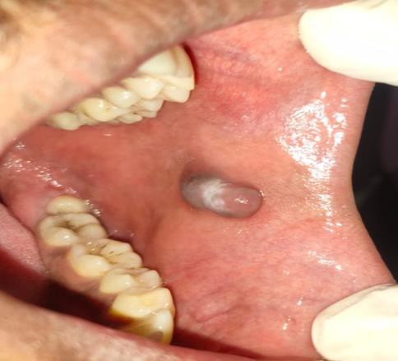
56

FIGURE 1: Pre-operative view showing traumatic fibroma associated with left buccal mucosa.
57

- Based on the clinical presentation and patient history, a provisional diagnosis of traumatic
- fibroma was established. Possible differential diagnoses included lipoma, mucocele, and
- neurofibroma. The patient was advised for the surgical removal of the lesion and counselling
- for cheek biting is done. Routine hematological investigations were within normal limits. After
- explaining the surgical procedure, informed consent was obtained. An excisional biopsy
- under local anesthesia using a scalpel was performed, hemostasis was achieved and
- sutures were placed as appreciated in Figure 2. The removed tissue was sent for
- histopathological analysis (Figure 3).

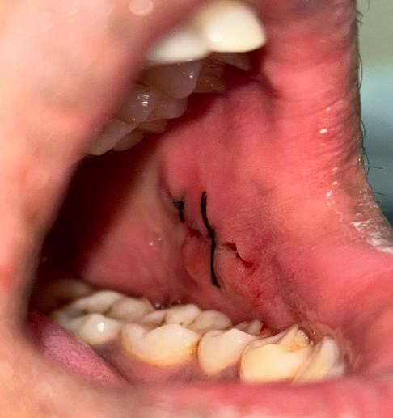

FIGURE 2: Surgical excision of traumatic fibroma was done by using a scalpel and sutures were placed
66

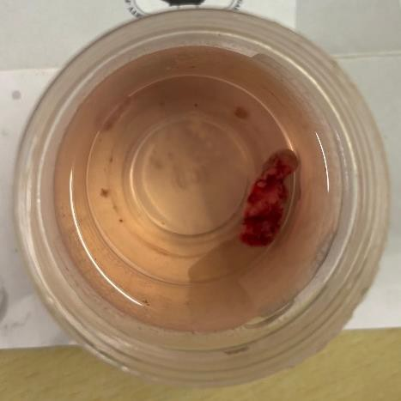
67

FIGURE 3: An excised lesion specimen was sent for histopathological examination
68
69
70
71
72
73
74
75
76
77
78
79
80
81
82
- Histopathology shows stratified squamous surface epithelium with keratosis and epithelial
- atrophy in the focal area. Underlying connective tissue stroma is fibrous, collagen fibers are
- arranged in bundles. The histopathological features confirmed the diagnosis of fibroma
- (Figure 4).
87
88

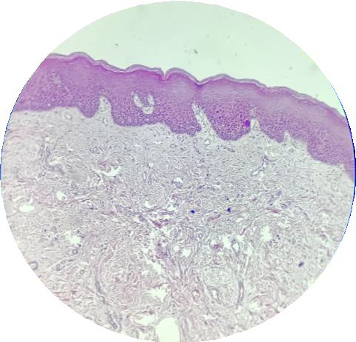

FIGURE 4: Histopathology
89
- Follow-up after 15 days revealed uneventful postoperative healing with no evidence of
- scarring (Figure 5). At the one-month follow-up, no evidence of recurrence was observed.

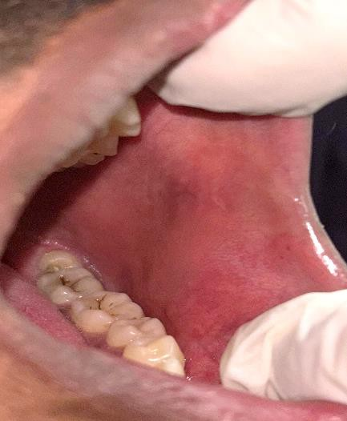

FIGURE 5: Follow-up examination after fifteen days revealed complete wound healing of the lesion.
92

2.2 Case 2
- A 45-year-old male patient reported to the Oral Medicine and Radiology Department with a
- chief complaint of soft tissue growth over the right buccal mucosa near retromolar area of
- the mouth. The lesion had been present in the oral cavity for nine months. The patient had a
- history of traumatic biting due to root pieces of right maxillary third molar. Intraoral
- examination revealed a smooth, painless sessile mass approximately 1.0 X 1.0 cm in size,
- soft to firm in consistency, the overlying mucosa shows slight brownish pigmentation, with no
- evidence of ulceration, as shown in Figure 6.
101
102
103


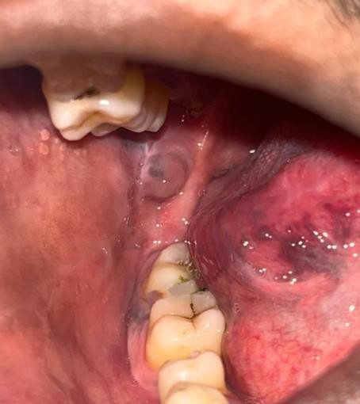
104

FIGURE 6: Pre-operative view of traumatic fibroma associated with right buccal mucosa near retromolar region.
105
106
107
108
109
110
111
112
113
114
115
116
117
118
119
120
121
- Based on the clinical presentation and patient history, a provisional diagnosis of traumatic
- fibroma was established. The patient was advised for the surgical removal of the lesion and
- extraction of root pieces. After explaining the surgical procedure, written consent was
- obtained from the patient. Under local anesthesia and following appropriate laser safety
- protocols, the lesion was excised using an 880-nm diode laser. As shown in Figure 7, the
- procedure resulted in excellent hemostasis with no bleeding, and the patient experienced
- neither discomfort nor pain during surgery.
129

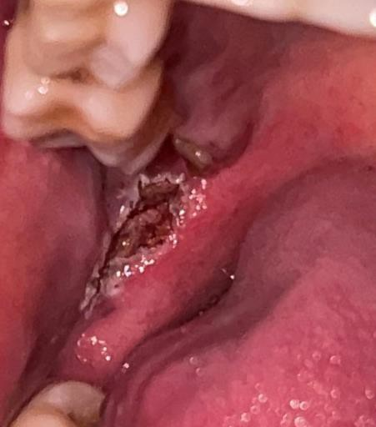

FIGURE 7: Surgical excision of traumatic fibroma was done by using a diode laser.
130
131
- The diagnosis was confirmed by histopathological examination of the excised specimen.At
- the seven-day postoperative follow-up, the patient showed satisfactory wound healing with
- no evidence of scarring, as illustrated in Figure 8.
135
136

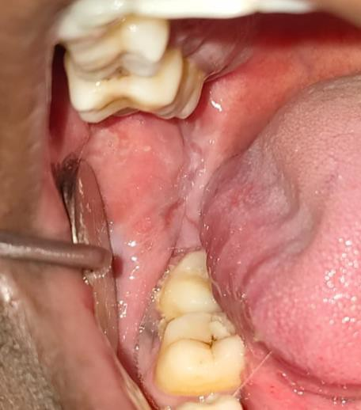

FIGURE 8: Recall examination after seven days revealed satisfactory wound healing.
137
138
139 3. Result And DISCUSSION
140
- Traumatic fibroma is a common reactive lesion caused by chronic irritation of the oral
- mucosa. Persistent trauma stimulates fibroblast proliferation, resulting in localized fibrous
- overgrowth1,2. Both reported cases demonstrated typical clinical features: smooth-surfaced
- nodules arising on trauma-prone mucosal sites. Histopathological findings in both cases
- were consistent with established descriptions in the literature, including dense collagenous
- stroma and stratified squamous epithelial covering 3,5.
- Scalpel excision has long been the conventional approach to treating traumatic fibroma. It is
- reliable, cost-effective, and provides adequate tissue for histopathological examination.
- However, limitations include intraoperative bleeding, the need for sutures, and relatively
- longer healing time. In Case 1, although healing was satisfactory, suturing and mild
- postoperative discomfort were unavoidable, consistent with findings reported by Bagan et
- al.4. Additionally, conventional scalpel surgery often requires longer operative time due to
- multiple procedural steps such as hemostasis and suturing.
- Diode lasers have emerged as an advantageous alternative for excising benign soft-tissue
- lesions. Their benefits include excellent haemostasis, reduced operative time, decreased
- postoperative inflammation, and minimal scarring due to precise tissue ablation and limited
- thermal damage7. In Case 2, diode laser excision resulted in bloodless surgery, improved
- visibility, reduced pain, and faster healing, which aligns with the findings of Diwan et al.8. The
- reduced operative time observed with diode laser excision can be attributed to the laser’s
- ability to simultaneously incise and coagulate tissue, eliminating the need for sutures and
- additional hemostatic measures.
- Recent studies further support the clinical superiority of diode lasers in the management of
- oral fibromas. Shnawa et al. reported that diode laser excision resulted in significantly
- reduced intraoperative bleeding, shorter operating time, enhanced patient comfort, and
- favorable histological outcomes compared with scalpel techniques9. A case series by La
- Terra et al. demonstrated predictable healing and high patient satisfaction following
- traumatic fibroma removal using a 980-nm diode laser, with procedures completed in
- reduced surgical time10. Similarly, Durga et al. highlighted bloodless and suture-free excision
- of oral traumatic fibromas using diode lasers, emphasizing improved postoperative comfort
- and rapid epithelialization, and procedural efficiency11. A comparative study also showed

- that diode lasers of different wavelengths (980 nm and 450 nm) were effective in fibroma
- excision, with reduced postoperative discomfort, shorter operative time and accelerated
- healing12.
- Despite these advantages, diode laser use is associated with certain limitations. The high
- initial cost of laser equipment and maintenance may limit its availability in routine clinical
- practice13. Furthermore, excessive thermal energy may lead to histopathological artifacts
- such as tissue shrinkage or carbonization, potentially affecting microscopic interpretation if
- improper parameters are used14. Adequate operator training and careful adjustment of laser
- settings are therefore essential.
- Sharma et al.5 emphasize that traumatic fibromas exhibit consistent morphology, making
- complete excision curative when performed properly. The absence of recurrence in both
- cases supports prior evidence indicating that recurrence is rare unless the causative trauma
- persists6. Overall, diode laser excision offers several advantages over conventional scalpel
- surgery, particularly in terms of reduced operating time, patient comfort, intraoperative
- control, and healing outcomes. For benign lesions such as traumatic fibroma, lasers may be
- considered a superior modality, especially in sensitive or highly vascular areas.

4. CONCLUSION
- Both scalpel and diode laser excision are effective treatment modalities for traumatic
- fibroma. However, diode laser surgery provides significant advantages, including minimal
- bleeding, reduced discomfort, faster postoperative healing and shorter operating time.
- Incorporating laser technology can enhance clinical outcomes and patient satisfaction in the
- management of soft-tissue oral lesions.

COMPETING INTERESTS
- Authors have declared that no competing interests exist.
195

AUTHORS’ CONTRIBUTIONS
- All authors read and approved the final manuscript.
198

CONSENT
- Written informed consent was obtained from the patient for publication of this case series
- and accompanying images.
- Ethical Approval:
- As per international standards or university standards written ethical approval has been collected and preserved by the author(s).

- Disclaimer (Artificial intelligence)
- Option 1:
- Author(s) hereby declare that NO generative AI technologies such as Large Language Models (ChatGPT, COPILOT, etc.) and text-to-image generators have been used during the writing or editing of this manuscript.
- Option 2:
- Author(s) hereby declare that generative AI technologies such as Large Language Models, etc. have been used during the writing or editing of manuscripts. This explanation will include the name, version, model, and source of the generative AI technology and as well as all input prompts provided to the generative AI technology
- Details of the AI usage are given below:
- 1.
- 2.
- 3.

202
203 REFERENCES
204
- 1. Shafer WG, Hine MK, Levy BM. (2012). Shafer’s Textbook of Oral Pathology.
- (7th ed). Elsevier.
- 2. Neville BW, Damm DD, Allen CM, Chi AC. (2016) Oral and Maxillofacial
- Pathology. (4th ed). Elsevier.
- 3. Regezi JA, Sciubba JJ, Jordan RCK. (2017) Oral Pathology: Clinical Pathologic
- Correlations. (7th ed). Elsevier.
- 4. Bagán JV, et al. Localised oral fibrous hyperplasia: A clinicopathological study of
- 85 cases. Med Oral Patol Oral Cir Bucal. 2010;15:e539-e543.
- 5. Sharma SK, Shukla P, Dash S: Dermoscopy of traumatic fibroma of the tongue .
214 Indian Dermatol Online J. 2023, 14:750-1. 10.4103/idoj.idoj_601_22
- 6. Regezi JA, Sciubba JJ. Oral mucosal lesions: Pathogenesis and behavior. In:
- Oral Pathology. Elsevier; 2017.
- 7. Romeo U, Del Vecchio A, Palumbo C, et al. Excision of benign oral lesions with
- an 810-nm diode laser: Experience on 206 cases. Photomed Laser Surg.
- 2011;29(4):221–226. DOI 10.1089/pho.2010.2911

242
220
221
222
223
224
225
226
227
228
229
230
231
232
233
234
235
236
237
238
239
240
241
- Diwan B, Shirbhate U, Bajaj P, et al. (October 27, 2023) Conventional Scalpel and Diode Laser Approach for the Management of Traumatic Fibroma. Cureus 15(10): e47810. DOI 10.7759/cureus.47810
- Shnawa, A. A., Taher, H. J., & Khalil, A. A. (2025). Minimally invasive excision of oral fibromas: a clinical and histological comparison between diode laser and scalpel techniques. Lasers in Dental Science, 9(1), 1-9.
- La Terra SL, Caccianiga G, Buoncristiani F, Alzahrani F, Alabeedi FM. Clinical outcomes of oral traumatic fibroma removal using a 980-nm diode laser: a series of four cases. Cureus. 2025;17(3):e80390. DOI 10.7759/cureus.80390
- Durga GV, Raju MS, Rani KM, Fatimah K, Salomi TS. Bloodless and suture-free diode laser management of oral traumatic fibroma and fibroepithelial polyp. Int J Life Sci Biotech Pharma Res. 2025;14(7):817–820.
- Al Ghazali SR, Ahmed SS, Abdulhameed BS. Clinical evaluation of oral fibroma lesion removal using two diode lasers (980 nm and 450 nm). Iraqi J Laser. 2024;23(1):80–89.
- Convissar RA. Principles and Practice of Laser Dentistry. 2nd ed. Elsevier; 2016.
- Suter VGA, Altermatt HJ, Sendi P, Bornstein MM. Histopathological effects of diode laser surgery on oral soft tissues. Lasers Surg Med. 2010;42(1):37–44. DOI 10.1002/lsm.20814

