District-Level Disparities in Female Education and Child Marriage: Evidence from Maharashtra, India

ABSTRACT
Aims
The study aims to examine district-level variations in women’s educational attainment and literacy in Maharashtra and to analyze their relationship with the prevalence of early marriage among women.
Study Design
This is a descriptive and analytical cross-sectional study based on secondary data analysis.
Place and Duration of Study
The study covers all 36 districts of Maharashtra, using data from the National Family Health Survey–5 (NFHS-5), conducted during 2019–2021.
Methodology
The study is based on district-level secondary data extracted from the National Family Health Survey–5 (NFHS-5, 2019–21) for all 36 districts of Maharashtra and follows a quantitative, cross-sectional analytical approach. As all districts are included, a complete enumeration (census) method is adopted and no separate sample size formula is required. NFHS-5 itself follows a two-stage stratified random sampling design at the household level, ensuring reliable district-level estimates (IIPS & ICF, 2021). Data collection involved identification of key indicators, district-wise compilation, and consistency checks using official fact sheets. Descriptive statistics were used to examine inter-district variations, while Pearson correlation analysis was applied to assess relationships between women’s educational indicators and child marriage prevalence, consistent with recent district-level studies in India (Raj et al., 2019; Singh et al., 2024). The findings were interpreted in comparison with national trends from NFHS-4 and NFHS-5 and supported by established sociological and demographic literature on education and marriage outcomes (Desai & Vanneman, 2015; UNICEF, 2020).
Results
Substantial inter-district disparities were observed. Urbanized districts such as Mumbai, Pune, Nagpur, and Thane reported very high female literacy and secondary schooling levels, along with very low child marriage prevalence. In contrast, districts such as Nandurbar, Parbhani, Bid, and Dhule exhibited low female educational attainment and high rates of early marriage. A strong negative correlation (r ≈ –0.66) was found between women’s completion of ten or more years of schooling and child marriage. Maharashtra’s overall child marriage rate (21.9%) was lower than the national average (23.3%), reflecting the state’s comparatively higher female literacy, though regional gaps remain pronounced.
Conclusion
The findings confirm that women’s education—particularly completion of secondary schooling—is a critical determinant in delaying marriage. Districts with higher female literacy and schooling consistently demonstrate lower child marriage prevalence. Strengthening access to quality education in lagging rural, tribal, and Marathwada districts, alongside supportive social and policy interventions, is essential for further reducing child marriage and advancing women’s empowerment in Maharashtra.
Keywords: Female Literacy, Women’s Education, Child Marriage, Educational Attainment, Women’s Empowerment

INTRODUCTION
Despite global and national progress in reducing child marriage, the practice remains a persistent challenge closely linked to women’s educational deprivation, particularly in developing countries. Extensive international research has established that girls with higher levels of education are significantly less likely to marry early, as education enhances autonomy, economic opportunity, and reproductive health outcomes (UNICEF, 2020; World Bank, 2018). In India, large-scale studies using NFHS data have confirmed a strong inverse relationship between women’s schooling and early marriage at the national level (Raj et al., 2019; UNFPA, 2022). Recent multilevel and geospatial analyses covering all Indian districts further demonstrate that completion of secondary education is the single most powerful protective factor against child marriage, even after controlling for wealth, caste, and place of residence (Singh et al., 2024; BMC Public Health, 2024). However, most existing studies either adopt a national or multi-state perspective or focus on selected regions, thereby masking substantial intra-state and district-level disparities (Desai & Vanneman, 2015).
The urgency of the present research is heightened by emerging evidence that educational disruptions following the COVID-19 pandemic have disproportionately affected girls, particularly in rural, tribal, and economically weaker regions, increasing the risk of school dropout and early marriage (Dutta et al., 2023). While Maharashtra performs better than the national average in female literacy, recent reports indicate that progress is highly uneven across districts, with Marathwada and tribal districts continuing to lag behind urban and industrial regions (IIPS & ICF, 2021). Existing studies rarely provide a systematic district-level analysis within a single advanced Indian state, limiting the ability to design targeted, region-specific interventions.
The novelty of this study lies in its comprehensive district-level examination of women’s education and child marriage across all 36 districts of Maharashtra, using the most recent NFHS-5 data. By integrating multiple educational indicators and correlational analysis, the study fills a critical gap in the literature by revealing fine-scale spatial inequalities that are obscured in national averages. This micro-level evidence is essential for informed policy formulation, localized educational planning, and effective strategies to eliminate child marriage and advance women’s empowerment.

OBJECTIVE
- To analyze district-level variations in women’s educational attainment and literacy in Maharashtra and examine how these factors influence the prevalence of early marriage across the state.

Methodology
District-level secondary data were extracted from the National Family Health Survey–5 (NFHS-5, 2019–21) for all 36 districts of Maharashtra. The study employed a quantitative, cross-sectional analytical approach. Key indicators analyzed included: female school attendance (age ≥6 years), female literacy (age 15–49), women with ten or more years of schooling (age 15–49), sex ratio (females per 1,000 males), and the proportion of women aged 20–24 married before 18 years. Descriptive statistics were used to examine inter-district variations, while Pearson correlation analysis was applied to assess relationships between women’s educational indicators and child marriage prevalence. This approach is consistent with recent district-level and geospatial studies examining early marriage determinants in India (Raj et al., 2019; BMC Public Health, 2024). Findings were interpreted in comparison with national trends from NFHS-4 and NFHS-5 and supported by existing sociological and demographic literature on education and marriage outcomes (Desai & Vanneman, 2015; UNICEF, 2020). Ashoka University Data Lab (2022) to justify the district-level analytical and geospatial approach.

RESULTS AND DISCUSSION
Table 1: District-level secondary data the National Family Health Survey–5
Sr.  No. | District | Female population age 6 years and above who ever attended school (%) | Sex ratio of the total population (females per 1,000 males) | Women with 10 or more years of schooling (%) | Women age 20-24 years married before age 18 years (%) | Women who are Literate (%)
1 | Ahmednagar | 77.4 | 967 | 45.7 | 26.9 | 86.20
2 | Akola | 86.3 | 951 | 52.7 | 13.5 | 87.50
3 | Amravati | 86.2 | 994 | 55 | 9.8 | 87.80
4 | Aurangabad | 78.4 | 978 | 48.4 | 35.8 | 83.10
5 | Bhandara | 80.3 | 1004 | 53.9 | 1.5 | 89.10
6 | Bid | 64.6 | 934 | 38.6 | 43.7 | 76.30
7 | Buldhana | 78.1 | 957 | 41.8 | 24.1 | 79.90
8 | Chandrapur | 78.9 | 974 | 57.5 | 9 | 87.80
9 | Dhule | 73.5 | 999 | 40.8 | 40.5 | 68.80
10 | Gadchiroli | 67.1 | 1048 | 42.3 | 10.1 | 79.40
11 | Gondia | 80.4 | 994 | 54.1 | 6.5 | 87.50
12 | Hingoli | 69.4 | 962 | 33.2 | 37.1 | 76.50
13 | Jalgaon | 77.5 | 983 | 40.8 | 28 | 76.50
14 | Jalna | 67.6 | 948 | 34.3 | 35 | 71.80
15 | Kolhapur | 80.2 | 1025 | 53.8 | 21 | 90.70
16 | Latur | 70.6 | 979 | 40.7 | 31 | 83.30
17 | Mumbai Suburban | 88.5 | 921 | 65.7 | 10 | 91.60
18 | Mumbai | 92.5 | 939 | 71.1 | 4.5 | 94.30
19 | Nagpur | 86.5 | 971 | 67.6 | 7.1 | 94.60
20 | Nanded | 68.1 | 970 | 31.6 | 32.2 | 71.90
21 | Nandurbar | 63.5 | 961 | 29.9 | 24 | 57.70
22 | Nashik | 78.2 | 913 | 42.6 | 29.6 | 80.00
23 | Osmanabad | 71.3 | 992 | 41.5 | 36.6 | 83.70
24 | Palghar | 77.5 | 963 | 48.3 | 14.6 | 77.60
25 | Parbhani | 67.1 | 966 | 28.8 | 48 | 73.40
26 | Pune | 84.8 | 918 | 61.2 | 24 | 89.00
27 | Raigarh | 73.7 | 1003 | 45 | 16 | 79.20
28 | Ratnagiri | 80.3 | 1069 | 41.2 | 4.4 | 87.20
29 | Sangli | 80.4 | 1027 | 54.6 | 27 | 90.30
30 | Satara | 78.5 | 1049 | 48.3 | 18.1 | 87.20
31 | Sindhudurg | 83.1 | 1035 | 49.4 | 5 | 92.10
32 | Solapur | 72 | 962 | 36 | 40.3 | 76.40
33 | Thane | 86.1 | 982 | 55.9 | 18.4 | 90.50
34 | Wardha | 85.1 | 979 | 56.5 | 9 | 93.00
35 | Washim | 76 | 948 | 42 | 27.7 | 78.00
36 | Yavatmal | 77.6 | 986 | 38.9 | 11.7 | 80.80
 | Maharashtra | 79.6 | 966 | 50.4 | 21.9 | 84.60
 | India | 71.8 | 1020 | 41 | 23.3 | 71.50
Source: Socio-Economic Abstract of Ahilyanagar District-2024

3.1 District Variation in Education and Marriage
The findings reveal pronounced district-level disparities in women’s schooling and literacy across Maharashtra, reflecting deeper structural and regional inequalities rather than isolated educational outcomes. Highly urbanized districts such as Mumbai Suburban, Mumbai, Nagpur, Pune, and Thane record very high female literacy (above 90%) and a substantial proportion of women completing ten or more years of schooling (above 60%) (IIPS, 2021). From a theoretical perspective, these outcomes align with human capital theory, which posits that urban environments offer greater returns to education through better employment opportunities, institutional access, and social mobility, thereby incentivizing continued schooling and delayed marriage (Desai & Vanneman, 2015). For instance, Mumbai Suburban’s high literacy (91.6%) and schooling completion (65.7%) correspond with its low prevalence of early marriage, illustrating how education operates as a protective mechanism.
In contrast, districts such as Nandurbar and Parbhani exhibit markedly lower female educational attainment alongside substantially higher child marriage rates (IIPS, 2021). These patterns are not merely educational deficits but are embedded in structural disadvantages, including rural isolation, tribal concentration, poverty, and limited secondary schooling infrastructure. Development theories emphasize that in such contexts, early marriage often functions as a coping strategy for economic insecurity and social vulnerability, particularly where educational opportunities for girls are scarce (UNICEF, 2020; World Bank, 2018). Parbhani’s exceptionally high child marriage rate (48%) despite moderate literacy levels highlights that literacy alone is insufficient; sustained secondary education is critical for delaying marriage.
Spatially, the contrast between urban–industrial corridors and tribal or Marathwada regions mirrors national patterns identified in earlier studies, where regional development disparities strongly shape women’s life outcomes (Raj et al., 2019). Recent geospatial analyses further confirm that completion of secondary education is the most powerful determinant of delayed marriage, surpassing the influence of household wealth or caste in many regions (BMC Public Health, 2024). The Maharashtra evidence reinforces this argument by demonstrating that districts with stronger educational infrastructure consistently achieve better marriage outcomes, even within a relatively developed state.
Overall, the discussion underscores that women’s education must be understood within a holistic socio-spatial framework, where educational access, regional development, and socio-economic conditions interact. The results thus validate existing theoretical and empirical literature while highlighting the need for region-specific interventions rather than uniform state-level policies.

Fig 1: Top 5 Districts in Women's Schooling (10+ years)
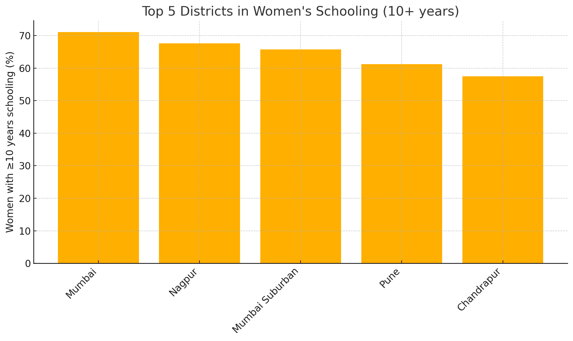
Source: Socie-economic abstract of Ahilyanagar District-2024

Fig 2: Bottom 5 Districts in Women's Schooling (10+ years)
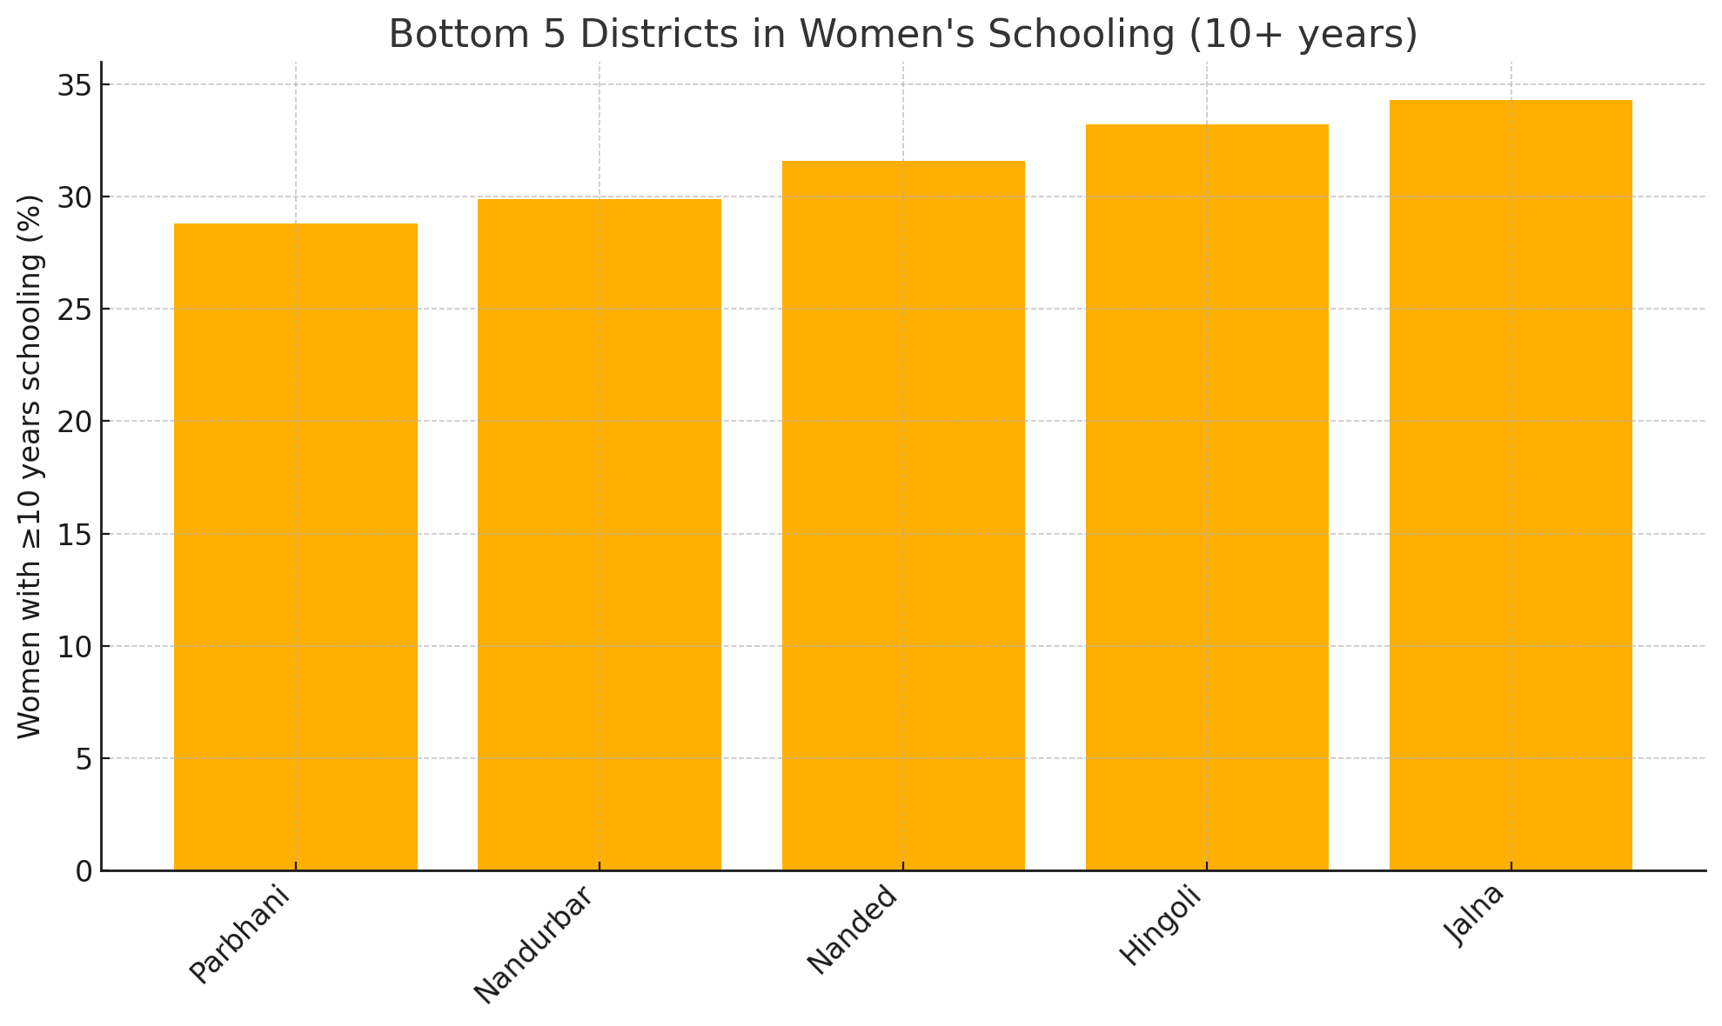
Source: Socie-economic abstract of Ahilyanagar District-2024

National analyses (NFHS-4 and 5) show a strong negative correlation between women’s education and underage marriage. In fact, states with the highest schooling have the lowest child marriage rates (Ashoka University Data Lab, 2022). Our Maharashtra data follows the same trend. Districts with higher female schooling and literacy consistently report much lower early marriage. A simple calculation from the above data yields a Pearson correlation of about –0.66 between women’s ≥10-year schooling rate and the share married before 18. This echoes the broader finding: for India overall, women’s ≥10-year schooling rose from 35.7% (NFHS-4) to 41.0% (NFHS-5) as the proportion married by 18 fell from 26.8% to 23.3% (MoHFW, 2021; IIPS & ICF, 2017). In summary, education appears to be the most significant predictor of delayed marriage in Maharashtra as well.
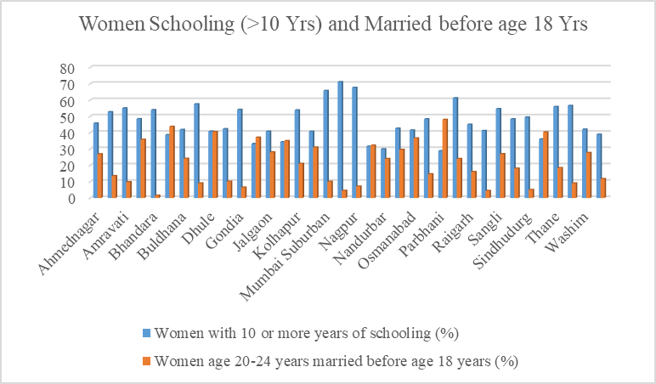
Source: Socie-economic abstract of Ahilyanagar District-2024

Fig 3: Women Schooling (>10 Yrs) and Married before age 18 Yrs

3.2 Correlations
Our analyses confirm national patterns: higher female education coexists with reduced child marriage. This aligns with national-level multivariate findings that women with higher education are dramatically less likely to marry early (BMC Public Health, 2024; Ashoka University Data Lab, 2022).
The strong positive correlation between female schooling and literacy (r ≈ 0.84) observed in this study reinforces established evidence that sustained school participation is essential for functional literacy outcomes among women (UNESCO, 2014). The negative association between women’s completion of secondary education and child marriage (r ≈ –0.66) is consistent with national and international findings, which demonstrate that each additional year of schooling significantly reduces the likelihood of marriage before 18 (Raj et al., 2019; UNICEF, 2020). Recent multilevel studies further suggest that secondary education not only delays marriage but also improves reproductive health outcomes and women’s autonomy, strengthening long-term development impacts (BMC Public Health, 2024; World Bank, 2018).
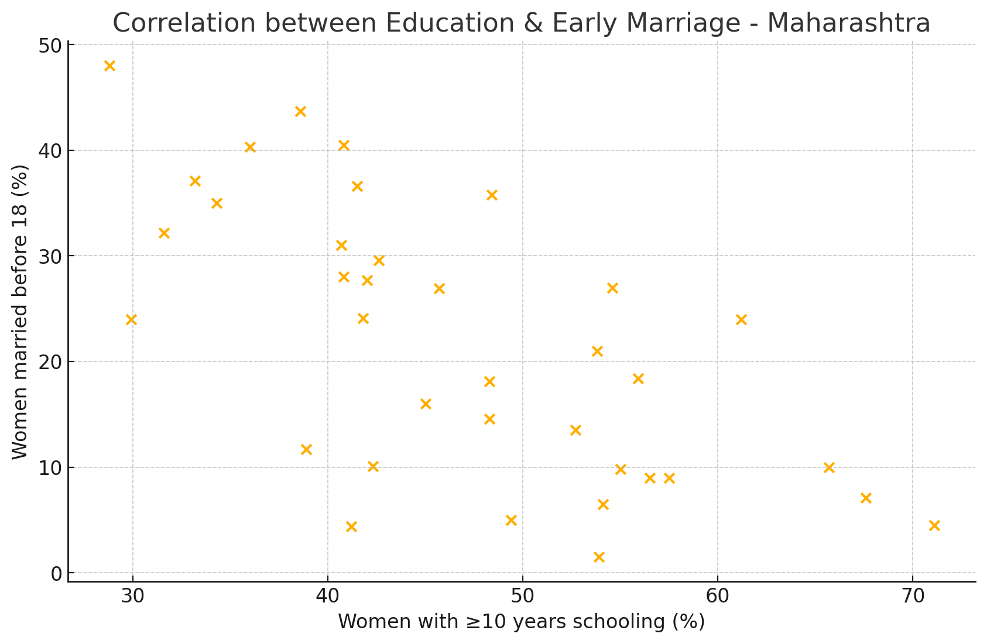
Source: Socie-economic abstract of Ahilyanagar District-2024

Fig 4: Correlation between Education & Early Marriage - Maharashtra
The sex ratio (females per 1000 males) also shows district variation. Overall Maharashtra (966) is below India (1020). Within the state, the highest ratios are in Ratnagiri (1069) and Satara (1049), while the lowest are in Nashik (913), Pune (918) and Mumbai Suburban (921). High female ratios in coastal and tribal areas often reflect male out-migration; low ratios in urban districts may reflect selective migration or demographic profiles. Sex ratio is linked to education and empowerment but can be influenced by many factors, so patterns are complex (Jha et al., 2018).
Fig 5: Correlation Matrix: Education, Literacy & Early Marriage
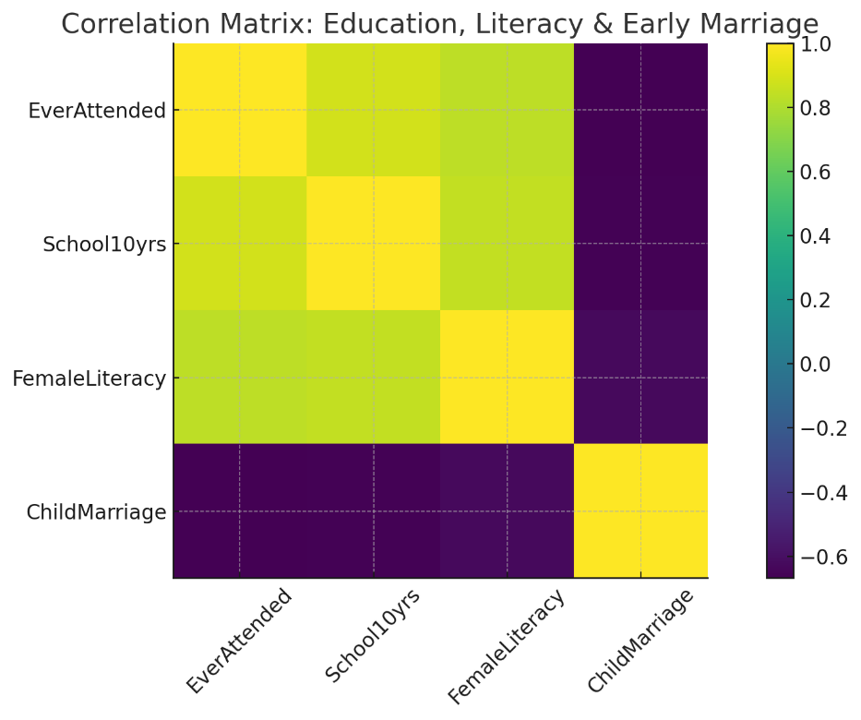
Source: Socie-economic abstract of Ahilyanagar District-2024

Fig 6: Sex ratio of the total population (females per 1,000 males)
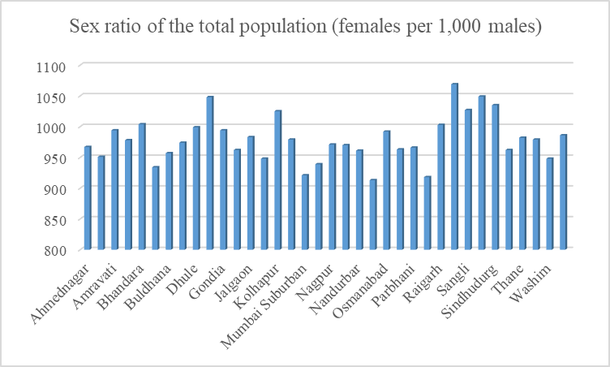
Source: Socie-economic abstract of Ahilyanagar District-2024

The sex ratio findings, while less directly linked in this analysis, also merit note. A more balanced or female-favoring ratio (as in Ratnagiri, Sindhudurg, Bhandara) may reflect patterns like male migration or better survival of girls, whereas very low ratios (Nashik, Pune) could indicate selective practices. However, because sex ratio is influenced by many social and migration factors, we focus on education and marriage as the primary concerns.

3.3 Sex Ratio and Educational Context
While sex ratio is not the primary explanatory variable in this study, its spatial variation provides important contextual insights. Higher female sex ratios in coastal and tribal districts such as Ratnagiri, Sindhudurg, and Gadchiroli may reflect male out-migration patterns, whereas lower ratios in metropolitan districts are often influenced by selective migration and urban labor markets (Jha et al., 2018). Previous demographic studies caution that sex ratio outcomes are shaped by multiple social, cultural, and economic processes and should therefore be interpreted alongside educational and marital indicators rather than independently (Desai & Vanneman, 2015).

3.4 Policy Implications
Maharashtra’s proposed “Earn and Learn” stipend program for female college students aims to increase higher education enrollment (Hindustan Times, 2024).
In policy terms, the evidence suggests that continuing to expand girls’ education – especially secondary schooling – is likely to reduce child marriage (UNICEF, 2020). Maharashtra’s overall success (state literacy 82.3% in 2011) (Government of Maharashtra, 2020) underlines progress, but district gaps remain. Programs targeting rural and disadvantaged districts (improving schools, reducing dropouts, offering scholarships) could further raise female education. Simultaneously, community campaigns and legal enforcement are needed in the high-marriage districts to change norms.
Evidence from national and international studies indicates that policies focused on expanding girls’ access to secondary and higher education are among the most effective interventions for reducing child marriage (UNICEF, 2020; World Bank, 2018). UNICEF (2020) and UNFPA (2022) to align findings with global and national policy frameworks. Scholarship schemes, conditional cash transfers, and incentives linked to school completion have demonstrated positive impacts in delaying marriage age in several Indian states (Raj et al., 2019). Maharashtra’s proposed stipend initiatives for female students align with these findings; however, targeted implementation in districts with persistently low female schooling is essential to address entrenched regional disparities (IIPS, 2021; BMC Public Health, 2024).

4 CONCLUSION
This study demonstrates that districts with higher levels of women’s schooling and literacy consistently exhibit lower prevalence of child marriage, confirming education as a decisive factor in delaying marriage among women in Maharashtra. Analysis of NFHS-5 data shows that although Maharashtra performs better than the national average in women’s education, substantial inter-district inequalities persist, with urban and economically advanced districts achieving near-universal literacy and minimal early marriage, while rural, tribal, and Marathwada districts continue to lag behind (MoHFW, 2021; IIPS & ICF, 2021). The findings clearly indicate that completion of secondary education is far more effective than basic literacy alone in reducing early marriage, as districts with higher proportions of women completing ten or more years of schooling report significantly fewer child brides (Ashoka University Data Lab, 2022). These results align with broader national evidence that education enhances women’s agency, health outcomes, and social mobility, thereby reducing vulnerability to early marriage (Desai & Vanneman, 2015; UNFPA, 2021). Consequently, strengthening access to quality secondary education—particularly in educationally backward districts—emerges as a critical strategy for addressing child marriage and advancing women’s empowerment in Maharashtra.

ACKNOWLEDGEMENTS
The author gratefully acknowledges the International Institute for Population Sciences (IIPS) and the Ministry of Health and Family Welfare (MoHFW), Government of India, for making the National Family Health Survey–5 (NFHS-5) data publicly available, which formed the basis of this study.
The author also acknowledges the use of artificial intelligence–based tools for assistance in organizing content, summarizing literature, and improving clarity of presentation. All analyses, interpretations, and conclusions are solely those of the author.
This research did not receive any specific grant from funding agencies in the public, commercial, or not-for-profit sectors. The funding agencies had no role in the study design; data collection, analysis, or interpretation; writing of the manuscript; or the decision to submit the article for publication.

DISCLAIMER (ARTIFICIAL INTELLIGENCE)
This research paper includes sections that were developed with the support of artificial intelligence (AI) tools to assist in organizing content, summarizing information, and enhancing clarity. All data used in the study originates from authentic and verified sources, primarily the National Family Health Survey (NFHS-5). The interpretations, conclusions, and final content have been reviewed and validated by the author.

REFERENCES
- Ashoka University Data Lab (CEDA). (2021). GenderStats 7: Underage marriage in India. Centre for Economic Data and Analysis, Ashoka University.
https://ceda.ashoka.edu.in/genderstats-7-underage-marriage-3/
- Ashoka University Data Lab (CEDA). (2022). GenderStats: District-level patterns of underage marriage in India. Centre for Economic Data and Analysis, Ashoka University.
- Bhardwaj, A. (2021). GenderStats 7: Underage marriage in India. CEDA, Ashoka University.
https://ceda.ashoka.edu.in/genderstats-7-underage-marriage-3/
- Desai, S., & Vanneman, R. (2015). India Human Development Survey–II (IHDS-II), 2011–12 [Data set]. Inter-university Consortium for Political and Social Research.
https://doi.org/10.3886/ICPSR36151.v2
- Dutta, S., Pal, B., Mondal, S., & Ghosh, J. (2023). Gender-specific education status after COVID-19 pandemic: A comparative study between two adjacent subdivisions of West Bengal, India. Asian Journal of Education and Social Studies, 49(4), 216–225.
https://doi.org/10.9734/ajess/2023/v49i41201
- Hindustan Times. (2025). Girls in higher education may soon get ₹2,000 per month under new scheme.
https://www.hindustantimes.com/cities/pune-news/girls-in-higher-education-may-soon-get-2-000-per-month-under-new-scheme-101755717641309.html
- International Institute for Population Sciences (IIPS), & ICF. (2021). National Family Health Survey (NFHS-5), 2019–21: India fact sheet. IIPS.
http://rchiips.org/nfhs/NFHS-5Reports/NFHS-5_INDIA_REPORT.pdf
- International Institute for Population Sciences (IIPS). (2021). NFHS-5 district fact sheets: Maharashtra. IIPS.
http://rchiips.org/nfhs/NFHS-5_FCTS/Maharashtra.pdf
- Jha, P., Kesler, M. A., Kumar, R., Ram, F., Ram, U., Aleksandrowicz, L., Bassani, D. G., Chandra, S., & Banthia, J. K. (2011). Trends in selective abortions of girls in India: Analysis of nationally representative birth histories from 1990 to 2005 and census data from 1991 to 2011. The Lancet, 377(9781), 1921–1928.
https://doi.org/10.1016/S0140-6736(11)60649-1
- Ministry of Health and Family Welfare. (2021). National Family Health Survey (NFHS-5): India fact sheet. Government of India.
https://dhsprogram.com/pubs/pdf/FR375/FR375.pdf
- Raj, A., McDougal, L., & Silverman, J. G. (2019). Associations of child marriage with health and human development outcomes in India. The Lancet Global Health, 7(8), e1028–e1038.
https://doi.org/10.1016/S2214-109X(19)30235-3
- Singh, M., Shekhar, C., & Gupta, J. (2024). Distribution and determinants of early marriage and motherhood: A multilevel and geospatial analysis of 707 districts in India. BMC Public Health, 24(1), 2844.
https://doi.org/10.1186/s12889-024-20038-2
- UNESCO. (2014). Teaching and learning: Achieving quality for all (Education for All Global Monitoring Report). UNESCO Publishing.
https://unesdoc.unesco.org/ark:/48223/pf0000225660
- UNFPA India. (2022). Child marriage in India: Key insights from NFHS-5 (Analytical Paper Series No. 1). UNFPA.
https://india.unfpa.org/sites/default/files/pub-pdf/analytical_series_1_-_child_marriage_in_india_-_insights_from_nfhs-5_final_0.pdf
- UNICEF. (2018). Child marriage: Latest trends and future prospects. United Nations Children’s Fund.
https://www.unicef.org/reports/child-marriage-latest-trends-and-future-prospects
- UNICEF. (2020). Child marriage: Latest trends and future prospects. United Nations Children’s Fund.
- Waghmare, A. (2024). Education levels in India. Data for India.
https://www.dataforindia.com/education-levels-in-india/
- World Bank Group. (2018). Missed opportunities: The high cost of not educating girls. World Bank.
https://doi.org/10.1596/978-1-4648-1206-5

