Original Research Article
Real-Time Power Distribution Transformer Monitoring Using a Wi-Fi–Based IoT System

Abstract
Wireless communication technologies provide a practical means for improving the monitoring and management of electrical distribution transformers. This study presents the design and implementation of an Internet of Things (IoT)–based system for real-time monitoring of distribution transformer parameters using a wireless local area network (WLAN). The proposed system comprises an embedded monitoring unit, a centralized web server, and a web-based client interface. The embedded unit integrates voltage and current sensing modules, a microcontroller, a Wi-Fi communication module, and a local display for on-site visualization. Acquired electrical parameters are digitized using an analog-to-digital converter and transmitted to the server through an event-driven WebSocket communication protocol. The server, implemented using a Django-based web application, supports real-time data visualization, structured data storage, and remote user management through a standard web browser interface. A prototype system was developed using an Arduino Mega 2560 microcontroller and an ESP8266 Wi-Fi module, with firmware and server applications implemented in C and Python, respectively. Experimental testing under laboratory conditions confirmed reliable real-time data transmission, accurate data logging, and effective remote monitoring capabilities. While the results demonstrate the feasibility of a low-cost, IoT-enabled monitoring solution for distribution transformers, challenges related to large-scale deployment, long-term reliability, data security, and system scalability remain and are identified as important directions for future work.
Keywords:
Distribution transformer monitoring; Internet of Things (IoT); Wireless local area network (WLAN); Real-time data acquisition; Smart power systems
1. Introduction
1.1 Background of the Study
Electric power distribution systems play a critical role in ensuring a reliable electricity supply to consumers. In Ghana, the Electricity Company of Ghana (ECG), as the primary electricity distributor, has the mandate to provide stable and quality power to its customers. Achieving this objective depends heavily on the effective monitoring and management of distribution substations, particularly distribution transformers, which constitute a vital component of the power distribution network.(Osei-Appiah & Arthur, 2022).
Currently, transformer monitoring practices largely depend on customer complaints before faults are identified. This reactive approach often results in prolonged power outages, increased supply interruption hours, and significant revenue losses. In addition, manual inspection of substations requires technicians to travel long distances to collect basic operational data such as voltage and current readings. Due to logistical constraints, some substations remain unmonitored for extended periods, sometimes until transformer failure occurs(Msane et al., 2024).
Advances in embedded systems, wireless communication, and Internet of Things (IoT) technologies present opportunities to address these challenges. Wireless monitoring systems enable real-time data acquisition and remote access to transformer operational parameters, reducing dependency on physical inspections.(Nižetić et al., 2020). This study proposes a Wi-Fi–based monitoring system using an Arduino microcontroller to provide continuous real-time monitoring of voltage and current parameters in distribution transformers.
1.2 Statement of the Problem
Distribution transformers are essential components of electrical power networks, responsible for stepping down high-voltage electricity to levels suitable for end users. Increasing electricity demand, coupled with aging infrastructure, has significantly reduced transformer lifespans. Common causes of transformer failure include overloading, overheating, feeder line faults, insulation degradation, and inadequate maintenance.
In Ghana, transformer condition assessment is predominantly based on customer feedback, resulting in delayed fault detection and slow response times. This approach negatively affects businesses and households and often leads to severe transformer damage or complete failure. Additionally, manual data logging of transformer parameters is time-consuming, costly, and prone to human error, as technicians must physically visit substations to collect readings.
Although Supervisory Control and Data Acquisition (SCADA) systems are used in some regions, they are limited by high implementation costs and restricted monitoring capabilities, particularly in capturing detailed transformer health parameters. Consequently, there is a need for a low-cost, efficient, and scalable monitoring solution that enables real-time data acquisition and remote access. This research addresses this gap by designing and implementing a distribution transformer monitoring system using wireless local area network (WLAN) technology.
1.3 Aim of the Study
The primary aim of this study is to design and implement a wireless-based system for monitoring distribution transformers over a WLAN, enabling early detection of faults and timely response to transformer outages.
1.4 Objectives of the Study
The specific objectives of the study are to:
- Design a prototype distribution transformer substation using voltage and current sensors with a circuit breaker model.
- Develop a server-side application for data reception, storage, and management.
- Implement a client system using an ESP8266 Wi-Fi module.
- Develop a user interface capable of displaying real-time transformer parameters.
- Enable remote monitoring of distribution transformers over a wireless network.
1.5 Significance of the Study
This study contributes to improving power distribution management by:
- Enabling remote monitoring of distribution substations within a networked environment.
- Allowing continuous monitoring of electrical parameters to prevent transformer damage.
- Reducing response time to transformer faults and minimizing supply interruption hours.
- Supporting efficient maintenance planning and operational decision-making.
This manuscript is important to the scientific community because it demonstrates a practical, low-cost, and scalable approach for real-time monitoring of distribution transformers using Internet of Things (IoT) and wireless communication technologies. By integrating embedded sensing, event-driven WebSocket communication, and centralized data management, the study bridges the gap between theoretical smart grid concepts and deployable monitoring solutions for real-world power distribution networks. The work contributes to ongoing research on proactive asset management and intelligent power infrastructure, particularly in regions where conventional SCADA systems are economically or logistically impractical. Moreover, the modular architecture and experimental validation provide a strong foundation for future research in advanced transformer diagnostics, predictive maintenance, and data-driven optimization of power distribution systems.

1.6 Scope of the Study
The study focuses on the development of a prototype system representing selected interfacing components of a distribution transformer. Voltage and current transformers are modeled using potentiometers, while a circuit breaker is represented using a contactor. The system is designed primarily for monitoring purposes and does not include full-scale field deployment.
1.7 Overview of Methodology
A deductive research approach was adopted. Existing literature on transformer monitoring and wireless communication systems was reviewed to establish system requirements and design principles. The proposed system was developed through hardware design, firmware programming, and software implementation. Simulation and laboratory testing were conducted to evaluate system performance, real-time data transmission, and reliability.
2. Methodology
2.1 System Architecture
The proposed distribution transformer monitoring system is designed around three main components: an embedded monitoring unit, a web server, and a web-based client interface. The embedded unit is deployed at the transformer site to acquire voltage and current measurements. These measurements are transmitted wirelessly to a centralized web server, where the data are processed, stored, and distributed to authorized users in real time. The web client provides users with access to both live and logged transformer data through standard web browsers.
Figure 1 presents the overall architecture of the proposed system, illustrating the interaction between the embedded unit, the wireless local area network (WLAN), the web server, and the client interface. This architecture enables continuous remote monitoring while minimizing the need for physical inspections.

Figure 1: System Overview Diagram

2.2 Embedded Monitoring Unit Design
The embedded monitoring unit serves as the physical interface between the distribution transformer and the monitoring system. It consists of sensor arrays for voltage and current measurement, a microcontroller for data processing, an LCD for on-site visualization, and a Wi-Fi module for wireless communication. The microcontroller utilizes its internal analog-to-digital converter (ADC) to process sensor signals before transmitting the data to the web server via a WebSocket connection.
The internal structure and functional components of the embedded unit are illustrated in Figure 2, which highlights the integration of sensing, processing, display, and communication modules.
Figure 2: System Block Diagram
2.3 Firmware Operation and Data Acquisition
The firmware of the embedded unit is designed to operate using a continuous execution loop supported by timer-driven interrupt routines. During system initialization, all hardware peripherals, including input/output ports, serial communication interfaces, and display modules, are configured. The system then enters a continuous monitoring mode in which voltage and current readings are periodically acquired, calibrated, and displayed locally.
To optimize network usage, sensor data are transmitted to the server only when changes are detected between consecutive readings. This strategy reduces redundant data transmission while preserving real-time responsiveness.
The data sampling interval $T_{s}$ determines the effective sampling frequency $f_{s}$, which is defined as
$$f_{s}= \frac{1}{T_{s}}$$
This parameter influences system responsiveness and network load, and was selected to balance real-time monitoring requirements with efficient wireless communication.
2.4 Sensor Data Calibration
The voltage and current signals acquired from the sensors are converted into digital values using the microcontroller’s analog-to-digital converter (ADC). To obtain meaningful electrical parameters, raw ADC readings are calibrated using linear scaling. The calibration process is expressed as:

$$X= \frac{A- A_{min}}{A_{max}- A_{min}} ×\left(X_{max}- X_{min}\right)+ X_{min}$$

where $X$represents the calibrated voltage or current value, $A$Denotes the raw ADC reading, $A_{min}$and $A_{max}$Are the minimum and maximum ADC values, and $X_{min}$and $X_{max}$Correspond to the minimum and maximum sensor output values. This calibration ensures an accurate representation of transformer operating parameters.
The analog-to-digital conversion process can be mathematically expressed as
$$ADC= \frac{v_{in}}{v_{ref}} ×(2^{n} -1)$$
Where $V_{in}$ is the sensor input voltage, $V_{ref}$ is the reference voltage of the microcontroller, and $n$ is the ADC resolution in bits.
The calibrated electrical parameter is then obtained using linear scaling as
$$X=m ×ADC +c$$
Where $X$ represents the measured voltage or current, and $m$ and $c$ are the calibration constants derived experimentally.
2.5 Web Server and Communication Framework
The web server functions as the central processing and data management unit of the system. It maintains WebSocket connections with embedded units to receive real-time sensor data, while simultaneously supporting HTTP connections for user access through web browsers. Received data are logged into a structured database and made available to authorized users.
Figure 3 illustrates the WebSocket-based communication flow between the embedded unit, server, and subscribed web clients. This communication framework enables efficient real-time data streaming and synchronized updates across multiple clients.
Figure 3: Program Flow for WebSocket Process
2.6 Web Client and Database Management
The web client is implemented as a browser-based interface accessible across multiple platforms, including mobile and desktop devices. Users authenticate through the server before accessing transformer data. The database is structured to store user credentials, transformer metadata, and time-stamped sensor readings, supporting both real-time visualization and historical analysis. Administrative access is restricted to authorized users, ensuring data integrity and system security.
3. Results and Discussion
3.1 Experimental Implementation and System Validation
The proposed distribution transformer monitoring framework was implemented and evaluated through an integrated hardware and software prototype designed to validate real-time sensing, wireless data transmission, and centralized monitoring capabilities. The embedded monitoring unit was assembled and operated under controlled laboratory conditions to assess its functional reliability and operational stability.(Noman et al., 2025). It should be noted that all experiments were conducted under controlled laboratory conditions using a prototype setup, and field-level operational factors such as environmental stress, network variability, and long-term aging effects were not considered in this phase of the study.

The physical implementation of the system during operation is shown in Figure 4 (Powered Transformer Module). This figure confirms the successful integration of voltage and current sensing modules, a microcontroller, a display interface, and Wi-Fi communication hardware within a compact embedded platform. The powered and operational state of the system demonstrates the feasibility of deploying low-cost, embedded monitoring units for continuous transformer surveillance.(Huang et al., 2025).
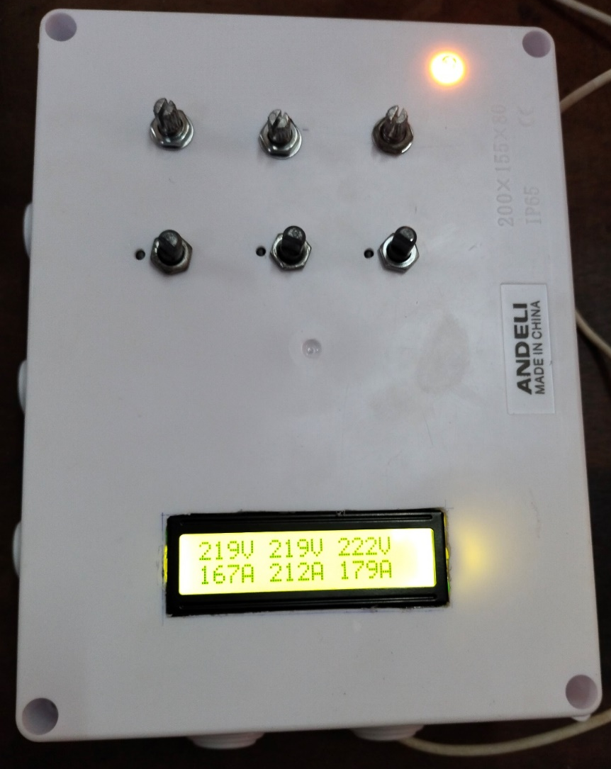
Figure 4 Powered Transformer Module
3.2 Real-Time Data Acquisition and Wireless Communication Performance
During testing, the embedded monitoring unit continuously acquired voltage and current measurements and transmitted these data to the server via a wireless local area network (WLAN) using the WebSocket protocol. The system maintained persistent communication without observable interruptions, indicating stable network performance under continuous operation.(Khalid et al., 2024)
The real-time voltage and current readings received at the server interface are presented in Figure 5 (WebSocket server displaying real-time readings just as the LCD). The close correspondence between values displayed locally on the embedded unit and those visualized at the server confirms accurate sensor calibration and reliable end-to-end data transmission. This result is particularly important for monitoring applications that require low latency and synchronized data visualization across distributed system components(Nkinyam et al., 2025).
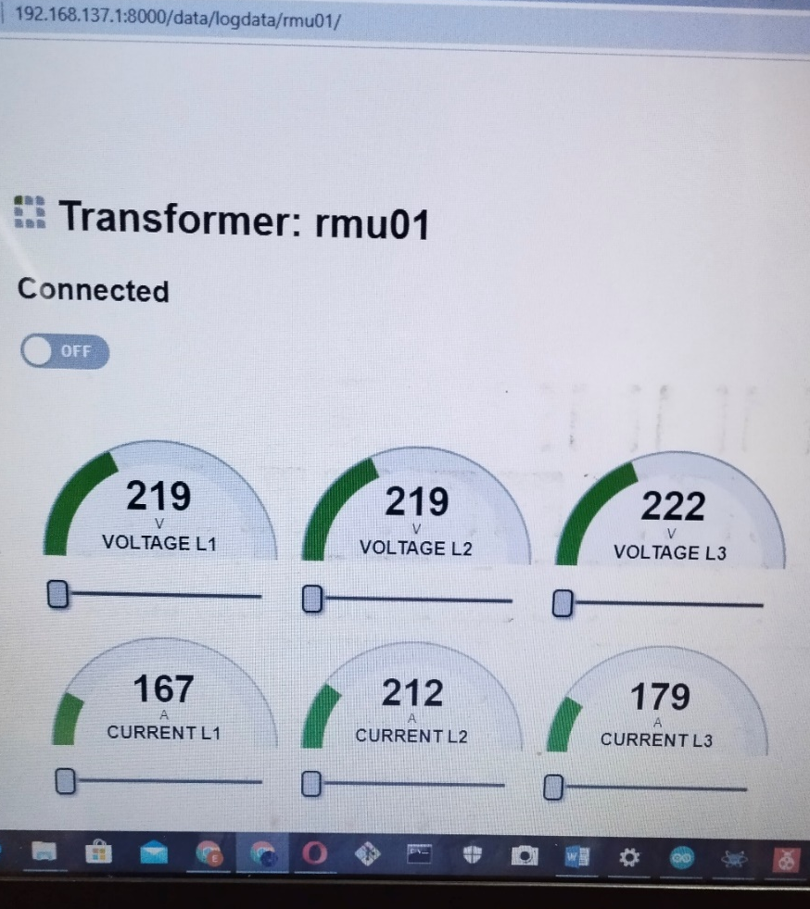
Figure 5: WebSocket server displaying real-time readings just as the LCD
3.3 Server-Side Data Logging and Multi-Client Visualization
In addition to real-time visualization, the server successfully logged incoming transformer data into a structured database with appropriate time stamps. The ability to simultaneously stream live data to connected clients while maintaining persistent data storage demonstrates the robustness of the server-side architecture(Saradopoulos et al., 2025).
The server interface shown in Figure 5 further illustrates the system’s capability to support concurrent access by multiple users without compromising data consistency. This dual functionality enables both immediate operational monitoring and retrospective analysis, which are essential for maintenance planning, fault diagnosis, and long-term asset management.
3.4 High-Impact Discussion and Infrastructure-Level Implications
The experimental results obtained in this study directly support the technical feasibility and reliability claims made for the proposed IoT-based distribution transformer monitoring system. The results obtained from the experimental evaluation highlight the practical significance of the proposed monitoring framework beyond mere functional implementation. The successful operation of the embedded unit, as evidenced by Figure 4, demonstrates that low-cost IoT-enabled devices can provide reliable, continuous monitoring of critical distribution infrastructure. This finding is particularly relevant in power distribution contexts where financial and logistical constraints limit the deployment of conventional supervisory systems.(Vicente et al., 2025).
The real-time data synchronization observed at the server interface in Figure 4 underscores the effectiveness of event-driven communication protocols such as WebSocket for infrastructure monitoring. Unlike traditional polling-based approaches, the persistent communication model employed in this system minimizes network overhead while preserving responsiveness. This characteristic is crucial when scaling monitoring solutions across multiple substations or geographically dispersed transformer assets.(Liu & Sun, 2012).
From an operational standpoint, the proposed system represents a transition from reactive to proactive asset management. Conventional transformer monitoring practices often rely on delayed fault reporting or infrequent manual inspections, leading to extended downtime and increased risk of equipment failure. In contrast, continuous real-time monitoring enables early detection of abnormal operating conditions, thereby supporting timely intervention and reducing the likelihood of catastrophic transformer damage.(Nkinyam et al., 2025; Tian et al., 2025).
At a broader system level, the architecture demonstrated in this study aligns with emerging smart grid paradigms that emphasize data-driven decision-making and digital infrastructure integration. The structured data logging capability provides a foundation for advanced analytics, including trend analysis, load profiling, and predictive maintenance. Such capabilities are increasingly recognized as critical for improving grid reliability, optimizing maintenance schedules, and extending the operational lifespan of power assets.(Yadav & Anand, 2025).
Moreover, the modular and extensible nature of the proposed framework allows for seamless integration of additional sensing parameters, such as temperature, oil level, and power quality metrics. This extensibility positions the system as a scalable platform for comprehensive transformer health assessment, rather than a narrowly scoped monitoring solution(Msane et al., 2024).
Overall, the results demonstrate that the proposed monitoring framework can contribute meaningfully to enhancing the resilience, efficiency, and sustainability of power distribution networks. By combining real-time sensing, wireless communication, and centralized data management, the system provides a practical pathway toward intelligent, scalable transformer monitoring suitable for both developing and advanced power systems.

3.5 Limitations and Practical Deployment Considerations
While the proposed monitoring framework demonstrates strong potential for real-time transformer surveillance, several limitations should be acknowledged. First, the experimental validation was conducted under controlled laboratory conditions using a prototype setup. Although this approach was sufficient to verify system functionality and communication reliability, real-world deployment may introduce additional challenges such as network instability, electromagnetic interference, and environmental stressors.
Second, the current implementation focuses primarily on electrical parameters, namely voltage and current. While these parameters are critical indicators of transformer operating conditions, a comprehensive transformer health assessment typically requires additional variables such as oil temperature, oil level, and power quality indices. The absence of these parameters limits the system’s ability to provide full diagnostic insight in its present form.
Finally, scalability considerations such as long-term data storage requirements, cybersecurity risks, and network congestion were not empirically evaluated in this study. These factors become increasingly important when deploying monitoring solutions across large distribution networks and should be addressed in future implementations.
3.6 Comparison with Conventional Transformer Monitoring Approaches
Compared to traditional transformer monitoring practices that rely on periodic manual inspections or customer-reported faults, the proposed system offers a fundamentally different operational paradigm. Conventional approaches are inherently reactive, often resulting in delayed fault detection and extended service interruptions. In contrast, the real-time monitoring capability demonstrated in this study enables continuous situational awareness and supports earlier identification of abnormal operating conditions.(Vlachou et al., 2025).
Unlike centralized Supervisory Control and Data Acquisition (SCADA) systems, which are often expensive and complex to deploy, the proposed framework leverages low-cost embedded hardware and wireless communication technologies. This cost-effective design makes the system particularly suitable for deployment in resource-constrained distribution networks, where large-scale SCADA implementation may be impractical(Aslam et al., 2025).
Furthermore, the use of event-driven WebSocket communication provides advantages over polling-based monitoring systems by reducing communication overhead and improving responsiveness. These characteristics enhance the system’s scalability and position it as a viable alternative or complement to existing transformer monitoring solutions.
3.7 Policy, Utility, and Infrastructure Implications
At the utility level, the proposed monitoring framework has the potential to support a transition toward data-driven asset management strategies. Continuous access to real-time and historical transformer data enables utilities to shift from corrective maintenance to condition-based and predictive maintenance practices. This transition can reduce unplanned outages, extend transformer lifespan, and optimize maintenance resource allocation.(Jolfaei et al., 2025).
From a policy perspective, the system aligns with broader objectives related to smart grid development, infrastructure resilience, and digital transformation of power systems. Policymakers and regulators seeking to improve power reliability, particularly in developing economies, may find value in promoting scalable, low-cost monitoring solutions such as the one presented in this study(Mahmood et al., 2024).
At the infrastructure level, the modular and extensible architecture demonstrated here provides a foundation for integrating advanced analytics, artificial intelligence–based fault prediction, and utility-wide asset management platforms. Such integration could play a significant role in enhancing grid reliability, supporting renewable energy integration, and improving overall energy system sustainability.
4. Conclusion
This study presented the design, implementation, and experimental validation of a wireless, IoT-enabled framework for real-time monitoring of distribution transformers. The consistency between the system design, implementation, and experimental results confirms that the proposed framework adheres to established electrical engineering and IoT system design principles. By integrating an embedded monitoring unit, wireless communication via a WLAN, and a centralized web-based server, the proposed system enables continuous acquisition, transmission, storage, and visualization of critical transformer electrical parameters.
The experimental results demonstrated that the system reliably acquires voltage and current data and transmits them in real time using an event-driven WebSocket communication protocol. The close agreement between locally displayed measurements and server-side visualizations confirms the accuracy of data acquisition and the robustness of the communication framework. These findings validate the feasibility of deploying low-cost embedded monitoring solutions as practical alternatives or complements to conventional transformer monitoring approaches.
Beyond technical feasibility, the study highlights the broader significance of transitioning from reactive to proactive transformer monitoring paradigms. Continuous real-time monitoring supports early detection of abnormal operating conditions, reduces dependence on manual inspections and customer fault reports, and enhances operational awareness within power distribution networks. The system architecture also provides a foundation for data-driven asset management, enabling utilities to improve reliability, reduce downtime, and optimize maintenance strategies.
Importantly, the modular and extensible nature of the proposed framework positions it as a scalable platform for future smart grid applications. By supporting structured data logging and real-time visualization, the system can be readily extended to incorporate advanced analytics, predictive maintenance algorithms, and additional sensing modalities. As such, the proposed solution contributes meaningfully to ongoing efforts aimed at improving the resilience, efficiency, and sustainability of modern power distribution infrastructure.
4.1 Future Research Directions
While the current study establishes a functional and reliable monitoring framework, several avenues for future research remain. First, large-scale field deployment across multiple substations is necessary to evaluate system performance under real operational conditions, including network variability and environmental stress factors. Second, integrating additional parameters such as transformer oil temperature, oil level, power factor, and harmonic distortion would enable a more comprehensive transformer health assessment.
Further research should also explore the incorporation of machine learning and artificial intelligence techniques for predictive fault detection and remaining-life estimation. Finally, addressing cybersecurity considerations and interoperability with existing utility asset management systems will be critical for large-scale adoption.

Disclaimer (Artificial intelligence)
Option 1:
Author(s) hereby declare that NO generative AI technologies such as Large Language Models (ChatGPT, COPILOT, etc.) and text-to-image generators have been used during the writing or editing of this manuscript.
Option 2:
Author(s) hereby declare that generative AI technologies such as Large Language Models, etc. have been used during the witing or editing of manuscripts. This explanation will include the name, version, model, and source of the generative AI technology and as well as all input prompts provided to the generative AI technology
Details of the AI usage are given below:
1.
2.
3.

REFRENCES
Aslam, M. M., Tufail, A., Gul, H., Irshad, M. N., & Namoun, A. (2025). Artificial intelligence for secure and sustainable industrial control systems—A Survey of challenges and solutions. Artificial Intelligence Review, 58(11), 349. https://doi.org/10.1007/s10462-025-11320-9
Huang, Y., Antwi-Afari, M. F., Sun, B., & Liu, J. (2025). Critical success factors for implementing self-powered wearable internet of things sensors in construction: A systematic literature review and conceptual framework. Applied Energy. https://doi.org/10.1016/j.apenergy.2025.126836
Gorjian Jolfaei, N., van der Linden, L., Chow, C. W. K., Gorjian, N., Jin, B., & Gunawan, I. (2025). Towards Smarter Infrastructure Investment: A Comprehensive Data-Driven Decision Support Model for Asset Lifecycle Optimisation Using Stochastic Dynamic Programming. Infrastructures, 10(9), 225 https://doi.org/10.3390/infrastructures10090225
Khalid, W., Jamil, M., Khan, A. A., & Awais, Q. (2024). Open-Source Internet of Things-Based Supervisory Control and Data Acquisition System for Photovoltaic Monitoring and Control Using HTTP and TCP/IP Protocols. Energies. https://doi.org/10.3390/en17164083
Liu, Q., & Sun, X. (2012). Research of Web Real-Time Communication Based on Web Socket. International Journal of Communications, Network and System Sciences, 5(12), 797–801. https://doi.org/10.4236/ijcns.2012.512083
Mahmood, M., Chowdhury, P., Yeassin, R., Hasan, M., Ahmad, T., & Chowdhury, N.-U.-R. (2024). Impacts of digitalization on smart grids, renewable energy, and demand response: An updated review of current applications. Energy Conversion and Management: X, 24, 100790. https://doi.org/10.1016/j.ecmx.2024.100790
Msane, M. R., Thango, B. A., & Ogudo, K. A. (2024). Condition Monitoring of Electrical Transformers Using the Internet of Things: A Systematic Literature Review. Applied Sciences. https://doi.org/10.3390/app14219690
Nižetić, S., Šolić, P., López-de-Ipiña González-de-Artaza, D., & Patrono, L. (2020). Internet of Things (IoT): Opportunities, issues and challenges towards a smart and sustainable future. Journal of Cleaner Production. https://doi.org/10.1016/j.jclepro.2020.122877
Nkinyam, C. M., Ujah, C. O., Asadu, C. O., Anyaka, B., & Olubambi, P. A. (2025). Development of a low-cost monitoring device for solar electric (PV) system using internet of things (IoT). Results in Engineering, 28, 107324. https://doi.org/10.1016/j.rineng.2025.107324
Noman, A. A., Baidya, P., Hossain, M. A., Dev, P., Saha, K., & Hossain, M. L. (2025). Design and Implementation IoT-Driven Distribution Transformer Health Monitoring System for the Smart Power Grid. Engineering Proceedings, 87(1). https://doi.org/10.3390/engproc2025087027
Osei-Appiah, V. K., & Arthur, J. L. (2022). Managing System Losses to Improve Energy Efficiency within the Electricity Company of Ghana (ECG) Limited. Smart Grid and Renewable Energy. https://doi.org/10.4236/sgre.2022.136008
Saradopoulos, I., Potamitis, I., Ntalampiras, S., Rigakis, I., Manifavas, C., & Konstantaras, A. (2025). Real-Time Acoustic Detection of Critical Incidents in Smart Cities Using Artificial Intelligence and Edge Networks. Sensors, 25(8), 2597. https://doi.org/10.3390/s25082597
Tian, K., Zhu, Z., Mbachu, J., Ghanbaripour, A., & Moorhead, J. (2025). Artificial intelligence in risk management within the realm of construction projects: A bibliometric analysis and systematic literature review. Journal of Innovation & Knowledge, 10(3), 100711. https://doi.org/10.1016/j.jik.2025.100711
Vicente, E. C., Silva, L. A., Fernandes, A. M. da R., & Parreira, W. D. (2025). A Structured Review of IoT-Based Embedded Systems and Machine Learning for Water Quality Monitoring. Applied Sciences, 15(21), 11719. https://doi.org/10.3390/app152111719
Vlachou, V. I., Karakatsanis, T. S., & Efstathiou, D. E. (2025). Recent Advances of Artificial Intelligence Methods in PMSM Condition Monitoring and Fault Diagnosis in Elevator Systems. Applied System Innovation, 8(5). https://doi.org/10.3390/asi8050154
Yadav, S., & Anand, R. (2025). Analysis of advancing paradigms of smart grid innovations, applications, challenges, future trends and strategic implementations. Discover Applied Sciences. https://doi.org/10.1007/s42452-025-07905-2

