Influence of Planting Geometry on Growth Dynamics of Ashok (Saraca asoca)

ABSTRACT
Ashok, Saraca asoca, is one of the evergreen medical tree species distributed in semi-evergreen to moist deciduous forests. Bark is largely used in ayurvedic treatments, especially to treat gynaecological problems. Mostly raw materials are procured from wild. Due to overharvesting, this species is ecologically disturbed, fragmented and need conservation attention. The present study aimed to understand the intervention of planting geometry/spacing on growth and biomass of Saraca asoca, a highly traded medicinal tree and species of conservation concern. Study consists of three planting geometry (spacing) viz., 1 x 1 m, 1 x 2 m and 2 x 2m planted in three different plots under large plot technique; further, plant growth was assessed for a period of eight years in Ashok. Result shows that plant height was significantly varied among three different spacing treatments at the age of 5½ year, and thereafter, spacing did not influence the plant height. Furthermore, basal diameter varied significantly among three spacing (planting geometry) at the age of 5½ to 7½ years. Among three planting geometry, plants grown at 1 x 2 m spacing resulted in height of 499.44 cm and basal diameter of 90.39 mm with height increment of 146.11 cm and basal diameter increment of 41.99 mm over a three years period. Thus, 1 x 2 m spacing is suggested for establishment of ashok plantation for bark harvesting. This information would be helpful among the scientific community while working out precision silvicultural practices for medicinal tree production systems and ex situ conservation of Ashok.
Keywords: Ashok planation, Growth pattern, Bark harvesting, Threatened species

1. INTRODUCTION
Ashok, commonly known as Sita Ashoka, Saraca asoca (Roxb.) Willd. (Family-Fabaceae), is a medicinal tree species used in Ayurvedic treatments. It is an understorey perennial evergreen tree occurs in semi-evergreen to moist deciduous forests and mostly found along the river streams. Species is distributed in Sri Lanka and the Indo-Malaysian region (Patwardhan et al., 2016; Devan & Warrier, 2021). In India, ashok trees are found in Peninsular India, comprising the Western and Eastern Ghats. Bark of ashok is having commercial value and is used to treat gynaecological problems, especially to control the excessive menstrual bleeding and hemorrhagic dysentery (Pradhan et al., 2009; Baranwal, 2014; Rathod and Ghante, 2021; Urumarudappa et al., 2023). Important phytochemicals such as epicatechin, catechin, procyanidin, leucocyanidin, linoleic acid, β-sitosterol, Quercetin, catechol, epicatechol and ceryl alcohol are found in the bark of ashok (Anon, 2014, Pradhan et al., 2009; Patwardhan et al., 2016, Bisht et al., 2017, Urumarudappa et al., 2023). Ashok based products in the form of tablets and syrups including ‘Ashokarishta’ and ‘Ashokaghrita’ are available in the market (Rathod and Ghante, 2021).
There is a demand for bark of this species from the pharmaceutical industries (Ved & Goraya, 2007). Mostly the bark of Polyalthia longifolia is used as common adulterant, apart from this, bark of Trema orientalis, Mallotus nudiflorus, Bombax ceiba, Bauhinia variegata, Caesalpinia pulcherrima, Humboldtia vahliana, Kingiodendron pinnatum are also reported to be adulterants to the bark of Ashok .
The raw materials are mostly collected from the wild. Overharvesting and exploitation of bark coupled with reproductive constraints may lead to depletion of the wild population (Ved & Goraya, 2007; Begum et al., 2014; Patwardhan et al., 2014). Earlier, this species was designated as globally ‘Vulnerable’ by IUCN, and now, it is re-categorised as Near Threatened under criteria B2ab(ii,iii) (Gole & Watve, 2025). Based on utility and conservation status, the National Medicinal Plant Board (NMPB), Government of India, prioritized this as one of the species for its commercial cultivation as well as conservation of its natural habitat (Ved & Goraya, 2007; Patwardhan et al., 2014). Studies on development of protocols for propagation, genetic variability and large-scale seedling production have been initiated (Mirgal et al., 2016; Gunaga et al., 2020). Moreover, this plant is recognized as ornamental trees and used in avenue plantation. However, information about plantation techniques, growth attributes and biomass accumulation for commercial cultivation of Ashok is scanty. In order to fulfil some of these gaps, this study was initiated to understand the growth pattern of Ashok in different planting geometry at South Gujarat condition, India.
2. MATERIALS AND METHOD
The present study was undertaken in the Forestry Farm located in the campus of Navsari Agricultural University, Navsari, Gujarat [20°55'21.18'' N and 72°54'29.24'' E with an altitude of 9 meter above the mean sea level] during 2025-26. The trial was established on an area previously managed under Acacia mangium plantation. This experimental site was covered by Eucalyptus clonal trial on one side, and casuarina plantation, multi-species plantation and farm road on other sides.
Study consisting of three different spacing (planting geometry) viz., S₁: 1 x 1 m, S₂: 1m x 2 m, and S₃: 2 x 2 m in large plot technique with three blocks separately for these three treatments (Plate 1). Total gross plot size of the experimental plot was 32 x 32 m (1024 m²) and the net plot size was 30 x 30 m (900 m²). Layout map of experimental design is provided at Plate 1.
Before field planting, soil working including ploughing was done. While planting, pit size of 30 x 30 x 30 cm was dug and vermicompost @100 g per plant was provided at the time of planting. The 15 months old seedlings raised from the nursery using seeds collected from trees located in the NAU campus were used for field planting. Planting was done during July 2015. Regular inter cultural operations like weeding, soil working and irrigation were done as per the requirements. Due to waterlogging conditions during the rainy season, there was a mortality in all the three plots; hence, casualty was replaced periodically to maintain the proper spacing in the experimental plots. During the assessment period, there were no major insect-pests or diseases recorded.
Periodic growth observation on basal diameter, height and number of branching were recorded. In this study, data on plant height and basal diameter recorded at 5½, 6½, 7½ and 8½ years are provided and results have been illustrated. Data were subjected to statistical analysis using CRD unequal replications (tree sampled in S₁=40, S₂ = 18, and S₃=10) and ANOVA was constructed using GRAPES1.0.0 statistical software. Standard error of mean (SEm), critical difference (CD) and coefficient of variation (CV) for each of the parameters was worked out. CD was used to compare the difference between two different treatments.
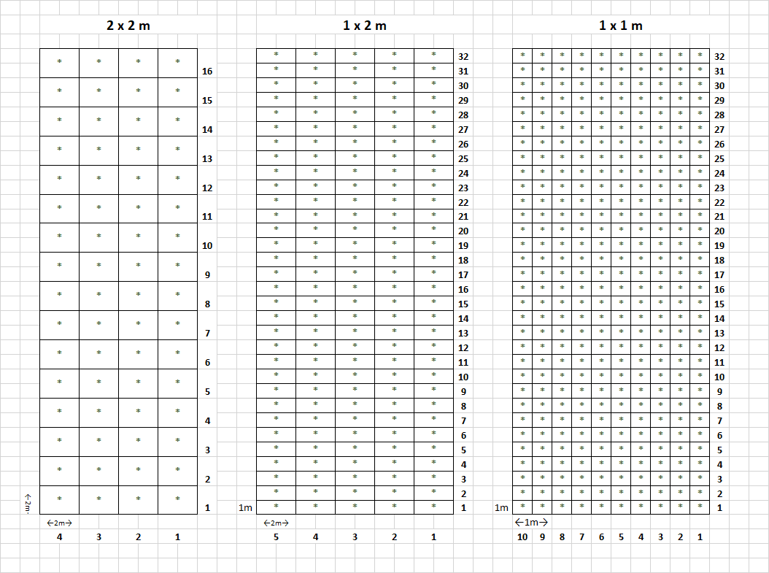
Plate 1: Layout map of Saraca asoca experiments with three spacing treatments

3. RESULTS AND DISCUSSION
Mean plant height and basal diameter of ashok plants were 25.5 cm and 6.25 mm, respectively at 8 months after planting. At 15 months after planting, the mean height of seedling was 55.5 cm and basal diameter was 8.45 mm. At 18 months, plants attained an average growth of 125 cm and basal diameter of 15.50 mm.
The overall height of plants grown in different planting geometry was 164, 217 and 191 cm and basal diameter of 25.8, 34.5 and 32.6 mm, respectively recorded in S₁, S₂ and S₃ treatments at the age of 30 months, while at 42 months age, the mean height reached to 180, 320 and 290 cm and mean basal diameter reached up to 30, 40 and 42 mm, respectively in S₁, S₂ and S₃ treatments. Plant growth recorded during 2020, the mean plant height was 257, 302 and 290 cm and mean basal diameter was 52, 59 and 59 mm, respectively in S₁, S₂ and S₃. Due to waterlogging conditions, nearly 50% mortality (51.87%, 45.31% and 59.38 % respectively in S₁, S₂ and S₃) was recorded over a period of 5 to 6 years.
Detailed growth of standing plants of ashok at the age of 5½, 6½, 7½ and 8½ years in three different planting geometry are depicted in Table 1. Statistical analysis shows that there was a significant variation in plant height among the three treatments at the age of 5½ years, where S₂ recorded the maximum height of 353.33 cm, followed by S₁ (321.75 cm); however, it was least in S₃ (273.50 cm). Further, spacing does not significantly affect the height growth at the age of 6½, 7½ and 8½ years in Ashok. In the case of basal diameter, a significant variation was recorded at the age of 5½ (37.85 to 48.40 mm), 6½ (54.23 to 63.45 mm), and 7½ (63.28 to 79.11 mm) years growth; however, it was non-significant at 8½ years age (Table 2). Among three spacing (planting geometry), maximum basal diameter was recorded in S₂, followed by S₃ and it was least in S₁ (Table 2).
The overall increment of height and basal diameter over period of three years in S₁ was 161.25 cm and 38.17 mm, respectively; while, in spacing- S₂, the overall height increment was 146.11 cm and basal diameter increment was 41.99 mm over three years period. In the case of S₃, height increment was 206.5 cm and basal diameter increment was 44.35 mm, respectively within a three years period (Fig. 1 and Fig. 2). Annual increment over a three years period for both height and basal diameter is presented in Fig. 1 and Fig. 2. The overall height and basal diameter of plants raised in the trial was 487 cm and 84.8 mm at the age of 8½ years. Study indicated that the growth of ashok planted at 1 x 2 m, followed by 1 x 1m spacing resulted in higher growth than planting geometry of 2 x 2 m.
The study demonstrates that the growth during the first 12 to 15 months is found to be slow to medium in Ashok and not much variation was noticed among the individuals belonging to three different spacing trials. This could be due to waterlogged condition during peak rainy season. After three to four years, impact of spacing on plant growth was started and height was showed significant difference among three different space geometry up to 5½ years; thereafter, the difference was non-significant since all the plants have reached almost similar height and no rapid growth was observed after the age of 6½ years. Positively, basal diameter was influenced by the spacing geometry and the spacing effect was significant up to the age of 7½ years; later, spacing did not affect the basal diameter. Being a short understory species, such a pattern is expected and data clearly shows that there is a need of canopy management by thinning plants in different plots, especially in the high-density plot, for further enhancement of growth and biomass accumulation.
Tree growth is one of the life history parameters and also a component of demographic variation in different tropical woody species. The growth response is largely dependent on biotic and abiotic factors (Rüger et al., 2011). It is reported that growth rates of tropical tree species are depending on several factors: nature of species, growing habitat including response to available resources like light, soil moisture, nutrients, and individual condition like age, size, vigor and genetic factors (Dalling et al., 2004; Herault et al., 2010; Rüger et al., 2011). Apart from these, for plantation species, planting geometry and canopy management play vital roles on growth and yield in tropical trees, especially species which are grown under orchard land use system. Cinnamon is one such commercial species cultivated for bark biomass and grown in plantation condition, and this species can be considered as model species for cultivation and sustainable harvesting of bark in Saraca asoca.
In cinnamon, generally heading back pruning at 10-12 cm above the ground after two years from establishment is practiced. It is recorded that, among the three spacing tested viz., 1.2 × 0.6 m with three plants per hill, 1.2 × 0.4 m with two plants per hill and 1.2 × 0.2 m with one plant per hill, the height, basal diameter and top diameter were found to be higher in 1.2 × 0.2 m spacing with one plant per hill in Cinnamomum verum (Aluthgamage et al., 2020). Further, Periasamy et al. (2025) suggested that closer spacing leads to increase in height and number of branches; but, girth was reduced in cinnamon. Such inference was also noticed by Ranatunga et al. (2003) in cinnamon. Higher growth achieved in closer spacing could be due to the competition among planted individuals for sunlight. Similar trend was also noticed in this study at the early stage of plant growth in closer spacing than in wider spacing; however, later stages, plants grown in 1 x 2 m spacing (planting geometry) showed better results than 2 x 2 m and 1 x 1 m spacing in Ashok. The study provides valuable ideas into the integrated spacing management while establishment of plantation of climate-resilient crops like Ashok for sustainable bark production in terms of yield and economic returns under semi-arid conditions.
4. CONCLUSION
Ashok growth pattern shows that basal diameter varied significantly among three planting geometry (spacing) at the age of 5½ to 7½ years, while plant height varied significantly among spacing treatments at 5½ year, thereafter, spacing effect on plant height was non-significant. Among three spacing, plants grown at 1 x 2 m (S₂) spacing showed a better growth. The present study helps in identifying 1 × 2 m as an ideal spacing for optimizing height and basal diameter for bark production in Ashok that provides practical exposure while establishment of plantations, so that sustainable bark harvesting can be made from conventional plantation to meet out the industrial demand; moreover, domestication limits the destruction of plants in the wild and support the species conservation. Future study pertaining to optimizing manure application, irrigation, coppicing and improved seed source are necessary for better yield in Ashok.
Table 1. Influence of planting geometry/spacing on periodic plant height (cm) growth in Ashok
Spacing Treatments | Years after planting
Spacing Treatments | 5½ | 6½ | 7½ | 8 ½
S₁ -1 x 1 m | 321.75^{ab} | 383.25 | 429.75 | 483.00
S₂ -1 x 2 m | 353.33ª | 397.50 | 426.11 | 499.44
S₃ -2 x 2 m | 273.50^{b} | 356.00 | 391.00 | 480.00
SEm (±) | 11.23 | 10.22 | 9.96 | 10.20
CD at 5% | 31.74 | NS | NS | NS
CV (%) | 21.98 | 16.88 | 14.89 | 13.25

Table 2. Influence of planting geometry/spacing on periodic basal diameter (mm) growth in Ashok
Spacing Treatments | Years after planting
Spacing Treatments | 5½ | 6½ | 7½ | 8 ½
S₁ -1 x 1 m | 43.73^{ab} | 54.23^{b} | 63.28^{b} | 81.90
S₂ -1 x 2 m | 48.40ª | 63.45ª | 79.11ª | 90.39
S₃ -2 x 2 m | 37.85^{b} | 56.93^{ab} | 76.80ª | 82.20
SEm (±) | 1.59 | 1.95 | 1.95 | 2.41
CD at 5% | 4.50 | 5.52 | 6.82 | NS
CV (%) | 22.85 | 21.69 | 21.69 | 21.97

Fig. 1. Plant height increment as influenced by three planting geometry/spacing in different growing periods in Ashok

Fig. 2. Plant basal diameter increment as influenced by three planting geometry/spacing in different growing periods in Ashok

DISCLAIMER (AI)
Author(s) hereby declare that NO generative AI technologies such as Large Language Models (ChatGPT, COPILOT, etc) and text-to-image generators have been used during writing or editing of manuscripts.

REFERENCES
- Aluthgamage, H.N., D.L.C.K. Fonseka, C.K. Beneragama & H.K.M.S. Kumarasinghe (2020). Influence of spacing and type of planting material on selected growth parameters of Cinnamomum verum J. Presl (Cinnamon): At the stage of first harvest. In: International Symposium on Agriculture and Environment, held at the Faculty of Agriculture, University of Ruhuna, Sri Lanka. pp. 39.
- Baranwal, V. (2014). Asoka: Herbal Boon to Gynaecological Problems: An Overview of Current Research. Ayurveda Journal of Health, 12(4), 58-62. https://www.researchgate.net/publication/317990000_Asoka_Herbal_Boon_to_Gynecological_Problems_An_Overview_of_Current_Research
- Begum, S. N., Ravikumar, K., & Ved, D. K. (2014). ‘Asoka’–an important medicinal plant, its market scenario and conservation measures in India. Current Science, 107(1), 26–28.
- Bisht, A., Irshad, S., Rawat, A. K. S., & Dwivedi, H. (2017). Pharmacognostical studies on Saraca asoca (Roxb.) Willd. flower. Tropical Plant Research, 4(1), 153–160. https://doi.org/10.22271/TPR.2017.V4.I1.022
- Dalling, J. W., Winter, K., & Hubbell, S. P. (2004). Variation in growth responses of neotropical pioneers to simulated forest gaps. Functional Ecology, 18(5), 725–736. https://doi.org/10.1111/j.0269-8463.2004.00868.x
- Devan, A. S., & Warrier, R. R. (2021). Saraca asoca – morphology and diversity across its natural distribution in India. International Journal of Complementary & Alternative Medicine, 14(6), 317-323. https://doi.org/10.15406/ijcam.2021.14.00578
- Gole, C.N. & Watve, A. (2025). Saraca asoca. The IUCN Red List of Threatened Species 2025: e.T34623A117646450. https://dx.doi.org/10.2305/IUCN.UK.2025-2.RLTS.T34623A117646450.en (Accessed on 22-12-2025).
- Gunaga, R. P., Mayur, M. M., Wanage, S. S., Mirgal, A. B., & Rane, A. D. (2020). Morphological variation in seed traits, germination and seedling growth in endangered medicinal tree species, Saraca asoca (Roxb.) de Wilde., from different seed sources of Konkan region, Maharashtra. Journal of Pharmacognosy and Phytochemistry, 9(4), 157-162.
- Hérault, B., Ouallet, J., Blanc, L., Wagner, F., & Baraloto, C. (2010). Growth responses of neotropical trees to logging gaps. Journal of Applied Ecology, 47, 821–831. https://doi.org/10.1111/j.1365-2664.2010.01826.x
- Mirgal, A. B., Gunaga, R. P., & Salunkhe, C. B. (2016). Seed size and its influence on germination, seedling growth and biomass in Saraca asoca (Roxb). De Wilde, critically endangered tree species of Western ghats, India. Journal of Applied and Natural Science, 8(3), 1599–1602.
- Patwardhan, A., Mhaskar, M., Pimputkar, M., Agarwal, P., Barve, N., & Vasudeva, R. (2014). Status of Saraca asoca: a species of conservation concern from Western Ghats biodiversity hot-spot. Biodivers. Watch, 3, 90-102.
- Patwardhan, A., Pimputkar, M., Mhaskar, M., Agarwal, P., Barve, N., Gunaga, R., Mirgal, A., Salunkhe, C., & Vasudeva, R. (2016). Distribution and population status of threatened medicinal tree Saraca asoca (Roxb.) De Wilde from Sahyadri– Konkan ecological corridor. Current Science, 111(9), 1500-06. https://doi.org/10.18520/cs/v111/i9/1500-1506
- Periasamy, S., Surekha, Bhat, R., & Uchoi, A. (2025). Optimization of Cinnamon Planting Density in Coconut Intercropping System in India. Scientifica, 2025(1), 6485499.
- Pradhan, P., Joseph, L., Gupta, V., Chulet, R., Arya, H., Verma, R., & Bajpai, A. (2009). Saraca asoca (Ashoka): A review. Journal of Chemical and Pharmaceutical Research, 1(1), 62-71. https://www.jocpr.com/
- Ranatunga, J., Senanayake, U. M., & Wijesekera, R. O. B. (2003). Cultivation and management of Cinnamon. In P. N. Ravindran, K. Nirmal Babu, & M. Shylaja (Eds.), Cinnamon and Cassia: The Genus Cinnamomum (1st ed., pp. 137–145). CRC Press. https://doi.org/10.1201/9780203590874
- Rathod, C.P. and M. H. Ghante (2021). Pharmacological importance of Saraca asoca: A review. Research Journal of Pharmacognosy and Phytochemistry, 13(3): 131-5. DOI: 10.52711/0975-4385.2021.00022
- Rüger, N., Berger, U., Hubbell, S. P., Vieilledent, G., & Condit, R. (2011). Growth strategies of tropical tree species: Disentangling light and size effects. Plos One, 6(9), e25330. https://doi.org/10.1371/journal.pone.0025330
- Urumarudappa, S. K. J., Rosario, S., & Sukrong, S. (2023). A comprehensive review on Saraca asoca (Fabaceae)-Historical perspective, traditional uses, biological activities, and conservation. Journal of Ethnopharmacology, 317, 116861.
- Ved, D. K., Sureshchandra, S. T., Barve, V., Srinivas, V., Sangeetha, S., Ravikumar, K., Kartikeyan, R., Kulkarni, V., Kumar, A. S., Venugopal, S. N., Somashekhar, B. S., Sumanth, M. V., Begum, N., Rani, S., Surekha, K. V., & Desale, N. (2016). FRLHT's ENVIS Centre on Medicinal Plants. FRLHT, Bengaluru. http://envis.frlht.org/
- Ved, D. K., & Goraya, G. S. (2007). Demand and supply of medicinal plants in India. NMPB, New Delhi & FRLHT, Bangalore, India, 18(85), 210-52.

