Estimation of Genetic parameters for Quantitative Traits for Genetic Variability in Black gram [Vigna mungo (L.) Hepper]

Abstract
In kharif 2024, the current study was carried out using a Randomised Block Design with three replications at the School of Agriculture, Loyola Academy Degree & P.G College. The goal of the current study was to analyse 40 Blackgram genotypes and one check (T-9). 40 Blackgram genotypes were found to differ significantly across all 13 quantitative characters examined by analysis of variance. For biological yield/plant, plant height, and harvest index, the most genotypic and phenotypic diversity was noted. For the number of branches/plant, biological yield/plant, and seed yield/plant, the highest GCV and PCV were noted.Biological yield/plant, days to maturity, seed/pod, number of branches/plant, and seed yield/plant all showed high heritability. For biological yield/plant, strong heritability and high genetic advancement as a proportion of the mean were noted.

Key Words: Black gram, GCV, PCV, Heritability, Biological yield, Quantitative characters, Genetic Variability.

Introduction:

Blackgram (Vigna mungo L. Hepper), often called mash or urdbean, is a grain legume that was domesticated from V. mungo var. silvestris (Lukoki, 1980). It has the chromosomal number 2n=2x=22 and is a member of the Leguminosae family. India is said to be the birthplace of blackgram (Zukovskiji, 1962). The nation's 1.61 million tonnes of uranium production in 2014–2015 was mostly focused in five states: Tamil Nadu, Madhya Pradesh, Maharashtra, Uttar Pradesh (UP), and Andhra Pradesh. Together, these five states produce over 70% of the nation's urd (Ministry of Agriculture, Govt. of India, 2015).

The estimations of heritability, in conjunction with genetic advance, hold greater significance than genetic advance alone for understanding the resultant impact of the most outstanding individuals (Johnson et al., 1955). Pulses are primarily grown as a rainfed crop in marginal soils, leading to suboptimal yields. Blackgram (Vigna mungo L. Hepper) is a significant short-duration legume crop grown across all agro-climatic zones of our country (Bansal et al., 2019). The predominant cultivated genotypes are of the indeterminate variety and demonstrate sensitivity to photoperiod conditions. The analysis reveals constrained genetic variability, accompanied by precise measurements for weight, protein content (%), iron content (mg/100g), zinc content (mg/100g), and seed yield per plant (g), established through the random selection of five plants from each genotype.

The primary constraints in the genetic enhancement of black-gram include limited genetic variability, the lack of a suitable ideotype for various cropping systems, a low harvest index, vulnerability to biotic and abiotic stresses, and the unavailability of high-quality seeds from improved varieties. The primary reason is the recurrent use of a restricted number of parents exhibiting a high degree of similarity in crossing programs (Jayamani and Sathya, 2023).

This source provides a cost-effective option for dietary protein, containing 24%. It contributes 76% carbohydrates. 3-5% fibre, 1.74% fat, and a significant amount of lysine are present in the vegetarian diet. This material represents the most abundant source of phosphoric acid. Exhibiting a wealth accumulation 5 to 10 times greater than that of other crops. Bean sprouts serve as a more advantageous food source for dietary protein compared to mung beans due to their extended shelf life (Mishra and Khan, 2001).

Genetic variability is essential for advancing crop breeding (Appalaswamy and Reddy, 2004). The evaluation of genetic diversity in pulses constitutes a crucial initial phase in a program aimed at enhancing crop yield. An accurate assessment of the nature and magnitude of diversity in a crop is crucial for understanding the extent of variation present for yield and its component traits. Seed yield is a multifaceted trait influenced by its primary components: the number of pods per plant, pod length, the number of seeds per pod, and the weight of 100 seeds. The enhancement of crop species necessitates an understanding of genetic variability concerning economically significant traits, as well as their heritability and genetic advancement, which is crucial for the formulation of future breeding programs.

Materials and Methods

The research trial was conducted at the School of Agriculture, the main farm of Loyola Academy. The research experiment was carried out during the Kharif season, 2024, comprising 40 genotypes of blackgram for the study of “Estimation of Genetic parameters for Quantitative traits for Genetic Variability in Blackgram [Vigna mungo (L.) Hepper]”. The list of genotypes is mentioned below in Table 1.

Table-1: List of Black Gram genotypes

Results and Discussion:
The present work, entitled “Estimation of Genetic parameters for Quantitative traits for Genetic Variability in Blackgram [Vigna mungo (L.) Hepper]” The data collected from 40 genotypes of blackgram were used to assess mean performance, analysis of variance, genetic parameters, and genetic variability.” The results are depicted below.

Table- 2. Analysis of variance for 13 different quantitative characters in 40 genotypes of blackgram.
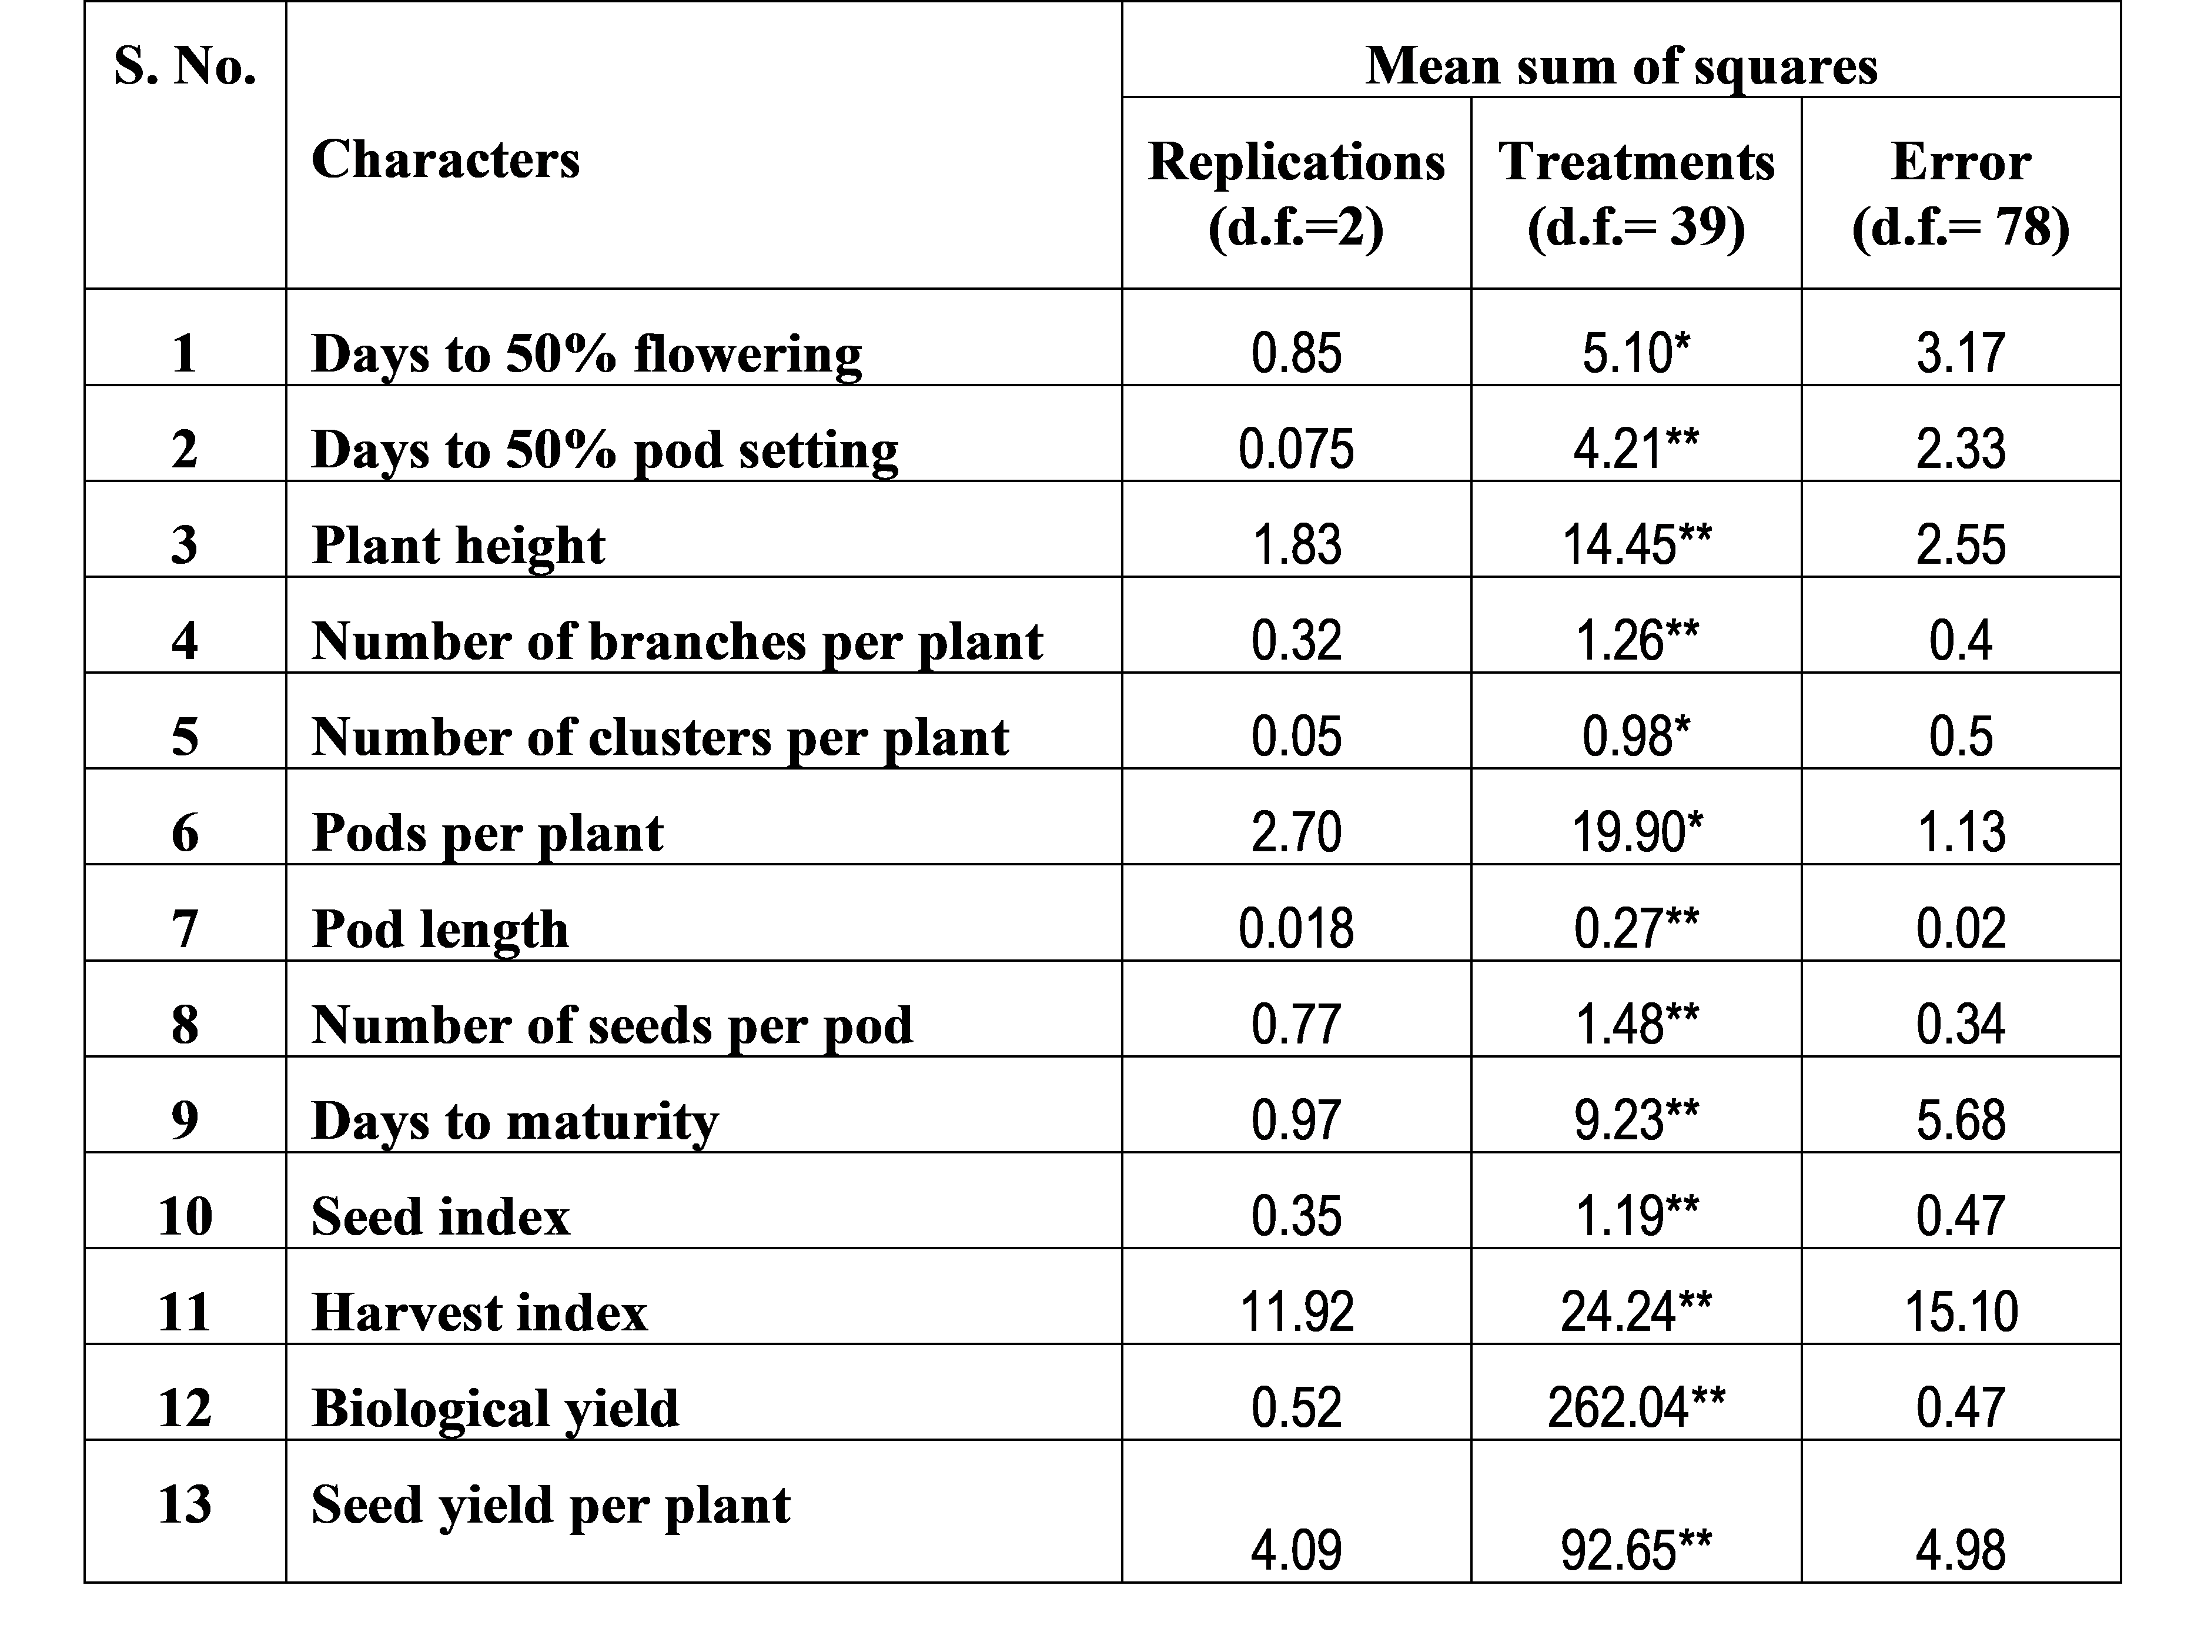

1. Analysis of Variance
The mean data for 13 characters, including days to 50% flowering, days to 50% pod setting, plant height, number of branches per plant, days to maturity, number of clusters per plant, number of pods per plant, pod length, number of seeds per pod, biological yield, harvest index, 100 seed weight, and seed yield per plant, were analysed using analysis of variance for the experimental design. Table 3a & 3b presents the mean sum of squares values for all 13 characters. The mean sum of squares for 40 genotypes was highly significant across all studied characters, indicating genetic divergence among the experimental materials. This suggests significant potential for the selection of promising lines within the current gene pool concerning yield and its components. The significant variability observed may result from the diverse sources of materials utilised and the environmental factors influencing the phenotypes.

2. Mean performance:
The mean values, coefficient of variation (C.V.), standard error of mean, critical difference (C.D.) at 5%, range of 40 genotype and 13 quantitative characters are presented in Table 3. which revealed a wide range of variation for all traits studied.
2.1.1. Days to 50% flowering
The mean performance of Days to 50% flowering varied from PGRV-99022 (46.33 days) to PLU-648 (50.66 days) with grand mean of 48.38days. The genotype PGRV-99022 (46.33 days) was earliest in terms of days to 50% flowering. The genotypeIC-250187 (51.33days), PLU-648 (50.66 days), UH82-15 (49.33 days) and UG-27 (49.00days) was found to be statistically at par withPLU-648 (50.66 days)

2.1.2 Days to 50% pod setting
Mean performance of days to 50% pod setting ranged from SHEKHAR (56.33days) to PU-31 (60.33 days) with mean value 58.30 days. The genotype was SHEKHAR (56.33 days) earliest in terms of days to 50% pod setting. The genotypes PU-31 (60.33days), PLU-277 (59.66 days), PLU-710 (58.66days), IC-56048 (57.66days), SHEKHAR-3 (56.33days) UH-82-35 (56.66days) and IPU-199-60 (56.00days), were statistically at par with PU-31 (60.33 days)
2.1.3 Days to maturity
Mean performance of days to maturity varied from UG-27 (65.00 days) to PLU-648 (72.00 days) with grand mean value 67.82days. The genotypes IPU7-3 (64.66days), P1 (65.33days), IC-56048 (66.66days), UH-82-35 (67.33days), P-31(69.66 days) and PANTH U-30 (70.00 days). Was statistically par with PLU-648 (72.00 days)
2.1.4 Plant Height (cm)
Mean performance of plant height ranged from PLU-277 (37.63cm.) to UH82-83 (63.03cm.) with grand mean value of 52.54cm. The genotypes PLU-277 (37.63cm), IPU99-16 (39.03cm), IC-140816 (42.90 cm),PLU-826(43.20cm) and PGRV-99022 (43.63cm) were identified as short plants, while other tall genotypes identified were UH82-83 (63.03cm), IC-56048(62.93cm),IC-106194 (62.83) and U-5 (60.93cm). The genotypes IPU-199-60(57.33cm), PKG U3 (58.21cm), U-9 (57.03cm), IPU7-3 (57.16 cm), PLU-648 (55.66cm), - were statistically at par with UH82-83 (63.03cm.)
2.1.5 Number of branches/plant
The mean values for number of branches per plant ranged from PLU 710 (1.33) to IPU96-1(4.0). The grand mean was registered as 2.85.More number of branches per plant was found in PLU-826 (3.66), IC56048 (3.33), PANTH U-30 (3.66), AZAD-1 (3.00) and Less number of primary branches was observed for Pant IC-250188 (1.33), PGRV-99022 (1.66), UH82-83 (2.66), U-9 (2.33). And UTTARA (2.00) the genotypes NDU5-7 (2.66), SHEKHAR-3 (2.4) and IC-91567 (2.66), were found to be statistically at par with IPU96-1 (4.0).

2.1.6 Number of clusters per plant
Number of clusters per plants had mean value ranged from UH-85-5 (3.66) to Azad-1 (6.66). The grand mean was 5.21. The genotypes IC-24129 (6.66), NDU 5-7 (5.66), IC-56048 (5.00), UH82-15 (4.66) and IC-250187 (5.33) recorded more number of clusters per plant. However, UH82-83(3.66),UG-27(4.6),U-5 (4.6), possessed less number of clusters per plant. The genotypes IC-24129 (6.6), P-1 (5.6), IPU-96-1 (5.66), were found to be statistically at par with Azad-1 (6.66).
2.1.7 Number of pods per plant
The mean performance of number of pod per plant ranged from IC-24129 (18.00) to NDU 5-7 (30.00). Grand mean for number of pods per plant was observed 25.88.The genotypes UH82-15 (19.66), IC-250187(22.00), IC-250188 (22.00), SPS-33 (23.00), and UH82-83 (23.00), were recorded very less number of pods per plant, whereas PANT U-30 (29.66), IC-106194 (29.00), U-9 (28.66), IPU 7-3 (28.00) and IPU-96-1 (27.33), had more number of pods per plant. The genotypes P-1 (27.00), PLU-648 (26.33), UH-85-5 (26.66), PU-31 (28.66), and IPU 99-16 (27.33), were found to be statistically at par with NDU 5-7 (30.00).
2.1.8 Pod length (cm).
Mean performance of pod length ranged from IC-24129 (3.69) to UG-27 (4.94cm) with grand mean of 4.48. Genotype PU-31 (4.93cm) exhibited maximum pod length. The genotypes IPU96-1 (4.72cm), AZAD-1 (4.64), UH82-15 (4.80), UH82-83 (4.70), UH-10(4.4), U-5 (4.38), IPU-199-60 (4.26cm), and IC-250190 (4.19), were statistically at par with UG-27 (4.94cm)
2.1.9.Number of seeds per pod
Number of seeds per pod ranged from PKG U3 (3.00) to T-9 (6.33) Average number of seeds per pod was recorded as 5.25. Genotypes IC-140816 (6.00), IC-250190 (6.00), SHEKHAR-3 (5.66), P-1 (5.66), and IC56048 (5.80) had more number of seeds per pod and the genotypes UH82-83(3.33), NDU 5-7 (4.00), PLU-710 (4.33), and STPN2 (4.00) had less number of seeds per pod. The genotypes IC-140816 (6.00), IC-250190 (6.00), SHEKHAR-3 (5.66), P-1 (5.66), and IC56048 (5.80) were found to be statistically at par with T-9 (6.33)
2.1.10.Biological yield / Plant (g)
Mean performance of biological yield varied from T-9 (35.2g) to NDU 5-7 (65.90g) with mean value 50.57g. Genotypes P-1 (64.85g), IPU 99-16 (63.70g), IC-250188(63.33g), IC56048 (62.70g) and STPN2 (61.43) exhibited maximum biological yield and genotypes IPU-96-1 (35.70g), U-5 (37.66g), UH-85-5 (38.00g), PLU 826 (38.33g), and U-9 (37.66g) had minimum biological yield. All the genotypes were found to be statistically different from NDU 5-7 (65.90g)
2.1.11. Harvest index (%)
The mean performance of harvest index ranged from T-9 (14.07%) to IC-140816 (41.5) with grand mean value 12.47%. The genotypes PU-31 (29.23%), PGRV-99022 (28.60%), IPU 7-3 (27.99%), AZAD-1 (23.79%), andP-1 (18.71%), exhibited maximum harvest index and genotypes STPN2 (16.42%), UH-85-5 (14.93%), IC-56048 (12.43%), and IPU 99-16 (14.18%) exhibited minimum harvest index. The genotypes, PU-31 (29.23%), PGRV-99022 (28.60%), IPU 7-3 (27.99%), AZAD-1 (23.79%), and P-1 (18.71%), which were statistically at par with the genotype IC-140816 (41.5)
2.1.12.Seed Index (g)
Data for 100 seed weight varied from PKG U3 (3.00g) to AZAD-1(5.07g) with a grand mean value of 3.86g. The genotypes P-1 (5.06g), IPU 7-3 (5.13g), UH82-15 (4.76g), UTTARA (4.28g) and IC56048 (4.06g) showed high value of 100 seed weight and genotypes IC-250188 (3.07g), UH82-83 (3.10g), IPU-96-1 (3.33g), PLU-710 (3.54g) and PLU-277 (3.33g) showed low value of 100 seed weight. GenotypeP-1 (5.06g), IPU 7-3 (5.13g), UH82-15 (4.76g), UTTARA (4.28g) and IC56048 (4.06g) were found to be statistically at par with AZAD-1(5.07g)

2.1.13.Seed yield per plant (g)
Mean performance of seed yield per plant ranged from PKG U3 (2.03g) to IC-140816 (25.96g) with a grand mean value of 8.47g. Genotypes AZAD-1 (21.46g), PU-31( 17.76g), SHEKHAR-3 (17.33g), P-1 (14.63g) and PGRV-99022 (13.83g) exhibited maximum seed yield per plant and genotypes PANTH U-30(8.33g), U-9 (8.80g), UH-10 (11.26g), IPU 7-3 (12.90g), and IC-56048 (10.33g) had minimum seed yield per plant. Genotypes AZAD-1 (21.46g), PU-31(17.76g), SHEKHAR-3 (17.33g), P-1 (14.63g) and PGRV-99022 (13.83g) were statistically at par with the genotype IC-140816 (25.96g)
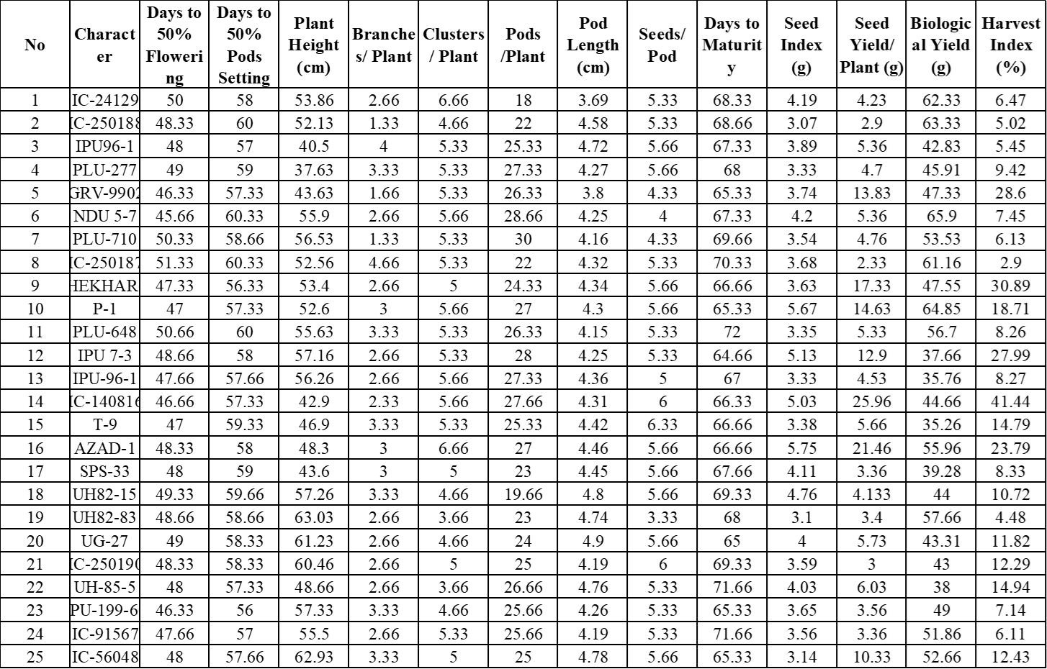
Table 3a: Mean performance of 40 black gram genotypes for 13 quantitative characters
Table 3b: Mean performance of 40 black gram genotypes for 13 quantitative characters
3.Estimation of genetic parameters
A critical aspect of crop improvement is the thorough examination of genetic variability. Variability is assessed through the estimation of mean genotypic and phenotypic variation, as well as the genotypic and phenotypic coefficients of variation, heritability, genetic advance, and genetic gain.
The environment significantly influences the expression of phenotype and genotype, as evidenced by phenotypic observations. Variability is evident in biometric parameters such as genotypic and phenotypic variation, genotypic coefficient of variation, broad-sense heritability, and genetic advance. This would significantly assist breeders in developing a selection program for the genetic enhancement of crop plants.
The estimates of variance, coefficient of variation, heritability, and genetic advance for all thirteen characters studied are summarised in Table 4, with further explanation provided in Figure 1.
Phenotypic and genotypic coefficient of variation:
The current study reveals, as shown in Table 4, that the phenotypic coefficient of variation generally exceeds the corresponding genotypic coefficient of variation, suggesting a significant environmental influence on the expression of these traits. Konda et al. (2007) reported analogous findings in black gram. Good correspondence was observed between the genotypic coefficient of variation and the phenotypic coefficient across all characters. The results of the genotypic coefficient of variation and phenotypic coefficient of variation are summarised as follows.
3.1.1 Phenotypic coefficient of variation:
A broad spectrum of phenotypic coefficient of variation (PCV) was noted for all traits, ranging from days to 50% pod setting (2.95) to seed yield per plant (63.79). The highest magnitude of PCV was observed for seed yield per plant (63.79), followed by harvest index (38), number of branches per plant (29.05), 100 seed weight (21.85), biological yield (18.51), seeds per pod (23), clusters per pod (15.68), plant height (13.25), pods per plant (10.50), days to 50% flowering (4.40), and days to maturity (12.90). This indicates a limited scope for selection aimed at improving these traits.
3.1.2 Genotypic coefficient of variation:
A broad spectrum of genotypic coefficient of variation (GCV) was noted for all traits, varying from 1.6 for days to 50% flowering to 63.79 for seed yield per plant. The highest magnitude of genotypic coefficient of variation (GCV) was observed for harvest index (66.94), followed by biological yield per plant (18.46), plant height (18.24), days to maturity (12.90), 100 seed weight (12.68), seeds per pod (11.72), clusters per plant (9.66), pods per plant (6.69), and pod length (1.60). According to Sarkar et al. (2006), the maximum GCV was recorded for branch number per plant.
3.1.3. Heritability (broad sense)
The estimates of the genotypic coefficient of variation (GCV) indicate the overall level of genotypic variability present in the material. The heritability of a trait reflects the proportion of genotypic variability that is transmitted from parents to offspring. Lush (1949) introduced the concept of broad sense heritability. This assesses the effectiveness of utilising genotypic variability in a breeding program. The genotypic variance and its components are affected by gene frequencies. The frequencies of genes vary across populations, leading to differing estimates of heritability for a specific trait in each population. Burton (1953) proposed that genetic variation, along with heritability estimates, would provide a clearer understanding of the anticipated efficiency of selection. Consequently, a trait exhibiting high genetic coefficient of variation and high heritability will be advantageous in selection programs. Table 3 presents the heritability estimates for all 13 characters.
Table 4 presents the broad-sense heritability estimates (%) for 13 studied characters, ranging from 17% to 99%. Pod length (98%), seeds per pod (85%), pods per plant (85%), seeds per pod (52%), number of primary branches per plant (37%), 100 seed weight (34%), and days to 50% pod setting (21%) exhibited high heritability. Neelawati and Govindarasu (2010) reported elevated heritability for branches per plant, biological yield, and seed yield.

3.1.4.Genetic advance
An examination of genetic advance (Table 4) indicated that it was substantial for biological yield per plant (19.18), harvest index (15.59), plant height (13.59), seed yield per plant (10.59), pods per plant (4.47), days to maturity (0.93), seeds per pod (0.91), days to 50% pod setting (0.75), days to 50% flowering (0.68), 100 seed weight (0.59), and clusters per plant (0.40).

3.1.5.Genetic advance as percent of mean
A high estimate of genetic advance as a percentage of the mean was recorded for biological yield per plant (37.93), plant height (25.87), harvest index (25.02), seed yield per pod (18.32), pods per plant (18.32), seeds per pod (17.43), pod length (13.62), clusters per plant (7.60), days to 50% pod setting (1.28), and days to maturity (1.37).

S.No. | Characters | Genotypic Coefficient of variation | Phenotypic coefficient of variation | Heritability (%) (broad sense) | Genetic advance | Genetic advance as % of mean
1 | Days to 50% flowering | 1.6 | 4.40 | 17 | 0.68 | 1.40
2 | Days to 50% pod setting | 1.36 | 2.95 | 21 | 0.75 | 1.28
3 | Days to maturity | 12.90 | 3.86 | 17 | 0.93 | 1.37
4 | Plant height | 18.24 | 13.25 | 95 | 13.59 | 25.87
5 | Number of branches/ plant | 7.61 | 29.85 | 37 | 0.65 | 22.97
6 | Cluster /plant | 9.66 | 15.68 | 24 | 0.40 | 7.60
7 | Pods /plant | 6.69 | 10.50 | 85 | 4.47 | 18.32
8 | Seed /pod | 11.72 | 16.23 | 52 | 0.91 | 17.43
9 | Pod length | 1.60 | 6.76 | 98 | 0.61 | 13.62
10 | Biological yield /plant | 18.46 | 18.51 | 99 | 19.18 | 37.93
11 | Harvest index | 66.94 | 38 | 82 | 15.59 | 25.02
12 | 100-seed weight | 12.68 | 21.85 | 34 | 0.59 | 15.55
13 | Seed yield /plant | 63.79 | 69.01 | 85 | 10.59 | 18.32
Table-4 Genetic parameters for 13 biometrical characters of 40 black gram genotypes.

Fig: 1 . Histogram depicting estimates of genetic parameters for 13 important agro-economic traits in blackgram

The genotype PGRV-99022 exhibits early flowering, as indicated by the mean performance of days to 50% flowering, along with a greater number of flowers observed at this stage. The data indicated that early flowering occurred approximately 46.33 days earlier compared to other blackgram genotypes. The genotype SHEKHAR exhibits the highest pod setting at the 50% mark in comparison to other blackgram genotypes, based on the mean performance of days to this threshold. The genotype UG-27 exhibits early maturity relative to other blackgram genotypes, as indicated by the mean performance of days to maturity. Maturity was observed for approximately 65 days in the UG-27 genotype. The mean performance for plant height (cm) was notably robust in the genotype UH-82-83, measuring 63.03 cm, in comparison to other blackgram genotypes. The mean performance for the number of branches per plant was observed, indicating that the genotype IPU96-1 exhibited a greater number of branches compared to other blackgram genotypes. The average performance for the number of clusters per plant indicated that the genotype Azad-1 formed more clusters (6.66), while the genotype UH-85-5 exhibited fewer clusters (3.66) in comparison to other blackgram genotypes. The mean performance for the character number of pods per plant indicated that the genotype NDU 5-7 exhibited the highest number of pods (30.00), while the genotype IC-24129 displayed the lowest number of pods per plant in comparison to other blackgram genotypes. The mean performance for character pod length indicated a high pod length (cm) in the genotype UG-27 (4.94), while a lower pod length was recorded in the genotype IC-24129 (3.69 cm) in comparison to other blackgram genotypes. The mean performance for the character number of seeds per pod indicated that genotype T-9 had a higher count (6.33), while genotype PKG U3 exhibited a lower count (3.00) in comparison to other blackgram genotypes. The mean performance for biological yield per plant (g) indicated that the genotype NDU 5-7 exhibited a high biological yield of 65.90 g, while the genotype T-9 demonstrated a lower yield of 35.2 g in comparison to other blackgram genotypes. The mean performance for the character harvest index (%) indicated a high harvest index percentage in the genotype IC-140816 (41.4%), while the lowest harvest index percentage was recorded in the genotype T-9 (14.07%) in comparison to other blackgram genotypes. The mean performance for the character seed index (g) was highest in the genotype AZAD-1 (5.07 g) and lowest in the genotype PKG-U3 (3.00 g) when compared to other blackgram genotypes. The mean performance for character seed yield per plant (g) indicated that the genotype IC-140816 exhibited the highest seed yield per plant at 25.96 g, while the genotype PKG U3 demonstrated the lowest seed yield per plant at 2.03 g, in comparison to other blackgram genotypes. The analysis of the phenotypic coefficient of variation revealed that the highest magnitude of PCV was observed in the number of branches per plant, seed yield per plant, biological yield per plant, and harvest index, suggesting significant variation in these traits. Sarkar et al. (2006) reported analogous findings in blackgram. The analysis of genotypic coefficient of variation revealed that the highest GCV was observed for the number of branches per plant, biological yield per plant, seed yield per plant, and harvest index, signifying substantial variation in these traits. Heritability estimates are valuable for predicting the inheritance of traits from parents to offspring. This serves as an effective measure of character transmission from parents to offspring (Falconer, 1981). Traits with significant heritability do not always result in substantial genetic improvement. Johnson and Robinson (1955) demonstrated that high heritability must be associated with high genetic advance to reach a more reliable conclusion. The breeder must exercise caution when making selections based on heritability, as it encompasses both additive and non-additive gene effects. Moderate heritability estimates were observed for days to 50% pod setting (21%), days to 50% flowering (17%), seed index (34%), and number of clusters per plant (24%) in relation to other genetic parameters of heritability. Neelawati and Govindarasu (2010) reported significant genotypic variability in the number of branches per plant, clusters per plant, biological yield, and seed yield, accompanied by high heritability and genetic advance. Heritability by itself does not reflect the extent of genetic enhancement achievable through the selection of specific genotypes. Therefore, understanding genetic advance in conjunction with heritability is highly beneficial. The phenomenon is characterised by a shift in gene frequency towards advantageous alleles under the influence of selective pressure from exercise.
Conclusion:
This study, titled “Estimation of Genetic Parameters for Quantitative Traits for Genetic Variability in Blackgram [Vigna mungo (L.) Hepper],” involved the assessment of genotypes to gather fundamental data on genetic variability, heritability, genetic advance, and genetic diversity across 13 quantitative traits. The experimental material consisted of 40 blackgram genotypes. The genotypes were assessed using a Randomised Block Design with three replications during Kharif 2024 at the School of Agriculture, Main Farm, Loyola Academy Degree and P.G. College. This document summarises the study's results and the conclusions derived from the experiment. Analysis of variance indicated that the mean sum of squares attributable to treatment was significant for all traits, demonstrating considerable genetic variability among the advanced breeding lines. This variability supports effective selection based on mean performance. The highest seed yield per plant was recorded for the genotype IC-140816 (25.96), followed by Azad-1 (21.46), SHEKHAR-3 (17.33), and PGRV-99022 (13.83). The analysis of GCV and PCV indicated that phenotypic variation exceeded genotypic coefficient of variation, suggesting an environmental influence on the expression of the studied character. Significant disparities between GCV and PCV were observed in cluster per plant, plant height, seed yield per plant, biological yield per plant, seed index, and harvest index. Heritability estimates indicated that traits such as seed index, biological yield per plant, seed yield per plant, and pods per plant exhibited high values, while days to 50% flowering were early and pod length per plant was of average length. Genetic advancements have demonstrated that traits such as plant height (cm), biological yield per plant, pods per plant, harvest index, days to 50% setting, and days to 50% flowering are significant. Genetic advancement of 5 percent of the mean indicated that traits such as seed yield per plant, plant height, biological yield per plant, clusters per plant, seed index, primary branches per plant, and harvest index are significant. The identified lines may be utilised in breeding pipelines for crop enhancement and can be disseminated in the public domain as new hybrids.

Disclaimer (Artificial intelligence)
Option 1:
Author(s) hereby declare that NO generative AI technologies such as Large Language Models (ChatGPT, COPILOT, etc.) and text-to-image generators have been used during the writing or editing of this manuscript.
Option 2:
Author(s) hereby declare that generative AI technologies such as Large Language Models, etc. have been used during the writing or editing of manuscripts. This explanation will include the name, version, model, and source of the generative AI technology and as well as all input prompts provided to the generative AI technology
Details of the AI usage are given below:
1. We declare that we have not used any AI OR CHAT GPT OR COPILOT

References :
- Appalaswamy, A. and Reddy, (2004). Stability analysis of yield in mung bean (Vigna radiata L. Wilczek) v.27(2):107-110, LEGUME RESEARCH.

- Mishra, D.K. and Khan, R.A. (2001). Stability analysis in urd bean for grain yield and associated traits. Indian Journal of Pulses Research, 14 (2): 145-147.

- Falconer, D. S., 1981. Introduction to Quantitative Genetics, Ed. 2. Longmans Green, London/New York.

- Bansal, R., Sharma, S., Tripathi, K., Gayacharan, & Kumar, A. (2019). Waterlogging tolerance in black gram [Vigna mungo (L.) Hepper] is associated with chlorophyll content and membrane integrity. Indian Journal of Biochemistry & Biophysics, 56, 81.
- Lush, J.N. (1949). Animal Breeding Plans (3rd Edn), The Collegiate Press, Iowa.
- Swamy, A. A., & Reddy, G. L. K. (2004). Genetic divergence and heterosis studies in mungbean (Vigna radiata L. Wilczek). Legume Research, 27(2), 115-118. https://indianjournals.com/journals.asp?id=100009&tid=100009&jid=100009&volume=27&issue=2&year=2004
- Burton, G. W., & DeVane, E. H. (1953). Estimating Heritability in Tall Fescue (Festuca Arundinacea) from Replicated Clonal Material. Agronomy Journal, 45(10), 478-481. https://doi.org/10.2134/AGRONJ1953.00021962004500100005X
- Johnson, H.W., Robinson, H.F., Comstock, R.F. (1955). Estimation of genetic environmental variability in soyabean. Agronomy Journal. 47: 314-318.

- Konda, C. R., Salimath, P. M., & Mishra, M. N. (2007). Genetic diversity in blackgram (Vigna mungo L. Hepper). Legume Research, 30(3), 212-214. https://arccjournals.com/journal/legume-research

- Jayamani, P. and Sathya, M. (2023). Genetic diversity in pod characters in blackgram. Legume Research. 36(3): 220- 223.
- Lukoki, L., Marechal, R., & Otoul, E. (1980). The wild ancestors of the cultivated beans Vigna radiata (L.) Wilczek and V. mungo (L.) Hepper. Bulletin du Jardin Botanique de Belgique.
- Sarkar, G., Panda, S. and Senapati, B. K. (2006). Genetic variability and character association in blackgram (Vigna mungo L.Hepper). Journal of Arid Legumes, 3 (1): 44-46.

- Neelavathi, S., & Govindarasu, R. (2010). ANALYSIS OF VARIABILITY AND DIVERSITY IN RICE FALLOW BLACKGRAM [VIGNA MUNGO (L.) HEPPER]. Legume Research, 33(3), 206-210. https://arccjournals.com/journal/legume-research

- Zhukovsky, P. M. (1962). Cultivated plants and their wild relatives. Commonwealth Agricultural Bureaux. https://openlibrary.org/books/OL20400000M/Cultivated_plants_and_their_wild_relatives
- Jardin Botanique National de Bee. 23- 3

