Growth and Income Inequality Nexus: A case study of selected Countries in South America

Abstract
Examining the complex interplay between economic growth and income inequality has traditionally been a key area of interest in economic research, albeit in developing contexts, such as South America. This study therefore attempt to examine this nexus through a panel analysis of Brazil, Colombia, Paraguay, Argentina and Uruguay. These nations have distinct economic challenge and the distribution of income, grasping these dynamics is essential for policymakers seeking balanced economic progress in the region. The study uses a panel dataset on income inequality and economic growth spanning the period 1991–2023. The income inequality was measured by the Gini Coefficient and economic growth was assessed by the real Gross Domestic product (RGDP). The negative–positive short-run nexus between the log of real gross domestic product (LNRGDP) and the log of the Gini coefficient (LNGINI), as well as the long-run relationship between economic growth and income inequality, supports the Kuznets hypothesis, which posits that as economies develop, income inequality initially increases and subsequently declines, resulting in a downward long-run relationship between inequality and economic growth in more mature economies. The findings suggest that sustained and inclusive economic growth can gradually reduce inequality, but poorly targeted government spending and rapid population growth may limit these gains. The study recommended that the policy makers in South America should ensure that policies improve the efficiency government expenditure, strengthen redistributive tax, and transfer systems are implemented.
Keywords: Inequality; Gini index; gross domestic product; government expenditure; domestic credit
INTRODUCTION
The connection between growth and income inequality is intricate and has been extensively explored, leading to all kinds of conclusions. Malliaros and Pacheco-Jaramillo (2025) emphasize how cross-country income inequality is driven by aggregate markups, demonstrating a link between high markups and income inequality. This phenomenon is particularly important when dealing with South American economies characterized by the concentration of market power. Holding all other factors constant, Halili and Rodriguez Gonzalez (2025) found that economic growth and institution quality each have contingent effects on income inequality. They contend that although economic growth may reduce inequality (as income inequality will always exist as long as there can be economic growth), strong institutions are needed to guarantee an equitable distribution of the fruits of growth. This approach is relevant especially for the cases of countries in South America, where institutional frameworks are heterogeneous and can condition the distributional outcomes of economic development.
Despite extensive research on the growth-inequality nexus, three critical gaps remain unaddressed in the South American context. First, existing studies predominantly employ cross-sectional analyses or focus on individual countries, failing to capture the heterogeneous dynamics across South American nations with varying institutional quality and development stages. Second, while the Kuznets hypothesis has been tested in various contexts, its validity in South America's unique environment—characterized by persistent inequality, commodity dependence, and frequent economic crises—remains underexplored using contemporary econometric techniques that account for cross-sectional dependence. Third, previous studies have not adequately examined the differential short-run versus long-run relationships between growth and inequality in this region, particularly using Panel ARDL methodology that can accommodate mixed orders of integration and country-specific heterogeneity.
This study makes three distinct contributions to the literature. First, it employs second-generation panel unit root tests (Pesaran CIPS, 2007) and Panel ARDL methodology to explicitly account for cross-sectional dependence among South American economies—a critical feature often overlooked in previous studies. This methodological advancement provides more reliable estimates in the presence of common shocks affecting the region. Second, by analyzing five countries (Brazil, Colombia, Paraguay, Argentina, and Uruguay) selected based on their high inequality levels and data availability, the study captures both large (Brazil, Argentina) and small (Paraguay, Uruguay) economies, offering insights into how the growth-inequality relationship varies across different economic scales and institutional contexts. Third, the study provides nuanced policy implications by distinguishing between short-run transitional effects and long-run equilibrium relationships, enabling policymakers to design phase-appropriate interventions. These contributions are particularly timely given South America's recent economic volatility and persistent inequality challenges, making the study's findings directly relevant for contemporary policy formulation in the region.

LITERATURE REVIEW
Several research has been carried out on the nexus between economic growth and income inequality. This study provides evidence of most recent literature on the debate. Halili and Rodriguez (2025) found institutional quality moderates this nexus, while Policardo and Carrera (2024) note wealth inequality acts to stifle growth in advanced economies. Batool and Sheikh (2024) connect agricultural export volatility with increased income gaps within Latin American countries (LAC). The socioeconomic progress of Uruguay in the last decades, crediting equity in growth (Tsitouras and Papapanagos 2025), showcases how sustainable progressive fiscal frameworks works. This terrain makes understanding the inequitable benefits of structural inequities and addressing them through targeted reforms in labour, education and tax policy, critical. The choice of the selected 5 countries for this study presents different policy contexts to investigate how growth-inequality processes unfold under different institutional and economic settings.
The empirical literature on the association between economic growth and income inequality illustrates the important role of market structures, institutions, and policy interventions in determining income distribution consequences. Through cross-country panel analysis, Malliaros and Pacheco-Jaramillo (2025) show that growing aggregate markups, which are indicative of concentrated market power, tend to increase income inequality. Their results highlight that a 1% increase in markups associates with a 0.3–0.5% increase in the GINI coefficient, indicating how firms’ pricing power to charge a higher markup impacts the lower income groups the most. They pinpoint progressive taxation and trade openness as mechanisms to ameliorate these effects, emphasising the importance of fiscal policy and openness in delivering more inclusive growth. This empirical rigor stands in contrast to the more qualitative focus of Chaudhary (2025), for example, who highlights systemic barriers such as colonial legacies, globalization, etc. that while valuable, do not have direct empirical support from the literature.
As observed by Halili and Rodriguez Gonzalez (2025), yet whose study is inaccessible for a thorough assessment, institutional quality appears to play a moderation role in this growth-inequality relationship. Similarly, Chaudhary (2025) addresses the need for inclusive institutions and human capital development to close inequality gaps, but the evidence put forth is largely theoretical without accompanying empirical analysis. Simultaneously, the question of how technological progress impacts inequality dynamics is debated; Elfaki and Ahmed (2024), for example, consider a technological Kuznets curve, suggesting that early technological adopters tend to increase inequality but that the eventual widespread diffusion of technology results in more inclusive growth, an argument which is not empirically validated by the studies considered.

METHODOLOGY
Scope of the Study
Using a panel data technique, this study explores the relationship between economic growth and income inequality in five selected South America countries. The selection of countries is based on it being the top 5 countries with income inequality in the region according to World bank Development Indicators (WDI 2025) availability of data, and its representativeness of the region’s economic diversity. By taking a cross-section of 5 countries over a common period, from 1991 to 2023 the panel data on income inequality, economic growth are sourced from WDI. The dependent variable is income inequality which is measured by the Gini Coefficient. The independent variable is economic growth measured by the real Gross Domestic product (RGDP).
Econometric Model Description and Specification
This study utilized an ARDL panel regression approach which can solve the problems of endogeneity and unobserved heterogeneity. To address this possible endogeneity concern, the estimations are executed using the Panel Autoregressive Distributed Lag Model (PARDL) estimator that can instrument lagged dependent variable and endogenous regressors. The Hausman test guides the model selection similarly is done by making use of fixed effects and random effects as well as Panel VECM estimates as robustness checks. This study include country and period fixed effects to absorb unobservable heterogeneity and time shocks.
Therefore, this study adopts the model of Elfaki and Ahmed (2024) to empirically examined the nexus between economic growth and income inequality. The model of Elfaki and Ahmed (2024) is given as:
GINI = F(GDP, GDP²)
Where:
GINI = Gini index
GDP = Gross Domestic Product
GDP² = Square of Gross Domestic Product.
Theoretical and Empirical Justification:
For this analysis, additional non-core variables are added to make the model more robust and realistic. They are total population, government expenditure, and domestic credit to the private sector. The data for these variables were sourced from World Bank Development Indicators (WDI 2025). The model of Elfaki and Ahmed (2024) is modified to capture the impact of these non-core variables on income equality.
Incorporating total population (POP), government expenditure (GEXP), and domestic credit to the private sector (DCPS) in the GINI model is theoretically sound since these variables have direct relevance in considering the socioeconomic factors driving the income distribution of a country. By altering labor supply and market equilibrium, population size may affect the dispersion of wages in an economy. Public spending, especially on social safety nets and education, has negative impact on income inequality, because of redistribution and human capital accumulation. Domestic credit to the private sector has the potential to either increase inequality or reduce it depending on who has access to those financial resources and investment opportunities, the quality of such loanable funds, and statistical evidence shows that a growth in credit can lead to an improvement or decrease in the Gini coefficient. For empirical justification, the model of Elfaki and Ahmed (2024) utilised GEXP, and DCPS as non-core variables in their analysis. Hence, this study adopted the same none-core variables.
This modified model of Elfaki and Ahmed (2024) is given as:
GINI = F(RGDP, POP, GEXP, DCPS)
Since RGDP, POP, and GEXP are very high in volume, they are logged in order to maintain consistency in the dataset. This also allows coefficients to be interpreted as percentages and the coefficients becomes elasticities. The econometric form of the model in natural log is given as:
LNGINI_{t} = β₀ + β₁LNRGDP_{t} + β₂LNPOP_{t} + β₃LNGEXP_{t} + β₄LNDCPS_{t} + μ_{t}

Where:
LN = Natural Logarithm
LNGINI = Natural log of Gini coefficient
LNRGDP = Natural log of real Gross Domestic Product
LNPOP = Natural log of population growth (Control Variable)
LNGEXP = Natural log government expenditures (Control Variable)
LNDCPS = Natural log of Domestic Credit to the Private Sector (% of GDP) (Control Variable)
μ_{t} = Error term
β₀ = Constant parameter
β₁-β₄ = Slope coefficients.

A priori expectation:
β₁ <0 in the short run. According to the Kuznets hypothesis, income inequality rises at the initial level of economic growth/development.
β₂ >0. The higher the population growth, the higher, the income inequality. This expectation is based on the Malthusian theory of population.
β₃ <0 The higher the government expenditures, the lower the income inequality. This expectation is based on the Keynesian aggregate demand model.
β₄ < or >0 depending on the institutional quality, access and distribution of financial credit or loanable funds.

Econometric model methodology:
The econometric model methodology of this study is based on the Panel Autoregressive Distributed Lag model (PARDL). One major rationale for the use of PARDL is that addresses endogeneity which is a common problem in macroeconomic studies and allows for mixed order of integration as well as accommodating heterogeneity. Empirical studies (Elfaki and Ahmed 2024) utilized PARDL in their study. The PARDL is given below:

Where:
Xit is Kx1 vector for all the explanatory variables of LNRGDP, LNPOP, LNGEXP, and LNDCPS.
i = 1991-2023
N = 1-5 (cross sections)
= constant
and are coefficient vectors
= fixed-effect (unobserved group dependent error)
= White noise error term.
Panel VECM:
Long-run cointegrating regression model:
LNGINI_{it} = β_{0i} + β_{1j}X_{it} + ε_{it}
Lagged residuals:
ε_{it-1} = ECT_{it-1} = LNGINI_{it} - β_{0i} - β_{1j}X_{it} - ε_{it}
ΔLNGNIit = αt +
Ɵ is the speed of adjustment.

RESULT
Preliminary Analysis
Descriptive Statistics

Table 1: Descriptive Statistics of the Variables
 | GINI | RGDP | POP | GEXP | DCPS(%GDP)
Mean | 49.7394 | 4.48E+11 | 18344457 | 1.56E+14 | 32.4916
Median | 51.0000 | 2.14E+11 | 5559386. | 3.33E+12 | 26.8791
Maximum | 60.1000 | 1.95E+12 | 52321152 | 1.10E+15 | 134.114
Minimum | 39.5000 | 1.70E+10 | 49.21507 | 3.28E+11 | 9.6825
Std. Dev. | 6.0186 | 5.60E+11 | 19258378 | 2.67E+14 | 17.7748
Skewness | -0.1684 | 1.433392 | 0.464055 | 1.897630 | 1.7385
Kurtosis | 1.7599 | 3.793294 | 1.364285 | 5.614137 | 8.5854
Jarque-Bera | 11.3522 | 60.8284 | 24.3165 | 146.0093 | 297.591
Probability | 0.0034 | 0.000 | 0.000 | 0.000 | 0.000
Sum | 8206.999 | 7.39E+13 | 3.03E+09 | 2.57E+16 | 5361.118
Sum Sq. | 414151.8 | 8.46E+25 | 1.16E+17 | 1.57E+31 | 226006.3
Sum Sq. Dev. | 5940.715 | 5.15E+25 | 6.08E+16 | 1.17E+31 | 51814.83
Observations | 165 | 165 | 165 | 165 | 165
Source: Computation done using E-views 14 (2025)
Hypothesis for Jarque-Bera test:
H₀: Normal distribution
H₁: No normal distribution.
The summary statistics suggest important trends in the data for the five South American countries. The Gini coefficient (mean: 49.74, median: 51.00) shows inequality remained high, despite political changes, comparable to trends in the region, however the range (39.50–60.10) and negative asymmetry (-0.17) indicates the average is supplied by some countries eg: Uruguay (generally lower Gini). Population growth (mean:18.3 million) has moderate spread (std. dev. : 19.3 million), but the median (5.6 million) emphasizes the smaller populations of Paraguay and Uruguay skewing the distribution. Government expenditure (GEXP) is heavily skewed (1.90) and kurtotic (5.61) with a mean ($156 trillion) massively out-scoring the median ($3.3 trillion) driven by the fiscal expansions of Argentina and Brazil. DCPS averages 32.5% of GDP but ranges widely (std. dev. : 17.77) and maximum (134.1%) when the trend of either Colombia or Brazil’s financialization is considered to have a right-skewed distribution (1.74).

Correlation Matrix
Tabel 2: Pair-wise Correlation Matrix
 | LNGINI | LNRGDP | LNPOP | LNGEXP | LNDCPS
LNGINI | 1 | 0.289 | -0.010 | 0.491 | 0.310
LNRGDP | 0.289 | 1 | 0.243 | -0.285 | 0.235
LNPOP | -0.010 | 0.243 | 1 | 0.229 | -0.367
LNGEXP | 0.491 | -0.285 | 0.229 | 1 | 0.264
LNDCPS | 0.310 | 0.235 | -0.367 | 0.264 | 1
Source: Computation done using E-views 14 (2025)
The Karl Pearson correlation matrix shows some interesting relationships between the economic indicators for the five countries. At a 0.491 correlation coefficient, LNGINI has a moderate and positive relationship with LNGEXP. The correlation coefficient of 0.289 and 0.310 depicts that there is a week positive relationship between LNGINI and LNRGDP and LNDCPS to LNGINI respectively. In contrast, the coefficient of -0.01 shows a very weak and negative relationship between LNPOP and LNGINI. Given the fact that correlation only depict size and direction of the relationship between two variables, further analysis are provided in the subsequent sections to aid hypothesis testing and policy implication.

Trend Analysis

Figure 1: Categorical trend of the Variables
Source: Computation done using E-views 14 (2025)
From the figure above, Gini coefficient of LNGINI showed a decrease trend (especially between early in the 1990s to the mid in 2000s) indicated that inequality tends to reduce but a mild increase at later stage. Real GDP (LNRGDP) shows an increase followed by steep falls through time, marking cyclical economic events for the South American countries. Population Growth Page: LNPOP is (fluctuating but upwards) while LNGEXP (Government Expenditures) increases at some points and stagnates. Finally, domestic credit to the private sector (LNDCPS) is highly variable due to differences in the level of activity in the financial sector. This provide evidence on the existence of trend in the data series.

Cross Dependence Test
Null hypothesis: Cross sectional independence
Alternate hypothesis: Cross sectional dependence.
Table 3: Test for Cross-sectional dependence
Variable | Breusch-Pagan  LM | Pesaran scaled  LM | Bias-corrected  scaled LM | Pesaran CD
Variable | Statistic | Statistic | Statistic | Statistic
LNGINI | 117.08*** | 23.94*** | 23.87*** | 10.30***
LNRGDP | 305.75*** | 66.13*** | 66.05*** | 17.48***
LNPOP | 322.52*** | 69.89*** | 69.81*** | 3.67***
LNGEXP | 401.47*** | 65.17*** | 65.1*** | 17.36***
LNDCPS | 71.53*** | 13.76*** | 13.68*** | 3.09***
Source: Computation done using E-views 14 (2025)
Where:
P<0.01 (1%) = ***
P<0.05 (5%) = **
P<0.1 (10%) = *
The cross sectional dependence result in Table 3 above depicts that each of the variables, LNGINI, LNRGDP, LNPOP, LNGEXP and LNDCPS have statistic values that are significant as shown by the asterisk sign (*) under the Breusch-Pagan LM, Pesaran scaled LM, bias-corrected scaled LM and Pesaran CD tests (all at the 1% significance level), strongly rejecting the null hypothesis of cross-sectional independence. This means that the panel data units are correlated or dependent on each other through unobserved common shocks or factors that affect all units at once (Hoyos and Sarafidis 2006, Pesaran 2021). The necessity of identifying such dependence is paramount because failure to do so can produce biased standard errors, thus leading to false inferences in panel models (Pesaran 2021). As a result, the study adopts the second-generation Pesaran CIPS (2007) unit root tests, accounting for cross-sectional dependency, leading to a more reliable econometric analysis.

Panel Unit root test
The unit root test result of Pesaran CIPS (2007) is given in the table below.
Null hypothesis: Existence of unit root
Alternative hypothesis: absence (stationarity) of data series
Table 4: Pesaran CIPS Unit Root tests
Variables | Pesaran CIPS
Variables | At level (constant and trend)  LN() | First Difference (constant)  DLN() | Order of Integration  I()
LNGINI | -2.68 | -4.43*** | I(1)
LNRGDP | -2.12 | -4.52*** | I(1)
LNPOP | -2.14 | 1.86* | I(1)
LNGEXP | -2.47 | -4.38*** | I(1)
LNDCPS | -2.13 | -2.54** | I(1)
Source: Computation done using E-views 14 (2025)
Given the Cross Sectional dependence test result, the Pesaran CIPS (2007) panel unit root test results in the table above confirm that all variables (LNGINI, LNRGDP, LNPOP, LNGEXP, LNDCPS) are non-stationary at levels and hence it can be established that all the variables become stationary after the first differences. This is evident from the test statistics at first difference showing significance at the significance level. This means that each of the variables are I(1), which is to say they have a unit root in level form but not in first differences. since the CIPS test allows for cross-sectional dependence, rejection of the null hypothesis at first difference implies that these variables are stationary and can be subjected to cointegration analysis.

PANEL REGRESSION
Cointegration test:
Null hypothesis: No cointegration mong the series
Alternate hypothesis: Existence of cointegration among the series.
Table 5: Pedroni and Kao Residual Cointegration Test
Pedroni Cointegration Test
 | Statistic
(Within-Dimension)
Panel v-Statistic | 0.84
Panel rho-Statistic | -0.04
Panel PP-Statistic | -2.24**
Panel ADF-Statistic | -3.33***
Weighted
Panel v-Statistic | 0.69
Panel rho-Statistic | 0.08
Panel PP-Statistic | -1.92**
Panel ADF-Statistic | -2.88***
(Between-Dimension)
Group rho-Statistic | 0.71
Group PP-Statistic | -2.71***
Group ADF-Statistic | -3.84***
Kao Cointegration Test | -2.23**
Source: Computation done using E-views 14 (2025)
Table 5 above provides the output of the panel cointegration tests. Given the significant statistics counted for both Pedroni as well as Kao panel cointegration tests, it can be concluded that there is cointegration in the data series. Specifically, the Panel PP-Statistic, Panel ADF-Statistic, Group PP-Statistic, and Group ADF-Statistic from the Pedroni test, that allows heterogeneity across panels, show at least one level of significance at 5%. Therefore, the null hypothesis of no cointegration is rejected. For further validation, the Kao test, which assumes homogeneity, however, also rejects the null hypothesis with a statistic value of -2.23 which is significant at 5% level.

Image 1: Optimal Lag Selection

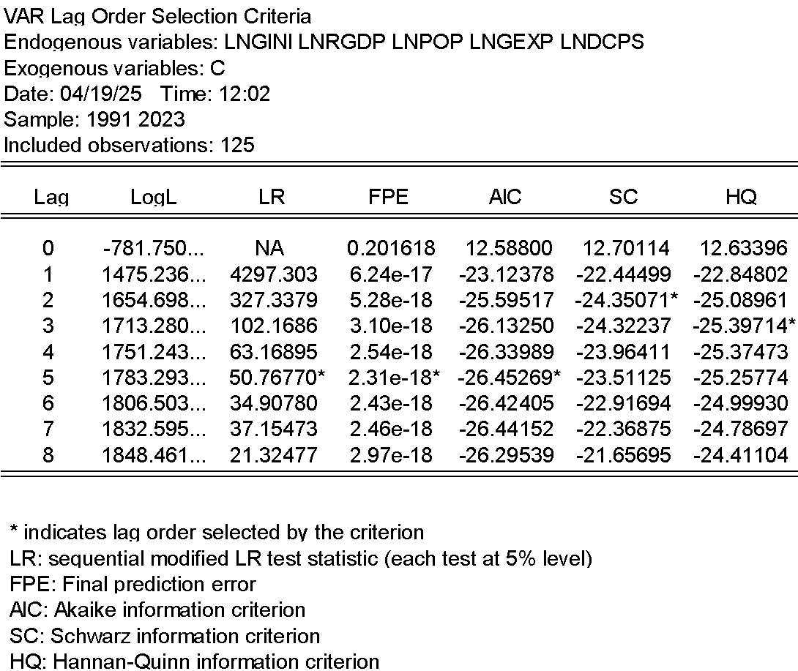
Source: Computation done using E-views 14 (2025)
Using the LR, FPE, and AIC criterion, 5 is the optimal lag length for the data series of this study. This is shown by the asterick (*) sign attached to the statistic of the criterion.
Panel ARDL
Table 6: PMG/PARDL result
Dependent Variable: LNGINI
Variable | Coefficient | P-value
Long run
LNRGDP | -0.85 | 0.00***
LNPOP | 0.48 | 0.00***
LNGEXP | 0.56 | 0.00***
LNDCPS | 0.01 | 0.48
Short run
ECM(-1) | -0.36 | 0.00***
DLNRGDP | 0.56 | 0.00***
DLNPOP | -37.53 | 0.26
DLNGEXP | -0.36 | 0.00***
DLNDCPS | -0.003 | 0.71
Cointegrating Equations for the selected Countries
Brasil
ECM(-1) | -0.79 | 0.00***
Colombia
ECM | -0.43 | 0.0013***
Paraguay
ECM(-1) | -0.25 | 0.057*
Argentina
ECM(-1) | -0.09 | 0.257
Uruguay
ECM(-1) | -0.23 | 0.021**
Source: Computation done using E-views 14 (2025)
The Panel ADRL result is given in the table above. The long-run elasticity coefficients in the PMG/panel ARDL model show the equilibrium relationships between the dependent variable and independent variables, which are typically interpreted in the context of the economic growth-inequality nexus. The elasticity coefficient of LNRGDP is -0.85 (p=0.00), indicating that a 1 percent increase in real GDP, all other factors remaining equal, will significantly decrease (p-value <0.05) the income inequality in south America in the long run by 0.85 percent. This finding is in tandem with the Kuznet hypothesis that at higher level of development, the relationship between growth and income inequality is negative. Empirically, this finding is in line with the findings of Elfaki & Ahmed (2024) and also Younsi and Bechtini (2020) who found a short run positive nexus between growth and income inequality, and a long run negative nexus between growth and income inequality for Asian economies and BRICS respectively.
The long-run elasticity coefficient of LNPOP is 0.48 (p=0.00), which means ceteris paribus, a 1% increase in population will increase inequality significantly by 0.48%. This is consistent with economic theory (Malthusian theory of population) that showed an increase in the total population would increase income inequality. The elasticity coefficient of LNGEXP is also positive and significant (0.56, p=0.00), which implies that reallocation of the spending to the poor increase inequality in the region; this might be again caused by inefficient allocation of the spending. This finding is in tandem with economic theory (Keynesian aggregate demand model) that states any increase in aggregate expenditure will lead to growth in aggregate income, aggregate demand, demand, and can reduce income inequality. The elasticity coefficient of LNDCPS is positive but insignificant (0.01, p=0.48) showing little evidence of a lasting impact of financial sector development on income inequality in South America. This finding adds more to literature on the contemporary complexity of the financial development and income inequality nexus. According to this result, income inequality is positively affected by financial development.
For the short-run analysis, the coefficient of the error correction term ECM (-1) has a value of -0.36 (p=0.00), which is negative and significant validating cointegration. This result depict an adjustment of approximately 36% of the previous period disequilibrium each period. That means it takes the system relatively little time to return to its long-run path after a shock has occurred. The elasticity coefficient of DLNRGDP is positive and significant (0.56, p=0.00) indicating that increases in GDP tend to increase inequality (possibly due to transitional poverty or potential effects where the benefits of GDP growth are focused around higher-income individuals, as postulated in the Kuznets hypothesis/transitional development models). The elasticity coefficient of DLNPOP is negative but insignificant (-37.53 p = 0.26), so this study do not establish a population short- run effect. The elasticity coefficient of DLNGEXP is negative and significant (-0.36, p=0.00); this indicates that higher levels of government expenditure lead to less inequality in the short run, a result that is not in tandem with the long-run result. DLNDCPS has a elasticity coefficient that is negative and statistically insignificant (-0.003, p=0.71), thus validating the absence of a short-run effect of the development of the financial sector.
Theoretical and Empirical Validation of Findings:
In a theoretical framework, the negative positive short-run nexus between LNRGDP and LNGINI and also the long-run relationship between economic growth (LNRGDP) and inequality supports the Kuznets hypothesis and its premise that, when economies evolve, an initial rise in inequality is observed which eventually falls back, leading to a downward long-run relationship between inequality and growth in mature economies. This also aligns with empirical results as reported in studies such as Halili and Rodriguez Gonzalez (2025) and Chaudhary (2025) that show the relationship between growth and inequality is a function of institutional quality and the stage of development of the economy, and can actually become negative in advanced economies with high growth rate.

Diagnostic Test of PARDL Estimator
Bound test for levels relationship
Null hypothesis: no levels relationship
Alternate hypothesis: levels relationship.

Table 7: Bound Test
Cross-Section | Obs | F-stat | t-stat
Brasil | 31 | 8.39 | -4.63*
Colombia | 31 | 3.56 | -1.99
Paraguay | 31 | 8.73 | -6.04*
Argentina | 31 | 3.92 | -3.17
Uruguay | 31 | 2.25 | -2.85
Sample |  | 5% | 1%
I(0) | 30 | 3.35 | 4.77
I(1) | 30 | 4.77 | 6.67
Source: Computation done using E-views 14 (2025)
The t-stat of Paraguay is higher than the bound test of I(0) and I(1) at 5% level of significance. This means that there is at least one levels relationship, this study therefore infer that levels relationship existence in the PMG/ARDL model. hence, the null hypothesis is rejected

PMG/PARDL Hausman Test
Null Hypothesis: Mean Group is similar to the PMG Estimator
Alternate Hypothesis: Mean Group is not similar to the PMG estimator
Table 8: PMG Hausman Test
Estimator | Statistics | P-value
Mean Group | 20.29 | 0.0004***
The P-value of the mean Group estimation is less than 5% hence, we reject the null hypothesis and accept the alternate concluding that the Mean Group estimator is similar to the PMG estimator.

Normality Test
Null hypothesis: Residuals are normally distributed
Alternate hypothesis: Residuals are not normally distributed.

Image 2: Jarque-Bera normality test results
The p-value of the Jarque-Bera is 0.516 and this is higher than 5% (0.05). we therefore fail to reject the null hypothesis inferring that the sample residuals are normally distributed. Hence, the PMG/PARDL is robust, and assumption of normality is validated.

Table 9: Dumitrescu Hurlin Panel Causality Tests
Null Hypothesis | W-Stat. | Zbar-stat. | Prob.
LNRGDP does not homogeneously cause LNGINI | 18.12 | 15.14 | 0.00***
LNGINI does not homogeneously cause LNRGDP | 3.51 | 1.27 | 0.20
LNPOP does not homogeneously cause LNGINI | 11.72 | 9.07 | 0.00***
LNGINI does not homogeneously cause LNPOP | 4.61 | 2.32 | 0.02**
LNGEXP does not homogeneously cause LNGINI | 14.38 | 11.60 | 0.00***
LNGINI does not homogeneously cause LNGEXP | 4.47 | 2.19 | 0.03**
LNDCPS does not homogeneously cause LNGINI | 7.27 | 4.84 | 0.00***
LNGINI does not homogeneously cause LNDCPS | 10.34 | 7.76 | 0.00***
Source: Computation done using E-views 14 (2025)
From the table above, the p-value of the null hypothesis that LNRGDP does not homogeneously cause LNGINI is 0.00 and this is less than 5%. Hence, we reject the null and infer that RGDP does homogeneously cause GINI in the selected countries. Also, the p-value of the null hypothesis that LNGINI does not homogeneously cause LNRGDP is 0.204 and is higher than 5%. Hence, we fail to reject the null and infer that there is unidirectional causality between RGDP and GINI and it runs from RGDP to GINI only and not from LNGINI to LNRGDP. From the P-values of the causal nexus between LNPOP and GINI, LNGEXP and LNGINI, and LNDCPS and LNGINI, there is a bi-directional causality among the pairs. That is, LNPOP homogeneously cause LNGINI and vice versa. Also, LNGEXP homogeneously cause LNGINI and vice versa. Finally, LNDCPS homogeneously cause LNGINI and vice versa.

ROBUSTNESS TESTS
Here, the Fixed effect (FE), Random Effect (RE), Panel VECM as robustness check. The Hausman test is utilised to determine the most efficient model between FE and RE. however, FE based on literature is often considered most efficient.
Table 10: Fixed Effect model (FE)
Dependent Variable: LNGINI
Variable | Coefficient | T-stat | P-value
C | 6.724 | 4.15 | 0.00***
LNRGDP | -0.092 | -0.54 | 0.59
LNPOP | -0.177 | -2.503 | 0.014**
LNGEXP | 0.066 | 0.444 | 0.658
LNDCPS | 0.013 | 0.926 | 0.356
Source: Computation done using E-views 14 (2025)
The Fixed Effect (FE) estimation results for determinants of income inequality (LNGINI) in South America are reported in Table 10 above. The constant (C) parameter is meaningful and represents existing inequality. For the explanatory variables, population size (LNPOP) is the only statistically-significant predictor (p=0.014) of income inequality in this model, and the relationship is negative (as population increases, income equality increases). Other variables such as real GDP (LNRGDP), government expenditure (LNGEXP) and domestic credit (LNDCPS) are insignificant since their p-values are higher than 10%. The FE model is appropriate in this case as it accounts for unobserved, time-invariant differences across entities (e.g., countries, regions) which isolates the impact of the included variables on income inequality and limits omitted variable bias.

Table 11: Random Effect model (RE)
Dependent Variable: LNGINI
Variable | Coefficient | T-stat | P-value
C | 2.81 | 26.18 | 0.000***
LNRGDP | 0.019 | 6.071 | 0.000***
LNPOP | -0.02 | -13.55 | 0.000***
LNGEXP | 0.036 | 21.39 | 0.000***
LNDCPS | -0.06 | -7.49 | 0.000***
Source: Computation done using E-views 14 (2025)
Table 11 above shows the output of the Random Effects (RE) model. The results show a highly significant correlation (p < 0.01) with LNRGDP (coefficient = 0.019) and LNGEXP (coefficient = 0.036) leading to more income inequality, and LNPOP (coefficient = -0.02) and LNDCPS (coefficient = -0.06) leading to decreased income inequality. Here the random effects model is provided because it accommodate the common issue of the unobserved heterogeneity which arises when we have a panel set of data of several entities

Table 12: Hausman Test
Null hypothesis: RE model is appropriate
Alternate Hypothesis: FE model is appropriate.
Variable | Chi-sq Statistic | Prob.
Cross-section random | 230.78 | 0.000***
Source: Computation done using E-views 14 (2025)
The Hausman test in Table 12 above depict that the p-value of the Chi-sq statistic is 0.000 and it is less than 5%. Hence, the null hypothesis is rejected and it can be concluded that the FE model is preferred and is the better and efficient estimator over the random effects model.

Table 13: Panel VECM
Dependent Variable: LNGINI
Variable | Coefficient | t-statistic
Long run
LNRGDP(-1) | -0.022 | -2.93**
LNPOP(-1) | 0.023 | 7.41***
LNGEXP(-1) | -0.033 | -6.20***
LNDCPS(-1) | 0.130 | 4.21***
Error Correction
ECM(-1) | 0.02 | 0.413
Source: Computation done using E-views 14 (2025)
The Panel VECM results are presented in Table 13 above. It depicts that there are long-run relationships between economic growth, population, government expenditure, domestic credit, and income inequality (LNGINI). In particular, higher economic growth (LNRGDP) and government expenditure (LNGEXP) correspond with reduced inequality, as indicated by their negative coefficients. By contrast, DCPS and POP leads to higher inequality as denoted by positive coefficients. The error correction term (ECM) is positive (not in tandem with economic theory) not as expected. In addition, it is not insignificant, indicating a weak short-run adjustment towards equilibrium.
The long run coefficients from the PARDL, VECM, and Fixed effect vary significantly.

POLICY IMPLICATION AND CONCLUSION
The Panel ARDL and causality tests have several policy implications. The findings revealed that a commitment to sustained and inclusive economic growth can open up pathways to gradual reductions in inequality over time. However, the findings also include a warning that the benefits of growth may be short lived and uneven, and that poorly targeted government spending and rapid population growth can outweigh gains in equality and equity. The policy makers in South America should ensure that policies improve the efficiency government expenditure, strengthen redistributive tax, and transfer systems are implemented. And that growth strategies are inclusive especially in the early boom stages of the economic cycle. The high levels of inequality that still persist in the region, even in periods of strong growth, highlight the need to utilized structural reforms to strengthen the distributive capacity of the state, improve labour market institutions and tackle the ground-level causes of regressive fiscal policies. These redistributive measures, coupled with macroeconomic growth, give South American countries the opportunity to have a better economic performance based on equity.
For the smaller economies of Paraguay and Uruguay, the key should be targeted development programs that would hasten the path away from short-run inequality spikes toward long-run equality benefits. In particular, Colombia , where the post-conflict environment presents a unique challenge to delivering shared prosperity, it should develop inclusive growth policies as tools to address those forces related to markets. This will expand net economic growth, while redistributing the gains from growth among all socio-economic groups.

Disclaimer (Artificial intelligence)

Author(s) hereby declare that NO generative AI technologies such as Large Language Models (ChatGPT, COPILOT, etc.) and text-to-image generators have been used during the writing or editing of this manuscript.

REFERENCES
Alpağut, S. (2025) The Relationship between Income distribution, inflation and economic Growth: examining the asymmetric relationship based on the Kuznets Hypothesis with Fourier functions. ekonomi politika ve finans araştirmalari dergisi 9(4), 656-677.
Aydoğan, H. and Yıldırım, H. (2025) Effects of productivity, R&D and income inequality on economic growth: an empirical estimation using panel data. Verimlilik Dergisi 59(1), 47-60.
Batool, S. and Sheikh, M. R. (2024) Analysing the role of food security, agricultural exports and income inequality in shaping economic growth trajectories in developing countries. Journal of Contemporary Macroeconomic Issues 5, 91-106.
Bola-Boongo, E., Kitoko Asenga, J. and Bahati, M. (2025) Trade openness, income inequality and economic growth in the Democratic Republic of Congo. HAL.
Chaudhary, V. (2025) Bridging the Gap: Exploring Inequality, Economic Growth, and Inclusion.
De Hoyos, R. E. and Sarafidis, V. (2006) Testing for cross-sectional dependence in panel-data models. The stata journal 6(4), 482-496.
Elfaki, K. E. and Ahmed, E. M. (2024) Testing technological Kuznets curve implications on achieving sustainable development goal 10 in seven Asian countries. technological forecasting and social change 209, 123785.
Gai, A. M., Purwati, S., Violin, V. and Ibrahim, M. M. (2024) The application of plural panelist synthesis method in identifying determinant factors that influence economic growth. jurnal sistim informasi dan teknologi, 18-22.
Halili, B. L. and Rodriguez Gonzalez, C. (2025) The contingent effects of economic growth and institutions on income inequality: an empirical study. the journal of international trade & economic development, 1-32.
Karountzos, P., Nikolaos, T.G., Damianos P. S., Kyriaki, I., Efthalitsidou, and Stavros P. M. (2024) GINI’s Odyssey in Greece: econometric analysis of income inequality, GDP, and unemployment through economic phases (Pre-crisis, crisis, memoranda, and post-memoranda). international journal of financial studies 12, 129.
Majeed, H. L. (2025) Economic growth and income inequality in Iraq: an assessment of the impact of public revenues and transfers on income redistribution.
Malliaros, P. and Pacheco-Jaramillo, W. A. (2025) Cross-country analysis of aggregate markups and their impact on income inequality. F1000Research 14, 184.
Miyashita, D. (2025) Economic growth and income inequality: the role of fiscal and monetary policy. Portuguese Economic Journal, 1-34.
Ngoc, B. H. and Hai, L. M. (2024) Time-frequency nexus between tourism development, economic growth, human capital, and income inequality in Singapore. Applied Economics Letters 31(4), 259-264.
Nguyen, L., Kaizoji, T. and Inoue, T. (2024) The causal relationship between income inequality and economic growth: evidence from panel data for Vietnam. Applied Economics, 1-15.
Nusair, A. E. (2025) Income Inequality and economic growth: a comparative study of developed and developing countries. middle east journal of economics, law and social sciences (MEJELSS), 1-11.
Pesaran, M. H. (2021) General diagnostic tests for cross-sectional dependence in panels. empirical economics 60(1), 13-50.
Pocho, A. G. (2025) Asymmetric relationship between income inequality and economic growth in Nigeria. international journal of economics and management 3(01), 1-12.
Policardo, L. and Carrera, E. J. S. (2024) Wealth inequality and economic growth: Evidence from the US and France. socio-economic planning sciences 92, 101804.
Tarchoun, M. and Ghraieb, I. (2025) The nonlinearity between the economic growth, international economy and income inequality using method of moments quantile regression. Journal of Ecohumanism 4(1), 3398-3409.
Tsitouras, A. and Papapanagos, H. (2025) The relationships between economic freedom, income inequality, and economic growth: empirical evidence from an asymmetric analysis in the case of Greece. Portuguese Economic Journal, 1-36.
Ullah, O., Rahman, Z. U., Guo, A. and Zeb, A. (2024) Disaggregated public spending, income inequality and its effect on economic growth: Empirical evidence from developing countries. Journal of the Knowledge Economy, 1-28.
Younsi, M. and Bechtini, M. (2020) Economic growth, financial development, and income inequality in BRICS countries: does Kuznets’ inverted U-shaped curve exist? J. Knowl. Econ. 11, 721–742.

APPENDIX I
PANEL DATA UTILISED
Year_id | C_Name | C_id | DCPS(%GDP) | RGDP | POP | GEXP | GINI
1991 | Brasil | 1 | 45.16 | 926678475712.66 | 49.83 | 2054069367400 | 56.60
1992 | Brasil | 1 | 84.47 | 921636677135.00 | 49.81 | 2023161278300 | 53.10
1993 | Brasil | 1 | 134.11 | 967024426444.37 | 49.80 | 2140813698900 | 60.10
1994 | Brasil | 1 | 69.52 | 1023623112494.87 | 49.78 | 2294872881000 | 59.80
1995 | Brasil | 1 | 43.49 | 1066858840351.51 | 49.77 | 2460661756500 | 59.50
1996 | Brasil | 1 | 40.78 | 1090424301744.44 | 49.75 | 2530370055000 | 59.80
1997 | Brasil | 1 | 40.85 | 1127442527385.92 | 49.73 | 2634658427500 | 59.80
1998 | Brasil | 1 | 29.53 | 1131254386908.34 | 49.72 | 2633152020100 | 59.60
1999 | Brasil | 1 | 29.83 | 1136547951157.10 | 49.70 | 2587811439200 | 59.00
2000 | Brasil | 1 | 31.14 | 1186419100699.97 | 49.68 | 2703687296700 | 58.70
2001 | Brasil | 1 | 29.00 | 1202909097080.86 | 49.66 | 2725562753600 | 58.40
2002 | Brasil | 1 | 29.65 | 1239639467559.79 | 49.64 | 2729683291200 | 58.10
2003 | Brasil | 1 | 27.69 | 1253781634079.45 | 49.62 | 2715315278600 | 57.60
2004 | Brasil | 1 | 29.37 | 1325999012823.98 | 49.60 | 2853464142500 | 56.50
2005 | Brasil | 1 | 31.84 | 1368459252346.20 | 49.58 | 2928589971100 | 56.30
2006 | Brasil | 1 | 35.43 | 1422677453441.88 | 49.56 | 3090629863400 | 55.60
2007 | Brasil | 1 | 40.69 | 1509032134017.69 | 49.54 | 3329251903400 | 54.90
2008 | Brasil | 1 | 45.78 | 1585905180276.35 | 49.52 | 3568511697500 | 54.00
2009 | Brasil | 1 | 47.49 | 1583909921216.67 | 49.50 | 3571584454800 | 53.70
2010 | Brasil | 1 | 52.76 | 1703150236842.00 | 49.48 | 3926299000000 | 53.30
2011 | Brasil | 1 | 58.08 | 1770840632932.71 | 49.46 | 4103882000000 | 52.90
2012 | Brasil | 1 | 62.52 | 1804861597918.79 | 49.44 | 4184081264800 | 53.40
2013 | Brasil | 1 | 64.23 | 1859094488365.14 | 49.42 | 4335269102500 | 52.70
2014 | Brasil | 1 | 66.03 | 1868463501755.79 | 49.40 | 4350557625700 | 52.00
2015 | Brasil | 1 | 66.83 | 1802212206904.68 | 49.38 | 4085682506800 | 51.90
2016 | Brasil | 1 | 62.19 | 1743173232503.86 | 49.36 | 3889774400200 | 53.40
2017 | Brasil | 1 | 59.48 | 1766233131755.03 | 49.34 | 3949486212200 | 53.30
2018 | Brasil | 1 | 60.22 | 1797736845059.11 | 49.32 | 4037221680900 | 53.90
2019 | Brasil | 1 | 62.79 | 1819683217790.43 | 49.30 | 4109415904800 | 53.50
2020 | Brasil | 1 | 68.70 | 1760056587883.53 | 49.29 | 3931737686400 | 48.90
2021 | Brasil | 1 | 68.81 | 1843881120012.46 | 49.27 | 4175908978700 | 52.90
2022 | Brasil | 1 | 70.61 | 1899505377653.06 | 49.24 | 4336987407200 | 52.00
2023 | Brasil | 1 | 71.65 | 1954752120905.50 | 49.22 | 4379509213800 | 52.45
1991 | Colombia | 2 | 23.40 | 122900122761.67 | 33098372.00 | 302260644263000 | 51.30
1992 | Colombia | 2 | 25.24 | 127871346008.24 | 33760571.00 | 328336072173000 | 51.40
1993 | Colombia | 2 | 28.67 | 134757742185.31 | 34441473.00 | 363369781856000 | 51.35
1994 | Colombia | 2 | 31.07 | 142593449287.22 | 35127410.00 | 403377590155000 | 52.72
1995 | Colombia | 2 | 33.66 | 150011784497.79 | 35804662.00 | 426913203507000 | 54.76
1996 | Colombia | 2 | 35.32 | 153095808839.25 | 36462745.00 | 433123220779000 | 56.80
1997 | Colombia | 2 | 36.48 | 158347444690.97 | 37121149.00 | 451120499620000 | 57.65
1998 | Colombia | 2 | 35.22 | 159249683235.26 | 37792165.00 | 445494323897000 | 58.08
1999 | Colombia | 2 | 31.65 | 152554802278.50 | 38454863.00 | 404113654163000 | 58.50
2000 | Colombia | 2 | 20.95 | 157016818928.93 | 39089934.00 | 414893869495000 | 58.40
2001 | Colombia | 2 | 21.91 | 159651401476.82 | 39709262.00 | 425396504845000 | 57.30
2002 | Colombia | 2 | 21.52 | 163649041384.45 | 40324680.00 | 436712036229000 | 56.00
2003 | Colombia | 2 | 21.08 | 170061255792.91 | 40937429.00 | 454066490973000 | 53.60
2004 | Colombia | 2 | 22.20 | 179130660092.78 | 41543171.00 | 478519451207000 | 55.00
2005 | Colombia | 2 | 22.75 | 187780451739.38 | 42128977.00 | 505797000000000 | 53.90
2006 | Colombia | 2 | 27.33 | 200393418124.06 | 42691084.00 | 546348000000000 | 54.60
2007 | Colombia | 2 | 30.57 | 213896316785.02 | 43235374.00 | 590015000000000 | 54.95
2008 | Colombia | 2 | 31.34 | 220919487240.85 | 43758808.00 | 620597000000000 | 55.30
2009 | Colombia | 2 | 30.06 | 223437193184.79 | 44271541.00 | 623442000000000 | 54.30
2010 | Colombia | 2 | 32.35 | 233479933032.17 | 44777319.00 | 660505000000000 | 54.60
2011 | Colombia | 2 | 34.96 | 249701866578.28 | 45259614.00 | 714845000000000 | 53.50
2012 | Colombia | 2 | 37.74 | 259471791121.29 | 45715810.00 | 750045000000000 | 52.60
2013 | Colombia | 2 | 39.48 | 272793056063.57 | 46151584.00 | 794135000000000 | 52.60
2014 | Colombia | 2 | 42.38 | 285066097496.81 | 46565429.00 | 841667000000000 | 52.50
2015 | Colombia | 2 | 46.91 | 293492370193.17 | 46969940.00 | 861506000000000 | 51.00
2016 | Colombia | 2 | 47.05 | 299618678572.19 | 47437512.00 | 872095000000000 | 50.60
2017 | Colombia | 2 | 49.81 | 303691577641.58 | 48131078.00 | 881801000000000 | 49.70
2018 | Colombia | 2 | 45.87 | 311479214511.80 | 49024465.00 | 912256000000000 | 50.40
2019 | Colombia | 2 | 46.04 | 321405606655.84 | 49907985.00 | 948903000000000 | 51.30
2020 | Colombia | 2 | 52.00 | 298309675728.09 | 50629997.00 | 877111000000000 | 53.50
2021 | Colombia | 2 | 47.91 | 330530695024.89 | 51188173.00 | 994486000000000 | 55.10
2022 | Colombia | 2 | 44.23 | 354622693594.66 | 51737944.00 | 1095183000000000 | 54.80
2023 | Colombia | 2 | 41.98 | 356787344438.83 | 52321152.00 | 1052589000000000 | 54.95
1991 | Paraguay | 3 | 16.94 | 16956625718.47 | 4144364.00 | 85348360925800 | 56.83
1992 | Paraguay | 3 | 19.97 | 17244282666.92 | 4253600.00 | 88480754798300 | 56.76
1993 | Paraguay | 3 | 23.11 | 18095522437.86 | 4362696.00 | 91926585188000 | 56.39
1994 | Paraguay | 3 | 26.88 | 19057827421.29 | 4471417.00 | 98377109871300 | 56.06
1995 | Paraguay | 3 | 23.96 | 20358106834.23 | 4579806.00 | 101712936948200 | 58.10
1996 | Paraguay | 3 | 25.79 | 20678499692.70 | 4687543.00 | 101266654673100 | 56.50
1997 | Paraguay | 3 | 32.77 | 21555788371.96 | 4794412.00 | 104797142642800 | 54.90
1998 | Paraguay | 3 | 24.52 | 21570454446.61 | 4900025.00 | 102057808130500 | 54.75
1999 | Paraguay | 3 | 25.06 | 21275784844.54 | 5003135.00 | 100065928755000 | 54.60
2000 | Paraguay | 3 | 23.76 | 20783433276.26 | 5100868.00 | 95844989027100 | 54.60
2001 | Paraguay | 3 | 24.17 | 20610088070.71 | 5187689.00 | 98646475000800 | 54.60
2002 | Paraguay | 3 | 20.86 | 20605676606.05 | 5261328.00 | 97235346435300 | 57.30
2003 | Paraguay | 3 | 12.69 | 21495995447.77 | 5326436.00 | 104047203716700 | 54.90
2004 | Paraguay | 3 | 12.30 | 22368177914.51 | 5388175.00 | 108594920587900 | 52.30
2005 | Paraguay | 3 | 12.28 | 22845400902.16 | 5448097.00 | 109173628231500 | 51.40
2006 | Paraguay | 3 | 11.67 | 23943606096.67 | 5505148.00 | 114140912931900 | 53.00
2007 | Paraguay | 3 | 13.72 | 25241738121.23 | 5559386.00 | 120214882583200 | 53.00
2008 | Paraguay | 3 | 18.76 | 26881515165.67 | 5613574.00 | 130665481539000 | 50.70
2009 | Paraguay | 3 | 21.58 | 26811317495.22 | 5671236.00 | 130810618967500 | 49.10
2010 | Paraguay | 3 | 25.42 | 29786095177.46 | 5737971.00 | 149396460974300 | 51.00
2011 | Paraguay | 3 | 28.95 | 31062837784.85 | 5814626.00 | 156769108677700 | 52.30
2012 | Paraguay | 3 | 31.55 | 30842899501.42 | 5897008.00 | 155757453810400 | 47.60
2013 | Paraguay | 3 | 34.38 | 33400724748.62 | 5982445.00 | 163671407457100 | 47.90
2014 | Paraguay | 3 | 38.14 | 35171376859.13 | 6069811.00 | 176849671467400 | 50.70
2015 | Paraguay | 3 | 43.35 | 36211447840.10 | 6159103.00 | 178320220855300 | 47.60
2016 | Paraguay | 3 | 41.36 | 37756961788.47 | 6249126.00 | 180735019684100 | 47.90
2017 | Paraguay | 3 | 41.16 | 39573101423.95 | 6338660.00 | 191216051901600 | 48.50
2018 | Paraguay | 3 | 44.60 | 40841122661.18 | 6427382.00 | 203500489170000 | 46.00
2019 | Paraguay | 3 | 47.75 | 40677000526.59 | 6515058.00 | 203900863632400 | 45.70
2020 | Paraguay | 3 | 50.71 | 40343536418.79 | 6603739.00 | 198237181271300 | 43.50
2021 | Paraguay | 3 | 49.46 | 41964030301.44 | 6684182.00 | 218200204322400 | 42.90
2022 | Paraguay | 3 | 51.02 | 42037903094.75 | 6760464.00 | 226216128959129 | 45.10
2023 | Paraguay | 3 | 52.55 | 44019622007.04 | 6844146.00 | 222300333943847 | 44.00
1991 | Argentina | 4 | 12.59 | 290094591011.84 | 33230294.00 | 327715613200 | 46.80
1992 | Argentina | 4 | 15.45 | 313120244489.89 | 33693527.00 | 381037663500 | 45.50
1993 | Argentina | 4 | 18.28 | 338817957426.04 | 34152717.00 | 405091186700 | 44.80
1994 | Argentina | 4 | 20.28 | 358592053441.55 | 34613491.00 | 431819911700 | 45.90
1995 | Argentina | 4 | 19.96 | 348389357874.28 | 35070020.00 | 408380320500 | 48.90
1996 | Argentina | 4 | 20.19 | 367643757074.80 | 35513793.00 | 435002506900 | 49.50
1997 | Argentina | 4 | 21.93 | 397463514160.87 | 35947791.00 | 477517853400 | 49.10
1998 | Argentina | 4 | 24.15 | 412766570325.76 | 36372860.00 | 495493252000 | 50.70
1999 | Argentina | 4 | 24.89 | 398792535409.29 | 36794682.00 | 472390414600 | 49.80
2000 | Argentina | 4 | 23.89 | 395646066535.88 | 37213984.00 | 467230919700 | 51.00
2001 | Argentina | 4 | 20.83 | 378202665751.85 | 37624825.00 | 437357157700 | 53.30
2002 | Argentina | 4 | 15.33 | 336999433710.19 | 38029349.00 | 362647430500 | 53.80
2003 | Argentina | 4 | 10.76 | 366780211148.67 | 38424282.00 | 403488171300 | 51.00
2004 | Argentina | 4 | 9.68 | 399898899166.74 | 38815916.00 | 451144553800 | 48.50
2005 | Argentina | 4 | 10.65 | 435296589745.34 | 39216789.00 | 492127553800 | 47.80
2006 | Argentina | 4 | 11.91 | 470325565798.35 | 39622115.00 | 537764094800 | 46.40
2007 | Argentina | 4 | 13.10 | 512690850741.56 | 40016763.00 | 598538620200 | 46.30
2008 | Argentina | 4 | 12.31 | 533491913656.28 | 40424148.00 | 639718223000 | 45.00
2009 | Argentina | 4 | 12.42 | 501917060966.24 | 40854831.00 | 589164608400 | 43.80
2010 | Argentina | 4 | 12.69 | 552738161802.46 | 41288694.00 | 672893242600 | 43.70
2011 | Argentina | 4 | 14.01 | 585924294024.79 | 41730660.00 | 741405053900 | 42.70
2012 | Argentina | 4 | 15.21 | 579910247223.43 | 42161721.00 | 731660038200 | 41.40
2013 | Argentina | 4 | 15.73 | 593858966307.16 | 42582455.00 | 761142579800 | 41.10
2014 | Argentina | 4 | 13.82 | 578937574935.70 | 43024071.00 | 731638716400 | 41.80
2015 | Argentina | 4 | 14.41 | 594749285413.21 | 43477012.00 | 762612349700 | 42.05
2016 | Argentina | 4 | 13.67 | 582376550428.09 | 43900313.00 | 750683234500 | 42.30
2017 | Argentina | 4 | 15.96 | 598790850843.68 | 44288894.00 | 795943827700 | 41.40
2018 | Argentina | 4 | 15.22 | 583118120294.00 | 44654882.00 | 766368221300 | 41.70
2019 | Argentina | 4 | 14.48 | 571450737224.44 | 44973465.00 | 699363328300 | 43.30
2020 | Argentina | 4 | 15.75 | 514874343768.07 | 45191965.00 | 630040473100 | 42.70
2021 | Argentina | 4 | 13.26 | 568636554720.07 | 45312281.00 | 709732055300 | 42.40
2022 | Argentina | 4 | 12.91 | 598603016935.29 | 45407904.00 | 770344708700 | 40.70
2023 | Argentina | 4 | 15.44 | 588959512629.69 | 45538401.00 | 778316325400 | 41.10
1991 | Uruguay | 5 | 25.51 | 26743802791.24 | 3122354.00 | 718075922900 | 41.30
1992 | Uruguay | 5 | 25.32 | 28865011154.88 | 3139702.00 | 809109291800 | 41.50
1993 | Uruguay | 5 | 24.86 | 29632112135.11 | 3156345.00 | 856506010900 | 41.20
1994 | Uruguay | 5 | 23.86 | 31789727752.35 | 3172834.00 | 934439788100 | 41.05
1995 | Uruguay | 5 | 26.44 | 31329539981.18 | 3189440.00 | 917939368800 | 40.90
1996 | Uruguay | 5 | 26.81 | 33077088488.94 | 3206324.00 | 973788073900 | 40.80
1997 | Uruguay | 5 | 25.91 | 35904413225.13 | 3223345.00 | 1031286354200 | 41.50
1998 | Uruguay | 5 | 40.52 | 37526894198.67 | 3239280.00 | 1088639242700 | 42.50
1999 | Uruguay | 5 | 43.60 | 36956130432.48 | 3254015.00 | 1064065350000 | 42.70
2000 | Uruguay | 5 | 45.09 | 36242902749.57 | 3266206.00 | 1030682201100 | 42.90
2001 | Uruguay | 5 | 53.85 | 34849678466.82 | 3274251.00 | 990629944300 | 45.00
2002 | Uruguay | 5 | 70.51 | 32155098813.22 | 3278867.00 | 884184713500 | 45.50
2003 | Uruguay | 5 | 43.19 | 32414038652.10 | 3281186.00 | 870668910000 | 45.00
2004 | Uruguay | 5 | 24.19 | 34036089123.99 | 3283148.00 | 914857275900 | 45.90
2005 | Uruguay | 5 | 22.47 | 36575226344.61 | 3285771.00 | 968856492700 | 44.70
2006 | Uruguay | 5 | 23.75 | 38074290288.91 | 3289506.00 | 1036302375500 | 45.90
2007 | Uruguay | 5 | 23.03 | 40564924117.34 | 3295153.00 | 1107639448800 | 46.40
2008 | Uruguay | 5 | 27.17 | 43475921755.06 | 3302177.00 | 1241304125300 | 45.10
2009 | Uruguay | 5 | 19.86 | 45320819970.80 | 3310091.00 | 1238739703000 | 45.50
2010 | Uruguay | 5 | 21.40 | 48857389210.18 | 3318580.00 | 1360003437000 | 44.50
2011 | Uruguay | 5 | 21.97 | 51379472633.58 | 3326825.00 | 1459643368400 | 42.20
2012 | Uruguay | 5 | 22.17 | 53197370201.04 | 3335401.00 | 1560676181700 | 39.90
2013 | Uruguay | 5 | 24.38 | 55664418793.74 | 3345337.00 | 1643540779100 | 40.50
2014 | Uruguay | 5 | 25.17 | 57467273107.59 | 3356334.00 | 1681297354700 | 40.10
2015 | Uruguay | 5 | 27.81 | 57680327998.67 | 3368017.00 | 1647783093800 | 40.10
2016 | Uruguay | 5 | 25.68 | 58655009122.87 | 3379283.00 | 1640270936400 | 39.70
2017 | Uruguay | 5 | 23.93 | 59675827109.95 | 3388438.00 | 1674010482300 | 39.50
2018 | Uruguay | 5 | 24.94 | 59774159541.44 | 3394534.00 | 1684381744400 | 39.70
2019 | Uruguay | 5 | 25.31 | 60329073569.22 | 3397206.00 | 1683283422400 | 39.70
2020 | Uruguay | 5 | 27.83 | 55876702366.17 | 3398968.00 | 1581265082482 | 40.20
2021 | Uruguay | 5 | 26.70 | 58984504648.28 | 3396695.00 | 1679642677701 | 40.80
2022 | Uruguay | 5 | 26.79 | 61761057234.80 | 3390913.00 | 1766239827950 | 40.60
2023 | Uruguay | 5 | 28.86 | 61988013788.34 | 3388081.00 | 1797821659075 | 40.70
RGDP | NY.GDP.MKTP.KD |  | Real GDP
GINI | SI.POV.GINI |  | Gini coefficient
POP | SP.POP.TOTL |  | Population
GEXP | NE.DAB.TOTL.KN |  | Government national expenditure
DCPS | FS.AST.PRVT.GD.ZS |  | Domestic Credit to the Private sector(%GDP)
Source: WDI (2025)

APPENDIX II
PRELIMINARY ANALYSIS
Descriptive, Correlation, and Trend Analysis

 | GINI | RGDP | POP | GEXP | DCPS(%GDP)
Mean | 49.73939 | 4.48E+11 | 18344457 | 1.56E+14 | 32.49162
Median | 51.00000 | 2.14E+11 | 5559386. | 3.33E+12 | 26.87910
Maximum | 60.10000 | 1.95E+12 | 52321152 | 1.10E+15 | 134.1136
Minimum | 39.50000 | 1.70E+10 | 49.21507 | 3.28E+11 | 9.682518
Std. Dev. | 6.018627 | 5.60E+11 | 19258378 | 2.67E+14 | 17.77482
Skewness | -0.168366 | 1.433392 | 0.464055 | 1.897630 | 1.738457
Kurtosis | 1.759902 | 3.793294 | 1.364285 | 5.614137 | 8.585430
Jarque-Bera | 11.35221 | 60.82835 | 24.31654 | 146.0093 | 297.5910
Probability | 0.003427 | 0.000000 | 0.000005 | 0.000000 | 0.000000
Sum | 8206.999 | 7.39E+13 | 3.03E+09 | 2.57E+16 | 5361.118
Sum Sq. | 414151.8 | 8.46E+25 | 1.16E+17 | 1.57E+31 | 226006.3
Sum Sq. Dev. | 5940.715 | 5.15E+25 | 6.08E+16 | 1.17E+31 | 51814.83
Observations | 165 | 165 | 165 | 165 | 165

Pair-Wise Correlation Matrix
 | LNGINI | LNRGDP | POP | LNGEXP | LNDCPS
LNGINI | 1 | 0.289 | -0.010 | 0.491 | 0.310
LNRGDP | 0.289 | 1 | 0.243 | -0.285 | 0.235
POP | -0.010 | 0.243 | 1 | 0.229 | -0.367
LNGEXP | 0.491 | -0.285 | 0.229 | 1 | 0.264
LNDCPS | 0.310 | 0.235 | -0.367 | 0.264 | 1

APPENDIX III
CROSS-SECTIONAL DEPENDENCE TEST
GINI
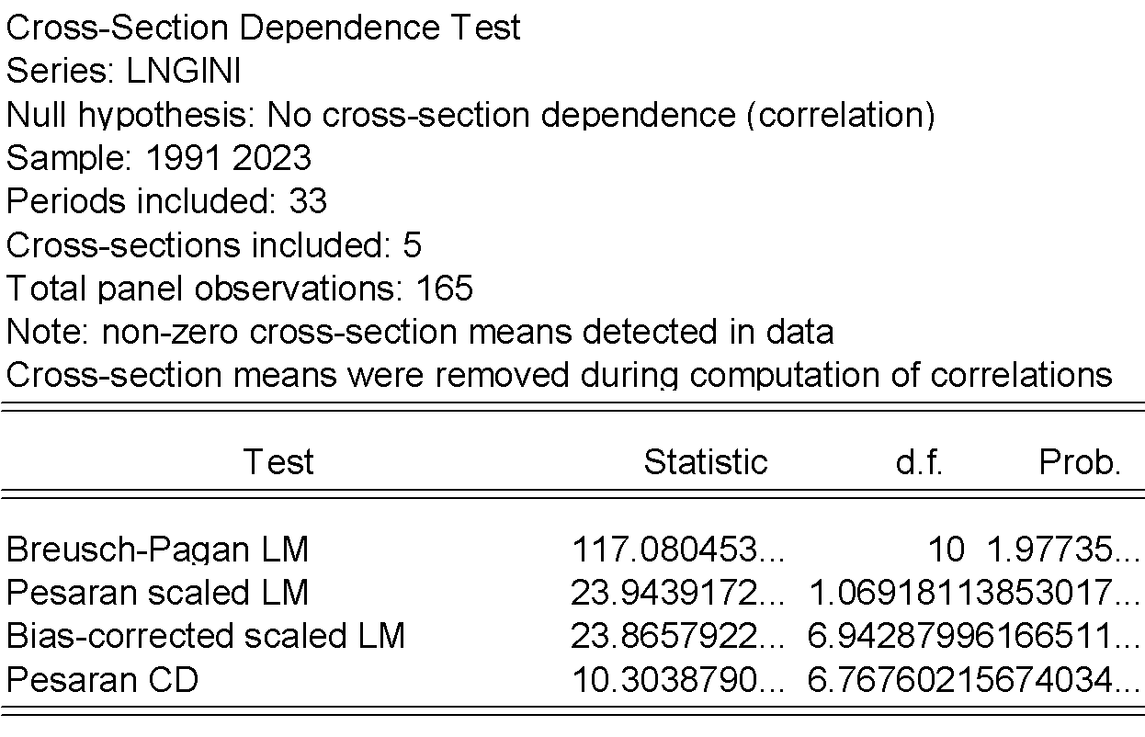

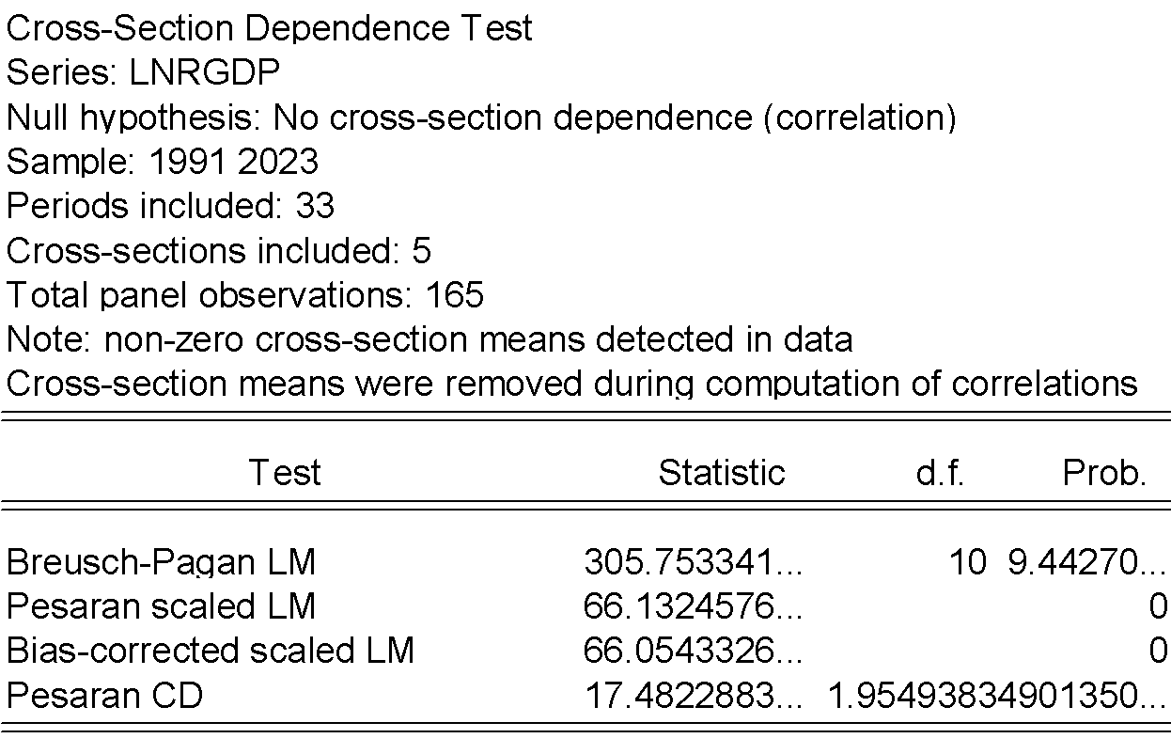

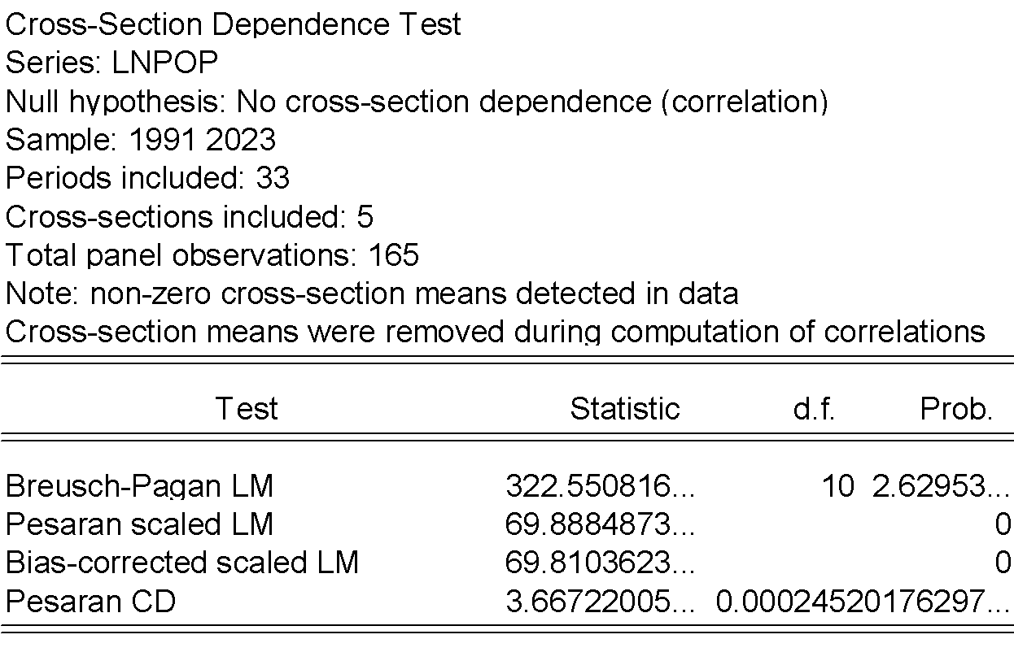

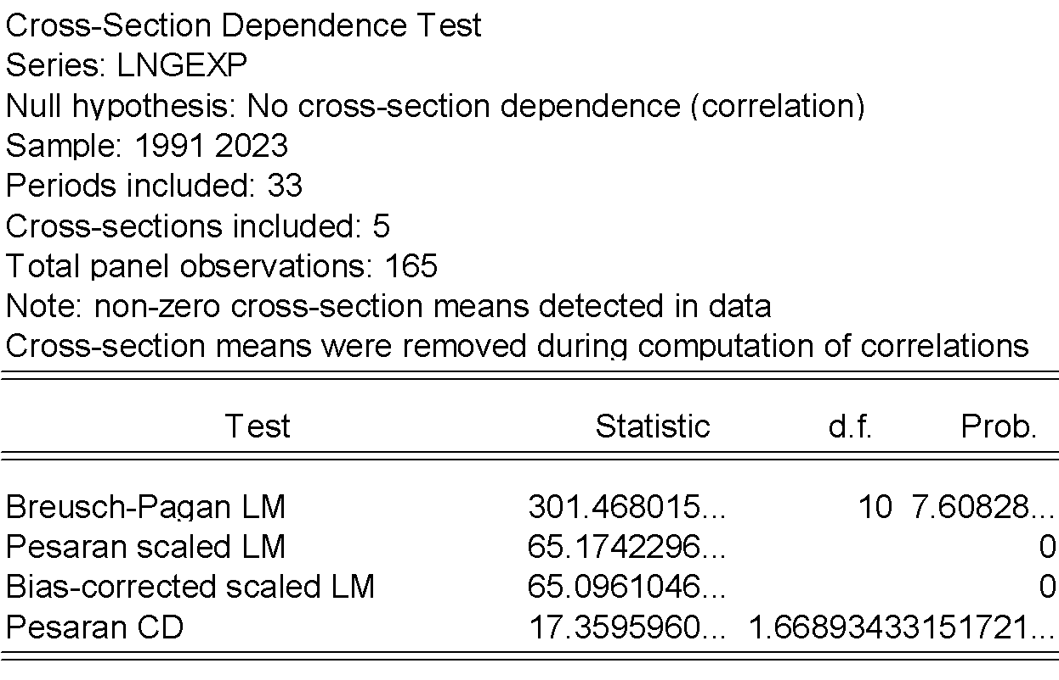

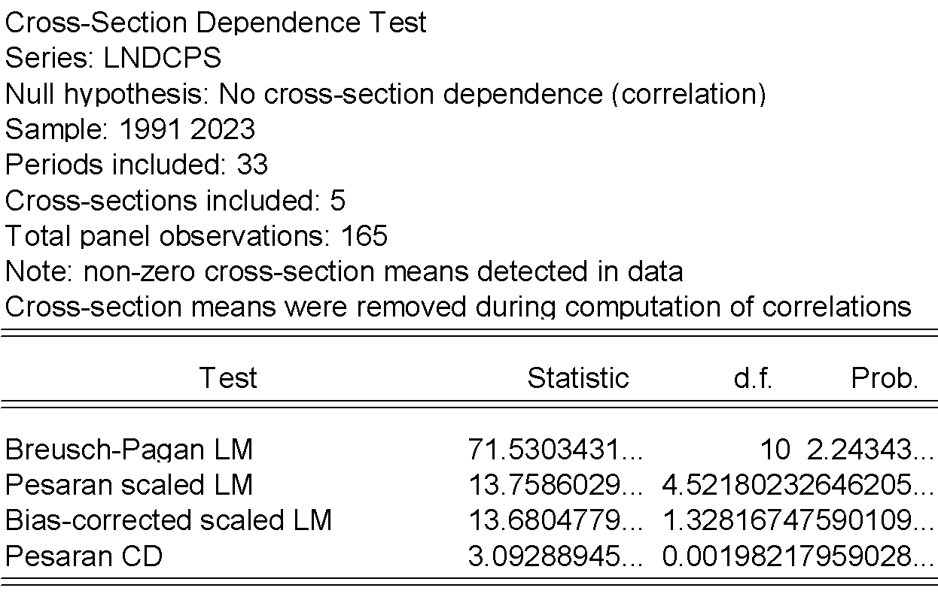

PANEL UNIT ROOT
Second generation unit root test
Pesaran CIPS (2007)
At level (summary stat) with constant and trend
LNGINI
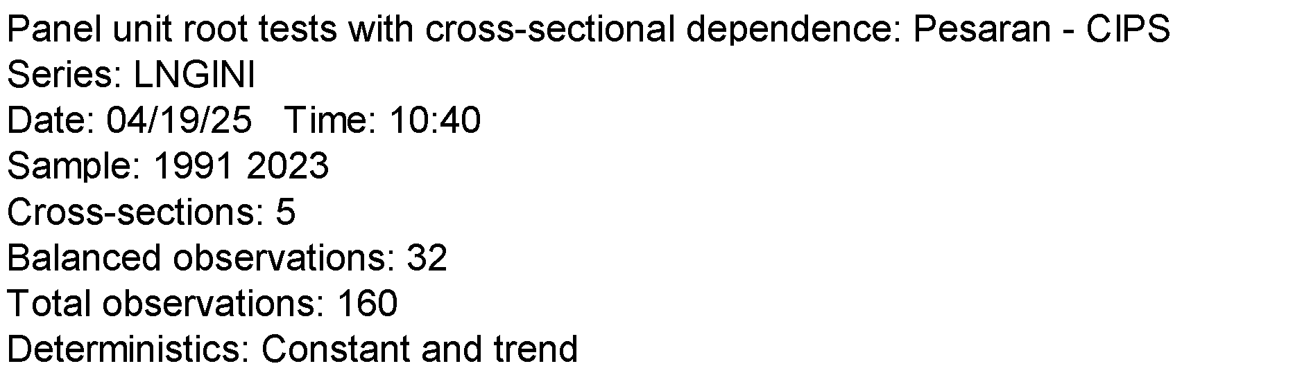
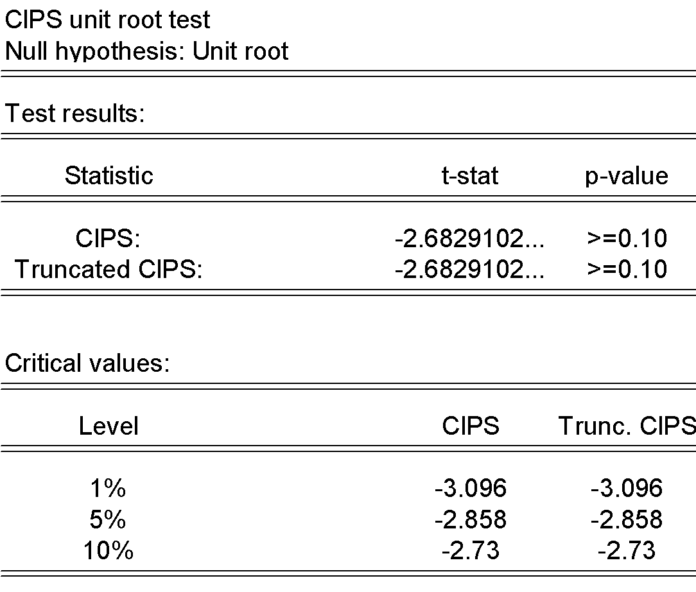

LNRGDP
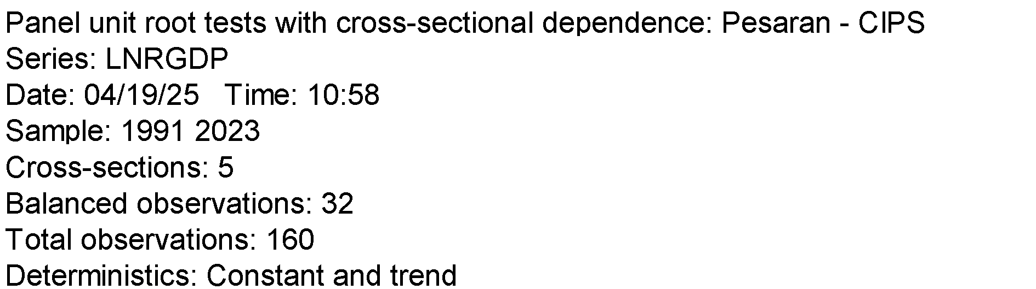
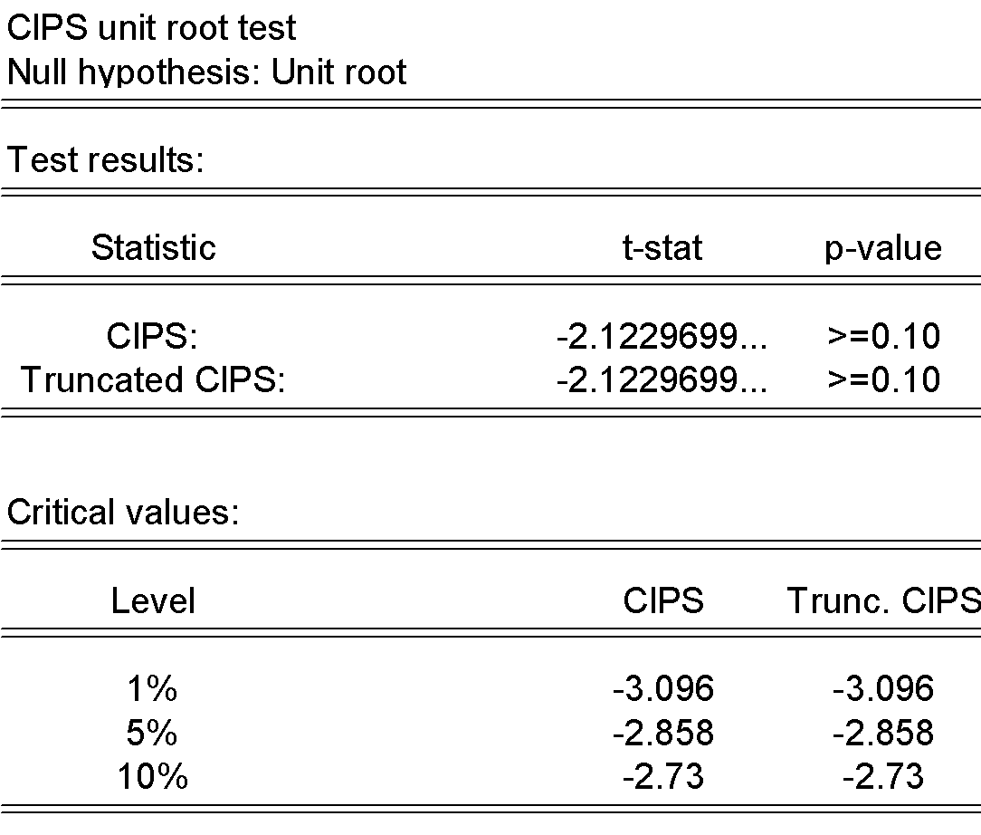
LNPOP
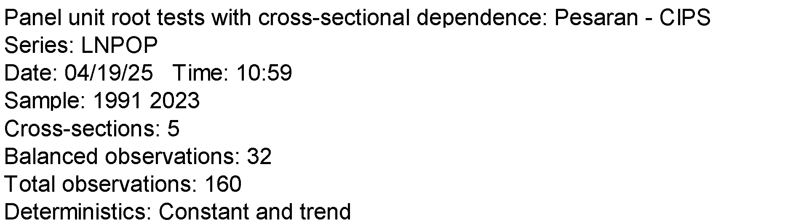
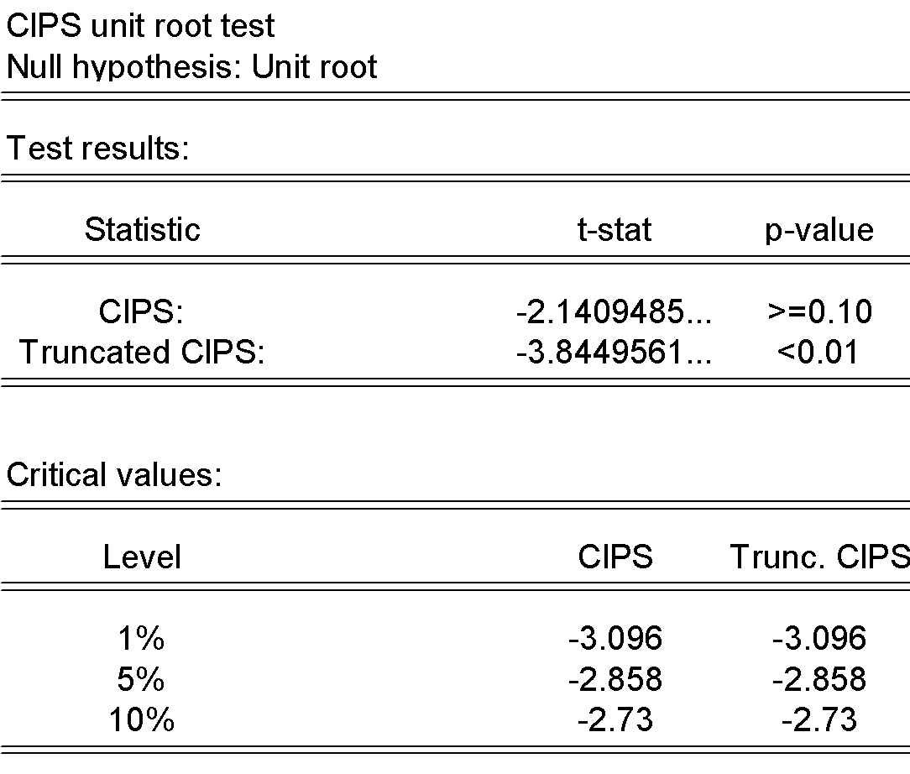

LNGEXP
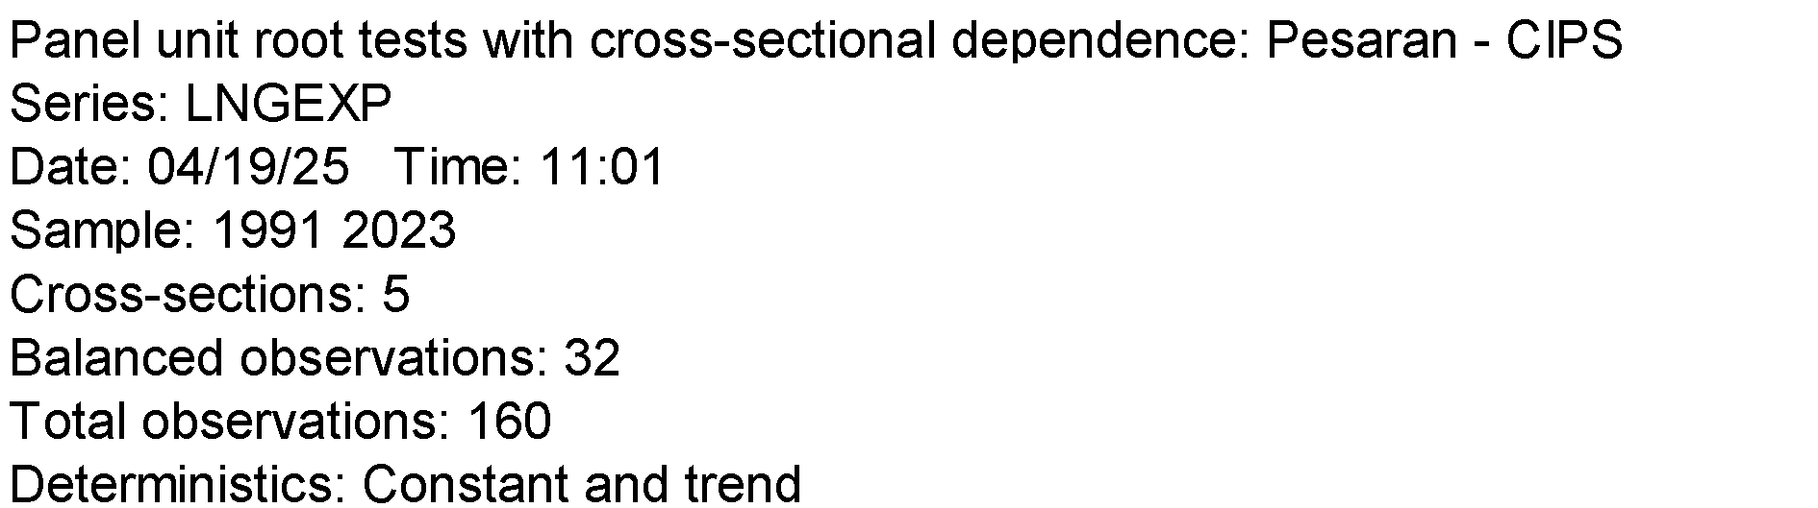
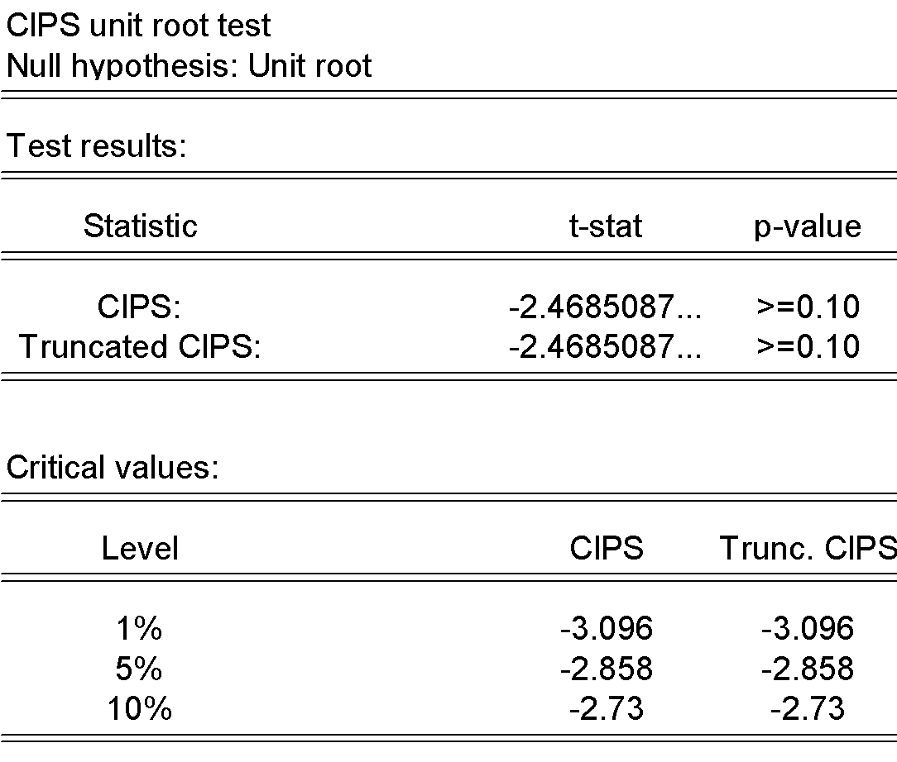

LNDCPS
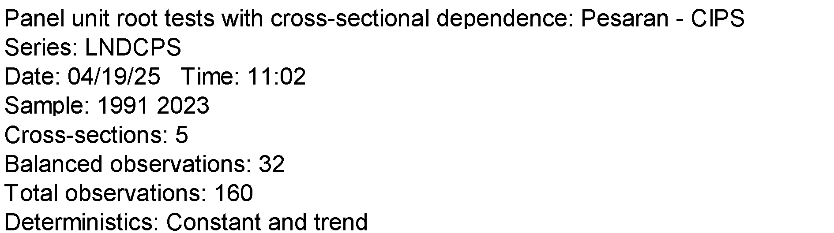
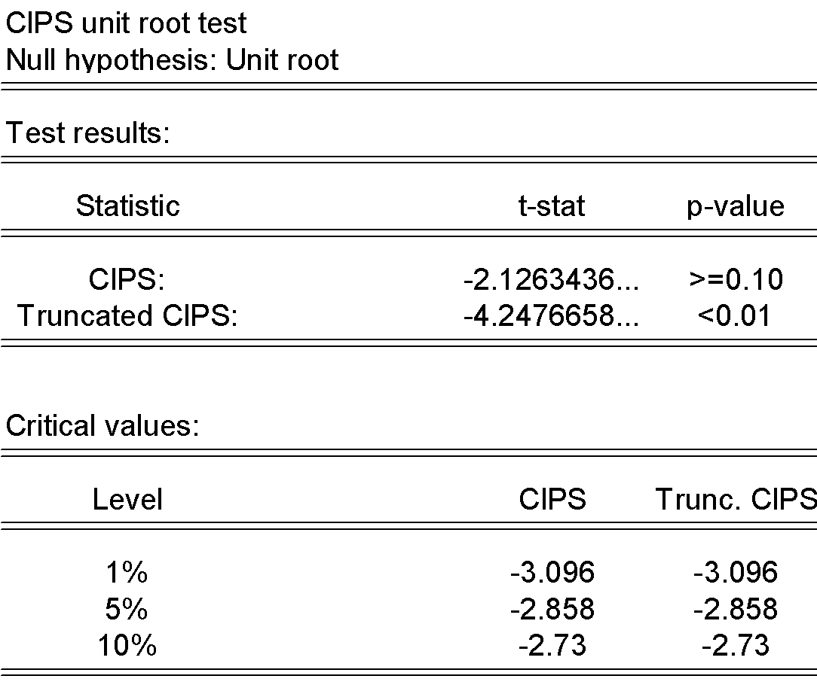

Pesaran CIPS (2007)
At FIRST DIFFERENCE with only constant
DLNGINI
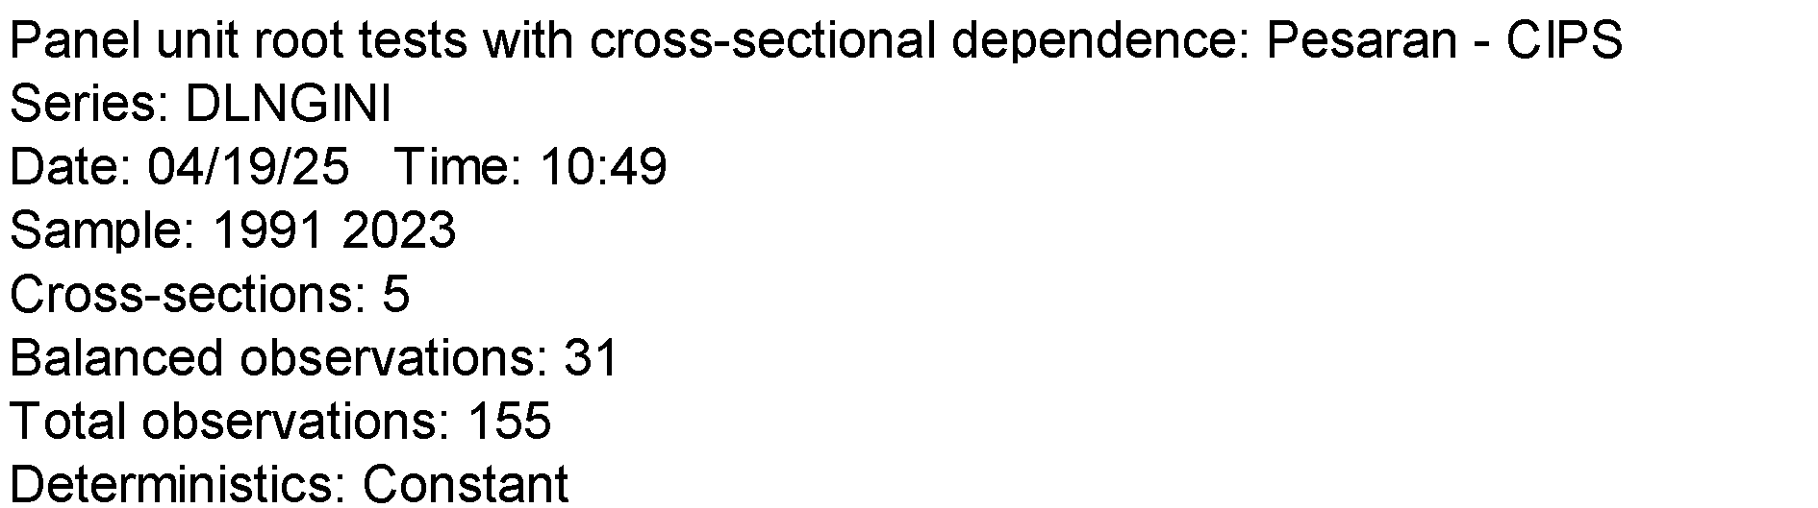
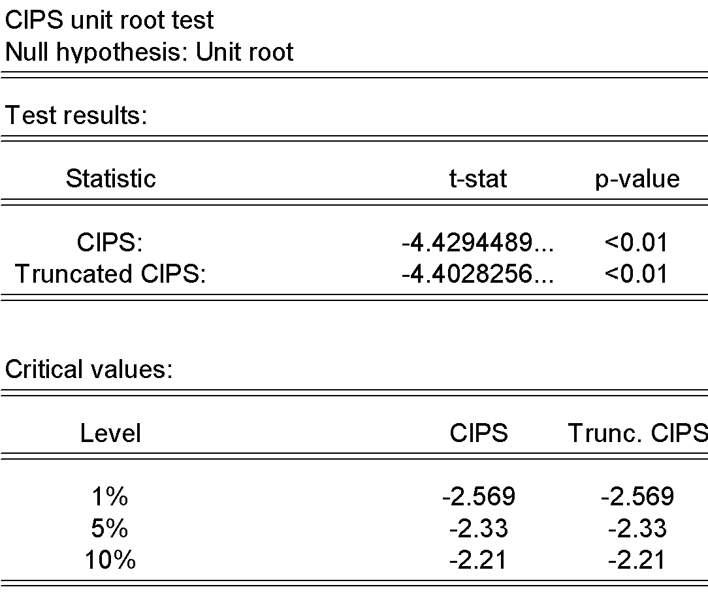

DLNRGDP
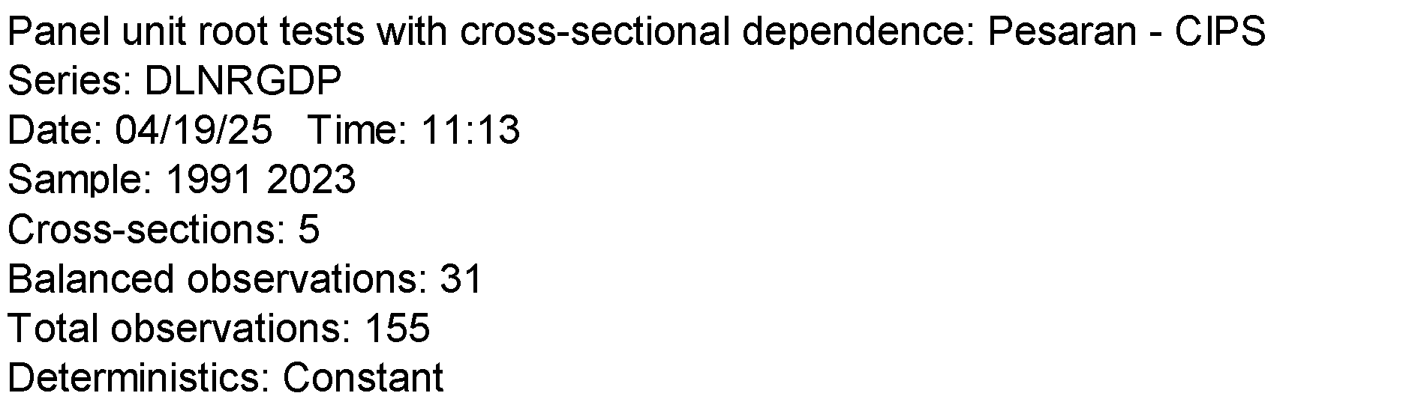
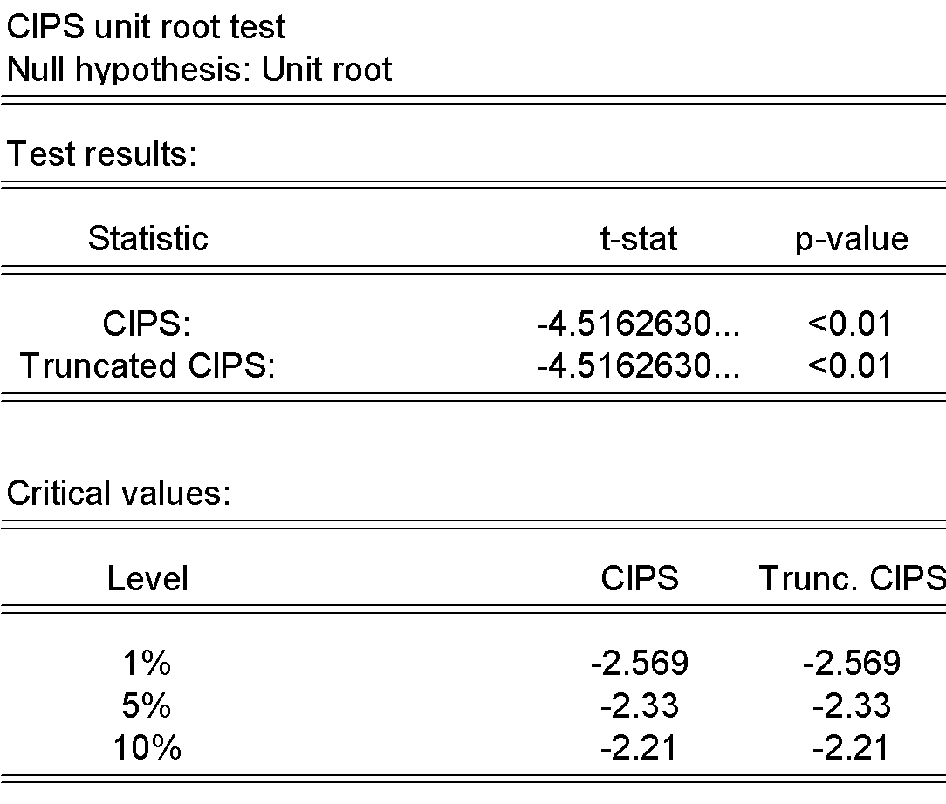

DLNPOP
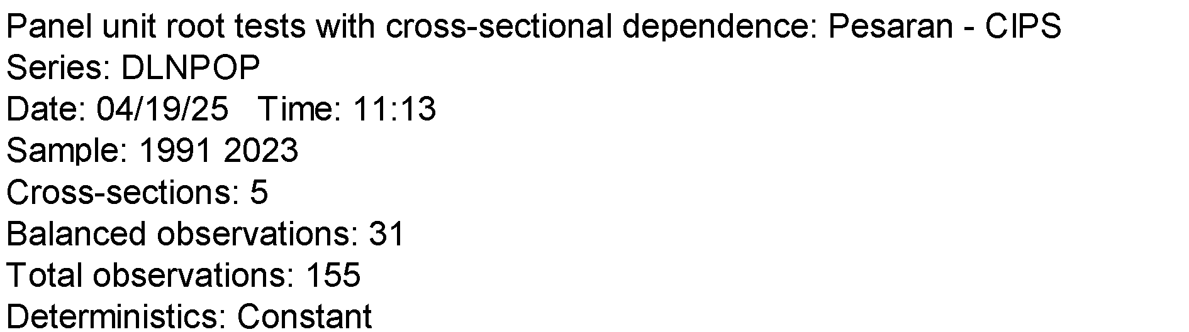
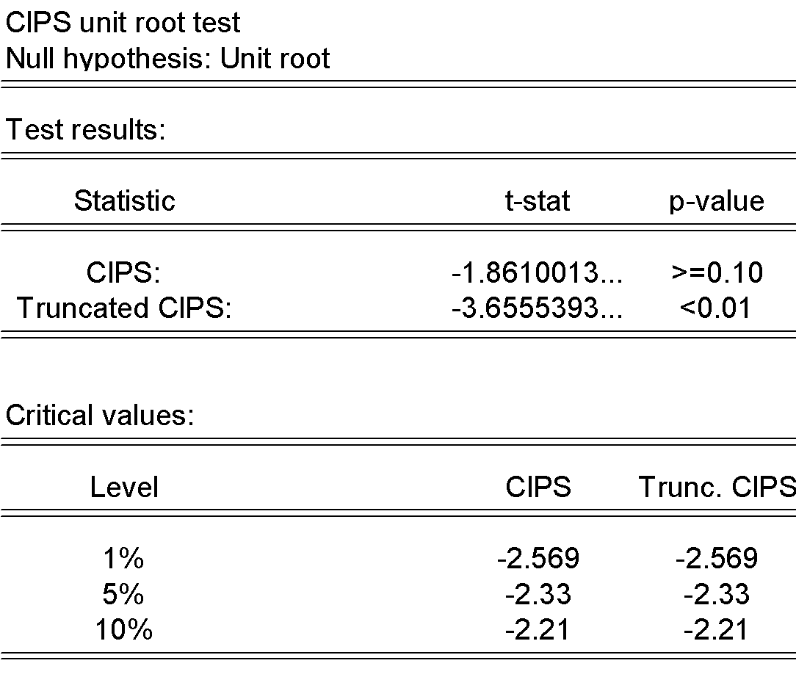

DLNGEXP
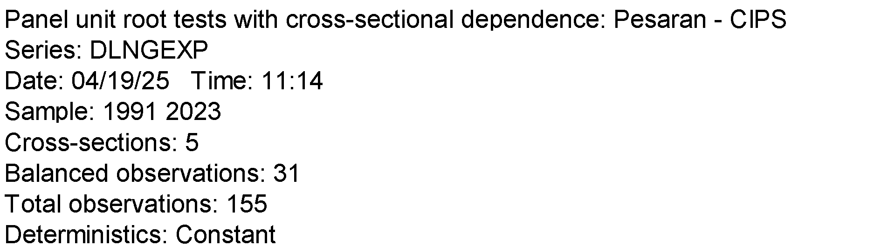
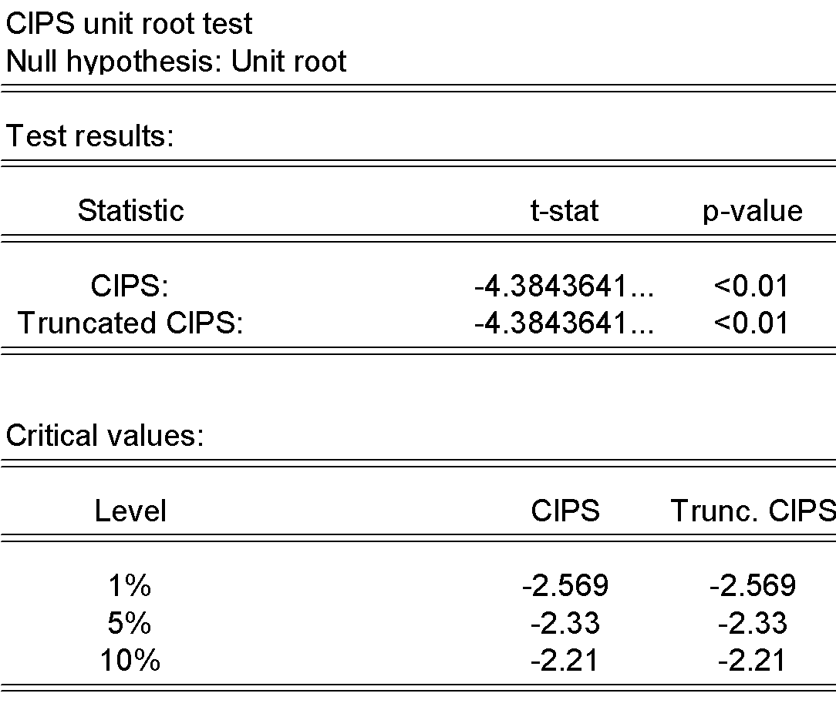

DLNDCPS
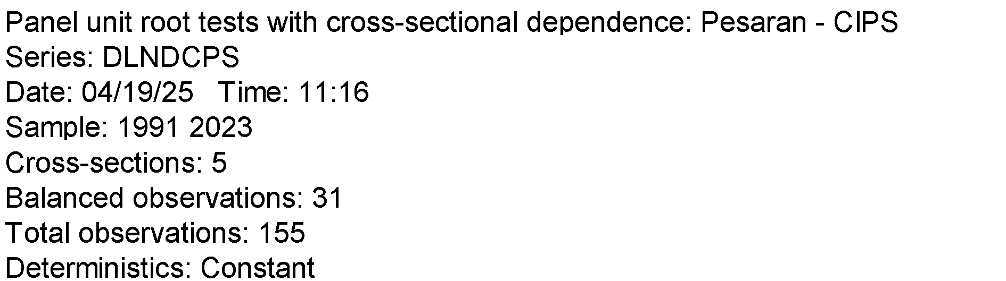
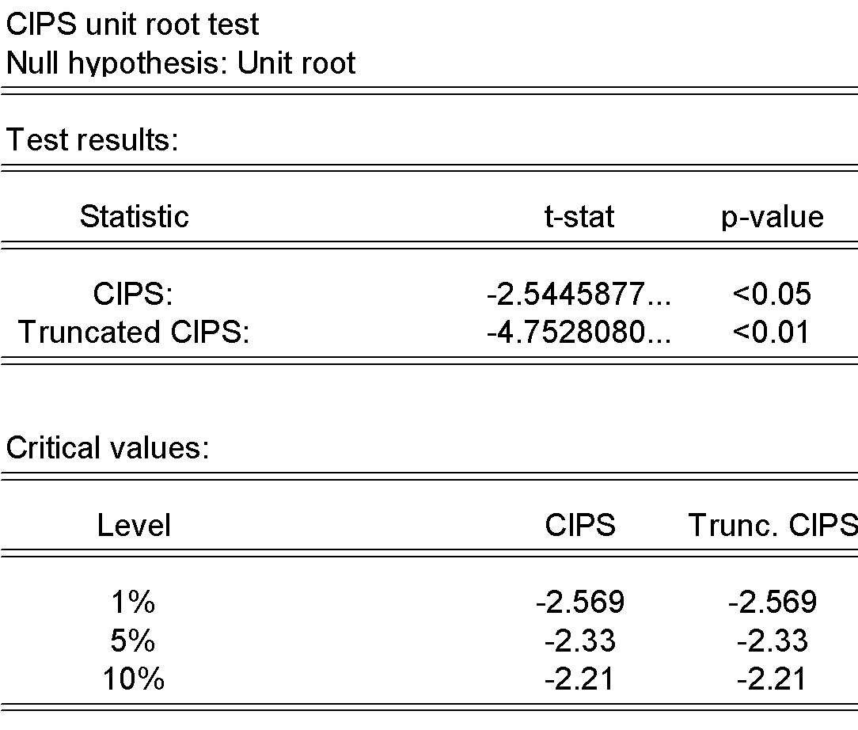

APPENDIX IV
PANEL REGRESSION RESULTS
Kao Residual Cointegration test
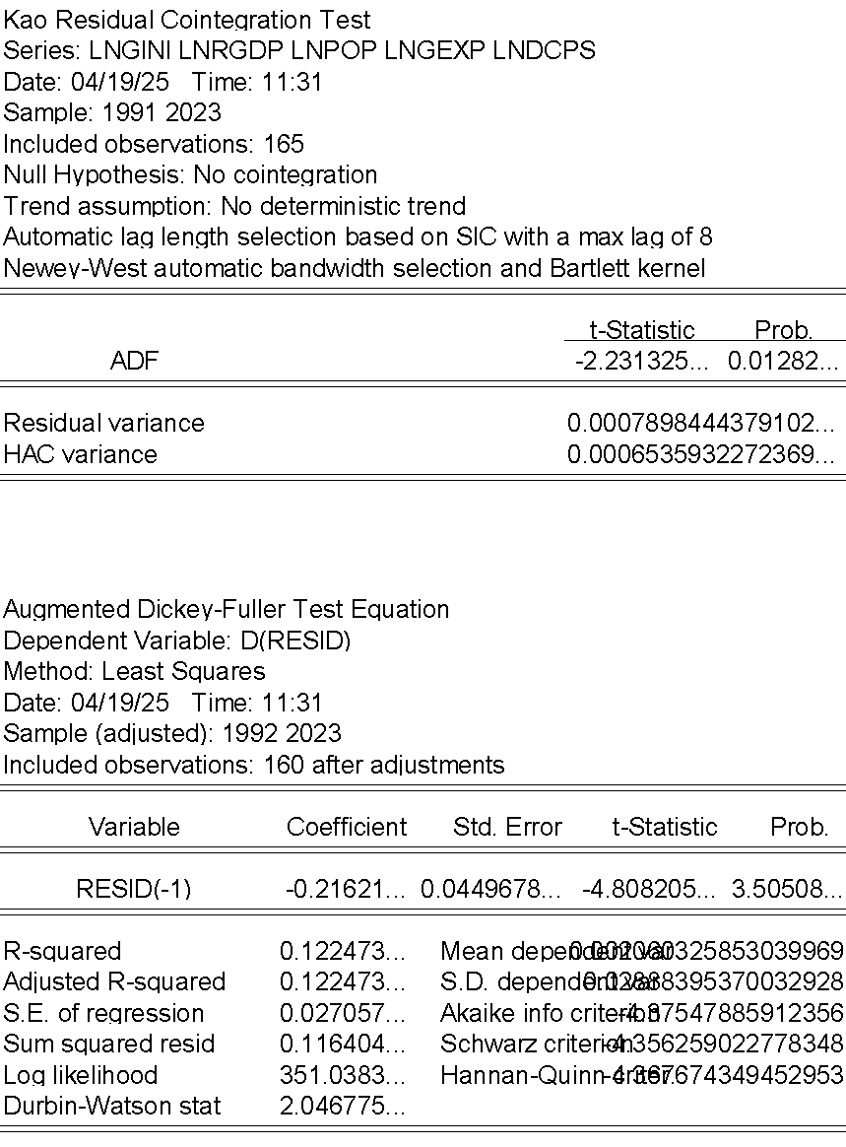

Pedroni Residual Cointegration test
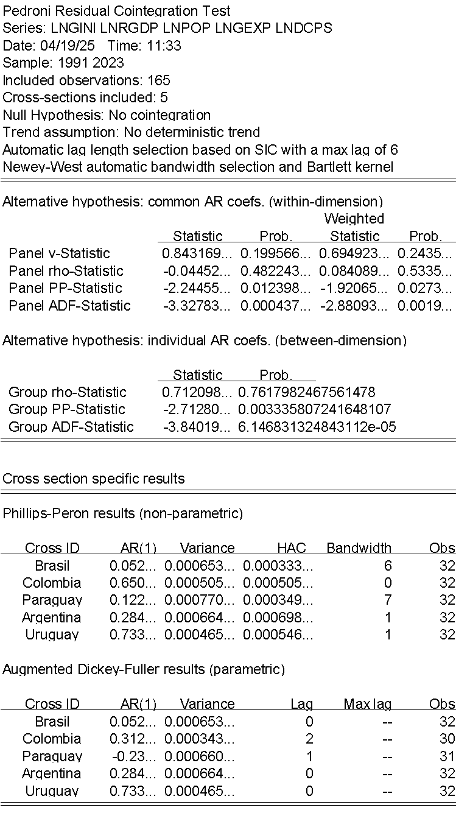

LAG structure

PANEL ARDL
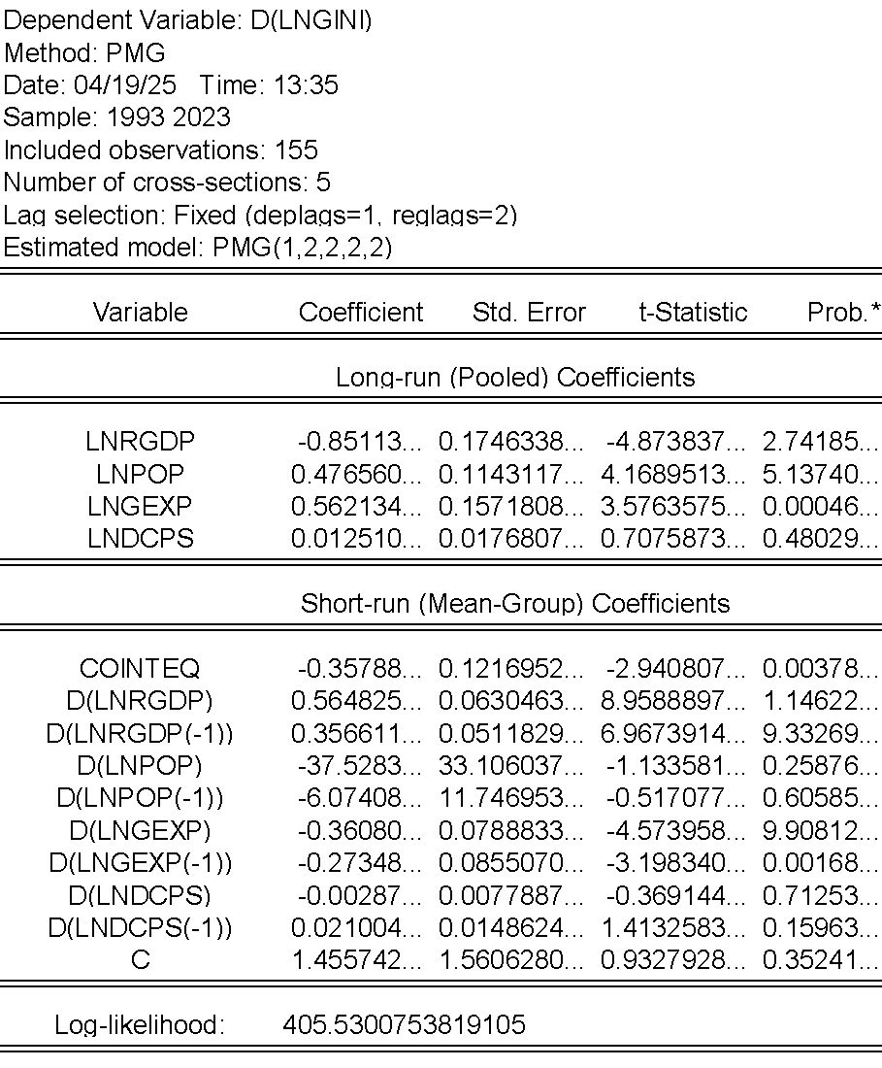

Brasil
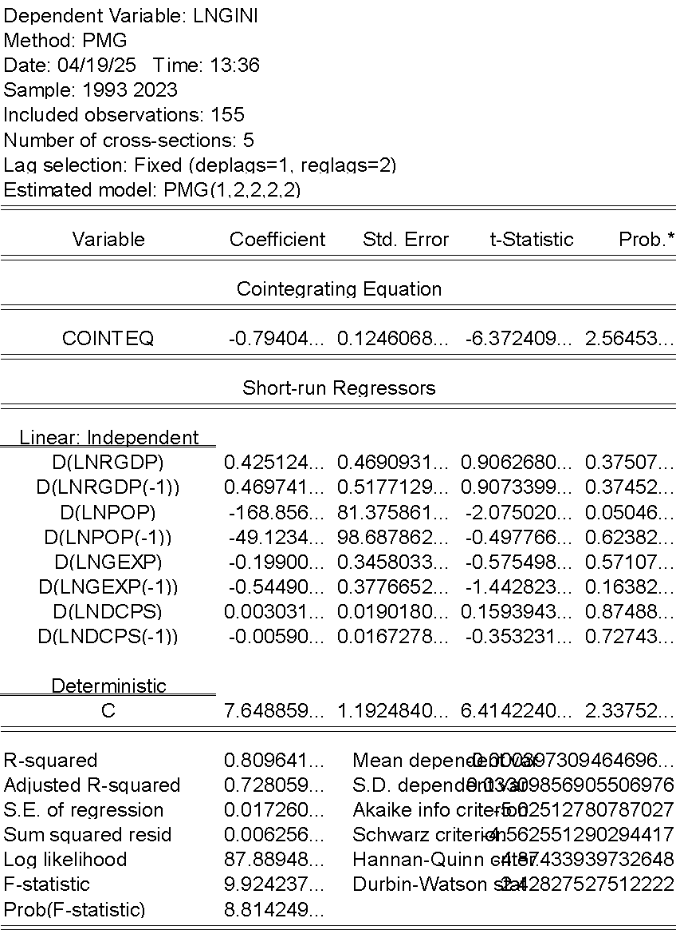

Columbia
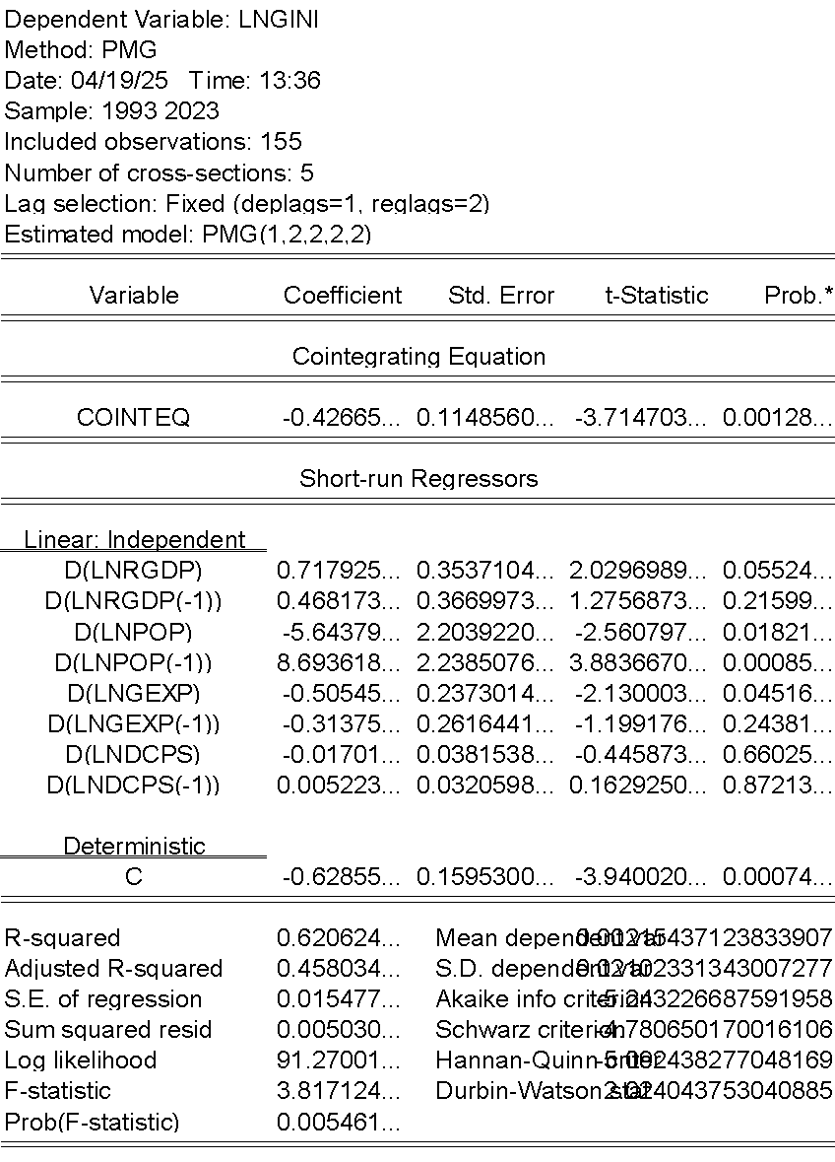

Paraguay
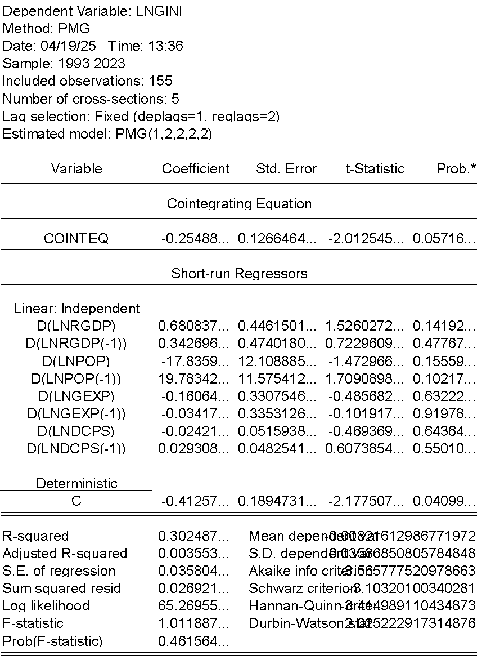
Argentina
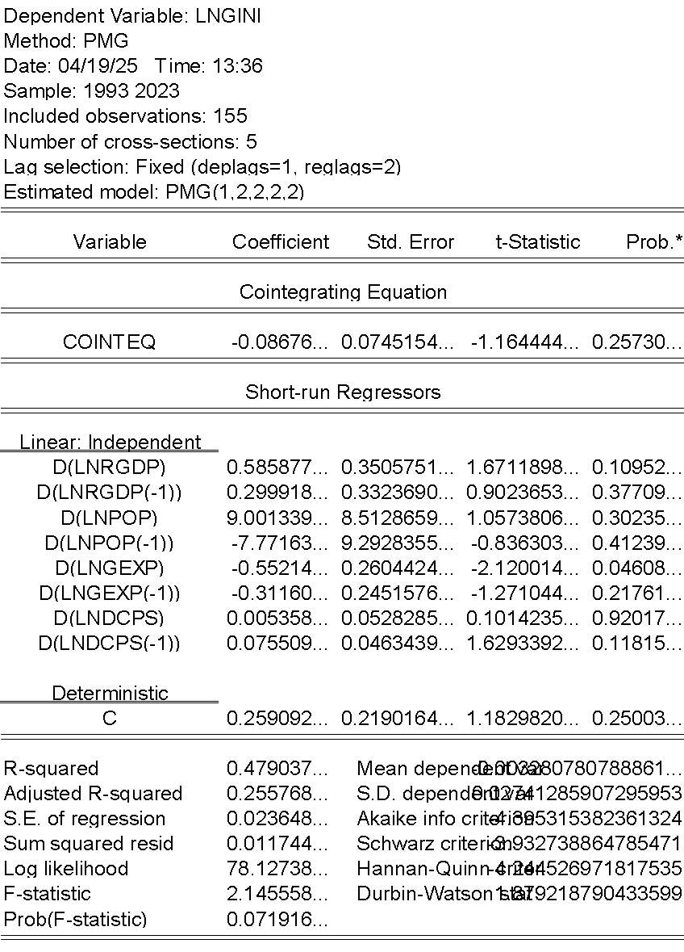

Uruguay
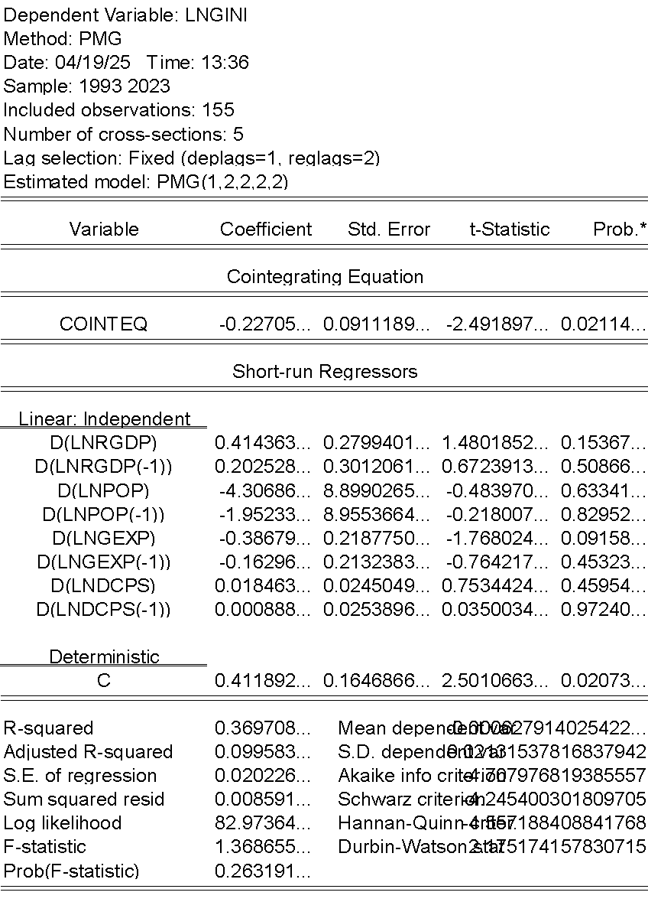

Bound test
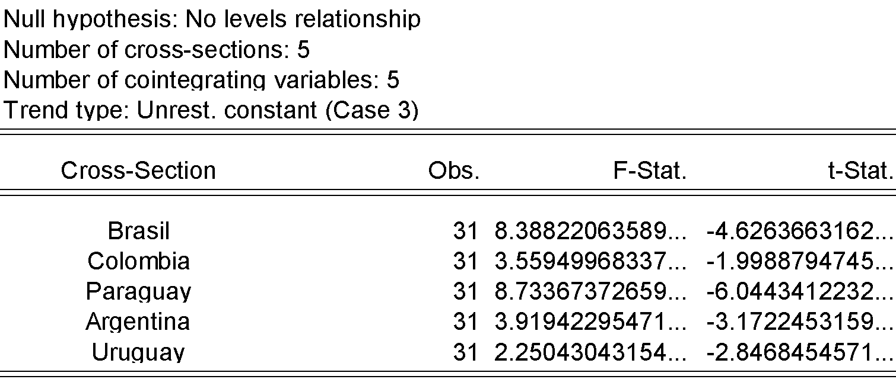
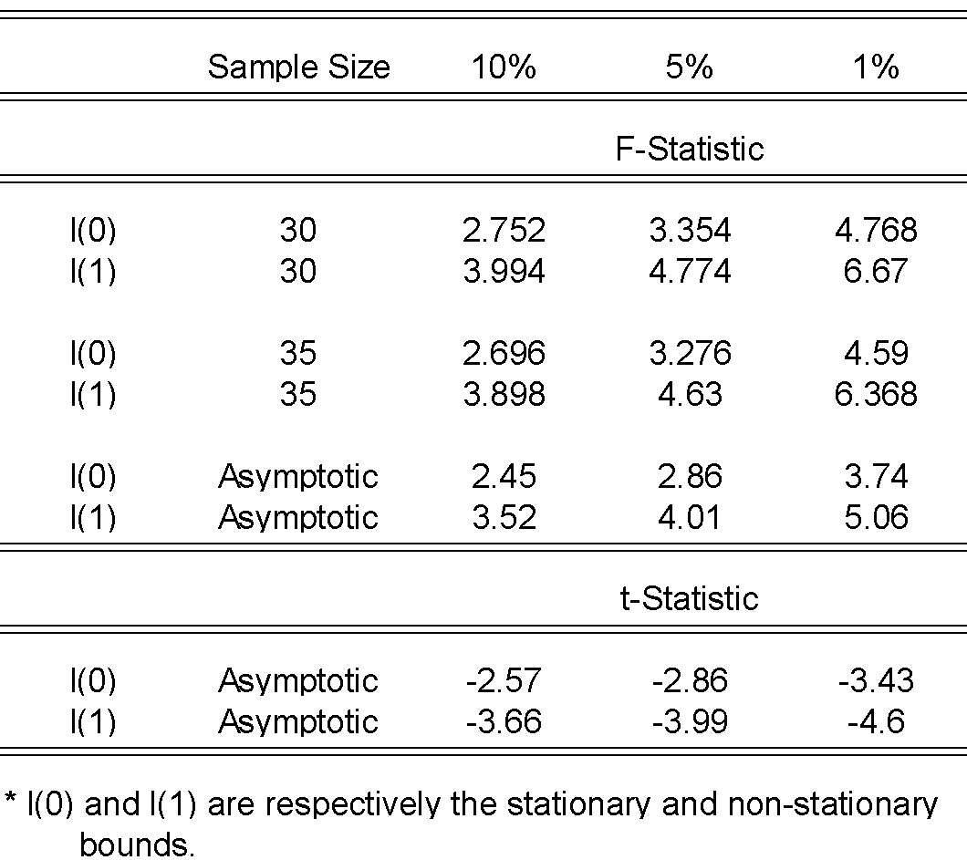

Hausman Test to check between MG and PMG
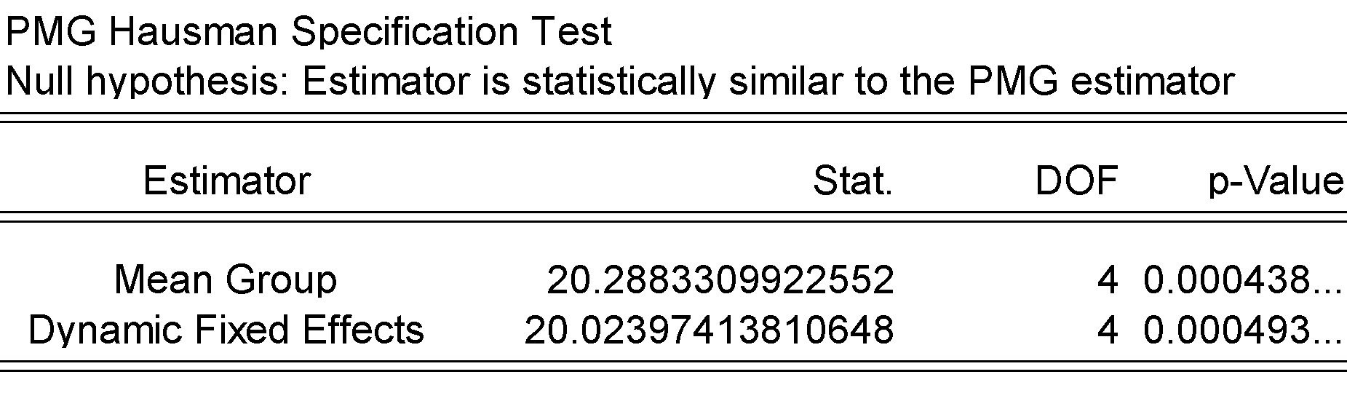

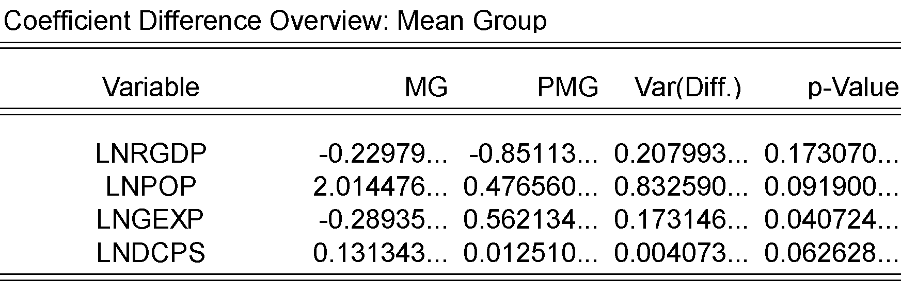

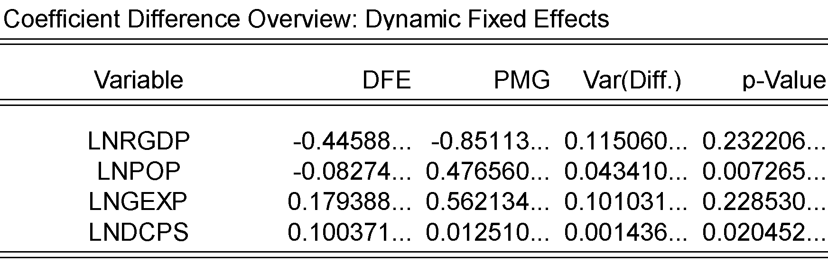

Normality test

Causality test
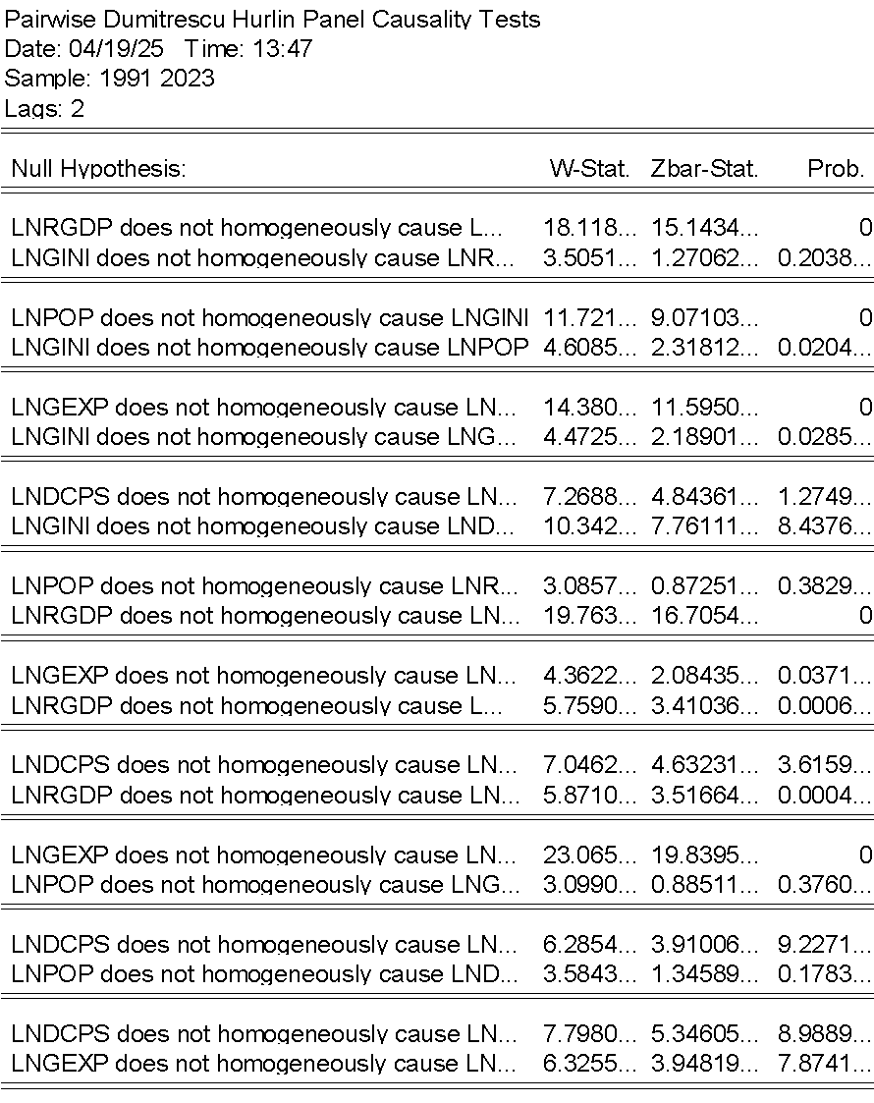

Panel VECM
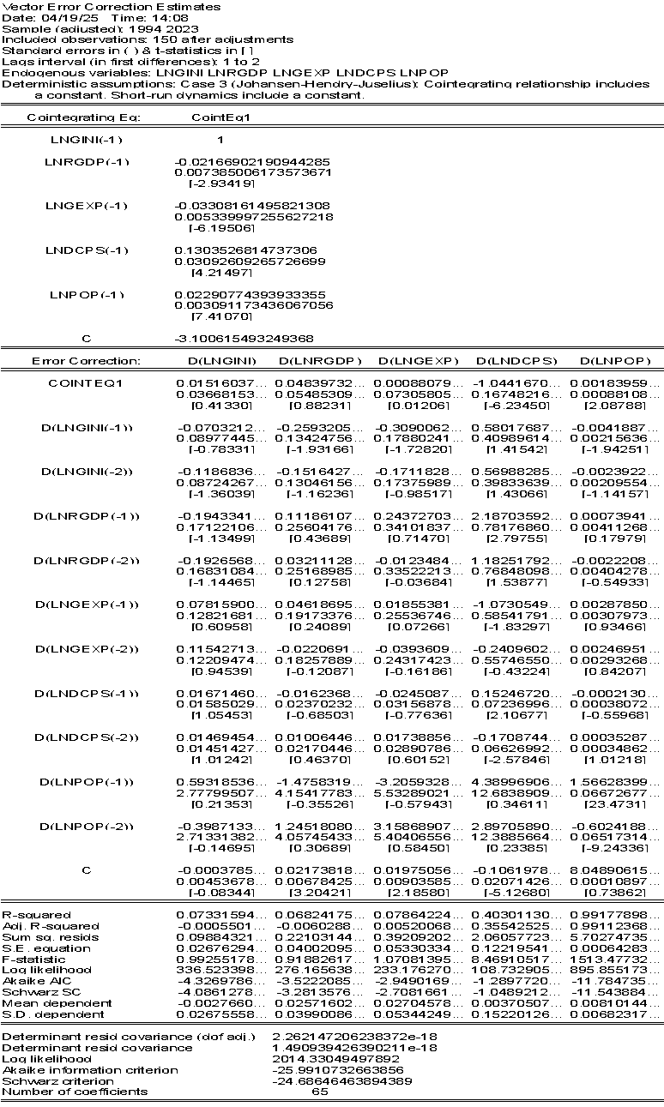
PANEL REGRESSION TEST
Pooled OLS
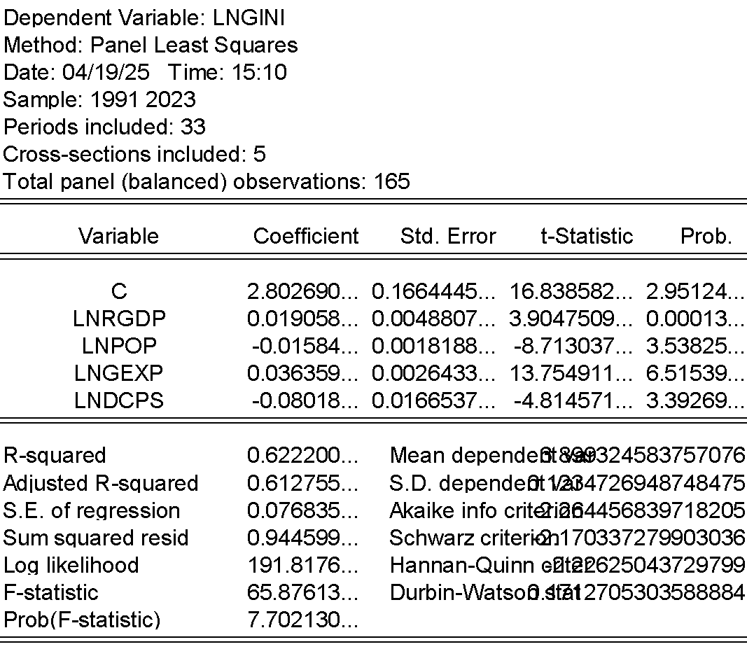

Fixed Effect
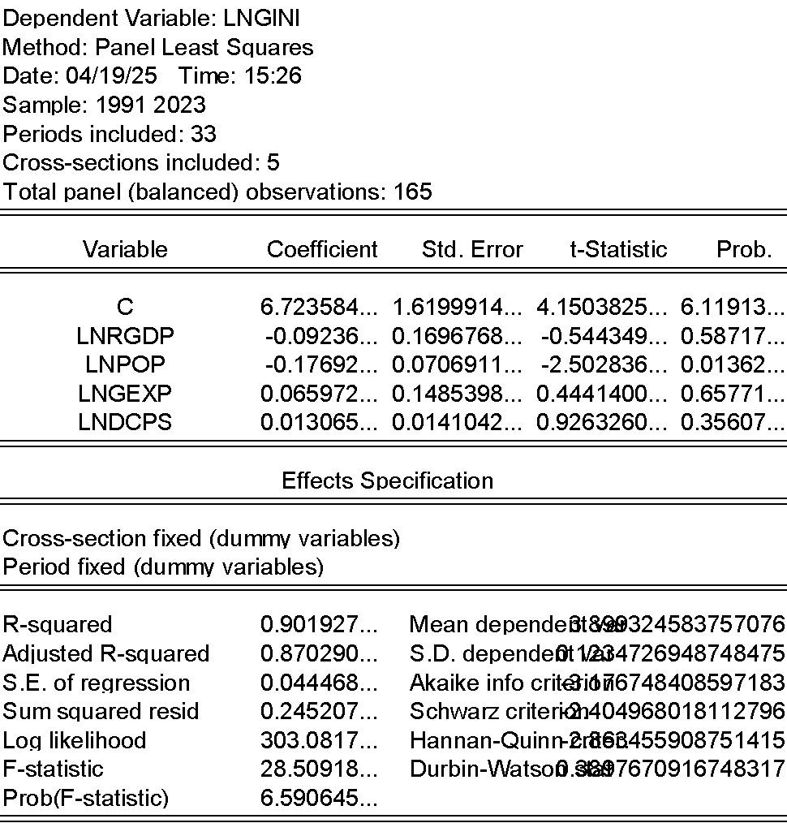
Random Effect
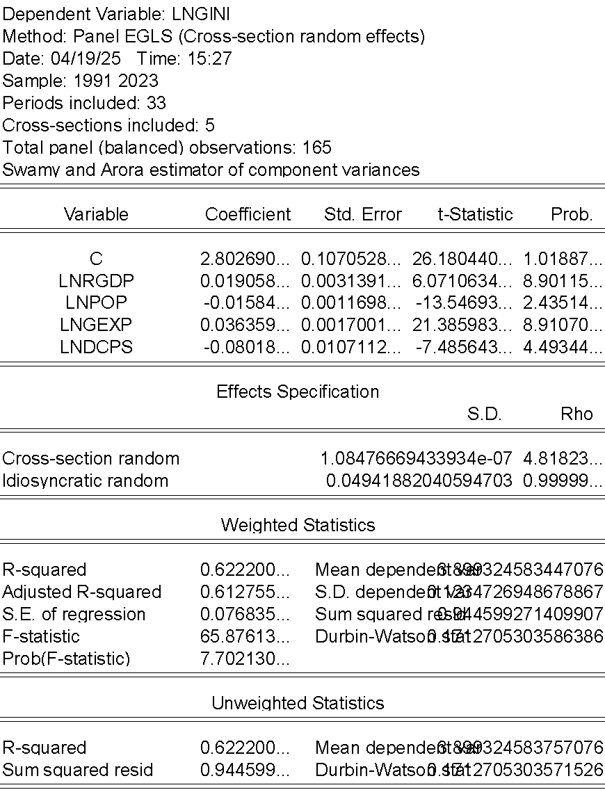

Cross sections
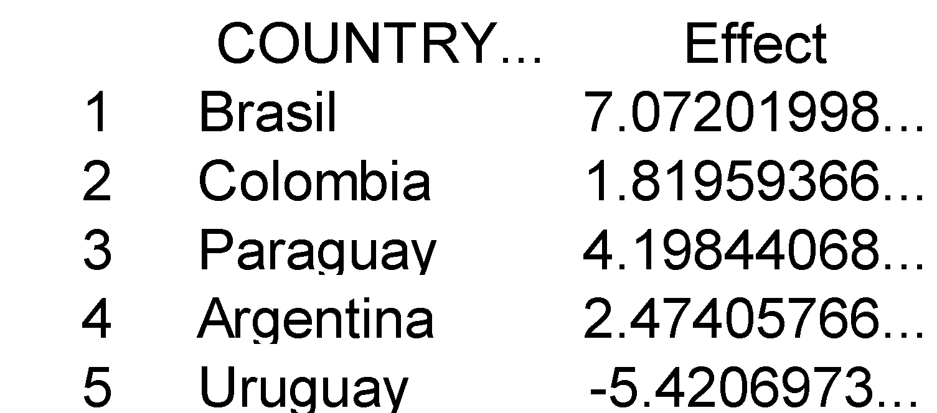

Hausman test
