System Approach to Project Management with Special Reference to Community Based Organisations in Nigeria

Abstract
Background: Effective project management is critical for the success of community development projects, particularly in resource-constrained environments like Nigeria. This study examines the role of planning, scheduling, and controlling within the systems approach to project management, using the Socio-Technical Systems Theory and Systems Theory as its theoretical foundation.
Objective: The main objective was to examine the role of planning, scheduling, and controlling within the systems approach to project management in community development projects in Port Harcourt, Nigeria. Grounded in Socio-Technical Systems Theory and Systems Theory, the research aims to explore how these project management pillars contribute to project success, defined here as timeliness, quality, and sustainability.
Methodology: This study employed a quantitative approach, using a descriptive survey design to collect data from 250 respondents across 10 community-based and non-governmental organizations.
Findings: The findings of this study revealed that comprehensive planning, risk identification, and resource allocation were essential for project success. Scheduling practices were found to be critical in meeting timelines and ensuring quality delivery, while controlling mechanisms, including real-time monitoring and corrective actions, were crucial in adapting to challenges.
Conclusion: The study concludes that integrating a systems approach to project management enhances the effectiveness and sustainability of community development projects. This research contributes to systems theory and project management scholarship by providing empirical evidence of how systems thinking can improve project management practices in the context of community development. Practical recommendations include the adoption of advanced project management tools, training for project managers, and the formalization of scheduling and control systems to enhance project outcomes.
By bridging theoretical gaps and offering actionable insights, this study advances the understanding of how structured project management can lead to more sustainable development in resource-constrained settings.
Keywords: Project management, Community development, Planning, Scheduling, Controlling

Introduction
Project management has become a crucial discipline driving the successful delivery of complex initiatives across various sectors, particularly in community development. At its core, project management represents the systematic application of knowledge, skills, tools, and techniques to meet stakeholder needs within defined constraints of scope, time, cost, and quality (Project Management Institute, 2025). This structured orientation helps organizations reduce inefficiencies, anticipate risks, and align outputs with intended outcomes, which is especially vital in community development projects where outcomes resonate profoundly with local livelihood, governance, and sustainability objectives (Bohra & Verma, 2024). Effective project management is not merely transactional; it is transformational, shaping how resources are marshaled, how uncertainty is navigated, and how impact at the community level is realized.
In community development, the stakes are high. Projects are often designed to improve education, infrastructure, health, and economic opportunity—areas deeply embedded in the social and economic fabric of local communities (Blak Bernat et al., 2023). A growing body of research argues that the challenges of planning, implementation, and control in such settings stem from the complex and interdependent nature of project elements, which include stakeholders with divergent priorities, resource scarcity, and evolving contextual pressures (Hosseini & Farid, 2025). Community development initiatives therefore demand a holistic conceptual lens that accommodates this complexity rather than simplistic linear models that treat planning, scheduling, and controlling as isolated tasks.
This need for a broader framing has spurred increased interest in the systems approach to project management. The systems approach transcends narrow task‑centric views by treating projects as interrelated ecosystems of people, processes, technologies, and environments (Kerzner, 2021; Larson & Gray, 2020). In such systems thinking, planning sets the stage for anticipating interactions among activities, scheduling optimizes the sequence and flow of those activities, and controlling monitors feedback loops that help recalibrate project behavior in real time (Project Management Institute, 2021). Contemporary scholarship highlights that this integrative perspective enhances adaptability and learning, which are crucial in dynamic environments like community development (Cohen, 2023). Additionally, advances in project scheduling—such as AI‑enhanced and risk‑aware approaches—offer new avenues for aligning human judgment with data‑informed decision processes (Suvvari & Saxena, 2024).
However, despite this promise, the practical application of systems‑oriented planning, scheduling, and controlling remains uneven, particularly in the context of developing countries. In Nigeria and comparable settings, implementing systematic project management practices is challenged by limited institutional capacity, fragmented stakeholder engagement, and gaps in training among local practitioners (Hamidu, 2024). Empirical studies have found that poor planning practices contribute to frequent delays, cost overruns, and ultimately, project abandonment—undermining the very development outcomes these efforts aim to achieve (Titarenko & Da Camara, 2025). This gap between theoretical frameworks and practical implementation underscores an urgent research need: to ground community development projects in models that integrate systems thinking with empirically validated project management practices responsive to local contexts.
Statement of the Problem
Effective project management is essential for the success of community development projects, particularly in developing countries like Nigeria, where challenges such as limited resources, political instability, and fragmented institutional capacity often undermine project outcomes. Despite the increasing recognition of the importance of systems-oriented project management approaches, such as planning, scheduling, and controlling, there remains a significant gap in their practical application within Nigerian community-based organizations (CBOs) and non-governmental organizations (NGOs). While many organizations acknowledge the theoretical value of these frameworks, they often face barriers such as inadequate training, poor stakeholder coordination, and lack of resources, leading to frequent project delays, cost overruns, and, in some cases, project abandonment.
The problem is exacerbated by the lack of empirical studies focused on how systems-based project management principles can be effectively integrated into the day-to-day operations of CBOs and NGOs in Nigeria. As a result, many community development projects fail to achieve their intended outcomes, leading to missed opportunities for social, economic, and infrastructural improvements. This study seeks to address this gap by exploring how planning, scheduling, and controlling, when integrated within a systems approach, can improve the management and success of community development projects in Port Harcourt, Nigeria.
This research is crucial because it will provide evidence on the effectiveness of the systems approach in a Nigerian context, offering practical insights for enhancing project management practices and fostering more sustainable and impactful community development initiatives.
Objectives
Drawing from quantitative survey data collected from community‑based organizations (CBOs) and NGOs in Port Harcourt, the research examines how the three pillars of project management (planning, scheduling and controlling) interact and impact project outcomes. Specifically, the study explores: (1) the impact of planning on system‑level project success; (2) the influence of scheduling practices in aligning project activities; and (3) the role of controlling mechanisms in sustaining performance and responsiveness amidst complexity.
To guide this inquiry, the following research questions are posed: What is the impact of planning on the systems approach to project management in community development projects? How does scheduling influence the systems approach in this context? And what role does controlling play within a systems‑oriented project management framework? These questions are framed to surface evidence not only about individual practices, but about their combined effects when embedded in a systems perspective.
Based on these research questions, the study tests the following hypotheses to determine the impact of key project management practices on community development projects in Nigeria:
Hypothesis 1 (H₁): There is a significant impact of project planning on the systems approach to project management among community development organizations in Nigeria.
Hypothesis 2 (H₂): Project scheduling has a significant impact on the systems approach to project management among community development organizations in Nigeria.
Hypothesis 3 (H₃): Project controlling has a significant impact on the systems approach to project management among community development organizations in Nigeria.

Literature Review

Theoretical Foundation
In project management, particularly within the realm of community development, a solid theoretical foundation is essential to understanding how various elements of a project interact within an organization. Two critical theories guide this study: the Socio-Technical Systems Theory and Systems Theory. These theories offer a nuanced perspective on the dynamics between the technical and social elements within organizations and highlight the importance of considering both internal and external factors in community development projects.
The Socio-Technical Systems Theory, which focuses on the integration of technical and human elements in an organization, was first introduced by Eric Trist and Ken Bamforth in the late 1940s and early 1950s, and later advanced by Fred Emery (Pasmore et al., 2019). This theory suggests that organizations must achieve a balance between these components for optimal performance (Paramonova, Lamas, & Sousa, 2024). In community development organizations, the technical element might involve the implementation of infrastructure, education programs, or healthcare services, while the social component includes community engagement, participation, and local governance (Hariyani, Hariyani, & Mishra, 2025). Leuhery (2024) emphasized that technological innovations can only be successful if the workforce is adequately trained and prepared. Without this balance, organizations may face disequilibrium, leading to inefficiencies or failure of the innovation. In the context of community development, this theory is vital as it underscores the need for technical solutions that are culturally appropriate and supported by the community. Therefore, when applying the systems approach to project management, community development organizations must ensure that the social dynamics—such as local needs, cultural sensitivities, and community involvement—are not neglected in favor of technological advancements (Kangana et al., 2024; Yousef, 2024).
On the other hand, Systems Theory, as proposed by Ludwig Von Bertalanffy in 1940, views organizations as a set of interconnected and interdependent parts. According to Von Bertalanffy, a change in one part of a system affects the entire system (Pouvreau, 2014). This theoretical framework is particularly relevant in understanding how community development projects are complex and multifaceted. Community development organizations operate in a dynamic environment, where various stakeholders, such as local governments, NGOs, and community members, must work together in harmony. The systems approach in project management, derived from Systems Theory, recognizes that a project must be treated as a whole, considering all its interrelated components—such as resources, stakeholders, and external factors (Bassi, 2025). This view highlights that the success of a project depends on the interactions between various elements, rather than focusing on individual tasks in isolation (Hussein, 2019). Community development projects must, therefore, recognize the broader context, where decisions made at one level of the project can have cascading effects throughout the entire system.
Image 1 illustrates how technical components (e.g., infrastructure, education programs) must be aligned with social factors (e.g., community involvement, cultural sensitivity) to ensure the successful implementation and sustainability of the project.
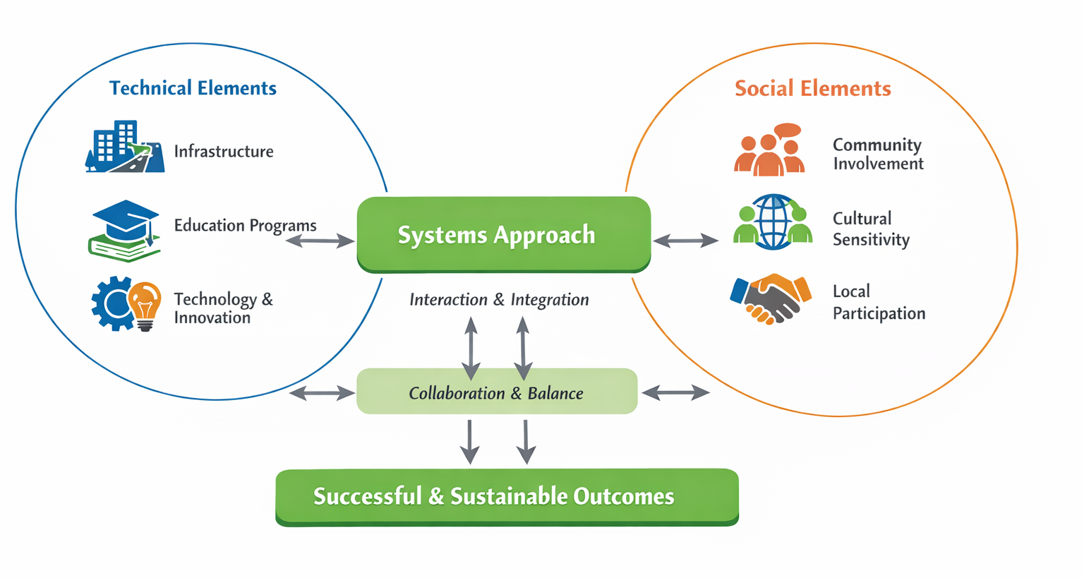 Image 1: Schematic Diagram of the Socio-Technical Systems Theory in Community Development Projects

Conceptual Review
The Concept of Project Management has evolved significantly over time, yet its core principles remain relevant across diverse industries. Project management, at its essence, is about navigating a project through its life cycle—from initiation to completion—while balancing constraints of scope, time, cost, and quality (Project Management Institute, 2025). In community development, this process is particularly challenging, as it involves numerous stakeholders with varying interests, limited resources, and often unpredictable external factors, such as political instability or socio-economic changes (Humenna, Safonov, & Kharlamova, 2025).
Project management in this context must be flexible and adaptable, with a clear understanding of goals and an organized method for executing tasks. Importantly, as the study suggests, the use of the systems approach to project management facilitates the identification of critical interdependencies between tasks and resources, ensuring that the project can adapt to unforeseen circumstances (Gorod, Hallo, & Nguyen, 2018). The systems approach emphasizes not only the management of individual project elements but also how these elements interact to achieve the desired outcomes. This perspective is particularly valuable in community development projects, where the complexity of stakeholder engagement and resource constraints necessitates a comprehensive and holistic management approach.
The Concept of the Systems Approach to Project Management builds on these principles by advocating for a comprehensive view of projects, where all components and stakeholders are considered in tandem. In this approach, the project is viewed as an interconnected system, where each part, such as task scheduling, resource allocation, and stakeholder management, affects the overall success of the project. As noted by Taresh et al. (2023), the systems approach enables managers to recognize potential risks early in the process, create more effective communication strategies, and align all project components towards a unified goal. For community development projects, where resources are scarce and the stakes are high, the systems approach ensures that project activities are well-coordinated, risks are mitigated, and resources are allocated efficiently. This holistic framework also fosters better collaboration among stakeholders, enhancing the potential for project success.
However, the literature also reveals significant challenges in applying a systems approach to project management in community development, particularly in developing countries like Nigeria. These challenges often arise from limited institutional capacity, fragmented stakeholder engagement, and inadequate training among local project managers (Iroha, Watanabe, & Satoshi, 2024). These barriers complicate the adoption of systematic project management practices, often leading to delays, budget overruns, and the abandonment of community development projects. The gap between theoretical frameworks and their practical implementation highlights the need for a more tailored approach to project management in these settings, taking into account the unique socio-political and economic challenges that shape project dynamics.
One of the key benefits of the systems approach, as identified in the literature, is its emphasis on improved communication, better risk management, and increased efficiency (Bassi, 2025). These benefits are particularly important in the context of community development projects, where multiple stakeholders must collaborate to achieve shared objectives. The systems approach helps clarify roles, streamline communication, and facilitate decision-making processes, ensuring that all parties are working towards the same goals.

Methodology

Study Design
The research employed a descriptive survey design with a quantitative approach. This design is particularly suited for examining the current state of planning, scheduling, and controlling practices in community development projects. The descriptive survey approach allows for the collection of data that describes the characteristics and practices of the community-based organizations (CBOs) and NGOs under study. The quantitative approach ensures that the findings are based on numerical data, which can be analyzed statistically to identify patterns, relationships, and significant factors.

Study Area
The study was conducted in Port Harcourt, the capital city of Rivers State, Nigeria, which serves as a key hub for various community development projects. The city is home to numerous community-based and non-governmental organizations (CBOs/NGOs) that engage in diverse community development activities, including education, healthcare, infrastructure, and economic empowerment. The study focused on organizations that operate within the Port Harcourt metropolis.
Port Harcourt is strategically important for this study because it offers a representative sample of the challenges and opportunities faced by organizations in community development within Nigeria. The city also reflects the typical socio-economic conditions, such as resource constraints and political dynamics, which are common to many community-based projects in the country.

Study Population and Sampling Technique
The sample for this study consisted of 300 respondents drawn from a population of 1,200 members across ten (10) community-based and non-governmental organizations (CBOs/NGOs) in Port Harcourt. The breakdown of the population distribution in the selected CBOs and NGOs is shown in Table 1 below. The organizations vary in size, with the number of members ranging from 75 to 180. This diversity allows for a broad range of responses and ensures that the findings of the study are generalizable to similar organizations across Nigeria.
Table 1: Population Distribution Table
Serial number | Name of Community-Based Organization and Non-Governmental Organization in Port Harcourt Metropolis, Rivers State | Number of members
1 | Community Development Committees | 95
2 | PALGA The Management Team Initiative | 180
3 | Society for Development and Community Empowerment | 77
4 | Women of Glory, Rumukalagbor | 75
5 | Education For All, Port Harcourt Facilitators Club | 133
6 | Ogbakiri-Ikwerre Development | 115
7 | Education for All Union of Port Harcourt | 120
8 | Helping Hands Association | 145
9 | Greater Port Harcourt Development Authority | 150
10 | International Society For Social Justice and Quality Education | 120
Total |  | 1200
Source: Port Harcourt Local Government Council, New Year Report (2023)
The 25 percent of this population of 1200 people was taken to make the sample size. Thus, the sample size of the study was 300 respondents and a convenience sampling method was used which allowed the recruitment of participants from a readily available population.
Data Collection Instrument
The primary data collection instrument for this study was a self-designed questionnaire referred to as “A systems approach to planning, scheduling, and controlling” Questionnaire (SAPACQ). The questionnaire was designed to gather data on the current practices of planning, scheduling, and controlling within the selected CBOs and NGOs. It contained both closed- and open-ended questions, which allowed for quantitative data collection while also providing respondents the opportunity to offer qualitative insights into their experiences and perceptions.
The questionnaire consisted of Section A and Section B. Section A collected information about the demographic information of participants capturing the basic information about the age, gender, education, and years of experience. Section B featured questions about:
- Planning Practices: Questions related to the planning processes and methodologies used in the organizations.
- Scheduling Practices: Questions about how tasks and activities are scheduled, including the tools and techniques used.
- Controlling Practices: Questions about how progress is monitored, deviations are tracked, and corrective actions are implemented.
The questions in Section B followed a four (4) point Likert scale of strongly agree (SA=4); agree (A=2); disagree (D=2) and strongly disagree (SD=1).
Questionnaire Validation and Reliability
The validity of the questionnaire was ensured through expert reviews from professionals in the field of project management and community development. The reliability of the instrument was tested through a pilot study that featured 30 respondents drawn from two community-based organizations and two non-governmental organizations in Oyigbo, Rivers State, which were not part of the final study sample. The responses were analyzed using Cronbach’s Alpha to determine internal consistency.
Table 2: Cronbach Alpha Values by Construct

Construct | Number of Items | Cronbach Alpha
Planning | 6 | 0.83
Scheduling | 5 | 0.86
Controlling | 3 | 0.88
Overall Score | 14 | 0.85

According to Johnson (2021) a Cronbach alpha value of 0.70 and above is considered acceptable for social science research. Therefore, the reliability coefficients obtained indicate high internal consistency, confirming that the questionnaire is reliable for measuring the study constructs.
Data Collection
Before the questionnaire for this study was administered, permission was granted by the directors and management of the various organizations and informed consent obtained from the participants.
A total of 300 copies of the questionnaire were administered physically to the respondents with the help of three research assistants having been briefed on the objective of the research and importance of the information needed from the questionnaire.

Data Analysis
The questionnaires were collected, coded, and data entered into Microsoft Excel. It was then imported into Statistical Package for Social Science for Windows (Version 16.0.1) for statistical analysis. Data were then analyzed descriptively using mean, percentages and standard deviation. Univariate analysis was carried out to analyze the research questions using mean ($\underline{X})$ score rating and standard deviation (S.D), while Remark (Rmk) was used to give the interpretation of the $\underline{X}$ score ratings for each questionnaire item. Every mean score rating above 2.50 represents an acceptance to the question item, while a mean value below the 2.50 criterion mean was considered not acceptable. The procedure of this method is given as:
$$\underline{X}=\frac{x}{Σx} = \frac{4}{10} =2.50$$
The question items were scaled of on a modified four points Likert scale of Strongly Agree (SA=4); Agree (A=2); Disagree (D=2) and Strongly Disagree (SD=1) with an ordinal value of 1,2,3 and 4.

Results
Response Rate
The response rate of this study was quite impressive. Out of 300 questionnaires distributed, 270 were retrieved, representing a retrieval rate of 95.4%. However, 20 of the retrieved questionnaires were discarded due to incomplete or incorrect filling, leaving 250 usable copies.
This resulted in a usable response rate of 92.60% (250/270), which is considered very good and encouraging for the study's validity. The high response rate suggests that the data collected is likely representative of the target population, enhancing the study's reliability and generalizability.
Table 3: Distribution and Retrieval of Respondents’ Questionnaire
Characteristics of Questionnaire | Available Quantity | Percentage (%)
Copies returned (received) | 270 | 95.4
Copies not returned (not received) | 30 | 4.5
Usable copies from the 270 copies returned | 250 | 70.4
Unusable (discarded) from the 270 copies returned | 20 | 20.6

Demographic Information of the Respondents
The study collected demographic data from 250 respondents, providing a comprehensive overview of the participants’ characteristics. The information about the characteristics of the respondents based on demographic variables explored are summarized in Table 3 and represented visually in Figures 1 to 4.
Gender distribution revealed that a majority of the respondents were male (61.2%, n=153), while 38.8% (n=93) were female. This distribution indicates a slightly higher male participation in the study.
In terms of age, the respondents were predominantly young adults, with 42% (n=105) falling in the 20-30 years age group. The second largest group was between 31-40 years (26.8%, n=67), followed by those aged 41-50 years (18.4%, n=46), and those above 50 years (12.8%, n=32). The age distribution suggests a youthful respondent base, predominantly under the age of 40.
The educational qualifications of the respondents showed a strong presence of tertiary education. Most respondents held a BSc/BEd/BA/HND (51.6%, n=129), followed by those with a master’s degree (MSc/Med/MA) at 26.8% (n=67). A smaller portion had obtained a Ph.D. (6.8%, n=17), while 14.8% (n=37) had other qualifications. This demonstrates that the respondents were well-educated, with the majority having bachelor’s degrees.
Regarding years of experience with their respective organizations, the largest group had over 10 years of experience (38.8%, n=97), followed by those with 6-10 years (28.8%, n=72). Respondents with 2-5 years of experience made up 20% (n=50), and 12.4% (n=31) had less than 2 years of experience. This indicates that a significant portion of the respondents had substantial experience in their roles, contributing to the reliability of their perspectives.
Overall, the demographic information reflects a well-educated and experienced group of respondents, predominantly male, with a youthful age distribution.
Table 4: Social Demographic Characteristics of the respondents (n=250)

Demographic Category | Frequency | Percentage (%)
Sex of Respondents
Male | 153 | 61.2
Female | 93 | 38.8
Age of Respondents
20-30 years | 105 | 42.0
31-40 years | 67 | 26.8
41-50 years | 46 | 18.4
Above 50 years | 32 | 12.8
Educational Qualifications of Respondents | 17 | 6.8
Ph.D | 67 | 26.8
MSc/Med/MA | 129 | 51.6
BSc/BEd/BA/HND | 37 | 14.8
Others
Years of Experience with the Organization
<2 years | 31 | 12.4
2-5 years | 50 | 20.0
6-10 years | 72 | 28.8
Above 10 years | 97 | 38.8

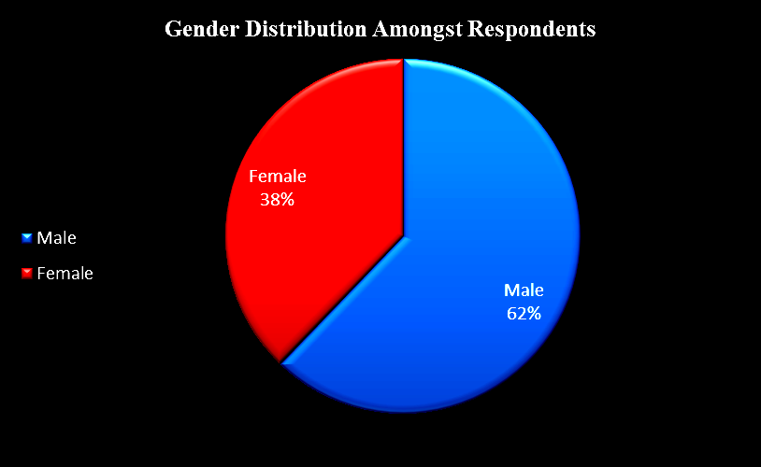
Figure 1: Gender distribution of Respondents

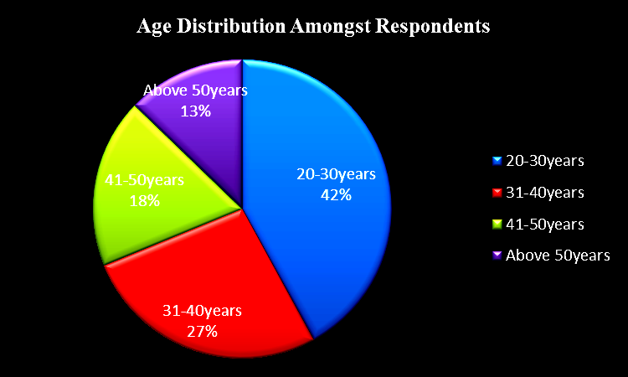
Figure 2: A distribution of Respondents

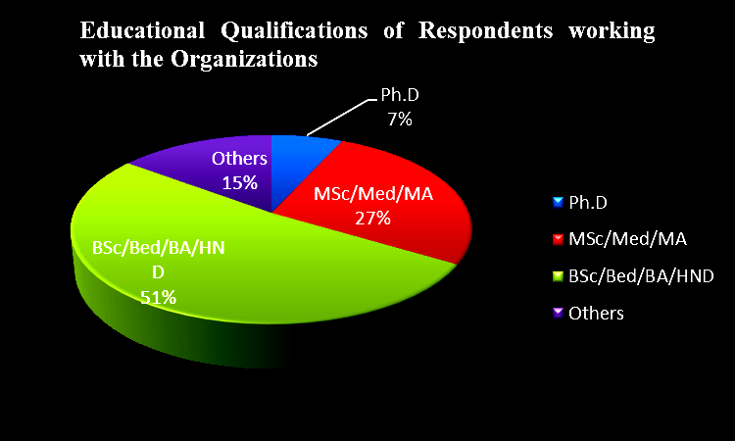
Figure 3: Educational Status of Respondents

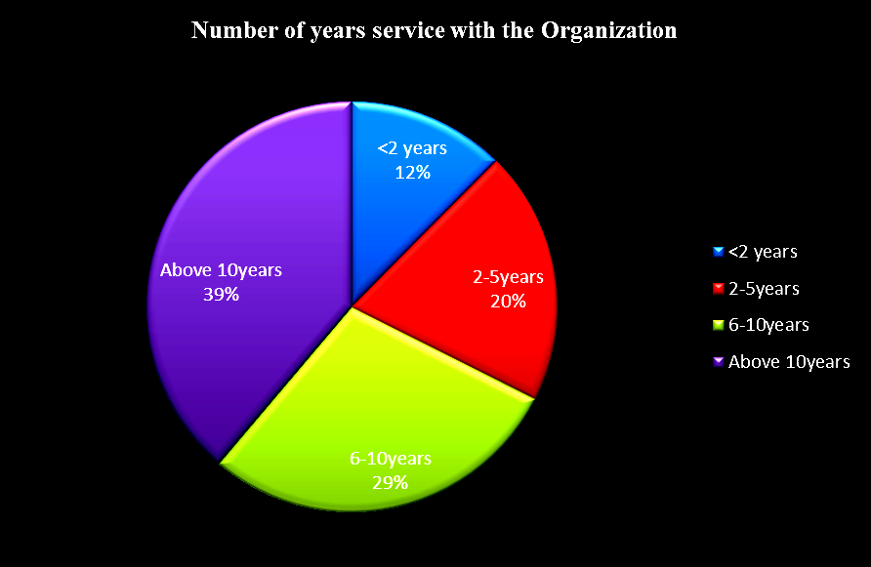
Figure 4: Respondents’ Years in Service

Reporting on the Impact of Planning on Systems Approach in Community Development Projects
The findings from the survey highlight a generally positive view on the role of planning in the systems approach to project management in community development projects in Nigeria. The grand mean of 3.00, with a standard deviation of 0.944, indicates that respondents generally agreed with the importance of planning in ensuring the success of community development projects.
Respondents strongly agreed with the notion that a project plan is created before the project's commencement, clearly outlining the scope, resources, and timeline, as reflected in the highest mean score of 3.41 (standard deviation = 0.976). This result emphasizes the critical role of detailed planning in establishing clear project parameters. Furthermore, the identification and continuous monitoring of project risks (mean = 2.98, standard deviation = 0.887) was viewed as essential at the project’s initiation, underscoring the importance of proactive risk management to prevent potential issues during the project’s lifecycle.
On the other hand, there was a moderate level of agreement regarding the allocation of human resources (mean = 2.72, standard deviation = 1.074). Although respondents acknowledged the importance of planning in preventing resource oversizing, the level of support was less pronounced. Overall, the results suggest a consensus on the significance of planning, supporting the view that effective and well-structured planning is vital to project success. By anticipating risks, aligning resources efficiently, and setting clear objectives, planning plays a crucial role in achieving positive outcomes in community development projects.
Table 5: Impact of Planning on the Systems Approach in Community Development Projects in Nigeria
S/No. | Items | SA (4) | A (3) | D (2) | SD (1) | N | $$\underline{X}$$ | Std | Rmk
1 | Before we embark on any project, we always prepare a detailed plan that includes a plan of conducted activities included in this phase. | 73 | 110 | 53 | 14 | 250 | 2.97 | 0.944 | A
2 | In any of our community projects, we first identify project risks at the beginning and monitor the same throughout the course of the project. | 97 | 86 | 32 | 35 | 250 | 2.98 | 0.887 | SA
3 | Good planning creates conditions for our project success and can solve many potential problems before they occur. | 64 | 73 | 58 | 55 | 250 | 2.58 | 1.095 | A
4 | The plan provides the allocation of human resources on the key phases of the project while preventing their oversizing. | 70 | 86 | 48 | 46 | 250 | 2.72 | 1.074 | A
5 | In terms of scope and the level of detail of the plan, we often distinguish the overall project plan and detailed plans. | 86 | 155 | 7 | 7 | 250 | 3.32 | 1.148 | A
6 | Our project plan is constructed before the start of the project and defines the project as a whole, along with necessary resources and time. | 107 | 140 | 3 | 0 | 250 | 3.41 | 0.976 | A
 | Grand Mean |  |  |  |  |  | 3.00 |  | Agree

Reporting on the Impact of Scheduling on Systems Approach in Project Management
The results from the survey provide valuable insights into the role of scheduling within the systems approach to project management in community development projects in Nigeria. As shown in Table 4, respondents generally agreed that scheduling is integral to successful project management. A majority of respondents (97) indicated that their community projects consistently include planned start and finish dates, durations, and resource allocation.
Furthermore, 125 of respondents strongly agreed that project scheduling is considered a crucial component of effective time management, highlighting its importance in ensuring timely delivery of project milestones. The presence of formal scheduling processes, such as timetables that outline start and finish dates while considering resources and stakeholders, was confirmed by a significant number of respondents. Moreover, the survey reveals that 62% of respondents acknowledged having formal policies for managing schedules, which is a positive indicator of organizational preparedness in time management (Mean = 3.32, Std = 1.148).
The scheduling process was also found to be valuable in tracking progress, with most respondents noting its strategic benefit in monitoring project timelines. Overall, the grand mean of 3.20 suggests that respondents perceive scheduling as a critical factor that contributes significantly to the successful execution of community development projects within a systems approach framework.
Table 6: Impact of Scheduling on Systems Approach in Project Management of Community Development Projects in Nigeria

S/No. | Items | SA (4) | A (3) | D (2) | SD (1) | N | $$\underline{X}$$ | Std | Rmk
1 | Our community project often schedules that include a planned start and finish date, duration, and resources assigned to each activity. | 82 | 97 | 34 | 37 | 250 | 2.90 | 0.905 | A
2 | In our organization, project scheduling is considered a critical component of successful time management. | 125 | 102 | 11 | 12 | 250 | 3.34 | 1.162 | SA
3 | For each project carried out by our organization, there is a timetable showing the forecast start and finish dates for activities or events within a project, programme, or portfolio, while taking available resources and stakeholders into consideration. | 86 | 117 | 28 | 19 | 250 | 3.02 | 0.986 | A
4 | Taking all factors into consideration, our organization has a procedure that requires the establishment of policies and documentation for maintaining, developing, managing, and controlling the schedules for time and resources for the completion of the project. | 86 | 155 | 7 | 7 | 250 | 3.32 | 1.148 | A
5 | Our organization gains strategic benefits from the schedule management process as it helps in monitoring and managing the schedule throughout the project. | 113 | 130 | 3 | 4 | 250 | 3.40 | 0.987 | SA
 | Grand Mean |  |  |  |  |  | 3.20 |  | Aggree

Controlling Practices in the Systems Approach to Project Management
The findings from the study provide valuable insights into the impact of controlling practices within the systems approach to project management in community development projects in Nigeria. Effective project control is viewed as crucial in ensuring that projects remain on track, with the majority of respondents (63.2%) strongly agreeing that project control helps deliver timely project information, which allows for corrective actions. This suggests that real-time monitoring and the ability to adjust are key to effective project management.
Similarly, respondents (56%) indicated that systemic project control enables them to monitor and compare planned objectives, risks, schedules, and budgets against actual project performance, reinforcing the importance of keeping projects aligned with their goals and requirements. Furthermore, the review of metrics and reports to identify variances from the project baseline received strong agreement (68% of respondents). This demonstrates that frequent monitoring is seen as essential for the identification of deviations and their correction before they become significant issues.
The grand mean score of 3.55, coupled with low standard deviations across the items, further reinforces the significance of controlling in ensuring project success. These findings indicate that the systems approach, when applied effectively in community development projects, fosters an environment of continuous monitoring and adjustment, ensuring that projects are more likely to achieve their intended outcomes despite the complex challenges they face.
Table 7: Impact of Controlling on Systems Approach in Project Management for Community Development Projects in Nigeria

S/No. | Items | SA (4) | A (3) | D (2) | SD (1) | N | $$\underline{X}$$ | Std | Rmk
1 | Effective project control helps our organization to deliver timely project information, allowing managers to take corrective measures to keep the project on track. | 158 | 81 | 6 | 5 | 250 | 3.57 | 1.o66 | SA
2 | In our organization, systemic project control helps us to monitor and compare planned objectives, requirements, risks, schedules, and budgets against what is actually being delivered. | 107 | 140 | 3 | 0 | 250 | 3.41 | 0.976 | A
3 | In our organization, we have a system that involves the regular review of metrics and reports that help us identify variances from the project baseline. | 170 | 77 | 6 | 0 | 250 | 3.67 | 1.054 | SA
 | Grand Mean |  |  |  |  |  | 3.55 |  | Agree

Hypothesis Testing
The following hypotheses were tested to assess the impact of planning, scheduling, and controlling on the systems approach to project management in community development projects:
Hypothesis 1 (H₁): Planning significantly impacts the systems approach to project management. The results show a grand mean of 3.00, above the criterion mean of 2.50, indicating that planning plays a crucial role in systems-oriented project management. Decision: Supported.
Hypothesis 2 (H₂): Scheduling significantly impacts the systems approach to project management. The grand mean score for scheduling was 3.20, suggesting that respondents view scheduling as essential for successful project management. Decision: Supported.
Hypothesis 3 (H₃): Controlling significantly impacts the systems approach to project management. The grand mean score for controlling was 3.55, the highest among the three constructs, demonstrating the significance of controlling in effective project management. Decision: Supported.

Discussion

Main Findings
This study investigated the influence of planning, scheduling, and controlling in the systems approach to project management in community development projects, with a particular focus on Nigeria. The findings underscore the importance of these three pillars in driving successful project outcomes. The results reveal that planning is seen as an essential first step in the management of community development projects, with the majority of respondents agreeing on the necessity of detailed and strategic planning. This is supported by high mean scores indicating that clear planning practices, including risk identification and resource allocation, are considered crucial for project success. Scheduling practices also emerged as vital to maintaining project timelines, with respondents acknowledging the importance of setting planned start and finish dates and the strategic benefits of time management. Controlling mechanisms were equally vital, as evidenced by the respondents’ consensus on the role of continuous monitoring and corrective action in keeping projects on track. The results of hypothesis testing reveal significant support for the role of planning, scheduling, and controlling in the systems approach to project management in community development. The data suggests that planning, scheduling, and controlling are interrelated components that drive project success.
Overall, the study’s findings suggest that a systems approach, which integrates planning, scheduling, and controlling, is essential for achieving the desired outcomes in community development projects, despite challenges like resource limitations and political constraints.
Comparison with Existing Literature
The importance of planning, scheduling, and controlling in project management, particularly in community development, is well documented in the literature. Recent studies emphasize the role of systematic planning in increasing project success rates by minimizing risks and maximizing resource utilization. For example, research by Elly (2023) and Suvvari & Saxena (2023)argues that meticulous project planning fosters better stakeholder coordination and enhances project predictability in developing countries. This aligns with the findings of this study, where respondents consistently highlighted the significance of planning before project initiation. The high mean scores for statements related to risk identification and resource allocation underscore the global consensus that early, well-structured planning is integral to the success of community development projects (Amin et al., 2023).
Scheduling, as an essential component of time management, has also been widely recognized in project management literature. Yadav (2025) emphasizes that effective scheduling helps ensure that tasks are completed on time and within the allocated budget. Similarly, the findings in this study reflect that respondents believe scheduling is critical for timely project delivery. A key similarity to the study by Soni & Ware (2023) and Suvvari & Saxena (2024)is the acknowledgment of formal scheduling systems and the use of timetables to track project milestones. The respondents in this study demonstrated a strong preference for formal policies and procedures to manage project timelines, highlighting the growing institutionalization of scheduling as a vital project management tool.
Moreover, controlling mechanisms are increasingly seen as crucial in adjusting to project challenges and ensuring that projects remain aligned with their objectives. The study by Alotaibi et al. (2025) argues that controlling is central to managing uncertainties in community development projects, as it provides real-time feedback on project performance. The respondents’ overwhelming support for the need to continuously monitor and adjust project activities aligns with Alotaibi et al. (2025) assertion that controlling facilitates proactive responses to deviations from the plan, thus ensuring that projects stay on track. The emphasis on regular reviews and corrective measures observed in this study supports this view, reinforcing the argument that controlling is a necessary component of any successful project, especially in environments fraught with complexity.
In contrast, while the literature emphasizes the theoretical frameworks surrounding project management practices, the focus of this study on Nigerian community-based organizations offers a unique empirical contribution. The local context of Nigeria—characterized by resource constraints, political interference, and fragmented stakeholder engagement—has not been sufficiently explored in previous research. This study bridges that gap by examining how these contextual factors shape the practical application of project management principles in community development projects. The findings suggest that, while systems thinking provides a comprehensive framework for project management, practical implementation is hindered by several barriers, including limited institutional capacity and inadequate training among local project managers (Adepoju & Obademi, 2023; Toriola-Coker et al., 2023). These barriers are consistent with the observations made by Apeh and Otu (2025), who noted that community-based organizations in Nigeria struggle with project management inefficiencies due to lack of formal training and resources.
Recommendations
Based on the findings of this study, it is imperative that project managers adopt a comprehensive and systematic approach to project management, particularly in the context of community development projects in Nigeria. First and foremost, it is recommended that project managers ensure thorough and detailed planning before the commencement of any project. This planning should include clear objectives, resource allocation, risk identification, and timelines, as these are crucial to the successful execution of the project. Effective planning serves as the foundation for managing uncertainties and aligning stakeholders with the project's goals, thus reducing the likelihood of delays and cost overruns.
Furthermore, scheduling practices should be given significant attention. Project managers, in collaboration with key stakeholders, must develop realistic schedules that factor in both resource availability and time constraints. Scheduling should not only focus on the project’s timeline but also on ensuring that tasks are assigned based on the availability and capacity of resources. This will help maintain momentum and prevent unnecessary delays, ensuring that quality is maintained throughout the project lifecycle. It is also essential for project managers to regularly update and adjust schedules as needed to accommodate unforeseen challenges, which is particularly important in dynamic community development projects.
Additionally, controlling mechanisms should be robust and adaptable. Project managers must continuously monitor resource utilization, comparing actual performance against planned objectives, timelines, and budgets. This real-time monitoring allows for corrective actions to be taken promptly, thereby keeping the project aligned with its goals and maintaining quality standards. Furthermore, feedback loops should be institutionalized to allow for iterative improvements during the project execution phase.
Finally, it is essential to invest in capacity building for project managers, particularly in adopting modern project management tools and techniques such as AI-based scheduling and risk management. These tools can significantly enhance the efficiency and effectiveness of project implementation, especially in complex community development projects. Training in these areas will help project managers navigate the unique challenges faced by CBOs and NGOs in Nigeria, ultimately contributing to the successful realization of community development objectives.
Strengths and Limitations
This study's strength lies in its comprehensive examination of the systems approach to project management within the unique context of community development in Nigeria. The use of a large sample size (250 respondents) from diverse organizations ensures that the findings are representative of the broader landscape of community-based organizations in Port Harcourt. The high response rate (92.6%) further enhances the reliability and validity of the study, providing a strong foundation for generalizing the findings to similar contexts within Nigeria.
Additionally, the use of a well-structured and reliable survey instrument, with a Cronbach’s alpha coefficient of 0.85, ensures that the data collected is consistent and trustworthy. The study's focus on empirical data, rather than relying solely on theoretical models, adds value to the existing body of literature by providing real-world insights into the practical application of project management principles in community development.
However, the study also has limitations that should be acknowledged. First, the research was confined to Port Harcourt, a single city in Nigeria. While Port Harcourt is representative of the socio-economic conditions and challenges faced by community development organizations in the country, the findings may not fully capture the diversity of practices in other regions of Nigeria. Future studies could expand the sample to include organizations in different states to provide a more comprehensive understanding of project management practices across the country.
Second, the study relied on self-reported data, which can introduce biases, such as social desirability or recall bias. Although efforts were made to minimize these biases through careful questionnaire design and informed consent procedures, the possibility of over-reporting positive behaviors or under-reporting challenges remains. Additionally, the study did not incorporate a longitudinal perspective, meaning that it does not assess the long-term impact of project management practices on the sustainability and success of community development projects. Future research could explore these long-term effects and examine how the systems approach evolves over time within different organizational contexts.

Conclusion
This study revealed that planning, scheduling, and controlling play a vital role in the successful management of community development projects in Nigeria. The analysis showed that thorough planning, including risk identification and resource allocation, is perceived as crucial for ensuring the smooth execution of projects. It was found that detailed planning at the project’s initiation leads to a more structured approach, reducing the likelihood of delays and cost overruns. The data indicated that effective scheduling, which includes setting realistic start and finish dates, is integral in maintaining project timelines without compromising on quality. Moreover, it was proven that controlling mechanisms—such as continuous monitoring and corrective actions—are essential for adjusting the course of the project in real-time, ensuring that it remains aligned with its objectives.
The findings also pointed to the importance of integrating a systems approach to project management, where planning, scheduling, and controlling are not isolated processes but interconnected elements that work together to achieve project success. This underscores the need for community-based organizations (CBOs) and non-governmental organizations (NGOs) to adopt a more systematic approach to project management. Based on these results, it is recommended that both policymakers and practitioners focus on building capacity through training in project management best practices, including the use of advanced tools such as AI-enhanced scheduling. Finally, future research should examine the long-term impact of these practices across different regions of Nigeria to better understand their role in driving sustainable development outcomes.

Consent
As per international standards or university standards, respondents’ written consent has been collected and preserved by the author(s).
Disclaimer (Artificial intelligence): Author hereby declare that NO generative AI technologies such as Large Language Models (ChatGPT, COPILOT, etc.) and text-to-image generators have been used during the writing or editing of this manuscript.
References
Adepoju, A., & Obademi, T. (2023). Assessment of Stakeholder Involvement and Borehole Water Projects Delivery in Kogi West Senatorial District, Nigeria. Journal of Digital Food, Energy & Water Systems, 4(1). https://doi.org/10.36615/digital_food_energy_water_systems.v4i1.2480
Alotaibi, R., Sohail, M., Edum-Fotwe, F. T., & Soetanto, R. (2025). Determining project control system effectiveness in construction project delivery. Engineering, Construction and Architectural Management. https://www.emerald.com/ecam/article-abstract/doi/10.1108/ECAM-04-2024-0529/1259389/Determining-project-control-system-effectiveness?redirectedFrom=fulltext
Amin, H., Scheepers, H., & Malik, M. (2023). Project monitoring and evaluation to engage stakeholders of international development projects for community impact. International Journal of Managing Projects in Business https://doi.org/10.1108/IJMPB-02-2022-0043
Apeh, P. E., & Otu, J. A. (2025). Project execution and rural development in selected area councils in Nigeria. Journal of Public Administration, Finance and Law, 13(33), 55-77. https://doi.org/10.47743/jopafl-2024-33-4
Bassi, A. (2025). The Systemic Approach in Project Management. In General Management Principles for Project Management: Effective Ways to Help Organizations Manage Business (pp. 73-91). Cham: Springer Nature Switzerland. https://doi.org/10.1007/978-3-031-98592-8_9
Blak Bernat, G., Qualharini, E. L., & Castro, M. S. (2023). Enhancing Sustainability in Project Management: The Role of Stakeholder Engagement and Knowledge Management in Virtual Team Environments. Sustainability, 15(6), 4896. https://doi.org/10.3390/su15064896
Bohra, P., & Verma, R. S. (2024). Optimizing sustainable construction projects through LNSGA III: a time-cost-environmental impact trade-off approach. Asian Journal of Civil Engineering, 25(5), 4343-4354. https://doi.org/10.1007/s42107-024-01052-6
Cohen, I. (2024). Data-driven project planning: An integrated network learning, process mining, and constraint relaxation approach in favor of scheduling recurring projects. IEEE Transactions on Engineering Management, 71, 7719-7729. https://doi.org/10.1109/TEM.2024.3384000
Elly, A. R. (2023). Project planning, stakeholder involvement, risk management, and project success - A case of selected NGOs in South Sudan. Texila International Journal of Management, 9(1), 1-10. https://doi.org/10.21522/TIJMG.2015.09.01.Art001
Gorod, A., Hallo, L., & Nguyen, T. (2018). A systemic approach to complex project management: Integration of command‐and‐control and network governance. Systems research and behavioral science, 35(6), 811-837. https://doi.org/10.1002/sres.2520
Hamidu, M. Z., Agboola, S. A., Faruq, M. Y., & Falade, A. A. (2024). Determinants of poor planning in public sector construction projects in Nigeria. Interdisciplinary Journal of Management Sciences, 1, 1-16. https://doi.org/10.38140/ijms-2024.vol1.10
Hariyani, D., Hariyani, P., & Mishra, S. (2025). Digital technologies for the Sustainable Development Goals. Green Technologies and Sustainability, 100202. https://doi.org/10.1016/j.grets.2025.100202

Hosseini, A., & Farid, A. M. (2025). Extending Resource Constrained Project Scheduling to Mega-Projects with Model-Based Systems Engineering & Hetero-functional Graph Theory. arXiv preprint arXiv:2510.19035. https://doi.org/10.48550/arXiv.2510.19035

Humenna, O., Safonov, Y., & Kharlamova, G. (2025). Strategic Management of Sustainable Community Development in Conditions of Turbulence and Uncertainty. In Sustainable Economic Development: Utilizing Non-Financial Performance, Sustainability Reporting, and Corporate Governance (pp. 1-29). Cham: Springer Nature Switzerland. https://doi.org/10.1007/978-3-031-96224-0_1

Hussein, B. (2019). The influence of project characteristics on project success factors. Insights from 21 real life project cases from Norway. Procedia Computer Science, 164, 350-357. https://doi.org/10.1016/j.procs.2019.12.193

Iroha, E. V., Watanabe, T., & Satoshi, T. (2024). Flawed Institutional Structures: Project Managers Underutilized in Nigeria’s Construction Industry. Buildings, 14(3), 807. https://doi.org/10.3390/buildings14030807

Johnson, E. (2021). Cronbach’s alpha. Encyclopedia of Autism Spectrum Disorders, 1248-1249. https://doi.org/10.1007/978-3-319-91280-6_307

Kangana, N., Kankanamge, N., De Silva, C., Goonetilleke, A., Mahamood, R., & Ranasinghe, D. (2024). Bridging Community Engagement and Technological Innovation for Creating Smart and Resilient Cities: A Systematic Literature Review. Smart Cities, 7(6), 3823-3852. https://doi.org/10.3390/smartcities7060147

Kerzner, H. (2021). Project management: a systems approach to planning, scheduling, and controlling. John Wiley & Sons. https://faculty.tamuc.edu/JDavis/tmgt/514/218/TMGT514-218-Syllabus.pdf
Larson, E. W., & Gray, C. F. (2020). *Project management: The managerial process* (8th ed.). McGraw-Hill Education. https://www.mheducation.com/highered/product/project-management-managerial-process-larson-gray/9781260238860.html
Leuhery, F. (2024). The role of technology in employee training and development: a systematic review of recent advances and future directions. Management Studies and Business Journal (Productivity), 1(3), 369-385. https://doi.org/10.62207/jmnzaw55

Paramonova, I., Lamas, D., & Sousa, S. (2024). Socio-Technical Trustworthiness (SoTechTrust): A Framework to Ensure the Trustworthiness of Socio-Technical Systems. In the World Conference on Qualitative Research (pp. 375-401). Cham: Springer Nature Switzerland. https://doi.org/10.1007/978-3-031-65735-1_21

Pasmore, W., Winby, S., Mohrman, S. A., & Vanasse, R. (2019). Reflections: Sociotechnical Systems Design and Organization Change. Journal of Change Management, 19(2), 67–85. https://doi.org/10.1080/14697017.2018.1553761

Pouvreau, D. (2014). On the history of Ludwig von Bertalanffy’s “general systemology”, and on its relationship to cybernetics - Part II: Contexts and developments of the systemological hermeneutics instigated by von Bertalanffy. International Journal of General Systems, 43(2), 172–245. https://doi.org/10.1080/03081079.2014.883743

Project Management Institute. (2025). The standard for project management and a guide to the project management body of knowledge (PMBOK guide) (8th ed.). https://www.pmi.org/-/media/pmi/documents/public/pdf/publications/pmbok-guide-eighth-edition_table-of-contents.pdf
Soni, P., & Ware, N. (2023). Brief overview of project scheduling process. International Journal of Engineering Research & Technology (IJERT), 12(4). https://www.ijert.org/brief-overview-of-project-scheduling-process
Suvvari, S. K., & Saxena, V. D. (2023). Stakeholder management in projects: Strategies for effective communication. Innovative Research Thoughts, 9(5), 188-201. https://doi.org/10.36676/irt.v9.i5.1479
Suvvari, S. K., & Saxena, D. V. D. (2024). Innovative Approaches to Project Scheduling: Techniques and Tools. Innovative Research Thoughts, 10 (2), 133–143. https://doi.org/10.36676/irt.v10.i2.1481
Taresh, N. S. S., Golestanizadeh, M., Sarvari, H., & Edwards, D. J. (2025). The Impact of Using Information Systems on Project Management Success Through the Mediator Variable of Project Risk Management: Results from Construction Companies. Buildings, 15(8), 1260. https://doi.org/10.3390/buildings15081260
Titarenko, R., & Da Camara, N. (2025). Investigation of Project Schedule Management Challenges Underpinned by Process Approach. PM World Journal. http://pmworldlibrary.net/wp-content/uploads/2025/02/pmwj149-Feb2025-Titarenko-Camara-Investigation-of-Project-Schedule-Management-Challenges-2.pdf
Toriola-Coker, L., Owolabi, H., Alaka, H., Bello, W. A., & Pathirage, C. (2023). Critical success factors (CSFs) for motivating end-user stakeholder's support for ensuring sustainability of PPP projects in Nigerian host communities. Journal of Engineering, Design and Technology, 21(3), 902-926. https://doi.org/10.1108/JEDT-04-2021-0202
Yadav, V. (2025). Project planning and scheduling. International Journal of Research Publication and Reviews, 6(2), 2675-2686. https://ijrpr.com/uploads/V6ISSUE2/IJRPR38850.pdf
Yousef, K. (2024). Exploring the impact of cultural diversity in global projects: A comparative analysis of virtual and face-to-face teamwork. International Journal of Cross Cultural Management, 24(2), 411-430. https://doi.org/10.1177/14705958241253754

