Domestic Wastewater Discharge Effects on Water Quality and Public Health in Choba River, Rivers State, Nigeria
Abstract
Urban rivers in the Niger Delta are increasingly impacted by untreated domestic wastewater due to rapid population growth, inadequate sanitation infrastructure, and unplanned urban development. This study evaluated the effects of domestic wastewater discharge on water quality and public health of the Choba River, Rivers State, Nigeria. Eighteen surface water samples were collected from three representative zones along the river course: an upstream control site, a midstream zone receiving major domestic wastewater inputs, and a downstream post-discharge zone. In situ measurements were conducted using calibrated portable meters, while laboratory analyses of biochemical oxygen demand (BOD), chemical oxygen demand (COD), nutrients, and heavy metals (Fe, Pb, Cd, Cr, Ni, Zn, and Cu) were performed using standard analytical methods and flame atomic absorption spectrophotometry. Microbiological quality was assessed using the membrane filtration technique. The weighted arithmetic water quality index (WQI) and human health risk assessment models were applied to evaluate cumulative pollution and exposure risks. The results showed progressive deterioration in water quality downstream of wastewater discharge points. pH declined from near-neutral conditions upstream (6.8–7.2) to slightly acidic levels downstream (5.9–6.4). Electrical conductivity and total dissolved solids increased markedly downstream, while dissolved oxygen decreased from 5.6–6.8 mg/L upstream to 1.9–3.2 mg/L downstream, indicating hypoxic conditions. BOD and COD increased substantially, reflecting severe organic pollution. Lead and cadmium concentrations exceeded guideline limits at downstream locations, and total coliform counts increased sharply from 120–480 CFU/100 mL upstream to 2,400–6,800 CFU/100 mL downstream. WQI values ranged from 132 (poor) upstream to 412 (unsuitable) downstream. Non-carcinogenic hazard quotients for children exceeded unity for lead (HQ = 1.94) and cadmium (HQ = 2.11). Therefore, domestic wastewater discharge has severely degraded the Choba River, rendering it unsuitable for domestic and recreational use.
Keywords: Domestic wastewater, surface water quality, heavy metals, microbiological contamination, Choba River

1.0 Introduction
Urban rivers in the Niger Delta play critical roles in domestic water supply, fisheries, recreation, and ecosystem regulation. However, rapid population growth, unplanned urban expansion, and inadequate wastewater management have increasingly transformed many of these rivers into recipients of untreated domestic effluents. Domestic wastewater discharge has therefore emerged as one of the most pervasive sources of surface water pollution in the region, with significant consequences for water quality, ecosystem health, and public safety (Ekesiobi et al., 2025).
Domestic wastewater typically contains high loads of organic matter, nutrients, suspended solids, pathogenic microorganisms, and trace contaminants. When discharged untreated into surface waters, these constituents alter the physicochemical balance of rivers, promote oxygen depletion, and increase microbial contamination. Studies across southern Nigeria have shown that rivers receiving household effluents experience elevated biochemical oxygen demand, nutrient enrichment, and reduced dissolved oxygen, conditions that are detrimental to aquatic life and limit water usability (Osuafor et al., 2025; Umueni et al., 2025). Such impacts are particularly pronounced in urban catchments where dilution capacity is limited and wastewater inputs are continuous.
In the Niger Delta, the vulnerability of surface waters is further amplified by the region’s hydroclimatic and geomorphological setting. High rainfall, low relief, and interconnected drainage networks enhance the transport of contaminants from urban landscapes into rivers. In addition, petroleum-related activities and associated atmospheric deposition contribute supplementary pollutant loads, including heavy metals, which may interact with domestic wastewater constituents to intensify environmental degradation (Aghanwa et al., 2025; Okpoji et al., 2025). Evidence from urban rivers and estuarine systems indicates that metals such as lead, cadmium, and nickel are frequently detected in waters receiving mixed domestic and industrial inputs, posing chronic ecological and human health risks (Okpoji et al., 2025).
Microbiological contamination remains a major public health concern in wastewater-impacted rivers. The presence of faecal indicator bacteria in surface waters has been widely linked to direct discharge of sewage and poor sanitation infrastructure in urban communities. Investigations of drinking and surface water sources in coastal and inland Niger Delta settlements have consistently reported high densities of coliforms and Escherichia coli, highlighting the risk of waterborne diseases for populations relying on untreated river water for domestic and recreational purposes (Ekesiobi et al., 2025; Osuafor et al., 2025). These risks are particularly acute in densely populated areas where rivers are used daily for bathing, washing, and fishing.
Beyond immediate health concerns, sustained domestic wastewater discharge undermines the ecological integrity of river systems. Ecotoxicological studies in Niger Delta waters have demonstrated that prolonged exposure to combined organic and metal pollution induces oxidative stress, histopathological damage, and altered physiological responses in fish and crustaceans, ultimately reducing biodiversity and ecosystem resilience (Ohaturuonye et al., 2025; Okpoji et al., 2025). Nutrient-driven eutrophication and organic loading further exacerbate these effects by promoting algal growth and hypoxic conditions, as reported in several regional assessments of surface waters (Umueni et al., 2025; Ekwere et al., 2025).
Integrated assessment approaches that combine physicochemical analysis, microbiological evaluation, and human health risk assessment have become increasingly important for understanding the full implications of wastewater pollution. Studies applying water quality indices and risk models in the Niger Delta have shown that rivers may appear acceptable based on isolated parameters yet remain unsuitable for human use when cumulative effects are considered (Ekesiobi et al., 2025; Ekwere et al., 2025). Such frameworks are particularly valuable for identifying vulnerable populations, including children, who are more susceptible to contaminants due to higher exposure rates relative to body weight.
The Choba River, located within Port Harcourt metropolis, exemplifies the pressures faced by urban rivers in the Niger Delta. Flowing through a densely populated environment influenced by residential settlements, student hostels, markets, and informal drainage networks, the river receives substantial volumes of untreated domestic wastewater. Despite its importance to local livelihoods and daily activities, comprehensive studies assessing the combined effects of domestic wastewater discharge on the physicochemical quality, microbiological status, and public health risks associated with the Choba River remain limited.
Therefore, this study investigates the effects of domestic wastewater discharge on the water quality of the Choba River and evaluates associated public health risks using an integrated assessment framework.

2.0 Materials and Methods

2.1 Study Area
The study was carried out along the Choba River in Choba community, Obio/Akpor Local Government Area, Rivers State, Nigeria. The river drains a highly urbanised environment characterised by residential settlements, markets, student hostels, and commercial facilities associated with the University of Port Harcourt. Domestic wastewater from household drains, septic tank overflows, and open gutters is discharged directly into the river at several locations. The area lies within the humid tropical climatic zone with a distinct wet season (April–October) and dry season (November–March). Mean annual rainfall exceeds 2,300 mm, while ambient temperatures typically range from 26 to 32 °C. The river is commonly used for washing, bathing, small-scale fishing, and other domestic activities.

2.2 Sampling Locations and Geographic Referencing
Three representative sampling zones were selected to capture spatial variation in water quality relative to domestic wastewater discharge. These comprised an upstream control site with minimal anthropogenic influence, a midstream site receiving major domestic wastewater inputs, and a downstream site reflecting cumulative impacts. Geographic coordinates of all sampling locations were recorded using a handheld Global Positioning System (GPS) receiver (Garmin eTrex series) to ensure accurate spatial referencing and reproducibility.
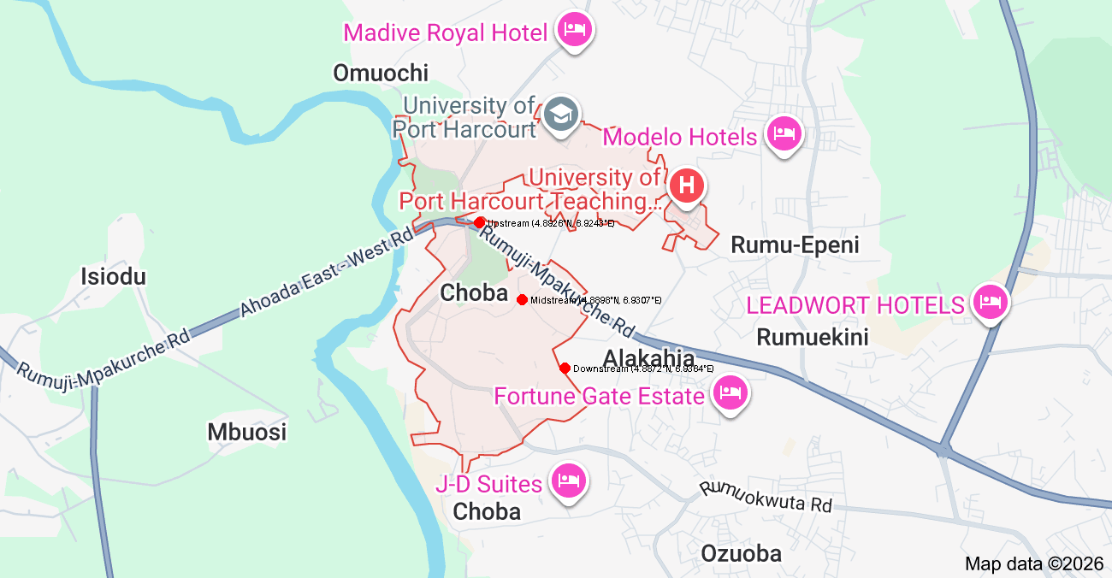
Figure 1: Map of Choba River showing sampling locations

Table 1: Geographic Coordinates of Sampling Locations Along Choba River
Sampling Zone | Location Description | Latitude (N) | Longitude (E)
Upstream | Choba River upstream control site | 4.8926° | 6.9243°
Midstream | Major domestic wastewater discharge zone | 4.8898° | 6.9307°
Downstream | Post-discharge zone | 4.8872° | 6.9364°

2.3 Sampling Design and Sample Collection
Surface water samples were collected using a stratified sampling design across the three zones. A total of eighteen samples were obtained, consisting of six samples from each zone. Sampling was conducted using pre-cleaned 1 L high-density polyethene bottles. Prior to collection, sampling bottles were rinsed three times with river water at each site. Samples for heavy metal analysis were preserved immediately by acidification with concentrated nitric acid to a pH < 2, while samples for microbiological analysis were collected separately in sterile glass bottles. All samples were stored in ice chests and transported to the laboratory for analysis within six hours of collection.

2.4 In situ Physicochemical Measurements
Water temperature, pH, electrical conductivity, total dissolved solids, and dissolved oxygen were measured on-site using a calibrated portable multiparameter water quality meter. Turbidity was determined using a digital turbidimeter. Measurements were taken in triplicate at each sampling location, and average values were used for subsequent analysis.

2.5 Laboratory Determination of Physicochemical Parameters
Biochemical oxygen demand (BOD₅) was determined using the standard five-day incubation method by measuring dissolved oxygen before and after incubation at 20 °C. Chemical oxygen demand (COD) was analysed using the dichromate reflux method. Nitrate concentration was determined by ultraviolet spectrophotometry, while phosphate was analysed using the ascorbic acid molybdenum blue method. All laboratory analyses followed standard protocols for surface water quality assessment.

2.6 Heavy Metal Analysis
For heavy metal determination, water samples were digested using concentrated nitric acid on a temperature-controlled hot plate until clear solutions were obtained. The digested samples were filtered and diluted with deionised water prior to analysis. Concentrations of iron (Fe), lead (Pb), cadmium (Cd), chromium (Cr), nickel (Ni), zinc (Zn), and copper (Cu) were quantified using flame Atomic Absorption Spectrophotometry. Calibration was performed using certified multi-element standard solutions, and analytical accuracy was ensured through periodic calibration checks.

2.7 Microbiological Analysis
The microbiological quality of the river water was assessed using the membrane filtration technique. Known volumes of samples were filtered through sterile 0.45 µm membrane filters, which were then placed on selective culture media. Total coliforms were enumerated on m-Endo agar, faecal coliforms on m-FC agar, and Escherichia coli on Eosin Methylene Blue agar. After incubation at appropriate temperatures, colonies were counted and expressed as colony-forming units per 100 mL (CFU/100 mL).

2.8 Water Quality Index
Overall water quality was evaluated using the weighted arithmetic water quality index (WQI) method.
The quality rating scale for each parameter was calculated as:
Qi = 100 × (Ci − Vo) / (Si − Vo)
where
Ci = measured concentration of the ith parameter,
Si = recommended standard or guideline value of the ith parameter,
Vo = ideal value of the parameter in pure water
(Vo = 0 for all parameters except pH = 7.0 and dissolved oxygen = 14.6 mg/L).
The relative weight assigned to each parameter was calculated as:
Wi = 1 / Si
The overall water quality index (WQI) was computed as:
WQI = Σ(Qi × Wi) / ΣWi (Ogbodo et al. 2020).
Based on the computed WQI values, water quality was classified as excellent, good, poor, very poor, or unsuitable for use according to standard WQI classification ranges.

2.9 Human Health Risk Assessment
Human health risk assessment was conducted for adults and children considering ingestion and dermal contact exposure pathways. The estimated daily intake (EDI) of metals through ingestion was calculated using:
EDI = (C × IR × EF × ED) / (BW × AT)
where C is the metal concentration in water (mg/L), IR is the ingestion rate (adults 100 mg/day; children 200 mg/day), EF is the exposure frequency (350 days/year), ED is the exposure duration (adults 30 years; children 6 years), BW is body weight (adults 70 kg; children 15 kg), and AT is the averaging time.
The non-carcinogenic hazard quotient (HQ) was calculated as:
HQ = EDI / RfD
The hazard index (HI) was obtained as the summation of HQ values for individual metals:
HI = ΣHQ
Values of HI greater than unity were interpreted as indicating potential non-carcinogenic health risk.

2.10 Quality Assurance and Statistical Analysis
Quality assurance and quality control measures included the use of reagent blanks, duplicate samples, and calibration verification standards. All analyses were performed in triplicate, and results were expressed as mean ± standard deviation. Descriptive statistical analyses were used to summarise spatial variations in water quality along the river course.

3.0 Results
The results obtained from the assessment of domestic wastewater discharge effects on the Choba River reveal marked spatial deterioration in water quality downstream of major wastewater input points, with clear implications for ecological integrity and public health. Water temperature showed minimal spatial variation, ranging between 27.4 and 30.2 °C, reflecting ambient tropical conditions and indicating that thermal pollution was not a dominant stressor. However, pH values declined from near-neutral conditions upstream (6.8–7.2) to slightly acidic conditions downstream (5.9–6.4), suggesting increased organic loading and biochemical processes associated with wastewater inputs.
Electrical conductivity increased substantially from upstream values of 210–340 µS/cm to downstream values of 620–980 µS/cm, indicating elevated ionic strength due to dissolved salts from domestic effluents. Similarly, total dissolved solids increased from 140–230 mg/L upstream to 410–690 mg/L downstream, exceeding recommended limits at several downstream locations. These trends demonstrate progressive mineral enrichment linked to wastewater discharge. Turbidity values rose sharply downstream, ranging from 18.6 to 46.3 NTU compared with upstream values of 4.2–9.8 NTU. The increase in turbidity reflects suspended solids, organic debris, and microbial biomass introduced by untreated domestic wastewater. Dissolved oxygen concentrations showed a corresponding decline, decreasing from 5.6–6.8 mg/L upstream to 1.9–3.2 mg/L downstream. This depletion indicates strong oxygen demand resulting from microbial decomposition of organic matter as shown in Table 2.

Table 2: Physicochemical Parameters of Choba River Water
Parameter | Upstream (Mean ± SD) | Midstream (Mean ± SD) | Downstream (Mean ± SD) | WHO Guideline
Temperature (°C) | 28.1 ± 0.9 | 29.0 ± 0.8 | 29.6 ± 0.7 | –
pH | 7.0 ± 0.2 | 6.5 ± 0.3 | 6.1 ± 0.3 | 6.5–8.5
Electrical Conductivity (µS/cm) | 275 ± 65 | 540 ± 120 | 820 ± 170 | 1,000
Total Dissolved Solids (mg/L) | 185 ± 42 | 460 ± 98 | 610 ± 140 | 500
Turbidity (NTU) | 6.8 ± 2.1 | 24.5 ± 7.8 | 36.9 ± 9.4 | 5
Dissolved Oxygen (mg/L) | 6.2 ± 0.6 | 3.6 ± 0.7 | 2.5 ± 0.5 | ≥5
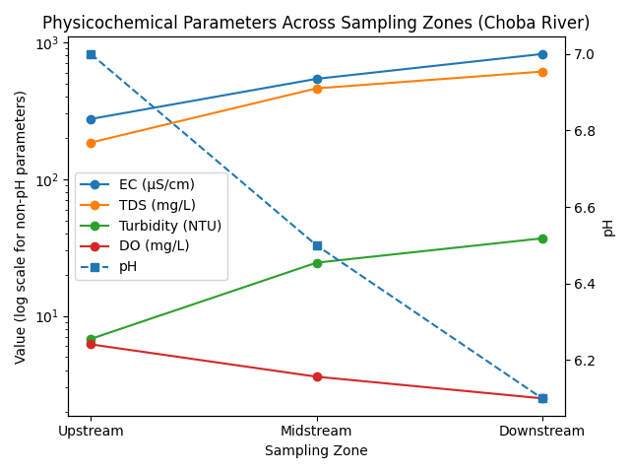
Figure 2: Spatial variation of physicochemical parameters across sampling zones of the Choba River.
Biochemical oxygen demand and chemical oxygen demand exhibited pronounced increases downstream. BOD values increased from 2.1–4.3 mg/L upstream to 18.7–36.4 mg/L downstream, while COD values rose from 14.5–28.6 mg/L to 82.4–156.8 mg/L. These elevated values confirm significant organic pollution and reduced assimilative capacity of the river receiving domestic wastewater as shown in Table 3.

Table 3: Organic Pollution Indicators in Choba River
Parameter | Upstream (Mean ± SD) | Midstream (Mean ± SD) | Downstream (Mean ± SD) | WHO Guideline
Biochemical Oxygen Demand (mg/L) | 3.1 ± 1.0 | 19.6 ± 6.4 | 31.2 ± 8.7 | ≤5
Chemical Oxygen Demand (mg/L) | 22.4 ± 6.1 | 96.3 ± 28.7 | 134.6 ± 34.9 | 40
Nutrient concentrations showed notable enrichment downstream. Nitrate levels increased from 2.4–6.1 mg/L upstream to 18.9–34.7 mg/L downstream, while phosphate concentrations increased from 0.18–0.42 mg/L to 2.1–4.8 mg/L. These concentrations indicate a high eutrophication potential and are consistent with inputs from household detergents, sewage, and food waste as shown in Table 4.

Table 4: Nutrient Concentrations in Choba River Water
Parameter | Upstream (Mean ± SD) | Midstream (Mean ± SD) | Downstream (Mean ± SD) | WHO Guideline
Nitrate (mg/L) | 4.3 ± 1.8 | 21.6 ± 7.2 | 29.4 ± 6.9 | 50
Phosphate (mg/L) | 0.31 ± 0.12 | 2.8 ± 1.1 | 4.1 ± 1.3 | 0.5

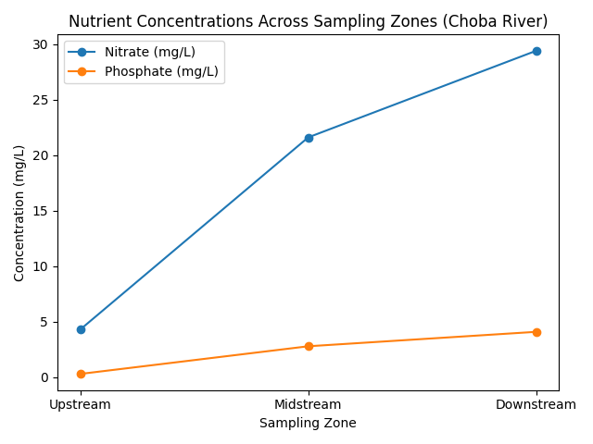
Figure 3: Spatial variation of nutrient concentrations across sampling zones of the Choba River
Heavy metal analysis revealed higher concentrations of iron, lead, and cadmium downstream relative to upstream sites. Iron ranged from 0.24–0.48 mg/L upstream and increased to 0.61–1.12 mg/L downstream. Lead concentrations increased from 0.003–0.008 mg/L upstream to 0.014–0.029 mg/L downstream, exceeding drinking water guidelines at several locations. Cadmium increased from below detection to 0.004–0.007 mg/L downstream, indicating contamination associated with domestic and urban waste sources. Chromium, nickel, zinc, and copper showed moderate increases but generally remained within guideline limits as shown in Table 5.

Table 5: Heavy Metal Concentrations in Choba River Water (mg/L)
Metal | Upstream (Mean ± SD) | Midstream (Mean ± SD) | Downstream (Mean ± SD) | WHO Guideline
Fe | 0.36 ± 0.11 | 0.72 ± 0.19 | 0.94 ± 0.26 | 0.3
Pb | 0.006 ± 0.002 | 0.018 ± 0.006 | 0.024 ± 0.008 | 0.01
Cd | <0.001 | 0.004 ± 0.001 | 0.006 ± 0.002 | 0.003
Cr | 0.014 ± 0.006 | 0.028 ± 0.010 | 0.035 ± 0.012 | 0.05
Ni | 0.011 ± 0.004 | 0.021 ± 0.008 | 0.029 ± 0.010 | 0.02
Zn | 0.18 ± 0.06 | 0.42 ± 0.15 | 0.63 ± 0.21 | 3.0
Cu | 0.07 ± 0.03 | 0.21 ± 0.08 | 0.34 ± 0.12 | 2.0

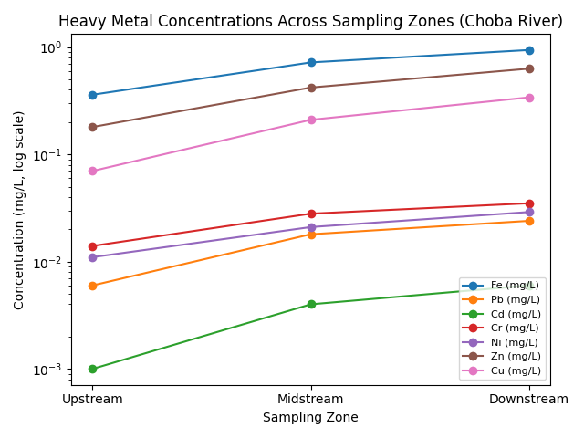
Figure 4: Spatial variation of heavy metal concentrations across sampling zones of the Choba River
Microbiological results showed severe faecal contamination of the river downstream of wastewater discharge points. Total coliform counts increased from 120–480 CFU/100 mL upstream to 2,400–6,800 CFU/100 mL downstream. Faecal coliforms ranged from 60–210 CFU/100 mL upstream and increased to 1,100–3,900 CFU/100 mL downstream. Escherichia coli was detected at all downstream stations, with counts ranging from 180–760 CFU/100 mL, confirming direct faecal pollution and indicating high risk for waterborne diseases as shown in Table 6.

Table 6: Microbiological Quality of Choba River Water (CFU/100 mL)
Parameter | Upstream | Midstream | Downstream | WHO Guideline
Total Coliforms | 320 ± 140 | 3,200 ± 1,150 | 5,400 ± 1,980 | 0
Faecal Coliforms | 140 ± 60 | 1,860 ± 720 | 3,200 ± 1,140 | 0
Escherichia coli | 90 ± 40 | 460 ± 180 | 720 ± 260 | 0
Water quality index values reflected progressive degradation along the river course. Upstream sites were classified as poor, while midstream and downstream sites were classified as very poor to unsuitable for domestic use. Parameters contributing most strongly to WQI deterioration included BOD, COD, turbidity, lead, and microbiological indicators as shown in Table 7.

Table 7: Water Quality Index (WQI) Classification
Sampling Zone | WQI Value | Water Quality Class
Upstream | 132 | Poor
Midstream | 298 | Very Poor
Downstream | 412 | Unsuitable for use
Public health risk assessment indicated that ingestion and dermal contact with river water posed significant non-carcinogenic risks, particularly for children. Hazard quotient values exceeded unity for lead and cadmium at downstream locations, while cumulative hazard index values indicated potential health concern for communities using the river for bathing, washing, fishing, and recreational activities, as shown in Table 8.

Table 8: Non-Carcinogenic Health Risk Assessment (Hazard Quotient)
Metal | HQ Adults | HQ Children | Risk Interpretation
Pb | 0.86 | 1.94 | Potential risk (children)
Cd | 0.74 | 2.11 | Significant risk
Ni | 0.58 | 1.23 | Potential risk
Cr | 0.29 | 0.51 | No risk

4.0 Discussion
The deterioration of water quality observed in the Choba River reflects a broader pattern reported for urban rivers across the Niger Delta, where untreated domestic wastewater represents a dominant source of pollution. Rivers flowing through densely populated settlements often receive continuous inputs of household effluents, resulting in altered physicochemical conditions, elevated microbial contamination, and increased public health risks (Asemota et al., 2025). Similar impacts of domestic wastewater on surface and drinking water quality have been documented in several Niger Delta communities, where untreated effluents significantly modified ionic composition, nutrient status, and microbial quality of receiving waters (Ekesiobi et al., 2025).
The progressive increase in electrical conductivity and total dissolved solids downstream of wastewater discharge points indicates enhanced ionic strength associated with dissolved salts, detergents, food residues, and human waste (Isueken et al, 2025). Nutrient enrichment observed in wastewater-impacted sections of the river is consistent with findings from peri-urban and agricultural catchments, where nitrate and phosphate loading promoted eutrophication and excessive microbial activity (Olotu et al., 2025). Sustained nutrient inputs have been shown to disrupt ecological balance in Niger Delta waters by accelerating oxygen depletion and triggering secondary contamination processes, thereby reducing water usability and ecosystem resilience (Ekwere et al., 2025).
Elevated biochemical oxygen demand and chemical oxygen demand values provide strong evidence of organic pollution in the Choba River. These parameters indicate excessive organic matter input and reduced assimilative capacity of the river system. Comparable conditions have been reported in urban rivers and estuarine environments within the Niger Delta, where organic enrichment from domestic and mixed waste sources resulted in hypoxic conditions and ecological stress, particularly in low-flow systems (Okpoji et al., 2025). Seasonal studies further demonstrate that organic pollution interacts with hydrological conditions to intensify oxygen depletion during periods of reduced dilution (Ogbaji et al., 2025). Persistent organic loading has been identified as a major stressor affecting water quality and aquatic organism health in the Niger Delta environments (Etesin et al., 2025).
The presence of elevated concentrations of heavy metals, especially lead and cadmium, in wastewater-impacted sections of the Choba River suggests combined influences of domestic wastewater, urban runoff, and atmospheric deposition. Studies on atmospheric fallout from gas flaring have shown that metal-bearing particulates can be transported and deposited into surface waters, where they become incorporated into river systems (Aghanwa et al., 2025). Similar anthropogenic metal enrichment patterns have been reported in urban rivers and sediments across the Niger Delta, where human activities dominate over natural geochemical controls (Okpoji et al., 2025). Geochemical and ecological risk assessments further indicate that continuous exposure to even moderate metal concentrations can result in long-term ecological stress, particularly in systems already burdened by organic pollution (Ekwere et al., 2025).
Microbiological contamination constitutes one of the most critical consequences of domestic wastewater discharge into the Choba River. High densities of total coliforms, faecal coliforms, and Escherichia coli provide clear evidence of direct faecal contamination and inadequate sanitation infrastructure. Similar levels of microbial contamination have been reported in surface and drinking water sources across the Niger Delta, where poor waste management and untreated sewage discharge were identified as primary causes rather than natural hydrochemical processes (Ekesiobi et al., 2025). Investigations of runoff-impacted waters further show that microbial risks often pose more immediate public health threats than chemical contaminants, especially in communities that rely on surface waters for domestic and recreational activities (Osuafor et al., 2025). Persistent microbial contamination of surface waters has also been linked to increased exposure to waterborne pathogens in urban environments (Etesin et al., 2025).
The use of integrated assessment tools such as the water quality index offers a comprehensive understanding of cumulative pollution effects in the Choba River. Classifying wastewater-receiving sections as very poor to unsuitable aligns with findings from similar assessments across the Niger Delta, where combined effects of organic pollution, heavy metals, and microbial indicators dominated water quality status (Ekesiobi et al., 2025). Integrated indices have proven effective in summarising complex datasets and guiding management interventions in polluted river systems (Ekwere et al., 2025).
Human health risk considerations further emphasise the severity of wastewater-induced pollution in the Choba River. Regional health risk assessments consistently demonstrate that children are more vulnerable to contaminants in polluted water bodies due to higher exposure rates relative to body weight and increased physiological sensitivity. Elevated non-carcinogenic risk indices for metals such as lead and cadmium have been reported for children exposed to contaminated water, sediments, and aquatic food resources (Anarado et al., 2023; Okpoji et al., 2025). Cumulative exposure through water contacts and dietary pathways has also been shown to amplify health risks in riverine communities, even where individual exposure routes appear moderate (Etesin et al., 2025).
Ecotoxicological evidence from the Niger Delta aquatic systems suggests that sustained domestic wastewater discharge has a detrimental impact on ecosystem health. Biomarker and bioaccumulation studies have demonstrated that combined exposure to metals and organic pollutants induces oxidative stress, histopathological damage, and impaired physiological function in fish and crustaceans (Ohaturuonye et al., 2025). These effects reduce biodiversity, impair fisheries productivity, and diminish the ecosystem services provided by urban rivers, as reported in broader ecological assessments within the region (Ekwere et al., 2025).

Conclusion
This study demonstrates that domestic wastewater discharge has substantially degraded the physicochemical, microbiological, and toxicological quality of the Choba River, confirming its status as a highly stressed urban water body within the Port Harcourt metropolis. The findings show that untreated household effluents are a dominant source of organic matter, nutrients, pathogenic microorganisms, and trace contaminants entering the river system, leading to progressive deterioration in water quality from upstream to downstream sections.
Elevated biochemical and chemical oxygen demand values, coupled with reduced dissolved oxygen levels, indicate strong organic pollution and impaired assimilative capacity of the river. Nutrient enrichment associated with wastewater inputs enhances eutrophication potential and promotes excessive microbial activity, further destabilising the river’s ecological balance. These conditions pose serious risks to aquatic organisms and compromise the ecosystem services traditionally provided by the river.
The presence of heavy metals, particularly lead and cadmium, at concentrations exceeding recommended guideline limits highlights the contribution of urban wastewater and associated activities to toxic contamination. Although some metals occurred at moderate levels, their persistence and potential for accumulation raise concerns regarding long-term ecological and human health impacts. The detection of high densities of faecal indicator bacteria confirms direct faecal contamination and underscores the immediate public health risks associated with contact with or use of the river water.
Integrated assessment using water quality indices classified the Choba River as very poor to unsuitable for domestic use, reflecting the cumulative influence of organic pollution, metal contamination, and microbiological hazards. Human health risk assessment further revealed that children are particularly vulnerable, with non-carcinogenic risk indices exceeding acceptable thresholds for key metals at wastewater-impacted sections of the river.
The study concludes that the Choba River is unsafe for domestic and recreational use in its current state. Effective wastewater management, including the provision of functional sewage treatment systems, improved urban sanitation, and enforcement of environmental regulations, is urgently required. Routine monitoring and community-based awareness programmes are also essential to mitigate ongoing pollution and protect public health. Without immediate and coordinated intervention, continued domestic wastewater discharge will further compromise the environmental integrity of the Choba River and exacerbate health risks for surrounding communities.

Disclaimer (Artificial intelligence)
Option 1:
The author (s) hereby declare that NO generative AI technologies such as Large Language Models (ChatGPT, COPILOT, etc.) and text-to-image generators have been used during the writing or editing of this manuscript.

References
- Aghanwa, C. I., Umueni, U. E., Etukudo, N. J., Amachree, J. B., Okpoji, A. U., Ejeka, C. J., & Ekwere, I. O. (2025). Atmospheric deposition of soot and heavy metals from gas flaring into surface waters of Ebocha, Rivers State, Nigeria. Asian Journal of Environment & Ecology, 24(11), 137–147. https://doi.org/10.9734/ajee/2025/v24i11822
- Anarado, C. J. O., Okpoji, A. U., & Anarado, C. E. (2023). Bioaccumulation and health risk assessment of lead, cadmium, arsenic, and mercury in blue crabs found in creeks in Bayelsa State of the Niger Delta region of Nigeria. Asian Journal of Environment & Ecology, 21(4), 46–59. https://doi.org/10.9734/AJEE/2023/v21i4469
- Asemota, P. O., Olotu, O. N., Akpan, N. A., Okpoji, A. U., Etesin, M. U., & Etukudo, E. W. (2025). Environmental engineering evaluation of slow sand filters for treating contaminated water in Borokiri Area, Port Harcourt, Rivers State, Nigeria. Journal of Environment, Climate, and Ecology, 2(2), 184–191. https://doi.org/10.69739/jece.v2i2.1307
- Ekesiobi, S. U., Ekpe, J. E., Okpoji, A. U., Hassan, D. H., Ekwere, I. O., Awortu, R. C., Etesin, M. U., Nwofia, U., Okeke, C. F., & Nwankwo, A. O. (2025). Hydrochemical characterisation and health-risk assessment of drinking water sources in Brass Island, Bayelsa State, Nigeria. Asian Journal of Chemical Sciences, 15(6), 64–76. https://doi.org/10.9734/ajocs/2025/v15i6406
- Ekpe, J. E., Okpoji, A. U., Ekwere, I. O., Anarada, C. J., Ewuola, A. A., Ufuoma, V. O., Okpanachi, C. B., Okonkwo, C. O., & Obunezi, O. A. (2025). Physico-chemical transport of pesticides and nutrients in irrigation water and their fate in agro-ecosystems of Rivers State, Nigeria. Palgo Journal of Agriculture, 9(2), 30–37.
https://doi.org/10.5281/zenodo.17148360
- Ekwere, I. O., Okpoji, A. U., Igwegbe, K. C., Okonkwo, C. O., Yekeen, A. A., Obunezi, O. C., Okpanachi, C. B., Garuba, M. H., Ogini, O. R., & Odibo, U. E. (2025). Nutritional–Toxicological Trade-Off: Comparative Study of Polycyclic Aromatic Hydrocarbons in Smoked and Oven-Dried Nile Tilapia (Oreochromis niloticus). Journal of Environment, Climate, and Ecology, 2(2), 90-97. https://doi.org/10.69739/jece.v2i2.952
- Ekwere, I. O., Okpoji, A. U., Okagbare, U. V., Ewuola, A. A., Awortu, R. C., Onoja, C. R., Alaekwe, I. O., Etesin, M. O., & Edodi, I. O. (2025). Nutritional evaluation of Nile tilapia (Oreochromis niloticus) processed by different drying methods in Akwa Ibom State, Nigeria. Journal of Sustainable Research and Development, 1(2), 11–17. https://doi.org/10.69739/jsrd.v1i2.1033
- Etesin, M. U., Ezeabsili, P. I., Agu, M. O., Okeke, C. F., Olotu, O. N., Aligwo, M. C., Eze, V. C., Nwankwo, A. O., Okpoji, A. U., & Ekong, I. U. (2025). Determination of polychlorinated biphenyls in soils and industrial effluents and health risks assessment in Uyo, Akwa Ibom State, Nigeria. Journal of Medical Science, Biology, and Chemistry, 2(2), 285–292. https://doi.org/10.69739/jmsbc.v2i2.1258
- Isueken, C. O., Asemota, P. O., Isaac, S. C., Okpoji, A. U., Nwankwo, A. O., Akpan, N. A., Ekwere, I. O., Etesin, M. U., & Alieze, A. B. (2025). Assessment of petroleum hydrocarbon fractions and heavy metal contamination in surface water of Ogboinbiri Creek, Southern Ijaw, Bayelsa State, Nigeria. Scientific Journal of Engineering and Technology, 2(2), 172–179. https://doi.org/10.69739/sjet.v2i2.1308
- John, E. E., Emah, O. A., Ifiok, O. E., Okpoji, A. U., Iyam, O. E., Henderson, O. O., Akinola, A. E., Gloria, N. A., & Charles, N. O. (2025). Health Risk Implications of Polycyclic Aromatic Hydrocarbons in Smoked and Dried Fish Consumed in Nigeria. Journal of Medical Science, Biology, and Chemistry, 2(2), 192–199. https://doi.org/10.69739/jmsbc.v2i2.1045
- Ogbaji, H. O., Akpan, N. A., Ijioma, C. C., Okpoji, A. U., Eze, V. C., Obi, J. N., Martins, N. P., & Etesin, M. U. (2025). Seasonal variation in hydrocarbon contamination of sediments and biota in Bonny Estuary, Rivers State, Nigeria. Asian Journal of Geographical Research, 8(4), 330–338. https://doi.org/10.9734/ajgr/2025/v8i4341
- Ogbodo, C., Wuana, R., Itodo, A. U. and Eneji, I. S. (2020). Physicochemical Parameters and Water Quality Index of Water in the Lower Usuma Dam, FCT, Nigeria. IIARD International Journal of Geography and Environmental Management, 6(2): 30-40.
- Ohaturuonye, S. O., Okpoji, A. U., Akpan, N. A., Njoku, C. A., Isaac, S. C., Etesin, M. U., & Ekwere, I. O. (2025). Biomarker responses in fish and crustaceans exposed to heavy metals and petroleum hydrocarbons in the Qua Iboe Estuary, Niger Delta. Asian Journal of Research in Zoology, 8(4), 234–244. https://doi.org/10.9734/ajriz/2025/v8i4233
- Okagbare, U. V., Umueni, U. E., Ekpe, J. E., Etukudo, N. J., Okpoji, A. U., Okoye, P. I., Ekwere, I. O., Etesin, M. U., Okpanachi, C. B., & Okafor, C. A. (2025). Geophysical and Hydrochemical Assessment of Groundwater Vulnerability to Oil Pollution in Yenagoa, Bayelsa State, Nigeria. Journal of Environment, Climate, and Ecology, 2(2), 138–146. https://doi.org/10.69739/jece.v2i2.1078
- Okpoji, A. U., Akpan, N. A., Eze, V. C., Ijioma, C. C., Hassan, D. H., Kareem, M. M., Obi, A. I., Aningo, G. N., Okoye, P. I., Ogbonnaya, C. N., Ekwere, I. O., Okeke, C. F., & Aligwo, M. C. (2025). Toxicity and bioaccumulation of heavy metals and polycyclic aromatic hydrocarbons in estuarine fish from the Andoni Estuary, Niger Delta, Nigeria. Journal of Applied Physical Science International, 17(2), 10–22. https://doi.org/10.56557/japsi/2025/v17i210026
- Okpoji, A. U., Anarado, C. O., Mmuta, E. C., Ekwere, I. O., Alaekwe, I. O., Odibo, U. E., Igwegbe, K. C., Eboj-Ajoku, I. O., & Obunezi, O. C. (2025). Toxicological evaluation of Pb, Cd, As, and Hg in blue crab from oil-polluted creeks in the Niger Delta. Journal of Life Science and Public Health, 1(1), 24–31. https://doi.org/10.69739/jlsph.v1i1.879
- Okpoji, A. U., Chinyere, U. E., Nwokoye, J. N., Ezekwuemen, O. I., Alaekwe, I. O., Odidika, C. C., Owughara, C. N., Enyi, C. M., & Kolawole, O. O. (2025). Environmental assessment of heavy metals and hydrocarbon pollution in surface waters of oil-bearing communities in Andoni, Rivers State, Nigeria. International Journal of Modern Science and Research Technology, 3(8), 22–30. https://doi.org/10.5281/zenodo.16904018
- Okpoji, A. U., Eboh-Ajoku, I. O., Mmuta, E. C., Ndubuisi, J. O., Alaekwe, I. O., Odibo, U. E., Nwoka, N. G., Okafor, C. A., & Obunezi, O. C. (2025). Integrated environmental risk assessment of BTEX and PAHs in water and sediment samples from the Bonny River, Nigeria. ISA Journal of Multidisciplinary (ISAJM), 2(4), 14–21. https://doi.org/10.5281/zenodo.16921896
- Okpoji, A. U., Ekwere, I. O., Igwegbe, K. C., Anarado, C. J. O., Ogbonna, C., Ewuola, A. A., Odibo, U. E., & Garuba, M. H. (2025). Volatile organic compounds from gas flaring and their atmospheric implications in the Niger Delta. Journal of Life Science and Public Health, 1(1), 32–39. https://doi.org/10.69739/jlsph.v1i1.962
- Okpoji, A. U., Ekwere, I. O., Igwegbe, K. C., Etesin, U. M., Ugwuanyi, G. C., Okpanachi, C. B., Ewuola, A. A., Mojisola, K. M., & Ezekwueme, O. I. (2025). Solar-enhanced photocatalytic degradation of pharmaceutical residues in wastewater using Fe-, Cu-, and Zn-doped TiO₂ nanomaterials. Journal of Environment, Climate, and Ecology, 2(2), 56–62. https://doi.org/10.69739/jece.v2i2.961
- Okpoji, A. U., Emem, J. A., Ekwere, I. O., Odibo, U. E., Aleaekwe, I. O., Warder, A. B., & Eboj-Ajoku, O. I. (2025). Bioaccumulation of nickel, lead, and cadmium in tissues of Callinectes sapidus from the Iko River, Nigeria: Implications for human health risk and environmental safety. Journal of Environment, Climate, and Ecology, 2(2), 29–37. https://doi.org/10.69739/jece.v2i2.844
- Okpoji, A. U., Etesin, M. U., Ekwere, I. O., Martins, N. P., Okpanachi, C. B., Adisa, O. J., & Okonkwo, C. C. (2025). Geochemical speciation and ecological risk of heavy metals in estuarine sediments of the Qua Iboe River, Nigeria. Asian Journal of Chemical Sciences, 15(6), 20–31. https://doi.org/10.9734/ajocs/2025/v15i6402
- Okpoji, A. U., Ndubuisi, J. O., Eboh-Ajoku, I. O., Emem, J. A., Ekwere, I. O., Alaekwe, I. O., Odibo, U. E., Igwegbe, K. C., Onoja, C. R., Warder, A. B., & InyangAbia, A. J. (2025). Trematode infections and histopathological effects in Chrysichthys nigrodigitatus from the polluted Andoni River, Niger Delta, Nigeria. Journal of Agriculture, Aquaculture, and Animal Science, 2(2), 66–72. https://doi.org/10.69739/jaaas.v2i2.882
- Okpoji, A. U., Nwoka, N. G., Odibo, U. E., Alaekwe, I. O., Okafor, C. A., Ogwu, N. G., & Akatakpo, C. U. (2025). Seasonal variation in hydrochemical characteristics and heavy metal risk assessment of groundwater in Andoni-Isiokwan District, Niger Delta, Nigeria. International Journal of Modern Science and Research Technology, 3(8), 44–51. http://www.ijmsrt.com
- Okpoji, A. U., Ogbaji, H. O., Hassan, D. H., Orji-Azuka, L. N., Rasheed, H. O., Ohaturuonye, S. O., Ejeka, J. C., Okpanachi, C. B., & Ekwere, I. O. (2025). Physico-chemical transport of volatile organic compounds (VOCs) from gas flaring into surface waters of Ogoniland, Rivers State, Nigeria. Asian Journal of Physical and Chemical Sciences, 13(4), 151–159. https://doi.org/10.9734/ajopacs/2025/v13i4271
- Okpoji, A. U., Orji-Azuka, L. N., Igwegbe, K. C., Ekwere, I. O., Ewuola, A. A., Garuba, M. H., & Etukudo, E. W. (2025). Water quality and ecotoxicological impacts of surfactants and heavy metals in urban rivers of Benin City, Niger Delta, Nigeria. Asian Journal of Geological Research, 8(3), 697–707. https://doi.org/10.9734/ajoger/2025/v8i3223
- Olotu, O. N., Okagbare, U. V., Okpoji, A. U., Orji-Azuka, L. N., Etesin, M. U., & Ekwere, I. O. (2025). Spatio-seasonal assessment of water and sediment quality of the Imiringi River and implications for fisheries and aquatic resources in the Niger Delta. Journal of Agriculture, Aquaculture, and Animal Science, 2(2), 174–184. https://doi.org/10.69739/jaaas.v2i2.1309
- Onoja, C. R., Ogbaji, H. O., Edodi, I. O., Mmuta, E. C., Igwegbe, K. C., Ogini, O. R., Odibo, U. E., Ewuola, A. A., Mahmoud, A. B., & Okpoji, A. U. (2025). Heavy Metal Contamination and Health Risk Assessment of Smoked-Dried Fish Sold in Eke-Awka Market, Anambra State, Nigeria. Journal of Sustainable Research and Development, 1(2), 18-25. https://doi.org/10.69739/jsrd.v1i2.1044
- Osuafor, O. O., Okeke, C. F., Agu, M. O., Isueken, C. O., Aligwo, M. C., Ohaturuonye, S. O., Okpoji, A. U., Etesin, M. U., & Ekwere, I. O. (2025). Hydrogeochemical characterisation and water quality assessment of streams impacted by agricultural runoff in Uyo, Akwa Ibom State, Nigeria. Asian Journal of Agricultural and Horticultural Research, 12(4), 182–192. https://doi.org/10.9734/ajahr/2025/v12i4427
- Umueni, U. E., Etukudo, N. J., Okoye, P. I., Okpoji, A. U., Eze, V. C., Aningo, G. N., Ekwere, I. O., & Garuba, M. H. (2025). Geochemical and ecological risk assessment of petroleum hydrocarbons in sediments of Forcados River, Delta State. Asian Journal of Geographical Research, 8(4), 287–298. https://doi.org/10.9734/ajgr/2025/v8i4337
- Umueni, U. E., Rasheed, H. O., Edodi, I. O., Aningo, G. N., Okpoji, A. U., Etesin, M. U., Okonkwo, C. C., Ekwere, I. O., Okeke, C. F., & Anarah, S. E. (2025). Nutrient enrichment and eutrophication potential of agricultural runoff in Otuoke, Bayelsa State, Nigeria. Asian Journal of Agricultural and Horticultural Research, 12(4), 154–163. https://doi.org/10.9734/ajahr/2025/v12i4424

