Plant-Parasitic Nematodes (PPNs) Associated
- with Sugarcane (Saccharum officinarum) in

Selected Areas of Northern Cebu, Philippines
4
5
11
16
17

- .
- ABSTRACT
21
Plant-parasitic nematodes (PPNs) are reported to be associated with sugarcane and are considered detrimental to the crop, resulting to low quality produce and low yielding ability. This study aimed at identifying the plant-parasitic nematode genera associated with sugarcane, as well as its prevalence in the selected sampling sites of Northern Cebu, Philippines. Root and soil samples were collected from Bogo City (Phil99-1793 & VMC84- 947), Medellin (VMC84-947 & Mauritius), and San Remigio (VMC84-947 & Mauritius). Nematodes from roots and soil rhizosphere were extracted following the standard methods and were identified up to genus level based on morphological characteristics. A total of eleven (11) plant-parasitic nematode genera (Criconema, Ditylenchus, Filenchus, Helicotylenchus, Hoplolaimus, Meloidogyne, Pratylenchus, Rotylenchulus, Rotylenchus, Tylenchus, and Xiphinema) which belong to nine different families were identified. Among these identified nematode genera, Meloidogyne were the most abundant in sugarcane roots, and Helicotylenchus in soil rhizosphere. However, no nematode genera recovered from the roots were considered prevalent as their frequency and abundance were too low, which occurred only in some localities. In roots, Helicotylenchus was the predominant nematode genera due to its high frequency of occurrence in all sampling sites and high abundance in two sampling sites. Other identified nematode genera were less prevalent as observed in their relatively low abundance and frequency of occurrence. These results may advance farmers’ knowledge on plant-parasitic nematodes associated with sugarcane in their locality and assess appropriate control measures in mitigating them.
22
- Keywords: Plant-parasitic nematodes, morphological characteristics, abundance, frequency,
- prevalence
25
26

27 1. INTRODUCTION
28
- Sugarcane (Saccharum officinarum L.) is a tall, perennial grass that belongs to the
- Poaceae/Gramineae family and is considered as one of the most important plantation crops
- grown in tropical and subtropical regions of the world, including the Philippines. It is
- propagated primarily by means of cuttings. Seed cane is spaced at 1.4 to 1.8 meters (4.5 to 6
- feet) apart at densities of 10,000 to 25,000 per hectare (The Editors of Encyclopaedia
- Britannica, 2025). Aside from sugar as its main product, it also produces extensive by-products
- such as biofuels, ethanol, straw, bagasse (cane fibers), molasses, and rum (The Editors of
- Encyclopaedia Britannica, 2025).
- According to Manzoor et al. (2023), approximately 28.3 million hectares are planted with
- sugarcane in more than 90 countries, with a total production of about 1.69 billion tons
- worldwide. “Brazil, Thailand, and Australia have been the top exporting countries of raw sugar
- cane since 2016, exporting approximately 25 million tonnes (Mt), 2.8 Mt, and 2.5 Mt,
- respectively, in 2020” (Voora et al., 2023). “In the Philippines, out of the approximately 30M ha.
- of the country’s total land area, sugarcane production is planted to about 422, 500 ha. with
- average annual yield of 57 tons/ha., contributing an annual revenue of about PhP 70 billion”
- (Tobias, 2020). “Based on the Sugar Regulatory Administration’s (SRA) sugar policy for crop
- year 2020-2021, 93% of the total output would go to domestic markets and 7% to the US”
- (USDA, 2021).
- “With favorable conditions, growing cultivated areas, and increasing productivity rates amidst
- the pandemic, infestations of pathogenic diseases in sugarcane have been a constant problem
- which is prevalently increasing. Extreme consideration of its security is needed because it is
- considered as a top export commodity. One major pathogen causing defects to sugarcane is
- the nematodes that feed mostly on the roots of the plant. Nematodes are small worms that
- cause serious damage to sugarcane” (Blair et al., 1999). “Symptoms of nematodes in sugarcane
- depend on the genus and include reduced root and shoot mass, reduced tillering, stunted,
- sparse and distorted roots, and less obvious symptoms such as necrosis and discolouration of
- roots” (Ramouthar & Bhuiyan, 2018). “Tillering is reduced and the height of the canopy may
- vary considerably because shoot elongation is affected. Below ground, swellings and galls are
- relatively easy to see on primary roots and the fine root system” (Stirling, 2023).
- “Sugarcane in South Africa hosts more than 90 species of 28 genera of plant-parasitic
- nematodes (PPNs). The more common species include Helicotylenchus dihystera,
- Pratylenchus zeae, Xiphinema elongatum and on sandy soils, Meloidogyne javanica, which
- caused an estimated 9% loss of production” (Berry et al., 2017). Several studies have
- uncovered PPN diversity in sugarcane fields in other countries such as Mauritius (Spaull,
- 1990), India (Sundararaj & Mehta, 1993), Kenya (Chirchir et al., 2008), South Africa (Berry et
- al., 2017), and Brazil (Noronha et al., 2017), revealing the most common PPN genera
- associated with sugarcane as Meloidogyne, Pratylenchus, Tylenchorhynchus, Rotylenchulus,
- and Helicotylenchus (Singh et al., 2020).
- “In the Philippines, there are few studies on plant-parasitic nematodes (PPNs) associated with
- sugarcane. In the central and southern Negros Occidental, Xiphinema insigne was the most
- predominant nematode genus associated with sugarcane” (Spaull & Cadet, 1990). Knowledge
- The identification and prevalence of PPNs associated with sugarcane are important in order
- to know how they cause a reduction in yield and to assess which appropriate control measures
- are effective in mitigating them. This study aimed to identify the PPN genera associated with
- sugarcane in Northern Cebu, Philippines, through morphological characteristics and to
- determine the prevalent PPNs in the area based on population density, frequency, and
- abundance.

76
77
78
79
80
81
82
83
84
85
86
87
88
89
90
91
92
93
94

95
96
97
98
99
100

MATERIALS AND METHODS

Sampling Sites and Location of the Study

Root and soil samples were collected from three sugarcane production areas in Northern Cebu (Bogo, Medellin, and San Remigio) on February 2023 (Figure 1). In each municipality, three sugarcane fields were randomly sampled and soil characteristics (texture, pH, temperature, moisture), sugarcane varieties grown, and management practices employed were recorded (Table 1). In each field, root samples were taken from five sample plants that showed symptoms of nematode infection (i.e., stunted growth, leaf discoloration, chlorosis/yellowing, necrosis, galling, root lesions, and shortened roots), which were collected by excavation using a digging bar. The roots were then separated from the cane and were placed in plastic bags, labeled, and stored properly. Approximately 200 grams of soil samples were also collected from the soil rhizosphere of each plant, up to 15 cm depth, using hand trowel and bolo. These soil samples were placed in plastic bags, labeled, and stored properly. The samples were brought to the Crop Protection laboratory of Cebu Technological University – Barili Campus for extraction and identification.
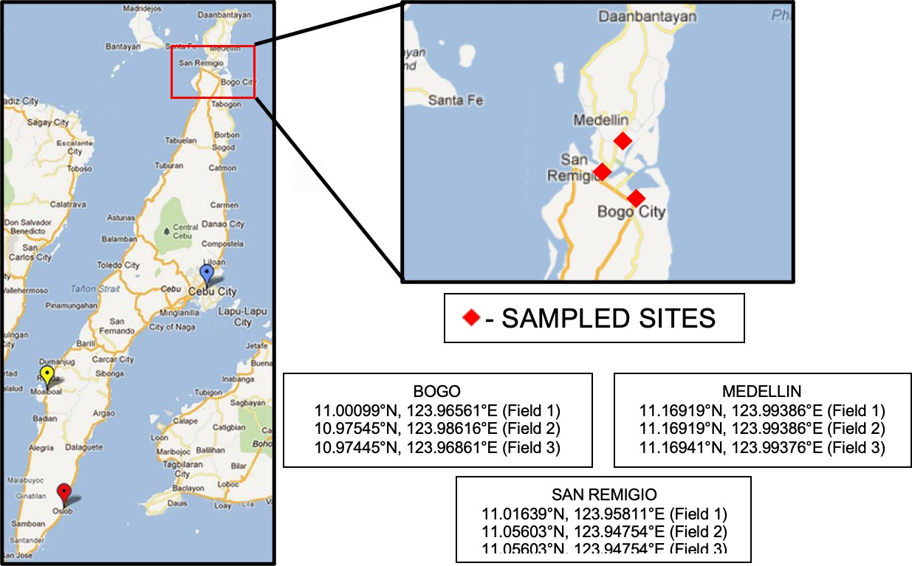

Fig 1. Sampling sites in Northern Cebu, Philippines

Table 1. Soil texture, pH, temperature, moisture, sugarcane varieties grown, and practices employed in the sampling sites

101
Sampling Soil Soil Sites Texture pH | Temperature (°C) | Soil Moisture | Variety | Practices after  Harvest
 |  |  | Phil99- | Trash
Bogo Clayey 6.8 | 23 | Dry | 1793, VMC  84-947 | Burning / Mulching
 |  |  | VMC 84- | Trash
Medellin Clay 6.6 | 23 | Normal | 947, | Burning /
 |  |  | Mauritius | Mulching
 |  |  | VMC 84- | Trash
San Remigio Loam 4.5 | 23.8 | Normal | 947, | Burning /
 |  |  | Mauritius | Mulching

Loamy Sandy

102
103
104

105
106
107
108
109
110
111
112
113
114
115
116
117
118
119
120
121
122
123
124
125
126
127
128
129
130
131
132
133
134
135
136
137
138
139
140
141
142
143
144
145
146
147
148
149
150
151

Extraction of Nematodes from Plant Roots

Nematode extraction was done at the Crop Protection laboratory of the Department of Agriculture and Food Science, Cebu Technological University – Barili Campus. Plant root samples were washed with running water and were cut into small pieces, approximately up to 1 cm, using a pair of scissors. Then, 5g of cut roots were macerated for about six seconds using a blender. The macerated roots were placed into a wire mesh lined with tissue paper and were placed over a bowl following a modified Baermann tray method. Water was added to the tray just enough to touch the bottom part of the mesh to get a clear suspension. Then, the set-up was incubated for 48 hrs. and application of water mists was done whenever necessary to avoid drying up.

Extraction of Nematodes from Soil

Soil samples were mixed thoroughly and 200 mL representative samples were processed using a combination of decanting and sieving (using a 212 µm and 53 µm aperture size) methods followed by incubation in modified Baermann tray method. The soil was placed in a wire mesh lined with tissue paper, which was placed over into a dish of water and left at room temperature for 48 hrs.

Preservation of Nematodes

After the specified extraction time, nematode suspensions were collected into test tubes and allowed to settle for 12 hrs. The supernatant was sucked using a pipette to reduce the volume of suspension. Nematodes were killed and fixed by adding hot 4% formalin (65°C- 70°C) into the nematode suspensions. Preserved nematodes were placed in the refrigerator until identification and assessment of population density.

2.4 Identification of Plant-Parasitic Nematodes
The extracted nematodes from soil and root samples were manually picked using a picking needle from the clear suspension under a stereomicroscope and were mounted to glass slide with a drop of water, covered with cover slip and sealed with colorless nail polish to prevent drying up of mounts. Plant-parasitic nematodes were identified to genus level following keys and references of Siddiqi (2006), Mekete et al. (2012), and others.

2.4 Assessment of Nematode Population Density and Prevalence

Population densities of plant-parasitic genera from root and soil samples per plant per sampling site were determined in three 5 ml aliquots in a counting dish under a stereomicroscope (Olympus, Germany). Nematode counts were expressed as 5g/roots and per 200 ml soil.
The prevalence of plant-parasitic nematode genera in roots and soil were determined using the relationship between abundance index (AI) and frequency (F) of occurrence computed using the formula:
total number of nematodes per gram roots or

152
153
Abundance (AI) = log
L soil in all positive samples number of positive samples

154
number of samples positive with nematodes Frequency (F)= total number of samples x 100

155
156
157
158
159
160
161
162
163
164
165
166
167
168
169
170
171
172
173
174
175
176
177
178
179
180
181
182
183
184
185
186
187
188
189
190
191
192
193
194
195
196
197
198
199
200
201
202
203
204
205

Based on the limits established by Fortuner and Merny (1973), a nematode was regarded as abundant if abundance ≥ 1.3 (20 individuals/g of roots) and abundance ≥ 2.3 (200 individuals/L of soil) in roots and soil, respectively. A nematode was regarded as frequent in the soil or roots when observed in at least 30% of the samples. All data were recorded in Excel and computed manually.

RESULTS AND DISCUSSION

Plant-Parasitic Nematode Genera Associated with Sugarcane

Various plant-parasitic nematode (PPN) genera were found in the root and soil samples of sugarcane in the selected sites of Northern Cebu, Philippines (Table 2). A total of eleven (11) genera of PPNs belonging to seven (7) different families were found associated with sugarcane in the surveyed fields. PPNs found include Criconema (Criconimatidae), Ditylenchus (Anguinidae), Filenchus (Tylenchidae), Helicotylenchus (Hoplolaimidae), Hoplolaimus (Hoplolaimidae), Meloidogyne (Heteroderidae), Pratylenchus (Pratylenchidae), Rotylenchulus (Hoplolaimidae), Rotylenchus (Hoplolaimidae), Tylenchus (Tylenchidae), and Xiphinema (Longidoridae). Of these genera, Filenchus, Meloidogyne, Helicotylenchus, and Pratylenchus were found associated with roots of sugarcane plants and all genera were present in the soil rhizosphere except Meloidogyne and Filenchus.

The nematode genera identified in this study were also reported in previous works conducted in the Philippines as well as in other countries. Davide (1988) reported four (4) major nematode genera associated with sugarcane in the country. Davide (1988) observed that Meloidogyne incognita bannered the species that were present in the collected samples of sugarcane- growing areas in the country, followed by Tylenchorhynchus martini, Rotylenchulus reniformis, and Pratylenchus zeae. The reported nematode genera were also found to occur in sugarcane crops in Northern Cebu.
In Kilimanjaro region of Tanzania, Singh et al. (2020) revealed the presence of seven plant- parasitic nematode (PPN) genera; Helicotylenchus, Hemicyliophora, Pratylenchus, Rotylenchulus, Scutellonema, Meloidogyne, and Tylenchorhynchus after they performed morphological and molecular analyses of PPNs from 12 sugarcane plantation sites of Tanganyika Planting Company (TPC). Four of these nematode genera (Helicotylenchus, Meloidogyne, Pratylenchus, and Rotylenchulus) were also found to occur in the sugarcane fields of Northern Cebu, Philippines.

In Paraná, Brazil, Martinha et al. (2022) reported that Pratylenchus, Meloidogyne, Helicotylenchus, Xiphinema, Hoplolaimus, Tylenchus, and Ditylenchus were some of the nematode genera that caused damage to the sugarcane-growing areas. These nematode genera were also observed in the present study, suggesting that these nematodes are commonly associated with sugarcane production. In addition, Meloidogyne spp. are considered as the most destructive plant-parasitic nematodes (PPNs), especially the females, highlighting strong sexual dimorphism (Indarti et al., 2025), as they are only motile during their J2 stage where they penetrate roots and become sedentary thereafter. Males on the other hand, are non-feeders, motile, and free-living in the soil, except during their larval stage (Eisenback & Triantaphyllou, 2020; Hoal, 2021).
Table 1. Soil texture, pH, temperature, moisture, sugarcane varieties grown, and practices employed in the sampling sites

206

Roots Rhizosphere

Family | Genus | Family | Genus
Heteroderidae | Meloidogyne | Anguinidae | Ditylenchus
Hoplolaimidae | Helicotylenchus | Criconimatidae | Criconema Hoplolaimus

Pratylenchidae Pratylenchus Hoplolaimidae

Tylenchide Filenchus
Helicotylenchus Rotylenchus Rotylenchulus

207
208
209

Genus Identification
Longidoridae Xiphinema
Pratylenchidae Pratylenchus
Tylenchidae Tylenchus

210
211
212
213
214
215
216
217
218

219
220
221
222
223
224
225

226
227
228
Morphological identification yielded 11 genera of plant-parasitic nematodes (PPNs) associated with sugarcane in Northern Cebu, Philippines. The important diagnostic characters that aid in the genus identification are herein presented:

Genus: Criconema (Mekete et al., 2012) (Figure 2)
Annuli smooth or variously ornamented, annuli of labial region smooth; labial region usually with six pseudolips wide and clearly set off the next body annulus; tail conoid-pointed to bluntly-rounded.
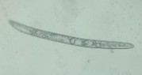  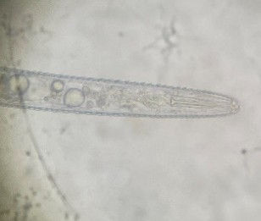  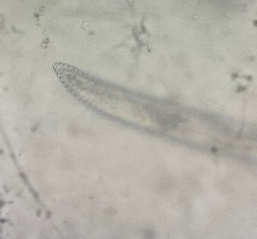  A | B | C

Fig 2. Genus: Criconema (A, 10x) whole body; (B, 100x) anterior; and (C, 100x) posterior

Genus: Ditylenchus (Siddiqi, 2000) (Figure 3)
Body usually under 1.5 mm long, not curving strongly when relaxed; mature adults slender; tails elongate-conoid to subcylindrical or filiform.

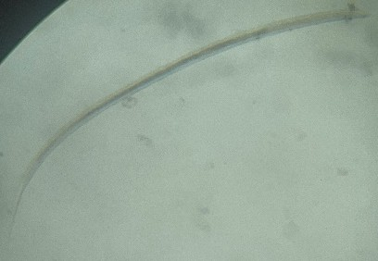  A | 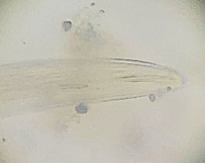  B | 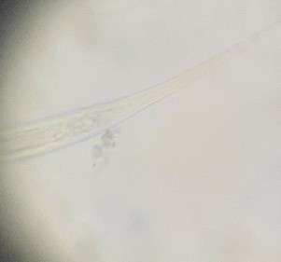  C

Fig 3. Genus: Ditylenchus (A, 10x) whole body; (B, 100x) anterior; and (C, 100x) posterior

229
230
231
232
233
234
235
236
237
238
239
240
241
242
243
244
245
246
247
248
249

250
251
252
253
254
255
256
257

258
259
260
261
262
263
Genus: Filenchus (Siddiqi, 2000) (Figure 4)
Body small to moderately large (0.3-1.3 mm), straight to arcuate when relaxed. Cephalic region broadly-rounded or conoid-rounded; tails generally filiform and straight, may be elongate-conoid and slightly ventrally arcuate but not hooked.
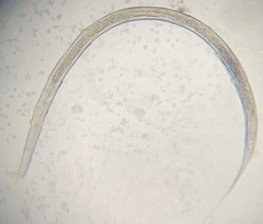

Fig 4. Genus: Filenchus whole body (40x)

Genus: Helicotylenchus (Uzma et al., 2015) (Figure 5)
Spirally-colloid or rarely arcuate; stylet robust; tail asymmetrical or hemispherical, short, dorsally-convex conoid; vulva located at 70% of the total body length.

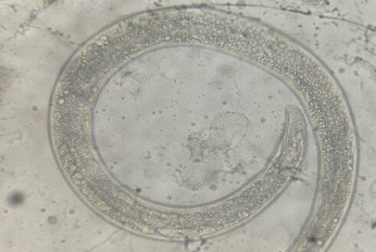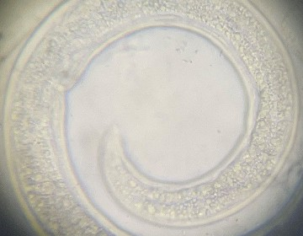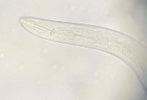
B
v
A

C

Fig 5. Genus: Helicotylenchus (A, 40x) whole body; (B, 100x) female mid-body region showing the vulva (v); and (C, 100x) anterior

Genus: Hoplolaimus (Daday, 1905; Siddiqi, 2000) (Figure 6)
Body arcuate or spiral-shaped; rounded stylet knobs, devoid of tooth-like projections; labial disc lemon-shaped or spindle-shaped; annulated female tail.
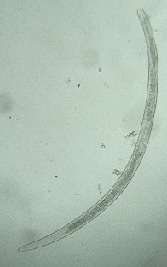
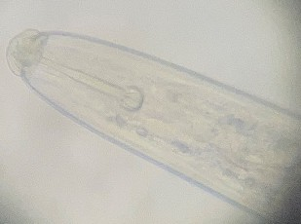
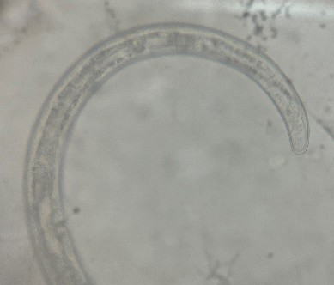

A

B

C

Fig 6. Genus: Hoplolaimus (A, 10x) whole body; (B, 100x) anterior; and (C, 40x) posterior

264
265
266
267
268
269
270
271
272
273
274
275
276
277
278
279
280
281
282

283
284
285
286
287
288
289
290
291

292
293
294
295
296
297
298
299
Genus: Meloidogyne (Eisenback, J. & Triantaphyllou H., 1991) (Figure 7)
Vermiform (male); rounded cephalic region, few annules; rounded tail, blunt tail tip (first stage juvenile) and vermiform, migratory and infective (second stage juvenile).
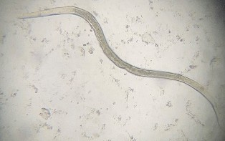
Fig 7. Genus: Meloidogyne whole body (40x)

Genus: Pratylenchus (Siddiqi, 2000) (Figure 8)
Rounded stylet; anteriorly flat or indented basal knobs; terminus rounded (rarely pointed) tail, sub-cylindrical to conoid (female); terminus smooth or annulated.
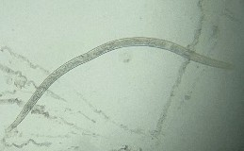
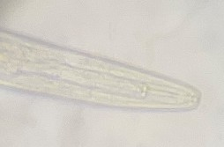
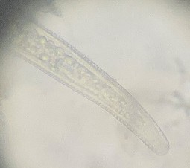

A

B

C

Fig 8. Genus: Pratylenchus (A, 10x) whole body; (B, 100x) anterior; and (C, 100x) posterior

Genus: Rotylenchulus (Siddiqi, 2000) (Figure 9)
Small-sized (usually 0.5 mm or under); cephalic region continuous, with or without distinct annules; male stylet weaker than that of females; tail elongate-conoid; slender spicule in males.

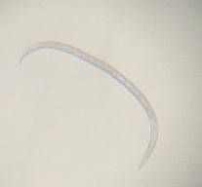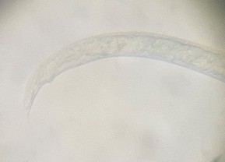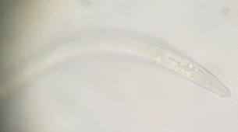

A
C
B
s

Fig 9. Genus: Rotylenchulus (A, 10x) whole body; (B, 100x) posterior showing the male spicule; and (C, 100x) anterior

300
301
302
303
304
305
306
307
308
309
310
311
312
313
314
315
316
317
318
319
320
321
322
323

324
325
326
327
328
329
330
331

332
333
334
Genus: Rotylenchus (Siddiqi, 2000) (Figure 10)
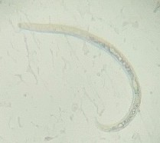
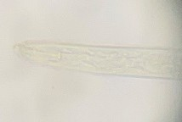
Cephalic region elevated, offset or continuous, round or truncate anteriorly, finely annulated; labial disc flat; stylet well-developed in both sexes; female tail cylindroid to dorsally convex- conoid.
B
A

Fig 10. Genus: Rotylenchus (A, 10x) whole body; (B, 100x) anterior Genus: Tylenchus (Siddiqi, 2000) (Figure 11)
Small to medium-sized (0.4-1.3 mm), ventrally-curved upon relaxation; cephalic region continuous, annulated; tail ventrally-arcuate; spicules cephalated, arcuate; cloacal lips slightly raised.

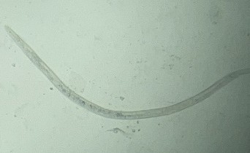  A | 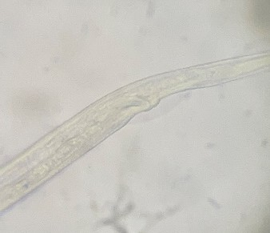  B | 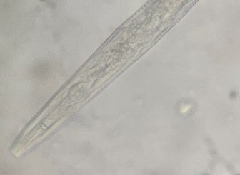  C

Fig 11. Genus: Tylenchus (A, 10x) whole body; (B, 100x) posterior; and (C, 100x) anterior

Genus: Xiphinema (Mekete et al., 2012; Tarjan, 1964) (Figure 12)
Stylet long, straight, tapering to a long slender point with long extensions; body long, stylet extensions with sclerotized basal flanges; shorter, conical, and digitate tail.
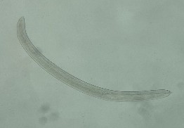
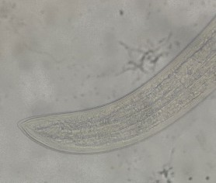
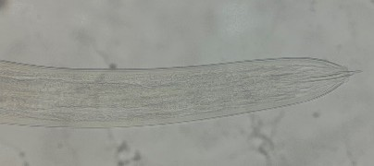

A
C
B

Fig 12. Genus: Xiphinema (A, 10x) whole body; (B, 100x) posterior; and (C, 100x) anterior

347
335 | 3.3 Population Density of Plant-Parasitic Nematode (PPN) Genera Associated with
336 | Sugarcane
337
338 | Population densities of plant-parasitic nematodes associated with sugarcane in roots and soil
339 | differed (Figure 13). It can be noted that population densities of plant-parasitic nematodes
340 | from root samples were generally low that ranged only from 2 to 11 per 5g roots. Meloidogyne
341 | had the highest population density (11/5g roots) followed by Filenchus (10/5g roots), while
342 | Pratylenchus and Helicotylenchus had a population density of 3 per 5g roots and 2 per 5g
343 | roots, respectively. In soil, Helicotylenchus (127/200 ml soil) was the predominant nematode
344 | genera followed by Xiphinema (91/200 ml soil), and Hoplolaimus (71/200 ml soil). The rest of
345 | the nematode genera (Criconema, Ditylenchus, Pratylenchus, Rotylenchulus, Rotylenchus,
346 | and Tylenchus) were recovered at lesser densities that ranged from 3 to 38 per 200 ml soil.

140
120
Population Density
100
80
60
40
20
0
127
91
71
38
10
18
2
11
3
3
10 12
17

Roots Soil

348
349
350
351
352
353
354
355
356
357
358
359
360
361
362
363
364
365
Filenchus Helicotylenchus Meloidogyne
Pratylenchus Criconema Ditylenchus
Helicotylenchus Hoplolaimus Pratylenchus
Rotylenchus Rotylenchulus Tylenchus
Xiphinema

Fig 13. Population density of plant-parasitic nematode (PPN) genera associated with roots and soil of sugarcane grown in Northern Cebu, Philippines

Population densities of nematode genera recovered from sugarcane roots were generally low, which can be attributed to several factors. It was noted in this study that the sample plants were already ratooned twice or thrice and mostly aged at 11-12 months. In Queensland, Australia, Blair et al. (1999) found out that nematode population densities were significantly higher in the roots of plant crops than ratoon crops, specifying the Pratylenchus genera. Similarly, in Australia and Burkina Faso, Berry et al. (2007) observed that ratoon crops were less susceptible than plant crops as its root systems became stronger and more rigid as it aged. In soil, higher population densities were observed. McSorley (2019) stated that soil is an excellent and is one of the natural habitats for plant-parasitic nematodes, and 100 cc of soil may contain several thousand of them. In addition, Ramadhani et al. (2022) validated that Helicotylenchus, were most common ectoparasites (Shokoohi, 2025), was one of the important nematode genera associated with sugarcane. In his research on the phytonematodes associated with sugarcane, Helicotylenchus was one of the major nematode genera recovered

366
367
368
369
370
371
372
373
374
375
376
377
378
379
380
381
382
383
384
385
386
387
388
389
390
391
392
393
394
395
396
397
398
399
400
401
402
403
404
405
406
407
408
409
410
411
412
413
414
415
416
417
based on the highest absolute population, which was also the frontrunner along with
Pratylenchus in Brathwaite’s (1980) study.

Plant-parasitic nematodes that were found at low densities might be due to the management practices of the farmers from Northern Cebu as they employ the “kaingin” system/trash burning and trash mulching. “Kaingin” was also referred to as ‘slash and burn’ by farmers in Matalom, Leyte (Lawrence et al., 1997). On the other hand, trash mulching was a common practice in sugarcane production that helped protect the soil as it minimized and/or prevented soil erosion (Mendoza et al., 2001). After harvest, 90% of the sugarcane farmers in Northern Cebu usually employ trash burning and the remaining 10% employ trash mulching as their means of land clearing and preparation for the next cropping season. In addition, once sugarcane has been established, they do not employ any form of weed management or pest control until harvest. According to Song (2023), a 4-year study of Bastow (2020) revealed that fire reduces soil nematode population by 76% in a semiarid grassland. As a response, Song (2023) investigated the effects of short-term prescribed fire on soil nematode communities and soil properties in an old-field grassland in Northern China which resulted to an increased soil nematode population by 77% and genus richness by 49%. For a more precise control of nematode population, Stirling (2023) recommended crop rotation, use of resistant and tolerant cultivars, nematicide application, and use of natural enemies or biocontrol agents like nematode-trapping fungi, soil microarthropods (nematophagous mites - Protogamasellus sp.), and bacteria in the genus Pasteuria.
The predominant nematode genera recovered in this study (Helicotylenchus) were considered as ectoparasites (Marmonier, 2019) which live outside the roots of sugarcane. Contributing to higher population densities, eggs of these plant-parasitic nematodes may remain dormant in the soil for a few months until conditions are favorable.

Prevalence of Plant-Parasitic Nematode (PPN) Genera Associated with Sugarcane
Based on frequency and abundance, prevalence of plant-parasitic nematodes in roots and soil rhizosphere of sugarcane varied (Figure 14). Based on the limits by Fortuner and Merny (1973), no nematode genera were considered as prevalent in roots as none reached the limit (AI, 1.3 and F,30%). Abundance index of the four nematode genera ranged only from 0.3 to 1, while the frequency of occurrence was 11% (Filenchus, Meloidogyne, and Pratylenchus) and 22% (Helicotylenchus), which were both below the threshold limits. In soil, Helicotylenchus and Xiphinema were the most prevalent nematode genera (AI, 2.33 and 2.53, respectively; F, 100% and 44%, respectively) as they surpassed the limits (AI,2.3 and F, 30%) set by Fortuner and Merny (1973). Similarly, Ramadhani et al. (2022) also observed that Helicotylenchus was the most prevalent nematode genera in Rajawali II, West Java. Román (1961) also revealed that Helicotylenchus was the most prevalent nematode genera in the selected fields of sugarcane in Central Soller and San Sebastián, Puerto Rico. Xiphinema was also noted to be prevalent in South Africa (Berry et al., 2008). Criconema, Ditylenchus, Hoplolaimus, and Pratylenchus were also regarded as frequent nematodes of sugarcane soil rhizosphere as their frequencies ranged from 33% to 89%, which were beyond the frequency limit (30%). However, these nematode genera were considered as omnipresent pathogens (Pascual et al., 2017; Fortuner and Merny, 1973) because of their abundance that ranged only from 1.65 to 2.28, which were below the threshold limit (2.3) in soil.

Among the nematode genera identified in this study, Filenchus, Meloidogyne, Rotylenchulus, Rotylenchus, and Tylenchus were considered as fortuitous parasites (Pascual et al., 2017; Fortuner and Merny, 1973) which do not cause economic loss due to low frequency and abundance as described by Fortuner and Merny (1973).

418
419
420
421
422
423
424
425
426
427
428
429
430
431
432

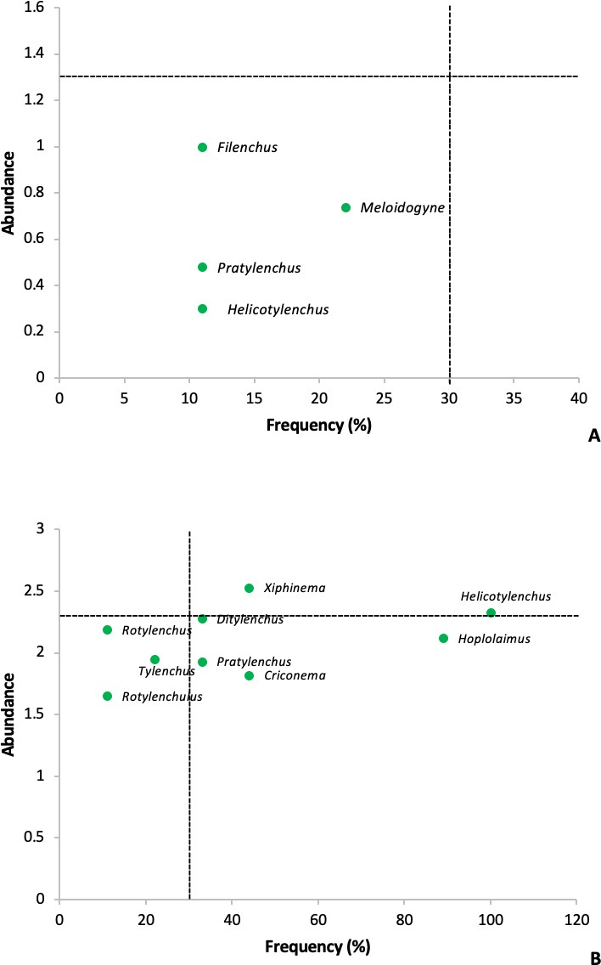
Figure 14. Frequency and abundance of plant-parasitic nematodes (PPNs) in sugarcane roots (A) and soil rhizosphere (B)

  - Occurrence and Abundance of Plant-Parasitic Nematode (PPN) Genera Associated with Sugarcane in the Localities

Nematode genera recovered from the different municipalities varied in frequency of occurrence and abundance (Table 3). In Bogo, the observed nematode genera were present in more than 30% of the fields surveyed but their abundance were generally low. In Medellin, Helicotylenchus, Hoplolaimus, and Xiphinema were frequent and abundant. Ditylenchus and Pratylenchus were also frequent but had low abundance. Other nematode genera were not recovered from the sampled sites. In San Remigio, all nematode genera were frequent except

433
434
435
436
437
438
439
440

441
442
443
444
445
446
447
448
449
450
451
452
453
454
455
456
457
458
459
460
461
462
463
464
465
466
Filenchus and Meloidogyne. In the sampled site, Helicotylenchus and Ditylenchus frequently occurred and were found to be abundant. Helicotylenchus was considered as potential pathogen as it was prevalent in all locations except in Bogo. The rest of the nematode genera were frequent but had very low abundance index from the different locations, which identified them as omnipresent nematodes.

Table 3. Occurrence and abundance of plant-parasitic nematodes (PPNs) associated with sugarcane in different sampling locations in Northern Cebu, Philippines

Genus | Bogo | Medellin | San Remigio
Criconema | + |  | +
Ditylenchus |  | + | +++
Filenchus | +
Helicotylenchus | + | +++ | +++
Hoplolaimus | + | +++ | +
Meloidogyne | +
Pratylenchus |  | + | +
Rotylenchulus |  |  | +
Rotylenchus |  |  | +
Tylenchus | + |  | +
Xiphinema | + | +++ | +
Notes: + = frequent (present in more than 30% of the fields surveyed); ++ = abundant (AI ≥ 1.3/5g roots; AI ≥ 2.3/L soil); and +++ = frequent and abundant (F ≥ 30% and AI ≥ 2.3/L soil).

The study of Martinha et al. (2022) stated that “the difference between the frequency of occurrences may be associated with the environmental factors, temperature, water content of the soil, sugarcane cultivar, and management adopted by producers that interfere with the density and frequency of genera associated with the sugarcane rhizosphere” (Bond et al., 2000; Matinha 2022).
In terms of soil type, the result of this study showing high presence of different nematode genera in San Remigio (Table 3) may be associated with its sandy loam type of soil (Table 1) which nematodes prefer more than any other type of soil (Warner, 2009).

In correlation with the physicochemical parameters of soil (water holding capacity, moisture content, pH, electrical conductivity, and temperature), Gade et al. (2021) surveyed the nematode diversity in sugarcane fields of Aurangabad District in India. It appeared that temperature and electrical conductivity provided a positive correlation to nematode diversity. Whereas to pH, it had a negative correlation. It was noted in this study that the pH of the three municipalities varied (Table 1), leading to the idea that as extremophiles (Sapir, 2021), plant- parasitic nematodes can survive in soils over wide ranges of pH (Warner, 2009).

CONCLUSION

Different plant-parasitic nematodes which differ in densities and prevalence, are in association with sugarcane. Identified plant-parasitic nematodes include Criconema, Ditylenchus, Filenchus, Helicotylenchus, Hoplolaimus, Meloidogyne, Pratylenchus, Rotylenchulus,

467
468
469
470
471
472
473
474
475
476
477
478
479
480
481
482
483
484
485
486
487
488
489
490
491
492
493
494
495
496
497
498
499
500
501
502
503
504
505
506
507
508
509
Rotylenchus, Tylenchus, and Xiphinema. No nematode genera recovered are considered prevalent in sugarcane roots due to low abundance index and frequency of occurrence. Helicotylenchus are the most prevalent plant-parasitic nematodes in soil rhizosphere, which could cause significant yield loss in sugarcane production if not properly managed. These results can further farmers’ knowledge on plant-parasitic nematodes associated with sugarcane in their locality.

ACKNOWLEDGEMENTS
The authors deeply appreciate the Cebu Technological University – Barili Campus and the Sugar Regulatory Administration VII for its continuous support.

COMPETING INTERESTS

Authors have declared that no competing interests exist.

Authors’ contributions
This work was carried out in collaboration among all authors. The success of this study was
due to the collaborative efforts and contributions of all authors. All authors read and approved the final manuscript.

Disclaimer (Artificial intelligence)
Option 1:
Author(s) hereby declare that NO generative AI technologies such as Large Language Models (ChatGPT, COPILOT, etc.) and text-to-image generators have been used during the writing or editing of this manuscript.
Option 2:
Author(s) hereby declare that generative AI technologies such as Large Language Models, etc. have been used during the writing or editing of manuscripts. This explanation will include the name, version, model, and source of the generative AI technology and as well as all input prompts provided to the generative AI technology
Details of the AI usage are given below:
1.
2.
3.

REFERENCES

Bastow, J. (2020). The impacts of a wildfire in a semiarid grassland on soil nematode abundances over 4 years. Biology and Fertility of Soils, 56, 675– 685. https://doi.org/10.1007/s00374-020-01441-4

Berry, S. D., Fargette, M., Spaull, V. W., Morand, S., & Cadet, P. (2008). Detection and quantification of root-knot nematode (Meloidogyne javanica), lesion nematode (Pratylenchus zeae) and dagger nematode (Xiphinema elongatum) parasites of sugarcane using real-time PCR. Molecular and Cellular Probes, 22(3), 168-176.
https://doi.org/10.1016/j.mcp.2008.01.003

Berry, S.D., Cadet, P., Spaull, V.W. (2017). Nematode Pests of Sugarcane. In: Fourie, H., Spaull, V., Jones, R., Daneel, M., De Waele, D. (eds) Nematology in South Africa: A View from the 21st Century. Springer, Cham. https://doi.org/10.1007/978-3-319-44210-5_11

Berry, S.D., Rhodes, R., Foster, J., Risede, J.M., & van Antwerpen, R. (2011). The Effect of Cover Crops on Plant-Parasitic Nematodes of Sugarcane, International Journal of Pest Management, 57:4, 363-375. https://doi.org/10.1080/09670874.2011.621984

Blair, B. L., Stirling, G. R., & Whittle, P. J. L. (1999). Distribution of Pest Nematodes on Sugarcane in South Queensland and Relationship to Soil Texture, Cultivar, Crop Age and Region. Australian Journal of Experimental Agriculture, 39(1), 43-50.
https://doi.org/10.1071/ea98085

Blair, B. L., Stirling, G. R., Pattemore, J. A., & Whittle, P. J. L. (1999). Occurrence of pest nematodes in Burdekin and central Queensland sugarcane fields. Australian Society of Sugar Cane Technology (Vol. 21, pp. 227-233). Australian Society of Sugar Cane Technologists.

Bond, J. P., McGawley, E. C., & Hoy, J. W. (2000). Distribution of plant-parasitic nematodes on sugarcane in Louisiana and efficacy of nematicides. Journal of Nematology, 32(4S), 493. PMCID: PMC2620482 PMID: 19271000

Brathwaite, C. W. D. (1975). PLANT PARASITIC NEMATODES ASSOCIATED WITH COWPEA (Vigna unguiculata (L.) WALP.) AND THE RELATION OF THEIR POPULATION
DENSITY TO CROP YIELD. https://doi.org/10.22004/ag.econ.263219

510
511
512
513
514
515
516
517
518
519
520
521
522
523
524
525
526
527
528
529
530
531
532
533
534
535
536
537
538
539
540
541
542
543
544
545
546
547
548
549
550
Chirchir, A. K. (2008). Plant parasitic nematodes associated with sugarcane in western kenya and their management using host resistance and crop mixtures (Doctoral dissertation, University of Nairobi).

Daday, J. (1905). Untersuchungen uber die Susswasser-Microfauna Paraguayas. Zoologica, 44, 1-374. CRID: 1570572700393951616. NII Article ID:
10018012340

Davide, R. G. (1988). Nematode Problems Affecting Agriculture in the Philippines. Journal of Nematology, 20(2), 214. PMCID: PMC2618802 PMID: 19290204

Eisenback, J.; Triantaphyllou, H. (1991). Root-Knot Nematodes: Meloidogyne Species and Races. https://10.1201/9781003066576-6

Eisenback, J.D.; Triantaphyllou, H.H. (2020). Root-Knot Nematodes: Meloidogyne Species and Races. Manual of Agricultural Nematology. CRC Press, pp. 191-274. https://10.1201/9781003066576-6

Fortuner, R. and Merny, G. (1973). Parasitic root nematodes associated with rice in Basse- Casamance (Senegal) and Gambia. ORSTOM Notebooks, Biology Series 21 :3-20. Cahiers de l'Office de la Recherche Scientifique et Technique Outre-Mer, Biologie, 1973, No. No. 21, 3-20

Gade, Rajendra & Ambhore, Ananta & Hiware, Chandrashekhar & Babasaheb,. (2021). THE NEMATODE DIVERSITY OF SUGARCANE FIELDS AND THEIR CORRELATION WITH PHYSICOCHEMICAL PARAMETERS OF SOIL FROM KHULTABAD TALUKA OF AURANGABAD DISTRICT (M.S.) INDIA.
https://www.researchgate.net/publication/354522792

Hoal, Garner. (2021). Literature review of Meloidogyne javancia. https://10.13140/RG.2.2.32572.97920.

Indarti, S., Shabrina, N. H., & Maharani, R. (2025). Microscopic image dataset of plant- parasitic nematode. Data in Brief, 111687. https://doi.org/10.1016/j.dib.2025.111687

Lawrence, A. (1997). Kaiñgin in the Philippines: is it the end of the Forest?. Rural Development Forestry Network Paper. No. 21f, 1-8 ref. 4. https://cdn-odi- production.s3.amazonaws.com/media/documents/1158.pdf

Manzoor, M., Khan, M. Z., Ahmad, S., Alqahtani, M. D., Shabaan, M., Sarwar, S., Hameed,
M. A., Zulfiqar, U., Hussain, S., Ali, M. F., Ahmad, M., & Haider, F. U. (2023). Optimizing Sugarcane Growth, Yield, and Quality in Different Ecological Zones and Irrigation Sources Amidst Environmental Stressors. Plants, 12(20), 3526.
https://doi.org/10.3390/plants12203526

Marmonier, A., Perfus-Barbeoch, L., Rancurel, C., Boissinot, S., Favery, B., Demangeat, G., & Brault, V. (2019). InVitro Acquisition of Specific Small Interfering RNAs Inhibits the Expression of some Target Genes in the Plant Ectoparasite Xiphinema index. International Journal of Molecular Sciences, 20(13), 3266. https://doi.org/10.3390/ijms20133266

Martinha, D. D., Silva, M. C. C., Maceda, A., Hahn, M. H., Calegario, R., Ruaro, L., & Duarte,
H. D. S. S. (2022). Survey of nematodes associated with sugarcane in the state of Paraná,

551
552
553
554
555
556
557
558
559
560
561
562
563
564
565
566
567
568
569
570
571
572
573
574
575
576
577
578
579
580
581
582
583
584
585
586
587
588
589
Brazil. Arquivos do Instituto Biológico, 89, e00332021. https://doi.org/10.1590/1808- 1657000332021

Mekete, T., Dababat, A. A., Sekora, N., Akyazi, F., & Abebe, E. (2012). Identification key for agriculturally important plant-parasitic nematodes: a manual for nematology. CIMMYT.

Mendoza, T.C., Samson, R., & Helwig, T. (2001). Evaluating the many benefits of sugarcane trash farming systems. Philippine Journal of Crop Science, 27(1), 43-51.

Noronha, M. D. A., Muniz, M. D. F. S., Cruz, M. D. M., Assunção, M. C., Castro, J. M. D. C., Oliveira, E. R. L. D., ... & Machado, A. C. Z. (2017). Meloidogyne and Pratylenchus species in sugarcane fields in the state of Alagoas, Brazil. Ciência Rural, 47, e20151402. https://doi.org/10.1590/0103-8478cr20151402

Pascual, M. L. D., Lim, A. K. R., & Cumagun, C. J. R. (2017). Plant-parasitic nematodes associated with organic and conventional vegetable farms in Laguna Province, Philippines. Archives of Phytopathology and Plant Protection, 50(15-16), 776-788. https://doi.org/10.1080/03235408.2017.1380940

Ramadhani, R. I., Damayanti, T. A., & Putra, L. K. (2022). The phytonematodes species on sugarcane plants (Saccharum officinarum L.) at Subang Sugar Factory PT PG Rajawali II, West Java. In IOP Conference Series: Earth and Environmental Science (Vol. 974, No. 1, p. 012040). IOP Publishing. https://10.1088/1755-1315/974/1/012040

Ramouthar, P. V., & Bhuiyan, S. A. (2018). Nematode parasites of sugarcane. In Plant parasitic nematodes in subtropical and tropical agriculture (pp. 658-686). Wallingford UK: CAB International. https://10.1079/9781786391247.0658

Román, J. (1961). A new species of the genus Helicotylenchus (Nematoda: Hoplolaimidae) attacking sugarcane. J. Agric. Univ. P. Rico, 45(4), 300-303. DOI: 10.46429/jaupr.v45i4.13764

Sapir, A. (2021). Why are nematodes so successful extremophiles?. Communicative & Integrative Biology, 14(1), 24-26. https://doi.org/10.1080/19420889.2021.1884343

Shokoohi, E. (2025). Helicotylenchus. In: Amaresan, N., Kumar, K. (eds) Compendium of Phytopathogenic Microbes in Agro-Ecology . Springer, Cham. https://doi.org/10.1007/978-3- 031-81999-5_22

Siddiqi, M. R. (2000). Tylenchida: parasites of plants and insects. CABI.

Singh, P. R., Kashando, B. E., Couvreur, M., Karssen, G., & Bert, W. (2020). Plant-parasitic nematodes associated with sugarcane in Kilimanjaro, Tanzania. Journal of Nematology, 52, e2020-59. https://10.21307/jofnem-2020-059

Song, M., McDaniel, M. D., Zhu, C., Lin, F., & Zhang, Y. (2023). Prescribed fire alters nematode communities in an old-field grassland. Ecology and Evolution, 13(4), e9977. https://doi.org/10.1002/ece3.9977

Spaull, V. W., & Cadet, P. (1990). Nematode parasites of sugarcane. Plant parasitic nematodes in subtropical and tropical agriculture’.(Eds M Luc, RA Sikora, J Bridge) pp, 461- 491.

590
591
592
593
594
595
596
597
598
599
600
601
602
603
604
605
606
607
608
609
610
611
612
613
614
615
616
617
618
619
620
621
622
623
624
625
626
27
Stirling, G.R. (2023). Management of Plant-Parasitic Nematodes on Sugarcane. Plant and Soil Nematodes. PSN 038.
https://static1.squarespace.com/static/65a72e9e0057f860a3a58c45/t/65cd97551fc54e7e67a 50ead/1707972438394/PSN+038++Management+of+plant- parasitic+nematodes+on+sugarcane.pdf
Stirling, G.R. (2023). Plant-Parasitic Nematodes on Sugarcane. Plant and Soil Nematodes. Fact Sheet PSN 037.

Sundararaj, P., & Mehta, U. K. (1993). Patterns of interspecific associations in plant parasitic nematodes of sugarcane ecosystems. Nematologia Mediterranea, 21(2), 275-277.
http://www.inaav.ba.cnr.it/vol21-2,%201993/vol21-2z2.pdf

Tarjan, A. C. (1964). Two new American dagger nematodes (Xiphinema: Dorylaimidae) associated with citrus, with comments on the variability of X. bakeri Williams, 1961. Helminthological Society of Washington. Vol. 31, No. 1, 65-76.
https://bionames.org/bionames-archive/issn/0018-0130/31/65.pdf
The Editors of Encyclopaedia Britannica (2025). Sugarcane. Encyclopaedia Britannica. https://www.britannica.com/plant/sugarcane

Tobias, A.M. (2020). Initiatives and Implications of Philippine Sugar Liberalization. Food and Fertilizer Technology for Asian and Pacific Region. https://ap.fftc.org.tw/article/1841

USDA, (2021). Sugar Annual. Global Agricultural Information Network. RP2021-0020. https://apps.fas.usda.gov/newgainapi/api/Report/DownloadReportByFileName?fileName=Su gar+Annual_Manila_Philippines_04-15-2021.pdf

Uzma, I., Nasira, K., Firoza, K., & Shahina, F. (2015). Review of the genus Helicotylenchus Steiner, 1945 (Nematoda: Hoplolaimidae) with updated diagnostic compendium. Pakistan Journal of Nematology, 33(2), 115-160.
Voora, V., Bermúdez, S., Le, H., Larrea, C., & Luna, E. (2023). Sugar cane prices and sustainability. Fecha de consulta, 13(03), 2024.

Warner, F. (2009). Soil fertility, pH, texture and nematodes. Diagnostic services. Michigan: Michigan State University. https://www.canr.msu.edu/news/soil_fertility_ph_texture_and_nematodes#:~:text=Fred%20 Warner%2C%20Michigan%20State%20University%20Extension%2C%20Diagnostic%20Ser vices%20%2D%20May%2014%2C%202009&text=Soils%20Testing%20Laboratory%2C%2 0soils%20in%20Michigan%20range%20in%20pH

