Original Research Article
AN INTEGRATED ANALYSIS OF PHYSIOLOGICAL ALTERATIONS IN MOTH BEAN IN RESPONSE TO PRE AND POST EMERGENCE HERBICIDES

ABSTRACT
Application of herbicide not only diminishes the weed activities but also influences crop physiological processes. The present study planned to evaluate the impact of pre and post emergence herbicides on physiological traits of two genotypes viz., MH-65 and MH-45, to examine the genotype specific behavioral pattern. Treatments given as per the recommended dose of pendimethalin, imazethapyr, quizalofop, and their combinations as compared to the control (no herbicide application) to analyze the relative water content (RWC), cell membrane stability (CMS), canopy temperature (CT), canopy temperature depression (CTD), chlorophyll content, and chlorophyll stability index (CSI). Results revealed that under control conditions, MH-65 recorded higher RWC (87.90%) and CMS (57.40%) than MH-45 (79.10% and 51.80%, respectively), indicating superior baseline physiological status whereas herbicide application showed significant decline in RWC, CMS, CTD, chlorophyll content, CSI and increase in CT in both genotypes. Maximum reductions in tested parameters were observed under combined herbicide treatments, particularly imazethapyr + quizalofop, where RWC declined to 45.30% in MH-65 and 40.60% in MH-45, while CMS decreased to 21.00% and 18.20%, respectively. Similarly, canopy temperature increased to 35.20–36.90 °C, whereas CTD declined to as low as 0.10–0.05 °C, indicating severe impairment of transpirational cooling. Chlorophyll content and CSI also showed marked reductions, with minimum values of 4.81mg g⁻¹ FW and 48.90% in MH-65, and 4.30mg g⁻¹ FW and 43.20% in MH-45. Genotype MH-65 significantly maintained lower CT and higher CTD, RWC, CMS, chlorophyll content, and CSI than MH-45, finally showed greater physiological resilience in response to different herbicide treatments. Thus, this study highlights the effectiveness of physiological traits as dependable markers for screening herbicide-tolerant genotypes and enhancing weed management practices.
Keywords: - Pre and post Herbicide, Physiological parameter, Relative water content, Cell membrane stability, Chlorophyll stability Index and Canopy temperature Depression.
INTRODUCTION
Moth bean (Vigna aconitifolia (Jacq.) Marechal) is an underutilized but climatically robust legume crop grown mostly in the arid and semi-arid regions of India (Dwivedi et al., 2023). It is highly adaptable to harsh environments due to its deep and rapidly expanding root system, short life cycle, and low input requirements, making it an essential crop for maintaining productivity even in low humidity and high temperature conditions (Chandora et al., 2023). Despite its inherent ability to tolerate drought and heat stress, moth bean is highly susceptible to weed competition, especially during the critical pre- and post-emergence growth stages (Rani et al., 2023).
Weed infestation is one of the major agricultural problems in moth bean cultivation and can cause yield losses of 30 to 50% by competing for water, nutrients, light, and space (Chandora and Rana, 2023). Traditional weed control methods, such as manual weeding, are often difficult due to labor shortages, frequent rainfall, and high operational costs, especially in rain-fed agro-ecosystems (Kaur et al., 2025). Therefore, chemical weed management has emerged as an effective and cost-effective option for weed control in moth bean cultivation (Sinchana et al., 2023). Pre-emergence and post-emergence herbicides, such as pendimethalin, fluchloralin, and imazethapyr, have been shown to significantly reduce weed density in moth bean crops and improve growth and yield quality (Kumar et al., 2025). Physiological traits serve as sensitive indicators of plant responses to both abiotic stress and chemical interventions (Sinchana et al., 2023).
Maintaining a high RWC is closely linked to drought tolerance and sustained photosynthetic efficiency in moth bean and other legumes (Meena et al., 2023). Disruption of membrane stability due to oxidative stress can lead to electrolyte leakage, reduced metabolic activity, and decreased stress tolerance (Rao et al., 2025). Studies on moth bean under drought stress have shown that reduced membrane stability is associated with reduced growth and physiological efficiency upon application of pendimethalin (Abbas et al., 2023).
Physiological disruption during the early vegetative or flowering stages, whether due to weed competition or herbicide use, can shorten pod filling time and reduce sink strength, ultimately impacting seed yield (Kundu et al., 2025). Increased canopy temperature is generally associated with stomatal closure, reduced transpiration, and moisture stress, while higher CTD values ​​indicate improved transpirational cooling and better water relations (Sadok et al., 2021). A decrease in chlorophyll content and CSI has been observed in moth bean under drought stress, leading to reduced photosynthetic efficiency and biomass accumulation (Ghimire et al., 2023). Therefore, this investigation was planned to conduct an integrated analysis of physiological changes in moth bean under pre- and post-emergence herbicide application.
MATERIALS AND METHODS
Seed procurement and rising of crop- The present study was conducted during the Kharif seasons 2024–25 at the research area of the Department of Botany, Baba Mastnath University, Asthal Bohar, Rohtak, Haryana, India, located at 28.87° N Latitude and 76.64° E Longitude. Seeds of two moth bean genotypes were procured from the ICAR–NBPGR, Pusa Campus, New Delhi. Prior to sowing, seeds were surface sterilized using 0.1% (w/v) mercuric chloride for 5 min and washed with the distilled water. The experiment was laid out in a Randomized Block Design (RBD) with three replications, in 2 × 1 m field plots size. The dominant weed flora included Chenopodium album, Dactyloctenium aegyptium, Portulaca oleracea, Digera arvensis, Cyperus rotundus, and Trianthema portulacastrum.
Herbicide used and treatments- Herbicide treatments consisted of pendimethalin 30% EC (pre-emergence), imazethapyr 10% SL (post-emergence), and quizalofop 10% EC (pre- and post-emergence), applied singly or in combinations along with an untreated control. The treatments included T₀ (control, no herbicide), T₁ (pendimethalin within 10 h after sowing), T₂ (imazethapyr at 30 days after sowing), T₃ (quizalofop within 10 h after sowing + 30 days after sowing), T₄ (pendimethalin + imazethapyr), T₅ (pendimethalin + quizalofop), and T₆ (imazethapyr + quizalofop).
Relative Water Content (RWC): Relative water content was determined with the method of Barrs and Weatherley (1962). Fully expanded young leaves were collected in triplicate and immediately after fresh weight (FW) was recorded using digital weighing balance (Wensar PGB 220). Leaves were then dipped in distilled water for 4 to 6hr for turgid weight (TW). Samples were wrapped in the paper and oven-dried at 70 °C for 72hr to dry weight (DW). RWC was calculated by using the given formula: RWC (%) = [(FW − DW) / (TW − DW)] × 100
Cell Membrane Stability (CMS): Cell membrane stability was evaluated using the electrolyte leakage method explained by Sullivan (1972). Leaf was cutting in discs and were thoroughly washed with double distilled water and incubated in test tubes containing 10ml of distilled water at room temperature for 4hr. Initial electrical conductivity (C₁) was recorded using a Digital Auto Conductivity Meter (HV-16) and autoclaved at 120°C for 20min, cooled at room temperature, and final conductivity (C₂) measured. CMS was calculated as: CMS (%) = [1 − (C₁ / C₂)] × 100
Canopy Temperature (CT): Canopy temperature was measured using a hand-held infrared thermometer (Fluke 62 Max) by the suggested method of Fuchs (1990). Readings were recorded in triplicate form the tagged plants between 12:00 and 1:00hr to minimize the variation at an angle of approximately 45° of the crop canopies. Whereas the canopy temperature depression was calculated according to Ayeneh et al. (2002) using the formula: CTD (°C) = Air temperature − Canopy temperature.
Chlorophyll Content: Total chlorophyll content was estimated by the method of Hiscox and Israelstam (1979). Fresh leaf tissue (100 mg) was incubated in dimethyl sulfoxide (DMSO) at 65 °C until leaf become colorless. Absorbance was recorded at 645 and 663 nm using LABMAN Double Beam UV-VIS Spectrophotometer (LMSP-UV1000B), and chlorophyll content was calculated Arnon (1949) method and expressed as mg g⁻¹ fresh weight.
Chlorophyll Stability Index (CSI): Chlorophyll stability index was estimated by Sawhney and Singh (2002). Leaf samples were divided into control and heat-treated sets. Chlorophyll content was estimated in both sets, and CSI was calculated as: CSI (%) = (Chlorophyll content after treatment / Chlorophyll content before treatment) × 100
Data analysis- Data were statistically analyzed using analysis of variance (ANOVA) under Randomized Block Design, and treatment means were compared at the 5% level of significance.
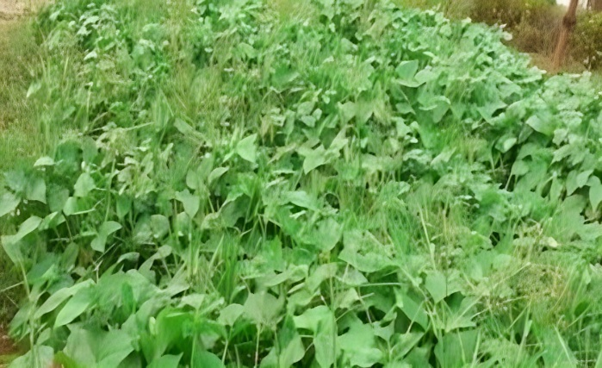 | 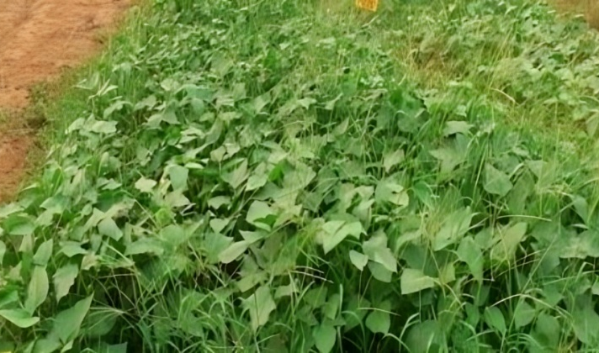
T0 – Control | T1 – Pendimethalin
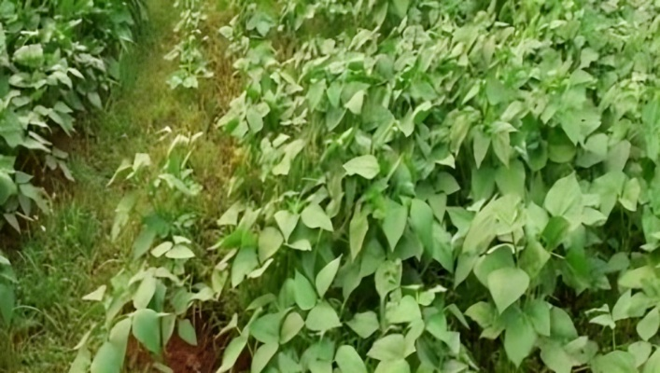 | 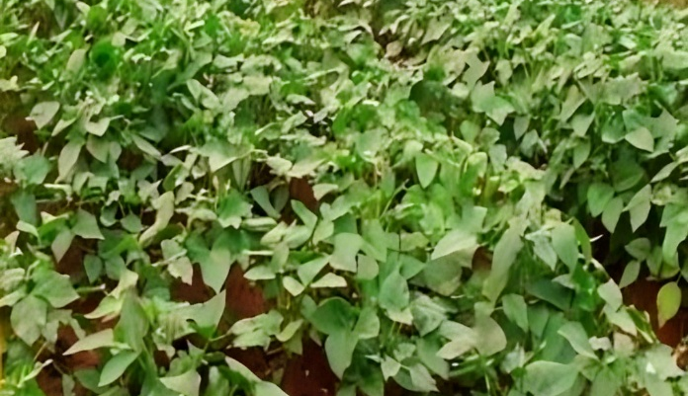
T2 – Imazethapyr | T3 – Quizalofop
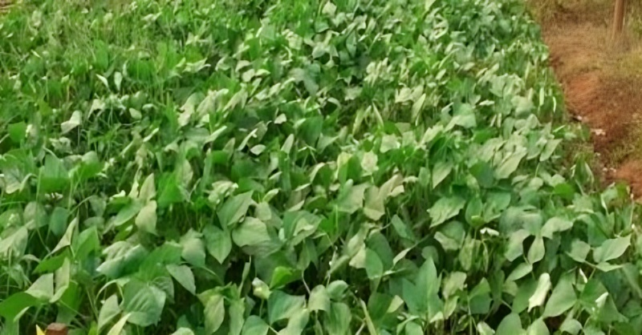 | 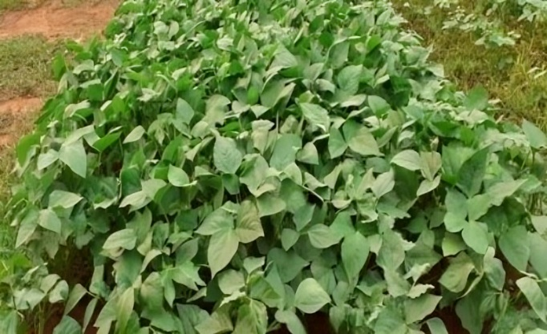
T4 – Pendi + Imaza | T5 – Pendi + Quiza
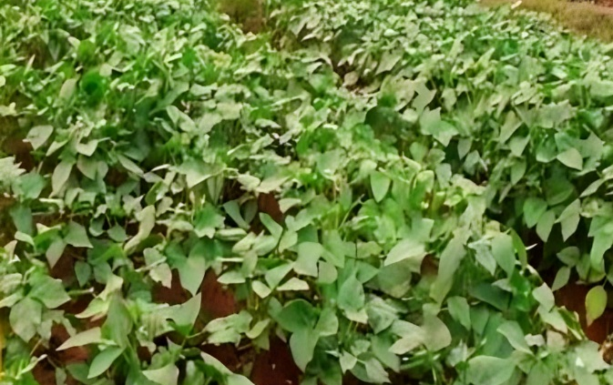
T6 – Imaza + Quiza
Figure- 1. Effect of different pre and pot herbicide treatments on moth bean growth

RESULTS
Relative Water Content (%): Relative water content (RWC) exhibited marked variation among treatments in both genotypes, indicating differential effects of herbicidal stress on plant water status (Table 1). The highest RWC was recorded under control conditions, measuring 87.90% in MH-65 and 79.10% in MH-45. Application of individual herbicides caused a noticeable decline in RWC, with pendimethalin maintaining relatively higher values (76.80% in MH-65; 69.20% in MH-45) compared to quizalofop and imazethapyr. The lowest RWC values were observed under combined herbicide treatments, particularly imazethapyr + quizalofop, which reduced RWC to 45.30% in MH-65 and 40.60% in MH-45. Across all treatments, genotype MH-65 consistently maintained higher RWC than MH-45, indicating a superior ability of MH-65 to sustain cellular hydration under herbicide-induced stress conditions.
Cell Membrane Stability (%): Cell membrane stability (CMS) followed a trend comparable to RWC, reflecting the extent of membrane damage under different herbicide treatments (Table 1). The maximum CMS was recorded under control condition in (57.40%) MH-65 and (51.80%) MH-45, suggesting highest membrane integrity under control conditions. Individual herbicide applications resulted in moderate reductions in CMS, whereas combined herbicide treatments caused a sharp decline, indicating enhanced membrane injury. The minimum CMS values were observed under imazethapyr + quizalofop, recording 21.00% in MH-65 and 18.20% in MH-45. Overall, CMS decreased in the order Control > Pendimethalin > Quizalofop > Imazethapyr > Pendimethalin + Quizalofop > Pendimethalin + Imazethapyr > Imazethapyr + Quizalofop. The consistently lower CMS values in MH-45 compared to MH-65 showed MH-45 is more susceptible to herbicide-induced membrane destabilization.
Table- 1. Effect of different pre and post emergence herbicides on relative water content and cell membrane stability in moth bean genotypes
Treatment | Relative Water Content (%) |  | Cell Membrane Stability (%)
Treatment | MH-65 | MH-45 | MH-65 | MH-45
T0 – Control | 87.90 ± 0.151 | 79.10 ± 1.070 | 57.40 ± 0.621 | 51.80 ± 0.890
T1 – Pendimethalin | 76.80 ± 1.478 | 69.20 ± 1.368 | 50.30 ± 0.416 | 45.20 ± 0.753
T2 – Imazethapyr | 60.20 ± 0.250 | 54.10 ± 0.845 | 39.10 ± 0.307 | 34.60 ± 0.359
T3 – Quizalofop | 64.50 ± 0.874 | 58.10 ± 1.332 | 42.20 ± 0.196 | 37.80 ± 0.609
T4 – Pendi + Imaza | 50.10 ± 0.806 | 45.20 ± 0.259 | 21.80 ± 0.020 | 18.90 ± 0.276
T5 – Pendi + Quiza | 58.60 ± 0.609 | 52.80 ± 1.207 | 28.40 ± 0.208 | 24.60 ± 0.244
T6 – Imaza + Quiza | 45.30 ± 0.306 | 40.60 ± 0.520 | 21.00 ± 0.437 | 18.20 ± 0.063
C.D. | 2.578 | 3.144 | 1.204 | 1.797
SE(m) | 0.828 | 1.009 | 0.386 | 0.577
SE(d) | 1.170 | 1.427 | 0.546 | 0.816
C.V. | 2.263 | 3.066 | 1.800 | 3.026
C.D.- Critical Difference, SE(m)- Standard Error Mean, SE(d)- Standard Error deviation, C.V.- Coefficient of Variation, Pendi- Pendimethalin, Imaza- Imazethapyr and Quiza- Quizalofop
Chlorophyll Stability Index (%): Chlorophyll stability index (CSI) exhibited significant variation among treatments in both genotypes, reflecting the impact of herbicidal stress on chlorophyll integrity (Table 2). The highest CSI values were recorded under control conditions, with 88.20% in MH-65 and 79.50% in MH-45, indicating maximum chlorophyll stability in the absence of herbicide stress. Application of individual herbicides resulted in a gradual decline in CSI, with pendimethalin-treated plants maintaining relatively higher CSI (81.40% in MH-65; 73.20% in MH-45) compared to imazethapyr and quizalofop. Among individual herbicides, quizalofop recorded higher CSI than imazethapyr, suggesting comparatively lower chlorophyll degradation. The lowest CSI values were observed under combined herbicide treatments, particularly imazethapyr + quizalofop, which reduced CSI to 48.90% in MH-65 and 43.20% in MH-45. Throughout all treatments, MH-65 consistently maintained higher CSI than MH-45, indicating greater chlorophyll stability under herbicide application.
Table- 2. Effect of different pre and post emergence herbicides on the chlorophyll stability index and chlorophyll content in moth bean genotypes
Treatment | Chlorophyll Stability Index (%) |  | Chlorophyll Content (mg g⁻¹ FW)
Treatment | MH-65 | MH-45 | MH-65 | MH-45
T0 – Control | 88.20 ± 0.201 | 79.50 ± 0.869 | 9.35 ± 0.036 | 8.45 ± 0.119
T1 – Pendimethalin | 81.40 ± 0.890 | 73.20 ± 0.229 | 8.20 ± 0.125 | 7.40 ± 0.125
T2 – Imazethapyr | 69.30 ± 1.154 | 62.10 ± 0.100 | 7.14 ± 0.071 | 6.45 ± 0.015
T3 – Quizalofop | 73.10 ± 1.067 | 65.80 ± 0.040 | 7.60 ± 0.134 | 6.90 ± 0.151
T4 – Pendi + Imaza | 55.80 ± 0.232 | 49.90 ± 0.806 | 5.86 ± 0.151 | 5.10 ± 0.036
T5 – Pendi + Quiza | 62.40 ± 1.234 | 55.60 ± 0.812 | 6.50 ± 0.074 | 5.80 ± 0.057
T6 – Imaza + Quiza | 48.90 ± 0.485 | 43.20 ± 0.821 | 4.81 ± 0.104 | 4.30 ± 0.089
C.D. | 2.351 | 1.794 | 0.354 | 0.318
SE(m) | 0.755 | 0.576 | 0.114 | 0.102
SE(d) | 1.067 | 0.814 | 0.161 | 0.144
C.V. | 1.910 | 1.626 | 2.789 | 2.788
C.D.- Critical Difference, SE(m)- Standard Error Mean, SE(d)- Standard Error deviation, C.V.- Coefficient of Variation, Pendi- Pendimethalin, Imaza- Imazethapyr and Quiza- Quizalofop
Chlorophyll content (mg g⁻¹ FW): Chlorophyll content showed fluctuating pattern with the application of herbicide treatments, indicating direct effects on the photosynthetic pigment system in both tested genotypes (Table 2). Under controlled condition, plants had highest chlorophyll concentration, with 9.35 mg g⁻¹ FW in MH-65 and 8.45 mg g⁻¹ FW in MH-45. Application of herbicides led a progressive decline in chlorophyll content, although the magnitude of reduction varied with the type of treatment. With single application of herbicides viz., pendimethalin caused the lowest reduction, whereas imazethapyr resulted in a comparatively greater decreasing pattern of concentration. Combined herbicide applications exerted a stronger negative effect, with imazethapyr + quizalofop showing the most pronounced reduction, lowering chlorophyll content to 4.81 mg g⁻¹ FW in MH-65 and 4.30 mg g⁻¹ FW in MH-45. Throughout all treatments, genotype MH-65 retained higher chlorophyll levels than MH-45, suggesting a greater capacity to preserve photosynthetic pigments under pre and post application of stress.
Canopy Temperature (°C): Canopy temperature varied significantly among treatments and genotypes, reflecting differences in stress tolerance and transpirational cooling capacity (Table 3). Lower canopy temperature was considered indicative of greater resilience, as it reflects efficient transpiration and heat dissipation. Under control conditions, both genotypes exhibited the lowest CT, with values of 28.40 °C in MH-65 and 29.30 °C in MH-45, indicating optimal physiological performance. Individual herbicide applications resulted in a gradual increase in CT, with pendimethalin-treated plants maintaining comparatively lower canopy temperature than those treated with imazethapyr and quizalofop. The highest CT values were recorded under combined herbicide treatments, particularly imazethapyr + quizalofop, which reached 35.20 °C in MH-65 and 36.90 °C in MH-45, indicating effect of the herbicide applications and reduced resilience.
Table- 3. Effect of different pre and post emergence herbicides on the canopy temperature and canopy temperature depression in moth bean genotypes
Treatment | Canopy Temperature (°C) |  | Canopy Temperature Depression (°C)
Treatment | MH-65 | MH-45 | MH-65 | MH-45
T0 – Control | 28.40 ± 0.229 | 29.30 ± 0.276 | 5.10 ± 0.110 | 4.50 ± 0.062
T1 – Pendimethalin | 29.00 ± 0.633 | 30.10 ± 0.235 | 4.50 ± 0.047 | 3.90 ± 0.078
T2 – Imazethapyr | 30.10 ± 0.687 | 31.40 ± 0.163 | 3.40 ± 0.068 | 2.90 ± 0.057
T3 – Quizalofop | 29.70 ± 0.276 | 30.90 ± 0.434 | 3.80 ± 0.095 | 3.30 ± 0.009
T4 – Pendi + Imaza | 33.20 ± 0.395 | 34.80 ± 0.580 | 0.30 ± 0.006 | 0.20 ± 0.006
T5 – Pendi + Quiza | 30.81 ± 0.609 | 32.10 ± 0.687 | 2.69 ± 0.021 | 2.20 ± 0.047
T6 – Imaza + Quiza | 35.20 ± 0.330 | 36.90 ± 0.661 | 0.10 ± 0.000 | 0.05 ± 0.000
C.D. | 1.502 | 1.594 | 0.193 | 0.126
SE(m) | 0.482 | 0.512 | 0.062 | 0.041
SE(d) | 0.682 | 0.723 | 0.088 | 0.057
C.V. | 2.701 | 2.750 | 3.776 | 2.880
C.D.- Critical Difference, SE(m)- Standard Error Mean, SE(d)- Standard Error deviation, C.V.- Coefficient of Variation, Pendi- Pendimethalin, Imaza- Imazethapyr and Quiza- Quizalofop
Canopy Temperature Depression (°C): Canopy temperature depression showed an opposite trend to canopy temperature and served as a reliable indicator of genotype resilience, with higher CTD values reflecting greater stress tolerance (Table 3). The maximum CTD was observed in the control, recording 5.10 °C in MH-65 and 4.50 °C in MH-45, indicating effective evaporative cooling. Individual herbicide treatments caused a reduction in CTD; however, pendimethalin-treated plants retained higher CTD values compared to imazethapyr and quizalofop. A pronounced decline in CTD was observed under combined herbicide applications, with imazethapyr + quizalofop showing the lowest CTD, declining to 0.10 °C in MH-65 and 0.05 °C in MH-45, reflecting minimal cooling capacity and low resilience. Overall, MH-65 exhibited consistently higher CTD values than MH-45, confirming its greater ability to maintain canopy cooling with application of chemical agents.
DISCUSSION
Herbicides are widely used to ensure effective weed control; however, their application may induce physiological and biochemical instability in crop plants. These abnormalities can influence plant water status, membrane integrity, canopy thermal regulation, and photosynthetic performance, thereby affecting overall stress resilience. Genotypic variation plays a critical role in determining the extent of these responses under herbicide exposure. The present discussion interprets the differential responses of MH-65 and MH-45 to individual and combined herbicide treatments based on integrated physiological traits. Relative water content (RWC) is direct indicator of plant water status and cellular hydration. Herbicide applications showed reductions in RWC have been associated with impaired root activity, altered membrane permeability, and restricted stomatal conductance, leading to reduced water absorption and increased transpirational losses (Bhattacharya, 2021). In present investigation severe decline in RWC under combined herbicide treatments, particularly imazethapyr + quizalofop, suggests a cumulative stress effect. Our study is aline with the result of Nathawat at al., (2021) found that sulphydryl compounds enhance growth but reduce the cell turgor due to the changing the cellular metabolism toward herbicide induced stress. Cell membrane stability decline in under herbicide treatments reflects increased membrane permeability and lipid peroxidation, commonly associated with reactive oxygen species (ROS) accumulation (Fedyaeva et al., 2024). In our investigation combined herbicide applications resulted in the greatest reduction in CMS, but MH-65 had enhanced membrane repairing mechanism had maximum CMS stability. Similar genotype-dependent differences in membrane stability under chemical and abiotic stress have been reported in different crop species (Bhattacharjee et al., 2023; Hanjagi et al., 2025). Canopy temperature integrates with the plant water status, stomatal conductance, and transpirational and lower the CT values reflect efficient transpiration and effective heat dissipation, whereas elevated CT indicates restricted cooling due to stomatal closure or impaired water transport (Jiang et al., 2023). In the present study, CT increased under herbicide treatments, with the highest value observed under combined applications. These findings align with earlier reports demonstrating that stress-tolerant genotypes maintain lower canopy temperatures under adverse conditions (Ninanya et al., 2021; Singh et al., 2022). Difference between ambient or air temperature and canopy temperature give a complementary measure to canopy temperature and functions as a robust pointer of plant cooling efficiency. Higher CTD values denote greater resilience through enhanced evaporative cooling (Still et al., 2021). In this study, CTD was highest under control conditions (5.10 °C in MH-65 and 4.50 °C in MH-45) and declined progressively with herbicide application. These findings are consistent with former statements explaining reduced CTD under stress due to impaired transpiration (Sadok et al., 2021; Chowdhury et al., 2021).

In the present research, chlorophyll content declined significantly under herbicide treatments, with the highest values recorded in the control (9.35 mg g⁻¹ FW in MH-65 and 8.45 mg g⁻¹ FW in MH-45). Herbicide-induced chlorophyll degradation may result from inhibited pigment biosynthesis and enhanced oxidative degradation (Baćmaga et al., 2024; Khatami et al., 2025). Chlorophyll stability index showed an integrated evaluation of chlorophyll maintenance under stress conditions and showed a clear declining trend with different applications, paralleling changes in chlorophyll content. Control plants exhibited the highest CSI values, whereas combined herbicide application caused conspicuous reductions. Higher CSI values improv pigment stability, possibly through better antioxidant activity and stress tolerant mechanisms (Bajpai & Srivastava, 2015; Ansari et al., 2024). The genotype maintains lower canopy temperature, higher canopy temperature depression, improved water status, and enhanced pigment stability highlights the importance of integrated physiological traits for better herbicide induced stress management.
CONCLUSION
Herbicide treatments significantly impact the plant physiological performance, with combined applications, particularly imazethapyr + quizalofop, causing the greatest reductions in relative water content, cell membrane stability, chlorophyll content, chlorophyll stability index and canopy temperature depression, along with increased canopy temperature. Across all treatments, genotype MH-65 consistently exhibited lower canopy temperature and higher canopy temperature depression, reflecting superior thermal regulation, water status, membrane integrity, and photosynthetic stability compared to MH-45. The synchronized response of water status, membrane stability, canopy cooling, and chlorophyll concentration highlight their effectiveness as indicators of herbicide induced tolerance and application management.
DISCLAIMER (ARTIFICIAL INTELLIGENCE)
Authors hereby declare that NO generative AI technologies such as Large Language Models (ChatGPT, COPILOT, and Gemini, etc.) and text-to-image generators not used during the writing or editing of this manuscript.
COMPETING INTERESTS
Authors have declared that no competing interests exist.
REFERENCES
Abbas, K., Li, J., Gong, B., Lu, Y., Wu, X., Lü, G., & Gao, H. (2023). Drought stress tolerance in vegetables: the functional role of structural features, key gene pathways, and exogenous hormones. International Journal of Molecular Sciences, 24(18), 13876. https://doi.org/10.3390/ijms241813876
Ansari, A. A., Akhatar, J., Sharma, S., Banga, S. S., & Atri, C. (2024). Integrating multiple statistical indices to measure the stability of photosynthetic pigment content and composition in Brassica juncea (L.) Czern germplasm under varying environmental conditions. Photosynthesis Research, 162(1), 63-74. https://doi.org/10.1007/s11120-024-01116-3
Arnon, D. I. (1949). Copper enzymes in isolated chloroplasts. Polyphenoloxidase in Beta vulgaris. Plant Physiology, 24(1), 1–15. https://doi.org/10.1104/pp.24.1.1
Ayeneh, A., van Ginkel, M., Reynolds, M. P., & Ammar, K. (2002). Comparison of leaf, spike, peduncle and canopy temperature depression in wheat under heat stress. Field Crops Research https://doi.org/10.1016/S0378-4290(02)00138-7
Baćmaga, M., Wyszkowska, J., & Kucharski, J. (2024). Environmental Implication of Herbicide Use. Molecules, 29(24), 5965. https://doi.org/10.3390/molecules29245965
Bajpai, J., & Srivastava, A. (2015). In vitro response of black gram genotypes to herbicide stress and elevation of antioxidative defence system. Acta Physiologiae Plantarum, 37(9), 182. https://doi.org/10.1007/s11738-015-1926-4
Barrs, H. D., & Weatherley, P. E. (1962). A re-examination of the relative turgidity technique for estimating water deficits in leaves. Australian Journal of Biological Sciences, 15, 413-428. https://doi.org/10.1071/BI9620413
Bhattacharjee, B., Ali, A., Rangappa, K., Choudhury, B. U., & Mishra, V. K. (2023). A detailed study on genetic diversity, antioxidant machinery, and expression profile of drought-responsive genes in rice genotypes exposed to artificial osmotic stress. Scientific Reports, 13(1), 18388. https://doi.org/10.1038/s41598-023-45661-8
Bhattacharya, A. (2021). Effect of soil water deficit on growth and development of plants: A review. In Soil water deficit and physiological issues in plants https://doi.org/10.1007/978-981-33-6276-5_5
Chowdhury, M. K., Hasan, M. A., Bahadur, M. M., Islam, M. R., Hakim, M. A., Iqbal, M. A., Javed, T., Raza, A., Shabbir, R., Sorour, S., Elsanafawy, N. E. M., Anwar, S., Alamri, S., Sabagh, A. E., & Islam, M. S. (2021). Evaluation of drought tolerance of some wheat (Triticum aestivum L.) genotypes through phenology, growth, and physiological indices. Agronomy, 11(9), 1792. https://doi.org/10.3390/agronomy11091792
Dwivedi, S. L., Chapman, M. A., Abberton, M. T., Akpojotor, U. L., & Ortiz, R. (2023). Exploiting genetic and genomic resources to enhance productivity and abiotic stress adaptation of underutilized pulses. Frontiers in Genetics, 14, 1193780. https://doi.org/10.3389/fgene.2023.1193780
Fedyaeva, A. V., Lyubushkina, I. V., Li, I., & Fedoseeva, I. V. (2024). Reactive oxygen species and depolarization the inner mitochondrial membrane under effect of synthetic auxin herbicides in plant cell culture of Arabidopsis thaliana L. Plant Physiology Reports, 29(3), 524-534. https://doi.org/10.1007/s40502-024-00806-3
Fuchs, M. (1990). Infrared measurement of canopy temperature and detection of plant water stress. Theoretical and Applied Climatology, 42(4), 253–261. https://doi.org/10.1007/BF00865986
Ghimire, B. K., Yu, C. Y., Kim, W. R., Moon, H. S., Lee, J., Kim, S. H., & Chung, I. M. (2023). Assessment of benefits and risk of genetically modified plants and products: current controversies and perspective. Sustainability. https://doi.org/10.3390/su15021722
Hanjagi, P. S., Awaji, S. M., Singh, A. K., & Gurumurthy, S. (2025). Adaptive Morpho-Physiological Mechanisms Conferring Resilience to Abiotic Stresses in Pulses: An Update. In M. K. Pandey et al. (Eds.), Breeding Climate Resilient and Future Ready Pulse Crops (pp. 7-40). Springer Nature Singapore. https://doi.org/10.1007/978-981-96-0483-8_2
Hiscox, J. D., & Israelstam, G. F. (1979). A method for the extraction of chlorophyll from leaf tissue without maceration. Canadian Journal of Botany, 57(12), 1332–1334. https://doi.org/10.1139/b79-163
Jiang, M., Guo, K., Wang, J., Wu, Y., Shen, X., & Huang, L. (2023). Current status and prospects of rice canopy temperature research. Food and Energy Security, 12(2), e424. https://doi.org/10.1002/fes3.424
Kanishka, R. C., Gayacharan, Basavaraja, T., Chandora, R., & Rana, J. C. (2023). Moth bean (Vigna aconitifolia): A minor legume with major potential to address global agricultural challenges. Frontiers in Plant Science, 14, 1179547. https://doi.org/10.3389/fpls.2023.1179547
Kaur, S., Kaur, N., Himanshu, & Mittal, S. (2025). A critical review on direct seeded rice vs transplanted rice: towards eco-friendly rice cultivation. International Journal of Agricultural & Statistical Sciences, 21(1). https://doi.org/10.59467/IJASS.2025.21.151
Khatami, S. A., Alebrahim, M. T., Mehdizadeh, M., & Mendes, K. F. (2025). Salicylic acid mitigates photosynthetic damage and oxidative stress in wheat (Triticum aestivum L.) induced by combination of mesosulfuron-methyl and iodosulfuron-methyl herbicide. Cereal Research Communications, 1-12. https://doi.org/10.1007/s42976-025-00707-7
Kumar, A., Kumari, R., Singh, S., & Kumar, P. (2025). Weed Management in Summer Sown Blackgram (Vigna mungo L.) through Sequential Application of Pre and Post-emergence Herbicides: A Review. Legume Research: An International Journal, 48(5). https://doi.org/10.18805/LR-5438
Kundu, S., Srinivasarao, C., Singh, V. K., & Naveen, J. (2025). Arid Eco-Region and Dryland Soil Health. Soil Health and Sustainability in India. https://doi.org/10.1002/9780891187400.ch3
Meena, M. K., Malik, A., Singh, R., Jogender, Singh, A. P., Naik, S., Meena, R. K., Singh, D., Kumar, T., Kumar, K., Mondal, K., Laxmi, R., Khan, S., & Kumar, V. (2023). Morphological and biochemical changes in moth bean during drought stress. International Journal of Environment and Climate Change, 13(11), 187–201. https://doi.org/10.9734/ijecc/2023/v13i113158
Nathawat, N. S., Rathore, V. S., Soni, M. L., Singh, J. P., & Yadava, N. D. (2021). Exogenous application of sulphydryl compounds enhances growth, photosynthetic efficiency and yield of moth bean (Vigna aconitifolia L.) under water limiting environment. Legume Research: An International Journal, 44(1). https://doi.org/10.18805/LR-4070.
Ninanya, J., Ramírez, D. A., Rinza, J., Silva-Díaz, C., Cervantes, M., García, J., & Quiroz, R. (2021). Canopy temperature as a key physiological trait to improve yield prediction under water restrictions in potato. Agronomy, 11(7), 1436. https://doi.org/10.3390/agronomy11071436
Rani, J., Dhull, S. B., Kinabo, J., Kidwai, M. K., & Sangwan, A. (2023). A narrative review on nutritional and health benefits of underutilized summer crop to address agriculture challenges: Moth bean (Vigna aconitifolia L.). Legume Science. https://doi.org/10.1002/leg3.204
Rao, M. J., Duan, M., Zhou, C., Jiao, J., Cheng, P., Yang, L., Wei, W., Shen, Q., Ji, P., Yang, Y., & Zheng, B. (2025). Antioxidant defense system in plants: Reactive oxygen species production, signaling, and scavenging during abiotic stress-induced oxidative damage. Horticulturae, 11(5), 477. https://doi.org/10.3390/horticulturae11050477
Sadok, W., Lopez, J. R., & Smith, K. P. (2021). Transpiration increases under high‐temperature stress: Potential mechanisms, trade‐offs and prospects for crop resilience in a warming world. Plant, Cell & Environment, 44(7), 2102-2116. https://doi.org/10.1111/pce.13970
Sawhney, V., & Singh, D. P. (2002). Effect of chemical desiccation at the post-anthesis stage on some physiological and biochemical changes in the flag leaf of contrasting wheat genotypes. Field Crops Research, 77(1), 1-6. https://doi.org/10.1016/S0378-4290(01)00192-7
Sinchana, J. K., & Raj, K. S. (2023). Weed Management in Pulses: A Review. Legume Research: An International Journal. https://doi.org/10.18805/LR-4375
Singh, S. K., Barman, M., Prasad, J. P., & Bahuguna, R. N. (2022). Phenotyping diverse wheat genotypes under terminal heat stress reveal canopy temperature as critical determinant of grain yield. Plant Physiology Reports, 27(2), 335-344. https://doi.org/10.1007/s40502-002-00647-y
Still, C. J., Rastogi, B., Page, G. F. M., Griffith, D. M., Sibley, A., Schulze, M., Hawkins, L., Pau, S., Detto, M., & Helliker, B. R. (2021). Imaging canopy temperature: shedding (thermal) light on ecosystem processes. New Phytologist. https://doi.org/10.1111/nph.17321

