Elaeocarpus ganitrus (Rudraksha): A treasure trove for novel medicinal world

Abstract
Elaeocarpus ganitrus commonly known as Rudraksha, a diverse genus of tropical and subtropical evergreen trees widely distributed across Asia, Australia, and the Pacific Islands. Various species within this genus, based on the review of literature for Elaeocarpus ganitrus (Rudraksha), have been drawn extensively scientific interest for their medicinal properties , used for treating various disease like stress, palpitation, asthma , migraine, nerve pain, epilepsy , lack of concentration, liver diseases, hypertension, arthritis ,infections and metabolic conditions due to its rich repository of bioactive compounds and longstanding use in traditional medicine . Therefore, the traditional medicinal value of tree creates interest for broad scientific research in this direction .This review consolidates comprehensive knowledge on the taxonomy, phytochemistry, pharmacological properties, and ecological roles of Elaeocarpus species, highlighting their potential applications in medicine and conservation. Additionally, we discuss conservation challenges and future research directions to enhance the sustainable utilization of these species. Further this article may be useful to the researcher and Scientist for their deep scientific study.
Keywords: Elaeocarpus ganitrus, Rudraksha, pharmacological, traditional medicine

Introduction
For thousands of years, plants have already been the cornerstone of the worldwide western medicine system. Native knowledge based on plants has been communicated from generation to generation in various parts of the world, especially in the Indian sub-continent, and has contributed significantly to creating different traditional medicine systems (Kumar VS, et al., 2013). Researchers usually accept that the most reliable useful source of ideas for new drugs is natural ingredients from plants and other species (Rates SMK, 2001).
Elaeocarpus is a large genus of flowering plants in the family Elaeocarpaceae, comprising approximately 600 species (Coode, 1984 deeply reconsidered by (Indhiramuthu et al., 2014). It is commonly known as Rudrakshya in Nepal, Bead Tree in English, Indian Olive and is locally known as ‘jalpai’ in the Indian district Jalpaiguri and is found to be an important minor fruit trees in the sub-Himalayan terai region of West Bengal, a tall evergreen broad-leaved tree found in areas ranging from sea coast to 2000 m above sea level (Joshi et al., 2020). Top producers include India, China, and Southeast Asia, accounting for over 70% of global production (Kumar et al., 2018). The global production of Elaeocarpus fruit was 1.3 million tonnes in 2020, with a 2.5% annual growth rate (Rawat et al., 2020).
Based on morphological and molecular characteristics the genus is sub-divided into Elaeocarpus, Ganitrus, and Holanthus (Heywood, 2007, Mabberley, 2008) and many more. Elaeocarpus species are widely distributed across tropical and subtropical regions (Weibel, 1989) including India, and can be found in various states across the country (Kumari et al., 2018) including Madagascar, Southeast Asia, Malaysia, Southern China, Japan, Australia, New Zealand, Fiji and Hawaii (Burkill et al., 1966).
These trees are renowned for their distinctive drupaceous fruits, often used in ancient traditional medicine and religious practices. For example, Rudraksha beads are immensely revered in Hinduism and Buddhism for their spiritual and medicinal properties and ecological roles in their native habitats, they contribute to biodiversity by providing habitat and food for various wildlife species. Several species have been reported to possess bioactive compounds with therapeutic properties. Elaeocarpus tree is well known for its spiritual or aesthetic values and provides many other ecosystem services (Pandey, 2001; Jawla et al., 2018). This review aims to synthesize recent studies on Elaeocarpus to provide a comprehensive understanding of its biological, ecological, and pharmacological significance. Moreover, the role of Elaeocarpus in traditional and modern medicine will be highlighted to bridge ethnobotanical knowledge with contemporary pharmacology.

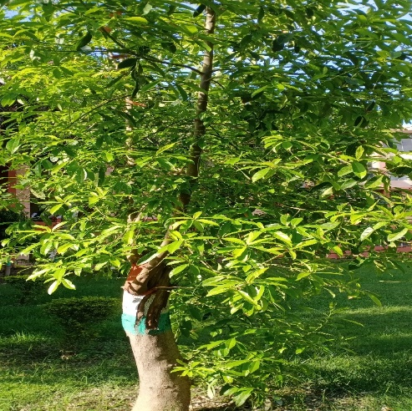
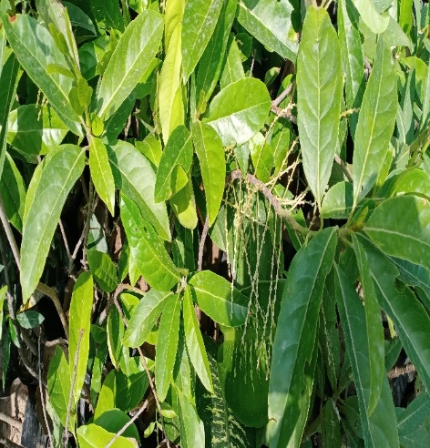
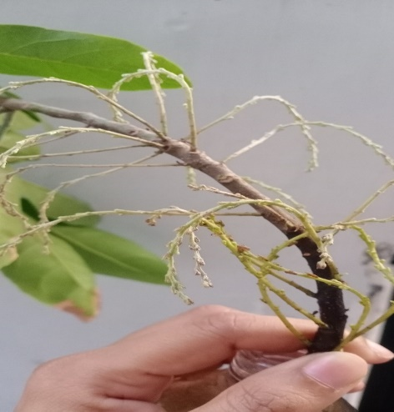
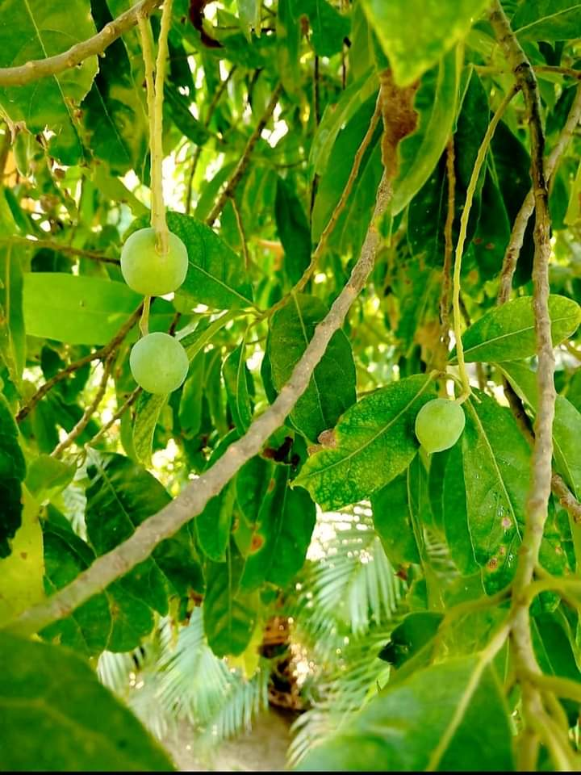
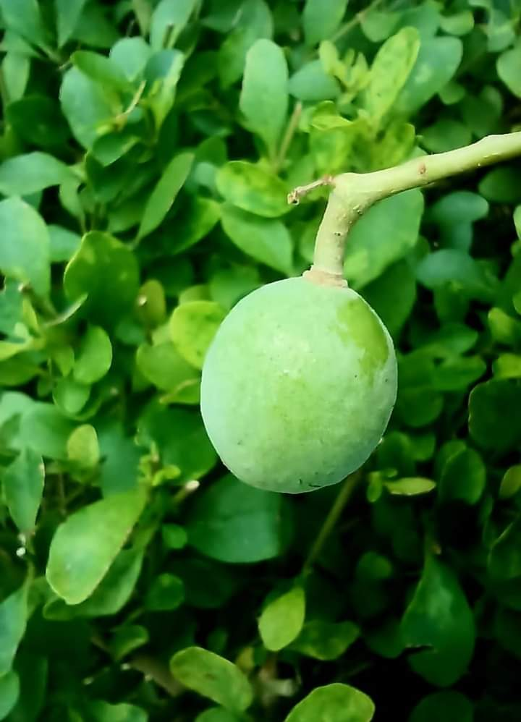
A
C
B
E
D
Fig.1 A. Elaeocarpus ganitrus tree B. Elaeocarpus ganitrus leaves C. Elaeocarpus ganitrus flowering D & E. Elaeocarpus Fruit.

Taxonomy and Distribution
Kumar et al., 2015 classify the Elaeocarpus as:
Kingdom: Plantae
Division: Magnoliophyta
Class: Magnoliopsida
Order: Oxalidale,
Family: Elaeocarpacae
Genus: Elaeocarpus.
Elaeocarpus species are extensively distributed across South and Southeast Asia, Australia, and Pacific islands. In Indian subcontinent which includes India, Bangladesh, Sri Lanka, Pakistan and Nepal is where it is commonly found. About 120 species are found in Asia, of which 29 species have been reported to be from India and mostly confined to the North-East and Southern India and a few species to Andaman and Nicobar Islands. Out of 29 species, only 18 species are found in North-East India (Mitei and Khuraijam, 2019). Eleven species were reported from the Western Ghats of Tamil Nadu, including the recently reported Elaeocarpus aristatus (Kumari et al., 2018). The genus comprises evergreen trees that thrive in tropical and subtropical climates, often found in montane and lowland forests.
Morphological characteristics: Elaeocarpus species exhibit diverse growth habits, covering from small shrubs to large trees (Kumar et al., 2011). The tree grows up to 14.60m-29.20m tall with a trunk diameter of up to 1.22m (Sharma et al., 2014).
Stem: The stem is cylindrical and has a coarse texture, featuring bark that is grey to white in colour (Kumari et al., 2018).
Leaves: Its leaves are shiny green on the upper side and dull leathery on the dorsal side, with ovate shapes and toothed edges (Heywood, 2007). The leaves measure 10-15 cm in length and 6-8 cm in width. They are simple, smooth, and oblong-lanceolate, with a mostly smooth or irregularly crenated margin and are shiny green, pointed or acuminate at the tip, slightly bitter, and lack any distinct smell.
Flowers: The flowers exhibit a white or yellow hue, fringed petals, anthers are linear, commonly blooming in April and May. Clusters of tightly packed flower stems typically arise from the junctions of fallen leaves.
Fruit : The fruits are globular or oval, small 1cm in diameter, start appearing in June and turn purple-deep blue or purple mealy when fully ripe in October , earning them the nickname "blueberry beads" (Kumar et al., 2011). The fully riped fruit presents a plump appearance and holds a blue seed inside. These fruits are also popular as Amritphala (Fruits of nectar) (Deepshikha, et al., 2023).
Seed: The seeds are brown, five-segmented, stony, firm, spherical, ovoid, or oval in shape, vary in size, and have longitudinal grooves and tubercles. The seed coats contains the multi-layered stone cells followed by thin-walled parenchymatic cells containing a reddish-brown pigment. The endosperm with calcium oxalate rosette crystals and oil globules composed of oval to polygonal parenchymatic cells , while the embryo consist of parenchymatous cells that contains oil globules (The Ayurvedic Pharmacopoeia of India, 2004). The term “Rudraksha” concerns to the innermost part of the bead located in the seed. Each seed defined as Mukhs’or faces, ranging from 1 to 24 accounting a variable numbers of perpendicular lines on its surface (Rashmi et al., 2014). Natural beads form can be separated from artificial beads by Cut test, copper coin test, properties test, eye test, x-ray test and CT scanning test (Prabha and Kaur, 2014).
Few key species include:
- Elaeocarpus ganitrus: often referred as Rudraksha, esteemed in Hindu culture for its spiritual significance.
- Elaeocarpus serratus: used in medicine and as a fruit-bearing tree locally to Sri Lanka and India.
- Elaeocarpus grandis: valued for large fruit and high-quality timber, Found in Australia.
- Elaeocarpus angustifolius: recognized for its potential medicinal properties, Dispersed in the Pacific region.
- Elaeocarpus floribundus: known for its antioxidant properties.
- Elaeocarpus hainanensis: A species that is rarely found in China,with potential pharmacological applications.
- Elaeocarpus oblongus: valued for its antimicrobial properties, Found in Southeast Asia,.
- Elaeocarpus japonicus : studied for its potential cardiovascular benefits, Distributed in Japan and China,
- Elaeocarpus sphaericus: typically used for its neuroprotective effects in Ayurvedic medicine.

Phytochemistry
In the last few decades, the phytochemical composition of Elaeocarpus has also been studied extensively (Sharma, S., et al., 2023, Miller et al., 2006). Elaeocarpus species provides a broad spectrum of bioactive phytoconstituents like, hydrocarbons, aldehydes, alkenes, amides ,alkaloids, glycosides, phenolic compounds, flavonoids, saponins, carbohydrates and fixed oils, fatty acids, diterpenoids, triterpenoids, cucurbitacins(AK Oungdele,et.al., 2019) , which are used for various ailments (Geetha , et.al., 2013). Notable bioactive compounds include:
- Flavonoids: show strong antioxidant and anti-inflammatory properties.
- Alkaloids: class of naturally occurring compounds found in plants, often with potent biological effects. They can have medicinal, toxic, or psychoactive properties together with analgesic effects.
- Tannins: well known for antimicrobial, astringent, and anti-inflammatory activities.
- Terpenoids and Saponins: Possess anti-cancer, antifungal, and immune-boosting properties.
- Phenolic Compounds: contributing to anti-aging effects as it exhibit significant free radical scavenging potential.
- Glycosides: cardiovascular benefits and metabolic regulation are associated.
- Ellagic Acid: gives hepatoprotective and anti-inflammatory benefits, found only in some species
- Coumarins: promising vasodilatory and anticoagulant effects.
- Steroids: Analyzed for their part in hormonal balance and immune modulation.
Chart 1: Bioactive phytoconstituents of Elaeocarpus and their biological activities
Phytochemical Activity | Biological Activity
Alkaloids | Antimicrobial, anti-inflammatory
Flavonoids | Antioxidant, cardioprotective
Ellagic | Antioxidant, anticancer
Tannins | Astringent, antimicrobial
Phenolic Compounds, | Anti-inflammatory, neuroprotective

Table 1. Bioactive compounds of Elaeocarpus and their pharmacological activities (Tripathy et al., 2023)
S.N | Bioactive compounds  of E. angustifolius | Structure | Pharmacological activities | References
 | Gallic acid | 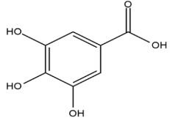 | Allergic inflammation, neuroprotective, antioxidant, rheumatoid arthritis, pelvic inflammation and gastroenteritis, obesity, pneumonia and hepatitis. | Bai et al., 2021
 | 4′-O-Methylellagic acid 3-(2″,3″-di-O-acetyl)-α-l-rhamnoside | 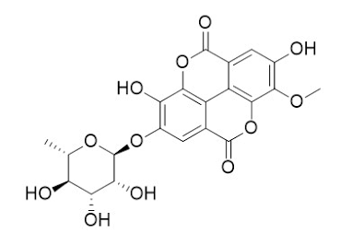 | Growth-inhibitory effect on Babesia gibsoni | Elkhateeb et al., 2005
 | 4,4′-O-Dimethylellagic acid 3-(2″,3″-di-O-acetyl)-α-l-rhamnosid | 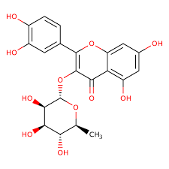 | High affinity of Antiviral activities | Ito et al., 2002
 | Geraniin | 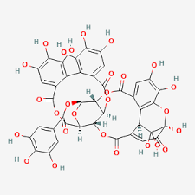 | Antiviral, Immunomodulatory, Antidiarrheic, Anticancer ,Apoptosis  Inhibit tumor necrosis | Joo et al., 2022
 | 1, 2, 3, 4, 6-penta-O-galloyl-β-d-glucose (PGG) | 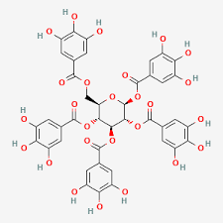 | Antiviral, immunomodulatory, recover antioxidant enzyme, apoptotic, caspase-3 activity , radioprotection, anti-tumor, inhibit angiogenesis | Sudrajat 2022
 | Ellagic acid | 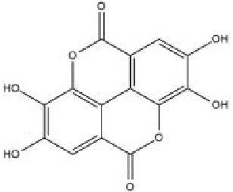 | Antioxidant, neuroprotective, anti-inflammatory, antiviral, apoptosis induction anticancer, antidiabetic, antihyperlipidemic, hepatoprotective. | Rios et al., 2018, Mehnaj et al. (2024)
 | Quercetin | 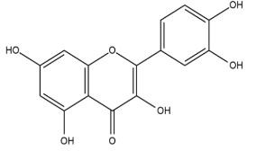 | Antioxidant, anti-inflammatory, anticancer, antiviral, antimalarial, antihypertensive, neuroprotective, hepatoprotective and cardioprotective properties. | Mahmud et al., 2023
 | Isoquercitrin | 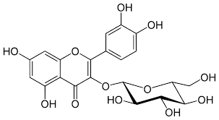 | Antioxidant, anti-inflammatory, anticancer, antiviral, antimalarial, | Kim et al., 2020
 | Rudrakine | 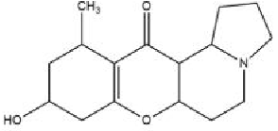 | Antihypertensive, antidepressant, anti-inflammatory, central analgesic activity, antioxidant, antimicrobial, antimalarial, cytotoxic, anxiolytic, Opioid Receptor Modulation and bronchial asthma. | Garg et al., 2013, Sudrajat 2022
 | Myricetin | 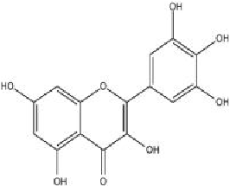 | Antioxidant, anti-inflammatory, anticancer, antidiabetic, antimalarial, cardioprotective and neuroprotective | Bordoloi et al., 2017,
 | Mearnsetin | 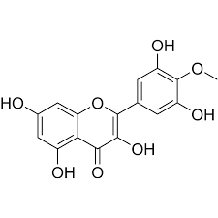 | Antimelanogenesis, Anti-tyrosinase, skin-whitening , antioxidant | Huang et al., 2021
 | Proanthocyanidins anthocyanin | 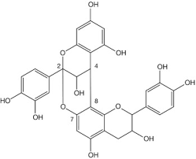 | Antioxidant, Inhibit α-amylase and α-glucosidase | Sudrajat 2022
 | Cucurbitacins | 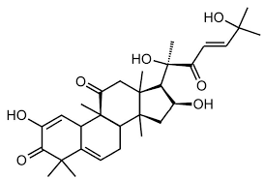 | Anticancer, induce apoptosis, arrest the cell cycle in G1/S phase, enhance the expression of tumor suppressor microRNAs ,antioxidant, antiinflammation, antiviral , Attenuate cell proliferation,  suppress PI3K/AKT/p70S6K signaling pathway | Sudrajat 2022
 | Kaempferol | 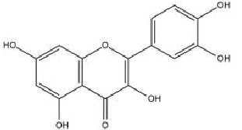 | Antioxidant ,Anti-inflammatory , Anticancer ,Antidiabetic, Cardioprotective , Neuroprotective , Antimicrobial ,Anti-metastatic ,Antiproliferative ,Hypolipidemic | Yuan et al., 2021
 | Ethyl gallate | 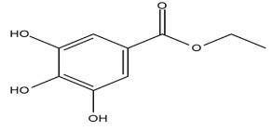 | Antioxidant, anticancer, UV protective. | Bai et al., 2021
 | Elaeocarpine | 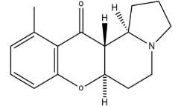 | Conditions affecting the mind, seizures, headaches, allergic reactions, neurological disorders, diabetes, asthma, cancer and various other circulatory issues. | Singh et al., 2015
 | Isoelaeocarpine | 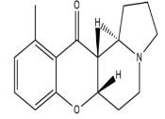 | Convulsions, anticancer, antidiabetic, asthma and anti-inflammatory. | Hong et al., 2019
 | Elaeocarpenine | 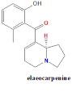 | Interacts with opioid receptors (μ, κ, δ subtypes), related to opioid-mediated activities and receptor binding affinities. | Ezeoke et al., 2018
 | Alloelaeocarpiline | 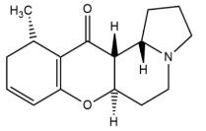 | Antidepressant, anti-inflammatory, central  Analgesic activity, antioxidant, antimicrobial, cytotoxic, anxiolytic and bronchial asthma. | Hong et al., 2019
 | Epielaeocarpiline | 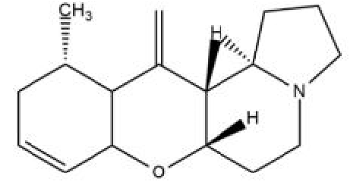 | Antioxidants fight against microbes, antimalarial, cytotoxic, anxiolytic, and bronchial asthma. | Katavic et al., 2006
 | Epialloelaeocarpiline | 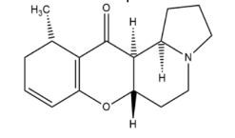 | Cytotoxic, anxiolytic, anti-hypertensive, antidepressant, anti-inflammatory, anticancer, antioxidant, antimicrobial and antimalarial. | Katavic et al., 2006
 | Isoelaeocarpiline | 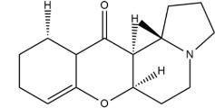 | Antihypertensive, antidepressant, antiinflammatory, central analgesic activity, antioxidant, antimicrobial, antimalarial, cytotoxic, anxiolytic and bronchial asthma. | Katavic et al., 2007
 | Proanthocyanidins | 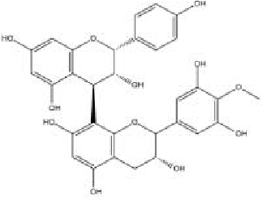 | Antioxidant, anti-inflammatory, and anticancer suppress the activity of alpha -glucosidase and beta-amylase. | Rue et al., 2018
 | Oleic acid | 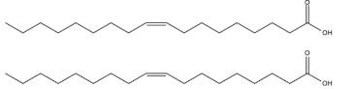 | Antihypertensive lowers cholesterol,  antidiabetic, memory enhancer, ulcerative colitis, emollient and anticancer. | Mirgorodskaya et al., 2023
 | Palmitic acid | 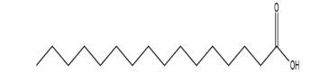 | Food additives, emollients, surfactants and cosmetics. | Carta et al., 2017
 | Linoleic acid | 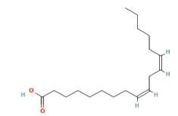 | Possessing protective effects on the cardiovascular system, anticancer properties, neuroprotective qualities, prevention of osteoporosis, antiinflammatory actions and antioxidative benefits. | Kim et al., 2014
 | Phytol/Phaeophytins | 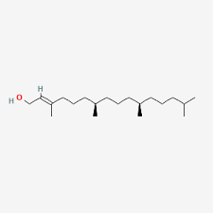 | Affinity for DOR, antioxidant, anticancer, antimicrobial | Ogundele and Das, 2019
 | Elaeocarpucins A-H | 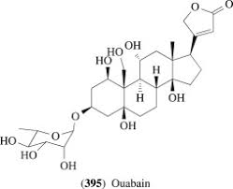 | antidiabetic, memory enhancer, ulcerative colitis, emollient and anticancer. | Pan et al., 2012
 | Dibutyl succinate | 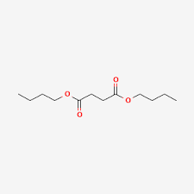 | antidiabetic, memory enhancer, ulcerative colitis, emollient and anticancer. | Ogundele et al., 2021a
 |  | 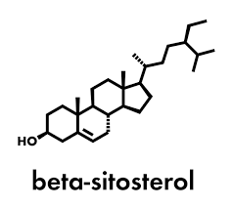 | Methanolic extract of leave and stem bark shows high affinity for antioxidant potential | Utami et al., 2013
  Phytosterol
  Beta-sitosterol
 | Daucosterol | 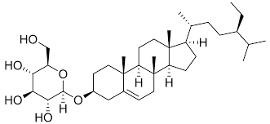 | antioxidant, anticancer, antimicrobial | Pan et al., 2012
 | Dotriacontane | 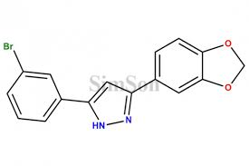 | Antifungal | Bordoloi et al., 2017
 | Triacontanoic acid | 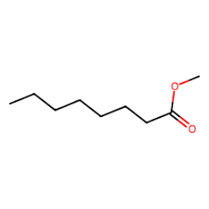 | Antifungal | Bordoloi et al., 2017
 | Octatriacontan-1-ol | 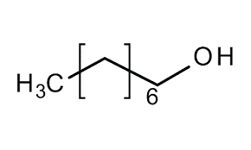 | Antifungal | Bordoloi et al., 2017
 | Decene  Hexadecane  Heptane | 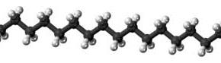 | Antifungal Affinity for DOR, Antioxidant, Antivirus, Antimicrobial | Ogundele et al., 2021

Gaseous Composition of Rudraksha
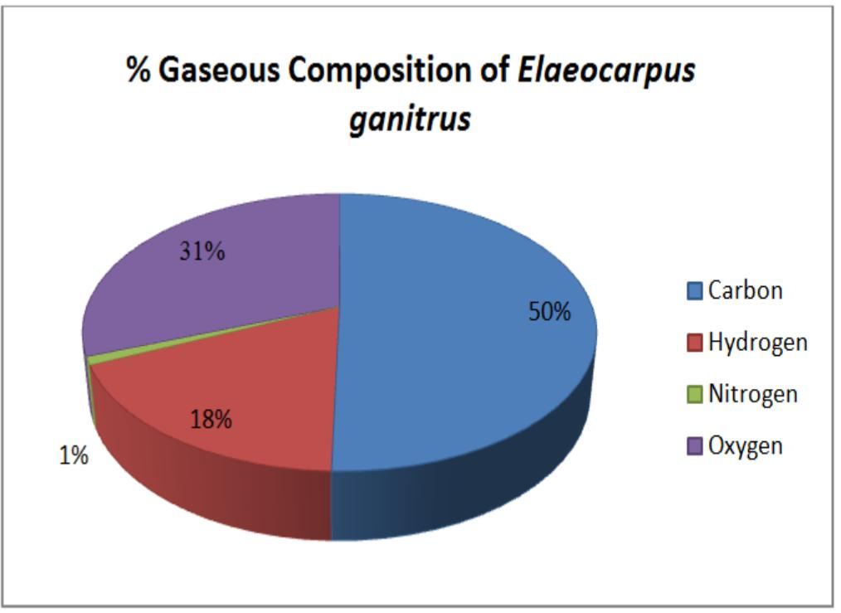
Rudraksha beads are comprising of carbon, hydrogen, oxygen, nitrogen and combined form of trace elements. Percentage composition of gaseous elements in Rudraksha beads are shown in figure 2:

Figure 2: Percentage Compositions of Gaseous Elements in E. ganitrus

The significance of Elaeocarpus in Ayurveda
The term "Rudraksha" comes from (Rudra: Refers to “Lord Shiva” and Aksha: means "eyes" or "tears”) roughly translates to "Lord Shiva's tears" or "eyes of Shiva”. Historically, Ayurveda have used Elaeocarpus in medicine for its preventive and therapeutic properties. According to Ayurveda, the bead, bark and leaves of the rudraksha tree, used to cure illnesses, headaches, fevers, skin disease and mental disorders. It is believed that without the need for allopathic drugs Rudraksha balances the body's doshas (vata, pitta, and kapha). Rudraksha is believed to have acidic properties that balance the body's energies, relieving headaches and mental issues. Ancient texts and Locals suggest it also helps control blood pressure and mental illnesses. (Ashraf et al., 2019).

Traditional and Economic Uses
Despite facing challenges like stagnant yields and limited expansion of cultivated areas (Sharma et al., 2019), Elaeocarpus production is projected to increase to meet growing demand. Estimates suggest that Elaeocarpus in vitro production will increase to 1.5 million tonnes by 2030 and 2.0 million tonnes by 2050 (Kumar et al., 2020). In several countries, including India, Sri Lanka, and Indonesia, Elaeocarpus accounts for a significant portion of daily caloric intake, with some estimates suggesting that it provides up to 20% of total caloric intake (Singh et al., 2020).
Elaeocarpus is a highly valuable crop having significant traditional, economical, medicinal, and food production importance. It is also a major export crop, contributes 1.2% to India's agricultural exports in 2020 (Hussain et al., 2020). Regardless its significance, yields are still low in India, highlighting the need for improved cultivation practices (Kumar et al., 2020).

According to Hindu mythology, people believe that, anyone who wears rudrakshya beads gets mental and physical powers. Elaeocarpus species have significant cultural, medicinal, and economical importance:
- Edible fruits: Consumed raw fleshy fruit for its nutritional values or used in folk medicine (Mundaragi, 2019).
- Medicinal properties: Elaeocarpus extracts used to treat various ailments such as fever, diabetes, antimicrobial, anti-inflammatory, antioxidant infections, and skin diseases, by indigenous healers (Rastogi et al., 1993)
- Valuable timber: E. ganitrus Roxb. a good quality timber-producing species and its light and strong white wood durable and rot resistant, suitable for furniture-making and construction (Kumar et al., 2014)
- Ornamental value: striking foliage, feather like flowers, and vibrant blue or purple fruits attracts the most.
- Ecological importance: providing food and habitat to animals, promoting biodiversity
- Religious and Spiritual Significance: Rudraksha beads, derived from E. ganitrus seeds, has gained a special place in Hinduism, Buddhism, and Jainism and considerd as sacred and holy according to mythological book “Puranas” (holy books, 18 types).
- Nutritional Applications: Some species produce delicious fruits that serves to local diets, offering nutritional and economic benefits.
- Aromatherapy and Essential Oils: because of their calming and therapeutic properties some species are used to enhance traditional medicine.
- Biofuel Potential: Investigation suggests that Elaeocarpus oil extracts could be used to develop as a sustainable biofuel source.
- The Rudraksha seeds are primarily used in India, Indonesia and Nepal as beads for organic jewellery and malas and valued similarly to semi-precious stones.(Deepshikha et al.,2023)

Uses of Elaeocarpus in Ayurveda
- Enlightenment: Associated with Lord Shiva, brings spiritual enlightenment and inner peace.
- Mind Relief: calm the mind and connect with divine energy by meditation.
- Stress-anxiety free: Rudraksha seed powder with nervine tonics, including Brahmi and Ashwagandha, to enhance cognitive ability and decrease mental stress
- Strengthen body frame: when there is torn off on various body parts Elaeocarpus is believed to strengthen the body frame.
- Blood detoxifier: Elaeocarpus can be used to remove blood impurities and enhance overall blood quality.
- Antibacterial properties: can be used for treating burns, marks, coughs, and breathing problems as Elaeocarpus is said to have antibacterial properties.
- Controls epilepsy: used to make a powder from the soft tissue of Elaeocarpus ripened fruit, bark, or bead that helps controlling epilepsy.
- Blood pressure and heart diseases: Elaeocarpus is suggested for hypertension and Heart health or CVS.
- Skin problems: Elaeocarpus can enhance the skin’s radiance and contribute to a charming facial appearance.
- Tongue cracks and loss of taste: heals alleviating sensations of heaviness, tongue cracks, and tastelessness by Elaeocarpus gargling is effectively considered.
- Improving memory power: Elaeocarpus, when taken with milk, is thought to help improve memory power.
- Fertility: It is suggested to aid in conception during the menstrual period, when combination of rudraksha and sarpakshi taken.
- Cure Brain diseases: Elaeocarpus is believed to be useful in treating various brain diseases, including brain fever.
- Burns and pox marks: The five-faced Elaeocarpus seed is mentioned for treating burn or pox marks on the face.
- Liver problems, jaundice, and stomach ache: Elaeocarpus is recommended for treating stomach pain, liver problems, jaundice, and related issues.
- Insect bites/poisonous effects: Elaeocarpus paste, when applied with lemon juice, is suggested for treating poisonous effects caused by insect bites (Jain et al., 2014).
- Urinary tract infection (UTI): fruits show efficient activities and can be recommended as a herbal drug formulation for treating UTI.
- Confrontation: An ultimate factor of resistance reside in a particular type of mukhi of Rudraksha. It resists the flow of bio-electrical current generated due to electromotive force among multiple organ system or parts of the body. This resistance generates a specific ampere of current flow depending on the aspect of conflict. It is much needed to disclose there that specific variety of Rudraksha sends precise impulses acting on a specific type of bio-chemicals in the brain thus bringing specific positive changes in the personality.
- Electromagnetic properties
Its electromagnetic properties are contributing to curing diseases and mind influencing. Research from the University of Mumbai has shown its benefits for nervous system, memory, and cardiovascular disorders.
The information provided above is based on traditional beliefs about the benefits of Elaeocarpus, and it is crucial to approach such remedies with caution and consult with healthcare professionals for modern medical advice (Jain et al., 2014). From Kerala, the Kani tribes use the plant Elaeocarpus for treating arthritis in ancient Ayurvedic medicative system (Khan M.L., et al., 2004).
Pharmacological Properties
Studies indicate that Elaeocarpus species are rich in core secondary metabolites, in mainly biological studies, E. ganitrus exhibited the broad range of pharmacological actions contributing to their pharmacological potential. The Elaeocarpus leaves, seeds and fruits are used in Ayurveda for several therapeutic and medicinal properties(P Lal, 2013).It is traditionally used to cure mental disorders, asthma, allergies, neurological disorder, diabetes, cancer and many circulatory disorders (B Singh et.al.,2015),antiviral (YH Joo et.al., 2022),antibacterial, antimicrobial (Mahajanakatti, et.al,2022) and cytotoxicity and skin fibroblasts( Yeol ,et.al., 2023). Including:
- Antioxidant Activity : clinical trials confirms that Elaeocarpus ganitrus exhibits strong antioxidant actions that attributes the presence of significant levels of phenolic , flavonoids , alkaloids compounds together with cucurbitacins in its chemical structure. A strong free radical scavenging property is delivered by E. ganitrus extracts gallic acid and ellagic acid, along with quercetin components, provided substantial contributions to this chemical activity (Malinga & Laing, 2024; Watanabe et al., 2024).and other species which contribute to anti-aging and protective effects against oxidative stress-related diseases such as neurodegeneration, cancer, and cardiovascular disorders . Research that showed the methanolic extracts of Rudraksha demonstrated equal DPPH (2,2-diphenyl-1-picrylhydrazyl) radical scavenging power equivalent to ascorbic acid (Padma and Don,2025).
- Anti-inflammatory Effects (Saha and Ahmed, 2009): presence of triterpenoids and flavonoids bioactive compounds retained by various E. species inhibit inflammatory mediators, making them potential nominee for treating inflammatory disorders. It is reported in the Indian Journal of Natural Products and Resources, the paw edema in rats following carrageenan administration were reduced as ethanolic extracts of E. ganitrus significantly reacts to it(Gupta et al. 2021)
- Neuroprotective Potential: Rudraksha (E. ganitrus) has also been explored for its impact on the protection of brain cells stems from the antioxidant activities, together with the blocking effect on glutamate neurotransmitters (Domatskiy & Sivkova, 2023; Dongmo & Tamesse, 2023), memory enhancement, cognitive functions, and neurological disorders such as Alzheimer’s and Parkinson’s diseases (Sarkar et al.,2024)..
- Antimicrobial Activity (Singh and Nath, 1999): Aqueous and ethanolic Elaeocarpus extracts demonstrate efficacy against bacterial and fungal pathogens like Escherichia coli, Staphylococcus aureus, Pseudomonas aeruginosa, and Candida albicans, conversely, emerging evidences suggests the seed extract established a zone of inhibition against gram-positive bacteria (Meena et al. 2019) , also had excellent antibacterial activity against food-borne bacteria and also propose potential for antibiotic development.
- Cardioprotective Properties: Certain species aids heart health by affecting vascular nitric oxide and calcium channels, regulating lipid metabolism, reducing hypertension, and preventing atherosclerosis.
- Immunomodulatory: studies have discovered that Rudraksha enhances immune cell proliferation while simultaneously controlling the release of cytokines to create immunomodulatory effects.
- Anticancer Properties (Rajkumar et al., 2009): Certain phytochemicals present in Elaeocarpus have demonstrated cytotoxic against CEM-SS and Hela cancer cell lines with IC50 values of less than 30 µg/ml, warranting further research into their chemopreventive potential.
- Hepatoprotective Effects (Nevin and Vijayammal, 2005): Studies suggest potential of many species in promoting liver health, and reducing liver toxicity.
- Antidiabetic Potential (Hule et al., 2011): committed results of Elaeocarpus extracts for maintaining blood glucose levels, making them potential herbal candidates for diabetes management . Rajan et al. (2020) demonstrated that the researchers found enhanced insulin sensitivity and their fasting blood glucose levels decreased, When in streptozotocin-induced diabetic rats were given E. ganitrus extract orally.
- Wound Healing and Skin Regeneration: It is found promoted collagen synthesis and wound healing also accelerated by some Elaeocarpus extracts.
- Cytotoxic activity (Biswas, et al.,2014): Chloroform-soluble bark extract of Elaeocarpus mastersii was found to reveal significant cytotoxic activity when evaluated against a panel of human cancer cell line52 .Cucurbitacin D, cucurbitacins, and cucurbitacin F isolated from Elaeocarpus mastersii showed cytotoxic effect beside KB (human oral epidermoid carcinoma) cells53. Ethanolic leaves extract of Elaeocarpus serratus showed Cytotoxic activity of plant extracts against brine shrimps.
- Antiviral Activity: Preliminary studies suggest potential effectiveness against viral infections, including herpes and influenza.
- Other activities: Ethanolic fruits extract of Elaeocarpus ganitrus exhibit sedative, anticonvulsive, hypnotic, tranquillizing, and antiepileptic properties. A combination of bark, leaf and stem of Elaeocarpus floribundus has been used as mouth wash and fruits has been used as antiseptic. Elaeocarpus grandis indolizidine alkaloids grandisine A and isoelaeocarpiline compounds combine to opoid receptor and have analgesic effect (Carroll, et al., 2005).
Pharmacological properties
Of Elaeocarpus
Cardioprotective
Antiviral
Wound Healing
Hepatoprotective
Anti-inflammatory
Cytotoxic
Antioxidant
Neuroprotective
Antimicrobial

Anticancer

Fig. 3 Pharmacological properties of Elaeocarpus species.

Ecological Importance
Approximately 120 Elaeocarpus species are distributed across variety of regions in Asia, encompassing countries like Nepal, Bhutan, Sikkim, Tibet, Java, Indonesia, and the Himalayan foothills. However, in Arunachal Pradesh the rudraksha production has significantly decreased due to factors like urbanization, excessive extraction of forest resources, forest ecosystems are disturbed on large-scale, construction activities (roads, buildings and hydroelectric dams,), forestlands are encroached for agriculture expansion, logging, shifting cultivation , and mining operations, (Rashmi et al., 2014). Additionally, they help in regulating the local ecosystems through soil stabilization and water retention like processes (kawsar, et. al 2023).
Elaeocarpus species also essential in preventing forest ecosystems and biodiversity conservation:
- Seed Dispersal: many birds, bats, and mammals’ feeds on Elaeocarpus fruit, aiding natural seed dispersal and forest regeneration (Kasi, K. S., & Ramasubbu, R. 2021)
- Soil Stabilization: promoting ecological stability,prevent soil erosion in tropical environments by using extensive root systems of Elaeocarpus trees .
- Biodiversity Support: Habitat, nesting sites, and food are provided for various wildlife species by the trees and supporting ecosystem resilience.
- Carbon Sequestration: Elaeocarpus forests also contribute a big role to carbon storage, aiding in climate change mitigation.
- Pollinator Attraction: many pollinators like Bees and butterflies are attracted by the beautiful flowers, enhancing biodiversity.
- Climate Regulation: Forests dominated by Elaeocarpus species contribute to microclimate stabilization and hydrological balance.
Conservation challenges can and future research directions
Due to its numerous uses and benefits, plant demands gradually increasing day by day. The main threats include reduced rates of natural seed banks with poor germination rate, anthropogenic activities and over collection of seed by local people for selling purposes. As a result leds over-exploitation, followed by declined in the population in India. But due to its specific origin and tropical climatic requirements, it is not easy to grow anywhere in the world. Consequently, the tree is now classified as endangered species on the IUCN Red Data List. (IUCN RED LIST of Threatened Species) and may even face extinction if immediate conservation measures are not taken up. In situ and ex situ conservation techniques are endorsed in view of their ethnic medicinal importance and to derive economic benefits due to increasing demand of Rudraksha beads at various Rudraksha centers in Asia (Khan et al., 2004).
To address this decline of the Rudraksha tree population, by taking a following multi-faceted approach, we can work towards preserving the Rudraksha tree and its unique benefits for future generations such as sustainable harvesting practices, Habitat protection, Ex-situ conservation, Seed banking, Community engagement, in-vitro research and development etc.
Common Diseases of Elaeocarpus that effect it’s pharmacological potential
Unfortunately, specific data on common diseases of Elaeocarpus in India isn't readily available. However, based on available research, some common diseases affecting Elaeocarpus species including their potential impact on its pharmacological properties with their management strategies like Leaf Spot Caused by Alternaria alternata, Anthracnose Caused by Colletotrichum gloeosporioides, Root Rot Caused by various pathogens, Damping-off caused by Rhizoctonia solani etc. that effects on pharmacological properties and management. Elaeocarpus species, like Elaeocarpus ganitrus(Rudraksha), have various pharmacological activities due to bioactive compounds like alkaloids, flavonoids, and phenolics. Diseases can impact plant health and potentially its bioactive compounds. Hence there are few simple and easy to apply management strategies that included -Pruning (Remove infected parts), Fungicide (Control fungal diseases) and Sanitation (Remove debris). Here's an list of diseases affecting Elaeocarpus species.
S.N | Disease and Causative Agent | Affected Part | Potential Impact on Pharmacological Properties | Management | References
 | Leaf Spot (Alternaria alternata) | Leaves | May impact leaf health and secondary metabolites | Fungicides, sanitation | Yang et al.
 | Anthracnose (Colletotrichum gloeosporioides) | Leaves | Could impact leaf health and plant vigor | Fungicides, pruning | Kumar et al.
 | Stem Blight (Pseudocryphonectria elaeocarpicola) | Stem | May affect plant health and bioactive compounds | Pruning, fungicides | Yang et al.
 | Decline Disease (Phytoplasmas) | Whole plant | May lead to decline in plant health and bioactive compounds | Vector control, removal of infected plants | Lee et al.
 | Fungal Infections (Various fungi) | Leaves, stems | May impact plant health and production of bioactive compounds | Fungicides, proper sanitation | Patel et al.
 | Powdery Mildew (Fungal pathogens) | Leaves | May affect photosynthesis and plant health | Fungicides, pruning | Patel et al.
 | Rust Diseases (Fungal pathogens) | Leaves | Could impact plant vigor and bioactive compounds | Fungicides, sanitation | Lee et al.
 | Damping-off (Rhizoctonia solani) | Seedlings | Leads to sudden wilting and death of seedlings | Soil treatment, fungicides
 | Nematode Infestations (Nematodes) | Roots | Could impact plant health and bioactive compound production | Nematode management, soil treatment
 | Sooty Mold (Fungal pathogens) | Leaves | May affect photosynthesis | Fungicides, sanitation
 | Root Rot (Various pathogens) | Roots | Could affect plant health and bioactive compound production | Soil management, fungicides
 | Bacterial Leaf Spot (Bacterial pathogens) | Leaves | May affect leaf health | Antibiotics, sanitation | Singh et al.
 | Phytoplasmal Diseases (Phytoplasmas) | Whole plant | May lead to decline in plant health | Vector control, removal of infected plants | Lee et al.
 | Leaf Blight (Fungal pathogens) | Leaves | May affect leaf health and plant vigor | Fungicides, pruning | Lee et al.
 | Canker Diseases (Fungal or bacterial pathogens) | Stems | Could impact plant health and bioactive compounds | Pruning, fungicides | Johnson et al.
 | Dieback (Fungal pathogens) | Branches | Could impact plant health | Pruning, fungicides | Johnson et al.
 | Stress-related Decline (Environmental stressors) | Whole plant | May affect plant health and bioactive compound production | Proper cultivation practices | Johnson et al.
 | Vascular Diseases (Fungal or bacterial pathogens) | Vascular system | May lead to decline in plant health | Pruning, fungicides | Bordoloi et al., 2017
 | Gall Diseases (Bacterial or fungal pathogens) | Various parts | Could impact plant health | Pruning, sanitation | Johnson et al.
 | Leaf Curl (Fungal or viral pathogens) | Leaves | Could impact plant health | Fungicides, sanitation | Johnson et al.
Table 2: Common Diseases of Elaeocarpus and their impact on pharmacological properties

Nanotechnology for better conservation of Elaeocarpus
Universally, government have invested extensively in nanotechnology research, with the United States leading the way (National Nanotechnology Initiative, 2015). In recent decades, nanotechnology has revolutionized medical sciences, particularly in diagnosis, drug delivery, molecular imaging, regenerative medicine, and Nano pharmaceuticals (Weissig et al., 2014; Khatoon et al., 2018). Green synthesis of nanoparticles is an environmentally friendly approach intended to eliminate toxic waste and reduce energy consumption. Nanotechnology has shown promising results in cancer treatment by targeting tumors with functional molecules like antibodies, nanoparticles, and cytotoxic agents (Lee et al., 2011, Yuan et al., 2019). Various methods have been developed for nanoparticle synthesis, including physical, chemical, biophysical, and biological approaches (Khan et al., 2017). However, there is a growing need for eco-friendly and controllable nanoparticle synthesis methods.

The use of Elaeocarpus extracts for antimicrobial applications has gained significant attention due to their potential advantages over traditional methods (Kumar et al., 2018). These extracts have been successfully utilized to synthesize nanoparticles, offering a promising alternative for antimicrobial treatments (Rajeshkumar et al., 2014). The evidences of the current study lead to the synthesis of novel and cost-effective drugs from Elaeocarpus ganitrus seeds extract by using the bio approach. Researchers are actively exploring the antimicrobial properties of Elaeocarpus extracts to develop novel antibiotics (Senthilkumar et al., 2020). Notably, the Elaeocarpus silver Nanoconjugates has demonstrated enhanced antimicrobial activity against a range of pathogens, surpassing the efficacy of commercial antibiotics (Chouhan et al., 2022). Also showed good cytotoxic impact against a prostate cancer (PC-3) cells line (Vinay SP et al. 2021).

Conclusion and Recommendation
In this article, we tried to conclude that in this modern era, Elaeocarpus should also be used as a drug because it shows antimicrobial (antibacterial, antiviral, and antifungal), antimalarial, antioxidant, immunostimulant, anti-inflammatory properties. Elaeocarpus species exhibit significant medicinal, ecological, and economic value. Their phytochemical richness and pharmacological potential make them valuable candidates for drug discovery, while their ecological role in biodiversity conservation underscores the need for sustainable management. Ongoing research continues to uncover new applications, making Elaeocarpus a promising focus for interdisciplinary studies in botany, pharmacology, and conservation science. However, It is required to carry out more pharmacological studies because there are insufficient pharmacological activity data for a number of the isolated components of Elaeocarpus , there is a need to focused on further research to elaborate the molecular mechanism of Rudraksha against corona virus and conduct preclinical and clinical studies on Rudraksha as phtyomedicine. Research needs good tests on people to check if Elaeocarpus ganitrus is safe and works well at the best dose. Using super tiny made particles (nanoparticles) might help make this research easier. Future studies could be directed to determine the active principle of the extracts and its mode of action in vitro and in vivo.

Disclaimer (Artificial intelligence)
Option 1:
Author(s) hereby declare that NO generative AI technologies such as Large Language Models (ChatGPT, COPILOT, etc.) and text-to-image generators have been used during the writing or editing of this manuscript.

References
- Kumar, V. S., & Navaratnam, V. (2013). Neem (Azadirachta indica): Prehistory to contemporary medicinal uses to humankind. Asian Pacific Journal of Tropical Biomedicine, 3(7), 505-514. https://doi.org/10.1016/S2221-1691(13)60105-7
- Rates, S. M. (2001). Plants as source of drugs. Toxicon, 39(5), 603-613. https://doi.org/10.1016/s0041-0101(00)00154-9
- Indhiramuthu, J., Geetha, D. H., & Rajeswari, M. (2014). Evaluation of antimicrobial potential of Elaeocarpus serratus L. International Journal of Pharmaceutical Sciences and Research, 5(8), 3467-3472. https://doi.org/10.13040/IJPSR.0975-8232.5(8).3467-72
- Heywood Mabberly Weibel, R. (1989). Elaeocarpus in the Pacific Islands. Journal of the Arnold Arboretum, 70(2), 141-162.
- Vinay, S. P., Udayabhanu, Sumedha, H. N., Shashank, M., Nagaraju, G., & Chandrasekhar, N. (2021). In-vitro antibacterial, antioxidant and cytotoxic potential of gold nanoparticles synthesized using novel Elaeocarpus ganitrus seeds extract. Journal of Science: Advanced Materials and Devices, 6(1), 127-133. https://doi.org/10.1016/j.jsamd.2020.09.008
- Kumari, B., Srivastava, A., & Tiwari, S. K. (2018). Elaeocarpus spp.: A threatened power generating plant, its geographical distribution, propagation through in vivo condition and its medicinal aspects. International Journal of Fauna and Biological Studies. https://www.faunajournal.com/archives/2018/vol5issue2/partA/5-2-1-701
- Sharma, D., & Vaishnava, A. (2023). In Vitro Shoot Regeneration of Elaeocarpus sphaericus (Rudraksha) – An Important Medicinal Plant. Frontiers in Crop Improvement. https://asthafoundation.in/journal/FCI/11_1_2023/51-54.pdf
- Dasgupta, A., Agarwal, S. S., & Basu, D. K. (1984). Anticonvulsant activity of the mixed fatty acids of Elaeocarpus ganitrus roxb. (Rudraksh). Indian Journal of Physiology and Pharmacology, 28(3), 245-246. https://pubmed.ncbi.nlm.nih.gov/6519771/
- Singh, R. K., & Nath, G. (1999). Antimicrobial activity of Elaeocarpus sphaericus. Phytotherapy Research, 13(5), 448-450. https://doi.org/10.1002/(sici)1099-1573(199908/09)13:5<448::aid-ptr480>3.0.co;2-6
- Dubey, G. A. (2018). Effect of extract of Rudraksha (Elaeocarpus ganitrus) on Parkinson's disease and depression. *World Journal of Pharmaceutical Research*, *7*(12), 937-947. https://doi.org/10.20959/wjpr201812-12697
- RaviPadma, K., & Don, K. R. (2025). Pharmacological Insights and Therapeutic Value of Rudraksha: Scientific Review. Journal of Biochemical Technology, 16(2), 93-104. https://doi.org/10.51847/vy3csFbduH
- IUCN. (2025). The IUCN Red List of Threatened Species. https://www.iucnredlist.org
- Arif, S., Sharma, A., & Islam, H. M. (2022). Plant-derived secondary metabolites as multiple signalling pathway inhibitors against cancer. Annals of Phytomedicine, 11(1), 189-200. https://doi.org/10.54085/ap.2022.11.1.18
- Aryal, P. (2021). Medicinal value of Elaeocarpus sphaericus: A review.Asian J. Pharmacogn., 6(3):15-21.
- Department of AYUSH, Ministry of Health and Family Welfare, Government of India. (2004). *Ayurvedic Pharmacopoeia of India. Part-I, Volume-IV*. https://pcimh.gov.in/publication/ayurveda-pharmacopoeial-publication
- Bagewadi, H. G., & Khan, A. K. A. (2015). Evaluation of anti-parkinsonian activity of Elaeocarpus ganitrus on haloperidol induced Parkinson's disease in mice. International Journal of Basic & Clinical Pharmacology, 4(1), 102–106. https://doi.org/10.5455/2319-2003.ijbcp20150218
- Bai, J., Zhang, Y., Tang, C., Hou, Y., Ai, X., Chen, X., Zhang, Y., Wang, X., & Meng, X. (2021). Gallic acid: pharmacological activities and molecular mechanisms involved in inflammation-related diseases. Biomedicine & Pharmacotherapy, 133, 110985. https://doi.org/10.1016/j.biopha.2020.110985
- Bordoloi, M.; Saikia, S.; Bordoloi, P.K.; Kolita, B.; Dutta, P.P.; Bhuyan, P.D. and Rao, P.G. (2017). Isolation, characterization and antifungal activity of very long chain alkane derivatives from Cinnamomum obtusifolium, Elaeocarpus lanceifolius and Baccaurea sapida. J.Mol. Struct., 1142:200-210.
- Bhuvaneswari, S. S., Prabha, T., Begum, S. S., Sivakuamr, T., Saranraj, P., Manivannan, V., & Kumar, B. A. (2021). Formulation and evaluation, comparison of herbal hair dye with marketed formulation. *Annals of Phytomedicine: An International Journal*, *10*(2), 175-181. https://doi.org/10.21276/ap.2021.10.2.24
- Carta, G., Murru, E., Banni, S., & Manca, C. (2017). Palmitic Acid: Physiological Role, Metabolism and Nutritional Implications. Frontiers in Physiology, 8, 902. https://doi.org/10.3389/fphys.2017.00902
- Saha, A., & Ahmed, M. (2009). The analgesic and anti-inflammatory activities of the extract of Albizia lebbeck in animal model. Pakistan Journal of Pharmaceutical Sciences, 22(1), 74-77. https://pubmed.ncbi.nlm.nih.gov/19168425/
- Deepika, R., Singh, J., & Kaur, N. (2018). Comparison of total phenolic content, total flavonoid content, antioxidant capacity and free radical scavenging activity of leaves of Elaeocarpus sphaericus and roots of Pelargonium zonale. Int. J. Curr. Microbial. App. Sci., 7(2), 2846-2854. https://doi.org/10.20546/ijcmas.2018.702.347
- Dogiparthi, L. K., Pottella, S., Doppalapudi, S., Pendyala, V., Sharabu, R., & Suryadevara, V. (2022). Design and characterization of Elaeocarpus ganitrus-based ointment for its wound healing property. Journal of Pharmaceutical Negative Results, 13(Special Issue 09), 6258-6263. https://doi.org/10.47750/pnr.2022.13.S09.746
- Carroll, A. R., Arumugan, G., Quinn, R. J., Redburn, J., Guymer, G., & Grimshaw, P. (2005). Grandisine A and B, novel indolizidine alkaloids with human delta-opioid receptor binding affinity from the leaves of the Australian rainforest tree Elaeocarpus grandis. Journal of Organic Chemistry, 70(5), 1889–1892. https://doi.org/10.1021/jo048525n
- Prakash, D., Saini, M., Tyagi, N., Madan, A., & Dutta, R. (2021). A mystical plant Azadirachta indica used as phytomedicine: state-of-the-art. Plant Cell Biotechnology and Molecular Biology, 22(71&72), 575-583. https://ikprress.org/index.php/PCBMB/article/view/7356
- Manoharan, A., Thamburaj, S., Kasipandi, M., Gayathri, J., Saikumar, S., Gayathri, N., & Thangaraj, P. (2019). Antioxidant and antimicrobial investigations of Elaeocarpus tectorius (Lour.) Poir. fruits against urinary tract infection pathogens. Biocatalysis and Agricultural Biotechnology. https://doi.org/10.1016/j.bcab.2019.101260
- Kasi, K. S., & Ramasubbu, R. (2021). Phenological patterns, fruit predation, and seed dispersal in two endangered trees (Elaeocarpus spp.) of southern Western Ghats, India. Journal of Asia-Pacific Biodiversity, 14(2), 275-282. https://doi.org/10.1016/j.japb.2021.02.002
- Sharma, S., Hussain, S., Rai, D. V., & Singh, A. N. (2023). A comprehensive analysis on the ecosystem services of Elaeocarpus L.(Elaeocarpaceae): a review. Journal of Phytology, 15, 12-37. https://doi.org/10.25081/jp.2023.v15.8020

