Geo-spatial Study of Women’s Education and Child Marriage in Maharashtra

ABSTRACT
Aims
The study aims to examine district-level variations in women’s educational attainment and literacy in Maharashtra and to analyze their relationship with the prevalence of early marriage among women.
Study Design
This is a descriptive and analytical cross-sectional study based on secondary data analysis.
Place and Duration of Study
The study covers all 36 districts of Maharashtra, using data from the National Family Health Survey–5 (NFHS-5), conducted during 2019–2021.
Methodology
District-level secondary data were extracted from the National Family Health Survey–5 (NFHS-5, 2019–21) for all 36 districts of Maharashtra. The study employed a quantitative, cross-sectional analytical approach. Key indicators analyzed included: female school attendance (age ≥6 years), female literacy (age 15–49), women with ten or more years of schooling (age 15–49), sex ratio (females per 1,000 males), and the proportion of women aged 20–24 married before 18 years. Descriptive statistics were used to examine inter-district variations, while Pearson correlation analysis was applied to assess relationships between women’s educational indicators and child marriage prevalence. This approach is consistent with recent district-level and geospatial studies examining early marriage determinants in India (Raj et al., 2019; BMC Public Health, 2024). Findings were interpreted in comparison with national trends from NFHS-4 and NFHS-5 and supported by existing sociological and demographic literature on education and marriage outcomes (Desai & Vanneman, 2015; UNICEF, 2020).
Results
Substantial inter-district disparities were observed. Urbanized districts such as Mumbai, Pune, Nagpur, and Thane reported very high female literacy and secondary schooling levels, along with very low child marriage prevalence. In contrast, districts such as Nandurbar, Parbhani, Bid, and Dhule exhibited low female educational attainment and high rates of early marriage. A strong negative correlation (r ≈ –0.66) was found between women’s completion of ten or more years of schooling and child marriage. Maharashtra’s overall child marriage rate (21.9%) was lower than the national average (23.3%), reflecting the state’s comparatively higher female literacy, though regional gaps remain pronounced.
Conclusion
The findings confirm that women’s education—particularly completion of secondary schooling—is a critical determinant in delaying marriage. Districts with higher female literacy and schooling consistently demonstrate lower child marriage prevalence. Strengthening access to quality education in lagging rural, tribal, and Marathwada districts, alongside supportive social and policy interventions, is essential for further reducing child marriage and advancing women’s empowerment in Maharashtra.
Keywords: Female Literacy, Women’s Education, Child Marriage, Educational Attainment, Women’s Empowerment

INTRODUCTION
Female education and literacy are central to improving women’s health, empowerment, and socio-economic development. Evidence from India’s National Family Health Survey (NFHS-5, 2019–21) indicates sustained progress, with the median age at first marriage for women rising to 19.2 years and the proportion married before 18 declining to about 23.3% nationwide (UNFPA, 2021; MoHFW, 2021). A strong inverse relationship exists between education and child marriage: only around 4% of women with higher education marry before 18, compared to nearly 48% of women with no schooling (UNFPA, 2021). District-level analyses further confirm this association, showing a strong negative correlation between completion of ten or more years of schooling and underage marriage (Ashoka University Data Lab, 2022; UNICEF, 2020). Recent multivariate studies demonstrate that women’s educational attainment remains the most significant predictor of delayed marriage even after controlling for wealth, caste, and residence (BMC Public Health, 2024; Raj et al., 2019). Despite overall gains, gender disparities persist, as women’s illiteracy levels in 2020 were comparable to men’s levels several decades earlier (Data for India, 2020; Desai & Vanneman, 2015). Maharashtra performs better than the national average in female literacy (≈84.6%), yet wide inter-district disparities continue to shape unequal outcomes in early marriage and women’s welfare (IIPS, 2021; MoHFW, 2021).

OBJECTIVE
- To analyze district-level variations in women’s educational attainment and literacy in Maharashtra and examine how these factors influence the prevalence of early marriage across the state.

DATA AND METHODS
District-level secondary data were extracted from the National Family Health Survey–5 (NFHS-5, 2019–21) for all 36 districts of Maharashtra. The study employed a quantitative, cross-sectional analytical approach. Key indicators analyzed included: female school attendance (age ≥6 years), female literacy (age 15–49), women with ten or more years of schooling (age 15–49), sex ratio (females per 1,000 males), and the proportion of women aged 20–24 married before 18 years. Descriptive statistics were used to examine inter-district variations, while Pearson correlation analysis was applied to assess relationships between women’s educational indicators and child marriage prevalence. This approach is consistent with recent district-level and geospatial studies examining early marriage determinants in India (Raj et al., 2019; BMC Public Health, 2024). Findings were interpreted in comparison with national trends from NFHS-4 and NFHS-5 and supported by existing sociological and demographic literature on education and marriage outcomes (Desai & Vanneman, 2015; UNICEF, 2020).

RESULTS AND DISCUSSION
Table 1: District-level secondary data the National Family Health Survey–5

Sr.  No. | District | Female population age 6 years and above who ever attended school (%) | Sex ratio of the total population (females per 1,000 males) | Women with 10 or more years of schooling (%) | Women age 20-24 years married before age 18 years (%) | Women who are Literate (%)
1 | Ahmednagar | 77.4 | 967 | 45.7 | 26.9 | 86.20
2 | Akola | 86.3 | 951 | 52.7 | 13.5 | 87.50
3 | Amravati | 86.2 | 994 | 55 | 9.8 | 87.80
4 | Aurangabad | 78.4 | 978 | 48.4 | 35.8 | 83.10
5 | Bhandara | 80.3 | 1004 | 53.9 | 1.5 | 89.10
6 | Bid | 64.6 | 934 | 38.6 | 43.7 | 76.30
7 | Buldhana | 78.1 | 957 | 41.8 | 24.1 | 79.90
8 | Chandrapur | 78.9 | 974 | 57.5 | 9 | 87.80
9 | Dhule | 73.5 | 999 | 40.8 | 40.5 | 68.80
10 | Gadchiroli | 67.1 | 1048 | 42.3 | 10.1 | 79.40
11 | Gondia | 80.4 | 994 | 54.1 | 6.5 | 87.50
12 | Hingoli | 69.4 | 962 | 33.2 | 37.1 | 76.50
13 | Jalgaon | 77.5 | 983 | 40.8 | 28 | 76.50
14 | Jalna | 67.6 | 948 | 34.3 | 35 | 71.80
15 | Kolhapur | 80.2 | 1025 | 53.8 | 21 | 90.70
16 | Latur | 70.6 | 979 | 40.7 | 31 | 83.30
17 | Mumbai Suburban | 88.5 | 921 | 65.7 | 10 | 91.60
18 | Mumbai | 92.5 | 939 | 71.1 | 4.5 | 94.30
19 | Nagpur | 86.5 | 971 | 67.6 | 7.1 | 94.60
20 | Nanded | 68.1 | 970 | 31.6 | 32.2 | 71.90
21 | Nandurbar | 63.5 | 961 | 29.9 | 24 | 57.70
22 | Nashik | 78.2 | 913 | 42.6 | 29.6 | 80.00
23 | Osmanabad | 71.3 | 992 | 41.5 | 36.6 | 83.70
24 | Palghar | 77.5 | 963 | 48.3 | 14.6 | 77.60
25 | Parbhani | 67.1 | 966 | 28.8 | 48 | 73.40
26 | Pune | 84.8 | 918 | 61.2 | 24 | 89.00
27 | Raigarh | 73.7 | 1003 | 45 | 16 | 79.20
28 | Ratnagiri | 80.3 | 1069 | 41.2 | 4.4 | 87.20
29 | Sangli | 80.4 | 1027 | 54.6 | 27 | 90.30
30 | Satara | 78.5 | 1049 | 48.3 | 18.1 | 87.20
31 | Sindhudurg | 83.1 | 1035 | 49.4 | 5 | 92.10
32 | Solapur | 72 | 962 | 36 | 40.3 | 76.40
33 | Thane | 86.1 | 982 | 55.9 | 18.4 | 90.50
34 | Wardha | 85.1 | 979 | 56.5 | 9 | 93.00
35 | Washim | 76 | 948 | 42 | 27.7 | 78.00
36 | Yavatmal | 77.6 | 986 | 38.9 | 11.7 | 80.80
 | Maharashtra | 79.6 | 966 | 50.4 | 21.9 | 84.60
 | India | 71.8 | 1020 | 41 | 23.3 | 71.50
Source: Socio-Economic Abstract of Ahilyanagar District-2024

3.1 District Variation in Education and Marriage
Female schooling and literacy vary greatly by district. Urbanized districts rank highest: Mumbai Suburban, Mumbai, Nagpur, Pune, and Thane all have >90% female literacy and >60% women with ≥10 years of schooling (IIPS, 2021). For example, Mumbai Suburban reports 91.6% literacy and 65.7% with ≥10 years schooling.
Nandurbar has only 57.7% female literacy and 29.9% with ≥10 years schooling, and a 24.0% child marriage rate (IIPS, 2021). Parbhani similarly reports 73.4% literacy, 28.8% schooling, and 48% early marriage — the highest in the state (IIPS, 2021).
The spatial pattern of women’s education and child marriage in Maharashtra reflects broader regional inequalities observed across India. Districts located in urban–industrial corridors and western Maharashtra demonstrate higher female educational attainment and delayed marriage, consistent with findings from earlier regional studies (Raj et al., 2019; Desai & Vanneman, 2015). Conversely, districts in tribal belts and the Marathwada region show persistent educational deprivation and elevated early marriage prevalence, aligning with national evidence that rural location, poverty, and limited secondary schooling infrastructure intensify child marriage risks (UNICEF, 2020; World Bank, 2018). Similar district-level disparities have been highlighted in recent geospatial analyses, which identify education as the strongest protective factor against early marriage, outweighing even household wealth in several regions (BMC Public Health, 2024).
Fig 1: Top 5 Districts in Women's Schooling (10+ years)
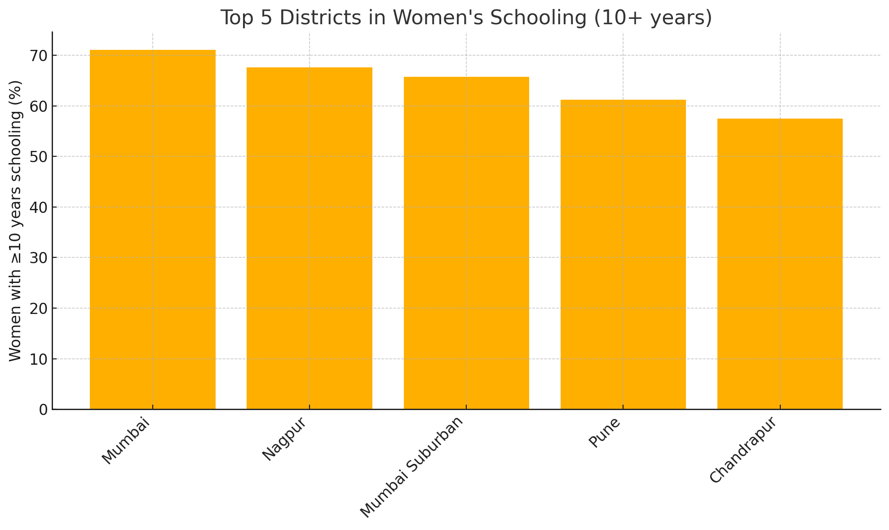

Fig 2: Bottom 5 Districts in Women's Schooling (10+ years)
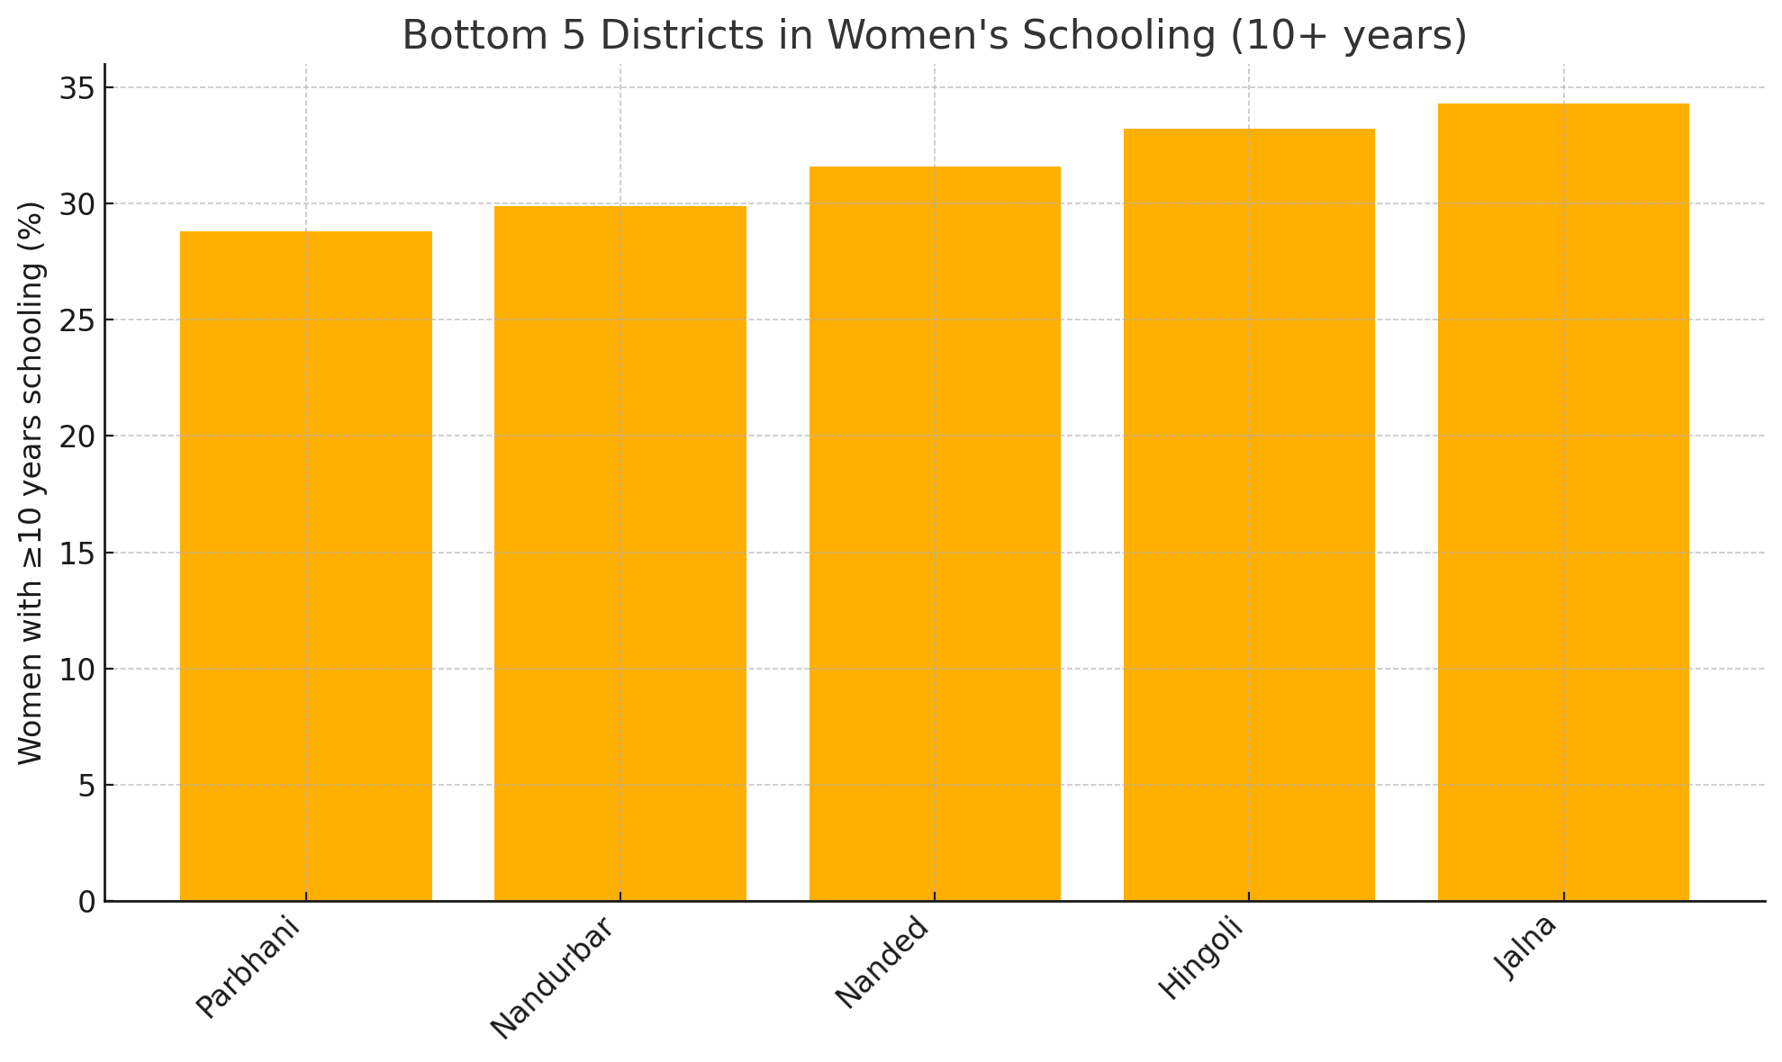
National analyses (NFHS-4 and 5) show a strong negative correlation between women’s education and underage marriage. In fact, states with the highest schooling have the lowest child marriage rates (Ashoka University Data Lab, 2022). Our Maharashtra data follows the same trend. Districts with higher female schooling and literacy consistently report much lower early marriage. A simple calculation from the above data yields a Pearson correlation of about –0.66 between women’s ≥10-year schooling rate and the share married before 18. This echoes the broader finding: for India overall, women’s ≥10-year schooling rose from 35.7% (NFHS-4) to 41.0% (NFHS-5) as the proportion married by 18 fell from 26.8% to 23.3% (MoHFW, 2021; IIPS & ICF, 2017). In summary, education appears to be the most significant predictor of delayed marriage in Maharashtra as well.
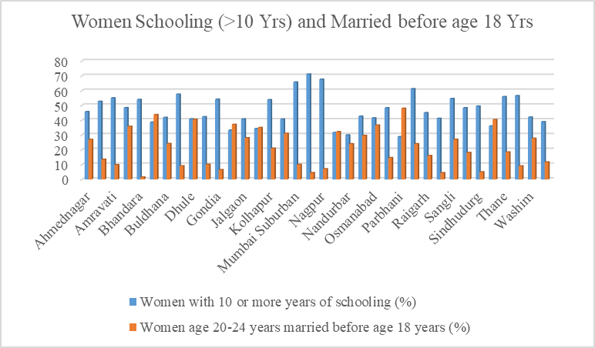
Fig 3: Women Schooling (>10 Yrs) and Married before age 18 Yrs

3.2 Correlations
Our analyses confirm national patterns: higher female education coexists with reduced child marriage. This aligns with national-level multivariate findings that women with higher education are dramatically less likely to marry early (BMC Public Health, 2024; Ashoka University Data Lab, 2022).
The strong positive correlation between female schooling and literacy (r ≈ 0.84) observed in this study reinforces established evidence that sustained school participation is essential for functional literacy outcomes among women (UNESCO, 2014). The negative association between women’s completion of secondary education and child marriage (r ≈ –0.66) is consistent with national and international findings, which demonstrate that each additional year of schooling significantly reduces the likelihood of marriage before 18 (Raj et al., 2019; UNICEF, 2020). Recent multilevel studies further suggest that secondary education not only delays marriage but also improves reproductive health outcomes and women’s autonomy, strengthening long-term development impacts (BMC Public Health, 2024; World Bank, 2018).
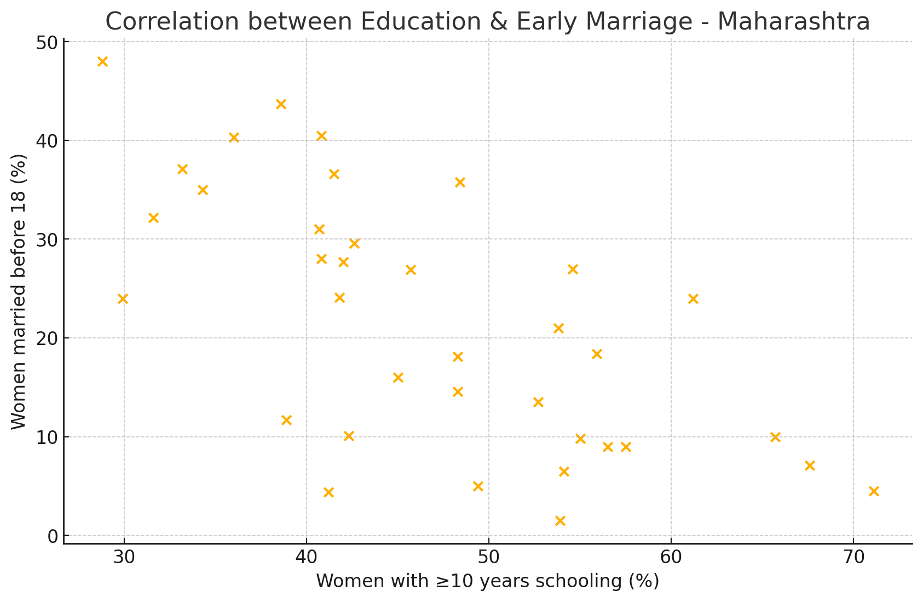
Fig 4: Correlation between Education & Early Marriage - Maharashtra
The sex ratio (females per 1000 males) also shows district variation. Overall Maharashtra (966) is below India (1020). Within the state, the highest ratios are in Ratnagiri (1069) and Satara (1049), while the lowest are in Nashik (913), Pune (918) and Mumbai Suburban (921). High female ratios in coastal and tribal areas often reflect male out-migration; low ratios in urban districts may reflect selective migration or demographic profiles. Sex ratio is linked to education and empowerment but can be influenced by many factors, so patterns are complex (Jha et al., 2018).
Fig 5: Correlation Matrix: Education, Literacy & Early Marriage
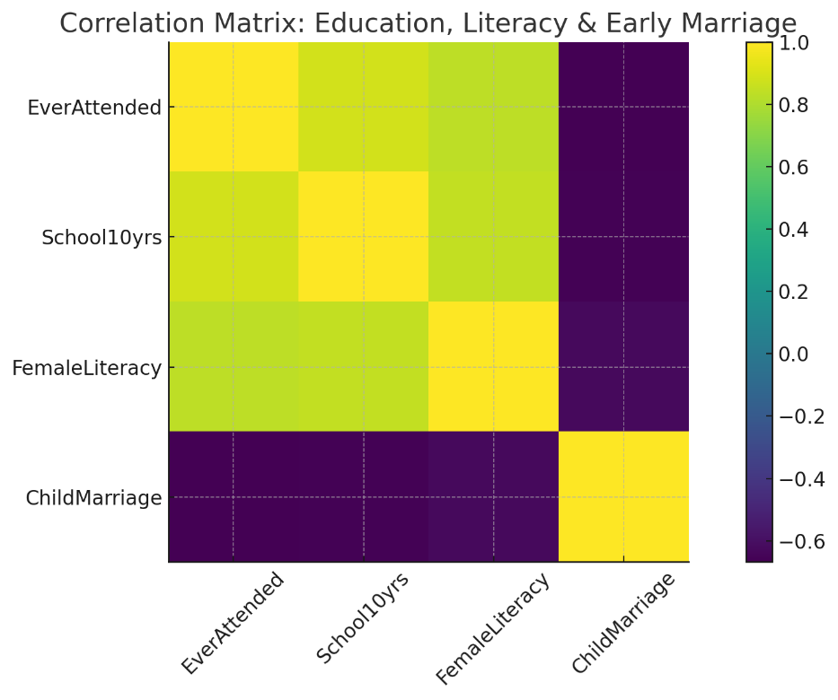
Fig 6: Sex ratio of the total population (females per 1,000 males)
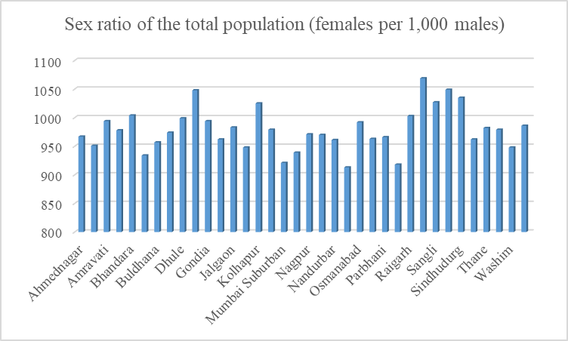

The sex ratio findings, while less directly linked in this analysis, also merit note. A more balanced or female-favoring ratio (as in Ratnagiri, Sindhudurg, Bhandara) may reflect patterns like male migration or better survival of girls, whereas very low ratios (Nashik, Pune) could indicate selective practices. However, because sex ratio is influenced by many social and migration factors, we focus on education and marriage as the primary concerns.

3.3 Sex Ratio and Educational Context
While sex ratio is not the primary explanatory variable in this study, its spatial variation provides important contextual insights. Higher female sex ratios in coastal and tribal districts such as Ratnagiri, Sindhudurg, and Gadchiroli may reflect male out-migration patterns, whereas lower ratios in metropolitan districts are often influenced by selective migration and urban labor markets (Jha et al., 2018). Previous demographic studies caution that sex ratio outcomes are shaped by multiple social, cultural, and economic processes and should therefore be interpreted alongside educational and marital indicators rather than independently (Desai & Vanneman, 2015).

3.4 Policy Implications
Maharashtra’s proposed “Earn and Learn” stipend program for female college students aims to increase higher education enrollment (Hindustan Times, 2024).
In policy terms, the evidence suggests that continuing to expand girls’ education – especially secondary schooling – is likely to reduce child marriage (UNICEF, 2020). Maharashtra’s overall success (state literacy 82.3% in 2011) (Government of Maharashtra, 2020) underlines progress, but district gaps remain. Programs targeting rural and disadvantaged districts (improving schools, reducing dropouts, offering scholarships) could further raise female education. Simultaneously, community campaigns and legal enforcement are needed in the high-marriage districts to change norms.
Evidence from national and international studies indicates that policies focused on expanding girls’ access to secondary and higher education are among the most effective interventions for reducing child marriage (UNICEF, 2020; World Bank, 2018). Scholarship schemes, conditional cash transfers, and incentives linked to school completion have demonstrated positive impacts in delaying marriage age in several Indian states (Raj et al., 2019). Maharashtra’s proposed stipend initiatives for female students align with these findings; however, targeted implementation in districts with persistently low female schooling is essential to address entrenched regional disparities (IIPS, 2021; BMC Public Health, 2024).

4 CONCLUSION
This analysis underscores that districts with higher women’s schooling and literacy show lower child marriage, reflecting national evidence that education delays marriage (UNFPA, 2021; Ashoka University Data Lab, 2022). Strengthening educational programs—especially in rural, tribal, and Marathwada regions—will be central to reducing child marriage and advancing women’s empowerment.
The NFHS-5 data reveal that Maharashtra as a whole leads India in women’s education, but the gains are uneven across districts (MoHFW, 2021; IIPS & ICF, 2021). Urban and prosperous areas achieve near-universal female literacy and minimal early marriage, while poorer regions lag far behind. Critically, women’s educational attainment is strongly linked to delays in marriage: districts where many women complete secondary schooling has far fewer child brides (Ashoka University Data Lab, 2022). These patterns underscore the importance of sustained investment in girls’ education as a means to improve gender equality and health (Desai & Vanneman, 2015). In Maharashtra’s case, continuing to raise female schooling levels in lagging districts should further reduce child marriage and advance women’s empowerment.

ACKNOWLEDGEMENTS
The author gratefully acknowledges the International Institute for Population Sciences (IIPS) and the Ministry of Health and Family Welfare (MoHFW), Government of India, for making the National Family Health Survey–5 (NFHS-5) data publicly available, which formed the basis of this study.
The author also acknowledges the use of artificial intelligence–based tools for assistance in organizing content, summarizing literature, and improving clarity of presentation. All analyses, interpretations, and conclusions are solely those of the author.
This research did not receive any specific grant from funding agencies in the public, commercial, or not-for-profit sectors. The funding agencies had no role in the study design; data collection, analysis, or interpretation; writing of the manuscript; or the decision to submit the article for publication.

DISCLAIMER (ARTIFICIAL INTELLIGENCE)
This research paper includes sections that were developed with the support of artificial intelligence (AI) tools to assist in organizing content, summarizing information, and enhancing clarity. All data used in the study originates from authentic and verified sources, primarily the National Family Health Survey (NFHS-5). The interpretations, conclusions, and final content have been reviewed and validated by the author.

REFERENCES
Ashoka University Data Lab (CEDA). (2021). GenderStats 7: Underage Marriage – 3.
Singh, M., Shekhar, C., & Gupta, J. (2024). Distribution and determinants of early marriage and motherhood: a multilevel and geospatial analysis of 707 districts in India. BMC Public Health, 24(1), 2844. https://doi.org/10.1186/s12889-024-20038-2
Waghmare, A. (2024). Education levels in India. Data For India. https://www.dataforindia.com/education-levels-in-india/
Desai, S., & Vanneman, R. (2015). India Human Development Survey-II (IHDS-II), 2011-12. Inter-university Consortium for Political and Social Research (ICPSR). https://doi.org/10.3886/ICPSR36151.v2
Hindustan Times. (2025). Girls in higher education may soon get ₹2,000 per month under new scheme. https://www.hindustantimes.com/cities/pune-news/girls-in-higher-education-may-soon-get-2-000-per-month-under-new-scheme-101755717641309.html
https://bmcpublichealth.biomedcentral.com/articles/10.1186/s12889-024-20038-2
Bhardwaj, A. (2021). GenderStats 7: Underage Marriage – 3. CEDA, Ashoka University. https://ceda.ashoka.edu.in/genderstats-7-underage-marriage-3/
International Institute for Population Sciences (IIPS) & ICF. (2021). National Family Health Survey (NFHS-5), 2019–21: India Fact Sheet. IIPS. http://rchiips.org/nfhs/NFHS-5Reports/NFHS-5_INDIA_REPORT.pdf
International Institute for Population Sciences (IIPS). (2021). NFHS-5 District Fact Sheets: Maharashtra. IIPS. http://rchiips.org/nfhs/NFHS-5_FCTS/Maharashtra.pdf
Jha, P., Kesler, M. A., Kumar, R., Ram, F., Ram, U., Aleksandrowicz, L., Bassani, D. G., Chandra, S., & Banthia, J. K. (2011). Trends in selective abortions of girls in India: analysis of nationally representative birth histories from 1990 to 2005 and census data from 1991 to 2011. The Lancet. https://doi.org/10.1016/S0140-6736(11)60649-1
https://doi.org/10.1136/bmjgh-2018-000981
Ministry of Health and Family Welfare. (2021). National Family Health Survey (NFHS-5): India Fact Sheet. Ministry of Health and Family Welfare. https://dhsprogram.com/pubs/pdf/FR375/FR375.pdf
Raj, A., McDougal, L., & Silverman, J. G. (2019). Associations of child marriage with health and human development outcomes in India. The Lancet Global Health, 7(8), e1028–e1038.
https://doi.org/10.1016/S2214-109X(19)30235-3
UNESCO. (2014). Teaching and learning: Achieving quality for all (Education for All Global Monitoring Report). UNESCO Publishing. https://unesdoc.unesco.org/ark:/48223/pf0000225660
UNFPA India. (2022). Child Marriage in India: Key Insights from NFHS 5. UNFPA Analytical Paper Series #1. https://india.unfpa.org/sites/default/files/pub-pdf/analytical_series_1_-_child_marriage_in_india_-_insights_from_nfhs-5_final_0.pdf
UNICEF. (2018). Child marriage: Latest trends and future prospects. United Nations Children’s Fund, New York. https://www.unicef.org/reports/child-marriage-latest-trends-and-future-prospects
World Bank Group. (2018). Missed opportunities: The high cost of not educating girls. World Bank Group. https://doi.org/10.1596/978-1-4648-1206-5

