An Investigation of the Proximate Composition, Phytochemical Constituents and Antioxidant Properties of Eupatorium Odoratum (Obiar Ofu)

Abstract
This study examined the nutritional composition, phytochemical makeup, and antioxidant properties of Eupatorium odoratum to assess its nutritional value and bioactive potential. The proximate analysis showed that carbohydrates made up the largest part at 36.067%, followed by crude fat at 23.738%. Moderate levels of crude protein at 18.1% and moisture at 13.233% were observed, while ash and crude fiber were 5.027% and 3.835%, respectively. The phytochemical analysis identified several bioactive compounds with hesperidin, gallocatechin, epicatechin, and naringin occuring in high concentrations, artemetin, apigenin, genistein, and silymarin were found in moderate concentrations, while ellagic acid, retusin, and isorhamnetin were not detected. Antioxidant tests indicated that E. odoratum effectively scavenges free radicals. The extract showed inhibitory activities against nitric oxide, ABTS, hydroxyl radicals, DPPH, and FRAP in a generally dose-dependent manner. However, its effectiveness was consistently lower than standard reference antioxidants like gallic acid and BHT. There was however strong DPPH scavenging activity and increased FRAP inhibition at higher concentrations. The findings show that Eupatorium Odratum has nutritional and phytochemical constituents as well as an antioxidant capacity which makes it a natural source of bioactive compounds for health-related purposes.

Keywords: Proximate, Phytochemical, Antioxidant, Eupatorium Odoratum, Inhibitory

- 0 Introduction
Eupatorium odoratum, commonly known as Siam weed, is a fast-growing perennial herb of the family Asteraceae that is native to the tropical Americas but now widely invasive across Africa, Asia, and the Pacific Islands (Tiamiyu & Okunlade, 2020). Although it poses significant ecological challenges due to its rapid growth, prolific seed production, and allelopathic effects, the plant is extensively used in traditional medicine for the treatment of wounds, burns, skin infections, and inflammatory conditions (Ali-Seyed & Vijayaraghavan, 2019).
Proximate composition is essential for evaluating the nutritional potential of plant materials. Parameters such as moisture and ash contents inform shelf life and mineral composition, respectively (Garuba et al., 2018), while protein, fat, and crude fiber levels are important indicators of dietary value and digestive health (Li & Komarek, 2017). These attributes suggest that E. odoratum may contribute to addressing nutritional deficiencies in resource-limited settings (Ogechukwu & Okoye, 2017). Phytochemicals, including alkaloids, flavonoids, tannins, saponins, terpenoids, phenolics, and essential oils, are largely responsible for the therapeutic properties of medicinal plants (Samarin & Nusrat, 2009; Okigbo et al., 2009). Flavonoids are notable for their antioxidant activity and role in mitigating oxidative stress and chronic diseases (Sharifi-Rad et al., 2020), while alkaloids exhibit diverse pharmacological effects, including analgesic and antimalarial activities (Uzor, 2020).
Medicinal plants remain a significant source of bioactive compounds with antimicrobial, antiviral, anticancer, antioxidant, and enzyme-inhibitory activities (Dar et al., 2023). E. odoratum has been traditionally employed for wound healing and inflammatory conditions and has demonstrated a broad spectrum of biological activities, including antimicrobial, anti-inflammatory, antidiabetic, and antioxidant effects (Vijayaraghavan et al., 2017). Antioxidants, which neutralize free radicals and prevent oxidative damage, play a critical role in these effects (Chaudhary et al. 2023).
This study aims to bridge traditional knowledge and scientific evidence by evaluating the proximate composition, phytochemical profile, and antioxidant properties of Eupatorium odoratum. Such findings may validate its ethnomedicinal uses, support the development of natural therapeutic or nutritional products, and inform sustainable approaches.

2.0 Method
2.1 Collection and Identification
The plant sample used in this study was collected from Agbani, Nkanu West Local Government Area, Enugu State. The plant was identified and authenticated by Prof. C. E. Eze of the Department of Applied Biology and Biotechnology, Enugu State University of Science and Technology, Enugu State, Nigeria.
2.2 Preparation of Plant material
The plant sample was taken to the Department of Biochemistry laboratory, Enugu State University of Science and Technology, where the leaves were separated from the stalks, washed, and air-dried at room temperature for 2–3 days. The dried sample was then ground into powder and stored in a clean, dry, airtight container until further analysis.
3.0 Methods
3.1 Proximate Analysis
3.1.1 moisture content
Moisture content was determined using the method described by AOAC (1995). A clean Petri dish was washed and oven-dried, after which approximately 2 g of the sample was weighed into it. The initial weight of the Petri dish and sample was recorded. The dish containing the sample was then placed in an oven and heated at 105 °C for 2 hours, cooled, and weighed. Heating was continued for an additional 1 hour intervals until a constant weight was obtained. The final constant weight was recorded and used for moisture content determination.

% Moisture Content = W₁ – W₂ x 100………….Eqn 1
Weight of the Sample

Where:
W₁ = Weight of petri-dish and sample before drying
W₂ = Weigh of petri-dish and sample after drying.
3.1.2 Ash content (AOAC, 1995)
Ash content was determined using the method described by AOAC (1995). An empty platinum crucible was washed, dried, and weighed. Approximately 2 g of the sample was placed in the crucible and incinerated in a muffle furnace at 550 °C for 3 hours. After ashing, the crucible was cooled in a desiccator and reweighed.
Calculations
% Ash Content = W₃ – W₁ x 100 ………………………Eqn 2
W₂ – W₁ 1

Where: W₁ = Weight of empty platinum crucible
W₂ = Weight of platinum crucible and sample before burning
W₃ = Weight of platinum and ash.

3.1.3 Crude Fibre
Crude Fiber determination was carried out using the AOAC (1995) method. The process involves defatting approximately 2g of the sample with petroleum ether if the fat content exceeds 10%. The defatted sample is then boiled under reflux for 30 minutes with 200ml of 1.25% H2SO4 solution. The solution is filtered through linen and washed with boiling water until the washings are no longer acidic. The residue is transferred to a beaker and boiled for 30 minutes with 200ml of 1.25% carbonate-free NaOH solution. The final residue is filtered through a Gooch crucible containing a thin layer of washed and ignited asbestos, dried in an electric oven, and weighed. The residue is then incinerated, cooled, and weighed again. The percentage of crude fiber is calculated as the loss in weight after incineration, multiplied by 100
$\text{\% }\text{Crude Fibre=}\frac{\text{Weight of Fibre}}{\text{Weight of Sample}} \text{x}\text{ 100}$ ……………………………….Eqn 3
3.1.4 Crude fat
The crude fat was determined using Soxhlet extraction method which involves continuously extracting a food sample with a non-polar organic solvent, such as petroleum ether, for approximately 1 hour or more. To perform the extraction, dry 250ml clean boiling flasks in an oven at 105-110°C for 30 minutes, then cool in a desiccator and weigh. Next, fill the boiling flasks with approximately 300ml of petroleum ether (boiling point 40-60°C), plug the extraction thimble with cotton wool, and assemble the Soxhlet apparatus. Reflux the sample for about 6 hours, then carefully remove the thimble and collect the petroleum ether for reuse. Finally, remove the flask, dry at 105-110°C for 1 hour, cool in a desiccator, and weigh.

$\%=\frac{\left(\text{Weight of Flask+Oil}\right)\text{-}\left(\text{Weight of Flask}\right)}{\text{Weight of Sample}}\text{ x 100 }$ ………………………. Eqn 4

3.1.5 Crude Proteins
Crude protein determination was carried out using the AOAC (1995) method. The process involved weighing exactly 0.5g of the sample into a 30ml Kjeldahl flask, taking care not to touch the sides of the flask. The flask was then stoppered and shaken, followed by the addition of 0.5g of Kjeldahl catalyst mixture. The mixture was heated cautiously in a digestion rack until a clear solution was obtained.
After digestion, the solution was allowed to stand for 30 minutes and cool. It was then made up to 100ml with distilled water to prevent caking. A 5ml aliquot was transferred to the Kjeldahl distillation apparatus, followed by 5ml of 40% sodium hydroxide.
The distillation process involved using a 100ml receiver flask containing 5ml of 2% boric acid and an indicator mixture (5 drops of Bromocresol blue and 1 drop of methylene blue). The flask was placed under the condenser, and distillation commenced until 50 drops were collected. The distillate was then titrated to a pink endpoint using 0.01N hydrochloric acid.

Calculations
% Nitrogen =Titre value x 0.01 x 14 x 4 … …………………..Eqn 5
% Protein = % Nitrogen x 6.25 …………………….. Eqn 6
3.1.6 Carbohydrate Determination
% Carbohydrate = 100 – (% Protein + % Moisture + % Ash + % Fat + % Fibre).. Eqn7
3.2 Phytochemical Analysis
3.2.1 Extraction of Phytochemicals
The extraction process involved weighing 0.2g of extract and transferring it to a test tube, followed by the addition of 15ml of ethanol and 10 ml of 50% m/v potassium hydroxide. The mixture was allowed to react in a water bath at 60°C for 3 hours. After the reaction, the product was transferred to a separatory funnel. The test tube was washed with 20ml of ethanol, 10ml of cold water, 10ml of hot water, and 3ml of hexane, with all washings added to the funnel. The combined extracts were washed three times with 10ml of 10% v/v ethanol aqueous solution. The ethanol solvent was evaporated, and the sample was solubilized in 1000μl of pyridine. A 200μl aliquot was then transferred to a vial for analysis.
3.2.2 Quantification by GC-FID
The analysis of phytochemicals was performed on an Agilent 6890 Gas Chromatograph equipped with a Flame Ionization Detector (FID) and a RESTEK 15m MXT-1 column (15m x 250μm x 0.15μm). The injector temperature was set at 280°C with splitless injection of 2μL of sample and a linear velocity of 30 cm/s, using Helium 5.0 pa.s as the carrier gas at a flow rate of 40 mL/min. The oven temperature was initially set at 201°C, then heated to 330°C at a rate of 3°C/min, and held at this temperature for 5 minutes. The detector operated at a temperature of 320°C. Phytochemicals were quantified by comparing the ratio of the area and mass of the internal standard to the area of the identified phytochemicals, with concentrations expressed in μg/g.
3.2.3 DPPH Spectrophotometric Assay
The scavenging ability of the natural antioxidants in the leaves towards the stable free radical DPPH was measured using the method of Mensor et al. (2001). The assay involved adding 20μl of leaf sample to 0.5ml of 0.1mM methanolic DPPH solution and 0.48ml of methanol, followed by incubation at room temperature for 30 minutes. Methanol served as the blank, while DPPH in methanol without the leaf sample served as the positive control, and butylated hydroxytoluene (BHT) was used as a reference standard. After incubation, the discolouration of the purple colour was measured at 518nm using a spectrophotometer (Genesys 10-S, USA). The radical scavenging activity was calculated accordingly.Scavenging activity % = 100 - (A518 (sample) - A518 (blank)) × 100 / A518 (blank)

3.2.4 Nitric Oxide Scavenging Activity Assay
The inhibition of nitric oxide radical generation was evaluated using the method of Green et al. (1982). The reaction mixture consisted of 2.0ml of sodium nitroprusside, 0.5ml of PBS, and 0.5ml of leaf sample (50mg), which was incubated at 25°C for 30 minutes. Following incubation, 0.5ml of Griess reagent was added, and the mixture was further incubated for 30 minutes. Control tubes were prepared without the leaf sample. The absorbance was measured at 546nm against a reagent blank using a spectrophotometer (Genesys 10-S, USA).

3.2.5 Hydroxyl Radical Scavenging Activity Assay
The hydroxyl radical scavenging activity was evaluated using the 2'-deoxyribose oxidative degradation method (Elizabeth and Rao, 1990). The reaction mixture (1.0ml) contained 0.1ml of deoxyribose, 0.1ml of FeCl3, 0.1ml of EDTA, 0.1ml of H2O2, 0.1ml of ascorbate, 0.1ml of KH2PO4-KOH buffer, and 20μl of sample. The mixture was incubated at 37°C for 1 hour. After incubation, 1.0ml of TBA was added, and the mixture was heated at 95°C for 20 minutes to develop the colour. The TBARS formation was measured spectrophotometrically (Genesys 10-S, USA) at 532nm against an appropriate blank. The hydroxyl radical scavenging activity was determined by comparing the absorbance of the control with that of the sample-treated groups. The per cent TBARS production for the positive control (H2O2) was fixed at 100%, and the relative per cent TBARS was calculated for the sample-treated groups.

3.2.6 Ferric Reducing Antioxidant Activity Assay
The reducing property of the extracts was determined using the method of Pulido et al. (2000). The assay involved mixing 0.25ml of extract with 0.25ml of 200mM sodium phosphate buffer (pH 6.6) and 0.25ml of 1% potassium ferrocyanide, followed by incubation at 50°C for 20 minutes. After incubation, 0.25ml of 10% trichloroacetic acid was added, and the mixture was centrifuged at 2000rpm for 10 minutes. A 1ml aliquot of the supernatant was mixed with 1ml of distilled water and 0.2ml of ferric chloride, and the absorbance was measured at 700nm.

4.0 Results
4.1 Proximate Analysis
The result shows highest content of carbohydrates and a slightly high level of crude fat. It has a moderate amount of crude protein and moisture, with lower levels of ash and crude fiber. The nutrient distribution suggests that the sample is energy-dense due to its high amount of carbohydrates and fat.
Table 1 Proximate composition of Eupatorium odoratum
Proximate parameter | Compositions (%)
Crude protein | 18.1
Moisture | 13.233
Ash | 5.027
Crude fat | 23.738
Crude fibre | 3.835
Carbohydrate | 36.067
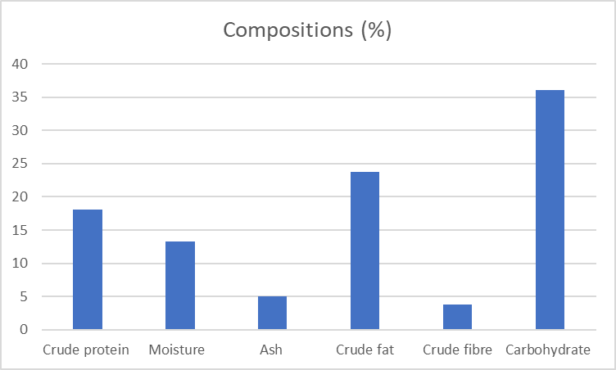
Fig 1: Composition (%) of Nutrient Content
4.2 Phytochemical Analysis
The phytochemical analysis shows a diverse range of concentrations among the compounds. Hesperidin, Gallocatechin, Epicatechin, and Naringin exhibit the highest concentrations, indicating their potential dominant presence in the sample. Compounds such as Artemetin, Apigenin, Genistein, and Silymarin are present in moderate amounts, while Ellagic acid, Retusin, Isorhamnetin, and Apigenin are notably absent.

Table 2 Phytochemical Content of Eupatorium odoratum
Phytochemicals | Concentration (ppm)
Artemetin | 2.71852
Ellagic acid | 0.00000
Retusin | 0.00000
Naringenin | 0.33692
Vanillic | 0.29927
Apigenin | 2.10073
Hesperidin | 1.38139
Isorhamnetin | 0.00000
Maricetin | 0.38775
Epicatechin | 0.00000
Daidzein | 0.34652
Genistein | 2.28520
Apigenin | 0.00000
Reveratrol | 0.44023
Lunamarin | 1.24481
Gallocatechin | 12.66056
Epicatechin | 14.97124
Naringin | 12.58438
Hesperidin | 17.07985
Silymarin | 2.71710

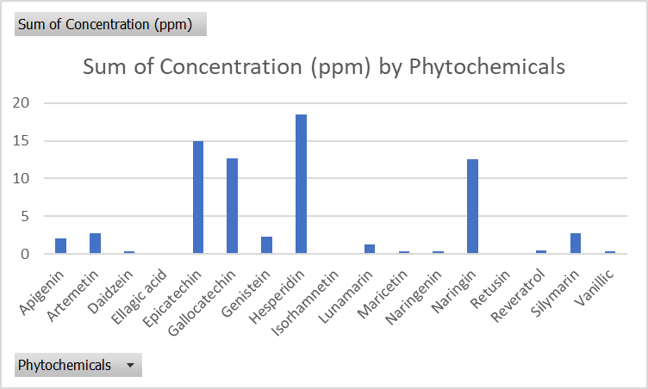
Fig 2: Sum of concentration (ppm) by Phytochemicals
4.3 Nitric Oxide Scavenging Activity
The nitric oxide scavenging activity of Eupatorium Odoratum increases from 2.601µg/ml at 10 mg/ml to 2.419µg/ml at 80 mg/ml but slightly decreases to 2.339µg/ml at 20 mg/ml. In comparison, gallic acid shows a stronger scavenging effect, starting at 1.794µg/ml at 10 mg/ml and significantly increasing to 5.565µg/ml at 80 mg/ml. This indicates that Eupatorium odoratum has activity in scavenging nitric oxide, especially at higher concentrations.
Table 3 Nitric Oxide Scavenging Activity
Concentration of extract | Eupatorium Odoratum concentration (ug/ml) | Gallic acid concentration (ug/ml)
10mg/ ml | 2.601 | 1.794
20mg/ml | 2.339 | 3.327
40mg/ml | 2.177 | 4.778
80mg/ml | 2.419 | 5.565

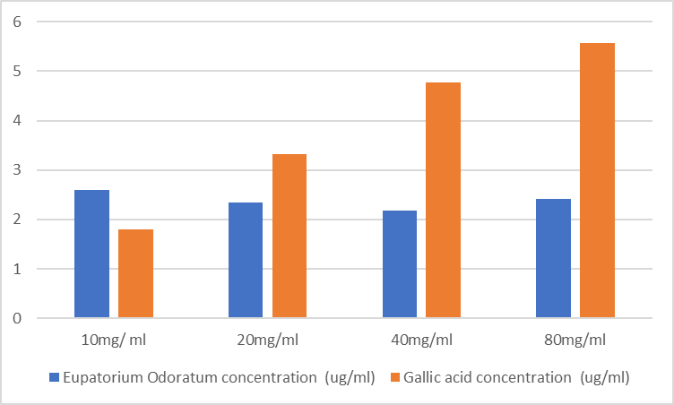
Fig 3: Nitric Oxide Scavenging Activity for the Concentration (ug/ml) of Eupatorium odoratum and Gallic acid
4.4 ABTS Scavenging Activity
Eupatorium Odoratum demonstrates an increase in ABTS scavenging activity from 76.167% at 10 mg/ml to 78.500% at 40 mg/ml, then decreases at 75.167% at 80 mg/ml. Gallic acid consistently shows higher scavenging activity, ranging from 77.611% at 10 mg/ml to 80.944% at 80 mg/ml. Eupatorium Odoratum indicate its potent in scavenging ABTS radicals especially at higher concentration.
Table 4 ABTS Scavenging Activity
Concentration of extract | Eupatorium Odoratum concentration (ug/ml) | Gallic acid concentration (ug/ml)
10mg/ ml | 76.167 | 76.167
20mg/ml | 77.667 | 78.667
40mg/ml | 78.500 | 80.500
80mg/ml | 75.167 | 80.500

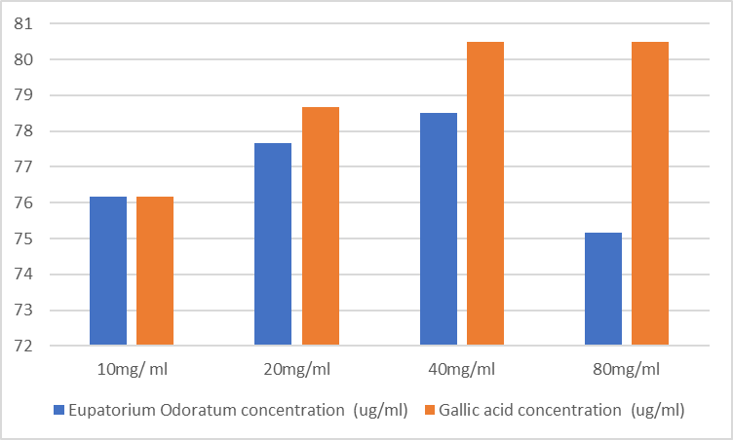

Fig 4: ABTS Scavenging Activity for the Concentration (ug/ml) of Eupatorium odoratum and Gallic acid

4.5 Hydroxyl Radical Scavenging Activity
The hydroxyl radical scavenging activity of Eupatorium odoratum increases from 60.674% at 10 mg/ml to 66.479% at 20 mg/ml, then decreases from 61.423% at 60 mg/ml to 62.734 at 80 mg/ml. Gallic acid shows more scavenging activity, starting at 60.294% at 10 mg/ml and increasing to 76.471% at 80 mg/ml. This data suggests that Eupatorium Odoratum has activity but Gallic acid is more effective in scavenging hydroxyl radicals, particularly at higher concentrations.
Table 5 Hydroxyl Radical Scavenging Activity
Concentration of extract | Eupatorium Odoratum concentration (ug/ml) | Gallic acid concentration (ug/ml)
10mg/ ml | 60.674 | 60.294
20mg/ml | 66.479 | 68.199
40mg/ml | 61.423 | 69.669
80mg/ml | 62.734 | 76.471

4.6 DPPH Scavenging Activity
Eupatorium Odoratum exhibits high DPPH scavenging activity, with values ranging from 92.893% at 10 mg/ml to 93.844% at 80 mg/ml, and then slightly decreasing to 92.804% at 20 mg/ml. However, Eupatorium Odoratum sample concentration is lower than the reference compound BHT which has a scavenging activity of 98.501% at high concentration. This indicates that Eupatorium Odoratum is potent but less effective than BHT in scavenging DPPH radicals.
Table 6 DPPH Scavenging Activity
Concentration of extract | Eupatorium Odoratum % scavenging activity
10mg/ ml | 92.893
20mg/ml | 92.804
40mg/ml | 92.982
80mg/ml | 93.844
Reference (BHT) BH | 98.501

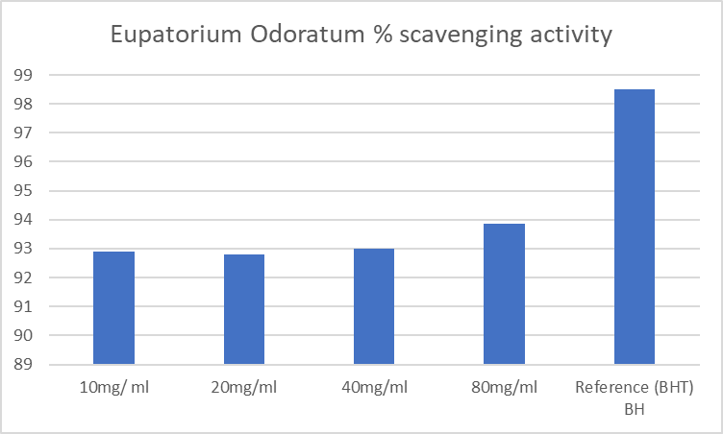

Fig 5: Eupatorium Odoratum % scavenging activity

4.7 FRAP inhibition
Eupatorium Odoratum shows increasing FRAP inhibition from 44.094% at 10 mg/ml to 70.341% at 40 mg/ml. Gallic acid also shows higher inhibition ranging from 77.671% at 10 mg/ml to 84.938% at 40 mg/ml, and slightly decreasing to 84.151% at 80 mg/ml. This indicates that Eupatorium Odoratum has FRAP inhibitory effect but not stronger than gallic acid, particularly at higher concentrations.
Table 7 FRAP inhibition
Concentration of extract | Eupatorium Odoratum % inhibition | Gallic acid % inhibition
10mg/ ml | 44.094 | 79.527
20mg/ml | 51.968 | 80.577
40mg/ml | 60.630 | 85.564
80mg/ml | 70.341 | 84.514

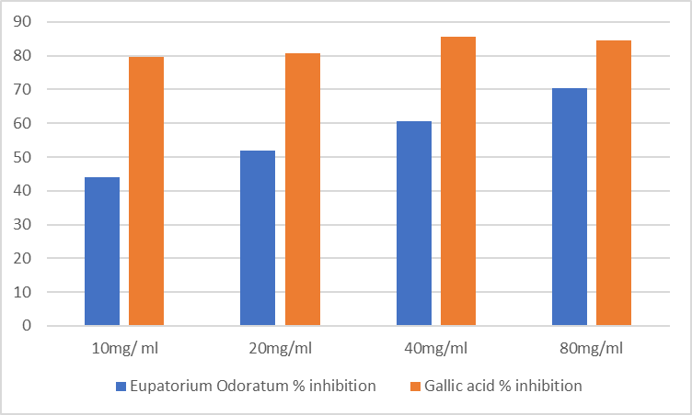
Fig 6: FRAP inhibition (%) of Eupatorium Odoratum and Gallic acid

5. Discussion
This study evaluated the proximate and phytochemical composition of Eupatorium odoratum as well as the antioxidant properties, in order to elucidate its nutritional profile, bioactive constituents, and potential health and therapeutic benefits. The proximate analysis demonstrated that crude protein accounted for 18.1% of the sample. Protein is fundamental to tissue repair, enzyme synthesis, muscle development, and immune function, as it supplies essential amino acids required for numerous physiological processes (Kelly & Pearce, 2020). The moisture content was 13.233%, a level that is particularly relevant to shelf life and vulnerability to microbial spoilage. Reduced moisture content is associated with limited microbial growth and improved storage stability (Chen et al., 2018). Ash content, an indicator of total mineral composition and an important contributor to bone health, fluid regulation, and enzymatic activity (Momoh et al., 2024), was recorded at 5.027%. Crude fat constituted 23.738% of the sample, indicating a relatively high lipid content. Dietary fats are essential for energy provision, maintenance of cell membrane integrity, and absorption of fat-soluble vitamins (Stevens, 2021)). Crude fibre content was 3.835%, underscoring its role in promoting digestive health and reducing the risk of constipation and certain chronic diseases (Oyegoke et al., 2024). Carbohydrates represented the largest proportion at 36.067%, highlighting their role as the primary energy source for metabolic processes, particularly brain and muscle activity (Arshad et al., 2025). Phytochemical screening revealed the presence of several bioactive compounds with established health-promoting properties. Phytochemicals are naturally occurring plant metabolites known for their diverse biological activities. Hesperidin was present at the highest concentration (17.07985 ppm) and is recognized for its antioxidant, anti-inflammatory, and antiviral effects (Zhang et al., 2024). Other notable compounds included gallocatechin (12.66056 ppm) and epicatechin (14.97124 ppm), both flavonoids associated with the reduction of oxidative damage and enhancement of cardiovascular health (Yang et al., 2001). Naringin (12.58438 ppm), a flavanone glycoside, has been reported to exhibit anti-carcinogenic and neuroprotective properties (Cirmi et al., 2016). The appreciable levels of these phytochemicals suggest significant therapeutic potential, particularly in the management of oxidative stress and its associated disorders.
Antioxidants function by scavenging and neutralizing free radicals (Salkadi, 2020). Free radicals are unstable molecules generated as a result of environmental exposure and physiological stress (Chaudhary et al., 2023). When inadequately neutralized, they induce oxidative stress, leading to cellular damage and disruption of normal physiological functions (Pizzino et al., 2017). Oxidative stress has been linked to the pathogenesis of numerous conditions, including cancer, arthritis, stroke, respiratory disorders, immune deficiencies, and other inflammatory or ischemic diseases, primarily through antioxidant enzyme inactivation and damage to essential cellular components (Jomova et al., 2023). Consequently, diets rich in antioxidants have been shown to lower the risk of chronic diseases such as cardiovascular disorders and certain cancers by mitigating oxidative damage (Ayoka et al., 2022). Eupatorium odoratum, has a long history of use in traditional medicine, and recent investigations have confirmed its notable antioxidant potential (Tiamiyu & Okunlade, 2020).
The antioxidant assays conducted in this study revealed that E. odoratum exhibits nitric oxide scavenging activity, particularly at higher extract concentrations, and displays moderate overall antioxidant capacity. Its ferric reducing antioxidant power (FRAP) showed a dose-dependent increase but remained lower than that of gallic acid. Similarly, the synthetic antioxidant butylated hydroxytoluene (BHT) demonstrated stronger scavenging activity than the plant extract. These results indicate that while E. odoratum is less potent than standard reference antioxidants, it nonetheless possesses considerable natural antioxidant activity, especially when applied at higher concentrations. Comparable findings have been reported in earlier studies, which noted that E. odoratum exhibits antioxidant effects but is generally less effective than gallic acid (Razzivina et al., 2024), and that synthetic antioxidants such as BHT often outperform natural plant extracts. The observed dose-dependent FRAP response is also consistent with reports on other naturally derived compounds.
This study provides meaningful insight into the nutritional composition, phytochemical profile, and antioxidant properties of Eupatorium odoratum. The findings support its potential application as a natural antioxidant source while underscoring the importance of comparative evaluations between natural extracts and synthetic antioxidants in determining efficacy.
6. Conclusion
Eupatorium odoratum demonstrates significant nutritional and antioxidant potential, characterized by high carbohydrate and crude fat contents, moderate protein levels, low moisture. The plant contains important bioactive phytochemicals, notably hesperidin, gallocatechin, epicatechin, and naringin, which are associated with antioxidant and health-protective effects. Antioxidant assays confirmed its ability to scavenge multiple free radicals in a concentration-dependent manner, although its activity was lower than standard antioxidants. The findings support the plant’s traditional medicinal use and highlight its potential as a natural source of antioxidants.
7. References
Ali-Seyed, M., & Vijayaraghavan, K. (2019). Nutraceuticals for wound healing: a special focus on Chromolaena odorata as guardian of health with broad spectrum of biological activities. In R. C. Gupta, A. Srivastava, & R. Lall (Eds.), Nutraceuticals in Veterinary Medicine (pp. 541-562). Springer International Publishing. https://doi.org/10.1007/978-3-030-04624-8_36
Alkadi, H. (2020). A review on free radicals and antioxidants. Infectious Disorders-Drug Targets, 20(1), 16-26. https://doi.org/10.2174/1871526518666180628124323
AOAC International. (1990). *Official methods of analysis* (15th ed.). Arlington, VA: Author.
Arshad, M. T., Maqsood, S., Altalhi, R., Shamlan, G., Mohamed Ahmed, I. A., Ikram, A., & Abdullahi, M. A. (2025). Role of Dietary Carbohydrates in Cognitive Function: A Review. Food Science & Nutrition, 13(7), e70516. https://doi.org/10.1002/fsn3.70516
Ayoka, T. O., Ezema, B. O., Eze, C. N., & Nnadi, C. O. (2022). Antioxidants for the Prevention and Treatment of Non-communicable Diseases. Journal of Exploratory Research in Pharmacology, 7(3), 179-189. https://doi.org/10.14218/JERP.2022.00028
Chaudhary, P., Janmeda, P., Docea, A. O., Yeskaliyeva, B., Abdull Razis, A. F., Modu, B., Calina, D., & Sharifi-Rad, J. (2023). Oxidative stress, free radicals and antioxidants: potential crosstalk in the pathophysiology of human diseases. Frontiers in Chemistry, 11, 1158198. https://doi.org/10.3389/fchem.2023.1158198
Chen, Y. C., Hsu, Y. C., & Wang, C. T. (2018). Effects of storage environment on the moisture content and microbial growth of food waste. Journal of Environmental Management, 214, 192-196. https://doi.org/10.1016/j.jenvman.2018.03.009
Cirmi, S., Ferlazzo, N., Lombardo, G. E., Maugeri, A., Calapai, G., Gangemi, S., & Navarra, M. (2016). Neurodegenerative diseases: Might citrus flavonoids play a protective role? Molecules, 21(10), 1312. https://doi.org/10.3390/molecules21101312
Dar, R. A., Shahnawaz, M., Ahanger, M. A., & Majid, I. U. (2023). Exploring the diverse bioactive compounds from medicinal plants: a review. Journal of Phytopharmacology, 12(3), 189-195. https://doi.org/10.31254/phyto.2023.12307
Garuba, T., Mustapha, O. T., & Oyeyiola, G. P. (2018). Shelf life and proximate composition of tomato (Solanum lycopersicum L.) fruits as influenced by storage methods. Ceylon Journal of Science, 47(4). https://doi.org/10.4038/cjs.v47i4.7557
Jomova, K., Raptova, R., Alomar, S. Y., Alwasel, S. H., Nepovimova, E., Kuca, K., & Valko, M. (2023). Reactive oxygen species, toxicity, oxidative stress, and antioxidants: chronic diseases and aging. Archives of Toxicology, 97(10), 2499-2574. https://doi.org/10.1007/s00204-023-03562-9
Kelly, B., & Pearce, E. L. (2020). Amino Assets: How Amino Acids Support Immunity. Cell Metabolism, 32(2), 154-175. https://doi.org/10.1016/j.cmet.2020.06.010
Li, Y. O., & Komarek, A. R. (2017). Dietary fibre basics: Health, nutrition, analysis, and applications. Food Quality and Safety. https://doi.org/10.1093/fqs/fyx007
Mensor, L. L., Menezes, F. S., Leitão, G. G., Reis, A. S., Santos, T. C. D., Coube, C. S., & Leitão, S. G. (2001). Screening of Brazilian plant extracts for antioxidant activity by the use of DPPH free radical method. Phytotherapy Research. https://doi.org/10.1002/ptr.687
Momoh, T. B., Appah, J., Onwumere, G. B., & Dan, V. M. Y. (2024). Assessment of phytochemical, mineral and proximate contents of African black night shade (Solanum nigrum) used for bone fracture treatment by traditional bone healers in Ogodo, Ankpa Kogi State, Nigeria. Journal of Applied Sciences and Environmental Management, 28(11B Supplementary), 3917-3922. https://www.ajol.info/index.php/jasem
Oraka, C. O., & Okoye, J. I. (2017). Effect of heat processing treatments on the nutrient and anti-nutrient contents of lima bean (Phaseolus lunatus) flour. International Journal of Food Science and Nutrition, 2(3), 13-17. https://www.foodsciencejournal.com/archives/2017/vol2/issue3/2-3-13-17.pdf
Okigbo, R. N., Anuagasi, C. L., & Amadi, J. E. (2009). Advances in selected medicinal and aromatic plants indigenous to Africa. Journal of Medicinal Plants Research, 3(2), 86-95. http://www.academicjournals.org/JMPR
Oyegoke, R. A., Oladele, J. O., Oladele, O. T., & Oladiji, A. T. (2024). Role of Dietary Fibre and Phytonutrients in Human Health and Nutrition. In A. T. Oladiji (Ed.), Nutrition and Diet in Health: Principles and Applications (pp. 121-147). CRC Press. https://doi.org/10.1201/9781003361497-12
Pizzino, G., Irrera, N., Cucinotta, M., Pallio, G., Mannino, F., Arcoraci, V., Squadrito, F., Altavilla, D., & Bitto, A. (2017). Oxidative stress: Harms and benefits for human health. Oxidative Medicine and Cellular Longevity. https://doi.org/10.1155/2017/8416763
Pulido, R., Bravo, L., & Saura-Calixto, F. (2000). Antioxidant activity of dietary polyphenols as determined by a modified ferric reducing/antioxidant power assay. Journal of Agricultural and Food Chemistry, 48(8), 3396-3402. https://doi.org/10.1021/jf9913458
Razzivina, V., Vasiljeva, A., Kronberga, A., Skudrins, G., Nakurte, I., Zogota, M., Mezaka, I., Pugovics, O., Grinberga, S., Dambrova, M., & Sile, I. (2024). Phenolic Content and Anti-Inflammatory Activity of Cultivated and Wild-Type Galium odoratum Extracts in Murine Bone Marrow-Derived Macrophages. Antioxidants, 13(12), 1447. https://doi.org/10.3390/antiox13121447
Samarin, S., & Nusrat, A. (2009). Regulation of epithelial apical junctional complex by Rho family GTPases. Frontiers in Bioscience (Landmark Edition), 14(3), 1129–1142. https://doi.org/10.2741/3298
Sharifi-Rad, M., Anil Kumar, N. V., Zucca, P., Varoni, E. M., Dini, L., Panzarini, E., Rajkovic, J., Tsouh Fokou, P. V., Azzini, E., Peluso, I., Mishra, A. P., Nigam, M., El Rayess, Y., El Beyrouthy, M., Polito, L., Iriti, M., Martins, N., Martorell, M., Docea, A. O., Setzer, W. N., Calina, D., Cho, W. C., & Sharifi-Rad, J. (2020). Lifestyle, oxidative stress, and antioxidants: back and forth in the pathophysiology of chronic diseases. Frontiers in Physiology, 11, 694. https://doi.org/10.3389/fphys.2020.00694
Stevens, S. L. (2021). Fat-soluble vitamins. Nursing Clinics of North America, 56(1), 33-45. https://doi.org/10.1016/j.cnur.2020.10.003
Tiamiyu, A. M., & Okunlade, O. A. (2020). Benefits and detriments of Siam weed (Chromolaena odorata): A review. Biochemistry and Biotechnology Research, 8(2), 21-28. https://netjournals.org/journals/BBR/BBR_Abstract/2020/14_08_20/Tiamiyu_and_Okunlade.php
Uzor, P. F. (2020). Alkaloids from plants with antimalarial activity: A review of recent studies. Evidence-Based Complementary and Alternative Medicine. https://doi.org/10.1155/2020/8749083
Vijayaraghavan, K., Rajkumar, J., Bukhari, S. N. A., Al-Sayed, B., & Seyed, M. A. (2017). Chromolaena odorata: A neglected weed with a wide spectrum of pharmacological activities (Review). Molecular Medicine Reports, 15(3), 1007-1016. https://doi.org/10.3892/mmr.2017.6133
Yang, C. S., Landau, J. M., Huang, M. T., & Newmark, H. L. (2001). Inhibition of carcinogenesis by dietary polyphenolic compounds. Annual Review of Nutrition, 21(1), 381-406. https://doi.org/10.1146/annurev.nutr.21.1.381

Zhang, P., Zhang, S., Hu, H., Hu, T., Shi, K., Xu, Y., Xu, G., Hu, H., & Pan, S. (2024). Synthesis and evaluation of novel hesperidin selenium-enriched derivatives as potential anti-inflammatory and antioxidant agents. Food Bioscience, 58, 103651. https://doi.org/10.1016/j.fbio.2024.103651

