Original Research Article
Extraction and Characterization of Oils from Cussonia bateri (Jansa) and Chrysobalanus icaco (Omillo) Seeds

.
ABSTRACT
Aims: To extract and characterize oils obtained from Cussonia bateri (Jansa) and Chrysobalanus icaco (Omillo) seeds.
Place and Duration of Study: Biochem Analytics Laboratory, Enugu, June 2024 to June 2025.
Study design: Mention the design of the study here.
Methodology: The oils were extracted using the Soxhlet method with n-hexane as solvent and characterized for key physicochemical properties including oil yield, density, viscosity, acid value, saponification value, iodine value, and moisture content. Fourier Transform Infrared (FTIR) spectroscopy, Gas Chromatography–Mass Spectrometry (GC–MS), were employed to determine functional groups and chemical composition.
Results: The results revealed that Jansa seeds yielded significantly more oil (50.21%) than Omillo seeds (10.77%). FTIR spectroscopy confirmed the presence of key functional groups—O–H, C=O, and C–H vibrations—commonly found in triglycerides and fatty acid esters. These spectral features were consistent with GC–MS results, which identified fatty acid methyl esters and aliphatic compounds as the dominant constituents in both oils.

Keywords: Jansa oil, Omillo oil, physicochemical characterization, GC–MS, FTIR

1. INTRODUCTION

The growing demand for plant-derived oils has spurred research into alternative, underutilized botanical sources beyond conventional edible oils. This demand is intensified by the expanding applications of vegetable oils in food, pharmaceutical formulations, cosmetics, surfactants, and biofuels. As global concern increases regarding the competition between food and industrial uses of edible oils, attention is turning toward non-edible and unconventional seeds as sustainable substitutes. In many developing regions, particularly in Africa, numerous oil-bearing seeds remain underexplored despite their traditional use by local communities.
Oil characteristics such as iodine value, saponification value, refractive index, density, and viscosity determine suitability for nutritional, industrial, or cosmetic purposes. Comprehensive characterization using Fourier-transform infrared (FTIR) spectroscopy and Gas Chromatography–Mass Spectrometry (GC–MS) has become essential for identifying functional groups, determining molecular structures, and profiling fatty acids in seed oils. However, scientific information on Jansa and Omillo seeds remains non-existent despite their availability. This study seeks to address this gap by evaluating the physicochemical, FTIR, and GC–MS characteristics of oils extracted from these two seeds.
A broad range of studies have investigated the physicochemical and fatty acid properties of both edible and non-edible seed oils. Abdul-Hammed et al. (2020) documented variations in viscosity, density, saponification values, and iodine values among refined vegetable oils, highlighting the influence of refining and processing techniques. Adejumo and Adekoya (2023) analyzed Telfairia occidentalis seed oil and reported nutritionally rich fatty acids and antioxidant capacity, demonstrating the value of indigenous seeds.
Temperature-dependent behaviour of oils has also been widely studied. Ado et al. (2025) reported that the properties of Helianthus annuus and Sesamum indicum oils vary significantly with temperature, indicating the sensitivity of seed lipids to processing conditions. Moringa seed oil, widely compared with olive oil, has been characterized by various researchers (Ajab et al., 2024; Anwar & Rashid, 2007), who noted excellent oxidative stability and favourable fatty acid compositions.
Aremu et al. (2015) reviewed physicochemical profiles of Nigerian plant seed oils, highlighting their high saponification values and moderate unsaturation. Interesterified vegetable oils have been shown to exhibit enhanced functional properties (Aslam et al., 2021), demonstrating how chemical modification can improve industrial applicability.
Recent studies continue to expand the characterization of less-common seeds. Cervera Chiner et al. (2024) studied Moringa seed oils and reported saponification values of 187–219 mg KOH/g and iodine values of 67–85 g I₂/100 g. Eze et al. (2025) characterized Calliandra surinamensis seed oil and confirmed moderate unsaturation. Ichu and Nwakanma (2019) provided broad ranges for saponification values (5.58–249.90 mg KOH/g) and refractive indices (1.4578–1.4773) across several edible-oil brands.
Other notable studies include analyses of African elemi fruit (Kiin Kabari et al., 2020), sunflower oil (Oguche, 2021), underutilized seeds (Owheruo et al., 2024), and common edible seeds (Moshood et al., 2022). Muhammad et al. (2023) characterized four indigenous oils and reported densities of 1.021–1.029 kg/m³ and saponification values between 140.25 and 155.68 mg KOH/g. Additional investigations on Khaya senegalensis (Oginni et al., 2024), Neocarya macrophylla (Rufai et al., 2023), Strychnos pungens (Zimudzi & Zharare, 2024), and other underutilized seeds (Za’aku et al., 2024; Popoola & Haruna, 2024) reinforce the growing interest in alternative seed oils.
Despite extensive research on many plant seeds, no studies have reported on the physicochemical or chemical properties of Jansa and Omillo seed oils, indicating a significant research gap this study aims to fill.

2. material and methods

2.1 Materials
All reagents used were of analytical grade. Equipment employed included a Soxhlet extractor, hot air oven, viscometer, FTIR spectrometer, digital balance, refractometer, muffle furnace, and GC–MS analyser. Glassware used were Pyrex products.
2.2 Sample Collection and Preparation
Raw seeds of Cussonia bateri (Jansa) and Chrysobalanus icaco (Omillo) were obtained from local markets in Enugu, Nigeria. The seeds were sun-dried, ground with an industrial blender, and sieved through a 500 µm mesh. The processed samples were stored in airtight containers and transported to the Biochem Analytics Laboratory, Enugu, for analysis.
2.3 Oil Extraction
Oil extraction was carried out using the Soxhlet apparatus with n-hexane as solvent. About 50 g of each powdered sample was loaded into the extraction thimble and refluxed for 6 hours at 45°C. The solvent was recovered using a rotary evaporator, and the extracted oil was dried at 105°C to remove residual moisture and stored in amber bottles.
The percentage oil yield was calculated using Equation (1):
$(\%)Oil yield=\frac{Weight of extracted oil}{Weight of seed sample}×100$
Physicochemical parameters were determined following AOAC (2016) protocols.
2.4 Characterization
FTIR spectra were recorded on a Shimadzu IRSpirit FTIR spectrometer with an ATR accessory over a wavenumber range of 4000–400 cm⁻¹, at a resolution of 4 cm⁻¹ with 32 scan accumulations
GC–MS analysis was conducted using an Agilent 7890A gas chromatograph coupled with a 5975C mass spectrometer, equipped with an HP-5MS capillary column (30 m × 0.25 mm × 0.25 µm) and helium as the carrier gas at 1.0 mL/min; a 1 µL splitless injection was performed, with the oven temperature programmed from 50 °C (2 min) to 300 °C at 10 °C/min, and compounds were identified by matching mass spectra to the NIST library.

3. results and discussion

3.1 Physicochemical Characterization
The key physical and chemical properties of the extracted oils are summarized in Table 1, alongside benchmark values from similar non-edible oils found in literature. With an oil yield of 50.21%, Jansa oil shows a notably high lipid content—well within the typical range of 20–55% for non-edible seed oils. This suggests that Cussonia bateri seeds could be a strong candidate for biodiesel production, especially since they don’t compete with food-grade oil sources.
Refractive Index (RI):
The refractive index reflects oil purity and unsaturation. Jansa oil (1.5015) and Omillo oil (1.4892) fall within the typical range for vegetable oils (≈1.45–1.48), comparable to pumpkin, sesame, almond, sunflower, and Balanites aegyptiaca seed oils. Jansa’s slightly higher RI suggests greater unsaturation, consistent with its higher iodine value.
Viscosity (VS):
Jansa (152.63) and Omillo (147.82) oils exhibit viscosities higher than many common edible oils (pumpkin, sunflower, sesame), though lower than almond oil (302.39). Elevated viscosity is linked to longer-chain fatty acids and stronger intermolecular forces. While this may limit direct use as fuel, it enhances suitability for lubricants and cosmetic formulations.
Iodine Value (IV):
Both oils—Jansa (102.11 g I₂/100 g) and Omillo (98.34 g I₂/100 g)—are classified as semi-drying, similar to groundnut, sunflower, sesame, and Khaya senegalensis seed oils. Their IVs exceed those of coconut and melon seed oils but remain below highly unsaturated oils like moringa (155). This indicates moderate oxidative susceptibility and versatility for edible and industrial uses.
Saponification Value (SV):
Jansa (238.74 mg KOH/g) and Omillo (232.65 mg KOH/g) show relatively high saponification values, pointing to shorter-chain fatty acids. These values, comparable to jatropha and cashew nut oils, highlight their potential in soap, shampoo, and cosmetic production.
Acid Value (AV) & Free Fatty Acids (FFA):
Jansa (AV = 11.11 mg KOH/g; FFA = 5.56%) and Omillo (AV = 9.87 mg KOH/g; FFA = 4.92%) record higher levels than refined edible oils such as sunflower and sesame, but are similar to castor and jatropha oils. These elevated values suggest refining is necessary for edible use, though they remain acceptable for industrial applications, particularly biodiesel after esterification.
Density (Ds)
The densities of Jansa (0.905 g/cm³) and Omillo (0.912 g/cm³) align with typical vegetable oils (0.88–0.93 g/cm³), ensuring compatibility with existing processing systems.
Jansa and Omillo oils demonstrate favorable physicochemical characteristics compared to established seed oils. Their moderate unsaturation, high saponification values, and appropriate density highlight strong potential for industrial and biofuel applications. However, their relatively high acid and FFA levels necessitate refining before edible use. Collectively, these findings position Jansa and Omillo oils as promising non-conventional oil resources with significant application prospects

Plant Seed / Family | RI | SG | VS | IV | SV | PV | AV | Ds | FFA | EV | Reference
Jansa Oil | 1.5015 |  | 152.63 | 102.11 | 238.74 |  | 11.11 | 0.905 | 5.56 |  | This study
Omillo Oil | 1.4892 |  | 147.82 | 98.34 | 232.65 |  | 9.87 | 0.912 | 4.92 |  | This study
Castor seed oil (Ricinus communis) | 1.792 | – | 0.43 | 58.64 | 180.77 | 158.64 | 14.8 | 0.948 | 7.4 | 165.97 | Nangbes et al., (2013)
Pumpkin seed oil (Telfairia occidentalis) | 1.461 | 0.928 | 44.7 | 15.8 | 187 | – | 62.6 | – | 31.49ᵃ | 124.4 | Bwade et al., 2013
Pumpkin seed oil (Telfairia occidentalis) | 1.476 | 0.911 | 119 | 123.83 | 162.69 | – | 4.77 | 0.911 | 2.40ᵃ | 157.92 | Nwabanne, 2012
Cashew nut seed oil (Anacardium occidentale) | 1.42 | 0.906 | – | 50.61 | 212 | 10.58 | 2.24 | 0.91 | 2.24 | 209.76 | Aremu & Akinwumi, 2014
Jatropha seed oil (Jatropha curcas L.) | – | 0.896 | 76.18 | 26.09 | 230.71 | 44 | 23.87 | 0.881 | 11.94 | 206.84 | Belewu et al., 2010
Sesame seed oil (Sesamum indicum L.) | 1.464 | 0.928 | – | 106 | 189.54 | 1.8 | 0.49 | – | 0.25ᵃ | 189.05 | Njoku et al., 2010
Almond seed oil (Prunus amygdalus) | 1.46 | – | 302.39 | 12.46 | 151.55 | 2.25 | 40.14 | 0.91 | 20.05 | 111.41 | Ogunsuyi & Daramola, 2013
Groundnut seed oil (Arachis hypogaea) | 0.147 | – | – | 100.7 | 170 | 0.47 | 2.52 | – | 1.26 | 167.48 | Ayoola & Adeyeye (2010)
Melon seed oil (Cucurbitaceae) | 1.47 | 1.51 | – | 3.45 | 8 | 1.72 | 8.02 | – | 4.03ᵃ | – | Akpambang et al., (2008)
Helianthus annuus | – | 0.912 | 41.6 | 104.57 | 188.64 | 8.36 | 1.8 | – | – | – | Ado et al., (2025)
Sesamum indicum | – | 0.825 | 32.7 | 106.59 | 201.68 | 8.75 | 1.68 | – | – | – | Ado et al., (2025)
Sunflower | 1.475 | 0.9211 | – | 118.01 | 190.37 | – | 0.14 | – | – | – | Khairuddin et al., (2024)
C.schweinfurthii pulp, | 1.46 | – | – | 67.25 | 155.68 | – | 1.22 | – | – | – | Muhammad et al., (2023)
B.aegyptiaca seeds | 1.46 | – | – | 96.44 | 147.26 | – | 0.75 | – | – | – | Muhammad et al., (2023)
Sesamum indicum seeds | 1.47 | – | – | 74.87 | 143.06 | – | 2.72 | – | – | – | Muhammad et al., (2023)
Cocos nucifera | 1.45 | – | – | 39.97 | 140.25 | – | 1.12 | – | – | – | Muhammad et al., (2023)
K.senegalensis seed | 1.462 | 0.9194 | – | 102.79 | 191.76 | 6.83 | 1.18 | – | – | – | Oginni et al., (2024)
C surinamensis | 1.2667 | 0.8973 | 5.8 | 101.14 | 158.95 | 7.72 | 10.9 | – | – | – | Eze et al., (2025)
Moringa oleifera Seed | – | – | – | 155 | 198 | – | 4.11 | – | – | – | Cervera-Chiner et al., (2024)
Table 1: Physicochemical properties of the Jansa and Omillo seeds and some selected seed oils

3.3 FTIR Spectroscopic Analysis
The FTIR spectra of Jansa and Omillo seed oils (Fig 1a and 1b) offer a fascinating glimpse into their molecular makeup, revealing the presence of functional groups commonly found in triglycerides and fatty acids. Both oils share a similar chemical backbone, as shown by their overlapping major absorption bands. However, subtle differences in peak intensity and sharpness hint at variations in composition and structure.
In the Jansa oil spectrum, a broad band around 3011.7 cm⁻¹ signals the presence of hydroxyl groups—likely from free fatty acids or glycerol. Strong peaks at 2922.0 cm⁻¹ and 2855.1 cm⁻¹ correspond to C–H stretching vibrations from –CH₂ and –CH₃ groups, confirming the long hydrocarbon chains typical of triglycerides. A sharp, prominent peak at 1744.4 cm⁻¹ marks the C=O stretch of ester carbonyl groups, a clear indicator of fatty acid esters. Additional bands at 1463.8 cm⁻¹ and 1376.1 cm⁻¹ reflect C–H bending, while signals between 1160 and 1030 cm⁻¹ point to C–O stretching—both consistent with ester linkages. Minor peaks between 870 and 720 cm⁻¹ suggest the presence of cis-alkene structures, common in unsaturated fatty acids.
Omillo oil shows a similar spectral profile, with strong absorption bands at 3473.9 cm⁻¹ (O–H stretch), 2922.2 cm⁻¹ and 2855.1 cm⁻¹ (C–H stretch), and 1744.4 cm⁻¹ (C=O stretch), confirming its triglyceride nature. However, the O–H band in Omillo is broader and more intense, indicating a higher concentration of free hydroxyl groups or moisture—consistent with its slightly elevated moisture content (0.94%) and acid value (15.46 mg KOH/g) compared to Jansa. Peaks between 1461.1 cm⁻¹ and 1155.5 cm⁻¹ reflect C–H bending and C–O stretching, while weaker bands near 872.2 cm⁻¹ confirm the presence of unsaturated fatty acids like oleic and linoleic acids.
When viewed side by side, both oils clearly contain the essential functional groups—C–H, C=O, and C–O—typical of natural triglyceride oils. Jansa oil, however, shows slightly sharper and more defined carbonyl and alkyl peaks, suggesting a higher concentration of esterified fatty acids. Omillo oil, on the other hand, displays a more pronounced O–H region, pointing to greater free fatty acid content or partial triglyceride breakdown.
These spectral differences align well with the physicochemical and GC–MS data: Jansa oil is richer in long-chain unsaturated esters like oleic acid and glycerol derivatives, while Omillo oil contains more free fatty acids and polar compounds. Ultimately, both oils demonstrate strong potential as non-edible feedstocks for biodiesel and other industrial applications, thanks to their rich ester content and functional group diversity.
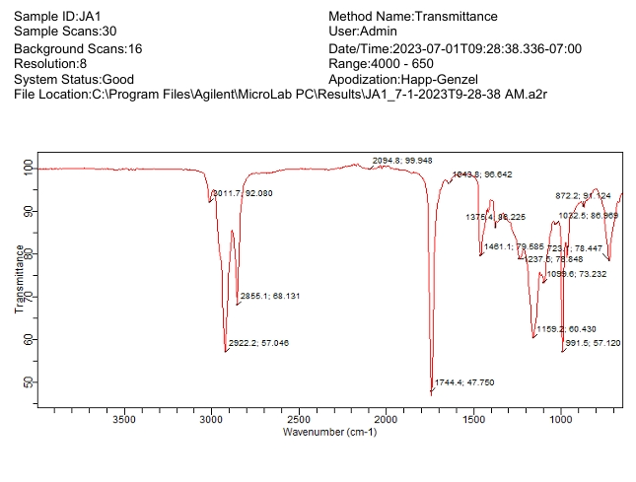
Fig 1a: FTIR spectrum of Jansa seed oil

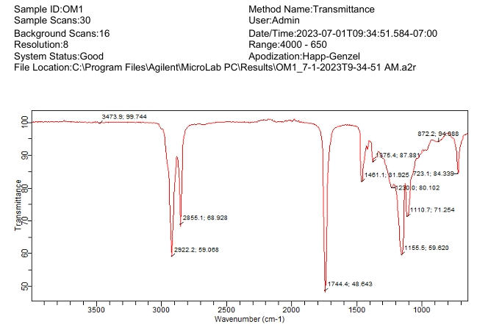
Fig 1b: FTIR spectrum of Omillo seed oil

Table 2. Comparative FTIR Peak Assignments for Jansa and Omillo Seed Oils
Wavenumber (cm⁻¹) | Jansa Oil | Omillo Oil | Functional Group Assignment
3473.9 – 3011.7 | 3011.7 | 3473.9 | O–H stretching vibration
2922.0 – 2855.1 | 2922.0, 2855.1 | 2922.2, 2855.1 | Asymmetric and symmetric C–H stretching
1744.4 | 1744.4 | 1744.4 | C=O stretching vibration
1463.8 – 1376.1 | 1463.8, 1376.1 | 1461.1 | C–H bending (scissoring/deformation)
1237.8 – 1160.2 | 1237.8, 1160.2 | 1155.5 | C–O stretching vibration
1115.2 – 991.5 | 1115.2, 991.5 | 1110.7 | C–O–C stretching / C–C skeletal vibration
872.2 – 720.1 | 872.2, 723.1 | 872.2, 723.1 | =C–H out-of-plane bending
601.1 – 500 | 601.1 (weak) | — | C–H rocking or fingerprint region

3.4 GC–MS Analysis
The GC–MS analysis of Jansa seed oil reveals a rich and varied chemical profile, showcasing a blend of fatty acid derivatives, hydrocarbons, oxygenated compounds, and nitrogen-containing heterocycles (Table 3). Eighteen major peaks were identified, with oleic acid (8.77%), 9-octadecenoic acid (Z)-, 2,3-dihydroxypropyl ester (9.48%), and 2,3-dihydroxypropyl elaidate (8.93%) standing out as the most abundant. These compounds are typical of mono-unsaturated fatty acids and their glycerol esters—key ingredients in vegetable oils commonly used for biodiesel. Their presence suggests that Jansa oil offers desirable traits like strong lubricity, high energy content, and decent oxidative stability.
In smaller amounts, compounds like hexadecane (1.91%), 1-cyclohexylnonene (0.33%), and 5-octen-2-one, 3,6-dimethyl- (0.21%) point to the presence of hydrocarbons and oxygenated alkenones, likely formed through lipid breakdown or oxidation. Cyclobutanone oxime (2.99%) and succinic acid esters (0.72%) further hint at intermediate oxygenated products that may arise during seed lipid metabolism.
What’s particularly intriguing is the detection of several bioactive and heterocyclic compounds. These include thymol (TMS derivative, 13.23%), a 4H-1,2,4-triazole-3,5-diamine derivative (10.63%), and [1,2,4] triazolo[1,5-a] pyrimidine carboxylic acid ester (8.86%)—all known for their antioxidant and antimicrobial properties. The relatively high levels of methyl pentadecyl ether (12.45%) and cyclotrisiloxane, hexamethyl- (15.74%) suggest the oil contains long-chain ether and siloxane compounds, which may boost its resistance to oxidation and improve thermal stability.
The GC–MS analysis of Omillo seed oil (Figure 3) paints a vivid picture of its chemical makeup, revealing a rich mix of fatty acid methyl esters (FAMEs), hydrocarbons, esters, and oxygenated compounds (Table 4). In total, 27 major components were identified, spanning a broad spectrum of saturated, monounsaturated, and polyunsaturated fatty acids, along with a few aromatic and heterocyclic compounds. These compounds appeared at retention times ranging from 8.59 to 37.75 minutes, with relative abundance values between 0.12% and 22.76%.
Among the standout molecules were 2-Decenal (E) and Heptanoic acid methyl ester, both detected early in the chromatogram and making up over 22% each of the total composition. Their presence points to short- and medium-chain fatty acid derivatives, which are typically more volatile. As the retention times increased, long-chain fatty acid methyl esters began to dominate—particularly palmitic acid (RA = 50.21%), oleic acid (RA = 59.14%), and stearic acid (RA = 60.42%). These are hallmark components of lipid-rich feedstocks, reinforcing Omillo oil’s potential for industrial use.
Oleic acid and its isomers were especially prominent, showing up at multiple retention times and collectively accounting for more than 16% of the total peak area. This high concentration of monounsaturated fatty acids is a promising sign for biodiesel production, as it contributes to better oxidative stability and fuel fluidity.
Other noteworthy compounds—like cis-11-eicosenoic acid, 13-octadecenoic acid methyl ester, and cis-9-tetradecenoic acid heptyl ester—add to the oil’s lubricating properties and thermal resilience. The presence of esters such as dodecanoic acid, 1-(hydroxymethyl)-1,2-ethanediyl ester (RA = 13.74%) and fumaric acid, 2-heptyl tridecyl ester further highlights the oil’s reactivity, making it a strong candidate for soap and surfactant production.
A few minor compounds, including 2-ethylacridine, 1-cyclohexylnonene, and cyclohexene 1-nitro, suggest some degree of oxidation or degradation—common in natural seed oils during processing.
Taken together, the mix of saturated (like palmitic and stearic acids) and unsaturated fatty acids (such as oleic and eicosenoic acids) gives Omillo oil a balanced profile. This balance translates to moderate viscosity, reliable ignition quality, and improved cold-flow behaviour—key traits for biodiesel and lubricant applications. The detection of high molecular weight esters and oxygenated compounds, including nitrogen-containing species like [1,2,4] Triazolo[1,5-a] pyrimidine-6-carboxylic acid ethyl ester, hints at complex interactions within the seed’s biochemical matrix.
The GC–MS analysis of Jansa and Omillo seed oils reveals that both share key chemical constituents—most notably oleic acid and its glycerol esters—highlighting their triglyceride-rich nature and suitability for biodiesel production. However, Jansa oil stands out for its higher concentration of unsaturated esters, including oleic and elaidate derivatives. This composition contributes to its increased viscosity and higher refractive index; traits often associated with enhanced fuel performance.
In contrast, Omillo oil contains a greater proportion of saturated fatty acids, such as palmitic and stearic acids. These compounds lend the oil greater oxidative stability and lower viscosity, making it well-suited for applications where durability under heat and storage conditions is essential.
Both oils also feature phenolic compounds like thymol and heterocyclic structures such as triazole and triazolopyrimidine. These bioactive molecules suggest inherent antioxidant properties, which can help extend the shelf life of biodiesel derived from these oils.
In summary, Jansa oil—with its richness in unsaturated esters—is better positioned for producing high-quality biodiesel, while Omillo oil’s saturated profile makes it ideal for uses that demand oxidative resilience and thermal stability.
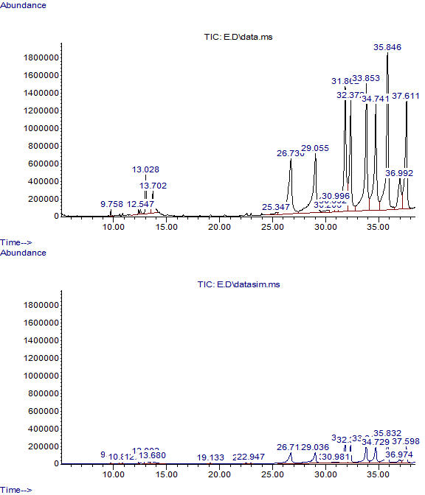
Fig 2a: Gas chromatogram of Jansa seed oil
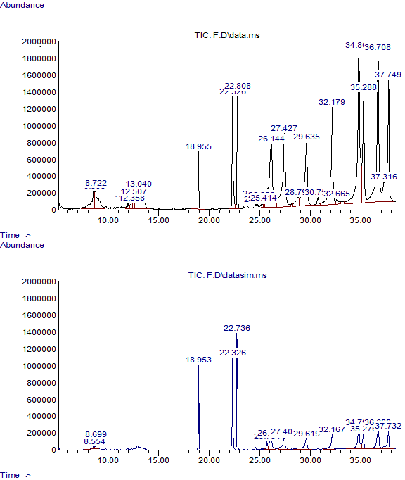
Fig 2b: Gas chromatogram of Omillo seed oil

Table 3: GC–MS identified chemical composition of Jansa seed oil
Peak | Retention Time | Area % | Identified Compounds
1 | 9.758 | 0.194 | 2,4-Nonadienal, (E,E)-
2 | 12.3768 | 0.1776 | 2-Cyclopenten-1-one, 3,4,4-trimethyl-
3 | 12.5472 | 0.2137 | 5-Octen-2-one, 3,6-dimethyl-
4 | 13.0284 | 2.9973 | Cyclobutanone, oxime
5 | 13.7019 | 1.9129 | Hexadecane
6 | 25.3468 | 0.3349 | 1-Cyclohexylnonene
7 | 26.7302 | 8.7667 | Oleic Acid
8 | 29.0548 | 9.4847 | 9-Octadecenoic acid (Z)-, 2,3-dihydroxypropyl ester
9 | 30.2061 | 0.4202 | 9-Octadecenoic acid, (E)-
10 | 30.6918 | 0.7196 | Succinic acid, dodec-2-en-1-yl but-3-en-1-yl ester
11 | 30.9959 | 1.165 | 3-Dibenzofuranamine
12 | 31.8617 | 12.4462 | Methyl pentadecyl ether
13 | 32.3719 | 8.9306 | 2,3-Dihydroxypropyl elaidate
14 | 33.8529 | 13.2325 | Thymol, TMS derivative
15 | 34.741 | 10.6337 | 4H-1,2,4-triazole-3,5-diamine, N3-(4-fluorophenyl)-N5-methyl-
16 | 35.8458 | 15.739 | Cyclotrisiloxane, hexamethyl-
17 | 36.9915 | 3.7692 | Fumaric acid, hexyl 4-methylpent-2-yl ester
18 | 37.6109 | 8.8621 | [1,2,4]Triazolo[1,5-a]pyrimidine-6-carboxylic acid, 7-amino-, ethyl ester

Table 4: GC–MS identified chemical composition of Omillo seed oil
Peak | Retention Time | Area % | Identified Compounds
1 | 8.5925 | 2.3497 | 2-Decenal, (E)-
2 | 8.7225 | 2.5925 | Heptanoic acid, methyl ester
3 | 11.9712 | 0.4498 | Nonanoic acid, 9-oxo-, methyl ester
4 | 12.3581 | 0.4233 | Cyclohexene, 1-nitro-
5 | 12.5069 | 0.5704 | Dodecane, 1-chloro-
6 | 13.0399 | 4.4288 | Oleic Acid
7 | 18.955 | 1.4251 | Hexadecanoic acid, methyl ester
8 | 22.3257 | 4.3967 | 9-Octadecenoic acid (Z)-, methyl ester
9 | 22.8079 | 4.4222 | Methyl stearate
10 | 24.6104 | 0.3106 | Methyl 9.cis.,11.trans.t,13.trans.-octadecatrienoate
11 | 24.8169 | 0.1279 | 1-Cyclohexylnonene
12 | 25.2204 | 0.3646 | Methyl 9.cis.,11.trans.t,13.trans.-octadecatrienoate
13 | 25.4139 | 0.1965 | cis-11-Eicosenoic acid
14 | 26.1444 | 8.7085 | Oleic Acid
15 | 27.4275 | 8.2183 | Oleic Acid
16 | 28.7971 | 1.1523 | 9-Octadecenoic acid, (E)-
17 | 29.6354 | 7.2511 | 13-Octadecenoic acid, methyl ester
18 | 30.7567 | 0.4794 | Octanoic acid, 1-methyltridecyl ester
19 | 32.179 | 7.8645 | 2-Ethylacridine
20 | 32.665 | 0.4832 | Fumaric acid, 2-heptyl tridecyl ester
21 | 34.8058 | 13.7442 | Dodecanoic acid, 1-(hydroxymethyl)-1,2-ethanediyl ester
22 | 35.2881 | 7.117 | 2,4-Cyclohexadien-1-one, 3,5-bis(1,1-dimethylethyl)-4-hydroxy-
23 | 36.7076 | 13.5084 | [1,2,4]Triazolo[1,5-a]pyrimidine-6-carboxylic acid, 4,7-dihydro-7-imino-, ethyl ester
24 | 37.3157 | 1.6162 | cis-9-Tetradecenoic acid, heptyl ester
25 | 37.7486 | 7.7985 | 2,4-Cyclohexadien-1-one, 3,5-bis(1,1-dimethylethyl)-4-hydroxy-

4. Conclusion

The extraction and analysis of Jansa and Omillo seed oils revealed clear differences in their physicochemical and structural characteristics, each pointing to distinct industrial potentials. Jansa seeds yielded significantly more oil (50.21%) than Omillo seeds (10.77%), making Jansa oil a more viable candidate for large-scale extraction and biodiesel feedstock development. Both oils showed densities, refractive indices, and viscosities that align well with reported values for non-edible plant oils, reinforcing their suitability for industrial processing.
FTIR spectroscopy confirmed the presence of key functional groups—O–H, C=O, and C–H vibrations—commonly found in triglycerides and fatty acid esters. These spectral features were consistent with GC–MS results, which identified fatty acid methyl esters and aliphatic compounds as the dominant constituents in both oils.
When compared, Jansa oil stood out for its higher molecular weight, lower free fatty acid (FFA) content, and stronger oxidative stability. In contrast, Omillo oil showed elevated saponification and acid values, suggesting it may be better suited for applications in soap, detergent, and cosmetic manufacturing, where high saponifiable content is beneficial. Both oils maintained low moisture levels (below 1%), indicating good stability and reduced risk of hydrolytic degradation.
Taken together, these findings highlight Jansa oil’s promise for biodiesel and lubricant production, while positioning Omillo oil as a strong candidate for personal care and cleaning product formulations. The study underscores the untapped potential of underutilized seed oils as sustainable, renewable resources for bio-based industries.

References

- Abdul-Hammed, M., Adegboyega, S. A., Abdulwahab, I., & Jaji, A. O. (2020). Viscosity-Temperature Stability, Chemical Characterization, and Fatty Acid Profiles of some Brands of Refined Vegetable Oil. Physical Chemistry Research, 8(3), 417-427. https://doi.org/10.22036/pcr.2020.221177.1737
- Adejumo, O. E., & Adekoya, O. O. (2023). Fatty acid composition, physicochemical and antioxidant characteristics of indigenous Telfairia occidentalis (fluted pumpkin) seed oil from Ogun State, Nigeria. The Nigerian Journal of Pharmacy, 57(2), 643–652. https://doi.org/10.51412/psnnjp.2023.24
- Ado, J. N., Oko, O. J., Egwaikhide, P. A., Japhet, T., & Edmund, L. O. (2025). Assessment of physicochemical properties of Helianthus annuus and Sesamum indicum seed oils at varying temperatures. Nigerian Research Journal of Chemical Sciences, 13(1). http://www.unn.edu.ng/nigerian-research-journal-of-chemical-sciences/
- Ajab, S. A., Nour, A. A. M., Nour, A. A. M., Abdulgadir, J. M., & Akhtar, M. S. (2024). Physicochemical Properties and Fatty Acids Composition of Moringa Seed Oil Compared with Olive Oil. Egyptian Academic Journal of Biological Sciences. C, Physiology and Molecular Biology, 16(1), 243-251. https://doi.org/10.21608/eajbsc.2024.344273
- Akpambang, V. O. E., Amoo, I. A., & Izuagie, A. A. (2008). Comparative compositional analysis on two varieties of melon (Colocynthis citrullus and Cucumeropsis edulis) and a variety of almond (Prunus amygdalus). Research Journal of Agriculture and Biological Sciences, 4(6), 639 – 642
- Anwar, F., & Rashid, U. (2007). Physico-chemical characteristics of Moringa oleifera seeds and seed oil from a wild provenance of Pakistan. Pakistan Journal of Botany, 39(5), 1443–1453. http://www.pakbs.org/pjbot/archive/pdfs/39(5)/PJB39(5)1443.pdf
- AOAC International. (2016). Official Methods of Analysis of AOAC International (20th ed.). AOAC International. https://www.eoma.aoac.org
- Aremu, M. O., & Akinwumi, O. D. (2014). Extraction, compositional and physicochemical characteristics of cashew (Anarcadium occidentale) nuts reject oil. Asian Journal of Applied Science and Engineering, 3, 33–40. https://ajase.weebly.com/archives.html
- Aremu, M. O., Ibrahim, H., & Bamidele, T. O. (2015). Physicochemical characteristics of the oils extracted from some Nigerian plant foods – a review. Chemical and Process Engineering Research. https://www.iiste.org/Journals/index.php/CPER/article/view/20910
- Aslam, F., Iqbal, S., Ariq, H. B. T., Imran, M., Rebezov, M., Chumakov, V., Kenijz, N., & Shariati, M. A. (2021). Physicochemical properties of chemically interesterified vegetable oils. Journal of Microbiology, Biotechnology and Food Sciences, 10(5), e4291. https://doi.org/10.15414/jmbfs.4291
- Ayoola, P. B., & Adeyeye, A. (2010). Effect of heating on the chemical composition and physico – chemical properties of Arachis hypogea (groundnut) seed flour and oil. Pakistan Journal of Nutrition, 9(8), 751–754. https://doi.org/10.3923/pjn.2010.751.754
- Belewu, M. A., Adekola, F. A., Adebayo, G. B., Ameen, O. M., Muhammed, N. O., Olaniyan, A. M., Adekola, O. F., & Musa, A. K. (2010). Physico-chemical characteristics of oil and biodiesel from Nigerian and Indian Jatropha curcas seeds. International Journal of Biological and Chemical Sciences, 4(2), 524–529. https://doi.org/10.4314/ijbcs.v4i2.58169
- Bwade, K. E., Aliyu, B., & Kwaji, A. M. (2013). physicochemical properties of pumpkin seed oil relevant to bio diesel production and other industrial applications. International Journal of Engineering, Business and Enterprise Applications, 4(1), 72 – 78.
- Cervera-Chiner, L., Pageo, S., Juan-Borrás, M., García-Mares, F. J., Castelló, M. L., & Ortolá, M. D. (2024). Fatty Acid Profile and Physicochemical Properties of Moringa oleifera Seed Oil Extracted at Different Temperatures. Foods, 13(17), 2733. https://doi.org/10.3390/foods13172733
- Eze, P. N., Irabor, E. E. I., & Akanbi, M. N. (2025). Physicochemical Characterization of Calliandra surinamensis Seed Oil. Faculty of Natural and Applied Sciences Journal of Applied Biological Sciences, 2(2), 97–101. https://fnasjournals.com/index.php/FNAS-JABS/article/view/755
- Ichu, C.B., & Nwakanma, H.O. (2019). Comparative Study of the Physicochemical Characterization and Quality of Edible Vegetable Oils. International Journal of Research in Informative Science Application & Techniques (IJRISAT), 3(2), 1–9. https://doi.org/10.46828/ijrisat.v3i2.56
- Kiin-Kabari, D. B., Umunna, P. S., & Giami, S. Y. (2020). Physicochemical Properties and Fatty Acid Profile of African Elemi Fruit Pulp Oil Compared with Palm Kernel Oil. European Journal of Agriculture and Food Sciences, 2(6). https://doi.org/10.24018/ejfood.2020.2.6.149
- Ksairuddin, M. M., Abdullah, A., & Mohd Nor, N. (2024). Physicochemical properties, fatty acid composition and characterization of Helianthus annuus seed oil. Malaysian Journal of Analytical Sciences, 28(6), 1258–1269. (Malaysian Journal of Analytical Sciences)
- Moshood, E. S., Nalado, D. D., Shittu, S. K., & Kamaldeen, O. S. (2022). Physicochemical properties of groundnut oil produced from Maibargo groundnut seed. American Journal of Agricultural Science, Engineering, and Technology, 6(3), 46–50. https://doi.org/10.54536/ajaset.v6i3.759
- Muhammad, H. S., Agada, R., Ogaji, I. J., & Ngwuluka, N. S. (2023). Physicochemical characterization and fatty acids composition of four indigenous plant oils. Scientific African, 20, e01669. https://doi.org/10.1016/j.sciaf.2023.e01669
- Nangbes, J. G., Nvau, J. B., Buba, W. M., & Zukdimma, A. N. (2013). Extraction and characterization of castor (Ricinus Communis) seed oil. The International Journal of Engineering and Science (IJES), 2(9), 105–109. https://www.theijes.com/papers/v2-i9/Part-2/B02920105109.pdf
- Njoku, O. U., Boniface, J. A. E., Obitte N. C., Odimegwu, D. C., & Ogbu, H. I. (2010). Some nutriceutical potential of benniseed oil. International Journal of Applied Research in Natural Products, 2(4), 11 – 19.
- Nwabanne, J. T. (2012). Kinetics and thermodynamics study of oil extraction from fluted pumpkin seed. International Journal of Multidisciplinary Sciences and Engineering, 3(6), 11–15. http://www.ijmse.org/html_papers/ijmse-v3n6-2012/ijmse-v3n6-2012-11.pdf
- Oginni, A. O., Adewuyi, A., & Oderinde, R. A. (2024). Physicochemical Properties of the Seed Oil of Khaya senegalensis. Food and Nutrition Sciences, 15, 171-178. https://doi.org/10.4236/fns.2024.153010
- Oguche, S. O. (2021). Extraction and Physicochemical Characterization of Sunflower Seed Oil. International Journal of Scientific Research in Chemical Sciences, 8(5), 1–3. https://www.researchgate.net/publication/358640000_Extraction_and_Physicochemical_Characterization_of_Sunflower_Seed_Oil
- Owheruo, J. O., Edo, G. I., Akpoghelie, P. O., Okoronkwo, K. A., Nwaogu, M. U., Ojulari, A. E., & Agbo, J. J. (2024). Physicochemical Characteristics of Oils Extracted from Selected Underutilized Seeds in Ozoro, Delta State, Nigeria. Natural Resources for Human Health, 4(1), 108–114. https://doi.org/10.53365/nrfhh/176713
- Popoola, C. A., & Haruna, A. D. (2024). Comparative analysis of physicochemical properties of oils from groundnut, melon, watermelon and orange seeds. International Journal of Research and Innovation in Applied Science (IJRIAS), 9(7). https://doi.org/10.51584/IJRIAS.2024.907013 —
- Rufai, U. F., Saidu, A., Muhammad, I. U., Adejumo, M., Bello, A. M., & Ayodeji, A. A. (2024). Comprehensive analysis of Neocarya macrophylla seed oil: Physicochemical, phytochemical, and fatty acid profiling for potential applications. Catalyx: Journal of Process Chemistry and Technology, 1(1).
- Shumi, L. D., & Bacha, E. G. (2022). Studies on Modeling and Physicochemical Properties of Oil Extracted from Moringa stenopetala Seed. Advances in Materials Science and Engineering. https://doi.org/10.1155/2022/4539533
- Za'aku, S. J., Arowora, K. A., & Joseph, I. (2024). Physicochemical characterisation and nutritional evaluation of oils from selected underutilised oilseeds. Asian Journal of Science, Technology, Engineering, and Art, 2(4), 476–492. https://doi.org/10.58578/ajstea.v2i4.3304
- Zimudzi, C., & Zharare, G. E. (2024). Yield, Physicochemical Properties, and Fatty Acid Profile of Vegetable Oil Extracted From Seed Coats of Strychnos pungens Soler. Fruits Collected in Chikomba, Zimbabwe. Journal of Lipids. https://doi.org/10.1155/2024/3257054

