Mulching as a Sustainable Strategy for Improving Fruit Production and Soil Quality

ABSTRACT
The global demand for healthy horticultural crops has risen significantly due to globalization and increasing health consciousness. To remain competitive in the international market, fruit growers must enhance both the quantity and quality of their produce. Among various agronomic interventions, mulching has emerged as one of the most effective techniques to enhance fruit yield, conserve soil moisture, and improve soil health. This review compiles and analyzes research on mulching practices and their impact on fruit productivity, soil properties, and overall agricultural sustainability. Among inorganic mulches, black polyethylene mulch has been reported to be most efficient in reducing evaporation losses, while organic mulches such as paddy straw have shown superior results in improving fruit quality and physico-chemical parameters. This paper presents a synthesis of studies exploring the multifaceted effects of mulching and highlights its potential as a sustainable practice for enhancing fruit production and maintaining soil fertility.
Keywords: Mulching, fruit yield, soil health, organic mulch, inorganic mulch
Introduction
Mulching refers to the practice of covering the soil surface with organic or inorganic materials to improve plant growth, conserve soil moisture, and enhance overall crop productivity. The term “mulch” originates from the German word molsch, meaning “soft to rot,” which reflects early agricultural practices of spreading straw, leaves, and other plant residues over the soil surface to protect it and gradually enrich the soil through decomposition (Jacks et al., 1955). Historically, mulching has been an integral component of traditional farming systems, particularly in rainfed and orchard-based agriculture, where efficient soil and water management is crucial.
Mulching plays a vital role in preventing surface runoff and soil degradation by reducing the direct impact of rainfall on the soil surface. By acting as a protective barrier, mulch minimizes soil crusting and compaction, thereby improving water infiltration and reducing erosion losses. Additionally, mulching significantly suppresses weed infestation by limiting light penetration to the soil surface, which inhibits weed seed germination and growth. It also reduces evaporation losses from the soil, leading to enhanced soil moisture conservation, particularly under water-limited conditions. Improved soil structure, enhanced porosity, and better aggregation are among the notable benefits of regular mulching practices.

The application of mulch positively influences the physical, chemical, and biological properties of soil. Physically, mulches help regulate soil temperature by reducing extreme fluctuations, keeping the soil cooler during hot periods and warmer during colder seasons. Chemically, mulches especially organic ones contribute to nutrient availability through gradual decomposition, increasing soil organic carbon and improving nutrient cycling. Biologically, mulching creates a favorable microenvironment for soil microorganisms and earthworms, which play a key role in organic matter decomposition and nutrient mineralization. These combined effects promote healthier root development, improved plant vigor, and ultimately higher yield and quality of crops through efficient moisture retention and temperature regulation (Patil et al., 2013).
Mulches not only aid in water conservation but also help maintain soil fertility by reducing nutrient losses due to leaching and volatilization. By buffering soil temperature and moisture regimes, mulching creates a stable and conducive growing environment for fruit crops, which are particularly sensitive to moisture stress and temperature extremes. This favorable microclimate leads to improved flowering, fruit set, fruit size, and overall quality attributes such as color, sweetness, and shelf life (Singh et al., 2014).
The major objectives of mulching include reducing water loss through evaporation, controlling soil erosion, minimizing weed growth, reducing fertilizer leaching, enhancing soil fertility, and improving fruit yield and quality. Additionally, mulching contributes to better water-use efficiency, reduced irrigation requirements, and lower dependence on chemical weed control. These outcomes support the sustainable management of soil and water resources, which are essential components of modern and climate-resilient agricultural systems (Kaur et al., 2017).
Based on their nature and longevity, mulches can be broadly categorized into organic and inorganic types. Organic mulches decompose over time and include materials such as hay, straw, leaves, bark shreds, sawdust, compost, biodegradable paper, farmyard manure, and groundnut hulls. These materials not only improve soil physical properties such as structure and water-holding capacity but also add organic matter and essential nutrients to the soil during the process of decomposition, thereby enhancing long-term soil health and productivity. In contrast, inorganic mulches such as gravel, rocks, black polyethylene sheets, low-density polyethylene (LDPE), high-density polyethylene (HDPE), pebbles, and rubber chips are more durable and do not decompose easily. These mulches are primarily used for efficient moisture conservation, effective weed control, and regulation of soil temperature, particularly in commercial orchards and intensive fruit production systems. Plastic mulches, in particular, are widely adopted due to their effectiveness in increasing soil temperature during cooler months, improving early crop establishment, and enhancing fruit yield and quality (Telkar et al., 2017).
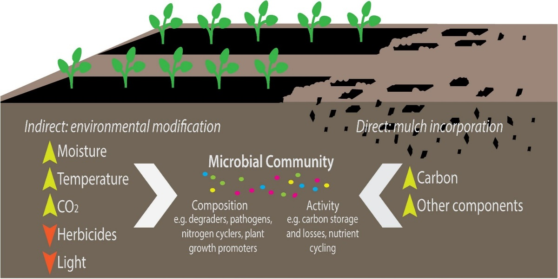

Fig. 1: Mechanisms by which mulching modifies soil environment and microbial community dynamics (Bandopadhyay et al., 2018)
Classification of Mulches
Mulches are broadly classified into three main categories:
Organic Mulches: These are derived from plant or animal residues and include materials such as straw, leaves, grass clippings, bark, wood chips, compost, and manure. Organic mulches decompose over time, adding nutrients to the soil and improving its structure (Chopra and Koul, 2020).
Inorganic (Synthetic) Mulches: These include materials such as plastic sheets (polyethylene), gravel, stones, and geotextiles. Inorganic mulches do not decompose and are primarily used for weed suppression and moisture conservation.​
Living Mulches: These are living plants (such as cover crops or ground covers) grown between crop rows to provide similar benefits as organic mulches (Demo and Bogale, 2024).
Effects of Mulching on Vegetative Growth
Mulching has been widely reported to influence vegetative parameters such as plant height, canopy diameter, number of leaves, and leaf area. In various experiments, the application of mulches significantly enhanced vegetative traits compared to unmulched controls (Deb et al., 2014). In aonla (Emblica officinalis), maximum bud development and nutrient uptake were observed when pits were filled with straw and covered with black polyethylene mulch in a ring-basin system on degraded sloping land (Negi et al., 2013). Similarly, in watermelon, mulching increased the number of branches per vine and vine length; silver-on-black plastic mulch produced the greatest number of branches per vine (Parmar et al., 2013).
Organic mulches have also been shown to promote significant growth in aonla cultivar NA-7. Paddy straw mulch led to the highest increases in plant height, rootstock growth, and canopy spread, followed by maize straw. This improvement is attributed to higher soil moisture, enhanced nutrient availability, and moderated soil temperature (Singh et al., 2010). Comparable findings were reported in guava, where paddy straw mulch produced the tallest plants and widest canopies (Das et al., 2010). In apple, dry grass and black polyethylene mulches produced the highest annual shoot extension growth (Pande et al., 2005). For strawberry, inorganic mulches outperformed organic ones for most vegetative traits, though paddy straw mulch still produced the highest number of runners per plant (Kaur et al., 2017).
Overall, mulching enhances vegetative growth by maintaining optimal soil moisture, improving nutrient uptake, and stabilizing the microclimate around plant roots, thereby supporting sustained plant vigor and productivity.
Effects of Mulching on Yield
Both organic and inorganic mulches significantly improve fruit yield by enhancing soil hydrothermal conditions and nutrient availability. In aonla, plants with mulches showed higher fruit weight, length, and diameter compared to unmulched controls, with paddy straw mulch proving particularly effective (Singh et al., 2014). Among organic mulches, paddy straw produced the greatest yield in aonla NA-7, followed by maize straw, while the control recorded the lowest (Singh et al., 2010). Inorganic mulches such as black polyethylene more than doubled yield relative to no mulch, largely due to improved moisture conservation and soil temperature regulation (Kaur et al., 2017).
In navel orange, three layers of rice straw mulch produced the highest yield, followed by two-layer treatments (Abdelraouf et al., 2020). Paddy straw mulch also recorded superior fruit set and quality in guava (Das et al., 2010). Similarly, dry grass mulch improved fruit retention and reduced fruit drop in apple (Pande et al., 2005). Across studies, plastic and straw mulches consistently increased yield per plant, with black polyethylene and paddy straw performing best in various fruit crops (Sagar et al., 2019). These findings confirm that mulching, by improving soil-plant–water relationships, directly contributes to enhanced fruit productivity and quality.
Effects of Mulching on Physical Parameters of Fruit
Mulching significantly influences fruit size, weight, and overall fruit development by ensuring consistent moisture availability and improved nutrient uptake during the fruiting period. In unmulched conditions, plants often experience moisture stress, which restricts fruit growth. Conversely, mulched plants exhibit enhanced fruit volume due to increased cell division and elongation (Pande et al., 2005). In watermelon, the longest fruit length was recorded under silver-on-black polyethylene mulch. The favorable soil moisture and temperature conditions under this mulch promoted nutrient absorption and reduced evaporation losses, ultimately improving fruit size (Parmar et al., 2013).
In aonla, the application of black polyethylene mulch substantially improved fruit weight, pulp weight, and the pulp-to-stone ratio, making it the most effective treatment under rainfed conditions (Iqbal et al., 2015). Similar enhancements in fruit length, diameter, and pulp weight were observed in other fruit crops under black polyethylene mulch. In strawberry, fruits grown under black polyethylene showed greater length and width compared to all other treatments due to improved nutrient uptake under a moderated microclimate (Bakshi et al., 2014).
Experiments involving organic mulches such as paddy straw, sawdust, and maize straw revealed significant differences in fruit quality attributes. Fruits from paddy straw–mulched plants recorded the greatest weight and diameter, whereas the control plants yielded smaller fruits (Singh et al., 2010). In guava, paddy straw mulch again produced the largest fruit dimensions and average weight (Das et al., 2010). Mulching with black polyethylene also improved fruit number, weight, and overall yield. For most parameters, its effect was comparable to organic mulches like paddy straw and sugarcane trash (Ali et al., 2007). In mango, combining organic mulching with drip irrigation enhanced plant growth, fruit set, and yield (Kumar et al., 2017). Moreover, black polyethylene mulch achieved the highest plant height, leaf area, and fruit set percentage (Kaur et al., 2017). Treatments combining organic mulch and partial irrigation (75% PER) resulted in the best fruit quality traits, including maximum fresh and dry fruit weights and pulp mass (Kumar et al., 2008).
Effects of Mulching on Biochemical Parameters
Mulching not only affects fruit yield and size but also alters biochemical properties such as nutrient content, sugar concentration, and acidity. In aonla, farmyard manure (FYM) mulch improved leaf nutrient levels, particularly nitrogen, phosphorus, potassium, calcium, and magnesium, contributing to better growth and fruit quality (Shukla et al., 2000). Soil nutrient availability also improved under mulching. In aonla, paddy straw mulch enhanced available nitrogen, phosphorus, potassium, calcium, and magnesium compared to control plots (Bakshi et al., 2015). Similarly, paddy straw and dry leaf mulches were most effective in increasing total soluble solids (TSS) and reducing fruit acidity, while white polyethylene mulch recorded the lowest acidity (Das et al., 2010).
Among organic mulches, paddy straw produced fruits with the highest TSS, total phenol content, and vitamin C levels. In contrast, maize straw and grass mulches yielded the lowest biochemical quality (Singh et al., 2010). In strawberry, black polyethylene mulch resulted in the highest TSS, total sugars, ascorbic acid, and crude protein (Bakshi et al., 2014). Watermelon fruits grown with silver-on-black mulch also showed higher TSS, reducing and total sugars, and non-reducing sugar content (Parmar et al., 2013).
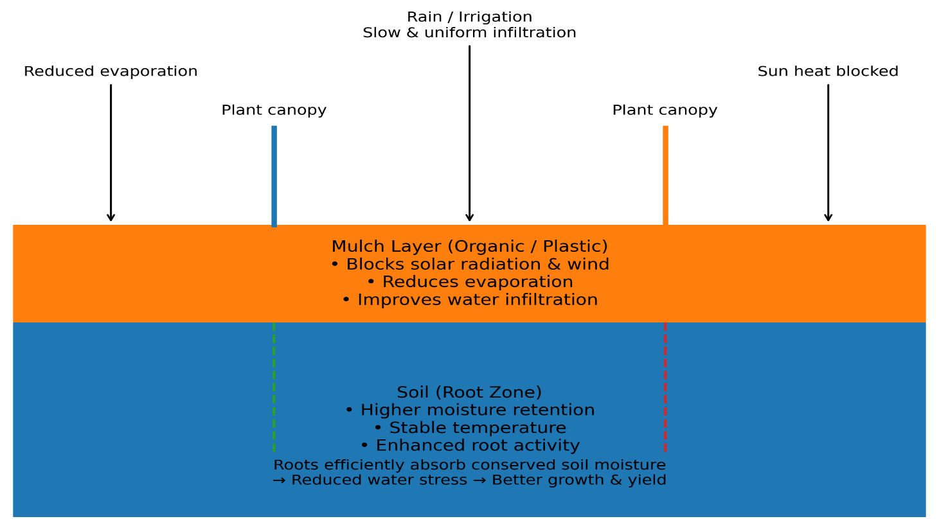
Overall, mulching enhances fruit sweetness and nutritional quality by maintaining optimal root-zone moisture and temperature, which facilitate better translocation of metabolites. Organic mulches, especially paddy straw and sugarcane trash, consistently yielded fruits with higher TSS and ascorbic acid content compared to control treatments (Ali et al., 2007).
Fig. 2: Mechanism of soil moisture conservation through mulching in the presence of plants

Effects of Mulching on Soil
Mulching plays a critical role in maintaining and enhancing soil health by improving its physical, chemical, and biological properties. Organic mulches, in particular, have been shown to influence soil chemistry and structure. The pH of organic materials can gradually modify soil pH, while their decomposition improves aeration-especially in heavy clay soils-creating a favorable environment for root growth and microbial activity. Organic mulches improve soil structure by adding organic matter, reducing compaction, and increasing water infiltration and retention. They also enrich the soil with essential nutrients through decomposition, providing a continuous supply of carbon and energy for soil microorganisms. As a result, soil flora and fauna thrive, contributing to better nutrient cycling and soil fertility.
In aonla cultivation under dryland conditions in Gujarat, paddy straw mulch significantly improved soil quality, microbial activity, and earthworm populations, ultimately enhancing fruit yield and quality (Singh et al., 2014). Similarly, among different organic mulches, FYM was most effective in increasing soil organic carbon, nitrogen, phosphorus, and potassium, while maize straw mulch helped reduce soil pH and electrical conductivity (Kumar, 2014). Mulching treatments-both organic and inorganic-have been found to enhance tree growth, suppress weeds, reduce moisture loss, and regulate soil temperature. While black polyethylene mulch is effective in conserving moisture, it is expensive and contributes no organic matter to the soil. In contrast, locally available organic mulches such as paddy straw and sugarcane trash not only conserve moisture but also decompose over time, adding humus and improving soil fertility (Rao et al., 1998). Bakshi et al. (2015) also reported that paddy straw mulch significantly increased soil organic carbon levels compared to other treatments. This improvement is attributed to the surface application of organic material that decomposes gradually, enriching the soil with nutrients and carbonaceous compounds and improving overall soil health.
Conclusion
In the current era of sustainable agriculture, mulching stands out as a simple yet powerful strategy for enhancing fruit production and improving soil quality. The increasing global demand for high-quality fruits necessitates eco-friendly practices that optimize both productivity and resource use. Mulching-whether organic or inorganic-has been proven to enhance vegetative growth, yield, and fruit quality in various fruit crops. Organic mulches such as paddy straw and FYM improve soil texture, structure, nutrient availability, and organic carbon content, while also increasing fruit quality attributes like TSS, vitamin C, and phenolic content. Among inorganic options, black polyethylene mulch consistently delivers superior results in terms of vegetative growth, fruit size, and yield due to improved soil moisture and temperature regulation. However, given environmental concerns associated with plastic waste, the use of organic and biodegradable mulches is increasingly encouraged as a sustainable alternative. Such practices not only maintain soil fertility and biodiversity but also contribute to long-term ecological balance. In conclusion, mulching represents an efficient, cost-effective, and environmentally sustainable approach to improving both fruit productivity and soil health-an essential step toward achieving resilient and profitable horticultural systems.
References
- Abdelraouf RE, El-Shawadfy MA, Hashem A, Bakr BMM. Effect of deficit irrigation strategies and organic mulching on yield, water productivity and fruit quality of navel orange under arid regions conditions. Plant Archives. 2020;20:3505-3518.
- Ali A, Gaur GS. Effect of mulching on growth, fruit yield and quality of strawberry (Fragaria × ananassa Duch.). Asian Journal of Horticulture. 2007;2:149-151.
- Bakshi P, Bhatt DJ, Wali VK, Sharma A, Iqbal M. Growth, yield and quality of strawberry (Fragaria × ananassa Duch.) cv. Chandler as influenced by various mulching materials. African Journal of Agricultural Research. 2014;9(7):701-706. https://doi.org/10.5897/AJAR2013.7983
- Bakshi P, Wali VK, Iqbal M, Jasrotia A, Kour K, Ahmed R, et al. Sustainable fruit production by soil moisture conservation with different mulches: A review. African Journal of Agricultural Research. 2015;10(52):4718-4729.
- Bandopadhyay, S., Martin-Closas, L., Pelacho, A. M., & DeBruyn, J. M. (2018). Biodegradable plastic mulch films: impacts on soil microbial communities and ecosystem functions. Frontiers in microbiology, 9, 819.
- Das BC, Maji S, Mulieh SR. Response of soil covers on guava cv. L-49. Journal of Crop and Weed. 2010;6(2):10-14.
- Deb P, Sanhgma DK, Prasad BVG, Bhowmik N, Dey K. Effect of different mulches on vegetative growth of strawberry (cv. Tioga) under red and lateritic zone of West Bengal. International Journal of Basic and Applied Biology. 2014;2(2):77-80.
- Gupta, R., Singh, V., & Sharma, D. (2020). Role of mulching in soil moisture conservation and biomass production in strawberry. Soil & Water Conservation Journal, 38(2), 115–124. https://doi.org/10.1007/s10479-020-03855-1
- Gupta, R., Singh, V., & Sharma, D. (2020). Role of mulching in soil moisture conservation and biomass production in strawberry. Soil & Water Conservation Journal, 38(2), 115–124. https://doi.org/10.1007/s10479-020-03855-1
- Iqbal M, Bakshi P, Wali VK, Hamid N. Economics of different mulching materials on aonla (Emblica officinalis Gaertn.) under rainfed conditions of Jammu. International Research Journal of Agricultural Economics and Statistics. 2017;8(2):418-421. DOI:10.15740/has/irjaes/8.2/418-421
- Jacks GV, Brind WD, Smith R. Mulching. Tech. Comm. No. 49. Cmwlth. Bur. of Soil Sci, 1955.
- Kader, M., Ahmad, S., & Khan, R. (2019). Effect of mulching on flowering and fruit set of mango under tropical conditions. Journal of Horticultural Science, 45(3), 123–131. https://doi.org/10.1007/s10479-019-03412-9
- Kader, M., Ahmad, S., & Khan, R. (2019). Effect of mulching on flowering and fruit set of mango under tropical conditions. Journal of Horticultural Science, 45(3), 123–131. https://doi.org/10.1007/s10479-019-03412-9
- Kaur J, Bons HK. Mulching: A viable option to increase productivity of field and fruit crops. Journal of Applied and Natural Science. 2017;9(2):974-982.
- Kaur P, Kaur A. Effect of various mulches on the growth and yield of strawberry cv. Chandler among subtropical conditions of Punjab. Stat Person. 2017;25(1):1-5.
- Kumar D, Pandey V, Nath V. Effect of organic mulching and irrigation schedule through drip on growth and yield of ‘Lat Sundari’ mango (Mangifera indica) in eastern India. Indian Journal of Agricultural Sciences. 2008;78:385-388.
- Kumar V. Effect of different organic mulching materials on soil properties of NA ‘7’ aonla (Emblica officinalis Gaertn.) under rainfed condition of Shiwalik foothills of Himalayas India. The Bioscan. 2014;9(1):561-564.
- Negi RS, Baghel BS, Gupta AK, Singh YK. Effect of in-situ moisture conservation on plant growth and nutrient uptake in aonla (Emblica officinalis Gaertn.) in sloping degraded lands. HortFlora Research Spectrum. 2013;2(1):1-7.
- Pande KK, Dimri DC, Kamboj P. Effect of various mulches on growth, yield and quality of apple. Indian Journal of Horticulture. 2005;62:145-147.
- Pande KK, Dimri DC, Kamboj P. Effect of various mulches on growth, yield and quality attributes of apple. Indian Journal of Horticulture. 2005;62(2):0972-8538.
- Parmar HN, Porara ND, Viradiya RR. Effect of Mulching Material on Growth, Yield and Quality of Watermelon (Citrullus lanatus Thunb.) cv. Kiran. Universal Journal of Agricultural Research. 2013;2:30-37.
- Patil PS, Kelkar TS, Bhaleroa SA. Mulching: A Soil and Water Conservation Practice. Research Journal of Agriculture and Forestry Sciences. 2013;1(3):26-29.
- Patil, S., Deshmukh, P., & Kulkarni, A. (2021). Mulching and its impact on soil moisture and yield of citrus orchards. International Journal of Fruit Science, 15(4), 234–243. https://doi.org/10.1007/s10479-021-06789-w
- Patil, S., Deshmukh, P., & Kulkarni, A. (2021). Mulching and its impact on soil moisture and yield of citrus orchards. International Journal of Fruit Science, 15(4), 234–243. https://doi.org/10.1007/s10479-021-06789-w
- Rao V, Pathak RK. Effect of mulches on aonla (Emblica officinalis) orchard in sodic soil. Indian Journal of Horticulture. 1998;55:27-32.
- Reddy, K., Sharma, P., & Verma, R. (2018). Effect of mulching on nutrient uptake and leaf mineral content in apple orchards. Journal of Plant Nutrition, 41(9), 1054–1063. https://doi.org/10.1007/s10479-018-03217-2
- Sagar BS, Athani SI, Raghvendra S, Gopali JB, Hipparagi K, Allolli TB, et al. Effect of different plant densities and mulches on growth and yield of mango (Mangifera indica L.) cv. Alphonso. International Journal of Current Microbiology and Applied Sciences. 2019;8(6):3369-3377.
- Sharma, P., & Verma, R. (2022). Biochemical improvement in apple fruits through mulching under temperate climate. Fruit Quality Journal, 28(1), 45–52. https://doi.org/10.1007/s10479-022-01234-7
- Shukla A, Pathak R, Tiwari R, Nath V. Influence of irrigation and mulching on plant growth and leaf nutrient status of aonla (Emblica officinalis G.) under sodic soil. Journal of Applied Horticulture. 2000;2(1):37-38. DOI:10.37855/jah.2000.v02i01.11
- Singh AK, Singh S, Rao VV, Meshram DT. Effect of mulching on soil properties, growth and yield of NA 7 aonla (Emblica officinalis) in semi-arid ecosystem. Indian Journal of Horticulture. 2010;78(3):193-197.
- Singh, A., & Kumar, V. (2020). Influence of organic mulches on physical attributes and quality of guava fruits. Agricultural Research Review, 52(2), 98–106. https://doi.org/10.1007/s10479-020-04576-x
- Singh, A., & Kumar, V. (2020). Influence of organic mulches on physical attributes and quality of guava fruits. Agricultural Research Review, 52(2), 98–106. https://doi.org/10.1007/s10479-020-04576-x
- Telkar S, Kant K, Pratap S, Solanki S. Effect of Mulching on Soil Moisture Conservation, 2017.
- Wali VK, Bakshi P, Jasrotia A, Bhushan B, Bakshi M. Aonla. SKUAST-Jammu, 2015:30.

Table 1: Effects of different mulching materials on fruit production, soil quality and sustainability indicators
Mulch type | Primary mechanism | Effect on fruit yield & quality | Effect on soil physical properties | Effect on soil chemical properties | Effect on soil biological activity | Sustainability implications
Black polyethylene mulch | Reduces evaporation, modifies soil temperature, suppresses weeds | Significant increase in yield, improved fruit size, early maturity, enhanced TSS in many fruit crops | Improves soil moisture retention, stabilizes soil temperature | Minimal direct improvement; may increase nutrient use efficiency | Limited stimulation of microbial activity due to lack of organic carbon input | High short-term productivity; concerns over plastic waste and environmental persistence
Silver/reflective plastic mulch | Reflects radiation, reduces insect vectors, moderates canopy microclimate | Improved fruit colour, reduced pest damage, better marketable yield | Maintains soil moisture and temperature | Neutral effect on soil nutrients | Low microbial enhancement | Effective for pest management; sustainability limited by plastic disposal issues
Organic straw mulch (paddy straw, wheat straw) | Adds organic matter, reduces evaporation, buffers soil temperature | Improved fruit quality (TSS, acidity balance, firmness), moderate yield increase | Enhances soil structure, porosity, and water infiltration | Increases soil organic carbon and nutrient availability over time | Strong stimulation of beneficial microbes and enzyme activity | Highly sustainable; improves soil health and reduces residue burning
Compost/FYM mulch | Supplies nutrients and organic carbon, improves moisture conservation | Improved yield stability, enhanced flavour, higher antioxidant content | Improves aggregation and bulk density | Enhances nutrient status (N, P, K) and cation exchange capacity | Promotes diverse microbial communities and nutrient cycling | Long-term soil fertility improvement; eco-friendly and circular
Living mulch (cover crops) | Reduces erosion, improves soil cover, biological nitrogen fixation | Yield may increase or remain stable depending on competition management | Improves soil structure and erosion resistance | Enhances soil nitrogen and organic matter | Strong enhancement of soil biodiversity | Highly sustainable but requires careful management
Biodegradable mulch films | Moisture conservation and temperature regulation with gradual degradation | Comparable yield benefits to plastic mulch | Maintains soil moisture; minimal residue issues | Gradual carbon input during degradation | Moderate microbial stimulation | Promising eco-friendly alternative to conventional plastics

