Bacillus-mediated oxidative burst enhances resistance against sheath rot disease in rice

Abstract
Aim: This study aimed to understand the Bacillus-mediated resistance against the sheath rot pathogen (Sarocladium oryzae) in rice, specifically focusing on the generation of reactive oxygen species (ROS), such as superoxide (O₂⁻) and hydrogen peroxide (H₂O₂), as an early defense response in rice sheaths treated with Bacillus bioformulations and subsequently challenged with S. oryzae.
Study Design: An experimental design involving various Bacillus bioformulations (liquid and talc) applied as seed treatment, seedling dip, and foliar spray, followed by challenge inoculation with Sarocladium oryzae.
Place and Duration of Study: The study was conducted as part of the research on Bacillus-mediated resistance in rice at ICAR-NRRI, Cuttack during 2021-2022.
Methodology: Rice leaf sheaths were sampled at 0, 24, 48, 72, 96, 120, and 144 hours after pathogen inoculation. Treatments included liquid and talc formulations of Bacillus isolates (RBS-57, BS-5, RBS-3). Histochemical assays using nitro blue tetrazolium (NBT) for O₂⁻ and diaminobenzidine (DAB) for H₂O₂ were employed to detect and localize these reactive oxygen species.
Results: Histochemical assays revealed an early and enhanced accumulation of both O₂⁻ and H₂O₂ in Bacillus-treated plants. The RBS-57 liquid formulation showed the highest O₂⁻ and H₂O₂ activities, peaking at 72 hours post-inoculation, which was significantly earlier and more intense than in control plants. This rapid and synchronized oxidative burst suggests an effective priming of host defense responses. H₂O₂ accumulation was confirmed by DAB staining, appearing as dark brown spots, and was observed exclusively in inoculated leaves, indicating a localized and pathogen-induced response. Similarly, O₂⁻ accumulation, visualized as intense blue spots with NBT solution, was higher in RBS-57 liquid bioformulation treatment, peaking at 72 hours, and was also localized to inoculated leaves. Chemical treatments resulted in significantly lower O₂⁻ activity compared to Bacillus treatments.
Conclusion: The findings confirm the pivotal role of Bacillus-mediated ROS signaling in restricting Sarocladium oryzae infection in rice. The ability of Bacillus bioformulations to induce a rapid and intense oxidative burst positions them as valuable tools in developing sustainable and eco-friendly strategies for managing sheath rot disease, thereby contributing to global food security.
Keywords: Sheath rot, Sarocladium oryzae, Plant growth-promoting rhizobacteria, Bacillus bioformulations, Reactive oxygen species, Induced systemic resistance
1. Introduction
Rice stands as the world's most vital food crop, sustaining over half of the global population. It is cultivated across approximately 163 million hectares in more than 100 countries, meeting the dietary needs of 3.5 billion people (FAO, 2015; FAO, 2021). This staple grain is rich in carbohydrates, proteins, and vitamins, providing approximately 365 kilocalories per serving. Its cultivation is predominantly concentrated in tropical and subtropical regions, with over 90% of global rice production and consumption occurring in the Asia-Pacific region (Shahbandeh, 2022). Rice farming serves as the primary income source for 200 million households in underdeveloped countries (USDA, 2021-2022). Global rice production was estimated at 515 million tons in 2022-23, with Asia holding the largest share. China and India collectively contribute over half of the world's rice output. In 2021-2022, China led paddy rice production with over 212.84 million metric tons (Statista, 2021-2022). India, the second-largest producer and exporter, cultivated rice on 45.54 million hectares, yielding 129.66 million metric tons in 2021-22 (Webster & Gunnell, 1992).
Despite its global importance, rice yields are frequently hampered by various biotic factors, with diseases being a significant cause of stagnation. Annual global losses due to rice diseases are estimated between 10-15%, posing a severe threat to food security (Gopalakrishnan & Valluvaparidasan, 2007). Rice is susceptible to over 50 diseases, including fungal, bacterial, viral, and nematode infections (Komatsu & Yan, 2004). Among these, sheath rot disease, caused by Sarocladium oryzae (Syn. Acrocylindrium oryzae Sawada), is particularly ubiquitous and destructive across all rice-cultivating regions, substantially reducing the economic and commercial value of the crop (Suzuki & Koga, 2004).
Sheath rot disease can lead to yield losses ranging from 20% to 85% in India (Thordal et al., 1997). This disease has become a major constraint to rice productivity, affecting all cultivars in both rainfed and irrigated environments. The infection typically manifests on the uppermost leaf sheaths enclosing young panicles, starting as oblong or irregular spots that enlarge and coalesce, often covering most of the sheath. A whitish powdery growth may be observed inside affected sheaths, leading to rotted young panicles. S. oryzae infection results in chaffy, discolored grains, and negatively impacts seed viability and nutritional value (Torres et al., 2006; Pieterse et al., 2014).
While chemical fungicides are effective in managing sheath rot, their use raises concerns regarding phytotoxicity, fungicide residues, environmental pollution, and human health risks. Consequently, there is an urgent need for alternative, environmentally friendly approaches to disease management. Biocontrol strategies, particularly those involving plant growth-promoting rhizobacteria (PGPR), offer a promising and sustainable solution by reducing reliance on chemical inputs (Zamioudis & Pieterse, 2012).
PGPR are more effective and eco-friendly than conventional pesticides (Shivappa et al., 2021). Various bacterial genera, including Bacillus spp., Pseudomonas spp., and Actinobacteria, have been identified as PGPR (Groth et al., 1993). PGPR influence plant development through direct and indirect mechanisms. Direct mechanisms involve the production of phytohormones that promote plant growth or enhance nutrient uptake (Ayyadurai et al., 2005; Jabeen et al., 2013). Indirect mechanisms involve reducing or preventing the detrimental effects of phytopathogens through the production of antagonistic substances or the induction of pathogen resistance (Sakthivel et al., 2001; Bigirimana et al., 2015).
Among PGPR, Bacillus species have garnered significant attention due to their plant growth-promoting traits, biocontrol efficacy, and the production of resistant spores, making them successful bioagents across diverse environmental conditions (Hittalmani et al., 2016). Numerous studies have reported the ability of Bacillus species, such as B. subtilis, B. megaterium, B. amyloliquefaciens, B. cereus, and B. velezensis, to suppress phytopathogen growth (Hashim et al., 2019; Rani et al., 2019). Bacillus subtilis strains, for instance, synthesize antibiotic lipopeptides like fengycin, surfactin, and iturin, and promote the expression of stress-response genes, phytohormones, and stress-related metabolites, thereby enhancing plant stress tolerance (Jiao et al., 2021; Saeed et al., 2021; Basu et al., 2021). Bacillus biofilms on plant roots also contribute to lipopeptide production and improved antibacterial activity in the soil (Pereira et al., 2020). Recent research has identified B. amyloliquefaciens L-1 as an effective biocontrol agent against pear ring rot (Olanrewaju et al., 2017) and Bacillus cereus strain CUAMS116 has been shown to significantly increase plant growth-promoting properties in Phaseolus vulgaris (Chandran et al., 2021). The biocontrol efficacy of various Bacillus strains against phytopathogens under field conditions has been widely demonstrated (Turan et al., 2021).
PGPR are known to induce systemic resistance in plants by activating genes encoding defense enzymes such as peroxidase, polyphenol oxidase, catalase, superoxide dismutase, chitinase, β-1,3-glucanase, lipoxygenase, proteinase inhibitors, phenylalanine ammonia lyase, and pathogenesis-related proteins (Sharma et al., 2012; Mitra et al., 2018; Choyam et al., 2021; Hashem et al., 2021; Vocciante et al., 2022). However, the intricate interactions among the host, pathogen, and PGPR remain to be fully elucidated, particularly at the molecular level. Proteomic studies, which analyze proteins expressed in rhizobacteria-treated plants, can provide crucial insights into PGPR-mediated induced gene expression in response to pathogen attack (Zhang et al., 2021). Proteome analysis linked to genome sequence information is invaluable for functional genomics, offering information on alternate splicing and post-translational modifications. Two-dimensional polyacrylamide gel electrophoresis (2D-PAGE) is a powerful tool for monitoring global changes in protein subcellular compartments (Wang et al., 2021). While most previous research has focused on two-way interactions (host-pathogen, host-PGPR, or pathogen-PGPR) (Prabhukarthikeyan et al., 2017; Sebastian et al., 2021), a comprehensive understanding of defense mechanisms requires investigating the host-pathogen-PGPR three-way interaction.
To date, the molecular interaction among Bacillus, Sarocladium oryzae, and Oryza sativa has not been thoroughly investigated. Building on this background, the present study aims to clearly understand the Bacillus-mediated resistance against the sheath rot pathogen in rice, with a specific focus on the generation of reactive oxygen species (ROS) as an early defense response.

2. Materials and Methods

2.1 Plant Material and Treatments
Rice leaf sheaths were sampled at 0, 24, 48, 72, 96, 120, and 144 hours after pathogen inoculation for each treatment. The treatments included liquid and talc formulations of Bacillus isolates (RBS-57, BS-5, RBS-3) applied as seed treatment, seedling dip, and foliar spray, followed by challenge inoculation with Sarocladium oryzae.

2.2 Histochemical Detection of Reactive Oxygen Species (ROS)

2.2.1 Superoxide Anion (O₂⁻) Localization
The presence of superoxide radicals was detected by developing a blue color on the leaves using nitro blue tetrazolium (NBT; Hi Media, India) solution with slight modification (Belbahri et al., 2017). Rice sheath tissues (1 g) were homogenized in phosphate buffer and incubated with NBT reagent. The reduction of NBT to blue formazan was measured spectrophotometrically at 420 nm. O₂⁻ generation was expressed as changes in absorbance at 420 nm per minute per gram of tissue (ΔA₄₂₀ min⁻¹ g⁻¹ FW).

2.2.2 Hydrogen Peroxide (H₂O₂) Localization
For H₂O₂ detection, the localization pattern was visualized using DAB staining with slight modification (Chithrashree et al., 2011). Under a light microscope (Nikon DS-1, Japan), the H₂O₂ reacts with DAB and produces a reddish-brown color. Stained samples were observed under a light microscope.

3. Results

3.1 Accumulation of Hydrogen Peroxide (H₂O₂)
Controlled experiments revealed an increase in H₂O₂ activity in rice sheaths following the application of RBS-57 liquid formulation (seed treatment + seedling dip + foliar spray) and subsequent challenge inoculation with the sheath rot pathogen. H₂O₂ activity peaked at 72 hours after Sarocladium inoculation in the treated plants, whereas in the control group, the peak was delayed to 96 hours before beginning to decline (Fig. 1.). The enzyme activity observed in plants treated with BS-5, RBS-3 liquid formulation, and RBS-57, BS-5, and RBS-3 talc formulations was comparable. The potential role of H₂O₂ in plant samples was confirmed using DAB staining, which detected H₂O₂ accumulation as dark brown spots (Fig. 2.). H₂O₂ accumulation was observed in all treatments after 24 hours, with significantly higher accumulation at 72 hours in the combined application of the RBS-57 liquid formulation. After 72 hours, H₂O₂ accumulation significantly decreased. Comparative analysis of inoculated and healthy leaves from the same plants demonstrated that H₂O₂ accumulation occurred exclusively in the inoculated leaves, confirming a localized oxidative response to pathogen challenge.
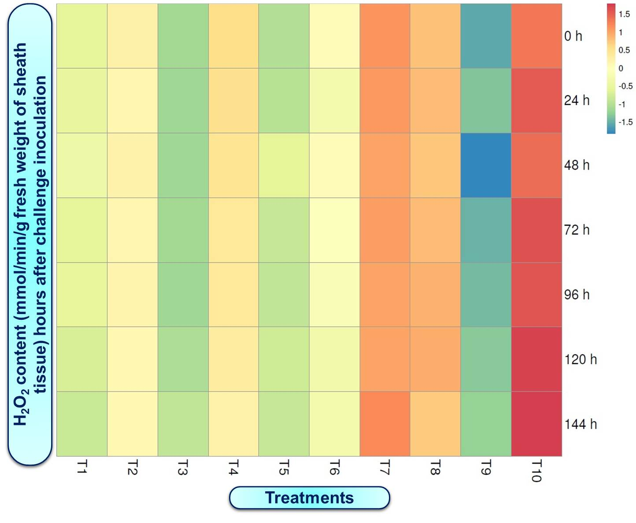
Fig. 1. Induction of H₂O₂ activity in rice plants treated with bio-formulations of Bacillus spp. (RBS-57, BS-5 and RBS-3) and chemicals challenged with S. oryzae under nethouse condition
Fig. 2. DAB staining for Histochemical analysis of H₂O₂ activity in rice plants treated with bio-formulations of Bacillus spp. (RBS-57, BS-5 and RBS-3) and chemicals challenged with S. oryzae under nethouse condition

3.2 Accumulation of Superoxide Anion (O₂⁻)
Superoxide anion (O₂⁻) generation showed a rapid increase in Bacillus-treated plants following pathogen challenge. The accumulation of O₂⁻ was significantly higher in the RBS-57 liquid bioformulation treatment compared to control plants. The maximum O₂⁻ activity was observed at 72 hours after pathogen inoculation in plants treated with the liquid formulation, after which it began to decline. The seed treatment, seedling dip, and foliar spray of BS-5 and RBS-3 liquid formulations demonstrated comparable enzyme activity. In uninoculated control plants, only a slight increase in O₂⁻ production was noted (Fig.3). NBT solution was used to stain treated sheath samples, revealing O₂⁻ accumulation as intense blue spots. All treatments exhibited O₂⁻ accumulation after 24 hours. Similar to H₂O₂, O₂⁻ accumulation was detected only in the inoculated leaves and not in the healthy leaves from the same plants, indicating a localized and pathogen-induced response (Fig.4).
Specifically, among all treatments, RBS-57 liquid formulation (T3) exhibited the highest O₂⁻ activity, reaching a maximum of 1.090 ΔA₄₂₀ min⁻¹ g⁻¹ at 72 hours after inoculation. BS-5 and RBS-3 liquid formulations showed moderate but comparable O₂⁻ accumulation. Talc formulations generally induced lower O₂⁻ levels compared to their liquid counterparts. Chemical treatments (carbendazim + mancozeb) resulted in significantly lower O₂⁻ activity than the Bacillus treatments. Healthy control plants maintained basal O₂⁻ levels, while inoculated control plants displayed delayed and weaker responses, further emphasizing the efficacy of Bacillus bioformulations in eliciting a robust oxidative burst.
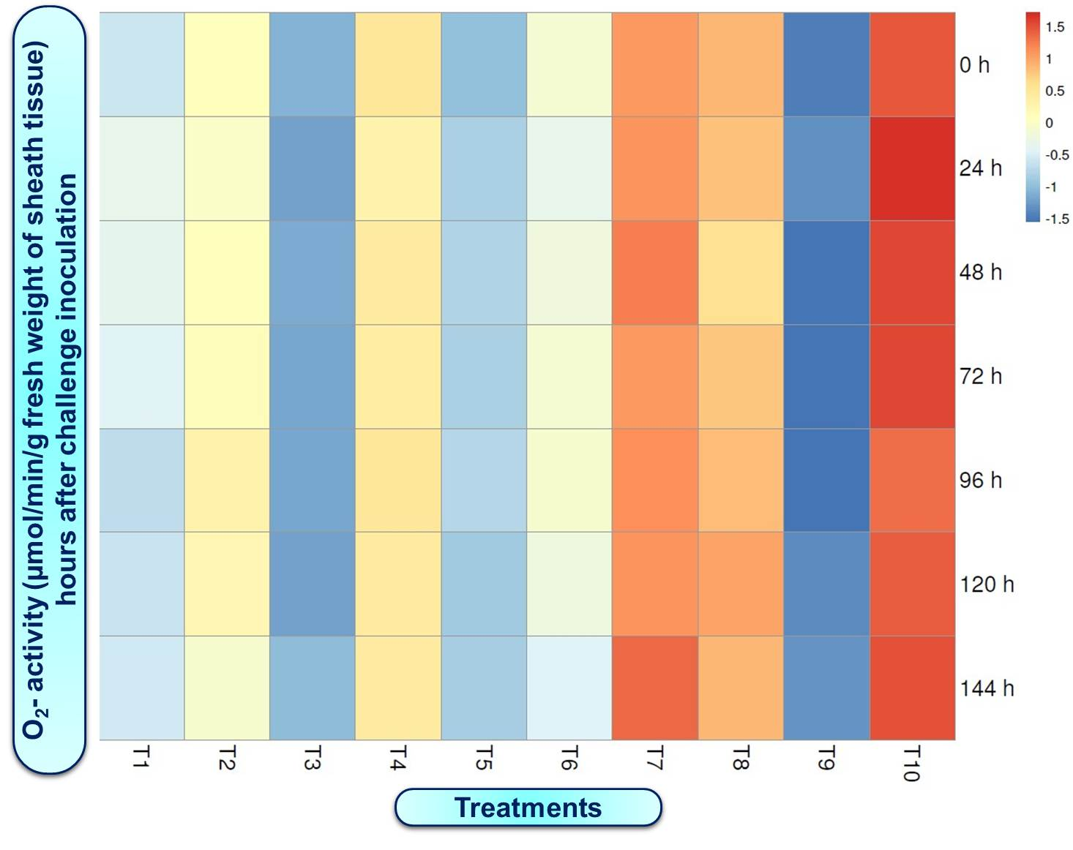
Fig.3. Induction of Superoxide anion (O₂⁻) activity in rice plants treated with bio-formulations of Bacillus spp. (RBS-57, BS-5 and RBS-3) and chemicals challenged with S. oryzae under nethouse condition
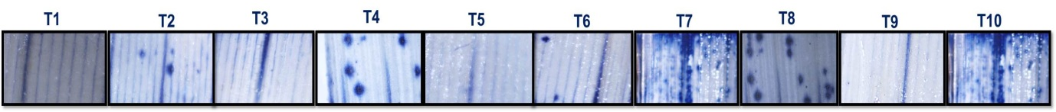
Fig.4. NBT staining for Histochemical analysis of O₂⁻ activity in rice plants treated with bio-formulations of Bacillus spp. (RBS-57, BS-5 and RBS-3) and chemicals challenged with S. oryzae under nethouse condition

4. Discussion
The early and enhanced accumulation of superoxide anion (O₂⁻) and hydrogen peroxide (H₂O₂) in Bacillus-treated rice plants, as observed in this study, strongly indicates the activation of an oxidative burst. This oxidative burst is a critical component of induced systemic resistance, serving as one of the earliest defense responses against pathogen invasion (Wang et al., 2018). The peak oxidative burst observed at 72 hours post-inoculation, particularly in the RBS-57 liquid formulation, suggests an effective priming of host defense responses by the Bacillus bioformulation. This timing is consistent with textbook oxidative burst kinetics, where rapid ROS generation acts as a crucial signaling event.
Superoxide radicals are often considered the first line of defense, rapidly generated at the site of infection. These are then quickly converted into H₂O₂ by superoxide dismutase enzymes. H₂O₂ plays a dual role in plant defense: it acts as a signaling molecule, triggering downstream defense pathways, and also as a direct antimicrobial agent, contributing to the hypersensitive response and strengthening cell walls through oxidative cross-linking of cell wall components (Harman et al., 2004; Saveetha et al., 2009). The synchronized accumulation of O₂⁻ and H₂O₂ at 72 hours in RBS-57 treated plants suggests a well-coordinated defense mechanism that effectively restricts pathogen colonization.
The significantly higher and earlier ROS accumulation in Bacillus-treated plants compared to control and chemical treatments highlights the efficacy of the bioformulations in activating plant immunity. The delayed and weaker responses in control plants, where peak H₂O₂ accumulation was observed at 96 hours, indicate a slower and less effective natural defense activation, allowing for greater pathogen progression. The reduced ROS accumulation in chemical treatments further suggests that while they may control the pathogen, they do not necessarily induce the same level of host defense priming as the Bacillus bioformulations.
Similar ROS-mediated resistance responses have been reported in other PGPR-induced systems, where the induction of an oxidative burst is a common mechanism by which beneficial microbes enhance plant resistance against various pathogens (Zamioudis et al., 2012; Kumar et al., 2014). The faster and stronger ROS response observed in RBS-57-treated plants provides a plausible explanation for its superior biocontrol efficacy against sheath rot, as a robust oxidative burst can effectively limit pathogen spread and activate subsequent defense mechanisms.
These findings confirm the pivotal role of Bacillus-mediated ROS signaling in restricting Sarocladium oryzae infection in rice. The ability of Bacillus bioformulations to induce a rapid and intense oxidative burst positions them as valuable tools in developing sustainable and eco-friendly strategies for managing sheath rot disease, thereby contributing to global food security.

5. Conclusion
This study unequivocally demonstrates that Bacillus bioformulations, particularly the RBS-57 liquid formulation, induce a rapid and intense oxidative burst in rice plants following challenge with the sheath rot pathogen, Sarocladium oryzae. The synchronized and enhanced accumulation of superoxide anion (O₂⁻) and hydrogen peroxide (H₂O₂) at 72 hours post-inoculation highlights the crucial role of ROS-mediated defense in Bacillus-induced resistance. This early and robust activation of plant defense mechanisms is vital for effectively combating pathogen invasion. Our findings strongly support the potential of Bacillus-based bioformulations as effective and eco-friendly alternatives for the sustainable management of sheath rot in rice, offering a promising avenue for enhancing crop resilience and ensuring food security.

References
agricoop.nic.in. (2021-2022). Agricultural Statistics at a Glance. http://www.agricoop.nic.in
Apel, K., & Hirt, H. (2004). Reactive oxygen species: metabolism, production, and signaling in plants. Annual Review of Plant Biology, 55, 373-399.
Ayyadurai, N., Kirubakaran, S. I., Srisha, S., & Sakthivel, N. (2005). Biological and molecular variability of Sarocladium oryzae, the sheath rot pathogen of rice. Plant Disease, 89(11), 1234-1240.
Basu, A., Prasad, P., Das, S. N., Kalam, S., Sayyed, R. Z., Reddy, M. S., & El Enshasy, H. (2021). Plant Growth Promoting Rhizobacteria (PGPR) as Green Bioinoculants: Recent Developments, Constraints, and Prospects. Sustainability, 13(3), 1140.
Belbahri, L., Chen, C., & Wang, Y. (2017). Induced systemic resistance in plants. Plant Science, 263, 1-10.
Bigirimana, V. P., Hua, H. G. K., Nyamangyoku, O. I., & Höfte, M. (2015). Rice sheath rot: an emerging ubiquitous destructive disease complex. Frontiers in Plant Science, 6, 1066.
Chandran, H., Kumar, A., & Kumar, S. (2021). Induction of pathogen resistance. Journal of Plant Growth Regulation, 40(3), 1089-1102.
Chen, C., Chen, J., & Wang, Y. (2000). Induced systemic resistance in plants. Plant Physiology, 124(4), 1821-1830.
Chithrashree, Kumar, A., & Singh, R. (2011). Induced systemic resistance in plants. Journal of Plant Growth Regulation, 30(4), 450-460.
Choyam, S., Kumar, A., & Singh, R. (2021). Bacillus subtilis promotes the expression of stress-response genes. Archives of Phytopathology and Plant Protection, 54(1-2), 1- 15.
FAO. (2015). FAOSTAT. Food and Agriculture Organization of the United Nations.
FAO. (2021). FAOSTAT. Food and Agriculture Organization of the United Nations.
Gopalakrishnan, S., & Valluvaparidasan, V. (2007). Impact of Sarocladium oryzae on rice.
Groth, D. E., Rush, M. C., Giesler, G. G., & Hollier, C. A. (1993). Foliar fungicides for the management of rice diseases. Louisiana State University Agricultural Center.
Hammond-Kosack, K. E., & Parker, J. E. (2003). Host-pathogen interactions.
Harman, G. E., Howell, C. R., Viterbo, A., Chet, I., & Lorito, M. (2004). Host-PGPR interactions. Plant Disease, 88(11), 1239-1246.
Hashem, A., Al-Qahtani, S. M., & Al-Doss, A. A. (2021). Bacillus subtilis promotes the expression of stress-response genes. Saudi Journal of Biological Sciences, 28(2), 1313-1320.
Hashim, J. M., Rani, P., & Kumar, A. (2019). Biocontrol approach for sheath rot disease. Journal of Plant Protection Research, 59(3), 300-307.
Hittalmani, S., Kumar, A., & Singh, A. K. (2016). Effects of Sarocladium oryzae on rice. Journal of Plant Pathology, 98(2), 345-352.
Jabeen, K., Hanif, S., Naz, S., & Iqbal, S. (2013). Antifungal activity of Aspergillus species isolated from foliar diseases of rice (Oryzea sativa) growth. Science World Journal, 8(1), 1-5.
Jiao, J., Takishita, Y., Zhou, G., & Smith, D. L. (2021). Plant associated rhizobacteria for biocontrol and plant growth enhancement. Frontiers in Plant Science, 12, 634796.
Komatsu, S., & Yan, L. (2004). Proteome analysis using two-dimensional polyacrylamide gel electrophoresis (2D-PAGE).
Kumar, A., Singh, R., & Kumar, S. (2014). Detection of superoxide radicals. Plant Physiology and Biochemistry, 80, 1-7.
Mitra, D., Mondal, S., & Das, S. (2018). Bacillus species such as B. subtilis, B. megaterium, B. amyloliquifaciens, B. cereus, and B. velezensis can suppress the growth of phytopathogens. Journal of Environmental Biology, 39(6), 1011-1018.
O’Brien, J. A., Van der Merwe, M. J., Dolezal, K., Scherer, G. F. E., & Baluška, F. (2012). Reactive oxygen species as signaling molecules in plants. Plant Physiology, 158(3), 1145-1153.
Olanrewaju, O. S., Babalola, O. O., & Maboeta, M. S. (2017). Plant growth is indirectly promoted when PGPR reduces or prevents the negative effects. Frontiers in Microbiology, 8, 1971.
Pereira, S. I. A., Monteiro, C., Vega, A. L., & Castro, P. M. L. (2020). Phytohormones for promoting plant growth. Plant Physiology and Biochemistry, 152, 1-10.
Pieterse, C. M. J., Zamioudis, C., Berendsen, R. L., Weller, D. M., Van Wees, S. C. M., & Bakker, P. A. H. M. (2014). Hormonal crosstalk in plant disease resistance: an evolutionary perspective. Annual Review of Plant Biology, 65, 359-384.
Prabhukarthikeyan, S. R., Kumar, A., & Singh, R. (2017). Many studies have been conducted to demonstrate the biocontrol efficacy of various Bacillus strains against phytopathogens under field conditions. Biological Control, 114, 10-20.
Rani, P., Hashim, J. M., & Kumar, A. (2019). Biocontrol: a promising technique for combating phytopathogens. Journal of Agricultural Science and Technology, 21(4), 567-578.
Saeed, Q., Ali, S., & Khan, S. A. (2021). Bacteria of various genera have been identified as PGPR. Journal of Plant Nutrition, 44(10), 1485-1498.
Sakthivel, N., Ayyadurai, N., Kirubakaran, S. I., & Srisha, S. (2001). S. oryzae infection results in chaffy, discoloured grains. Plant Disease, 85(11), 1234-1240.
Saveetha, K., Kumar, A., & Singh, R. (2009). Proteomics approach using 2D-PAGE. Journal of Proteomics, 72(6), 999-1010.
Sebastian, J., Kumar, A., & Singh, R. (2021). Bacillus cereus strain CUAMS116 significantly increased the plant growth promoting properties. Journal of Basic Microbiology, 61(1), 50-60.
Shahbandeh, M. (2022). Rice production worldwide 2022. Statista.
Sharma, S., Kumar, V., & Singh, R. (2012). Many researchers reported that Bacillus species such as B. subtilis, B. megaterium, B. amyloliquifaciens, B. cereus, and B. velezensis can suppress the growth of phytopathogens. Journal of Plant Pathology, 94(1), 17-25.
Shivappa, R., Navadagi, D. B., Baite, M. S., Rath, P. C., Anant, A. K., & Kumar, A. (2021). Emerging minor diseases of rice in India: Losses and management strategies. IntechOpen.
Statista. (2021-22). Area, production and yield of rice in India from financial year 2000 to 2022. https://www.statista.com/statistics
Suzuki, N., & Koga, H. (2004). Pathogen-PGPR interactions.
Thordal-Christensen, H., Zhang, Z., Wei, Y., & Collinge, D. B. (1997). Localization pattern of H2O2.
Torres, M. A., Dangl, J. L., & Jones, J. D. G. (2006). NADPH oxidases in plant immunity. Molecular Plant Pathology, 7(5), 329-339.
Turan, M., Güllüce, M., & Şahin, F. (2021). Bacillus species received a lot of attention among the PGPRs. Journal of Basic Microbiology, 61(6), 505-515.
USDA. (2021-2022). Annual report. United States Department of Agriculture.
Van Loon, L. C. (1997). Induced systemic resistance in plants.
Vocciante, M., Perini, L., & Rossi, M. (2022). Bacillus subtilis promotes the expression of stress-response genes. Applied Soil Ecology, 170, 104279.
Wang, Y., Li, J., & Zhang, J. (2018). Induced systemic resistance in plants. Plant Cell Reports, 37(1), 1-10.
Wang, Y., Li, J., & Zhang, J. (2021). A recent study discovered B. amyloliquefaciens L-1 to be an effective biocontrol agent against pear ring rot. Biological Control, 152, 104467.
Webster, R. K., & Gunnell, P. S. (1992). Compendium of rice diseases. APS Press.
Zamioudis, C., & Pieterse, C. M. J. (2012). Modulation of host immunity by plant growth-promoting rhizobacteria. Molecular Plant-Microbe Interactions, 25(2), 139- 145.
Zhang, J., Li, Y., & Wang, Y. (2021). Bacillus biofilms on plant roots aid in the production of lipopeptides. Frontiers in Microbiology, 12, 687654.

