Original Research Article

Cluster analysis of diverse rice accessions for grain yield and yield related traits

ABSTRACT

Aims: The current study focused on evaluating diverse set of rice accessions to identify genetically diverse candidates, which can serve as parents in hybridization and transgressive breeding programs aimed at developing superior pure lines with improved grain yield, based on ten yield-related traits.
Study design: The subset of 3k Panel was evaluated in augmented design with ten blocks
Methodology: A total of 200 rice germplasm lines belong to 3K RGP along with five checks (Swarna sub-1, Sahyadri Jalamukthi, Sahyadri Kempumukthi, Jyothi and Sahyadri Jyothi) were evaluated for ten yield and yield related traits at ZAHRS Shivamogga, Karnataka, during summer 2024 and AHRS Kathalagere, Davanagere, Karnataka during Kharif 2024. Diversity was analyzed using K means clustering
Results: The diversity assessment of rice accessions revealed the presence of six distinct clusters in both the environments, with the highest inter-cluster distance (4.868) observed between Clusters 3 and 4 in first environment, and between clusters 1 and 3 (4.670) in second environment indicating substantial genetic divergence. Accessions from these clusters could be utilized in hybridization, followed by selfing and selection, to develop improved pure lines. Notably, accessions in Cluster 2 and 3 exhibited high seed yield along with superior yield related traits in first environment, and clusters 2 and 1 in second environment, making them promising candidates for hybrid breeding programs.
Conclusion: The combined evaluation across two environments clearly highlights the existence of well-organized and readily exploitable phenotypic diversity within the subset of 3K panel. The recognition of consistently superior clusters, together with environment-dependent divergent groups, offers a strong basis for cluster-oriented parent selection and for formulating focused breeding approaches aimed at developing high-yielding and environmentally resilient rice varieties.

Keywords: Diversity; clustering; rice; 3k panel.

1. INTRODUCTION

Rice (Oryza sativa L.) is one of the most important carbohydrate-rich cereals and forms a staple component of human nutrition, particularly across Asian countries. It serves as the principal food source for nearly half of the world’s population, contributing approximately 40–80% of the daily caloric intake in several Asian regions, where it is commonly consumed two to three times per day. Beyond its nutritional value, rice cultivation supports the livelihoods of millions of smallholders and marginal farmers. Archaeological and historical evidence suggests that rice farming in India began between 1500 and 1000 B.C., highlighting its deep-rooted presence in the subcontinent. Moreover, rice occupies a central role in Indian cultural practices, religious ceremonies, and festivals, and is traditionally associated with the goddess Annapoorneshwari, symbolizing sustenance and abundance (Vijay and Roy, 2013).

Estimates from the United Nations indicate that the global population is projected to rise to approximately 8.5 billion by the year 2030, which is expected to place considerable strain on rice improvement and breeding initiatives worldwide (Van Bavel, 2013). Consequently, a 50% increase in rice production will be required to adequately satisfy the growing food demand.

Enhancing the genetic capacity of crop varieties represents one of the most effective strategies available for raising rice productivity. Owing to its extensive inherent genetic variation, rice offers significant opportunities for broadening and strengthening its genetic base. Such diversity plays a crucial role in generating elite recombinant lines and therefore forms a cornerstone of crop improvement efforts. The success of breeding initiatives, particularly those involving hybrid development, is largely influenced by the level of genetic variation among parental lines (Rana et al., 2004). Insufficient genetic diversity can severely constrain breeding efficiency and restrict potential gains in yield and quality (Cornelious et al., 2002). Consequently, systematic evaluation of genetic variability is essential, as it provides breeders with critical guidance for advancing breeding programs. This assessment facilitates the identification of agronomically diverse and compatible parents for crossing and enhances the likelihood of obtaining desirable recombinants in subsequent segregating generations (Goulet et al., 2017).

Machine learning methodologies, particularly clustering-based techniques, are highly effective for analyzing complex multivariate datasets. Among these methods, k-means clustering—an unsupervised algorithm originally proposed by MacQueen (1967) is well suited for characterizing phenotypic variation due to its computational simplicity, scalability and ease of biological interpretation. By grouping accessions in a manner that minimizes variation within clusters, k-means generates concise representations of trait distributions through cluster centroids. This allows researchers and plant breeders to readily compare genotype groups with respect to yield, plant structural attributes and quality-associated characteristics.

In rice, this approach enables the detection of distinct groups corresponding to high-yielding types, stress-tolerant forms, or ideotypes that integrate multiple favorable characteristics. Additionally, k-means clustering facilitates subsequent breeding applications, including the formation of breeding pools, selection of genetically diverse parental lines, identification of representative entries for multi-environment evaluations and organization of data for association studies or genomic prediction models. Consequently, the incorporation of k-means clustering into rice diversity studies enhances both biological insight and informed decision-making within breeding programs. Against this background, the present investigation focuses on evaluating phenotypic variation among rice germplasm for yield related traits using k-means clustering, with the objectives of delineating distinct diversity groups, describing their trait patterns across environments and providing actionable information to support targeted improvement of grain yield.
.

2. MATERIALS AND METHODS

The investigation was conducted using a broad-based rice diversity panel, the 3K panel, which is obtained from Division of Crop Improvement, ICAR-CSSRI, Karnal, Haryana. This panel comprises genetically diverse rice genotypes representing global variability. The field experimentation was undertaken across two growing environments, during summer 2024 at ZAHRS, Shivamogga and Kharif 2024 At AHRS, Kathalagere, involving 200 accessions (indica (135), aus (26), trophical (18), aro (8), japonica (6), temperate (5) and admixture (2)), respectively. The trials were laid out following an Augmented RCBD design with five checks namely, Swarna sub-1, Sahyadri Jalamukthi, Jyothi, Sahyadri Jyothi (Advanced breeding line of Tunga × Jyothi, present in varietal release pipeline) and Sahyadri Kempumukthi. The recommended agronomic practices were uniformly implemented to ensure proper crop establishment, growth and protection.

Comprehensive phenotypic data were recorded on yield and associated attributes. The time required to reach 50% flowering was measured as the number of days elapsed from sowing until approximately half of the plants within an accession showed the emergence of their first open flower. For yield-related evaluations, five plants were randomly sampled from each accession and mean values were computed for nine traits, including plant height, total tiller count per plant, number of productive tillers, panicle length, spikelet number per panicle, spikelet fertility, thousand grain weight and single plant yield. The grain length-to-breadth ratio was determined using a rice grain analyzer. Validated mean values were used for further statistical analysis after eliminating outliers. To assess phenotypic variability and identify patterns within the 3K panel, a k-means clustering method was applied to the dataset using the Factoextra package in R software (version 4.1.1). The equality of variances among clusters was examined through Levene’s test, and cluster-specific trait means were subsequently calculated using standard statistical procedures.

$$\text{J= }\sum_{\text{i=k}}^{\text{m}}{\sum_{\text{k=1}}^{\text{k}}{{\text{ω}}_{\text{ik}} {\left\|{\text{X}}^{\text{2}}\text{- }{\text{μ}}_{\text{k}}\right\|}^{\text{2}} }}$$
Where,
J = Objective (cost) function to be minimized
K = Total number of clusters
m = Total number of data points
xi-ith data point
μk = Center (mean vector) of cluster k
ωik = 1, if data point xi belongs to cluster k; otherwise, 0 ‖X2-μk ‖2 = Squared Euclidean distance between data point Xi and its cluster center μk.

3. RESULTS AND DISCUSSION

3.1 Cluster analysis

Across the two evaluation environments, the rice panel exhibited a consistent clustering pattern. A total of 200 accessions in the first environment (Table 1) and second environment (Table 2) were each partitioned into six distinct clusters (Fig. 1 and Fig. 2). This repeated classification highlights pronounced multivariate divergence and confirms the presence of well-defined genetic structure within the germplasm set. While the number of clusters remained unchanged between seasons, their composition varied, with cluster sizes ranging from 23 to 45 accessions in first environment and approximately 21 to 50 accessions in the second environment. Such variation indicates differential responsiveness of genotype groups to environments. The persistence of six corresponding cluster identities across both seasons, alongside noticeable reassignment of individual genotypes among clusters, suggests that although the overall clustering framework is robust, phenotypic expression is partly modulated by environmental conditions. This reflects a clear genotype × environment interaction for the traits considered in the clustering analysis. In the first environment, Cluster 6 comprised the largest number of accessions (45), followed by Clusters 5, 1, 4, 3 and 2 with 42, 41, 29, 25 and 23 entries, respectively. In contrast, in the second environment, Cluster 6 contained the maximum number of genotypes (50), followed by clusters 5, 2, 4, 3 and 1 with 47, 40, 24, 23 and 21 accessions, respectively. Overall, these results indicate that a portion of the genetic diversity remains stable across environments, as reflected by consistently large clusters, whereas other components are more environment-dependent, represented by smaller or variable clusters that may harbor genotypes with distinct or extreme trait profiles.

3.2 Cluster means
Analysis of cluster means across the two environments (Tables 3 and 4) highlighted distinct ideotypes for both phenology and yield productivity, which is essential for effectively exploiting genetic divergence in a high-impact breeding program. In the first environment, Cluster 2 was characterized by medium tall plants, moderate days to 50% flowering, quite high number of productive tillers, high number of spikelets per panicle, high thousand grain weight and the highest single plant yield, identifying it as the primary high-yielding group. Clusters 3 exhibited moderate to tall stature and high number of productive tillers, quite long panicles, along with fairly high yields, suggesting their potential as secondary sources for yield improvement. In contrast, Clusters 4 and 5 generally displayed lower single plant yield, despite some genotypes having acceptable moderate thousand grain weight, long panicles indicating that these clusters primarily represent low-to-moderate yielding backgrounds but may still contribute valuable traits such as flowering time or other yield related traits.
In the second environment, the overall pattern of divergence among clusters was preserved, but the rankings shifted, reflecting a clear genotype × environment interaction. Here, Cluster 2 achieved the highest single plant yield along with other yield related traits, marking it as the most productive group. Clusters 1 also showed high single plant yield with notably high panicle length, number of productive tillers and substantial number of spikelets per panicle, positioning them as complementary high-yielding ideotypes with enhanced yield related traits. Conversely, Cluster 3 and 6 contained accessions with reduced yields. Together, this spectrum illustrates a range from highly productive to less productive groups, allowing breeders to strategically target them for either direct selection or as donors of traits like early flowering, reduced stature, or specific morphological features.

Considering both seasons jointly, clusters consistently exhibiting early to medium flowering, medium tall plants, high number of productive tillers, and superior single plant yields, particularly Cluster 2 and 3 in environment one and Clusters 2 and 1 in second environment can be regarded as robust donor sources for single plant yield improvement across diverse environments. The presence of clusters with contrasting phenology, plant height and yield characteristics provides an opportunity to design crosses between highly divergent yet complementary groups. This strategy can maximize heterosis for grain yield while simultaneously combining favorable tiller and panicle traits. Overall, the structured divergence in cluster means, along with environment-specific shifts in top-performing clusters, underscores the importance of multi-environment evaluation and supports cluster-based parent selection aimed at developing high-yielding and stable fodder genotypes for target production environments.

3.3 Average intra and inter cluster distance
In the first environment (Table 5), intra-cluster distances ranged from 2.322 in Cluster 6 to 4.48 in Cluster 2, indicating that Cluster 2 was the most genetically diverse within itself, followed by Clusters 3 (4.122) and 5 (3.666). In contrast, Clusters 1 (3.053), 4 (3.089) and 6 (2.322) were comparatively more uniform. Inter-cluster distances showed greater variation, with the largest divergence observed between Clusters 3 and 4 (4.868), followed by Clusters 2 and 4 (4.668). The smallest separations occurred between Clusters 1 and 6 (2.139), 5 and 6 (2.434), reflecting a clear gradient from highly divergent to relatively similar cluster pairs.

In the second environment (Table 6), within-cluster variation was somewhat more consistent, ranging from 2.599 in Cluster 5 to 4.22 in Cluster 1. Clusters 1 (4.22), 4 (3.711), and 2 (3.403) exhibited relatively higher intra-cluster variability, whereas Clusters 5 (2.599) and 3 (2.949) were more compact. Inter-cluster distances in this environment were moderately distributed, with the greatest divergence noted between Clusters 1 and 3 (4.670) and Clusters 1 and 6 (4.027), while the lowest distances were observed for Clusters 2 and 5 (2.395) and 5 and 6 (2.465), again highlighting a spectrum of divergence among cluster pairs.

Overall, the patterns observed across both seasons demonstrate that intra-cluster and inter-cluster distances, confirming that the clusters represent cohesive groups within a broader genetic landscape. Clusters with high internal variation and strong divergence from other clusters (cluster 2 in first environment and cluster 1 in second environment) provide rich sources of genetic diversity, suitable for both within-cluster selection and wide hybridization. Conversely, more uniform clusters that still maintain significant separation from other groups (notably Clusters 3 and 4 in first environment & clusters 1 and 3 in second environment) can act as stable donor parents in crosses with highly variable clusters, enabling the exploitation of heterosis while keeping segregation manageable.

Table 1. Clustering pattern of 200 rice accessions of rice 3K panel during summer 2024 at ZAHRS, Shivamogga

Cluster number | Number of Accessions | Entry number
1 | 41 | 1, 3, 7, 13, 15, 31, 35, 38, 39, 49, 50, 53, 65, 68, 72, 74, 76, 80, 82, 87, 93, 95, 101, 102, 107, 117, 124, 127, 128, 144, 154, 156, 157, 172, 173, 186, 197, 200, c2, c3, c5
2 | 23 | 17,18, 22, 24, 34, 42, 43, 48, 57, 58, 60, 67, 69, 73, 78, 81, 103, 123, 131, 141, 167, 195
3 | 25 | 33, 45, 66, 88, 104, 108, 109, 110, 119, 120, 137, 138, 139, 143, 148, 158, 160, 169, 178, 183, 185, 193, 194, 198, 199
4 | 29 | 2, 4, 5, 6, 8, 9, 10, 12,14, 16, 19, 20, 21, 27, 28, 29, 30, 36, 40, 62, 89, 90, 97, 99, 122, 126, 129, 133, 151
5 | 42 | 11, 26, 41, 47, 51, 54, 55, 63, 64, 75, 79, 83, 84, 85, 91, 92, 94, 96, 98, 100, 105, 111, 113, 114, 116, 121, 136, 152, 161, 162, 164, 165, 174, 180, 184, 188, 189, 190, 191, 192, 196, c4
6 | 45 | 23, 25, 32, 37, 44, 46, 52, 56, 59, 61, 70, 71, 77, 86, 106, 112, 115, 118, 125, 130, 132, 134, 135, 140, 142, 145, 146, 147, 149, 150, 153, 155, 159, 163, 166, 168, 170, 171, 175, 176, 177, 179, 181, 182, 187, c1

Cluster number | Number of Accessions | Entry number
1 | 21 | 33, 45, 66, 88, 104, 110, 119, 120, 137, 138, 139, 143, 148, 158, 160, 168, 169, 178, 183, 185, 198
2 | 40 | 17, 18, 22, 23, 24, 34, 35, 42, 43, 46, 48, 57, 58, 61, 67, 69, 71, 73, 78, 81, 84, 87, 103, 106, 108, 112, 123, 131, 134, 141, 147, 159, 167, 171, 179, 187, c1, c2, c3
3 | 23 | 1, 4, 8, 9, 10, 12, 14, 16, 19, 20, 21, 28, 30, 32, 36, 40, 51, 76, 79, 89, 98, 126, 136
4 | 24 | 26, 52, 60, 74, 92, 109, 132, 135, 181, 184, 188, 189, 190, 191, 192, 193, 194, 195, 196, 197, 199, 200, c4, c5
5 | 47 | 3, 6, 7, 13, 15, 25, 27, 29, 31, 39, 44, 50, 53, 65, 68, 70, 72, 77, 80, 82, 93, 95, 101, 102, 107, 115, 117, 124, 125, 127, 128, 140, 142, 146, 149, 154, 155, 156, 157, 170, 172, 173, 175, 176, 177, 182, 186
6 | 50 | 2, 5, 11, 37, 38, 41, 47, 49, 54, 55, 56, 59, 62, 63, 64, 75, 83, 85, 86, 90, 91, 94, 96, 97, 99, 100, 105, 111, 113, 114, 118, 121, 122, 129, 130, 133, 144, 145, 150, 151, 152, 153, 161, 162, 163, 164, 165, 166, 174, 180
Table 2. Clustering pattern of 200 rice accessions of rice 3K panel during Kharif 2024 at AHRS, Kathalagere

Table 3. Cluster-wise mean performance for yield and related traits in rice during summer 2024 at ZAHRS, Shivamogga

Cluster | DFF | LBR | NPT | NSPP | NT | PH | PL | SF | SPY | TW
1 | 82.979 | 3.463 | 15.812 | 103.113 | 16.700 | 90.922 | 24.030 | 93.159 | 31.222 | 26.063
2 | 79.562 | 2.891 | 21.524 | 164.443 | 22.302 | 112.076 | 24.195 | 88.052 | 49.115 | 26.672
3 | 87.340 | 3.632 | 26.467 | 100.387 | 27.661 | 110.796 | 26.101 | 92.891 | 41.177 | 21.720
4 | 73.773 | 2.785 | 10.498 | 83.933 | 11.217 | 113.656 | 24.125 | 92.407 | 18.748 | 24.827
5 | 91.138 | 2.899 | 13.204 | 105.308 | 13.934 | 135.444 | 28.073 | 91.633 | 28.555 | 23.750
6 | 79.385 | 2.747 | 19.315 | 97.072 | 20.602 | 118.767 | 24.817 | 92.943 | 35.789 | 26.343

Table 4. Cluster-wise mean performance for yield and related traits in rice during Kharif 2024 at AHRS, Kathalagere

Cluster | DFF | LBR | NPT | NSPP | NT | PH | PL | SF | SPY | TW
1 | 83.183 | 3.756 | 26.563 | 103.577 | 27.748 | 111.019 | 25.471 | 92.095 | 38.902 | 22.110
2 | 80.096 | 2.847 | 20.394 | 144.925 | 21.621 | 109.699 | 24.499 | 92.062 | 44.905 | 26.021
3 | 77.362 | 2.897 | 10.713 | 91.361 | 12.073 | 105.680 | 24.263 | 89.497 | 20.126 | 21.365
4 | 103.949 | 2.886 | 18.269 | 101.704 | 22.680 | 119.373 | 22.224 | 94.870 | 34.319 | 24.305
5 | 80.197 | 3.265 | 16.980 | 93.441 | 18.046 | 99.679 | 22.283 | 92.905 | 33.824 | 27.344
6 | 85.060 | 2.911 | 13.287 | 96.611 | 14.877 | 131.105 | 27.635 | 94.546 | 28.923 | 26.146

(Where, Where, DFF= Days to fifty percent flowering, NT= Number of tillers per plant, NPT= Number of productive tillers per plant, PL Panicle length, NSPP= Number of spikelets per plant, SF= Spikelet fertility, TW= Thousand grain weight, SPY= Single plant yield, LBR= Length to breadth ratio of grain.)

Table 5. Intra and inter cluster distance values for yield and related traits in rice during summer 2024 at ZAHRS, Shivamogga
 | 1 | 2 | 3 | 4 | 5 | 6
1 | 3.054 | 3.393 | 3.156 | 2.565 | 2.899 | 2.139
2 | 3.393 | 4.485 | 3.331 | 4.668 | 3.916 | 2.759
3 | 3.156 | 3.331 | 4.122 | 4.868 | 3.958 | 2.724
4 | 2.565 | 4.668 | 4.868 | 3.089 | 2.541 | 2.744
5 | 2.899 | 3.916 | 3.958 | 2.541 | 3.666 | 2.434
6 | 2.139 | 2.759 | 2.724 | 2.744 | 2.434 | 2.322

Table 6. Intra and inter cluster distance values for yield and related traits in rice during Kharif 2024 at AHRS, Kathalagere
 | 1 | 2 | 3 | 4 | 5 | 6
1 | 4.223 | 2.781 | 4.670 | 3.248 | 3.034 | 4.027
2 | 2.781 | 3.403 | 3.948 | 2.998 | 2.396 | 3.165
3 | 4.670 | 3.948 | 2.950 | 4.042 | 2.716 | 2.664
4 | 3.248 | 2.998 | 4.042 | 3.712 | 2.738 | 2.871
5 | 3.034 | 2.396 | 2.716 | 2.738 | 2.599 | 2.465
6 | 4.027 | 3.165 | 2.664 | 2.871 | 2.465 | 3.307

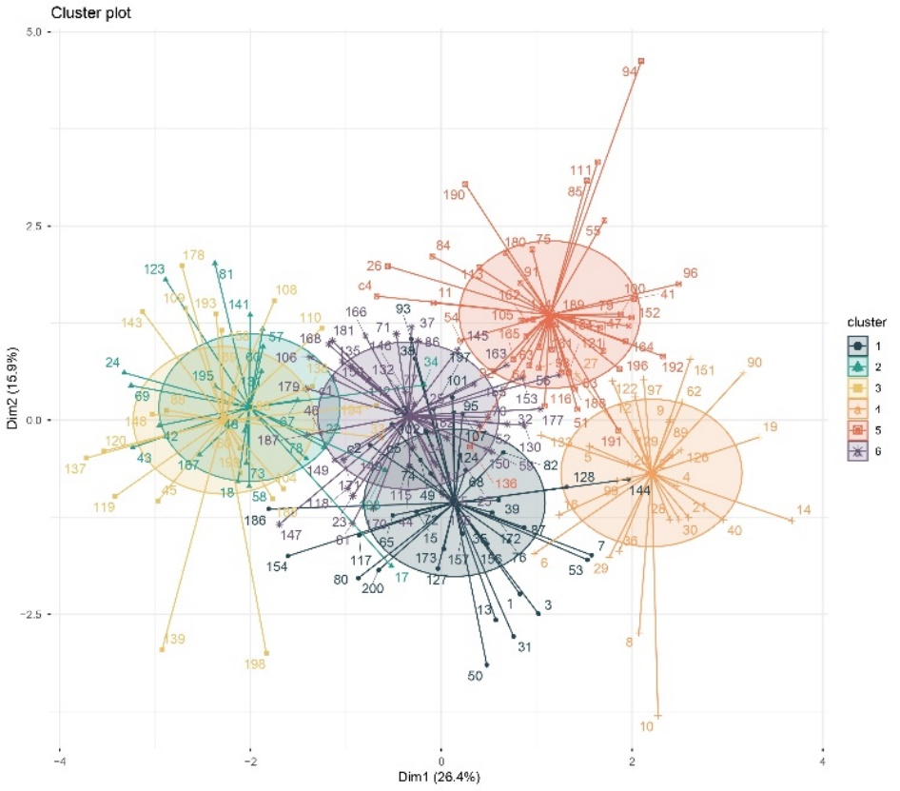

Fig. 1. Cluster analysis for yield and related traits in rice in Environment-1

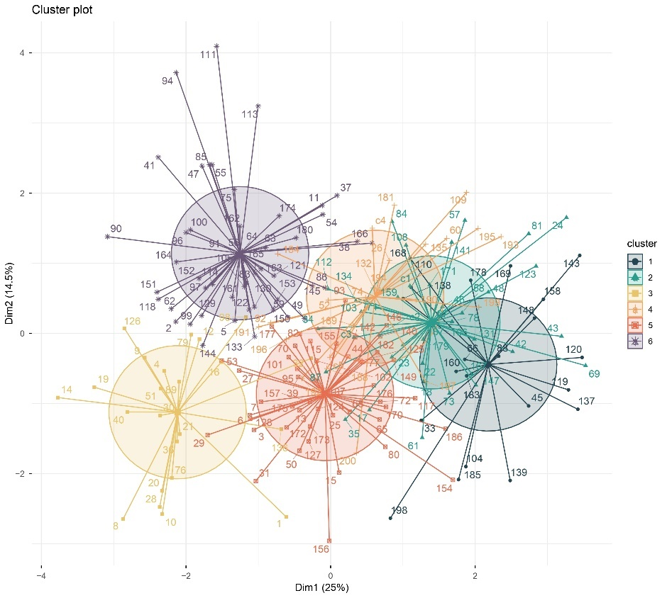
Fig. 2. Cluster analysis for yield and related traits in rice in Environment-2

4. CONCLUSION

The two-environment assessment of the sub set of 3K rice panel demonstrated a consistent yet environmentally responsive pattern of multivariate divergence, with genotypes consistently grouping into six distinct clusters across both the environments. Although the overall clustering framework remained stable, noticeable changes in cluster sizes, mean trait performance and divergence metrics highlighted significant genotype × environment interactions affecting key yield-related characteristics. Distinct ideotypes were identified, ranging from tall, high number of productive tillers, high thousand grain weight, high-single plant yield groups to low-yielding clusters that may serve as donors for specific traits, providing multiple options for targeted improvement.

Clusters 2 and 3 in first environment and 2 and 1 in second environment consistently exhibited superior single plant yields, with moderate to high number of productive tillers per plant, number of spikelets per panicle, panicle length, thousand grain weight made them as reliable donor sources for yield enhancement. Analysis of inter- and intra-cluster distances confirmed considerable genetic divergence, particularly among Clusters 3 and 4 in first environment and clusters 1 and 3 in second environment, offering promising opportunities for heterotic hybrid combinations. The observed structured variability across seasons emphasizes the importance of multi-season evaluation and supports the use of cluster-based parental selection to combine complementary traits effectively.

Overall, the findings provide a solid empirical basis for employing k-means clustering and diversity analysis in maize breeding programs aimed at developing high-yielding, stable and broadly adaptable fodder genotypes for variable production environments. Similar approaches to assess maize diversity have been reported by Sharma et al. (2021), Shrivastav et al. (2022), Singh et al. (2022), Burman et al. (2023), Prasad et al. (2023), Chandana et al (2024), Chandraker et al. (2024) and Sheeba et al. (2025).

DISCLAIMER (ARTIFICIAL INTELLIGENCE)

Author(s) hereby declare that NO generative AI technologies such as Large Language Models (ChatGPT, COPILOT, etc.) and text-to-image generators have been used during the writing or editing of this manuscript.

REFERENCES

Burman, M., Nair, S.K. & Sharma, D. (2023). Assessing the Genetic Diversity for Yield Attributing Traits in Aromatic Rice Landraces Using Multivariate Analysis. International Journal of Bio-resource and Stress Management, 14(9), 1284-1294.
Cornelius Paul, L. (2001). Contributions to multiplicative model analysis of genotype-environment data. Statistical Consulting Section, American Statistical Association, Joint Statistical Meetings. August. 7
Chandana, B., Seeja, G., Surendran, M. & Thara, S.S. (2024). Genetic diversity analysis of rice (Oryza sativa L.) genotypes for yield and sheath blight screening. Journal of Advances in Biology & Biotechnology, 27(11), 413-420.
Chandraker, P., Sharma, B., Parikh, M. & Saxena, R.R. (2024). Assessment of genetic diversity in aromatic short grain rice (Oryza sativa L.) genotypes using pca and cluster analysis. International Journal of Plant & Soil Science, 36(5), 82-94.
Goulet, B.E., Roda, F. & Hopkins, R. (2017). Hybridization in plants: Old ideas, new techniques. Plant Physiology. 173(1): 65-78.
MacQueen J. (1967) Some methods for classification and analysis of multivariate observations. In: Proceedings of the Fifth Berkeley Symposium on Mathematical Statistics and Probability. Vol 1. Berkeley: University of California Press: 281-297.
Prasad, B.D., Pankaj, K. & Sangita, S. (2023). Cluster Analysis of Rice (Oryza Sativa L.) Mutant Lines of Using Morphological Parameters. International Journal of Plant & Soil Science, 35(2), 23-26.
Rana, M. & Bhat, K. (2004). A comparison of AFLP and RAPD markers for geneticdiversity and cultivar identification in cotton. J. Plant Biochem. Biotechnol. 13(1): 19-24.
Singh, S., Singh, S.K., Korada, M., Khaire, A., Singh, D.K., Habde, S.V., Majhi, P.K. & Rai, B., (2022). Morpho-molecular diversity analysis in Rice (Oryza sativa L.) Genotypes using microsatellite markers. Indian J Agricultural Res, 1, 1-8.
Sharma, M., Abdullah, G.M., Salgotra, R.K., Hangloo, S., Singh, A.K., Sharma, V. & Singh, A. (2021). Genetic diversity analysis in rice (Oryza sativa L.) germplasm of Jammu region of Jammu and Kashmir. Indian Journal of Genetics and Plant Breeding, 81(04), 529-537.
Sheeba, A. & Mohan, S. (2025). Genetic Diversity Studies in Drought Tolerant Rice (Oryza sativa L.) Genotypes. Agricultural Science Digest, 45(1), 86-90.
Shrivastav, S.P., Verma, O.P., Lal, K., Singh, V. & Srivastava, K. (2022). Genetic divergence analysis in rice (Oryza sativa L.) germplasms under sodic soil. Indian Journal of Agricultural Research, 1, 5.
Vijay, D., & Roy, B. (2013), Breeding biotechnology and seed production of field crops, chapter-4 rice (Oryza Sativa L.). New India Publishing Agency, 71-122. https://www.researchgate.net/publication/329976319_Rice_Oryza_sativa_L
Van Bavel, J. (2013). The world population explosion: Causes, backgrounds and projection for the future. Facts, views and vision in ObGyn. 5(4): 281.

APPENDIX

Entry no | IRGC NUMBER | Entry no | IRGC NUMBER | Entry no | IRGC NUMBER | Entry no | IRGC NUMBER | Entry no | IRGC NUMBER
1 | IRGC 126156 | 21 | IRGC 128258 | 41 | IRGC 128104 | 61 | IRGC 122165 | 81 | IRGC 128155
2 | IRGC 125607 | 22 | IRGC 127235 | 42 | IRGC 125933 | 62 | IRGC 125630 | 82 | IRGC 125987
3 | IRGC 121954 | 23 | IRGC 127224 | 43 | IRGC 125608 | 63 | IRGC 127215 | 83 | IRGC 127196
4 | IRGC 128180 | 24 | IRGC 127339 | 44 | IRGC 127101 | 64 | IRGC 127327 | 84 | IRGC 127735
5 | IRGC 125781 | 25 | IRGC 131919 | 45 | IRGC 127226 | 65 | IRGC 127835 | 85 | IRGC 127283
6 | IRGC 132323 | 26 | IRGC 127570 | 46 | IRGC 127761 | 66 | IRGC 125869 | 86 | IRGC 127978
7 | IRGC 128393 | 27 | IRGC 125645 | 47 | IRGC 132420 | 67 | IRGC 128118 | 87 | IRGC 121958
8 | IRGC 127355 | 28 | IRGC 128287 | 48 | IRGC 122055 | 68 | IRGC 127832 | 88 | IRGC 128238
9 | IRGC 127110 | 29 | IRGC 121120 | 49 | IRGC 125841 | 69 | IRGC 120921 | 89 | IRGC 125917
10 | IRGC 128085 | 30 | IRGC 127722 | 50 | IRGC 127156 | 70 | IRGC 127966 | 90 | IRGC 127938
11 | IRGC 122053 | 31 | IRGC 117454 | 51 | IRGC 127411 | 71 | IRGC 127545 | 91 | IRGC 128137
12 | IRGC 121005 | 32 | IRGC 127294 | 52 | IRGC 124442 | 72 | IRGC 125887 | 92 | IRGC 125844
13 | IRGC 127155 | 33 | IRGC 128330 | 53 | IRGC 122108 | 73 | IRGC 127907 | 93 | IRGC 121128
14 | IRGC 127430 | 34 | IRGC 128338 | 54 | IRGC 128103 | 74 | IRGC 126123 | 94 | IRGC 132387
15 | IRGC 127030 | 35 | IRGC 128273 | 55 | IRGC 127495 | 75 | IRGC 127945 | 95 | IRGC 127807
16 | IRGC 127729 | 36 | IRGC 121038 | 56 | IRGC 128463 | 76 | IRGC 127100 | 96 | IRGC 122286
17 | IRGC 125629 | 37 | IRGC 127398 | 57 | IRGC 127227 | 77 | IRGC 126140 | 97 | IRGC 128241
18 | IRGC 125654 | 38 | IRGC 126007 | 58 | IRGC 127830 | 78 | IRGC 125931 | 98 | IRGC 125789
19 | IRGC 128297 | 39 | IRGC 127497 | 59 | IRGC 126011 | 79 | IRGC 125877 | 99 | IRGC 126294
20 | IRGC 126199 | 40 | IRGC 126173 | 60 | IRGC 122291 | 80 | IRGC 127713 | 100 | IRGC 127095

Entry no | IRGC NUMBER | Entry no | IRGC NUMBER | Entry no | IRGC NUMBER | Entry no | IRGC NUMBER
101 | IRGC 122285 | 126 | IRGC 127614 | 151 | IRGC 128184 | 176 | IRGC 117446
102 | IRGC 127442 | 127 | IRGC 125989 | 152 | IRGC 127121 | 177 | IRGC 128046
103 | IRGC 127393 | 128 | IRGC 128049 | 153 | IRGC 125610 | 178 | IRGC 128310
104 | IRGC 127944 | 129 | IRGC 126258 | 154 | IRGC 125976 | 179 | IRGC 125696
105 | IRGC 125873 | 130 | IRGC 124421 | 155 | IRGC 126175 | 180 | IRGC 120968
106 | IRGC 122076 | 131 | IRGC 125913 | 156 | IRGC 125609 | 181 | IRGC 121154
107 | IRGC 126223 | 132 | IRGC 127829 | 157 | IRGC 117466 | 182 | IRGC 127879
108 | IRGC 127974 | 133 | IRGC 127745 | 158 | IRGC 128063 | 183 | IRGC 125801
109 | IRGC 128105 | 134 | IRGC 127908 | 159 | IRGC 128004 | 184 | IRGC 128253
110 | IRGC 127956 | 135 | IRGC 125965 | 160 | IRGC 122292 | 185 | IRGC 126966
111 | IRGC 128181 | 136 | IRGC 127864 | 161 | IRGC 127711 | 186 | IRGC 127630
112 | IRGC 127148 | 137 | IRGC 127696 | 162 | IRGC 127975 | 187 | IRGC 128160
113 | IRGC 127448 | 138 | IRGC 131997 | 163 | IRGC 127689 | 188 | IRGC 127550
114 | IRGC 128090 | 139 | IRGC 125950 | 164 | IRGC 127230 | 189 | IRGC 128420
115 | IRGC 127223 | 140 | IRGC 131976 | 165 | IRGC 127268 | 190 | IRGC 127231
116 | IRGC 127533 | 141 | IRGC 121582 | 166 | IRGC 127736 | 191 | IRGC 127918
117 | IRGC 125822 | 142 | IRGC 121974 | 167 | IRGC 125715 | 192 | IRGC 127624
118 | IRGC 126148 | 143 | IRGC 12564 | 168 | IRGC 128126 | 193 | IRGC 127730
119 | IRGC 125614 | 144 | IRGC 122014 | 169 | IRGC 125754 | 194 | IRGC 127636
120 | IRGC 127989 | 145 | IRGC 128162 | 170 | IRGC 127444 | 195 | IRGC 127443
121 | IRGC 132429 | 146 | IRGC 126150 | 171 | IRGC 127982 | 196 | IRGC 132318
122 | IRGC 126159 | 147 | IRGC 121134 | 172 | IRGC 127919 | 197 | IRGC 128128
123 | IRGC 127926 | 148 | IRGC 127217 | 173 | IRGC 121103 | 198 | IRGC 128439
124 | IRGC 132421 | 149 | IRGC 128132 | 174 | IRGC 127322 | 199 | IRGC 135582
125 | IRGC 122232 | 150 | IRGC 127560 | 175 | IRGC 128038 | 200 | IRGC 125959
c1 | Sahyadri Kempumkthi | c3 | Jyothi | c4 | Sahyadri Jalamukthi | c5 | Swarna sub-1
c2 | Sahyadri Jyothi

