Original Research Article
Integrative Ethnobotanical and GC–MS Analysis of Valeriana jatamansi Jones: Pharmacological Potential and Conservation Importance

Abstract
Medicinal plants remain vital to traditional and modern medicine due to their diverse bioactive compounds and cultural significance. The present study integrates ethnobotanical knowledge with phytochemical profiling to explore the medicinal potential of Valeriana jatamansi Jones from the Langate Forest Division, Kashmir. Ethnobotanical surveys revealed the plant’s widespread traditional use for treating neurological, gastrointestinal, and inflammatory ailments. Methanolic rhizome extracts were analyzed using Gas Chromatography–Mass Spectrometry (GC–MS), identifying patchouli alcohol (46.01%), maaliol (26.53%), and calarene (17.39%) as major sesquiterpenes. These oxygenated and hydrocarbon sesquiterpenes contribute to the plant’s sedative, antioxidant, antimicrobial, and anti-inflammatory properties. The convergence of ethnomedicinal practices and chemical evidence supports the traditional therapeutic applications of V. jatamansi Jones and highlights the Langate population as a high patchouli alcohol chemotype. The findings emphasise the need for conservation, sustainable utilization, and validation of indigenous pharmacological knowledge for future phytopharmaceutical development.
Keywords: Valeriana jatamansi Jones; ethnobotany; GC–MS analysis; sesquiterpenes; traditional medicine; Kashmir Himalaya

- Introduction
Medicinal plants have long been a cornerstone of traditional healthcare systems and continue to play a crucial role in both primary healthcare and modern pharmaceutical research. This enduring significance is attributed to their diverse bioactive compounds, as well as their affordability and accessibility (Wu et al., 2023). Ethnopharmacological knowledge, particularly that preserved within Indigenous and rural communities, offers invaluable insights for identifying plants with therapeutic potential and initiating pharmacological and phytochemical investigations (Awoke et al., 2024). However, the sustainability of these resources is increasingly threatened by overharvesting and habitat loss, underscoring the urgent need for conservation and systematic documentation efforts (Chen et al., 2018). Valeriana jatamansi Jones (syn. V. wallichii DC.) is a prominent medicinal herb widely used in Ayurveda, traditional Chinese medicine, and other Asian medical practices to treat neurological and psychosomatic disorders such as anxiety, insomnia, epilepsy, and stress-related ailments (Gautam et al., 2021; Jugran et al., 2020; Yan et al., 2019). Its roots and rhizomes are rich in iridoids, valepotriates, lignans, flavonoids, and sesquiterpenoids, which contribute to its sedative, antidepressant, antioxidant, and antimicrobial properties (He et al., 2025; Yan et al., 2019; Zhang et al., 2017). Ethnobotanical documentation remains a vital effort to preserve vanishing traditional knowledge, especially in biodiverse and culturally diverse regions (Oladeji et al., 2020). Modern ethnobotanical research aims to develop hypothesis-driven and theoretically informed approaches to better understand human-plant interactions and contribute to biodiversity conservation and sustainable resource management (De Albuquerque et al., 2008; Gaoue et al., 2017). Complementing these efforts, gas chromatography–mass spectrometry (GC–MS) has become a key analytical technique for profiling volatile and semi-volatile plant constituents, facilitating quality control and bioactivity-guided studies. In ethnobotanical studies, GC-MS is employed to characterize bioactive compounds in plants traditionally used by indigenous and local communities to treat various ailments. This can help to scientifically validate ethnobotanical knowledge, understand the chemical basis of therapeutic effects, and guide the discovery of novel pharmaceuticals or antioxidants. In summary, ethnobotany and GC-MS complement each other by combining cultural botanical knowledge with precise chemical analyses. This integration aids conservation efforts, supports the sustainable use of plant biodiversity, and fosters novel drug discovery derived from traditional knowledge substantiated by molecular chemical data (Lawson et al., 2020; Póvoa et al., 2024). Within this interdisciplinary context, the present study aimed to comprehensively explore the ethnobotanical and phytochemical significance of Valeriana jatamansi Jones by integrating traditional knowledge with advanced analytical techniques. Specifically, the research sought to document the traditional uses of V. jatamansi Jones among indigenous and local communities, emphasizing its ethnomedicinal applications and cultural relevance. In parallel, Gas Chromatography–Mass Spectrometry (GC–MS) was employed to identify and characterize the plant’s volatile bioactive compounds.

2. Materials and Methods:
2.1 Study area
The research was conducted in the Langate Forest Division (LFD) (Fig.1), positioned at an altitude ranging from 2000 to 3500 m above sea level, with coordinates of 34°15'22′′ N latitude and 74°07'52" E longitude. The terrain is mountainous, experiencing temperate to sub-alpine climate conditions, with annual rainfall averaging between 66 and 167 mm. Temperatures in this area vary from -10°C to 35°C (Nisa et al., 2025).

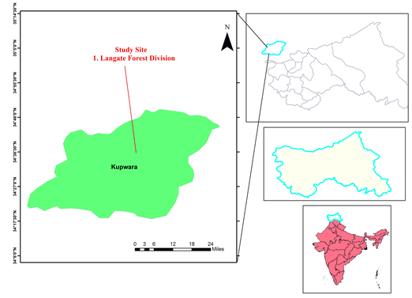

Fig. 1. Map showing the study area of Valeriana jatamansi Jones in the Langate Forest Division, Kupwara District, Jammu and Kashmir, India.
2.2 Field Survey and Collection of Plant Specimens
Field investigations were conducted to document the use of medicinal plants, their methods of administration, and the therapeutic parts involved, with the participation of community elders and healers (Anis et al., 2000). Rhizomes of the species were collected from Mawar and Rafiabad (Langate Forest Division) for extraction and chemical analyses. The samples were authenticated using herbarium vouchers.

2.3 Extraction and GC–MS Analysis of Bioactive Compounds
The air-dried and finely powdered rhizomes were subjected to Soxhlet extraction, followed by filtration as described by Abdel-Lateef et al. (2016). The resulting methanolic extracts were subsequently analyzed using Gas Chromatography–Mass Spectrometry (GC–MS) to characterise the volatile and semi-volatile bioactive constituents. Chromatographic separation was carried out on a capillary column, with helium as the carrier gas. The ionisation mode was electron impact (EI), and compounds were identified by comparing their mass spectra with NIST library databases (Garg et al., 2024).
3. Results
Ethnobotanical documentation from the Langate Forest Division of Kashmir has revealed that Valeriana jatamansi Jones is locally recognized by several vernacular names and is widely used in traditional medicine. The species is commonly referred to as Mushkbala in Kashmiri and Hindi, Bhutijatt in the local Kashmiri dialect, Tagar or Tagara in Sanskrit and Ayurvedic literature. As summarised in Table 1, the roots and rhizomes of V. jatamansi Jones are utilized in multiple traditional preparations. The preparation of dried and powdered roots into herbal teas or infusions aligns with its traditional role in calming the nervous system and promoting sleep, indicating its anxiolytic and sedative properties. GC-MS analysis revealed that the major constituent detected was patchouli alcohol (46.01%), followed by maaliol (26.53%) and calarene (β-gurjunene) (17.39%), indicating that sesquiterpene alcohols and hydrocarbons dominate the volatile composition of the extract (Fig. 1 and Table 2). Valeriana jatamansi Jones is rich in both oxygenated and hydrocarbon sesquiterpenes, dominated by patchouli alcohol, with notable maaliol and calarene levels. Minor constituents include seychellene, β-guaiene, and viridiflorol. These compounds contribute to the plant’s sedative, antioxidant, anti-inflammatory, and antimicrobial properties (Table 3).
Table 1. Vernacular Names and Traditional Preparation Methods of Valeriana jatamansi in Langate Forest Division Kashmir
Aspect | Details
Vernacular names | Mushkbala (Kashmiri / Hindi); Bhutijatt (local Kashmiri name); Tagar / Tagara (Sanskrit / Ayurvedic trade name)
Preparation methods | 1. Roots and rhizomes are dried and powdered to make herbal tea or infusion for calming nerves and improving sleep.  2. Decoction prepared by boiling roots in water is used orally for stomach and nervous disorders.  3. Root paste or oil extract is applied externally to treat skin ailments, wounds, and inflammation.

Table 2. Major Compounds Identified from Valeriana jatamansi by GC–MS
Peak (RT, min) | Compound | Structures | Molecular Weight (g/mol) | Peak Area (%)
38.264 | Patchouli alcohol | 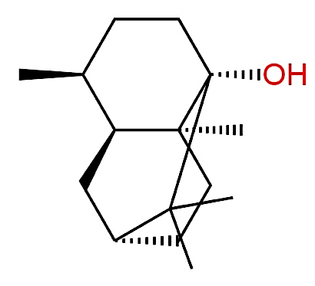 | 222.37 | 46.01
41.815 | Maaliol | 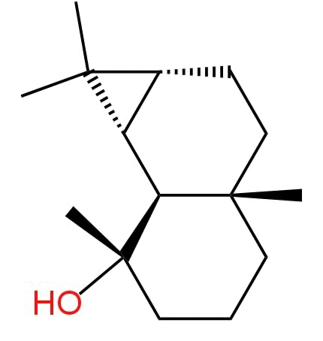 | 220.35 | 26.53
42.997 | β-Guaiene | 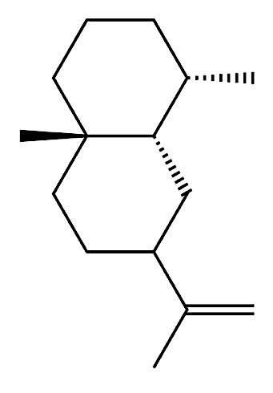 | 204.35 | 1.54
43.154 | Seychellene | 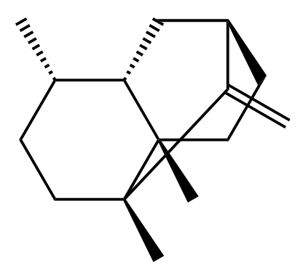 | 204.35 | 5.13
58.329 | Viridiflorol | 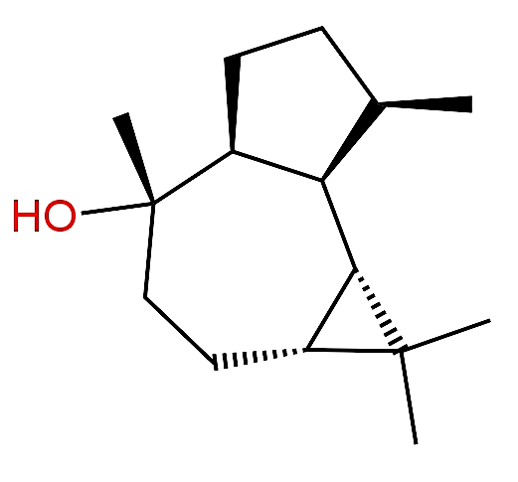 | 222.37 | 3.40
60.030 | Calarene (β-gurjunene) | 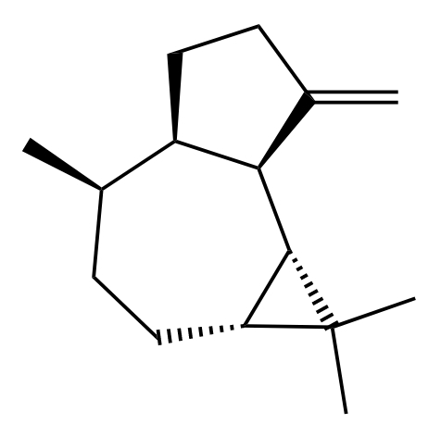 | 204.35 | 17.39

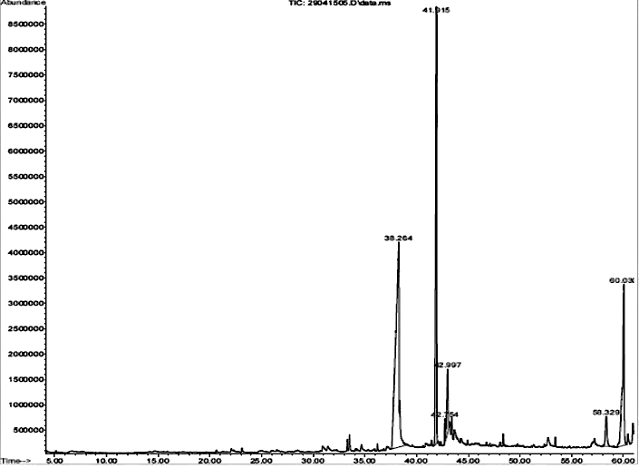
Fig. 2. GC-MS chromatogram

Table 3. Major sesquiterpene compounds identified in Valeriana jatamansi Jones, their chemical classes, approximate concentration ranges reported in previous studies, and key pharmacological or bioactive properties as documented in the literature.
Compound | Chemical class | Approx. range in other studies of V. jatamansi | Key reported activities
Patchouli alcohol | Oxygenated sesquiterpene alcohol | ~7–70% in different populations | Sedative, antioxidant, anti-inflammatory, antimicrobial, cytotoxic (Jugran et al., 2019; Çelik & Kırmızıbekmez, 2025; Thusoo et al., 2014; Maurya et al., 2021; Chen et al., 2021)
Maaliol | Oxygenated sesquiterpene alcohol | 0.3–28% | Antimicrobial, anti-inflammatory (in other aromatic species) (Çelik & Kırmızıbekmez, 2025; Thakur et al., 2022)
Calarene (β-Gurjunene) | Sesquiterpene hydrocarbon | 3–9% (often) | Antimicrobial, anti-inflammatory (reported in essential oils) (Cornara et al., 2020; Thusoo et al., 2014)
Seychellene | Sesquiterpene hydrocarbon | Increases with repeated distillation | Antioxidant, antimicrobial (in other plant oils) (Thakur et al., 2022; Thusoo et al., 2014)
β-Guaiene | Sesquiterpene hydrocarbon | Typically minor | Antioxidant, antimicrobial (in related species) (Jugran et al., 2019; Thusoo et al., 2014)
Viridiflorol | Oxygenated sesquiterpene alcohol | Usually low | Antimicrobial, anti-inflammatory (various reports) (Çelik & Kırmızıbekmez, 2025; Thusoo et al., 2014)

Fig 3. Distribution of sesquiterpene classes in Valeriana jatamansi Jones showing an equal proportion of oxygenated sesquiterpene alcohols and non-oxygenated (hydrocarbon) sesquiterpenes, each constituting 50% of the total identified compounds.

Discussion

4.1 Convergence of ethnobotanical knowledge with phytochemical and pharmacological evidence
The present study, conducted in the Langate Forest Division of Kashmir, underscores a notable alignment between traditional ethnomedicinal practices and the phytochemical composition of Valeriana jatamansi Jones. The widespread use of this plant for neurological and psychological conditions such as insomnia, anxiety, nervousness, and stress aligns with its historical significance in Himalayan ethnomedicine and Ayurvedic texts (Jugran et al., 2019; Mir et al., 2024). The frequent use of its dried roots and rhizomes in teas, decoctions, and topical applications reflects a sophisticated indigenous understanding of dosage, preparation, and therapeutic precision. GC–MS analysis identified patchouli alcohol as the main component (46.01%), with maaliol and calarene following, indicating that sesquiterpene alcohols and hydrocarbons dominate the volatile profile of the Langate population. This chemical composition provides a solid mechanistic basis for the sedative, anxiolytic, antioxidant, and anti-inflammatory properties traditionally associated with V. jatamansi Jones. Patchouli alcohol is well-documented for its ability to influence central nervous system activity via GABAergic pathways, antioxidant defences, and anti-neuroinflammatory effects (Thusoo et al., 2014; Chen et al., 2021). The presence of oxygenated sesquiterpenes like maaliol and viridiflorol further broadens the bioactivity range, particularly in antimicrobial and anti-inflammatory actions, supporting its external use for skin conditions and wound healing as noted by local practitioners. Notably, similar ethnobotanical trends have been observed throughout the Kashmir Himalaya, where V. jatamansi Jones is highly valued for treating neurological and digestive issues (Mir et al., 2024). These findings thus affirm the conceptual harmony between traditional medical systems and contemporary phytochemical validation.

4.2 Chemotypic significance of the Langate Forest Division population
Significant chemotypic diversity has been observed in V. jatamansi Jones across its Himalayan and trans-Himalayan range, with populations exhibiting notable differences in sesquiterpene prevalence and the relative concentration of patchouli alcohol (He et al., 2018; Maurya et al., 2021; Thakur et al., 2022). The Langate population is distinctly classified under the high patchouli alcohol chemotype, a profile previously identified in certain areas of Himachal Pradesh and Uttarakhand but rarely documented in the Kashmir Himalaya with comprehensive ethnobotanical evidence (Bisht et al., 2020). This chemotypic variation has significant implications. Firstly, the pharmacological effectiveness is greatly influenced by the proportions of oxygenated sesquiterpenes, which have greater bioavailability and biological activity compared to their hydrocarbon counterparts. Studies on electrophysiological responses and acetylcholinesterase inhibition have shown that essential oils rich in patchouli alcohol and similar oxygenated sesquiterpenes exhibit stronger CNS depressant and anxiolytic properties (Cornara et al., 2020). Secondly, chemotypic profiling is crucial for the quality control and standardization of herbal formulations. Patchouli alcohol and calarene are now recognized as reliable chemical markers for the authentication and efficacy evaluation of V. jatamansi-based products (Jugran et al., 2019; Wang et al., 2024). The 1:1 ratio of oxygenated to non-oxygenated sesquiterpenes found in the Langate population indicates a balanced and pharmacologically adaptable chemotype. Thirdly, from a conservation and cultivation perspective, identifying high-value chemotypes provides a scientific basis for selecting superior germplasm for ex-situ propagation and sustainable agricultural programs, thereby alleviating pressure on wild populations (He et al., 2018; Dhiman et al., 2020; Thakur et al., 2022).

4.3 Conservation urgency, sustainability, and protection of traditional knowledge
The integration of ethnobotanical and phytochemical data must be interpreted against the backdrop of escalating conservation threats. Valeriana jatamansi Jones is extensively harvested for its roots and rhizomes, a practice that impedes population recovery and has resulted in localized depletion across the Himalayan region (Dhiman et al., 2020; Jugran et al., 2021; Charmakar et al., 2021). In the Kashmir Himalaya, uncontrolled harvesting, combined with habitat fragmentation and the erosion of traditional knowledge, has further strained natural populations (Rashid et al., 2018; Mir et al., 2024). A study from Nepal and the western Himalayas indicates a strong dependence on wild-harvested resources for livelihoods, alongside a decline in the availability of chemically potent germplasm, necessitating the urgent implementation of sustainable harvesting practices and cultivation-based supply chains (Charmakar et al., 2021; Thakur et al., 2022). The Langate population's high patchouli alcohol content underscores its importance as a key conservation unit. Equally significant is the documentation of local names, preparation methods, and therapeutic uses, which not only preserves intangible cultural heritage but also provides a solid foundation for fair benefit-sharing and intellectual property rights. This documentation aligns with the Nagoya Protocol and India's national biodiversity policies, ensuring the recognition and rights of indigenous knowledge holders (Jugran et al., 2021; Wang et al., 2024; Mbelebele et al., 2024). Therefore, the Langate Forest Division case study exemplifies how well-documented ethnobotanical knowledge, when paired with comprehensive phytochemical analysis, can establish a scientifically robust and ethically sound framework for researching medicinal plants. The identification of a high-value chemotype, coupled with its significant traditional use, underscores V. jatamansi Jones as a pivotal species for conservation-focused phytopharmaceutical development in the Kashmir Himalaya. Such integrative strategies are essential for balancing biodiversity conservation, cultural resilience, and the sustainable use of Himalayan medicinal plant resources.
Conclusion
This study bridges traditional ethnobotanical knowledge and modern phytochemical analysis to validate the therapeutic relevance of Valeriana jatamansi Jones from Kashmir’s Langate Forest Division. The predominance of patchouli alcohol and other sesquiterpenes provides strong biochemical support for its traditional use in managing neurological and inflammatory disorders. The discovery of a unique high patchouli alcohol chemotype highlights the pharmacological significance and conservation importance of the species. Recording local vernacular names, traditional preparation techniques, and community-based practices not only safeguards cultural heritage but also contributes to informed and sustainable resource management. Overall, the integration of GC–MS-based profiling with ethnomedicinal documentation establishes a replicable framework for conserving biodiversity and advancing evidence-based traditional medicine in the Himalayan region.
References

Abdel-Lateef, E., El-Ahwany, E., Hassenein, H., El-Wakil, E., Hammam, O., Mahmoud, F., Kandil, S., Taleb, H., El-Sayed, M. M., & Hassenein, H. I. (2016). Bioactive chemical constituents of Curcuma longa L. rhizomes extract inhibit the growth of human hepatoma cell line (HepG2). Acta Pharmaceutica, 66(3), 387–398. https://doi.org/10.1515/acph-2016-0028
Anis, M., Sharma, M. P., & Iqbal, M. (2000). Herbal ethnomedicine of the Gwalior Forest Division in Madhya Pradesh, India. Pharmaceutical Biology, 38(4), 241–253. https://doi.org/10.1076/1388-0209(200009)3841-AFT241
Awoke, A., Gudesho, G., Akmel, F., & Shanmugasundaram, P. (2024). Traditionally used medicinal plants for human ailments and their threats in Guraferda District, Benchi-Sheko zone, Southwest Ethiopia. Journal of Ethnobiology and Ethnomedicine, 20(1). https://doi.org/10.1186/s13002-024-00709-5
Bisht B, Karki G, Padalia R, Kowalski P. Significant definitions. 2020. DOI: 10.1056/nejm197701132960236
Bisht VK, Kandari LS, Negi JS. Chemical composition and chemotypic variation of Valeriana jatamansi essential oil from different Himalayan regions. Journal of Applied Research on Medicinal and Aromatic Plants. 2020;18:100260. DOI: 10.1016/j.jarmap.2020.100260
Çelik C, Kırmızıbekmez H. The genus Valeriana L.: ethnopharmacology, phytochemistry and biological activities—an updated review. Phytochemistry Reviews. 2025;24:3337–3441. https://link.springer.com/article/10.1007/s11101-024-10061-x
Çelik, C., & Kırmızıbekmez, H. (2025). The genus Valeriana L.: ethnopharmacology, phytochemistry and biological activities—an updated review. Phytochemistry Reviews. https://doi.org/10.1007/s11101-024-10061-x

Charmakar S, Kunwar R, Sharma H, Rimal B, Baral S, Joshi N, et al. Production, distribution, use and trade of Valeriana jatamansi Jones in Nepal. Global Ecology and Conservation. 2021. https://doi.org/10.1016/j.gecco.2021.e01792

Charmakar S, Shrestha BB, Rokaya MB. Harvesting pressure, trade, and conservation status of Valeriana jatamansi in Nepal Himalaya. Journal of Ethnobiology and Ethnomedicine. 2021;17:62. DOI: 10.1186/s13002-021-00493-8

Chen, G., Kongkiatpaiboon, S., Wang, X., Sun, W., & Cai, X. (2018). Conserving threatened widespread species: a case study using a traditional medicinal plant in Asia. Biodiversity and Conservation. https://doi.org/10.1007/s10531-018-1648-1

Chen, J., Xie, X., Li, M., Xiong, Q., Li, G., Zhang, H., Chen, G., Xu, X., Yin, Y., Peng, F., & Peng, C. (2021). Pharmacological activities and mechanisms of action of Pogostemon cablin Benth: a review. Chinese Medicine. https://doi.org/10.1186/s13020-020-00413-y
Chen Y, Zhou C, Ge Z, Liu Y, Liu Y, Feng W, Li S. Patchouli alcohol: Pharmacological activities and mechanisms of action. Phytomedicine. 2021;83:153477. DOI: 10.1016/j.phymed.2021.153477
Cornara, L., Ambu, G., Trombetta, D., Denaro, M., Alloisio, S., Frigerio, J., Labra, M., Ghimire, G., Valussi, M., & Smeriglio, A. (2020). Comparative and functional screening of three species traditionally used as antidepressants: Valeriana officinalis L., Valeriana jatamansi Jones ex Roxb. and Nardostachys jatamansi (D.Don) DC. Plants, 9. https://doi.org/10.3390/plants9080994

Cornara, L., Ambu, G., Trombetta, D., Denaro, M., Alloisio, S., Frigerio, J., Labra, M., Ghimire, G., Valussi, M., & Smeriglio, A. (2020). Comparative and functional screening of three species traditionally used as antidepressants: Valeriana officinalis L., Valeriana jatamansi Jones ex Roxb. and Nardostachys jatamansi (D.Don) DC. Plants. https://doi.org/10.3390/plants9080994

Albuquerque, U. P., Araujo, T., Ramos, M. A., Nascimento, V., Araújo, E. L., Alencar, N. L., & Monteiro, J. M. (2008). How ethnobotany can aid biodiversity conservation: Reflections on investigations in the semi-arid region of NE Brazil. *Biodiversity and Conservation*, *18*(1), 127–150. https://doi.org/10.1007/s10531-008-9463-8

Pal, P. K., Dhiman, B., Sharma, P., & Manhas, S. (2020). Biology, chemical diversity, agronomy, conservation and industrial importance of Valeriana jatamansi: A natural sedative. Journal of Applied Research on Medicinal and Aromatic Plants. https://doi.org/10.1016/j.jarmap.2020.100243

Dhiman, N., & Bhattacharya, A. (2020). Nardostachys jatamansi (D.Don) DC.-Challenges and opportunities of harnessing the untapped medicinal plant from the Himalayas. Journal of Ethnopharmacology. https://doi.org/10.1016/j.jep.2019.112211
Dhiman A, Nain P, Kumar A. Conservation status, cultivation prospects, and sustainable utilization of Valeriana jatamansi in the Indian Himalaya. Environmental Monitoring and Assessment. 2020;192:740. DOI: 10.1007/s10661-020-08657-3
Gaoue, O. G., Bond, M., Hart, G., Seyler, B. C., Coe, M. A., & McMillen, H. (2017). Theories and major hypotheses in ethnobotany. Economic Botany, 71(3), 269–287. https://doi.org/10.1007/s12231-017-9389-8

Gautam, R. D., Kumar, A., Kumar, R., Chauhan, R., Singh, S., Kumar, M., Kumar, D., Kumar, A., & Singh, S. (2021). Clonal Propagation of Valeriana jatamansi Retains the Essential Oil Profile of Mother Plants: An Approach Toward Generating Homogenous Grade of Essential Oil for Industrial Use. Frontiers in Plant Science. https://doi.org/10.3389/fpls.2021.738247

Garg, G., Bharadwaj, A., Chaudhary, S., & Gupta, V. (2024). Chemical profiling of bioactive compounds in the methanolic extract of wild leaf and callus of Vitex negundo using gas chromatography-mass spectrometry. World Journal of Experimental Medicine, 14(1). https://doi.org/10.5493/wjem.v14.i1.88064
He, X., Wang, S., Shi, J., Sun, Z., Lei, Z., Yin, Z., Qian, Z., Tang, H., & Xie, H. (2018). Genotypic and environmental effects on the volatile chemotype of Valeriana jatamansi Jones. Frontiers in Plant Science. https://doi.org/10.3389/fpls.2018.01003

He, Y., Lu, J., Pang, R., Ding, L., Wang, Y., Xiao, H., Cheng, C., Luo, Y., Hu, X., & Wang, W. (2025). Iridoids derived from Valeriana jatamansi Jones alleviates neuroinflammation and blood spinal cord barrier permeability after spinal cord injury by activating the Nrf2/HO-1 signaling pathway. Frontiers in Pharmacology, 16. https://doi.org/10.3389/fphar.2025.1597719
He Y, Xiao H, Deng C, Xiong J, Yang X. Genetic and chemical diversity of Valeriana jatamansi populations from China and the Himalayas. Industrial Crops and Products. 2018;124:552–560. DOI: 10.1016/j.indcrop.2018.08.036
Jugran, A. K., Bhatt, I. D., & Rawal, R. S. (2021). Cultivation and utilization of Valeriana jatamansi Jones for conservation planning and management. In Medicinal Plants, Sustainable Development and Biodiversity. https://doi.org/10.1007/978-3-030-74779-4_5

Jugran, A. K., Rawat, S., Bhatt, I. D., & Rawal, R. S. (2019). Valeriana jatamansi: An herbaceous plant with multiple medicinal uses. Phytotherapy Research. https://doi.org/10.1002/ptr.6245

Jugran, A. K., Rawat, S., Bhatt, I. D., & Rawal, R. S. (2020). Essential oil composition, phenolics and antioxidant activities of Valeriana jatamansi at different phenological stages. Plant Biosystems, 155(4), 891–898. https://doi.org/10.1080/11263504.2020.1810803
Jugran AK, Bhatt ID, Rawat S, Nandi SK. Valerianaceae in the Indian Himalayan Region: Ethnobotany, phytochemistry, and pharmacology. Journal of Ethnopharmacology. 2019;236:164–177. DOI: 10.1016/j.jep.2019.02.036
Jugran AK, Rawat S, Bhatt ID. Integrating ethnobotany and conservation biology for Himalayan medicinal plants. Biodiversity and Conservation. 2021;30:3735–3755. DOI: 10.1007/s10531-021-02238-1
Lawson, S. K., Sharp, L. G., Powers, C. N., McFeeters, R. L., Satyal, P., & Setzer, W. N. (2020). Volatile Compositions and Antifungal Activities of Native American Medicinal Plants: Focus on the Asteraceae. Plants, 9(1), 126. https://doi.org/10.3390/plants9010126

Maurya, A. K., Sharma, A., Kumar, K., Chander, R., Kumar, A., Kumar, D., Padwad, Y. S., Chand, G., & Agnihotri, V. K. (2021). Comparative studies of essential oils composition and cytotoxic activity of Valeriana jatamansi Jones. Journal of Essential Oil Research, 33, 584–591. https://doi.org/10.1080/10412905.2021.1966846
Maurya AK, Semwal DK, Rawat U, Semwal RB. Chemotypic variation and pharmacological relevance of Valeriana jatamansi essential oil. Biochemical Systematics and Ecology. 2021;94:104201. DOI: 10.1016/j.bse.2020.104201
Mbelebele, Z., Mdoda, L., Ntlanga, S. S., Nontu, Y., & Gidi, L. S. (2024). Harmonizing Traditional Knowledge with Environmental Preservation: Sustainable Strategies for the Conservation of Indigenous Medicinal Plants (IMPs) and Their Implications for Economic Well-Being. Sustainability. https://doi.org/10.3390/su16145841
Mbelebele M, Chikowe I, van Wyk B-E. Ethnobotanical knowledge protection and benefit-sharing under the Nagoya Protocol. Journal of Ethnobiology and Ethnomedicine. 2024;20:14. DOI: 10.1186/s13002-024-00618-3
Mir, A. M., Mir, B. A., & Peer, L. A. (2024). Medicinal plants of the Himalayan Tral region of Kashmir, India: an ethnobotanical study of their diversity, use patterns, and health implications. Ethnobotany Research and Applications. https://doi.org/10.32859/era.27.33.1-19

Mir SA, Rashid A, Bhat AA. Ethnomedicinal knowledge of threatened Himalayan medicinal plants in Kashmir Valley. Ethnobotany Research and Applications. 2024;27:1–18. DOI: 10.32859/era.27.1

Nisa, M. M. U., Sofi, P. A., Ahmad, P. I., Masoodi, K. Z., Pala, N. A., Bhat, G. M., Bhat, T. B., Rahman, F., Haq, S. I. U., & Abid, T. (2025). Phytochemical profiling and ethnobotanical study of Podophyllum hexandrum Royle.: Insights from Langate Forest Division, Jammu and Kashmir. International Journal of Environment and Climate Change, 15(4), 91–103. https://doi.org/10.9734/ijecc/2025/v15i44795

Oladeji, O. S., Oluyori, A. P., Adelowo, F. E., & Bankole, D. T. (2020). Ethnobotanical description and biological activities of Senna alata. *Evidence-Based Complementary and Alternative Medicine*, *2020*, Article ID 2580259. https://doi.org/10.1155/2020/2580259

Patan, A. (2018). Valeriana jatamansi: An ethnobotanical review. Asian Journal of Pharmaceutical and Clinical Research. https://doi.org/10.22159/ajpcr.2018.v11s4.31706

Patan, A. (2018). VALERIANA JATAMANSI: AN ETHNOBOTANICAL REVIEW. Asian Journal of Pharmaceutical and Clinical Research. https://doi.org/10.22159/ajpcr.2018.v11s4.31706

Póvoa, O., Farinha, N., Lopes, V., Machado, A. M., & Figueiredo, A. C. (2024). Coriander (Coriandrum sativum L.) from Alentejo (South Portugal)—Ethnobotany and Potential Industrial Use. Foods, 13(6), 929. https://doi.org/10.3390/foods13060929

Rashid, N., Gbedomon, R. C., Ahmad, M., Salako, V. K., Zafar, M., & Malik, K. (2018). Traditional knowledge on herbal drinks among indigenous communities in Azad Jammu and Kashmir, Pakistan. Journal of Ethnobiology and Ethnomedicine, 14(1), 16. https://doi.org/10.1186/s13002-018-0217-8

Rashid A, Anand VK, Serwar J. Less known wild edible and medicinal plants of Kashmir Himalaya. Indian Journal of Traditional Knowledge. 2018;17:704–715

Thakur, B. K., Shivani, Mahajan, M., & Pal, P. K. (2022). Chemical Diversity of Essential Oil of Valeriana jatamansi from Different Altitudes of Himalaya and Distillation Methods. Molecules. https://doi.org/10.3390/molecules27082387

Thakur, B. K., Mahajan, M., & Pal, P. K. (2022). Chemical Diversity of Essential Oil of Valeriana jatamansi from Different Altitudes of Himalaya and Distillation Methods. Molecules. https://doi.org/10.3390/molecules27082387

Thusoo, S., Gupta, S., Sudan, R., Kour, J., Bhagat, S., Hussain, R., & Bhagat, M. (2014). Antioxidant activity of essential oil and extracts of Valeriana jatamansi roots. BioMed Research International. https://doi.org/10.1155/2014/614187

Thusoo, S., Gupta, S., Sudan, R., Kour, J., Bhagat, S., Hussain, R., & Bhagat, M. (2014). Antioxidant activity of essential oil and extracts of Valeriana jatamansi roots. BioMed Research International. https://doi.org/10.1155/2014/614187

Wang, Z., Shi, Y., Zhang, X., Sun, J., Guo, D., Luan, F., Zhao, G., & Zou, J. (2024). Research progress in the ethnopharmacology, phytochemistry, pharmacology, toxicology, and quality control of Valeriana jatamansi Jones. Journal of Ethnopharmacology, 332, 118403. https://doi.org/10.1016/j.jep.2024.118403
Wang Y, Li X, Zhang J, Chen S. Pharmacological mechanisms and quality markers of Valeriana species. Frontiers in Pharmacology. 2024;15:1298745. DOI: 10.3389/fphar.2024.1298745
Wu, P., Wu, W., Zhang, S., Han, J., Liu, C., Yu, H., Chen, X., & Chen, X. (2023). Therapeutic potential and pharmacological significance of extracellular vesicles derived from traditional medicinal plants. Frontiers in Pharmacology. https://doi.org/10.3389/fphar.2023.1272241

Wang, L., Sun, Y., Zhao, T., Li, Y., Zhao, X., Zhang, L., Wu, L., Zhang, L., Zhang, T., Wei, G., Altamirano, A., Tong, Y., & Yan, Z. (2020). Antidepressant effects and mechanisms of the total iridoids of Valeriana jatamansi on the brain-gut axis. Planta Medica, 86(3), 172–179. https://doi.org/10.1055/a-1068-9686

Zhang, X. M., Zhu, J. L., Sun, Y., Dai, Y. L., Chen, X., Cao, J. H., Yang, R. C., Chen, C., Ma, C. Y., Zhang, T. E., Chen, Y. H., & Yan, Z. Y. (2018). Anxiolytic potency of iridoid fraction extracted from Valeriana jatamansi Jones and its mechanism: a preliminary study. Natural Product Research, 32(17), 2071–2075. https://doi.org/10.1080/14786419.2017.1360881
Zhao, S., Ji, X., Li, J., Han, D., Yang, L., Huang, Y., et al. (2025). Valeriana Jatamansi: An Overview of Phytochemistry, Pharmacology, Clinical Prospects, and Network Analysis of Drug Targets. American Journal of Chinese Medicine, 53(4), 1027–1063. https://doi.org/10.1142/S0192415X25500399

