Original Research Article

Land Suitability Evaluation for Cocoa (Theobroma cacao L) in the Rembangan Sub Watershed Jember Regency

.
ABSTRACT

The development of cocoa plants requires data and information regarding land potential and land suitability class assessment based on the physical and chemical properties of the soil in order to achieve optimal productivity. The objective of this study was to provide information on land suitability for cocoa cultivation in the Rembangan Sub-watershed. The research was conducted using a descriptive-exploratory method, with soil sampling carried out through a purposive random sampling technique, and by collecting both primary and secondary data. Soil samples were analyzed in the laboratory, followed by matching land qualities with land characteristics. The results showed that the land characteristics in the Sub watershed area were divided into two actual land suitability classes: S3 (marginally suitable) and N (not suitable), with limiting factors including soil texture, base saturation, pH H₂O, total nitrogen (N-total), available phosphorus (P₂O₅), available potassium (K₂O), slope gradient, and erosion hazard. Improvement efforts that can be implemented include the application of dolomite, urea fertilizer, SP-36 fertilizer, KCl fertilizer, as well as the construction of terraces and infiltration pits (rorak). After improvement measures were applied, the potential land suitability classes became S2 (moderately suitable), S3 (marginally suitable), and N (not suitable).

Keywords: Land evaluation, Land suitability, Cocoa plant, Matching method, Fertilizer recommendation

1. INTRODUCTION

The plantation subsector is one of the subsectors that plays an important role in increasing the country's income. In 2022, this subsector contributed 3.76% to the Gross Domestic Product (GDP) followed by the food crops subsector with 2.32%, the livestock subsector with 1.52%, and the horticulture sector with 1.44%. The plantation subsector also serves as a supplier of industrial raw materials, an absorber of labor and a source of foreign exchange earnings. The export value of Indonesia’s plantation commodities reached 59.56 billion USD in 2022 (BPS, 2023). Cocoa is the third-largest contributor in the plantation sector with an export value of 2.27 billion USD thus playing an important role in boosting the economy.

Cocoa (Theobroma cacao L.) is one of the important plantation commodities that supports the development of the agricultural sector. In addition to being a source of foreign exchange cocoa also serves as one of the pillars of the national economy (Mustaman et al., 2019). Indonesia is the largest cocoa producer and exporter in Asia and ranks third in the world after Ghana and Pantai Gading. However, in recent years the cocoa plantation area in Indonesia has continued to decline. In 2019 the total area reached approximately 1.56 million hectares but it decreased to 1.39 million hectares in 2023. This decline is due to land conversion to other commodities considered more profitable. As a result the national average cocoa production decreased by around 14% from 2019 to 2023 (BPS, 2024). Meanwhil cocoa productivity which was recorded at 721 kg/ha in 2019 dropped to 715 kg/ha in 2022 (BPS, 2023).

Jember Regency is one of the regions that cultivates cocoa plants. Based on data from the Ministry of Agriculture of the Republic of Indonesia in 2021 and 2022 the cocoa plantation area was recorded at 1.148 hectares. However, during this period production decreased from 550 kg/ha to 547 kg/ha. Productivity also declined from 754 kg/ha in 2021 to 751 kg/ha in 2022. Although the decrease is relatively small it can still cause losses for both farmers and the plantation sector.

The Rembangan Sub watershed in Jember Regency is dominated by the agricultural sector and has great potential. Most of the population works in agriculture, particularly in food crops and plantation commodities. One of the main plantation crops in this area is coffee. Coffee plants have characteristics that are quite similar to cocoa especially in terms of climate and growing environment, such as rainfall ranging from 2.000–3.000 mm, air temperature between 21–25°C, and an altitude of 300–800 meters above sea level (Astuti et al., 2021). Therefore, appropriate land-use planning through land suitability evaluation is necessary. The goal is to minimize the risk of crop failure and to identify the potential of land for cocoa cultivation. With this approach, it is expected that cocoa plants can grow well, productivity can increase, and the regional economy can benefit positively.

Land evaluation is the process of assessing land resources for specific purposes using proven effective methods or approaches which include the interpretation of surveys and studies of landforms soils, vegetation, climate, and other aspects in order to identify and compare potential land uses. The results of this evaluation provide information about the suitability of the land for particular requirements. According to FAO (1976) as cited in Hardjowigeno & Widiatmaka (2018), land evaluation should take into account economic, social, and environmental aspects.

Land suitability is a measure of how well a particular land area can be used including for cocoa cultivation (Bakhtiar et al., 2021). The level of land suitability indicates the land’s ability to support plant growth based on its properties and characteristics (Dewantara & Azis, 2021). Therefore, it is important to conduct land assessment or evaluation before planting. Information about the land suitability class for cocoa can help optimize the development of cocoa plantations.

2. material and methods

The method used in this study was a descriptive-explorative method based on land unit maps. Land units were created by overlaying data on soil type, slope, and land use. The results of this overlay showed that the Rembangan Sub-watershed consists of 24 land mapping units, which served as the basis for observing land characteristics, as shown in Figure 1. Soil samples were collected from each land mapping unit without replication, with five sampling points taken per unit and then composited. Soil sampling was carried out at a depth of 0–20 cm.

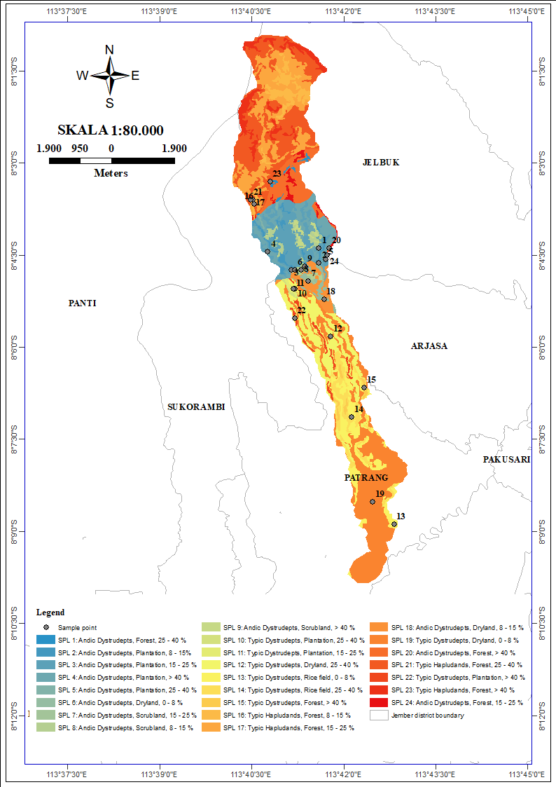

Fig. 1. Land Unit Map (LMU) and Sample Point Collection
The analysis included various chemical and physical properties of the soil. This study utilized a combination of data including secondary data collected from various related institutions. The methods and references are presented in Table 1.

Table 1. Land characteristic methods and references
Land Characteristics | Method | Reference
Soil Texture | Hydrometer | (Bouyoucos, 1927)
Soil pH | Measurement using pH meter 1:5 | (Eviati & Sulaiman, 2009)
N-Total | Kjeldahl | (Kjeldahl, 1883)
Available P | Olsen & Bray | (Olsen et al.. 1954; Bray & Kurtz, 1945)
Available K | NH₄OAc Extract 1M pH 7 | (Chapman, 1965)
Cation Exchange Capacity (CEC) | NH₄OAc Extract 1M pH 7 | (Chapman, 1965)
Ca, Na, Mg | NH₄OAc Extract 1M pH 7 | (Chapman, 1965)
C-Organic | Walkley & Black | (Walkley & Black, 1934)
Salinitas (DHL) | Measurement using EC Meter | (Eviati & Sulaiman, 2009)
Temperature (℃) | Citra Satelit (MODIS) | https://lpdaac.usgs.gov/products/mod11a2v061/
Rainfall (2014-2023) (mm/tahun) | Citra Satelit (CHIRPS) | https://www.chc.ucsb.edu/data/chirps
Slope (%) | Spatial Analysis | (Moore et al., 1991)
Erosion Hazard (ton/ha/tahun) | USLE | (Wischmeier & Smith, 1978)
Soil Depth (cm) | Field Observation | (Sukarman et al.. 2017)
Drainage | Field Observation | (Sukarman et al.. 2017)

The determination of land suitability level was carried out using the matching method. This method is used to compare land characteristics with the growth requirements of cocoa plants. The growth requirements were obtained from the book published by the Indonesian Center for Agricultural Land Resources Research and Development (BBSDLP, 2016). The growth requirements of cocoa plants are presented in Table 2.

Table 2. Cocoa plant growth requirements
Land use requirements  /Land characteristics | Land suitability class
Land use requirements  /Land characteristics | S1 | S2 | S3 | N
Temperature (tc)
Annual average temperature (°C) | 25-28 | >28-32 | >32-33 | >33
 |  | 20-<25 |  | <20
Water availability (wa)
Rainfall (mm/year) | 1.500 - 2.500 | 1.250- <1.500 | 1.100-1.250 | <1.100
 |  | >2.500–3.000 | >3.000-3.500 | >3.500
Number of dry months (<60 mm/month) | <2 | >2-3 | >3-5 | >5
Oxygen availability (oa)
Drainage | good, moderately good | moderately impeded | impeded, moderately rapid | Very impeded, rapid
Rooting media (rc)
Texture | fine, moderately fine | medium | Moderately coarse, very fine | coarse
Soil depth (cm) | >100 | 75-100 | 50-75 | <50
Nutrient retention (nr)
CEC (cmol/kg) | >16 | 5-16 | <5 | -
Base saturation (%) | >35 | 20-35 | <20 | -
pH H₂O | 6.0-7.0 | 5.5-6.0 | <5.5
 |  | 7.0-7.6 | >7.6
C-organik | >1.2 | 0.8-1.2 | <0.8 | -
Available nutrients (na)
N total (%) | >0.21 | 0.1-0.2 | <0.1 | -
Available P₂O₅ (ppm) | >16 | 10-15 | <10 | -
K₂O (me/100g) | >0.3 | 0.1-0.3 | <0.1 | -
Toxicity (xc)
Salinity (dS/m) | <1.1 | 1.1-1.8 | 1.8-2.2 | >2.2
Erosion hazard (eh)
Slope (%) | <8 | 8-15 | 15-40 | >40
Erosion hazard | Very slight | slight-moderate | heavy | Very heavy
Source: (Wahyunto et al., 2016; Kementerian Ministry of Agriculture, 2014)

3. results and discussion

3.1 Land Characteristics

The actual land characteristics were used to analyze the land suitability for cocoa plants in the Rembangan Sub-watershed. The land characteristics were obtained from field observations, laboratory analyses, and secondary data processing. The results of the land characteristics in the Rembangan Sub-watershed are presented in Table 3.

Table 3. Results of land characteristic analysis
LMU | Temperature (°C) | Rainfall (mm/year) | Drainage | Tekstur | CEC  (cmol/kg) | BS  (%) | pH H₂O | C-organik  (%) | N Total (%) | P- Available (ppm) | K (ppm) | Slope  (%) | Effective Soil depth (cm) | EC | Erosion  hazard
1 | 21 | 2720 | Moderately rapid | Moderately coarse | 23.05 | 22.66 | 6.10 | 2.37 | 0.178 | 8.94 | 0.46 | 25 - 40 | 150 | 0.05 | Slight
2 | 22 | 2722 | Good | Fine | 21.64 | 25.95 | 5.85 | 1.37 | 0.139 | 8.08 | 0.65 | 8 - 15 | 100 | 0.02 | Slight
3 | 22 | 2722 | Good | Medium | 18.87 | 37.35 | 6.64 | 1.95 | 0.189 | 22.51 | 0.83 | 15 - 25 | 90 | 0.03 | Very slight
4 | 22 | 2721 | Moderately rapid | Medium | 36.91 | 17.71 | 6.31 | 3.10 | 0.279 | 5.63 | 0.81 | > 40 | 60 | 0.03 | Very heavy
5 | 21 | 2721 | Moderately rapid | Medium | 37.06 | 10.93 | 6.14 | 2.13 | 0.282 | 5.22 | 0.08 | 25 - 40 | 110 | 0.02 | Moderate
6 | 23 | 2723 | Moderately rapid | Moderately fine | 22.01 | 30.64 | 5.90 | 1.39 | 0.159 | 17.82 | 1.08 | 0 - 8 | 100 | 0.03 | Heavy
7 | 22 | 2723 | Good | Moderately fine | 25.27 | 17.68 | 5.91 | 2.30 | 0.272 | 5.40 | 0.05 | 15 - 25 | 100 | 0.02 | Heavy
8 | 22 | 2722 | Good | Medium | 21.44 | 21.17 | 5.65 | 2.17 | 0.138 | 1.59 | 0.22 | 8 - 15 | 100 | 0.04 | Moderate
9 | 22 | 2722 | Moderately rapid | Moderately fine | 19.26 | 26.18 | 5.75 | 2.07 | 0.186 | 9.77 | 0.23 | > 40 | 110 | 0.02 | Very heavy
10 | 23 | 2724 | Good | Medium | 34.69 | 25.65 | 5.55 | 2.97 | 0.288 | 17.08 | 0.54 | 25 - 40 | 150 | 0.03 | Heavy
11 | 23 | 2724 | Moderately good | Fine | 20.78 | 28.61 | 5.48 | 2.52 | 0.217 | 3.91 | 0.39 | 15 - 25 | 100 | 0.04 | Heavy
12 | 23 | 2728 | Good | Moderately fine | 26.36 | 29.41 | 5.58 | 1.78 | 0.080 | 3.47 | 0.29 | 25 - 40 | 100 | 0.03 | Moderate
13 | 24 | 2737 | Moderately impeded | Fine | 26.44 | 29.05 | 5.55 | 1.61 | 0.161 | 30.52 | 0.52 | 0 - 8 | 75 | 0.02 | Slight
14 | 24 | 2735 | Moderately impeded | Moderately fine | 22.77 | 29.27 | 5.62 | 1.65 | 0.108 | 7.42 | 0.01 | 25 - 40 | 100 | 0.03 | Moderate
15 | 24 | 2735 | Good | Fine | 28.33 | 26.86 | 5.40 | 1.43 | 0.370 | 1.63 | 0.16 | > 40 | 75 | 0.03 | Very slight
16 | 20 | 2718 | Moderately rapid | Moderately coarse | 26.83 | 19.81 | 5.29 | 2.99 | 0.098 | 13.14 | 0.27 | 8 - 15 | 100 | 0.04 | Moderate
17 | 20 | 2719 | Good | Moderately coarse | 24.82 | 26.18 | 5.13 | 2.68 | 0.276 | 12.45 | 0.78 | 15 - 25 | 100 | 0.05 | Heavy
18 | 23 | 2723 | Good | Moderately fine | 23.87 | 26.69 | 5.26 | 1.46 | 0.112 | 0.37 | 0.01 | 8 - 15 | 80 | 0.03 | Heavy
19 | 25 | 2736 | Moderately good | Fine | 23.85 | 34.42 | 6.56 | 1.37 | 0.152 | 20.56 | 0.01 | 0 - 8 | 80 | 0.03 | Very slight
20 | 21 | 2720 | Moderately rapid | Moderately coarse | 31.18 | 20.98 | 5.92 | 3.18 | 0.380 | 10.26 | 0.49 | > 40 | 150 | 0.04 | Very slight
21 | 20 | 2719 | Good | Moderately coarse | 24.89 | 23.16 | 6.25 | 2.97 | 0.312 | 19.82 | 1.00 | 25 - 40 | 150 | 0.09 | Slight
22 | 23 | 2729 | Moderately rapid | Moderately fine | 21.78 | 25.07 | 6.01 | 1.73 | 0.111 | 3.03 | 0.03 | > 40 | 110 | 0.02 | Very heavy
23 | 20 | 2719 | Moderately rapid | Moderately coarse | 33.08 | 25.12 | 5.85 | 1.85 | 0.098 | 6.90 | 0.75 | > 40 | 150 | 0.02 | Very slight
24 | 21 | 2720 | Good | Moderately coarse | 28.71 | 25.43 | 5.41 | 3.02 | 0.318 | 18.48 | 0.41 | 15 - 25 | 150 | 0.09 | Very slight

3.1.1 Temperature

The air temperature in the Rembangan Sub-watershed, based on MODIS (Moderate Resolution Imaging Spectroradiometer) data from 2014–2023 shows an average temperature of 22ºC with minimum temperatures ranging around 21ºC and maximum temperatures reaching 25ºC. The optimum temperature for cocoa plants is 30–32ºC with a minimum range of 18–21ºC. The air temperature in the Rembangan Sub-watershed falls into the actual land suitability classes S1 (Highly suitable) and S2 (Moderately suitable). Air temperature plays an important role in supporting plant growth because it affects various physiological processes such as photosynthesis and metabolism in cocoa plants. Low temperatures can cause leaf drop and flower desiccationwhich in turn reduces the growth rate. High temperatures will stimulate flowering, but the flowers will then quickly fall off (Ding et al., 2019).

3.1.2 Rainfall

The annual rainfall in the Rembangan Sub-watershed based on CHIRPS data (2014–2023) shows an average rainfall of 2724 mm. The lowest rainfall is around 2718 mm in LMU 16, while the highest is around 2,737 mm in LMU 13. Monthly rainfall in this area ranges from 41.5 to 448.2 mm. The highest average occurs in February and the lowest in September. The Rembangan Sub-watershed has a monsoonal pattern characterized by one peak rainy season and one peak dry season. According to the Schmidt–Ferguson classification the Rembangan Sub-watershed falls into climate type B (wet) with 9 wet months and 2 dry months. Rainfall in the Rembangan Sub-watershed falls into the actual land suitability class S2 (moderately suitable). Cocoa plants can grow in areas with rainfall below 800 mm/year, while rainfall exceeding 4500 mm/year is less suitable because it increases the risk of fungal diseases such as fruit rot (Ding et al., 2019).

3.1.3 Soil Drainage
Soil drainage describes the soil's ability to channel water. Good drainage allows excess water to flow out optimally without causing waterlogging, whereas poor drainage can lead to water accumulation and hinder root growth.
The Rembangan Sub-watershed is dominated by well-drained soils, covering an area of 1,284.79 ha or 48.86%. Moderately well-drained soils occupy 552.22 ha or 21.00%. Somewhat poorly drained soils cover 240.56 ha or 9.15%. Moderately rapid drainage is found on land covering 400.24 ha or 15.22%. Good soil drainage is characterized by homogeneous soil with no mottles or iron and manganese stains, and with a grayish color. Good drainage is desirable because cocoa plants cannot grow well under waterlogged conditions.
Cocoa plants are highly sensitive to oxygen deficiency in the root zone. Impeded drainage causes the soil to become waterlogged which restricts air from entering the soil pores. As a result, the roots experience oxygen shortage which inhibits root respiration and disrupts water and nutrient absorption. (Gabriela et al., 2022).

3.1.4 Soil Texture
Soil texture is a component that describes the proportions of sand, silt, and clay particles in the soil. Soil texture influences water-holding capacity, infiltration, and the soil’s ability to store and supply nutrients to plants (Harefa & Zebua, 2024). Soil texture analysis was carried out using the Hydrometer method. The dominant soil texture in the Rembangan Sub-watershed is sandy clay loam. The ideal soil texture for cocoa plant growth is clay loam with a composition of 30–40% clay fraction, 50% sand, and 10–20% silt. This texture is considered capable of maintaining a balance between water retention and good drainage thereby supporting plant growth and respiration (Matatula & Mahulette, 2022).
3.1.5 Cation Exchange Capacity (CEC)
CEC represents the total number of exchangeable cations on negatively charged colloid surfaces, which plays an important role in nutrient availability for plants. The Rembangan Sub-watershed has the highest CEC in LMU 5 with a value of 37.06 cmol(+) kg⁻¹ and the lowest in LMU 13 at 18.87 cmol(+) kg⁻¹. The average CEC content is 26.00 cmol(+) kg⁻¹. The soil CEC in the Rembangan Sub-watershed falls into the S1 (highly suitable) class. High soil CEC generally indicates better soil fertility potential because it can retain more nutrients. This is in line with (Syahri et al., 2020) who stated that the higher the soil CEC value the higher the soil fertility level as more available and exchangeable cations can be utilized by plants. Conversely, low soil CEC indicates lower fertility.
3.1.6 Base Saturation (BS)
Base Saturation (BS) is the percentage of exchangeable base cations within the total exchangeable cations in the soil. The Base Saturation in the Rembangan Sub-watershed falls into the low to very low category, with values ranging from 10.93% to 37.35%. The low Base Saturation (BS) values indicate that the amount of exchangeable base cations is limited which occurs due to the leaching of basic cations by rainfall. (Mustafa et al., 2022). The ease with which cations are released and absorbed by plants depends on the level of base saturation. The base saturation content in the soil can be influenced by low pH or acidic soil conditions. Acidic soil pH indicates low levels of dissolved nutrients. Base saturation is also influenced by the soil CEC. According to (Ade Sahfitra et al., 2023) Low BS is influenced by an excess of undecomposed organic matter in the soil solution, excess salts, and excess water.
3.1.7 Soil pH
Soil pH has a direct influence on nutrient availability, microbial activity, and the physical and chemical properties of the soil in supporting plant growth. The pH measurements in the study area ranged from slightly acidic to neutral with values between 5.13 and 6.64. Neutral pH (6.6–7.5) covers an area of 182.47 ha or 6.94%. Slightly acidic pH (5.6–6.5) covers 1,651.68 ha or 62.76%, and acidic pH (4.6–5.5) covers 797.81 ha or 30.3%. This indicates that the Rembangan Sub-watershed is dominated by slightly acidic soil pH. Low soil acidity (pH) is closely related to high rainfall, as base cations tend to be leached. According to Winarso (2005), when rainwater infiltrates the soil base cations such as Ca and Mg will be leached out. These base cations in the soil are then replaced by acidic cations such as Al and H. Therefore, soils formed in areas with high rainfall are generally more acidic.

The optimal soil pH for cocoa is neutral or ranges from 5.6 to 6.8 (Irsyam, 2025). According to Suryani et al. (2022) soils in cocoa plantations generally have a pH ranging from slightly acidic to neutral and cocoa can grow at pH levels between 4.8 and 6.8. Differences in soil pH values in each Land Mapping Unit (LMU) can be influenced by several factors including base saturation and the characteristics of adsorbed cations (Felix & Arifin Lias, 2020).
3.1.8 C-Organic
C-Organic is a component of organic matter therefore the amount of C-organic can reflect the organic matter content in the soil. Organic matter plays an important role in determining the soil’s ability to support plant growth, so when the level of soil organic matter decreases, the soil’s ability to sustain plant productivity also declines (Suwarno, 2009). The c-C-organikontent varies from low to high levels. The lowest c-C-organikontent 1.37%, is found in LMU 2 and LMU 19, while the highest C-organic 3.18%, is found in LMU 20. The C-organic in the Rembangan Sub-watershed falls into the S1 (highly suitable) class. Differences in C-organic in each Land Mapping Unit (LMU) can be influenced by several factors such as land use (vegetation), slope steepness, and soil type (Romadhon & Hermiyanto, 2021).
3.1.9 N-Total

The highest nitrogen content in the Sub-watershed is found in LMU 20 with a value of around 0.38% while the lowest nitrogen content is in LMU 12 with a value of around 0.08%. The differences in nitrogen levels can be caused by several factors, including organic matter, leaching by water, and plant uptake. This is in line with research findings stating that nitrogen loss from the soil occurs because it is absorbed by plants, used by microorganisms, bound in the form of nitrate or NH4⁺ to illite minerals so that it cannot be utilized by plants, and because NO3⁻ is easily leached by rainfall (Di et al., 2024). The availability of sufficient nitrogen nutrients can optimize plant growth especially during the vegetative phase when photosynthesis is actively taking place allowing cell division, elongation, and differentiation to proceed properly (Pramesti & Hermiyanto, 2019).

3.1.10 Available Phosphorus

Phosphorus plays an important role in photosynthesis, respiration, energy transfer and storage, as well as cell division and enlargement in plants. High phosphorus content in the soil can result from phosphate rocks that contain high levels of P thereby increasing the availability of phosphate. (Nugroho et al., 2020). The highest phosphorus content is found in LMU 13 with a value of around 30.52 ppm, while the lowest is in LMU 18 with a value of around 0.37 ppm. The low phosphorus content may be caused by low mineral content in the soil, parent material that is poor in phosphorus, and the tendency of phosphorus to bind with other elements such as iron (Fe), aluminum (Al), or calcium (Ca), making it less available for plant uptake (Aditya et al., 2020).
3.1.11 Potassium (K₂O)
Potassium is required by plants in smaller amounts compared to nitrogen (N) and phosphorus (P). Potassium plays a role in regulating various physiological processes in plants such as cell division, photosynthesis, stomatal opening and closing, and enzyme performance (Santoso & Hermiyanto, 2018). The availability of potassium in the soil is influenced by factors such as soil mineral type, weathering, organic matter content and land management practices. The K₂O content in the Rembangan Sub-watershed ranges from 0.01 me/100 g to 1.08 me/100 g. The low K₂O content may be due to inadequate land management and the ease with which potassium is leached as a result of high rainfall. This condition generally causes potassium levels in the soil to be low (Hasanah et al., 2023).
3.1.12 Slop

The Rembangan Sub-watershed is located in the upper area of the Bedadung Watershed with slope gradients ranging from 0–>40%. The slopes fall into categories from flat to very steep. Flat land covers 721.09 ha or 27.42%. This flat area has a low erosion rate because the gentle slope causes slow surface runoff resulting in low erosion risk. Gently sloping land covers 212.09 ha or 8.07%. In this category there is potential for mild to moderate erosion. Surface runoff begins to increase compared to flat land. Moderately steep land covers 526.43 ha or 20.03%. At this slope erosion potential is moderate to high because surface runoff is faster reducing the soil’s infiltration capacity. Steep land is the largest area covering 846.14 ha or 32.18%. Steep slopes have a very high erosion risk due to very rapid surface runoff and the soil’s very low water-holding capacity. Meanwhile, very steep land covers 323.57 ha or 12.30%.

3.1.13 Salinity
Soil salinity occurs due to the presence of soluble salts in the soil originating naturally from processes such as rock weathering and seawater intrusion as well as from human activities. Soils with high salinity levels can inhibit water absorption by plant roots thereby reducing growth and lowering crop productivity. The entire area of the Rembangan Sub-watershed has salinity levels categorized as low which is <1.0 dS/m. The EC values in this area range from 0.017 to 0.089 dS/m with an average value of 0.033 dS/m. According to Eviati & Sulaeman (2022) EC values of <1.0 dS/m are classified as very low and generally do not cause salinity effects that are harmful to plant growth. The highest EC values were found in SPL 24 with 0.089 dS/m and SPL 21 with 0.085 dS/m while the lowest values were recorded in SPL 9 and SPL 23 at 0.017 dS/m. These very low EC values indicate that the soil does not have salinity problems. This is consistent with the findings of Rahman et al., (2023) who stated that soils with EC <1.0 dS/m do not experience growth constraints due to low soluble salt content.
3.1.14 Effective soil depth

The effective soil depth obtained in this study ranges from 60 to 150 cm. The effective depth is predominantly categorized within 100–<150 cm distributed across 18 land mapping units (SPL) with an area of 58.36 ha out of a total of 1,534.5 ha. Sharma & Kumar, (2024) stated that soils with an effective depth of >100 cm have advantages such as greater water storage capacity wider root development and better access to soil nutrients. The effective soil depth categorized as moderate covers 41.64% of the total area (1,094.81 ha) distributed across 6 LMU.

3.1.15 Soil erosion

Soil erosion is the process or event of the loss of the topsoil layer caused by the movement of water or wind. The erosion hazard level in the Rembangan Sub-watershed assessed using the USLE method falls within the category of very slight to very severe. The amount of surface soil lost ranges from 0.01 to 7.59 cm/year. The average annual erosion rate in the Rembangan Sub-watershed is 2.04 cm/year.

3.2 Actual land suitability
Actual land suitability or current land suitability refers to the suitability class obtained based on field observations and laboratory analyses. The matching results between land characteristics and the growth requirements of cocoa plants indicate that the actual land suitability class for cocoa in the Rembangan Sub-watershed falls into classes S3 (Marginally Suitable) and N (Not Suitable). These areas have not yet undergone improvements or management practices to address the existing limitations or constraining factors in the field. The distribution of land suitability classes shown in Figure 2 is dominated by class S3, covering an area of 2,330.99 ha or 88.65%, while class N covers 298.32 ha or 11.35%.

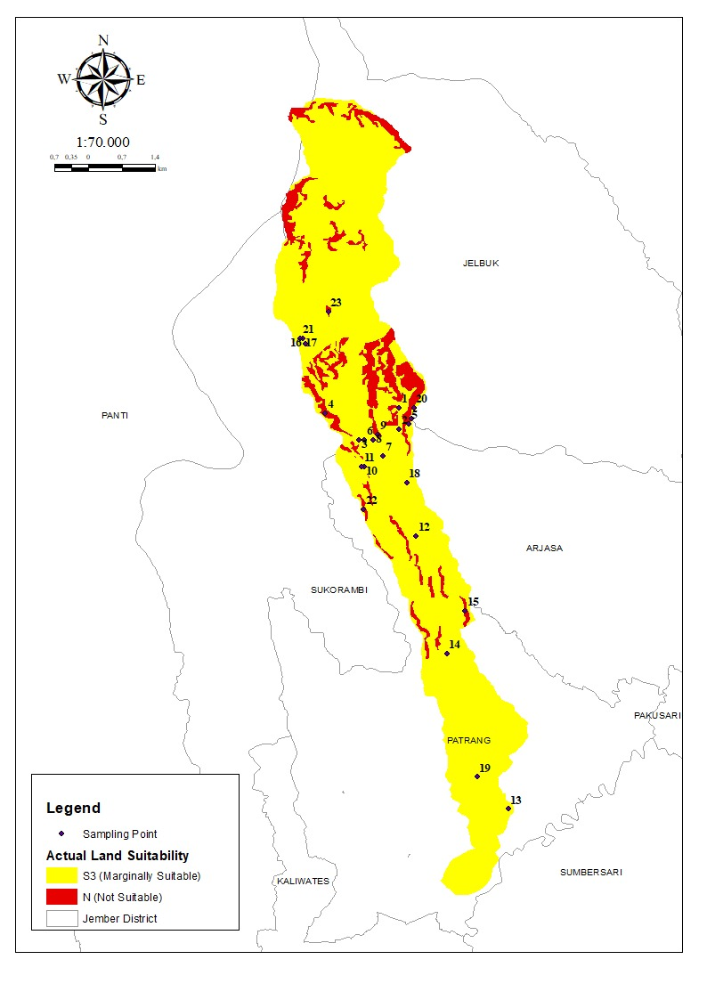

Fig. 2. Map of actual land suitability classes for cocoa plants
The limiting factors in the actual land suitability include (rc1) soil texture, (nr2) base saturation, (nr3) soil pH, (na1) total nitrogen, (na2) available P₂O₅, (na3) K₂O, (eh) slope gradient, and erosion hazard. The description of land suitability classes and their limiting factors can be seen in Table 4.
Table 4. Actual land suitability classes based on limiting factors
LMU | Actual | Ha | Land area | %
1 S3 (oa. rc1. na2. eh1) |  | 10.20 | 0.39
2 S3 (na2) |  | 29.97 | 1.14
3 S3 (eh1) |  | 182.47 | 6.94
4 N (eh1.2) |  | 137.47 | 5.23
5 S3 (oa. nr2. na2.3. eh1) |  | 3.99 | 0.15
6 S3 (oa. eh2) |  | 24.99 | 0.95
7 S3 (nr2. na2.3. eh1.2) |  | 7.08 | 0.27
8 S3 (na2) |  | 37.21 | 1.42
9 N (eh1.2) |  | 20.89 | 0.79
10 S3 (eh1.2) |  | 5.33 | 0.20
11 S3 (nr3. na2. eh1.2) |  | 5.75 | 0.22
12 S3 (na1.2. eh1) |  | 232.32 | 8.84
13 S3 (na3) |  | 149.63 | 5.69
14 S3 (na2.3. eh1) |  | 90.93 | 3.46
15 N (eh1) |  | 15.61 | 0.59
16 S3 (oa. rc1. nr2.3. na1) |  | 81.74 | 3.11
17 S3 (rc1. nr3. eh1.2) |  | 303.96 | 11.56
18 S3 (nr3.na2.3. eh2) |  | 63.16 | 2.40
19 S3 (na3) |  | 546.47 | 20.78
20 S3 (oa. rc1. eh1) |  | 120.96 | 4.60
21 S3 (rc1. eh1) |  | 407.69 | 15.51
22 N (eh1.2) |  | 28.13 | 1.07
23 N (eh1) |  | 96.22 | 3.66
24 S3 (rc1. nr3. eh1) |  | 27.17 | 1.03

3.3 Potensial land suitability

The potential land suitability class refers to the condition of land suitability that can be achieved after improvements are made to the limiting factors present in each land unit. However, not all limiting factors can be corrected therefore, it is important to first identify which constraints serve as barriers in the actual land suitability. Efforts to improve land conditions must also consider economic aspects, as such improvements may require substantial costs. In addition, the physical conditions of the land must be taken into account. By considering these various factors, appropriate and sustainable decisions can be made.
The distribution of land suitability classes in the Rembangan Sub-watershed (Figure 3) shows that the area is dominated by class S2 (Moderately suitable) covering 1,379.27 ha or 52.46%. This is followed by class S3 (Marginally suitable) covering 951.72 ha or 36.19%, and class N (Not suitable), covering 298.32 ha or 11.35%. These conditions indicate that the potential land suitability is predominantly classified as S2 followed by S3 and N. The improvement of land suitability from S3 to S2 requires specific interventions based on existing land conditions.
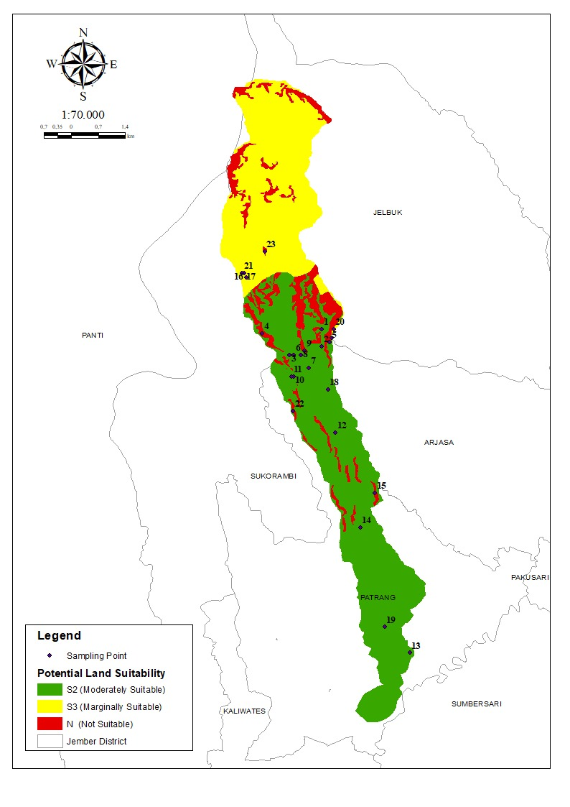
Fig. 3. Map of potential land suitability classes for cocoa plants
The potential land suitability classes obtained after improvement efforts are N, S3 and S2. Land that was initially classified as marginally suitable (S3) improved to moderately suitable (S2) while land classified as N (not suitable) did not undergo improvement efforts because areas in the not suitable class are generally difficult to rehabilitate. Limiting factors such as soil texture are inherently difficult to modify and are therefore considered permanent limiting factors that cannot be improved. In SPL 1, 16, 20, 21, and 24, the land suitability class remained S3 however, the limiting factor was in the rooting medium (rc) in the form of soil texture. In SPL 2, 3, 5, 6, 7, 8, 10, 11, 12, 13, 14, 18, and 19, the land suitability class increased to S2 (moderately suitable) after improvement efforts were made to address the limiting factors. Improvement efforts were carried out on the drainage system by constructing furrows, applying dolomite to improve soil pH and base saturation, and applying fertilizers such as urea, SP-36, and KCl to meet the nutrient requirements of the plants.

4. Conclusion

Land evaluation in the Rembangan Sub-watershed shows diverse conditions for cocoa cultivation. Suitable climate and soil chemical properties, such as C-organic content and CEC, are key supporting factors. However, several limiting factors need attention, including low base saturation, acidic soil pH, low P₂O₅, total N, K₂O, moderately rapid drainage, steep slopes, and high erosion risk. Most of the area falls into the S3 (marginally suitable) class covering 2,330.99 ha (88.65%), while not suitable (N) land covers 298.32 ha (11.35%). After land improvements, 1,379.27 ha (52.46%) reached S2 (moderately suitable) while N-class areas remained unchanged. This indicates that about 88.65% of the land has potential for enhancement to become more productive for cocoa cultivation. Proper land management strategies, including furrow drainage, dolomite application to improve soil pH and base saturation, and fertilization with urea, SP-36, and KCl, can optimize nutrient availability. With effective management the Rembangan Sub-watershed has significant potential to be developed as a productive cocoa cultivation area.

References

Ade Sahfitra, A., Kapasitas Tukar, V., Jurnal Ilmiah Pertanian, B., & Kapasitas Tukar Kation Dan Kejenuhan Basa Pada Tanah Hemic Haplosaprist Yang Dipengaruhi Oleh Pasang Surut Di Pelalawan Riau, V. (2023). The Variation Of Cation Exchange Capacity (Cec) And Base Saturation (Bs) In Hemic Haplosaprists Soil Influenced By Tidal In Pelalawan Riau. 19(1).
Astuti, Y. T. M., Rahayu, E., Santosa, T. N. B., Putra, D. P., Solifudin, A., Wijayanti, Y., & Fittkow, M. (2021). Study of Agronomic Characteristics of Robusta Coffee at Coffee Plantations in Temanggung , Indonesia. E3S Web of Conferences, 226, 1–10
Central Bureau of Statistics. (2023). Indonesian Cocoa Statistics. Jakarta
Central Bureau of Statistics. (2024). SEDAPP Online Manual (Providing Plantation Company Data with SKB-Online Application). Jakarta: Central Bureau of Statistics
Dewantara, R., & Azis, D. (2021). Evaluation of Tobacco Plantation Land Suitability in Aceh Tengah Regency Using Geographic Information System Analysis. Geoscience Education Journal, Vi.
Ding, H. H., Widjajanto, D., & Rahman, A. (2019). Evaluation Of Land Adjustments For Cocoa (Theobroma Cacao L.) Development In Enclave Zone About Lindu Sigi District. 7(4), 364–372.
Gabriela, S.-C., Viviana, C.-C., Otiniano Alberto, J., Leonel, A.-H., Ricardo, B.-V., BorjasVentura, R., & Selva Andina Biosph, J. (2022). Article history. Saravia-Castillo et al. In Journal of the Selva Andina Biosphere ®. Bolivia. All rights reserved. J. Selva Andina Biosph (Vol. 10, Issue 2).
Hardjowigeno, S. & Widiatmaka. 2018. Land Suitability Evaluation and Land Use Planning. Gadjah Mada University Press. Yogyakarta.
Hasanah, U., Khusrizal, K., Muliana, M., Akbar, H., & Yusra, Y. (2023). Determination of Land Suitability for Irrigated Rice Plants in Tanah Luas District, North Aceh Regency. Scientific Journal of Agroecotechnology Students, 1(4), 81.
Https://Doi.Org/10.29103/Jimatek.V1i4.10461
Irsyam, S. A. R. (2025). Analysis of Soil Fertility Status in Cocoa Plants (Theobroma cacao L.) in Herlang District, Bulukumba Regency. AgrotekMAS, Vol 6 No.1.
Ministry of Agriculture of the Republic of Indonesia. (2023). Indonesian Cocoa Export Statistics Jakarta: Ministry of Agriculture of the Republic of Indonesia.
Matatula, A. J., & Mahulette, A. S. Cocoa.
Mustafa, M., Maulana, A., Irfan, U. R., & Tonggiroh, A. 2022. Evaluation of Soil Fertility in Post-Laterite Nickel Mining Land in Southeast Sulawesi. Journal of Natural Sciences and Environment, 13(1).
Mustaman, W., Tjoneng, A., & Abdullah, A. 2019. Evaluation of Land Suitability and Economic Feasibility of Cocoa Plants in Gantarang Keke District, Bantaeng Regency. Agrotek: Scientific Journal of Agricultural Sciences, 3(1), 40-54.
Pramesti, A. D., & Hermiyanto, B. 2019. The Effect of Bagasse Compost and Water Hyacinth Liquid Organic Fertilizer on Endomycorrhizal Infection and Sorghum (Sorghum Bicolor (L.) Moench) Production on Paseban Coastal Sandy Land, Jember Regency. Berkala Ilmiah Pertanian, 2(3), 108-114.
https://doi.org/10.19184/bip.v2i3.16283
Rahman, M.M., Kibria, M.G., & Islam, M.A. 2023. Soil Electrical Conductivity As An Indicator Of Soil Health And Crop Productivity In Diverse Agroecosystems. Journal Of Soil Science And Plant Nutrition, 23(2), 1542-1559.
Romadhon, M. R., & Hermiyanto, B. (2021). Determination of Soil Fertility Index in Dinoyo Sub-watershed, Jember Regency. Journal of Soil and Climate, 45(1), 27.
Https://Doi.Org/10.21082/Jti.V45n1.2021.27-37
Sharma, V., & Kumar, A. (2024). Effective Rooting Depth As A Critical Parameter For Agricultural Land
Evaluation: A Comprehensive Assessment Framework. Ecological Indicators, 158, 110660.
Syahri, Y. F., Rauf, M., Paembonan, S. A., & Larekeng, S. H. (2020). Land Suitability Evaluation And Economic Feasibility Of Cocoa Farming. Environmental Research, Engineering And Management, 76(3), 96–108. Https://Doi.Org/10.5755/J01.Erem.76.3.24701
Winarso, S. 2005. Soil Fertility; Fundamentals of Soil Health and Quality. Gava Media. Yogyakarta.

