SURGICAL MANAGEMENT OF UNILATERAL CHERRY EYE IN BEAGLE DOG – A CASE REPORT

ABSTRACT:

A 5 month old beagle was presented with a history of a swollen mass at the medial canthus of the right eye since 3 days. Clinical examination revealed a protruding reddish mass, congestion of conjunctival blood vessels, excessive lacrimation and frequent blinking of the affected eye. Based on the clinical history and ophthalmic examination, the condition was diagnosed as prolapse of the gland of the third eyelid. Surgical correction was done using Morgan’s Pocket Technique. The dog showed complete recovery and no recurrence or postoperative complications were observed during follow-up period.
INTRODUCTION:
Cherry eye, defined as prolapse of the gland of the third eyelid, is a commonly reported ophthalmic disorder in dogs. Although cherry eye may develop at any age, it is most commonly diagnosed in dogs younger than two years and may affect one or both eyes (Hendrix, 2013). The condition is frequently observed in predisposed breeds such as Shih Tzu, Beagle, Pomeranian and Bulldog. The primary etiological factor is believed to be weakening of the connective tissue that normally secures the gland in its anatomical position. Several surgical techniques have been described for the management of cherry eye.The gland of the third eyelid plays a crucial role in maintaining ocular surface health by contributing approximately 30–57% of the aqueous component of the tear film (Multari et al., 2016). Excision of this gland significantly increases the risk of keratoconjunctivitis sicca, highlighting the importance of gland preservation. Consequently, surgical repositioning of the prolapsed gland, rather than removal, is currently regarded as the gold standard for treatment. Among the various repositioning methods, Morgan’s Pocket Technique is widely preferred as it allows stable repositioning of the gland while preserving its physiological function (Crispin, 2005; Gómez, 2012; Hendrix, 2013; Yaygingul et al., 2019).
CASE HISTORY AND DIAGNOSIS:
A 6 month old beagle dog was presented with a three-month history of a swollen mass at the medial canthus of the right eye (Fig.1).Clinical examination revealed normal pulse and respiration rates, along with a normal body temperature of 102.1°F. Ophthalmic examination showed a congested prolapsed mass associated with ocular discharge and epiphora. Based on the clinical history and ocular findings, the condition was tentatively diagnosed as prolapse of the gland of the third eyelid (cherry eye). Surgical correction was planned using Morgan’s Pocket Technique.
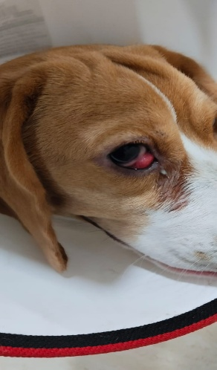
Fig.1 Photograph showing prolapse of third eyelid gland in Beagle
SURGICAL TREATMENT:

The dog was prepared for surgery and positioned in lateral recumbency. Pre-anesthetic medication was administered using atropine sulphate at a dose of 0.04 mg/kg followed by xylazine hydrochloride and butorphanol at 1 mg/kg and 0.2mg/kg intramuscularly respectively. General anesthesia was induced with propofol at a dose of 2 mg/kg intravenously followed by endotracheal intubation and anesthesia was maintained using 2% isoflurane. The affected eye was thoroughly flushed with normal saline solution. The prolapsed gland was completely exteriorized by gentle traction of the third eyelid using stay sutures (Fig. 2). Two parallel conjunctival incisions were made on either side of the prolapsed gland involving both the bulbar and palpebral conjunctival surfaces. The mucosa overlying the gland was carefully separated from the surrounding submucosa along the incision margins (Fig.3). The gland was then repositioned ventrally into its normal anatomical location between the two incision lines. The conjunctiva was closed using a continuous suture pattern with 5-0 absorbable suture material (Vicryl), apposing the edges of the incisions (Fig.4). A second reinforcing layer of sutures was placed in a continuous Cushing pattern parallel to the first suture line. The suture knots were positioned on the outer (limbal) surface to minimize corneal irritation. Immediately following surgery, the third eyelid returned to its normal position (Fig.5). Postoperative care included topical administration of ciprofloxacin eye drops four times daily for seven days, along with application of an Elizabethan collar to prevent self-trauma until resolution of inflammation. Dog showed complete recovery without any recurrence (Fig. 6).
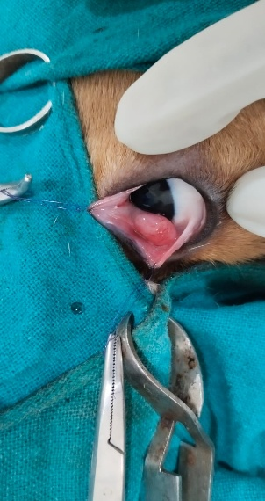
Fig.2. Photograph showing traction of third eyelid gland using stay sutures

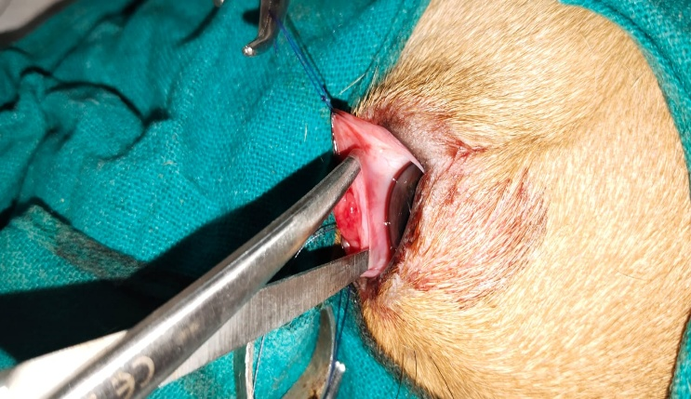

Fig.3. Photograph showing creating Pocket after parallel incision

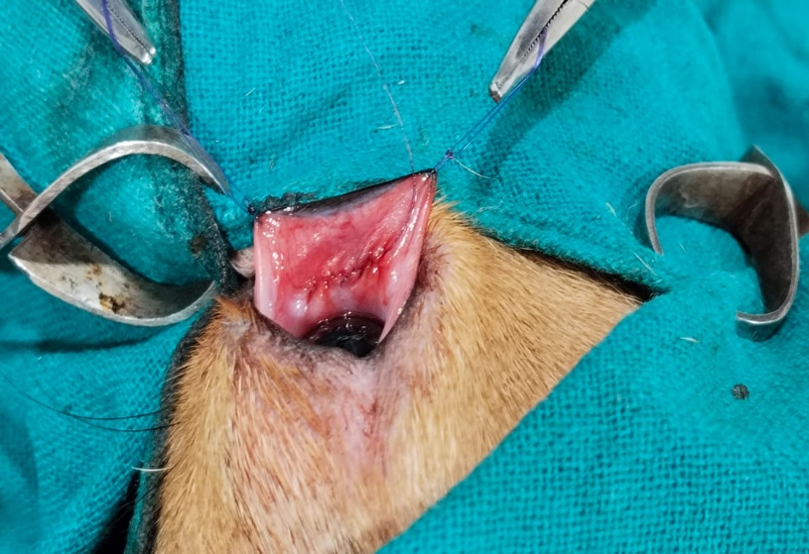
Fig.4. Photograph showing apposing edges of incison using Vicryl 5-0

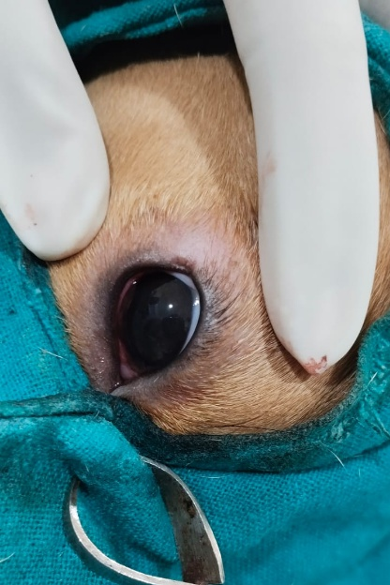
Fig.5. Photograph reposition of gland immediately after surgery

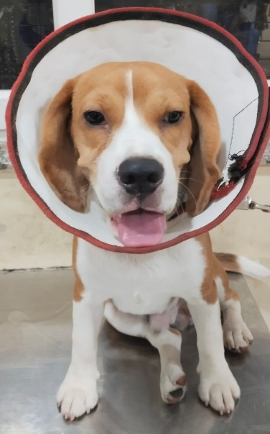
Fig.6. Photograph of dog showing complete resolution on 12th post operative day

DISCUSSION:
Cherry eye or prolapse of the gland of the third eyelid is a commonly reported ophthalmic condition in dogs (Yaygingul et al., 2019). Surgical management remains the definitive treatment option for this condition (Slatter, 2003; Fossum et al., 2013). In the present case, Morgan’s Pocket Technique was selected for correction of the prolapsed gland. Previous studies have demonstrated that gland repositioning procedures are preferable as they preserve tear production and reduce the likelihood of postoperative complications such as recurrence and keratoconjunctivitis sicca. Morgan’s Pocket method has shown high success rates with reports indicating up to 94.12% effectiveness, minimal complications and no negative impact on tear secretion (Singh et al., 2016; Deveci et al., 2020). In agreement with these findings, the current case showed an uneventful recovery with no recurrence during the follow-up period. In contrast, Thamizharasan et al. (2016) reported successful outcomes following complete excision of the gland; however, this approach was associated with compromised tear production. Supporting this finding, Saito et al. (2001) observed a significant reduction in tear secretion, with tear production decreasing to approximately 37% within two weeks following gland removal.
CONCLUSION:

Based on the outcome of this case, it is concluded that Morgan’s Pocket Technique is a safe and effective method for the surgical correction of cherry eye in dogs with excellent preservation of gland function and minimal risk of recurrence.

REFERENCES:

Crispin, S.M. Notes on Veterinary Ophthalmology. Oxford: Blackwell Publishing Ltd; 2005.

Deveci, M., Işler, C., Yurtal, Z., Altuğ, M. and Kirgiz, Ö. 2020. Evaluation of Morgan’s pocket technique in the treatment of nictitans gland prolapse in dogs. Turkish Journal of Veterinary and Animal Sciences, 44(3): 521-527.

Fossum, T. W., Dewey, C. W., Horn, C. V., Johnson, A. L., MacPhail, C. M., Radlinsky, M. A. G., Schulz, K. S., & Willard, M. D. 2013. Small Animal Surgery. 4th ed. Philadelphia: Elsevier Mosby, St. Louis Missouri, 316-317 pp.

Gómez, J.B.R. 2012. Repairing nictitans gland prolapse in dogs. Vet. Rec. 171: 244-245.

Hendrix DVH. Diseases and surgery of the canine conjunctiva and nictitating membrane. In Gelatt KN, Gilger BC, Kern TJ, editors. Veterinary Ophthalmology, Ames: Wiley Blackwell; 2013, p. 945-975.

Multari D, Perazzi A, Contiero B, De Mattia G, Iacopetti I. Pocket technique or pocket technique combined with modified orbital rim anchorage for the replacement of a prolapsed gland of the third eyelid in dogs: 353 dogs. Vet Ophthalmol. 2016;19(3):214-219.

Saito, A., Izumisawa, Y., Yamashita, K. and Kotani, T. 2001. The effect of third eyelid gland removal on the ocular surface of dogs. Veterinary Ophthalmology, 4(1): 13-18.

Singh, K., Gopinathan, A., Sangeetha, P., Sarangom, S., Kallianpur, N., Shivaraju, S., Maiti, S. K. and Kumar, N. 2016. Morgan's pocket technique for the surgical management of cherry eye in dogs: A report of 14 cases. Indian Journal of Animal Research, 51 (4): 795-797.

Slatter, D., 2003. Textbook of Small Animal Surgery. 3rd ed. Philadelphia: Saunders, USA,1364 p.

Thamizharasan, A. Murugan, M.S. and Parthiban, S. 2016. Surgical management of cherry eye in a dog. Intas Polivet, 17(II): 420-421.

Yaygingul, R., Bozkan, Z., Bilgen Şen, Z., Kibar Kurt, B., Bulut, O., & Belge, A. (2019). Surgical Treatment of Prolapse of the Third Eyelid Gland in Dogs using Modified Morgan Pocket Technique. Indian J. Anim. Res..https://doi.org/10.18805/ijar.B-1131

