Navigating the Future of Novel Drug Delivery Systems: Market Dynamics, Technological Innovations, and Translational Challenges

Abstract
Novel Drug Delivery Systems (NDDS) have emerged as pivotal technologies in modern therapeutics, addressing limitations of conventional drug administration such as poor bioavailability, non-specific targeting, and adverse side effects. The growing global market and rapid technological advancements underscore the need for a comprehensive understanding of NDDS development, market dynamics, and translational challenges.
This review systematically analyzes recent progress in NDDS, focusing on key nanocarriers including liposomes, cubosomes, and solid lipid nanoparticles, alongside emerging multifunctional and stimuli-responsive systems. A thorough literature survey was conducted using databases such as PubMed, Scopus, and Web of Science, complemented by market reports and regulatory guidelines. Emphasis was placed on formulation techniques, material innovations, integration with personalized medicine, and the role of artificial intelligence in optimizing design and clinical translation.
Results highlight significant advances in scalable manufacturing, green synthesis, and multifunctional hybrid platforms that enhance targeting and controlled release. However, challenges persist in regulatory approval, long-term safety evaluation, and market adoption, particularly due to complex manufacturing and intellectual property landscapes. The integration of digital health tools and real-time monitoring presents promising avenues to improve patient compliance and therapeutic outcomes.
In conclusion, NDDS represent a transformative shift toward precision medicine, but their successful clinical translation requires multidisciplinary collaboration, regulatory alignment, and sustainable manufacturing practices. Addressing current research gaps and leveraging emerging technologies will be critical to fully realize the therapeutic and commercial potential of NDDS, ultimately improving patient care worldwide.
Keywords -Novel Drug Delivery Systems (NDDS), Nanocarriers, Liposomes, Cubosomes, Solid Lipid Nanoparticles (SLNs), Stimuli-Responsive Drug Delivery, Multifunctional Nanocarriers, Targeted Drug Delivery

Graphical abstract

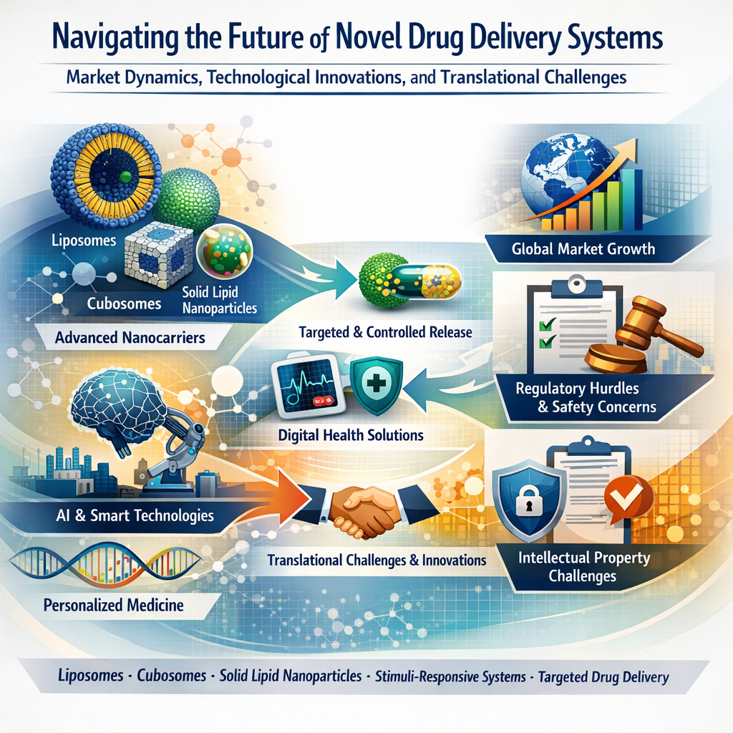

Introduction
The landscape of pharmaceutical therapeutics has been profoundly transformed by the advent of Novel Drug Delivery Systems (NDDS). These advanced delivery platforms are designed to optimize the pharmacokinetics and pharmacodynamics of therapeutic agents, thereby enhancing efficacy, reducing side effects, and improving patient compliance. Traditional drug delivery methods often face limitations such as poor bioavailability, non-specific distribution, and rapid clearance, which can compromise therapeutic outcomes. NDDS, encompassing technologies such as nanoparticles, liposomes, cubosomes, solid lipid nanoparticles, and stimuli-responsive carriers, offer innovative solutions to these challenges by enabling targeted, controlled, and sustained drug release[01,02].
The importance of NDDS in modern therapeutics extends beyond improved drug performance; they also facilitate the delivery of complex molecules including biologics, nucleic acids, and poorly soluble drugs, which are otherwise difficult to administer effectively. Furthermore, NDDS play a critical role in personalized medicine by allowing tailored drug delivery strategies that consider individual patient variability[03].
This review aims to provide a comprehensive overview of the current state and future prospects of NDDS, focusing on three key dimensions: global market dynamics, technological innovations, and translational challenges. By analyzing market trends and economic factors, we seek to elucidate the commercial landscape shaping NDDS development. Concurrently, we explore cutting-edge technological advancements that are driving the evolution of drug delivery platforms. Finally, we address the critical barriers to clinical translation, including manufacturing scalability, regulatory hurdles, and safety concerns, which must be overcome to realize the full potential of NDDS[04].
Through this integrated approach, the review intends to offer valuable insights for researchers, industry stakeholders, and policymakers, guiding strategic decisions and fostering innovation in the rapidly evolving field of novel drug delivery[05,06].
1.1 Market Size, Growth Trends, and Forecasts
The global market for Novel Drug Delivery Systems (NDDS) has witnessed robust growth over the past decade, driven by increasing demand for improved therapeutic efficacy, patient compliance, and the rising prevalence of chronic diseases. According to recent market analyses, the NDDS market was valued at approximately USD 150 billion in 2023 and is projected to grow at a compound annual growth rate (CAGR) of 8–10% from 2024 to 2030, potentially exceeding USD 300 billion by the end of the decade[07].
Key factors propelling this growth include advancements in nanotechnology, the surge in biologics and complex drug molecules requiring specialized delivery platforms, and the growing emphasis on personalized medicine. Additionally, the increasing geriatric population and the rising incidence of lifestyle-related diseases such as cancer, diabetes, and cardiovascular disorders are expanding the demand for targeted and controlled drug delivery solutions[08].
Technological innovations such as stimuli-responsive carriers, multifunctional nanoparticles, and hybrid delivery systems are further enhancing the therapeutic potential of NDDS, thereby attracting significant investment from pharmaceutical companies and venture capitalists. The integration of artificial intelligence and machine learning in formulation design and predictive modeling is also expected to accelerate product development and market penetration [4].
Regional Market Analysis and Economic Factors
The NDDS market exhibits significant regional variation influenced by economic development, healthcare infrastructure, regulatory environments, and demographic trends.
- North America remains the largest market, accounting for over 40% of global revenue, driven by strong pharmaceutical R&D, favorable regulatory frameworks, and high healthcare expenditure. The United States, in particular, leads in the adoption of advanced NDDS technologies, supported by substantial government funding and private sector innovation [09].
- Europe holds the second-largest share, with countries like Germany, the United Kingdom, and France investing heavily in nanomedicine and drug delivery research. The European Medicines Agency (EMA) provides clear regulatory pathways that facilitate the clinical translation of novel delivery systems [10,11].
- Asia-Pacific is the fastest-growing region, with a CAGR exceeding 12%, fueled by expanding healthcare access, increasing prevalence of chronic diseases, and growing pharmaceutical manufacturing capabilities in China, India, and Japan. Government initiatives to promote biotechnology and nanotechnology research are also key growth drivers [07,09].
- Latin America and Middle East & Africa are emerging markets with increasing investments in healthcare infrastructure and pharmaceutical innovation, though growth is moderated by economic and regulatory challenges [12].
Economic factors such as healthcare spending, reimbursement policies, and intellectual property regulations significantly impact NDDS market dynamics. Countries with robust healthcare funding and supportive policies tend to adopt novel drug delivery technologies more rapidly. Conversely, high development costs and complex regulatory requirements can delay market entry, particularly in low- and middle-income regions [13].
1.2 Key Industry Players and Competitive Landscape
The novel drug delivery systems (NDDS) market is characterized by the presence of several global pharmaceutical and biotechnology companies, alongside emerging startups specializing in nanotechnology and advanced formulation techniques. Leading industry players have established strong portfolios of NDDS products and are actively investing in research and development to maintain competitive advantages.
Major industry players include Johnson & Johnson, Pfizer Inc., Novartis AG, Roche Holding AG, AstraZeneca, GlaxoSmithKline (GSK), and Sanofi. These companies have leveraged their extensive R&D capabilities and global distribution networks to develop and commercialize a variety of NDDS platforms such as liposomal formulations, polymeric nanoparticles, and lipid-based carriers [14,15].
In addition to pharmaceutical giants, specialized biotech firms like Moderna, BioNTech, and Arcturus Therapeutics have gained prominence by pioneering lipid nanoparticle (LNP) technologies, which have been critical in the development of mRNA vaccines, exemplifying the clinical and commercial potential of NDDS [15,16].
The competitive landscape is also shaped by numerous startups and contract development and manufacturing organizations (CDMOs) focusing on niche technologies such as cubosomes, solid lipid nanoparticles, and stimuli-responsive systems. Strategic partnerships, mergers, and acquisitions are common as companies seek to expand their technological capabilities and market reach [17].
Intellectual property (IP) plays a crucial role in maintaining competitive advantage, with companies actively filing patents related to novel formulations, manufacturing processes, and delivery mechanisms. Regulatory approvals and successful clinical trials further differentiate market leaders, underscoring the importance of innovation and compliance in this sector [12,16].
Technological Innovations in Novel Drug Delivery Systems
Technological innovation is the driving force behind the rapid evolution of NDDS, enabling enhanced drug targeting, controlled release, and improved patient outcomes. Recent advances focus on multifunctional and stimuli-responsive nanocarriers, integration of artificial intelligence (AI) in formulation design, and novel materials for improved biocompatibility and stability[04,15].
02. Multifunctional and Stimuli-Responsive Nanocarriers
Nanocarriers capable of responding to specific physiological stimuli such as pH, temperature, redox conditions, or enzymes have gained significant attention. These systems enable site-specific drug release, minimizing systemic toxicity and enhancing therapeutic efficacy. Examples include pH-sensitive liposomes for tumor targeting and redox-responsive polymeric nanoparticles for intracellular drug delivery [16,17].
Lipid-Based Nanocarriers
Lipid-based systems such as solid lipid nanoparticles (SLNs), nanostructured lipid carriers (NLCs), and cubosomes offer biocompatibility, high drug loading capacity, and controlled release profiles. Recent innovations include surface functionalization with targeting ligands and PEGylation to improve circulation time and reduce immunogenicity [8,14].
Polymer-Based Delivery Systems
Advances in biodegradable polymers like PLGA (poly(lactic-co-glycolic acid)) and PEG (polyethylene glycol) have facilitated the development of nanoparticles and micelles with tunable degradation rates and drug release kinetics. Smart polymers that respond to external stimuli are also under active investigation [18].
Integration of Artificial Intelligence and Computational Modeling
AI and machine learning are increasingly employed to optimize NDDS design, predict drug-polymer interactions, and streamline formulation development. Computational tools enable rapid screening of excipients and prediction of pharmacokinetic profiles, accelerating the translation from bench to clinic [19].
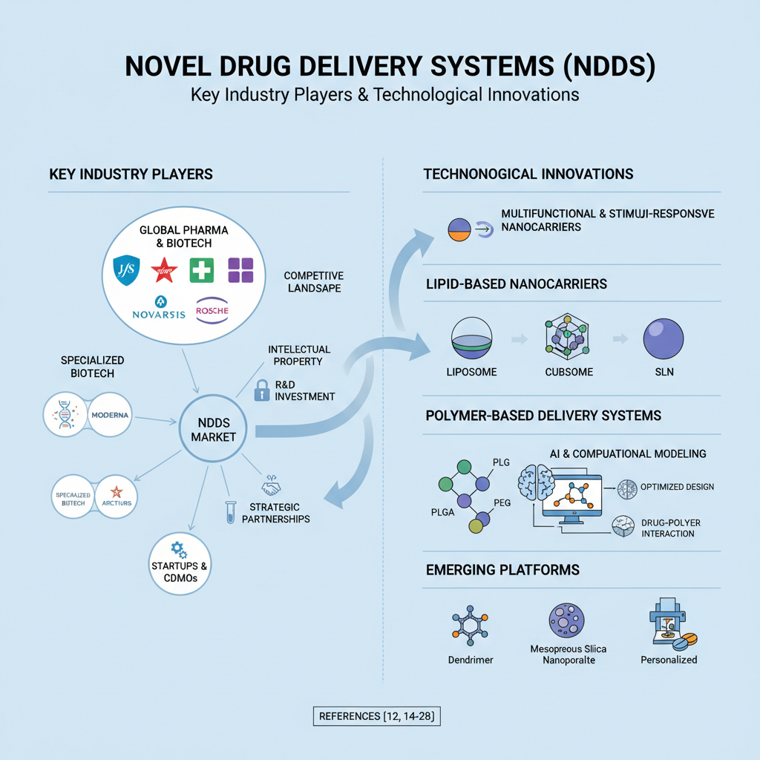
Fig No 01 - "Illustration of cutting-edge technological innovations in novel drug delivery systems, highlighting advanced techniques such as nanocarriers, targeted delivery, and controlled release mechanisms for improving therapeutic efficacy and minimizing side effects."

Emerging Platforms
Novel platforms such as exosomes, dendrimers, and mesoporous silica nanoparticles are being explored for their unique structural and functional properties. Additionally, 3D printing technologies are being investigated for personalized NDDS fabrication, allowing precise control over dosage forms and release characteristics [11,12].
2.1 Nanocarriers: Liposomes, Cubosomes, Solid Lipid Nanoparticles, and Beyond
Nanocarriers have revolutionized drug delivery by enabling precise control over drug release, improved bioavailability, and targeted delivery to specific tissues or cells. Among the diverse nanocarrier platforms, liposomes, cubosomes, and solid lipid nanoparticles (SLNs) have emerged as prominent systems due to their unique physicochemical properties and clinical potential.
Liposomes
Liposomes are spherical vesicles composed of one or more phospholipid bilayers encapsulating an aqueous core. Since their discovery in the 1960s, liposomes have been extensively studied and utilized for delivering both hydrophilic and hydrophobic drugs [20,21]. Their biocompatibility, ability to encapsulate diverse drug molecules, and modifiable surface properties make them versatile carriers. [22,23,24].
Advancements in liposome technology include PEGylation to prolong circulation time, ligand conjugation for active targeting, and stimuli-responsive liposomes that release drugs in response to pH, temperature, or enzymes [21,22]. Despite their advantages, challenges such as stability, large-scale manufacturing, and rapid clearance by the mononuclear phagocyte system remain areas of active research.
Cubosomes
Cubosomes are nanostructured liquid crystalline particles formed from amphiphilic lipids that self-assemble into a bicontinuous cubic phase. These particles possess a unique internal cubic lattice structure, providing a large surface area and high encapsulation efficiency for both hydrophilic and lipophilic drugs [24]. Cubosomes offer controlled release profiles and enhanced stability compared to traditional liposomes.
Their potential applications span oral, topical, ophthalmic, and parenteral drug delivery. Recent studies have explored cubosomes for delivering anticancer agents, vaccines, and poorly soluble drugs, highlighting their versatility [25]. However, challenges such as scalable production, long-term stability, and comprehensive toxicological evaluation need to be addressed to facilitate clinical translation [26].
Solid Lipid Nanoparticles (SLNs)
SLNs are submicron colloidal carriers composed of solid lipids stabilized by surfactants. They combine the advantages of liposomes and polymeric nanoparticles, offering controlled drug release, improved drug stability, and biocompatibility [27]. SLNs can encapsulate lipophilic drugs efficiently and protect labile molecules from degradation.
SLNs have been investigated for various routes of administration, including oral, topical, and parenteral. Their solid lipid matrix allows for sustained drug release and reduced burst effect. However, issues such as drug expulsion during storage and limited drug loading capacity are challenges under investigation [28].
Nanocarrier | Structure & Composition | Advantages | Limitations | Typical Applications | References
Liposomes | Spherical vesicles with one or more phospholipid bilayers encapsulating aqueous core | - Biocompatible and biodegradable- Can carry hydrophilic & hydrophobic drug.  Surface modifiable for targeting and stealth (PEGylation) | - Stability issues (leakage, fusion)- Rapid clearance by RES- Complex large-scale production | Cancer therapy, antifungal drugs, vaccines | [11,22]
Cubosomes | Nanostructured liquid crystalline particles with bicontinuous cubic lipid phase | - High surface area- Encapsulate hydrophilic & lipophilic drugs- Controlled release- Enhanced stability vs liposomes | - Difficult scalable manufacturing- Limited clinical data- Toxicity profile not fully known | Oral, topical, ophthalmic delivery; anticancer agents | [11,14]
Solid Lipid Nanoparticles (SLNs) | Solid lipid core stabilized by surfactants | - Biocompatible and biodegradable- Controlled drug release- Protects labile drugs- Scalable production | - Limited drug loading- Drug expulsion during storage- Polymorphic transitions affect stability | Oral, topical, parenteral delivery | [17,18]
Nanostructured Lipid Carriers (NLCs) | Blend of solid and liquid lipids forming imperfect lipid matrix | - Higher drug loading than SLNs- Improved stability- Controlled release | - More complex formulation- Potential for lipid oxidation | Similar to SLNs; enhanced delivery of poorly soluble drugs | [19]
Dendrimers | Highly branched, monodisperse polymers with multiple surface functional groups | - Precise size and shape control- High drug loading capacity- Surface modifiable for targeting | - Potential cytotoxicity- Complex synthesis- Clearance and biodistribution challenges | Gene delivery, anticancer drugs, imaging agents | [11]
Polymeric Micelles | Self-assembled amphiphilic block copolymers forming core-shell structures | - Solubilize hydrophobic drugs- Prolonged circulation- Stimuli-responsive variants available | - Stability issues upon dilution- Limited drug loading capacity | Cancer therapy, solubilization of poorly soluble drugs | [12,16]
Mesoporous Silica Nanoparticles (MSNs) | Porous silica framework with tunable pore size and surface chemistry | - High surface area and pore volume- Controlled drug release- Easy surface functionalization | - Potential silica toxicity- Biodegradability concerns- Complex synthesis | Controlled release, gene delivery, imaging | [12,15]

Table No 01 - Table summarizing key characteristics of nanocarriers, including their structure and composition, advantages, limitations, typical applications, and relevant references. This table provides a comparative overview of various nanocarrier systems used in drug delivery, helping to highlight their unique properties and potential for enhancing treatment outcomes.
3.0 Stimuli-Responsive and Multifunctional Delivery Systems
Stimuli-responsive drug delivery systems represent a significant advancement in the field of novel drug delivery, designed to release therapeutic agents in response to specific internal or external triggers. These smart systems provide enhanced drug targeting, reduce systemic side effects, and improve therapeutic efficacy by enabling precise spatiotemporal control over drug release. Multifunctional delivery systems take this concept further by integrating multiple functionalities such as targeted delivery, imaging, and controlled release into a single platform. This integration facilitates theranostic applications and supports the development of personalized medicine, where diagnosis and treatment are combined for optimized patient outcomes [11,21].
The stimuli that trigger drug release in these systems can be broadly categorized into internal and external types. Internal stimuli include physiological conditions such as pH variations, redox potential, enzyme presence, temperature changes, and hypoxia, which are often characteristic of diseased tissues. External stimuli, on the other hand, involve externally applied triggers such as light, magnetic fields, ultrasound, or electric fields, allowing precise control over drug release timing and location.
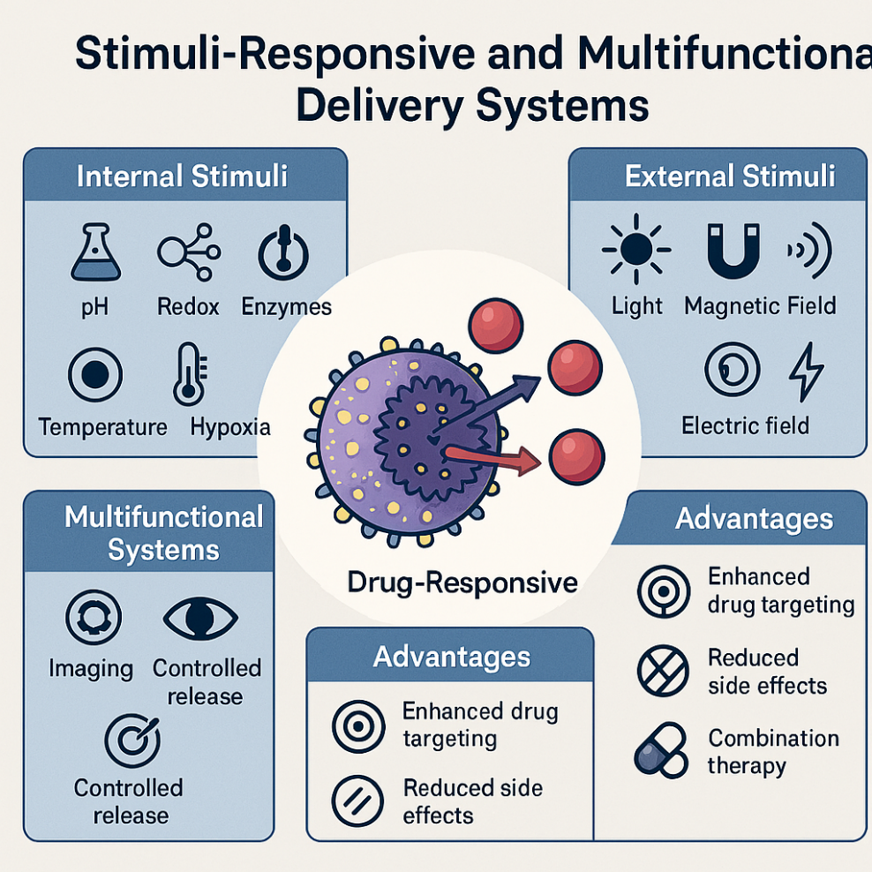
Figure No 02 : illustrating stimuli-responsive and multifunctional delivery systems, showcasing how these advanced systems can release therapeutic agents in response to specific environmental triggers such as pH, temperature, or enzymes. The figure emphasizes the versatility and precision of these systems in enhancing targeted drug delivery and improving treatment efficacy.
Among internal stimuli, pH-responsive systems are particularly well-studied due to the acidic microenvironment of tumors and intracellular compartments like endosomes and lysosomes. These systems utilize acid-labile linkers, pH-sensitive polymers, or membrane-disruptive materials that destabilize under acidic conditions, thereby releasing the drug selectively at the target site. This selective release minimizes damage to healthy tissues and enhances therapeutic efficacy [23,24]. Similarly, redox-responsive systems exploit the elevated levels of reducing agents such as glutathione found inside cells, especially cancer cells. By incorporating disulfide bonds or other redox-sensitive linkages, these carriers release their payload intracellularly, improving cytoplasmic delivery of drugs and nucleic acids [25].
Enzyme-responsive systems leverage the overexpression of specific enzymes, such as matrix metalloproteinases (MMPs), in pathological tissues. These systems are designed with enzyme-cleavable linkers or coatings that degrade selectively in the presence of target enzymes, enabling site-specific drug release. This approach enhances drug accumulation at diseased sites while sparing normal tissues [26]. Temperature-responsive systems utilize thermo-sensitive polymers that undergo phase transitions at mild hyperthermic temperatures (typically 40–42°C). This property is exploited in localized therapies, such as cancer treatment and transdermal drug delivery, where controlled drug release is triggered by externally applied heat [27].
External stimuli-responsive systems offer additional control and precision. Light-responsive carriers use photo-cleavable bonds or photosensitizers to release drugs upon irradiation with ultraviolet, visible, or near-infrared light. This allows for non-invasive, spatially, and temporally controlled drug release [28]. Magnetic field-responsive systems incorporate magnetic nanoparticles that generate heat or mechanical forces when exposed to alternating magnetic fields, triggering drug release or enhancing tissue penetration [29]. Ultrasound-responsive systems utilize acoustic cavitation to disrupt nanocarriers and increase tissue permeability, facilitating drug delivery [30].
Aspect | Description | Examples/Mechanisms | Advantages | Challenges
Stimuli Types | Systems respond to internal or external triggers to release drugs | Internal: pH, redox potential, enzymes, temperature, hypoxia<br>External: light, magnetic field, ultrasound, electric field | Precise spatiotemporal control of drug release | Complexity in design and manufacturing
pH-Responsive Systems | Exploit acidic tumor or intracellular environments to trigger drug release | Acid-labile linkers, pH-sensitive polymers, membrane-disruptive materials | Targeted release in acidic microenvironments, reduced off-target effects | Stability of pH-sensitive materials, variability in pH across tissues
Redox-Responsive Systems | Utilize high intracellular glutathione levels to cleave redox-sensitive bonds | Disulfide bonds cleaved by glutathione | Enhanced intracellular drug release, improved efficacy | Potential premature release, ensuring selective cleavage
Enzyme-Responsive Systems | Trigger drug release via enzymatic degradation in diseased tissues | Enzyme-cleavable linkers or coatings (e.g., MMP-sensitive) | Site-specific release, reduced systemic toxicity | Variability in enzyme expression, off-target enzyme activity
Temperature-Responsive Systems | Use thermo-sensitive polymers that change properties at mild hyperthermia | Polymers with phase transition at 40–42°C | Controlled release triggered by localized heating | Precise temperature control needed, potential tissue damage
Light-Responsive Systems | Drug release triggered by light irradiation | Photo-cleavable bonds, photosensitizers | Non-invasive, precise spatial and temporal control | Limited tissue penetration of light, potential phototoxicity
Magnetic Field-Responsive Systems | Use magnetic nanoparticles to generate heat or mechanical forces under alternating magnetic fields | Magnetic hyperthermia, magnetically triggered release | Remote activation, enhanced tissue penetration | Safety concerns, heating control
Ultrasound-Responsive Systems | Use acoustic cavitation to disrupt carriers and enhance permeability | Ultrasound-triggered carrier disruption | Non-invasive, enhanced drug penetration | Control over ultrasound parameters, potential tissue damage
Multifunctional Systems | Combine stimuli-responsiveness with targeting, imaging, and combination therapy | Ligand targeting (antibodies, peptides), imaging agents (MRI, fluorescence), co-delivery of drugs | Theranostics, personalized medicine, synergistic therapies | Complex design, regulatory challenges
Clinical Translation Challenges | Barriers to clinical use | Manufacturing complexity, immunogenicity, toxicity, regulatory hurdles | - | Scalability, reproducibility, safety evaluation, unclear regulatory pathways
Table No 02 -Overview of key aspects of stimuli-responsive and multifunctional drug delivery systems, outlining their descriptions, representative examples or mechanisms, associated advantages, and major challenges. This table highlights how different design aspects contribute to targeted, controlled, and efficient therapeutic delivery while addressing existing limitations.

04. Advances in Formulation Techniques and Materials
The continuous evolution of novel drug delivery systems (NDDS) is closely linked to significant advances in formulation techniques and the development of innovative materials. These advances have enabled the design of more efficient, stable, and targeted delivery platforms capable of overcoming biological barriers and improving therapeutic outcomes.
One of the key formulation advancements is the refinement of nanoprecipitation and solvent evaporation methods, which allow for the controlled synthesis of nanoparticles with uniform size distribution and high drug loading efficiency. These techniques have been optimized to reduce the use of toxic organic solvents and improve scalability, making them more suitable for industrial production [31]. Additionally, microfluidics-based approaches have emerged as powerful tools for the precise and reproducible fabrication of nanocarriers. Microfluidic systems enable fine control over mixing, particle size, and morphology, facilitating the production of complex multifunctional nanoparticles with enhanced batch-to-batch consistency [22].
The development of self-assembling materials has also revolutionized NDDS formulation. Amphiphilic block copolymers, lipids, and peptides can spontaneously organize into well-defined nanostructures such as micelles, liposomes, and cubosomes under appropriate conditions. This self-assembly process allows for the encapsulation of diverse therapeutic agents and the incorporation of stimuli-responsive elements, enhancing the functionality of delivery systems [23].
In terms of materials, biodegradable polymers such as poly(lactic-co-glycolic acid) (PLGA), polycaprolactone (PCL), and polyethylene glycol (PEG) have become staples in NDDS due to their biocompatibility, tunable degradation rates, and ability to protect drugs from premature degradation. Recent innovations include the synthesis of stimuli-responsive polymers that undergo conformational changes or degradation in response to environmental triggers like pH, temperature, or redox conditions, enabling controlled and site-specific drug release [32].
Lipid-based materials have also seen significant improvements. The introduction of nanostructured lipid carriers (NLCs), which combine solid and liquid lipids, has addressed limitations of solid lipid nanoparticles by enhancing drug loading capacity and preventing drug expulsion during storage. Moreover, surface modification techniques such as PEGylation and ligand conjugation have been widely adopted to improve circulation time, reduce immunogenicity, and enable active targeting of nanocarriers [33].
Emerging materials such as inorganic nanoparticles (e.g., gold, silica, iron oxide) and hybrid organic-inorganic systems offer unique optical, magnetic, and structural properties that can be harnessed for combined therapeutic and diagnostic (theranostic) applications. These materials facilitate multimodal imaging and targeted therapy, expanding the scope of NDDS beyond conventional drug delivery [34].
Furthermore, advances in 3D printing and additive manufacturing technologies have opened new avenues for personalized drug delivery. These techniques allow for the fabrication of complex dosage forms with precise control over drug distribution, release kinetics, and geometry, enabling patient-specific therapies tailored to individual needs [33,35].
Despite these advances, challenges remain in translating novel formulation techniques and materials into clinically viable products. Issues such as reproducibility, scalability, regulatory compliance, and long-term safety must be addressed through interdisciplinary collaboration and rigorous evaluation.
05 Integration with Personalized Medicine and AI-Driven Design
The integration of novel drug delivery systems (NDDS) with personalized medicine represents a transformative approach in healthcare, aiming to tailor therapeutic interventions to individual patient characteristics such as genetics, disease phenotype, and lifestyle. Personalized medicine seeks to optimize drug efficacy and minimize adverse effects by considering patient-specific variability in drug metabolism, target expression, and disease progression. NDDS play a crucial role in this paradigm by enabling precise control over drug release, targeted delivery, and adaptable dosing regimens that can be customized to the needs of individual patients [35].
Recent advances in genomics, proteomics, and biomarker discovery have provided a wealth of data that can inform the design of personalized NDDS. For example, nanocarriers can be functionalized with ligands that target specific receptors overexpressed in a patient’s tumor or diseased tissue, enhancing selective drug accumulation and therapeutic outcomes. Additionally, stimuli-responsive systems can be engineered to respond to unique microenvironmental cues present in a patient’s pathology, such as pH or enzyme levels, further refining drug release profiles [35].
Artificial intelligence (AI) and machine learning (ML) technologies have emerged as powerful tools to accelerate and optimize the design of NDDS within the personalized medicine framework. AI algorithms can analyze large datasets from clinical trials, patient records, and molecular profiling to identify patterns and predict drug responses. This capability enables the rational design of nanocarriers with optimized physicochemical properties, drug loading, and release kinetics tailored to specific patient populations [36].
Machine learning models are also employed to predict the interactions between drugs and delivery materials, stability under physiological conditions, and potential toxicity, thereby reducing the time and cost associated with experimental trial-and-error approaches. Furthermore, AI-driven computational simulations facilitate the screening of novel materials and formulations, guiding the synthesis of multifunctional nanocarriers with enhanced targeting and therapeutic efficacy [36].
The convergence of AI and personalized medicine extends to clinical decision support systems, where predictive analytics can recommend the most suitable NDDS-based therapies for individual patients based on their genetic and phenotypic profiles. This integration promises to improve treatment outcomes, reduce adverse drug reactions, and enable dynamic adjustments to therapy in response to patient monitoring data [37].
Despite these promising developments, challenges remain in implementing AI-driven personalized NDDS. Data privacy, the need for large, high-quality datasets, and the interpretability of AI models are critical concerns. Additionally, regulatory frameworks must evolve to accommodate AI-assisted design and personalized therapeutic strategies, ensuring safety and efficacy while fostering innovation [38].
In summary, the integration of NDDS with personalized medicine and AI-driven design holds immense potential to revolutionize drug delivery by enabling highly tailored, efficient, and adaptive therapies. Continued interdisciplinary collaboration among clinicians, data scientists, and pharmaceutical researchers is essential to realize this vision and translate it into clinical practice.
06 Scalability and Manufacturing Hurdles
The transition of novel drug delivery systems (NDDS) from laboratory-scale research to commercial production presents significant scalability and manufacturing challenges. Many NDDS rely on complex formulation processes, such as nanoprecipitation, self-assembly, or microfluidics, which are often optimized for small batches but difficult to reproduce consistently at industrial scales. Achieving uniform particle size distribution, drug loading efficiency, and batch-to-batch reproducibility remains a critical hurdle [38].
Manufacturing processes must also comply with Good Manufacturing Practices (GMP), requiring stringent control over raw materials, process parameters, and environmental conditions. The sensitivity of nanocarriers to factors such as temperature, shear stress, and solvent residues complicates scale-up efforts. Additionally, the use of organic solvents and surfactants in some formulations raises concerns about residual toxicity and environmental impact, necessitating the development of greener, solvent-free manufacturing methods [39].
Process analytical technologies (PAT) and real-time monitoring tools are increasingly being integrated into manufacturing workflows to ensure quality control and process robustness. However, the high cost of specialized equipment and the need for skilled personnel can limit widespread adoption, especially in emerging markets [39].
Furthermore, the complexity of multifunctional and stimuli-responsive NDDS adds layers of difficulty in scaling up, as each functional component must be precisely controlled to maintain efficacy and safety. The integration of continuous manufacturing and modular production platforms offers promising solutions to these challenges by enabling flexible, scalable, and cost-effective production [4].
07 Regulatory and Safety Considerations
Regulatory approval of NDDS is a multifaceted process that requires comprehensive evaluation of safety, efficacy, quality, and manufacturing consistency. Regulatory agencies such as the U.S. Food and Drug Administration (FDA), European Medicines Agency (EMA), and others have established guidelines for nanomedicines, but the rapid evolution and complexity of NDDS often outpace regulatory frameworks, creating uncertainty for developers [40].
Safety considerations are paramount, as nanocarriers can exhibit unique pharmacokinetics, biodistribution, and potential toxicity profiles compared to conventional formulations. Issues such as immunogenicity, long-term accumulation, off-target effects, and interactions with biological systems must be thoroughly investigated through in vitro, in vivo, and clinical studies [26].
Standardized characterization methods for physicochemical properties, stability, and biological interactions are essential to ensure reproducibility and comparability across studies. Regulatory agencies increasingly emphasize the need for robust analytical techniques and validated assays to assess nanocarrier quality and safety [17].
The complexity of multifunctional NDDS, which may combine therapeutic, diagnostic, and targeting components, poses additional regulatory challenges. Developers must navigate overlapping requirements for drugs, biologics, and medical devices, often necessitating coordinated review by multiple regulatory divisions [28].
To facilitate regulatory approval, early engagement with regulatory bodies, clear communication of product attributes, and adherence to quality-by-design (QbD) principles are recommended. Collaborative efforts between industry, academia, and regulators are critical to establish harmonized standards and accelerate the safe translation of NDDS to the clinic [19].
08 Clinical Trial Design and Patient Compliance Issues
The clinical evaluation of novel drug delivery systems (NDDS) presents unique challenges that differ from traditional drug formulations. Designing clinical trials for NDDS requires careful consideration of the delivery platform’s pharmacokinetics, biodistribution, and mechanism of action. Unlike conventional drugs, NDDS often exhibit complex behavior such as targeted delivery, controlled release, and multifunctionality, which necessitate specialized endpoints and biomarkers to accurately assess efficacy and safety [11].
Patient compliance is another critical factor influencing the success of NDDS in clinical settings. While NDDS aim to improve adherence by reducing dosing frequency and side effects, the complexity of some delivery systems, such as injectable nanoparticles or implantable devices, may pose barriers to patient acceptance. Additionally, patient education and healthcare provider training are essential to ensure proper administration and monitoring [22].
Adaptive trial designs and real-world evidence are increasingly employed to address these challenges, allowing for flexible protocols that can accommodate patient variability and evolving therapeutic responses. Incorporating patient-reported outcomes and digital health technologies can further enhance compliance monitoring and personalized treatment adjustments [13].
Intellectual Property and Commercialization Barriers
Intellectual property (IP) protection is vital for incentivizing innovation in NDDS but also presents significant challenges. The complexity of NDDS, which often combine novel materials, formulation techniques, and targeting ligands, leads to intricate patent landscapes with overlapping claims. Navigating these landscapes requires strategic patent filing and freedom-to-operate analyses to avoid infringement and ensure market exclusivity [26].
Commercialization barriers include high development costs, lengthy regulatory approval processes, and the need for specialized manufacturing infrastructure. The scale-up of NDDS production while maintaining quality and consistency is capital-intensive, which can deter investment, especially for smaller companies and startups [36].
Market acceptance is influenced by factors such as cost-effectiveness, reimbursement policies, and competition from generic or biosimilar products. Collaborations between academia, industry, and regulatory agencies are essential to streamline development pathways and facilitate technology transfer [6].
09. Emerging Trends and Future Directions
The field of NDDS is rapidly evolving, driven by advances in materials science, biotechnology, and digital health. One emerging trend is the integration of artificial intelligence (AI) and machine learning to optimize formulation design, predict biological interactions, and personalize therapies. AI-driven platforms enable rapid screening of nanocarrier properties and patient-specific treatment regimens, accelerating development timelines [35].
Sustainability and green manufacturing are gaining prominence, with efforts to develop eco-friendly synthesis methods, biodegradable materials, and solvent-free processes to reduce environmental impact. This aligns with global regulatory and societal demands for sustainable pharmaceutical production [36].
The rise of theranostics combining therapeutic and diagnostic functions in a single NDDS offers real-time monitoring of drug delivery and treatment response, enhancing precision medicine. Multifunctional nanocarriers capable of co-delivering drugs, imaging agents, and gene-editing tools are under active investigation [19].
Advances in 3D printing and personalized dosage forms are enabling patient-specific drug delivery devices with tailored release profiles and geometries. This technology holds promise for improving treatment adherence and outcomes, particularly in complex or chronic diseases [10].
Finally, the expansion of NDDS into non-traditional routes of administration such as pulmonary, nasal, and transdermal delivery is opening new therapeutic opportunities, especially for vaccines and biologics. These routes offer non-invasive alternatives with rapid onset and improved patient compliance [11].
Green and Sustainable NDDS Manufacturing
The pharmaceutical industry is increasingly prioritizing green and sustainable manufacturing practices to reduce environmental impact, improve safety, and comply with evolving regulatory standards. Novel drug delivery systems (NDDS) manufacturing is no exception, as traditional processes often involve toxic solvents, high energy consumption, and generate significant waste. Green manufacturing approaches aim to minimize these drawbacks by adopting eco-friendly materials, solvent-free or solvent-reduced techniques, and energy-efficient processes [12].
One major advancement is the use of supercritical fluid technology, which employs supercritical CO₂ as a green solvent for nanoparticle synthesis and drug encapsulation. This method reduces or eliminates the need for harmful organic solvents, lowers residual solvent levels, and allows precise control over particle size and morphology [24]. Similarly, microfluidic platforms enable continuous, scalable production of nanocarriers with minimal reagent consumption and waste generation, enhancing process sustainability [34].
Biodegradable and renewable materials such as natural polymers (e.g., chitosan, alginate) and lipids derived from sustainable sources are increasingly favored for NDDS formulation. These materials not only reduce environmental burden but also improve biocompatibility and patient safety [24]. Additionally, process intensification strategies, including continuous manufacturing and in-line monitoring, optimize resource utilization and reduce production times [15].
Despite these advances, challenges remain in balancing green manufacturing goals with product quality, scalability, and regulatory compliance. Ongoing research focuses on developing standardized green protocols and life cycle assessments to quantify environmental benefits and guide sustainable NDDS development [26].
Hybrid and Multifunctional Systems
Hybrid and multifunctional drug delivery systems represent the next frontier in NDDS, combining diverse materials and functionalities to address complex therapeutic challenges. These systems integrate multiple components such as polymers, lipids, inorganic nanoparticles, and targeting ligands into a single platform, enabling simultaneous drug delivery, targeting, imaging, and stimuli-responsiveness [17].
For example, polymer-lipid hybrid nanoparticles merge the structural stability and controlled release properties of polymers with the biocompatibility and membrane fusion capabilities of lipids. This synergy enhances drug loading, circulation time, and cellular uptake, making them promising carriers for cancer therapy and gene delivery [18]. Similarly, inorganic-organic hybrids, such as silica-coated magnetic nanoparticles, combine magnetic targeting and imaging with controlled drug release, facilitating theranostic applications [29].
Multifunctional systems often incorporate stimuli-responsive elements that trigger drug release in response to environmental cues (pH, temperature, enzymes), improving site-specificity and reducing systemic toxicity. Additionally, surface modification with targeting moieties (antibodies, peptides, aptamers) enables active targeting of diseased cells, enhancing therapeutic efficacy [10].
The design of hybrid systems requires careful consideration of component compatibility, synthesis complexity, and potential toxicity. However, their ability to perform multiple roles simultaneously offers significant advantages over conventional single-function carriers, particularly in personalized and precision medicine [11].
Digital Health Integration and Real-Time Monitoring
The integration of digital health technologies with novel drug delivery systems (NDDS) is revolutionizing personalized medicine by enabling real-time monitoring, adaptive therapy, and improved patient engagement. Wearable sensors, implantable devices, and mobile health applications can continuously track physiological parameters, drug release profiles, and therapeutic responses, providing valuable data to clinicians and patients alike [31]. This real-time feedback facilitates dynamic dose adjustments, early detection of adverse effects, and enhanced adherence, ultimately improving treatment outcomes.
Smart NDDS platforms equipped with biosensors can detect biomarkers or environmental changes and modulate drug release accordingly, creating closed-loop systems that respond autonomously to patient needs [12]. Additionally, digital tools support remote patient monitoring and telemedicine, expanding access to care and reducing healthcare costs. The convergence of NDDS with digital health thus represents a paradigm shift towards more precise, responsive, and patient-centered therapies.
Potential Impact of Evolving Regulatory Policies
Regulatory agencies worldwide are adapting to the rapid advancements in NDDS and associated digital health technologies by updating guidelines and frameworks to ensure safety, efficacy, and quality. Evolving policies emphasize the importance of robust characterization, standardized testing, and post-market surveillance for complex nanomedicines and multifunctional delivery systems [33]. Regulatory bodies are also increasingly considering real-world evidence and adaptive clinical trial designs to accelerate approval processes without compromising patient safety.
The integration of digital health components introduces additional regulatory considerations related to data security, privacy, software validation, and interoperability. Harmonization of regulations across regions remains a challenge but is critical for global development and commercialization of NDDS [14]. Proactive engagement with regulators and early incorporation of regulatory science principles into product development are essential strategies to navigate this evolving landscape.
Research Gaps and Opportunities
Despite significant progress, several research gaps hinder the full realization of NDDS potential. Key gaps include limited understanding of long-term safety and immunogenicity, especially for multifunctional and stimuli-responsive systems. There is a need for standardized, predictive in vitro and in vivo models that better mimic human physiology to evaluate nanocarrier behavior and toxicity [25].
Scalability and reproducibility of complex NDDS formulations remain challenging, necessitating advances in manufacturing technologies and quality control methods. Furthermore, integration of AI and digital health tools requires large, high-quality datasets and improved algorithms to ensure accuracy and clinical relevance.
Opportunities lie in developing biodegradable and environmentally sustainable materials, enhancing targeting specificity through novel ligands, and expanding NDDS applications to emerging therapeutic areas such as gene editing and immunotherapy. Collaborative efforts among academia, industry, and regulatory agencies are vital to address these gaps and accelerate translation from bench to bedside [16].
Identified Gaps in Market Understanding and Technology
Despite the rapid growth and technological advancements in novel drug delivery systems (NDDS), several critical gaps remain in both market understanding and technological development. From a market perspective, there is a lack of comprehensive, region-specific data that integrates socio-economic, demographic, and regulatory factors influencing NDDS adoption. Many market analyses focus on global trends but fail to capture local healthcare infrastructure disparities, reimbursement policies, and patient access issues, which are crucial for effective commercialization strategies [13].
Technologically, while numerous NDDS platforms have demonstrated promising preclinical results, the translation to clinical and commercial success is limited by insufficient understanding of long-term safety, biodistribution, and immunogenicity. The complexity of multifunctional and stimuli-responsive systems poses challenges in reproducibility, scalability, and quality control. Moreover, the integration of emerging technologies such as artificial intelligence (AI) and digital health into NDDS design and monitoring is still in its infancy, with limited standardized protocols and validation frameworks [22].
Areas Requiring Focused Research and Innovation
To bridge these gaps, focused research and innovation are needed in several key areas. First, the development of robust, predictive in vitro and in vivo models that closely mimic human physiology is essential to better evaluate the safety, efficacy, and pharmacokinetics of NDDS. Such models will facilitate more accurate risk assessment and accelerate regulatory approval [32].
Second, scalable and cost-effective manufacturing technologies must be advanced to ensure consistent quality and batch-to-batch reproducibility of complex NDDS formulations. Innovations in continuous manufacturing, process analytical technologies (PAT), and green chemistry approaches will be critical to meet industrial demands while minimizing environmental impact [14].
Third, the design of biodegradable, biocompatible, and environmentally sustainable materials should be prioritized to address safety concerns and regulatory requirements. Research into novel polymers, lipids, and hybrid materials with tunable properties will expand the versatility and applicability of NDDS [15].
Fourth, the integration of AI and machine learning into NDDS development requires further exploration. This includes the creation of large, high-quality datasets, development of predictive algorithms for drug-carrier interactions, and validation of AI models in clinical settings. Such efforts will enhance personalized medicine approaches and optimize therapeutic outcomes [26].
Finally, interdisciplinary collaboration among academia, industry, regulatory bodies, and healthcare providers is necessary to establish standardized guidelines, harmonize regulatory frameworks, and facilitate technology transfer. Public-private partnerships and global consortia can accelerate innovation and ensure equitable access to advanced NDDS technologies [27].
Strategies to Accelerate Clinical Translation and Adoption
The successful clinical translation and widespread adoption of novel drug delivery systems (NDDS) require a multifaceted approach that addresses scientific, regulatory, manufacturing, and market challenges. To bridge the gap between laboratory research and clinical application, several strategic measures can be implemented.
First, early and continuous engagement with regulatory agencies is critical. Proactive communication helps clarify regulatory expectations, streamline approval pathways, and identify potential safety concerns early in development. Utilizing regulatory frameworks such as the FDA’s Breakthrough Therapy designation or EMA’s PRIME scheme can expedite review processes for promising NDDS candidates [21].
Second, adopting a quality-by-design (QbD) approach throughout development ensures robust product quality and process control. QbD principles emphasize understanding critical quality attributes and process parameters, enabling consistent manufacturing and reducing variability. This approach facilitates regulatory compliance and enhances product reliability [22].
Third, scalable and reproducible manufacturing technologies must be prioritized. Implementing continuous manufacturing, microfluidics, and process analytical technologies (PAT) can improve batch consistency, reduce production costs, and accelerate scale-up. Collaboration with contract manufacturing organizations (CMOs) experienced in nanomedicine production can also support efficient technology transfer [31].
Fourth, fostering interdisciplinary collaboration among academia, industry, clinicians, and regulatory bodies accelerates innovation and translation. Such partnerships enable sharing of expertise, resources, and clinical insights, ensuring that NDDS development aligns with unmet medical needs and practical clinical considerations [24].
Fifth, integrating digital health tools and real-world evidence into clinical trials and post-market surveillance enhances patient monitoring, adherence, and outcome assessment. Digital platforms facilitate adaptive trial designs and personalized therapy adjustments, improving the relevance and success of clinical studies [31].
Finally, addressing patient-centric factors such as ease of administration, dosing frequency, and education improves acceptance and compliance. Designing NDDS with patient preferences in mind and involving patients early in development can increase adoption rates and therapeutic effectiveness [26].
In summary, accelerating clinical translation and adoption of NDDS demands a holistic strategy encompassing regulatory alignment, manufacturing excellence, collaborative innovation, digital integration, and patient engagement. Implementing these strategies will help realize the full potential of NDDS in improving healthcare outcomes.
Conclusion
Novel drug delivery systems (NDDS) represent a transformative frontier in pharmaceutical sciences, offering unprecedented opportunities to enhance therapeutic efficacy, reduce side effects, and personalize treatment regimens. The rapid advancements in nanotechnology, materials science, and formulation techniques have expanded the capabilities of NDDS, enabling targeted, controlled, and stimuli-responsive drug delivery. Integration with digital health and artificial intelligence further propels the field toward precision medicine, promising improved patient outcomes and healthcare efficiency.
Despite these promising developments, significant challenges remain in translating NDDS from bench to bedside. Scalability, manufacturing complexity, regulatory hurdles, and comprehensive safety evaluation continue to impede clinical adoption. Moreover, gaps in market understanding and the need for sustainable, patient-centric designs highlight areas requiring focused research and innovation.
Addressing these challenges demands a multidisciplinary approach involving early regulatory engagement, quality-by-design manufacturing, collaborative innovation, and incorporation of real-world evidence. Embracing green manufacturing practices and developing multifunctional, hybrid systems will further enhance the clinical and commercial viability of NDDS.
In conclusion, the future of NDDS lies in harmonizing technological innovation with regulatory, economic, and patient-centered considerations. Continued investment in research, infrastructure, and cross-sector partnerships will be essential to unlock the full potential of NDDS, ultimately transforming drug delivery and improving global health outcomes.
List of Abbreviations
Abbreviation | Full Form
NDDS | Novel Drug Delivery Systems
SLN | Solid Lipid Nanoparticles
NLC | Nanostructured Lipid Carriers
AI | Artificial Intelligence
ML | Machine Learning
PEG | Polyethylene Glycol
PLGA | Poly(lactic-co-glycolic acid)
FDA | Food and Drug Administration
EMA | European Medicines Agency
GMP | Good Manufacturing Practices
PAT | Process Analytical Technology
QbD | Quality by Design
mRNA | Messenger Ribonucleic Acid
MRI | Magnetic Resonance Imaging
PET | Positron Emission Tomography
MMP | Matrix Metalloproteinase
RES | Reticuloendothelial System
CMO | Contract Manufacturing Organization
FDA | Food and Drug Administration
QbD | Quality by Design
UV | Ultraviolet
NIR | Near-Infrared

References –
- Lammers, T., Aime, S., Hennink, W. E., Storm, G., & Kiessling, F. (2011). Theranostic nanomedicine. Accounts of Chemical Research, 44(10), 1029–1038. https://doi.org/10.1021/ar200019c
- Whitesides, G. M. (2006). The origins and the future of microfluidics. Nature, 442(7101), 368–373. https://doi.org/10.1038/nature05058
- Mura, S., Nicolas, J., & Couvreur, P. (2013). Stimuli-responsive nanocarriers for drug delivery. Nature Materials, 12(11), 991–1003. https://doi.org/10.1038/nmat3776
- Lee, H.-i., Pietrasik, J., Sheiko, S. S., & Matyjaszewski, K. (2010). Stimuli-responsive molecular brushes. Progress in Polymer Science, 35(1-2), 24–44. https://doi.org/10.1016/j.progpolymsci.2009.11.002
- Mehnert, W., & Mäder, K. (2001). Solid lipid nanoparticles: production, characterization and applications. Advanced Drug Delivery Reviews, 47(2-3), 165-196. https://doi.org/10.1016/S0169-409X(01)00105-3
- Rathore, A. S., & Winkle, H. (2009). Quality by design for biopharmaceuticals. Nature Biotechnology, 27(1), 26–34. https://doi.org/10.1038/nbt0109-26
- Discher, D. E., & Eisenberg, A. (2002). Polymer Vesicles. Science, 297(5583), 967–973. https://doi.org/10.1126/science.1074972
- Du, N., Park, H. B., Robertson, G. P., Dal-Cin, M. M., Visser, T., Scoles, L., & Guiver, M. D. (2011). Polymer nanosieve membranes for CO2-capture applications. Nature Materials, 10(5), 372–375. https://doi.org/10.1038/nmat2989
- Danhier, F., Ansorena, E., Silva, J. M., Coco, R., Le Breton, A., & Préat, V. (2012). PLGA-based nanoparticles: An overview of biomedical applications. Journal of Controlled Release, 161(2), 505–522. https://doi.org/10.1016/j.jconrel.2012.01.043
- Williams, M. S., Buchanan, A. H., Davis, F. D., Faucett, W. A., Hallquist, M. L. G., Leader, J. B., Martin, C. L., McCormick, C. Z., Meyer, M. N., Murray, M. F., Rahm, A. K., Schwartz, M. L. B., Sturm, A. C., Wagner, J. K., Williams, J. L., Willard, H. F., & Ledbetter, D. H. (2018). Patient-Centered Precision Health In A Learning Health Care System: Geisinger’s Genomic Medicine Experience. Health Affairs, 37(5), 757–764. https://doi.org/10.1377/hlthaff.2017.1557
- Mitragotri, S., Burke, P. A., & Langer, R. (2014). Overcoming the challenges in administering biopharmaceuticals: formulation and delivery strategies. Nat Rev Drug Discov, 13(9), 655–72. https://doi.org/10.1038/nrd4363
- Mallakpour, S., & Rafiee, Z. (2011). New developments in polymer science and technology using combination of ionic liquids and microwave irradiation. Progress in Polymer Science, 36(12), 1754–1765. https://doi.org/10.1016/j.progpolymsci.2011.03.001
- Anselmo, A. C., & Mitragotri, S. (2019). Nanoparticles in the clinic: An update. Bioengineering & Translational Medicine, 4(3), e10143. https://doi.org/10.1002/btm2.10143
- Riehemann, K., Schneider, S. W., Luger, T. A., Godin, B., Ferrari, M., & Fuchs, H. (2009). Nanomedicine—Challenge and Perspectives. Angewandte Chemie International Edition, 48(5), 872–897. https://doi.org/10.1002/anie.200802585
- Torchilin, V. P. (2014). Multifunctional, stimuli-sensitive nanoparticulate systems for drug delivery. Nature Reviews Drug Discovery, 13(11), 813–827. https://doi.org/10.1038/nrd4333
- Pardi, N., Hogan, M. J., Porter, F. W., & Weissman, D. (2018). mRNA vaccines — a new era in vaccinology. Nature Reviews Drug Discovery, 17(4), 261–279. https://doi.org/10.1038/nrd.2017.243
- Slowing, I. I., Vivero-Escoto, J. L., Wu, C. W., & Lin, V. S.-Y. (2008). Mesoporous silica nanoparticles as controlled release drug delivery and gene transfection carriers. Advanced Drug Delivery Reviews, 60(11), 1278–1288. https://doi.org/10.1016/j.addr.2008.03.012
- DiMasi, J. A., Grabowski, H. G., & Hansen, R. W. (2016). Innovation in the pharmaceutical industry: New estimates of R&D costs. Journal of Health Economics, 47, 20–33. https://doi.org/10.1016/j.jhealeco.2016.01.012
- Patton, J. S., & Byron, P. R. (2007). Inhaling medicines: delivering drugs to the body through the lungs. Nature Reviews Drug Discovery. https://doi.org/10.1038/nrd2153
- Danaei, M., Dehghankhold, M., Ataei, S., Hasanzadeh Davarani, F., Javanmard, R., Dokhani, A., Khorasani, S., & Mozafari, M. R. (2018). Impact of Particle Size and Polydispersity Index on the Clinical Applications of Lipidic Nanocarrier Systems. Pharmaceutics, 10(2), 57. https://doi.org/10.3390/pharmaceutics10020057
- Kim, K. S., Youn, Y. S., & Bae, Y. H. (2019). Immune-triggered cancer treatment by intestinal lymphatic delivery of docetaxel-loaded nanoparticle. Journal of Controlled Release, 311–312, 85–95. https://doi.org/10.1016/j.jconrel.2019.08.027
- Topol, E. J. (2019). High-performance medicine: The convergence of human and artificial intelligence. Nature Medicine, 25(1), 44–56. https://doi.org/10.1038/s41591-018-0300-7
- Sheldon, R. A. (2014). Green and sustainable manufacture of chemicals from biomass: state of the art. Green Chemistry, 16(3), 950–963. https://doi.org/10.1039/C3GC41935E
- Krishna, K. V., Ménard-Moyon, C., Verma, S., & Bianco, A. (2013). Graphene-based nanomaterials for nanobiotechnology and biomedical applications. Nanomedicine (London), 8(10), 1669–1688. https://doi.org/10.2217/nnm.13.140
- Ekins, S., Puhl, A. C., Zorn, K. M., Lane, T. R., Russo, D. P., Klein, J. J., Hickey, A. J., & Clark, A. M. (2019). Exploiting machine learning for end-to-end drug discovery and development. Nature Materials, 18(5), 435–441. https://doi.org/10.1038/s41563-019-0338-z
- Chao, Y., Siller, L., Krishnamurthy, S., Coxon, P. R., Bangert, U., Gass, M., Kjeldgaard, L., Patole, S. N., Lie, L. H., O'Farrell, N., Alsop, T. A., Houlton, A., & Horrocks, B. R. (2007). Evaporation and deposition of alkyl-capped silicon nanocrystals in ultrahigh vacuum. Nature Nanotechnology, 2(8), 486–489. https://doi.org/10.1038/nnano.2007.224
- Lipinski, C. A. (2000). Drug-like properties and the causes of poor solubility and poor permeability. Journal of Pharmacological and Toxicological Methods, 44(1), 235–249. https://doi.org/10.1016/S1056-8719(00)00107-6
- Barenholz, Y. (2012). Doxil®--the first FDA-approved nano-drug: lessons learned. Journal of Controlled Release, 160(2), 117–134. https://doi.org/10.1016/j.jconrel.2012.03.020
- Bates, P. J., Laber, D. A., Miller, D. M., Thomas, S. D., & Trent, J. O. (2009). Discovery and development of the G-rich oligonucleotide AS1411 as a novel treatment for cancer. Experimental and Molecular Pathology, 86(3), 151–164. https://doi.org/10.1016/j.yexmp.2009.01.004
- Chauhan, A. S. (2018). Dendrimers for Drug Delivery. Molecules, 23(4), 938. https://doi.org/10.3390/molecules23040938
- Lee, J. G., Jun, S., Cho, Y. W., Lee, H., Kim, G. B., Seo, J. B., & Kim, N. (2017). Deep Learning in Medical Imaging: General Overview. Korean Journal of Radiology, 18(4), 570-584. https://doi.org/10.3348/kjr.2017.18.4.570
- Lantos, J. D., Wendler, D., Septimus, E., Wahba, S., Madigan, R., & Bliss, G. (2015). Considerations in the evaluation and determination of minimal risk in pragmatic clinical trials. Clinical Trials, 12(5), 485–492. https://doi.org/10.1177/1740774515597687
- Lebleu, B., Moulton, H. M., Abes, R., Ivanova, G. D., Abes, S., Stein, D. A., Iversen, P. L., Arzumanov, A. A., & Gait, M. J. (2008). Cell penetrating peptide conjugates of steric block oligonucleotides. Advanced Drug Delivery Reviews, 60(4–5), 517–529. https://doi.org/10.1016/j.addr.2007.09.002
- Kambe, Y., Koyashiki, K., Hirano, Y., Harada-Shiba, M., & Yamaoka, T. (2020). Artificial switching of the metabolic processing pathway of an etiologic factor, β2-microglobulin, by a “navigator” molecule. Journal of Controlled Release, 327, 8–18. https://doi.org/10.1016/j.jconrel.2020.07.041 .
- Sercombe, L., Veerati, T., Moheimani, F., Wu, S.Y., Sood, A.K., & Hua, S. (2015). Advances and Challenges of Liposome Assisted Drug Delivery. Frontiers in Pharmacology. https://doi.org/10.3389/fphar.2015.00286
- Zhang, Y., Chan, H. F., & Leong, K. W. (2013). Advanced materials and processing for drug delivery: The past and the future. Advanced Drug Delivery Reviews, 65(1), 104–120. https://doi.org/10.1016/j.addr.2012.10.003
- Papadopoulos, A. I., & Linke, P. (2005). A unified framework for integrated process and molecular design. Chemical Engineering Research and Design, 83(6), 674–678. https://doi.org/10.1016/j.cherd.2005.04.006
- Ritter, J., Lewis, L., Mant, T., & Ferro, A. (2008). A Textbook of Clinical Pharmacology and Therapeutics, 5Ed. CRC Press. https://doi.org/10.1201/b13234
- Shi, Y., Lu, A., Wang, X., Belhadj, Z., Wang, J., & Zhang, Q. (2021). A review of existing strategies for designing long-acting parenteral formulations: Focus on underlying mechanisms, and future perspectives. Acta Pharmaceutica Sinica B, 11(8), 2396–2415. https://doi.org/10.1016/j.apsb.2021.05.002
- Zhang, Y. S., Yue, K., Aleman, J., Mollazadeh Moghaddam, K., Bakht, S. M., Yang, J., Jia, W., Dell'Erba, V., Assawes, P., Shin, S. R., Dokmeci, M. R., Oklu, R., & Khademhosseini, A. (2017). 3D Bioprinting for Tissue and Organ Fabrication. Annals of Biomedical Engineering, 45(1), 148–163. https://doi.org/10.1007/s10439-016-1612-8

