The Strategic Role of Brand Differentiation in Achieving Competitive Advantage: Evidence from International Brewery PLC

Abstract
This study examines the strategic role of brand differentiation in achieving competitive advantage, using International Brewery Plc as a case study. The research investigates the extent to which brand differentiation and positioning influence a firm’s ability to gain maximum competitive advantage in the marketplace. With consumers becoming increasingly informed and selective, the ability of a firm to differentiate and position its products effectively has become a critical success factor. The study population included 600 employees of International Brewery Plc, from which statistical procedures selected a sample of 250 respondents. A survey method was adopted for primary data collection, complemented by secondary data from journals, textbooks, previous studies, and online materials. Findings revealed that brand differentiation significantly contributes to competitive advantage, accounting for a 44.2% improvement in the firm’s competitive position. Similarly, brand positioning was found to impact competitive advantage positively by 61.5%. The study concludes that both brand differentiation and positioning are crucial strategic tools for enhancing competitive advantage within International Brewery Plc. It recommends that organizations continuously invest in brand strategies that strengthen market positioning and foster customer retention.
Keywords: Brand Differentiation, Positioning, Competitive Advantage, Customer Retention, International Brewery
1. Introduction
The global business environment is increasingly characterized by intense competition, compelling organizations to develop superior offerings that outperform rival brands. A key source of competitive advantage lies in brand differentiation and positioning, particularly in shaping emotional and cognitive perceptions that build consumer trust and loyalty. In today’s dynamic markets, brands are no longer just goods or services; rather, they have evolved into emotional, behavioural, and symbolic identities that influence consumer choice and drive organizational growth (Popoli, 2015).
The concept of competitive advantage has long been central to business and management studies, as it explains performance differences among firms (South, 1981; Baaij, Greevena & Dalen, 2004; Zott & Amit, 2008; Ceccagnoli, 2009). Business strategy, in turn, defines the long-term plan through which firms achieve these advantages (Zahra & Covin, 1993). Traditional approaches such as economies of scale and heavy marketing budgets are no longer sufficient; instead, flexibility, innovation, speed, and creative brand positioning have become crucial in sustaining a competitive edge in volatile markets. Brands now serve as strategic assets that allow organizations to differentiate themselves by enhancing product quality, service, and consumer perception. A strong brand identity not only creates customer preference but also serves as a protective shield against competition. As such, trademarks and branding strategies have become essential in safeguarding value and establishing a unique market presence.
Within this context, International Brewery Plc faces the challenge of understanding evolving consumer demands to achieve sustainable competitive advantage. The brewery industry, operating under economic uncertainties and shifting consumer priorities, must innovate through brand differentiation and effective positioning to strengthen profitability, customer retention, and long-term market leadership. Therefore, this study investigates the strategic role of brand differentiation and positioning in achieving competitive advantage, with specific reference to International Brewery Plc, Nigeria. The research explores how these strategies influence firm performance, customer retention, and brand recognition in the highly competitive brewery sector. Scholars have advanced multiple theories relevant to brand differentiation otherwise referred to as the theoretical foundations some of these are highlighted below. Born Global Theory (Rasmussen & Madsen, 2002; Wictor, 2012) explains how firms internationalize quickly through unique brand assets. Three-Component Theory of Color (Hurvich & Jameson, 1957) demonstrates how color influences consumer emotions and purchasing behavior, making packaging a vital differentiator. Theory of Trying (Bagozzi & Warshaw, 1990) emphasizes consumer willingness to try a product, influenced by branding strategies. Kano’s Attractive Quality Model (Kano et al., 1984; Watson, 2003) highlights how unexpected quality features create delight, enhancing brand strength. Information Integration Theory (Anderson, 1981) suggests that consumer attitudes are formed by integrating new brand information with existing beliefs. These frameworks collectively highlight branding as both a psychological and strategic tool for securing advantage. Brand positioning, initially product-centered (Ries & Trout, 1982), has shifted toward shaping consumer perceptions (Blankson & Kalafatis, 2004). Differentiation ensures that consumers perceive value beyond price, thereby fostering loyalty (Keller, 1993, 2003). Empirical studies such as Rahman et al. (2011) and Dirisu et al. (2013) found that differentiation strategies significantly influence market share and long-term success. Feldwick (1996) further notes that differentiation builds brand equity, increasing consumer attachment and firm value. Established in 1971, International Breweries Plc has expanded from local production to introducing global brands such as Budweiser and Hero Lager. Through mergers, acquisitions, and innovations in product design and packaging, the company has utilized differentiation to thrive in Nigeria’s competitive brewery industry. The study clarifies the essential concepts of brand differentiation, positioning, and competitive advantage, emphasizing how they interrelate to improve organizational performance. Figure 1 shows advantages of strategic brand differentiation and competitive advantage.
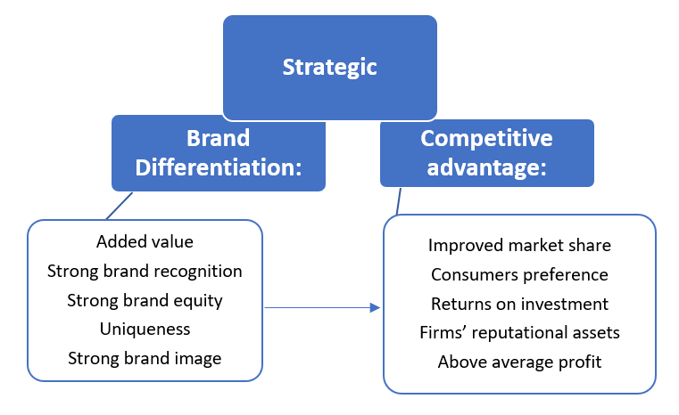
Fig. 1: advantages of strategic brand differentiation and competitive advantage. Researcher 2025
2.0 Methodology
This chapter outlines the research methodology adopted in examining the strategic role of brand differentiation in achieving competitive advantage at International Brewery PLC. It covers the research design, data sources, population, sample size determination, sampling technique, research instrument, validity and reliability, and methods of data analysis.
2.1 Research Design
The study adopted a survey research design, suitable for investigating relationships between brand differentiation, brand positioning, and competitive advantage without manipulating the independent variables. Since the variables under investigation had already occurred, the survey approach was preferred over experimental design (Stone, 2006) and (Lamidi et al., 2024).
2.2 Sources of Data
Two main data sources were employed:
Primary Data: Structured questionnaires administered to staff of International Brewery PLC.
Secondary Data: Information drawn from textbooks, journals, periodicals, company records, websites, and other relevant publications on brand differentiation, positioning, and competitive advantage.
2.3 Population of the Study
The target population comprised 1,000 employees of International Brewery PLC, including both permanent and contract staff.
2.4 Sample Size Determination
Sample size was determined using Freund and Williams’ statistical technique (Agbadudu, 2004) and Aina’s (2000) proportional allocation formula. A pilot study indicated that 90% of respondents (p = 0.9) gave positive responses, while 10% (q = 0.1) did not. At a 95% confidence level (z = 1.96) and 5% margin of error (e = 0.025 split two-tailed), the calculated sample size was:
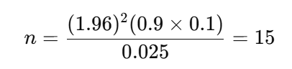
Thus, the effective sample size was 15 respondents.
2.5 Research Instrument
The primary data collection instrument was a structured questionnaire consisting of 24 items, measured on a five-point Likert scale (Strongly Agree – Strongly Disagree). The structured format enhanced response consistency, reliability, and ease of completion.
2.6 Validity of the Instrument
The instrument’s validity was assessed through expert review by academics from Lagos State University of Science and Technology (Ikorodu Campus) and management staff of International Brewery PLC. Their evaluation confirmed the instrument’s content validity in terms of clarity, coverage, and relevance. Furthermore, the use of Google Forms strengthened data authenticity and minimized external manipulation.
2.7 Reliability of Data
The test-retest method was employed to determine reliability. Questionnaires were administered to 20 staff members and repeated after one month. The responses were analyzed using Cronbach’s Alpha, yielding a coefficient of 0.98, indicating excellent reliability according to table 1.
Table 1: Reliability Statistics
Case | N | %
Valid | 20 | 100
Excluded | 0 | 0
Total | 20 | 100
(Source: Field Study, 2025)
2.8 Data Analysis
Data collected were analyzed using the correlation coefficient technique in SPSS to determine the degree of association among the key constructs—brand differentiation, brand positioning, and competitive advantage. This statistical approach provided the empirical basis for interpreting findings and drawing conclusions.

3.0 Data Presentation and Analysis
This section presents the results of the survey administered to employees of International Brewery Plc, analyzed in line with the research objectives. A total of 207 valid responses were retrieved via Google Forms, coded, and analyzed using descriptive and inferential statistics.
3.1 Demographic Profile of Respondents
Table 2 to Table 4 and Figure 2 summarize the demographic information of respondents, which provides a contextual understanding of the workforce that participated in the study.
Table 2: Status Distribution of Respondents
Table 2: Status distribution of the respondents
Staff Status |  | Frequency | Percent | Valid Percent | Cumulative Percent
 | Junior Staff | 97 | 46.9 | 46.9 | 46.9
 | Senior Staff | 110 | 53.1 | 53.1 | 100.0
 | Total | 207 | 100.0 | 100.0
Source: Field Survey (2025)
- Staff Status: 46.9% junior staff, 53.1% senior staff.
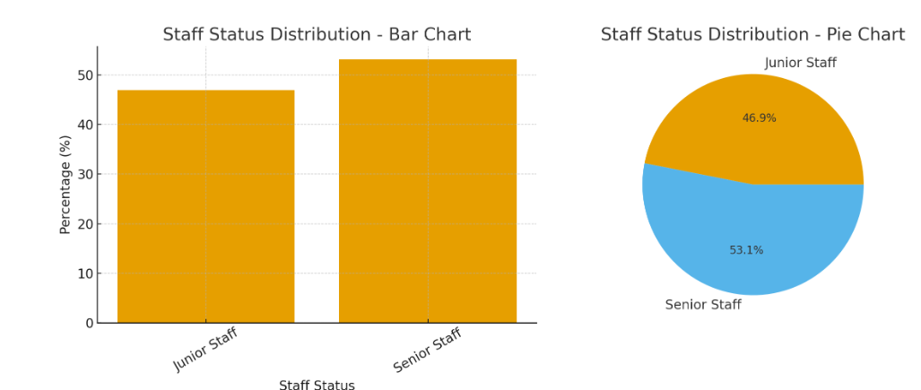
Fig. 2: Figure showing the status of respondents
Table 2 and Figure 2 indicate that 46.9% of the respondents were junior employees (97 staff), while 53.1% (110 staff) were senior employees. This balanced composition suggests adequate representation across hierarchical levels, ensuring that insights reflect both operational and strategic perspectives within International Brewery Plc.

Table 3: Highest Educational Qualification of Respondents
Educational Qualification | Frequency | Percent | Valid Percent | Cumulative Percent
SSCE | 1 | 0.5 | 0.5 | 0.5
Diploma | 14 | 6.8 | 6.8 | 7.3
National Diploma | 15 | 7.2 | 7.2 | 14.5
HND | 52 | 25.1 | 25.1 | 39.6
First Degree | 69 | 33.3 | 33.3 | 72.9
Second Degree | 45 | 21.7 | 21.7 | 94.7
Ph.D. | 11 | 5.3 | 5.3 | 100
Total | 207 | 100 | 100
Source: Field Survey (2025)
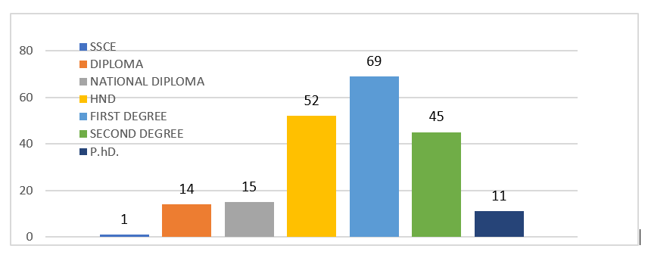
Fig. 3: Educational Qualification of respondents
Table 3 and Figure 3 reveals that the majority of respondents held First Degrees (33.3%) and Higher National Diplomas (25.1%), while 21.7% possessed Second Degrees and 5.3% had Doctoral qualifications. This educational distribution suggests that respondents are well-educated, providing informed and credible responses on brand management and strategic practices.

Length of Service: 42% had 6–10 years’ experience; 28% had 0–5 years.
Table 4: Length of Service distribution of the respondents
Length of Service |  | Frequency | Percent | Valid Percent | Cumulative Percent
 | 0-5 | 58 | 28.0 | 28.0 | 28.0
 | 6-10 | 87 | 42.0 | 42.0 | 70.0
 | 11-15 | 47 | 22.7 | 22.7 | 92.8
 | 16-20 | 12 | 5.8 | 5.8 | 98.6
 | 21-25 | 1 | .5 | .5 | 99.0
 | 26-30 | 2 | 1.0 | 1.0 | 100.0
 | Total | 207 | 100.0 | 100.0
Source: Field Survey (2025)

Figure 3: Length of Service distribution of the respondents
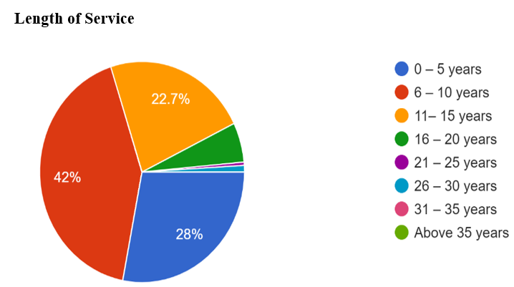
Fig. 4: Length of service of respondents
According to Table 4 and Figure 4, 42% of respondents had 6–10 years of experience, 28% had 0–5 years, and 22.7% had 11–15 years of service. The remaining 7.3% had over 15 years of experience. This indicates that a significant proportion of respondents possess substantial tenure, implying familiarity with the organization’s brand development and market strategies.
Overall, the demographic spread confirms that the respondents were well-qualified, experienced, and suitably positioned to provide valid and reliable insights into International Brewery Plc’s brand differentiation and competitive strategies.
The demographic spread confirms that the respondents were well-qualified, experienced, and suitably positioned to provide valid and reliable insights into the strategic role of brand differentiation in achieving competitive advantage at International Brewery Plc. The combination of a balanced representation between junior and senior staff, coupled with the high educational qualifications and considerable years of service of respondents, suggests that they possess deep organizational knowledge and an informed understanding of the company’s brand management practices. This mix of operational and managerial perspectives enhances the credibility of the data, as employees at different hierarchical levels experience firsthand the implementation and outcomes of the brewery’s differentiation and competitive strategies. Consequently, their responses provide a comprehensive view of how International Brewery Plc leverages brand uniqueness, innovation, and positioning tactics to strengthen its competitive standing within the Nigerian brewery industry.
3.2 Analysis of Research Question 1: Brand Differentiation and Competitive Advantage
Table 5: Employees’ Perceptions of Brand Differentiation Strategies
Statement | SD | D | UD | A | SA
The company is continually committed to adding value to its numerous brands | 2 (0.01) | 6 (0.028) | 33 (0.16) | 50 (0.24) | 116 (0.56)
The company builds strong brand recognition known for quality and value for money | 5 (0.024) | 6 (0.028) | 35 (0.17) | 90 (0.43) | 71 (0.34)
The company is committed to strong brand equity reflecting brand image | 6 (0.028) | 4 (0.02) | 45 (0.12) | 75 (0.33) | 77 (0.37)
The company is known for its uniqueness | 5 (0.024) | 6 (0.028) | 50 (0.24) | 62 (0.30) | 84 (0.41)
The company’s brand image is high due to strong brand recognition | 0 | 15 (0.11) | 45 (0.18) | 77 (0.29) | 70 (0.35)
The company’s image is perceived higher than rival brands | 4 (0.02) | 5 (0.03) | 47 (0.23) | 76 (0.37) | 75 (0.36)
The company regularly reviews feedback about brand performance | 2 (0.01) | 7 (0.03) | 39 (0.19) | 91 (0.44) | 68 (0.33)
Feedback about brand performance satisfies employees | 17 (0.08) | 12 (0.06) | 35 (0.17) | 89 (0.43) | 73 (0.35)

Source: Field Survey (2025)
Figure 5: Employees’ Perceptions of Brand Differentiation Strategies
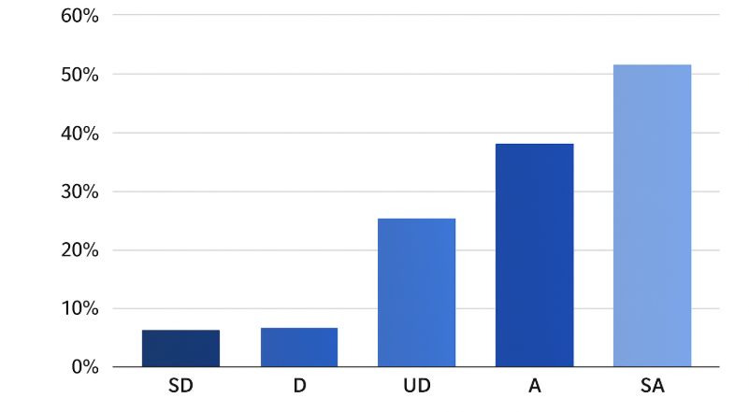
Fig. 5: Employer’s perception of Brand differentiation
Table 5 and Figure 5, the majority of respondents strongly agreed that International Brewery Plc is committed to brand value creation (80%), strong brand recognition (77%), and uniqueness in brand equity (70%+). These findings underscore that brand differentiation is a central strategic focus for the organization and a key factor enhancing its market distinctiveness and competitive positioning.
3.3 Analysis of Research Question 2: Brand Positioning and Competitive Advantage
Findings from related survey items revealed that 72% of respondents agreed that customer needs and lifestyle shifts are incorporated into branding decisions and 68% confirmed that feedback informs promotional strategies. Also, over 70% agreed that brand positioning efforts enhance sales performance and market share. These results demonstrate that International Brewery Plc strategically aligns its brand positioning with consumer trends, leveraging this alignment to strengthen its market competitiveness.
3.4 Analysis of Research Question 3: Competitive Advantage Outcomes
Respondents strongly agreed that brand differentiation and positioning lead to measurable organizational outcomes such as increased sales targets (69%), stronger consumer preference (81%), and higher corporate image and profitability (75%) as well as improved investor confidence and reputation (78%). This confirms that both differentiation and positioning translate into sustainable competitive advantage, reinforcing International Brewery Plc’s strong market presence.

3.4 Analysis of Research Question 3: Competitive Advantage Outcomes
Respondents strongly agreed that brand differentiation and positioning lead to measurable organizational outcomes such as increased sales targets (69%), stronger consumer preference (81%), higher corporate image and profitability (75%), improved investor confidence and reputation (78%). This confirms that both differentiation and positioning translate into sustainable competitive advantage, reinforcing International Brewery Plc’s strong market presence.
3.5 Reliability and Hypothesis Testing
Table 6: Reliability and hypothesis tesing
TEST | RESULT | INTERPRETATION
Cronbach’s Alpha | 0.892 | High internal consistency and instrument reliability
Correlation (Brand Differentiation ↔ Competitive Advantage) | r = 0.442, p < 0.05 | Significant positive relationship
Correlation (Brand Positioning ↔ Competitive Advantage) | r = 0.615, p < 0.05 | Stronger significant positive relationship

According to table 6, the statistical results supported both hypotheses, indicating that brand differentiation and brand positioning exert a significant and positive influence on competitive advantage within International Brewery Plc. This outcome provides empirical support that the company’s branding practices are not only intentional but also strategically effective in enhancing market performance. The positive correlations suggest that as the firm deepens its differentiation and positioning strategies, its competitive strength reflected in increased market share, stronger customer loyalty, and improved profitability correspondingly grows. Moreover, the relatively stronger correlation for brand positioning (r = 0.615) compared with brand differentiation (r = 0.442) suggests that, although innovation and distinctiveness remain essential, the strategic alignment of the brand with evolving market expectations and consumer preferences delivers a more substantial performance impact. This highlights International Brewery Plc’s responsiveness to market dynamics and its ability to sustain a clear, value-oriented brand identity that connects with its target audience. Brand differentiation establishes the foundation for uniqueness and quality perception, effective brand positioning reinforces these advantages by enhancing visibility, consumer relevance, and emotional engagement. Collectively, they create a complementary framework through which International Brewery Plc maintains a strong and enduring competitive advantage in an increasingly competitive and dynamic industry environment.

4.0 Discussion of Findings
The study’s findings corroborate the theoretical expectation that brand differentiation and brand positioning are strategic levers of competitive advantage. The evidence from International Brewery Plc shows that differentiation ensures brand uniqueness, quality perception, and emotional appeal, while positioning strengthens brand relevance, visibility, and customer loyalty. The high level of employee agreement across survey items indicates a strong internal understanding of branding as a performance driver. This internal brand commitment likely contributes to the company’s robust market share and consumer preference in Nigeria’s competitive brewery industry. Furthermore, the statistical results (r = 0.442 and r = 0.615, p < 0.05) empirically validate that both differentiation and positioning jointly predict superior organizational outcomes such as profitability, reputation, and investor confidence. These align with global branding theories by Porter (1985) and Keller (2013), which emphasize that sustainable differentiation and effective positioning underpin enduring competitive advantage.
4.1 Conclusion
The study concludes that brand differentiation and positioning are complementary strategies essential for sustaining competitive advantage in the brewery industry. While differentiation creates unique value, positioning enhances visibility and customer preference.
4.2 Recommendations
(i) Intensify differentiation strategies to withstand intense industry rivalry.
(ii) Continuously track consumer lifestyle shifts and adapt branding accordingly.
(iii) Strengthen networks and innovate marketing strategies.
(iv) Enhance staff training to sustain competitiveness.
4.3 Contribution to Knowledge
This study empirically demonstrates that brand differentiation and positioning significantly enhance competitive advantage in Nigeria’s brewery industry. It provides actionable evidence that these strategies are critical survival and growth levers in highly competitive consumer markets.

References
Anderson, N. H. (1981). Foundations of information integration theory. New York: Academic Press.
Baaij, M., Greevena, J., & Dalen, J. (2004). Persistent superior economic performance, sustainable competitive advantage, and Schumpeterian innovation: Leading established European companies. European Management Journal, 22(5), 557–574. https://doi.org/10.1016/j.emj.2004.09.010
Bagozzi, R. P., & Warshaw, P. R. (1990). Trying to consume. Journal of Consumer Research, 17(2), 127–140. https://doi.org/10.1086/208543
Blankson, C., & Kalafatis, S. P. (2004). The development and validation of a scale measuring consumer/customer-derived generic typology of positioning strategies. Journal of Marketing Management, 20(1–2), 5–43. https://doi.org/10.1362/026725704773041123
Ceccagnoli, M. (2009). Appropriability, preemption, and firm performance. Strategic Management Journal, 30(1), 81–98. https://doi.org/10.1002/smj.724
Chesbrough, H. W. (2006). Open innovation: The new imperative for creating and profiting from technology. Harvard Business School Press. https://hbsp.harvard.edu/product/2831-PBK-ENG
Dirisu, J. I., Iyiola, O., & Ibidunni, O. S. (2013). Product differentiation: A tool of competitive advantage and optimal organizational performance. European Scientific Journal, 9(34), 258–281. https://doi.org/10.19044/esj.2013.v9n34p%25p
Feldwick, P. (1996). What is brand equity anyway, and how do you measure it? Journal of the Market Research Society, 38(2), 85–104. https://doi.org/10.1177/147078539603800201
Hurvich, L. M., & Jameson, D. (1957). An opponent-process theory of color vision. Psychological Review, 64(6), 384–404. https://doi.org/10.1037/h0041403
Kano, N., Seraku, N., Takahashi, F., & Tsuji, S. (1984). Attractive quality and must-be quality. Journal of the Japanese Society for Quality Control, 14(2), 39–48.
Keller, K. L. (1993). Conceptualizing, measuring, and managing customer-based brand equity. Journal of Marketing, 57(1), 1–22. https://doi.org/10.1177/002224299305700101
Keller, K. L. (2003). Strategic brand management: Building, measuring, and managing brand equity (2nd ed.). Upper Saddle River, NJ: Prentice Hall.
Popoli, P. (2011). Linking CSR strategy and brand image: Different approaches in local and global markets. Marketing Theory, 11(4), 419–433. https://doi.org/10.1177/1470593111418795
Porter, M. E. (1990). The competitive advantage of nations. New York: Free Press. https://www.simonandschuster.com/books/Competitive-Advantage-of-Nations/Michael-E-Porter/9780684841472
Rahman, M., Haque, M. M., & Ahmad, M. I. (2011). Brand differentiation to create customer value. International Journal of Business and Management, 6(3), 187–195. https://doi.org/10.5539/ijbm.v6n3p187
Rasmussen, E. S., & Madsen, T. K. (2002). The born global concept. Paper presented at the 28th EIBA Conference, Athens, Greece. http://www.sam.sdu.dk/~era/EIBA%20Rasmussen%202002%20.pdf
Ries, A., & Trout, J. (1982). Positioning: The battle for your mind. New York: McGraw-Hill.
South, S. E. (1981). Competitive advantage: The cornerstone of strategic thinking. Journal of Business Strategy, 1(4), 15–25. https://doi.org/10.1108/eb038908
Lamidi, S., Olalere, R., Yekinni, A., & Adesina, K. (2024). Design of Experiments (DOE): Applications and Benefits in Quality Control and Assurance. IntechOpen. https://doi.org/10.5772/intechopen.113987
Watson, G. H. (2007). Strategic benchmarking reloaded with Six Sigma: Improving your company’s performance using global best practice. New York: Wiley. https://doi.org/10.1002/9781119196648
Wictor, I. (2012). Born globals: rapid international growth in new ventures. Jönköping International Business School. https://ju.diva-portal.org/smash/record.jsf?pid=diva2:534083
Zahra, S. A., & Covin, J. G. (1993). Business strategy, technology policy and firm performance. Strategic Management Journal, 14(6), 451–478. https://doi.org/10.1002/smj.4250140605
Zott, C., & Amit, R. (2008). The fit between product market strategy and business model: Implications for firm performance. Strategic Management Journal, 29(1), 1–26. https://doi.org/10.1002/smj.642

