The role of E commerce platforms in shaping the future of retail

Abstract
This article looks at how e-commerce platforms are changing retail by using new technologies, making shopping easier for users, and helping all groups grow. Amazon, Shopify, Flipkart, and Meesho have now become digital ecosystems that make it possible to personalize in real time, use social commerce, and predict logistics. In India and similar countries, people are using mobile devices, vernacular languages, and nearby delivery to get involved in digital activities. The research investigates how trust, involvement, and social involvement affect people’s decisions to buy online. The industry also points out that platforms are introducing ethical and sustainable shipping and circular economy solutions. It is argued in the article that, by analyzing trends and using data, technology, and responsible design, e-commerce platforms are leading the way in retail changes.
Keywords: E-commerce, personalization, social commerce, digital trust, mobile-first retail, sustainability.

1. Introduction
The retail industry is changing a lot around the world, mostly due to the increase in digital technology and more people shopping online. It is forecasted that e-commerce will make up over 25% of all retail sales and earn more than USD 7.3 trillion in 2025 (Oberlo, 2024). It means that digital platforms are now used for selling goods and will also be the main structures for commerce in the future.
Amazon, Shopify, Flipkart, Meesho, and TikTok Shop have become more advanced than they were before. They rely on AI, predictive analytics, and cloud logistics to provide both businesses and consumers with all the solutions they need. E-commerce platforms today, as Masoner (2025) explains, help users sell items, keep their stock under control, process payments, look at their data, interact with buyers, and deliver orders in real time.
Because of the COVID-19 pandemic, the shift happened much faster. Because of the rules about social distancing and lockdowns, many people who avoided online shopping are now shopping online most of the time. This means that people now want services to be easy, quick, tailored to them, and accessible on several devices. According to Amelia (2025), this change proves that digital technology has fully transformed retail, with the key benefit being the use of strong platforms and flexible technology.
The biggest effect of e-commerce platforms is that companies must now focus on personalization. Nowadays, platforms use real-time data about users to adjust the products they show and the advertisements they get. Abhishek Agarwal (2025) states that personalization is what mainly influences customer experience today. Thanks to AI, platforms can guess what customers are looking for, help them find products, and encourage them to come back again. This is especially seen in predictive analytics, which analyze a person’s history, past purchases, and the way they write reviews to give them special offers (Brenninkmeijer, 2024; Bulkrock, BaniMustafa & Qusef, 2025).
Also, platforms are now bringing together the activities of shopping and socializing. Using social media to shop is becoming a common trend very fast. Rather than using Instagram, TikTok, and Facebook only for ads, brands now use them as online shops, so users can buy, consult influencers, and watch live streams of new items (Stone, 2025). Since people are looking for experiences that are real and instant, these features meet what consumers now hope for, mainly younger ones. Therefore, it is becoming hard to distinguish between entertainment and commerce.
E-commerce platforms help MSMEs get involved in the digital market. Since digital infrastructure is advancing quickly in India, platforms provide people with an easy way to take part in retail markets across the country and overseas. Because of mobile-first design, using local languages, and local payment methods, sellers from Tier 2 and Tier 3 cities can reach more customers. As the World Economic Forum (2025) points out, buying from local businesses is great for the community’s economy. NorthStar-Consulting (2025) further explains that smaller companies can now use platforms to help them expand internationally.
In addition, their abilities in logistics and supply chain are getting better every day. Currently, hyperlocal delivery, automated delivery in the last mile, and AI-based inventory forecasting are required to satisfy customers who want their orders at any time and place (Kapadia, 2025). Besides managing logistics, Amazon FBA and Flipkart Fulfilment help a company become more competitive by ensuring trust, reducing the risk of losing customers during checkout, and making people happy.
At the same moment, people are paying more attention to how ethics and sustainability affect platform-led commerce. Today, people are more knowledgeable about how their spending affects the world around them. For this reason, leading sites now offer carbon-neutral shipping, use eco-certified tags for their products, and make their supply chains open to everyone (Shopify, 2024). They follow corporate social responsibility and also respond to people who care about ethics in business.
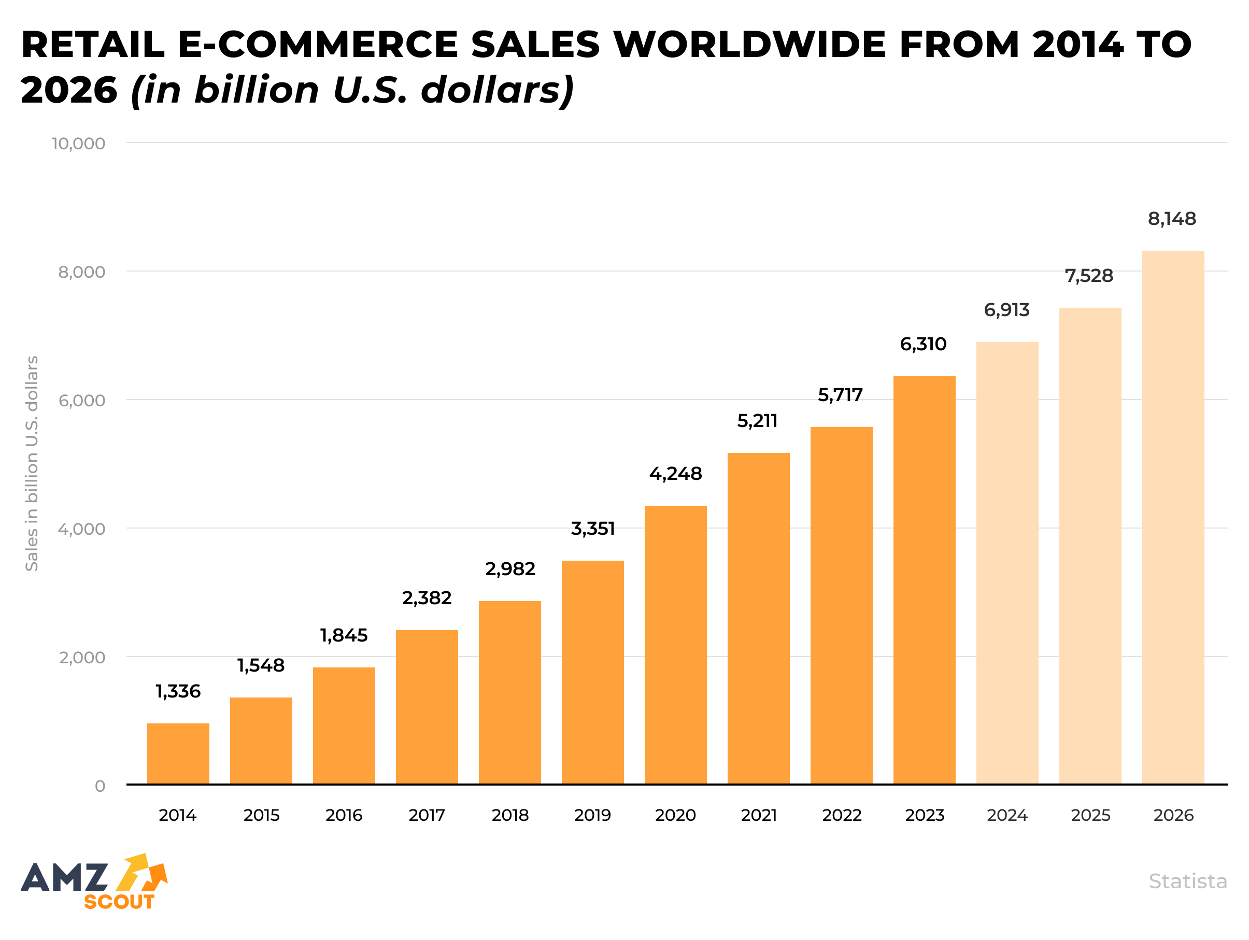
Figure 1: Global E-Commerce Retail Sales, 2015–2025
Source: Team (2025)
All things considered, e-commerce platforms have gone beyond their initial purpose of being online stores. Now, they handle all parts of retail, starting with finding products and ending with receiving them. By using AI-powered personalization, social commerce, new logistics, and proper governance, these platforms are creating the future of retail.

2. Convergence of Social Media and E-Commerce
Social commerce, which happens when social media and e-commerce meet, is one of the biggest changes affecting the retail industry. Before, social media platforms focused on helping brands promote themselves and interact with customers. Nowadays, these platforms are designed so that users can look for products, get suggestions, and buy them all without leaving the website. By mixing content with commerce, brands are changing the way consumers interact with them and choose what to buy.
The main reason for this convergence is that people are relying more on digital ways to trust and be influenced. According to Bulkrock et al. (2025), people now depend on what others say, what influencers recommend, and UGC to make their choices. Instagram, TikTok, and YouTube are highly effective sales engines since they use visuals, other users’ experiences, and personalized content to boost demand and encourage people to buy.
Because of this change, users can now watch or read something and buy the product right away. For example, TikTok Shop gives users the option to buy products through the videos and offers AI-selected products, allowing them to make purchases on the spot (Stone, 2025). Likewise, Instagram Shopping makes it possible for users to browse through collections, see how much things cost, and buy them in the same app. Because of these features, the sales funnel is no longer as long and complicated as it used to be.
Table 1: Key Social Commerce Platforms and Features (2025)
Platform | Commerce Features | Key Strength | Target Demographic
Instagram | In-app checkout, product tagging | Visual branding, influencer integration | Millennials, Gen Z
TikTok Shop | Livestream shopping, AI personalization | Virality, short-form video engagement | Gen Z, Gen Alpha
Facebook Shops | Marketplace, group selling | Community commerce, cross-device reach | All age groups
Pinterest | Buyable Pins, visual search | Inspiration-based discovery | Females 25–44
YouTube Shopping | Product tagging in videos | Product demos, long-form storytelling | Tech & lifestyle users
It is especially effective in this area to use influencer marketing. Unlike regular celebrities, digital influencers tend to create a bond with their followers that seems close and real. Abhishek Agarwal (2025) says that users trust influencers, not only for what they know about products, but also because they show what people want to be and relate to. Because of this trust, people are likely to engage more and convert when the content is natural and attractive to look at.
Real-time tools such as live streams, polls, Q&A, and reaction stickers also add a lot of value. Thanks to these features, users are more encouraged to take part in what the brand does, which increases their bond and desire to buy. To make the most of this trend, platforms have set up systems for influencers to earn money and for brands to easily work with them (Nguyen, 2025).
Besides, this merging of industries depends heavily on data. Social media platforms use advanced analytics to notice likes, comments, shares, and how long people spend on pages, then use this information to tailor each person’s feed. Because of hyper-targeting, ads are more relevant and valuable, which leads to a rise in clicks and conversions (Brenninkmeijer, 2024; EComposer, 2025).
Still, bringing social and commercial functions together can cause certain issues. More people are worried about how companies influence consumers, protect their data, and the amount of advertising they receive. Both regulators and platforms are being asked to promote transparency when it comes to paid partnerships and protect data privacy (Shopify, 2025). Ensuring both users and the business gain from the platform is still considered very important and ethical.
All in all, social media and e-commerce coming together has completely changed the retail experience by making influence a key part of the system. With native ads, brands can join consumers where they usually spend time on the internet, turning simple browsing into engaging and buying opportunities. This development changes the way retail works and also changes what a store means in the world of online platforms.

3. Digital Trust, Engagement, and Social Presence
As digital platforms grow in their range of services, trust, involvement, and social aspects now play a key role in understanding consumer actions. They do not only help with technology; instead, they serve as main tools that turn digital activities into transactions. They play a role in shaping both what people intend to buy and what they actually buy, mainly when there is too much information and no chance to touch the products.

3.1 Digital Trust: Reducing Perceived Risk
People will only act as consumers online if they trust the company. Unlike in normal stores, e-commerce does away with physical contact and uses online payments, remote delivery, and computer-based suggestions. In this case, trust covers the platform’s honesty, the trustworthiness of the content providers, and the quality of the products. Hajli (2014) believes that trust includes both logical risk assessment and emotional confidence in a person’s credibility and reliability.
Now, e-commerce sites use several ways to win trust: showing who the sellers are, clear return policies, promises to protect buyers, and AI-based fraud detection (Bulkrock et al., 2025). They help lower uncertainty and also make online transactions seem more acceptable, mainly in places where people are still suspicious about online transactions.

3.2 Engagement: The Currency of Digital Attention
Now, e-commerce includes much more than just looking at products or putting them in a shopping cart; it includes likes, comments, saving items, leaving reviews, sharing them, and clicking on links. Hollebeek et al. (2014) believe that engagement involves several factors and shows how much a person is involved with different content, products, or platforms. When people are highly engaged, they tend to remember the brand, buy it more often, and promote it after their purchase.
Platforms encourage users to stay engaged by including quizzes about products, special deals with a countdown, stories that can be swiped, and notifications showing what others have bought (Nguyen, 2025). They attract the audience’s eye and help people recognize and care about the brand, which are important before they decide to buy.

3.3 Social Presence: Humanizing the Digital Experience
Social presence means how much a consumer feels that a platform or brand interaction is genuine and full of social interaction. Lu, Fan, and Zhou (2016) believe that platforms that allow users to interact with each other live, use chatbots, rely on influencers’ stories, or respond immediately to feedback are more likely to make users trust the platform and feel satisfied.
Social commerce has made this situation even more noticeable. Livestream shopping, influencer Q&A, and user comments form a virtual environment that resembles talking to a salesperson or your friends in a store. The close relationships that influencers have with their followers encourage younger people to trust and care about them more.
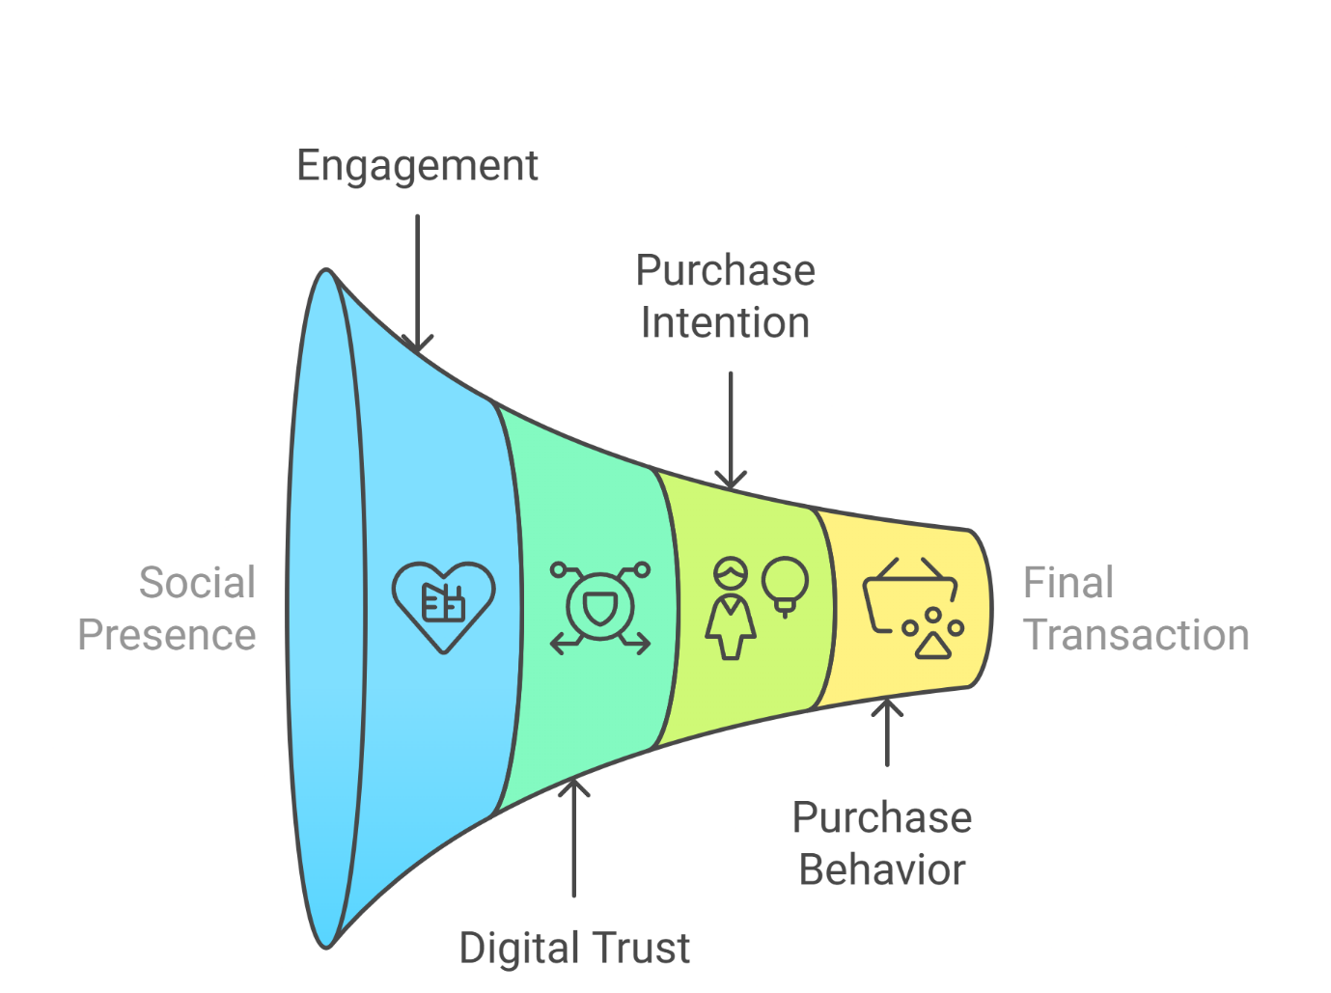

Figure 2: The Consumer Influence Funnel in Digital Retail
3.4 Integrated Effect: From Influence to Action
They all work together and are not separate from each other. Having a social presence helps people feel more involved, and this involvement increases trust when they see it many times; trust then encourages them to buy more. The effect of this process can be seen clearly in mobile retail, since content that is emotional, credible, and visually appealing is most successful with people who have very little time.
Table 2: Mediators of Consumer Behavior in Platform-Based Retail
Mediator | Definition | Role in Consumer Behavior
Trust | Confidence in platform, content, and transaction | Reduces perceived risk and uncertainty
Engagement | Behavioral and emotional participation | Enhances interest, recall, and likelihood to act
Social Presence | Perceived human warmth and interactivity | Builds emotional connection and brand affinity
All these psychological factors make up the underlying structure of digital commerce. Even though technology makes it possible to grow operations, it is the feelings and relationships within a company that help customers stay loyal and support the brand.
4. Personalization and Predictive Algorithms in E-Commerce
Today, retailers must use personalization as a new technology and a key strategy. Since people use several devices and platforms to shop, they now want shopping experiences that are personalized for them. Thanks to the data and advanced algorithms they have, e-commerce platforms are leading the way in offering such experiences with predictive analytics, AI-assisted suggestions, and interfaces that respond to users’ situations.
4.1 From One-Size-Fits-All to Individually Curated Journeys
Before, retailers focused on general groups of customers and used wide-reaching advertising. On the other hand, today’s digital platforms can divide users into small groups, making it possible to send personalized messages, product ideas, and offers to each person. Abhishek Agarwal (2025) states that personalization is now a key factor in both making users happy and maintaining a strong position in the market. Consumers now hope that platforms will understand their needs, make it easy to find products, and avoid making decisions that are too hard.
Machine learning algorithms are used to analyze a person’s browsing history, what they click on, what they have bought before, the time they spend on a page, and the tone of reviews. In Brenninkmeijer’s (2024) view, personalization technologies are moving from using fixed rules to using AI that can respond and change in real time. They help by recommending products and also adjust search results, emails, landing pages, and app pages to suit each user.
4.2 The Role of Predictive Analytics in Consumer Decision-Making
Platforms can estimate what customers will do in the future using their past and current actions. For instance, algorithms can tell you the chances of cart abandonment and deliver special offers (such as time-limited discounts), or find out the perfect moment to send reminders to bring customers back. Bulkrock et al. (2025) explain that combining predictive models with NLP is very effective for platforms to understand how customers feel and match them with suitable products.
Table 3: Types of Personalization and Predictive Features in E-Commerce
Technique | Function | Consumer Impact
Behavioral Targeting | Uses browsing/purchase history to recommend products | Increases relevance and conversion
Retargeting Algorithms | Tracks users across devices/platforms for abandoned carts | Reduces bounce rate and lost sales
Sentiment-Based Filtering | Analyzes review language to rank or flag product quality | Builds trust and informs decision-making
Context-Aware Recommendations | Adjusts suggestions based on device, time, or location | Enhances real-time relevance

Such strategies ensure that the customer journey is smooth and natural, especially on mobile apps, where there is not much room and users want things to happen fast. Recommendations tailored to each user save time and help the site react to users’ actions, which boost CTR, AOV, and CLV.
4.3 Personalization in the Indian Context
In India and similar markets, personalization helps people who are not very familiar with technology. Offering different languages, appropriate product recommendations, and AI help in searching, platforms help first-time and semi-urban users shop online more easily. Flipkart and Meesho have now added vernacular suggestions and voice searching to meet the needs of India’s diverse people (Shopify, 2025; World Economic Forum, 2025).
Besides, predictive personalization in India is usually designed for customers who are sensitive to cash, as the algorithms highlight offers, EMI plans, and cashback discounts. Because of this sensitivity, more people can trust the platform and are likely to use it again.
4.4 Ethical Considerations and Data Transparency
Even though personalization is helpful, using consumers’ data more often brings up important ethical questions about privacy, consent, and how algorithms work. When personalization goes too far, it may result in filter bubbles, which means users only get a limited choice and less freedom to make their own decisions (Nguyen, 2025). Likewise, some people have criticized predictive pricing for appearing unfair because it shows users different prices depending on their likely ability to pay.
Some of the leading platforms are providing users with controls over their ads, clear information about cookies, and AI explanations, so they know why certain content or prices appear (Shopify, 2025). Such initiatives are important for keeping consumers’ trust, which is necessary for the success of personalization.

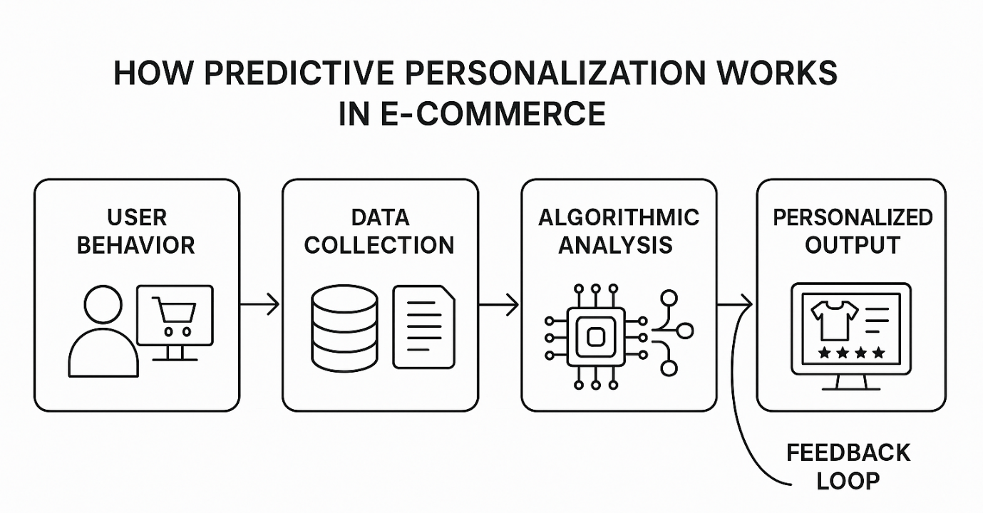Figure 3: How Predictive Personalization Works in E-Commerce

4.5 Toward Emotionally Intelligent Platforms
The future of personalization will depend on how well platforms can understand and answer to users’ emotions, not only on how accurate their predictions are. AI is being developed to better understand a user’s needs by looking at their tone, how they phrase things, or even their facial expressions, if they are shopping in AR. This way of caring for customers can lead to them being more satisfied, loyal to the brand, and sharing the company’s values in the future.
To sum up, predictive algorithms and personalization systems are changing the way retailers interact with customers. The use of technology and understanding people’s actions allows e-commerce platforms to provide services that are efficient, meaningful, and responsive to society. As the technologies develop, it will be important to guarantee that innovation goes hand in hand with making sure everyone is included and the process is transparent, so that personalization supports, instead of limits, the user’s experience.
5. The Indian Context: Mobile-First and Hyperlocal Commerce
India is becoming a major player in e-commerce because of its fast-growing smartphone use, more people learning to use the internet, and a growing group of people who start online with their mobile devices. While in the West, people used the internet on their desktops to shop online, in India, e-commerce started with mobile phones. Because of this mobile-focused system, both the platforms and consumers have changed, leading to a local approach to retail progress.
5.1 Rise of Mobile-First Consumption
Shopify (2025) states that more than 80% of Indian online shoppers use their mobile devices to visit e-commerce sites. This trend is strongest in Tier 2 and Tier 3 cities, since many people in these places use their phones as their main or only way to go online. In these situations, e-commerce platforms should be designed for small screens, little data, and regional language selections.
Flipkart, Meesho, and JioMart have been driving the trend by focusing on mobile users. Some examples are shopping through apps, voice search, support for many languages, and easy navigation for those using the app for the first time. Meesho has helped a lot by making it easy for micro-entrepreneurs and homemakers to sell items via WhatsApp and Facebook groups, turning these platforms into places to buy and sell (World Economic Forum, 2025).
5.2 Empowering Local Sellers and SMEs
An important benefit of India’s e-commerce growth is that it gives SMEs a fair chance to take part in the market. In the past, small sellers were unable to join traditional retail because it was too costly and they had a limited area to sell in. Now, e-commerce platforms provide everything needed, such as online stores, inventory tracking, logistics help, and real-time reports, so that rural sellers can compete nationally (NorthStar-Consulting, 2025).
Table 4: E-Commerce Adoption Among Indian Consumers by Age Group (Urban Tier 1 and Tier 2 Cities)
Age Group | Preferred Platforms | Purchase Frequency | Key Motivation
18–24 | Instagram, Meesho, Amazon | High | Trend discovery, influencer trust
25–34 | Flipkart, Myntra, Amazon | Very High | Convenience, fast delivery
35–44 | Amazon, WhatsApp, JioMart | Medium | Price, product variety
45+ | WhatsApp, Facebook Marketplace | Low to Medium | Familiarity, assisted purchase
By adding UPI and cash-on-delivery, the buying process for new users has become even less difficult. Besides, e-commerce sites are now designed to meet the ways people in India shop, such as buying for festivals, purchasing in bulk, and being cost-conscious.
5.3 Hyperlocal Fulfillment and Last-Mile Logistics
Because India has diverse geography and variable infrastructure, handling goods and services is not easy. They are doing this by creating more local fulfillment centers, dark stores, and joining forces with local courier services. The use of local retail stores and gig workers in Flipkart’s “Flipkart Quick” and Amazon’s “I Have Space” programs has made it possible to cut down delivery times in both crowded and remote places (Kapadia, 2025).
These models not only provide quick deliveries, but also help local people find jobs and lower the environmental impact because the deliveries are shorter. Because of these innovations, users are more likely to keep using these new digital services.
5.4 Cultural Relevance and Vernacular Commerce
Indian consumers are very diverse, as what they prefer depends on their regional language, cultural customs, and seasonal events. Using local content, unique offers, and campaigns that match the culture helps e-commerce platforms retain customers for a long time. For these holidays, platforms are introducing special collections with messages and collaborations that fit the local culture.
Moreover, video commerce is becoming popular in semi-urban areas, since people there might find it easier to understand products through video rather than through text. TikTok Shop’s reviews, YouTube demos, and Facebook Live selling are some of the ways content-rich commerce can help people discover and trust products in many languages (Stone, 2025).
5.5 Challenges and the Path Forward
Although the economy has grown a lot, there are still some problems. Lack of digital infrastructure, hard-to-reach areas for logistics, many languages, and little trust in technology among those who are not well-educated are holding back the use of e-commerce by all. It is important for platforms, government, and local businesses to join forces and invest in digital training, better internet access for everyone, and protection rules for consumers.
To sum up, India demonstrates how retail can be transformed by platforms, mobile devices, including all regions, and the creativity of entrepreneurs. Because Alibaba’s e-commerce model is mobile-based, focused on local areas, and includes social features, it benefits its diverse users and teaches other countries how to build a sustainable and inclusive digital retail system.

6. Fulfillment Innovation and Logistics as a Competitive Advantage
Now, the main competition in digital retail is based on how fast, reliable, and efficient fulfillment is, not only on what is being sold or its price. As e-commerce platforms grow and offer more services, their success in controlling last-mile delivery, improving warehouses, and managing inventory in real time has become very important for their long-term success. Fulfillment is now a key part of a company’s strategy, affecting how customers feel about the brand, how much they trust it, and how loyal they remain to the platform.

6.1 The Strategic Role of Fulfillment in Platform-Based Retail
Before, retailers kept their goods locally and it was the customer who had to bring them home. Unlike before, e-commerce platforms are responsible for this and guarantee convenience with doorstep delivery, same-day shipping, and easy returns. This transformation requires a lot of infrastructure, for example, regional distribution centers, algorithm-based storage, and well-linked courier services.
According to Kapadia (2025), Amazon and Flipkart have started using AI to predict which products will be in high demand and place them closer to cities, as forecasts show. Because of these models, deliveries happen faster, warehousing expenses decrease, and fulfillment is more accurate.

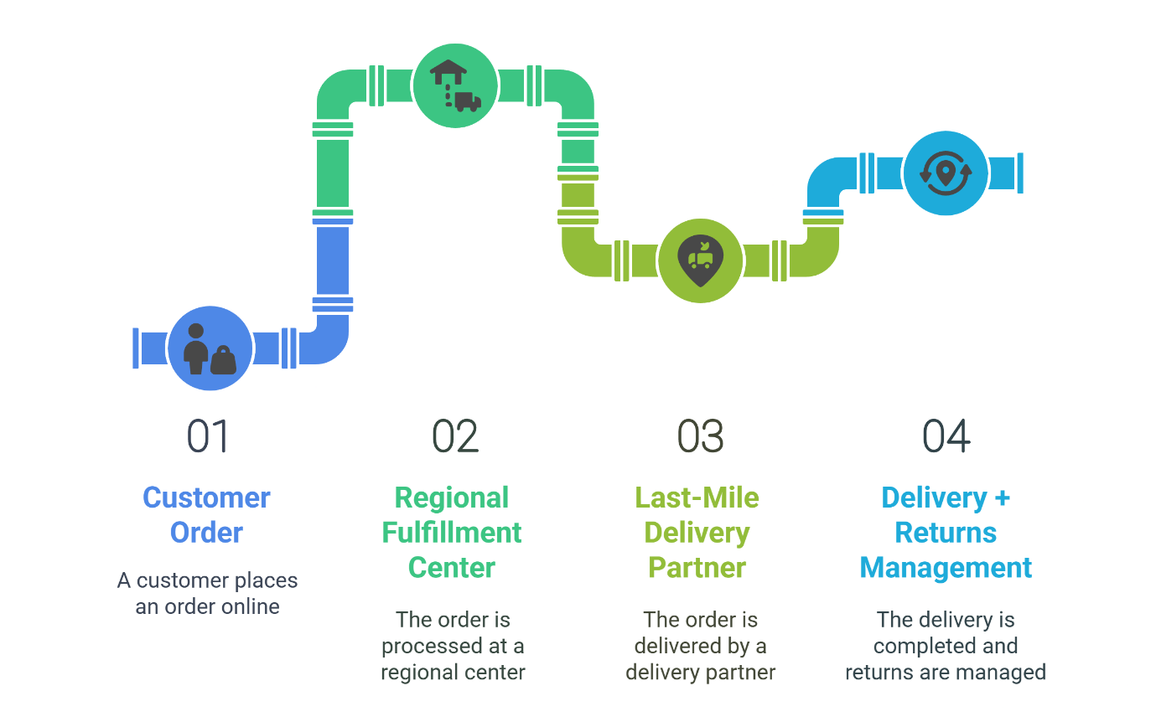Figure 4: E-Commerce Fulfilment Ecosystem
Because of logistics optimization, platforms can make sure their service is fast and reliable, which encourages customers to come back and enjoy a good shopping experience (Shopify, 2025).

6.2 Comparison of Fulfillment Models Across Leading Platforms
Each e-commerce platform uses its own fulfillment approach depending on the size of its operations, the category of its products, and the location of its customers. Amazon’s FBA approach brings all logistics together and ensures the same level of service, while Flipkart’s Flipkart Fulfilment does the same for warehousing, packing, and delivery. On the other hand, many marketplace platforms depend on third-party logistics providers (3PLs) to cut down on expenses, though this can result in uneven and slow delivery.
Table 5: Comparative Overview of Fulfillment Models (India, 2025)
Platform | Fulfillment Model | Delivery Time | Returns Handling | Strengths
Amazon | Fulfillment by Amazon (FBA) | 1–2 days | Centralized, seamless | Speed, reliability
Flipkart | Flipkart Fulfilment | 1–3 days | Platform-managed | Regional distribution
Meesho | 3PL integration | 3–5 days | Seller-dependent | Low-cost, scalable
JioMart | Retail-store assisted | Same-day in zones | Store-managed or hybrid | Hyperlocal speed
These models show the choices a company makes regarding cost, customer happiness, and its control over operations. Speed and a smooth experience are usually the main concerns for platforms serving premium customers, but value-driven platforms aim for efficiency and low costs.

6.3 Hyperlocal Delivery and Micro-Fulfillment Centers
Since people want their orders delivered faster, platforms have added micro-fulfillment centers (MFCs) in high-demand zones. Because of their location and the slow or distant fulfillment centers, these cities benefit a lot from these.
Flipkart Quick and Amazon Fresh make use of MFCs to send groceries, electronics, and essentials to customers within 2–4 hours. They make use of algorithms to plan the best routes, group orders as they come in, and hire people to deliver the goods (Kapadia, 2025; Shopify, 2025). At the same time, platforms join forces with neighborhood Kirana stores to serve as the final link in the delivery chain, making it easier for both the platforms and community stores.

6.4 Returns Management and Reverse Logistics
Many people overlook the fact that returns and reverse logistics play a big role in customer trust and expenses. Nowadays, providing easy returns that include automated pickups, real-time tracking, and fast refunds is necessary to keep customers, mainly in areas such as fashion and electronics where returns are more common.
AI is now used by platforms to estimate the chances of a return, depending on the product, its size, the buyer’s profile, and what the seller is rated. Thanks to these predictions, return periods, restocking tactics, and guidance on sizes can be improved, while still maintaining the level of service (Brenninkmeijer, 2024; Bulkrock et al., 2025).

6.5 Environmental Considerations in Fulfillment
Because deliveries are happening faster and more orders are being placed, taking care of the environment is now a major issue. The leading companies are now spending on electric vehicles for deliveries, offsetting carbon emissions, and using recyclable materials for their packaging. As an example, Amazon’s Climate Pledge is working to make half of all its deliveries carbon-neutral by 2030 (Shopify, 2024). Indian companies are trying out EV-based partnerships and grouping their delivery centers to cut down on the emissions from their vehicles.
All in all, fulfillment is now a key priority and a main focus for digital retailers. Those who excel in smart, flexible, and sustainable fulfillment get loyal customers and have an edge over their competitors. As e-commerce grows, companies with advanced logistics processes will determine not only how fast goods are delivered, but also the standards of today’s retail market.
7. Ethical, Inclusive, and Sustainable Commerce
Since e-commerce platforms are expanding worldwide and locally, people now expect them to act responsibly, include everyone, and protect the environment. Apart from being convenient and personalized, what today’s consumers, especially younger ones, really want is transparency, fairness, and doing business with a purpose. For this reason, the future of retail is influenced by both advanced technology and the platforms’ efforts to ensure fairness and sustainability.
7.1 The Rise of Ethical Consumerism
Nowadays, a bigger group of consumers takes into account ethical issues when deciding what to purchase, such as fair jobs, the environment, privacy, and a company’s values. If platforms do not meet these standards, users may stop trusting them and will not remain loyal for long. According to Shopify (2024), most Gen Z and Millennials want to buy from companies that are clearly concerned about sustainability and social issues.
This has driven platforms to develop tools for ethical transparency, including:
- Product certification labels (organic, cruelty-free, carbon-neutral),
- Sustainability filters in search and recommendation engines,
- Brand impact stories and sourcing disclosures.
Etsy and Amazon, for example, offer “climate-friendly” badges, while Flipkart has introduced “Green” categories for low-impact products. These features not only serve compliance and branding functions but also act as decision-making aids for ethically motivated consumers.
Table 6: Platform Sustainability Initiatives (2025)
Platform | Sustainability Focus | Key Initiative | Impact Target
Amazon | Environmental impact | Climate Pledge: Net-zero emissions by 2040 | 50% of shipments carbon-neutral by 2030
Flipkart | Green logistics | EV-based last-mile delivery & green warehousing | EV-only fleets in major cities
Etsy | Carbon-neutral deliveries | Offsetting shipping emissions | 100% offsets since 2021
Meesho | Resource-efficient commerce for SMEs | Digitizing small sellers, reducing paper usage | Paperless onboarding, digital invoices
7.2 Digital Inclusion: Closing the Access Gap
Although e-commerce has helped many people, digital inequality still affects a lot of people, mainly in rural areas, among seniors, and in marginalized groups. Those who want to promote inclusive commerce should focus on accessibility, localizing for different regions, and providing digital education. Flipkart’s vernacular UI, Meesho’s mobile reseller model, and JioMart’s partnership with Kirana stores are successful in helping people who are not well-served by digital solutions.
In addition, commerce that welcomes all genders is gaining attention. Thanks to Meesho, thousands of women in India now work from home as entrepreneurs because it makes getting products, managing logistics, and handling customers easy. Because of these efforts, people in communities with few job opportunities can earn money and become financially independent (World Economic Forum, 2025).
7.3 Ethical Use of Data and Algorithmic Fairness
As technology advances and personalization becomes more common, people start to ask about the ethics of using data and algorithms. People are more and more worried about how their information is being gathered, analyzed, and used for profit. Platforms are using several measures to keep users’ trust.
- Transparent data dashboards, where users can manage preferences,
- Consent-first cookie and tracking policies,
- Auditable AI systems that avoid discriminatory targeting or pricing.
Nguyen (2025) points out that AI can lead to unfair results, for example by giving more ads for high-end products to those who can afford them and less to those who cannot. Trust in digital services is more likely to last when platforms take fairness audits and ethics into account in their AI.
7.4 Circular and Regenerative Retail Models
In response to environmental pressures, many platforms are exploring models that go beyond sustainability to embrace circular commerce. This includes:
- Resale and recommerce (e.g., ThredUp, OLX, Quikr),
- Repair and refurbishment programs (Amazon Renewed),
- Subscription-based consumption (rental or try-before-you-buy).
They help companies save resources, make products last longer, and give consumers who care about the environment and about prices more options. In 2024, Shopify reports that more and more people in urban areas are using less packaging, biodegradable materials, and reusable delivery containers.
7.5 Regulation and Industry Self-Governance
The growing complexity of ethical and sustainable commerce necessitates multi-stakeholder regulation, combining governmental policies, industry standards, and platform self-regulation. Examples include:
- India’s Consumer Protection (E-Commerce) Rules, which mandate transparency in product listings and grievance redressal mechanisms;
- The EU’s Digital Services Act, which holds platforms accountable for algorithmic transparency and content moderation;
- Voluntary charters such as the Sustainable Retail Coalition, which promote carbon tracking and ethical sourcing guidelines.
E-commerce platforms that proactively align with such frameworks stand to benefit not only in compliance but also in brand reputation and investor confidence, particularly as ESG (Environmental, Social, Governance) criteria gain prominence in capital markets.

8. Conclusion
The way retail works and will develop in the future has been changed by e-commerce platforms. Besides handling transactions, they now act as complete ecosystems that bring together personalization, social selling, new logistics ideas, and ethics. It is clear from how Amazon, Flipkart, Shopify, and Meesho are changing the way customers shop by using data, engaging them in real time, and using predictive tools.
In such markets, people can now take part in retail thanks to mobile-first services, local delivery, and digital support for all. This proves that the platform is not only involved in commerce but also helps integrate society and the economy.
Even so, as platforms become more powerful, it is important to deal with privacy, fairness in algorithms, and the environmental effects by being open and responsible in innovation. The success of retail will now rely more on being efficient while also following ethical standards.
In the end, e-commerce platforms are not only keeping up with the future of retail, but also helping to define it. If they manage to offer trust, personalization, inclusivity, and sustainability, they will remain important in the future digital economy.
References
- Bulkrock, O., BaniMustafa, A., & Qusef, A. (2025). Predicting Product Rating Based on Customer Reviews and Feedback. In Sustainable Data Management: Navigating Big Data, Communication Technology, and Business Digital Leadership. Volume 1 (pp. 377-388). Cham: Springer Nature Switzerland.
- Abhishek Agarwal. (2025, May 7). https://customerthink.com/why-personalization-is-the-future-of-customer-experience-in-ecommerce/
- Masoner, L. (2025, May 6). 10 Best E-Commerce Platforms of 2025. Forbes Advisor. https://www.forbes.com/advisor/business/software/best-ecommerce-platform/
- Amelia, N. (n.d.). Digital Transformation in the Retail Industry: 2025 Insights. https://www.edstellar.com/blog/digital-transformation-in-retail
- Brenninkmeijer, T. (2024, January 29). How AI is changing ecommerce personalization. CMSWire.com. https://www.cmswire.com/ecommerce/how-ai-is-changing-ecommerce-personalization/
- EComposer. (2025, June 2). How AI personalization is transforming eCommerce in 2025. https://ecomposer.io/blogs/news/how-ai-personalization-is-transforming-ecommerce-in-2025
- Al-Refai, M. (2025, April 17). 11 omnichannel trends shaping the retail landscape in 2025. https://feedonomics.com/blog/omnichannel-trends/
- Al-Refai, M. (2025, April 17). 11 omnichannel trends shaping the retail landscape in 2025. https://feedonomics.com/blog/omnichannel-trends/
- NorthStar-Consulting UK. (2025, April 1). NorthStar-Consulting | Internationalisation Experts. NorthStar-Consulting - SME Consultancy & Reputation Experts. https://northstar-consulting.uk/
- Ecommerce share of retail sales (2022–2028) [Oct ‘24 Update]. (n.d.). Oberlo. https://www.oberlo.com/statistics/ecommerce-share-of-retail-sales
- Nguyen, H. (2025, May 19). Data Analytics in E-commerce: 2025 Guide to Drive growth. SavvycomSoftware. https://savvycomsoftware.com/blog/data-analytics-in-ecommerce/
- What is digital transformation in retail? Trends and examples. (2025, May 7). Shopify. https://www.shopify.com/retail/digital-transformation-in-retail
- 11 Best ecommerce Platforms for your business in 2025. (2025, May 29). Shopify. https://www.shopify.com/blog/best-ecommerce-platforms
- Retail Predictive Analytics: Use cases & Types of Data (2025). (2025, March 27). Shopify. https://www.shopify.com/retail/retail-predictive-analytics
- 8 Omnichannel Trends for 2025 & Beyond. (2025, March 19). Shopify. https://www.shopify.com/retail/omnichannel-trends
- Ecommerce Sustainability: How to Embrace Responsible Retail. (2024, April 5). Shopify. https://www.shopify.com/blog/ecommerce-sustainability
- SPD Technology. (n.d.). Data Analytics in eCommerce: The 2025 Guide | SPD Technology. https://spd.tech/data/data-analytics-in-ecommerce-a-strategic-guide-for-2025/
- Kapadia, S. (2025, June 3). To avoid product shortages, big retailers are scrapping reactive methods for AI. Business Insider. https://www.businessinsider.com/walmart-target-use-ai-to-prevent-inventory-shortages-2025-6
- Stone, M. (2025, January 29). TikTok Shop’s former boss on how the platform changed e-commerce forever — and how AI is leveling the playing field. Business Insider. https://www.businessinsider.com/how-tiktok-shop-ai-transformed-e-commerce-landscape-2025-1
- How to help small businesses thrive in the digital economy. (2025, June 3). World Economic Forum. https://www.weforum.org/stories/2025/01/digital-economy-small-businesses/
- Team, A. (2025, March 4). ECommerce Statistics and Facts for 2025. AMZScout Blog. https://amzscout.net/blog/ecommerce-statistics/

