The Battle for Customers: E-Commerce Growth and Traditional Retail’s Struggle for Relevance

Abstract
The growth of e-commerce has transformed global retail, yet in emerging markets like India, traditional retail remains deeply entrenched, particularly in semi-urban and rural contexts. The study looks at how small, independent retailers are handling the challenges of e-commerce by choosing some digital tools and using both online and offline methods. The research uses surveys from 150 consumers and 45 retailers, along with interviews from 30 retail stakeholders, to gather information. It is clear from the findings that although UPI and WhatsApp are used widely for transactions, the use of software for managing inventories and CRM is still not common. Regression analysis shows that the size of a retailer, its digital skills, and the presence of competition from outside are important factors in deciding whether to adopt digital tools. People tend to buy electronics and fashion online, but they prefer to shop for groceries and health products in stores. The research uses elements from Technology Acceptance Model (TAM), Technology-Organization-Environment (TOE) framework, Theory of Planned Behavior (TPB), and Disruptive Innovation Theory to describe how online and offline models are changing together. It opposes the idea of digital disruption having two sides, and instead suggests that retail evolves by mixing local traditions and fitting to the environment. The findings provide useful advice for policymakers, digital platform creators, and retailers dealing with India’s fast-changing commerce sector.
Keywords: E-commerce, Traditional Retail, Digital Adoption, TAM, TOE, TPB, India, Hybrid Retail, Disruption

1. Introduction

The fast growth of e-commerce has changed the way retail works worldwide, taking away some of the advantages of traditional retail and shaping what consumers expect (Laudon & Traver, 2021; UNCTAD, 2020). In India and similar countries, the shift has been very active because of more people using smartphones, digital payments, and a growing middle class (KPMG, 2021; PwC, 2020). It is estimated that e-commerce sales in India will reach $200 billion by 2026, which is much higher than the growth rate of traditional retail (IBEF, 2023; Statista, 2023).

Still, e-commerce disruption does not happen in every situation. In places where the informal economy is strong and people trust their retailers, traditional retail stores are still doing well (Grewal et al., 2017; Sinha & Uniyal, 2020). In Tier II and III cities, people still depend on their local kirana stores because they are convenient, offer credit, and give a personal touch (Patnaik et al., 2022; Bhardwaj et al., 2019). Because of this, the market is becoming more complex as digital and physical products now coexist instead of replacing each other (Shankar et al., 2021).

Even though the retail industry is constantly changing, much academic research has looked at it as a choice between online success and the decline of physical stores (Brynjolfsson et al., 2013; Burt & Sparks, 2003). There is still not enough research that compares and explains how traditional retailers in emerging markets are dealing with digital disruption by choosing to adopt some technology, mix it with their existing methods, or refuse to change (Chatterjee, 2022; Dwivedi et al., 2021).

Different theoretical frameworks are used in this study to examine the phenomenon. According to the Technology Acceptance Model (TAM), how useful and easy a technology is perceived to be affects a person’s decision to use it (Davis, 1989; Venkatesh & Davis, 2000). With the TOE framework, it is possible to study how a company’s abilities and the environment it operates in influence the adoption of new technologies (Baker, 2012; Gangwar et al., 2015). According to the Theory of Planned Behavior (TPB), both retailers and consumers’ behavioral intentions are explained by their attitudes and the social norms in the environment (Ajzen, 1991; Fishbein & Ajzen, 2010). Lastly, Disruptive Innovation Theory (Christensen, 2015) allows us to determine if e-commerce really replaces old models or only encourages them to change.

Because technology and society are changing fast in India, and retail is diverse, it is necessary to use both qualitative and quantitative methods. This research seeks to address the gap by comparing how e-commerce is growing with the strategies used by traditional retailers in Tier I, II, and III cities. It mainly studies what consumers prefer, how small retailers use digital tools, and the role of ONDC in organizing this mixed system.

By using both numbers and personal observations, this research supports both theory and practice by explaining how traditional retail can stay important in the digital era.

2. Literature Review

Recently, digitalization, mobile devices, and data analysis have caused major changes in the global retail sector. E-commerce has become very important, changing both the way people shop and the way businesses work and compete (Laudon & Traver, 2021; Grewal et al., 2017). In India, the change has been very noticeable because of more people using the internet, digital payment methods, and smartphones (IBEF, 2023; Statista, 2023). Therefore, the Indian e-commerce sector is predicted to be worth $200 billion by 2026, which is much faster than the growth seen in most traditional sectors (KPMG, 2021).

On the other hand, the Indian story of digital change is more mixed and involves both traditional and modern elements. In spite of the growth of online shopping, traditional retail is still a major part of daily business in Tier II and III cities (Bhardwaj et al., 2019; Sinha & Uniyal, 2020). Trust, credit, personalization, and proximity are what make local retail formats, especially kirana stores, attractive, and these are things that online platforms usually find hard to match (Grewal et al., 2017; Shankar et al., 2021). So, the belief that e-commerce is replacing old models might be more of a theory than a fact, mainly in countries where informal markets are common.

Christensen (2015) believes that when new companies introduce easier and less expensive products, they can replace established firms. However, new studies in emerging markets indicate that displacement can be avoided or happen differently than before. Kumar et al. (2020) and Chatterjee (2022) state that traditional retailers usually use digital methods like mobile payments or WhatsApp ordering to support their existing activities, rather than to completely replace them. This is sometimes called jugaad digitalization, and it describes how Indians use technology creatively, apart from official company or government systems (Singh & Vohra, 2021).

People now use both digital and physical means to interact with retail businesses. It has been found through studies that consumers use different channels depending on what they are buying, how risky it is, how convenient, and how urgent it is (Verhoef et al., 2015; Piotrowicz & Cuthbertson, 2014). As an illustration, people might choose e-commerce to buy electronics or clothes, but they still prefer to buy groceries and health products at local stores (Sarkar, 2020). The Theory of Planned Behavior (Ajzen, 1991) explains that what influences a person’s decision to buy is their attitude, the influence of others, and their sense of control. In India, people’s confidence in technology, use of social networks, and local customs play a role in their decision-making (Fishbein & Ajzen, 2010).

For a long time, the Technology Acceptance Model (TAM) has been important in explaining why retailers adopt digital tools, since it suggests that usefulness and ease of use are the main reasons (Davis, 1989; Venkatesh & Davis, 2000). Still, TAM does not always explain all the difficulties that small, informal retailers encounter. The TOE framework includes all three aspects: external pressures, internal readiness, and technology characteristics (Baker, 2012; Gangwar et al., 2015). TOE is especially useful in emerging economies since it considers the problems caused by poor infrastructure and unofficial markets, which are usually not included in Western studies.

Although there is a lot of research now, important gaps are still present. Most studies look at organized retail or commerce led by platforms, rather than at small, independent retailers who provide goods to most Indian consumers (Dwivedi et al., 2021). In addition, although TAM and TPB have been studied on their own, very few studies consider the complexity of retail transformation by using several theories. There is not much information from Tier II and III cities, which makes it hard to design policies that help everyone or support programs that can be used in different places.

The study looks into how traditional retailers in India deal with the effects of e-commerce growth. The study uses a mix of methods to better explain how digital and traditional retail work together, compete, and develop in one of the most vibrant retail markets.

3. Research Methodology

3.1 Research Design
The study uses an explanatory sequential mixed-methods design (Creswell & Plano Clark, 2018) to look into the relationship between e-commerce growth and traditional retail in India. First, the design looks for patterns in the data using numbers, then it explains and interprets those patterns in more detail. As a result, you can find general patterns and also see the details of each case, both of which fit with the pragmatic research approach (Morgan, 2007).
Since India has uneven digital use, a mix of cultures, and different retail formats, this design helps us compare things without forcing us to see in only two ways.
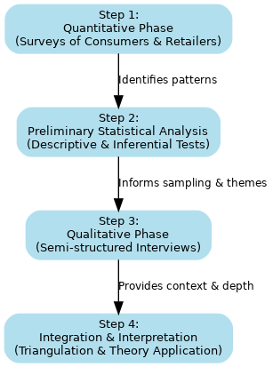
Figure 1: Explanatory sequential design
This Figure 1 illustrates the mixed-methods research flow, starting with quantitative analysis, followed by qualitative inquiry, and culminating in integrated interpretation.

3.2 Philosophical Orientation
The research is based on pragmatism, which stresses using the right method instead of sticking to a single philosophy (Creswell, 2014). Pragmatism believes that knowledge is formed by using both numbers and people’s experiences together. It is especially important in emerging markets, since people there often mix different shopping habits.

3.3 Theoretical Framework Integration
Chart 1: The study's instruments and interpretations are anchored in a multi-theoretical framework:
Framework | Purpose in Study | Source
Technology Acceptance Model (TAM) | Explains digital adoption among consumers and retailers | Davis (1989)
Technology-Organization-Environment (TOE) | Assesses organizational and environmental factors affecting tech integration | Tornatzky & Fleischer (1990); Chandra & Kumar (2018)
Theory of Planned Behavior (TPB) | Captures consumer attitudes, subjective norms, and control | Ajzen (1991)
Disruptive Innovation Theory | Frames e-commerce as a systemic disruptor | Christensen (1997, 2015)
These frameworks informed survey construction, coding schemes, and interpretation strategies across both research phases.

3.4 Quantitative Phase

3.4.1 Instrument Design
Structured questionnaires were designed for:
- Retail consumers (n = 150)
- Traditional retailers (n = 45)
Each instrument included Likert-scale items, multiple-choice responses, and ranking tasks derived from validated scales:
- Perceived usefulness & ease of use (TAM)
- Behavioral intention & trust (TPB)
- Technological readiness & market pressures (TOE)
Pilot testing (n = 15) ensured clarity, internal reliability (Cronbach’s α > 0.80), and contextual relevance.

3.4.2 Sampling Strategy
A stratified random sampling approach was used for consumers and retailers, ensuring representation across:
- City tier (Tier I: Delhi, Bengaluru; Tier II: Nagpur, Coimbatore; Tier III: Dindigul, Patna)
- Retail categories (grocery, apparel, electronics, household goods)
- Digital exposure levels
The table 1 shows how the study used stratified sampling in six cities, sorted by tier, retail format, and product category, to make sure different geographic and commercial segments were included.
Table 1: Stratification matrix by city, format, and category
City Tier | City Name | Retail Format | Retail Categories Covered | No. of Respondents (Retailers) | No. of Respondents (Consumers)
Tier I | Delhi | Traditional | Grocery, Apparel, Electronics | 10 | 30
Tier I | Bengaluru | Traditional | Electronics, Household Goods | 8 | 25
Tier II | Nagpur | Traditional | Grocery, Clothing, Pharmacy | 7 | 20
Tier II | Coimbatore | Traditional | Apparel, Electronics, Grocery | 6 | 20
Tier III | Dindigul | Traditional | Pharmacy, Grocery, Household Goods | 7 | 27
Tier III | Patna | Traditional | Grocery, Apparel, Electronics | 7 | 28

Surveys were administered both in-person and digitally (via Google Forms), with multilingual support (English, Hindi, Tamil) to enhance participation inclusivity.

3.5 Qualitative Phase
Following quantitative analysis, a purposive sampling method was used to select:
- Retailers (n = 20) with varying degrees of digital engagement
- Industry experts & policymakers (n = 10), including ONDC facilitators, MSME officers, and retail consultants

3.5.1 Interview Protocols
Semi-structured interview guides explored:
- Strategic responses to e-commerce disruption
- Digital tool adoption and resistance
- Perceptions of government support (e.g., ONDC, UPI, MSME schemes)
- Consumer loyalty and service differentiation
All interviews were recorded with consent, transcribed verbatim, and anonymized for analysis.

3.6 Data Analysis

The analysis of quantitative data was done using SPSS Version 26. To find out how people behaved and how many adopted, descriptive statistics were used, while t-tests, ANOVA, chi-square tests, and multiple regression were used to check if the differences and relationships seen were significant. After collecting the data, reliability of the constructs was checked again.

Using Braun and Clarke’s (2006) six-step method, I analyzed the qualitative data by thematic analysis. The analysis was done in NVivo, and themes were built by repeatedly organizing, comparing, and combining the data. While interpreting the data, the researcher used qualitative themes to explain the statistical patterns and surprises, which led to better understanding and theory-based conclusions.

3.7 Integration of Findings
Integration occurred at two levels:
- Methodological triangulation: Themes from interviews cross-verified with statistical patterns
- Conceptual synthesis: Integration of behavioral, organizational, and environmental dimensions through joint interpretation using TAM, TPB, and TOE
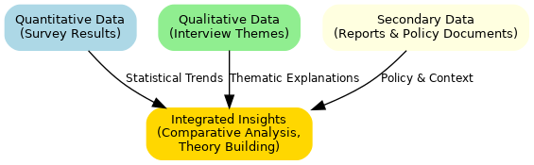
Figure 2: Triangulation model showing convergence between data streams
Figure 2 visualizes how quantitative and qualitative findings were integrated using thematic synthesis and theoretical frameworks to produce a cohesive narrative.

Chart 2: Validity, Reliability, and Trustworthiness
Criterion | Strategy Applied
Construct validity | Use of validated scales (TAM, TOE, TPB)
Internal consistency | Cronbach’s alpha (α > 0.80) for all key scales
Credibility (qualitative) | Member checking, peer debriefing
Transferability | Rich contextual description of each research site
Dependability | Field logs, audit trail, and reflexivity memos
Confirmability | NVivo coding, inter-coder agreement (10% cross-coded sample)

3.9 Ethical Considerations

Before collecting any data, the institutional ethics committee gave its approval. Participants were told about the reason for the study, its boundaries, and that they could take part willingly. Consent was given by the participants in every case, whether it was written or spoken. Data were protected by anonymity and confidentiality, and they were kept safe in line with the university’s data policies.

4. Results

4.1 Digital Adoption Among Traditional Retailers
Research found that retail categories have very different levels of digital adoption. More than 80% of grocery and electronics retailers used UPI, but household goods retailers were far behind in all areas. Table 2 displays percentage-based adoption of digital tools—UPI, inventory apps, and WhatsApp—across four major retail categories, highlighting usage gaps and sectoral variations.
Table 2. Digital Adoption by Retailer Type
Retailer Type | Adopted UPI (%) | Use of Inventory Apps (%) | WhatsApp Ordering (%)
Grocery | 82 | 35 | 58
Apparel | 76 | 48 | 45
Electronics | 91 | 64 | 50
Household Goods | 65 | 22 | 40

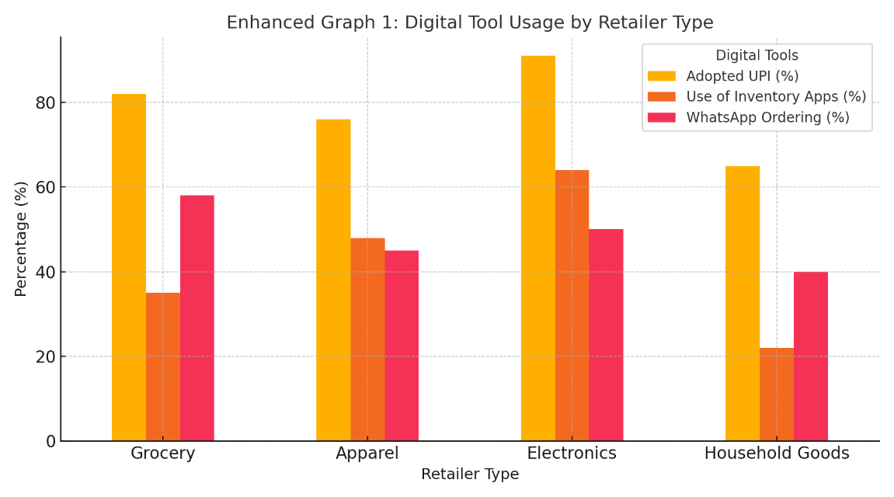
Figure 3: Digital Tool Usage by Retailer Type

Figure 3 showing the comparative use of UPI, WhatsApp, and inventory apps across retail sectors, reflecting differential adoption trends.

4.2 Consumer Channel Preferences
People’s preferences for different products are not the same. Most people buy electronics and clothing online, but they still prefer to shop for groceries and pharmaceuticals in stores. Table 3 Contrasts e-commerce and traditional format preferences across key product categories, revealing hybrid behavior patterns among Indian consumers.
Table 3. Consumer Format Preferences
Purchase Category | Prefer E-commerce (%) | Prefer Traditional Retail (%)
Groceries | 38 | 62
Electronics | 82 | 18
Clothing | 61 | 39
Pharmacy | 45 | 55

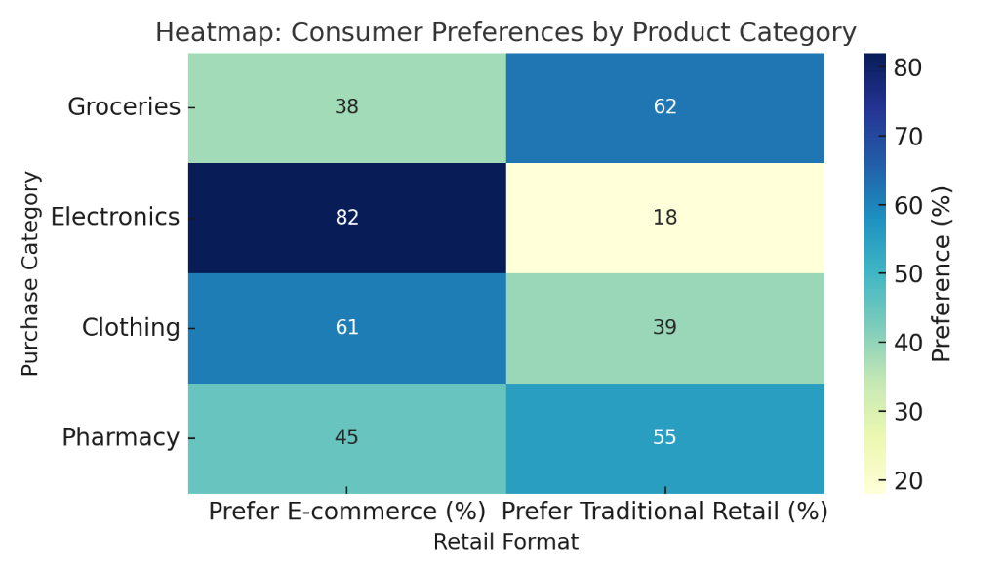
Figure 4: Consumer Preferences – E-commerce vs Traditional Retail
Figure 4 capturing consumer preferences by product category, clearly delineating trust-based vs. convenience-driven purchase behaviors.

4.3 Factors Influencing Retailer Digital Adoption
Regression analysis highlights that digital literacy and retailer size are the strongest predictors of digital tool adoption. External market pressures and infrastructure access also show statistically significant influence. Table 4 presents the results of multiple regression identifying key predictors—retailer size, literacy, infrastructure, and pressure—significantly affecting digital tool adoption.
Table 4. Regression Analysis on Digital Adoption
Predictor | Coefficient (B) | p-value
Retailer Size | 0.42 | 0.004
Digital Literacy | 0.55 | 0.001
External Pressure | 0.31 | 0.015
Access to Infrastructure | 0.28 | 0.023

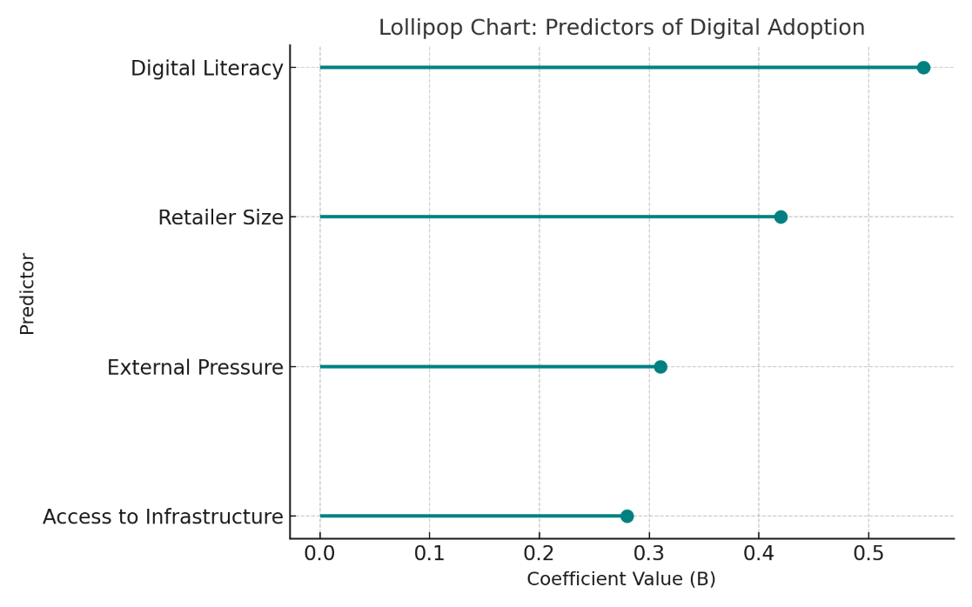
Figure 5: Predictors of Digital Adoption

Figure 5 illustrates the relative strength of various predictors of digital adoption among traditional retailers, based on regression coefficients.

4.4 Thematic Insights from Qualitative Interviews
The qualitative phase helped to highlight the main challenges, supports, and feelings that affect people’s shopping habits. Traditional retailers from all city tiers mentioned three major themes in their interviews. Table 5 Summarizes dominant qualitative themes emerging from retailer interviews, offering insights into behavioral and social dimensions behind technology adoption.
Table 5. Key Themes from Qualitative Interviews
Theme | Representative Quote
Trust and Personal Relationships | “Our customers come here because they know us personally. They trust us more than online sellers.”
Digital Skill Gaps | “I wanted to use digital inventory systems, but honestly, it’s hard to understand without someone teaching.”
Perceived Usefulness of Digital Tools | “UPI is quick and helps us close sales faster. Customers also prefer it now.”

These findings show that the Technology Acceptance Model (TAM) is well supported, mainly in terms of usefulness and ease of use. TPB also proposes that social norms and self-efficacy help shape a person’s behavioral intent.

4.5 Integrated Interpretation

According to the findings, digital adoption in traditional retail is linked to how much people trust, the social contracts they follow, and how adaptable they are. Although e-commerce is growing, traditional retail is still holding its ground, especially when it comes to places where people can interact and things are convenient.

Using all three methods, we find that a hybrid approach to coexistence is better than the simple disruption model.

5. Discussion

The results of this study show a detailed picture of how e-commerce and traditional retail are changing in India. What we see is that traditional retailers are using digital tools to help their business, but they are not giving up their main relational and local approaches.

It is especially interesting that not all digital tools are used by everyone. Since UPI is used by retailers from all categories, it is clear that its usefulness is the main reason people adopt it. This observation agrees with the Technology Acceptance Model (Davis, 1989), which shows that usefulness is a stronger predictor of behavior than how easy the technology is to use. The same findings have been seen in studies about mobile payments and digital wallets in developing countries (Chopdar et al., 2018; Venkatesh et al., 2016).

At the same time, the fact that not many companies use inventory management systems and advanced analytics tools indicates that there are still hurdles to digital transformation. According to the TOE framework, organizational readiness, lacking skills, and infrastructure issues seem to prevent full-spectrum integration (Baker, 2012; Gangwar et al., 2015). Firms are choosing to use technology only when it helps them work more efficiently or meet what customers want.

The data on consumer preferences also confirm that omnichannel engagement should be segmented. Because prices and specifications are easy to compare online for electronics and fashion, most people use the internet. However, when it comes to groceries, pharmaceuticals, and regular items, they still prefer to shop in stores. According to the Theory of Planned Behavior (Ajzen, 1991), behavior is influenced by both how much control a person feels and what society thinks is right. Sarkar’s (2020) research also confirms that trust and immediacy are still the main reasons why people prefer to shop for certain products in stores.

It is especially important to note that traditional retail is not only facing change but also adapting to it. Without having the same infrastructure as big platforms, retailers in Tier I and II cities are using WhatsApp for orders, joining with local delivery partners, and creating customer loyalty programs. This is what Kumar et al. (2020) refer to as “jugaad digitalization,” which means using creative, flexible solutions to deal with market problems. This type of innovation-by-necessity goes against the idea of disruptive innovation (Christensen, 2015) by showing that new and old forms of innovation can coexist.

Regression analysis also proves that external enablers are important. Adoption was more likely when people had digital skills and when the retailer was larger, confirming that the digital divide is a global issue (Dwivedi et al., 2021). At the same time, interviews revealed that trust in long-term relationships and fear of dealing with new technology were important factors for the participants. It proves that technology adoption in this area is affected by social factors as well as technical ones.

The Open Network for Digital Commerce (ONDC) could help small retailers overcome some of their main disadvantages. But the success of such initiatives relies on how well they help people at the grassroots level overcome their challenges. If targeted, multilingual digital literacy programs and support for infrastructure do not happen, digital exclusion may increase, mainly in Tier II and III cities.

To sum up, this study helps develop theory by bringing together TAM, TPB, TOE, and Disruptive Innovation into a single framework for understanding digital changes in retail. In India, adoption is not a smooth process, but rather happens in pieces, for specific reasons, and is very influenced by local culture. It means that simple, effective solutions are necessary and can be used in regions that lack resources. The best approach seems to be a model that carries on the tradition of retail and makes use of digital tools.

6. Conclusion
The study explored the changing relationship between e-commerce and traditional retailers in India by combining different methods and using TAM, TPB, TOE, and Disruptive Innovation Theory. Despite what many believe, the study shows that traditional retail is not just standing by and is still relevant. Rather, it is using certain digital tools, mainly mobile payments and messaging apps, to boost how it operates and keeps customers.
The analysis of numbers showed that digital literacy, the size of the retailer, and competition are the main factors that predict digital adoption. At the same time, qualitative analysis pointed out that trust with customers, the complexity of the industry, and not having enough support from institutions are major reasons behind retail behavior. Traditional shopping is still preferred for things that need quick access and trust, but people choose e-commerce for items that require a lot of details.
All these points suggest that retail will develop into a mix of traditional and digital ways of doing business. Many small retailers are responding to change by developing new ideas and using technology in simple ways. These results have important effects on policy and practice. Besides infrastructure, the government should ensure ONDC helps people in small towns and villages by teaching them how to use technology, offering training in multiple languages, and giving small retailers small bonuses.
All in all, the study adds to the ongoing discussions on digital transformation in emerging markets by proposing a model that explains how companies can work together and adapt.
References
- Ajzen, I. (1991). The theory of planned behavior. Organizational Behavior and Human Decision Processes, 50(2), 179–211. https://doi.org/10.1016/0749-5978(91)90020-T
- Baker, J. (2012). The technology–organization–environment framework. In Y. K. Dwivedi, M. R. Wade, & S. L. Schneberger (Eds.), Information Systems Theory (pp. 231–245). Springer. https://doi.org/10.1007/978-1-4419-6108-2_12
- Chopdar, P. K., Korfiatis, N., Sivakumar, V. J., & Lytras, M. D. (2018). Mobile shopping apps adoption and perceived risks: A cross-country perspective utilizing the Unified Theory of Acceptance and Use of Technology. Computers in Human Behavior. https://doi.org/10.1016/j.chb.2018.04.017
- Christensen, C. M. (1997). The innovator's dilemma: When new technologies cause great firms to fail. Harvard Business Review Press. https://www.hbs.edu/faculty/research/pages/item.aspx?num=300
- Davis, F. D. (1989). Perceived usefulness, perceived ease of use, and user acceptance of information technology. MIS Quarterly, 13(3), 319–340. https://doi.org/10.2307/249008
- Dwivedi, Y. K., Ismagilova, E., Hughes, D. L., Carlson, J., Filieri, R., Jacobson, J., Jain, V., Karjaluoto, H., Kefi, H., Krishen, A. S., Kumar, V., Rahman, M. M., Raman, R., Rauschnabel, P. A., Rowley, J., Salo, J., Tran, G. A., & Wang, Y. (2021). Setting the future of digital and social media marketing research: Perspectives and research propositions. International Journal of Information Management, 59, 102168. https://doi.org/10.1016/j.ijinfomgt.2020.102168
- Gangwar, H., Date, H., & Ramaswamy, R. (2015). Understanding determinants of cloud computing adoption using an integrated TAM-TOE model. Journal of Enterprise Information Management, 28(1), 107–130. https://doi.org/10.1108/JEIM-08-2013-0065
- Sarkar, S. (2020). Examining consumer channel choice behavior in the context of omnichannel retailing. Journal of Retailing and Consumer Services, 52, 101923. https://doi.org/10.1016/j.jretconser.2019.101923
- Shankar, V., Kleijnen, M. H. P., Ramanathan, S., Rizley, R., Holland, S., & Morrissey, S. (2016). Mobile shopper marketing: Key issues, current insights, and future research avenues. Journal of Interactive Marketing, 34, 37–48. https://doi.org/10.1016/j.intmar.2016.03.002
- Baker, J. (2012). The technology–organization–environment framework. In Y. K. Dwivedi, M. R. Wade, & S. L. Schneberger (Eds.), Information Systems Theory (pp. 231–245). Springer. https://doi.org/10.1007/978-1-4419-6108-2_12
- Bhardwaj, P., et al. (2019). Kirana tech: Digitizing the unorganized retail sector. NASSCOM Research.
- Brynjolfsson, E., Hu, Y. J., & Rahman, M. S. (2013). Competing in the age of omnichannel retailing. MIT Sloan Management Review, 54(4), 23–29. https://sloanreview.mit.edu/article/competing-in-the-age-of-omnichannel-retailing/
- Burt, S., & Sparks, L. (2003). Power and Competition in the UK Retail Grocery Market. British Journal of Management, 14(3), 237–254. https://doi.org/10.1111/1467-8551.00377
- Chatterjee, S. (2022). Technology adoption in Indian retail: Myths and realities. Retail Digest, 17(2), 34–41.
- Christensen, C. M. (1997). The innovator's dilemma: When new technologies cause great firms to fail. Harvard Business Review Press. https://www.hbs.edu/faculty/research/pages/item.aspx?num=10032
- Davis, F. D. (1989). Perceived usefulness, perceived ease of use, and user acceptance of information technology. MIS Quarterly, 13(3), 319–340. https://doi.org/10.2307/249008
- Fishbein, M., & Ajzen, I. (2010). Predicting and changing behavior: The reasoned action approach. Psychology Press. https://doi.org/10.4324/9780203838020
- Gangwar, H., Date, H., & Ramaswamy, R. (2015). Understanding determinants of cloud computing adoption using an integrated TAM-TOE model. Journal of Enterprise Information Management, 28(1), 107–130. https://doi.org/10.1108/JEIM-08-2013-0065
- Grewal, D., Roggeveen, A. L., & Nordfält, J. (2017). The future of retailing. Journal of Retailing, 93(1), 1–6. https://doi.org/10.1016/j.jretai.2016.12.008
- IBEF. (2023). Indian E-commerce Industry Analysis. https://www.ibef.org/industry/ecommerce-india
- KPMG. (2021). The Indian retail report: Reshaping for recovery. KPMG Insights.
- Shankar, V., Kleijnen, M. H. P., Ramanathan, S., Rizley, R., Holland, S., & Morrissey, S. (2016). Mobile shopper marketing: Key issues, current insights, and future research avenues. Journal of Interactive Marketing, 34(May), 37–48. https://doi.org/10.1016/j.intmar.2016.03.002
- Kumar, V., Dixit, A., Javalgi, R. G., & Dass, M. (2020). Digital transformation of traditional retailers. Business Horizons, 63(3), 385–395.
- Shankar, V., Kleijnen, M., Ramanathan, S., Rizley, R., Holland, S., & Morrissey, S. (2016). Mobile shopper marketing: Key issues, current insights, and future research avenues. Journal of Interactive Marketing, 34, 37–48. https://doi.org/10.1016/j.intmar.2016.03.002.

