Mass spectrometric, thermodynamic studies using MNDO method and evaluation of the antibacterial and antifungal activities of Bougainvillea spectabilis extracts

Abstract
Bougainvillea spectabilis Willd. (Family Nyctaginaceae) possesses several bioactive chemical components. Consequently, wood and bark portions were extracted using several solvents in the current investigation. In particular, the bark samples were extracted using methanol, acetone, and n-butanol; the essential oils (EO) from the wood samples were extracted using the hydro distillation process. The chemical compounds in each extract were identified by gas chromatography-mass spectrometry (GC-MS) with possible mass spectrometric investigations for the main compounds. The extracts were evaluated for their bioactivities against some plant pathogenic bacterial strains namely Agrobacterium tumefaciens (MG706145), Ralstonia solanacearum (GH425351), Erwinia amylovora (HG423347), Pectobacterium carotovorum (HF674984), P. atrosepticum (MG706146), and Dickeya solani (HF569035) and molecularly identified isolated fungi namely Rhizoctonia solani ON808453, Fusarium oxysporum ON808454 and Penicillium digitatum ON808455. The main chemical components in bark methanol extract (ME) were (Z)-9-octadecenoic acid (24.16%), oleic acid (23.84%), retinal (12.07%), trans-13-octadecenoic acid (9.41%), and cis-13-eicosenoic acid (8.30%). Bark butanol extract (BE) showed the presence of main chemical components 9-nonanal (38.33%) and (E)-2-nonenal, (18.91%) and octanal (13.56%). The main chemical components in bark acetone extract (AcE) were (E)-2-decenal (31.23%), 2-undecenal (18.37%) and nonanal (15.15%) and (Z)-9-octadecenoic acid (10.23%). The main chemical components in wood EO were cis-1,3-dimethylcyclohexane (43.69%), 1,3,5-cycloheptatriene (24.62%), and 2-ethyl-1-hexanol (10.69%) followed by 3-methyl-heptane (8.16%) and methyl-cyclohexane (7.26%). At 4000 µg/mL, the maximum activity against the growth of the chosen bacterial strains was reported in bark ME, BE, AcE, and wood EO, while it was 2000 µg/mL against the growth of fungal strains. The main ingredients in the two samples under investigation were split into two groups for this study. Group I consisted of compounds with long-chain hydrocarbons that had an oxygen atom in a single or double bond in their structures, such as methyl ester, nonanal, 2-decenal, and 2-undecenal. The second group (II) of cyclic compounds, which include 1,3,5-cycloheptatriene and cis-1,3-dimethylcyclohexane, have 6 or 7 bonds in their structures. Based on the semi-empirical calculation of MNDO thermodynamic data, the most stable molecules are those with negative values.
Keywords: Bougainvillea spectabilis; MNDO method; Bark extract; Essential oil; Plant pathogens
Introduction
To analyze the molecular structures of organic molecules, theoretical chemistry—which includes quantum chemical calculations like Modified Neglect of Diatomic Overlap, or MNDO—has proven to be an extremely effective approach. Because semi-empirical quantities such as dipole moments, total energies, electron energy, and formation heats have been discovered to have significant correlations (Abd El-Kareem et al., 2020; Musa et al., 2012). Simplified variants of Hartree-Fock theory, known as semiempirical methods, include empirical corrections—modifications generated from experimental data—to enhance performance. Typically, acronyms that represent some of the underlying theoretical presumptions are used to refer to these techniques. While previous approaches use simpler integral schemes like CNDO and INDO, the most often used methods (MNDO, AM1, and PM3) are all based on the Neglect of Differential Diatomic Overlap (NDDO) integral approximation. The three techniques are all part of the Zero Differential Overlap (ZDO) method class, which ignores any two-electron integrals involving charge distributions at two centers. To compensate for the approximate quantum mechanical model, several parametric corrections are applied along with several additional approximations to expedite computations. The specific semiempirical approach is characterized by the way the parameterization is carried out. The parameterization process for MNDO, AM1, and PM3 is carried out so that the computed energy is expressed as heat of formations rather than total energies (Thiel, 2014). Additionally, the most effective way to compute the structure of matter and support experimental research is semi-empirical (MNDO), a quantum mechanical method for determining the thermochemical properties of molecules used in chemistry and physics to determine the electronic structure of molecules (Abd El-Kareem et al., 2020).
Plant extractives have useful uses as biological agents against a wide-range of pathogens including plant-infections bacteria, viruses, or fungi (Mohamed et al., 2019; Salem et al., 2021a; Salem et al., 2021b; Salem et al., 2021c; Salem et al., 2016a), or against fungi colonizing wood and wood products (Hosseinihashemi et al., 2016a; Hosseinihashemi et al., 2016b; Mansour et al., 2015; Mansour and Salem, 2015; Salem et al., 2016b). These bioactivities have been proven by the presence of several bioactive compounds or chemical groups like saponins, phenolic compounds, flavonoid compounds, essential oils, alkaloids, lignans, quinones, saponins, tannins, and terpenoids (Abdelkhalek et al., 2020; Ashmawy et al., 2020b; Ghogar et al., 2016; Salem et al., 2019).
Bougainvillea spectabilis Willd., (Family Nyctaginaceae), a woody shrub, tropical and sub-tropical plants, have been shown to own several bioactive chemical groups like flavonoids, aldehydes, saponins, triterpenoids, phenols, sterols, quinones, glycosides, tannins, and furanoids (Abarca-Vargas and Petricevich, 2018; Ashmawy et al., 2020b; Do et al., 2016; Do et al., 2018; Jawla et al., 2013; Orozco-Villafuerte et al., 2019). The alcoholic extracts from leaves were observed some antibacterial activities (Fawad et al., 2012). B. spectabilis leaf extracts have reportedly been shown to provide therapeutic benefits, including larvicidal, antiviral, anti-inflammatory, antibacterial, anti-diabetic, and anti-fertility potential (Abarca-Vargas and Petricevich, 2018; Joshi et al., 1984; Narayanan et al., 1987; Saikia and Das, 2009; Shaiq Ali et al., 2005; Umamaheswari et al., 2008). Extracts from B. spectabilis showed different biological activities such as anti-inflammatory activity in experimental animal models (Mandal et al., 2015). The leaves ethanolic extract observed antihyperglycemic activity (Malviya et al., 2010; Purohit and Sharma, 2006), and antioxidant activity (Venkatachalam et al., 2012), and the aqueous root bark extract has hypoglycaemic and hyoplipidaemic activity in diabetic rats (Jawla et al., 2012). Bougainvinone G was isolated and identified from the stem bark of B. spectabilis and showed cytotoxicity against five cancer cell lines (Do et al., 2016). Spinasterol, and quercetin were also isolated from leaf extract (Chang et al., 1993). Root and branch extracts showed the presence of fatty acids and fatty alcohols (Sumitra et al., 2009; Vukovic et al., 2013).
Eight peltogynoids, and vogainvinone from A to M, flavonoid compounds, have been isolated from stem-bark (Do et al., 2016). Volatile compounds mainly methyl salicylate terpinolene, 2-furfural cadina-1, 4-diene, and linalool (Sumitra et al., 2009) have been reported in leaves and branches. In lab testing, an extract from the leaves of B. spectabilis suppressed the tospovirus responsible for tomato spotted wilt on Capsicum annum and groundwater (Balasaraswathi et al., 1998). The okra yellow vein mosaic virus infection was significantly reduced by using B. spectabilis (Pun et al., 1999). Some chemical compounds were isolated from leaves like pinitol with hypoglycemic effects (Adebayo et al., 2005) and antidiabetic compounds (Narayanan et al., 1987). Different solvent extracts from flowers showed the presence of alkaloids, phlobatannins and terpenoids, phenol, flavonoids, steroids, tannins, cardinolides, and essential oils with several bioactivities against fungi (Sudipta et al., 2012). Secologanin dimethyl acetal, α- and β-amyrin, α- and β-amyrin acetate, kaempferol, and kaempferol-3-O-rhamnoside have isolated from the methanolic extract of leaves (Ahmed and Abd Elkarim, 2021)
Potato bacterial pathogens pose a significant threat to potato plants and tubers, causing extensive damage. Two common bacterial species known to infect potatoes are Dickeya and Pectobacterium. These pathogens can cause soft rot in tubers, blackleg, and wet rot diseases in stems. The spread of Pectobacterium atrosepticum and Dickeya blackleg symptoms typically occurs in humid conditions, where slim wet, and rotted-black lesions develop from the parent tuber to the stems. Additionally, Ralstonia solanacearum is one of the most severe bacterial plant diseases in Egypt, causing bacterial wilt and potato brown disease (Afifi et al., 2001). Erwinia amylovora is another highly destructive bacterium, responsible for fire blight disease, which can attack apple and pear fruit trees and has been reported to affect pear plantations in Egypt (Borkar and Yumlembam, 2016). Agrobacterium tumefaciens, on the other hand, causes crown gall disease in over 140 dicot plant species (Ashmawy et al., 2020a; Ashmawy et al., 2020c; Mohammed et al., 2019; Salem et al., 2015; van der Wolf and De Boer, 2015; van der Wolf et al., 2012). Crop growth can be significantly disrupted by phytopathogenic fungi, leading to severe economic losses in agriculture worldwide. Among these fungi, Fusarium oxysporum is known to cause vascular disease, commonly referred to as "Fusarium Wilt," resulting in significant losses (Cárdenas-Laverde et al., 2021). Rhizoctonia solani is a soil-borne fungus with a broad range of hosts and is responsible for various plant diseases such as collar rot, root rot, damping off, and wire stem (Akber et al., 2023). Black root rot is a severe disease caused by one or more fungal genera, including F. oxysporum (Edel-Hermann and Lecomte, 2018; Juber et al., 2014; Oldenburg et al., 2017) and Rhizoctonia spp. (Asad-Uz-Zaman et al., 2015; Matsumoto and Yoshida, 2006), also poses a significant threat to crops.
These led us to look for additional bioactive metabolites from this plant with comparable chemical structures and their ability to combat plant diseases. Therefore, there is available information regarding its pharmacological, phytochemistry, and toxicological activities especially the extracts from leaves and flowers. No reports about the extracts from bark and wood as bioactivity against plant pathogens. As part of a continuing search for plant-derived antimicrobial agents, this study aimed to explore the application of several extracts from B. spectabilis wood and bark as potential plant-antibacterial and antifungal agents.
Materials and methods
2.1. Extraction Method of Plant Parts and GC/MS analysis
Wood and bark samples of Bougainvillea spectabilis Willd. were collected from Alexandria, Egypt (Figure 1). Wood and bark materials were air-dried at room temperature and then grown to powder. Methanol, acetone, and butanol solvents were used for the bark extraction, where about 150 g of powdered bark was divided into three quantities (each of 50 g), and each amount was soaked in each solvent for three days. After this period, the extracted materials were filtered with a cotton plug and Whatman filter paper to afford the bark methanol, butanol, and acetone extracts. The extracts were concentrated in a vacuum using a rotary evaporator. The concentrated extracts were poured into Petri dishes and air-dried before further analysis. The essential oil from wood was achieved using the hydrodistillation method in a Cleavinger-type apparatus for 3 h (Mohareb et al., 2023; Taha et al., 2023).
Figure 1. Bougainvillea spectabilis wood and bark samples and the produced extracts
GC–MS analysis of the extracts
The chemical composition of the extracts was analyzed using a Focus GC-DSQ Mass Spectrometer (Thermo Scientific, Austin, TX, USA), equipped with a direct capillary column TR–5MS (30 m x 0.25 µm x 0.25 µm film thickness) at the Atomic and Molecular Physics Unit, Experimental Nuclear Physics Department, Nuclear Research Centre, Egyptian Atomic Energy Authority, Inshas, Cairo, Egypt. The column oven temperature was initially held at 60 °C and then increased by 5 °C/min until it reached 200 °C, with a holding time of 2 min, and then increased to 300 °C (10 °C/min). The injector temperature was kept at 270 °C, while helium was used as the carrier gas with a constant flow rate of 1 mL/min. The samples, diluted to 1 µL, were automatically injected using the Auto-sampler AS3000 in split mode with a solvent delay of 2 min. Full-scan mode EI mass spectra were collected at 70 eV ionization voltages over the range of m/z 50–550. The ion source and transfer line temperatures were set at 200 and 250 °C, respectively. The identification of components was carried out by comparing their retention times and mass spectra with those in the WILEY 09 and NIST 11 mass spectral database and confirmed with the values of the standard reverse standard index (RSI) (Abdelsalam et al., 2019).
The most common method used for terpene qualitative and quantitative measurement is Gas Chromatography-Mass Spectrometry (GC-MS) (Abd El-Kareem et al., 2024; Behiry et al., 2020a; Taha et al., 2023). To ensure that there is no contamination in the GC or MS before beginning analysis, the GC-MS was tuned and calibrated using Xcalibur software 2.2 SP1.48. All mass spectra of the separated peaks were compared with multiple libraries attached to the software (NIST014 and Wiely 09). The Adam technique is only compatible with the older Xcalibur software version (1.4), not the more recent one. However, the hold time in the utilized GC-MS oven program at the ultimate temperature (300 °C) is crucial to prevent any residual from the injected sample that could alter the chromatogram of the subsequent sample. This hold time can vary from 1 to 10 min (Pizzo et al., 2024).
The combination of chromatography with mass spectrometry, specifically gas chromatography-mass spectrometry (GC-MS), is a highly effective method for analyzing volatile or derivatized nonvolatile molecules present at low concentrations. This technique provides extensive information, as well as increased sensitivity, selectivity, and greater capabilities for structural determination, in comparison to other methods used for structural characterization such as IR and Raman spectroscopy (Gemperline et al., 2016).
Computation Method
To optimize the geometry of the molecules under investigation, semi-empirical calculations were performed using the molecular modeling software Hyperchem7.5 (W.Thiel 2003, HyperChemTM, Release 7.5 Pro 2002) (Ali et al., 2021; Behiry et al., 2020b; Taha et al., 2023). The calculations were carried out using the MNDO routine and the Polak-Ribiere conjugated gradient algorithm (Abd El-Kareem et al., 2018a; Taha et al., 2023). To obtain molecular properties such as heat of formation, total energy, ionization energy, electron affinity, and dipole moment for both the neutral and cation states, a geometry optimization mode was conducted after the optimization of the molecular geometry (Abd El-Kareem et al., 2018a).
Antibacterial activity of bark and wood extracts of Bougainvillea spectabilis
Bark methanol, acetone and butanol extracts, and wood essential oil of B. spectabilis were prepared at concentrations of 125, 250, 500, 2000, and 4000 µg/mL. These extracts were then tested against the growth of the following bacterial strains: Agrobacterium tumefaciens (MG706145), Ralstonia solanacearum (GH425351), Erwinia amylovora (HG423347), Pectobacterium carotovorum (HF674984), P. atrosepticum (MG706146), and Dickeya solani (HF569035) using the agar-well diffusion method in a nutrient agar (NA) medium (Ashmawy et al., 2020c). The inhibition zone diameter (mm) was measured after 48 h of incubation, and each treatment was replicated three times (Sambrook et al., 1989).
Isolation of the fungal pathogens
The fungal pathogens were obtained from tomato plant root and fruit samples infected in the Nubaria district of Behira Governorate in Egypt. To initiate the isolation process, plant tissue samples showing symptoms of infection were surface-sterilized with a 70% ethanol solution, followed by washing with sterile distilled water to remove any external contaminants.
The cleaned samples were then aseptically transferred to the Potato Dextrose Agar (PDA) medium. The samples were incubated at 25°C for 7 days to allow fungal colonies to develop. Once fungal growth was observed, individual colonies were isolated using a sterile loop and streaked onto fresh PDA plates to obtain pure cultures.
The purified fungal cultures were then examined microscopically and macroscopically to assess their morphological characteristics, including colony color, texture, and structure (Nelson et al., 1983; Pitt and Hocking, 2009; Sneh et al., 1991). These morphological traits were used for preliminary identification of the fungal pathogens. Furthermore, all the isolated fungi were subjected to molecular identification.
ITS identification of tested fungi and phylogenetic construction
The isolates were cultivated on a PDA medium for one week at 25 °C. Fresh mycelia were used to extract total DNA using the QIAquick PCR purification Kit (QIAGEN, Manchester, England). The internal transcribed spacer region of the rDNA (ITS genes) was amplified using ITS1/ITS4 primers (White, 1990), and the resulting amplicons were sequenced. Forward sequences were assembled by Macrogen Co., Seoul, Korea, and then submitted to GenBank for accession and deposition. The phylogenetic tree was constructed using the maximum likelihood method with bootstrapping among the identified isolates and retrieved GenBank isolates using MEGA 11 software (Tamura et al., 2021).
Antifungal activity of extracts
One-week-old cultures grown on potato dextrose agar (PDA) medium were harvested to yield pure cultures of the identified fungal strains. By incorporating the various necessary concentrations of the extracts into the agar medium, the agar dilution process was completed. From actively growing cultures, a single 5-mm culture disk of each fungal strain was removed and placed in the center of the Petri dishes (Hassan et al., 2021). In brief, the extracts were diluted in 10% dimethyl sulfoxide (DMSO) and the essential oil was mixed with a few drops of Tween-80 (0.01%) (Mohamed et al., 2020), then, a series of two-fold dilutions of the extracts 500, 1000, and 2000 μg/mL were prepared and compared with referenced fungicide, viz., 25 µg/mL, Azoxystrobin 25% SC. The Petri dishes were incubated at 30 °C for 7 days. The controls contained only PDA medium and fungal discs in the middle. Inhibition percentage of fungal growth (IPFG) of the tested fungi was calculated with the following formula: Inhibition percentage of fungal growth (IPFG) = [(Control growth - Growth in treatment)/Growth in control] × 100. The experiment was conducted in triplicate for each treatment, as well as for the positive control (25 µg/mL, Azoxystrobin 25% SC) and negative control (10% DMSO) (Shakam et al., 2022).
Statistical Analysis
The two-way ANOVA is a statistical technique used to analyze data with two independent variables, such as extracts and their concentrations. The SAS software was used to perform this analysis, and the means of the treatments were compared to the control treatment using Duncan's Multiple Range Test with a significance level of 0.05.
Results
Antibacterial activity
The bioactivity of extracts from Bougainvillea spectabilis is shown in Table 1. The bark methanol extract (ME) at 1000, 2000, and 4000 µg/mL and bark acetone extract (AcE) at 4000 µg/mL showed the highest activity against Agrobacterium tumefaciens with inhibition zone (IZ) value of 10 mm. At the concentration of 4000 µg/mL, bark AcE showed the highest activity against Ralstonia solanacearum with an IZ value of 9 mm, and the butanol extract (BE) against Erwinia amylovora with an IZ value of 11 mm. Bark BE observed abundant activity against Pectobacterium carotovorum at 2000 and 4000 µg/mL with IZ values of 11 mm and 11.66 mm, respectively. The highest activity against P. atrosepticum was observed using the bark BE at 1000, 2000, and 4000 µg/mL concentrations with an IZ value of 9 mm. Bark BE and AcE at 4000 µg/mL showed the highest activity against Dickeya solani with an IZ value of 10 mm.
Table 1. Antibacterial activity of extracts against plant pathogenic bacteria
Extract | Con.  µg/mL | Agrobacterium tumefaciens | Ralstonia solanacearum | Erwinia amylovora | Pectobacterium carotovorum | Pectobacterium atrosepticum | Dickeya solani
Wood Essential oil | 125 | 7±0.00 | 0.00 | 6±0.00 | 8±0.00 | 6±0.00 | 0.00
Wood Essential oil | 250 | 7±0.00 | 6±0.00 | 6±0.00 | 8±0.00 | 7±0.00 | 6±0.00
Wood Essential oil | 500 | 7±0.00 | 6±0.00 | 7±0.00 | 8±0.00 | 7±0.00 | 6±0.00
Wood Essential oil | 1000 | 8±0.00 | 7±0.00 | 7±0.00 | 8±0.00 | 7±0.00 | 7±0.00
Wood Essential oil | 2000 | 8±0.00 | 7±0.00 | 7±0.00 | 8±0.00 | 7±0.00 | 7±0.00
Wood Essential oil | 4000 | 8±0.00 | 7±0.00 | 7±0.00 | 9±0.00 | 7±0.00 | 7±0.00
Bark butanol extract | 125 | 7±0.00 | 6±0.00 | 7±0.00 | 6.33±0.57 | 8±0.00 | 5.66±0.57
Bark butanol extract | 250 | 7±0.00 | 6±0.00 | 7±0.00 | 7.66±0.57 | 8±0.00 | 6.66±0.57
Bark butanol extract | 500 | 7±0.00 | 7±0.00 | 8±0.00 | 7.33±0.57 | 8±0.00 | 7.33±0.57
Bark butanol extract | 1000 | 8±0.00 | 7±0.00 | 8±0.00 | 9.33±0.57 | 9±0.00 | 8.66±1.15
Bark butanol extract | 2000 | 8±0.00 | 7±0.00 | 9±0.00 | 11±1 | 9±0.00 | 8.66±1.15
Bark butanol extract | 4000 | 8±0.00 | 8±0.00 | 11±0.00 | 11.66±1.15 | 9±0.00 | 10±1.00
Bark acetone extract | 125 | 0.00 | 6±0.00 | 0.00 | 8±0.00 | 6±0.00 | 6±0.00
Bark acetone extract | 250 | 0.00 | 7±0.00 | 6±0.00 | 8±0.00 | 7±0.00 | 6±0.00
Bark acetone extract | 500 | 6±0.00 | 8±0.00 | 7±0.00 | 9±0.00 | 7±0.00 | 7±0.00
Bark acetone extract | 1000 | 8±0.00 | 8±0.00 | 8±0.00 | 9±0.00 | 8±0.00 | 7±0.00
Bark acetone extract | 2000 | 8±0.00 | 8±0.00 | 9±0.00 | 9±0.00 | 8±0.00 | 7±0.00
Bark acetone extract | 4000 | 10±0.00 | 9±0.00 | 9±0.00 | 9±0.00 | 8±0.00 | 10±0.00
Bark methanol extract | 125 | 7±0.00 | 6±0.00 | 6±0.00 | 7±0.00 | 7±0.00 | 6±0.00
Bark methanol extract | 250 | 8±0.00 | 6±0.00 | 7±0.00 | 7±0.00 | 7±0.00 | 6±0.00
Bark methanol extract | 500 | 8±0.00 | 7±0.00 | 7±0.00 | 8±0.00 | 7±0.00 | 7±0.00
Bark methanol extract | 1000 | 10±0.00 | 7±0.00 | 8±0.00 | 8±0.00 | 8±0.00 | 8±0.00
Bark methanol extract | 2000 | 10±0.00 | 8±0.00 | 8±0.00 | 8±0.00 | 8±0.00 | 8±0.00
Bark methanol extract | 4000 | 10±0.00 | 8±0.00 | 8±0.00 | 8±0.00 | 8±0.00 | 8±0.00
Negative Control | 0.00 | 0.00 | 0.00 | 0.00 | 0.00 | 0.00 | 0.00
Ciprofloxacin | 25 µg/disc | 6.10±0.17 | 7.00±0.00 | 8.07±0.12 | 16.30±0.26 | 8.17±0.29 | 6.27±0.25
P-value |  | <0.0001 | <0.0001 | <0.0001 | <0.0001 | <0.0001 | <0.0001
*SD, standard deviation; ** Highly significant at 0.01 level of probability
Fungal identification
Isolation and fungal morphology
Three fungal isolates were recovered from infected tomato plants using the methodology outlined in the ‘Materials’ and ‘Methods’ section. Cultures that possessed typical morphological characteristics of Rhizoctonia solani, Fusarium oxysporum and Penicillium digitatum were purified.
ITS analysis and phylogenetic tree
The rDNA regions of the ITS were amplified and sequenced for all fungal isolates. The nucleotide sequences blasted in NCBI confirmed that the three isolates were identical to the initial identifications of R. solani, F. oxysporum, and P. digitatum. The sequences were deposited in GenBank under accession numbers ON808453, ON808454, and ON808455, respectively. The phylogenetic tree provided illustrates the genetic relationships among various isolates of Rhizoctonia solani, Penicillium digitatum, and Fusarium oxysporum. The tree reveals distinct clusters corresponding to these three fungal species, with each cluster containing multiple isolates. The numbers on the branches represent bootstrap values, which indicate the confidence level of the branching patterns. Higher values, especially those close to 100%, suggest strong support for the associated clades, while lower values indicate less certainty in the relationships depicted (Fig. 2).
Figure 2. Phylogenetic tree constructed using the maximum likelihood method with bootstrapping to illustrate the evolutionary relationships among the identified isolates Rhizoctonia solani (accession number ON808453), Fusarium oxysporum (accession number ON808454), and Penicillium digitatum (accession number ON808455), along with retrieved isolates from GenBank.
The Rhizoctonia solani cluster demonstrates a close genetic relationship among its isolates. Your isolate, identified as ON808453, is closely grouped with other isolates such as PP599188, HG934419, and KJ866422. The high bootstrap values supporting this cluster reinforce the strong genetic similarity among these strains. This clustering suggests that the genetic makeup of your R. solani isolate shares a significant portion of its sequence with these other isolates, indicating a closely related lineage (Fig. 2).
Similarly, the Penicillium digitatum isolates form a distinct cluster in the tree. In the ON808455 isolate you provided groups with strains like MK878440, MK450692, and MN880263, highlighting their genetic similarity. However, some internal branches within this group exhibit lower bootstrap values, indicating a degree of variability within the P. digitatum isolates. Despite this, the overall clustering remains well-supported, suggesting that these strains, while genetically diverse, still belong to the same species and share a common ancestry (Fig. 2).
The Fusarium oxysporum isolates form their own separate cluster, distinct from the other two species. Your isolate, ON808454, clusters with other strains such as MT529524, MN216217, and MT560380, indicating a strong genetic relationship within this group. The high bootstrap values observed in this cluster suggest a reliable and well-supported grouping, reinforcing the close genetic connections among these F. oxysporum isolates (Figure 2).
In summary, the phylogenetic tree effectively demonstrates species-specific clustering, with each species forming a distinct and well-supported group. The isolates you sequenced are correctly identified as Rhizoctonia solani, Penicillium digitatum, and Fusarium oxysporum, and the tree highlights the genetic relationships among these isolates. The observed genetic diversity within each species, particularly in the P. digitatum group, suggests variability that may be relevant for understanding their pathogenic potential.
Antifungal activity of extracts
Table 2 presents the antifungal activity of extracts from B. spectabilis against R. solani, F. oxysporum, and P. digitatum. At the level of concentration 2000 µg/mL, bark AcE, and wood EO showed the highest reduction rate percentage of fungal growth (RPFG) percentage of 28.51 % and 27.77 %, respectively, against R. solani growth. The highest RPFG percentages against the growth of F. oxysporum were observed at 2000 µg/mL by bark ME and BE with values of 55.55% and 51.11%, respectively, also bark ME at 1000 µg/mL showed RPFG value of 50.74 %. Wood EO at 1000 µg/mL and 2000 µg/mL showed the highest activity against the growth of P. digitatum with RPFG values of 51.48 %, and 51.85 %, respectively, followed by bark BE and AcE with RPFG values of 48.14 %. F. oxysporum and P. digitatum were more susceptible to the extracts than R. solani.
digitatum as affected by extracts from Bougainvillea spectabilis wood and bark.
Table 2. Antifungal activity of extracts against plant pathogenic fungi
Extract | Con. µg/mL | Rhizoctonia solani | Fusarium oxysporum | Penicillium digitatum
Control | 0 | 0.00 | 0.00 | 0.00
Wood Essential oil | 500 | 21.48±0.64 | 25.18±1.69 | 45.55±0.00
Wood Essential oil | 1000 | 22.22±1.11 | 27.41±1.69 | 51.48±0.64
Wood Essential oil | 2000 | 27.77±1.11 | 48.51±0.64 | 51.85±0.64
Bark butanol | 500 | 0.00 | 0.00 | 0.00
Bark butanol | 1000 | 14.07±0.64 | 48.88±1.11 | 47.03±0.64
Bark butanol | 2000 | 17.03±0.64 | 51.11±2.22 | 48.14±0.64
Bark acetone | 500 | 22.96±0.64 | 43.70±2.31 | 43.33±1.11
Bark acetone | 1000 | 22.96±1.28 | 45.55±1.11 | 44.44±0.00
Bark acetone | 2000 | 28.51±0.64 | 45.92±1.69 | 48.14±0.64
Bark methanol | 500 | 12.96±0.64 | 43.33±0.00 | 0.00
Bark methanol | 1000 | 18.14±0.64 | 50.74±0.64 | 0.00
Bark methanol | 2000 | 20.74±0.64 | 55.55±0.00 | 0.00
Azoxystrobin 25% SC | 25 µg/mL | 43.43±0.92 | 60.70±0.20 | 54.07±0.67
P-value |  | <0.0001 | <0.0001 | <0.0001

Chemical compounds of Bougainvillea spectabilis extracts
The identified chemical composition of B. spectabilis bark ME is shown in Table 3 and represents 15 compounds. The main chemical components were (Z)-9-octadecenoic acid or Δ9-cis-oleic acid (24.16 %), oleic acid (23.84 %) and retinal (12.07 %), followed by trans-13-octadecenoic acid (9.41 %), cis-13-eicosenoic acid (8.30%), Z-(13,14-epoxy)tetradec-11-en-1-ol acetate (4.56%), methyl-cyclohexane (3.57 %) and 5-phenyl-decane (3.23 %).
The identified chemical composition of B. spectabilis bark BE is shown in Table 4 and represents 21 compounds. The main chemical components were 9-nonanal (38.33%), (E)-2-nonenal, (18.91%), and octanal (13.56%), followed by heptanal (5.03%), (E)-2-decen-1-ol (4.12 %), (E)-2-decenal (3.50 %) and (E)-2-octenal (3.25 %).
Table 3. The chemical composition of Bougainvillea spectabilis bark methanol extract using GC-MS analysis
Peak | RT* | Name | Area % | Molecular Weight | Molecular formula | RSI
1 | 3.23 | Methyl-cyclohexane | 3.57 | 98 | C₇H₁₄ | 916
2 | 3.32 | 1-Nonanol | 1.34 | 144 | C₉H₂₀O | 767
3 | 3.86 | 6-Methyl-2-heptanol | 1.85 | 130 | C₈H₁₈O | 790
4 | 4.49 | 2-Ethenylcyclopent-2-enol | 2.18 | 110 | C₇H₁₀O | 974
5 | 4.63 | 2,2,4,5-Tetramethyl-1,3-dioxolane | 0.68 | 130 | C₇H₁₄O₂ | 706
6 | 6.95 | 3-Octanol | 0.90 | 130 | C₈H₁₈O | 707
8 | 19.48 | 5-Phenyl-decane | 3.23 | 218 | C₁₆H₂₆
9 | 19.57 | Oleic acid methyl ester | 23.84 | 296 | C₁₉H₃₆O₂ | 830
10 | 20.15 | Panaxydol | 2.18 | 260 | C₁₇H₂₄O₂ | 832
11 | 21.77 | Z-(13,14-Epoxy)tetradec-11-en-1-ol acetate | 4.56 | 268 | C₁₆H₂₈O₃ | 832
12 | 22.25 | (Z)-9-Octadecenoic acid | 24.16 | 282 | C₁₈H₃₄O₂ | 822
13 | 24.78 | Retinal | 12.07 | 284 | C₂₀H₂₈O | 801
14 | 25.33 | trans-13-Octadecenoic acid | 9.41 | 282 | C₁₈H₃₄O₂ | 839
15 | 25.56 | cis-13-Eicosenoic acid | 8.30 | 310 | C₂₀H₃₈O₂ | 804
*RT, retention time (min), ** RSI, matching factor between getting mass spectrum and database mass spectra
Table 4. The chemical composition of Bougainvillea spectabilis bark butanol extract reported using GC-MS analysis
Peak | RT* | Compound | Area % | Molecular Weight | Molecular formula | RSI
1 | 3.14 | 3,4,5,6-Tetrahydroxy-2-oxo-hexanoicacid | 0.49 | 194 | C₆H₁₀O₇ | 718
2 | 3.68 | 1-Chloro hexane | 1.18 | 120 | C₆H₁₃Cl | 683
3 | 5.17 | 5-Heptyldihydro-2(3H)-furanone | 0.57 | 184 | C₁₁H₂₀O₂ | 725
4 | 8.63 | 3-Methyl-hexane | 0.53 | 100 | C7H16 | 873
5 | 12.19 | Octane | 0.54 | 114 | C8H18 | 877
6 | 15.75 | Hexanal | 0.72 | 100 | C6H12O | 808
8 | 18.46 | (E)-2-Decen-1-ol | 2.01 | 156 | C10H20O | 772
9 | 19.29 | 2-Undecanol | 1.50 | 172 | C11H24O | 838
10 | 19.77 | Heptanal | 5.03 | 114 | C7H14O | 817
11 | 22.11 | (E)-2-Decen-1-ol | 4.12 | 156 | C10H20O | 686
12 | 22.46 | (E)-2-Decenal | 3.50 | 154 | C10H18O | 691
13 | 22.96 | Isopinocarveol | 0.93 | 152 | C10H16O | 686
14 | 23.42 | Octanal | 13.56 | 128 | C8H16O | 832
15 | 24.66 | (E)-2-Octenal | 3.25 | 126 | C8H14O | 823
16 | 24.91 | trans-Pinocarveol | 0.27 | 152 | C10H16O | 758
17 | 25.55 | 1-Decene | 1.92 | 140 | C10H20 | 787
18 | 26.76 | Nonanal | 38.33 | 142 | C9H18O | 865
19 | 27.64 | β-Ethyl-benzeneacetaldehyde | 0.94 | 148 | C10H12O | 680
20 | 28.14 | 8,11-Octadecadiynoic acid, methyl ester | 2.08 | 290 | C19H30O2 | 706
21 | 28.69 | (E)-2-Nonenal | 18.91 | 140 | C9H16O | 885
*RT, retention time (min), ** RSI, matching factor between getting mass spectrum and database mass spectra.

The identified chemical composition of B. spectabilis bark AcE is shown in Table 5 and represented 14 compounds. The main chemical components were (E)-2-decenal (31.23%), 2-undecenal (18.37%) and nonanal (15.15%) and (Z)-9-octadecenoic acid (10.23%), followed by (E)-2-dodecenal (5.12%), octanal (4.66%), 1-dodecene (3.98%), and (E)-2-nonenal (3.12%).
Table 5. The chemical composition of Bougainvillea spectabilis bark acetone extract reported using GC-MS analysis
Peak | RT* | Name | Area % | Molecular Weight | Molecular formula | RSI
1 | 4.05 | 1-Tetradecanol | 0.51 | 214 | C₁₄H₃₀O | 738
2 | 4.29 | Dodecane | 0.85 | 170 | C₁₂H₂₆ | 728
3 | 7.94 | (E)-2-Decen-1-ol | 2.62 | 156 | C₁₀H₂₀O | 789
4 | 10.23 | 1-Dodecene | 3.98 | 168 | C₁₂H₂₄ | 767
5 | 10.56 | 2-Undecanol | 0.70 | 172 | C₁₁H₂₄O | 860
6 | 11.37 | Octanal | 4.66 | 128 | C₈H₁₆O | 928
8 | 13.73 | (E)-2-Dodecenal | 5.12 | 182 | C₁₂H₂₂O | 811
9 | 14.68 | Nonanal | 15.15 | 142 | C9H₁₈O | 919
10 | 16.94 | (E)-2-Nonenal | 3.12 | 140 | C₉H16O | 901
11 | 17.78 | (Z)-9-Octadecenoic acid | 10.23 | 282 | C₁₈H₃₄O₂ | 840
12 | 19.91 | (E)-2-Decenal | 31.23 | 154 | C₁₀H₁₈O | 925
13 | 23.33 | (E,E)-2,4-Dodecadienal | 1.87 | 180 | C₁₂H₂₀O | 888
14 | 25.59 | 2-Undecenal | 18.37 | 168 | C₁₁H₂₀O | 924
*RT, retention time (min), ** RSI, matching factor between getting mass spectrum and database mass spectra
The identified chemical constituents of B. spectabilis wood EO are shown in Table 6 and represent 7 compounds. The main chemical components were cis-1,3-dimethylcyclohexane (43.69%), 1,3,5-cycloheptatriene (24.62%), and 2-ethyl-1-hexanol (10.69%) followed by 3-methyl-heptane (8.16%) and methyl-cyclohexane (7.26%).

Table 6. The chemical composition of Bougainvillea spectabilis wood essential oil reported using GC-MS analysis
Peak | RT* | Compound | Area % | Molecular Weight | Molecular formula | RSI
1 | 3.01 | Methyl-cyclohexane | 7.26 | 98 | C₇H₁₄ | 927
2 | 3.09 | 2-Ethyl-1-hexanol | 10.69 | 130 | C₈H₁₈O | 855
3 | 3.19 | 3-Methyl-heptane | 8.16 | 114 | C₈H₁₈ | 886
4 | 3.35 | 1-Dodecene | 1.20 | 168 | C₁₂H₂₄ | 824
5 | 3.63 | cis-1,3-Dimethylcyclohexane | 43.69 | 112 | C₈H₁₆ | 827
6 | 4.83 | 1,3,5-Cycloheptatriene | 24.62 | 92 | C₇H₈ | 943
8 | 12.87 | 1,2-dimethyl-benzene | 3.56 | 106 | C₈H₁₀ | 900
*RT, retention time (min), ** RSI, matching factor between getting mass spectrum and database mass spectra
Mass spectrometric investigation of the main components in the extracts
Bougainvillea spectabilis bark methanol extract
From the mass spectrum of the peak at retention time (RT) 19.57 min represents the (Z)-9-octadecenoic acid, methyl ester (oleic acid, methyl ester) component (Fig. S1) suggesting its molecular formula C₁₉H₃₆O₂. The molecular ion peak was observed at m/z 296 with relative intensity (RI) = 10% and the peak at m/z 69 (RI= 100%) represents the base peak. Other significant fragment ions observed were 264 (40%), 97 (80%), and 83 (80%).
The mass spectrum of the peak at RT 22.25 min represents the 9-octadecenoic acid component (Fig. S2) suggesting its molecular formula C₁₈H₃₄O₂. The molecular ion peak was observed at m/z 282 with RI = 1% and the peak at m/z 55 (RI= 100%) represents the base peak. Other significant fragment ions observed were 195 (15%), 97 (40%), and 69(62%).
Bougainvillea spectabilis bark butanol extract
From the mass spectrum of the peak at RT, 26.76 min represents the nonanal component (Fig. S3) suggesting its molecular formula C₉H₁₈O. The molecular ion peak was observed at m/z 142 with RI = 1% and the peak at m/z 57 (RI= 100%) represents the base peak. Other significant fragment ions observed were 98 (48%), 82 (40%), and 70 (50%).
The mass spectrum of the peak at RT 28.69 min represents (E)-2-nonenal, component (Fig. S4) suggesting its molecular formula C₉H₁₆O. The molecular ion peak was observed at m/z 140 with RI = 2% and the peak at m/z 55 (RI= 100%) represents the base peak. Other significant fragment ions observed were 91 (42%), 83 (75%), and 70 (90%).
Bougainvillea spectabilis bark acetone extract
The mass spectrum of the peak at RT 19.91 min represents the (E)-2-decenal component (Fig. S5) suggesting its molecular formula C₁₀H₁₈O. The molecular ion peak was observed at m/z 154 with RI = 1% and the peak at m/z 70 (RI= 100%) represents the base peak. Other significant fragment ions observed were 97 (35%), 83 (75%), and 55(83%).
The mass spectrum of the peak at RT 25.59 min represents the 2-undecenal component (Fig. S6) suggesting its molecular formula C₁₁H₂₀O. The molecular ion peak was observed at m/z 168 with RI = 1% and the peak at m/z 70 (RI= 100%) represents the base peak. Other significant fragment ions observed were 97 (30%), 83 (74%), and 57 (79%).

Bougainvillea spectabilis wood essential oil

The mass spectrum of the peak at RT 3.63 min represents the cis-1,3-dimethylcyclohexane component (Fig. S7) suggesting its molecular formula C₈H₁₆. The molecular ion peak was observed at m/z 112 with RI = 30% and the peak at m/z 97 (RI= 100%) represents the base peak. Other significant fragment ions observed were 85 (70%), 71 (40%), and 55 (88%).
The 1,3,5-cycloheptatriene component is represented by the peak at RT 4.83 min in the mass spectrum (Fig. S8), which suggests that its chemical formula is C₇H₈. The base peak is represented by the peak at m/z 91 (RI = 100%), whereas the molecular ion peak was found at m/z 92 with RI = 55%. There were two more notable fragment ions found: 90 (10%) and 65 (15%).
Computation Method
From the calculated data of the studied compounds (Table 7), values were obtained for the heat of formation, ionization, total, binding, electronic energies, and dipole moment. These thermochemical data are necessary to describe the conformational properties of the studied molecules (Abd El-Kareem et al., 2018b). Table 7 presents the thermodynamic data of the studied molecules calculated within the modified neglect of diatomic overlap (MNDO) framework.
Table 7. Thermodynamic data reported of the studied constituents using MNDO method
Compound | ΔH_{F} (M)  kcal.mol⁻¹ | ΔH_{F}(M)⁺  kcal.mol⁻¹ | ΔH_{F}(M⁾⁻  kcal.mol⁻¹ | Total Energy (M)  kcal.mol⁻¹ | Total Energy(M)+  kcal.mol⁻¹ | *I.E  eV | Electron affinity (EA)**  eV | Binding Energy (M)  kcal.mol⁻¹ | Dipole Moment  (M) D
9-Octadecenoic acid, methyl ester | -139 | 68 | -143 | -28724 | -28517 | 8.97 | -0.17 | -5381 | 4.046
9-octadecenoic acid | -146 | 54 | -148 | -79128 | -79130 | 8.67 | -0.08 | -5114 | 4.53
Nonanal | -76 | 156 | -71 | -39894 | -39662 | 10.06 | -0.21 | -2611 | 2.467
2-Decenal | -56 | 166 | -77 | -42824 | -24602 | 9.6 | -0.91 | -2763 | 3.116
2-Undecenal | -61 | 161 | -82 | -46432 | -46210 | 9.6 | -0.91 | -3043 | 3.117
cis-1,3-Dimethylcyclohexane | -37 | 208 | 16 | -28861 | -28616 | 10.6 | -2.3 | -2237 | 0.019
1,3,5-Cycloheptatriene | 29 | 216 | 12 | -23233 | -23045 | 8.1 | -0.73 | -1584 | 0.094
*The value of the ionization energies (IE) was calculated with the following equation, IE [M] =ΔH_{f} [M] ^{+•}− ΔH_{f} [M]; where ΔH_{f} [M] ^{+•} and ΔH_{f} [M] are the heats of formation of the molecular ion and neutral molecule, respectively.
***The value of the electron affinity (EA) was calculated with the following equation, EA [M] =ΔH_{f} [M] − ΔH_{f} [M]⁻¹; where ΔH_{f} [M]⁻¹and ΔH_{f} [M] are the heats of formation of the anion and neutral molecule, respectively.

In this study, the main components in the two studied samples were divided into two groups, the first group (I) are the compounds that contain long chain hydrocarbons containing oxygen atoms in single or double bonds in their structures namely; 9-octadecenoic acid, methyl ester, 9-octadecenoic acid, nonanal, 2-decenal and 2-undecenal. The second group (II) cyclic compounds contain sixth or seventh bonds in their structures including cis-1,3-dimethylcyclohexane and 1,3,5-cycloheptatriene as shown in Figure 3.

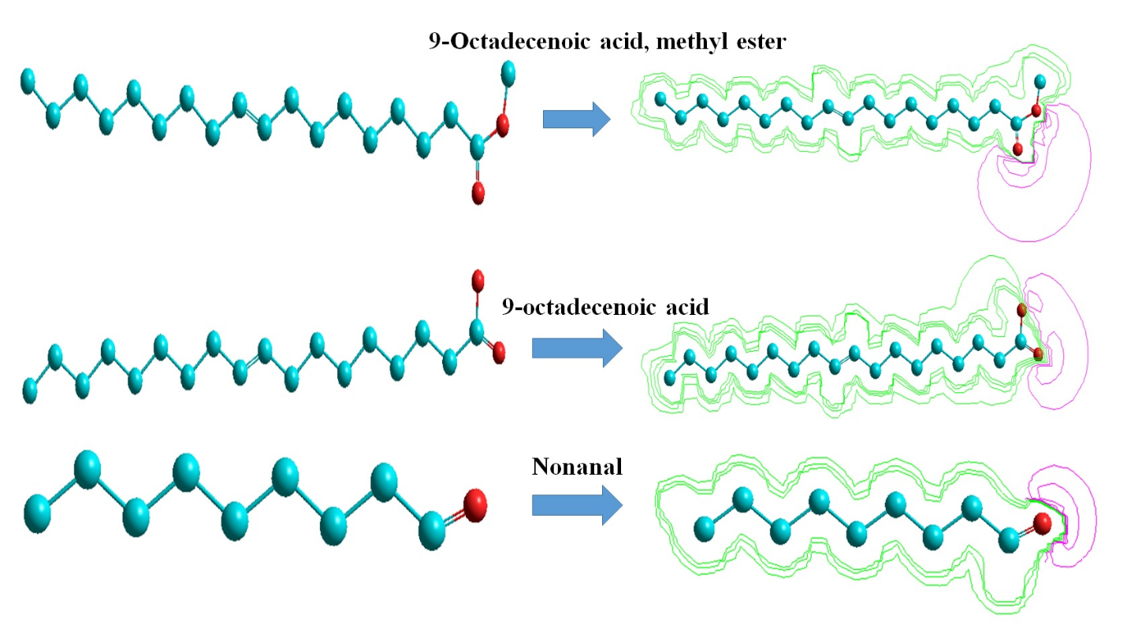
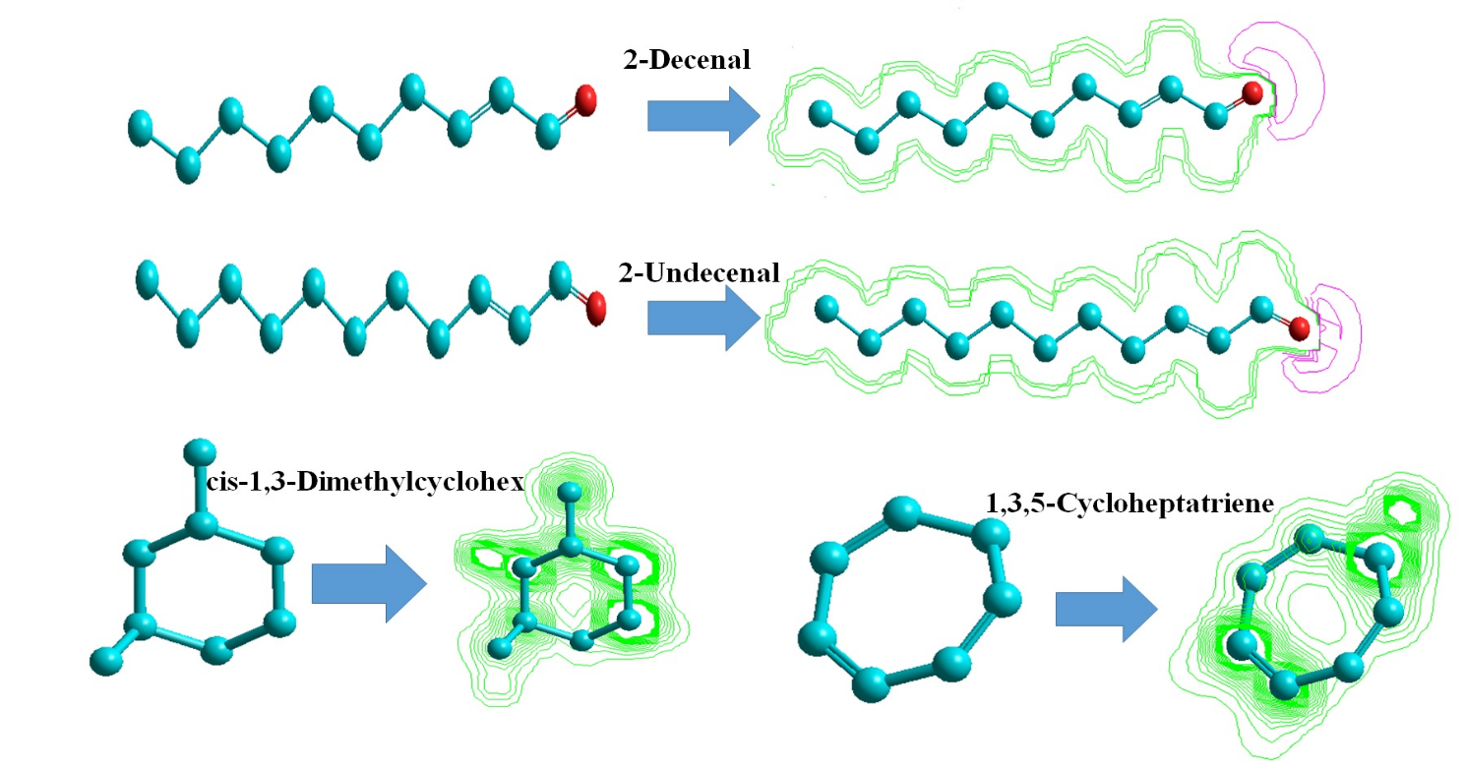
Figure 3. The optimized structures and Isosurface plot of the electrostatic potential (ESP) of the studied constituents using the Modified Neglect of Diatomic Overlap (MNDO) method at ground state.

Table 7 shows all thermodynamic data calculated using MNDO semi-empirical calculation. From the calculated data of the studied molecule (Table 7), one can observe that the negative values of the heat of formations Δ_{F}(M) and total energy for group (I); 9-octadecenoic acid, methyl ester, 9-octadecenoic acid, nonanal, 2-decenal and 2-undecenal neutral molecules have negative values that mean these molecules are stable and the 9-octadecenoic acid, molecule is the most stable.
This is due to the presence of the oxygen atom (single and double bond) and methyl group in their structures, while group (II) cis-1,3-dimethylcyclohexane and 1,3,5-cycloheptatriene have low values of heat of formations (-37, 29 Kcal/mol, respectively). From these values, the second group is relatively less stable than the first group, which has oxygen atoms in their structures. This is confirmed by the values of dipole moment, hence the first group has the higher values of dipole moment (4.046, 4.53, 2.467, 3.116, and 3.117) in comparison with the second group (0.019 and 0.094). Also, one can observe that group (I) has higher values of ionization energies (around 10 eV) in comparison with group (II) (around 8 eV). These are due to the higher stability of group (I). The same was observed in electron affinities values, group (I) has higher values of EA as shown in Table 7.
The electrostatic potential (ESP) field generated by a molecular system is known to be closely related to many of its properties and thus contains valuable information for their description. For this reason, electrostatic characteristics have attracted the attention of researchers in the field of quantitative structure-activity and structure-property relationships (Breneman and Martinov, 1996).
From the electrostatic standpoint, the molecule represents a system of charges located at certain spatial points. With this assumption, the electrostatic potential surface (ESP) can be computed in the vicinity of the molecule. The displaying of ESP with real-time interactive color graphics is a powerful tool that can provide significant insights concerning intermolecular association and molecular properties (Weiner et al., 1982). The two-dimensional (2D) mapped surface of the electrostatic potential computed for the conformer optimized with the MNDO method is shown in Fig. 3. This plot gives information on the reactivity of the molecule in reactions with electrophilic or nucleophilic reagents. The red colors indicate negative ESP regions followed by green colors, which denote neutral ESP regions. The color-coded computer graphic representation of the electrostatic potential surface of the molecules 9-octadecenoic acid, methyl ester, 9-octadecenoic acid, nonanal, 2-decenal, and 2-undecenal shows oxygen atoms attached in single and double bond have the highest negative ESP regions, being the sites for electrophilic attack. On the other hand, cis-1,3-dimethylcyclohex and 1,3,5-cycloheptatriene show neutral ESP regions with green colors being the sites for nucleophilic. This means that in the acidic medium, the protonation reaction will occur preferably at the O atom in the first studied group.
Discussion
Some infections caused by bacteria, including soft rot (Pectobacterium atrosepticum), brown rot (Ralstonia solanacearum), and blackleg diseases (Dickeya solani) were identified in potato tubers (Ashmawy et al., 2018; Kabeil et al., 2008). The diseases mentioned above are barriers to Egypt's potato production. Therefore, the creation of effective strategies for managing these bacterial infections is essential for improving potato production and exports. Agrobacterium tumefaciens causes crown gall, a soil-borne pathogen that is characterized by the growth of tumors at the sites of wounds (Pionnat et al., 1999). The bacterium may be present as a latent infection or as a systemic infection in the xylem (Martí et al., 1999).
In the present work, bark and wood extracts of Bougainvillea spectabilis were bioassayed for their potential effects against the growth of some bacterial and fungal strains. The bioactivity of extracts from B. spectabilis against the growth of the bacterial strains A. tumefaciens, Ralstonia solanacearum, Erwinia amylovora, Pectobacterium carotovorum, and Dickeya solani were observed with various degrees of inhibition according to the type of extract and the concentration of extract. Additionally, the reduction of fungal growth of Rhizoctonia solani, Fusarium oxysporum, and Penicillium digitatum was also recorded. The presence of general metabolic toxins or substances with a broad spectrum of antibiotic activity against both bacteria and fungi could be indicated by this activity.
The chemical compounds identified in the methanol, acetone, and n-butanol extracts from the bark of B. spectabilis as well as the essential oil (EO) from the wood were characterized by the GC-MS analysis. The identified compounds were related to aliphatic hydrocarbons including alkanes, alkenes, and cycloalkanes as well as fatty acids. Several abundant compounds were identified including (Z)-9-octadecenoic acid, oleic acid, retinal, trans-13-octadecenoic acid, cis-13-eicosenoic acid, 9-nonanal, (E)-2-nonenal, octanal, (E)-2-decenal, 2-undecenal, nonanal, cis-1,3-dimethylcyclohexane, 1,3,5-cycloheptatriene, 2-ethyl-1-hexanol, 3-methyl-heptane and methyl-cyclohexane. According to the thermodynamic data calculated using MNDO semi-empirical calculation, the molecules that have negative values mean they are most stable.
Previous research revealed that the hexane oily extract from B. spectabilis bark contained the most active compounds against P. carotovorum subsp. carotovorum and Dickeya solani, with inhibition zone values of 12 and 12.33 mm at a concentration of 4000 μg/mL. These compounds included nonanal, cis-2-nonenal, octanal, β-sitosterol, 3-hydroxy-dodecanoic acid, heptanal, 8-oxabicyclo[5.1.0]octane, (E)-2-octen-1-al, 1-decene, (E)-2-decen-1-ol, 9-oxabicyclo[6.1.0]nonan-4-ol, and 1-chlorohexane (Ashmawy et al., 2020b). The unsaturated fatty acid 1,2-dipalmitoleoyl glyceryl phosphate, n-henetriacontanol, and n-octacos-9-enoic acid have been isolated from root extract (Sumitra et al., 2009). Pinitol, β-sitosterol, quercetin and quercetin-3-O-α-L-rhamnopyranoside. For the first time, pinitol, β-sitosterol, quercetin, and quercetin-3-O-α-L-rhamnopyranoside were isolated from the stem bark of B. spectabilis (Jawla et al., 2013).
Alkanes, alkenes, and cycloalkanes compounds of pentacosane, heptacosane, nonacosane, 9-octylhexacosane, 1-nonadecene, 1-hexacosene, and cyclooctacosane were identified in bracts with flowers of Bougainvillea x buttiana (Abarca-Vargas et al., 2016). Fatty acid compounds like (E)-9-octadecenoic acid, hexadecanoic acid, octadecanoic acid, 9,12-octadecadienoic acid (Z,Z), and dodecanoic acid were identified from bracts with flowers of Bougainvillea x buttiana (Abarca-Vargas et al., 2016; Arteaga Figueroa et al., 2017), while n-octacos-9-enoic acid was identified from B. spectabilis roots (Sumitra et al., 2009). Several volatile compounds were identified from B. spectabilis leaves and branches including methyl salicylate, butyl formate, butyl acetate, methyl 2-methylbutanoate, methyl hexadecanoate, ethyl hexadecanoate, propyl hexadecanoate, hexanal, heptanal, ethyl 3-hydroxy-hexanoate, terpinolene, methyl linolenate, α-(E)-ionone, (Z)-2-hexenal, linaool, 2-heptadecanone, toluene and (Z)-3-hexenyl salicylate (Vukovic et al., 2013).
Various solvent extracts of B. spectabilis leaves showed maximum inhibitory effect on all tested bacteria (Staphylococcus aureus, Bacillus subtilis, Streptococcus faecalis, Micrococcus luteus, Escherichia coli, Pseudomonas aeruginosa, Salmonella typhii, Klebsiella pneumoniae, Proteus vulgaris, Serratia marcescens, and Shigella flexneri) except Vibrio cholerae (Umamaheswari et al., 2008). Considerable antimicrobial activity was observed in all flower extracts of B. spectabilis with varied effectiveness (Sudipta et al., 2012). Several solvent extracts from B. spectabilis leaves observed potential antimicrobial activity against fungi A. fumigatus, A. flavus, and A. niger and bacterial strains E. coli, V. cholerae, K. pneumoniae, S. aureus, and Streptomyces (Dhankhar et al., 2013). Among several solvents, stem extract activity was higher in methanol against the growth of Salmonella typhi (Rashid and Ali, 2013).
Additionally, some other plant extracts that revealed the same components in B. spectabilis extracts showed possible antimicrobial properties. The n-butanol extract obtained from Pinus halepensis cones, for example, contains several bioactive compounds, such as 2,-methylenecholestan-3-ol, 3,4-dimethyldihydrofuran-2,5-dione, (Z)-9-octadecenoic acid, trans-2-undecenoic acid, and 3,7-dimethyl-1,7-octanediol. These compounds have been shown to have potential efficaciousness against D. solani, R. solanacearum, and A. tumefaciens (Ashmawy et al., 2020a). Hexane extract from wood of Citharexylum spinosum showed the presence of 2-undecenal, trans-2-decenal, oleic acid, nonanal, 2-methylenecholestan-3-ol, and (Z)-2-tridecenal and observed an IZ value of 10 mm against the growth of P. carotovorum subsp. carotovorum at 4000 µg/mL level of concentration (Ashmawy et al., 2020b).
For the bioactivity of the most abundant compounds, fatty acids, including cis-9-octadecenoic acid (oleic acid), are known to inhibit the QS signal autoinducer-2 (AI-2) (Widmer et al., 2007). The rhizospheric bacterium Stenotrophomonas maltophilia BJ01 exhibited anti-biofilm and quorum quenching properties through the use of cis-9-octadecenoic acid (Singh et al., 2013). When oleic acid concentrations increased, the adhering bacterial population of Staphylococcus aureus reduced proportionately, whereas the planktonic population had the reverse impact (Stenz et al., 2008). Nonanal had been reported to have antimicrobial activity against Penicillium cyclopium (Zhang et al., 2017). Octanal, nonanal, and decanal presented potential antifungal activity against the growth of Aspergillus flavus both in culture medium and on maize kernels (Li et al., 2021).
The soybean volatile compounds aldehydes' highest potential to inhibit A. flavus growth was ranked as follows: benzaldehyde > 2-octenal > (E)-2-heptenal > octanal > (E)-2-hexenal > nonanal > hexanal, followed by 2,4 hexadienal (Cleveland et al., 2009). The aldehydes' highest level of activity to lower AFB1 was graded as follows: (E)-2-heptenal > hexanal > nonanal > 2,4 hexadienal > (E)-2-heptenal (Cleveland et al., 2009). Both octanal and nonanal agents have the potential to damage the integrity of A. flavus cell membranes and decrease their overall lipid content (Li et al., 2021). In addition, the cell membranes of A. flavus, Geotrichum citri-auranti, Penicillium cyclopium, and P. expansum may be damaged by octanal (Zhou et al., 2014), nonanal (Zhang et al., 2017), and decanal exposures, respectively.
This study indicated the bioactivities of metabolites from bark methanol, acetone and butanol extracts, and wood essential oil of B. spectabilis against the growth of various bacterial and fungal strains of plant pathogens including; bacterial strains Agrobacterium tumefaciens, Ralstonia solanacearum, Erwinia amylovora, Pectobacterium carotovorum and Dickeya solani and fungal strians Rhizoctonia solani, Fusarium oxysporum and Penicillium digitatum. The analysis of chemical compounds by GC-MS afforded several bioactive compounds in the extracts like nonanal (Z)-9-octadecenoic acid, oleic acid, retinal, trans-13-octadecenoic acid, cis-13-eicosenoic acid, 9-nonanal, (E)-2-nonenal, octanal, (E)-2-decenal, and 2-undecenal, which could be used in the future investigations as antimicrobial agents extracted from B. spectabilis. The most stable molecules are those with negative values based on the semi-empirical calculation of MNDO thermodynamic data for the most abundant compounds.

References
Abarca-Vargas, R., Peña Malacara, C. F., & Petricevich, V. L. (2016). Characterization of chemical compounds with antioxidant and cytotoxic activities in Bougainvillea x buttiana holttum and standl, (Var. rose) extracts. Antioxidants, 5(4), 45. https://doi.org/10.3390/antiox5040045 .
Abarca-Vargas, R. and Petricevich, V.L. (2018). Bougainvillea Genus: A Review on Phytochemistry, Pharmacology, and Toxicology. Evidence-Based Complementary and Alternative Medicine. 2018, 9070927. https://doi.org/10.1155/2018/9070927.
Abd El-Kareem, M.S., A. Rabbih, M., Elansary, H.O. and A. Al-Mana, F. (2020). Mass spectral fragmentation of Pelargonium graveolens essential oil using GC–MS semi-empirical calculations and biological potential. Processes. 8(2), 128. https://doi.org/https://doi.org/10.3390/pr8020128.
Abd El-kareem, M. S. M., ElDesawy, M., Hawash, M., & Fahmy Ahmed, M. E. dain. (2018). Structural investigation of sparfloxacin drug using mass spec-trometry and MNDO semi-empirical molecular orbital calcu-lations. International Journal of Advanced Chemistry, 6(1), 74-78. https://doi.org/10.14419/ijac.v6i1.9177 .
Abd El-Kareem, M. S. M., Rabbih, M. A., & Selim, E. T. M. (2018). Semi-Empirical and HOMO, LUMO Studies of Some Chlorinated Pesticides Compounds. Communications in Computational Chemistry, 6(1), 1-12. https://doi.org/10.4208/cicc.2018.v6.n1.1.
Abd El-Kareem, M.S.M., Rabbih, M.A., Rashad, A.M. and El-Hefny, M. (2024). Essential oils from fennel plants as valuable chemical products: gas chromatography–mass spectrometry, FTIR, quantum mechanical investigation, and antifungal activity. Biomass Conversion and Biorefinery. https://doi.org/10.1007/s13399-024-05675-2.
Abdelkhalek, A., Salem, M.Z.M., Kordy, A.M., Salem, A.Z.M. and Behiry, S.I. (2020). Antiviral, antifungal, and insecticidal activities of Eucalyptus bark extract: HPLC analysis of polyphenolic compounds. Microbial Pathogenesis. 147, 104383. https://doi.org/https://doi.org/10.1016/j.micpath.2020.104383.
Abdelsalam, N.R., Salem, M.Z.M., Ali, H.M., Mackled, M.I., El-Hefny, M., Elshikh, M.S. and Hatamleh, A.A. (2019). Morphological, biochemical, molecular, and oil toxicity properties of Taxodium trees from different locations. Industrial Crops and Products. 139, 111515. https://doi.org/https://doi.org/10.1016/j.indcrop.2019.111515.
Adebayo, J. O., Adesokan, A. A., Olatunji, L. A., Buoro, D. O., & Soladoye, A. O. (2005). Effect of ethanolic extract of Bougainvillea spectabilis leaves on haematological and serum lipid variables in rats. Biokemistri, 17(1), 45-50. https://doi.org/10.4314/biokem.v17i1.32588
Afifi, M. A., Zayan, S. A., Khatab, M. A., & Elmayargi, H. A. (2001). The first application of disease forecast and early warning system in Egypt for Potato late blight. *The Plant Pathology Journal*, *17*(6), 373-374. https://www.koreascience.or.kr/.
Ahmed, A. H., & Abd Elkarim, A. S. (2021). Bioactive Compounds with Significant Anti- Rheumatoid Arthritis Effect Isolated for the First time from Leaves of Bougainvillea spectabilis. Current Pharmaceutical Biotechnology, 22(15), 2048-2053. https://doi.org/10.2174/1389201021666201229111825.
Akber, M. A., Mubeen, M., Sohail, M. A., Khan, S. W., Solanki, M. K., Khalid, R., Abbas, A., Divvela, P. K., & Zhou, L. (2023). Global distribution, traditional and modern detection, diagnostic, and management approaches of Rhizoctonia solani associated with legume crops. Frontiers in Microbiology, 13, 1091288. https://doi.org/10.3389/fmicb.2022.1091288.
Ali, H. M., Elgat, W. A. A., El-Hefny, M., Salem, M. Z. M., Taha, A. S., Al Farraj, D. A., Elshikh, M. S., Hatamleh, A. A., & Abdel-Salam, E. M. (2021). New approach for using of Mentha longifolia L. and Citrus reticulata L. essential oils as wood-biofungicides: GC-MS, SEM, and MNDO quantum chemical studies. Materials, 14(6), 1361. https://doi.org/10.3390/ma14061361.
Arteaga Figueroa, L., Abarca-Vargas, R., García Alanis, C. and Petricevich, V.L. (2017). Comparison between Peritoneal Macrophage Activation by Bougainvillea x buttiana Extract and LPS and/or Interleukins. BioMed Research International. 2017, 4602952. https://doi.org/10.1155/2017/4602952.
Asad-Uz-Zaman, M., Bhuiyan, M.R., Khan, M.A.I., Alam Bhuiyan, M.K. and Latif, M.A. (2015). Integrated options for the management of black root rot of strawberry caused by Rhizoctonia solani Kuhn. Comptes Rendus Biologies. 338(2), 112-120. https://doi.org/https://doi.org/10.1016/j.crvi.2014.11.006.
Ashmawy, N.A., Al Farraj, D.A., Salem, M.Z.M., Elshikh, M.S., Al-Kufaidy, R., Alshammari, M.K. and Salem, A.Z.M. (2020a). Potential impacts of Pinus halepensis Miller trees as a source of phytochemical compounds: antibacterial activity of the cones essential oil and n-butanol extract. Agroforestry Systems. 94(4), 1403-1413. https://doi.org/10.1007/s10457-018-0324-5.
Ashmawy, N.A., Behiry, S.I., Al-Huqail, A.A., Ali, H.M. and Salem, M.Z. (2020b). Bioactivity of selected phenolic acids and hexane extracts from Bougainvilla spectabilis and Citharexylum spinosum on the growth of Pectobacterium carotovorum and Dickeya solani bacteria: An opportunity to save the environment. Processes. 8(4), 482. https://doi.org/https://doi.org/10.3390/pr8040482.
Ashmawy, N. A., Salem, M. Z. M., El Shanhorey, N., Al-Huqail, A. A., Ali, H. M., & Behiry, S. I. (2020). Eco-friendly wood-biofungicidal and antibacterial activities of various Coccoloba uvifera L. leaf extracts: HPLC analysis of phenolic and flavonoid compounds. BioResources, 15(2), 4165-4187. https://doi.org/10.15376/biores.15.2.4165-4187.
Ashmawy, N.A., Salem, M.Z.M., El-Hefny, M., Abd El-Kareem, M.S.M., El-Shanhorey, N.A., Mohamed, A.A. and Salem, A.Z.M. (2018). Antibacterial activity of the bioactive compounds identified in three woody plants against some pathogenic bacteria. Microbial Pathogenesis. 121, 331-340. https://doi.org/https://doi.org/10.1016/j.micpath.2018.05.032.
Balasaraswathi, R., Sadasivam, S., Ward, M. and Walker, J.M. (1998). An antiviral protein from Bougainvillea spectabilis roots; purification and characterisation. Phytochemistry. 47(8), 1561-1565. https://doi.org/https://doi.org/10.1016/S0031-9422(97)00788-7.
Behiry, S.I., Nasser, R.A., S.M. Abd El-Kareem, M., Ali, H.M. and Salem, M.Z.M. (2020a). Mass Spectroscopic Analysis, MNDO Quantum Chemical Studies and Antifungal Activity of Essential and Recovered Oil Constituents of Lemon-Scented Gum against Three Common Molds. Processes. 8(3), 275. https://doi.org/10.3390/pr8030275.
Behiry, S.I., Nasser, R.A., SM Abd El-Kareem, M., Ali, H.M. and Salem, M.Z. (2020b). Mass spectroscopic analysis, MNDO quantum chemical studies and antifungal activity of essential and recovered oil constituents of lemon-scented gum against three common molds. Processes. 8(3), 275. https://doi.org/https://doi.org/10.3390/pr8030275.
Borkar, S. G., & Yumlembam, R. A. (2016). Bacterial diseases of crop plants. CRC Press. https://doi.org/10.1201/9781315367972
Breneman, C. M., & Martinov, M. (1996). The use of electrostatic potential fields in QSAR and QSPR. In J. S. Murray & K. Sen (Eds.), *Molecular electrostatic potentials: Concepts and applications* (pp. 143-179). Elsevier. https://doi.org/10.1016/S1380-7323(96)80042-2
Cárdenas-Laverde, D., Barbosa-Cornelio, R. and Coy-Barrera, E. (2021). Antifungal activity against Fusarium oxysporum of botanical end-products: an integration of chemical composition and antifungal activity datasets to identify antifungal bioactives. Plants. 10(12), 2563. https://doi.org/https://doi.org/10.3390/plants10122563.
Chang, W. S., Lee, Y. J., Lu, F. J., & Chiang, H. C. (1993). Inhibitory effects of flavonoids on xanthine oxidase. Anticancer Research, 13(6A), 2165-2170. https://pubmed.ncbi.nlm.nih.gov/8297130/
Cleveland, T.E., Carter-Wientjes, C.H., De Lucca, A.J. and Boué, S.M. (2009). Effect of Soybean Volatile Compounds on Aspergillus flavus Growth and Aflatoxin Production. Journal of Food Science. 74(2), H83-H87. https://doi.org/https://doi.org/10.1111/j.1750-3841.2009.01078.x.
Dhankhar, S., Sharma, M., Ruhil, S., Balhara, M., Kumar, M., & Chhillar, A. (2013). Evaluation of antimicrobial and antioxidant activities of Bougainvillea spectabilis. International Journal of Pharmacy and Pharmaceutical Sciences, 5(3), 178-182. https://doi.org/10.22159/ijpps.2013.v5i3.1000
Do, L.T.M., Aree, T., Siripong, P., Pham, T.N.K., Nguyen, P.K.P. and Tip-pyang, S. (2016). Bougainvinones A–H, Peltogynoids from the Stem Bark of Purple Bougainvillea spectabilis and Their Cytotoxic Activity. Journal of Natural Products. 79(4), 939-945. https://doi.org/10.1021/acs.jnatprod.5b00996.
Do, L. T. M., Aree, T., Siripong, P., Vo, N. T., Nguyen, T. T. A., Nguyen, P. K. P., & Tip-pyang, S. (2018). Cytotoxic Flavones from the Stem Bark of Bougainvillea spectabilis Willd. Planta Medica, 84(2), 129-134. https://doi.org/10.1055/s-0043-118102.
Edel-Hermann, V. and Lecomte, C. (2018). Current Status of Fusarium oxysporum Formae Speciales and Races. Phytopathology®. 109(4), 512-530. https://doi.org/10.1094/PHYTO-08-18-0320-RVW.
Fawad, S.A., Khalid, N., Asghar, W. and Suleria, H.A.R. (2012). In vitro comparative study of Bougainvillea spectabilis “stand” leaves and Bougainvillea variegata leaves in terms of phytochemicals and antimicrobial activity. Chinese Journal of Natural Medicines. 10(6), 441-447. https://doi.org/https://doi.org/10.1016/S1875-5364(12)60085-5.
Gemperline, E., Keller, C. and Li, L. (2016). Mass Spectrometry in Plant-omics. Analytical Chemistry. 88(7), 3422-3434. https://doi.org/10.1021/acs.analchem.5b02938.
Ghogar, A., Jiraungkoorskul, K. and Jiraungkoorskul, W. (2016). Paper Flower, Bougainvillea spectabilis :Update Properties of Traditional Medicinal Plant. Journal of Natural Remedies; Vol 16, No 3 (2016). 16(3), 82-87. https://doi.org/https://doi.org/10.18311/jnr%2F2016%2F5703.
Hassan, H.S., Mohamed, A.A., Feleafel, M.N., Salem, M.Z., Ali, H.M., Akrami, M. and Abd-Elkader, D.Y. (2021). Natural plant extracts and microbial antagonists to control fungal pathogens and improve the productivity of Zucchini (Cucurbita pepo L.) in vitro and in greenhouse. Horticulturae. 7(11), 470. https://doi.org/https://doi.org/10.3390/horticulturae7110470.
Hosseinihashemi, S.K., Nazari, L., Lashgari, A. and Salem, M.Z. (2016a). Evaluation of inner bark extract of barberry stem and its synergy with propiconazole, EDTA, BHT, and their combinations against the white-rot fungus Trametes versicolor. BioResources. 11(1), 1505-1517. https://doi.org/10.15376/biores.11.1.1505-151.
Hosseinihashemi, S.K., Salem, M.Z., HosseinAshrafi, S.K. and Latibari, A.J. (2016b). Chemical composition and antioxidant activity of extract from the wood of Fagus orientalis: water resistance and decay resistance against Trametes versicolor. BioResources. 11(2), 3890-3903. https://doi.org/10.15376/biores.11.2.3890-3903.
Jawla, S., Kumar, Y. and Khan, M.S.Y. (2012). Hypoglycemic activity of Bougainvillea spectabilis stem bark in normal and alloxan-induced diabetic rats. Asian Pacific Journal of Tropical Biomedicine. 2(2, Supplement), S919-S923. https://doi.org/https://doi.org/10.1016/S2221-1691(12)60337-2.
Jawla, S., Kumar, Y. and Khan, M.S.Y. (2013). Isolation of antidiabetic principle from Bougainvillea spectabilis willd (Nyctaginaceae) stem bark. Tropical Journal of Pharmaceutical Research. 12(5), 761-765. https://doi.org/http://dx.doi.org/10.4314/tjpr.v12i5.15.
Joshi, D., Mujumdar, A. and Narayanan, C. (1984). Anti-inflammatory activity of Bougainvillea spectabilis leaves. Indian Journal of Pharmaceutical Sciences. 46(5), 187-188.
Juber, K. S., Al-Juboory, H. H., & Al-Juboory, S. B. (2014). Fusarium wilt disease of strawberry caused by Fusarium oxysporum f. sp. Fragariae in Iraq and its control. Journal of Experimental Biology and Agricultural Sciences, 2(4), 419-427. http://www.jebas.org
Kabeil, S. S., Lashin, S. M., El-Masry, M. H., El-Saadani, M. A., Abd-Elgawad, M. M., & Aboul-Einean, A. M. (2008). Potato brown rot disease in Egypt: Current status and prospects. American-Eurasian Journal of Agricultural & Environmental Sciences, 4(1), 44-54. https://www.idosi.org/aejaes/aejaes.htm
Li, Q., Zhu, X., Xie, Y. and Liang, J. (2021). Antifungal properties and mechanisms of three volatile aldehydes (octanal, nonanal and decanal) on Aspergillus flavus. Grain & Oil Science and Technology. 4(3), 131-140. https://doi.org/https://doi.org/10.1016/j.gaost.2021.07.002.
Malviya, N., Jain, S., & Malviya, S. (2010). Antidiabetic potential of medicinal plants. Acta Poloniae Pharmaceutica, 67(2), 113-118. https://pubmed.ncbi.nlm.nih.gov/20369787/
Mandal, G., Chatterjee, C. and Chatterjee, M. (2015). Evaluation of anti-inflammatory activity of methanolic extract of leaves of Bougainvillea spectabilis in experimental animal models. Pharmacognosy Res. 7(1), 18-22. https://doi.org/10.4103/0974-8490.147194.
Mansour, M.M., Abdel-Megeed, A., Nasser, R.A. and Salem, M.Z.M. (2015). Comparative evaluation of some woody tree methanolic extracts and Paraloid B-72 against phytopathogenic mold fungi Alternaria tenuissima and Fusarium culmorum. BioResources. 10(2), 2570-2584. https://doi.org/10.15376/biores.10.2.2570-2584.
Mansour, M.M.A. and Salem, M.Z.M. (2015). Evaluation of wood treated with some natural extracts and Paraloid B-72 against the fungus Trichoderma harzianum: Wood elemental composition, in-vitro and application evidence. International Biodeterioration & Biodegradation. 100, 62-69. https://doi.org/https://doi.org/10.1016/j.ibiod.2015.02.009.
Martí, R., Cubero, J., Daza, A., Piquer, J., Salcedo, C.I., Morente, C. and López, M.M. (1999). Evidence of Migration and Endophytic Presence of Agrobacterium tumefaciens in Rose Plants. European Journal of Plant Pathology. 105(1), 39-50. https://doi.org/10.1023/A:1008660500107.
Matsumoto, M. and Yoshida, T. (2006). Characterization of isolates of binucleate Rhizoctonia spp. associated with strawberry black root rot complex using fatty acid methyl ester (FAME) profiles. Journal of General Plant Pathology. 72(5), 318-322. https://doi.org/10.1007/s10327-006-0286-8.
Mohamed, A. A., Behiry, S. I., Ali, H. M., EL-Hefny, M., Salem, M. Z. M., & Ashmawy, N. A. (2020). Phytochemical compounds of branches from P. halepensis oily liquid extract and S. terebinthifolius essential oil and their potential antifungal activity. Processes, 8(3), 330. https://doi.org/10.3390/pr8030330.
Mohamed, E.I.B., Ibrahim, E.A.K., Ahmed, S.O.M., Mohamed, Z.M.S. and Hameda, A.Y. (2019). Chemical Composition and Antimicrobial Activity of Bark and Leaf Extracts of Cupressus sempervirens and Juniperus phoenicea Grown in Al- Jabel Al-Akhdar Region, Libya. The Natural Products Journal. 9(4), 268-279. https://doi.org/http://dx.doi.org/10.2174/2210315508666180223151210.
Mohammed, S., Samad, A.A. and Rahmat, Z. (2019). Agrobacterium-Mediated Transformation of Rice: Constraints and Possible Solutions. Rice Science. 26(3), 133-146. https://doi.org/https://doi.org/10.1016/j.rsci.2019.04.001.
Mohareb, A.S.O., Elashmawy, M.A.A., Nawar, M.E.M., Abdelrahman, A.K., Ahmed, F.M., Hassona, A.E.A. and Salem, M.Z.M. (2023). Chemical compositions and antifungal activity of Corymbia citriodora, Cupressus macrocarpa, and Syzygium cumini extracts: GC–MS and HPLC analysis of essential oils and phenolic compounds. Biomass Conversion and Biorefinery. https://doi.org/10.1007/s13399-023-05106-8.
Musa, A.Y., Jalgham, R.T.T. and Mohamad, A.B. (2012). Molecular dynamic and quantum chemical calculations for phthalazine derivatives as corrosion inhibitors of mild steel in 1M HCl. Corrosion Science. 56, 176-183. https://doi.org/https://doi.org/10.1016/j.corsci.2011.12.005.
Narayanan, C. R., Joshi, D. D., Mujumdar, A. M., & Dhekne, V. V. (1987). Pinitol—A new anti-diabetic compound from the leaves of Bougainvillea spectabilis. *Current Science*, *56*(3), 139-141. https://currentscience.ac.in/.
Nelson, P. E., Toussoun, T. A., & Marasas, W. F. O. (1983). Fusarium species: An illustrated manual for identification. The Pennsylvania State University Press. https://catalog.hathitrust.org/Record/000590079.
Oldenburg, E., Höppner, F., Ellner, F. and Weinert, J. (2017). Fusarium diseases of maize associated with mycotoxin contamination of agricultural products intended to be used for food and feed. Mycotoxin Research. 33(3), 167-182. https://doi.org/10.1007/s12550-017-0277-y.
Orozco-Villafuerte, J., Escobar-Rojas, A., Buendía-González, L., García-Morales, C., Hernandez-Jaimes, C. and Alvarez-Ramirez, J. (2019). Evaluation of the protection and release rate of bougainvillea (Bougainvillea spectabilis) extracts encapsulated in alginate beads. Journal of Dispersion Science and Technology. 40(7), 1065-1074. https://doi.org/10.1080/01932691.2018.1496834.
Pionnat, S., Keller, H., Héricher, D., Bettachini, A., Dessaux, Y., Nesme, X. and Poncet, C. (1999). Ti Plasmids from AgrobacteriumCharacterize Rootstock Clones That Initiated a Spread of Crown Gall Disease in Mediterranean Countries. Applied and Environmental Microbiology. 65(9), 4197-4206. https://doi.org/10.1128/AEM.65.9.4197-4206.1999.
Pitt, J. I., & Hocking, A. D. (2009). Fungi and food spoilage. https://doi.org/10.1007/978-0-387-92207-2
Pizzo, J. S., Rutz, T., Ojeda, A. S., Kartowikromo, K. Y., Hamid, A. M., Simmons, S., da Silva, A. L. B. R., & Rodrigues, C. (2024). Quantifying terpenes in tomato leaf extracts from different species using gas chromatography-mass spectrometry (GC-MS). Analytical Biochemistry. https://doi.org/10.1016/j.ab.2024.115503
Pun, K. B., Doraiswamy, S., & Jeyarajan, R. (1999). Screening of plant species for the presence of antiviral principles against okra yellow vein mosaic virus. Indian Phytopathology, 52(3), 221-223. https://epubs.icar.org.in/index.php/IPPJ/article/view/19519
Purohit, A. and Sharma, A. (2006). Blood Glucose Lowering Potential of Bougainvillea Spectabilis Willd. Leaf Extract in Streptozotocin Induced Type-I Diabetic Albino Rats. INDIAN DRUGS-BOMBAY-. 43(7), 538.
Rashid, F., Sharif, N., Ali, I., Sharif, S., Nisa, F. U., & Naz, S. (2013). Phytochemical analysis and inhibitory activity of Ornamental Plant (Bougainvillea spectabilis). Asian Journal of Plant Science & Research, 3(2), 1-5. https://www.imedpub.com/articles/phytochemical-analysis-and-inhibitory-activity-of-ornamental-plant-bougainvillea-spectabilis.pdf.
Saikia, H. and Das, S. (2009). Antidiabetic action of Bougainvillea spectabilis (leaves) in normal and alloxan induced diabetic albino rats. Indian Drugs. 46, 391-397.
Salem, M. Z. M., Alotaibi, S. S., Elgat, W. A. A. A., Taha, A. S., Fares, Y. G. D., El-Shehawi, A. M., & Ghareeb, R. Y. (2021). Antifungal Activities of Wood and Non-Wood Kraft Handsheets Treated with Melia azedarach Extract Using SEM and HPLC Analyses. Polymers, 13(12), 2012. https://doi.org/10.3390/polym13122012.
Salem, M.Z.M., Ashmawy, N.A., Elansary, H.O. and El-Settawy, A.A. (2015). Chemotyping of diverse Eucalyptus species grown in Egypt and antioxidant and antibacterial activities of its respective essential oils. Natural Product Research. 29(7), 681-685. https://doi.org/10.1080/14786419.2014.981539.
Salem, M.Z.M., El-Hefny, M., Ali, H.M., Abdel-Megeed, A., El-Settawy, A.A.A., Böhm, M., Mansour, M.M.A. and Salem, A.Z.M. (2021b). Plants-derived bioactives: Novel utilization as antimicrobial, antioxidant and phytoreducing agents for the biosynthesis of metallic nanoparticles. Microbial Pathogenesis. 158, 105107. https://doi.org/https://doi.org/10.1016/j.micpath.2021.105107.
Salem, M.Z.M., Mansour, M.M.A. and Elansary, H.O. (2019). Evaluation of the effect of inner and outer bark extracts of sugar maple (Acer saccharum var. saccharum) in combination with citric acid against the growth of three common molds. Journal of Wood Chemistry and Technology. 39(2), 136-147. https://doi.org/10.1080/02773813.2018.1547763.
Salem, M.Z.M., Mohamed, A.A., Ali, H.M. and Al Farraj, D.A. (2021c). Characterization of Phytoconstituents from Alcoholic Extracts of Four Woody Species and Their Potential Uses for Management of Six Fusarium oxysporum Isolates Identified from Some Plant Hosts. Plants. 10(7), 1325. https://doi.org/10.3390/plants10071325.
Salem, M.Z.M., Zayed, M.Z., Ali, H.M. and Abd El-Kareem, M.S.M. (2016a). Chemical composition, antioxidant and antibacterial activities of extracts from Schinus molle wood branch growing in Egypt. Journal of Wood Science. 62(6), 548-561. https://doi.org/10.1007/s10086-016-1583-2.
Salem, M.Z.M., Zidan, Y.E., El Hadidi, N.M.N., Mansour, M.M.A. and Abo Elgat, W.A.A. (2016b). Evaluation of usage three natural extracts applied to three commercial wood species against five common molds. International Biodeterioration & Biodegradation. 110, 206-226. https://doi.org/https://doi.org/10.1016/j.ibiod.2016.03.028.
Sambrook, J., Fritsch, E. and Maniatis, T. (1989). Molecular Cloning: A Laboratory Manual 2nd ed. 1989 Cold Spring HarborCold Spring Harbor. New York.
Shaiq Ali, M., Amir Ibrahim, S., Ahmed, F. and Kashif Pervez, M. (2005). Color versus bioactivity in the flowers of Bougainvillea spectabilis (Nyctaginaceae). Natural Product Research. 19(1), 1-5. https://doi.org/10.1080/14786410310001630609.
Shakam, H.M., Mohamed, A.A. and Salem, M.Z.M. (2022). Down-regulatory effect of essential oils on fungal growth and Tri4 gene expression for some Fusarium oxysporum strains: GC-MS analysis of essential oils. Archives of Phytopathology and Plant Protection. 55(8), 951-972. https://doi.org/10.1080/03235408.2022.2064081.
Singh, V.K., Kavita, K., Prabhakaran, R. and Jha, B. (2013). Cis-9-octadecenoic acid from the rhizospheric bacterium Stenotrophomonas maltophilia BJ01 shows quorum quenching and anti-biofilm activities. Biofouling. 29(7), 855-867. https://doi.org/10.1080/08927014.2013.807914.
Sneh, B., Burpee, L. and Ogoshi, A. (1991). Identification of Rhizoctonia Species. APS Press, St. Paul, Minnesota. 135 pp.
Stenz, L., François, P., Fischer, A., Huyghe, A., Tangomo, M., Hernandez, D., Cassat, J., Linder, P. and Schrenzel, J. (2008). Impact of oleic acid (cis-9-octadecenoic acid) on bacterial viability and biofilm production in Staphylococcus aureus. FEMS Microbiology Letters. 287(2), 149-155. https://doi.org/10.1111/j.1574-6968.2008.01316.x.
Swamy, M. K., Sudipta, K. M., Lokesh, P., Neeki, M. A., Rashmi, W., Bhaumik, S. H., Darshil, S. H., Vijay, R., & Kashyap, S. S. N. (2012). Phytochemical screening and in vitro antimicrobial activity of Bougainvillea spectabilis flower extracts. International Journal of Phytomedicine, 4(3), 375-379. https://core.ac.uk/works/234690000
Singh, S., Reddu, S. K., Sharma, S. K., & Ali, M. (2009). New unsaturated fatty acid from roots of Bougainvillea spectabilis Willd. Asian Journal of Chemistry, 21(6), 4744-4748. https://asianpubs.org/index.php/ajchem/article/view/18225
Taha, A.S., Ibrahim, I.H.M., Abo-Elgat, W.A.A., Abdel-Megeed, A., Salem, M.Z.M. and El-Kareem, M.S.M.A. (2023). GC–MS, quantum mechanics calculation and the antifungal activity of river red gum essential oil when applied to four natural textiles. Scientific Reports. 13(1), 18214. https://doi.org/10.1038/s41598-023-45480-x.
Tamura, K., Stecher, G. and Kumar, S. (2021). MEGA11: Molecular Evolutionary Genetics Analysis Version 11. Molecular Biology and Evolution. 38(7), 3022-3027. https://doi.org/10.1093/molbev/msab120.
Thiel, W. (2014). Semiempirical quantum–chemical methods. WIREs Computational Molecular Science. 4(2), 145-157. https://doi.org/https://doi.org/10.1002/wcms.1161.
Umamaheswari, A., Shreevidya, R. and Nuni, A. (2008). In vitro antibacterial activity of Bougainvillea spectabilis leaves extracts. Advances in Biological Research. 2(1-2), 1-5.
van der Wolf, J., & De Boer, S. H. (2015). Phytopathogenic Bacteria. In B. Lugtenberg (Ed.), Principles of Plant-Microbe Interactions: Microbes for Sustainable Agriculture (pp. 65-77). Springer International Publishing. https://doi.org/10.1007/978-3-319-08575-3_9
van der Wolf, J.M., Michta, A., van der Zouwen, P.S., de Boer, W.J., Davelaar, E. and Stevens, L.H. (2012). Seed and leaf treatments with natural compounds to induce resistance against Peronospora parasitica in Brassica oleracea. Crop Protection. 35, 78-84. https://doi.org/https://doi.org/10.1016/j.cropro.2012.01.008.
Venkatachalam, R.N., Singh, K. and Marar, T. (2012). Bougainvillea spectabilis, a good source of antioxidant phytochemicals. Research Journal of Pharmaceutical, Biological and Chemical Sciences. 3(3), 605-613.
Vukovic, N., Kacaniova, M., Hleba, L. and Sukdolak, S. (2013). Chemical Composition of the Essential oil of Bougainvillea spectabilis from Montenegro. Journal of Essential Oil Bearing Plants. 16(2), 212-215. https://doi.org/10.1080/0972060X.2013.794014.
Weiner, P.K., Langridge, R., Blaney, J.M., Schaefer, R. and Kollman, P.A. (1982). Electrostatic potential molecular surfaces. Proceedings of the National Academy of Sciences. 79(12), 3754-3758. https://doi.org/10.1073/pnas.79.12.3754.
White, T. (1990). Amplification and direct sequencing of fungal ribosomal RNA genes for phylogenetics. In PCR Protocols: A Guide to Methods and Applications (pp. 315-322). Academic Press. doi:10.1016/B978-0-12-372180-8.50042-1.
Widmer, K.W., Soni, K.A., Hume, M.E., Beier, R.C., Jesudhasan, P. and Pillai, S.D. (2007). Identification of Poultry Meat-Derived Fatty Acids Functioning as Quorum Sensing Signal Inhibitors to Autoinducer-2 (AI-2). Journal of Food Science. 72(9), M363-M368. https://doi.org/https://doi.org/10.1111/j.1750-3841.2007.00527.x.
Zhang, J.-h., Sun, H.-l., Chen, S.-y., Zeng, L. and Wang, T.-t. (2017). Anti-fungal activity, mechanism studies on α-Phellandrene and Nonanal against Penicillium cyclopium. Botanical Studies. 58(1), 13. https://doi.org/10.1186/s40529-017-0168-8.
Zhou, H., Tao, N. and Jia, L. (2014). Antifungal activity of citral, octanal and α-terpineol against Geotrichum citri-aurantii. Food Control. 37, 277-283. https://doi.org/https://doi.org/10.1016/j.foodcont.2013.09.057.

Appendix

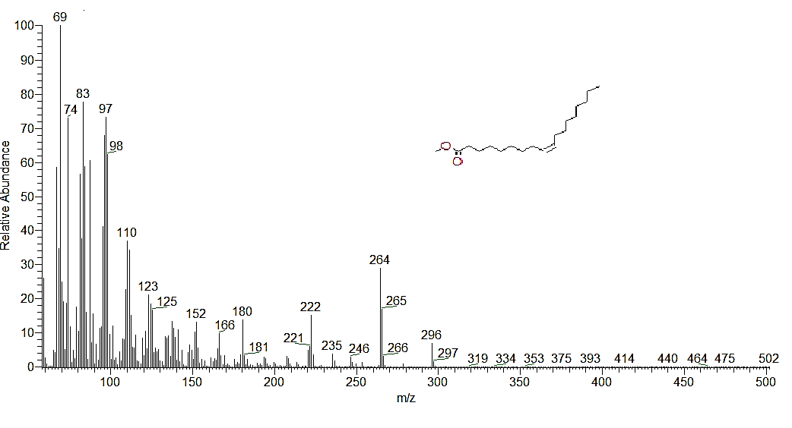
Figure S1. The 70 eV mass spectrum of (Z)-9-octadecenoic acid, methyl ester component at RT 19.57 in B. spectabilis bark ME.
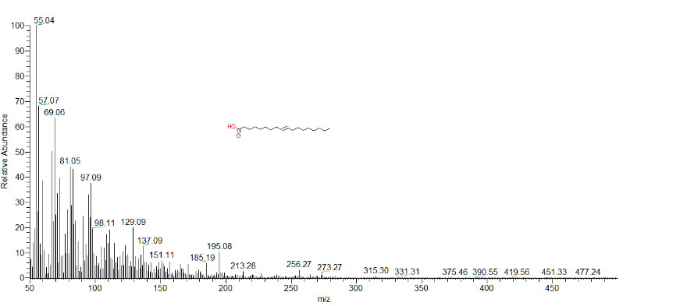
Figure S2. The 70 eV mass spectrum of the (Z)-9-octadecenoic acid compound at RT 22.25 in Bougainvillea spectabilis bark methanol extract.
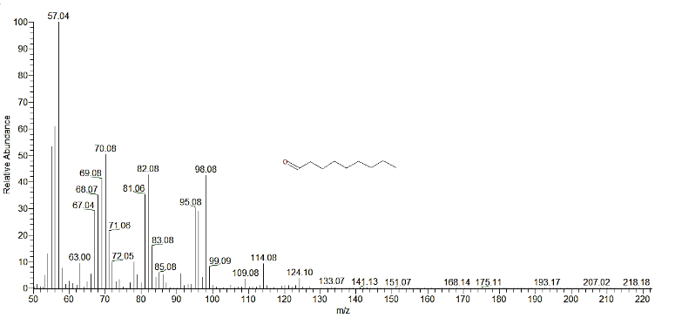
Figure S3. The 70 eV mass spectrum of the nonanal at RT 26.67 in B. spectabilis bark butanol extract

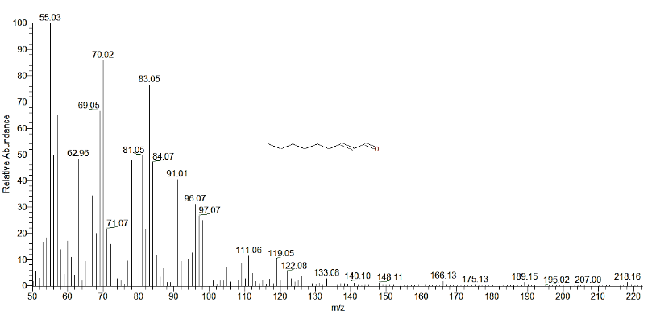
Figure S4. The 70 eV mass spectrum of the (E)-2-nonenal at RT 28.69 in B. spectabilis bark butanol extract.
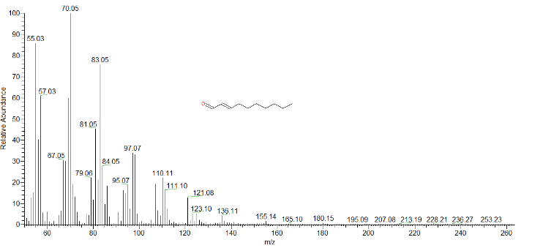
Figure S5. The 70 eV mass spectrum of the (E)-2-decenal, RT 19.91 in B. spectabilis bark acetone extract.
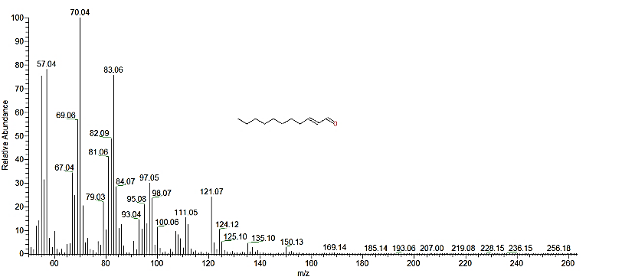
Figure S6. The 70 eV mass spectrum of the (E)-2-undecenal RT 25.59 in B. spectabilis bark acetone extract.
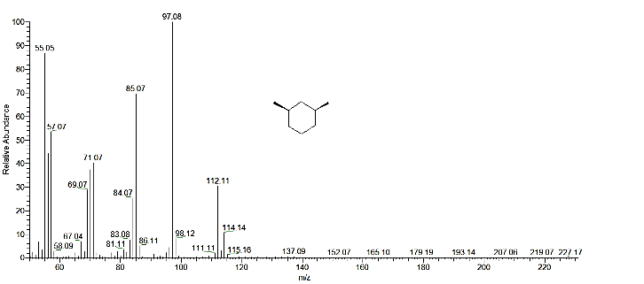
Figure S7. The 70 eV mass spectrum of the cis-1,3-dimethylcyclohexane at RT 3.63 in B. spectabilis wood essential oil.

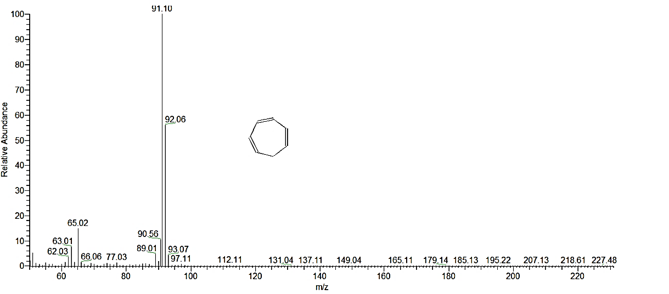
Figure S8. The 70 eV mass spectrum of the 1,3,5-cycloheptatriene RT 4.83 in B. spectabilis wood essential oil.

