______________________________________________________________________________
A Similarity Study of Homoleptic and Heteroleptic Divalent Metal Complexes: Synthesis, Characterization and Antimicrobial Activities

Abstract
The emergence of multidrug-resistant bacteria and fungi has become a major challenge in the pharmaceutical industry. Therefore, there is urgent need for new synthetic antimicrobial agents. In this paper, the synthesis, characterization and antimicrobial examination of the homoleptic and heteroleptic Ni²⁺, Cu²⁺, and Zn²⁺ complexes of N-(2-hydroxy-1-naphthaldehyde)-2-amino-6-nitrobenzothiazole and 2,2’-bipyridine chelators is portrayed. The homoleptic complexes were prepared at ligands to metal ratio of 2:1 and the heteroleptic complexes were prepared at 1:1:1 ratio of Schiff base, 2,2’-bipyridine and metal. The metal salts used include nickel(II) acetatetetrahydrate, copper(II) acetatedihydrate and zinc(II) acetatedihydrate while CH₃CH₂OH served as solvent and triethylamine served as buffer. There were good yields when the compounds were isolated after preparation, various colors, high melting/decomposition temperature (206 ≥ 360 ºC) were observed. The compounds were soluble in DMSO and DMF but insoluble in water. The spectroscopic analysis confirmed various coordinations. Imine coordination, was between 1616 – 1642 cm⁻¹ whereas typical M-N coordination was seen between (647 - 513 cm-1) and M-O (580 - 457 cm⁻¹). Antimicrobial screening was carried out against six bacteria (e.g., S. aureus, B. cerus, P. aeruginosa, P. mirabilis, S. typhi and K. pneumoniae) and three fungi (e.g.; The strain of A. niger, A. flaus and R. stalonfer) with inhibition zone of 1.0 - 14.0 mm (bacteria) and 1.0 - 25.0 mm (fungi). Interestingly, the activities recorded for both homoleptic and heteroleptic complexes were impressive which presents them as good antibacterial and antifungi drugs. However, the heteroleptic complexes had most of the highest inhibition zones showing them as better antimicrobial agents.

Keywords: Homoleptic, Heteroleptic, Metal(II) Complexes, Synthesis, Spectral, Antimicrobial
Introduction
Antimicrobial resistance (AMR) has become a significant health issue in the world, diminishing the efficacy of available antibiotics and creating an indication of necessary new types of therapeutic approaches (WHO, 2015). Metallic complexes have been seen as the alternative antimicrobial agents because of the structural flexibility and the elevated bioactivity due to the metal ligand interactions (Zhang et al., 2018). The reason why schiff bases are so helpful is its ease of production, high chelating capacity with transition metal ions to form coordination compounds with well-known pharmacological characteristics (Singh et al., 2014).
An element whose atom has a partially filled d sub-shell, or which can give birth to cations with an incomplete d sub-shell" is defined as transition metal according to the IUPAC, though it is occasionally expanded to include lanthanides and actinides (4f and 5f shells). This transition metal ions are Lewis' acids, or electron acceptors, that can attach to Lewis bases, or ligands (L), using a "lone-pair" of electrons to form a coordination molecule or complex MLn (n = number of ligands). The metal's first coordination sphere is where the ligands bind, while the second coordination sphere may contain substances like uncoordinated solvent molecules that stabilize the complex (Sargeson, 1984). Several ligand types are available for bonding with the transition metals, e.g., amines (NH₃), phosphine (PH₃), alcohol (ROH), thiol (SH), aldehyde (CHO), ketone RCOR’ etc. Also, special type of ligands known as Schiff base named after the inventor, Hugo Schiff are available. Because of their electron-rich nitrogen and electron-deficient carbon, these Schiff bases also referred to as azomethine chelator or ligand have a remarkable propensity to chelate with transition metals and thereby enhance their biological activities (Wail et al., 2018). This allows for a variety of electrophilic and nucleophilic reactions at the respective centers (Xia et al., 2004; Timofeeva et al., 2019; Wantulok et al., 2020; Tyagi et al., 2023). Additionally, the azomethine moiety aids in the explanation of the biological system's trans-amination and racemization mechanisms (More et al., 2019). Because of their many uses, metal complexes made from different Schiff bases are highly sought-after in the field of coordination chemistry and globally both for their medicinal value, catalytic and dye properties (Tsacheva et al., 2023; Aytac et al., 2023; Hussain et al., 2023; Hasan et al., 2023; Pradeep et al., 2023; Reena et al., 2023),
Schiff bases and their metal complexes are more relevant in the biological and medical domains. Their activity profile is significantly influenced by the kind of Schiff base and the metal that is included into the complex. Compared to organic compounds, metal complexes of Schiff base origin provide superior pharmacological action mechanisms, because the imine functional group is physiologically active. Schiff bases are more effective metal complex ligands (Bhalla et al., 2024) and those with oxygen and nitrogen donors have extraordinary biological qualities that are boosted (Krikavovh et al., 2016). Additionally, the nitrogen atom in azomethines gives metal ions binding sites and enables attachment to a variety of biomolecule substrates, including proteins and amino acids, in biological systems and pathogens (Habu, 2018). According to reports in the literature, complexes created by this interaction have a variety of biological functions because of the -C=N-imine connection (Wail et al., 2018). Medicinal chemists and biologists have shown a great deal of interest in some metallic complexes of the azomethine type because of their improved antibacterial qualities (Festus, 2017). This paper summarizes and describes homoleptic and heteroleptic complexes of Ni²⁺, Cu²⁺, and Zn²⁺ of N-(2-hydroxy-1-naphthaldehyde)-2-amino-6-nitrobenzothiazole and tests their antimicrobial effects to identify potential new metal-based antibacterial and antifungal agents.
Experimentation
Materials: Schiff base ligand (N-(2-hydroxy-1-naphthaldehyde)-2-amino-6-nitrobenzothiazole), triethylamine, acetic acid, 2,2'-bipyridine, drying agent, nickel(II)acetatetetrahydrate, copper(II)acetatedihydrate, zinc(II)acetatedihydrate, DMF, ethanol(CH₃CH₂OH), distilled water (H₂O), hydrochloric acid, chloroform, methanol, dichloromethane, acetone, and DMSO.

Characterization: The structural elucidation of the prepared compounds were carried by test for the melting/decomposition points of the metal(II) complexes with the aid of a transparent cut-glass capillary tube inserted in an electrochemical m.pt. machine. The functional groups present the complexes were identified using infrared spectra techniques (PerkinElmer Infrared Spectrophotometer) recorded in the region 4000 – 400 cm^{–1}. The recording of the complexes’ Electronic reflectance spectra was done at room temperature with aid of Perkin Elmer UV/Vis spectrometer from 900 to 190 nm.

Biological Activity: In-vitro antimicrobial properties of the synthesized homoleptic and heteroleptic metal(II) complexes were conducted by employing the nutrient agar diffusion technique. Six bacterial strains were used: S. aureus, B. cereus, P. aeruginosa, P. mirabilis, S. typhi and K. pneumoniae while three fungi were used: A. niger, A. flaus, and R. stalonfer. The diluent for the various complexes is DMSO which also served as the negative control. Streptomycin served as the positive control for bacterial whereas Miconazole served as positive control for the fungi. Wells were made on the nutrient agar contained in each plate with the aid of 8 mm cork borer. Using a micro syringe, of 80 uL each sample was inoculated into the nutrients in duplicate, followed by 18-24 h incubation at 37 ºC for the bacterial and 48 h at 30 ºC for the fungi. The resulting inhibition zones were determined in diameter (mm) and the mean value calculated (Olalekan & Didia, 2019; Festus & Didia, 2023).

Synthesis of the homoleptic M²⁺ Complexes
Two differently prepared ligands were employed in the synthesis of the metal(II) complexes. To prepare the homoleptic type complex, 0.5 g (7.18 x 10⁻⁴ mol) of the ligand was dissolved in 20 mL CH₃CH₂OH, and stirred to acquire homogenous phase followed by the addition of 0.176 g of Ni(CO₂CH₃)₂.4H₂O salt that was initially dissolved in 10 mL of C₂H₆O. 8 drops of triethylamine buffer solution was also added. The resulting mixture was stirred and allowed to reflux for 6 h. The products were left to cool to room temperature, filtered, and dried which gave the anticipated complex. The same approach was employed to obtain the Cu²⁺ and Zn²⁺ homoleptic metal complexes using 0.156 g Cu(CO₂CH₃)₂.2H₂O and 0.158 g Zn(CO₂CH₃).2H₂O. The reaction is as summarized in the scheme below.

Scheme 1: Synthesis of Homoleptic M²⁺ Complexes of Azomethine Based Chelator

Synthesis of the heteroleptic M²⁺ Complexes
2,2'-bipyridine and N-(2-hydroxy-1-naphthaldehyde)-2-amino-6-nitrobenzothiazole ligands were both used to prepare Ni²⁺, Cu²⁺ and Zn²⁺ heteroleptic complexes. To synthesize the Ni2+ complex, 0.5 g (7.18 x 10⁻⁴ mol) of N-(2-hydroxy-1-naphthaldehyde)-2-amino-6-nitrobenzothiazole chelator was reacted with 0.223 g of 2,2’-bipyridine in 20 mL EtOH, followed by the addition of 0.176 g Mn(CH₃CO₂)₂.4H₂O already dissolved in 10 mL of EtOH. Triethylamine buffer solution was added in drops. This mixture was then allowed to stir in a heating mantle under refluxing condition at a temperature range of 40 – 60 ºC for a time interval of 6 h. This resulted to the nickel heteroleptic complex and the reaction took place in a ratio of 1 : 1: 1. The product was allowed to cool at RT, filtered, dried and the mass and % yield obtained. 0.156 g of Cu(CO₂CH₃)₂.2H₂O (0.156 g) and 0.158 g of Zn(CO₂CH₃).2H₂O (0.158 g) were used to obtain the Cu and Zn heteroleptic complexes using the approach as discussed for Ni²⁺. The scheme summarizing the reaction is given below.

Scheme 2: Synthesis of Ni²⁺, Cu²⁺ and Zn²⁺ Heteroleptic complexes

Results and Discussions
Table 1 Analytical Data of homoleptic M²⁺ Complexes
Compounds | Colour | M W (g/mol) | Yield(%) | M.Pt(ºC)
[Ni(C₃₈H₂₅O₉N₆S₂] | orange | 831.69 | 69.4 | 269 – 272
[Cu(C₃₆H₂₂O₁₁N₆S₃Cl₂] | Brick red | 848.55 | 39.5 | 347 – 350
[Zn(C₃₈H₂₅O₉N₆S₂] | Dirty green | 838.41 | 22.1 | > 360

Table 2 Analytical data of heteroleptic M²⁺ complexes
Compounds | Colour | M.W (g/mol) | Yield % | M.Pt (ºC)
[Ni(C₃₀H₂₁O₃N₅S)] nH₂O | Wine red | 589.69 | 201 | >360
[Cu(C₃₆H₂₂O₁₁N₆S₃Cl₂] nH₂O | Dark brown | 606.55 | 293 | 206 – 208
[Zn(C₃₀H₂₁O₃N₅S)] nH₂O | Black | 596.41 | 320 | 346 – 348

Analytical studies. The Ni²⁺, Cu²⁺ and Zn²⁺ homoleptic and heteroleptic complexes had good yields ranging from 39.5 - 137.5 and 201 – 320 % respectively. The complexes also assumed different shades of colour and from stoichiometric point of view, the homoleptic complexes reacted in 2:1 molar ratio while that involving heteroleptic complexes reacted in a molar ratio of 1 : 1 : 1. The homoleptic complexes had melting point ranging from 269 ≥ 360 ºC whereas all the heteroleptic type melted in the range 206 ≥ 360 ºC. Interestingly, none of the metal complexes had the same melting point confirming the formation of new different compounds (Yesmin et al., 2020).

Solubility Data for the Chelator and its M²⁺ Complexes. The solubility test for the homoleptic and heteroleptic complexes showed that the Ni²⁺ complexes had good solubility in DMSO and DMF (Yesmin et al., 2020), while Cu and Zn complexes were soluble in DMSO but insoluble in DMF. All the complexes were generally insoluble in H₂O as expected. Zn²⁺ heteroleptic complex was also found to be soluble in chloroform and dichloromethane while the other complexes were slightly soluble.

Vibrational spectral result of homoleptic and heteroleptic M²⁺ complexes
Table 3 Vibrational spectral result for the homoleptic M²⁺ complexes (cm⁻¹)
Compound | OH | C-H | C=N | C=C | C-N | C-C | NO₂ | C-N | C-O | M-N | M-O
[Ni(C₃₈H₂₅O₉N₆S₂]nH₂O | 3450 | 2074 | 1642 | 1591 | 1540 | 1435 | 1332 | 1250 | 1123 | 520 | 461
[Cu(C₃₆H₂₂O₁₁N₆S₃Cl₂]nH₂O | 3437 | 2164 | 1619 | 1602 | 1584 | 1428 | 1332 | 1253 | 1123 | 528 | 468
[Zn(C₃₈H₂₅O₉N₆S₂]nH₂O | 3438 | 2347 | 1631 | 1587 | 1521 | 1455 | 1334 | 1231 | 1126 | 520 | 492

Table 4 Vibrational spectral result of Heteroleptic M²⁺ complexes (cm⁻¹)
Compound | OH | C-H | C=N | C=C | C-N | C-C | NO₂ | C-N | C-O | M-N | M-O
[Ni(C₃₀H₂₁O₃N₅S)]nH₂O | 3443 | 2348 | 1642 | 1592 | 1541 | 1426 | 1334 | 1250 | 1147 | 520 | 457
[Cu(C₃₆H₂₂O₁₁N₆S₃Cl₂]nH₂O | 3429 | 2665 | 1616 | 1603 | 1580 | 1422 | 1324 | 1246 | 1123 | 526 | 462
[Zn(C₃₀H₂₁O₃N₅S)]nH₂O | 3405 | 2077 | 1622 | 1580 | 1557 | 1420 | 1330 | 1279 | 1116 | 560 | 490

Fourier transition infrared (FT-IR) spectroscopy
Coordination sites involved in metal – ligand chelation are here described by the FTIR results obtained for both homoleptic and heteroleptic metal(II) complexes, the spectra data obtained were further compared similar structures available in literature and used to assign important bands to some key functional groups (Ahmed et al., 2015). The band usually observed at 1633 cm⁻¹ for imine FG shifted to entirely different frequencies within 1616 – 1642 cm⁻¹ in all the M²⁺complexes, indicating a participation of the imine nitrogen in coordination with the metal ion (Hamil et al., 2020). This shift in imine band for the metal complexes presents new bands in the 457–580 cm⁻¹ and 513–647 cm⁻¹ regions (Festus & Okocha, 2017). These are bands apportioned M–O and M–N vibrations in metal complexes (Borase et al., 2021). Broad bands similitude of the OH group were seen in the spectra of the complexes in the range 3380 – 3450 cm⁻¹, these were identified as the OH group of water molecules (Festus et al., 2023) while the OH present in the organic moity often sighted at 3401 cm⁻¹, deprotonated and served as bonding site to the metal ions as shown by the absence of the OH band in the spectra of the M²⁺ complexes and observance of a new band at 457 – 580 cm⁻¹ already assigned to M – O coordination (Festus & Wodi, 2021).

Electronic spectral result of homoleptic and heteroleptic M²⁺ complexes
Table 5. Electronic spectral result of Homoleptic M²⁺ complexes
Compounds | Wavelength, λ_{max} (nm) | Absorption band, ῡ (cm⁻¹) | Transition(s)band assignment | Geometry
[Ni(C₃₈H₂₅O₉N₆S₂]nH₂O | 302, 342, 398  460, 634, 686 | 33113,29239, 25126  21739, 15773, 14577 | π → π*, ո → π*  d→d, d→d | Octahedral
[Cu(C₃₆H₂₂O₁₁N₆S₃Cl₂]nH₂O | 262, 342, 358  648, 682, 762 | 38168, 33113, 29239  15432, 14663,13123 | π → π*, ո → π*  d→d, d→d | Octahedral
[Zn(C₃₈H₂₅O₉N₆S₂]nH₂O | 254, 342, 398  652, 686 | 39370, 32679, 25126  15337, 14577 | π → π*, ո → π*  d→d | Octahedral

Table 6. Electronic spectral result of Heteroleptic M²⁺ complexes
Compounds | Wavelength, λ_{max} (nm) | Absorption band, ῡ (cm⁻¹) | Transition(s)band assignment | Geometry
[Ni(C₃₀H₂₁O₃N₅S)]nH₂O | 258, 354  642, 774 | 38759, 28249  15576,12919 | π → π*, ո → π*  d→d | O.h
[Cu(C₃₆H₂₂O₁₁N₆S₃Cl₂]nH₂O | 322, 366  652, 686 | 31056, 27322  15337, 14577 | π → π*, ո → π*  d→d | O.h
[Zn(C₃₀H₂₁O₃N₅S)]nH₂O | 302, 342  650, 682 | 33113, 29239  15385, 14663 | π → π*, ո → π*  d→d | O.h

Electronic spectroscopy
The electronic reflectance spectra of the nickel complex [Ni(C₃₈H₂₅O₉N₆S₂] showed three different bands at higher wavelength 460, 634 and 686 nm. These are d-d transitions assignable to ³T_{1g}→³A_{2g}, ³T_{1g}→³T_{1g} and ³T_{1g}→³T_{2g} octahedral transitions (Festus, 2021), along with the bands in the low wavelength region at 302 and 328 nm, attributed to 𝜋→𝜋∗ and 𝑛→𝜋∗ transitions, respectively (Kundu et al., 2016). The electronic absorption spectrum of the copper complex, [Cu(C₃₆H₂₂O₁₁N₆S₃Cl₂] exhibited absorption band in the high wavelength region of 648 and 682 nm ascribed to ²E_{g}→²T_{2g} transition suggestive of octahedral geometry (Narendra & Parashuram, 2017). Other high energy bands for the Cu²⁺ complex was observed at 262 and 358 nm being for 𝜋→𝜋∗ and 𝑛→𝜋∗ LMCT transitions. The zinc complex, [Zn(C₃₈H₂₅O₉N₆S₂] in its electronic spectrum displayed high energy absorption band at 254 nm associated with 𝜋→𝜋∗ transition and 306 nm assignable to the LMCT (Festus et al., 2023). The zinc(II) complex did not display d→d transition band as was seen in other complexes in the visible spectrum, this is common with zinc complexes; nonetheless, a M→L transfer charge transition have observed alongside intraligand absorption bands. Notwithstanding, the Zn(II) complex was allotted a geometry of octahedral type (Narendra & Parashuram, 2017).

Antimicrobial data of Homoleptic and Heteroleptic metal(II) complexes
Table 7 Antibacterial data of Homoleptic M²⁺ complexes [Zone of Inhibition (mm)]
Compounds | B. c | K. p | P. a | P. m | S. a | S. t
[Ni(C₃₈H₂₅O₉N₆S₂]nH₂O | 5.0 ± 1.0 | 1.0 ± 1.0 | 0.0 ± 0.0 | 5.0 ± 1.0 | 9.0 ± 1.0 | 4.0 ± 0.0
[Cu(C₃₆H₂₂O₁₁N₆S₃Cl₂]nH₂O | 10.0 ± 0.0 | 2.0 ± 0.0 | 6.5 ± 0.5 | 0.0 ± 0.0 | 12.0 ± 0.0 | 4.5 ± 0.5
[Zn(C₃₈H₂₅O₉N₆S₂]nH₂O | 6.0 ± 0.0 | 4.5 ± 0.5 | 2.0 ± 0.0 | 0.0 ± 0.0 | 13.0 ± 1.0 | 6.0 ± 0.0
Streptomycin | 18.0 ± 0.0 | 11.0 ± 1.0 | 9.0 ± 1.0 | 10.5 ± 0.5 | 19.0 ± 1.0 | 10.5 ± 0.5
DMSO | 0.0 ± 0.0 | 0.0 ± 0.0 | 0.0 ± 0.0 | 0.0 ± 0.0 | 0.0 ± 0.0 | 0.0 ± 0.0

Table 8 Antibacterial data of Heteroleptic M²⁺ complexes [Zone of Inhibition (mm)]
Compounds | B. c | K. p | P. a | P. m | S. a | S. t
[Ni(C₃₀H₂₁O₃N₅S)]nH₂O | 6.0 ± 0.0 | 0.0 ± 0.0 | 4.0 ± 0.0 | 0.0 ± 0.0 | 11.0 ± 1.0 | 5.5 ± 0.5
[Cu(C₃₆H₂₂O₁₁N₆S₃Cl₂]nH₂O | 11.0 ± 1.0 | 4.0 ± 0.0 | 6.0 ± 0.0 | 5.5 ± 0.5 | 9.0 ± 1.0 | 2.0 ± 0.0
[Zn(C₃₀H₂₁O₃N₅S)]nH₂O | 11.0 ± 1.0 | 4.0 ± 0.0 | 6.0 ± 0.0 | 5.5 ± 0.5 | 9.0 ± 1.0 | 2.0 ± 0.0
Streptomycin | 18.0 ± 0.0 | 11.0 ± 1.0 | 9.0 ± 1.0 | 10.5 ± 0.5 | 19.0 ± 1.0 | 10.5 ± 0.5
DMSO | 0.0 ± 0.0 | 0.0 ± 0.0 | 0.0 ± 0.0 | 0.0 ± 0.0 | 0.0 ± 0.0 | 0.0 ± 0.0
Where: S.a = Staphylococcus aureus; B.c = Bacillus cerus; Ps.a = Pseudomonas aeruginosa; P. m = Proteus mirabilis, S. t = salmonella typhi; K. p = Klebsiella pneumoniae

Antibacterial assay of the homoleptic and heteroleptic M²⁺ complexes
Six bacterial strains: Pseudomonas aeruginosa, Proteus mirabilis, Salmonella typhi, Staphylococcus aureus, Bacillus cereus and Klebsiella pneumoniae were used to test the potency of the synthesized homoleptic metal complexes in inhibiting the above mentioned bacterial. The M(II) complexes were dissolved in DMSO (which also served as negative control) while streptomycin standard drug served as positive control. The result is summarized in Table 7. Results as obtained from the antimicrobial screening indicates that the Ni, Cu, and Zn complexes were able to inhibit all the bacterial strains except in one case where Cu and Zn could not inhibit Proteus mirabilis and Ni could not inhibit Pseudomonas aeruginosa. Their inhibition of the bacterial growth was recorded in the range 1.0 – 13.0 mm. The data obtained at the end of the antibacterial screening for the heteroleptic metallic complexes showed them as good inhibitors against the six bacterial strains in the range 2.0 – 11.0 mm. The nickel, copper and zinc heteroleptic complexes particularly had good inhibitory activity against all the bacterial under investigation and so, are seen as promising antibacterial agents. However, it was just in one case where Ni complex had zero activity against Klebsiella pneumoniae and Proteus mirabilis.
Comparing the biological activities of the homoleptic Cu²⁺ and Zn²⁺ complexes, to those of the heteroleptic complexes of the same metal systems, the heteroleptic were observed to be better inhibitors. While the Cu²⁺ and Zn²⁺ recorded zero activity against Proteus mirabilis, Cu²⁺ and Zn²⁺ heteroleptic typed complexes recorded 5.5 mm inhibitory value against the bacterial. While Ni2+ homoleptic and heteroleptic complexes both had zero activity against Proteus mirabilis. The better activity recorded for the heteroleptic complexes is said to as a result of the presence of two different ligands having additional functional sites that are antibacterial.
The standard drug, streptomycin had inhibitory from 9.0 – 19.0 mm against all the bacterial strains thereby observed to have the newly prepared homoleptic and heteroleptic metal(II) complexes. The negative control, DMSO on the other hand, recorded zero activity on all the bacterial studied. Interestingly, due to chelate effect, the metal complexes had improved activity than the chelator. When the structure of the metal complexes were considered, they were found to be similar to those of the natural biological compounds hence, the reason to have inhibited the growth of these microorganisms (Festus et al., 2020), also the presence of -N=CH- functional group which is a known active inhibitory site helped in antibacterial property of the complexes (Křikavovȧ et al., 2016; Habu, 2018). The increase in the lipophilic character of the metal complexes in the lipid membrane also helped to cease the growth of microorganisms (Adlym et al., 2020).

Table 9. Antifungi data of Homoleptic M²⁺ complexes
Compounds | A. n | A. f | R. s
[Ni(C₃₈H₂₅O₉N₆S₂]nH₂O | 5.0 ± 1.0 | 7.0 ± 1.0 | 17.5 ± 0.5
[Cu(C₃₆H₂₂O₁₁N₆S₃Cl₂]nH₂O | 11.0 ± 1.0 | 0.0 ± 0.0 | 0.0 ± 0.0
[Zn(C₃₈H₂₅O₉N₆S₂]nH₂O | 0.0 ± 0.0 | 1.0 ± 1.0 | 13.0 ± 1.0
Miconazole | 17.0 ± 1.0 | 19.5 ± 0.5 | 16.0 ± 0.0
DMSO | 0.0 ± 0.0 | 0.0 ± 0.0 | 0.0 ± 0.0

Table 10 Antifungi data of Heteroleptic M²⁺ complexes Zone of Inhibition (mm)
Compounds | A. n | A. f | R. s
[Ni(C₃₀H₂₁O₃N₅S)]nH₂O | 1.0 ± 1.0 | 3.0 ± 1.0 | 16.0 ± 0.0
[Cu(C₃₆H₂₂O₁₁N₆S₃Cl₂]nH₂O | 14.0 ± 0.0 | 5.0 ± 1.0 | 1.0 ± 1.0
[Zn(C₃₀H₂₁O₃N₅S)]nH₂O | 0.0 ± 0.0 | 0.0 ± 0.0 | 12.0 ± 0.0
Miconazole | 17.0 ± 1.0 | 19.5 ± 0.5 | 16.0 ± 0.0
DMSO | 0.0 ± 0.0 | 0.0 ± 0.0 | 0.0 ± 0.0
Where; A. n = Aspergillus niger, A. f = Aspergillus flavus, R. s = Rhizopus stolonifera.

Antifungal Data of Homoleptic and Heteroleptic M²⁺ complexes
The data obtained from this assay are summarized in Table 9 and 10 below. Considering the record, the least activity had an inhibitory value of 1.0 mm while the highest activity was recorded at mean 17.5 mm. Amongst the homoleptic metal(II) complexes, Ni²⁺ inhibited all the fungi studied, whereas Cu²⁺ only inhibited Aspergillus niger at 11.0 mm and Zn²⁺ inhibited Aspergillus fungus at 1.0 mm and Rhizopus stalonfer at 13.0 mm. Comparing this result to the heteroleptic counterpart, the Ni²⁺ complexes inhibited all the fungi, just as the Ni2+ homoleptic complexes did, unlike the Cu²⁺ homoleptic complexes, the Cu2+ heteroleptic complexes was able to inhibit all the fungi. On the other hand, both the homoleptic and heteroleptic complexes of Zn metal(II) ion had zero inhibitory activity against Aspergillus niger, in the case where the Zn homoleptic complex recorded 1.0 mm activity against Aspergillus fungus, its heteroleptic counterpart hrecorded zero activity. Therefore, at an average consideration, the homoleptic metal(II) complexes are said to have performed lesser than the heteroleptic complexes. This observation must have been so made as a result of the presence of two different ligand type in the heteroleptic complexes having more active pharmacophore. Generally, these complexes are thereby presenting as a promising antifungal pro-drug agent. Tweedy’s chelation theory is used to explain these antifungi properties of the above complexes (Yesmin et al., 2020). Also, overtones concept further supports the antifungi property of the studied complexes. Several reports on the antifungi activity of similar systems have presented them as more promising inhibitors with improved bio-functions (Habu, 2018).
Figure 1. Plates of antimicrobial assay of homoleptic and heteroleptic M²⁺ complexes
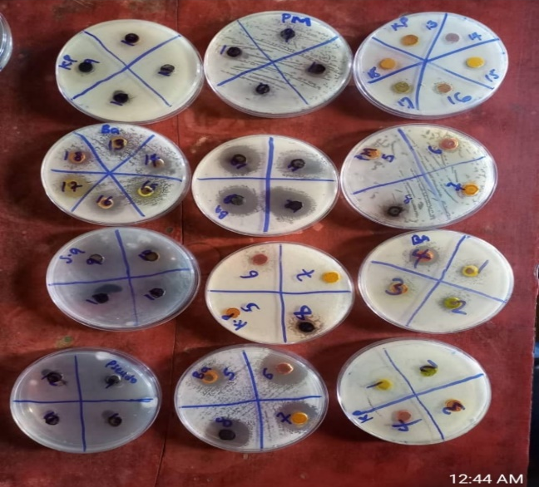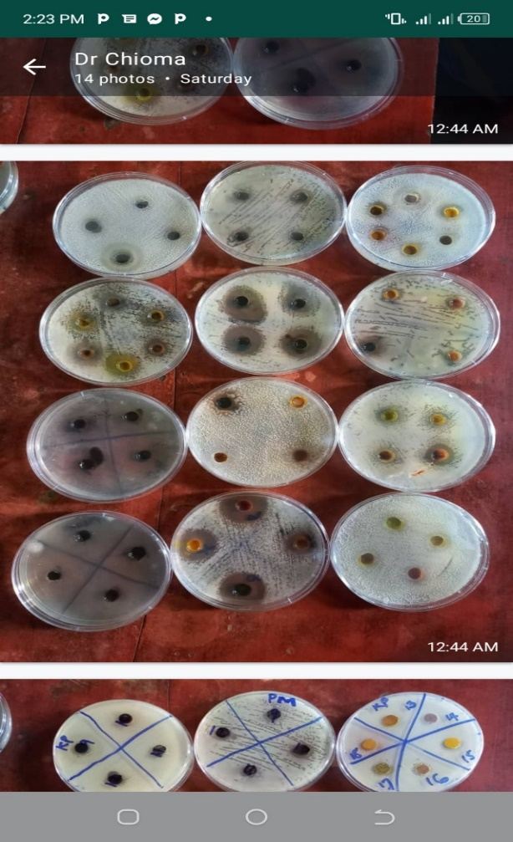

Conclusion
In this present study, new homoleptic and heteroleptic Ni2+, Cu2+, and Zn2+ complexes of a Schiff base N-(2-hydroxy-1-naphthaldehyde)-2-amino-6-nitrobenzothiazole have been synthesized and described in this work. Coordination was proved by structural analyses using imine nitrogen and phenolic oxygen, and the complexes were all in octahedral formations. The complexes were thermally stable and had specific colors and were soluble in both DMSO and DMF. The antimicrobial activity was tested against a series of bacterial and fungal isolates and was found to have strong inhibitory power with heteroleptic complexes showing superior results to their homoleptic counterparts. The presented results indicate that mixed-ligand coordination increases the biological activity and therefore heteroleptic metal(II) complexes are promising compounds to be used to develop new antibacterial and antifungal drugs. Altogether, this paper highlights the perspective of Schiff base metal complexes in solving the global problem of multidrug resistant pathogens and forms a basis of further optimization of metal-based antimicrobial therapeutic solutions.

Declaration of competing interest: The authors hereby declare that there are no conflicts of interest financially and idea that may have appeared to influence this study.

References
- Abd El-Lateef, H. M., Abu-Dief, A. M., Abdel-Rahman, L. H., Sañudo, E. C., & Aliaga-Alcalde, N. (2015). Electrochemical and theoretical quantum approaches on the inhibition of C1018 carbon steel corrosion in acidic medium containing chloride using some newly synthesized phenolic Schiff bases compounds. Journal of Electroanalytical Chemistry, 743, 120–133. https://doi.org/10.1016/j.jelechem.2015.02.023 .

- Adly, O. M., Shebl, M., Abdelrhman, E. M., & El-Shetary, B. A. (2020). Synthesis, spectroscopic, X-ray diffraction, antimicrobial and antitumor studies of Ni(II) and Co(II) complexes derived from 4-acetyl-5, 6-diphenyl-3 (2H)-pyridazinone and ethylenediamine. Journal of Molecular Structure, 1219, 128607. https://doi.org/10.1016/j.molstruc.2020.128607 .
- Ahmed, N., Riaz, M., Ahmed, A., & Bhagat, M. (2015). Synthesis, characterisation, and biological evaluation of Zn(II) complex with tridentate (NNO Donor) Schiff base ligand. International Journal of Inorganic Chemistry. https://doi.org/10.1155/2015/607178 .

- Aliyu, H. N., & Zayyan, R. S. (2014). Synthesis, Analysis and Bioactivity Evaluation of Copper(II) Tetradentate Schiff Base Complex. International Journal of Current Microbiology and Applied Science, 3(1), 445-452. http://www.ijcmas.com/ .

- Aytac, S., Gundogdu, O., Bingol, Z., & Gulcin, I. (2023). Synthesis of Schiff Bases Containing Phenol Rings and Investigation of Their Antioxidant Capacity, Anticholinesterase, Butyrylcholinesterase, and Carbonic Anhydrase Inhibition Properties. Pharmaceutics, 15(3), 779–796. https://doi.org/10.3390/pharmaceutics15030779 .

- Baildya, N., Ghosh, N. N., & Chattopadhyay, A. P. (2019). Anti-corrosive properties of quercetin and its derivatives on Fe(111) surface: a quantum chemical approach. SN Applied Sciences, 1(7), 735. https://doi.org/10.1007/s42452-019-0772-1 .

- Borase, J. N., Mahale, R. G., Rajput, S. S., & Shirsath, D. S. (2021). Design, synthesis and biological evaluation of heterocyclic methyl substituted pyridine Schiff base transition metal complexes. SN Applied Sciences, 3(197) https://doi.org/10.1007/s42452-021-04144-z

- Saraf, D. V., Kulkarni, P. A., Deshpande, V. G., & Habib, S. I. (2017). Heterocyclic Schiff base Cu(II) metal complexes and their X-Ray diffraction study. European Journal of Pharmaceutical and Medical Research, 4(9), 680-683. https://www.ejpmr.com/archive .

- Dey, D., Ray, R., & Hazra, B. (2014). Antitubercular and antibacterial activity of quinonoid natural products against multi-drug resistant clinical isolates. Phytotherapy Research, 28, 1014-1021. https://doi.org/10.1002/ptr.5090 .

- Ekennia, A. C., Onwudiwe, D. C., Osowole, A. A., Okpareke, O. C., Olubiyi, O. O., & Lane, J. R. (2019). Coordination compounds of heterocyclic bases: synthesis, characterization, computational and biological studies. Res. Chem. Intermed., 45(3), 1169–1205. https://doi.org/10.1007/s11164-018-3664-x .

- Elemike, E. E., Nwankwo, H. U., & Onwudiwe, D. C. (2018). Synthesis and characterization of Schiff bases NBBA, MNBA and CNBA. Heliyon. https://doi.org/10.1016/j.heliyon.2018.e00670 .

- Afshari, F., Ghomi, E. R., Dinari, M., & Ramakrishna, S. (2023). Recent Advances on the Corrosion Inhibition Behavior of Schiff base Compounds on Mild Steel in Acidic Media. ChemistrySelect, 8, 1-31. https://doi.org/10.1002/slct.202203231 .

- Fasina, T. M., & Ogundele, O. (2014). Synthesis, characterization and antimicrobial activity of some transition metal complexes of schiff base derived from o-phenylenediamine and 5-nitrosalicyaldehyde. Der Pharma Chemica, 6(4), 18-22. http://derpharmachemica.com/archive.html .

- Fasina, T. M., Ogundele, O., Ejiah, F. N., & Dueke-Eze, C. U. (2012). Biological activity of copper(II), cobalt(II), and nickel(II) complexes of Schiff base derived from o-phenylenediamine and 5-bromosalicylaldehyde. International Journal of Biological Chemistry, 6(1), 24-30. https://doi.org/10.3923/jbc.2012.24.30 .

- Festus, C. (2017). Synthesis, characterization and antibacterial studies of heteroleptic Co(II), Ni(II), Cu(II) and Zn(II) complexes of N-(2-hydroxybenzylidene)pyrazine-2-carboxamide. International Journal of Chemistry, Pharmacy & Technology, 2(5), 202-211.

- Festus, C., & Okocha, O. (2017). Behaviour of N-(2-hydroxybenzylidene)pyrazine-2-carboxamide in complexation towards Fe(II), Co(II), Ni(II) and Cu(II) ions: Synthesis, spectral characterization, magnetic and antimicrobial properties. International Journal of Chemistry, Pharmacy & Technology, 2(4), 143-153.

- Festus, C., Odozi, W. N., & Olakunle, M. (2020). Preparation, spectral characterization and corrosion inhibition studies of (e)-n-{(thiophene-2-yl)methylene}pyrazine-2-carboxamide Schiff base ligand. Protection of Metals and Physical Chemistry of Surfaces, 56(3), 651-662. https://doi.org/10.1134/S2070205120030107 .

- Festus, C., Ekpete, O. A., & Don-Lawson, C. D. (2020). Novel Metal2+ complexes of N-(1,4-dihydro-1,4-oxonaphthalen-3-yl) pyrazine-2-carboxamide: Synthesis, structural characterization, magnetic properties and antimicrobial activities. Current Research in Chemistry, 12, 1-10. https://doi.org/10.3923/crc.2020.1.10 .

- Festus, C., Ayogu, J. I., & Ibeji, C. U. (2021). Ligation Actions of 2-(3-hydroxypyridin-2-ylamino)naphthalen-1,4-dione: Synthesis, Characterization, In-vitro Antimicrobial Screening, and Computational Studies. Indian Journal of Heterocyclic Chemistry, 31(1), 1-13. https://connectjournals.com/abstract/indian-journal-of-heterocyclic-chemistry/Ligation-Actions-of-2-(3-hydroxypyridin-2-ylamino)naphthalen-1,4-dione:-Synthesis,-Characterization,-In-vitro-Antimicrobial-Screening,-and-Computational-Studies/1 .

- Festus, C., & Wodi, C. T. (2021). Corrosion inhibition; and antimicrobial studies of bivalent complexes of 1-(((5-ethoxybenzo[d]thiazol-2-yl)imino)methyl)naphthalene-2-ol chelator: Design, synthesis, and experimental characterizations. Direct Research Journal of Chemistry and Materials Science, 8, 31-43. https://doi.org/10.26765/DRJCMS0126893913 .

- Festus, C., Wodi, C. T. & Iyo, I. A. (2023). Performance of Organic Frameworks as Thriving Mild Steel Corrosion Inhibitors in Acid Medium: Syntheses and Characterization. Protection of Metals and Physical Chemistry of Surfaces, 22(4), 152.

- Festus C., Ezugwu, C. & Okpareke, O. (2023). Synthesis, characterization, DFT and biological studies of Fe(II), Cu(II), and Zn(II) complexes of keto-imine chelators. Inorganica Chimica Acta., 545, 3-9.
- Festus, C. & Didia, L. E. (2023). Applied studies of heterocyclic substituted azomethine-based chelator and its divalent complexes: synthesis, spectral and theoretical characterization. FNAS Journal of Scientific Innovations, 5(2), 1-12.

- Habu, N. A. (2018). Schiff Bases and their Transition Metal Complexes: The Drugs for the Next Generation. Professorial Inaugural Lecture No. 3.

- Hamil, A., Khalifa, M. K., Almutaleb, A. A., & Qasim, M. (2020). Synthesis, Characterization and Antibacterial Activity Studies of Some Transition Metal Chelates of Mn(II), Ni(II) and Cu(II) with Schiff Base Derived from Diacetylmonoxime with Ophenylenediamine. Advanced Journal of Chemistry-Section A, 3(4), 524–533.

- Hasan, A. H., Abdulrahman, F. A., Obaidullah, A. J., Alotaibi, H. F., Alanazi, M. M., Noamaan, M. A., Murugesan, S., Amran, S. I., Bhat, A. R. & Jamalis, J. (2023). Discovery of novel coumarin-schiff base hybrids as potential acetylcholinesterase inhibitors: design, synthesis, enzyme inhibition, and computational studies, Pharm. 16, 971–1003.
- Hosseinpournajjar, E, Kianfar, A H, & Dinari, M (2022). Synthesizing and characterization of Cu(II) polymer complex: application for removing heavy metals from aqueous solutions. Journal of the Iranian Chemical Society, 19(5), 1963–1977.

- Hussain, R., Khan, S., Ullah, H., Ali, F., Khan, Y., Sardar, A., Iqbal, R., Ataya, F. S., El-Sabbagh, N. M. & Batiha, G. E. (2023). Benzimidazole-based schiff base hybrid scaffolds: a promising approach to develop multi-target drugs for alzheimer’s disease, Pharm., 16, 1278–1298.
- John, S., Jeevana, R., Aravindakshan, K. K. & Joseph, A. (2017). “Corrosion inhibition of mild steel by N(4)-Substituted thiosemicarbazone in hydrochloric acid media,” Egyptian, Journal of Petroleum, 26(2), 405-412.

- Křikavová, R., Vančo, J., Trávníček, Z., Buchtík, R., & Dvořák, Z. (2016). Copper(II) quinolinonato-7-carboxamido complexes as potent antitumor agents with broad spectra and selective effects. RSC Advances, 6, 3899-3909. https://doi.org/10.1039/C5RA22141B .

- Kundu, S., Pramanik, A. K., Mondal, A. S., & Mondal, T. K. (2015). Ni(II) and Pd(II) complexes with new N, O donor thiophene appended Schiff base ligand: Synthesis, electrochemistry, X-ray structure and DFT calculation. Journal of Molecular Structure, 1100, 27-33. https://doi.org/10.1016/J.MOLSTRUC.2015.07.019
.

- Mahmoud, W. A., Hassan, Z. M., & Ali, R. W. (2020). Synthesis and spectral analysis of some metal complexes with mixed Schiff base ligands 1-[2-(2-hydroxybenzylideneamino)ethyl]pyrrolidine-2,5-dione (HL1) and (2-hydroxybenzalidine)glycine (HL2). Journal of Physics: Conference Series. https://doi.org/10.1088/1742-6596/1660/1/012027 .

- More, M. S., Joshi, P. G., Mishra, Y. K., & Khanna, P. K. (2019). Metal complexes driven from Schiff bases and semicarbazones for biomedical and allied applications: a review. Materials Today Chemistry https://doi.org/10.1016/j.mtchem.2019.100195 .
- Muhammad, S. S., Muhammadu, M. Y., & Usman, S. U. (2018). Synthesis and evaluation of the efficacies of some schiff bases for the removal of heavy metals from wastewater. Science World Journal, 13(4), 108-114. https://www.scienceworldjournal.org/index.php/swj/article/view/100 .

Murmu, M., Saha, S. K., Murmu, N. C., & Banerjee, P. (2019). Effect of stereochemical conformation into the corrosion inhibitive behaviour of double azomethine based Schiff bases on mild steel surface in 1 mol L−1 HCl medium: An experimental, density functional theory and molecular dynamics simulation study. Corrosion Science, 146, 134-151. https://doi.org/10.1016/j.corsci.2018.10.002 .

- Chaudhary, N. K., & Mishra, P. (2017). Metal Complexes of a Novel Schiff Base Based on Penicillin: Characterization, Molecular Modeling, and Antibacterial Activity Study. Bioinorganic Chemistry and Applications. https://doi.org/10.1155/2017/692767

- Abu Hassan, N. H., Mohd Zulkamal Punnia, N. N., & Dzulkifli, N. N. (2020). Schiff Base As A Corrosion Inhibitor. In *International Jasin Multimedia & Computer Science Invention & Innovation Exhibition (3rd edition)* (pp. 58-61). UiTM Cawangan Melaka Kampus Jasin. https://ir.uitm.edu.my/id/eprint/40000/
- Olalekan, T. E., & Didia, L. E. (2019). Synthesis, characterization and antimicrobial activity of o-phenylenediamine Schiff base and its metal(II) complexes. Science Focus, 23(1), 1–10. https://doi.org/10.36293/sfj.2019.0032
- Pradeep, S. D., Gopalakrishnan, A. K., Manoharan, D. K., Soumya, R. S., Gopalan, R. K., & Mohanan, P. V. (2023). Isatin derived novel Schiff bases: An efficient pharmacophore for versatile biological applications. Journal of Molecular Structure, 1271, 134121. https://doi.org/10.1016/j.molstruc.2022.134121.
- Reena, V. N., Kumar, K. S., Shilpa, T., Nair, R. A., Bhagyasree, G. S., & Nithyaja, B. (2023). Photocatalytic and enhanced biological activities of Schiff base capped fluorescent CdS nanoparticles. Journal of Fluorescence, 33(5), 1927–1940. https://doi.org/10.1007/s10895-023-03193-4
- Rezvani, M., Rahmanzadeh, A., & Ganji, D. M. (2023). Corrosion protection performance of Laurhydrazide N’-propan-3-one (LHP) adsorbed on zinc surface: A DFT-MD simulation investigation. Materials Today Communications, 36. https://doi.org/10.1016/j.mtcomm.2023.10646

- Raczuk, E., Dmochowska, B., Samaszko-Fiertek, J., & Madaj, J. (2022). Different Schiff Bases—Structure, Importance and Classification. Molecules, 27(3), 787. https://doi.org/10.3390/molecules27030787.
- Silas, O., Orhorhoro, E. K., & Tamuno, R. (2020). Corrosion evaluation on mild steel in different selected media. International Journal of Engineering Applied Sciences and Technology, 5(3), 33-38. https://doi.org/10.33564/IJEAST.2020.v05i03.006.

- Singh, K., Barwa, M. S., & Tyagi, P. (2006). Synthesis, characterization and biological studies of Co(II), Ni(II), Cu(II) and Zn(II) complexes with bidentate Schiff bases derived by heterocyclic ketone. European Journal of Medicinal Chemistry, 41(1), 147–153. https://doi.org/10.1016/j.ejmech.2005.06.006

- Suresh, R., Sakthinathan, S. P., Kamalakkannan, D., Ranganathan, K., Sathiyamoorthi, K., Mala, V., Arulkumaran, R., Vijayakumar, S., Sundararajan, R., Vanangamudi, G., Subramanian, M., Thirunarayanan, G., Vanaja, G., & Kanagambal, P. (2015). Solvent-Free Synthesis of Azomethines, Spectral Correlations and Antimicrobial Activities of Some E-Benzylidene 4-Chlorobenzenamines. Bulletin of the Chemical Society of Ethiopia, 29(2), 275-290. https://doi.org/10.4314/bcse.v29i2.10.

- Thakur, S., Jaryal, A., & Bhalla, A. (2024). Recent advances in biological and medicinal profile of schiff bases and their metal complexes: An updated version (2018–2023). Results in Chemistry. https://doi.org/10.1016/j.rechem.2024.101350

- Timofeeva, D. S., Ofial, A. R., & Mayr, H. (2019). Nucleophilic reactivities of Schiff base derivatives of amino acids. Tetrahedron. https://doi.org/10.1016/j.tet.2018.11.075

- Tsacheva, I., Todorova, Z., Momekova, D., Momekov, G., & Koseva, N. (2023). Pharmacological activities of schiff bases and their derivatives with low and high molecular phosphonates. Pharmaceuticals, 16(7), 938. https://doi.org/10.3390/ph16070938

- Tyagi, A., Purohit, S., Oswal, P., Rawat, S., Negi, V., Singh, A. K., & Kumar, A. (2023). Nucleophilic substitution reaction as an important tool in the synthetic protocol for selenium donor containing Schiff bases: applications of metal complexes in homogeneous catalysis. New Journal of Chemistry, 47, 12511–12535. https://doi.org/10.1039/D3NJ01400A .
- Al Zoubi, W., Al-Hamdani, A. A. S., Ahmed, S. D., & Basheer, H. M. (2018). Synthesis, characterization, and antioxidant activities of imine compounds. Journal of Physical Organic Chemistry, 32(1). https://doi.org/10.1002/poc.3916

- Wantulok, J., Szala, M., Quinto, A., Nycz, J. E., Giannarelli, S., Sokolová, R., Książek, M., & Kusz, J. (2020). Synthesis, Electrochemical and Spectroscopic Characterization of Selected Quinolinecarbaldehydes and Their Schiff Base Derivatives. Molecules, 25(9), 2053. https://doi.org/10.3390/molecules25092053 .

- World Health Organization. (2015). Global action plan on antimicrobial resistance. World Health Organization. https://iris.who.int/handle/10665/193736 .

- Xavier, A., & Srividhya, N. (2014). Synthesis and Study of Schiff base Ligands. IOSR Journal of Applied Chemistry, 7(11), 06-15. https://doi.org/10.9790/5736-071110615 .

- Xia, M., Wang, S. H., & Yuan, W. B. (2004). Lewis Acid Catalyzed Electrophilic Substitution of Indole with Aldehydes and Schiff's Bases Under Microwave Solvent‐Free Irradiation. Synthetic Communications. https://doi.org/10.1081/SCC-200028611 .
- Yesmin, M. F., Hossain, M. S., Nasira, S., Uddin, N., Ashrafuzzaman, M., Haque, M. M., & Banu, L. A. (2020). Cu (II) and Ni (II) Complexes of Schiff Base: Synthesis, Characterization and Antibacterial Activity. International Journal of Advanced Research in Chemical Science, 7(1), 9-15. https://doi.org/10.20431/2349-0403.0701002.

- Zemede, Y. B., & Kumar, A. S. (2015). Synthesis, characterization, corrosion inhibition and biological evaluation of schiff bases. International Journal of ChemTech Research, 7(01), 279-286. https://sphinxsai.com/2015/ch_vol7_no1/4/(279-286)%20014.pdf.

- Zhang, W., Jin, R., & Wu, G. (2018). Metal complexes as potential antimicrobial agents: A review. Coordination Chemistry Reviews, 360, 25–45.

Appendix 1. IR Spectra
IR Spectra of homoleptic M²⁺ complexes
[Ni(C₃₈H₂₅O₉N₆S₂] [Cu(C₃₆H₂₂O₁₁N₆S₃Cl₂] [Zn(C₃₈H₂₅O₉N₆S₂]
IR Spectra of heteroleptic M²⁺ complexes
[Ni(C₃₀H₂₁O₃N₅S)]nH₂O [Cu(C₃₆H₂₂O₁₁N₆S₃Cl₂]nH₂O [Zn(C₃₀H₂₁O₃N₅S)]nH₂O
Appendix 2. UV-VIS Spectra
UV-VIS Spectra of homoleptic M²⁺ complexes
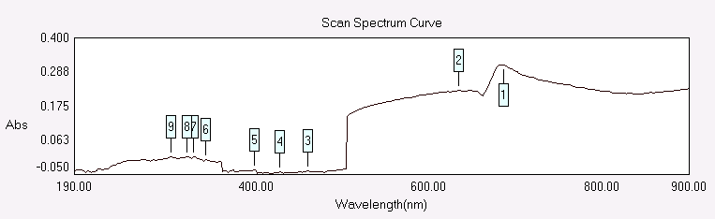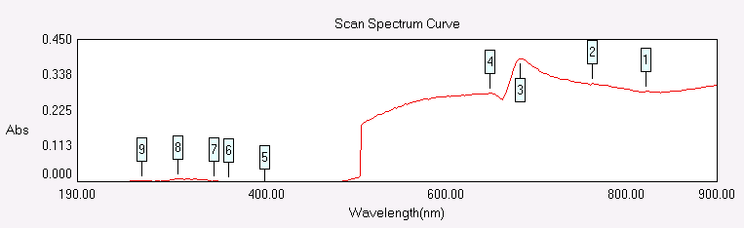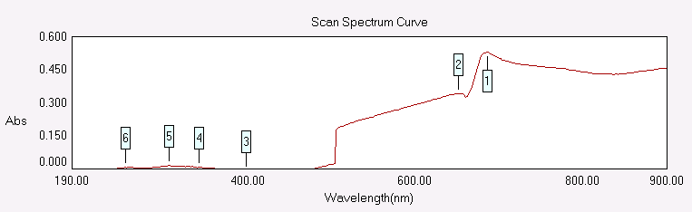
[Ni(C₃₈H₂₅O₉N₆S₂] [Cu(C₃₆H₂₂O₁₁N₆S₃Cl₂] [Zn(C₃₈H₂₅O₉N₆S₂]

UV-VIS Spectra of homoleptic M²⁺ complexes
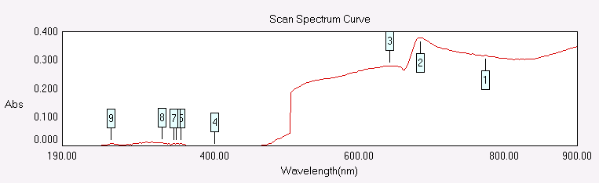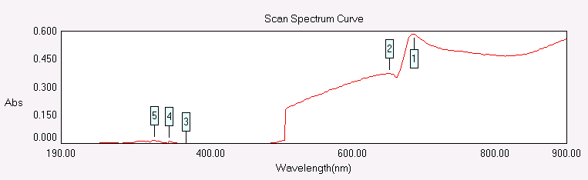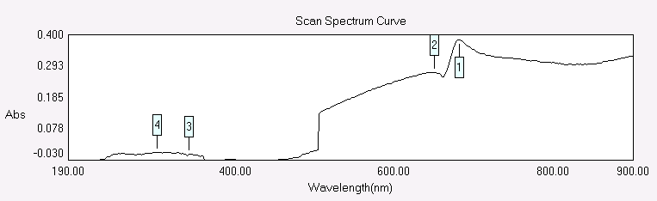
[Ni(C₃₀H₂₁O₃N₅S)]nH₂O [Cu(C₃₆H₂₂O₁₁N₆S₃Cl₂]nH₂O [Zn(C₃₀H₂₁O₃N₅S)]nH₂O

