SEX DETERMINATION USING PROXIMAL FEMORAL MORPHOMETRY IN A NIGERIAN POPULATION

ABSTRACT
Introduction: Sex estimation is one of the first and basic aims of forensic anthropology. The femur has been described as the most dimorphic long bone commonly used for sex identification with application of multiple femoral morphometries known to produce more efficient outcomes. The aim of this study is to determine sex of individuals using proximal femoral morphometry in a Nigerian population.
Methods: A total number of 150 dry femur bones (comprising 75 right and 75 left femur) of males and females were used for this study. Measurements which include femoral neck length (anterior and posterior diameter), femoral head diameter (vertical and transverse), proximal breadth and femoral neck thickness were taken using a vernier calliper and values recorded. Results were statistically analysed.
Results: The total mean value for anterior neck length for males was 26.47mm while for females it was 29.88mm, the vertical head diameter for males was 45.63mm while for females it is 47.75mm and the femoral neck thickness for males was 31.78mm and for females was 27.75mm. All the measured parameters except proximal breadth showed significant difference (P<0.05) between the male and female.
Conclusion: The parameters used in this study showed that there was variation in the mean values of the measured parameters in comparison to other population.

Keywords: Sex Determination; Proximal Femoral Morphometry; Nigerian Population.

INTRODUCTION:
Sex estimation is one of the first and basic aim in forensic anthropology. When the skeletons are well preserved, the use of multiple morphological variables of the coxal bone and the skull as well as the diameters of the femur and humeral heads, generally offer very reliable results and are preferable to single variable approaches to sex estimation ^{1,2}. Complete, well-preserved skeletons from primary burial locations are rarely the most common finding in bio-archaeological and forensic investigations ^{3,4}. Sex remains the foremost step for developing a reliable biological profile in human identification from skeletal remains ^{5,6}. The human cranial and pelvic bones are the most preferred bones for sex attribution by osteometry and may also be considered for age estimation ⁷. These bones may not always be available or may not be well preserved due to the effect of anthropic and taphonomic processes ^{8_10}. The femur has been described as the most dimorphic long bone commonly used for sex identification and also to estimate age with application of multiple femoral morphometrics known to produce more efficient outcomes ^{11_13}. Data concerning the sexing potential of the femur is available in the literature and it is well known that this data varies a great deal according to the population sample from which they have been taken ^{15_20.} These studies contribute to demonstrate that there is considerable intra and inter population variability in femoral dimensions and no single standardized formula can be used within all population groups for sexing individuals. This is due to the influence of specific genetics, environment and sociocultural factors ^{21,14.} The proximal femur plays a crucial role in forming the hip joint and facilitating movements of the thigh ²². Although global sex estimation models have been proposed, there is the need for population- based studies to validate these global models ²³. In a study conducted by ²⁴, nine bony parameters were measured from the proximal femur in a total of 96 dry femora. Results revealed that the length of the femur showed a maximum positive correlation with vertical head diameter, followed by the neck diameter, thickness and foveal depth. Another study to evaluate the proximal femoral dimensions and describe sexual or bilateral dimorphism among Southern Nigerians was conducted by ²⁵ using pelvic radiographs. Results showed that there was no significant bilateral difference in proximal femoral dimensions with the right side having higher values in parameters except neck length (NL) and neck diameter (ND). Studies on the proximal femoral dimensions from different populations have also been conducted which includes morphometric study to analyse the normal neck-shaft angle and torsion of the femur in the Gujarat, Indian population ²⁶, proximal femoral morphometry to customize implants design to suit Indians ²⁷, morphology of the proximal femur in the Southwest Coast of India ²⁸, proximal femoral anatomy of the Chilean population ²⁹.

MATERIALS AND METHODS:
This study was conducted using 150 dry femur bones obtained from the departments of Anatomy of Delta State University, University of Port Harcourt and Rivers State University. This comprise of 75 left and 75 right respectively without any form of deformity, fragmentation or damage. The bone to be measured was positioned appropriately and measured with the aid of a vernier calliper while measurements obtained were recorded. Parameters measured includes:
Femoral Neck length: Which is the distance between the base of the femoral head and the greater trochanter. It can be measured in 2 ways;
- Femoral Anterior Neck Length (FNL (A)): This was measured on the anterior surface as the distance between the head and the intertrochanteric line.
- Femoral Posterior Neck Length (FNL (P)): This was measured on the posterior surface as the distance between the head and the intertrochanteric crest.
Femoral Head Diameter: The distance between the two extreme points of the femoral head or the measurement of the widest part of the femoral head. It can be measured in 2 ways;
- Femoral Head Vertical Diameter (FHD (V)): This was measured as the straight distance between the highest and deepest points of the head of femur.
- Femoral Head Transverse Diameter (FHD (T)): Was measured as the straight distance between the most laterally projected points on the head of femur.
Proximal Breadth (PB): It is the distance from the most medially placed point on the head to the most laterally placed point on the greater trochanter
Femoral Neck Thickness: This is the thickness of the neck of the femur in anteroposterior axis.
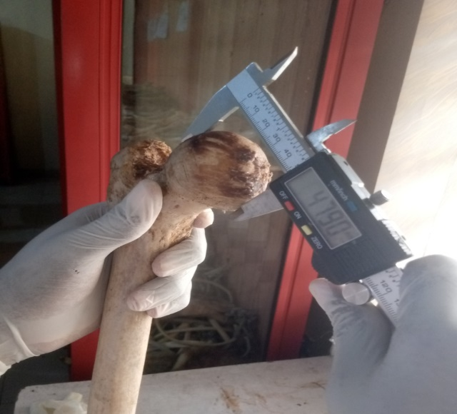
Fig 1. Femoral Head Vertical Diameter

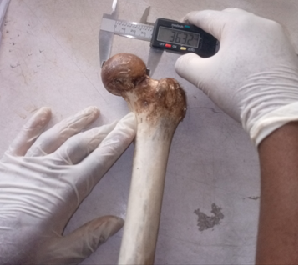
Fig 2. Femoral Neck Transverse Diameter
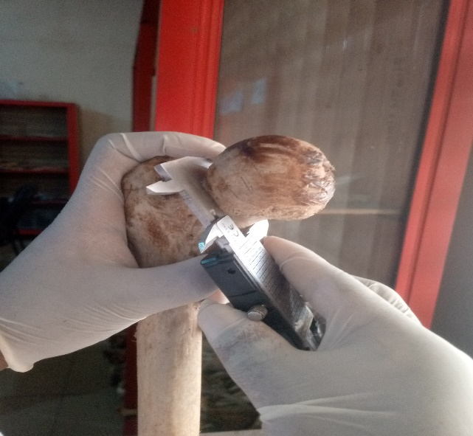
Fig 3. Femoral Neck Thickness
DATA ANALYSIS METHOD
Data was analysed using the following statistical tools:
A student's t-test is a statistical method used to determine if there's a significant difference between the means of two groups, Correlation equation was used to calculate the strength and direction of the linear relationship between two continuous variables and Discriminant Function Analysis.

RESULTS:
The results of this study are as presented on the tables below:
Table 1. Table showing the comparison of the mean values of the male and female femur. From the table it is observed that for each of the measured parameters, the females have a higher mean value than the males except for femoral neck thickness (FNT) in which the males have a higher mean value. Also from the table, we can observe that all the measured parameters showed significant difference except the proximal breadth.
Table 2. Table showing sex determination using discriminant function analysis of the femur bone. From the table, it is observed that the Eigen value is 0.331 which is less than 1 and the value of wilks’ lambda is 0.751 (which is closer to 1) suggests a lesser discriminatory power of model. The canonical correlation has a value of 0.498 suggesting a moderate correlation between the set of predictors (measured parameters of the proximal right femur) and the discriminant function used to distinguish between sexes. The probability value of the t test shows discrimination between the group is highly significant p<0.05 at 6 degrees of freedom. The sex centroid for male has a negative value (-0.13) indicating its position on the other side of the discriminant axis while the female has a positive value (2.39) indicating its position on the other side of the discriminant axis. The predictive power for each of the measured parameters for sex determination gives 49.8%.
Table 3. Table showing sex determination using discriminant analysis of the left femur bone. From the table, it is observed that the Eigen value is 0.179 which is less than 1 and the value of the wilks’ lambda is 0.848 (which is closer to 1) suggests a lesser discriminating power of the model. The canonical correlation has a value of 0.390 suggesting a moderate correlation between the set of predictors (measured parameters of the proximal right femur) and the discriminant function used to distinguish between sexes. The sex centroid for male has a negative value (-0.09) indicating its position on the other side of the discriminant axis while the female has a positive value (2.05) indicating its position on the other side of the discriminant axis. The predictive power for each of the measured parameters for sex determination gives 39%.
Table 1. Comparison of the mean values of measured parameters of male and female femur bone
Parameters | male | Female | T-score | p-value | inference
FNL (A) | 26.47±1.88 | 29.88±2.31 | -4.10 | 0.0068 | S
FNL (P) | 32.18±1.72 | 34.50±1.82 | -3.52 | 0.0057 | S
FHD (V) | 45.63±1.01 | 47.75±1.42 | -4.16 | 0.0054 | S
FHD (T) | 42.30±1.20 | 44.50±1.48 | -4.13 | 0.006 | S
P. B | 84.77±3.62 | 96.38±0.85 | -1.87 | 0.063 | NS
FNT | 31.78±2.13 | 27.75±4.26 | 2.65 | 0.0089 | S
Key: FNL (A) - Femoral neck length (Anterior), FNL (P) - Femoral neck length (Posterior)
FHD (V) -Femoral head diameter (Vertical), FHD (T) -Femoral head diameter (Transverse)
PB -Proximal breadth, FNT - Femoral neck thickness, St. D- Standard deviation, N- Number.

Table 2. Sex determination using Discriminant analysis of the right femur bone
Eigenvalue | Canonical Correlation | Predictive power | Wilks' Lambda | Chi-square | df | sig
0.331ª | 0.498 | 49.8% | 0.751 | 19.99 | 6 | 0.003
Sex centroid
Male | -0.13
Female | 2.39

Table 3. Sex determination using Discriminant analysis of the left femur bone
Eigenvalue | Canonical Correlation | Predictive power | Wilks' Lambda | Chi-square | df | sig
0.179 | 0.390 | 39% | 0.848 | 11.536 | 6 | 0.73
Sex centroid
Male | -0.09
Female | 2.05

DISCUSSION:
Osteological sex estimation models are population-specific and the extrapolation of such a model from one population to another may be problematic ⁹. Although global sex estimation models have been proposed, there is the need for population-based studies to validate these global models ²³.
In this study, the proximal morphometry of dry femur bones belonging to Nigerian population were measured and used for sex determination. There have been limitations on identification of mutilated or decomposed individuals using skeletal remains, especially amongst the Nigerian population. The long bones of the human skeleton or their fragments considerably contribute for the establishment of sexual identity. It was observed in this study that the females had a higher mean value for all the measured parameters except for femoral neck thickness in which the males had a higher mean value which shows greater level of variation as when compared to those of other population. It is also noted that for all the measured parameters the p value (p< 0.05) shows significance except the proximal breadth which suggests that there is some degree of statistical significant difference between the male and female femur bones. This finding suggests that the measured parameters used to assess the femur bones can help differentiate between males and females within the Nigerian population.
Also, for the measured parameters, the p value (p <0.05) shows no significance; implying that there is no significant difference between the right and left femur bone because under standard conditions; the overall structure and function of the left and right femur bones are similar, but minor differences in size, shape and other morphometric characteristics can exist between the two sides. However, despite this natural variation, there should still be a high degree of symmetry between the left and right femur bones in healthy individuals. Significant asymmetry may indicate underlying issues such as developmental abnormalities, injuries or diseases.
The Anterior femoral neck length according to research conducted by ³⁰ using dry femur in a Brazilian population showed a higher mean value 31.70mm for males and 31.09mm for females when compared to the mean value for each of these parameters gotten from this study as shown in table 1. The vertical femoral head diameter from the study conducted by ²⁴ showed a little similar mean value for males 45.32mm and females 42.32mm when compared to the mean value gotten from this study which showed a slightly higher value as shown in table 1.
From table 2 and 3, we can observe that for the sex centroid the male has a negative value (-0.13 and -0.09) respectively; indicating its position on the other side of the discriminant axis and the females has a positive value (2.39 and 2.05) respectively; indicating its position on the other side of the discriminant axis. From this, we can note that that there is a large absolute difference between these values; suggesting the more effective the discriminant function is at distinguishing between the males and females based on the selected predictor variable.
From table 2 and 3, we can also observe that the value of canonical correlation is 0.498 and 0.390 (canonical correlation value should be closer to 1 to have a stronger correlation) which suggests a moderate correlation between the set of predictors (measured parameters of the proximal femur) and the discriminant functions used to distinguish between sexes in my Nigerian population sample. This indicates that there is a meaningful relationship between the morphometric measurements of the right and left femur and the ability to predict the sex of individuals within my study population.
We can note from table 2 and 3 that the predictive power for each of the measured parameters is 49.8% and 39% respectively. This suggests that for each of the measured parameters, their predictive power for sex determination is moderate (because the values gotten are relatively close to average i.e., 50%), hence are not strong parameters for sex determination for the Nigerian population.

CONCLUSION:
From this study, we have been able to establish a reference database for the Nigerian population on the expected range of measurements of the measured parameters of the proximal femur in regards to sex determination.
From the results discussed; it shows that the measured parameters of the proximal femur though not strongly but can moderately predict the sex of individuals within the Nigerian population.

REFERENCES
- Bruzek J, Murail P. Methodology and reliability of sex determination from the skeleton. In: Schmitt A, Cunha E, Pinheiro J eds. Forensic Anthropology and Medicine: Complementary Sciences from Recovery to Cause of Death. Totowa: Humana Press; 2006:225-242. https://doi.org/10.1007/978-1-59745-099-7_9
- Klales A. Sex Estimation of the Human Skeleton. New York: Academic Press; 2020: 50-54. https://www.elsevier.com/books/sex-estimation-of-the-human-skeleton/klales/978-0-12-815767-1
- Albanese J, Cardoso H, Saunders S. Universal methodology for developing univariate simple-specific sex determination methods: an example using the epicondylar breadth of the humerus. J. Archaeol. Sci 2005;32:143-152. https://doi.org/10.1016/j.jas.2004.08.003
- Bidmos M, Dayal M. Further evidence to show population specificity of discriminant function equations for sex determination using the talus of South African black. J Forensic Sci. 2004;49(6):1-5 https://doi.org/10.1520/jfs2003431
- Krishan K, Chatterjee PM, Kanchan T, Kaur S, Baryah N, Singh RK. A review of sex estimation techniques during examination of skeletal remains in forensic anthropology casework. Forensic Sci Int. 2016;261:165.e1. https://doi.org/10.1016/j.forsciint.2016.02.007
- Srivastava R, Saini V, Rai RK, et al. Sexual dimorphism in ulna: an osteometric study from India. J Forensic Sci.2013;58(5):1251-1256. https://doi.org/10.1111/1556-4029.12158
- Cuzzullin MC, Curate F, Freire AR, et al. Validation of anthropological measures of the human femur for sex estimation in Brazilians. Aust. J. Forensic Science 2020;1-14. https://doi.org/10.1080/00450618.2020.1729411
- Ford JM, Kumm TR, Decker SJ. An analysis of Hounsfield unit values and volumetrics from computerized tomography of the proximal femur for sex and age estimation. J Forensic Sci 2020;65:591-596. https://doi.org/10.1111/1556-4029.14216
- Carvallo D, Retamal R. Sex estimation using the proximal end of the femur on a modern Chilean sample. Forensic Sci Int Rep 2020;2: Article 100077, 200-212. https://doi.org/10.1016/j.fsir.2020.100077
- Curate F, Coelho J, Gonçalves D, et al. A method for sex estimation using the proximal femur. Forensic Sci Int 2016;266:1-579. https://doi.org/10.1016/j.forsciint.2016.06.011
- Curate F, Albuquerque A, Ferreira I, Cunha E. Sex estimation with the total area of the proximal femur: A densitometric approach. Forensic Sci Int 2017;275:110-116. https://doi.org/10.1016/j.forsciint.2017.02.035
- Singh PK, Karki RK, Palikh AK, Menezes RG. Sex determination from the bicondylar width of the femur: A Nepalese study using digital X-ray images. Kathmandu Univ Med J 2016;14(55):198-201. https://www.kumj.com.np/issue/55/198-201.pdf
- Paschal A, Ross AH. Biological sex variation in bone mineral density in the cranium and femur. Sci Justice 2018; 58(4):287-291. https://doi.org/10.1016/j.scijus.2018.01.002
- Alunni-Perret V, Staccini P, Quatrehomme G. Sex determination from the distal part of the femur in a French contemporary population. Forensic Sci Int 2008;175:113-117. https://doi.org/10.1016/j.forsciint.2007.05.018
- Taylor JV, DiBennardo R. Determination of sex of white femora by discriminant function analysis: forensic science applications. J Forensic Sci 1982;27(2):417–423. https://pubmed.ncbi.nlm.nih.gov/7097210/
- Iscan MY, Steyn M. The Human Skeleton in Forensic Medicine. 3rd ed. Springfield, IL: Charles C Thomas; 2013:213-222. https://www.ccthomas.com/details.cfm?titleid=1000
- Holliday W, Falsetti B. A new method for discriminating African-American from European-American skeletons using postcranial osteometrics reflective of body shape. J Forensic Sci 1999;44 (5): 926–930. https://doi.org/10.1520/JFS12018J
- Asala S. Sex determination from the head of the femur of South African whites and blacks. Forensic Sci Int 2001;117:15–22. https://doi.org/10.1016/s0379-0738(00)00444-8
- MacLaughlin SM, Bruce MF. A simple univariate for determining sex from fragmentary femora: its application to a Scottish short cist population. Am J Phys Anthropol 1985;67:413–417. https://doi.org/10.1002/ajpa.1330670413
- Kranioti, E. F., Vorniotakis, N., Galiatsou, C., Işcan, M. Y., & Michalodimitrakis, M. (2009). Sex identification and software development using digital femoral head radiographs. Forensic Science International, 189(1-3), 113.e1-113.e7. https://doi.org/10.1016/j.forsciint.2009.04.014
- Lavelle, C. L. (1974). An analysis of the human femur. American Journal of Anatomy, 141(3), 415–426. https://doi.org/10.1002/aja.1001410310
- Chaurasia, B. D. (2020). *Human Anatomy: Regional and applied Dissection and Clinical – Lower Limb, Abdomen and Pelvis* (8th ed., Vol. 2). CBS Publishers & Distributors Pvt Ltd. https://www.cbspd.com
- Steyn, M., & Patriquin, M. L. (2009). Osteometric sex determination from the pelvis--does population specificity matter?. Forensic Science International, 191(1-3), 113.e1-5. https://doi.org/10.1016/j.forsciint.2009.07.009
- Gupta, M., Devadas, D., Sahni, C., Nayak, A., Tiwari, P. K., & Mishra, A. (2022). Morphometric Analysis of the Proximal Femur With Its Clinical Correlation in Eastern Uttar Pradesh Region. Cureus, 14(9):e28780. https://doi.org/10.7759/cureus.28780
- Obikili, E. N., & Omotoso, D. R. (2020). Morphological evaluation and clinical significance of proximal femoral dimensions among Southern Nigerian population. International Journal of Research in Medical Sciences, 8(12), 4180–4184. https://doi.org/10.18203/2320-6012.ijrms20205285
- Skaria, S., Kulkarni, M., & Vaishnani, H. (2022). Morphometric study of proximal femur and its applications in prosthesis designing: A cross-sectional Study from Western India. Journal of Clinical and Diagnostic Research, 16(5), AC01-AC04. https://www.jcdr.net/back_issues.asp?issn=0973-709x&year=2022&month=May&volume=16&issue=5&page=AC01-AC04&id=16331
- Sobana, M., & Nedunchezhiyan, S. (2019). Osteometric study of proximal femur. International Journal of Anatomy and Research, 7(1.1), 6108-6112. https://doi.org/10.16965/ijar.2018.416
- Kamath, S. U., Agarwal, S., & Austine, J. (2020). Morphology of Proximal Femur in South-West Coast of India. Malays Orthop J, 14(3), 143-150. https://doi.org/10.5704/MOJ.2011.022
- Osorio H, Schorwer K, Coronado C, Delgado J, Aravena P. Proximal femoral epiphysis anatomy in Chilean population. Orthopaedic and forensic aspects. Int J Morphol 2012;30(1): 258-262
- Caiaffo, V., Albuquerque, P. P., Albuquerque, P. V., & Oliveira, B. D. (2019). Sexual diagnosis through morphometric evaluation of the proximal femur. International Journal of Morphology, 37(2), 391-396. https://doi.org/10.4067/s0717-95022019000200391

