Evaluation of Antimicrobial and Cytotoxic Properties of Gold Nanoparticles Synthesised from Rudraksha (Elaeocarpus ganitrus Roxb.)

Abstract
Green synthesis of metallic nanoparticles offers a sustainable alternative to conventional chemical methods, providing enhanced biocompatibility and reduced environmental impact. In this study, gold nanoparticles (AuNPs) were synthesized using Elaeocarpus ganitrus (Rudraksha) leaf extract, which functioned as a natural reducing and stabilizing agent. Reaction optimization revealed that 1000 µM HAuCl₄, a 1:9 extract-to-precursor ratio, and alkaline pH 10 produced the most uniform and stable nanoparticles, confirmed by a sharp surface plasmon resonance peak at approximately 530 nm. FTIR analysis indicated that hydroxyl, carbonyl, and amide-containing phytoconstituents facilitated both metal ion reduction and nanoparticle capping, while XPS confirmed complete conversion of Au³⁺ to metallic Au⁰. SEM micrographs showed faceted nanoparticles ranging from 20–80 nm, and DLS measurements revealed a hydrodynamic size of ~120 nm, consistent with an organic capping layer. The biosynthesized AuNPs exhibited potent antimicrobial effects, demonstrating over 60% inhibition of Escherichia coli and substantial suppression of Aspergillus niger growth in a dose-dependent manner. Cytotoxicity evaluation in 3T3-L1 fibroblasts showed high biocompatibility at lower concentrations, with cell viability exceeding 80% up to 50 µg/mL and an estimated IC₅₀ of 180–220 µg/mL. The findings highlighted Rudraksha- mediated AuNPs as promising candidates with strong antimicrobial potential and excellent biocompatibility.

Key words: Gold nanoparticles, Rudraksha, Green synthesis, Antimicrobial activity, Cytotoxicity

Graphical Abstract
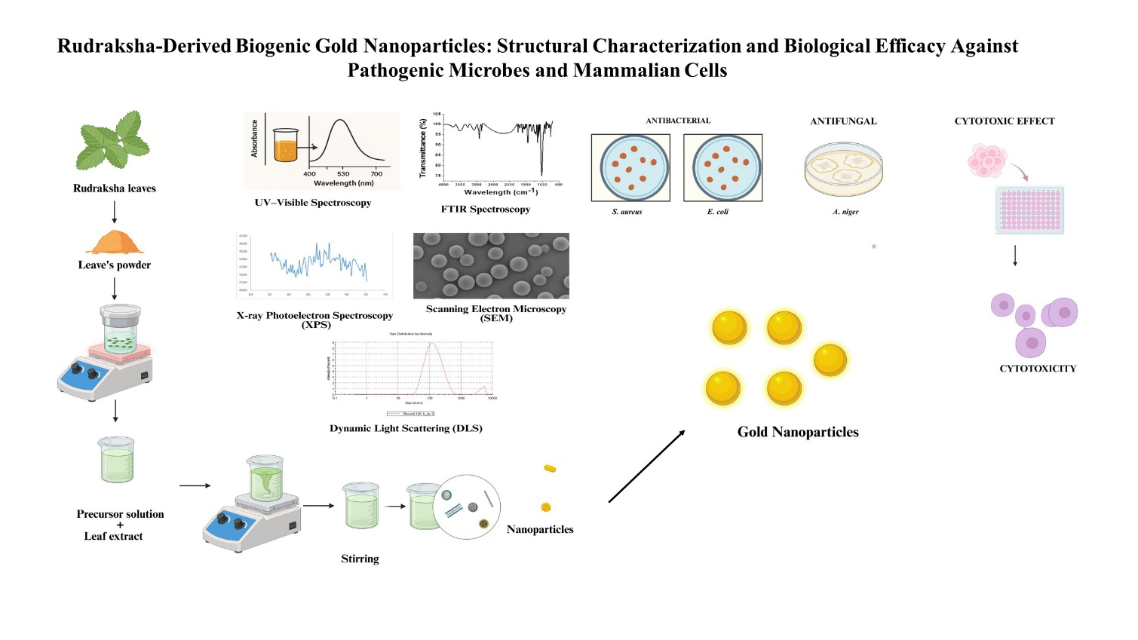

1. Introduction
Nanotechnology has emerged as one of the most transformative fields of modern science, with wide-ranging applications in engineering, agriculture, environmental science, astronomy, and particularly in medical science (John, 2025). Among the numerous nanomaterials developed, gold nanoparticles (AuNPs) have drawn remarkable attention due to their unique physicochemical properties, including localized surface plasmon resonance (LSPR), high surface-to-volume ratio, easy surface fictionalization, and wide biocompatibility (Dahan et al., 2023). These attributes enable their use in diverse physicochemical and biomedical applications such as drug delivery, biosensing, imaging, photothermal therapy, and antimicrobial interventions. However, the method of nanoparticle synthesis remains a critical query of their size, shape, surface chemistry, stability, and ultimately, biological performance.
Traditional physical and chemical routes for nanoparticle production, although effective, are associated with unavoidable limitations. Physical approaches often require high energy input, specialized equipment, and are not economically feasible for large-scale production (Fernandes et al., 2023). Chemical methods typically depend on toxic reducing agents (e.g., sodium borohydride, hydrazine, and citrate), organic solvents, and stabilizers that may leave harmful residues on nanoparticle surfaces. Such residues pose considerable challenges for biomedical applications, as they can lead to cytotoxic effects, immunogenic responses, and cellular environmental hazards (Szczyglewska et al., 2023). Therefore, a paradigm shift toward sustainable and eco-friendly nanoparticle synthesis method has been necessitated, giving rise to the rapidly expanding field from red to green nanotechnology.
Green synthesis of nanoparticles utilizes biological entities, such as plant extracts, bacteria, fungi, and algae, as reducing and stabilizing agents (Singh et al., 2023). Among these, plant-based approaches have gained prominence due to their simplicity, scalability, and the abundance of phyto-compounds that serve as both reductants and capping agents. Plant extracts typically contain polyphenols, flavonoids, alkaloids, terpenoids, proteins, sugars, and signal molecules (hormones and vitamins) which facilitate the reduction of metal ions and provide stability to the resulting nanostructures (Adeyemi et al., 2022). This biogenic approach eliminates the need for hazardous chemicals, aligns with principles of green chemistry, and generates nanoparticles that are inherently more compatible in biomedical systems
Several plant-mediated syntheses of AuNPs have been reported, employing extracts from leaves, roots, seeds, flowers, and fruits, more commonly from leaves of medicinal plants. Such nanoparticles often exhibit enhanced stability and demonstrate promising antimicrobial, anticancer, and antidiabetes activities, owing to the synergistic effects of the metal core and the bioactive molecules adhered to their surface (Munir et al., 2021). Moreover, green-synthesized AuNPs offer opportunities for tailoring particle size and morphology by modulating experimental parameters such as precursor volume, enzymes concentrations, pH, and temperature (Ali Dheyab et al., 2025). These features not only expand their biomedical potential but also support scalability for industrial and clinical applications.
Elaeocarpus ganitrus Roxb., commonly known as Rudraksha, belongs to the family Elaeocarpaceae, is a sacred and medicinally important plant widely distributed in tropical and subtropical regions of South and Southeast Asia (Ahmad et al, 2017). Rudraksha holds significant ethnopharmacological value and is traditionally employed in Ayurvedic and folk medicine for treating ailments such as stress, hypertension, neurological disorders, and microbial infections (Sharma et al., 2023). Elaeocarpus ganitrus (Rudraksha) leaves are rich in phytochemicals such as flavonoids, phenolic acids, alkaloids, and terpenoids, which offer strong reducing and stabilizing potential for nanoparticle biosynthesis ( Ref.). The bioactive components present in the leaves can efficiently reduce Au³⁺ ions while simultaneously enhancing formation of gold nanoparticles, enabling a clean, eco-friendly, and plant-mediated synthesis route. These constituents possess antioxidant, antimicrobial, anti-inflammatory, anticancer, and antidiabetes properties, which make the extract as an excellent candidate for green nanotechnology applications (Ranawat&Deshwal, 2021). Despite the rich medicinal profile of Rudraksha, limited studies have explored its potential in nanoparticle synthesis, presenting a unique opportunity to harness its phytochemical richness for biomedical nanomaterial development (Barathi et al., 2024).
Cytotoxicity remains one of the most critical obstacles in the biomedical application of nanoparticles. Several factors, including size, shape, concentration, surface charge, and the biochemical properties of surface coatings, govern the interaction of AuNPs with biological systems (Kus-Liśkiewicz et al., 2021). While small-sized nanoparticles often penetrate into cellular membranes efficiently, they may also disrupt intracellular homeostasis and induce oxidative stress. Similarly, higher concentrations of nanoparticles can generate reactive oxygen species (ROS), compromise membrane integrity, and trigger apoptosis or necrosis of programmed and healthy cells. The cytotoxic profile of nanoparticles is also strongly cell-type dependent, with cancer cells often being more susceptible to nanoparticle-induced stress compared to normal healthy cells (Shafiq et al., 2025). Therefore, evaluating cytotoxicity alongside antimicrobial efficacy is indispensable in establishing the therapeutic relevance and nanosafety of green-synthesized AuNPs.
The biomedical relevance of gold nanoparticles is further enhanced by their ability to exert antimicrobial activities against a broad spectrum of pathogens, including Gram-positive and Gram-negative bacteria as well as fungi (Mikhailova, 2021). The mechanism of antimicrobial action typically involves nanoparticle attachment to microbial membranes, ROS generation, disruption of membrane integrity, leakage of intracellular contents, and interference with infecting microbe’s DNA/RNA replication (Rosli et al., 2021). These effects are amplified when the nanoparticles are stabilized by plant-derived phytochemicals, which may contribute additional antimicrobial potency. Owing to alarming rise of multidrug-resistant pathogens, the development of novel antimicrobial agents through green nanotechnology provides a timely and sustainable remedy against microbial infections.
The present study focused on the green synthesis of AuNPs using aqueous leaf extract of Rudraksha as a natural reducing and stabilizing agent. The study outlined an eco-friendly method of nanoparticle fabrication, followed by comprehensive characterization using spectroscopic and microscopic techniques to determine the structural and morphological features of the synthesized particles. Further, the antimicrobial activity of Rudraksha-mediated AuNPs was evaluated against clinically relevant bacterial and fungal strains, and cytotoxicity was evaluated in 3T3-L1 fibroblast cells to assess the biocompatibility of the synthesized gold nanoparticles. The potential of Rudraksha based AuNPs as antimicrobial agents, along with their selectivity and biocompatibility was investigated for biofabrication.

2. Materials and Methods
2.1 Materials
Rudraksha leaves were collected from the Shobhit University campus, Meerut (UP), India. Chloroauric acid (HAuCl₄·3H₂O, ≥99.9%, Sigma-Aldrich) was used as the metal precursor. All chemicals used were analytical grade. Milli-Q water (18.2 MΩ·cm) was used throughout.
The bacterial strain, Escherichia coli (MTCC 739), and the fungal strain Aspergillus niger were obtained from IMTECH, Chandigarh, India. 3T3-L1 cells (mouse embryonic pre-adipocyte fibroblast line) were obtained from NCCS, Pune, India.
2.2 Preparation of Rudraksha leaves extract (RLE)
Rudraksha leaves were washed, shade-dried for 7 days, and ground into a fine powder. Twenty-five grams of powder was heated in 100 mL of distilled water at 80 °C for 15 minutes. The mixture was allowed to cool, filtered (Whatman No.1), centrifuged at 5000 rpm for 10 minutes, and the clear supernatant was stored at 4 °C for further reaction.
2.3 Green synthesis of gold nanoparticles (AuNPs)
RLE and 1 mM HAuCl₄ were mixed in a 1:9 (v/v) ratio and incubated at 40 °C under continuous stirring. Formation of gold nanoparticles (RLE-AuNPs) was confirmed by a color change from pale yellow to ruby red.
Reaction parameters were optimized by varying precursor concentration (1–5 mM), extract volume (5–25 mL), and pH (4–10). Synthesized AuNPs were centrifuged at 12,000 rpm for 20 min, washed thrice with Milli-Q water, and redispersed for further analysis (Figure 1).
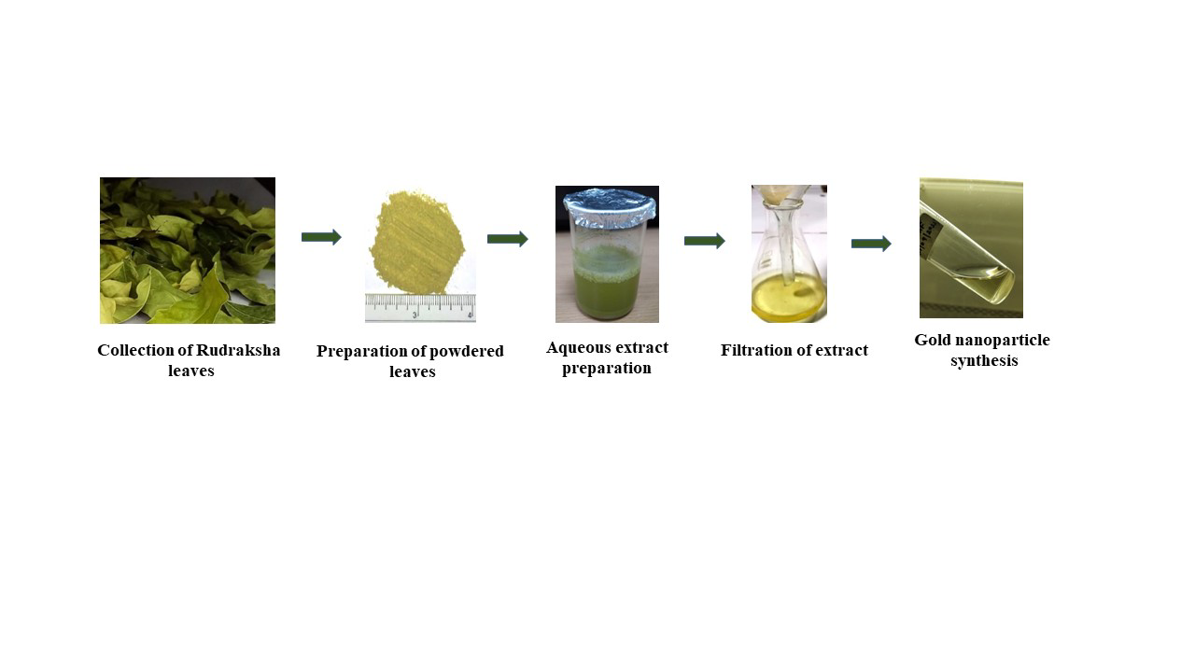Figure 1. Schematic of Rudraksha leaves extract-mediated gold nanoparticles synthesis

2.4 Characterization of AuNPs
2.4.1 UV–Visible spectroscopy
UV–Vis spectra were recorded using a Shimadzu UV-2600 spectrophotometer in the range of 300–800 nm. The characteristics SPR peaks were monitored to confirm nanoparticle formation.
2.4.2 FTIR spectroscopy
FTIR spectra (4000–400 cm⁻¹; Bruker Tensor II, 4 cm⁻¹ resolution) were obtained for dried extract and AuNPs using the KBr pellet method to identify functional groups responsible for reduction and capping.
2.4.3 X-ray photoelectron spectroscopy (XPS)
XPS was performed using a monochromatic Al Kα source (1486.6 eV). High-resolution Au 4f spectra (80–95 eV) were used to determine oxidation state. Binding energies were calibrated to the C 1s peak at 284.8 eV.
2.4.4 Scanning electron microscopy (SEM)
SEM imaging was performed using a ZEISS EVO microscope (EHT = 15 kV; InLens detector). A drop of AuNP suspension was dried on a silicon wafer and imaged to examine surface morphology and aggregation.
2.4.5 Dynamic light scattering (DLS)
DLS was measured using a Zetasizer Nano ZS90. Samples were diluted (1:10) in Milli-Q water and sonicated for 5 minutes before measurement. Z-average size, polydispersity index (PDI) at 25 °C.
2.5 Antimicrobial activity
2.5.1 MIC and MBC assay
A standardized inoculum of the test organism (E. coli), adjusted to 1×10⁶ CFU/mL, was first prepared for the assay. Serial dilutions of the RLE-AuNPs, (25–200 µg/mL) were then made in a Mueller–Hinton broth and dispensed into microtiter wells. At time zero, the prepared bacterial suspension was added to each tube or well containing the respective drug concentrations, along with control wells lacking the drug. The inoculated tubes or plates were then incubated at 37°C for 24 hours. After incubation, the minimum inhibitory concentration (MIC) was determined by visually inspecting the wells for turbidity, with the MIC defined as the lowest concentration at which no visible growth occurred. To determine the minimum bactericidal concentration (MBC), aliquots from all wells showing no visible growth were sub-cultured onto fresh, drug-free agar plates and incubated for an additional 18–24 hours. The MBC was identified as the lowest concentration of the antimicrobial agent that yielded no bacterial colonies or demonstrated a 99.9% reduction in the initial inoculums.
2.5.2 Antifungal assay
A spore suspension of A. niger (1 × 10⁶ spores/mL) was treated with RLE-AuNPs (25–200 µg/mL) and incubated at 28 °C for 30 minutes. After treatment, 100 µL was plated on Sabouraud Dextrose Agar and incubated at 28 °C for 48 h. MIC and MFC were calculated as described for bacteria.
2.6 Cytotoxicity profiling of RLE-AuNPs
The cytotoxic potential of the AuNPs was assessed using the MTT assay, a colorimetric method that measures the reduction of MTT to formazan by metabolically active cells, thereby providing a quantitative evaluation of cell viability.

2.6.1 Cell culture
3T3-L1 cells were cultured in DMEM supplemented with 10% fetal bovine serum (FBS) and 1% penicillin–streptomycin at 37 °C and 5% CO₂.
2.6.2 MTT Assay
3T3-L1 cells (1 × 10⁴ cells/well) were seeded into 96-well plates and treated with varying concentrations of AuNPs (5–500 µg/mL) for 24, 48, and 72 hs. Following treatment, 20 µL of MTT solution (5 mg/mL) was added to each well and incubated for 4 h at 37 °C. The resulting formazan crystals were dissolved in 100 µL DMSO, and absorbance was measured at 570 nm. Cell viability was calculated by relative to untreated controls, and IC₅₀ values were determined using nonlinear regression analysis in GraphPad Prism 9.
2.7 Statistical analysis
All experiments were conducted in triplicate. Data were expressed as mean ± SD. One-way ANOVA followed by Tukey’s post hoc test was used for statistical significance (p < 0.05). GraphPad Prism 9.0 was used for analysis.
3. Results
3.1 Optimization of gold nanoparticle synthesis
The synthesis of Rudraksha-mediated AuNPs was optimized by varying precursor concentration, extract-to-precursor ratio, and pH. The initial conversion of the pale-yellow HAuCl₄ solution to a ruby-red color (Figure 2B) confirmed successful nanoparticle formation.
Precursor concentration strongly influenced nanoparticle yield (Figure 2A). Among the tested conditions (250–1000 µM), 1000 µM produced the deepest ruby-red color, indicating efficient reduction. Variation in extract proportion (Figure 2C) showed that the 1:9 extract-to-precursor ratio produced the most uniform and stable colloidal color, while both lower and higher extract volumes resulted in weaker or overloaded reactions (Table 1). pH also significantly impacted reduction efficiency (Figure 2D). Optimal color intensity was observed at pH 10, whereas acidic conditions yielded minimal color development.

Table 1. Optimized conditions for RLE-AuNPs synthesis

Parameter | Optimal Value
HAuCl₄ concentration | 1000 µM
Extract: Precursor | 1:9
pH | 10
Visual indicator | Color change: yellow → ruby red

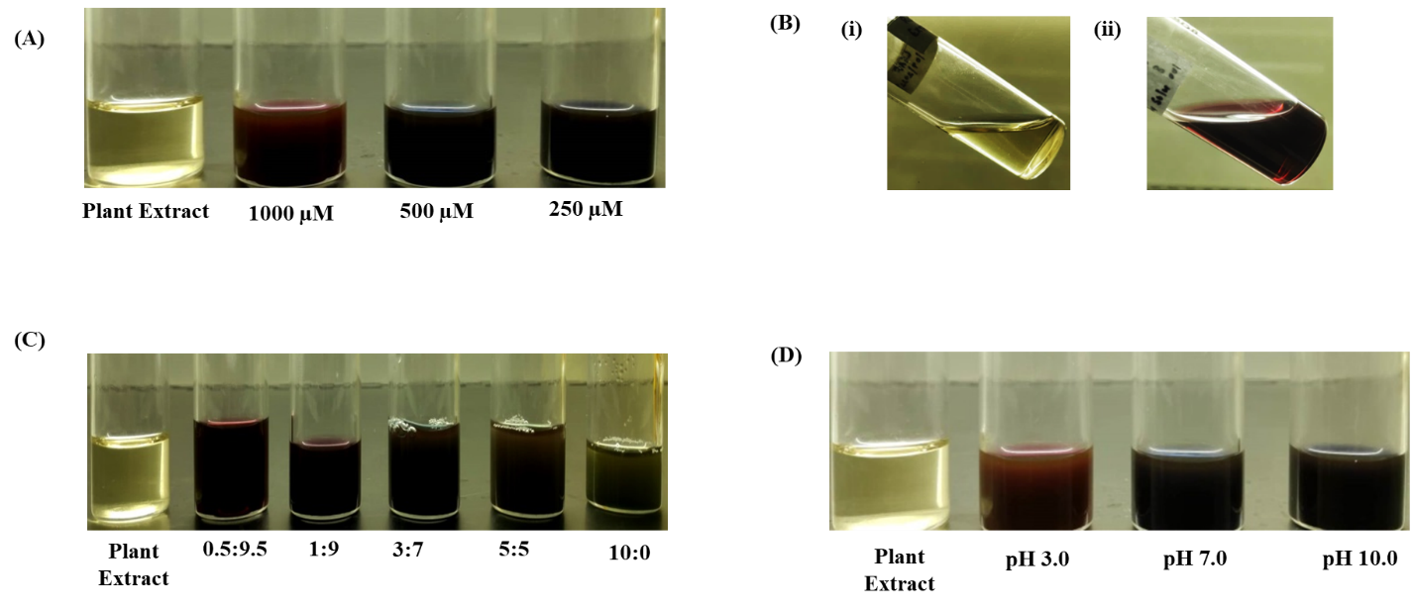
Figure 2. Optimization of RLE-AuNPs synthesis under varying experimental conditions(A) Effect of precursor concentration (1000, 500, and 250 µM HAuCl₄).(B) Visual confirmation of AuNP synthesis: (i) gold precursor solution before reaction; (ii) color change to ruby red after nanoparticle formation.(C) Effect of extract-to-precursor ratios (0.5:9.5, 1:9, 3:7, 5:5, 10:0), (D) Effect of pH conditions (3.0, 7.0, and 10.0).
3.2 Characterization of RLE-AuNPs
3.2.1 UV–Visible spectroscopy analysis
UV–Visible spectroscopy was employed to confirm nanoparticle formation and evaluated the influence of precursor concentration, extract-to-precursor ratio, pH, and reaction time on the optical characteristics of Rudraksha-mediated gold nanoparticles. Across all experimental conditions, the appearance of a characteristic surface plasmon resonance (SPR) band in the 525–540 nm range validated the successful synthesis of RLE-AuNPs (Figure 3).
3.2.1.1 Effect of precursor concentration
The SPR spectra recorded for different concentrations of HAuCl₄ (250, 500, and 1000 µM) demonstrated a clear enhancement in peak sharpness and intensity with increasing precursor concentration (Figure 3A). The 1000 µM solution exhibited the highest SPR absorbance and the most symmetric peak at ~530 nm, suggesting efficient nucleation and greater nanoparticle yield. In contrast, 250 and 500 µM displayed weaker peaks, indicating incomplete reduction and lower particle density.
3.2.1.2 Effect of extract-to-precursor ratio
Variation in extract volume resulted in distinct differences in spectral profiles (Figure 3B). The 1:9 extract-to-precursor ratio yielded the strongest and most well-defined SPR band, corresponding to optimal phytochemical availability for both reduction and surface stabilization. Ratios with insufficient extract produced weak SPR intensities, while higher extract volumes caused peak broadening due to excess organic matter in the reaction environment.
3.2.1.3 Effect of pH
The SPR patterns obtained at different pH conditions (Figure 3C) revealed a pronounced dependence on the reaction medium. At pH 10, the SPR band was intense and narrow, signifying highly efficient reduction under alkaline conditions. A moderate SPR peak was observed at pH 7, while acidic pH (3.0) produced a broad, low-intensity signal, indicating incomplete reduction and heterogeneous nanoparticle formation.
3.2.1.4 Time-dependent formation kinetics
The temporal evolution of SPR intensity (Figure 3D) demonstrated the progressive development of gold nanoparticles. Early spectra showed weak and broad peaks characteristic of initial nucleation. Over time, the SPR band intensified and sharpened, reflecting particle growth and stabilization as phytochemicals completed reduction and capped the forming nanostructures. This trend is consistent with the kinetic profile of plant-mediated nanoparticle synthesis.
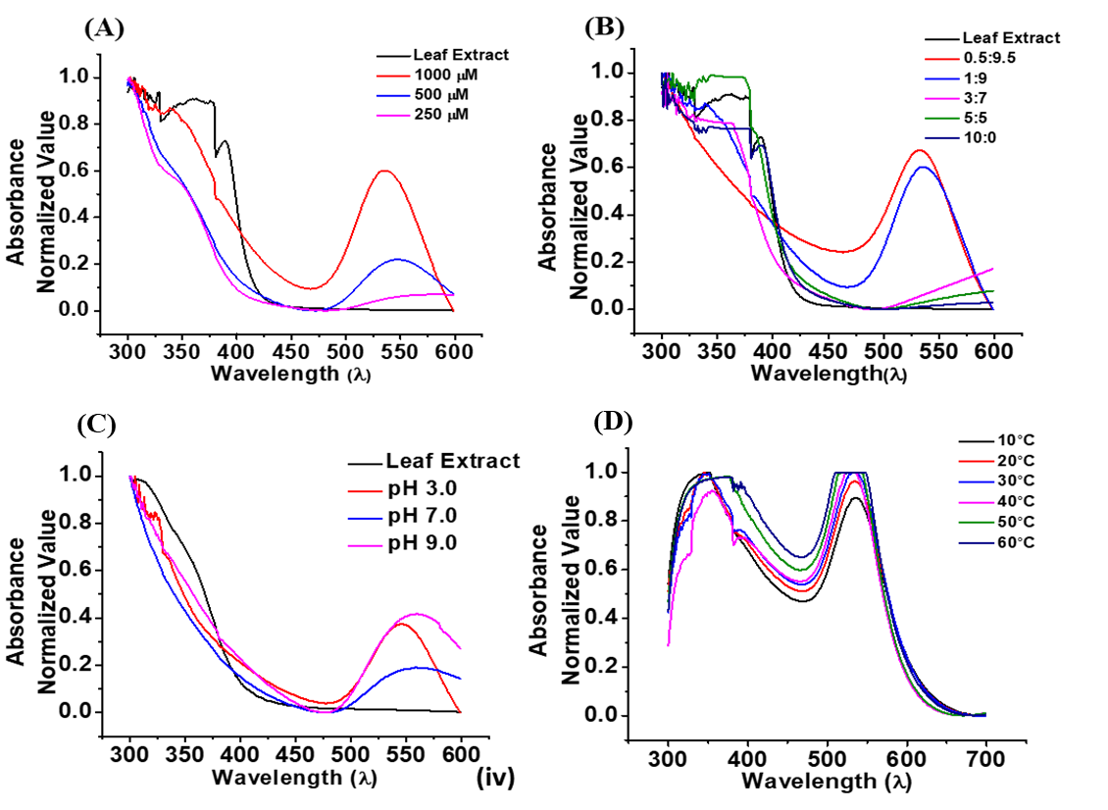
Figure 3. UV–Visible spectra of RLE-AuNPs synthesized under different conditions(A)Precursor concentration (1000, 500, 250 µM).(B) Extract-to-precursor ratios (0.5:9.5 to 10:0),(C) pH effect (3.0–10.0),(D) Time-dependent formation kinetics.In all cases, the characteristic SPR peak around 530 nm confirmed AuNP formation, with optimized conditions at 1000 µM precursor, 1:9 extract ratio, pH 7–10, and 40 °C.
3.2.2 FTIR analysis
FTIR analysis of the RLE-AuNPs (Figure 4) showed a broad band at ~3400 cm⁻¹ corresponding to O–H stretching of polyphenols, indicating their role in reduction and capping. Weak bands at 2900–2850 cm⁻¹ reflected aliphatic C–H stretching. A prominent peak near 1630–1650 cm⁻¹ was assigned to C=O stretching of carbonyl or amide groups, confirming their involvement in metal ion reduction. Multiple sharp peaks in the 1400–1000 cm⁻¹ region corresponded to C–O and C–N vibrations, characteristic of flavonoids and other phytochemicals. These observations confirmed that Rudraksha-derived biomolecules participate in both the reduction of Au³⁺ and the stabilization of ELE-AuNPs surfaces.
Figure 4. FTIR spectrum of Rudraksha-mediated gold nanoparticles showing major functional groups involved in reduction and capping
3.4 XPS analysis
X-ray photoelectron spectroscopy confirmed the formation of metallic gold in the RLE-AuNPs. The XPS spectrum recorded in the 80–94 eV region (Figure 5) displayed two characteristic peaks corresponding to the Au 4f doublet. The lower-energy peak near ~84 eV represented the Au 4f₇/₂ state, while the higher-energy peak at ~88 eV corresponded to Au 4f₅/₂, consistent with the spin–orbit splitting expected for metallic Au⁰. The absence of additional shoulders or higher-binding-energy features indicated that no oxidized states (Au⁺ or Au³⁺) were present, confirming the complete reduction of Au³⁺ ions by Rudraksha phytochemicals during nanoparticle synthesis.
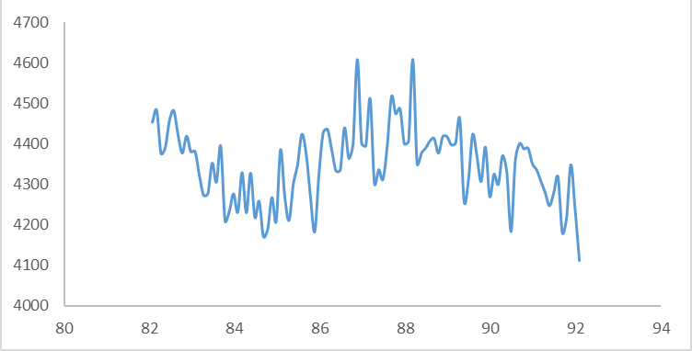
Figure 5. XPS spectrum of RLE-AuNPs showing the characteristic Au 4f doublet confirming metallic Au⁰
3.5 SEM morphological analysis
SEM analysis revealed the surface morphology of the RLE-AuNPs (Figure 6). The micrograph showed well-defined, faceted nanoparticles distributed across an irregular organic matrix derived from the Rudraksha. Individual particles exhibited angular or quasi-cubic features with sizes roughly in the 20–80 nm range, based on the 200 nm scale bar. The clustering observed in some regions is characteristic of green-synthesized nanoparticles, where phytochemical capping agents remained attached to the particle surfaces. The contrast between bright crystalline particles and the surrounding darker matrix confirmed the successful formation of gold nanostructures embedded within plant-derived stabilizing material.
Figure 6. SEM micrograph of RLE-AuNPs showing faceted crystalline structures embedded in an organic matrix (scale bar: 200 nm)
3.6 Dynamic light scattering (DLS) analysis
DLS analysis revealed that RLE-AuNPs exhibited a dominant hydrodynamic size distribution centered around ~120 nm, indicating the formation of a relatively uniform particle population (Figure 7). The intensity-based curve showed a sharp primary peak, characteristic of well-dispersed nanoparticles stabilized by phytochemicals from the Rudraksha extract. A minor secondary peak in the higher size range suggested the presence of aggregates, which was commonly observed in green-synthesized colloids due to natural organic capping layers. The hydrodynamic size (~120 nm) was larger than the SEM core size (20–80 nm) due to the solvation layer and the presence of phytochemical capping agents.

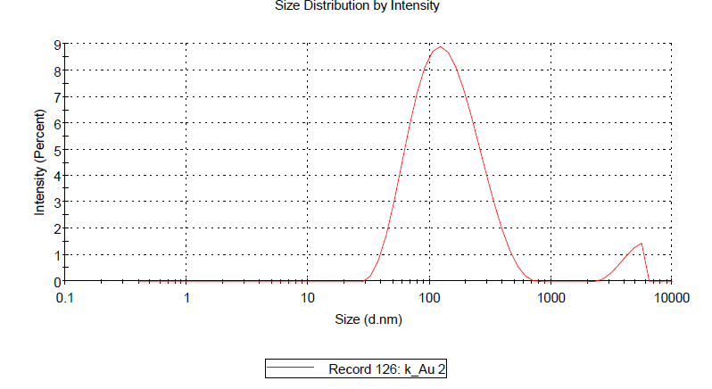
Figure 7. DLS intensity-based hydrodynamic size distribution of Rudraksha-mediated gold nanoparticles showing a dominant peak around ~120 nm
3.3 Antimicrobial activity
3.3.1 Antibacterial potential of RLE-AuNPs
The antibacterial potential of the RLE-AuNPs was assessed against E. coli by enumerating colony-forming units (CFUs) following treatment at varying nanoparticle concentrations. The untreated control plate (Figure A) exhibited dense and uniform E. coli growth, representing 100% cell viability. Treatment with 20 ppm AuNPs (Figure B) resulted in a noticeable reduction in colony density, corresponding to approximately 80% survival, indicating the onset of growth inhibition.
A marked decline in CFUs was observed at 50 ppm (Figure C), where the survival rate dropped to nearly 50%, demonstrating a strong concentration-dependent antibacterial effect. The highest concentration tested, 100 ppm (Figure D), produced the greatest inhibition, with only sparse colonies present, representing approximately 20% survival relative to the control. These trends are quantitatively reflected in the bar graph, which showed a progressive decrease in E. coli viability with increasing RLE-AuNPs dose. RLE-AuNPs exhibited clear and potent dose-dependent antibacterial activity against E. coli, with substantial inhibition evident even at 20 ppm and near-complete suppression at 100 ppm.
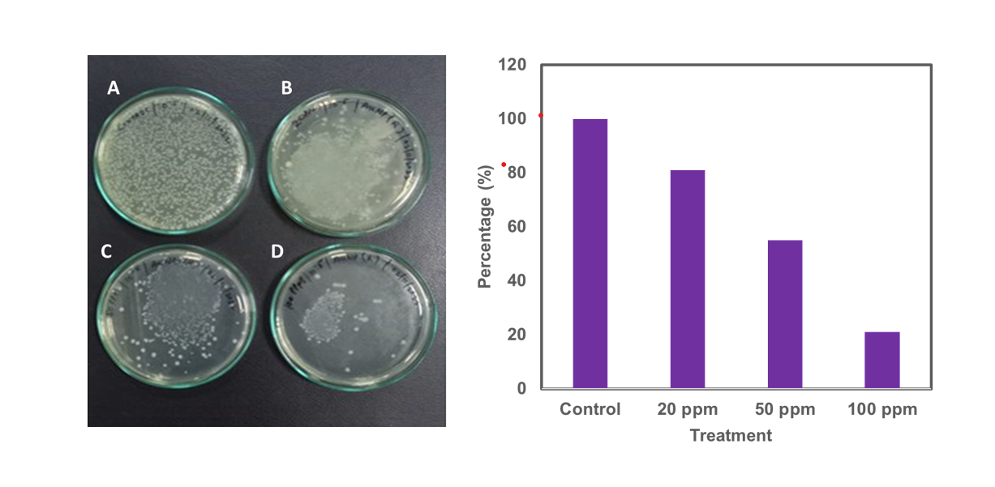
Figure 8. Dose-dependent antibacterial activity of RLE-AuNPs against E. coli
3.3.2 Antifungal activity against Aspergillus niger
The antifungal activity of the RLE-AuNPs was evaluated against Aspergillus niger using CFU-based quantification at a 1:100000 dilution. The untreated control plate (Figure A) exhibited dense fungal growth, representing 100% viability. In contrast, treatment with AuNP(R) (Figure B) resulted in a marked reduction in colony density, with viability decreasing to approximately 40%, indicating substantial inhibition of spore germination and early mycelial development.
A further decrease in fungal growth was observed with the RLE-AuNPs (Figure C), where CFU numbers were visibly lower compared to AuNP(R), corresponding to ~30% survival. The quantitative bar graph supported this observation, showing a clear and consistent decline in fungal viability across treatments, with AuNP(R) exhibiting superior antifungal potency. These results demonstrated that the RLE-AuNPs possess strong antifungal activity against A. niger, with the Rudraksha-derived nanoparticles showing the highest efficacy. This enhanced activity likely reflected the richer phytochemical capping layer provided by Rudraksha leaf extract, which may improve nanoparticle stability and biointeraction with fungal cells.

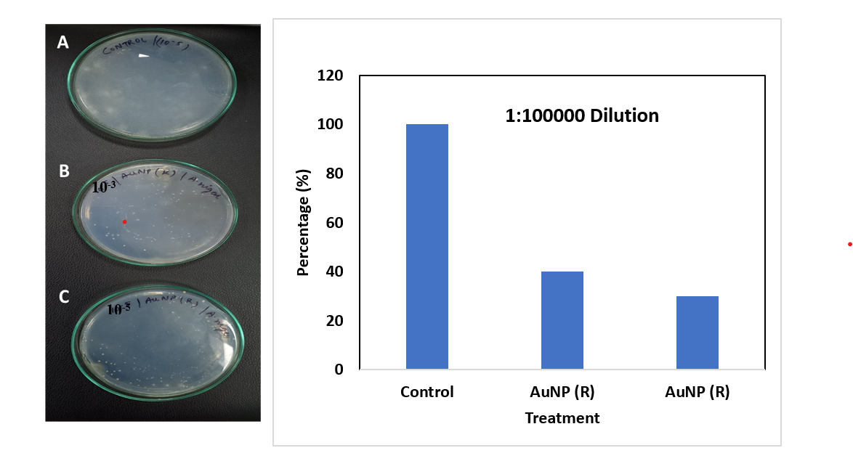
Figure 9: Antifungal activity of RLE-AuNPs against Aspergillus niger

3.9 Cytotoxicity assessment using MTT assay
The cytotoxicity of RLE-AuNPs was evaluated in 3T3-L1 cells using the MTT assay at concentrations ranging from 5 to 500 µg/mL. A clear dose-dependent decline in cell viability was observed across all exposure periods (24, 48, and 72 hs), consistent with previously reported trends for biogenic AuNPs. At low concentrations (5–50 µg/mL), the nanoparticles exhibited minimal cytotoxicity, maintaining cell viability above 80%. Moderate concentrations (100–200 µg/mL) resulted in a noticeable reduction in metabolic activity, while the highest concentration (500 µg/mL) produced substantial cytotoxicity.
A time-dependent pattern was also evident, with viability further decreasing at 48 and 72 hs compared to 24 h, reflecting cumulative nanoparticle–cell interactions and progressive intracellular stress over prolonged exposure. Overall, the synthesized AuNPs demonstrated acceptable biocompatibility at low and moderate concentrations, with cytotoxic effects emerging primarily at higher doses. These findings supported the potential biomedical applicability of RLE-AuNPs within safe concentration thresholds (Table 2).
Table 2. Cell viability (%) of 3T3-L1 cells after exposure to RLE-AuNPs
Conc (µg/ml) | 24 h | 48 h | 72 h
5 | 96 ± 2 | 93 ± 2 | 90 ± 3
10 | 94 ± 2 | 91 ± 2 | 87 ± 3
25 | 90 ± 3 | 86 ± 3 | 82 ± 3
50 | 85 ± 3 | 80 ± 3 | 74 ± 4
100 | 70 ± 3 | 65 ± 3 | 60 ± 3
200 | 58 ± 3 | 52 ± 3 | 48 ± 4
300 | 50 ± 3 | 45 ± 3 | 40 ± 4
400 | 42 ± 2 | 36 ± 3 | 32 ± 3
500 | 35 ± 3 | 30 ± 3 | 26 ± 3

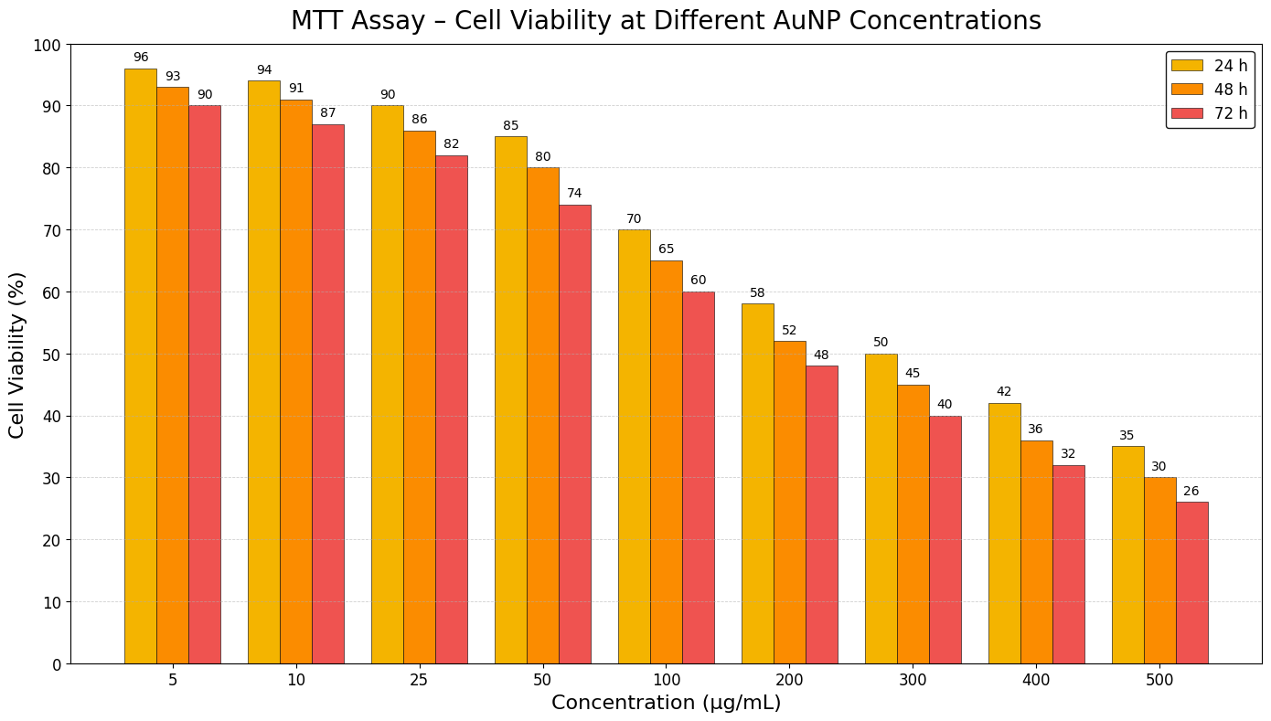

Figure 10. Cell viability of 3T3-L1 cells treated with RLE-AuNPs
4. Discussion
This study demonstrated a successful, environmental benevolent synthesis of gold nanoparticles (ELE-AuNPs) using Rudraksha leaf extract and provided an integrated assessment of their structural, antimicrobial, and cytotoxic properties. The collective findings reinforced the potential of phytochemical-mediated nanofabrication as a reliable alternative to conventional chemical routes, while highlighting the mechanistic basis by which reaction conditions and surface phytoconstituents governed nanoparticle function.
The reaction optimization experiments revealed that precursor concentration, extract ratio, and pH played decisive roles in determining the rate and extent of Au³⁺ reduction. Among all combinations, 1000 µM HAuCl₄, a 1:9 extract-to-precursor ratio, and alkaline pH 10 produced nanoparticles displaying the most intense surface plasmon resonance (SPR) peak at ~530 nm. The strong, narrow SPR peak reflected uniform nucleation and reduced polydispersity, correlating with efficient electron transfer from phenolic and carbonyl groups under alkaline conditions. These observations aligned with established principles of green nanoparticle synthesis, wherein high pH promoted deprotonation of hydroxyl functionalities, enhancing their reducing capability and accelerating metal ion conversion. The time-dependent sharpening of the SPR band further supported a controlled growth mechanism facilitated by the phytochemical matrix.
Spectroscopic analyses provided complementary evidence regarding the synthesis mechanism and structural integrity of the RLE-AuNPs. FTIR spectra identified O–H, C=O, and C–N vibrational signatures, confirming the involvement of polyphenols, flavonoids, and amide-bearing compounds in both reduction and capping processes. Such dual functionality is well documented for biomolecules in green nanotechnology and was critical for stabilizing freshly nucleated nanocrystals against aggregation. XPS analysis, showed the characteristic Au 4f doublet without additional oxidized species, confirmed complete bioreduction of Au³⁺ ions to metallic Au⁰. The absence of residual ionic gold underscored the strong reductive capabilities of Rudraksha-derived phytochemicals and suggested a clean, contamination-free synthesis pathway suitable for biomedical applications.
Morphologically, the SEM micrographs revealed the formation of quasi-spherical to faceted nanoparticles ranging from 20 to 80 nm. These angular features were typical of green-synthesized AuNPs where heterogeneous phytochemical adsorption onto growing facets influenced growth kinetics. The slightly larger hydrodynamic size (~120 nm) observed via DLS reflected the combined contribution of organic capping layers and hydration shells, phenomena consistently reported for plant-mediated nanoparticles. The presence of a dominant, sharp DLS peak also indicated relatively stable colloidal behavior with limited aggregation, an essential property for biological applications.
The antimicrobial activity profiles of the RLE-AuNPs demonstrated strong and dose-dependent inhibition against both E. coli and Aspergillus niger. For E. coli, viability decreased from ~80% at 20 ppm to ~20% at 100 ppm, indicating potent bactericidal potential even against a Gram-negative organism typically more resistant due to its outer membrane barrier. The antibacterial mechanism likely involved multiple simultaneous pathways: membrane disruption driven by nanoparticle adhesion, oxidative stress induced by ROS production, and interference with key enzymatic processes or DNA replication. The phytochemical-rich capping layer may further enhanced membrane affinity or contribute synergistically via inherent antimicrobial constituents.
Similarly, the antifungal activity of RLE-AuNPs against A. niger revealed marked suppression of spore germination and hyphal development, with outperforming the comparative plant extract. This enhanced efficacy may stem from the distinct phytochemical corona imparted by the Rudraksha, which could increase nanoparticle–cell wall interactions or destabilize chitinous structures. Since fungal pathogens typically exhibited higher structural robustness, the pronounced inhibition observed here underscored the therapeutic potential of these biogenic nanoparticles.
The cytotoxicity evaluation in 3T3-L1 fibroblasts demonstrated that RLE-AuNPs possessed good biocompatibility at low and moderate concentrations, maintaining >80% viability up to 50 µg/mL. The gradual decline in viability at concentrations ≥100 µg/mL and over prolonged exposure (48–72 h) aligned with recognized cellular responses to nanoparticles, including ROS generation, mitochondrial dysfunction, and lysosomal perturbation. Importantly, the estimated IC₅₀ range (180–220 µg/mL) is consistent with values reported for other biogenic AuNPs, indicating that RLE-AuNPs fell well within acceptable nanosafety thresholds. The prepared nanoparticles showed good cytotoxic impact against a prostate cancer (PC-3) cells line (Vinay et. al, 2021). The broad therapeutic window—strong antimicrobial activity at low concentrations and cytotoxic effects only at much higher doses-supported their suitability for translational applications such as antimicrobial coatings, wound healing formulations, and biosensing interfaces.
A key strength of this study was the integration of Rudraksha’s ethnomedicinal phytochemistry with nanotechnology. The plant was known for antioxidant, antimicrobial, and anti-inflammatory properties, and these attributes appeared to be translated onto the nanoparticle surface through the phytochemical capping. This biofunctionalization could enhance biological interactions, improve colloidal stability, and reduce unintended cytotoxicity relative to chemically synthesized AuNPs. The convergence of plant-based phytochemistry and metallic nanostructures thus offers synergistic advantages that warrant further investigation.
The findings established a reliable, green, and scalable method for producing biologically active AuNPs using Rudraksha leaf extract. The nanoparticles displayed well-defined physicochemical features, potent antimicrobial activity, and favorable cytotoxicity profiles, positioning them as promising candidates for biomedical and environmental applications. Future work should focus on mechanistic elucidation of microbial inhibition pathways, in vivo toxicity and biodistribution studies, and functional integration into therapeutic or diagnostic platforms to fully exploit their translational potential.
5. Conclusion
Current study demonstrated a green and efficient method for synthesizing uniform, phytochemical coated gold nanoparticles using Rudraksha leaf extract. Optimized condition yielded stable, well defined gold nanoparticle having strong antimicrobial potential and high biocompatibility. Future work would be focused on elucidating molecular mechanisms, validating in vivo safety, and exploring their integration into practical biomedical systems.
Disclaimer (Artificial intelligence)
Option 1:
Author(s) hereby declare that NO generative AI technologies such as Large Language Models (ChatGPT, COPILOT, etc.) and text-to-image generators have been used during the writing or editing of this manuscript.
Option 2:
Author(s) hereby declare that generative AI technologies such as Large Language Models, etc. have been used during the writing or editing of manuscripts. This explanation will include the name, version, model, and source of the generative AI technology and as well as all input prompts provided to the generative AI technology
Details of the AI usage are given below:
1.
2.
3.
References
- Adeyemi, J. O., Oriola, A. O., Onwudiwe, D. C., & Oyedeji, A. O. (2022). Plant Extracts Mediated Metal-Based Nanoparticles: Synthesis and Biological Applications. Biomolecules, 12(5), 627. https://doi.org/10.3390/biom12050627
- Ahmad, Nabeel, Bhatnagar, Sharad, Saxena, Ritika, Iqbal, Danish, Ghosh, Ashoke K, Dutta, Rajiv (2017) Biosynthesis and Characterization of Gold Nanoparticles: Kinetics, In vitro and In vivo study; Material Science & Engineering C; 78, 553-564. https://doi.org/10.1016/j.msec.2017.03.282
- Dheyab, M. A., Tang, J. H., Abdul Aziz, A., Hussein Nowfal, S., Jameel, M. S., Alrosan, M., Oladzadabbasabadi, N., & Ghasemlou, M. (2025). Green synthesis of gold nanoparticles and their emerging applications in cancer imaging and therapy: a review. Reviews in Inorganic Chemistry, 45(4), 663-685. https://doi.org/10.1515/revic-2024-0048
- Barathi, S., Ramalingam, S., Krishnasamy, G., & Lee, J. (2024). Exploring the biomedical frontiers of plant-derived nanoparticles: Synthesis and biological reactions. Pharmaceutics, 16(7), 923. https://doi.org/10.3390/pharmaceutics16070923
- Chowdhury, S. S., Hasan, M., & Ghosh, A. (2024). Medicinal Plant-Based Nanoparticle Synthesis and their Diverse Applications. In Ethnopharmacology and OMICS Advances in Medicinal Plants Volume 2: Revealing the Secrets of Medicinal Plants (pp. 213-250). Springer Nature Singapore. https://doi.org/10.1007/978-981-97-4292-9_10
- Dahan, K. A., Li, Y., Xu, J., & Kan, C. (2023). Recent progress of gold nanostructures and their applications. Physical Chemistry Chemical Physics, 25(28), 18545-18576. https://doi.org/10.1039/D3CP01549A
- Edo, G. I., Mafe, A. N., Ali, A. B. M., Akpoghelie, P. O., Yousif, E., Isoje, E. F., Igbuku, U. A., Ismael, S. A., Essaghah, A. E. A., Ahmed, D. S., Ozsahin, D. U., Umar, H., &Alamiery, A. A. (2025). Green Biosynthesis of Nanoparticles Using Plant Extracts: Mechanisms, Advances, Challenges, and Applications. BioNanoScience, 15(2), 267. https://doi.org/10.1007/s12668-025-01883-w
- Fernandes, C., Jathar, M., Sawant, B. K. S., &Warde, T. (2023). Scale-Up of Nanoparticle Manufacturing Process. In Pharmaceutical Process Engineering and Scale-up Principles (pp. 173-203). Cham: Springer Nature Switzerland. https://doi.org/10.1007/978-3-031-31380-6_12
- John, J. (2025). Cutting-Edge nanoparticle innovations in biomedical science: Synthesis, Applications, Challenges, and Future Prospects. Journal of Nanotechnology and Nanomaterials, 6(1), 43-66. https://doi.org/10.33696/Nanotechnol.6.062
- Kus-Liśkiewicz, M., Fickers, P., & Ben Tahar, I. (2021). Biocompatibility and Cytotoxicity of Gold Nanoparticles: Recent Advances in Methodologies and Regulations. International Journal of Molecular Sciences. https://doi.org/10.3390/ijms222010952
- Mikhailova, E. O. (2021). Gold nanoparticles: Biosynthesis and potential of biomedical application. Journal of Functional Biomaterials, 12(4), 70. https://doi.org/10.3390/jfb12040070
- Munir, H., Bilal, M., Mulla, S. I., Abbas Khan, H., & Iqbal, H. M. N. (2021). Plant-mediated green synthesis of nanoparticles. In Advances in green synthesis: Avenues and sustainability (pp. 75-89). Cham: Springer International Publishing. https://doi.org/10.1007/978-3-030-67884-5_4
- Napagoda, M., Madhushanthi, P., Wanigasekara, D., & Witharana, S. (2022). Plant-based nanomaterials and their antimicrobial activity. In Eco-Friendly Biobased Products Used in Microbial Diseases (pp. 155-179). CRC Press. https://doi.org/10.1201/9781003243700-10
- Ranawat, S., &Deshwal, S. (2022). A REVIEW ON PHYTOCONSTITUENTS AND PHARMACOLOGICAL ASPECTS OF ELAEOCARPUS GANITRUS (RUDRAKSHA) PLANT. World Journal of Pharmaceutical Research. https://doi.org/10.20959/wjpr20223-23240
- Rosli, N. A., Teow, Y. H., & Mahmoudi, E. (2021). Current approaches for the exploration of antimicrobial activities of nanoparticles. Science and Technology of Advanced Materials, 22(1), 885-907. https://doi.org/10.1080/14686996.2021.1978801
- Schröter, L., & Ventura, N. (2022). Nanoplastic toxicity: Insights and challenges from experimental model systems. Small, 18(31), 2201680. https://doi.org/10.1002/smll.202201680
- Shafiq, M. S., Saleem, M., Ishaque, I., Zahra, T., Sarfraz, A., Sohail, M., Kiran, R., Batool, N., Ullah, I., Rashid, U., & Rafique, S. (2025). Nanoparticle-Induced Oxidative Stress in Human Cell Lines: Enzymatic Biomarkers and Gene Expression Disturbances. Scholarly Academic Journal Of Biosciences, 13(7), 926-959. https://doi.org/10.36347/sajb.2025.v13i07.007
- Shah, D. D., Chorawala, M. R., Mansuri, M. K. A., Parekh, P. S., Singh, S., & Prajapati, B. G. (2024). Biogenic metallic nanoparticles: from green synthesis to clinical translation. Naunyn-Schmiedeberg's Archives of Pharmacology, 397(11), 8603-8631. https://doi.org/10.1007/s00210-024-03236-y
- Sharma, S., Hussain, S., Rai, D. V., & Singh, A. N. (2023). A comprehensive analysis on the ecosystem services of Elaeocarpus L. (Elaeocarpaceae): a review. Journal of Phytology, 15, 12-37. https://doi.org/10.25081/jp.2023.v15.8020
- Singh, H., Desimone, M. F., Pandya, S., Jasani, S., George, N., Adnan, M., Aldarhami, A., Bazaid, A. S., &Alderhami, S. A. (2023). Revisiting the green synthesis of nanoparticles: Uncovering influences of plant extracts as reducing agents for enhanced synthesis efficiency and its biomedical applications. International Journal of Nanomedicine, 18, 4727–4750. https://doi.org/10.2147/IJN.S419369
- Szczyglewska, P., Feliczak-Guzik, A., & Nowak, I. (2023). Nanotechnology–General Aspects: A Chemical Reduction Approach to the Synthesis of Nanoparticles. Molecules, 28(13), 4932. https://doi.org/10.3390/molecules28134932
- Vinay, S.P., Udayabhanu, Sumedha, H.N., Shashank, M., Nagaraju, G., Chandrasekhar, N. (2021) In-vitro antibacterial, antioxidant and cytotoxic potential of gold nanoparticles synthesized using novel Elaeocarpus ganitrus seeds extract; Journal of Science: Advanced Materials and Devices, 6 (1), 127-133. https://doi.org/10.1016/j.jsamd.2020.09.008

