Advances in Micropropagation and Tissue Culture for Horticultural Crops: A Review

Abstract
High-quality planting material that is genetically uniform, physiologically vigorous, and pathogen-free is essential for sustainable horticultural crop production. Traditional vegetative propagation methods such as cuttings, suckers, and grafting are limited by low multiplication rates and the high risk of transmitting systemic pathogens, particularly viruses, bacteria, and viroids. Plant tissue culture offers a reliable alternative, enabling rapid clonal multiplication and reducing disease transmission through the use of clean, meristematic tissues. Key micropropagation stages, including establishment, multiplication, rooting, and acclimatization, collectively facilitate the large-scale production of true-to-type plants. Advanced regeneration pathways such as organogenesis and somatic embryogenesis further support the propagation of elite and recalcitrant genotypes, germplasm conservation, and genetic improvement programs. Recent technological innovations including bioreactor systems, low-cost culture strategies, LED lighting, molecular diagnostics, and AI-assisted culture management have significantly enhanced the efficiency, scalability, and commercial feasibility of micropropagation. Integration of tissue culture with molecular biology and precision agriculture is increasingly strengthening global efforts to supply high-quality, disease-free planting material for diverse horticultural crops.
Keywords: micropropagation, tissue culture, temporary immersion system, somatic embryogenesis, synthetic seed, bioreactor, genome editing, horticulture
1.Introduction
Horticultural crop production requires planting material that is genetically uniform, physiologically vigorous, and free from pathogens (Abdalla et al., 2022). However, conventional methods of vegetative propagation such as cuttings, suckers, layering, grafting, and division often limit the multiplication rate and increase the chances of transmitting systemic pathogens, particularly viruses, bacteria, and viroids (Awotedu et al., 2021). These limitations are especially critical in vegetatively propagated horticultural crops such as banana, potato, strawberry, sugarcane, citrus, grapevine, and ornamentals, where the demand for true-to-type and disease-free stock plants is high (Sidhu, 2011).
Plant tissue culture has emerged as a transformative solution to these challenges, providing a precise, controlled, and efficient method of clonal propagation (Pithiya et al., 2021). Techniques such as meristem culture, microshoot proliferation, organogenesis, somatic embryogenesis, and protoplast-based regeneration enable rapid multiplication and minimize pathogen transmission by utilizing clean, small, and genetically stable tissues. Tissue culture also supports long-term germplasm conservation, facilitates the multiplication of elite or recalcitrant genotypes, and provides platform material for genetic transformation, genome editing, and synthetic seed production (Yasemin and Beruto, 2024).
In recent years, significant improvements in the efficiency, scalability, and economic viability of micropropagation have been achieved through innovations such as temporary immersion bioreactors, automation, low-cost media formulation, LED-based lighting, molecular diagnostics, and AI-assisted culture management (Kartha et al., 2024). These technological advances are increasingly integrating plant tissue culture with molecular biology, engineering, and precision agriculture to address commercial production needs, conservation priorities, and global demand for high-quality planting material in horticultural crops (Koti and Bill, 2025).
2. Core Techniques of Micropropagation and Technological Evolution
2.1 Traditional Stages and Goals
Tissue culture propagation is generally carried out in four well-defined stages, each with specific technical requirements and biological objectives (Abdalla et al., 2022).
Stage I (Establishment) involves selecting, excising, and surface-sterilizing explants—usually shoot tips or meristems and introducing them into a sterile culture environment. The objective is to achieve aseptic establishment while maintaining viability and regenerative capacity. In many horticultural crops, meristem culture is essential for producing pathogen-free plants because apical meristems are typically free of systemic viruses due to high metabolic activity and lack of vascular connections (Kane et al., 2016).
Stage II (Multiplication) consists of rapid shoot proliferation through axillary bud activation or de novo organogenesis. Cytokinins such as BAP, kinetin, or TDZ are commonly used to induce multiple shoots, while optimization of light, carbon sources, and subculture intervals enhances multiplication rates. The goal is to obtain a large number of uniform microshoots without genetic variation. Responses vary among horticultural crops, requiring species- and genotype-specific protocol refinement (Singh, 2015).
Stage III (Rooting) involves inducing roots on regenerated shoots using exogenous auxins (IBA or NAA) or modifying the culture medium’s physical properties, such as gelling strength and nutrient concentration. Adequate rooting is crucial for successful ex vitro establishment. This stage remains a major bottleneck in many woody and perennial horticultural crops due to inherent difficulties in root induction (Bhojwani and Dantu, 2013).
Stage IV (Acclimatization) transfers in vitro–grown plantlets to greenhouse or nursery conditions. Gradual adjustment of humidity, light intensity, and temperature allows plantlets to develop structural and physiological adaptations such as cuticle formation, stomatal regulation, and functional root systems. Successful acclimatization ensures high survival and prepares plants for field transplantation (Kane et al., 2016).
Each stage aims to meet specific biological and commercial objectives. Major applications of micropropagation include large-scale multiplication of high-quality planting material, production of disease-free nursery stock using meristem and thermotherapy techniques, clonal preservation of elite horticultural genotypes, and provision of regenerable tissues for genetic transformation, genome editing, and other modern biotechnological tools (Roy, 2024). For instance, banana, strawberry, gerbera, and gladiolus rely heavily on micropropagation for commercial production, while crops such as citrus, grapevine, mango, and potato use tissue culture primarily for virus elimination and maintaining elite lines (Yaseen et al., 2023).
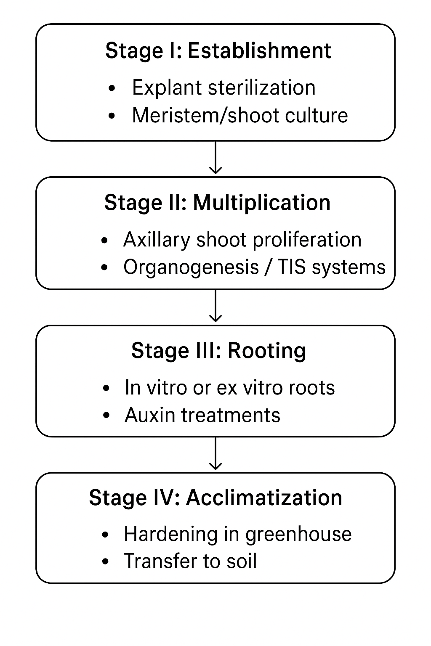

Flow chart 1: Acclimatization procedure

2.2 Somatic Embryogenesis and Organogenesis
Somatic embryogenesis and organogenesis represent two fundamental pathways of in vitro plant regeneration and remain central to micropropagation, genetic improvement, and conservation strategies in horticultural crops. Both routes rely heavily on cellular totipotency, but they differ significantly in developmental sequence, scalability, and responsiveness across species and genotypes (Desai, et al., 2022).

2.2.1 Somatic Embryogenesis: Concept and Process
Somatic embryogenesis involves the development of embryos from somatic or non-gametic cells that mimic the bipolar structure of zygotic embryos. These somatic embryos possess both root and shoot meristems, enabling complete plantlet regeneration without the need for separate rooting stages. The process generally follows the stages of induction, embryo formation, maturation, and conversion into plantlets (Desai, et al., 2022).

Somatic embryogenesis involves several key stages, beginning with the induction of embryogenic callus using auxins such as 2,4-D or NAA, or through stress triggers like osmotic stress, desiccation, and temperature shock (Garcia, et al., 2019). This is followed by histodifferentiation and maturation of somatic embryos, which is supported by reduced auxin levels and increased cytokinin or ABA supply (Pádua, et al., 2018). The final stage involves germination and conversion of embryos into complete plantlets under appropriate light and balanced nutrient conditions. Somatic embryogenesis offers several advantages, including high-throughput propagation where thousands of embryos can be produced from a single explant synthetic seed technology for easy handling, transportation, and sowing of encapsulated embryos, and germplasm conservation, particularly for recalcitrant-seeded species and clonally propagated horticultural crops such as mango, coconut, and date palm. It is also highly valuable in transformation systems; as somatic embryos provide uniform tissues ideal for Agrobacterium-mediated genetic transformation or genome editing (Méndez-Hernández et al., 2019). Recent advancements in this field include the use of temporary immersion bioreactors (TIBs) that significantly enhance embryogenic yield and uniformity, liquid culture systems that allow synchronized embryo development and improved scalability, and molecular markers and transcriptomic tools for identifying embryogenic competence and monitoring embryo quality (Sengul, et al., 2015). Additionally, innovations such as low-cost gelling agents and automated embryo sorting have improved the commercial feasibility of the technique. However, challenges remain, including somaclonal variation, asynchronous embryo development, and poor conversion rates of embryos into plantlets in certain woody perennial species.

2.2.2 Organogenesis: Direct and Indirect Pathways
Organogenesis refers to the formation of shoots or roots from somatic tissues, occurring either through direct organogenesis (from meristems without callus) or indirect organogenesis (via callus). Direct organogenesis is preferred for micropropagation due to greater genetic stability, while the indirect pathway is useful for recalcitrant tissues despite a higher risk of somaclonal variation (Singh & Kundu, 2024).
Key Features:
- Direct organogenesis: Arises from pre-existing meristems such as nodal explants and shoot tips; widely used in banana, rose, gerbera, and grape.
- Indirect organogenesis: Involves callus formation followed by redifferentiation; suitable for difficult-to-regenerate crops.
Organogenesis is influenced by genotype, explant type, and plant growth regulator balance especially the auxin–cytokinin ratio. Light, carbon source, micronutrients, and stress pre-treatments (wounding, osmotic stress, temperature shock) further enhance regeneration potential (Schwarz & Beaty, 2018).
It is widely applied in clonal multiplication of elite cultivars, virus elimination through meristem-based regeneration, and developing robust regeneration systems required for genetic transformation and CRISPR-mediated genome editing.
Tissue culture
Tissue culture is a biotechnological technique in which plant cells, tissues, or organs are grown in vitro under sterile and controlled environmental conditions on an artificial nutrient medium, utilizing the natural ability of plant cells to divide, differentiate, and regenerate into whole plants (Trigiano, and Gray, 2016)
Tissue culture is the aseptic in vitro cultivation of plant tissues on artificial nutrient media under controlled conditions for rapid plant regeneration (Loyola-Vargas, et al., 2018).
Tissue culture includes micropropagation, callus culture, cell suspension culture, organogenesis, somatic embryogenesis, haploid production, and protoplast culture, and it plays a vital role in plant breeding, germplasm conservation, horticulture, genetic engineering, and nursery production (Gupta, and Ibaraki 2006).
Objectives of Tissue Culture
The major objectives of plant tissue culture include rapid clonal multiplication, which aims to produce a large number of genetically identical and true-to-type plants within a short period, especially for commercially important crops. Tissue culture is widely used for the production of pathogen-free planting material through meristem culture, helping eliminate viruses and generate disease-free stock for crops such as banana, potato, sugarcane, strawberry, grape, citrus, and ornamentals. Another important objective is the conservation of genetic resources, which is achieved through in vitro conservation, slow-growth storage, and cryopreservation of shoot tips, embryos, pollen, and rare plant species. Tissue culture also assists plant breeding programs by supporting embryo rescue, haploid production through anther culture, somaclonal variation, and protoplast fusion for somatic hybrid development. It enables the propagation of plants that are difficult to multiply through conventional methods, such as orchids, forest species, and medicinal plants. Tissue culture allows year-round production of planting material regardless of seasonal variations and serves as a platform for the production of secondary metabolites such as alkaloids, terpenoids, and pigments through cell suspension cultures (Trigiano, and Gray 2016). It plays a key role in conserving endangered species via rapid in vitro multiplication and contributes significantly to genetic transformation systems, including Agrobacterium-mediated transformation, CRISPR/Cas gene editing, and regeneration of transformed plants.
Principles of Tissue Culture:
Plant tissue culture is fundamentally based on the principle of totipotency, which states that every plant cell possesses the genetic potential to regenerate into a complete plant under the right conditions. This process involves dedifferentiation, where specialized cells revert to a meristematic state to form callus, followed by redifferentiation, in which callus cells develop into shoots, roots, or embryos depending on hormonal cues (Smith, 2013). Aseptic conditions are essential and require strict sterilization of the working environment, tools, and media using laminar airflow cabinets, autoclaving, and aseptic handling techniques. Successful tissue culture also depends on controlled environmental conditions, including suitable nutrient media, appropriate concentrations of plant growth regulators, optimal temperature (24–28°C), a 16/8-hour photoperiod, 60–70% humidity, and a pH range of 5.6–5.8. Hormonal regulation plays a crucial role: high cytokinin levels stimulate shoot formation, high auxin levels promote rooting, and a balanced auxin-to-cytokinin ratio induces callus formation. The composition of the nutrient medium must include macronutrients, micronutrients, essential vitamins, a carbon source such as sucrose, and gelling agents like agar to support growth and morphogenesis (Shahzad, et al., 2017).
Major Steps of Plant Tissue Culture:
The tissue culture process begins with the selection of healthy, disease-free, and genetically uniform donor plants maintained under clean conditions. Explant collection follows, where tissues such as shoot tips, nodal segments, leaves, meristems, anthers, ovules, or cotyledons are excised, and the physiological age and season significantly influence their regenerative response. Surface sterilization is then carried out by washing explants with detergents, followed by treatment with ethanol and disinfectants such as sodium hypochlorite or mercuric chloride, and finally rinsing with sterile water to eliminate surface contaminants. Explants are inoculated onto sterilized nutrient media inside a laminar airflow cabinet using flame-sterilized tools (Loyola-Vargas et al., 2018). Depending on the hormonal composition of the medium, explants undergo shoot multiplication or callus induction, leading to organogenesis or somatic embryogenesis. Rooting is then achieved by transferring shoots to auxin-rich media, where the development of strong root systems indicates readiness for the next stage. The final step is hardening and acclimatization, in which plantlets are gradually adapted to external environmental conditions in mist chambers or polyhouses using substrates such as cocopeat and perlite to ensure their successful establishment and survival (Razdan, 2002).

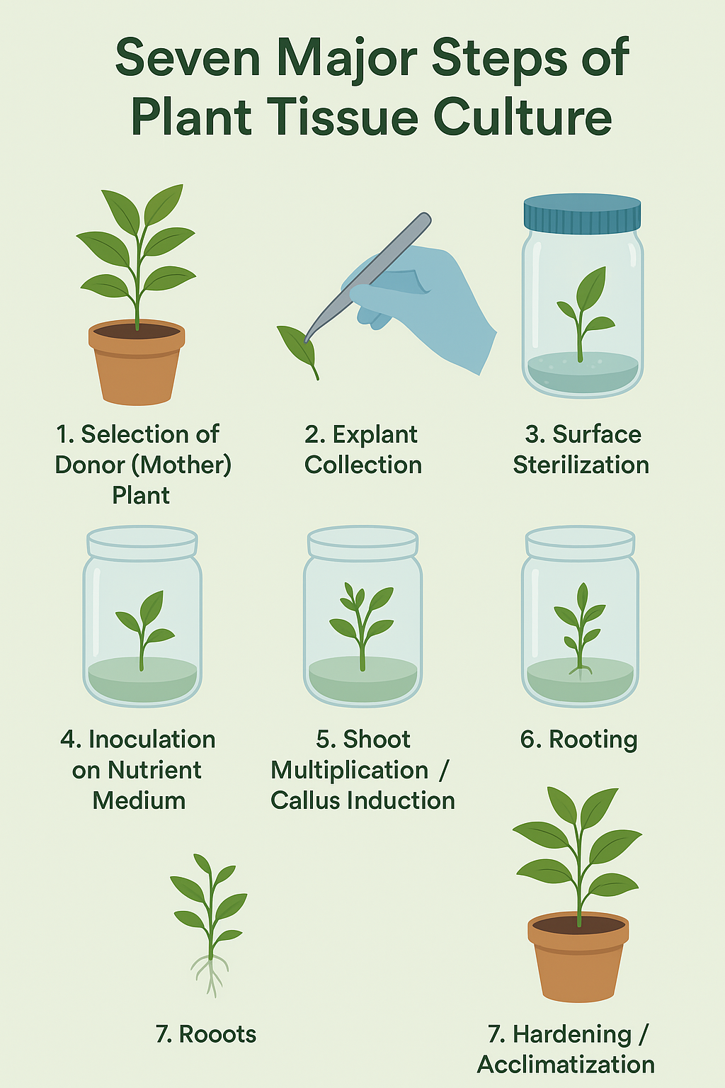

Fig 1: Principle of Plant Tissue Culture
Types of Tissue Culture
Meristem culture involves culturing actively dividing meristems to eliminate viruses and rapidly multiply elite clones, as these cells are naturally disease-free. Callus culture is used to induce an unorganized mass of cells that serves as a platform for secondary metabolite production, somaclonal variation, and genetic transformation. Cell suspension culture consists of growing dispersed cells in liquid media under constant agitation, making it ideal for large-scale metabolite production, synthetic biology applications, and bioreactor-based cultivation. Organ culture focuses on growing specific plant organs such as shoots, roots, leaves, anthers, ovules, and embryos to study developmental processes, physiology, and regeneration (Rai, et al., 2022). Protoplast culture involves enzymatic removal of cell walls to obtain protoplasts, which are utilized for somatic hybridization, genetic engineering, and delivery systems for gene editing. Anther and pollen culture enables the production of haploids and doubled haploids, thereby accelerating breeding programs by rapidly achieving homozygosity. Somatic embryogenesis allows somatic cells to form embryo-like structures that develop into whole plants and is particularly valuable for synthetic seed production and large-scale forestry propagation. Shoot tip and nodal culture uses shoot tips or nodal segments for commercial clonal propagation of crops such as banana, sugarcane, bamboo, potato, and various ornamental plants. Synthetic seed culture involves encapsulating somatic embryos or shoot tips in alginate beads to create synthetic seeds that can be easily stored, transported, and handled with minimal contamination risk (Twaij, et al., 2020).

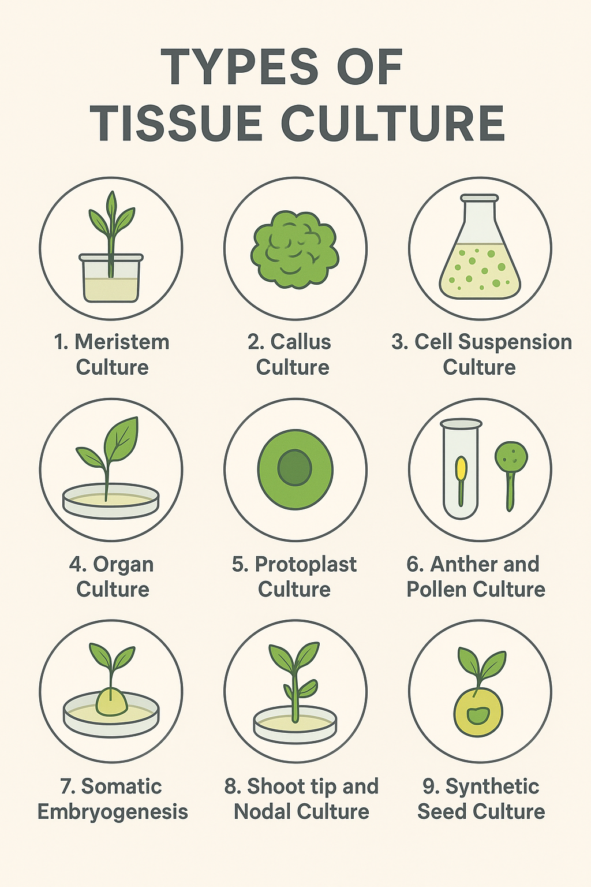
Fig 2: Types of Tissue Culture

3. Scale-Up: Bioreactors and Temporary Immersion Systems (TIS)
Scaling up from small-scale laboratory culture vessels to commercial production systems remains one of the biggest bottlenecks in plant micropropagation. Traditional semisolid media-based systems, though reliable for protocol development, are labor- and cost-intensive and limited in scalability due to frequent subculturing requirements and high consumption of gelling agents and sterile consumables (Verma, et al., 2021). Bioreactor-based methods, especially those based on liquid culture, have emerged as effective alternatives that offer higher nutrient uptake, uniform growth conditions, and significantly higher multiplication rates than traditional methods. Elimination of solidifying agents not only saves money but also allows better mass transfer, which in turn facilitates faster and uniform development of culture tissues (Georgie et al., 2014).
Of these, TIS came into broad focus due to their abilities to overcome physiological disorders commonly associated with continuous liquid immersion, such as hyperhydricity, chlorosis, and poor structural integrity. Mechanistically, TIS devices operate to expose the explants intermittently to liquid nutrient medium, followed by periods of aeration, thus creating an optimal balance between nutrient availability and gas exchange. This pulsated exposure minimizes physiological stress, enhances shoot elongation, improves biomass accumulation, and significantly increases the survival rates of plantlets during ex vitro acclimatization (Lyam, et al., 2012).
The various operational parameters, such as vessel geometry, medium volume, aeration efficiency, and material composition, have to be considered in detail for the successful deployment of the bioreactor systems (Murthy, et al., 2023). Immersion frequency and duration have to be fine-tuned with the metabolic and developmental requirements of each species, given that excessive immersion promotes hyperhydricity and insufficient immersion imposes limitation on nutrient uptake. Inoculum density is also critical to determining nutrient competition and micro environmental stability within the vessel. Incorporation of appropriate gas exchange filters is also an essential feature to avoid ethylene accumulation and other gaseous imbalances that may impede morphogenesis. Although TIS systems decrease labor and allow semi-automated production, they require careful management of contamination risks inherent in liquid media. Moreover, initial capital investment in bioreactor units is high; however, long-term cost savings, besides significantly higher multiplication efficiency, makes them commercially viable for commercial propagation industries (De Carlo, et al., 2021).
In general, the integration of bioreactor and TIS technologies marks a milestone in the commercialization of micropropagation by way of enhanced productivity, plant uniformity, a reduction in labor use, and superior acclimatization levels. Bioreactor-based micropropagation will undoubtedly assume an increasingly central role in world horticultural production systems as engineering innovations continue to improve system design (Rodríguez-Deméneghi 2024).
4. Synthetic Seeds, Cryopreservation, and Germplasm Conservation
Synthetic seed technology is recognized for its versatility and novelty in storing, distributing, and direct field planting of in vitro–derived propagules. Conventionally, it involves the encapsulation of somatic embryos, axillary buds, nodal segments, or microshoots in a hydrogel matrix, generally sodium alginate, complexing with calcium salts into bead-like, sowable units. The encapsulated propagules therein assume the appearance and handling features of true seeds, thus allowing easy transport, short-term storage, and mechanized sowing while maintaining clonal fidelity. Synthetic seeds are useful in cases where species either do not form orthodox seeds or produce recalcitrant seed physiology or are vegetatively propagated, thus being highly relevant to many fruit, plantation, and ornamental crops (Saxena, et al., 2019).
Success within these synthetic seed systems is determined by a variety of technical factors that include the composition and concentration of the encapsulation matrix, the metabolic status of the propagule, and post-encapsulation storage conditions. Recent literature has discussed enhancements in gel formulations, including those with osmo protectants, antifungal compounds, nutrient supplements, and growth regulators, all of which enhance the storage stability and conversion efficiency. Further strides in the area of desiccation-tolerant somatic embryos have also enhanced the feasibility of synthetic seed technology for long-term conservation and large-scale distribution programs.
Cryopreservation plays a complementary role by enabling long-term germplasm storage through ultra-low temperature preservation, usually in liquid nitrogen at –196°C, where metabolic activity is effectively arrested. Novel cryopreservation methods like vitrification, encapsulation–dehydration, encapsulation–vitrification, and droplet vitrification have been successful on an array of horticultural crops in the modern day, ensuring genetic stability with high post-thaw recovery rates. Such protocols allow the preservation of elite genotypes, rare cultivars, and endangered species while minimizing the risks associated with field-based germplasm banks, such as pest outbreaks, climatic stresses, and genetic drift (Gantait, and Mitra 2019).
The combination of synthetic seed technology with cryogenic storage has provided strong tools for both the short-term distribution and long-term conservation. For example, encapsulated somatic embryos can be stored at low temperature for immediate uses or dehydrated and cryopreserved for extended conservation periods. Additionally, molecular markers and viability assays are also in routine practice nowadays to verify the genetic fidelity and physiological stability after storage and recovery (Ekinci et al., 2019).
Together, synthetic seeds and cryopreservation technologies form a vital part of the contemporary horticultural germplasm management systems. They support the conservation of genetic diversity, facilitate global germplasm exchange, and ensure the availability of high-quality planting material for breeding, propagation, and commercial production programs (Sharma, et al., 2023).
5. Integration of Molecular Tools and Genome Editing
Recent advances in molecular biology have greatly redefined the scope, precision, and applications of plant tissue culture in horticultural science. Tissue culture remains the basic tool for plant genetic transformation, as it provides a controlled environment for DNA delivery, selection, and transformation of tissues. In classic transformation systems Agrobacterium tumefaciens-mediated gene transfer and biolistic particle bombardment the availability of responsive explants, optimized protocols for regeneration, and reliable schemes for selection remain basic prerequisites (Tripathi, and Shukla, 2024). Callus induction, shoot regeneration, and rooting efficiency are essential factors affecting transformation success, particularly in recalcitrant crops exhibiting species-specific or genotype-dependent responses (Pandey, et al., 2025).
This rapid evolution of the CRISPR/Cas genome editing platforms has expanded these applications to include precise improvements for disease resistance, nutritional quality, abiotic stress tolerance, shelf-life, and other horticulturally important traits (Parmar, et al., 2017). Although most editing approaches still depend on tissue culture for the regeneration of whole plants from edited cells, a number of emerging strategies attempt to circumvent or minimize the dependence on tissue culture (Sharma, et al., 2023). Such innovations are focused on reducing somaclonal variation, improving editing efficiencies, reducing regeneration time, and mitigating regulatory concerns sometimes associated with conventional transgenic methodologies (Sakthivel, et al., 2025).
Despite these advances, for many horticultural species-especially woody perennials, recalcitrant fruit crops, and ornamentals-robust tissue culture and regeneration pipelines remain indispensable for obtaining stable, heritable edits. As genome editing technologies continue to advance, integration of molecular tools with optimized tissue culture protocols will be necessary for accelerating trait development and breeding innovations in horticultural crops (Quiroz, et al., 2025).
6. Underpinning Technologies: Nanotechnology, Omics, and Automation
6.1 Nanotechnology
Nanotechnology has lately emerged as a promising complementary tool in plant tissue culture, with new approaches to the improvement of delivery systems, increasing culture efficiency, and enhancing tolerance to stress in plants. Attempts have been made with a broad variety of nanoparticles, such as metal oxides, carbon nanotubes, silica nanoparticles, and polymeric nanocarriers, which are capable of delivering growth regulators, vitamins, elicitors, and nucleic acids through plant cell walls with enhanced efficiency and reduced degradation. There in vitro applications are expected to enhance nutrient uptake, improve germination, stimulate organogenesis, and increase the rate of somatic embryogenesis (Balamurugan, et al., 2024).
Besides this, nanoparticles exhibit excellent antimicrobial properties and thus find application in sterilization and contamination control during inoculation. For example, silver nanoparticles have shown promise in depleting the microbial load with a minimum level of toxicity to tissues at optimized concentrations (Al-Qudah, et al., 2022). DNA or RNA delivery through the use of nanocarriers is another promising alternative to conventional transformation systems, although studies in horticultural crops are very limited.
Despite encouraging findings, nanotechnology in micropropagation remains largely at an experimental level. Standardization of protocols, long-term biosafety assessment, environmental risk evaluation, and regulatory guidelines have to be done before widespread applications in commercial horticultural systems become possible (Tariq, et al., 2020).
6.2 Omics-Guided Protocol Optimization
Omics approaches, including transcriptomic, proteomics, metabolomics, and epigenomics, are all being used increasingly to elucidate the molecular basis of in vitro responses. These technologies offer in-depth views of genes, proteins, and metabolites involved in developmental transitions such as callus induction, shoot regeneration, and somatic embryogenesis. Identifying molecular markers of embryogenic competence or indicators of culture recalcitrance, omics analyses enable the rational, data-driven optimization of tissue culture protocols. In this regard, transcriptomic analyses identified the regulatory networks related to auxin- and cytokinin-responsive genes during induction phases, whereas metabolomic profiling established a relationship between some compounds and embryogenic potential. This enabled researcher to more precisely adjust media formulations, change plant growth regulator ratios, light, and carbon conditions to maximize regeneration frequencies for those species that are problematic in vitro. Omics-assisted approaches represent a powerful direction forward to overcome genotype-specific limitations and improve reproducibility in horticultural micropropagation systems (Ramírez-Mosqueda et al., 2025).
6.3 Automation, Robotics, and Digital Monitoring
Automation is rapidly replacing many aspects of the work in commercial micropropagation by minimizing labor, improving uniformity, and maintaining high levels of asepsis (Bajaj, 2012). Large-scale production workflows increasingly incorporate robotic systems that undertake repetitive operations, such as the cutting of explants, their transfer, and microshoot separation, to enhance speed and uniformity. Fully automated subculturing and conveyor-based handling platforms further rationalize production, offering semi-continuous production and minimizing the risk of human-borne contamination. Advanced sensing technologies allow real-time monitoring of key culture parameters, such as pH, dissolved oxygen, temperature, humidity, carbohydrate consumption, and volatile organic compounds indicative of physiological stress or contamination. The integration of digital imaging tools with AI-assisted analytics enables continuous assessment of growth patterns, the detection of morphological abnormalities, and the prediction of optimal subculture intervals. Such systems maintain stable microenvironments and improve decision-making in bioreactor and TIS operations. These three advanced technologies-robotics, sensor networks, and data-driven control systems-together will pave the way for developing intelligent, fully automated micropropagation facilities for large-scale, high-quality production at reduced operational costs (Bethge, 2023).
7. Crop-Specific Applications and Success Stories
7.1 Banana and Plantain
Banana is among the most commercially micropropagated crops in the world (Suman, 2017). Its adoption of meristem culture and scalability through somatic embryogenesis marked a complete revolution in the production of planting material. TC banana plants are:
- Pathogen-free, in particular from Fusarium wilt, viruses, and nematodes;
- Uniform and vigorous,
- Available year-round at commercial scale.
The application of bioreactor systems, enhanced media formulations, and automated culture vessels has resulted in increased multiplication rates with reduced production costs. In many countries, TC banana has now formed the backbone of commercial nurseries and export-oriented production.
7.2 Ornamentals (Carnations, Orchids, Gerbera, Anthurium)
Ornamental crops have benefited a lot from micropropagation owing to the demand for (Rajeevan, et al., 2016):
- High aesthetic uniformity,
- Year-round supply,
- The rapid expansion of elite varieties.
Most of the recent commercial propagation techniques include liquid-phase bioreactors, TIS, and synthetic seed technology. Asymbiotic seed germination, PLB culture, and somatic embryogenesis are considered the mainstays for mass multiplication of orchids, which often grow very slowly and are difficult to propagate conventionally.
7.3 Fruit Crops (Mango, Apple, Citrus, Grapes)
While many woody perennials exhibit recalcitrance in vitro, major advances have been achieved through (Lal, et al., 2023):
- Micrografting to rejuvenate and establish difficult-to-culture genotypes,
- Somatic embryogenesis for creating embryogenic lines in citrus and mango.
- In vitro rooting and acclimatization of clonal rootstocks, such as apple M-series and citrus rootstocks.
Cryopreservation of elite germplasm.
These techniques support both the conservation and commercial nursery programs. However, for many fruit trees, genotype dependence, low multiplication rates, and difficult acclimatization remain constraints.
7.4 Specialty and Underutilized Horticultural Crops
Several high-value but underused crops, e.g. stevia, medicinal plants, spice crops and rare ornamentals have recently demonstrated excellent response to:
- Temporary immersion systems reduce hyperhydricity, thus improving shoot quality.
- Advanced somatic embryogenesis protocols allowing high frequency regeneration.
- Low-cost culture systems, supporting decentralized propagation in small nurseries.
These technologies have made possible the pilot-scale production, germplasm rescue, and ex situ conservation of many species that previously were too difficult or expensive to propagate (Tyagi, and Sharma 2024).
7.5 Emerging Frontiers
- Frontline research is integrating micropropagation with:
- Genomic selection and marker-assisted screening for true-to-type fidelity
- CRISPR/Cas genome editing tools for targeted trait improvement.
- Metabolomics-guided optimization of culture media
- Artificial intelligence and imaging for automated quality assessment
- Smart bioreactors with precise environmental and nutrient control.
These advancements herald the transition toward next-generation plant tissue culture ecosystems that are high-throughput, cost-effective, and genetically precise.
Table 1. Major Micropropagation Techniques and Their Applications in Horticultural Crops
Technique | Description | Key Advantages | Limitations | Major Horticultural Crops
Meristem Culture | Isolation and culture of apical/axillary meristems to regenerate virus-free plants. | Produces pathogen-free stock; maintains genetic fidelity. | Skilled handling required; low initial multiplication rate. | Banana, potato, sugarcane, strawberry.
Axillary Bud Proliferation | Shoot multiplication through activation of axillary buds. | High clonal fidelity; scalable for commercial propagation. | Requires repeated subculturing; risk of contamination. | Ornamentals, banana, grape.
Organogenesis | Induction of shoots or roots directly/indirectly from explants or callus. | High regeneration potential; useful for transformation. | Somaclonal variation if callus phase prolonged. | Tomato, pepper, apple, citrus.
Somatic Embryogenesis | Formation of embryos from somatic cells for mass multiplication. | Suitable for automation; synthetic seed production possible. | Genotype dependence; risk of variation. | Mango, citrus, coffee, ornamentals.
Temporary Immersion Systems (TIS) | Alternating immersion of explants in liquid medium via automated cycles. | Higher multiplication rate; reduced hyperhydricity; low labor costs. | Requires equipment and monitoring; risk of contamination. | Banana, stevia, orchids, medicinal plants.
Bioreactor-Based Propagation | Large-scale culture in automated liquid bioreactors. | High throughput; cost-effective at scale. | High initial investment; technical expertise needed. | Banana, ornamentals, spices.
Synthetic Seed Technology | Encapsulation of somatic embryos/protocols for storage and field planting. | Easy handling and transport; long-term conservation. | Low conversion rate in some species. | Orchids, medicinal plants, citrus.
Protoplast Culture & Fusion | Isolation of protoplasts for regeneration or somatic hybridization. | Allows novel hybrids; supports genome editing. | Difficult regeneration; species-specific limitations. | Citrus, brassicas, ornamentals

8. Challenges and Bottlenecks
8.1 Recalcitrance and Genotype Dependence
One of the most persistent challenges in horticultural micropropagation is the strong influence of genotype on tissue culture responses. Many fruit, vegetable, plantation, and ornamental crops exhibit recalcitrance, meaning that standard regeneration protocols do not work uniformly across cultivars. Even within the same species, differences in endogenous hormone balance, phenolic exudation, and morphogenic potential result in highly variable responses. Consequently, protocols often require genotype-specific optimization of explant type, culture media, plant growth regulators (PGRs), and environmental conditions. This increases the time, cost, and research investment required before achieving reliable mass propagation.
8.2 Contamination and Microbial Management
Microbial contamination particularly from endophytes and latent microbes remains a major bottleneck in both small- and large-scale propagation systems. Contamination risks are amplified in liquid-based cultures, bioreactors, and temporary immersion systems, where microbes can spread rapidly throughout production batches. Maintaining strict sterilization protocols, regular monitoring, high-quality water systems, and aseptic handling facilities is essential. However, these requirements increase operational cost and demand highly trained personnel.
8.3 Somaclonal Variation and Genetic Fidelity
Although micropropagation aims to produce true-to-type plants, certain culture conditions—such as long-term callus phases, stress induction, or repeated subculturing—may lead to somaclonal variation. Such unintended genetic or epigenetic changes can compromise the uniformity, yield, or stress tolerance of distributed planting material. Ensuring genetic fidelity requires the integration of molecular markers (SSR, RAPD, AFLP, SNP) and epigenetic assays, which further increases the cost and complexity of commercial operations.
8.4 High Cost and Limited Economic Scalability
Commercial-scale micropropagation demands significant investments in infrastructure, skilled labor, energy inputs, air filtration systems, consumables, and quality assurance. Additionally, advanced technologies such as automated bioreactors, robotics, and AI-controlled growth systems involve high capital expenditure. These financial barriers limit the adoption of modern tissue culture approaches by small and medium-scale nurseries, especially in developing countries.
8.5 Regulatory, Certification, and Biosafety Constraints
The commercialization of micropropagated plants, synthetic seeds, genome-edited materials, and pathogen-free planting stock requires compliance with diverse and evolving regulatory frameworks. Certification standards for virus indexing, pathogen-free status, GMO/GE classification, and germplasm exchange differ across countries, resulting in slow approvals and limiting global distribution. Industry stakeholders frequently request streamlined certification procedures, harmonization of standards, and clearer guidelines for genome-edited and nanotechnology-based products.
9. Future Directions and Research Priorities
9.1 Minimizing Tissue-Culture Dependence Through Novel Gene Editing Approaches
Recent advances in CRISPR/Cas delivery methods—such as meristem-targeted editing, pollen-mediated transformation, nanoparticle delivery, and RNP-based systems—offer the possibility of editing plants without traditional tissue culture. Such “tissue-culture-free” pipelines can reduce regeneration-associated variation, shorten timelines, and improve cultivar transformation efficiency. Further research is needed to standardize these methods across diverse horticultural crops.
9.2 Development of Species-Agnostic and Low-Cost Bioreactor Platforms
Improving the affordability and scalability of micropropagation requires new-generation, modular bioreactors designed for broad compatibility across species. Innovations such as GreenTray®, low-cost TIS units, 3D-printed bioreactor components, and energy-efficient automated systems demonstrate promising cost reductions. Research should focus on optimizing immersion cycles, aeration patterns, nutrient delivery, and contamination resistance.
9.3 Standardization of Synthetic Seed and Cryopreservation Protocols
Synthetic seed technology and cryostorage have immense potential for germplasm conservation and long-distance germplasm distribution. However, protocols vary widely between species and tissue types. Priorities include:
- optimizing encapsulation matrices,
- validating dehydration and PVS (plant vitrification solution) regimes,
- improving re-growth and field establishment rates, and
- creating standardized guidelines for major horticultural taxa.
Such standardization will support wider commercial adoption and improve long-term conservation strategies.
9.4 Integration of Omics, AI, and Data-Driven Optimization
Machine learning and multi-omics (transcriptomic, proteomics, metabolomics, epigenomics) offer powerful tools for predicting explant responses and designing ideal culture conditions. Future research should explore:
- AI-driven media formulation,
- predictive modeling of morphogenic competence,
- automated detection of contamination,
- integration of digital twins for bioreactor management.
- Such innovations can reduce reliance on time-consuming empirical trial-and-error approaches.
9.5 Environmental, Biosafety, and Life-Cycle Assessments
With the increasing use of nanomaterials, synthetic matrices, and novel delivery systems, it is necessary to evaluate their environmental fate, interactions with ecosystems, and long-term sustainability. Comprehensive hazard assessments, biodegradability studies, and life-cycle analyses will help ensure safe deployment and build regulatory confidence.
9.6 Strengthening Capacity Building and Technology Transfer
Expanding micropropagation adoption requires:
- training programs for small nurseries,
- public–private partnerships,
- subsidized technology packages,
- localized protocol development centers.
Such initiatives can democratize access to high-quality planting material and boost horticultural productivity.
10. Practical Recommendations for Practitioners
The genotype screening to select the responsive types of plants should be the starting point for practitioners involved in micropropagation and tissue culture-based plant production. It involves the testing of various explant sources, such as meristems, nodal segments, or leaf tissues, in combination with various PGR combinations and concentrations. These small-scale trials lay the groundwork for establishing the most effective and economical protocol prior to large-scale multiplication.
When scaling up from semisolid to liquid culture systems, it is desirable to start off with a pilot-scale TIS. At this stage, the protocol should include optimization of frequency and duration of immersion along with inoculum density, as these are the key factors contributing to shoot quality, development of hyperhydricity, and overall contamination of cultures. Well-controlled immersion cycles can significantly enhance vigor while reducing physiological disorders related to continuous liquid contact.
Confirmation of genetic fidelity in tissue culture-raised plants increasingly involves the incorporation of periodic molecular assessments. Simple sequence repeat markers, single nucleotide polymorphism markers, and other DNA fingerprinting tools can provide reliable confirmation that the regenerated plants remain true-to-type, especially in protocols involving callus phases where somaclonal variation is more likely to occur.
Large-scale production will require practitioners to compare the cost-per-plant for semisolid media, continuous liquid systems, and TIS platforms. This will need to take into consideration labor, electricity, consumables, bioreactor cost, and postculture acclimatization survival rates, since acclimatization is often the most resource-intensive step and can greatly influence the final cost of plant production.
Lastly, producers must constantly be on the lookout for region-specific certification requirements governing the production, testing, and distribution of tissue-culture-derived planting materials. This relates to regulations touching on pathogen indexing, nursery accreditation, and phytosanitary certification. With recent regulatory discussions on genome-edited crops, practitioners in the field should likewise keep tabs on updated biosafety frameworks for their compliance, as well as for the unhindered commercialization of new tissue culture-based products.
11. Conclusion
In the modern era, micropropagation and plant tissue culture have remained the base technologies of horticultural production systems. Within the past couple of decades, there have been significant enhancements in temporary immersion bioreactors, automated culturing platforms, synthetic seed technologies, molecular diagnostics, genome editing, and supportive tools such as nanomaterials and multi-omics approaches that have greatly increased the efficiency, reliability, and applicability of in vitro propagation across a wide array of horticultural crops. Such innovations have improved multiplication rates, lowered contamination risks, enhanced genetic fidelity monitoring, and allowed for long-term conservation of elite germplasm.
In spite of these advances, some obstacles persist. Species-specific recalcitrance, genotype-dependent plant regeneration responses, and risks of contamination hinder the development of uniform protocols across horticultural taxa. Likewise, the high initial capital investment in bioreactors and automation systems, together with qualified labor, limits the spread to small- and medium-scale nurseries. Moreover, regulatory ambiguities related to certification of pathogen-free status and an upcoming policy framework for genome-edited plants add to the challenges in reaching global scales for these technologies. Multidisciplinary collaboration among plant biotechnologists, engineers, molecular scientists, economists, and regulatory authorities will be needed to overcome these constraints. This would help in refining the protocols, reducing the cost of production, enhancing biosafety, and harmonizing regulatory frameworks. Ultimately, strengthening and scaling these technologies will pave the way for the horticulture sectors globally to access resilient, disease-free, and high-quality planting material to further support growers' productivity, sustainability, and economic viability.

Disclaimer (Artificial intelligence)
Option 1:
Author(s) hereby declare that NO generative AI technologies such as Large Language Models (ChatGPT, COPILOT, etc.) and text-to-image generators have been used during the writing or editing of this manuscript.
Option 2:
Author(s) hereby declare that generative AI technologies such as Large Language Models, etc. have been used during the witing or editing of manuscripts. This explanation will include the name, version, model, and source of the generative AI technology and as well as all input prompts provided to the generative AI technology
Details of the AI usage are given below:
1.
2.
3.

Reference
Abdalla, N., El-Ramady, H., Seliem, M. K., El-Mahrouk, M. E., Taha, N., Bayoumi, Y., ... & Dobránszki, J. (2022). An academic and technical overview on plant micropropagation challenges. Horticulturae, 8(8), 677. https://doi.org/10.3390/horticulturae8080677
Al-Qudah, T., Mahmood, S. H., Abu-Zurayk, R., Shibli, R., Khalaf, A., Lambat, T. L., & Chaudhary, R. G. (2022). Nanotechnology applications in plant tissue culture and molecular genetics: a holistic approach. Current Nanoscience, 18(4), 442-464. https://doi.org/10.2174/1573413717666211118111333
Awotedu, B. F., Omolola, T. O., Akala, A. O., Awotedu, O. L., & Olaoti-Laaro, S. O. (2021). Vegetative propagation: A unique technique of improving plants growth. World News of Natural Sciences, 35, 83-101. https://bibliotekanauki.pl/articles/2090000.pdf
Bajaj, Y. P. (2012). High-tech and Micropropagation I (Vol. 17). Springer Science & Business Media. https://doi.org/10.1007/978-3-642-76415-8
Balamurugan, V., Abdi, G., Karthiksaran, C., Thillaigovindhan, N., & Arulbalachandran, D. (2024). A review: improvement of plant tissue culture applications by using nanoparticles. Journal of Nanoparticle Research, 26(8), 188. https://doi.org/10.1007/s11051-024-06103-2
Bethge, H. L. (2023). Towards automated phenotyping in plant tissue culture.
Bhojwani, S. S., & Dantu, P. K. (2013). Micropropagation. In Plant tissue culture: An introductory text (pp. 245-274). India: Springer India. https://doi.org/10.1007/978-81-322-1026-9
De Carlo, A., Tarraf, W., Lambardi, M., & Benelli, C. (2021). Temporary immersion system for production of biomass and bioactive compounds from medicinal plants. Agronomy, 11(12), 2414. https://doi.org/10.3390/agronomy11122414
Desai, P., Desai, S., Rafaliya, R., & Patil, G. (2022). Plant tissue culture: Somatic embryogenesis and organogenesis. In Advances in plant tissue culture (pp. 109-130). Academic Press. https://doi.org/10.1016/B978-0-323-90795-8.00006-0
Ekinci, H., Çiftçi, Y. Ö., & Nadarajan, J. (2019). Medium-and long-term conservation of ornamental plants using synthetic seed technology. In Synthetic Seeds: Germplasm Regeneration, Preservation and Prospects (pp. 259-281). Cham: Springer International Publishing. https://doi.org/10.1007/978-3-030-24631-0_11
Gantait, S., & Mitra, M. (2019). Applications of synthetic seed technology for propagation, storage, and conservation of orchid germplasms. In Synthetic seeds: germplasm regeneration, preservation and prospects (pp. 301-321). Cham: Springer International Publishing. https://doi.org/10.1007/978-3-030-24631-0_13
Garcia, C., Furtado de Almeida, A. A., Costa, M., Britto, D., Valle, R., Royaert, S., & Marelli, J. P. (2019). Abnormalities in somatic embryogenesis caused by 2, 4-D: an overview. Plant Cell, Tissue and Organ Culture (PCTOC), 137(2), 193-212 https://doi.org/10.1007/s11240-019-01569-8 .
Georgiev, V., Schumann, A., Pavlov, A., & Bley, T. (2014). Temporary immersion systems in plant biotechnology. Engineering in life sciences, 14(6), 607-621. https://doi.org/10.1002/elsc.201300166
Gupta, S. D., & Ibaraki, Y. (Eds.). (2006). Plant tissue culture engineering (Vol. 6, pp. 313-327). Netherlands: Springer. https://doi.org/10.1007/978-1-4020-3694-1
Kane, M. E., Kauth, P. J., & Stewart, S. L. (2016). 30 Micropropagation. Plant propagation Concepts and laboratory exercises, 359. https://doi.org/10.1201/b17340
Kartha, K. K. (2024). Meristem culture and germplasm preservation. In Cryopreservation of plant cells and organs (pp. 115-134). Crc Press. https://doi.org/10.1201/9781003574675
Koti, P., & Bill, T. (2025). Plant tissue culture and genetic transformation in crop improvement. J. Bacteriol Mycol Open Access, 13(1), 61-69. https://medcraveonline.com/JBMOA/JBMOA-13-00569
Lal, M., Jamwal, M., Sood, Y., Bakshi, P., Sharma, N., Sharma, S., & Kumar, S. (2023). Micropropagation of fruit crops: A review. Plant Science Today, 10(1), 108-117. https://doi.org/10.14719/pst.1891
Loyola-Vargas, V. M., & Ochoa-Alejo, N. (2018). An introduction to plant tissue culture: advances and perspectives. Plant cell culture protocols, 3-13. https://doi.org/10.1007/978-1-4939-8594-4_1
Lyam, P. T., Musa, M., Jamaleddine, Z., Okere, U. A., & Odofin, W. T. (2012). Temporary Immersion Bioreactors (TIBs) potential in meeting crop production demand in Nigeria. Journal of Biology and Life Sciences, 3(1), 66-86. https://doi.org/10.5296/jbls.v3i1.1156
Méndez-Hernández, H. A., Ledezma-Rodríguez, M., Avilez-Montalvo, R. N., Juárez-Gómez, Y. L., Skeete, A., Avilez-Montalvo, J., ... & Loyola-Vargas, V. M. (2019). Signaling overview of plant somatic embryogenesis. Frontiers in plant science, 10, 77. https://doi.org/10.3389/fpls.2019.00077
Murthy, H. N., Joseph, K. S., Paek, K. Y., & Park, S. Y. (2023). Bioreactor systems for micropropagation of plants: present scenario and future prospects. Frontiers in plant science, 14, 1159588. https://doi.org/10.3389/fpls.2023.1159588
Pádua, M. S., Santos, R. S., Labory, C. R. G., Stein, V. C., Mendonça, E. G., Alves, E., & Paiva, L. V. (2018). Histodifferentiation of oil palm somatic embryo development at low auxin concentration. Protoplasma, 255(1), 285-295. https://doi.org/10.1007/s00709-017-1143-7
Pandey, H., Misra, V., Sharma, A., Chatterjee, B., Sutradhar, M., Kumar, R., ... & Sharma, S. (2025). Interventions of plant tissue culture techniques and genome editing in medicinally important spice crops. Medicinal Plant Biology, 4(1). https://doi.org/10.48130/mpb-0025-0023
Parmar, N., Singh, K. H., Sharma, D., Singh, L., Kumar, P., Nanjundan, J., ... & Thakur, A. K. (2017). Genetic engineering strategies for biotic and abiotic stress tolerance and quality enhancement in horticultural crops: a comprehensive review. 3 Biotech, 7(4), 239. https://doi.org/10.1007/s13205-017-0870-y
Pithiya, M. B., Sharma, S. K., Sharma, M., Sharma, M., & Kotwal, N. (2022). Advancements and challenges in plant tissue culture: a comprehensive overview. J Plant Biota, 1, 12-16. https://doi.org/10.51470/JPB.2022.1.1.12
Quiroz, L. F., Khan, M., Gondalia, N., Lai, L., McKeown, P. C., Brychkova, G., & Spillane, C. (2025). Tissue culture-independent approaches to revolutionizing plant transformation and gene editing. Horticulture Research, 12(2), uhae292. https://doi.org/10.1093/hr/uhae292
Rai, A. C., Kumar, A., Modi, A., & Singh, M. (Eds.). (2022). Advances in plant tissue culture: current developments and future trends. Academic Press. https://www.elsevier.com/books/advances-in-plant-tissue-culture/rai/978-0-323-90795-8
Rajeevan, P. K., Geetha, C. K., & Rajendran, P. (2017). Orchid-centric floriculture development in Kerala, India. Acta Horticulturae, (1165), 15-26. https://doi.org/10.17660/ActaHortic.2017.1165.3
Ramírez-Mosqueda, M. A., Cadena-Zamudio, J. D., Cruz-Cruz, C. A., Aguirre-Noyola, J. L., Barbón, R., Gómez-Kosky, R., & Angulo, C. (2025). Somatic Embryogenesis: A Biotechnological Route in the Production of Recombinant Proteins. BioTech, 14(4), 93. https://doi.org/10.3390/biotech14040093
Razdan, M. K. (2002). An introduction to plant tissue culture. Oxford and IBH publishing.
Rodríguez-Deméneghi, M. V. (2024). Use of Temporary Immersion Systems in the Establishment of Biofactories. In Micropropagation Methods in Temporary Immersion Systems (pp. 25-41). New York, NY: Springer US. https://doi.org/10.1007/978-1-0716-3654-1_3
Roy, S. (2024). Plant Tissue Culture as an Effective Tool for Virus-Free Medicinal Plant Production. Tissue Culture Techniques and Medicinal Plants, 162-191. https://doi.org/10.1201/b23374-8
Sakthivel, S. K., Vennapusa, A. R., & Melmaiee, K. (2025). Enhancing quality and climate resilient traits in vegetatively propagated polyploids: transgenic and genome editing advancements, challenges and future directions. Frontiers in Genetics, 16, 1599242. https://doi.org/10.3389/fgene.2025.1599242
Saxena, A., Shukla, M., & Saxena, P. (2019). Synthetic seeds: Relevance to endangered germplasm conservation in vitro. Synthetic Seeds: Germplasm Regeneration, Preservation and Prospects, 21-60. https://doi.org/10.1007/978-3-030-24631-0_2
Schwarz, O. J., & Beaty, R. M. (2018). Organogenesis. In Plant tissue culture concepts and laboratory exercises (pp. 95-104). Routledge. https://doi.org/10.1201/9780203743133
Sengul, Y., Bener, A., & Uyar, A. (2015). Emerging technologies for improving embryo selection: a systematic review. Advanced health care technologies, 55-64. https://doi.org/10.2147/AHCT.S71272
Shahzad, A., Sharma, S., Parveen, S., Saeed, T., Shaheen, A., Akhtar, R., ... & Ahmad, Z. (2017). Historical perspective and basic principles of plant tissue culture. In Plant biotechnology: principles and applications (pp. 1-36). Singapore: Springer Singapore. https://doi.org/10.1007/978-981-10-2961-5_1
Sharma, M., Kumar, P., & Dwivedi, P. (2023). Artificial seed production and cryopreservation technology for conservation of plant germplasm with special reference to medicinal plants. In Medicinal Plants: Biodiversity, Biotechnology and Conservation (pp. 581-593). Singapore: Springer Nature Singapore. https://doi.org/10.1007/978-981-19-9936-9
Sharma, P., Pandey, A., Malviya, R., Dey, S., Karmakar, S., & Gayen, D. (2023). Genome editing for improving nutritional quality, post-harvest shelf life and stress tolerance of fruits, vegetables, and ornamentals. Frontiers in Genome Editing, 5, 1094965. https://doi.org/10.3389/fgeed.2023.1094965
Sidhu, Y. (2011). In vitro micropropagation of medicinal plants by tissue culture. The Plymouth Student Scientist, 4(1), 432-449. https://doi.org/10.24382/swyq-fr06
Singh, A. (2015). Micropropagation of plants. In Plant biology and biotechnology: volume II: plant genomics and biotechnology (pp. 329-346). New Delhi: Springer India. https://doi.org/10.1007/978-81-322-2283-5_16
Singh, A., & Kundu, S. (2024). Impact of Direct and Indirect Organogenesis in Agriculture. Agriculture Re-imagined: Innovations and Strategies for Sustainable Growth, 47. https://doi.org/10.62906/bs.book.198
Smith, R. H. (2013). Plant tissue culture: techniques and experiments. academic press. https://www.elsevier.com/books/plant-tissue-culture/smith/978-0-12-415985-3
Suman, S. (2017). Plant tissue culture: A promising tool of quality material production with special reference to micropropagation of banana. Biochemical & Cellular Archives, 17(1). https://connectjournals.com/archives.php?journal_id=3896&volume_no=17
Tariq, A., Ilyas, S., & Naz, S. (2020). Nanotechnology and plant tissue culture. In Nanoagronomy (pp. 23-35). Cham: Springer International Publishing. https://doi.org/10.1007/978-3-030-41275-3_2
Trigiano, R. N., & Gray, D. J. (2016). Plant tissue culture, development, and biotechnology. CRC Press. https://doi.org/10.1201/9781439896143
Shruti, A., Tripathi, A., & Shukla, S. (2024). Methods of genetic transformation: major emphasis to crop plants. Journal of Microbiology, Biotechnology and Food Sciences. https://doi.org/10.55251/jmbfs.10276
Twaij, B. M., Jazar, Z. H., & Hasan, M. N. (2020). Trends in the use of tissue culture, applications and future aspects. International Journal of plant biology, 11(1), 8385. https://doi.org/10.4081/pb.2020.8385
Tyagi, S., & Sharma, A. (2024). In Vitro Production of Some Underutilized and Unconventional Horticultural Crops. In Biotechnological Advances in Horticultural Crops (pp. 112-128). CRC Press. https://doi.org/10.1201/9781003343707
Verma, P., Khan, S. A., & Alhandhali, A. J. A. (2021). Bioreactor Upscaling of Different Tissue. Plant Growth Regulators: Signalling under Stress Conditions, 455. https://doi.org/10.1007/978-3-030-61153-8_21
Yaseen, I., Fayaz, S., Khursheed, A., Gupta, A., Hassan, G. I., Rajan, R., ... & Jayarajan, S. (2022). Advances in Propagation and Nursery Management: Methods and Techniques. In Apples (pp. 45-57). CRC Press. https://doi.org/10.1201/9781003239925
Yasemin, S., & Beruto, M. (2024). A review on flower bulb micropropagation: Challenges and opportunities. Horticulturae, 10(3), 284. https://doi.org/10.3390/horticulturae10030284

