Original Research Article

Regeneration Status of Trees in Tropical Dry Evergreen Forest of Southern Coromandel Coast, Peninsular India

ABSTRACT

Aims: Quantitative field study was conducted to assess forest regeneration status in ten tropical dry evergreen forest (TDEF) sites at southern Coromandel Coast.
Study design: Quantitative field survey.
Place and Duration of Study: Tamil Nadu, One year
Methodology: Forest regeneration study was conducted in ten tropical dry evergreen forest sites located on the southern Coromandel Coast. A twenty 10 m × 10 m (100 m²; 0.01 ha) square plots were randomly laid in all forest sites. All encountered plants were identified to species level in the field. Individuals up to the height <20 cm were considered as seedlings, whereas the height classes 20.1-40 cm, 40.1-100 cm, and 100.1-<10 girth at breast height (gbh) cm were considered as saplings. Height class classification followed Induchoodan (1993). Regeneration status of species was identified with density of seedlings, saplings, and adult plants. Five regeneration categories were recognized as in Shankar (2001): 1. Good regeneration: Seedlings > saplings> adults; 2. Fair regeneration: Seedlings > saplings ≥ adults; 3. Poor regeneration: (i) Species survives only as saplings but not as seedlings; (ii) Seedlings < saplings < adults; 4. No regeneration: Species absent both in seedlings and saplings but present as adults; and, 5. New regeneration: Species present only in seedlings or saplings but not as adult trees
Results: A total of 51640 seedlings were recorded from ten study sites. Seedling density varied from 1970 to 9050 ha⁻¹. On an average each site had 5163 ± 2507 seedlings ha⁻¹. A sum of 38130 saplings was encountered. Sapling density ha⁻¹ ranged from 1560 to 7670 plants ha⁻¹, while the mean sapling density was recorded as 3813 ± 1954 plants ha⁻¹. Species richness of young plants ha⁻¹ varied from 25 to 33 in study area. The mean species richness of the study area was 28.5 ± 3.20 species ha⁻¹. On average, each mature individual had 11.84 ± 2.94 young plants in the study area. Young-mature plant ratios differed from 7.27 to 14.78. The proportion of species showing good, fair, poor and no regeneration varied considerably among study sites. The present investigation recorded a net loss of 3.11 to 43.78% of seedlings during the seedling-sapling transition stage, and a further loss of 66.44 to 84.4% of saplings in the developmental phase from saplings to trees. The seedling survival rate ranged from 5.61 to 12.10%.
Conclusion: The mean young plant density, diversity, and species richness obtained in the recent study are comparable with those of the world’s tropical forests.

Keywords: seedling density; sapling density; dry forest; Tamil Nadu; young-mature plant ratio

1. INTRODUCTION

The developmental stages, namely, seedlings, saplings, and mature plants, are all essential to maintain the viable plant communities in forests. The mortality of young plants (seedlings and saplings) affects the long-term density of mature plants in forests. Likewise, the death of mature plants strongly influences the density of young plants. If young plants are constantly disturbed, the forest could lose its capacity for regeneration. Lack of regeneration makes species ‘living dead’ (Janzen, 1986). In addition, without regeneration, the forest cannot maintain its species diversity and survival. Therefore, information on forest regeneration is necessary. Forest regeneration is essential to maintain long-term ecological functions of forests (Donoso and Nyland, 2005; Ao et al. 2024)). Additionally, the knowledge on forest regeneration dynamics is important to enhance forest productivity, to preserve species composition and diversity (Oliver and Larson, 1990; Murali et al. 1996; Revathy and Sundarapandian, 2025). Besides, regeneration is an important factor that ensures successive generations of plants (Barnes et al. 1998). Researchers have reported number of factors that influence seedling and sapling establishments in forest ecosystems (Crow and Metzer, 1987; Mansingh et al. 2025). For example, the structure and composition of matured trees (Krainovic et al. 2025) and availability of forest gaps created by tree fall (Veblen, 2000) are largely affect seedling recruitment and regeneration in forest ecosystems
The population structure of plants (seedlings, saplings and mature plants) exhibits regeneration status of species and forests (Rajapakshe et al. 2024). Growth of younger individuals in the presence of matured plants is essential to the survival of any natural plant community (Taylor and Zisheng, 1988; Williams et al. 2024). A species must occur in substantial numbers as seedlings and saplings to ensure its continuous survival in the community. The natural (storm, hurricanes, fire, disease etc.) as well as anthropogenic (forest clearing, biomass removal, fire, seed predation etc.) mediated calamities severely affect natural regeneration of forests (Sundriyal et al. 1994; Oluwajuwon et al. 2024; Koppad et al. 2024) and ecosystem processes. Besides, the information on regeneration of forest communities is vital to understand the phyto-diversity conservation potential of forests (Baidya et al. 2024). Moreover, a species secures its existence through regeneration, accordingly, regeneration is important to long-term survival.
A thorough literature survey on available resources shows that forest regeneration studies are very limited for TDEFs. The current study was conducted to assess the regeneration status of 10 tropical dry evergreen forest sites on the southern Coromandel Coast of peninsular India. Objectives of the present study are (a) estimation of density and species richness of seedlings and saplings in ten tropical dry evergreen forest sites; (b) measuring young plant diversity through diversity indices; and (c) assessment of regeneration status of individual species and forest tree community.

2. material and methods
2.1 Field survey
A forest regeneration study was conducted at 10 tropical dry evergreen forest sites on the southern Coromandel Coast (Figure 1). Twenty 10 m × 10 m (100 m²; 0.01 ha) square plots were randomly laid in all forest sites. All encountered plants were identified to species level in the field. Individuals up to the height <20 cm were considered as seedlings, whereas the height classes 20.1-40 cm, 40.1-100 cm, and 100.1-<10 gbh cm were considered as saplings. Height class classification followed Induchoodan (1993). Regeneration status of species was identified with the density of seedlings, saplings, and adult plants. Five regeneration categories were recognized as follows (Shankar, 2001): 1. Good regeneration: Seedlings > saplings> adults; 2. Fair regeneration: Seedlings > saplings ≥ adults; 3. Poor regeneration: (i) Species survives only as saplings but not as seedlings; (ii) Seedlings < saplings < adults; 4. No regeneration: Species absent both in seedlings and saplings but present as adults; and, 5. New regeneration: Species present only in seedlings or saplings but not as adult trees
The number of species present in a unit area is defined as species richness. All species recorded in one ha were summed to estimate species richness ha⁻¹. The number of individuals per unit area is called the density. To determine the forest's young plant density ha⁻¹, all recorded plants were tallied.
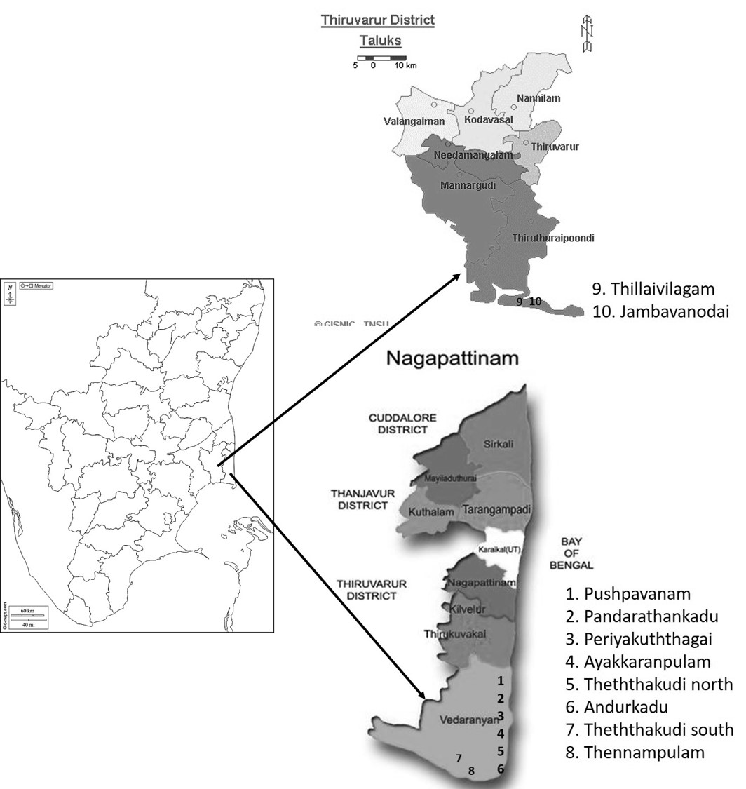
Figure 1. Map of the study area wherein tree regeneration study conducted.

2.2. Diversity indices

Shannon diversity (H), Shannon Equitability index (EH) and Simpson’s Dominance indices were computed as follows (as in Magurran, 1988).
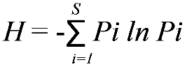
Where: H = the Shannon diversity index; Pi = fraction of the entire population made up of species i; S = number of species encountered; ∑ = sum from species 1 to species S. Shannon’s equitability (EH) is computed by dividing H by H_{max} (where H_{max} = lnS). Shannon’s evenness (EH) = H / H_{max} = H / ln S. Whilst, Simpson’s dominance index (D) was computed with following formula. D = ∑ ni(ni-1)/N(N-1) where D is measure of dominance; ni = the number of individuals in the i^{th} species; N = the total number of individuals of all the species in the sample.

2.3. Population structure
All the recorded young plants were classified into four height classes as per their height (cm): 1) < 20 cm; 2) 20.1-40 cm; 3) 40.1-100 cm; and 4) > 100 cm-< 10 cm gbh. The sum of young plants in each of the four height classes and their contribution to the site total density were computed. Population structure was determined at all study sites by calculating the contribution of four height classes to the site's young-plant density.
3. results and discussion

3.1. Density of seedlings (< 20 cm)

A total of 51630 seedlings were recorded from ten study sites. Seedling density varied from 1970 to 9050 ha-1. Among the study sites, JI recorded the lowest seedling density (1970 plants ha-1), while TN had the highest (9050 plants ha-1). On average, each site had 5163 ± 2507 seedlings ha-1 (Table 1).

Table 1. Details of quantitative assessment of seedlings and saplings recorded in study area. (top value of each category is in bold face).
Site | Species  richness ha⁻¹ | Seedling  density  ha⁻¹ | Sapling density  ha⁻¹ | Shannon  index (H) | Shannon equitability  Index (H’) | Simpson  index (D)
AU | 31 | 4930 | 4420 | 2.64 | 0.77 | 0.14
AM | 29 | 3230 | 1840 | 2.96 | 0.88 | 0.07
JI | 28 | 1970 | 1560 | 2.88 | 0.86 | 0.08
PK | 25 | 4650 | 3230 | 2.55 | 0.79 | 0.13
PI | 25 | 7990 | 6120 | 2.60 | 0.80 | 0.14
PM | 25 | 2890 | 2800 | 2.55 | 0.79 | 0.13
TM | 33 | 4770 | 4020 | 2.86 | 0.82 | 0.09
TN | 30 | 9050 | 4410 | 2.46 | 0.72 | 0.16
TS | 26 | 3600 | 2060 | 2.54 | 0.78 | 0.13
TV | 33 | 8550 | 7670 | 2.49 | 0.71 | 0.14
Mean±S.D. | 28.5 ± 3.20 | 5163 ± 2507 | 3813 ±  1954 | 2.65 ± 0.18 | 0.79 ±  0.05 | 0.12 ± 0.03

3.2. Density of saplings (> 20 cm-< 10 cm gbh)

A total of 38130 saplings were encountered in the study area. Sapling density per hectare ranged from 1560 to 7670 plants. Among the ten study sites, site JI had the lowest number of saplings (1560 plants per hectare), while site TV had the highest (7670 plants per hectare). The average sapling density was 3813 ± 1954 plants ha⁻¹ (Table 1).
Overall, the site TV recorded the highest number of young plants (16220 plants ha⁻¹), followed by PI (14110 plants ha⁻¹), and TN (13460 plants ha⁻¹). The site JI had the lowest number of young plants (3530 plants ha⁻¹), followed by AM (5070 plants ha⁻¹) and TS (5660 plants ha⁻¹) (Table 2).

Table 2. The ratios of young-mature plants in the study area
Site | Species  richness of young plant ha⁻¹ | Species  richness of mature plant ha⁻¹ | Density  of young plant ha⁻¹ | Density  of mature  plant ha⁻¹ | Young-Mature plant ratio (Y/M)
AU | 31 | 31 | 9350 | 791 | 11.90
AM | 29 | 30 | 5070 | 400 | 12.68
JI | 28 | 28 | 3530 | 397 | 8.89
PK | 25 | 25 | 7880 | 1084 | 7.27
PI | 25 | 25 | 14110 | 955 | 14.78
PM | 25 | 26 | 5690 | 638 | 8.92
TM | 33 | 33 | 8790 | 523 | 16.81
TN | 30 | 30 | 13460 | 957 | 14.07
TS | 26 | 26 | 5660 | 517 | 10.95
TV | 33 | 34 | 16220 | 1337 | 12.13
Mean±S.D. | 28.5 ± 3.20 | 28.8 ± 3.3 | 8976 ± 4308 | 759.9 ± 317.5 | 11.84 ± 2.94

The contribution of individual species to the site's young plant density varied considerably. In AM, Garcinia spicata had high young plant density (770 plants ha⁻¹), followed by Pongamia pinnata (630 plants ha⁻¹) and Syzygium cumini (540 plants ha⁻¹). Maytenus emarginata represented the least number of individuals (20 plants ha-1), followed by Borassus flabellifer and Manilkara hexandra (each 30 plants ha⁻¹).
In AU, the characteristic species Memecylon umbellatum contributed the maximum (3070 plants ha⁻¹) to the site's young plant density, followed by Diospyros montana (690 plants ha⁻¹) and Syzygium cumini (680 plants ha⁻¹). Species such as Ficus benghalensis, Chionanthes zeylanica, Flacourtia indica, and Borassus flabellifer contributed 0, 10, 10, and 20 plants ha-1 to the site's young plant density, respectively.
Of 3530 plants ha⁻¹, Syzygium cumini constituted the highest (660 plants ha⁻¹) followed by Atalantia monophylla (420 plants ha⁻¹) and Glycosmis mauritiana (290 plants ha⁻¹) whereas species such as Crateva magna, Ficus benghalensis and Ficus hispida contributed 20 plants ha⁻¹ each to site young plant density in JI.
Memecylon umbellatum (3300 plants ha⁻¹), Diospyros ebenum (2130 plants ha⁻¹), and Diospyros ferrea (1940 plants ha⁻¹) had the maximum share, while species such as Ficus benghalensis (20 plants ha⁻¹), Borassus flabellifer (40 plants ha⁻¹), and Flacourtia indica (80 plants ha⁻¹) had the minimum share in site young plant density at PI.
The characteristic, abundant species Memecylon umballatum represented with large number of young plants (2380 plants ha⁻¹) followed by Canthium dicoccum (880 plants ha⁻¹) and Diospyros ferrea (680 plants ha⁻¹). Canthium coromandelicum, Borassus flabellifer and Catunaregam spinosa and Breynia vitis-idaea respectively had 10, 20, and 30 young plants ha⁻¹ in PK.
Memecylon umbellatum (1790 plants ha⁻¹), Garcinia spicata (490 plants ha⁻¹), and Atalantia monophylla (470 plants ha⁻¹) had a high number of young plants, while Ficus benghalensis (0 plants ha⁻¹), Canthium coromandelicum, and Flacourtia indica (each with 20 plants ha⁻¹) had a low number of individuals in PM.
Out of 8790 young plants recorded, Garcinia spicata (2120 plants ha⁻¹), Atalantia monophylla (890 plants ha⁻¹), Syzygium cumini (740 plants ha⁻¹), Diospyros ferrea (640 plants ha⁻¹), and Benkara malabarica (510 plants ha⁻¹) contributed more than 500 young individuals to the site density in TM. Meanwhile, Diospyros ebenum (10 plants ha⁻¹), Securenega leucopyrus (20 plants ha⁻¹), and Catunaregam spinosa (20 plants ha⁻¹) recorded the lowest densities.
The abundant and characteristic species Memecylon umbellatum had a greater number of young plants (4670 plants ha⁻¹), followed by Glycosmis mauritiana (2090 plants ha⁻¹) and Syzygium cumini (1100 plants ha⁻¹). In contrast, Lepisanthes tetraphylla (20 plants ha⁻¹), Ficus benghalensis (30 plants ha⁻¹), and Pavetta indica (50 plants ha⁻¹) contributed fewer densities to the young plant community in TN.
In TS, Memecylon umbellatum (1390 plants ha⁻¹), Garcinia spicata (1320 plants ha⁻¹), and Glycosmis mauritiana (530 plants ha⁻¹) made up half of the young plant community, while Premna latifolia (10 plants ha⁻¹), Canthium dicoccum (30 plants ha⁻¹), and Lepisanthes tetraphylla (30 plants ha⁻¹) together constituted less than 2% of the young plant community.
Memecylon umbellatum (4670 plants ha⁻¹), Garcinia spicata (2550 plants ha⁻¹), and Tarenna asitaica (1690 plants ha-1) had a large number of young plants, whilst Euphorbia antiquorum, Ficus benghalensis, and Borassus flabellifer together had just 20 individuals in the site TV.
The mean young plant density obtained in study sites (mean = 8976 plants ha⁻¹) is comparable to that reported by Deb and Sundriyal (2011), who recorded 8619 young plants ha-1 (mean) in Indian tropical forests, and by Hossain (1994), who found 8928 young plants ha-1 in a dry forest in Bangladesh. Young plant density of this study is very low compared to Tripathi et al. (2008), who recorded 51,200-96,900 young plants ha⁻¹ in tropical evergreen forests of Meghalaya, India; Deb and Sundriyal (2008) recorded 17,648 and 16,110 young plants ha⁻¹ in two tropical evergreen forests of Arunachal Pradesh; Induchoodan (1993) found 12,000-64,000 young plants ha⁻¹ in tropical wet evergreen forests of Kerala, south India; Teketay (1997) documented 16,290 and 32,650 young plants ha⁻¹ in two dry Afromontane forests in Ethiopia; Aravena et al. (2002) recorded 38,000 to 76,000 young plants ha⁻¹ in a temperate evergreen forest, Chile; Donoso (1989) found 3,18,000 young plants ha⁻¹ in coastal forests of Chile; Donoso (1989) recorded 1.697 million young plants (including herb species) in Andes; and, Donoso and Nyland (2005) documented an average of 15,298 young plants ha⁻¹ in seven evergreen forests of Chile.
However, the mean young plant density recorded in this study is higher than in temperate evergreen forest of Chile (837 young plants ha⁻¹; Armesto and Fuentas, 1988); tropical evergreen forest of Eastern Ghats, Tamil Nadu (range = 252-624; mean = 484.25 ha⁻¹; Chittibabu, 2002); tropical semi-evergreen forest of Shervarayan hills, Tamil Nadu (range = 143-250; mean = 183.5 ha⁻¹); and tropical semi-evergreen forest of Arunachal Pradesh (692 ha⁻¹; Deb and Sundriyal, 2008).
A large number of factors affect young plant density in forests. Frugivores have a direct relationship with seed germination, seedling density, and survival. Dispersal modes such as scatter-dispersal and clump-dispersal largely influence young plant density (Howe, 1989). Seed predators, pathogens, and herbivores also play crucial roles in young plant density. In addition, the density and size of frugivores that depend on fruits for their food affects young plant density (Janson, 1983; Gautier-Hion et al., 1985; Chazdon et al. 2023). In general, forest gaps enhance seedling density and survival (Janzen, 1970; Armenta-Montero et al. 2023). Removal of fruit-bearing trees and hunting frugivores that depend on fruits for their nutrition also affects seedling density in forests (Howe, 1989).

3.3. Loss of individuals to developmental stages

The total number of individuals (seedlings + saplings + mature plants) recorded across sites varied considerably (range = 3927-17557 individuals ha⁻¹). On average, each study site had 52.94 ± 5.42% (range = 45.67-62.77%) of seedlings, 38.87% (mean = 30.59-43.69%) of saplings, and 8.19% (range = 5.61-10.11%) of mature trees. Present investigation recorded a net loss of 3.11 to 43.78% seedlings during seedling-sapling transition stage, and a loss of 66.44 to 84.4% saplings in developmental phase from saplings to trees. Survival rate of seedlings ranged from 5.61 to 12.10% (Table 3). These findings contrast with those of Deb and Sundriyal (2008). They recorded plant communities with 73, 25, and 2% of seedlings, saplings, and mature trees in evergreen forests at Arunachal Pradesh, India. Further, they recorded a net loss of 10-50% seedlings and 21-30% of saplings during transition stages. Several factors, including soil moisture (Mueller-Dombois et al. 1980; Teketay, 1997), light intensity (Whitmore et al. 1990), and soil nutrient availability (Ceccon et al. 2003), have been found to play crucial roles in seedling development and survival. Our study sites experience 4-6 dry months per year; hence, soil moisture could play a vital role in seedling survival. In addition, the present study sites have poor nutrient soils; thus, soil nutrients may also play significant roles in seedling survival. However, no studies have been conducted on effects of these factors on seedling survival in TDEFs. Long-term monitoring studies are needed to pinpoint the effects of biotic and abiotic factors on seed germination and seedling survival. Biotic factors, such as pathogens, herbivores, and frugivores, also play crucial roles in seedling survival in forests. Since no studies have been conducted to elucidate the effects of biotic factors on seed deposition, germination, and survival in TDEFs, further research is needed to examine the relationships between seeds and biotic factors, as well as between seeds and abiotic factors.

Table 3. Density and net loss of individuals during the transition from the seedling-sapling and sapling-mature phases in the study area.
Site code | Seedling  density (%) | Net loss (%) | Sapling  density (%) | Net loss (%) | Mature  trees (%)
AU | 4930 (48.60) | 10.35 | 4420 (43.60) | 82.10 | 791 (7.80)
AM | 3230 (59.06) | 43.04 | 1840 (33.64) | 79.26 | 400 (7.30)
JI | 1970 (50.17) | 20.81 | 1560 (39.72) | 74.55 | 397 (10.11)
PK | 4650 (51.87) | 30.54 | 3230 (36.03) | 66.44 | 1084 (12.10)
PI | 7990 (53.04) | 20.40 | 6120 (40.62) | 84.40 | 955 (6.34)
PM | 2890 (45.67) | 3.11 | 2800 (44.25) | 77.21 | 638 (10.08)
TM | 4770 (51.22) | 15.72 | 4020 (43.17) | 87.00 | 523 (5.61)
TN | 9050 (62.77) | 51.27 | 4410 (30.59) | 78.30 | 957 (6.64)
TS | 3600 (58.28) | 43.78 | 2060 (33.35) | 74.90 | 517 (8.37)
TV | 8550 (48.70) | 10.29 | 7670 (43.69) | 82.57 | 1337 (7.61)
Mean | 5163 (52.94) | 24.93 | 3813 (38.87) | 78.67 | 759.9 (8.20)
S.D. | 2507 (5.42) | 16.44 | 1954 (5.07) | 5.89 | 317.5 (2.00)

3.4. Species richness

Species richness of young plants per hectare ranged from 25 to 33 in the study area. The average species richness was 28.5 ± 3.20 species per hectare. The sites TV and TM had the highest number of species (each 33 species ha⁻¹), followed by AU (31 species ha⁻¹) and TN (30 species ha⁻¹), while the sites PI, PK, and PM contained the fewest species (each 25 species ha⁻¹) (Table 1) Botanical name and family of all the recorded plant species provided in Appendix 1.
Species richness of young plants (mean = 28.5 species ha⁻¹; range 25-33 species ha⁻¹) inventoried in this study is low compared to tropical forests of Bangladesh (39, 52 species; Hossain, 1994); dry Afromontane forests of Ethiopia (40-41 species ha⁻¹; Teketay, 1997); evergreen forests of northeast India (range 36-72 species ha⁻¹; Deb and Sundriyal, 2011); tropical evergreen forests of Arunachal Pradesh (44-87 species ha⁻¹; Deb and Sundriyal, 2008); and, evergreen forests of Eastern Ghats, south India (30-36; Chittibabu, 2002). However, the species richness of young plants obtained in this study is high compared to old-growth evergreen forests of Chile and the tropical semi-evergreen forest of Arunachal Pradesh. Donoso and Nyland (2005) recorded 10-16 young plant species ha⁻¹ in seven evergreen forests in Chile. Deb and Sundriyal (2008) found 20 young plant species ha⁻¹ in a semi-evergreen forest of Arunachal Pradesh. On the other hand, the species richness of young plant ha-1 recorded in this study is comparable to that of semi-evergreen forests of Shervarayan hills, south India (24-27 species ha⁻¹).
More than 90% of mature tree species were represented in seedlings and saplings at the study sites. This result suggests that the study area shows good regeneration. However, Ficus benghalensis did not occur as either a seedling or a sapling in AU, PM, and TV. Euphorbia antiquorum did not occur as young plants in TV. These findings suggest that the two species could lose their place in these forests very soon, as they were not represented in any of the four recognized height classes in this study. It is well known that a species must occur in substantial numbers as seedlings and saplings to ensure its continuous survival in the community (Taylor and Zisheng, 1988).

3.5. Diversity

Among the ten sites, AM recorded the highest Shannon index (H) value (H = 2.96), while TN recorded the lowest (H = 2.46). The mean Shannon diversity index (H) was 2.65 ± 0.18 (Table 1). As to Shannon equitability index (H’), the site AM had the maximum value (H’ = 0.88) and TV had the least value (H’ = 0.71). On average, each site had a Shannon equitability index of 0.79 ± 0.05 (Table 1). About Simpson dominance index (D), the site TN had a high (D = 0.16), followed by AU, PI, and TV (D = 0.14 each), while AM (D = 0.07), JI (D = 0.08), and TM (D = 0.09) recorded low values (Table 1).
The mean Shannon diversity index (H) recorded for young plant communities in the study area (2.65 ± 0.18) is more or less equal compared to tropical evergreen (mean = 2.61; Chittibabu, 2002) and tropical semi-evergreen forests (mean = 2.54; Kadavul, 1999) of Eastern Ghats, Tamil Nadu. Likewise, the calculated average Simpson dominance index (D = 0.12 ± 0.03) is similar to that of tropical forests (tropical evergreen forest, mean = 0.12, Chittibabu, 2002; tropical semi-evergreen, mean = 0.13).
All the recorded species contributed differently to the total site density and abundance, leading to differences in diversity indices across sites. Most of the species in site AM contributed equally to the total site density compared to other sites, resulting in a higher Shannon equitability index (0.88).
It has been recognized that the lower the Simpson dominance index (D) value, the more diverse the community is. Therefore, the site AM is relatively more varied than other sites in study area. In site AM, a large number of species contributed equally to the total density compared with those in the remaining sites. If one or a few species are dominant in an ecosystem, it is considered less diverse. If several species have relatively similar abundance, then it is recognized as a highly diverse ecosystem. It has been widely accepted that the forests of high species diversity are relatively healthier than forests of poor species diversity (McPherson and Rowntree, 1989; Thaiutsa et al. 2008). In this study, forest sites showed relatively unhealthy diversity, top five species constituted about 53.06 % of tree density in site AM, 59.68% in site AU, 51.27% in JI, 61.93% in PK, 64.07% in PI, 62.57% in PM, 55.75% in TM, 69.39% in TN, 65.19% in TS, and 71.21% in the site TV.

3.6. Young-Mature plant ratios

On average, each mature individual had 11.84 ± 2.94 young plants in the study area. Young-mature plant ratios differed from 7.27 to 14.78. The site PK had the lowest Y/M ratio (7.27), while PI had the highest (14.78) (Table 2).
Disturbances (manmade, browsing animals, pathogens, etc.) play critical roles in seed deposition, germination, growth, survival, and density. Among various disturbances, anthropogenic activities such as fruit, seed, and seedling collection, and forest clearance are widely reported as important factors that largely affect young plant density in forests. It is documented that each year, local people remove ground flora during festivals to sit and sleep on the forest floor at JI, PK, and PM; this severe disturbance reduces the ratios of young to mature plants in these sites. Site PK recorded the lowest ratio of young-to-mature plants at 7.27, followed by JI (8.89) and PM (8.92) (Table 2). Local people collect seeds for edible and medicinal purposes, and gardeners collect seeds and seedlings for sale. Seedling collection and browsing by domestic animals are evident and operational in AU and TS; these activities could contribute to reducing young plant density in these sites. Earlier, cattle browsing has been reported as an important factor that reduced the density of seedlings and saplings in semi-evergreen forests of the Eastern Ghats, South India. Several researchers, including Augspurger (1984), Augspurger and Kelly (1984), Barker and Kirkpatrick (1994), Gerhardt (1984), Chapman and Chapman (1997), found external disturbances such as heavy logging and animal browsing as influencing factors in regeneration and density of species in forests. Disturbance is very low or absent at sites AU, AM, PI, TM, TN, and TV; hence, these sites recorded high ratios of young-to-mature plants.

3.7. Relationship between mature and young plants

The density of adult plants (≥ 10 cm gbh) showed a positive relationship with the density of young plants (< 10 cm gbh). The correlation between young and mature plant densities was strong and positive across the study sites. The correlation coefficient of determination was r² = 0.71 (p<.0001) (Figure 2).
In all sites, the density of mature plants consistently correlates with the density of younger plant communities. Therefore, the number of mature trees influences the density of young plant populations in these forests. Many biotic and abiotic factors impact seed deposition, germination, seedling development, and survival. To date, no studies have been conducted to identify the factors that affect the population structure and survivability of young plants in TDEFs.

Figure 2. Relationship between young and adult plant density in the study area.
3.8. Population structure of predominant species

Four of six predominant species showed expanding population structures. Drypetes sepiaria recorded an expanding population structure in PI and PK, while in PM, the species showed a disturbed population structure. Similarly, Garcinia spicata exhibited an undisturbed population structure in PM, TS, and TV, but showed a disturbed population structure in TM (Figure 3).

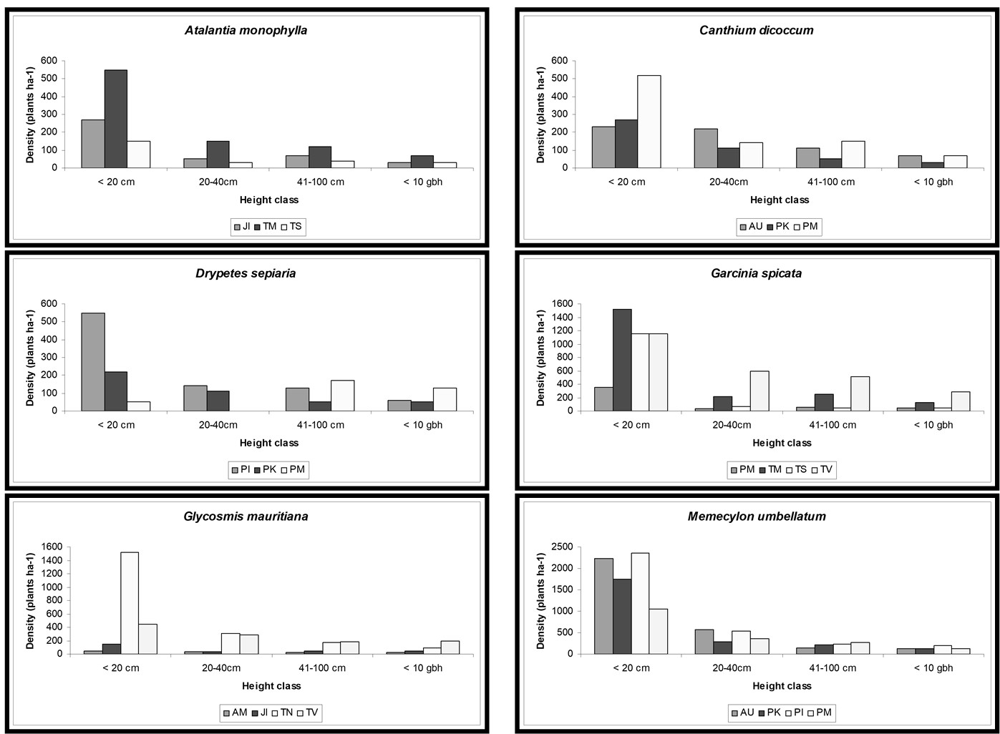
Figure 3. Young plant density of predominant species in the study area.

Suppose a species has a satisfactory number of plants in all three developing categories, namely, seedlings, saplings, and young trees. In that case, it shows expanding regeneration structure, whereas an insufficient number of plants in any of the three categories mentioned above signifies poor regeneration.
Throughout the world, researchers have identified many biotic and abiotic factors that influence the developmental dynamics of plant populations and communities. For example, the interaction between the density of frugivores (biotic) and the abundance of fruits, as well as the level and occurrence of disturbances, determine the population size of juvenile and mature trees in the forest community (Armesto and Pickett, 1985; Mishra et al. 2004).
Invariably, the density of seedlings (< 20 cm) was greater than that of saplings (> 20 to < 10 cm gbh) in all the sites. The transition from seedlings to saplings is crucial for species. Plants that successfully emerge as saplings can have a better chance of surviving in a forest community than seedlings.
When considering all four height classes together, seven sites — AM, AU, PI, PK, TN, TN, and TV — showed good regeneration, while three sites — JI, PM, and TS — exhibited a disturbed regeneration structure (Figure 4). In site JI, the second height class (< 20 cm) had fewer individuals (450) than the third (490) and fourth categories (620). Site PM had a larger number of plants in the third category (41-100 cm; 1070 plants) than in the second and fourth height classes. Meanwhile, in TS, the fourth category (> 100 - < 10 cm gbh) had a significantly higher number of plants compared to the second (640) and third (590) height classes. The disturbed population structure clearly indicates that disturbances—natural or manmade—are active in these sites. Of the ten study sites, seven had a reverse J-shaped population structure curve, indicating undisturbed populations and suggesting that no disturbances are active in these sites.

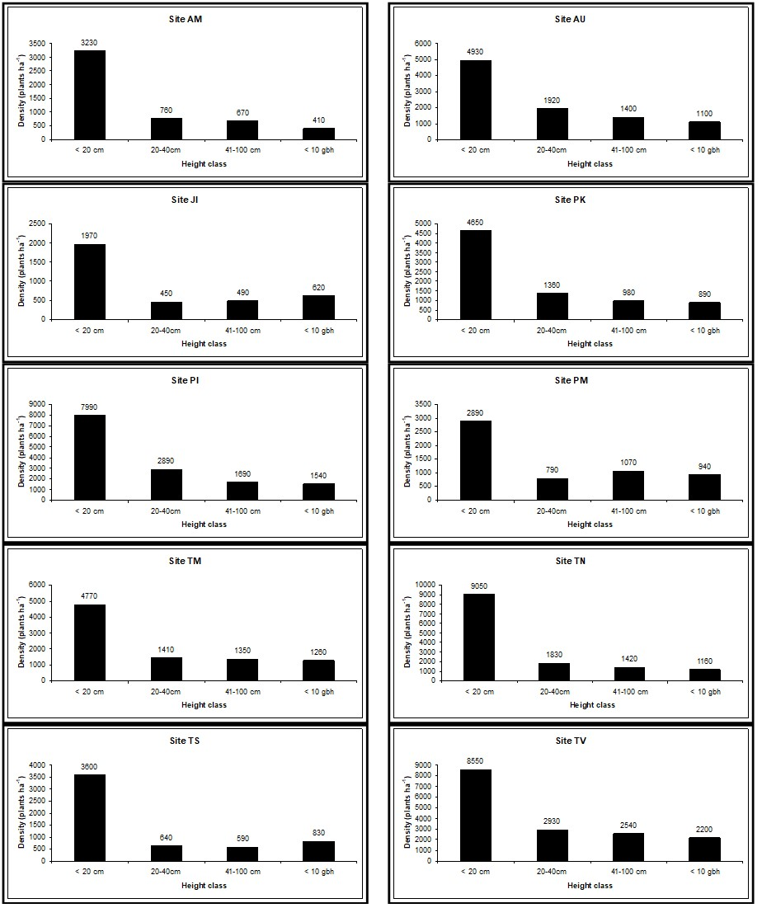
Figure 4. Height class-wise distribution of young plants in the study area

3.9. Regeneration status

The proportion of species showing good, fair, poor, and no regeneration varied considerably among study sites. Of the four regeneration classes, species in the good and poor categories were present in all ten sites, while no species exhibited fair regeneration in the study area. A single species in PM and two species in TV showed no regeneration (Table 4).

Table 4. Regeneration status of species in the study area.
Site | Regeneration status
Site | Good | Fair | Poor | No regeneration
AM | 9 | 0 | 20 | 0
AU | 10 | 0 | 21 | 0
JI | 14 | 0 | 14 | 0
PI | 10 | 0 | 15 | 0
PK | 14 | 0 | 11 | 0
PM | 9 | 0 | 16 | 1
TM | 9 | 0 | 24 | 0
TN | 8 | 0 | 22 | 0
TS | 9 | 0 | 17 | 0
TV | 13 | 0 | 18 | 2

It has been recognized that the information on regeneration status of a forest is an important tool in understanding of present and its future plant population, and as well as existing disturbance level (Kennard et al. 2002). In addition, it has been showed that quantification of density of young plants is important to identify the principal species, its persistence and capability of maintaining its dominance in subsequent generations (Martijena and Bullock, 1994). Moreover, composition of future vegetation could be predicted on the basis of the existing regeneration stand composition (Swaine and Hall, 1988).
In AM, a total of 15 species shows disturbed population structure. According to young plant density, Garcinia spicata dominated the forest’s understory followed by Pongamia pinnata and Syzygium cumini. This pattern shows that these three species may dominate the forest canopy in the near future. All these species have fewer than 30 individuals in the overstory. The dominant adult species Pterospermum canescens and Glycosmis mauritiana will lose their dominance in the future because these species have lesser number of juveniles than many other regenerating species. In addition, local people selectively cut branches of Pterospermum canescens for fuelwood. It is noted that local people collect the leaves of Glycosmis mauritiana for medicinal purposes, thereby limiting the regeneration of G. mauritiana. Due to greater levels of extraction, preferred species possibly become rarer in forest sites (Hare et al. 1997). Earlier, the scarcity of young plants of a few primary woody species has also been reported in tropical forests of Ghana (Swaine and Hall, 1988).
As in site AM, in site AU, 15 species also show somewhat disturbed population structure. When considering the population structure of all species and height classes together, this site shows an expanding population structure. Young plant density of the dominant, characteristic species, Memecylon umbellatum, ensures its dominance in the forest. This species is represented in all four height classes with a good number of individuals. Canthium dicoccum will lose its dominance in the future because Diospyros montana and Syzygium cumini have a larger number of young plants than C. dicoccum. Species that are absent in any of the four height categories could miss their place in the forest in the future.
Overall, the site JI shows a disturbed population structure of 28 young plant species, 16 show expanding population structure. With a good number of growing individuals, Atalantia monophylla ensures its dominance. While having fewer young plants, two predominant species, namely, Borassus flabellifer and Glycosmis mauritiana, could lose their dominance in the future. In areas with a large number of individuals, Syzygium cumini dominates the forest floor; hence, this species could become predominant in the future.
Among 25 young plant species, only four showed disturbed population structure in PI. By having a greater number of individuals in a growing population, four predominant species, Diospyros ebenum, D. ferrea, Drypetes sepiaria, and Memecylon umbellatum, ensure their dominance in the forest. Aglaia elaegnoidea and Canthium dicoccum may become pre-dominants or co-dominants in the future.
Nearly one-third of species are showing disrupted population structures in PK. The distinctive and dominant species Memecylon umbellatum maintains its prominence with 2380 young plants in the understory. A member of Rutaceae, Atalantia monophylla, may become a dominant species in the future because it has more young plants than some other leading species.
Approximately two-thirds of species display disturbed population structure in PM. Interestingly, a predominant species, Drypetes sepiaria, has a disturbed population structure. When considering the density of all four height classes together, the site shows a non-expanding population structure. The characteristic species of TDEF, Memecylon umbellatum, exhibits an expanding population structure with 1790 individuals on the forest floor. Among the four predominant species, Drypetes sepiaria could lose its predominance in the future. Atalantia monophylla may compete with pre-dominants to become one of the pre-dominants in the future.
On the site TM, nine species show disturbed population structure. With a good number of individuals in all four height classes, the predominant species (three species) conserve their predominance. Edible fruit-bearing Syzygium cumini could become a predominant species, along with the other two species, namely Benkara malabarica and Azadirachta indica.
Of the 30 species recorded, nine do not have representatives in any of the first, second, or third height classes at site TN. This finding signifies that these species could lose their places in the future. All three predominant species maintain their future predominance with ample numbers of young plants. However, three species, Canthium dicoccum, Diospyros ebenum, and Syzygium cumini, may compete with the pre-dominants to dominate the forest’s future canopy.
Half of the species do not have representatives in the first, second, or third height classes in site TS. By having a large number of young plants, the two predominant species, Garcinia spicata and Memecylon umbellatum, may continue to dominate. Atalantia monophylla and Pterospermum canescens could lose their dominant status in the future; these two have fewer younger individuals than Glycosmis mauritiana. Due to good representation of individuals in all four height categories, G. mauritiana could become a predominant one in the future.
Fourteen species did not have representatives in either the first, second, or third height classes on site TV. With 4670 young plants, the unique and characteristic species Memecylon umbellatum maintains its predominance. All four predominant species have a good number of individuals in all four height classes. With just 28 mature individuals in the canopy, Syzygium cumini has 1530 younger individuals in the forest’s growing young plant community. With this enormous number of seedlings and saplings, this species could become a predominant one in the future.
Previously, Swaine and Hall (1988) and Henle et al. (2004) found that the composition of a growing younger plant community would specify the composition of upcoming vegetation; however, over time, changing environmental conditions could invalidate this effect. Further, they stated that in the lack of natural calamities such as flood, cyclone, forest fire etc. the young plants will progressively form the future forest canopy.
In all our study plots, the species composition of overstories is similar to that of young plant layers. This result is not in line with that of Jones et al. (1994), Richards (1996), and Deb and Sundriyal (2008). They found that the species composition of juveniles on the forest floor differed from that of their respective overstories. The total forest area of the current study sites ranged from 1.1 to 2.7 ha; smaller forest areas and fragmentation could limit seed deposition of other species not recorded in the study plots. Earlier, Teketay (1997) found that fragmentation and the lack of long-distance seed dispersal were crucial factors that block the establishment of other species.

4. Conclusion

Density, diversity, and species richness of young plants recorded in the study area are comparable with those in the world’s dry and evergreen forests. Due to anthropogenic disturbances, three of ten sites exhibited a disturbed population structure in the study area. With sufficient numbers of young plants, Memecylon umbellatum maintains its dominance across seven sites. Because of the disturbed population structure, some currently dominant species may lose their dominance in the future. Conversely, a few species might compete with existing dominant species to become leaders with large numbers in young plant communities. Until now, studies in TDEFs have not been conducted to explore the relationships among young plant density and biotic and abiotic factors. Therefore, considerable research is needed to understand the factors influencing seed set and maturation, seed dispersal and deposition, seed germination, seedling development, and survival. A long-term monitoring study is essential to evaluate seedling survival strategies in TDEFs.

Disclaimer (Artificial Intelligence)
Author(s) hereby declare that NO generative AI technologies such as Large Language Models (ChatGPT, COPILOT, etc and text-to-image generators have been used during the writing or editing of this manuscript.

References

Ao, A., Changkija, S., & Tripathi, S. K. (2024). Patterns of forest community diversity, regeneration potential and carbon storages along an altitudinal gradient in Eastern Himalaya, India. Environmental and Sustainability Indicators, 22, 100399.
Aravena, M. C., Carmona, C. A., Perez, C. A., & Armesto, J. J. (2002). Changes in tree species richness, stand structure and soil properties in a successional chronosequence in northern Chiloe Island, Chile. Revista de Historia Natural, 75, 339–360.
Armesto, J. J., & Fuentes, E. R. (1988). Tree species regeneration in tree-fall gaps in a mid-elevation temperate rain forest in southern Chile. Vegetatio, 74(2–3), 151–159.
Armesto, J. J., & Pickett, S. T. A. (1985). Experiments on disturbance in old-field plant communities: Impact on species richness and abundance. Ecology, 66(1), 230–240.
Augspurger, C. K. (1984). Light requirements of neotropical tree seedlings: A comparative study of growth and survival. Journal of Ecology https://doi.org/10.2307/2259531

Augspurger, C. K., & Kelly, C. K. (1984). Pathogen mortality of tropical tree seedlings: Experimental studies of the effects of dispersal distance, seedling density, and light conditions. Oecologia, 61(2), 211–217.
Baidya, S., Sumant, S., Bhuyan, A., Hazarika, N. J., Thakur, B., Gogoi, N., ... & Devi, A. (2024). Tree population structure and carbon stock of tropical wet evergreen forest in Dehing Patkai National Park, Assam, Northeast India. International Journal of Ecology and Environmental Sciences, 50(2), 303-313.
Barnes, B. V., Zak, D. R., Denton, S. R., & Spurr, S. H. (1998). Forest ecology. John Wiley.
Barker, P. C. J., & Kirkpatrick, J. B. (1994). Phyllocladus asplenifolius: Variability in the population structure, regeneration niche, and dispersion pattern in Tasmanian forest. Australian Journal of Botany, 42(2), 163–190.
Ceccon, E., Huante, P., & Campo, J. (2003). Effects of nitrogen and phosphorus fertilization on the survival and recruitment of seedlings in two abandoned dry forests in Yucatán, Mexico. Forest Ecology and Management, 182(1–3), 387–402.
Chapman, C. A., & Chapman, L. J. (1997). Forest regeneration in logged and unlogged forests of Kibale National Park, Uganda. Biotropica, 29(4), 396–412. https://doi.org/10.1111/j.1744-7429.1997.tb00035.x
Chazdon, R., Norden, N., Colwell, R. K., & Chao, A. (2022). Monitoring recovery of tree diversity during tropical forest restoration: Lessons from long-term trajectories of natural regeneration. Philosophical Transactions of the Royal Society B: Biological Sciences, 378, 20210069. https://doi.org/10.1098/rstb.2021.0069
Chittibabu, C. V. (2002). Plant diversity inventories in undisturbed and human-impacted tropical evergreen forests of the Kolli hills, Eastern Ghats, India (PhD thesis). Pondicherry University.
Crow, T. R., & Metzger, F. T. (1987). Regeneration under selection cutting. In R. D. Nyland (Ed.), Managing northern hardwoods (Miscellaneous Publication 13, pp. 81–94). State University of New York, Faculty of Forestry.
Deb, P., & Sundriyal, R. C. (2008). Tree regeneration and seedling survival patterns in old-growth lowland tropical rainforest in Namdapha National Park, North-East India. Forest Ecology and Management, 255(12), 3995–4006.
Deb, P., & Sundriyal, R. C. (2011). Vegetation dynamics of an old-growth lowland tropical rainforest in North-east India: Species composition and stand heterogeneity. International Journal of Biodiversity and Conservation, 3(9), 405–430.
Donoso, C. D. (1989). Regeneration and growth in the evergreen forest type after cutting. Bosque, 10(1-2), 69–83.
Donoso, P. J., & Nyland, R. (2005). Seedling density according to structure, dominance and understory cover in old-growth evergreen forests in the coastal range of Chile. Revista Chilena de Historia Natural, 78(1), 51–63.
Gautier-Hion, A., Duplantier, J. M., Quris, R., Feer, F., Sourd, C., Decoux, J. P., Dubost, G., Emmons, L., Erard, C., Hecketsweiler, P., Moungazi, A., Roussilhon, C., & Thiollay, J. M. (1985). Fruit characters as a basis of fruit choice and seed dispersal in a tropical forest vertebrate community. Oecologia, 65(3), 324–337.
Gerhardt, T. D. (1984). Strength and stiffness of notched, green oak pallet (Research Paper FPL 452). U.S. Department of Agriculture, Forest Service, Forest Products Laboratory.
Hare, M. A., Lantagne, D. O., Murphy, P. G., & Chero, H. (1997). Structure and tree species composition in a subtropical dry forest in the Dominican Republic: Comparison with a dry forest in Puerto Rico. Journal of Tropical Ecology, 13(1), 1–17. https://doi.org/10.1017/S026646740001040X
Hossain, M. (1994). Tree species diversity of a natural forest: A study of Bamu reserve forest (Review Paper No. 226). Institute of Forestry and Environmental Sciences, University of Chittagong.
Howe, H. F. (1989). Scatter- and clump-dispersal and seedling demography: Hypothesis and implications. Oecologia, 79(3), 417–426.
Induchoodan, N. C. (1993). Ecological studies on the sacred groves of Kerala (PhD thesis). Pondicherry University.
Janson, C. H. (1983). Adaptation of fruit morphology to dispersal agents in a neotropical forest. Science, 219(4581), 187–189.
Janzen, D. H. (1970). Herbivores and the number of tree species in tropical forests. American Naturalist, 104(940), 501–528.
Janzen, D. H. (1986). Guanacaste National Park: Tropical ecological and cultural restoration. Editorial Universidad Estatal a Distancia.
Jones, R. H., Sharitz, R. R., Dixon, P. M., Segal, P. S., & Schneider, R. L. (1994). Woody plant regeneration in four floodplain forests. Ecological Monographs, 64(3), 345–367.
Kennard, D. K., Gould, K., Putz, F. E., Fredericksen, T. S., & Morales, F. (2002). Effect of disturbance intensity on regeneration mechanisms in a tropical dry forest. Forest Ecology and Management, 162(2–3), 197–208.
Koppad, G., Gowda, G. B., & Das, A. (2024). Assessment of Forest Composition, Structure and Biomass Dynamics Using Permanent Plot Inventories in Yellapur Forest Division, India. International Journal of Environment and Climate Change, 14(12), 342-359.
Krainovic, P. M., Brandão, D. O., & de-Miguel, S. (2025). Current constraints to reconcile tropical forest restoration and bioeconomy. Sustainability Science, 20(1), 219–229.
Lieberman, D., Hartshorn, G. S., Lieberman, M., & Peralta, R. (1990). Forest dynamics at La Selva Biological Station, 1969–1985. In A. H. Gentry (Ed.), Four neotropical rainforests (pp. 509–521). Yale University Press.
Magurran, A. E. (1988). Ecological diversity and its measurement. Princeton University Press.
Mansingh, A., Pradhan, A., Sahoo, S. R., Cherwa, S. S., Mishra, B. P., Rath, L. P., ... & Panda, B. P. (2025). Tree diversity, population structure, biomass accumulation, and carbon stock dynamics in tropical dry deciduous forests of Eastern India. BMC Ecology and Evolution, 25(1), 48. https://doi.org/10.1186/s12862-025-02385-9
Martijena, N. E., & Bullock, S. H. (1994). Monospecific dominance of a tropical deciduous forest in Mexico. Journal of Biogeography, 21(1), 63–74.
McPherson, E. G., & Rowntree, R. A. (1989). Using structural measures to compare twenty-two U.S. tree populations. Landscape Journal, 8(1), 13–23.
Mishra, B. P., Tripathi, O. P., Tripathi, R. S., & Pandey, H. N. (2004). Effects of anthropogenic disturbance on plant diversity and community structure of a sacred grove in Meghalaya, Northeast India. Biodiversity and Conservation, 13(2), 421–436.
Mueller-Dombois, D., Jacobi, J. D., Cooray, R. G., & Balakrishnan, N. (1980). Ohia rain forest study: Ecological investigations of the Ohia dieback problem in Hawaii (Miscellaneous Publication 183). Hawaii Institute of Tropical Agriculture.
Murali, K. S., Shankar, U., Uma Shaanker, R., Ganeshaiah, K. N., & Bawa, K. S. (1996). Extraction of forest products… Impact on regeneration and species composition. Economic Botany, 50(3), 252–269.
Oliver, C. D., & Larson, B. C. (1990). Forest stand dynamics. McGraw Hill.
Oluwajuwon, T. V., Chazdon, R. L., Ota, L., Gregorio, N., & Herbohn, J. (2024). Bibliometric and literature synthesis on assisted natural regeneration: An evidence base for forest and landscape restoration in the tropics. Frontiers in Forests and Global Change, 7, 1412075. https://doi.org/10.3389/ffgc.2024.1412075
Rajapakshe, R., Karthigesu, J., Thavananthan, S., Sivachandiran, S., Navaneetham, V., & Sinnamani, S. (2024). Restoring a dry tropical forest through assisted natural regeneration: Enhancing tree diversity, structure, and carbon stock. Trees, Forests and People, 17, 100616. https://doi.org/10.1016/j.tfp.2024.100616
Rakotoarisoa, M. V., Carrière, S. M., Randriambanona, H., Laques, A.-E., Rakotondrabe, T., & Randriamalala, J. R. (2025). Native tropical forest species regeneration in non-native eucalyptus tree plantations along the agricultural landscapes of south-eastern Malagasy highlands, Madagascar. Global Ecology and Conservation, 60, e03631. https://doi.org/10.1016/j.gecco.2025.e03631
Revathy, U., & Sundarapandian, S. M. (2025). Tree diversity and regeneration status of the endemic species-rich tropical montane shola forest in the central and southern Western Ghats, India: Emphasizing the need for conservation. Journal for Nature Conservation, 87, 126987.
Richards, P. W. (1996). The tropical rain forest: An ecological study. Cambridge University Press.
Shankar, U. (2001). A case of high tree diversity in a sal (Shorea robusta)—dominated lowland forest of Eastern Himalaya: Floristic composition, regeneration and conservation. Current Science, 81, 776–786. https://www.currentscience.ac.in/Volumes.aspx

Sundriyal, R. C., Sharma, E., Rai, L. K., & Rai, S. C. (1994). Tree structure, regeneration and woody biomass removal in a subtropical forest of Mamlay watershed, Sikkim Himalaya. Vegetatio, 113(1), 53–63.
Swaine, M. D., & Hall, J. B. (1988). The mosaic theory of forest regeneration and forest composition in Ghana. Journal of Tropical Ecology, 4(3), 253–269.
Taylor, A. H., & Zisheng, Q. (1988). Regeneration patterns in old-growth Abies-betula forest in Wolong natural reserve, Sichuan, China. Journal of Ecology, 76(4), 1204–1218.
Teketay, D. (1997). Seedling populations and regeneration of woody species in dry Afromontane forests of Ethiopia. Forest Ecology and Management, 98(2), 149–165.
Thaiutsa, B., Puangchit, L., Kjelgren, R., & Arunpraparut, W. (2008). Urban green space, street trees and heritage large tree assessment in Bangkok, Thailand. Urban Forestry & Urban Greening, 7(3), 219–229.
Tripathi, O. P., Pandey, H. N., & Tripathi, R. S. (2008). Effects of human activities on the structure and composition of woody species in the Nokrek Biosphere Reserve, Meghalaya. Journal of Plant Ecology, 32(1), 73–79.
Veblen, T. T. (2000). Disturbance patterns in southern Rocky Mountain forests. In R. L. Knight, F. W. Smith, S. W. Buskirk, W. H. Romme, & W. L. Baker (Eds.), Forest fragmentation in the southern Rocky Mountains (pp. 31–54). University Press of Colorado.
Whitmore, T. C. (1990). An introduction to tropical rain forests. Oxford University Press.
Williams, B. A., Beyer, H. L., Fagan, M. E., Chazdon, R. L., Schmoeller, M., Sprenkle-Hyppolite, S., Griscom, B. W., Watson, J. E. M., Tedesco, A. M., Gonzalez-Roglich, M., Daldegan, G. A., Bodin, B., Celentano, D., Wilson, S. J., Rhodes, J. R., Alexandre, N. S., Kim, D.-H., Bastos, D., & Crouzeilles, R. (2024). Global potential for natural regeneration in deforested tropical regions. Nature, 636(8041), 131–137. https://doi.org/10.1038/s41586-024-08106-4
APPENDIX

Appendix 1. Botanical name and family of plants recorded from the study area.
Binomial | Family
Aglaia elaeagnoidea (A .Juss .) Benth. | Meliaceae
Albizia lebbeck (L.) Benth. | Mimosaceae
Allophylus serratus (Hiern) Kurz | Sapindaceae
Anacardium occidentale L. | Anacardiaceae
Atalantia monophylla DC. | Rutaceae
Azadirachta indica A. Juss. | Meliaceae
Benkara malabarica (Lam.) Tirveng. | Rubiaceae
Borassus flabellifer L. | Arecaceae
Breynia vitis-idaea (Burm. f.) C.E.C. Fisch. | Euphorbiaceae
Calophyllum inophyllum L. | Clusiaceae
Canthium coromandelicum Alston | Rubiaceae
Canthium dicoccum (Gaertn.) Merr. | Rubiaceae
Carmona retusa (Vahl) Masam. | Boraginaceae
Cassia fistula L. | Caesalpiniaceae
Catunaregam spinosa (Thunb.) Tirveng. | Rubiaceae
Chionanthus zeylanicus L. | Oleaceae
Commiphora caudata Engl. | Burseraceae
Crateva magna (Lour.) DC. | Capparidaceae
Diospyros ebenum J. König | Ebenaceae
Diospyros ferrea (Willd.) Bakh. | Ebenaceae
Diospyros montana Roxb. | Ebenaceae
Diospyros peregrina Gurke | Ebenaceae
Drypetes sepiaria (Wight & Arn.) Pax & K. Hoffm. | Euphorbiaceae
Ehretia pubescens Benth. | Boraginaceae
Euphorbia antiquorum L. | Euphorbiaceae
Ficus benghalensis L. | Moraceae
Ficus hispida L. f. | Moraceae
Flacourtia indica (Burm. f.) Merr. | Flacourtiaceae
Garcinia spicata Hook. | Clusiaceae
Glycosmis mauritiana Tanaka | Rutaceae
Gmelina asiatica L. | Verbenaceae
Ixora pavetta Andrews | Rubiaceae
Lannea coromandelica (Houtt.) Merr. | Anacardiaceae
Lepisanthes tetraphylla (Vahl.) Radlk. | Sapindaceae
Madhuca longifolia (J. König ex L.) J.F. Macbr. | Sapotaceae
Manilkara hexandra (Roxb.) Dubard | Sapotaceae
Maytenus emarginata (Willd.) Ding Hou | Celastraceae
Memecylon umbellatum Burm. f. | Melastomataceae
Morinda coreia Buch. -Ham. | Rubiaceae
Ochna serrata L. | Ochnaceae
Pamburus missionis (Wight) Swingle | Rutaceae
Pavetta indica L. | Rubiaceae
Phyllanthus reticulatus Poir. | Euphorbiaceae
Pongamia pinnata (L.) Merr. | Papilionaceae
Premna latifolia Roxb. | Verbenaceae
Pterospermum canescens Roxb. | Sterculiaceae
Sapindus emarginatus Vahl | Sapindaceae
Sapium insigne (Royle) Benth. & Hook. f. | Euphorbiaceae
Securenega leucopyrus (Willd.) Muell.-Arg. | Euphorbiaceae
Streblus asper Lour. | Moraceae
Syzygium cumini (L.) Skeels | Myrtaceae
Tamarindus indica L. | Caesalpiniaceae
Tarenna asiatica Kuntze ex K. Schum. | Rubiaceae
Terminalia arjuna Wight & Arn. | Caesalpiniaceae
Thespesia populnea (L.) Sol. Ex Corrêa | Malvaceae

