Performance Evaluation of Mini-tractor operated Zero-till Planter for NEH Region
ABSTRACT
In this study, a zero-till planter matching to mini tractor for small farm mechanization wasdesigned, developed andits operating parameters were optimized in the laboratory for planting of mustard (L. Brassica nigra). Sowing of mustard is done in between 15 October to 15 November, majorly sowing of mustard is done by broadcasting method in which 8 to 10 kg seed is needed for sowing one hectare and if the sowing of mustard is delayed it affects the germination rate of seed as well as productivity of crop. Several designs of planters operated by various sources of power are available worldwide. Due to very less (0.01-0.03 ha h⁻¹) work rate of animal drawn planters, farmers of north- eastern hilly (NEH) region of India are reluctant to use them. The available tractor drawn planters are mostly designed for cereal crops and there is paucity of their performance evaluation for pulses and oilseeds. Moreover, they are large in size (11-13 tynes) making them unsuitable for narrow terraces and valley lands prevalent in NEH region. To reduce the cost of operation by saving seeds, minimizing the sowing time through timely sowing by planter and enhance the productivity of mustard crop by placing the mustard seeds at uniform depth, seed to seed spacing and row to row spacing zero till planter for small tractor was designed and developed according to the drawbar horsepower of mini-tractor besides considering the limitations of the small size hill farms of NEH region of India.To meet all these requirements three operating parameters with three levels namely seed metering cell diameter(A) (3.0, 3.5 and 4.0 mm), three hopper fill levels(B) (10, 20 and 30 mm) and three operating speeds(C) (2.0, 3.0 and 4.0 km h⁻¹) was optimized to get the best combination of operating parameter. Responses considered in this study were missing index (I_{miss}), multiple index (I_{multi}), quality of feed index (I_{q}), and degree of variation (I_{v}).Twenty-seven experiments (3×3×3) got from Taguchi experimental design were performed in the laboratory using sticky belt method and responses were recorded and evaluated thereafter. Lowest I_{miss} (9%), I_{multi} (10%), and I_{v} (12.3%) and highest I_{q}(81%) were observed at 3.5 mm cell diameter, 10.0 mm hopper fill and 2.0 km h⁻¹ forward speed at p < 0.05 significance level.
Keywords: Mustard planter, Taguchi experimental design, Signal-to-noise ratio, Missing index and Multiple index
INTRODUCTION
The North Eastern Region (NER) of India comprises of Arunachal Pradesh, Assam, Manipur, Meghalaya, Mizoram, Tripura, Nagaland and Sikkim States. The geographical area of its region is mostly hilly with about 10% area under valley of Manipur and Assam. The hills are predominantly under terrace cultivation with exception of some area under slash and burn cultivation. The cropping intensity of the region is about 130% with average mechanization level of 0.63 kW ha⁻¹ in year 2016-2017 (Layeket al., 2014). Most of the land is left follow after harvest of paddy (Roy, 2015).
The mustard (L. Brassica nigra) is oil seed crop grown under the rain fed condition in valleys by broadcasting.Crop yield increases as the level of mechanization increases due to timely farm operations, increased utilization efficiency of agricultural inputs, higher work quality, reduction in cost of operations and drudgery (Godaraet al., 2015). Through appropriate mechanization, the crop cultivation operations can be done timely that leads to intensive crop production system (Srigiriet al., 2016). To get the potential yield, seeds have to be placed at optimum soil moisture zone at recommended depth and spacing for proper germination and growth of crop. These requirements can only be achieved by the mechanical placement of seeds.
In India, sowing of mustard crop is done in betweenOctober to November after harvest of Kharif crops.Late sown mustard is exposed to high temperature and evaporative demand during its reproductive phase leads to prematurity and low productivity (Kumar et al., 2018). Sowing of mustard is mostly done by broadcasting method in which plant to plant spacing is not maintained.It is important to maintain the desired plant population through planting method that may help to avoid unnecessary plant population density and thereby additional thinning operation (Jangir et al., 2017).
Large size tractor mounted planters available in the market are not suitable under terrace cultivation and animal drawn planter have low work rate makes them ineffective. Small planters having 5-7 rows matching to mini tractors are available but they have not been designed for zero till planting.Also, their operating parameter has not been scientifically optimized. Therefore, to enhance the mechanization of mustard crop cultivationunder zero-till condition in NER and to get best possible performance parameters for sowing of mustard crop zero-till planter was developed. Further, an attempt has been made to optimize the metering parameters of seed metering device to get a better combination of operating parameters of the zero-till planter. The experimental design was developed using Taguchi design of experiment based on the sound to noise ratio (S/N ratio) and mean of the responses. Analysis of variance (ANOVA) was used to establish the effect of selected three independent variables on five dependent variables.
MATERIALS AND METHODS
- Development of planter
The agronomical requirement of mustard cultivation (30 cm row to row spacing and 10 cm seed to seed spacing) for better growth and plant yield was kept in mind while designing and developing of five rows zero-till mustard planter.
To maintain the row-to-row spacing 30 cm and plant-to-plant spacing 10 cm, the inverted-T furrow opener was fastened to the planter frame at a 30 cm distance. The seed plate was designed to distribute seeds at 10 cm intervals. The distance between furrow openers was adjusted to maintain different row spacing.
A vertical metering system was placed below the planter's hopper to accurately measure single seeds at a predetermined distance. The tractor's hydraulic mechanism allows for adjustable planting depths. The developed zero-till planter (Fig.1 and 2) consisting of frame, furrow openers, seed conveying pipe, mast for hitching, seed box, seed metering mechanism, chain and sprocket, ground wheel and connecting link. Engineering properties of mustard seeds i.e. Size, angle of repose were studied for the designing of the seed metering plate and to determine the hopper shape for better flow of seeds.
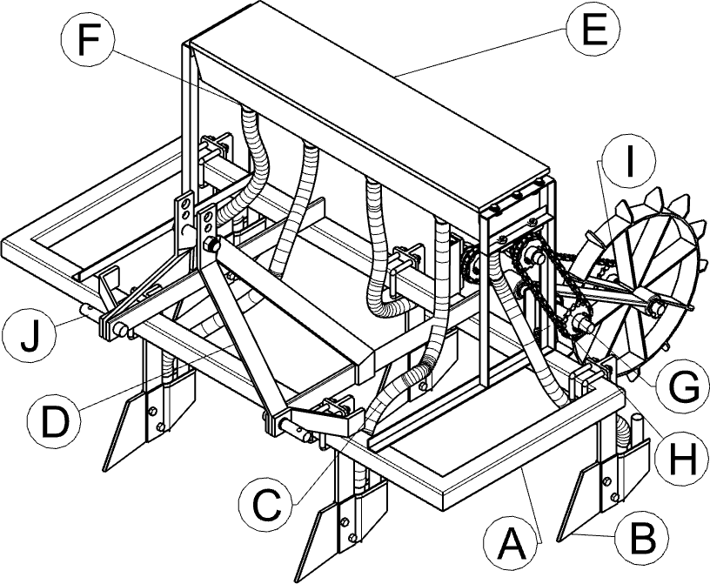
Fig.1 Isometric view of the zero-till planter

[A. Frame, B. Furrow opener, C. Seed conveying pipe, D. Mast for hitching, E. Seed hopper, F. Seed metering mechanism, G. Sprocket, H. Chain, I. Ground wheel, J. Connecting link.]
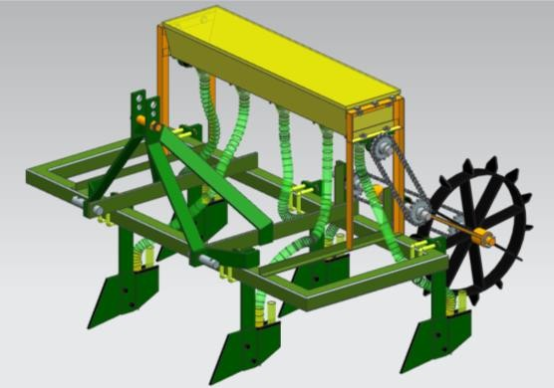

Fig.2 Developed zero-till planter
- Experimental Design layout
2.1 Research plan
The following experimental design was used to achieve the desired objective of optimizing the operating parameters and experimental design. The details of independent and dependent variables considered in this study are given in Table 1.
Table 1. Experimentaldesigninthepresentstudy

1.Independentvariables
Variables | Symbol | Levels | Valueof levels
i)Seed metering plate cell diameter (mm) | A | 3 | 3.0,3.5and 4.0
ii)Hopperfilllevel (cm) | B | 3 | 1.0,2.0 and3.0
iii)Forwardspeed(kmh⁻¹) | C | 3 | 2.0,3.0and 4.0
2.Dependentvariables
- Missing index, I_{miss}(%)
- Multiple index, I_{multi}(%)
- Quality of feed index, I_{y} (%)
- Degree of variation, I_{q} (%)
Taguchi design of experiment a statistical tool, was adopted in experimental design of the present study. Taguchi orthogonal array with full factorial design was used in arranging the factors and design of experiment (DOE) in combination with a particular order including the entire factors. Levels of independent factors (responses) as shown in Table 1 were selected to design the experiments. The total numbers of the experiments to be carried out were 27 as shown in the Table 2. The parameters were standardized to simplify computation and to deduce the relative effect of parameters on responses. Twenty-seven experiments with three replications were conducted in a laboratory test for finding more accurate results
Table 2 Full factorial design for control factors
Sl. No. | Factors
Sl. No. | Seed metering Cell (mm) | Hopper fill level (cm) | Operating speed  (km h⁻¹⁾
01 | 3.0 | 1 | 2
02 | 3.0 | 1 | 3
03 | 3.0 | 1 | 4
04 | 3.0 | 2 | 2
05 | 3.0 | 2 | 3
06 | 3.0 | 2 | 4
07 | 3.0 | 3 | 2
08 | 3.0 | 3 | 3
09 | 3.0 | 3 | 4
10 | 3.5 | 1 | 2
11 | 3.5 | 1 | 3
12 | 3.5 | 1 | 4
13 | 3.5 | 2 | 2
14 | 3.5 | 2 | 3
15 | 3.5 | 2 | 4
16 | 3.5 | 3 | 2
17 | 3.5 | 3 | 3
18 | 3.5 | 3 | 4
19 | 4.0 | 1 | 2
20 | 4.0 | 1 | 3
21 | 4.0 | 1 | 4
22 | 4.0 | 2 | 2
23 | 4.0 | 2 | 3
24 | 4.0 | 2 | 4
25 | 4.0 | 3 | 2
26 | 4.0 | 3 | 3
27 | 4.0 | 3 | 4

For data analysis, Taguchi method of experimental design and ANOVA were applied to evaluate the effect of treatments on responses. The aim of optimization was to minimize the I_{miss}, I_{multi}, I_{v}and maximize the I_{q}. For this purpose, “smaller-is-better” and “larger-is-better’ respectively wereused to find out the Signal-to-noise (S/N) ratio of responses. Following relationship were used to calculate the S/N ratio of responses
$$S/N_{s}=-10\log\left[\frac{1}{n}\sum_{i=1}^{n}{Y_{i}^{2}}\right]$$ | (1)
$$S/N_{l}=-10 log⁡\left[\frac{1}{n}\sum_{i=0}^{n}{\frac{1}{Y_{i}^{2}}}\right]$$ | (2)
Where$S/N_{s}$and ${S/N}_{l}$are signal-to-noise ratio for minimize and maximize respectively, dB; nis numbers of measurement and $y_{i}$is measured values, %.
- Experimental Method
The sticky belt setup having 10.0 m length, 0.6 m width was prepared according to Bureau of Indian Standard test code ISI 6316: 1993for laboratory experiment.The metering unit setup consisted of the frame of the planter, seed box, ground wheel, chain and sprocket for transmission of rotary power from the ground wheel to the metering mechanism. Seed tube was arranged in such a way that minimum dropping height could be achieved to prevent displacement of seeds after dropping. Metering mechanism setup was operated over the sticky belt as per the treatment combinations obtained from Taguchi experimental design and responses were measured. The responses were calculated by using the relationships recommended by Yadachiet al., 2013.
3.1 Missing index (I_{miss})
Missing index (I_{miss}) indicates the incapability of seed metering unit to drop even a single seed within the desired range of seed spacing. Missing index is the indicator of how often the seed skips the desired spacing. Missing index is the percentage of spacing greater than 1.5 times the theoretical spacing and it was calculated by using following standard relationship (equation 3)
I_{miss} = $\frac{n_{1}}{N}×100$ | (3)
where, I_{miss} = Missing index (%) ; n₁= Number of spacing ≥ 1.5 times of the theoretical spacing and N = Total numbers of measured spacing.
3.2 Multiple index (I_{multi})
Multiple index (I_{multi}) includes two or more seeds picked and dropped by the seed metering unit by a single groove in the metering plate. Multiple index is an indicator of more than one seed dropped within the desired spacing. Multiple index was calculated by using the following standard relationship (equation 4)
I_{multi} = $\frac{n_{2}}{N}×100$ | (4)
where, I_{multi} = Multiple index (%), n₂ = Number of spacing ≤ 0.5 times of theoretical spacing and N = Total numbers of measured spacing
3.3 Quality of feed index (Iq)
The quality of feed index (Iq) is the measure of how often the spacing is close to the theoretical spacing. It is the percentage of spacing that are more than half but not more than1.5 times the theoretical spacing (>0.5 and <1.5 times of theoretical spacing). The quality of feed index was calculated by using the equation (5)
I_{q} = 100 – (I_{miss +}I_{multi}) | (5)
where, Iq = Quality of feed index
3.4 Degree of variation (I_{v})
Degree of variation (I_{v}) is a measure of the variability in the spacing of the seeds after removing the variability due to skips and multiples. It is the coefficient of variance of the spacing that are classified as single and it was calculated by the equation (6)
I_{v} = $\frac{S_{d}}{S}$ | (6)
where, S_{d} = Standard deviation of the spacing more than half but not more than 1.5 times the theoretical spacing and S = Theoretical spacing between two seeds.
- Statistical Analysis
The laboratory data measured from the sticky belt and field data recorded were statistically analysed by using the Taguchi design of experiment. The experimental optimization was done using Minitab software version 19.1.1. The ANOVA was used to evaluate the significance of operating parameters (seed metering cell, hopper fill level and operating speed) and responses (missing index, multiple index, quality of feed index, degree of variation and mechanical seed damage) at 5% level of significance level.
RESULTS AND DISCUSSIONS
Effect of treatments on responses
To design the experiment and analysis of data, the ANOVA, and Taguchi method of experimental design were applied to evaluate the effect of treatments (also called control factors or fixed factors) [seed metering cell size (factor A), hopper fill height (factor B) and forward speed of planter (factor C)] on responses namely missing index (I_{miss} ), multiple index (I_{multi}), degree of variation (I_{v}) and quality of feed index (I_{f}). Full factorial design (3³) experiments having mixed orthogonal array were conducted in the laboratory on sticky belt and tabulated in Table 3.
Analysis of Signal-to-Noise ratio (S/N) ratio for responses
Operating parameters (i.e. control factors) based optimization of responses in the form of missing index, multiple index, quality of feed indexand degree of variance was carried out after estimation of S/N ratio for it (Table 3). All these response was measured for each experimental design combination using Taguchi experimental design and the same is given as control factors in Table 3 the lowest value of the missing index, multiple index and degree of variation and highest value of quality of feed index is very important for improving the seed placement in the soil for this reason, the “smaller-is-better” and “larger-is-better” option was selected for calculation of the S/N ratio in Minitab software for missing index, multiple index, degree of variation and quality of feed index, respectively. It was observed that the I_{miss} ranged between 9% to 17%, I_{multi} from 10% to 17%, I_{v} from 12.30% to 18.9% and I_{q} ranges from 71% to 81% respectively at different treatment combinations as obtained from Taguchi design. Value of responses for each combination of operating factor is presented in the Table 2. These values were within the range as reported by Bakhtiari and Loghavi, 2009; Kumar et al., 2015 and Singh et al., 2012.In Table 3, bold values indicate optimum S/N ratios at corresponding treatment and graphically presented in Fig. 3 to 6.
Table.3 Effect of treatments on responses at different combination levels
Sl. No. | Control factors |  |  | Responses (%)
Sl. No. | A  (mm) | B  (cm) | C  (km h⁻¹) | I_{miss} | S/N ratio for I_{miss} (dB) | I_{multi} | S/N ratio for I_{multi} (dB) | I_{v} | S/N ratio for I_{v} (dB) | I_{q} | S/N ratio for I_{q} (dB)
01 | 3.0 | 1 | 2 | 12 | -21.58 | 10 | -20.00 | 16.60 | 37.61 | 76 | -24.40
02 | 3.0 | 1 | 3 | 13 | -22.27 | 12 | -21.58 | 18.52 | 37.50 | 75 | -25.35
03 | 3.0 | 1 | 4 | 15 | -23.52 | 14 | -22.92 | 18.84 | 37.02 | 71 | -25.50
04 | 3.0 | 2 | 2 | 13 | -22.52 | 13 | -22.27 | 16.95 | 37.38 | 74 | -24.58
05 | 3.0 | 2 | 3 | 14 | -22.92 | 14 | -22.92 | 18.88 | 37.14 | 72 | -25.52
06 | 3.0 | 2 | 4 | 16 | -24.08 | 15 | -23.52 | 18.90 | 36.77 | 69 | -25.52
07 | 3.0 | 3 | 2 | 14 | -22.92 | 12 | -21.58 | 14.96 | 37.38 | 74 | -23.49
08 | 3.0 | 3 | 3 | 16 | -24.08 | 13 | -22.27 | 17.53 | 37.02 | 71 | -24.87
09 | 3.0 | 3 | 4 | 17 | -24.60 | 15 | -23.52 | 19.65 | 36.65 | 68 | -25.86
10 | 3.5 | 1 | 2 | 9 | -19.08 | 10 | -20.00 | 12.30 | 38.16 | 81 | -21.79
11 | 3.5 | 1 | 3 | 11 | -20.82 | 11 | -20.82 | 14.53 | 37.84 | 78 | -23.24
12 | 3.5 | 1 | 4 | 12 | -21.58 | 13 | -22.27 | 14.60 | 37.50 | 75 | -23.28
13 | 3.5 | 2 | 2 | 10 | -20.00 | 12 | -21.58 | 14.17 | 37.84 | 78 | -23.02
14 | 3.5 | 2 | 3 | 12 | -21.58 | 15 | -23.52 | 15.13 | 37.26 | 73 | -23.59
15 | 3.5 | 2 | 4 | 13 | -22.27 | 16 | -24.08 | 17.21 | 37.02 | 71 | -24.71
16 | 3.5 | 3 | 2 | 13 | -22.27 | 13 | -22.27 | 14.64 | 37.38 | 74 | -23.31
17 | 3.5 | 3 | 3 | 15 | -23.52 | 15 | -23.52 | 16.52 | 36.90 | 70 | -24.36
18 | 3.5 | 3 | 4 | 16 | -24.08 | 17 | -24.60 | 17.53 | 36.52 | 67 | -24.87
19 | 3.5 | 1 | 2 | 10 | -20.00 | 14 | -22.92 | 13.25 | 37.61 | 76 | -22.44
20 | 4.0 | 1 | 3 | 12 | -21.58 | 15 | -23.52 | 14.65 | 37.26 | 73 | -23.31
21 | 4.0 | 1 | 4 | 13 | -22.27 | 16 | -24.08 | 17.95 | 37.02 | 71 | -25.08
22 | 4.0 | 2 | 2 | 13 | -22.27 | 15 | -23.52 | 15.65 | 37.14 | 72 | -23.89
23 | 4.0 | 2 | 3 | 15 | -23.52 | 16 | -24.08 | 16.53 | 36.77 | 69 | -24.36
24 | 4.0 | 2 | 4 | 16 | -24.08 | 17 | -24.60 | 18.56 | 36.52 | 67 | -25.37
25 | 4.0 | 3 | 2 | 14 | -22.92 | 13 | -22.27 | 16.52 | 37.26 | 73 | -24.36
26 | 4.0 | 3 | 3 | 15 | -23.52 | 14 | -22.92 | 17.93 | 37.02 | 71 | -23.07
27 | 4.0 | 3 | 4 | 17 | -24.60 | 17 | -24.60 | 18.31 | 36.39 | 66 | -25.25

From Table 3, the results indicate that the missing index of metering mechanism increased with an increase in hopper fill level and operating speed whereas decreases with increasing seed metering cell size. This may be due to the fact that at higher speed, the available time for filling of cell was very short and cell could not be filled up. At higher hopper fill, there may be compaction of seed and it could not freely flow to fill the cell. Multipleindex of metering mechanism increased with an increase in hopper fill level and seed metering cell size whereas decreases with increasing operating speed. This may be due to operating speed was increased time required to fill the cell is very less. When the cell size is large, effect of both forward speed and hopper fill is nullified up to some extent. Quality of feed index of metering mechanism increased with an increase in operating speed and seed metering cell size. This may be due to quality of feed index is associated with the missing index and multiple index. Degree of variation of metering mechanism increased with an increase in operating speed and hopper fill level and decreased with increasing the seed metering cell size. This is in line with the findings by other researchers the values are in line with the findings by other researchers (Bakhtiari and Loghavi, 2009, Kumar et al., 2015 and Singh et al., 2012).

Table 4. Response table of S/N ratio at different treatments
Level | Missing index (dB) |  |  | Multiple index (dB)
Level | A | B | C | A | B | C
1 | -23.14 | -21.42 | -21.48 | -22.29 | -22.02 | -21.82
2 | -21.69 | -22.56 | -22.65 | -22.52 | -23.35 | -22.80
3 | -22.76 | -23.62 | -23.46 | -23.62 | -23.07 | -23.80
Delta | 1.45 | 2.20 | 1.98 | 1.33 | 1.33 | 1.98
Degree of variation (dB) |  |  |  | Quality of feed index (dB)
1 | -25.01 | -23.83 | -23.48 | 37.17 | 37.51 | 37.53
2 | -23.58 | -24.51 | -24.41 | 37.38 | 37.10 | 37.19
3 | -24.35 | -24.61 | -25.05 | 37.00 | 36.95 | 36.83
Delta | 1.43 | 0.80 | 1.57 | 0.38 | 0.56 | 0.71
A, B and C are cell dia, hopper fill and forward speed respectively and level 1, 2 and 3 are their values(level 1, 2 and 3of A are 3.0, 3.5 and 4.0 mm; level 1,2 and 3 of B are 10.0, 20.0 and 30.0 mm; level 1,2 and 3 of C are 2.0, 3.0 and 4.0 km h⁻¹) respectively.
From Table 4 and Fig. 3 to 6, it could be seen that highest values of S/N ratios were corresponding to level 1 of B and C and level 2 of A except multiple index where S/N ratio was highest for level 1 of A. Therefore, based on the S/N ratio, the treatment combination of 3.5 mm cell dia, 10.0 mm hopper fill and 2.0 km h⁻¹ forward speed were considered as optimized.
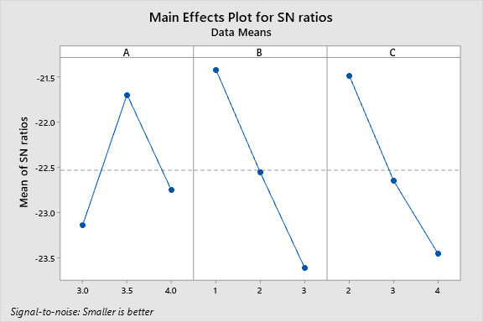

Fig. 3: Effect of operating parameters on S/N ratios for I_{miss}
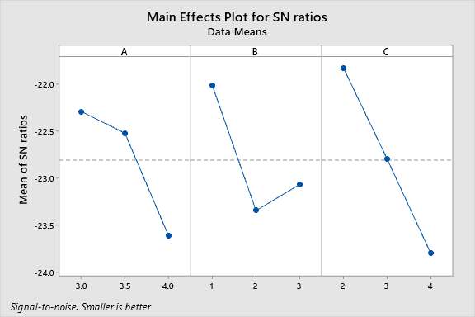

Fig. 4: Effect of operating parameters on S/N ration for I_{multi}
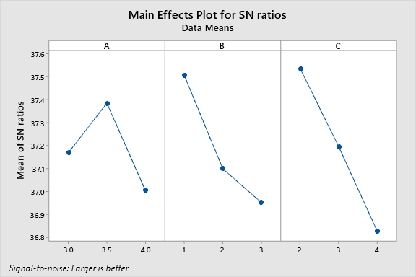

Fig. 5: Effect of operating parameters on S/N ratio for I_{q}
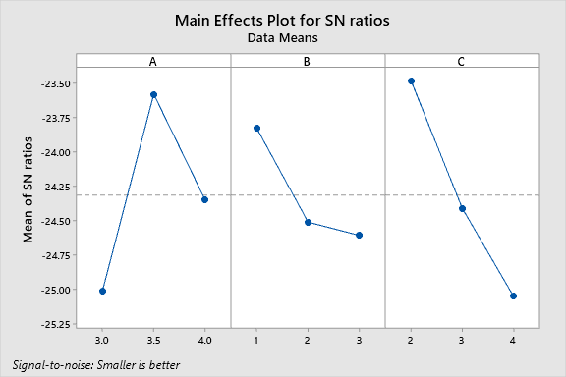

Fig. 6: Effect of operating parameters on S/N ratio for I_{v}
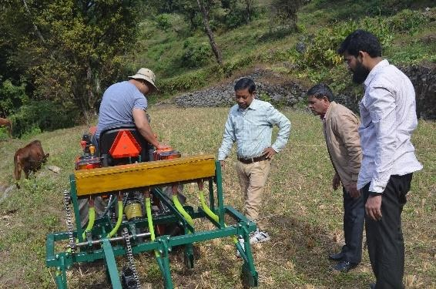
Fig.7 Performance evaluation of the planter
Table 5.Analysis of variance of responses
Missing index
Variance source | Degree of freedom (DF) | Sum of square (SS) | Mean square (MS) | F-Value | P-value | Contribution rate (%)
A | 2 | 21.556 | 10.7778 | 25.53^{S} | 0.000 | 17.86
B | 2 | 50.000 | 25.0000 | 59.21^{S} | 0.000 | 41.44
C | 2 | 40.667 | 20.3333 | 48.16^{S} | 0.000 | 33.70
Error | 20 | 8.444 | 0.4222 |  |  | 7.00
Total | 26 | 120.667 |  |  |  | 100.00
Multiple index
A | 2 | 22.30 | 11.1481 | 12.97^{s} | 0.000 | 21.65%
B | 2 | 19.85 | 9.9259 | 11.55^{s} | 0.000 | 19.28%
C | 2 | 43.63 | 21.8148 | 25.39^{s} | 0.000 | 42.37%
Error | 20 | 17.19 | 0.8593 |  |  | 16.69%
Total | 26 | 102.96 |  |  |  | 100.00%
Quality of feed index
A | 2 | 47.19 | 23.593 | 13.94^{s} | 0.000 | 13.78%
B | 2 | 105.41 | 52.704 | 31.14^{s} | 0.000 | 30.77%
C | 2 | 156.07 | 78.037 | 46.11^{s} | 0.000 | 45.57%
Error | 20 | 33.85 | 1.693 |  |  | 9.88%
Total | 26 | 342.52 |  |  |  | 100.00%
Degree of variation
A | 2 | 32.56 | 16.2820 | 19.83^{s} | 0.000 | 33.12%
B | 2 | 10.02 | 5.0086 | 6.10^{s} | 0.009 | 10.19%
C | 2 | 39.32 | 19.6589 | 23.94^{s} | 0.000 | 39.99%
Error | 20 | 16.42 | 0.8211 |  |  | 16.70%
Total | 26 | 98.32 |  |  |  | 100.00%
From the ANOVA Table 4, it may be seen that each treatment factors A, B and C had significant effect on responses.
Treatments (A, B, C) had significant effect on the responses at 5% significance level and 95% confidence level. It is also seen that the contribution of factor B i.e. hopper fill level was highest (41.44%) responsible factor for change in missing index. Change in I_{multi}was greatly (42.37%) influenced by forward speed. It may be due tocompaction of seed at higher hopper fill and with increase in operating speed, the time required to fill the cell is reduced. Therefore, I_{v} and I_{q} were mainly affected by the operating speed (45.57% and 40%).
Field performance
Field performance of zero-till planer was done on optimize operating condition, the performance of planter was assessed in terms of placing the seeds at uniform spacing 10 cm seed to seed, 30 cm row to row distance and depth of sowing was maintained 5 cm, due to this good germination of seed 92% and desired plant population was achieved. Effective field capacity and field efficiency were found 0.45 ha h⁻¹ and 75.82%, respectively
CONCLUSIONS
The signal-to-noise ratio based optimization of treatments indicated that the combination of 3.5 mm seed metering cell size, 10.0mm hopper fill level and 2.0 km h⁻¹ operating speed were found as the optimum operating parameters. ANOVA shows that all the three treatments considered in this study had significant effectson the responsesp < 0.05 significance level. The minimum values of missing index, multiple index, quality of feed index and degree of variation of the zero-till planter were 9%, 10%, 81% and 12.3% respectively. The contribution of operating speed and hopper fill level for change in responses were higher as compared to cell diameter. Optimize of operating condition was found good for operating the planter in field for sowing of mustard crop for reducing the cost of operation and to mechanize the oil seed (production) in NER region. Further a study can be done to assess the zero till planter on larger area and longer duration to check its field performance at optimize operating conditions.
ACKNOWLEDGEMENT
Authors acknowledge College of Agricultural Engineering and Post-Harvest Technology, Ranipool, Gangtok, Sikkim for using its facility to conduct the study.
REFERENCES
- Bakhtiari, M. R. and Loghavi, M. (2009). Development and evaluation of an innovative garlic clove precision planter. Journal of Agricultural Science and Technology, 11, 125-136.
- Godara,A; Sharma, M. and Sharma, A. K. (2015). Influence of different types of furrow openers on soil disruption for tractor drawn seed drill. Journal of Scientific and Engineering Research, 2(3), 1-8.
- ISI 6316: (1993). Test code for Sowing-Equipmentseed-Cum-Fertilizerdrill, Bureau of Indian standards, Manak Bhavan, New Delhi, India.
- Jangir,R.; Arvadia, L.K. and Kumar, S. (2017). Growth and yield of mustard (Brassica juncea L.), dry management. Int. J. Curr. Microbiol. App. Sci, 6(7), 2586-2593.
- Kumar, A.; Lal, M.; Mohan, N.; Kumar, M. and Kumar, N. (2018). Effect of different sowing dates on yield and yields attributes of Indian mustard (Brassica juncea L) genotypes. Int. J. Pure App. Biosci, 6(2), 848.
- Kumar, R.; Adamala, S.; Rajwade, Y.A. and Singh, H. V. (2015). Performance evaluation of a tractor mounted pneumatic planter for sorghum in dryland. African Journal of Agricultural Research, 10(39), 3767-3772.
- Layek, J.A.Y.A.N.T.A.; Chowdhury, S.A.M.I.K.; Ramkrushna, G.I. and Das, A. (2014). Evaluation of different lentil cultivars in lowland rice fallow under no-till system for enhancing cropping intensity and productivity. Indian Journal of Hill Farming, 27(2), 4-9.
- Roy, A. (2015). Food security in North-East Region of India. Conference Paper.​ NITI Aayog. (2021). Demand & Supply Projections Towards 2033.
- Singh, M. K.; Kumar, N.; Verma, P. and Garg, S.K. (2012). Performance evaluation of mechanical planters for planting of chickpea and pigeonpea. Journal of Food Legumes, 25(2), 131-134.
- Srigiri, D.; Veeraprasad, G.; Rajkiran, B. and Edukondalu, L. (2016). Performance evaluation of manually operated push type multi crop planter. International Journal of Agriculture Sciences, 3(2), 1624-1626.
- Yadachi, S.; Mani, I.; Kalra, M. S.; Kumar A.; Sahoo, P. K. (2013). Development and evaluation of inclined plate metering mechanism for carrot seed. Journal of Agricultural Engineering, 50(2), 10-16.

