Generation and Evaluation of Genomic Markers in Grapes (Vitis vinifera L.)
Abstract
The present study focused on the identification and validation of simple sequence repeat (SSR) markers associated with important berry traits in grapevine (Vitis vinifera L.). Young leaf samples from four grape genotypes and ten hybrids were used for DNA extraction and molecular analysis. High-quality genomic DNA was successfully isolated and quantified, confirming its suitability for PCR amplification. Microsatellite regions were identified from candidate gene sequences using the MISA tool, and primers were designed with Primer3Plus. Out of five designed SSR primers, four exhibited polymorphism among grape genotypes, while two demonstrated polymorphism in hybrid populations. These validated SSR markers serve as potential tools for genetic diversity analysis and marker-assisted selection in grape breeding programs aimed at improving berry quality traits.
Keywords: Vitis vinifera, SSR markers, polymorphism, berry traits.
Introduction
Grapes (Vitis vinifera L.), belonging to the family Vitaceae, are among the most ancient and economically valuable fruit crops in the world. Their cultivation dates back to over 6,000 years and they have been integral to cultural, religious, and economic activities in various civilizations. Grapes are cultivated in diverse climatic zones across the globe, including temperate, subtropical, and tropical regions. The primary uses of grapes include fresh consumption (table grapes), dried forms (raisins), fermented beverages (wine and liquor), juices, and vinegar. Their wide application in food, beverages, and industrial sectors highlights their socio-economic significance (Alleweldt et al., 1990; Reisch and Pratt, 1996). Globally, grape production covers approximately 7.4 million hectares, yielding over 75 million tonnes annually. The majority of the production is concentrated in countries such as Italy, Spain, the United States, France, and China. While Europe has traditionally dominated viticulture, emerging economies such as India, Brazil, and South Africa are gaining prominence due to technological advancements, varietal improvement, and enhanced export-oriented cultivation practices (Kok, 2014).
In India, grape cultivation has greatly expanded over the past few decades, most notably in Maharashtra, Karnataka, Tamil Nadu, together with Mizoram. About 20 commercial varieties are cultivated in the country, a select few economically dominant. These include ‘Thompson Seedless,’ ‘Sharad Seedless,’ and ‘Flame Seedless,’ alongside ‘Anab-e-Shahi.’ According to the 2023–24 data set al, grape cultivation now in India covers an area over 1,75,930 hectares. Maharashtra's contribution is with more than 80% of the national production. India also surfaced as a large table grape exporter, so export volumes totalled 343,982 metric tons including over USD 417 million value. Europe, the Middle East, together with Southeast Asia import Indian grapes due to strict quality control standards, cold chain infrastructure, plus improved post-harvest technology.
Important traits can include berry size, weight, color, firmness, sweetatness (measured as TSS), and also acidity. Texture, as well as the seed content, happen to be important traits for them. These traits have influence toward direct consumption. Berry size is a critical trait within wine and table grape industries. Smaller berries are often preferred within wine production because their high skin-to-pulp ratio improves the extraction of anthocyanins, tannins, and other phenolic compounds (Matthews and Nuzzo, 2007). Big, hard, unseeded grapes do well in the table grape market al. They also need a crisp texture in order to have bet alter consumer appeal as well as transportability. Berry firmness, determined largely through cell wall structure and mesocarp turgidity, is necessary for mechanical resilience and maintaining post-harvest shelf life (Lin et al al., 2023). Berry traits are, however, influenced quantitatively and inherited through environmental interactions and multiple genes. Temperature, water availability, pruning methods, along with canopy management greatly affect berry size. Sugar accumulation and ripening uniformity are affected by these factors (Barbagallo et al., 2011; Melo et al., 2013).
Molecular markers, different from morphological as well as biochemical markers, are abundant all through the genome, stable, also environment-independent. RAPDs, AFLPs, RFLPs, SNPs, also SSRs are major classes of molecular markers. Marker systems began with RFLP in the 1980s and progressed to PCR-based markers such as AFLP and RAPD (Nadeem et al., 2017). Genomics provides insights into sequence polymorphisms like SSRs and SNPs, which are foundational for molecular marker creation (Sinha et al., 2021). Next came highly informative SSRs and SNPs, which were hastened by next-generation sequencing (NGS) technologies (Abbas et al., 2024). These markers have applications within various fields. On account of their high polymorphism, codominance, reproducibility, as well as ease of PCR amplification, SSRs (Simple Sequence Repeats or microsatellites) are particularly helpful to grape research among these (Ashley and Dow, 1994; Sefc et al., 2001). SSRs were classified as simple perfect, simple imperfect, compound perfect, or compound imperfect (Wang et al,2009). The development of SSR markers for grapes has greatly improved by initiatives like the Vitis Microsatellite Consortium (VMC), which identified over 350 loci widely used in research (Riaz et al., 2004).
SSR markers have been used successfully for genetic diversity and germplasm characterization. They have also been used for fingerprinting of cultivars along with clone verification in addition to marker-trait association studies. Important traits like berry weight, size, firmness were mapped via QTL (Guo et al., 2019; Razi et al., 2020).
For the development of SSR primers, it can be labor-intensive for large populations. Genotyping based on capillary electrophoresis is also costly (Guichoux et al., 2011). These markers are PCR-based, locus-specific, and occur in both coding and non-coding regions. SSRs are widely used in genetic diversity studies, linkage and QTL mapping, cultivar identification, and marker-assisted selection in crops such as grapevine, rice, and wheat (Gupta & Varshney, 2000). SSR are highly applicable in breeding as they are multi allele, co dominant and highly informative and occurs with high relative number, good coverage across the genome and can be experimentally reproduced (Pan, 2010; Powell et al., 1996; Pan et al., 2006). For marker-assisted breeding, trait-specific markers are indeed important because they enable rapid screening of progenies for those desired traits. QTL mapping as well as association studies have identified chromosomal regions linked to these traits. Yet, genetic backgrounds need validation across diverse sets because many regions are population-specific. Therefore, the current focus rests on developing SSR markers linked to validated QTLs and confirming they associate in multiple populations and environments (Pei et al., 2023; Ahmad et al., 2018).
Materials and Methods
The grape accessions and grape hybrids maintained in germplasm field at NRC Grapes, Pune. Sample of young, pale green coloured leaves from the shoot tips of a single healthy plant per accession were collected and utilized for DNA isolation. A total of 14 DNA samples were isolated, comprising 4 grape genotypes and 10 grape hybrids, which were utilized for the further validation of molecular markers. Name of the accessions and hybrids are listed in Table 1. and Table 2. Extraction of DNA from young healthy leaves of grapes was carried out using MagGenome kit (Cat No.- MG20PIL-50).
Table 1. List of grape genotypes
Sr. No. | Name of Variety | Sr. No. | Name of Variety
1 | Muskat of Alexandria (R6/5) | 3 | Viognier (R28/02)
2 | Red Globe (R15/01) | 4 | Petit Syrah (R34/05)

Table 2. Grape hybrids for the validation of SSR markers
Sr No. | Name of Grape hybrid | Sr No. | Name of Grape hybrid
1 | L24/84 | 6 | L25/103
2 | L24/111 | 7 | L25/121
3 | L24/68 | 8 | L24/63
4 | L24/65 | 9 | L25/89
5 | L24/100 | 10 | L24/42

Quantification of DNA and Quality Check
Nanodrop Quantification
DNA was quantified using NanoPhotometer to determine the concentration of DNA. A 1–2 µl of each DNA sample was loaded and absorbance was measured at 260 nm and 280 nm. Samples at A 260/280 with a ratio ~1.8 to 2.0 were considered to be of good quality and free from protein contamination. The quality of DNA was tested on agarose gel electrophoresis.
Agarose Gel Electrophoresis
Quality of genomic DNA was examined on agarose gel by comparing with the λ Hind III Double digest DNA ladder. Agarose gel of 0.8 % was prepared using 1X TAE buffer. After the gel cooled then ethidium bromide (Sigma) was added. The liquid gel was poured into the gel casting tray, into which a comb had been previously put. A DNA sample in combination with loading dye was loaded into each well of the gel. λ Hind III Double digest DNA ladder was loaded as a control in the adjacent well. The electrophoresis was carried out at 70V for 1h. DNA was visualized under a gel documentation unit. After quantification, DNA was diluted to 10-25 ng/µl with sterile double-distilled water. The diluted DNA was subsequently used for PCR amplification.
Microsatellite Analysis
The Grape genome sequence available in the public domain was used to design primers for selected candidate genes and to identify the microsatellite regions in and around candidate genes using web software. Primers were designed in the flanking microsatellite regions.
Sequence Retrieval using JBrowser
The candidate gene sequence was obtained using its chromosome number and gene ID. FASTA format of the sequence was obtained by using JBrowser including 4000 bp upstream and 4000 bp downstream sequence of the gene. Exported this region in FASTA format for SSR analysis.
SSR repeat identification using MISA
Perfect dinucleotide to hexanucleotide simple sequence repeats were identified using the MISA tool, specifying a minimum of six dinucleotide and five tetranucleotide to hexanucleotide repeats. It took an input sequence file in FASTA format and could process multiple FASTA files. The minimum number of repeats (e.g., no single base repeats: set to 0) was set. MISA identified and outputs SSR motifs with their positions and types (e.g., di-, tri, tetra-nucleotide repeats). Results of the microsatellite search were stored in two files:
1. In "<FASTfile>.misa" the localization and type of identified microsatellite(s) were stored in a table wise manner.
2. The file "<FASTfile>.statistics" summarizes different statistics as the frequency of a specific microsatellite type according to the unit size or individual motifs.
Primer Designing Using Primer3Plus
The SSR obtained region was highlighted and ~150 bp of upstream and downstream Sequence were extracted. Primer3Plus software was used to design the primers in flanking regions. The designed primers were synthesized by a commercial service provider. The sequence of the designed primers given in Table 3.
Table 3. List of microsatellite primers with sequence information
Sr No | Primer Name | Sequence (5’ to 3’) |  | Tm(⁰C)
1 | VIT03_1290_MS2 | F | AGTTAGGGTTGAGTTGTGGA | 56
1 | VIT03_1290_MS2 | R | TAAAACCCATAGCCACTCCA | 56
2 | VIT03_1660_MS4 | F | GATCCAAGGAAGAGGAAGGA | 56
2 | VIT03_1660_MS4 | R | AGGTTACATTCAGACCCACA | 56
3 | VIT04_0270_MS1 | F | AGTCATGTATATCCTATATCTTGACT | 55
3 | VIT04_0270_MS1 | R | AGAGAGACCAATAGTTTCCA | 55
4 | VIT05_0510_MS2 | F | ATGAGATTCTGAAAGCGAGG | 54
4 | VIT05_0510_MS2 | R | AATTTAGACCCGGAAACCTC | 54
5 | VIT05_1400_MS | F | GGCAAAACTGAGGATTGAGA | 55
5 | VIT05_1400_MS | R | AAATTTAGGGACAGGCACAC | 55

PCR Reaction
KAPA Taq PCR kit (REF KK1015) was used for the PCR amplification. Prepared PCR master mix per reaction (20 µl total volume):
Table 4. PCR Reaction master mix components
Component | Volume (1X)
10X PCR buffer (with MgCl₂) | 2.0 µl
dNTPs (10 mM) | 1.6 µl
Forward Primer (10 µM) | 0.8 µl
Reverse Primer (10 µM) | 0.8 µl
Taq DNA Polymerase | 0.2 µl
Template DNA | 2.0 µl
Nuclease-free water | 12.6 µl
Total | 20 µl

Screening of Primers
Four grape genotypes (Table 1) were used for screening of 5 primers (Table 4) using standardised PCR parameters for each primer. Polymorphic markers identified through this screening were subsequently used for the analysis of the hybrid population. PCR amplification was performed for 35 cycles to study the polymorphism pattern.

Validation of SSR Markers
Validation of SSR markers was carried out using a hybrid population. Only polymorphic SSR markers were used for this purpose. A total of 10 hybrids, as listed in Table 2. were used for validation. The PCR parameters as described above were used.
Gel Documentation and Visualization
Electrophoresis was performed at 70 V for 1–2 hours when analysing 2 genotypes during temperature optimization or to assess polymorphism. After gel electrophoresis, the gel was carefully taken out, and a photograph was taken on a gel documentation system. SSR marker polymorphism was confirmed through distinct banding patterns observed on gel electrophoresis across 10 grape hybrids.
Results and Discussion
Young leaf tissues were collected from the shoot tips of a single healthy plant of each accession and used for DNA extraction. The extracted DNA was of high quality, with concentrations ranging from 120 to 450 µg/µL. Nanodrop analysis revealed A260/280 ratios greater than 1.8, indicating minimal protein contamination and good purity (Tables 5. and Table 6). Furthermore, agarose gel electrophoresis of 4 genotypes and 10 hybrids (Plate 1.) revealed a single, intact, high-molecular-weight DNA band for each sample, confirming the integrity and suitability of the DNA for downstream molecular analysis.
Table 5. DNA quantification of four grape genotypes
Sr No. | Grape Accession | Concentration | A260/280 | A260/230
1 | R06/05 | 445.75 | 1.64 | 0.84
2 | R15/01 | 177.20 | 1.73 | 1.24
3 | R15/08 | 124.90 | 1.78 | 1.49
4 | R19/01 | 206.00 | 1.74 | 1.10

Table 6. DNA quantification of ten grape hybrids
Sr No. | Name of Grape hybrid | Concentration | A260/280 | A260/230
1 | L24/84 | 96.35 | 2.0 | 0.8
2 | L24/111 | 123.85 | 1.7 | 0.5
3 | L24/68 | 104.30 | 1.8 | 0.5
4 | L24/65 | 267.15 | 2.0 | 1.0
5 | L24/100 | 70.95 | 1.6 | 0.2
6 | L24/123 | 70.20 | 1.59 | 0.63
7 | L24/58 | 136.05 | 1.9 | 0.8
8 | L25/36 | 72.75 | 1.7 | 1.6
9 | L24/76 | 117.75 | 1.74 | 0.98
10 | L24/79 | 96.95 | 1.8 | 0.5

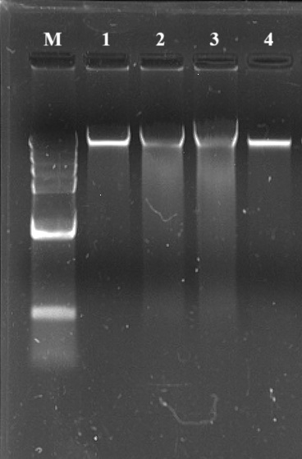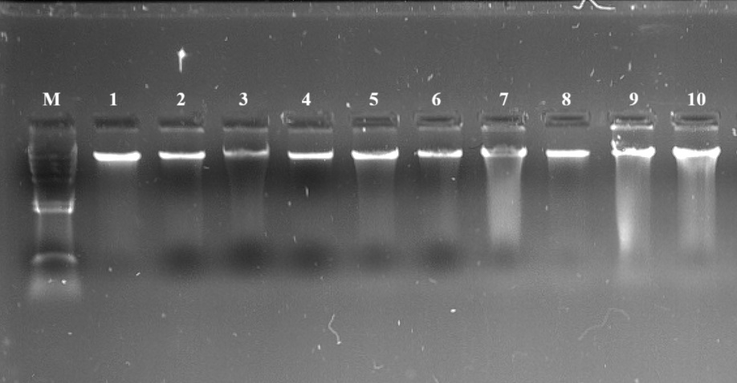
Plate 1: Agarose Gel Electrophoresis of Genomic DNA Extracted from Grape Genotypes and Hybrids. M – λ Hind III Double digest DNA ladder
Identification of Microsatellite Regions
The genome sequence for 5 candidate genes was retrieved in FASTA format using the JBrowse genome browser. The MISA program was used to identify perfect simple sequence repeats (SSRs) ranging from di-nucleotide to tetra-nucleotide motifs, along with their types and positions within the sequence
Primer Design
The SSR-containing region was identified, and approximately 150 bp of upstream and downstream sequences were extracted. Primers were designed from the flanking regions using Primer3Plus software. For this study, 5 microsatellite regions were selected for primer design. Each candidate gene was represented by at least one microsatellite region. The list of designed primers is given in Table 7.
Standardisation of Annealing Temperature
The designed primer pairs had different Tm depending upon GC content. Therefore, optimal annealing temperature was determined for each primer pair to avoid nonspecific amplification and primer dimer. Gradient thermal cycler was used to amplify four DNA samples at three different temperatures. The annealing temperature varied from 53-58℃. The optimised annealing temperature for each primer is given in Table 7
Table 7. Optimised annealing temperature for different primers
Sr. No. | Primer Name | Annealing temperature
1 | VIT03_1290_MS2 | 56
2 | VIT03_1660_MS4 | 56
3 | VIT04_0270_MS1 | 55
4 | VIT05_0510_MS2 | 55
5 | VIT05_1400_MS | 55

Screening of Primers for Polymorphism
Microsatellite (SSR) analysis was conducted using 5 genotypes (Table 1) and 5 primer pairs (Table 7). Out of these, 4 primers were found to be polymorphic (Table 8), one was monomorphic. Only the polymorphic primers were selected for further analysis. The representative gel of primer screening is shown in plates 2 - 4.
Table 8. SSR primer amplification and polymorphism analysis
Sr. No. | Primer Name | Amplification Result | Polymorphism Status
1 | VIT03_1290_MS2 | Amplified | Monomorphic
2 | VIT03_1660_MS4 | Amplified | Polymorphic
3 | VIT04_0270_MS1 | Amplified | Polymorphic
4 | VIT05_0510_MS2 | Amplified | Polymorphic
5 | VIT05_1400_MS | Amplified | Polymorphic

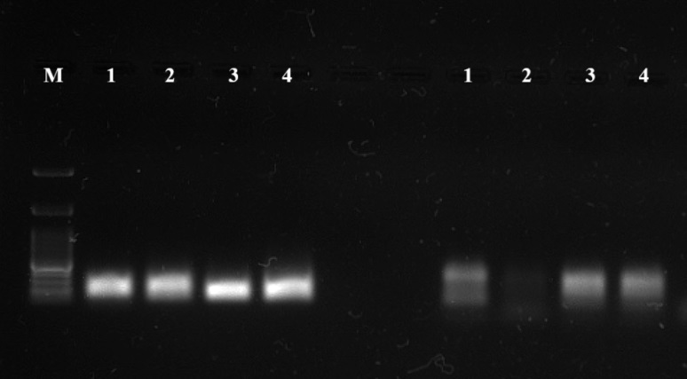
Plate 2: Amplification of DNA using primer VIT03_1660_MS4 and VIT 04_0270_MS1 showing polymorphism bands among four genotypes

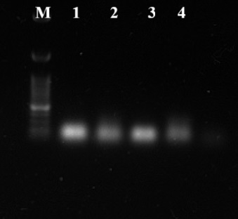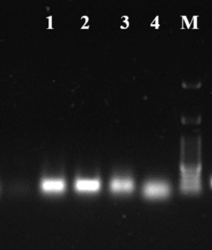
Plate 3: Amplification of DNA using primer VIT 03_1290_MS2 and VIT05_0510_MS2 showing monomorphic and polymorphic bands among four genotypes respectively

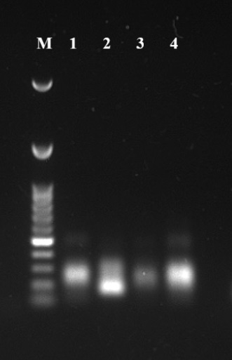
Plate 4: Amplification of DNA using primer VIT05_1400_MS showing polymorphism bands among four genotypes

Validation of SSR Markers
SSR primer screening for polymorphism was performed using 4 grape genotypes (Table 1.) and 5 SSR primer pairs (Table 8), resulting in the identification of 4 polymorphic SSR primers. Four SSR primer pairs were subsequently used for amplification of hybrid population. It was observed that some of the primer pairs that detected polymorphism among four grape genotypes did not detect polymorphism among hybrids (Table 9).
Table 9. Polymorphism status of selected SSR primers used for validation in 50 grape hybrids
Sr No | Primer Name | Amplification Result | Polymorphism Status
1 | VIT03_1290_MS2 | Amplified | Monomorphic
2 | VIT03-1660-MS4 | Amplified | Polymorphic
3 | VIT04-0270-MS1 | Amplified | Monomorphic
4 | VIT05-0510-MS2 | Amplified | Polymorphic
5 | VIT05_1400_MS | Amplified | Monomorphic

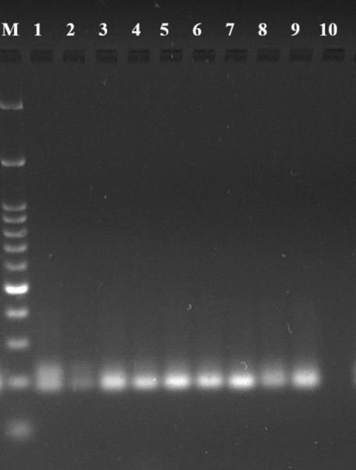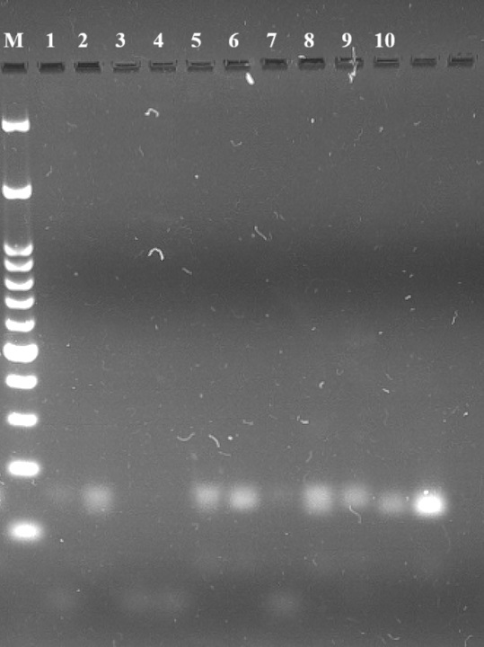
Plate 5: Amplification of 10 hybrids using primer VIT 03_1290_MS2 and VIT03_1660_MS4
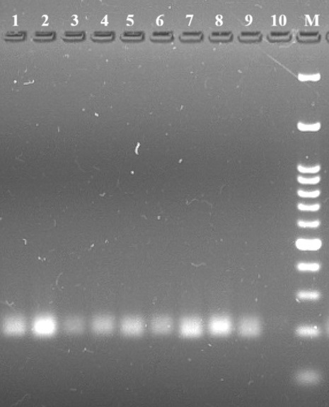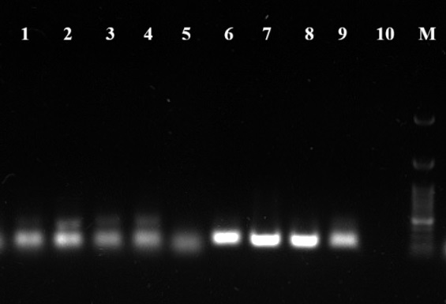
Plate 6: Amplification of 10 hybrids using primer VIT 04_0270_MS1 and VIT05_0510_MS2
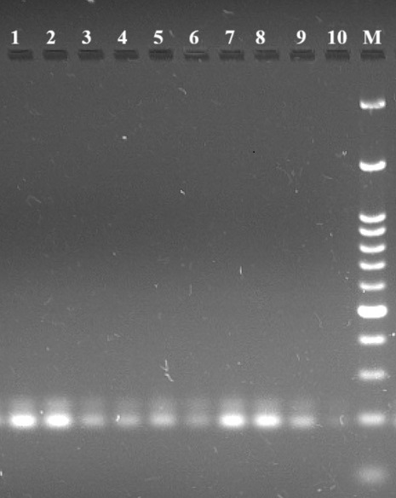
Plate 7: Amplification of 10 hybrids using primer VIT05_1400_MS
The marker-wise description is as follows:
VIT03_1290_MS2
The primer VIT03_1290_MS2 detected one allele. Allele was monomorphic among the hybrids, showed presence in 9 hybrids and absence in 1hybrid. (Plate 5).
VIT03-1660-MS4
The primer VIT03-1660-MS4 detected two alleles. Allele 1 was polymorphic among the hybrids, was present in 8 hybrids and absent in 2 hybrids (Plate 5).
VIT04-0270-MS1
The primer VIT04-0270-MS1 detected a single allele, which was monomorphic among the hybrids. The allele band was present in all 10 hybrids (Plate 6).
VIT05-0510-MS2
The primer VIT05-0510-MS2 detected two alleles. Allele 1 was polymorphic among the hybrids, was present in 9 hybrids and absent in 1 hybrid. Allele 2 was detected in 3 hybrids, (Plate 6).
VIT05-1400-MS
The primer VIT05-1400-MS detected two alleles. Allele 1 was monomorphic among the hybrids. Both the alleles were absent in all 10 hybrids (Plate 7).
Conclusion
The study successfully developed and validated SSR markers targeting microsatellite regions of grape candidate genes. Four primers showed polymorphism among genotypes, confirming their effectiveness in distinguishing genetic variability. Two primers were further validated in hybrid populations, indicating their potential use in molecular characterization and trait-specific studies. These SSR markers can be applied in genetic diversity assessment, cultivar identification, and future marker-assisted breeding programs to enhance berry quality and productivity in grapes.

Disclaimer (Artificial intelligence)
Option 1:
Author(s) hereby declare that NO generative AI technologies such as Large Language Models (ChatGPT, COPILOT, etc.) and text-to-image generators have been used during the writing or editing of this manuscript.

References
Abbas, H., Wang, X., Xu, J., and Wang, M. (2024). Recent advances in molecular markers and their applications in crop improvement. Frontiers in Plant Science. 15, 123456.
Ahmad, A., Wang, J. D., Pan, Y. B., Sharif, R. and Gao, S. J. (2018). Development and Use of Simple Sequence Repeats (SSRs) Markers for Sugarcane Breeding and Genetic Studies. Agronomy. 8(11), 260.
Alleweldt, G., Spiegel-Roy, P. and Reisch, B. (1990). Grapes (Vitis). In: Moore JN, Ballington JR (eds) Genetic resources of temperate fruit and nuts crops. International Society for Horticultural Science. Madison. 290, 291-330.
Ashley, M. V. and Dow, B. D. (1994). The use of microsatellite analysis in population biology: background, methods and potential applications. Molecular ecology and evolution: approaches and applications. 185-201.
Barbagallo, M. G., Guidoni, S. and Hunter, J. J (2011). Berry Size and Qualitative Characteristics of Vitis vinifera L. cv. Syrah S. Afr. J. Enol. Vitic., Vol. 32, No. 1.
Guichoux, E., Lagache, L. and Wagner, S. (2011). Current trends in microsatellite genotyping. Mol Ecol Resour. 11(4), 591-611.
Guo, D. L., Zhao, H. L., Li, Q., Zhang, G. H., Jiang, J. F., Liu, C. H. and Yu, Y. H. (2019). Genome-wide association study of berry related traits in grape (Vitis vinifera L.) based on genotyping-by-sequencing markers. Horticulture Research. 6:11.
Gupta, P. K. and Varshney, R. K. (2000). The development and use of microsatellite markers for genetic analysis and plant breeding with emphasis on bread wheat. Euphytica. 113(3), 163–185.
Kok, D. (2014). A review on grape growing in Tropical regions. Turk J Agric Nat Sci.1:1236-1241.
Lin, H., Ma, L., Guo, Q., Liu, C., Hou, Y., Liu, Z., Zhao, Y., Jiang, C., Guo, X. and Guo, Y. (2023). Berry texture QTL and candidate gene analysis in grape (Vitis vinifera L.). Horticulture Research. 10 (12),226.
Matthews, M. A. and Nuzzo, V. (2007). Berry size and yield paradigms on grape and wine quality. Proc. Int. Workshop on Advances in Grapevine and Wine Research. Acta Hortic. 754: 261-267.
Melo, M. S., Schultz, H. R. and Hunter, J. J. (2013). Implications of berry size variation of Vitis vinifera L. cv. Syrah. Journal of viticulture and Enology, Vol. 28, - (2), pp. 776-780.
Nadeem, M. A., Nawaz, M. A., Shahid, M. Q., Dogan, Y., Comertpay, G., Yıldız, M., Hatipoglu, R., Ahmad, F., Alsaleh, A., Labhane, N., ozkan, H. and Chung, G. (2017). DNA molecular markers in plant breeding: Current status and recent advancements in genomic selection and genome editing. Biotechnology & Biotechnological Equipment. 32(2), 261–285.
Pan, Y. B. (2006). Highly polymorphic microsatellite DNA markers for sugarcane germplasm evaluation and variety identity testing. Sugar Tech. 8(4), 246-256.
Pan, Y. B. (2010). Databasing molecular identities of sugarcane (Saccharum spp.) clones constructed with microsatellite (SSR) DNA markers. American Journal of Plant Sciences. 1: 87-94.
Pei, D., Song, S., Kang, J., Zhang, C., Wang, J., Dong, T., Ge, M., Pervaiz, T., Zhang, P. and Fang, J. (2023). Characterization of Simple Sequence Repeat (SSR) Markers Mined in Whole Grape Genomes. Genes. 14, 663.
Powell, W., Machray, G. C. and Provan, J. (1996). Polymorphism revealed by simple sequence repeats. Trends in Plant Science.1(7), 215–222.
Razi, M., Amiri, M. E., Darvishzadeh, R., Doulati Baneh, H., Alipour, H., and Martinez-Gomez, P. (2020). Assessment of genetic diversity of cultivated and wild Iranian grape germplasm using retrotransposon-microsatellite amplified polymorphism (REMAP) markers and pomological traits. Molecular Biology Reports, 47(10), 7593-7606.
Reisch, B. I., Pratt, C. (1996). Grapes In: Janick J, Moore JN (eds) Fruit breeding. Wiley. New York, pp 297–369.
Riaz, S., Dangl, G. S., Edwards, K. J. and Meredith, C. P. (2004). A microsatellite marker-based framework linkage map of Vitis vinifera L. Theor Appl Genet. 108(5),864 - 872.
Sefc, K. M., Lefort, F., Grando, M. S., Scott, K. D., Steinkellner, H. and Thomas, M. R. (2001). Microsatellite markers for grapevine: a state of the art. Molecular Biology & Biotechnology of the Grapevine. 433-463.
Sinha, P., Singh, V. K., Bohra, A., Kumar, A., Reif, J. C., and Varshney, R. K. (2021). Genomics and breeding innovations for enhancing genetic gain for climate resilience and nutrition traits. Theoretical and Applied Genetics. 134(6), 1829-1843.
Wang, J., Gong, Z., Zheng, J., Li, Z., Zhou, G., Xu, Y., and Li, X. (2024). Genomic and epigenomic insights into the mechanism of cold response in upland cotton (Gossypium hirsutum). Plant physiology and Biochemistry. 206: 108-206.

