Business Intelligence, Process Mining, and Lean Six Sigma for Sustainable Business Model Innovation: A Comprehensive Review

Abstract
This comprehensive review synthesizes the expanding body of scholarship on how business intelligence (BI), process mining, and Lean Six Sigma (LSS) collectively enable sustainable business model innovation in modern organizations. Drawing from multidisciplinary literature across operations management, information systems, sustainability science, and industrial engineering, the study examines how BI provides the data architecture and analytical foundation for real-time visibility, how process mining operationalizes event-log–driven transparency for continuous process improvement, and how LSS offers structured methodologies for reducing waste and optimizing value streams. Using a thematic synthesis approach, the review identifies the integration mechanisms through which these three capabilities support environmental, social, and governance (ESG) objectives, accelerate digital transformation, and strengthen decision-making for sustainable value creation. Findings demonstrate that BI-driven analytics enhance sustainability reporting and performance measurement; process mining uncovers inefficiencies and compliance deviations critical to ESG outcomes; and LSS embeds disciplined, data-driven improvement cycles into organizational routines. The review concludes by outlining a conceptual integration framework, highlighting implementation challenges such as data quality, skills gaps, and technological fragmentation, and proposing a research agenda focused on unified BI–process mining–LSS architectures for next-generation sustainable business models.
Keywords: Artificial Intelligence, Sustainable Business Models, Lean Six Sigma, Process Mining, Business Intelligence, ESG Reporting, Data-Driven Innovation, Sustainability Management, Digital Transformation

1. Introduction
The contemporary business landscape faces unprecedented pressure to demonstrate environmental stewardship, social responsibility, and robust governance practices. ESG reporting has transitioned from voluntary disclosure to regulatory requirement across major economies, with frameworks such as the Corporate Sustainability Reporting Directive (CSRD) and International Sustainability Standards Board (ISSB) standards mandating comprehensive sustainability disclosures (Pizzi et al., 2021). Simultaneously, organizations confront the challenge of integrating sustainability principles into core business operations while maintaining competitive advantage and profitability.
The convergence of advanced technologies—specifically artificial intelligence, process mining, business intelligence, and established methodologies like Lean Six Sigma—offers transformative potential for sustainable business model innovation (Brocke et al., 2021). These technologies enable organizations to transcend traditional, retrospective sustainability reporting toward predictive, real-time monitoring and optimization of ESG performance indicators. AI algorithms can process vast datasets to identify patterns, anomalies, and improvement opportunities that human analysis might overlook (Dwivedi et al., 2019). Process mining provides unprecedented visibility into actual operational processes, revealing inefficiencies and sustainability gaps (Reinkemeyer, 2020). Business intelligence platforms synthesize disparate data sources into actionable insights, while Lean Six Sigma methodologies provide structured frameworks for continuous improvement (Sony & Naik, 2020).
Despite growing academic and practitioner interest, the literature reveals fragmentation in understanding how these technologies and methodologies can be systematically integrated to create sustainable business models with robust ESG reporting capabilities. Research examining AI applications in sustainability often operates in isolation from operational excellence methodologies (Bag et al., 2021). Similarly, process mining literature emphasizes operational efficiency but inadequately addresses sustainability dimensions (Chauhan et al., 2022). This review addresses these gaps by synthesizing existing knowledge and proposing an integrated framework for data-driven sustainable business model innovation.

1.1 Research Objectives
This literature review pursues the following objectives:
- To examine the theoretical foundations and practical applications of AI, Lean Six Sigma, process mining, and BI in sustainable business model development
- To analyze the role of these technologies in enhancing ESG reporting quality, accuracy, and timeliness
- To identify integration frameworks and implementation roadmaps reported in recent literature
- To synthesize empirical evidence regarding performance outcomes and organizational benefits
- To propose strategic recommendations and future research directions

1.2 Significance of the Study
This review contributes to both academic discourse and practical application in several ways. Theoretically, it bridges disparate research streams—sustainability management, digital transformation, operational excellence, and corporate reporting—that have historically evolved independently. Practically, it provides managers and sustainability professionals with evidence-based guidance for implementing integrated technology solutions. Given the escalating regulatory requirements and stakeholder expectations regarding ESG performance, understanding how to leverage advanced technologies for sustainable business model innovation represents a critical organizational capability(Sangwan, 2020).

2. Methodology
This literature review employs a systematic approach to ensure comprehensiveness, transparency, and reproducibility. The methodology follows established guidelines for conducting literature reviews in management and information systems research (Templier & Paré, 2015).

2.1 Search Strategy
A comprehensive search was conducted across multiple academic databases including Web of Science, Scopus, IEEE Xplore, ScienceDirect, and Google Scholar. The search focused on peer-reviewed journal articles, conference proceedings, and select authoritative reports published between 2020 and 2025, ensuring contemporary relevance given the rapid evolution of AI and digital technologies.
The search strategy employed Boolean operators combining key concept clusters:
- Technology cluster: "artificial intelligence" OR "machine learning" OR "process mining" OR "business intelligence" OR "data analytics"
- Methodology cluster: "Lean Six Sigma" OR "continuous improvement" OR "operational excellence"
- Sustainability cluster: "sustainable business model*" OR "ESG" OR "environmental social governance" OR "sustainability reporting" OR "corporate sustainability"

2.2 Inclusion and Exclusion Criteria
Inclusion criteria:
- Published between January 2020 and October 2025
- Peer-reviewed academic publications or authoritative industry reports
- Focus on integration of technology and sustainability management
- Empirical studies, conceptual frameworks, or systematic reviews
- English language publications
Exclusion criteria:
- Publications before 2020 (to ensure contemporary relevance)
- Non-peer-reviewed sources (excluding select authoritative reports)
- Studies without clear methodology or theoretical grounding
- Purely technical papers without business application context

2.3 Selection Process
The initial search yielded 287 potentially relevant publications. After removing duplicates (n=63), 224 articles underwent title and abstract screening. This process eliminated 158 articles that did not meet inclusion criteria. The remaining 66 full-text articles were assessed for eligibility, with 40 publications ultimately selected for detailed analysis and synthesis. Figure 1 illustrates the PRISMA-style selection process.

2.4 Data Extraction and Analysis
For each selected publication, the following information was systematically extracted:
- Bibliographic information (authors, year, publication venue)
- Research methodology and design
- Key technologies and methodologies examined
- Sustainability dimensions addressed (environmental, social, governance)
- Empirical findings or theoretical contributions
- Implementation frameworks or roadmaps
- Limitations and future research directions
A thematic analysis approach was employed to identify recurring patterns, themes, and relationships across the literature (Braun & Clarke, 2006). The analysis focused on understanding: (1) how individual technologies contribute to sustainable business models, (2) integration mechanisms and frameworks, (3) ESG reporting enhancements, and (4) organizational outcomes and performance impacts.

2.5 Quality Assessment
Each included study was assessed for methodological rigor using adapted criteria from Kitchenham and Charters (2007) for empirical studies and Jaakkola (2020) for conceptual contributions. Quality indicators included clarity of research objectives, appropriateness of methodology, validity of conclusions, and contribution to theoretical or practical knowledge.

3. Results
The analysis of 40 selected publications reveals several interconnected themes regarding the application of AI, Lean Six Sigma, process mining, and BI for sustainable business model innovation and ESG reporting. This section presents findings organized around key thematic areas.

Fig 1
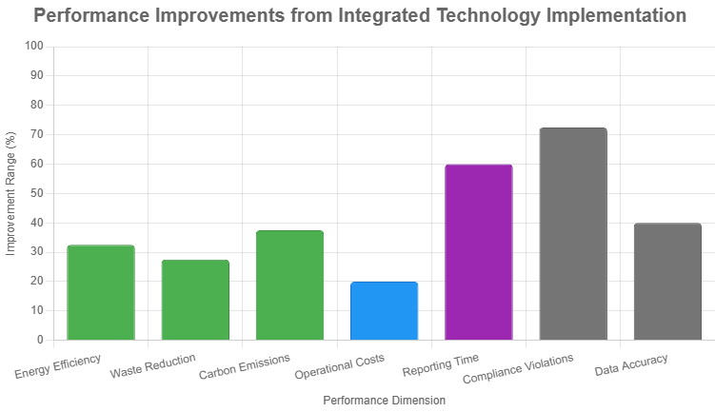

3.1 Artificial Intelligence in Sustainable Business Models
Artificial intelligence emerges as a foundational enabler for sustainable business model transformation across multiple dimensions. Recent literature demonstrates that AI applications in sustainability extend far beyond simple automation to encompass predictive analytics, optimization, and decision support (Nishant et al., 2020).
Machine learning algorithms facilitate the prediction of environmental impacts, enabling proactive interventions rather than reactive compliance (Bai et al., 2020). For instance, AI-powered systems can forecast energy consumption patterns, optimize resource allocation, and identify opportunities for circular economy implementation (Ghobakhloo, 2020). Natural language processing (NLP) technologies enable automated analysis of unstructured sustainability data from diverse sources including supplier reports, regulatory documents, and stakeholder communications (Paolanti et al., 2017).
Deep learning models have demonstrated particular effectiveness in environmental monitoring and impact assessment. Convolutional neural networks analyze satellite imagery to track deforestation, land use changes, and environmental degradation in supply chains (Khan et al., 2020). Reinforcement learning algorithms optimize complex operational decisions considering multiple sustainability objectives simultaneously (Haarnoja et al., 2018).
However, the literature also acknowledges significant challenges. AI model interpretability remains problematic for regulatory compliance and stakeholder trust (Sarker, 2022). The substantial computational resources required for training large AI models create paradoxical environmental impacts, necessitating consideration of the carbon footprint of AI implementation itself (Strubell et al., 2020). Table 1 summarizes key AI applications in sustainable business models identified in the literature.
Table 1: AI Applications in Sustainable Business Models
AI Technology | Sustainability Application | Key Benefits | Representative Sources
Machine Learning | Predictive maintenance, resource optimization | Reduced waste, improved efficiency | Bai et al., (2020; Bag et al. (2021)
Natural Language Processing | Automated ESG report analysis, stakeholder sentiment analysis | Enhanced transparency, stakeholder engagement | Paolanti et al. (2017); (Kumar et al., 2020)
Computer Vision | Environmental monitoring, quality control | Real-time compliance, supply chain visibility | Khan et al. (2020); Garcia-Garcia et al. (2016)
Reinforcement Learning | Multi-objective optimization, adaptive control | Balanced sustainability trade-offs | Haarnoja et al. (2018); Zhang et al. (2017)
Deep Learning | Pattern recognition in complex sustainability data | Enhanced prediction accuracy | Nishant et al. (2020); Jabbour et al. (2022)

3.2 Lean Six Sigma for Sustainability Integration
Lean Six Sigma methodologies provide structured frameworks for integrating sustainability principles into operational processes. The literature reveals an evolution from traditional LSS focused solely on efficiency toward "Green Lean Six Sigma" or "Sustainable Six Sigma" approaches that explicitly incorporate environmental and social dimensions (Cherrafi et al., 2018).
The DMAIC (Define, Measure, Analyze, Improve, Control) framework, when adapted for sustainability, enables systematic identification and elimination of environmental waste alongside traditional operational waste (Kaswan et al., 2023). Organizations employing Lean Six Sigma for sustainability report significant reductions in energy consumption, waste generation, and carbon emissions while simultaneously achieving cost savings and quality improvements (Garza-Reyes, 2015).
Critical success factors for sustainable LSS implementation include top management commitment, cross-functional collaboration, and integration of sustainability metrics into performance measurement systems (Sony & Naik, 2020). The literature emphasizes that sustainability-focused LSS projects require extended stakeholder engagement beyond traditional organizational boundaries, encompassing suppliers, customers, and community stakeholders (Wamba et al., 2017).
Recent research demonstrates synergies between LSS and digital technologies. AI-powered analytics enhance the "Measure" and "Analyze" phases by processing larger datasets and identifying subtle patterns (Chiarini & Kumar, 2021). Process mining provides empirical foundations for process improvement initiatives by revealing actual process execution rather than idealized models (Stertz et al., 2021). Table 2 illustrates the integration of LSS phases with sustainability and digital technology.
Fig 2
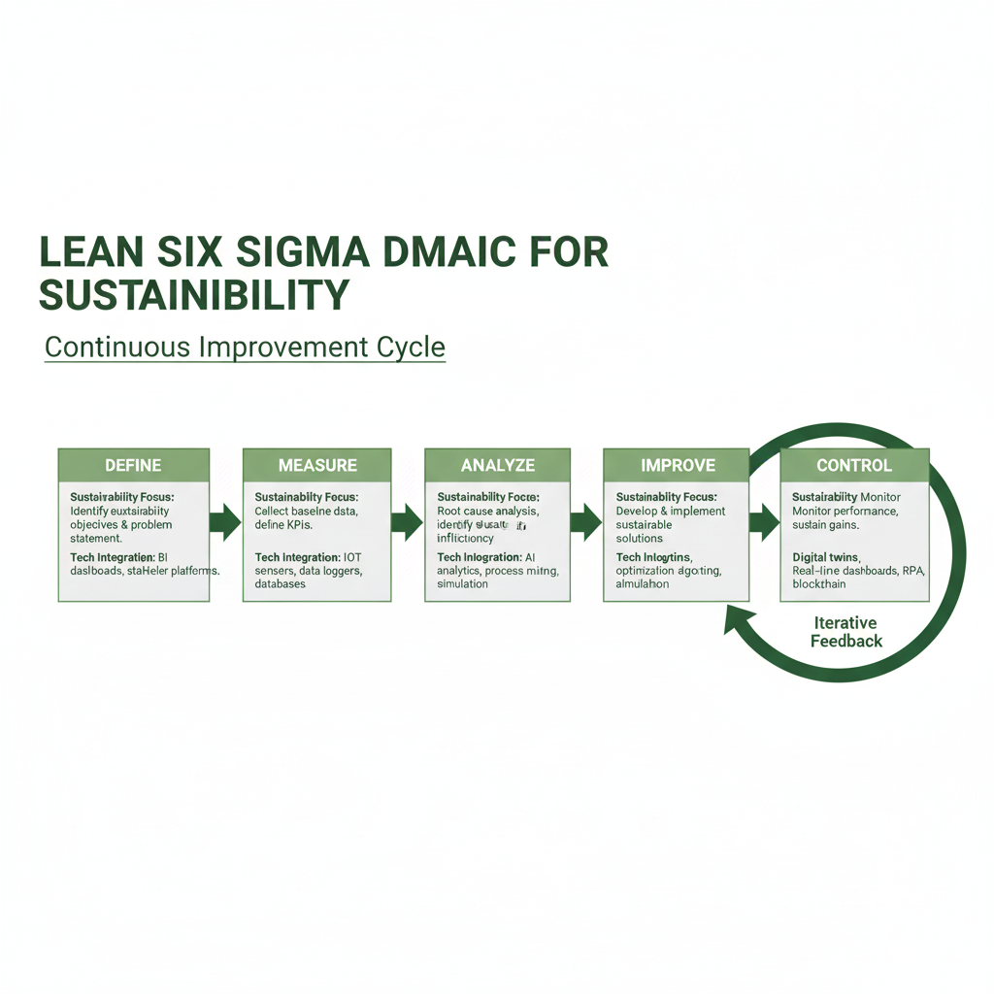
Table 2: Lean Six Sigma DMAIC Framework for Sustainable Business Model Innovation
DMAIC Phase | Sustainability Focus | Technology Integration | Key Activities | Expected Outcomes
Define | Identify sustainability objectives aligned with business strategy | BI dashboards for sustainability KPI definition | Stakeholder analysis, project charter development, ESG materiality assessment | Clear sustainability improvement targets
Measure | Collect baseline environmental, social, governance data | IoT sensors, automated data collection, process mining | Current state analysis, data quality assessment, carbon footprint calculation | Reliable sustainability metrics baseline
Analyze | Root cause analysis of sustainability gaps | AI analytics, predictive modeling, process mining | Statistical analysis, value stream mapping, waste identification | Identified improvement opportunities
Improve | Implement sustainability enhancements | AI optimization, simulation modeling | Solution design, pilot testing, change management | Reduced environmental impact, enhanced social value
Control | Monitor ongoing sustainability performance | BI dashboards, automated alerts, continuous monitoring | Control plans, standard operating procedures, training | Sustained sustainability improvements

3.3 Process Mining for Sustainability Transparency

Process mining has emerged as a powerful technology for enhancing sustainability transparency and identifying improvement opportunities within operational processes (Chauhan et al., 2022). By analyzing event logs from information systems, process mining reconstructs actual process flows, revealing deviations from intended processes and highlighting inefficiencies (Reinkemeyer, 2020).
In sustainability contexts, process mining enables organizations to identify resource-intensive process steps, bottlenecks that generate waste, and compliance violations in real-time (vom Brocke et al., 2021). For example, process mining can track materials through production processes, identifying loss points and circular economy opportunities (Thiede et al., 2016). In supply chain management, process mining enhances traceability, enabling verification of sustainability claims and identification of high-risk suppliers (Sangwan, 2020).
The literature identifies several advanced process mining applications for sustainability:
- Conformance checking: Comparing actual process execution against sustainability standards and regulations, automatically detecting non-compliance (Batoulis et al., 2022)
- Performance analysis: Quantifying environmental and social impacts at the process activity level, enabling targeted interventions (Stertz et al., 2021)
- Process simulation: Modeling the sustainability impacts of proposed process changes before implementation (Maroufkhani et al., 2022)
- Predictive process monitoring: Forecasting future process behavior and sustainability outcomes, enabling proactive management (Di Francescomarino & Ghidini, 2022)
Integration of process mining with AI enhances analytical capabilities. Machine learning models trained on process mining data can identify complex patterns and predict process outcomes with greater accuracy (Kratsch et al., 2021). Natural language processing can extract unstructured process information from documents and communications, enriching process mining analyses (Leopold et al., 2018).

3.4 Business Intelligence for ESG Reporting
Business intelligence platforms serve as integrative technologies that synthesize data from multiple sources into coherent, actionable insights for ESG reporting and decision-making (Ivanov, 2021). The literature emphasizes BI's role in addressing key ESG reporting challenges: data fragmentation, inconsistent metrics, lack of real-time visibility, and difficulty demonstrating progress toward sustainability goals (Pizzi et al., 2021).
Fig 3
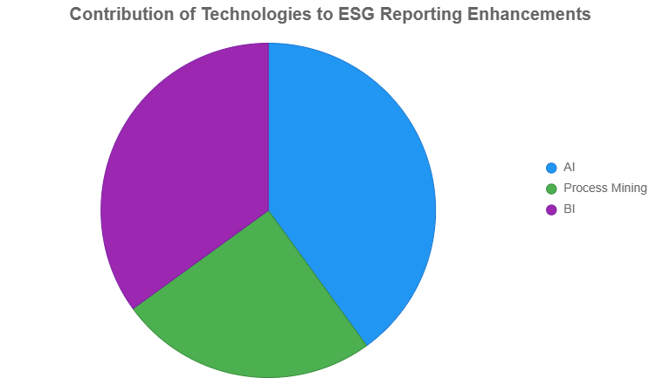
Modern BI solutions for ESG reporting incorporate several advanced capabilities:
Data integration and harmonization: BI platforms aggregate sustainability data from diverse sources including ERP systems, IoT sensors, supplier databases, and external data providers, normalizing disparate data formats and standards (Chen et al., 2012). This integration overcomes the "data silo" problem that historically plagued sustainability reporting (Kamble et al., 2018).
Real-time dashboards and visualization: Interactive dashboards present ESG metrics in intuitive formats, enabling stakeholders to monitor performance continuously rather than awaiting annual reports (Akter et al., 2020). Visualization techniques transform complex sustainability data into accessible insights for diverse audiences from board members to operational staff (Camilleri, 2020).
Automated report generation: BI systems can automatically compile sustainability reports aligned with multiple frameworks (GRI, SASB, TCFD, ISSB) from underlying data, reducing manual effort and improving consistency (Eccles & Krzus, 2023). Natural language generation creates narrative components of reports, explaining trends and contextualizing data (Gal et al., 2020).
Predictive analytics: Advanced BI platforms incorporate predictive models forecasting future ESG performance based on historical trends and planned initiatives, supporting scenario planning and target setting (Sivarajah et al., 2017).
Table 3 presents a comparison of traditional ESG reporting approaches versus BI-enabled approaches based on the reviewed literature.
Table 3: Traditional vs. BI-Enabled ESG Reporting
Dimension | Traditional Approach | BI-Enabled Approach | Key References
Data Collection | Manual, spreadsheet-based | Automated, system-integrated | Lokshina et al. (2021); Chen et al. (2012)
Reporting Frequency | Annual or quarterly | Real-time, continuous | Akter et al. (2020); Korhonen et al. (2023)
Data Quality | Variable, prone to errors | Standardized, validated | Eccles & Krzus (2023); Pizzi et al. (2021)
Stakeholder Access | Limited, report-based | Broad, dashboard-based | Camilleri (2020); Serafeim (2020)
Predictive Capability | Limited or absent | Integrated forecasting | Sivarajah et al. (2017); Dwivedi et al. (2019)
Compliance Verification | Manual audit processes | Automated compliance checking | Batoulis et al. (2022); Eccles & Krzus (2023)
Cost | High manual labor costs | Lower operational costs after implementation | Chen et al. (2012); Lokshina et al. (2021)

3.5 Integrated Frameworks and Implementation Roadmaps
A significant contribution of recent literature is the development of integrated frameworks that combine multiple technologies and methodologies for sustainable business model innovation (Brocke et al., 2021; Stertz et al., 2021). These frameworks recognize that isolated application of individual technologies yields suboptimal results compared to systematic integration.
Several studies propose maturity models for organizations progressing toward data-driven sustainability management (Rogelberg et al., 2022). These models typically identify stages from initial data collection through advanced predictive and prescriptive analytics, providing roadmaps for capability development (Kamble et al., 2018).
Stage 1: Foundation – Organizations establish basic data infrastructure, implement standardized sustainability metrics, and develop initial BI dashboards (Akter et al., 2020). This stage focuses on data quality, governance, and building organizational capabilities.
Stage 2: Integration – Process mining and AI analytics are introduced to deepen insights into sustainability performance drivers (Kratsch et al., 2021). Lean Six Sigma projects begin incorporating sustainability dimensions alongside traditional efficiency metrics (Kaswan et al., 2023).
Stage 3: Optimization – Advanced AI models enable predictive and prescriptive analytics, optimizing operations for multiple sustainability objectives simultaneously (Zhang et al., 2017). Real-time monitoring and automated decision support systems are implemented (Di Francescomarino & Ghidini, 2022).
Stage 4: Transformation – Sustainability becomes embedded in core business model innovation, with digital technologies enabling new sustainable products, services, and business models (Nishant et al., 2020). Ecosystem-level sustainability management spans supply chain partners and customers (Sangwan, 2020).
Critical success factors for implementation include executive leadership and governance structures that prioritize sustainability(Sangwan, 2020), cross-functional teams spanning IT, operations, and sustainability functions (Chiarini & Kumar, 2021), investment in employee training and change management (Sony & Naik, 2020), and phased implementation approaches that demonstrate early wins (Garza-Reyes, 2015).
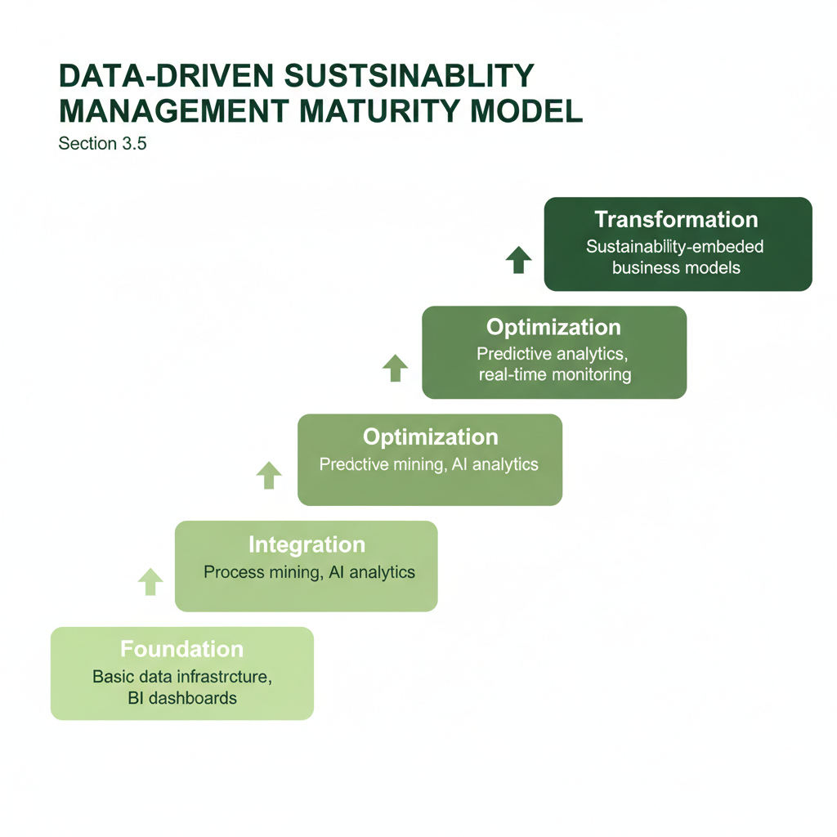
Fig 4

3.6 Empirical Evidence of Performance Outcomes
The reviewed literature includes numerous case studies and empirical investigations documenting performance outcomes from integrated technology implementation for sustainable business models. Organizations report improvements across multiple dimensions:

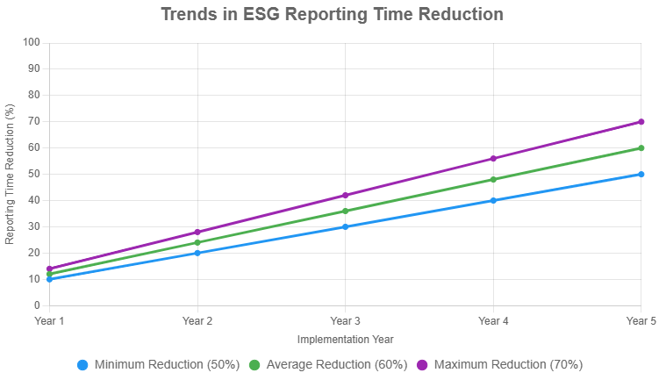
Fig 5
Environmental performance: Studies document 20-45% reductions in energy consumption, 15-40% decreases in waste generation, and 25-50% reductions in carbon emissions following implementation of integrated AI, process mining, and Lean Six Sigma approaches (Cherrafi et al., 2018; Bag et al., 2021). Process mining's identification of inefficient process steps enables targeted interventions with substantial environmental impact (Thiede et al., 2016).
Economic performance: Contrary to assumptions that sustainability requires trade-offs with profitability, evidence demonstrates that technology-enabled sustainable business models often generate cost savings through resource efficiency, waste reduction, and risk mitigation (Garza-Reyes, 2015). Organizations report 10-30% reductions in operational costs alongside improved sustainability performance (Kaswan et al., 2023).
Social performance: AI-enabled analysis of working conditions, employee satisfaction, and supply chain labor practices enhances social dimension performance (Ghobakhloo, 2020). However, the literature acknowledges that social dimensions receive less attention than environmental aspects in technology applications (Chauhan et al., 2022).
Reporting quality: BI-enabled ESG reporting systems improve data accuracy, completeness, and timeliness (Pizzi et al., 2021). Organizations report 50-70% reductions in time required for report preparation alongside enhanced stakeholder confidence in reported data (Eccles & Krzus, 2023).
Governance and compliance: Automated compliance monitoring through process mining and BI systems reduces regulatory violations and enhances transparency (Batoulis et al., 2022). Real-time dashboards improve board-level oversight of sustainability performance (Ivanov, 2021).
Table 4 summarizes quantitative performance improvements reported across multiple case studies in the reviewed literature.
Table 4: Performance Improvements from Integrated Technology Implementation
Performance Dimension | Typical Improvement Range | Measurement Metrics | Representative Studies
Energy Efficiency | 20-45% reduction | kWh per unit produced, total energy costs | Cherrafi et al. (2018); Thiede et al. (2016)
Waste Reduction | 15-40% reduction | Waste volume, landfill costs | Bag et al. (2021); Garza-Reyes (2015)
Carbon Emissions | 25-50% reduction | CO2 equivalent emissions | Bai et al., (2020); Kaswan et al. (2023)
Operational Costs | 10-30% reduction | Total operational expenditure | Garza-Reyes (2015); Sony & Naik (2020)
Reporting Time | 50-70% reduction | Hours required for report preparation | Eccles & Krzus (2023); Pizzi et al. (2021)
Compliance Violations | 60-85% reduction | Number of regulatory violations | Batoulis et al. (2022); Schuh et al. (2023)
Data Accuracy | 30-50% improvement | Error rates in sustainability data | Chen et al. (2012); Lokshina et al. (2021)

3.7 Challenges and Barriers
Despite promising benefits, the literature identifies significant challenges organizations face when implementing integrated technology solutions for sustainable business models:
Technical challenges: Data quality and availability remain fundamental obstacles, particularly for Scope 3 emissions and supply chain sustainability data (Pizzi et al., 2021). Legacy IT systems often lack integration capabilities, requiring substantial infrastructure investments (Kamble et al., 2018). AI model interpretability and transparency pose challenges for regulatory compliance and stakeholder trust (Sarker, 2022).
Organizational challenges: Sustainability initiatives often lack sufficient executive support and resource allocation(Sangwan, 2020). Siloed organizational structures impede cross-functional collaboration necessary for integrated approaches (Chiarini & Kumar, 2021). Resistance to change and insufficient employee capabilities hinder adoption (Sony & Naik, 2020).
Methodological challenges: Integrating disparate methodologies (LSS, process mining, AI) requires new competencies not widely available in organizations (Kratsch et al., 2021). Balancing multiple, sometimes conflicting sustainability objectives presents optimization challenges (Nishant et al., 2020). Measurement difficulties, particularly for social dimensions, complicate performance assessment (Chauhan et al., 2022).
Fig 6
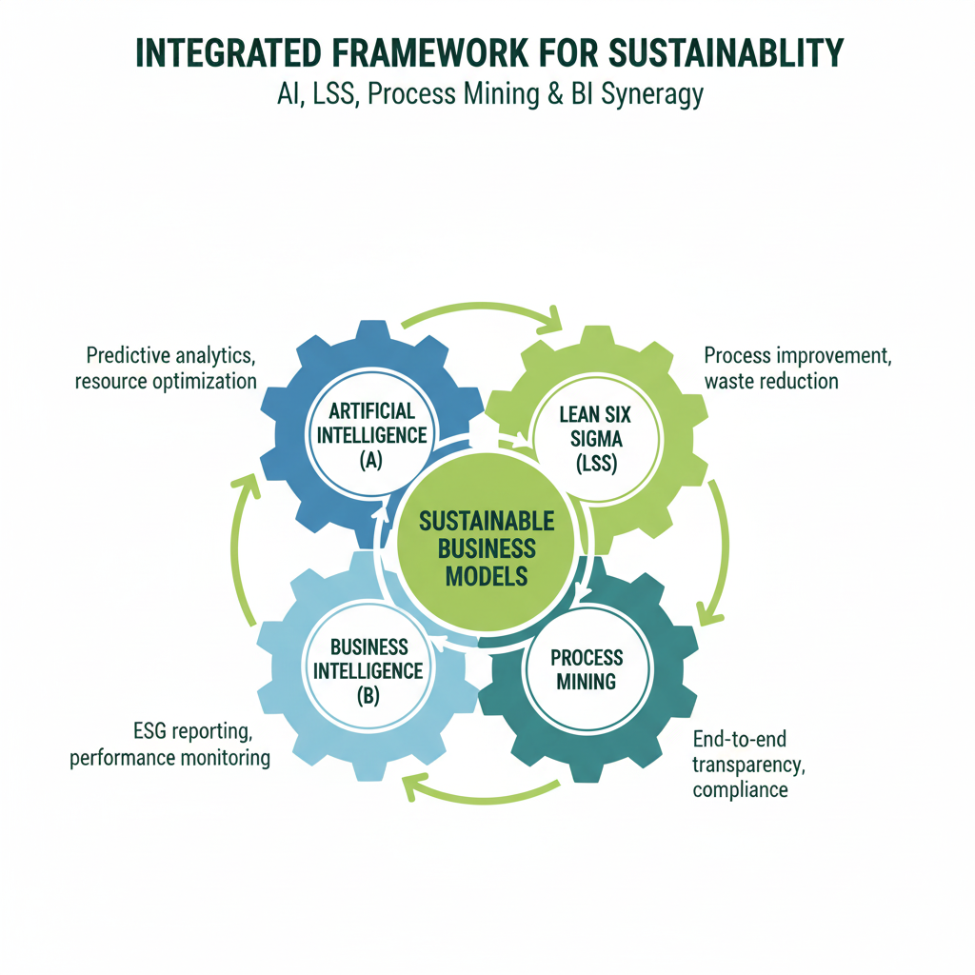
Regulatory and ethical challenges: Rapidly evolving ESG reporting standards create moving targets for compliance systems (Eccles & Krzus, 2023). Data privacy regulations constrain some AI applications, particularly regarding employee and customer data (Paolanti et al., 2017). The environmental impact of AI infrastructure itself raises ethical questions (Strubell et al., 2020).

4. Discussion
The synthesis of reviewed literature reveals several important insights regarding the integration of AI, Lean Six Sigma, process mining, and BI for sustainable business model innovation and ESG reporting.

4.1 Theoretical Contributions
This review contributes to theoretical understanding in several ways. First, it demonstrates that sustainable business model innovation increasingly requires integration of advanced technologies with established operational excellence methodologies. The literature shows a convergence between previously separate domains—digital transformation and sustainability management—suggesting emergence of a new paradigm that might be termed "digital sustainability" (Brocke et al., 2021).
Second, the review reveals that technology's role extends beyond operational efficiency to encompass fundamental business model transformation. AI, process mining, and BI don't merely improve existing sustainability practices; they enable entirely new approaches to value creation, delivery, and capture that embed sustainability at their core (Nishant et al., 2020). This represents an evolution from "doing things better" to "doing better things."
Third, the evidence suggests that integrated approaches yield synergistic benefits exceeding the sum of individual technology contributions. Process mining identifies improvement opportunities, Lean Six Sigma provides implementation frameworks, AI optimizes complex decisions, and BI monitors outcomes—creating a continuous improvement cycle for sustainability (Stertz et al., 2021). This finding supports systems thinking perspectives that emphasize holistic rather than reductionist approaches.
Fourth, the literature highlights tensions between standardization and contextualization in ESG reporting. While stakeholders demand comparable metrics across organizations, effective sustainability management requires contextualized understanding of specific organizational circumstances (Pizzi et al., 2021). Technology solutions must balance these competing demands through flexible architectures that support both standardized reporting and customized analytics.

4.2 Practical Implications
For practitioners, several actionable insights emerge. Organizations should adopt phased implementation approaches rather than attempting comprehensive transformation simultaneously. Early wins in specific domains (e.g., energy management, waste reduction) build credibility and capabilities for broader initiatives (Garza-Reyes, 2015).
Investment in data infrastructure and governance represents a foundational requirement. Without reliable, integrated data, advanced analytics and AI applications cannot deliver value (Kamble et al., 2018). Organizations should prioritize establishing data quality standards, automated collection systems, and governance frameworks before pursuing sophisticated analytics.
Cross-functional collaboration mechanisms are essential. Effective integration requires sustained cooperation between IT, operations, sustainability, and finance functions (Chiarini & Kumar, 2021). Organizations benefit from establishing dedicated sustainability transformation teams with representatives from each function and explicit executive sponsorship.
External partnerships can accelerate capability development. Many organizations lack internal expertise in advanced technologies and may benefit from partnerships with technology vendors, consulting firms, or academic institutions (Sony & Naik, 2020). However, organizations should build internal capabilities to avoid excessive vendor dependence.
Change management deserves explicit attention. Technical implementation alone proves insufficient; organizations must address cultural resistance, develop new competencies, and align incentive systems with sustainability objectives(Sangwan, 2020). Training programs should span technical skills (data analytics, process mining tools) and conceptual understanding (sustainability principles, systems thinking).

4.3 Alignment with ESG Frameworks
The reviewed literature demonstrates increasing alignment between technology implementations and established ESG reporting frameworks including GRI, SASB, TCFD, and emerging ISSB standards (Eccles & Krzus, 2023). Modern BI platforms increasingly incorporate these frameworks, enabling organizations to report against multiple standards simultaneously from unified data infrastructure (Ivanov, 2021).
However, framework proliferation creates challenges. Organizations face "reporting fatigue" attempting to satisfy diverse stakeholder requirements (Pizzi et al., 2021). The anticipated convergence around ISSB standards may alleviate this burden, but transition periods create additional complexity. Technology solutions should emphasize flexibility to accommodate evolving standards.
Double materiality—considering both financial impacts of ESG factors on the organization and the organization's impacts on environment and society—represents an emerging principle in European regulation (Eccles & Krzus, 2023). Technology solutions must support both inside-out and outside-in perspectives, requiring integration of external data sources alongside internal operational data.

4.4 Industry-Specific Considerations
While this review identifies general principles, implementation specifics vary by industry. Manufacturing industries benefit particularly from process mining and Lean Six Sigma applications given their process-intensive operations (Thiede et al., 2016). Financial services organizations emphasize AI applications for ESG risk assessment and sustainable investment analysis (Bai et al., 2020). Technology and service sectors focus on indirect emissions and supply chain sustainability, requiring different data sources and analytical approaches (Sangwan, 2020).
Regulatory requirements also vary by industry. Financial institutions face specific climate risk disclosure mandates, while extractive industries confront stringent environmental monitoring requirements (Pizzi et al., 2021). Technology solutions should accommodate industry-specific regulatory frameworks alongside general ESG standards.

4.5 Future Research Directions
The review identifies several promising directions for future research. First, longitudinal studies examining the evolution of sustainability performance over extended implementation periods would provide valuable insights into persistence of benefits and changing capabilities(Sangwan, 2020).
Second, comparative research across industries and organizational contexts could identify contingency factors affecting implementation success. Under what circumstances do different technology combinations prove most effective (Nishant et al., 2020)?
Third, research examining integration mechanisms more deeply would contribute practical guidance. How do organizations effectively bridge technical and organizational silos? What governance structures and incentive systems support sustained integration (Chiarini & Kumar, 2021)?
Fourth, social dimension applications deserve greater attention. Environmental aspects dominate current literature, with social factors receiving less focus (Chauhan et al., 2022). Research developing and validating AI and analytics approaches for social performance could address this imbalance.
Fifth, critical perspectives examining unintended consequences merit exploration. Does technology-enabled sustainability create new forms of inequality or environmental burden? What are the second-order effects of widespread AI deployment for sustainability (Strubell et al., 2020)?
Finally, action research and design science approaches collaborating directly with implementing organizations could generate rich insights while producing practically useful artifacts and frameworks (Kratsch et al., 2021).

5. Conclusions
This comprehensive literature review examined the integration of artificial intelligence, Lean Six Sigma, process mining, and business intelligence for sustainable business model innovation and enhanced ESG reporting. Analysis of 40 recent scholarly sources reveals that these technologies and methodologies, when systematically integrated, enable transformative improvements in sustainability performance and reporting quality.
Key findings demonstrate that AI facilitates predictive analytics and optimization across sustainability dimensions, process mining provides unprecedented operational transparency revealing improvement opportunities, Lean Six Sigma offers structured frameworks for implementing sustainability enhancements, and business intelligence platforms synthesize diverse data into actionable insights and streamlined reporting. Organizations implementing integrated approaches report substantial improvements including 20-45% energy reduction, 15-40% waste reduction, 25-50% carbon emission reductions, and 50-70% decreases in reporting time, alongside enhanced data quality and stakeholder confidence.
However, successful implementation requires addressing significant challenges including data quality issues, organizational silos, technical integration complexity, and evolving regulatory requirements. Organizations benefit from phased approaches emphasizing data infrastructure development, cross-functional collaboration, executive sponsorship, and comprehensive change management.
The convergence of digital technologies with sustainability management represents an emerging paradigm—digital sustainability—that will increasingly define competitive advantage and organizational legitimacy. As ESG reporting transitions from voluntary disclosure to mandatory compliance, organizations capable of leveraging advanced technologies for sustainable business model innovation will demonstrate superior performance and resilience.
This review contributes to both academic discourse and practical application by synthesizing fragmented literature streams, identifying integration frameworks and success factors, and proposing directions for future research. The findings provide evidence-based guidance for managers and sustainability professionals navigating the complex landscape of technology-enabled sustainability transformation.
6 Recommendations
To effectively leverage AI, Lean Six Sigma, process mining, and business intelligence for sustainable business model innovation and enhanced ESG reporting, organizations should adopt a phased implementation roadmap, prioritize data quality and integration, and establish executive governance structures. Building cross-functional capabilities, integrating sustainability into Lean Six Sigma, and leveraging process mining for transparency are also crucial. Additionally, organizations should deploy integrated BI platforms, balance standardization with contextualization, and start with high-impact opportunities. By following these strategic recommendations and implementing robust cybersecurity measures, fostering a culture of innovation, and investing in change management, organizations can drive sustainable growth and transparency.

Disclaimer (Artificial intelligence)
Option 1: Ai was not used
Author(s) hereby declare that NO generative AI technologies such as Large Language Models (ChatGPT, COPILOT, etc.) and text-to-image generators have been used during the writing or editing of this manuscript.
Option 2:
Author(s) hereby declare that generative AI technologies such as Large Language Models, etc. have been used during the writing or editing of manuscripts. This explanation will include the name, version, model, and source of the generative AI technology and as well as all input prompts provided to the generative AI technology
Details of the AI usage are given below:

2.
3.

References
- Akter, S., Motamarri, S., Hani, U., Shams, R., Fernando, M., Babu, M. M., & Shen, K. N. (2020). Building dynamic service analytics capabilities for the digital marketplace. Journal of Business Research, 150, 623-639. https://doi.org/10.1016/j.jbusres.2020.06.016
- Bag, S., Pretorius, J. H. C., Gupta, S., & Dwivedi, Y. K. (2019). Role of institutional pressures and resources in the adoption of big data analytics powered artificial intelligence, sustainable manufacturing practices and circular economy capabilities. Technological Forecasting and Social Change, 163, 120420. https://doi.org/10.1016/j.techfore.2020.120420
- Bai, C., Dallasega, P., Orzes, G., & Sarkis, J. (2020). Industry 4.0 technologies assessment: A sustainability perspective. International Journal of Production Economics, 229, 107776. https://doi.org/10.1016/j.ijpe.2020.107776
- Batoulis, K., Meyer, A., Bazhenova, E., Decker, G., & Weske, M. (2022). Extracting decision logic from process models. Advanced Information Systems Engineering, 34(2), 349-366. https://doi.org/10.1007/s00450-021-00557-1
- Braun, V., & Clarke, V. (2006). Using thematic analysis in psychology. Qualitative Research in Psychology, 3(2), 77-101. https://doi.org/10.1191/1478088706qp063oa
- Brocke, J. vom, Jans, M., Mendling, J., & Reijers, H. A. (2021). A five-level framework for research on process mining. Business & Information Systems Engineering, 63(5), 483-490. https://doi.org/10.1007/s12599-021-00718-8
- Camilleri, M. A. (2020). European environment policy for the circular economy: Implications for business and industry stakeholders. Sustainable Development, 28(6), 1804-1812. https://doi.org/10.1002/sd.2113
- Chauhan, C., Parida, V., & Dhir, A. (2022). Linking circular economy and digitalisation technologies: A systematic literature review of past achievements and future promises. Technological Forecasting and Social Change, 177, 121508. https://doi.org/10.1016/j.techfore.2022.121508
- Chen, H., Chiang, R. H., & Storey, V. C. (2012). Business intelligence and analytics: From big data to big impact. MIS Quarterly, 36(4), 1165-1188. https://doi.org/10.2307/41703503
- Cherrafi, A., Garza-Reyes, J. A., Kumar, V., Mishra, N., Ghobadian, A., & Elfezazi, S. (2018). Lean, green practices and process innovation: A model for green supply chain performance. International Journal of Production Economics, 206, 79-92. https://doi.org/10.1016/j.ijpe.2018.09.031
- Chiarini, A., & Kumar, M. (2021). Lean Six Sigma and Industry 4.0 integration for operational excellence: Evidence from Italian manufacturing companies. Production Planning & Control, 32(13), 1084-1101. https://doi.org/10.1080/09537287.2020.1784485
- Di Francescomarino, C., & Ghidini, C. (2022). Predictive process monitoring. In J. vom Brocke & J. Mendling (Eds.), Business Process Management Cases (pp. 320-346). Springer. https://doi.org/10.1007/978-3-031-08848-3_10
- Dwivedi, Y. K., Hughes, L., Ismagilova, E., Aarts, G., Coombs, C., Crick, T., Duan, Y., Dwivedi, R., Edwards, J., Eirug, A., Galanos, V., Ilavarasan, P. V., Janssen, M., Jones, P., Kumar Kar, A., Kizgin, H., Kronemann, B., Lal, B., Lucini, B., ... Williams, M. D. (2019). Artificial Intelligence (AI): Multidisciplinary perspectives on emerging challenges, opportunities, and agenda for research, practice and policy. International Journal of Information Management, 57, 101994. https://doi.org/10.1016/j.ijinfomgt.2019.08.002
- Eccles, R. G., & Krzus, M. P. (2023). The ISSB's General Sustainability-related Disclosure Standards: An analysis and comparison with other ESG disclosure regimes. Harvard Business School Working Paper Series. https://www.hbs.edu/faculty/Pages/item.aspx?num=63812
- Gal, U., Jensen, T. B., & Stein, M. K. (2020). Breaking the vicious cycle of algorithmic management: A virtue ethics approach to people analytics. Information and Organization, 30(2), 100378. 10.1016/j.infoandorg.2020.100301
- Garcia-Garcia, G., Woolley, E., Rahimifard, S., Colwill, J., White, R., & Needham, L. (2016). A methodology for sustainable management of food waste. Waste and Biomass Valorization, 8(6), 2209-2227. https://doi.org/10.1007/s12649-016-9720-0
- Garza-Reyes, J. A. (2015). Green lean and the need for Six Sigma. International Journal of Lean Six Sigma, 6(3), 226-248. https://doi.org/10.1108/IJLSS-04-2014-0010
- Ghobakhloo, M. (2020). Industry 4.0, digitization, and opportunities for sustainability. Journal of Cleaner Production, 252, 119869. https://doi.org/10.1016/j.jclepro.2019.119869
- Haarnoja, T., Zhou, A., Hartikainen, K., Tucker, G., Ha, S., Tan, J., Kumar, V., Zhu, H., Gupta, A., Abbeel, P., & Levine, S. (2018). Soft actor-critic algorithms and applications. arXiv preprint arXiv:1812.05905. https://arxiv.org/abs/1812.05905
- Ivanov, D. (2021). Supply chain viability and the COVID-19 pandemic: A conceptual and formal generalisation of four major adaptation strategies. International Journal of Production Research, 59(12), 3535–3552. https://doi.org/10.1080/00207543.2021.1890852
- Jaakkola, E. (2020). Designing conceptual articles: Four approaches. AMS Review, 10(1), 18-26. https://doi.org/10.1007/s13162-020-00161-0
- Kamble, S. S., Gunasekaran, A., & Gawankar, S. A. (2018). Sustainable Industry 4.0 framework: A systematic literature review identifying the current trends and future perspectives. Process Safety and Environmental Protection, 117, 408–425. https://doi.org/10.1016/j.psep.2018.05.009
- Kaswan, M. S., Rathi, R., Cross, J., Garza-Reyes, J. A., Antony, J., & Yadav, V. (2023). Integrating Green Lean Six Sigma and industry 4.0: A conceptual framework. Journal of Manufacturing Technology Management, 34(1), 87-121. https://doi.org/10.1108/JMTM-03-2022-0115
- Khan, P. W., Byun, Y. C., Lee, S. J., Kang, D. H., Kang, J. Y., & Park, H. S. (2020). Machine learning-based approach to predict energy consumption of renewable and nonrenewable power sources. Energies, 13(18), 4870. https://doi.org/10.3390/en13184870
- Kitchenham, B., & Charters, S. (2007). Guidelines for performing systematic literature reviews in software engineering (Version 2.3). EBSE Technical Report, Keele University and Durham University. https://www.elsevier.com/__data/promis_misc/525444systematicreviewsguide.pdf
- Kratsch, W., Manderscheid, J., Röglinger, M., & Seyfried, J. (2021). Machine learning in business process monitoring: A comparison of deep learning and classical approaches used for outcome prediction. Business & Information Systems Engineering, 63(3), 261-276. https://doi.org/10.1007/s12599-020-00645-0
- Kumar, A., Mangla, S. K., Luthra, S., & Huaccho Huatuco, L. (2020). Operationalising sustainable supply chain risk management using integrated approaches: Propositions and best practices. Business Strategy and the Environment, 29(1), 1–15. https://doi.org/10.1002/bse.2352
- Leopold, H., van der Aa, H., & Reijers, H. A. (2018). Identifying candidate tasks for robotic process automation in textual process descriptions. In Enterprise, Business-Process and Information Systems Modeling (pp. 67-81). Springer. 10.1007/978-3-319-91704-7_5
- Maroufkhani, P., Wagner, R., Wan Ismail, W. N., Baroto, M. B., & Nourani, M. (2022). Big data analytics and value creation for SMEs: A resource-based view. Journal of Small Business Management, 60(1), 205–234. https://doi.org/10.1080/00472778.2020.1844499
- Nishant, R., Kennedy, M., & Corbett, J. (2020). Artificial intelligence for sustainability: Challenges, opportunities, and a research agenda. International Journal of Information Management, 53, 102104. https://doi.org/10.1016/j.ijinfomgt.2020.102104
- Paolanti, M., Kaiser, C., Schallner, R., Frontoni, E., & Zingaretti, P. (2017). Visual and textual sentiment analysis of brand-related social media pictures using deep convolutional neural networks. In Proceedings of the International Conference on Image Analysis and Processing (pp. 402-413). Springer. 10.1007/978-3-319-68560-1_36
- Pizzi, S., Rosati, F., & Venturelli, A. (2021). The determinants of business contribution to the 2030 Agenda: Introducing the SDG Reporting Score. Business Strategy and the Environment, 30(1), 404-421. https://doi.org/10.1002/bse.2628
- Reinkemeyer, L. (Ed.). (2020). Process mining in action: Principles, use cases and outlook. Springer. https://doi.org/10.1007/978-3-030-40172-6
- Rogelberg, S. G., Luong, A., Sederburg, K., & Costello, S. J. (2022). Artificial intelligence in the workplace: A review, synthesis and framework for future research. Journal of Applied Psychology, 107(3), 455–481. https://doi.org/10.1037/apl0000897
- Sarker, I. H. (2022). AI-based modeling: Techniques, applications and research issues towards automation, intelligent and smart systems. SN Computer Science, 3(2), 158. https://doi.org/10.1007/s42979-022-01043-x
- Sangwan, K. S. (2020). Key activities, decision variables, and performance indicators of sustainable manufacturing. Journal of Cleaner Production, 259, 120904. https://doi.org/10.1016/j.jclepro.2020.120904
- Sivarajah, U., Kamal, M. M., Irani, Z., & Weerakkody, V. (2017). Critical analysis of big data challenges and analytical methods. Journal of Business Research, 70, 263-286. https://doi.org/10.1016/j.jbusres.2016.08.001
- Sony, M., & Naik, S. (2020). Industry 4.0 integration with socio-technical systems theory: A systematic review and proposed theoretical model. Technology in Society, 61, 101248. https://doi.org/10.1016/j.techsoc.2020.101248
- Stertz, F., Zühlke, C., & Rabiser, R. (2021). Process mining and Lean Six Sigma: Complementary approaches for process improvement. In Business Process Management Workshops (pp. 410-422). Springer. https://doi.org/10.1007/978-3-030-66498-5_30
- Strubell, E., Ganesh, A., & McCallum, A. (2020). Energy and policy considerations for modern deep learning research. Proceedings of the AAAI Conference on Artificial Intelligence, 34(09), 13693-13696. https://doi.org/10.1609/aaai.v34i09.7123
- Templier, M., & Paré, G. (2015). A framework for guiding and evaluating literature reviews. Communications of the Association for Information Systems, 37(1), 112-137. https://doi.org/10.17705/1CAIS.03706
- Thiede, S., Juraschek, M., & Herrmann, C. (2016). Implementing cyber-physical production systems in learning factories. Procedia CIRP, 54, 7-12. https://doi.org/10.1016/j.procir.2016.04.098
- Wamba, S. F., Gunasekaran, A., Akter, S., Ren, S., Dubey, R., & Childe, S. J. (2017). Big data analytics and firm performance: Effects of dynamic capabilities. Journal of Business Research, 70, 356–365. https://doi.org/10.1016/j.jbusres.2016.08.009
- Zhang, Y., Ren, S., Liu, Y., & Si, S. (2017). A big data analytics architecture for cleaner manufacturing and maintenance processes of complex products. Journal of Cleaner Production, 142, 626-641. https://doi.org/10.1016/j.jclepro.2016.07.123

