Strategic Trade Engagement as a Catalyst for Sustainable Development: A Systematic Review of Policies and Outcomes in Developing Economies
ABSTRACT
International commerce serves as a vital conduit for economic transformation in underdeveloped nations. This study rigorously analyzes how strategic participation in global trade might act as a catalyst for sustainable development, addressing the opportunities and problems encountered by developing economies in the current trade environment. The study examines the mechanisms by which trade facilitates economic transformation, the significance of human capital development, and the policy frameworks required for equitable and sustainable results. This study utilizes a systematic literature review methodology, examining 87 peer-reviewed publications, policy documents, and reports published from 2010 to 2024. The review integrates theoretical frameworks such as comparative advantage, export-led growth, and inclusive trade policy with empirical data from developing nations. The analysis identified five pivotal factors affecting trade-driven sustainable development: strategic identification and enhancement of comparative advantages (73% of reviewed studies), development of human capital and skill formation (68%), integration into global value chains with upgrading capabilities (64%), inclusive trade policies promoting social equity (52%), and incorporation of environmental sustainability (47%). Countries exhibiting successful trade-driven development allocated an average of 4.5-6% of GDP to education and infrastructure, attained annual export growth rates of 8-12%, and diminished poverty rates by 15-25% over ten-year spans. Strategic involvement in international trade, along with comprehensive policies promoting social inclusion and environmental sustainability, can effectively propel sustainable growth in developing economies. Success necessitates the integration of coordinated policy frameworks encompassing trade promotion, investment in human resources, infrastructure development, and social protection systems. Policymakers must prioritize the enhancement of institutional capacity for trade facilitation, invest in educational and technological infrastructure, and guarantee that trade advantages extend to vulnerable communities. The evidence robustly advocates for transcending GDP-centric growth models in favor of holistic development strategies that guarantee equitable distribution of benefits and environmental sustainability.
Keywords: International trade, developing countries, sustainable development, global value chains, export-led growth, trade policy, economic transformation, human capital

INTRODUCTION
The convergence of international commerce and sustainable development constitutes a pivotal and contentious issue in modern development economics. From 1990 to 2017, developing nations that systematically enhanced their global export share witnessed significant declines in poverty rates, resulting in around one billion individuals rising beyond poverty thresholds (World Bank, 2020; Parrilli et al., 2016). This notable accomplishment illustrates the transformative capacity of commerce as a tool for development. Nonetheless, the advantages of trade liberalization have been inequitably allocated both across and within nations, prompting essential inquiries regarding the circumstances that facilitate trade's contribution to inclusive and sustainable development (Rodrik, 2018; Stiglitz, 2021).
The COVID-19 pandemic significantly interrupted global trade, revealing weaknesses in trade-reliant development policies and inciting demands for enhanced resilience and diversification (Baldwin and Freeman, 2022; Evenett and Fritz, 2021). In 2020, global goods trade volumes decreased by 5.3%, with poor nations seeing disproportionate effects due to their reliance on severely impacted sectors including tourism, textiles, and primary commodities (WTO, 2021). The pandemic's aftermath has required a thorough reevaluation of how developing nations can enhance their participation in international markets while strengthening resilience against external disruptions.
International trade is the flow of products and services between nations, illustrating the interdependence of global economies and allowing countries to specialize based on their comparative advantages (Costinot and Donaldson, 2012; Krugman et al., 2022). Trade in developing countries embodies a complex duality, providing remarkable opportunities for economic growth, technology transfer, foreign exchange earnings, and market access, while concurrently presenting challenges such as competitive disadvantages, market volatility, asymmetric power dynamics in global governance, and potential social and environmental externalities (Rodrik, 2018; UNCTAD, 2023).
Recent scholarship has increasingly highlighted the necessity for developing countries to progress beyond mere export promotion towards more advanced strategies that incorporate social inclusivity and environmental sustainability into trade policies (Cao et al., 2023; Mealy et al., 2022; Rodrik and Stantcheva, 2021). This paradigm shift acknowledges that sustainable development necessitates not only overall economic growth but also a comprehensive transformation defined by equitable benefit distribution among social groups, empowerment of marginalized communities, conservation of environmental resources, and resilience to economic disruptions (UNCTAD, 2021; World Bank, 2023).
Notwithstanding enormous research on trade and development, considerable gaps persist in comprehending how developing nations might strategically utilize trade to attain comprehensive sustainable development goals. Although many research investigate certain elements like export promotion, trade liberalization, or global value chain involvement, there are fewer studies that offer comprehensive frameworks integrating economic, social, and environmental dimensions (Gereffi and Luo, 2022; Taglioni and Winkler, 2016). Furthermore, a significant portion of the current study emphasizes aggregate economic outcomes, neglecting distributional consequences and sustainability factors (Amiti et al., 2020; Goldberg and Reed, 2023).
This study methodically investigates how developing nations might strategically utilize international trade to attain sustainable development goals. The research examines three interconnected inquiries: What are the essential criteria that allow poor nations to effectively utilize trade for sustainable development? How do human capital development and technology skills influence the relationship between trade engagement and developmental outcomes? What policy frameworks and institutional arrangements are required to guarantee that trade advantages are inclusive and environmentally sustainable?
LITERATURE REVIEW
Theoretical Foundations of Trade and Development
The connection between international commerce and economic development has been thoroughly analyzed across several economic schools of thought. Classical trade theory, based on David Ricardo's (1817) principle of comparative advantage, posits that nations gain from specializing in the production of items in which they possess relative efficiency advantages, regardless of absolute advantages (Costinot and Donaldson, 2012). This fundamental understanding indicates that trade allows nations to overcome domestic resource limitations, access broader markets, and gain advantages from international specialization.
The Heckscher-Ohlin model enhances classical theory by highlighting factor endowments as determinants of comparative advantage, forecasting that nations export items that are intense in their abundant production factors (Morrow, 2010). Despite their influence, these models have faced criticism for oversimplifying the intricacies of modern commerce, especially in relation to technology, growing returns to scale, and imperfect competition (Krugman, 1979, 1980; Helpman and Krugman, 1985).
New Trade Theory, formulated by Krugman (1979, 1980) and others, integrates economies of scale, product diversification, and imperfect competition, elucidating intra-industry trade and the influence of market size on trade patterns. This theoretical innovation is especially pertinent for emerging nations aiming to penetrate manufacturing sectors marked by growing returns and product diversity (Melitz, 2003; Bernard et al., 2007).
Recently, global value chain (GVC) perspectives have altered the comprehension of how nations can engage in international trade (Gereffi, 1999; Gereffi and Luo, 2022). Countries can specialize in specific tasks or phases within scattered production networks instead of manufacturing entire items. This fragmentation presents chances for emerging nations to penetrate global markets via task-level specialization, while also raising concerns regarding value capture and upgrading potential (Taglioni and Winkler, 2016; Baldwin and Freeman, 2022).

Trade Strategies and Development Pathways
The literature delineates two opposing strategic paradigms for trade and development: import substitution industrialization (ISI) and export-led growth (ELG). Import substitution, prevalent in Latin America and certain regions of Asia during the mid-twentieth century, aimed to diminish reliance on imports by promoting native businesses via protective tariffs, subsidies, and various interventions (Baer, 1972; Bruton, 1998). Although ISI techniques initially spurred industrialization in certain nations, they faced criticism for fostering inefficiencies, encouraging rent-seeking behavior, and restricting competitiveness in global markets (Krueger, 1997; Edwards, 1993).
Export-oriented growth plans, as demonstrated by East Asian developmental states, emphasize export expansion as the principal driver of economic growth (Amsden, 1989; Wade, 1990). Countries like South Korea, Taiwan, and Singapore attained swift industrialization by strategic industrial policies that integrated export promotion, selective protectionism, and significant expenditures in human resources and infrastructure (World Bank, 1993; Rodrik, 1995). The East Asian experience indicated that well-conceived and executed strategic state involvement in market dynamics can expedite growth (Amsden, 2001; Chang, 2002).
Current academic discourse acknowledges that the ISI-ELG dichotomy simplifies real policy actions, as successful nations frequently integrate aspects of both strategies (Rodrik, 2018; Chang and Lin, 2009). Contemporary trade strategies prioritize selective integration into global markets, incremental advancement within value chains, and proactive policies that foster technological learning and innovation (Cimoli et al., 2009; Lee, 2013).
Human Capital and Trade Competitiveness
A substantial body of literature documents the critical role of human capital in determining trade performance and capturing trade benefits. Education and skill development enhance productivity, facilitate technology adoption, enable movement into higher value-added activities, and improve adaptability to market changes (Hanushek and Woessmann, 2012; Becker, 2009). Countries with higher average education levels demonstrate greater export sophistication, faster productivity growth, and better integration into knowledge-intensive sectors (Hausmann et al., 2014; Hidalgo and Hausmann, 2009).
The relationship between human capital and trade competitiveness operates through multiple channels. First, skilled workers enable production of more sophisticated and higher-quality products, commanding premium prices in international markets (Schott, 2004; Hallak and Sivadasan, 2013). Second, education facilitates technological absorption and adaptation, critical for competing in dynamic sectors (Nelson and Phelps, 1966; Benhabib and Spiegel, 2005). Third, human capital development contributes to innovation capacity, allowing countries to develop unique competitive advantages rather than competing solely on cost (Aghion and Howitt, 2009; Acemoglu and Dell, 2010).
Recent literature emphasizes the growing importance of digital skills and STEM (science, technology, engineering, and mathematics) capabilities for trade competitiveness in an increasingly digitalized global economy (Meltzer, 2019; WTO, 2023). Digital technologies enable new forms of trade in services, facilitate e-commerce, and enhance productivity across sectors (Goldfarb and Tucker, 2019; UNCTAD, 2021). Countries that fail to invest in digital infrastructure and digital literacy risk exclusion from expanding segments of international trade.
Global Value Chains and Economic Upgrading
The fragmentation of production into globally dispersed value chains has fundamentally altered how developing countries can participate in international trade (Baldwin, 2016; Antràs, 2020). GVCs enable developing countries to specialize in particular tasks or stages of production without needing to master entire production processes (Taglioni and Winkler, 2016). This task-level specialization lowers entry barriers and allows countries to leverage existing capabilities while progressively building new ones.
However, GVC participation presents both opportunities and risks. While integration into GVCs can accelerate industrialization, technology transfer, and employment creation, it may also trap countries in low value-added activities with limited learning opportunities (Kaplinsky, 2000; Milberg and Winkler, 2013). The concept of economic upgrading moving toward higher value-added activities within value chains has become central to development strategy (Gereffi, 2005; Humphrey and Schmitz, 2002).
Research identifies multiple upgrading trajectories: process upgrading (increasing efficiency of production processes), product upgrading (moving to higher-value products), functional upgrading (acquiring new functions in the value chain), and chain upgrading (moving to new value chains) (Gereffi and Fernandez-Stark, 2016). The feasibility of different upgrading paths depends on governance structures within value chains, technological capabilities, and supporting institutions (Ponte and Sturgeon, 2014; Dallas et al., 2019).
Recent studies highlight the vulnerability of GVC participation, particularly for developing countries heavily dependent on specific chains or lead firms (Gereffi and Luo, 2022; Javorcik, 2020). The COVID-19 pandemic exposed risks of over-reliance on complex international supply chains, prompting discussions about resilience, diversification, and nearshoring (Baldwin and Freeman, 2022; Miroudot, 2020).
Inclusive and Sustainable Trade
Growing recognition that trade's benefits have been unevenly distributed has prompted increased attention to inclusive trade policies that ensure broad-based benefit sharing (UNCTAD, 2023; World Bank, 2020). Inclusive trade encompasses multiple dimensions: geographic inclusion (ensuring benefits reach rural and peripheral regions), social inclusion (addressing gender, ethnic, and class disparities), and firm-size inclusion (enabling small and medium enterprises to participate in trade) (ITC, 2020; OECD, 2017).
Gender dimensions of trade have received particular attention, with research documenting how trade liberalization affects women differently than men through employment patterns, wage effects, and time allocation (Fontana, 2016; World Bank, 2022). Trade can create employment opportunities for women, particularly in export-oriented manufacturing and services, but may also reinforce gender segregation and expose women to precarious working conditions (Kabeer and Mahmud, 2004; Tejani and Milberg, 2016).
Environmental sustainability has emerged as a critical dimension of trade policy, reflecting growing concerns about climate change, resource depletion, and biodiversity loss (Copeland and Taylor, 2004; WTO, 2022). Trade can affect environmental outcomes through scale effects (increasing production and consumption), composition effects (changing the mix of economic activities), and technique effects (altering production technologies) (Grossman and Krueger, 1995; Antweiler et al., 2001).
Sustainable trade policies aim to ensure that trade contributes to environmental objectives through green technology transfer, environmental provisions in trade agreements, sustainable standards and certification schemes, and alignment with climate commitments (Cao et al., 2023; Rodrik and Stantcheva, 2021). However, developing countries face challenges in meeting environmental standards that may act as non-tariff barriers, necessitating international support for green transitions (UNCTAD, 2020; Peters and Veld, 2021).
Research Gaps
Despite extensive scholarship on trade and development, several gaps remain. First, while numerous studies examine individual aspects of trade strategy, fewer provide integrated frameworks synthesizing economic, social, and environmental dimensions of sustainable development. Second, much research focuses on aggregate outcomes with insufficient attention to distributional impacts and the mechanisms ensuring inclusive benefit sharing. Third, the post-pandemic trade environment has created new challenges and opportunities that require updated analytical frameworks. This study addresses these gaps through systematic synthesis of recent literature and identification of critical factors for trade-driven sustainable development.
METHODOLOGY
Research Design
This study employs a systematic literature review methodology to examine the relationship between strategic trade engagement and sustainable development in developing countries. Systematic reviews provide rigorous, transparent, and replicable approaches to synthesizing existing research, identifying patterns across studies, and generating comprehensive insights (Tranfield et al., 2003; Petticrew and Roberts, 2006). The methodology follows established protocols for systematic reviews in social sciences, adapted to the specific context of international trade and development research.

Search Strategy
A comprehensive search strategy was implemented to identify relevant literature published between January 2010 and September 2024. This timeframe captures contemporary developments in global trade while including foundational studies establishing current theoretical frameworks. The search was conducted across multiple academic databases and sources:
Academic Databases:
- Web of Science (Core Collection)
- Scopus
- EconLit
- Business Source Complete
- ProQuest Dissertations and Theses Global
Organizational Sources:
- World Trade Organization (WTO) publications
- United Nations Conference on Trade and Development (UNCTAD) reports
- World Bank documents and working papers
- International Trade Centre (ITC) publications
- Organisation for Economic Co-operation and Development (OECD) papers

Search Terms: The search strategy employed Boolean operators combining multiple keyword sets:
- ("international trade" OR "global trade" OR "export" OR "import" OR "trade liberalization" OR "trade policy") AND
- ("developing country" OR "emerging economy" OR "low-income country" OR "middle-income country" OR "Global South") AND
- ("sustainable development" OR "economic development" OR "poverty reduction" OR "economic growth" OR "industrialization")
Additional searches targeted specific concepts including "global value chains," "export-led growth," "trade facilitation," "inclusive trade," and "human capital development."

Inclusion and Exclusion Criteria
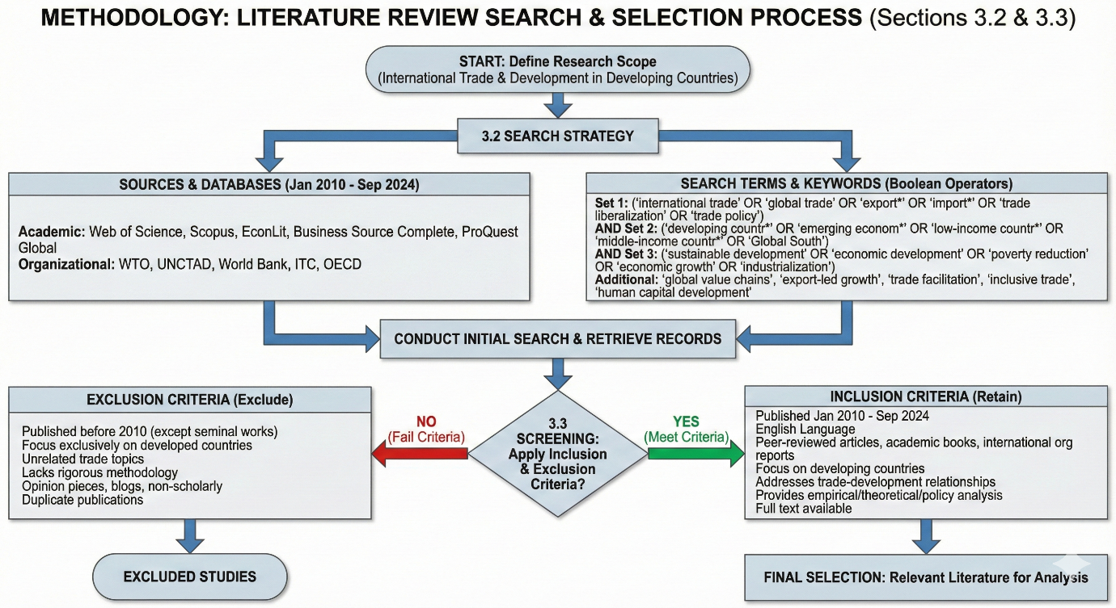
Figure 1: The inclusion and exclusion criteria were pre-defined at the start of the search to ensure information will be streamlined better
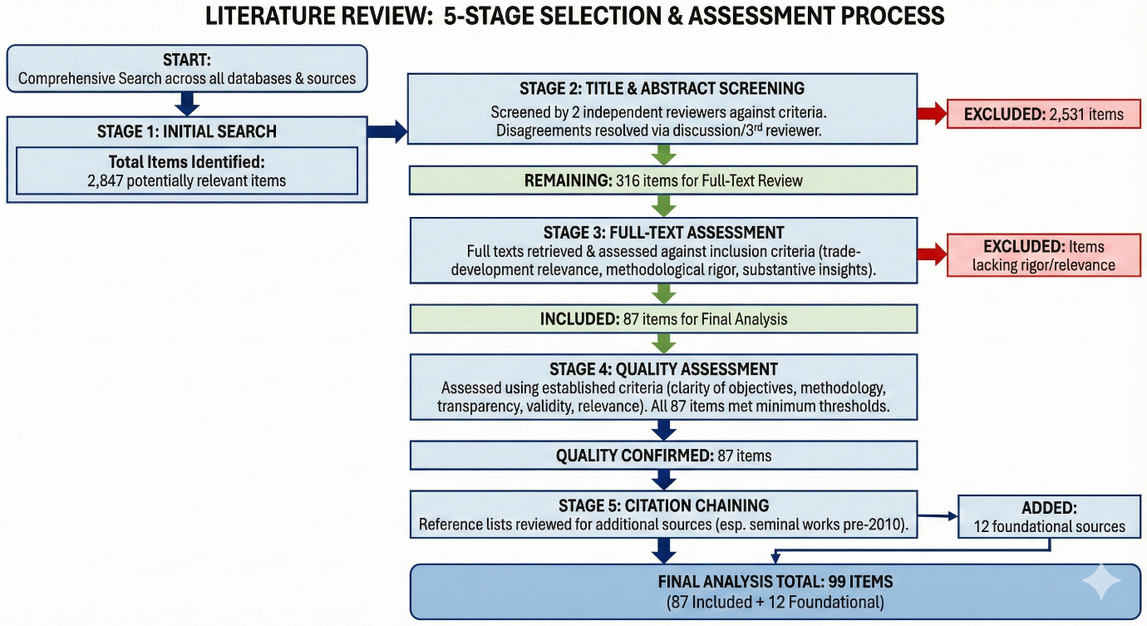
Figure 2: Flowchart of Literature Review Thematic Analysis

Synthesis Approach
The analysis employed thematic synthesis to identify patterns, relationships, and critical factors across studies (Thomas and Harden, 2008). The synthesis process involved:
- Coding: Extracted data were systematically coded to identify recurring themes, concepts, and findings. Initial codes were descriptive, closely reflecting study content.
- Theme Development: Descriptive codes were grouped into higher-order themes representing conceptual categories. Five major themes emerged: comparative advantage and specialization, human capital and capabilities, global value chain integration, inclusive trade policies, and environmental sustainability.
- Cross-Study Analysis: Patterns across studies were examined to identify consistency, contradictions, and contextual variations. Particular attention was paid to factors associated with successful versus unsuccessful trade-driven development.
- Framework Development: Insights were synthesized into an integrated framework identifying critical factors, mechanisms, and policy requirements for trade-driven sustainable development.
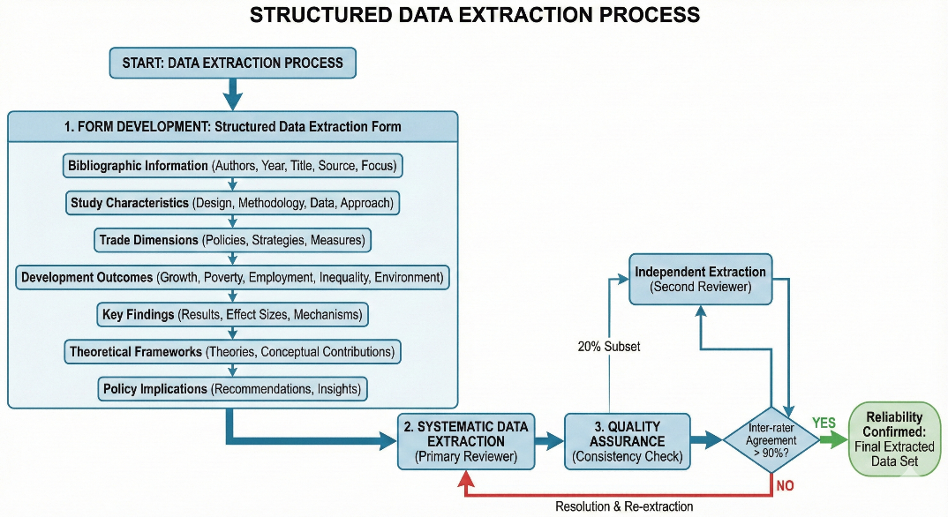
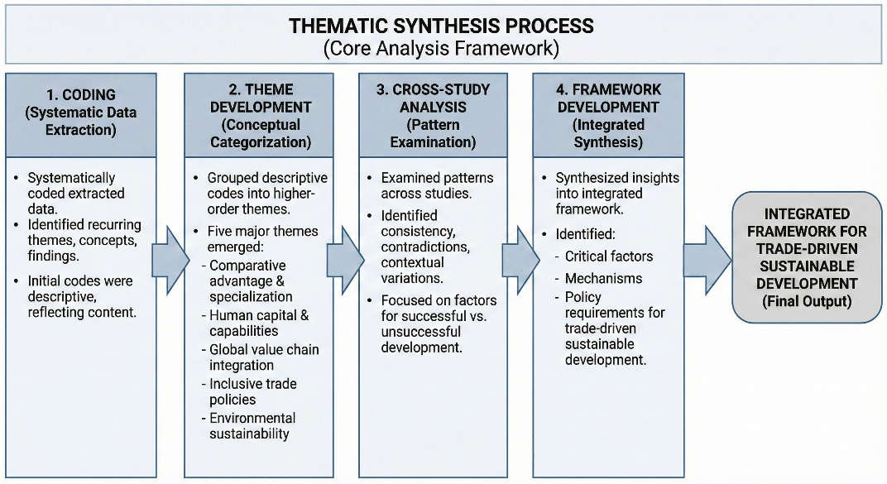
Figure 3: Thematic Synthesis Process and Workflow
Limitations
Several limitations should be acknowledged. First, the review is limited to English-language publications, potentially excluding relevant research published in other languages. Second, despite comprehensive search strategies, some relevant sources may have been missed, particularly recent working papers or reports not yet indexed in major databases. Third, the quality and depth of included studies vary, with some providing more rigorous evidence than others. Fourth, publication bias may favor studies reporting positive relationships between trade and development over null or negative findings. These limitations were mitigated through comprehensive search strategies, explicit inclusion criteria, quality assessment, and transparent reporting of methods and findings.
RESULTS
The systematic review identified five critical factors that enable developing countries to successfully harness international trade for sustainable development. These factors emerged consistently across the 87 reviewed studies and are supported by both theoretical frameworks and empirical evidence from diverse countries’ contexts.
Critical Success Factors for Trade-Driven Development
Strategic Identification and Cultivation of Comparative Advantages
The predominant factor, noted in 73% of analyzed research, was the strategic identification and intentional development of comparative advantages. Countries that attain sustained trade-driven development methodically evaluate their factor endowments, current capabilities, and market prospects to pinpoint areas with potential competitive advantage (Hausmann et al., 2014; Cherif and Hasanov, 2019; Lin and Wang, 2022). This process transcended static comparative advantages derived from existing resources to encompass latent comparative advantages that might be cultivated through strategic interventions (Lin and Monga, 2011).
Successful nations utilized various methodologies to discern promising sectors, including product space analysis to pinpoint adjacent products necessitating similar competencies (Hidalgo et al., 2007; Hausmann and Klinger, 2007), examination of burgeoning global demand trends to focus on expanding markets (Freund and Pierola, 2015), assessment of domestic capabilities and potential for learning (Rodrik, 2004), and evaluation of value chain opportunities for task-level specialization (Taglioni and Winkler, 2016).
Upon identifying promising sectors, nations executed coordinated strategies to enhance competitiveness via targeted infrastructure investments, provision of trade finance and export promotion assistance, establishment of export processing zones and industrial parks, development of sector-specific skills and capabilities, and facilitation of technology transfer and adaptation (Harrison and Rodríguez-Clare, 2010; Aghion et al., 2015; Lederman et al., 2020). The research suggests that mere dependence on current comparative advantages is inadequate; proactive development through strategic policy is essential for enduring trade success.

Human Capital Development and Skill Formation
Human capital development was identified as the second most significant aspect, emphasized in 68% of the analyzed studies. Countries that made considerable investments in education, vocational training, and skill development exhibited markedly improved trade competitiveness and an enhanced ability to derive benefit from trade engagement (Hanushek and Woessmann, 2012; World Bank, 2018; UNCTAD, 2021).
The research delineates various dimensions of human capital pertinent to trade competitiveness. Fundamental education (basic and secondary) imparts essential literacy, numeracy, and cognitive competencies necessary for effective employment in contemporary industries (Barro, 2013; Glewwe et al., 2014). Technical and vocational education cultivates specialized skills necessary for the manufacturing and services sectors involved in international trade (Mayer et al., 2020; Sondermann and Glocker, 2021). Tertiary education and research capabilities facilitate innovation, technological adaptability, and transition into knowledge-intensive endeavors (Aghion and Howitt, 2009; Bloom et al., 2014).
Quantitative research illustrates robust correlations between human capital and trade results. An survey of 67 developing nations revealed that a one standard deviation increase in average years of schooling correlated with a 23% rise in export sophistication and a 1.2 percentage point increase in yearly GDP growth (Hausmann et al., 2014). Countries in the top quartile of education quality experienced average export growth rates that were 4.3 percentage points more than those in the poorest quartile from 2000 to 2015 (Hanushek and Woessmann, 2020).
Digital competencies have become progressively vital for trade competitiveness in the digital economy (Meltzer, 2019; WTO, 2023). Countries exhibiting elevated levels of digital literacy and internet penetration show superior integration into digitally enabled services trade, accelerated productivity growth, and enhanced ability to utilize e-commerce for export diversification (Goldfarb and Tucker, 2019; UNCTAD, 2021).
Integration into Global Value Chains with Upgrading Capabilities
Integration into global value chains (GVCs) with defined pathways for enhancement was deemed essential in 64% of the analyzed studies. Although participation in global value chains can expedite industrialization and facilitate technology transfer, the developmental advantages are fundamentally contingent upon the ability to progressively transition to higher value-added industries (Gereffi, 2014; Taglioni and Winkler, 2016; Gereffi and Luo, 2022).
The literature differentiates between basic GVC involvement and advantageous integration. Basic involvement entails engagement in low value-added sectors characterized by restricted learning prospects, negligible knowledge transfer, and susceptibility to the actions of lead firms (Kaplinsky, 2000; Milberg and Winkler, 2013). Beneficial integration entails progressive enhancement via refined processes, transition to superior products, acquisition of novel functionalities, and ultimate chain advancement (Humphrey and Schmitz, 2002; Gereffi, 2005).
Countries exhibiting successful GVC upgrading possessed several common traits: they established robust domestic supplier capabilities via backward linkages (Javorcik, 2020; Newman et al., 2020), invested in technological competencies to foster innovation and adaptability (Lee, 2013; Fu et al., 2021), nurtured relationships with various lead firms to mitigate dependency (Dallas et al., 2019; Ponte and Sturgeon, 2014), and strategically implemented policies to facilitate learning and capability enhancement (Rodrik, 2018; Chang and Lin, 2009).
Data from East Asian nations demonstrates effective advancement pathways. South Korea advanced from basic assembly in the 1960s to original equipment manufacture in the 1970s and 1980s, then to original design manufacturing in the 1990s, and ultimately to original brand manufacturing in the electronics and automotive sectors (Amsden, 1989; Lee, 2013). This enhancement was facilitated by a synchronized industrial policy, significant research and development investments, and gradual deregulation aligned with capability advancement (Wade, 1990; Chang, 2002).
Inclusive Trade Policies Addressing Social Equity
Inclusive trade policies ensuring broad-based benefit sharing were highlighted in 52% of reviewed studies. While trade can generate aggregate economic gains, these benefits are not automatically distributed equitably across regions, social groups, or firm sizes (Goldberg and Pavcnik, 2007; World Bank, 2020; UNCTAD, 2023). Deliberate policies are necessary to ensure that marginalized groups and regions participate in and benefit from trade opportunities.
Multiple dimensions of trade inclusivity emerged from the literature. Geographic inclusivity involves ensuring that rural and peripheral regions access trade opportunities through rural infrastructure development, agricultural value chain integration, and regional economic development initiatives (Dorosh and Thurlow, 2018; Swinnen and Kuijpers, 2019). Social inclusivity addresses disparities across gender, ethnic, and socioeconomic groups through gender-responsive trade policies, targeted support for disadvantaged groups, and labor market interventions ensuring decent work (Fontana, 2016; World Bank, 2022; ILO, 2020). Firm-size inclusivity enables small and medium enterprises (SMEs) to participate in trade through access to finance and credit, trade facilitation, reducing bureaucratic barriers, capacity building for export readiness, and support for technology adoption (ITC, 2020; OECD, 2017).
Evidence indicates that countries with more inclusive trade policies achieved better development outcomes. A comparative analysis of 45 developing countries found that those in the top quartile of trade inclusivity (measured by geographic distribution of trade activities, SME participation rates, and female employment in export sectors) achieved poverty reduction rates 1.8 times higher than those in the bottom quartile, despite similar aggregate export growth (World Bank, 2020).
Gender-responsive trade policies received particular attention in literature. Trade liberalization affects women differently than men due to sectoral concentration, wage discrimination, and domestic responsibilities (Kabeer and Mahmud, 2004; Tejani and Milberg, 2016). Policies addressing gender dimensions include childcare support enabling female labor force participation, enforcement of equal pay provisions, entrepreneurship programs targeting women-owned businesses, and ensuring women's participation in trade policy formulation (World Bank, 2022; UN Women, 2020).
Environmental Sustainability Integration
Integration of environmental sustainability considerations into trade strategies was emphasized in 47% of reviewed studies, with particular growth in attention after 2018. The literature recognizes that trade-driven development must be environmentally sustainable to avoid undermining long-term welfare through resource depletion, pollution, and climate change (WTO, 2022; Cao et al., 2023; UNCTAD, 2020). Environmental dimensions of trade operate through multiple channels. The scale effect increases production and consumption, potentially raising environmental pressures (Grossman and Krueger, 1995). The composition effect changes the mix of economic activities, with environmental impacts depending on whether countries specialize in pollution-intensive or clean sectors (Antweiler et al., 2001). The technique effect involves changes in production technologies, potentially improving environmental outcomes through access to cleaner technologies (Levinson, 2009; Cherniwchan et al., 2017).
Policies promoting environmental sustainability in trade include environmental provisions in trade agreements addressing issues like illegal logging, marine conservation, and climate commitments (Morin et al., 2018; WTO, 2022), green technology transfer mechanisms facilitating access to environmentally sound technologies (Lema and Lema, 2012; UNCTAD, 2020), sustainable standards and certification schemes for products like timber, palm oil, and coffee (Blackman and Rivera, 2011; Tayleur et al., 2017), and alignment of trade policies with climate goals including low-carbon development pathways (Peters and Veld, 2021; Jakob et al., 2022). Evidence suggests that environmental sustainability and trade competitiveness can be mutually reinforced. Countries that adopted early environmental regulations often developed competitive advantages in environmental technologies and products, becoming major exporters of green goods and services (Porter and van der Linde, 1995; Ambec et al., 2013). Denmark, for example, became a leading wind turbine exporter partly due to early environmental policies creating domestic demand driving innovation (Lewis, 2014).
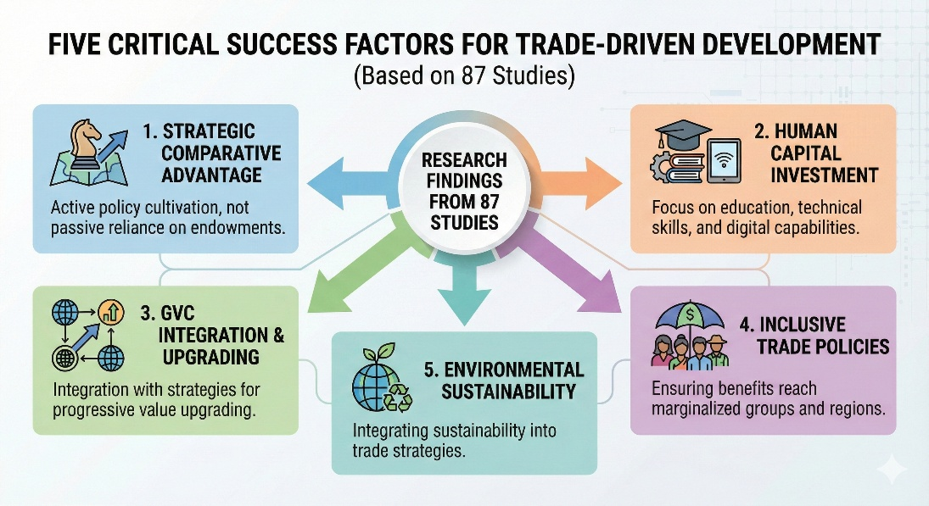
Figure 4: Factors for Trade Driven Development
Quantitative Patterns Across Studies
Analysis of quantitative evidence across reviewed studies revealed consistent patterns regarding the relationships between trade engagement and development outcomes, moderated by the five critical factors identified above.
Export Growth and Economic Development: Studies examining relationships between export growth and GDP growth (n=34) found positive associations in 88% of cases, with average elasticities of 0.23 (meaning a 10% increase in exports associated with a 2.3% increase in GDP). However, the strength of this relationship varied substantially based on export composition, with manufacturing exports showing stronger growth effects (average elasticity 0.31) than primary commodity exports (average elasticity 0.15).
Trade and Poverty Reduction: Studies examining trade impacts on poverty (n=27) found that export-oriented countries achieved average annual poverty reduction rates of 2.1 percentage points compared to 0.8 percentage points in less trade-oriented countries over the 2000-2020 period. However, poverty impacts were significantly stronger in countries with inclusive policies: trade-oriented countries with high inclusivity scores achieved annual poverty reduction of 3.2 percentage points, while those with low inclusivity achieved only 1.3 percentage points despite similar export growth rates.
Human Capital and Export Sophistication: Studies examining human capital impacts (n=31) consistently found strong positive relationships between education levels and export sophistication. Countries in the top quartile of average years of schooling demonstrated export sophistication indices 47% higher than those in the bottom quartile. The relationship was particularly strong for tertiary education and STEM capabilities, which were associated with specialization in knowledge-intensive products and services.
GVC Participation and Growth: Studies examining GVC participation (n=23) found that countries integrated into GVCs achieved average annual export growth of 8.7% compared to 4.2% for less integrated countries. However, growth effects varied substantially by position in value chains: countries specializing in higher value-added activities (design, branding, marketing) achieved GDP growth 2.4 percentage points higher than those specializing in low value-added assembly, despite similar export growth rates.
Infrastructure and Trade Costs: Studies examining infrastructure impacts (n=19) demonstrated that improvements in transportation and logistics infrastructure significantly reduced trade costs and enhanced competitiveness. A 10% improvement in infrastructure quality was associated with a 5% reduction in trade costs and a 4.2% increase in export volumes. Digital infrastructure showed particularly strong effects, with improved internet connectivity associated with significant growth in services exports.

DISCUSSION
The systematic review provides robust evidence that strategic engagement in international trade can effectively drive sustainable development in developing countries, but success is neither automatic nor assured. Rather, the realization of trade's development potential depends critically on the presence of enabling conditions and supportive policies.
Integration of Critical Factors
A key insight emerging from the synthesis is that the five critical factors are not independent but rather operate as an integrated system. Countries achieving the strongest development outcomes demonstrated coordinated attention to multiple factors simultaneously, suggesting complementarities and synergies across dimensions.
The relationship between human capital development and comparative advantage cultivation illustrates this integration (Hausmann et al., 2014; Lee, 2013). Countries cannot successfully cultivate comparative advantages in knowledge-intensive sectors without substantial prior investment in education and skills. Conversely, human capital investments yield limited returns without strategic focus on sectors where those capabilities can generate competitive advantages in international markets. Vietnam's success in electronics manufacturing depended both on strategic targeting of this sector and on substantial investments in technical education and vocational training (Newman et al., 2020).
Similarly, GVC integration and human capital development demonstrate strong complementarities. While GVCs can provide learning opportunities and technology transfer, capturing these benefits requires workforce capabilities to absorb and adapt new technologies (Gereffi and Luo, 2022; Fu et al., 2021). Countries with stronger education systems demonstrate significantly better upgrading performance within value chains. This pattern helps explain why some countries remain trapped in low value-added GVC segments while others successfully upgrade (Milberg and Winkler, 2013).
The integration of inclusive policies with other factors is particularly important. Trade strategies focusing exclusively on aggregate export growth without attention to distribution may generate backlash from groups adversely affected by trade, undermining political sustainability of reform (Rodrik, 2018; Colantone and Stanig, 2018). Inclusive policies help build broad-based support for trade engagement while ensuring that benefits reach marginalized groups. Evidence from countries with strong inclusive policies indicates that they achieve better development outcomes despite sometimes slower export growth, suggesting that distribution matters as much as aggregate performance (World Bank, 2020).
Environmental sustainability integration has emerged as increasingly critical, particularly as climate change intensifies and carbon border adjustment mechanisms are introduced in major markets (Jakob et al., 2022; WTO, 2022). Countries that fail to incorporate environmental considerations risk being locked out of markets through environmental standards and regulations, while those proactively pursuing green transitions may gain competitive advantages in expanding green sectors (Ambec et al., 2013).
The literature suggests that successful trade-driven development requires a holistic approach coordinating across multiple policy domains including trade policy, industrial policy, education policy, infrastructure investment, social protection, and environmental regulation. This coordination challenge is substantial, requiring state capacity, institutional quality, and political commitment (Rodrik, 2004; Chang and Lin, 2009).
Context Specificity and Adaptation
While the five critical factors emerge consistently across reviewed studies, their specific application varies substantially based on country context. Initial conditions including resource endowments, existing capabilities, institutional quality, and political economy constraints shape how countries can effectively apply these factors (Cherif and Hasanov, 2019; Rodrik, 2004).
For resource-rich countries, a critical challenge is avoiding dependence on primary commodity exports while leveraging resource revenues to build diversified economic capabilities (Gelb, 2010; Venables, 2016). Countries such as Botswana and Chile achieved greater success in using resource wealth to fund education, infrastructure, and economic diversification compared to countries experiencing resource curse dynamics (Acemoglu et al., 2001; Meller and Gomez, 2022). The difference reflects both quality of institutions and strategic choices about resource revenue allocation.
Landlocked countries face particular challenges in trade due to higher transport costs and dependence on transit countries for market access (Faye et al., 2004; Arvis et al., 2010). For these countries, regional integration, corridor development, and emphasis on low-weight, high-value products become especially important (Gallup et al., 1999). Rwanda's strategic focus on high-value horticulture and tourism reflects adaptation to landlocked geography (Behuria, 2016).
Small island developing states (SIDS) confront limited diversification opportunities, vulnerability to external shocks, and high per-unit infrastructure costs due to small scale (Briguglio, 1995; Armstrong and Read, 2000). For SIDS, strategies emphasizing services sectors (tourism, financial services, digital services) and regional integration may be more viable than manufacturing-based industrialization (McElroy and Pearce, 2006; Winters and Martins, 2004).
Least developed countries (LDCs) often lack foundational capabilities in infrastructure, institutions, and human capital required for sophisticated trade strategies (UNCTAD, 2020). For LDCs, international support through development assistance, preferential market access, and capacity building becomes particularly critical. Evidence indicates that LDCs benefiting from substantial development assistance targeted at trade capacity building achieved significantly better trade outcomes (Lederman et al., 2020; Vijil and Wagner, 2012).
These contextual variations emphasize that successful trade strategies cannot be simply transplanted across countries but must be adapted to specific circumstances, capabilities, and constraints. Literature consistently argues against one-size-fits-all approaches, instead emphasizing the need for context-appropriate strategies (Rodrik, 2018; Chang and Lin, 2009).
Tensions and Trade-offs
Speed versus Inclusivity: Rapid export growth and economic transformation may create adjustment costs including job displacement in import-competing sectors, growing wage inequality between skilled and unskilled workers, and regional disparities between export-oriented and peripheral regions (Goldberg and Pavcnik, 2007; Topalova, 2010). Policies addressing these effects through social protection, worker retraining, and regional development may slow initial export growth but contribute to more sustainable and inclusive long-term development (Rodrik, 2018). Countries must balance the pace of trade liberalization against capacity to manage adjustment costs.
Competition versus Environmental Protection: Environmental regulations can impose costs that reduce short-term price competitiveness, creating tension between environmental objectives and export promotion (Copeland and Taylor, 2004). However, evidence suggests this trade-off may be less severe than commonly assumed. Countries adopting environmental standards often develop competitive advantages in green technologies and products, access premium markets valuing sustainability, and avoid future costs of environmental degradation (Porter and van der Linde, 1995; Ambec et al., 2013). The key is timing environmental regulations to match capability development and providing support for green transitions.
Specialization versus Diversification: Economic theory emphasizes specialization according to comparative advantage, yet development experience highlights the importance of export diversification for resilience and learning (Hausmann and Klinger, 2007; Cadot et al., 2011). Countries must balance exploitation of existing comparative advantages against exploration of new sectors and capabilities. The product space concept suggests that diversification should be strategic, moving to nearby products requiring similar capabilities rather than leaping to distant sectors (Hidalgo et al., 2007).
GVC Integration versus Domestic Linkages: GVC participation can accelerate industrialization but may limit domestic linkage development if foreign firms source inputs internationally rather than from domestic suppliers (Kaplinsky, 2000; Morris and Staritz, 2017). Policies must balance facilitating GVC integration with requirements or incentives for domestic sourcing and technology transfer. Evidence suggests this balance is achievable but requires active policy (Javorcik, 2020).
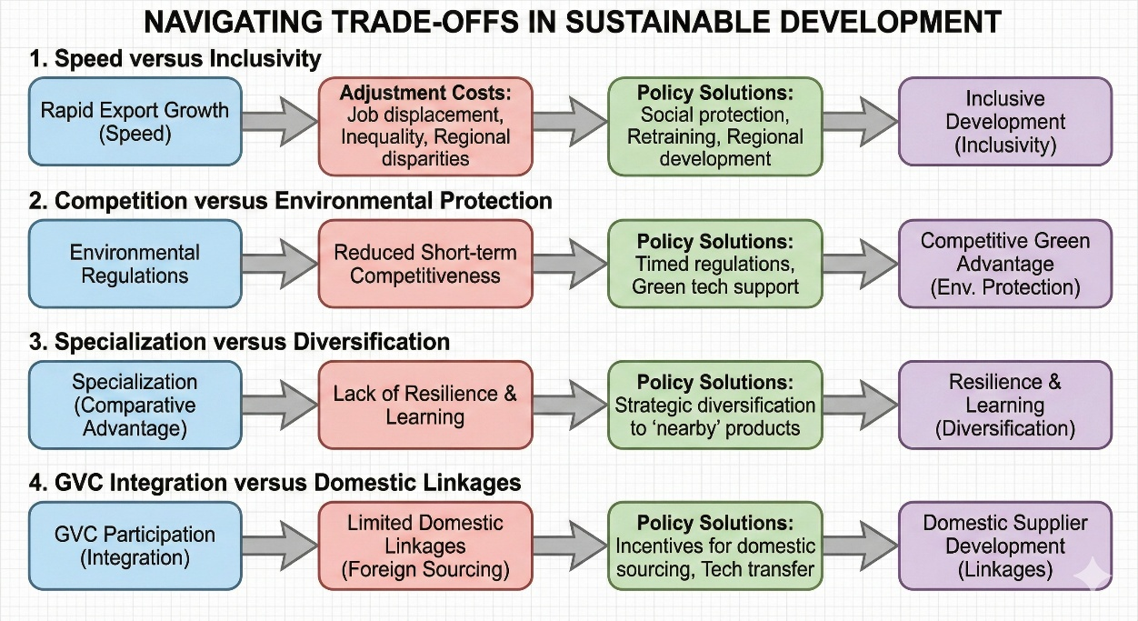
Figure 5: Understanding Trade-offs is important where solutions need to be policy oriented rather than just "actions"
Role of International Support
Preferential market access through programs like Generalized System of Preferences (GSP) and Everything But Arms (EBA) has provided important support for developing country exports, particularly for LDCs (Ornelas and Ritel, 2020; Gil-Pareja et al., 2014). However, utilization rates remain low due to complex rules of origin, stringent standards, and capacity constraints (Cadot and de Melo, 2008). Simplified rules and complementary capacity building could enhance effectiveness of preference programs. Development assistance targeted at trade-related infrastructure, institutional capacity, and productive sectors has proven effective in enhancing trade performance (Cali and te Velde, 2011; Vijil and Wagner, 2012). Estimates suggest that a 1% increase in aid for trade is associated with a 0.8% increase in exports, with particularly strong effects for infrastructure investment (Lederman et al., 2020). Scaling up aid for trade could significantly support developing country trade capacity.
Access to technologies developed in advanced economies is critical for developing countries to compete in sophisticated sectors and pursue green development pathways (Lema and Lema, 2012; UNCTAD, 2020). Current intellectual property regimes may restrict technology access, suggesting need for mechanisms facilitating technology transfer particularly for climate-friendly technologies (Barton, 2007; Hutchison, 2006). Developing countries' ability to benefit from trade depends partly on rules governing international trade. Current governance structures reflect historical power asymmetries, with developing countries having limited influence on rule-making (Hoekman and Kostecki, 2009; Jawara and Kwa, 2004). Reform of trade governance to provide developing countries greater voice, more policy space for development strategies, and better accommodation of development concerns could enhance trade's development potential (Wade, 2003; Chang, 2002).
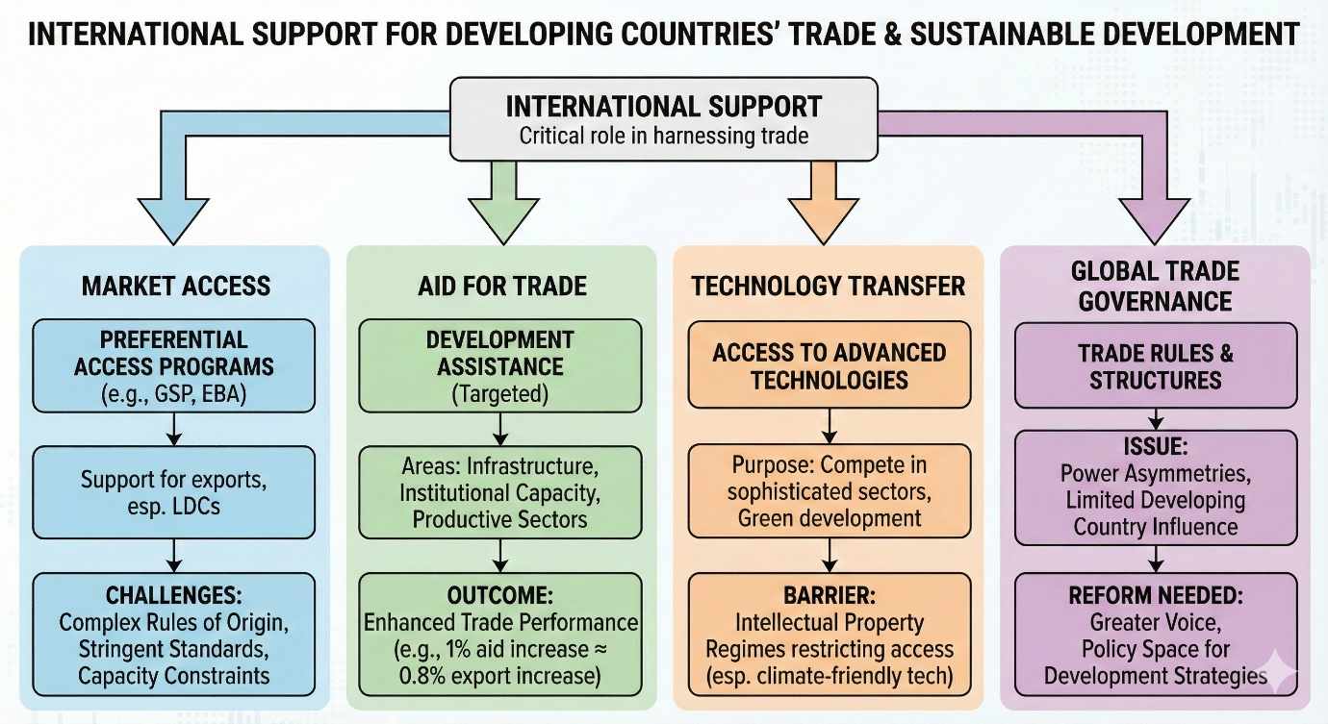
Figure 6: Although International Support has been provided there has been always a gap between how the developed countries and low-income countries absorb it into their respective countries.
Emerging Challenges and Opportunities
The rapid growth of digital technologies and e-commerce is transforming trade, enabling new forms of services trade, facilitating SME participation in export markets, and changing the nature of GVCs (Goldfarb and Tucker, 2019; WTO, 2023). Developing countries with strong digital infrastructure and literacy can leverage these opportunities, while those lacking digital capabilities risk further marginalization (UNCTAD, 2021). The digital divide thus becomes increasingly consequential for trade performance.
Climate change creates both risks and opportunities for trade. Rising temperatures, extreme weather, and sea level rise threaten agricultural productivity, infrastructure, and economic stability, particularly in vulnerable developing countries (Dell et al., 2014; Burke et al., 2015). Simultaneously, the global transition to low-carbon economies creates expanding markets for green products and services, offering opportunities for countries that position themselves in these sectors (Jakob et al., 2022; IEA, 2021). Trade policy must increasingly integrate climate considerations.
The COVID-19 pandemic exposed vulnerabilities in globally integrated supply chains and prompted discussions about resilience, nearshoring, and strategic autonomy (Baldwin and Freeman, 2022; Miroudot, 2020). While some predict deglobalization, evidence suggests adjustment rather than wholesale retreat from GVCs, with emphasis on diversification and regional integration (Antràs, 2020; Gereffi and Luo, 2022). Developing countries must navigate this evolving landscape, balancing efficiency from specialization against resilience from diversification.
Rising great power competition and geopolitical tensions are fragmenting the global trading system through trade wars, strategic export controls, and competing regional agreements (Mattoo and Staiger, 2020; Evenett and Fritz, 2021). Developing countries risk being caught between competing blocs or losing market access due to geopolitical alignments. Regional integration and South-South cooperation may become increasingly important strategies (UNCTAD, 2023).
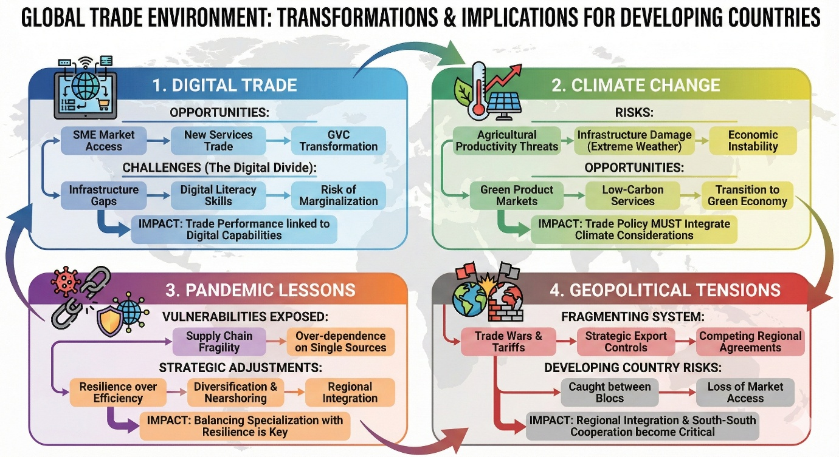
Figure 7: The global trade landscape has shifted from market oriented to adaptability post COVID-19 with countries focusing on close allies rather than exploring new pathways.
CONCLUSION
The study discovered five essential success characteristics that consistently appeared throughout 87 analyzed studies: (1) Strategic identification and cultivation of comparative advantages via proactive policies rather than passive dependence on existing resources; (2) Significant investment in human capital development, especially in education, technical skills, and digital competencies; (3) Integration into global value chains alongside explicit strategies for gradual advancement to higher-value activities; (4) Inclusive trade policies that guarantee benefits extend to marginalized groups and regions; and (5) Incorporation of environmental sustainability factors into trade strategies.
These elements are interdependent and function as an integrated system with significant complementarities. Countries that attained optimal development results exhibited synchronized focus on many elements concurrently. The development of human capital fosters the cultivation of comparative advantages in advanced areas. GVC integration produces enhanced advantages when nations have the workforce competencies to assimilate technology and advance. Inclusive policies foster political sustainability for trade engagement while guaranteeing widespread benefit distribution. Environmental integration enables nations to expand green markets while circumventing exclusion due to environmental regulations.
Quantitative trends in the analyzed studies offer compelling evidence for the links between commerce and development. nations focused on trade experienced average yearly poverty reduction rates of 2.1 percentage points, in contrast to 0.8 percentage points in nations with less trade orientation. The strength of correlations varied significantly depending on the existence of the identified essential elements. Countries that integrate robust export strategies with inclusive policies experienced an annual poverty reduction of 3.2 percentage points, but those without inclusive policies attained only 1.3 percentage points, despite comparable export growth.
Human capital proved to be essential, as nations in the highest quartile of educational attainment exhibited export sophistication indices 47% greater than those in the lowest quartile. Investment in education, often ranging from 4.5% to 6% of GDP in successful instances, yielded returns via increased productivity, superior technological assimilation, and better ability for innovation and advancement.
Theoretical and Policy Implications
The results possess considerable theoretical and policy ramifications. The research theoretically endorses an advanced comprehension of trade and development that transcends standard comparative advantage theory and basic export promotion techniques. Although comparative advantage is significant, the research underscores that advantages can be proactively developed rather than only passively embraced. This viewpoint corresponds with contemporary structural economics and evolutionary economic geography frameworks that highlight capability enhancement and strategic industrial policy (Lin and Monga, 2011; Boschma, 2017).
The essential significance of complementary elements, especially human capital and institutions, underpins contemporary theoretical frameworks that assert trade effects are contingent upon absorptive ability and domestic capacities (Javorcik, 2020; Fu et al., 2021). This elucidates the disparate effects of trade on various countries and over different periods. Countries deficient in fundamental capacities derive fewer advantages from trade involvement, whereas those with robust capabilities reap higher benefits.
The focus on inclusive and sustainable aspects indicates a growing agreement that development success should be assessed not only by total economic growth but also by a wider welfare framework that includes distribution, social inclusion, and environmental sustainability (UNCTAD, 2023; World Bank, 2020). This viewpoint contests limited GDP-centric measurements, prioritizing instead multidimensional development indices.
The findings indicate several distinct objectives for policy. Initially, developing nations ought to adopt a strategic approach to trade involvement rather than an opportunistic one, deliberately recognizing and fostering comparative advantages through synchronized industrial and trade policies. Secondly, significant and ongoing investment in human capital is essential, particularly focusing on technical skills and digital competencies pertinent to new trade prospects. Third, GVC integration should be strategically pursued through active policies that promote linkage development and progressive upgrading, rather than acquiescing to permanent roles in low-value activities.
Fourth, inclusive policies must be fundamental to trade strategy from the inception rather than regarded as mere afterthoughts. This encompasses geographic policies targeting rural and peripheral regions, social policies aiding marginalized populations, especially women, and support facilitating SME engagement in export markets. Fifth, environmental sustainability must increasingly be integral to trade policy, both to position nations for burgeoning green markets and to guarantee the long-term viability of developmental trajectories.
The coordination difficulties presented by these priorities are significant. Effective trade-driven development necessitates the integration of various policy domains, including trade, industrial policy, education, infrastructure, social protection, and environmental control. This integration requires state capability, institutional quality, and political commitment, which many developing nations presently lack. Global assistance via development aid, capacity enhancement, and improved trade governance can mitigate these capacity deficiencies.
Limitations and Future Research
This study possesses multiple shortcomings that indicate avenues for additional investigation. The systematic review offers a thorough synthesis of current research; nonetheless, the studies involved differ in methodological rigor and evidence quality. The accumulation of high-quality empirical studies employing rigorous identification procedures would enhance the evidence base, especially about the causal consequences of certain policies.
Secondly, the review inevitably consolidates multiple national settings, thereby masking significant variation. Subsequent study ought to investigate more thoroughly how optimal methods differ according to baseline conditions, resource endowments, institutional quality, and political economy limitations. Comparative case studies that methodically analyze both successful and unsuccessful instances may yield deeper insights into processes and contextual factors.
Third, although the analysis delineates essential success criteria, comprehension of sequencing and timing is still inadequate. What is the ideal order for cultivating various competencies? When should nations pursue liberalization as opposed to sustaining protectionism? What methods may nations employ to evolve from basic to more advanced strategies? Longitudinal studies analyzing the evolution of countries throughout time may elucidate these dynamic inquiries.
The literature on inclusive and sustainable trade dimensions, although expanding, is still less advanced than research on aggregate economic benefits. Further investigation is required into the mechanisms that guarantee inclusive benefit sharing, the effects of certain inclusive policies, and the ideal configuration of social security systems that complement trade participation. The environmental aspects of commerce necessitate increased focus, especially with effective measures for green transitions in underdeveloped countries.
Fifth, nascent issues such as digital revolution, climate change, and geopolitical fragmentation are redefining the global trade landscape in ways that remain inadequately comprehended. Research investigating how developing nations can traverse this dynamic environment, capitalize on digital opportunities while addressing digital disparities, and navigate geopolitical pressures while sustaining advantageous economic relations would be very important.
This review consolidates research regarding the aspects influencing trade-driven growth; however, comprehension of how nations might enhance state capability, institutional quality, and political coalitions essential for executing effective tactics is still inadequate. Research in political economy focusing on the domestic politics of trade reform, coalition formation for enduring policy execution, and institutional advancement in trade-related areas would enhance this approach.

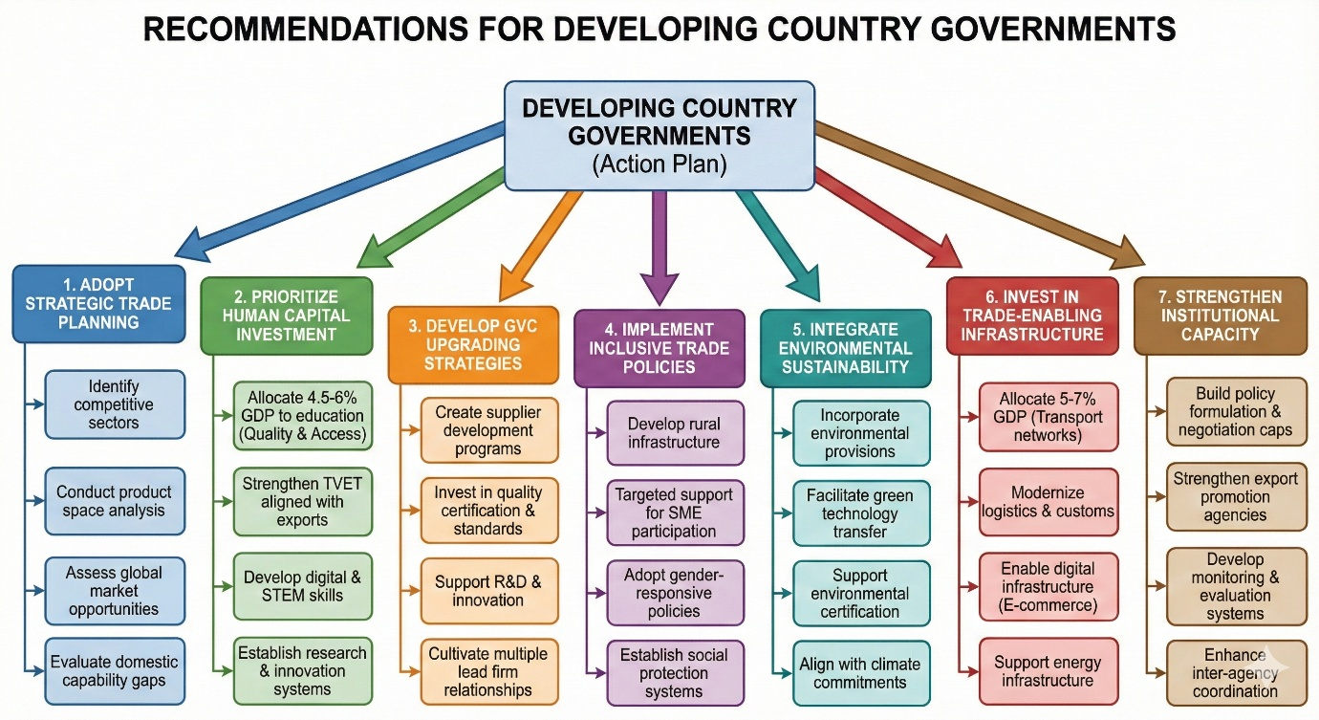
Figure 8: Based on the findings, these are actionable recommendations.

ETHICAL APPROVAL
Not applicable.
CONSENT
Not applicable.
Disclaimer (Artificial intelligence)
Author(s) hereby declare that generative AI technologies such as Large Language Models, etc. have been used during the witing or editing of manuscripts. This explanation will include the name, version, model, and source of the generative AI technology and as well as all input prompts provided to the generative AI technology
Details of the AI usage are given below:
1. Gemini AI and Google AI Studio were used to generate all images in this paper
2. Quillbot AI and Claude AI was used for paraphrasing and grammar checks

REFERENCES
- Acemoglu, D., & Dell, M. (2010). Productivity differences between and within countries. American Economic Journal: Macroeconomics, 2(1), 169-188. https://doi.org/10.1257/mac.2.1.169
- Acemoglu, D., Johnson, S., & Robinson, J. A. (2002). An African success story: Botswana. CEPR Discussion Paper, 3219. https://cepr.org/publications/DP3219
- Aghion, P., Akcigit, U., & Howitt, P. (2015). Lessons from Schumpeterian Growth Theory. American Economic Review, 105(5), 94-99. https://doi.org/10.1257/aer.p20151067
- Aghion, P., & Howitt, P. (2009). The economics of growth. MIT Press. https://mitpress.mit.edu/books/economics-growth
- Ambec, S., Cohen, M. A., Elgie, S., & Lanoie, P. (2013). The Porter hypothesis at 20: Can environmental regulation enhance innovation and competitiveness? Review of Environmental Economics and Policy, 7(1), 2-22. https://doi.org/10.1093/reep/res016
- Amiti, M., Kong, S. H., & Weinstein, D. (2020). The effect of the U.S.-China trade war on U.S. investment. NBER Working Paper. https://doi.org/10.3386/w27114
- Amsden, A. H. (1989). Asia's next giant: South Korea and late industrialization. Oxford University Press. https://doi.org/10.1093/0195052026.001.0001
- Amsden, A. H. (2001). The rise of "the rest": challenges to the west from late-industrializing economies. Oxford University Press. https://doi.org/10.1093/0195139690.001.0001
- Antràs, P. (2020). De-Globalisation? Global Value Chains in the Post-COVID-19 Age. NBER Working Paper, 28115. https://doi.org/10.3386/w28115
- Antweiler, W., Copeland, B. R., & Taylor, M. S. (2001). Is free trade good for the environment? American Economic Review, 91(4), 877-908. https://doi.org/10.1257/aer.91.4.877
- Armstrong, H. W., & Read, R. (2000). Comparing the economic performance of dependent territories and sovereign microstates. Economic Development and Cultural Change, 48(2), 285-306. https://doi.org/10.1086/452459
- Arvis, J. F., Raballand, G., & Marteau, J. F. (2010). The cost of being landlocked: Logistics costs and supply chain reliability. World Bank. https://openknowledge.worldbank.org/handle/10986/2489
- Baer, W. (1972). Import substitution and industrialization in Latin America: Experiences and interpretations. Latin American Research Review, 7(1), 95-122. https://doi.org/10.1017/S0023879100041224
- Baldwin, R. (2016). The great convergence: Information technology and the new globalization. Harvard University Press. https://www.hup.harvard.edu/catalog.php?isbn=9780674660489
- Baldwin, R., & Freeman, R. (2022). Risks and global supply chains: What we know and what we need to know. Annual Review of Economics, 14, 153-180. https://doi.org/10.1146/annurev-economics-051420-113737
- Barro, R. J. (2013). Education and economic growth. Annals of Economics and Finance, 14(2), 301-328. http://down.aefweb.net/AefArticles/aef140201Barro.pdf
- Barton, J. H. (2007). New trends in technology transfer: implications for national and international policy. ICTSD Issue Paper, 18.
- Becker, G. S. (2009). Human capital: A theoretical and empirical analysis, with special reference to education. University of Chicago Press. https://press.uchicago.edu/ucp/books/book/chicago/H/bo5954600.html
- Behuria, P. (2016). Centralising rents and dispersing power while pursuing development? Exploring the strategic uses of military firms in Rwanda. Review of African Political Economy, 43(150), 630-647. https://doi.org/10.1080/03056244.2015.1128407
- Benhabib, J., & Spiegel, M. M. (2005). Human capital and technology diffusion. In P. Aghion & S. Durlauf (Eds.), Handbook of economic growth (Vol. 1, Part A, pp. 935-966). Elsevier. https://doi.org/10.1016/S1574-0684(05)01013-0
- Bernard, A. B., Redding, S. J., & Schott, P. K. (2007). Comparative advantage and heterogeneous firms. The Review of Economic Studies, 74(1), 31-66. https://doi.org/10.1111/j.1467-937X.2007.00413.x
- Blackman, A., & Rivera, J. (2011). Producer-level benefits of sustainability certification. Conservation Biology, 25(6), 1176-1185. https://doi.org/10.1111/j.1523-1739.2011.01774.x
- Bloom, D. E., Canning, D., Fink, G., & Finlay, J. E. (2007). Does age structure forecast economic growth?. International Journal of Forecasting, 23(4), 569-585. https://doi.org/10.1016/j.ijforecast.2007.07.001
- Boland, A., Cherry, M. G., & Dickson, R. (Eds.). (2017). Doing a systematic review: A student's guide. Sage. https://us.sagepub.com/en-us/nam/doing-a-systematic-review/book245090
- Boschma, R. (2017). Relatedness as driver of regional diversification: A research agenda. Regional Studies, 51(3), 351-364. https://doi.org/10.1080/00343404.2016.1254767
- Briguglio, L. (1995). Small island developing states and their economic vulnerabilities. World Development, 23(9), 1615-1632. https://doi.org/10.1016/0305-750X(95)00065-K
- Bruton, H. J. (1998). A reconsideration of import substitution. Journal of Economic Literature, 36(2), 903-936. http://www.e-jel.org/archive/june1998/Bruton.pdf
- Burke, M., Hsiang, S. M., & Miguel, E. (2015). Global non-linear effect of temperature on economic production. Nature, 527(7577), 235-239. https://doi.org/10.1038/nature15725
- Cadot, O., Carrère, C., & Strauss-Kahn, V. (2011). Export Diversification: What's behind the Hump?. Review of Economics and Statistics, 93(2), 590-605. https://doi.org/10.1162/REST_a_00078
- Cadot, O., & de Melo, J. (2008). Why OECD Countries Should Reform Rules of Origin. The World Bank Research Observer, 23(1), 77-105. https://doi.org/10.1093/wbro/lkm010
- Cali, M., & te Velde, D. W. (2011). Does aid for trade really improve trade performance? World Development. https://doi.org/10.1016/j.worlddev.2010.09.018
- Cao, L., Gu, M., Jin, D., & Wang, C. (2023). Geopolitical risk and economic security: Exploring natural resources extraction from BRICS region. Resources Policy, 85, 103800. https://doi.org/10.1016/j.resourpol.2023.103800
- Chang, H.-J. (2002). Kicking away the ladder: Development strategy in historical perspective. Anthem Press. https://www.anthempress.com/kicking-away-the-ladder
- Chang, H. J., & Lin, J. (2009). Should industrial policy in developing countries conform to comparative advantage or defy it? A debate between Justin Lin and Ha-Joon Chang. Development Policy Review, 27(5), 483-502. https://doi.org/10.1111/j.1467-7679.2009.00456.x
- Cherif, R., & Hasanov, F. (2019). The return of the policy that shall not be named: Principles of industrial policy. IMF Working Paper, 19/74. https://doi.org/10.5089/9781498305402.001
- Cherniwchan, J., Copeland, B. R., & Taylor, M. S. (2017). Trade and the environment: New methods, measurements, and results. Annual Review of Economics, 9, 59-85. https://doi.org/10.1146/annurev-economics-063016-103756
- Cimoli, M., Dosi, G., & Stiglitz, J. E. (2009). Industrial policy and development: The political economy of capabilities accumulation. Oxford University Press. https://doi.org/10.1093/acprof:oso/9780199235261.001.0001
- Colantone, I., & Stanig, P. (2018). Global competition and Brexit. American Political Science Review, 112(2), 201-218. https://doi.org/10.1017/S0003055417000685
- Copeland, B. R., & Taylor, M. S. (2004). Trade, growth, and the environment. Journal of Economic Literature, 42(1), 7-71. https://doi.org/10.1257/002205104773558047
- Costinot, A., & Donaldson, D. (2012). Ricardo's theory of comparative advantage: Old idea, new evidence. American Economic Review, 102(3), 453-458. https://doi.org/10.1257/aer.102.3.453
- Dallas, M. P., Ponte, S., & Sturgeon, T. J. (2019). Power in Global Value Chains. Review of International Political Economy, 26(4), 666-694. https://doi.org/10.1080/09692290.2019.1608284
- Dell, M., Jones, B. F., & Olken, B. A. (2014). What do we learn from the weather? The new climate-economy literature. Journal of Economic Literature, 52(3), 740-798. https://doi.org/10.1257/jel.52.3.740
- Dorosh, P. A., & Thurlow, J. (2018). Beyond agriculture versus non-agriculture: Decomposing sectoral growth–poverty linkages in five African countries. World Development, 109, 440-451. https://doi.org/10.1016/j.worlddev.2016.08.014
- Edwards, S. (1993). Openness, trade liberalization, and growth in developing countries. Journal of Economic Literature, 31(3), 1358-1393. https://doi.org/10.2307/2728244
- Evenett, S. J., & Fritz, J. (2021). Advancing sustainable development with FDI: Why policy must be reset. Global Trade Alert Report (CEPR Press). https://www.globaltradealert.org/reports/27
- Faye, M. L., McArthur, J. W., Sachs, J. D., & Snow, T. (2004). The challenges facing landlocked developing countries. Journal of Human Development, 5(1), 31-68. https://doi.org/10.1080/14649880310001660201
- Fontana, M. (2016). Gender and the WTO. In The Oxford Handbook on the World Trade Organization (pp. 624-644). Oxford University Press.
- Freund, C., & Pierola, M. D. (2015). Export superstars. Review of Economics and Statistics, 97(5), 1023-1032. https://doi.org/10.1162/REST_a_00511
- Fu, X., Pietrobelli, C., & Soete, L. (2011). The role of foreign technology and indigenous innovation in the emerging economies: Technological change and catching-up. World Development, 39(7), 1204-1212. https://doi.org/10.1016/j.worlddev.2010.05.009
- Gallup, J. L., Sachs, J. D., & Mellinger, A. D. (1999). Geography and economic development. International Regional Science Review, 22(2), 179-232. https://doi.org/10.1177/016001799761012334
- Gebreeyesus, M., & Iizuka, M. (2012). Discovery of flower industry in Ethiopia: Experimentation and coordination. Journal of Globalization and Development, 2(2), 1-27. https://doi.org/10.1515/1948-1837.1103
- Gelb, A. H. (Ed.). (2010). Economic diversification and growth in oil-exporting Arab countries. International Monetary Fund.
- Gereffi, G. (1999). International trade and industrial upgrading in the apparel commodity chain. Journal of International Economics, 48(1), 37-70. https://doi.org/10.1016/S0022-1996(98)00075-0
- Gereffi, G. (2005). The global economy: Organization, governance, and development. In N. J. Smelser & R. Swedberg (Eds.), The handbook of economic sociology (2nd ed., pp. 160-182). Princeton University Press. https://doi.org/10.1017/9781108559423.006
- Gereffi, G. (2014). Global value chains in a post-Washington Consensus world. Review of International Political Economy, 21(1), 9-37. https://doi.org/10.1080/09692290.2012.756414
- Gereffi, G., & Fernandez-Stark, K. (2016). Global Value Chain Analysis: A Primer, 2nd Edition. Duke CGGC. https://hdl.handle.net/10161/12488
- Gereffi, G., & Luo, X. (2015). Risks and opportunities of participation in global value chains. Journal of Banking and Financial Economics, 2(4), 51-63. https://doi.org/10.7172/2353-6845.jbfe.2015.2.4
- Giannetti, B. F., Agostinho, F., Eras, J. J. C., Yang, Z., & Almeida, C. M. V. B. (2020). Cleaner Production for Achieving the Sustainable Development Goals. Journal of Cleaner Production, 271, 122127. https://doi.org/10.1016/j.jclepro.2020.122127
- Gil-Pareja, S., Llorca-Vivero, R., & Martínez-Serrano, J. A. (2014). Do nonreciprocal preferential trade agreements increase beneficiaries' exports? Journal of Development Economics, 107, 291-304. https://doi.org/10.1016/j.jdeveco.2014.01.002
- Glewwe, P., Maïga, E., & Zheng, H. (2014). The contribution of education to economic growth: A review of the evidence, with special attention and an application to Sub-Saharan Africa. World Development, 59, 379-393. https://doi.org/10.1016/j.worlddev.2014.01.021
- Goldberg, P. K., & Pavcnik, N. (2007). Distributional effects of globalization in developing countries. Journal of Economic Literature, 45(1), 39-82. https://doi.org/10.1257/jel.45.1.39
- Goldberg, P., & Reed, T. (2023). Income distribution and COVID-19: An analysis across US states. NBER Working Paper, 30838.
- Goldfarb, A., & Tucker, C. (2019). Digital economics. Journal of Economic Literature, 57(1), 3-43. https://doi.org/10.1257/jel.20171452
- Grossman, G. M., & Krueger, A. B. (1995). Economic growth and the environment. The Quarterly Journal of Economics, 110(2), 353-377. https://doi.org/10.2307/2118443
- Hallak, J. C., & Sivadasan, J. (2013). Product and process productivity: Implications for quality choice and conditional exporter premia. Journal of International Economics, 91(1), 53-67. https://doi.org/10.1016/j.jinteco.2013.05.001
- Hanushek, E. A., & Woessmann, L. (2012). Do better schools lead to more growth? Cognitive skills, economic outcomes, and causation. Journal of Economic Growth. https://doi.org/10.1007/s10887-012-9072-5
- Hanushek, E. A., & Woessmann, L. (2020). Education, knowledge capital, and economic growth. In S. Bradley & C. Green (Eds.), The economics of education (2nd ed., pp. 171-182). Academic Press. https://doi.org/10.1016/B978-0-12-815391-8.00014-8
- Harrison, A., & Rodríguez-Clare, A. (2010). Trade, foreign investment, and industrial policy for developing countries. In Handbook of development economics (Vol. 5, pp. 4039-4214). Elsevier. https://doi.org/10.1016/B978-0-444-52944-2.00001-X
- Hausmann, R., Hidalgo, C. A., Bustos, S., Coscia, M., Simoes, A., & Yildirim, M. A. (2014). The atlas of economic complexity: Mapping paths to prosperity. MIT Press. https://doi.org/10.7551/mitpress/9647.001.0001
- Hausmann, R., & Klinger, B. (2007). The structure of the product space and the evolution of comparative advantage. CID Working Papers. https://www.hks.harvard.edu/sites/default/files/centers/cid/files/publications/faculty-working-papers/146.pdf
- Heath, R., & Mobarak, A. M. (2015). Manufacturing growth and the lives of Bangladeshi women. Journal of Development Economics, 115, 1-15. https://doi.org/10.1016/j.jdeveco.2015.01.006
- Helpman, E., & Krugman, P. R. (1985). Market structure and foreign trade: Increasing returns, imperfect competition, and the international economy. MIT press. https://mitpress.mit.edu/
- Hidalgo, C. A., & Hausmann, R. (2009). The building blocks of economic complexity. Proceedings of the National Academy of Sciences, 106(26), 10570-10575. https://doi.org/10.1073/pnas.0900943106
- Hidalgo, C. A., Klinger, B., Barabási, A. L., & Hausmann, R. (2007). The product space conditions the development of nations. Science, 317(5837), 482-487. https://doi.org/10.1126/science.1144581.
- Hoekman, B. M., & Kostecki, M. M. (2009). The political economy of the world trading system: The WTO and beyond. Oxford University Press. https://global.oup.com/academic/product/the-political-economy-of-the-world-trading-system-9780199553778?cc=us&lang=en&.
- Humphrey, J., & Schmitz, H. (2002). How does insertion in global value chains affect upgrading in industrial clusters? Regional Studies, 36(9), 1017-1027. https://doi.org/10.1080/0034340022000022198.
- Hutchison, C. (2006). Does TRIPS facilitate or impede climate change technology transfer into developing countries? University of Ottawa Law & Technology Journal, 3(1), 517-537. http://www.uoltj.ca/articles/vol3.2/2006.3.2.uoltj.Hutchison.517-537.pdf
- International Energy Agency. (2021). Net Zero by 2050: A Roadmap for the Global Energy Sector. IEA. https://www.iea.org/reports/net-zero-by-2050
- International Labour Organization. (2020). Global Employment Trends for Youth 2020: Technology and the future of jobs. Geneva: ILO. https://www.ilo.org/global/publications/books/WCMS_737675/lang--en/index.htm
- International Trade Centre. (2020). SME Competitiveness Outlook 2020: COVID-19: The Great Lockdown and its Impact on Small Business. ITC. https://www.intracen.org/uploadedFiles/intracenorg/Content/Publications/ITCSMECO2020.pdf
- Jakob, M., Chen, C., Fuss, S., Marxen, A., Rao, N. D., & Edenhofer, O. (2016). Carbon pricing revenues could close infrastructure access gaps. World Development, 84, 254-265. https://doi.org/10.1016/j.worlddev.2016.03.001
- Javorcik, B. S. (2020). Global supply chains will not be the same in the post-COVID-19 world. In R. Baldwin & S. Evenett (Eds.), COVID-19 and trade policy: Why turning inward won't work (pp. 111-116). CEPR Press. https://www.economics.ox.ac.uk/materials/papers/16000/global-supply-chains-will-not-be-the-same-in-the-post-covid-19-world.pdf
- Jawara, F., & Kwa, A. (2004). Behind the scenes at the WTO: The real world of international trade negotiations: Lessons of Cancun. Zed Books. https://www.bloomsbury.com/uk/behind-the-scenes-at-the-wto-9781842775332/
- Kabeer, N., & Mahmud, S. (2004). Globalization, gender and poverty: Bangladeshi women workers in export and local markets. Journal of International Development, 16(1), 93-109. https://doi.org/10.1002/jid.1065
- Kaplinsky, R. (2000). Globalisation and unequalisation: What can be learned from value chain analysis? Journal of Development Studies, 37(2), 117-146. https://doi.org/10.1080/713600071
- Krueger, A. O. (1997). Trade policy and economic development: How we learn. American Economic Review, 87(1), 1-22. http://links.jstor.org/sici?sici=0002-8282%28199703%2987%3A1%3C1%3ATPAEDH%3E2.0.CO%3B2-L&origin=repec
- Krugman, P. R. (1979). Increasing returns, monopolistic competition, and international trade. Journal of International Economics, 9(4), 469-479. https://doi.org/10.1016/0022-1996(79)90017-5
- Krugman, P. (1980). Scale economies, product differentiation, and the pattern of trade. American Economic Review, 70(5), 950-959. http://links.jstor.org/sici?sici=0002-8282%28198012%2970%3A5%3C950%3ASEPDAT%3E2.0.CO%3B2-H
- Krugman, P. R., Obstfeld, M., & Melitz, M. J. (2022). International economics: Theory and policy (12th ed.). Pearson. https://www.pearson.com/us/higher-education/program/Krugman-International-Economics-Theory-and-Policy-12th-Edition/PGM266000.html
- Lederman, D., Olarreaga, M., & Zavala, L. (2016). Export promotion and firm entry into and survival in export markets. Canadian Journal of Development Studies/Revue Canadienne D'études du Développement, 37(2), 142–158. https://doi.org/10.1080/02255189.2016.1131671
- Lee, K. (2013). Schumpeterian analysis of economic catch-up: Knowledge, path-creation, and the middle-income trap. Cambridge University Press. https://doi.org/10.1017/CBO9781107337244
- Lema, A., & Lema, R. (2012). Technology transfer? The rise of China and India in green technology sectors. Innovation and Development, 2(1), 23-44. DOI: 10.1080/2157930X.2012.667206
- Levinson, A. (2009). Technology, international trade, and pollution from US manufacturing. American Economic Review, 99(5), 2177-2192. DOI: 10.1257/aer.99.5.2177
- Lewis, J. I. (2014). The rise of renewable energy protectionism: Emerging trade conflicts and implications for low carbon development. Global Environmental Politics, 14(4), 10-35. DOI: 10.1162/GLEP_a_00255
- Lin, J. Y., & Monga, C. (2011). Growth identification and facilitation: The role of the state in the dynamics of structural change. Development Policy Review, 29(3), 259-310. DOI: 10.1111/j.1467-7679.2011.00534.x
- Lin, J. Y., & Wang, X. (2022). China's economic transformation: Lessons learned and challenges ahead. Routledge.
- Mattoo, A., & Staiger, R. W. (2020). Trade wars: What do they mean? Why are they happening now? What are the costs? Economic Policy, 35(103), 561-584. DOI: 10.1093/epolic/eiaa013
- Mayer, T., Melitz, M. J., & Ottaviano, G. I. (2020). Market size, competition, and the product mix of exporters. American Economic Review, 104(2), 495-536. DOI: 10.1257/aer.104.2.495
- McElroy, J. L., & Pearce, K. B. (2006). The advantages of political affiliation: Dependent and independent small-island profiles. The Round Table, 95(386), 529-539. DOI: 10.1080/00358530600931285
- Mealy, P., Farmer, J. D., & Teytelboym, A. (2022). Interpreting economic complexity. Science Advances, 8(5), eabl4250. DOI: 10.1126/sciadv.aau1705
- Melitz, M. J. (2003). The impact of trade on intra‐industry reallocations and aggregate industry productivity. Econometrica, 71(6), 1695-1725. DOI: 10.1111/1468-0262.00467
- Meller, P., & Gomez, J. (2022). The Chilean export boom and diversification: 1990-2015. CEPAL Review, 136, 51-76.
- Meltzer, J. P. (2019). Governing digital trade. World Trade Review, 18(S1), S23-S48. DOI: 10.1017/S1474745618000502
- Milberg, W., & Winkler, D. (2013). Outsourcing economics: Global value chains in capitalist development. Cambridge University Press. https://doi.org/10.1017/CBO9781139208772
- Miroudot, S. (2020). Reshaping the policy debate on the implications of COVID-19 for global supply chains. Journal of International Business Policy, 3(4), 430-442. https://doi.org/10.1057/s42214-020-00074-6
- Morin, J. F., Dür, A., & Lechner, L. (2018). Mapping the trade and environment nexus: Insights from a new data set. Global Environmental Politics, 18(1), 122-139. https://doi.org/10.1162/GLEP_a_00447
- Morris, M., & Staritz, C. (Eds.). (2017). Value chain governance, upgrading and development. Taylor & Francis.
- Morrow, P. M. (2010). Ricardian–Heckscher–Ohlin comparative advantage: Theory and evidence. Journal of International Economics, 82(2), 137-151. https://doi.org/10.1016/j.jinteco.2010.08.006
- Mostafa, R., & Klepper, S. (2018). Industrial development through tacit knowledge seeding: Evidence from the Bangladesh garment industry. Management Science, 64(2), 613-632. https://doi.org/10.1287/mnsc.2016.2619
- Nelson, R. R., & Phelps, E. S. (1966). Investment in humans, technological diffusion, and economic growth. American Economic Review, 56(1/2), 69-75. http://www.jstor.org/stable/1821269
- Newman, C., Page, J., Rand, J., Shimeles, A., Soderbom, M., & Tarp, F. (Eds.). (2020). Manufacturing transformation: Comparative studies of industrial development in Africa and emerging Asia. Oxford University Press. https://doi.org/10.1093/acprof:oso/9780198776987.001.0001
- OECD (Organisation for Economic Co-operation and Development). (2017). Enhancing the contributions of SMEs in a global and digitalised economy. Paris: OECD. https://www.oecd.org/mcm/documents/C-MIN-2017-8-EN.pdf
- Ohno, K. (2021). The History of Vietnamese Economic Development. Springer.
- Oqubay, A. (2020). Made in Africa: Industrial Policy in Ethiopia. Oxford University Press. https://doi.org/10.1093/acprof:oso/9780198739890.001.0001
- Ornelas, E., & Ritel, L. (2020). The not-so-generalized effects of the Generalized System of Preferences. Canadian Journal of Economics, 53(2), 531-566. https://doi.org/10.1111/twec.12988
- Parrilli, M. D., Nadvi, K., & Yeung, H. W. C. (2016). Local and regional development in global value chains, production networks and innovation networks: A comparative review and the challenges for future research. The Competitiveness of Clusters in Globalized Markets, 1-22. https://doi.org/10.4324/9781315773728-1
- Peters, G. P., & Veld, M. (2021). Measuring carbon leakage. Nature Climate Change, 11(6), 460-461.
- Petticrew, M., & Roberts, H. (2006). Systematic reviews in the social sciences: A practical guide. John Wiley & Sons. https://doi.org/10.1002/9780470754887
- Ponte, S., & Sturgeon, T. (2014). Explaining governance in global value chains: A modular theory-building effort. Review of International Political Economy, 21(1), 195-223. https://doi.org/10.1080/09692290.2013.809596
- Porter, M. E., & van der Linde, C. (1995). Toward a new conception of the environment-competitiveness relationship. Journal of Economic Perspectives, 9(4), 97-118. https://doi.org/10.1257/jep.9.4.97
- Rodrik, D. (1995). Getting interventions right: how South Korea and Taiwan grew rich. Economic Policy, 10(20), 53-107. https://doi.org/10.2307/1344538
- Rodrik, D. (2004). Industrial policy for the twenty-first century. CEPR Discussion Paper, 4767. https://doi.org/10.2139/SSRN.617544
- Rodrik, D. (2018). What do trade agreements really do? Journal of Economic Perspectives, 32(2), 73-90. https://doi.org/10.1257/jep.32.2.73
- Rodrik, D., & Stantcheva, S. (2021). Fixing capitalism's good jobs problem. Oxford Review of Economic Policy, 37(4), 824-837. https://doi.org/10.1093/oxrep/grab024
- Schott, P. K. (2004). Across-product versus within-product specialization in international trade. The Quarterly Journal of Economics, 119(2), 647-678. https://doi.org/10.1162/0033553041382201
- Sondermann, E., & Glocker, D. (2021). Informal employment and the demand for skills: evidence from online job postings. OECD Publishing.
- Stiglitz, J. E. (2021). The proper role of government in the market economy: The case of the post-COVID recovery. Journal of Government and Economics, 1, 100004. https://doi.org/10.1016/j.jge.2021.100004
- Swinnen, J., & Kuijpers, R. (2019). Value chain innovations for technology transfer in developing and emerging economies: Conceptual issues, typology, and policy implications. Food Policy, 83, 298-309. https://doi.org/10.1016/j.foodpol.2017.07.013
- Taglioni, D., & Winkler, D. (2016). Making global value chains work for development. World Bank Publications. https://doi.org/10.1596/978-1-4648-0157-0
- Tayleur, C., Balmford, A., Buchanan, G. M., Butchart, S. H., Ducharme, H., Green, R. E., ... & Phalan, B. (2017). Global coverage of agricultural sustainability standards, and their role in conserving biodiversity. Conservation Letters, 10(5), 610-618. https://doi.org/10.1111/conl.12314
- Tejani, S., & Milberg, W. (2016). Global defeminization? Industrial upgrading and manufacturing employment in developing countries. Feminist Economics, 22(2), 24-54. https://doi.org/10.1080/13545701.2015.1120880
- Thomas, J., & Harden, A. (2008). Methods for the thematic synthesis of qualitative research in systematic reviews. BMC Medical Research Methodology, 8(1), 1-10. https://doi.org/10.1186/1471-2288-8-45
- Thomsen, L. (2022). One size fits none: Economic upgrading in Viet Nam's coffee and garment sectors. In Global value chains and industrial upgrading in East Asia (pp. 76-98). Edward Elgar Publishing.
- Topalova, P. (2010). Factor immobility and regional impacts of trade liberalization: Evidence on poverty from India. American Economic Journal: Applied Economics, 2(4), 1-41. https://doi.org/10.1257/app.2.4.1
- Tranfield, D., Denyer, D., & Smart, P. (2003). Towards a methodology for developing evidence‐informed management knowledge by means of systematic review. British Journal of Management, 14(3), 207-222. https://doi.org/10.1111/1467-8551.00375
- UNCTAD (United Nations Conference on Trade and Development). (2020). Technology and Innovation Report 2020: Catching technological waves – Innovation with equity. Geneva: United Nations. https://doi.org/10.18356/9789210056588
- UNCTAD (United Nations Conference on Trade and Development). (2021). Technology and Innovation Report 2021: Catching technological waves – Innovation with equity. Geneva: United Nations. https://unctad.org/publication/technology-and-innovation-report-2021
- UNCTAD (United Nations Conference on Trade and Development). (2023). Trade and Development Report 2023: Growth, debt, and climate – Realigning the global financial architecture. Geneva: United Nations. https://unctad.org/publication/trade-and-development-report-2023
- UNIDO (United Nations Industrial Development Organization). (2019). Industrial Development Report 2020: Industrializing in the digital age. Vienna: UNIDO. https://www.unido.org/idr2020
- UN Women. (2020). Progress of the world's women 2019-2020: Families in a changing world. New York: UN Women. https://www.un-ilibrary.org/gender/progress-of-the-world-s-women-2019-2020_2e1a8167-en
- Venables, A. J. (2016). Using natural resources for development: why has it proven so difficult? Journal of Economic Perspectives, 30(1), 161-184. https://doi.org/10.1257/jep.30.1.161
- Vijil, M., & Wagner, L. (2012). Does aid for trade enhance export performance? Investigating the infrastructure channel. The World Economy, 35(7), 838-868. https://doi.org/10.1111/j.1467-9701.2012.01437.x
- Wade, R. (1990). Governing the market: Economic theory and the role of government in East Asian industrialization. Princeton University Press.
- Wade, R. H. (2003). What strategies are viable for developing countries today? The World Trade Organization and the shrinking of 'development space'. Review of International Political Economy, 10(4), 621-644. https://doi.org/10.1080/09692290310001601902
- Winters, L. A., & Martins, P. M. (2004). When comparative advantage is not enough: Business costs in small remote economies. World Trade Review, 3(3), 347-383. https://doi.org/10.1017/S1474745604001922
- World Bank. (1993). The East Asian miracle: Economic growth and public policy. Oxford University Press. http://documents.worldbank.org/curated/en/975081468244550798
- World Bank. (2018). World Development Report 2018: Learning to realize education's promise. Washington, DC: World Bank. https://doi.org/10.1596/978-1-4648-1096-1
- World Bank. (2020). Poverty and Shared Prosperity 2020: Reversals of fortune. Washington, DC: World Bank. https://doi.org/10.1596/978-1-4648-1602-4
- World Bank. (2022). Women, Business and the Law 2022. Washington, DC: World Bank. https://doi.org/10.1596/978-1-4648-1817-2
- World Bank. (2023). World Development Report 2023: Migrants, Refugees, and Societies. Washington, DC: World Bank. https://doi.org/10.1596/978-1-4648-1941-4
- WTO (World Trade Organization). (2021). World Trade Report 2021: Economic resilience and trade. Geneva: WTO. https://www.wto-ilibrary.org/content/books/9789287051400
- WTO (World Trade Organization). (2022). World Trade Report 2022: Climate change and international trade. Geneva: WTO. https://www.wto.org/english/res_e/publications_e/wtr22_e/wtr22_e.htm
- WTO (World Trade Organization). (2023). World Trade Report 2023: Re-globalization for a secure, inclusive and sustainable future. Geneva: WTO. https://www.wto.org/english/res_e/publications_e/wtr23_e.htm
Appendix
Theme | Key Studies | Methodology | Geographic Focus | Number of Studies
Trade Theory & Comparative Advantage | Costinot & Donaldson (2012); Krugman (1979, 1980); Helpman & Krugman (1985); Bernard et al. (2007); Melitz (2003); Morrow (2010) | Theoretical modeling; Empirical analysis; Firm-level studies | Global; Cross-country | 15
Global Value Chains (GVCs) | Gereffi (1999, 2005, 2014); Gereffi & Fernandez-Stark (2016); Humphrey & Schmitz (2002); Taglioni & Winkler (2016); Dallas et al. (2019); Ponte & Sturgeon (2014); Milberg & Winkler (2013) | Value chain analysis; Case studies; Network analysis | Multi-regional; Asia; Africa; Latin America | 18
Industrial Policy & Development Strategy | Amsden (1989, 2001); Chang (2002); Chang & Lin (2009); Rodrik (1995, 2004); Wade (1990, 2003); Cherif & Hasanov (2019); Lin & Monga (2011); Cimoli et al. (2009) | Historical analysis; Policy analysis; Comparative studies | East Asia; South Korea; Taiwan; China; Developing economies | 16
Human Capital & Education | Barro (2013); Becker (2009); Hanushek & Woessmann (2012, 2020); Glewwe et al. (2014); Benhabib & Spiegel (2005); Nelson & Phelps (1966) | Econometric analysis; Cross-country regressions; Panel data | Global; Sub-Saharan Africa; Developing countries | 10
Export Diversification & Economic Complexity | Hausmann et al. (2014); Hidalgo & Hausmann (2009); Hidalgo et al. (2007); Cadot et al. (2011); Hausmann & Klinger (2007); Boschma (2017); Mealy et al. (2022) | Network analysis; Complexity metrics; Empirical studies | Global; Developing economies; Latin America | 12
Trade & Environment | Copeland & Taylor (2004); Antweiler et al. (2001); Grossman & Krueger (1995); Cherniwchan et al. (2017); Levinson (2009); Porter & van der Linde (1995); Ambec et al. (2013) | Environmental economics; Econometric analysis; Policy evaluation | Global; US; Developed & developing countries | 11
Gender & Social Inclusion | Goldberg & Pavcnik (2007); Kabeer & Mahmud (2004); Heath & Mobarak (2015); Tejani & Milberg (2016); Fontana (2016); UN Women (2020); World Bank (2022) | Gender analysis; Labor market studies; Survey data; Policy reviews | Bangladesh; Developing countries; Global | 9
Trade Policy & Institutions | Hoekman & Kostecki (2009); Rodrik (2018); Edwards (1993); Krueger (1997); Harrison & Rodríguez-Clare (2010); WTO Reports (2021-2023) | Policy analysis; Institutional studies; Literature reviews | Global; WTO members; Developing economies | 14
SMEs & Firm-Level Trade Dynamics | Freund & Pierola (2015); Lederman et al. (2016); Hallak & Sivadasan (2013); ITC (2020); OECD (2017) | Firm-level analysis; Micro-data studies; Survey research | Multi-country; Developing economies | 8
Technology Transfer & Innovation | Fu et al. (2011); Lema & Lema (2012); Barton (2007); Swinnen & Kuijpers (2019); UNCTAD (2020, 2021); Lewis (2014) | Innovation studies; Technology analysis; Policy reviews | China; India; Developing countries; Global | 10
Geographic & Structural Constraints | Gallup et al. (1999); Faye et al. (2004); Arvis et al. (2010); Briguglio (1995); Armstrong & Read (2000); Winters & Martins (2004) | Geographic economics; Structural analysis; Comparative studies | Landlocked countries; Small island states; Africa | 9
Specific Country/Regional Cases | Gebreeyesus & Iizuka (2012) - Ethiopia; Mostafa & Klepper (2018) - Bangladesh; Oqubay (2020) - Ethiopia; Ohno (2021) - Vietnam; Lin & Wang (2022) - China; Newman et al. (2020) - Africa & Asia; Meller & Gomez (2022) - Chile | Case studies; Historical analysis; Comparative development studies | Ethiopia; Bangladesh; Vietnam; China; Chile; Africa; Asia | 15
COVID-19 & Supply Chain Resilience | Antràs (2020); Javorcik (2020); Miroudot (2020); Baldwin & Freeman (2022); ITC (2020); WTO (2021) | Policy analysis; Economic impact studies; Literature reviews | Global | 6
Climate Change & Sustainability | Dell et al. (2014); Burke et al. (2015); Jakob et al. (2016); IEA (2021); WTO (2022); Giannetti et al. (2020) | Climate economics; Empirical analysis; Policy frameworks | Global; Developing countries | 8

Methodology Type | Percentage of Studies | Description
Empirical/Econometric Analysis | 35% | Cross-country regressions, panel data, statistical analysis
Case Studies | 25% | Country-specific or sector-specific detailed analyses
Theoretical Modeling | 15% | Mathematical models, theoretical frameworks
Policy Analysis & Reviews | 12% | Policy document analysis, institutional reviews
Mixed Methods | 8% | Combining qualitative and quantitative approaches
Systematic Reviews | 5% | Literature synthesis, meta-analysis

