Digital vs. Physical: How Technology is Redefining the Retail Landscape

Abstract
Due to quick technological progress and new demands from buyers, the global retail industry is changing rapidly. Shopping, which used to be only in stores, has now changed to mostly being done online and tailored to each person. The paper looks at how retail is being transformed as digital and physical ways of shopping come together due to advances in technology and what customers want. The paper aims to explore how technology is redefining the retail landscape. Even though online shopping is convenient and flexible, going to a store gives a unique experience and emotional connection. Recent studies and industry trends are analysed to see how both formats compare in terms of strategy and how omnichannel retail is becoming the main model. Artificial intelligence, mobile platforms, augmented reality, and immersive environments are assessed to see how they influence customers, their loyalty, and the company’s ability to respond quickly. The paper also looks at ethical and management issues, pointing out that balancing innovation with trust, privacy, and inclusivity is very important. It appears that the future of retail will involve using digital tools while maintaining the originality of physical stores, making it possible for retailers to adapt to what consumers want. Practitioners should understand that to succeed in the future, businesses need to concentrate on forming adaptable, inclusive, and experience-centred retail environments.

Keywords: Digital retail, Physical retail, Omnichannel strategy, Retail technology, Consumer experience, Phygital retail.

1. Introduction
Recent advances in technology have reshaped and continue to reshape many industries. Retailing is no exception. In recent times, technological advances have accelerated dramatic shifts and caused significant disruptions in the retail landscape (Shankar et al., 2021; Caboni, 2020; Helm et al., 2020). Due to quick technological progress and new demands from buyers, the global retail industry is changing rapidly (Shankar et al., 2021). Shopping, which used to be only in stores, has now changed to mostly being done online and tailored to each person. Since people shop more online and in stores, the old difference between physical and online retail is disappearing and being replaced by a new type of commerce that uses both channels (Akturk & Ketzenberg, 2022; Verhoef et al., 2021).
A large number of customers are getting attracted towards online retailing; this is because e-stores usually offer them a variety of services and products according to their preferences. Convenience, round-the-clock availability, flexible pricing, discounts, as well as free doorstep delivery are some of the major benefits of shopping online (Kumar & Ayodeji, 2021; Lin et al., 2023). It shows how retail has changed over time, from the first days of e-commerce in the 1990s to the introduction of mobile commerce, using multiple channels, and, most recently, with the help of augmented reality (AR), virtual reality (VR), and the metaverse (Kovács & Keresztes, 2024; Thaichon et al., 2024). Figure 1 outlines the way digital technologies have been introduced into retail stores as time has passed.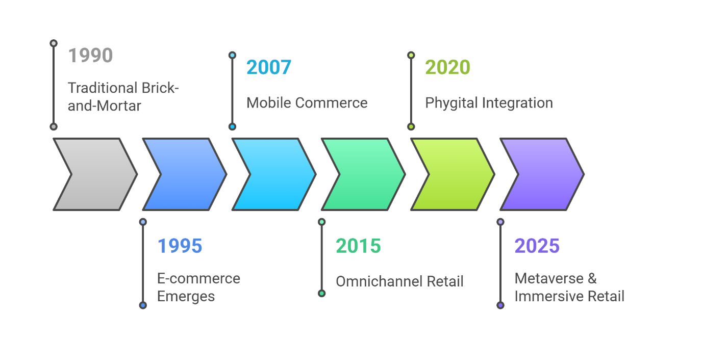Figure 1. The Evolution of Retail Formats
In situations where people value seeing, touching, and buying things right away, as well as getting personal assistance, physical retail is still important (Bonfrer, Chintagunta, & Dhar, 2022; Wallström, Hjelm Lidholm, & Sundström, 2024). Shopping in department stores, boutiques, and concept stores still gives customers emotional and relational benefits that support or improve their experience online. At the same moment, digital platforms make use of artificial intelligence, big data, and mobile devices to provide unbeatable convenience, efficiency, and personalization for many users (Manjula et al., 2021; Aydin-Gokgoz, Ataman, & Van Bruggen, 2022).
For this reason, people working in retail are now seeing it as an integrated system where different formats are used together to meet consumer needs in different places and situations (Thaichon, Phau, & Weaven, 2022). The appearance of “phygital” retail is a clear example of how physical and digital are coming together (Orazi & Nyilasy, 2025). Mele and his colleagues (2021) explain that phygital retail involves mixing digital and physical elements to improve the emotional, behavioral, and social parts of shopping.
This convergence has many important results. Retailers should update their technology as well as the way they interact with customers, serve them, and operate within the company. Verhoef et al. (2021) point out that digital transformation calls for cooperation between different teams, quick reactions, and placing customers at the center of innovation. Being distinct in this changing world depends on how well a retailer brings together physical and digital shopping.
The paper looks into how technology is changing the retail industry by comparing digital and physical forms. The first part looks at the emergence of digital retail, and then the second part discusses whether physical stores will still matter. After that, the strengths and weaknesses of each country are evaluated using a comparative approach. After that, the paper analyzes the impact of omnichannel integration and new technologies such as AI, AR/VR, and the metaverse, and ends with ideas about the future of retail.
In this way, the study provides insights on how retailers can manage technological changes, satisfy customers’ growing needs, and combine their operations with emotional engagement in today’s phygital world.

2. The Rise of Digital Retail
Retail being digitalized is one of the biggest changes in the history of commerce. Thanks to progress in internet, mobile, and data technology, digital retail has grown from a simple way to buy things into an important part of the world’s retail sector. Now, it includes different platforms like e-commerce websites, mobile apps, social commerce, and digital environments that are made to give people personalized, efficient, and context-aware shopping.
The main advantage of digital retail is that it is very convenient. People can shop for and purchase goods at any time and from any place. Mobile commerce has made it possible for users to shop on their phones and tablets, so shopping can be done at any time and in any place. Mobile platforms have helped retailers to reach customers with targeted ads and engage them in real time, encouraging them to buy things they need at the moment.
Using advanced technology is one of the main ways digital retail can provide a unique and efficient experience for its customers. Nowadays, everything from suggesting products, setting personal prices, using chatbots, and grouping customers is possible because of AI, big data analytics, and predictive algorithms. Verhoef et al. (2021) point out that these tools help companies give both many and unique experiences to customers, which increases their involvement and the number of sales, and also makes the company’s work more efficient.
The ways these technologies are used in retail are shown in Table 1.
Table 1: Key Technologies Driving Digital Retail
Technology | Function | Application Example | Brand Example
Artificial Intelligence (AI) | Personalization & automation of customer journeys | Product recommendations, chatbots, dynamic pricing | Amazon, Netflix
AR/VR | Product visualization & immersive shopping | Virtual try-ons, interactive previews | IKEA, Lenskart
Mobile Applications | On-the-go access, location-based services | Push notifications, in-app loyalty programs | Starbucks, Sephora
Big Data Analytics | Behavior analysis & targeting | Segmentation, dynamic offers, sentiment analysis | Walmart, Alibaba
Apart from personalization, digital retail makes information clear and gives customers more control. People can read product reviews, compare the prices of different stores, and trust in both influencer and user-generated content when making their choices. Now, because of the information available online, consumers, and not retailers, have more power in product categories where there is little difference between brands (Sheth & Uslay, 2022).
At the same time, retailers are using new technology to solve digital retail’s main challenge, which is not offering a physical experience. AR and VR allow customers to see products in 3D and test how they would work in real life. Xi and Hamari (2021) state that virtual storefronts in VR are becoming more common, as they add gaming elements and extra interactivity to the experience of shopping inside a store.
In the past decade, the use of digital retail has grown at a very fast pace. As can be seen in Figure 2, e-commerce’s share of global retail sales has gone from 7% in 2015 to 25% that is expected in 2025. Because of the COVID-19 pandemic, people and businesses were forced to quickly switch to digital solutions while keeping their distance (Wang et al., 2021).

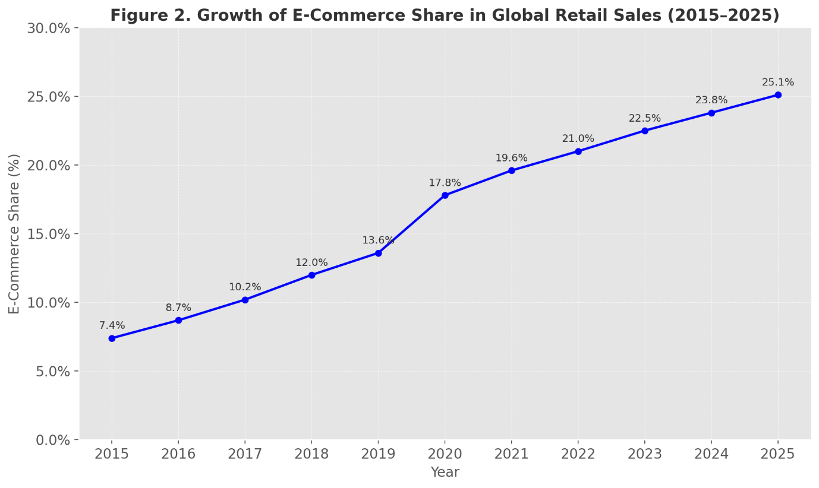Figure 2. Growth of E-Commerce Share in Global Retail Sales
Even though digital retail has many good sides, it also faces some problems. Many people have worries about privacy, the safety of their data, and making too many choices. According to Turel, Qahri-Saremi, and Vaghefi (2021), some negative sides of digitalization are algorithmic manipulation, overly personalized experiences, and anxiety about being watched. Besides, there are certain categories and groups of people for whom digital shopping does not provide the same sensory and emotional experience as physical shopping.
Digital transformation in operations means spending a lot on infrastructure, logistics, security, and human resources. Amazon and Alibaba are successful digital retailers because they have created systems that connect user experience, efficient supply chains, and different platforms to ensure smooth service for many users (Verhoef et al., 2021).

3. The Resilience of Physical Stores
Even with the fast growth of online shopping, physical stores still play an important role. Most of the predictions about a mass exodus of stores from the high street have not come true, since people still like to buy certain items in stores. Retail stores remain strong when they embrace digital changes and continue to rely on their main qualities of being tangible, reliable, and personal.
One major advantage of shopping in a store is that it allows customers to use more than one sense. Unlike online shops, people can touch, try, smell, or taste the goods in a physical store. In categories such as apparel, cosmetics, luxury goods, and food, sensory experiences are very important because they greatly affect people’s decisions to buy (Bonfrer, Chintagunta, & Dhar, 2022). Engaging with products in stores boosts customers’ trust and makes it less likely that they will return them.
The immediacy of shopping in a store is becoming more important as people want things fast. People can buy a product and take it home right away, so they don’t have to worry about long deliveries. Although digital services aim to make deliveries fast, physical stores are still more convenient when time is very important (Alexander & Kent, 2021).
In addition, people find that physical stores offer valuable connections and feelings. Talking with experts, being in a stylish store, and sharing shopping with others are things that make customers happy, and these experiences cannot be duplicated by technology. According to Wallström, Hjelm Lidholm, and Sundström (2024), loyalty from customers is usually built through face-to-face interactions in stores, which is not as easy to do in online settings.
These comparative strengths are summarized in Table 2.
Table 2: Strengths of Physical Retail Compared to Digital
Strength Dimension | Physical Retail Strength | Digital Retail Limitation
Sensory Experience | Touch, try, and inspect products in real time | Lacks tactile/physical inspection
Immediate Product Access | Walk out with product immediately | Delivery delays, especially in remote areas
Personalized Human Service | Staff support and in-store assistance | Automated or impersonal service
Social and Emotional Engagement | Social interaction and shopping as leisure activity | Shopping experience often isolated
Trust and Transparency | Visible operations build trust (e.g., quality, hygiene) | Invisible processes may reduce trust
Brand Presence | Flagship stores reinforce brand identity | Requires online branding to compensate
In addition, the function of physical stores is being changed in the context of omnichannel retail. Nowadays, stores are not just meant for buying; they also act as showrooms, places for services, pickup spots for online orders, and centers that help with digital brand experiences. The ability to use many functions makes it easier for retailers to combine channels and respond to new situations (Mele et al., 2021).
Building trust and credibility is easier in emerging markets when people can visit a store. The authors mention that in areas with little digital usage or doubt about online shopping, having a physical store helps brands gain trust and confidence from customers. Besides, those who are not as comfortable with technology or prefer meeting someone in person usually choose to shop in stores, making physical stores important and meaningful to society.
It is important to mention that physical stores are now using technology to make shopping inside better. Self-checkout kiosks, augmented reality mirrors, mobile POS systems, and information through QR codes are examples of how stores are becoming more digital. These new ideas help businesses work more efficiently and meet what consumers expect based on their digital experiences (Wang et al., 2021).
To sum up, physical retail is still an important part of the current retail world, not in spite of digital, but together with it. The reason it is resilient is that it provides things digital cannot, such as physical trust, strong emotions, and human relationships. Even as the retail industry changes, physical stores will remain important, now with new technology and as part of a wider omnichannel plan.
4. Head-to-Head: Digital vs. Physical Retail
This section shows the main differences between digital and physical retail formats in terms of strategy and experience. Even though both models are meant to meet what customers want and add value, their strengths are not the same in every situation. This analysis summarizes research to show the strengths, weaknesses, and ways in which convergence is bringing about a new balance in retail.
Digital retail is praised for how easy it is to use and how much it can grow. Today’s consumers enjoy around-the-clock service, worldwide reach, and the chance to compare different offers in no time. Because of mobile commerce, digital access is everywhere, and artificial intelligence has made it possible to give personalized service to many people at the same time (Aydin-Gokgoz et al., 2022). Through digital formats, companies can instantly change their prices, product selection, and marketing information, and they can use user data to make predictions (Verhoef et al., 2021).
On the other hand, shopping in stores offers a better experience and faster results. People prefer to check products, speak with experts, and carry their purchases home right away. Going shopping with friends, joining in-store activities, and the overall atmosphere of a brand contribute to customers staying loyal for a long time (Wallström et al., 2024).
The process of forming trust is not the same in all these formats. In the online world, trust is influenced by user opinions, secure ways to pay, and the design of the interface (Wang et al., 2021). In stores, trust comes from being able to see staff, the way things are done, and the real products, which is very important for those buying for the first time or spending a lot of money.
All of these formats have particular constraints. Digital means often lack the feeling and senses you get in stores, while physical shops may be restricted by their location, the things they sell, and the people working there. In numerous cases, these issues are fixed by using omnichannel approaches that allow customers to enjoy both online convenience and immediate service in stores. These distinctions are summarized in Table 3.
Table 3: Digital vs. Physical Retail – Strategic Comparison
Dimension | Digital Retail | Physical Retail
Convenience | Accessible anytime, anywhere; mobile-enhanced | Location-bound but immediate product access
Experience | Personalized content; limited sensory input | Multi-sensory, interactive, socially engaging
Trust | Built via reviews, system security, and UX | Built via human service, product tangibility
Adaptability | Agile, data-driven, scalable | Less agile, higher overhead, localized trust
Loyalty | Incentive-based; emerging in immersive formats | Emotionally driven; strengthened by in-store service
It is evident from the analysis that using only digital or physical retail is not enough. As a result, their strengths suggest that formats will work together in the future, instead of being seen as separate options. Those retailers who recognize these trends and unite their stores and online platforms with one technology, messaging, and logistics will be ready to satisfy omnichannel shoppers.
5. Omnichannel Retail: Bridging the Divide
Because consumers are now more complex and technology is playing a bigger role, retailers are using omnichannel strategies to link online and offline shopping together. Omnichannel retailing improves on multichannel by making all the sales channels work together in real time for the benefit of the consumer.
It isn’t only about merging digital and physical parts of retail. A company should focus on the way consumers interact with the brand, delivering the same messages, data, and services everywhere. Thaichon, Phau, and Weaven (2022) explain that the best omnichannel models put experience integration ahead of managing channels, so that customers can enjoy benefits and avoid difficulties in any way they connect.
A key part of successful omnichannel retailing is when online, mobile, and physical stores are well connected. As an example, a customer could start on the brand’s app, look for the product at a nearby store, use the store’s directions to locate it, and finish the purchase through mobile checkout. Mele et al. (2021) mention this phenomenon as the “phygital experience,” stressing how important it is for all aspects to fit together.
To succeed in omnichannel, a business needs advanced technology, such as real-time stock checks, one customer database, and unified ways of handling orders. It is important for retailers to gather all consumer information and history in one place to make it available for use on every channel. Verhoef et al. (2021) state that this type of internal alignment is crucial to meet the expectations of today’s customers. Table 4 shows the key points that make up a strong omnichannel strategy.
Table 4: Core Components of Effective Omnichannel Strategy
Component | Description | Benefit | Example
Channel Integration | Consistent branding and service across all channels | Reduces friction and improves brand perception | Nike, Apple
Real-Time Inventory Mgmt. | Live inventory updates across physical and digital | Avoids stockouts and enhances order accuracy | Zara, Decathlon
Unified Customer Data | Centralized customer profiles and behavior data | Enables personalization and targeted promotions | Amazon, Sephora
Seamless Experience Design | Unified UX/UI across apps, web, and in-store tech | Enhances usability and consumer comfort | H&M, Warby Parker
Flexible Fulfillment Options | Click-and-collect, ship-from-store, curbside pickup | Increases speed and delivery flexibility | Target, Walmart
Cross-Channel Loyalty | Points/rewards redeemable online and offline | Strengthens loyalty and engagement | Starbucks, Ulta
Besides making things more efficient and personal, using omnichannel strategies encourages customers to stay loyal. According to Wallström, Hjelm Lidholm, and Sundström (2024), loyalty is now more related to having the same emotions and ease of use when using different channels. A good experience in one channel should strengthen the brand’s presence and motivate consumers to connect more with the company.
Stores are now being used more carefully by retailers in their omnichannel approaches. They now act as places where products are shipped, people can experience the brand, and services are provided. Alexander and Kent explain that digital fitting rooms, self-checkout stations, and mobile POS devices are being introduced by fashion retailers to help customers and still keep a human touch.
In addition, in developing countries, using omnichannel approaches helps companies handle infrastructure issues and earn customers’ trust. Stojković et al. (2023) explain that being present in person gives trust, and digital features make things more convenient. Companies that use both formats wisely can access different groups of customers and reduce their risks at the same time.
But there are difficulties that come with using an omnichannel approach. Retailers have to manage problems related to data control, system compatibility, and divisions within the organization. The authors point out that for omnichannel to work well, it requires customers to believe in the system’s dependability and how easy it is to use. If a company fails to be consistent on all channels, it may cause customers to get frustrated, drop their carts, or view the brand in a bad light.
To sum up, omnichannel retail is now essential because the difference between digital and physical commerce is hard to tell. When operations, data, and experiences are aligned on every channel, retailers can address the varied and rapid changes in consumer expectations and make themselves stand out among many competitors.
6. Conclusion
At present, the retail sector is marked by merging trends, significant changes, and greater complexity. It has been shown that technology is changing the divide between digital and physical retail, altering what consumers expect, and urging retailers to come up with new ideas in experience, operations, and strategy. Although digital retail makes things easier, more personal, and accessible around the world, physical stores still have advantages in involving the senses, building trust, and offering a rich experience.
It becomes clear from the comparison that each format has its own strengths and weaknesses depending on the situation. Digital ways of communication are fast and full of data, though they usually lack the feeling and touch that comes with real interaction. Using physical formats means you get immediate service, personal attention, and a chance to meet others, but they are more expensive and less flexible than digital ones. Omnichannel approaches are helping to merge the benefits of these two channels, so consumers enjoy a smooth journey using any platform.
The convergence of these industries is made possible mostly by new technology. Thanks to AI and immersive technologies like AR, VR, and the metaverse, retail is progressing toward a future that connects people more and is also more intelligent and customized for each person. Because of these advances, retailers are required to develop new technological, organizational, and ethical abilities. Because retail is now driven by data, we must also deal with privacy, bias in algorithms, and growing digital exhaustion by using responsible design and clear governance.
In terms of strategy, those retailers that put customers first and use new technologies to boost convenience, trust, and emotions will be the most successful and competitive. Businesses now have to offer omnichannel integration because it is expected by the market. Retailers should create operations, experiences, and loyalty programs that match the way consumers interact with them in many places.
The evolving retail world provides researchers with many opportunities to study hybrid buying habits, how immersive shopping affects people’s minds, ethical design in retail, and differences in access and usability due to the digital divide. Practitioners should understand that to succeed in the future, businesses need to concentrate on forming adaptable, inclusive, and experience-centered retail environments.

Disclaimer (Artificial intelligence)
Option 1:
Author(s) hereby declare that NO generative AI technologies such as Large Language Models (ChatGPT, COPILOT, etc.) and text-to-image generators have been used during the writing or editing of this manuscript.
Option 2:
Author(s) hereby declare that generative AI technologies such as Large Language Models, etc. have been used during the writing or editing of manuscripts. This explanation will include the name, version, model, and source of the generative AI technology and as well as all input prompts provided to the generative AI technology
Details of the AI usage are given below:
1.
2.
3.

References
- Akturk, M. S., & Ketzenberg, M. (2022). Exploring the competitive dimension of omnichannel retailing. Management Science, 68(4), 2732-2750.
- Alexander, B., & Kent, A. (2021). Tracking technology diffusion in-store: a fashion retail perspective. International Journal of Retail & Distribution Management, 49(10), 1369-1390.
- Verhoef, P. C., Broekhuizen, T., Bart, Y., Bhattacharya, A., Dong, J. Q., Fabian, N., & Haenlein, M. (2021). Digital transformation: A multidisciplinary reflection and research agenda. Journal of business research, 122, 889-901.
- Xi, N., & Hamari, J. (2021). Shopping in virtual reality: A literature review and future agenda. Journal of Business Research, 134, 37-58.
- Thaichon, P., Phau, I., & Weaven, S. (2022). Moving from multi-channel to Omni-channel retailing: Special issue introduction. Journal of Retailing and Consumer Services, 65, 102311.
- Sheth, J. N., & Uslay, C. (2022). Creating enduring customer value. Journal of Creating Value, 8(2), 241-252.
- Wallström, S., Hjelm Lidholm, S., & Sundström, M. (2024). Retailers view on customer loyalty–a social resource theory perspective. The International Review of Retail, Distribution and Consumer Research, 34(4), 399-416.
- Yoo, K., Welden, R., Hewett, K., & Haenlein, M. (2023). The merchants of meta: A research agenda to understand the future of retailing in the metaverse. Journal of Retailing, 99(2), 173-192.
- Wang, X., Wong, Y. D., Chen, T., & Yuen, K. F. (2021). Adoption of shopper-facing technologies under social distancing: A conceptualisation and an interplay between task-technology fit and technology trust. Computers in Human Behavior, 124, 106900.
- Stojković, D., Dokić, A., Vlacic, B., & Silva, S. C. E. (2023). Toward the inter-channel synergy renaissance in emerging markets: evidence from adding clicks to bricks in Serbia. International Journal of Emerging Markets, 18(9), 3309-3333.
- Mele, C., Russo-Spena, T., Tregua, M., & Amitrano, C. C. (2021). The millennial customer journey: a Phygital mapping of emotional, behavioural, and social experiences. Journal of Consumer Marketing, 38(4), 420-433.
- Aydin-Gokgoz, Z., Ataman, M. B., & Van Bruggen, G. (2022). The rise of mobile marketing: A decade of research in review. Foundations and Trends® in Marketing, 17(3), 140-226.
- Marine-Roig, E. (2021). Measuring online destination image, satisfaction, and loyalty: Evidence from Barcelona districts. Tourism and Hospitality, 2(1), 62-78.
- Bonfrer, A., Chintagunta, P., & Dhar, S. (2022). Retail store formats, competition and shopper behavior: A Systematic review. Journal of Retailing, 98(1), 71-91.
- Turel, O., Qahri-Saremi, H., & Vaghefi, I. (2021). Dark sides of digitalization. International Journal of Electronic Commerce, 25(2), 127-135.
- Shankar, V., Kalyanam, K., Setia, P., Golmohammadi, A., Tirunillai, S., Douglass, T., Hennessey, J., Bull, J. S., & Waddoups, R. (2021). How technology is changing retail. Journal of Retailing, 97(1), 13–27. https://doi.org/10.1016/j.jretai.2020.10.006
- Kovács, I., & Keresztes, É. R. (2024). Digital Innovations in E-Commerce: Augmented Reality Applications in Online Fashion Retail—A Qualitative Study among Gen Z Consumers. Informatics, 11(3), 56. https://doi.org/10.3390/informatics11030056
- Thaichon, P., Quach, S., Barari, M., & Nguyen, M. (2024). Exploring the role of omnichannel retailing technologies: Future research directions. Australasian Marketing Journal, 32(2), 162-177. https://doi.org/10.1177/14413582231167664
- Manjula, S., Balaji, P., Deepa, N., & Vidhyavathi, A. (2021). Digital transformation on food retail industries – A review. Asian Journal of Agricultural Extension, Economics & Sociology, 39(11), 88–101. https://doi.org/10.9734/ajaees/2021/v39i1130729
- Orazi, D. C., & Nyilasy, G. (2025). Phygital products: Effects and boundaries of metaverse-first retail strategies. Journal of Retailing. Advance online publication. https://doi.org/10.1016/j.jretai.2025.01.002
- Shankar, V., Kalyanam, K., Setia, P., Golmohammadi, A., Tirunillai, S., Douglass, T., Hennessey, J., Bull, J. S., & Waddoups, R. (2021). How technology is changing retail. Journal of Retailing, 97(1), 13–27. https://doi.org/10.1016/j.jretai.2020.10.006
- Caboni, F. (2020). The use of digital technology to reshape the retail store. International Journal of Business and Management, 15(1), 149–156. https://doi.org/10.5539/ijbm.v15n1p149
- 23. Helm, S., Kim, S. H., & Van Riper, S. (2020). Navigating the ‘retail apocalypse’: A framework of consumer evaluations of the new retail landscape. Journal of Retailing and Consumer Services, 54, 101683. https://doi.org/10.1016/j.jretconser.2018.09.015
- Kumar, V., & Ayodeji, O. G. (2021). E-retail factors for customer activation and retention: An empirical study from Indian e-commerce customers. Journal of Retailing and Consumer Services, 59, 102399. https://doi.org/10.1016/j.jretconser.2020.102399
25. Lin, J., Choi, T.-M., & Kuo, Y.-H. (2023). Will providing return-freight insurances do more good than harm to dual-channel e-commerce retailers? European Journal of Operational Research, 307(3), 1225–1239. https://doi.org/10.1016/j.ejor.2022.09.025

