Review Article
Current Trends and Future Perspectives in Treatment Strategies for Dye-Containing Textile Wastewater

Abstract
Discharge of high quantities of colored and poisonous effluents emitted by the textile industries has imposed a life-threatening environmental threat. Such effluents are composed of recalcitrant synthetic dyes and heavy metals which increase biochemical and chemical oxygen demand, decrease dissolved oxygen, and eventually cause damage to aquatic ecosystems. Azo and anthraquinone dyes, especially, are not biodegradable and get deposited as dangerous pollutants. The present work is focused on a systematic review of various dye remediation technology reported in the articles mostly published since 2015. Scopus, Web of Science, and ScienceDirect resources were used to find literature, and specific keywords (photocatalysis, bioremediation, hybrid technology, nanotechnology, and advanced oxidation processes (AOPs), dye-laden textile effluents) were used to locate the literature in the databases. Several operational parameters and results were compared to determine technological performance. Extensive literature review on photocatalytic pollutant removal with UV/TiO₂ and UV/ZnO, especially doped forms, shows a high time performance of 98 percentage of BOD/COD and 99 percentage of color/lignin removal. Azo bonds and aromatic rings are broken with the help of microbial and enzymatic treatments via bacteria, fungi, algae, and yeast, and key enzymes laccases, azoreductases, manganese peroxidases, and lignin peroxidases to cleave azo bonds, aromatic rings under mild, environmentally friendly conditions to achieve synergistic and sustainable decolorization and detoxification of textile dyes in wastewater. Recent studies advocate the implementation of hybrid and artificial intelligence (AI) based technologies to design more sustainable approach to address the issue. The review also emphasizes several comparative results to find out cost-effective, scalable, eco-friendly methods in line with the idea of the circular economy and the sustainability objectives of the contemporary textile industries.
Keywords: Textile pollution; Synthetic dye; Wastewater; Toxicity; Remediation techniques; Hybrid technologies.

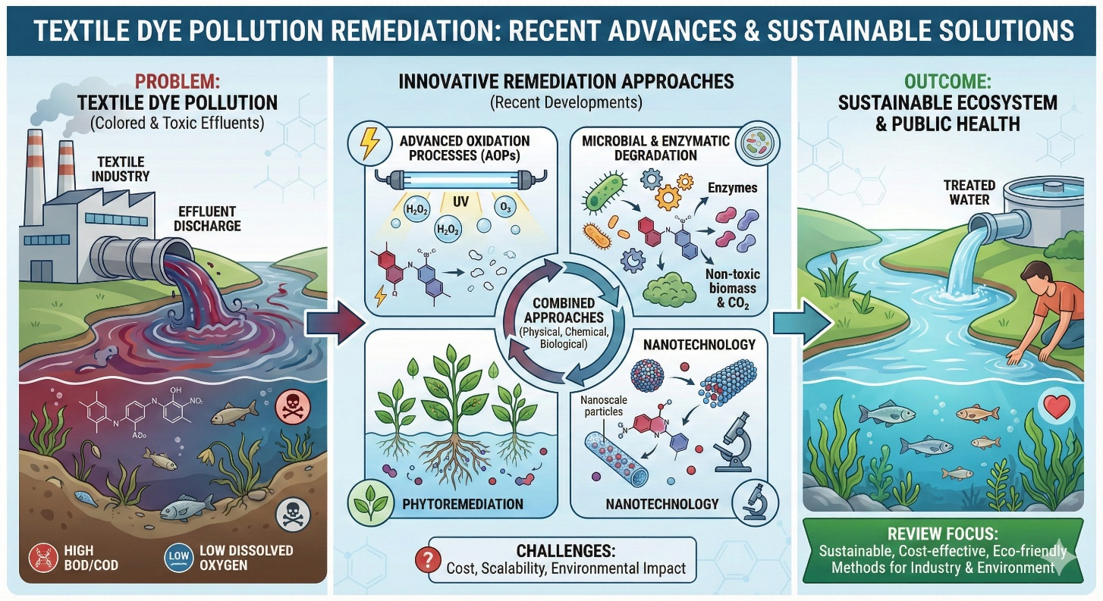
Graphical Abstract: Textile dye pollution remediation: Recent advances and sustainable solutions (Image generated using Google Gemini AI for illustrative purposes).
- Introduction
The textile dye pollution issue has emerged as one of the most significant environmental problems of modern industrial process [1]. It is well known that the textile industry is one of the major causes of water pollution globally, and the dyes and finishing processes of textiles are accountable for the industrial water pollution worldwide. The wastewater flow is substantial and it is a complex mixture of synthetic dyes, chemicals, and other toxic chemicals which are leading to degradation of aquatic ecosystem drastically [2]. Textile dyeing is water intensive requires huge amount of water can be used to dye and finish one kilogram of cotton fibre, which puts a lot of pressure on freshwater resources [3]. In addition, the current trend of the fast fashion industry has helped to increase the rate at which textiles are produced, which in turn has contributed to increased pollution and depletion of resources. Besides, the wastewater of textile dyeing not only affects the growth of aquatic life and photosynthesis of water bodies because of the excessive light absorption by dyes, but also increases the biochemical oxygen demand (BOD) and chemical oxygen demand (COD) in the receiving water bodies, thereby affecting their water quality [4]. Synthetic dyes are the most widely used dyes in the world by textile industry and there are more than 10,000 different types of dyes available in the market [5]. They include benefits of bright colors, low price, and convenience in manufacture as compared to natural dyes which were used up to the middle of the 19th century. However, the use of synthetic dyes, especially the azo dyes, which account for some 60-70% of all dyes used, is linked with long tenacity, bioaccumulation and carcinogenicity. In addition, many dye molecules are made up of complex aromatic structures and chlorinated substances which makes the dyes toxic and resistant to environmental degradation [6]. In addition to dyes, textile effluents include an array of toxic chemicals such as heavy metals, surfactants, fixatives and endocrine disrupting chemicals such as phthalates and nonylphenol ethoxylates (NPEs). In addition to being hazardous to aquatic organisms, these compounds may also harm human health through water and food chain contamination. Exposure to such pollutants has been associated with allergic reactions, mutagenic effects and hormonal disruptions in humans and wildlife [7]. Fig. 1. shows the different path way of toxicity caused due to discharge of untreated effluents of textile dye into water bodies. It highlights the potential behaviour of pollutants to degrade aquatic ecosystems and enter the human food chain by the consumption of contaminated seafood. The diagram also summarizes the severe adverse effects on human health, ranging from skin disorders and organ damage to reproductive dysfunction and genotoxicity. Textile dye wastewaters are complex in nature and exhibit high toxicity, hence, effective wastewater treatment is necessary in order to minimize possible environmental damage and human health risks. Wastewater Treatment is a process used to eliminate or convert colour, chemical and inorganic pollutants and toxic compounds prior to disposal or re-use. Conventional methods like physical, chemical, and biological treatment have been used but these have several limitations like incomplete degradation of dyes, production of secondary pollutants, sludge disposal problems, and high operational costs [8, 9]. The growing recognition of such shortcomings has sped up the research activities toward novel sustainable remediation methods that can increase the efficiency of dye removal while lowering the environmental footprints. The advanced processes include enzymatic degradation, microbial biodegradation, advanced oxidation processes, phytoremediation, membrane filtration, and applications of nanotechnology [10]. The combination of these techniques and the implementation of hybrid treatment systems have shown good results for the treatment of textile wastewater [11]. The purpose of this review is to present an overall survey of the recent approaches developed for remediation of textile dyes from wastewater. The different conventional and advanced treatment techniques are reviewed critically with respect to their mechanisms, efficiencies, advantages as well as limitations. Strategies that are environmentally friendly as well as economically efficient are emphasized and applied to deal with the emerging issues of textile dye pollution. The coverage is that of both physical-chemical and biological techniques and also of novel hybrid technologies. By bringing together existing research results, this review should inform future work to optimize textile dye wastewater treatment to protect ecosystems and human health, and to enable the sustainable development of the textile industry in the world.
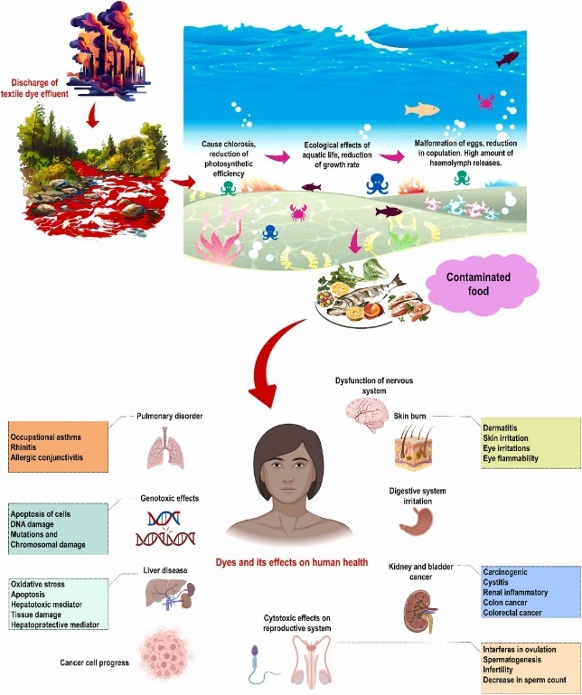
Fig.1. Transmission of dye-laden wastewater and its pollution, along with its effects on human health. Reproduced from Al-Tohamy et al., Ecotoxicology and Environmental Safety 231 (2022) 113160, under the Creative Commons CC BY-NC-ND 4.0 licence (http://creativecommons.org/licenses/by-nc-nd/4.0/). [7]
- Characteristics and Composition of Textile Wastewater
Textile wastewater is a complex mixture characterized by intense colour and a high load of various chemical and physical pollutants. The effluent typically contains a variety of synthetic dyes, including azo, anthraquinone, and reactive dyes, along with residual dye intermediates, surfactants, salts, solvents, and heavy metals such as chromium, copper, zinc, and lead [12]. Due to the application of alkalis such as sodium hydroxide and detergents, the pH value of textile waste water is mostly alkaline, which ranges mostly between 8.7 and 10.9 [13]. Chemical Oxygen Demand (COD) level is quite high (sometimes between 150 to 12000 mg/L) representing the presence of oxidizable organic compounds, while Biochemical Oxygen Demand (BOD) values range from 80 to 6000 mg/L depending on the processing stage and type of fibre [14]. Total Dissolved Solids (TDS) concentrations are also usually high, in the range of several thousand mg/L and this is often the result of the high salt content used in dye fixing and in fabric processing [15]. These parameters indicate the high pollutant load and toxicity potential of textile wastewaters, making the treatment of this wastewater critical prior to its discharge to the environment in order to avoid environmental damage.

- Sources of wastewater in textile processing steps
Wastewater from textile industries is produced from the different processing stages with all contaminating elements. Key sources are pretreatment operations such as desizing, scouring, and bleaching where natural oils, waxes and starches are eliminated using alkalis and enzymes leaving alkaline effluent with high BOD and suspended solids. Dyeing stage is a major reason of colors and chemical load, as dyes and fixing agents are used, which in turn result in wastewater with a high content of persistent synthetic dyes and salts [16]. Printing processes add pigments and thickeners to the effluent, which further adds to organic and chemical pollution. Finally, finishing treatments such as softening, water repellence and antimicrobial applications add surfactants, emulsifiers, and other hazardous chemicals to the wastewater. Each processing step differs regarding water consumption, pollutant load, pH and the chemical composition, which requires multi-stage or integrated treatment approaches for the effective treatment of the composite textile effluent and minimizing the environmental impact of the effluent.
- Adverse impact of textile dye on Human Health
The textile dyeing process uses a huge number of chemicals to produce desirable colors and useful properties, but many of them are highly dangerous for our health. Table 1 is summarized information of various dyes, which are used in textile processing and their negative effects. Azo dyes, which are a major class of colorants, may decompose into carcinogenic amines, and formaldehyde, which is used in finishing, is a known irritant and possible carcinogen [`17]. Upon being used as mordants or dye components, heavy metals such as chromium and lead may accumulate in the body and cause severe organ damage. Other chemicals such as chlorinated phenols, pesticides, PFCs and phthalates have been linked with a variety of health problems including endocrine disruption, reproductive problems, and damage to vital organs [18,19,20,21]. The exposure to these chemicals can occur through skin contact with treated fabrics, inhalation of fumes during the processing or ingestion of contaminated water and food.
- Chart 1: Adverse impact of textile dye on Human Health

Chemical Name | Function in Dyeing | Potential Adverse Health Impacts
Azo Dyes | Used for colouring fibers | Release carcinogenic amines upon degradation, linked to bladder cancer [17].
Formaldehyde | Used as a fixing agent, for crease resistance | Skin and eye irritation, respiratory issues, classified as a potential carcinogen [22].
Heavy Metals (e.g., Chromium, Copper, Lead, Cadmium, Mercury) | Used in some dyes and mordants for colour fixation | Can accumulate in the body, causing organ damage (kidney, liver), neurological problems, and are toxic [23, 24, 25]56, 57].
Chlorinated Phenols (e.g., Pentachlorophenol) | Used as preservatives and fungicides | Skin irritation, liver and kidney damage, potential carcinogen [20].
Pesticides | Used on natural fibers like cotton before processing | Neurotoxicity, endocrine disruption, skin and eye irritation [19].
PFCs (Perfluorinated Compounds) | Used for water and stain resistance | Persistent in the environment and body, linked to liver damage, immune system effects, and developmental issues [20].
Phthalates | Used as plasticizers in printing pastes | Endocrine disruption, reproductive health issues, developmental problems in children [21].

- Conventional Treatment Methods
  - Physical approaches
Physical treatment methods are widely used in the removal of dyes from textile wastewater, since they are easy to operate and are effective in colour removal [26]. Adsorption, especially with activated carbon, is a relatively widespread method as it is characterized by high surface area and adsorption capacity for many types of dye molecule [27]. Ion exchange technique makes use of resins that bind with the charged dye molecules to separate them from the wastewater giving selective removal, particularly for ionic dyes [28]. Membrane Filtration Methods such as microfiltration, ultrafiltration, nanofiltration, and reverse osmosis work on the principle of size exclusion or trapping dye molecules according to the size of the pores [29]. These membrane technologies have high rejection rates for dyes and other micropollutants whereas they can be limited by membrane fouling and energy consumption. While physical methods perform well in reducing colour and suspended solids, the dye molecules are generally not degraded, leading to secondary waste that must be disposed of. Fig. 2. demonstrates different physical methods available for treatment of contaminated textile wastewater.
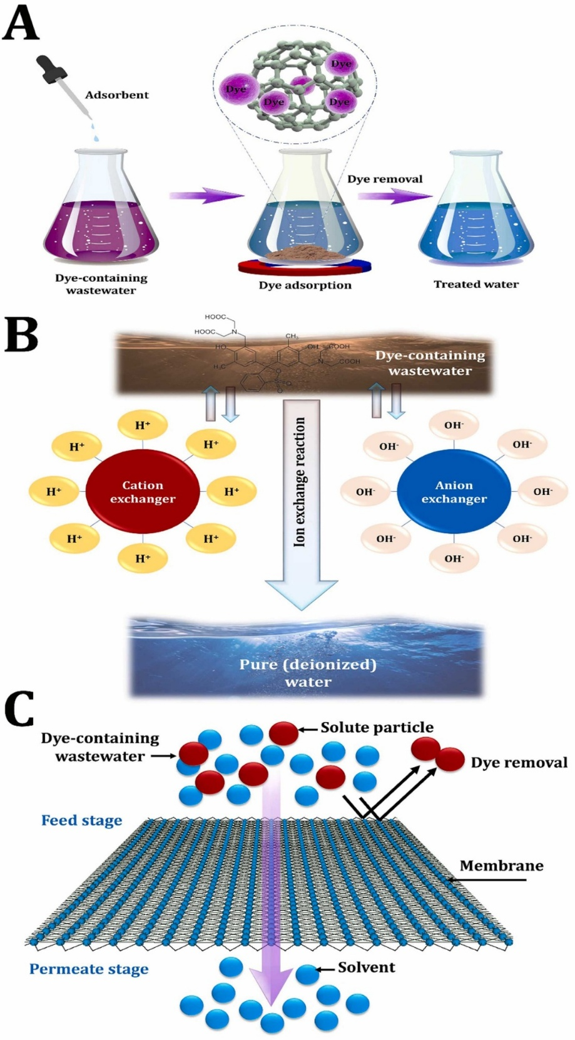
Fig. 2. Physical methods for treating textile wastewater, including (A) dye adsorption, (B) ion exchange, and (C) membrane filtration. Reproduced from Al-Tohamy et al., Ecotoxicology and Environmental Safety 231 (2022) 113160, under the Creative Commons CC BY-NC-ND 4.0 licence (http://creativecommons.org/licenses/by-nc-nd/4.0/). [7]
  - Chemical processes
Chemical treatment approaches are an integral part of textile dye remediation and are used individually or in combination with other methods [26]. Fig. 3. illustrates various chemical methods of textile dye wastewater treatment. In this context, Coagulation-flocculation is involved to destabilize and aggregate the dye particles and suspended solids, so that it reduces removal of the same by sedimentation or filtration process [30]. The process entails the addition of coagulants like alum or ferric chloride which neutralizes charges and assists in floc formation. Oxidation processes, such as advanced oxidation processes (AOPs), such as Fenton's reagent, photooxidation, ozonation, etc., are employed to produce highly reactive species such as hydroxyl radicals that can be used to degrade complex dye molecules into less harmful substances [31]. Ozonation specifically is effective at decolorizing wastewater by attacking the chromophore groups of dyes in wastewater to improve biodegradability. However, these types of chemical treatments can be expensive, dosages need to be carefully managed, and residual chemicals or sludge may need to be managed as a result.

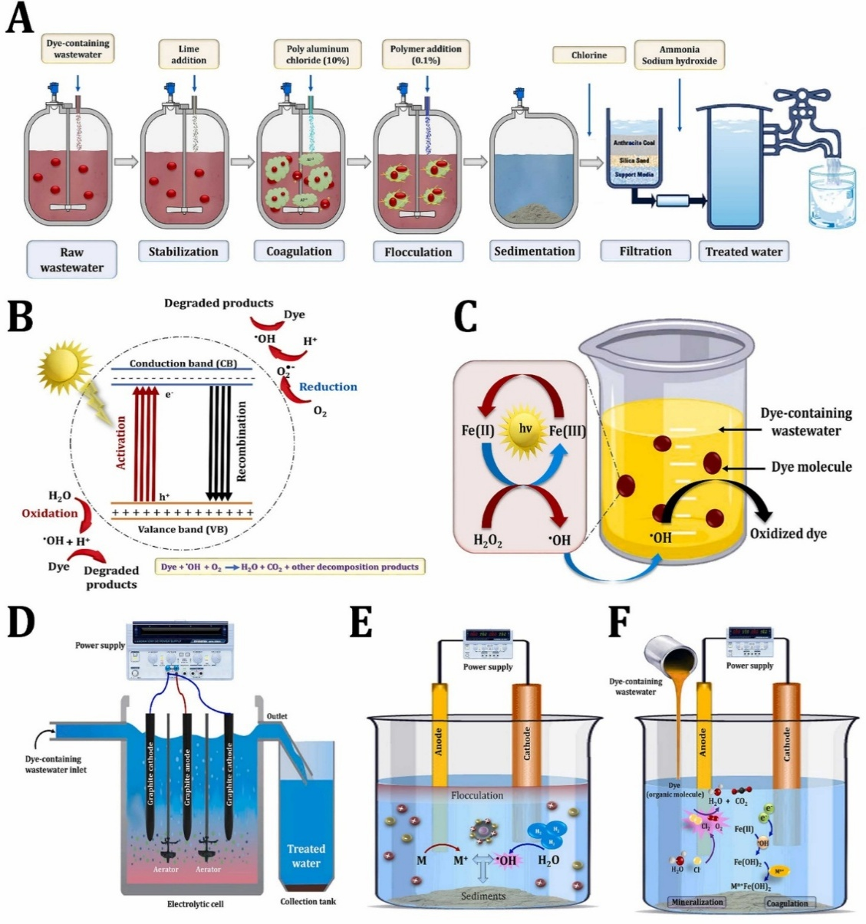

Fig. 3. Chemical approaches for textile dye wastewater treatment, including coagulation-flocculation (A), photocatalytic degradation of toxic dye molecules (B), photo-Fenton (C), electro-Fenton (D), electrocoagulation (E), and anodic oxidation approach (F).]. Reproduced from Al-Tohamy et al., Ecotoxicology and Environmental Safety 231 (2022) 113160, under the Creative Commons CC BY-NC-ND 4.0 licence (http://creativecommons.org/licenses/by-nc-nd/4.0/). [7]
  - Limitations and challenges of physical and chemical methods
Although physical and chemical approaches have been widely used in the wastewater treatment of textile industries, they have come with several limitations and challenges. Physical processes generally do not destroy dyes but transfer them between liquid and solid phase creating sludge or spent adsorbents that must be properly disposed in order not to create a secondary pollution problem [32]. Membrane technologies, though effective, have high capital and operation costs, energy requirements, and membrane fouling, resulting in poor life and efficiency [33]. Chemical treatments can be associated with toxic reagents and lead to the creation of hazardous byproducts and/or excessive sludge, which requires additional treatment steps [34]. Moreover, it is not easy to achieve full mineralization of diverse and complex dye structures, and some of the chemical methods may not be sustainable and eco-friendly. Together, these challenges make the need for integrated or hybrid treatment systems and development of economical, efficient and environmentally benign remediation technology for textile dye wastewater.
  - Biological Remediation Strategies
    - Microbial degradation using bacteria, fungi, algae, yeast
Microbial degradation uses various types of microorganisms such as bacteria, fungi, algae, and yeast to degrade complex molecules of textile dyes into simpler molecules that are less toxic [35]. Bacteria, such as Bacillus, Pseudomonas and Proteus species have demonstrated an incredible efficiency to degrade azo dyes under both aerobic and anaerobic conditions [36]. Fungi particularly white-rot fungi such as Phanerochaete chrysosporium, produce extracellular ligninolytic enzymes involved in the mineralization of synthetic dyes [37]. Algae and yeast also make an important contribution by adsorbing dyes to their biomass and metabolizing them. Microorganisms break down dyes primarily by the enzymatic processes by cleavage of azo bonds and aromatic rings, which causes detoxification and decolorization [38]. These biodegradation processes are affected by environmental parameters such as pH, temperature and oxygen availability. Utilization of microbial consortia is often beneficial for improving dye degradation by synergistic interactions between species, and thus, microbial bioremediation has become a potential and sustainable treatment option for textile wastewater treatment.
    - Enzymatic treatment
This method consists on the application of specific enzymes that have the ability to catalyse the breakdown of textile dyes and provide a targeted and eco-friendly remediation strategy. Key enzymes are laccases, azoreductases, manganese peroxidases and lignin peroxidases that are produced by fungi and bacteria [38]. Laccases oxidize the phenolic and non-phenolic dye structures, which helps with the dye decolorization and degradation. Azoreductases specialise in reductive cleavage of azo bonds under anaerobic conditions that decomposes azo dyes to colourless aromatic amines that are further mineralized [39]. These enzymes work under mild reaction conditions and they tend to produce less harmful byproducts than the chemical treatments. Immobilization of enzymes on appropriate carriers gives extra stability and reusability of enzymes for more practicality in industrial applications. Enzymatic processes coupled with microbial degradation enhance the treatment efficiency and are considered as promising tools for sustainable textile dye wastewater treatment.
  - Advantages of bioremediation
Bioremediation has advantages over conventional physical and chemical treatment methods which make it an attractive solution for textile dye waste water remediation [40]. Primarily, it is an eco-friendly approach since it is done with the use of naturally occurring microorganisms or enzymes to detoxify the pollutants without producing harmful secondary waste and without using toxic chemicals. The process is usually cost-effective because it requires less energy and less chemical inputs [41]. Furthermore, bioremediation systems have potential to change pollutant concentrations and the composition of targeted complex dye. The biological degradation pathways often result in complete mineralization of dyes to end products that are harmless to the environment and poses no environmental or health hazards [42]. Moreover, the bioremediation technologies can be developed to be integrated with existing wastewater treatment infrastructure and that can be scaled for industrial applications, making them feasible for sustainable textile effluent management.
- Integrated Treatment Approaches
Integrated treatment approaches use a combination of physical, chemical and biological methods in order to take advantage of their complementary nature and provide more effective remediation of textile dye wastewater than in the case of individual methods [43]. Physical methods like adsorption or membrane filtration are efficient in removal of dyes and suspended solids whereas chemical processes like coagulation or advanced oxidation break complex dye molecules into simpler ones. Further precipitation of these intermediates and reduction of toxicity and organic load is achieved by biological treatments. This synergistic combination helps improve the removal efficiency of dyes as a whole, decreases the treatment times, and also helps in reducing the formation of toxic byproducts or excessive sludge. Such multi-stage systems can be adapted to deal with the complex and changing compositions of textile effluents, to ensure higher colour removal and improved water quality. Despite the promising results on the laboratory and pilot scale, there are still problems in scaling up and optimising these integrated systems for industrial applications.
- Hybrid technologies and process optimization
Hybrid wastewater treatment technologies use different remediation mechanisms in the same treatment system to optimise dye degradation and resources. Such as advanced oxidation processes is hyphenated with membrane bioreactors or sequential photocatalytic coupled with biological operations [44]. Process optimization includes parameters such as pH, temperature, retention time and dosing rates in order to optimize the process and save costs [45]. Emerging designs are not only attempting to eliminate pollutants, they are also attempting to recover water, dyes, or energy in a reusable way, so that they can be reused in accordance with the circular economy ideas. The coagulation/flocculation, adsorption and filtration processes were incorporated to form a hybrid process in a treatment system and showed significantly increased removal efficiencies as compared to the individual processes. Pilot scale trials confirmed the effectiveness of this integrated method which resulted in removal efficiencies of 97.5, 98 and 98.4, 86.1 and 93.5% of COD, Total Suspended Solid (TSS), colour, total nitrogen and turbidity respectively and thus validated its usefulness in full scale textile wastewater treatment systems [46]. Optimization is also directed towards reducing sludge formation and total detoxification of intermediates. Despite the improvements there are challenges such as complex reactor design, costs of operation and variability of effluents that show more research is needed to develop economically feasible and sustainable hybrid treatment systems in scale.
- Advanced and Emerging Strategies
  - Nanotechnology for enhanced dye removal
Nanotechnology provides new approaches to solve the textile dye remediation problem with nanoparticles, nanocomposites and nanostructured materials with a large surface area and high adsorptive and catalytic properties [47]. Nanomaterials including titanium dioxide (TiO₂), zinc oxide (ZnO) and graphene oxide are capable of dye adsorption and catalysis for dye degradation/organic pollutant by photocatalysis under visible or ultra-violet (UV) light [48,49,50]. Functionalized nanomaterials enhance selective and reusability, which allows for fast and efficient removal of dyes even at low levels. In this context, photocatalytic treatment, particularly employing UV/TiO₂ and UV/ZnO photocatalysts, reveals significant removal rates. Doped photocatalysts have shown enhanced performance, achieving removal percentages of 98 % for BOD and COD, and 99 % for color and lignin [51]. Hence, nanotechnology reduces the treatment time and chemical use which is a promising eco-friendly and economical alternative to conventional methods.
  - Use of microbial biosorbents and biofilms
Microbial biosorbents and biofilms lay use on naturally occurring microorganisms and their biomass to adsorb and break down textile dyes. Biosorbents which are bacteria, fungi and algae based possess surfaces with large number of functional groups that bind to the dye molecule and help in removal from wastewater [52]. Biofilms, microbial communities that are attached to solid surfaces, improve the degradation of the dye because of synergistic metabolic activity in spatially organized consortia. These microbial systems are sustainable, self-regenerating and adaptable to different pollutant loads, therefore these systems are considered as effective bioremediators.
  - Bioreactor technology for efficient dye degradation
Bioreactors combine biological treatment processes and controlled environmental conditions in order to optimise dye degradation. Membrane bioreactors, anaerobic reactors, and sequencing batch reactors, provide support for the microbial growth and enzymatic activity, which are associated with high removal efficiency and stable operation. These systems can be adapted for large-scale industrial use which have advantages such as small design, low sludge production, and have the potential to degrade a wide range of dyes and their intermediates effectively.
  - Microbial fuel cells
Microbial fuel cell (MFCs) is a new technology which provides a combination of wastewater treatment and bioelectricity production [53]. Electroactive bacteria found in MFCs decompose textile dyes and organic pollutants and give out electrons to electrodes to generate electrical energy. This two-fold purpose allows energy to be extracted out of the wastewater treatment operations, lowering the operation expenses and ecological impact.
  - Genetic engineering approaches
Genetic engineering improves the microbial dye degradation abilities by gene modification responsible for dye degrading enzymes [54]. Engineered bacteria or fungi could express increased levels of laccases, azoreductases or peroxidases which would enhance degradation rates and extend the substrates involved. These approaches can also be used to develop hardy strains which can withstand harsh industrial effluent conditions. Although genetic engineering is still in an early stage, there is a great potential for customized bioremediation solutions.
  - Plant-microbe mediated phytoremediation
Phytoremediation is a combination of plants with their associated microbes to remove, degrade or stabilize dyes in wastewater [55]. Some species of plants have the ability to absorb dye molecules or to degrade them using rhizosphere microbial communities. This type of approach provides acceptable onsite wastewater treatment in terms of environmental facilities and esthetics, especially in the cases of constructed wetlands or bioremediation parks. Plant-microbe systems are effective for promoting sustainability through the recycling of nutrients and improvement of soil and water qualities [56].
- Challenges and Future Perspectives
Textile dye wastewater treatment is constantly facing some technical and economic barriers, which prevent the technical and commercial application of advanced treatment technologies. Several state-of-the-art approaches demand high levels of capital investment, operation and maintenance knowledge and skills that are problematic for cost-effective application, particularly in developing countries. Furthermore, variations in dye composition and volume of effluent make the design of universal treatment systems complex. From an environmental sustainability point of view, it is very important to develop greener processes, which can minimize energy consumption, avoid secondary pollution and reduce hazardous byproducts and sludge generation. Prospects are bright in the new areas such as nanotechnology, microbial engineering, biotechnology and digital technologies such as artificial intelligence (AI), machine learning (ML) and internet of things (IoT) [57]. AI and ML can be used to optimize the process parameters for treatment, predict the performance, and provide a real-time monitoring capability for efficient dye removal [58,59]. The use of artificial intelligence models is considered a potent mechanism in solving environmental problems as it has a high degree of predictive accuracy and, they can capture nonlinear relationships that are likely to be complex. The models have been used widely to explain adsorption processes of a wide range of pollutants in the various waste waters including organic pollutants (e.g. dyes), inorganic pollutants (e.g. heavy metal ions) and mixed pollutants. Besides, techniques of artificial intelligence were successfully used to anticipate the main water quality parameters during membrane filtration that will allow more stable performance estimation and optimization of the processes [60]. IoT devices enable operational management of treatment plants to collect data continuously and remotely, creating more automation and lower operational costs. Nanomaterials can be used to improve the adsorption and catalytic degradation of dyes, engineered microbes can be used to improve degradation rates and tolerance to harsh conditions and plant-microbe systems can be used for sustainable bioremediation. Future research needs to be aimed at overcoming the problem of scalability and regulations while integrating the cost-effective, environmentally benign, and smart technology-driven approach to achieve sustainable textile dye wastewater remediation and the protection of ecosystem and human health
- Conclusion
In conclusion, recent developments in textile dye wastewater remediation represent considerable progress in the development of different treatment technologies including physical, chemical, biological and the latest emerging methods such as nanotechnology, biological engineering and biotechnological innovations. The integration of artificial intelligence, machine learning and IoT based monitoring brings in further process optimization and real-time management. These advancements of water treatment in a collective manner, contribute to the improvement in colour removal efficiency, pollutant degradation, and resource recovery while minimising harmful byproducts and sludge generation. The creation and implementation of efficient, economic and environmentally friendly methods is of paramount importance to meet the increasing environmental challenges due to textile dye pollution. Sustainable treatment methods not only ensure that the aquatic eco-systems and human health are well taken care of they also aid in regulatory compliance and in the movement of the textile industry towards a greener production process. Hence, a holistic and scalable remediation solutions should be developed to combine technological innovation with environmental stewardship to develop more robust remedial solutions to textile wastewater management and long-term ecological protection.

Disclaimer (Artificial intelligence)
Option 1:
Author(s) hereby declare that NO generative AI technologies such as Large Language Models (ChatGPT, COPILOT, etc.) and text-to-image generators have been used during the writing or editing of this manuscript.
Option 2:
Author(s) hereby declare that generative AI technologies such as Large Language Models, etc. have been used during the writing or editing of manuscripts. This explanation will include the name, version, model, and source of the generative AI technology and as well as all input prompts provided to the generative AI technology
Details of the AI usage are given below:
1.
2.
3.
Disclaimer
Author herby declare that during the preparation of this work, the author used Google Gemini AI to generate the graphical abstract and to refine the English by rephrasing very few sentences to produce clearer and more meaningful sentences. After using this tool/service, the author carefully reviewed and edited all AI-assisted material and takes full responsibility for the final content of the publication

Reference:
- Khattab, T. A., Abdelrahman, M. S., & Rehan, M. (2020). Textile dyeing industry: Environmental impacts and remediation. Environmental Science and Pollution Research, 27(4), 3803-3818. https://doi.org/10.1007/s11356-019-07137-z .

- Islam, T., Repon, M. R., Islam, T., Sarwar, Z., & Rahman, M. M. (2023). Impact of textile dyes on health and ecosystem: a review of structure, causes, and potential solutions. Environmental Science and Pollution Research, 30(4), 9207-9242. https://doi.org/10.1007/s11356-022-24398-3 .

- Raja, A. S. M., Arputharaj, A., Saxena, S., & Patil, P. G. (2019). Water requirement and sustainability of textile processing industries. Water in textiles and fashion, pp.155-173. https://doi.org/10.1016/B978-0-08-102633-5.00009-9 .

- Akter, T., Protity, A.T., Shaha, M., Al Mamun, M. and Hashem, A., 2023. The impact of textile dyes on the environment. In Nanohybrid materials for treatment of textiles dyes (pp. 401-431). Singapore: Springer Nature Singapore. https://doi.org/10.1007/978-981-99-3901-5_17

- Slama, H. B., Chenari Bouket, A., Pourhassan, Z., Alenezi, F. N., Silini, A., Cherif-Silini, H., Oszako, T., Luptakova, L., Golińska, P., & Belbahri, L. (2021). Diversity of synthetic dyes from textile industries, discharge impacts and treatment methods. Applied Sciences, 11(14), 6255. https://doi.org/10.3390/app11146255 .

- Benkhaya, S., M'rabet, S., & El Harfi, A. (2020). Classifications, properties, recent synthesis and applications of azo dyes. Heliyon, 6(1). https://doi.org/10.1016/j.heliyon.2020.e03271

- Al-Tohamy, R., Ali, S.S., Li, F., Okasha, K.M., Mahmoud, Y.A.G., Elsamahy, T., Jiao, H., Fu, Y., & Sun, J. (2022). A critical review on the treatment of dye-containing wastewater: Ecotoxicological and health concerns of textile dyes and possible remediation approaches for environmental safety. Ecotoxicology and Environmental Safety, 231, 113160. https://doi.org/10.1016/j.ecoenv.2021.113160 .

- Mishra, S., Chowdhary, P. and Bharagava, R.N., 2018. Conventional methods for the removal of industrial pollutants, their merits and demerits. In Emerging and eco-friendly approaches for waste management (pp. 1-31). Singapore: Springer Singapore. https://doi.org/10.1007/978-981-10-8669-4_1

- Kallawar, G. A., & Bhanvase, B. A. (2024). A review on existing and emerging approaches for textile wastewater treatments: challenges and future perspectives. Environmental Science and Pollution Research, 31(2), 1748–1789. https://doi.org/10.1007/s11356-023-31175-3 .

- Ilyas, A. and Batool, K., 2025. Innovative enzymatic and microbial approaches for wastewater bioremediation: Advances in enzyme engineering, biotechnology, and nanotechnology for sustainable water management - A comprehensive review. Premier Journal of Science, 9. https://doi.org/10.70389/pjs.100074

- Badawi, A. K., & Zaher, K. (2021). Hybrid treatment system for real textile wastewater remediation based on coagulation/flocculation, adsorption and filtration processes: Performance and economic evaluation. Journal of Water Process Engineering, 40, 101963. https://doi.org/10.1016/j.jwpe.2021.101963 .

- Yaseen, D. A., & Scholz, M. (2019). Textile dye wastewater characteristics and constituents of synthetic effluents: a critical review. International Journal of Environmental Science and Technology, 16(2), 1193-1226. https://doi.org/10.1007/s13762-018-2130-z .

- Ramesh Kumar, M., Malathy, R., Paramasivam, S., Chung, I.M., Kim, S.H., & Mayakrishnan, P. (2022). pH neutralization of textile industry wastewater for effective recycling. Pigment & Resin Technology, 51(1), 80-90. https://doi.org/10.1108/PRT-10-2020-0106 .

- Wang, X., Jiang, J. and Gao, W., 2022. Reviewing textile wastewater produced by industries: characteristics, environmental impacts, and treatment strategies. Water Science and Technology, 85(7), pp.2076-2096. https://doi.org/10.2166/wst.2022.088

- Patel, H. and Vashi, R.T., 2015. Characterization and treatment of textile wastewater. Elsevier. https://doi.org/10.1016/c2014-0-02395-7

- Wang, Z., Xue, M., Huang, K., & Liu, Z. (2011). Textile dyeing wastewater treatment. In P. J. Hauser (Ed.), Advances in Treating Textile Effluent (pp. 91-116). https://doi.org/10.5772/22670 .

- Azo dyes and human health: A review. Journal of Environmental Science and Health, Part C, 34(4), pp.233-261. https://doi.org/10.1080/10590501.2016.1236602

- Chen, X., Ning, X.A., Lai, X., Wang, Y., Zhang, Y., & He, Y. (2021). Chlorophenols in textile dyeing sludge: Pollution characteristics and environmental risk control. Journal of Hazardous Materials, 416, 125721. https://doi.org/10.1016/j.jhazmat.2021.125721 .

- Mujtaba, G., Muhammad, N., Shah, Q., Khan, M., & Abbood, N.K. (2023). Water pollution hazards and toxicity caused by textile industries effluent. Journal of ICT, Design, Engineering and Technological Science, 7(2), 22-27. https://doi.org/10.33150/JITDETS-7.2.3 .

- Darbra, R. M., Dan, J. G., Casal, J., Àgueda, A., Capri, E., Fait, G., Schuhmacher, M., Nadal, M., Rovira, J., Grundmann, V., & Barceló, D. (2011). Additives in the textile industry. In Global risk-based management of chemical additives I: Production, usage and environmental occurrence (pp. 83-107). Springer Berlin Heidelberg. https://doi.org/10.1007/698_2011_101 .

- Castro, A. M., Nogueira, V., Lopes, I., Rocha-Santos, T., & Pereira, R. (2019). Evaluation of the potential toxicity of effluents from the textile industry before and after treatment. Applied Sciences, 9(18), 3804. https://doi.org/10.3390/app9183804 .

- Dubey, S.K. and Das, P., 2021. Formaldehyde: Risk assessment, environmental, and health hazard. In Hazardous Gases (pp. 169-182). Academic Press. https://doi.org/10.1016/b978-0-323-89857-7.00026-8

- Sarwar, T., & Khan, S. (2022). Textile industry: Pollution health risks and toxicity. In Textile Wastewater Treatment: Sustainable Bio-nano Materials and Macromolecules, Volume 1 (pp. 1-28). Springer Nature Singapore. https://doi.org/10.1007/978-981-19-2832-1_1 .

- Kumar, A. and Dutta, R.K., 2017. Rapid Photoluminescence Quenching Based Detection of Cu²⁺ in Aqueous Medium by CdS Quantum Dots Surface Passivated by Thiourea. Analytical Sciences, 33(5), pp.565-571. https://doi.org/10.2116/analsci.33.565

- Kumar, A. and Dutta, R.K., 2018. Photoluminescence quenching based visual and spectroscopic method for mercury sensing by surface-modified cadmium sulphide quantum dots. Journal of Nanoscience and Nanotechnology, 18(4), pp.2686-2694. https://doi.org/10.1166/jnn.2018.14313

- Piaskowski, K., Świderska-Dąbrowska, R., & Zarzycki, P. K. (2018). Dye removal from water and wastewater using various physical, chemical, and biological processes. Journal of AOAC International, 101(5), 1371-1384. https://doi.org/10.5740/jaoacint.18-0051 .

- Raninga, M., Mudgal, A., Patel, V.K., Patel, J. and Sinha, M.K., 2023. Modification of activated carbon-based adsorbent for removal of industrial dyes and heavy metals: A review. Materials Today: Proceedings, 77, pp.286-294. https://doi.org/10.1016/j.matpr.2022.11.358

- Raghu, S., & Basha, C. A. (2007). Chemical or electrochemical techniques, followed by ion exchange, for recycle of textile dye wastewater. Journal of Hazardous Materials, 149(2), 324-330. https://doi.org/10.1016/j.jhazmat.2007.03.087 .

- Sójka-Ledakowicz, J., Koprowski, T., Machnowski, W., & Knudsen, H. H. (1998). Membrane filtration of textile dyehouse wastewater for technological water reuse. Desalination, 119(1-3), 1-9. https://doi.org/10.1016/S0011-9164(98)00078-2 .

- Sonal, S., & Mishra, B. K. (2021). Role of coagulation/flocculation technology for the treatment of dye wastewater: trend and future aspects. In Water pollution and management practices (pp. 303-331). Springer Singapore. https://doi.org/10.1007/978-981-15-8358-2_13 .

- Ledakowicz, S., & Paździor, K. (2021). Recent achievements in dyes removal focused on advanced oxidation processes integrated with biological methods. Molecules. https://doi.org/10.3390/molecules26040870 .

- Kumar, P. S., & Saravanan, A. (2017). Sustainable wastewater treatments in textile sector. In Sustainable fibres and textiles (pp. 323-346). Woodhead Publishing. https://doi.org/10.1016/B978-0-08-102041-8.00011-1 .

- Marcucci, M., Ciabatti, I., Matteucci, A., & Vernaglione, G. (2003). Membrane technologies applied to textile wastewater treatment. Annals of the New York Academy of Sciences, 984(1), 53-64. https://doi.org/10.1111/j.1749-6632.2003.tb05992.x.

- Roy Choudhury, A. K. (2013). Green chemistry and the textile industry. Textile Progress, 45(1), 3-143. https://doi.org/10.1080/00405167.2013.807601 .

- Khan, R., Bhawana, P., & Fulekar, M. H. (2013). Microbial decolorization and degradation of synthetic dyes: a review. Reviews in Environmental Science and Bio/Technology, 12(1), 75-97. https://doi.org/10.1007/s11157-012-9287-6 .

- Pandey, A., Singh, P., & Iyengar, L. (2007). Bacterial decolorization and degradation of azo dyes. International Biodeterioration & Biodegradation, 59(2), 73-84. https://doi.org/10.1016/j.ibiod.2006.08.006 .

- Kumar, V., Pallavi, P., Sen, S. K., & Raut, S. (2024). Harnessing the potential of white rot fungi and ligninolytic enzymes for efficient textile dye degradation: A comprehensive review. Water Environment Research, 96(1), e10959. https://doi.org/10.1002/wer.10959 .

- Singh, R. L., Singh, P. K., & Singh, R. P. (2015). Enzymatic decolorization and degradation of azo dyes—A review. International Biodeterioration & Biodegradation, 104, 21-31. https://doi.org/10.1016/j.ibiod.2015.04.027 .

- Sandhya, S. (2010). Biodegradation of Azo Dyes Under Anaerobic Condition: Role of Azoreductase. In Biodegradation of Azo Dyes (pp. 39-57). https://doi.org/10.1007/698_2009_43 .

- Srivastava, A., Rani, R. M., Patle, D. S., & Kumar, S. (2022). Emerging bioremediation technologies for the treatment of textile wastewater containing synthetic dyes: a comprehensive review. Journal of Chemical Technology & Biotechnology, 97(1), 26–41. https://doi.org/10.1002/jctb.6891 .

- Sharma, I., 2020. Bioremediation techniques for polluted environment: concept, advantages, limitations, and prospects. In Trace metals in the environment-new approaches and recent advances. IntechOpen. https://doi.org/10.5772/intechopen.90453 .

- Khan, R., Bhawana, P. and Fulekar, M.H., 2013. Microbial decolorization and degradation of synthetic dyes: a review. Reviews in Environmental Science and Bio/Technology, 12(1), pp.75-97. https://doi.org/10.1007/s11157-012-9287-6

- Ceretta, M. B., Nercessian, D., & Wolski, E. A. (2021). Current trends on role of biological treatment in integrated treatment technologies of textile wastewater. Frontiers in Microbiology, 12, 651025. https://doi.org/10.3389/fmicb.2021.651025 .

- Molinari, R., Lavorato, C., & Argurio, P. (2020). Application of hybrid membrane processes coupling separation and biological or chemical reaction in advanced wastewater treatment. Membranes. https://doi.org/10.3390/membranes10100281 .

- Khorram, A. G., & Fallah, N. (2018). Treatment of textile dyeing factory wastewater by electrocoagulation with low sludge settling time: Optimization of operating parameters by RSM. Journal of Environmental Chemical Engineering, 6(1), 635-642. https://doi.org/10.1016/j.jece.2017.12.054 .

- Badawi, A.K. and Zaher, K., 2021. Hybrid treatment system for real textile wastewater remediation based on coagulation/flocculation, adsorption and filtration processes: Performance and economic evaluation. Journal of Water Process Engineering, 40, p.101963. https://doi.org/10.1016/j.jwpe.2021.101963

- Cai, Z., Sun, Y., Liu, W., Pan, F., Sun, P., & Fu, J. (2017). An overview of nanomaterials applied for removing dyes from wastewater. Environmental Science and Pollution Research, 24(19), 15882-15904. https://doi.org/10.1007/s11356-017-9003-8 .

- Khan, Q., Sayed, M., & Gul, I. (2023). Titania/reduced graphene oxide nanocomposites (TiO2/rGO) as an efficient photocatalyst for the effective degradation of brilliant green in aqueous media: effect of peroxymonosulfate and operational parameters. Environmental Science and Pollution Research, 30(27), 71025-71047. https://doi.org/10.1007/s11356-023-27316-3 .

- Madhu, P., Dasauni, K., Joshi, P., Nailwal, T. K., Nenavathu, B. P. N., & Kumar, A. (2025). Sulfur-doped zinc oxide nanoparticles for enhanced degradation of 2, 4-DCP under natural sunlight. Journal of Nanoparticle Research, 27(2), 46. https://doi.org/10.1007/s11051-025-06247-9 .

- Mathew, J., John, N., & Mathew, B. (2023). Graphene oxide-incorporated silver-based photocatalysts for enhanced degradation of organic toxins: a review. Environmental Science and Pollution Research, 30(7), 16817-16851. https://doi.org/10.1007/s11356-022-25026-w .

- Shafeeyan, M.S., 2024. Application of photocatalytic and Fenton processes for the degradation of toxic pollutants from pulp and paper industry effluents. Water Resources and Industry, 32, p.100260. https://doi.org/10.1016/j.wri.2024.100260

- Aragaw, T. A., & Bogale, F. M. (2021). Biomass-Based Adsorbents for Removal of Dyes From Wastewater: A Review. Frontiers in Environmental Science, 9, 764958. https://doi.org/10.3389/fenvs.2021.764958 .

- Asghar, A., Abdul Raman, A.A. and Daud, W.M.A.W., 2014. Recent advances, challenges and prospects of in situ production of hydrogen peroxide for textile wastewater treatment in microbial fuel cells. Journal of Chemical Technology & Biotechnology, 89(10), pp.1466-1480. https://doi.org/10.1002/jctb.4460

- Anandita, Raees, K., Shahadat, M. and Ali, S.W., 2023. Mechanistic interaction of microbe in dye degradation and the role of inherently modified organisms: a review. Water Conservation Science and Engineering, 8(1), p.43. https://doi.org/10.1007/s41101-023-00219-7

- Gayathiri, E., Prakash, P., Selvam, K., Awasthi, M.K., Gobinath, R., Karri, R.R., Ragunathan, M.G., Jayanthi, J., Mani, V., Poudineh, M.A. and Chang, S.W., 2022. Plant microbe based remediation approaches in dye removal: a review. Bioengineered, 13(3), pp.7798-7828. https://doi.org/10.1080/21655979.2022.2049100

- Srivastava, J.K., Chandra, H., Kalra, S.J., Mishra, P., Khan, H. and Yadav, P., 2017. Plant–microbe interaction in aquatic system and their role in the management of water quality: a review. Applied Water Science, 7(3), pp.1079-1090. https://doi.org/10.1007/s13201-016-0415-2

- Alprol, A.E., Mansour, A.T., Ibrahim, M.E.E.D. and Ashour, M., 2024. Artificial intelligence technologies revolutionizing wastewater treatment: Current trends and future prospective. Water, 16(2), p.314. https://doi.org/10.3390/w16020314

- Zamfir, F.S., Carbureanu, M. and Mihalache, S.F., 2025. Application of machine learning models in optimizing wastewater treatment processes: A review. Applied Sciences, 15(15), p.8360. https://doi.org/10.3390/app15158360

- Lowe, M., Qin, R. and Mao, X., 2022. A review on machine learning, artificial intelligence, and smart technology in water treatment and monitoring. Water, 14(9), p.1384. https://doi.org/10.3390/w14091384

- Xu, W.L., Wang, Y.J., Wang, Y.T., Li, J.G., Zeng, Y.N., Guo, H.W., Liu, H., Dong, K.L. and Zhang, L.Y., 2024. Application and innovation of artificial intelligence models in wastewater treatment. Journal of Contaminant Hydrology, 267, p.104426. https://doi.org/10.1016/j.jconhyd.2024.104426

