Assessment of the changes in soil chemistry induced by winged bean production under lowland agroclimatic conditions in Papua New Guinea

Abstract

The winged bean is a native plant of Papua New Guinea (PNG), is highly nutritious and the entire plant can be eaten. Despite these, it is an orphan (underutilized) crop grown on a small scale. Since climate change is anticipated to cause food insecurity due to a decline in the yield and quality of staples, there is a need to promote underutilized crops. This research aimed to study the agronomic potentials of PNG’s winged bean and make it a staple crop to address malnutrition and food security under climate change by promoting wider publicity and production. To attain this aim, three-winged bean cultivars collected from the highlands (Hgn and K92) and the lowland (Rab) were grown under greenhouse conditions at the School of Agriculture, PNG University of Technology, Papua New Guinea. The three cultivars were grown in 30 cm polythene pots containing nearly 1,300 g of topsoil and replicated five times, set up in a completely randomized design (CRD) manner. In each pot, a total of ten seeds of each cultivar were sown, except in the control treatment, and allowed to run for five months. Within the first month, the plants were thinned to five per pot and managed until harvest. Assessment of plant growth parameters began around this time and continued for three months. During harvesting, soil samples were taken from within the 30 cm root zone of each plant and composited by mixing with samples from all the replicates. A 500 g subsample was taken from the composite samples, packed into sealable paper bags and transported to the laboratory. The samples were air-dried for three days and then processed for instrumental analysis of soil nutrients and measurement of soil parameters. The average data from the five replicates of each treatment, plant, and soil were pooled, averages calculated, and statistically analysed. The results showed winged bean cultivar-specific induced changes in soil chemistry, and growth was dependent on the origin of the agroclimatic zones. The lowland cultivar was fast-growing, taller, leafier, and more productive than the two highland cultivars. This is the first study to evaluate the soil requirements of winged bean collected from different agroecological zones in PNG. The results have broader implications for future research and medium-to-large-scale production, making the winged bean a popular and alternative staple crop under climate change.

Keywords: climate change, lowland, PNG, soil chemistry, winged bean

Introduction

The winged bean (Psophocarpus tetragonolobus (L., DC.) is a dicot plant belonging to the family Fabaceae (subfamily Papilionoideae). The plant's genome is diploid (2n = 2x = 18), made up of a karyotype with three pairs of short and six pairs of long chromosomes. It is a flowering and self-pollinated plant whose flowers open in the morning (Karikari, 1972). The self-pollinating habit of winged bean indicates that vectors are not required for pollination. One study, however, showed some levels of outcrossing in PNG by carpenter bees (Xylocopa aruana) during wet seasons, supporting evidence of possible cross-pollination. The pollen grains from fully opened flowers remained viable for 24 hours, and the stigma is receptive for 33 hours.
Winged bean grows well in the equatorial countries in Southern Asia, Melanesia and the Pacific area, with diversity in PNG (Khan, 1982). It is a high-altitude crop in PNG and does well above 2,000 meters above sea level. The center of origin is still debated, but the winged bean is found mainly in Asia (India, Sri Lanka, Bangladesh, Myanmar, Thailand, Laos, Vietnam, Malaysia, Philippines, and Indonesia) and the Pacific (e.g., Eagleton, 1999). The confusion arising from some accounts suggesting an origin in Africa, supported by evidence of cytological studies being consistent with five species of Africa (e.g., Khan, 1976), the western Indian Ocean based on linguistic and historical evidence, and a Melanesian origin, since a significant center of diversity is found in the highlands of PNG, despite Khan's (1976) suggestion of a recent introduction. A recent phylogenetic study that analyzed three regions in the genome and a nuclear internal transcribed spacer suggested winged bean could have a history of origin outside of the African species (Yan et al., 2018). The latter study, however, did point out that the closest relative could be P. scandens based on their success in hybridizing with the winged bean.
The winged bean is cultivated in many areas for several uses. In Indonesia, the mature pods are roasted (NAS, 1981; Randal, 2015), compared to the immature pods being consumed in PNG and Malaysia (Claydon, 1975). The tuber is also consumed in Myanmar, PNG, and Thailand after being prepared in several ways (boiled, steamed, fried, or roasted) (Lepcha et al., 2017). The other parts of the plant, such as leaves and flowers, are also reported to be consumed alone or with the pods and tubers. Although winged bean is a lesser-known legume and is considered an orphan (underutilized crop), it is high-yielding (Chinnadurapi & Devi, 2025). Green bean yield of 10 tons per ha, mature seed yields of 2 tons per ha (e.g., Nangju & Baudoin, 1979), and tuber yields of 11 tons per ha (Khan et al., 1977) have been reported. The overall yield range of 2 – 11 tons per ha from all the edible parts of winged bean calls for further research in developing and improving the genetic and agronomic traits of the species currently cultivated to increase productivity and yield. One way to address the low yield is to produce high-yielding hybrid cultivars by crossing multiple parent lines of different origins to combine all the essential traits, genetics, and agronomics. Part of the work includes multi-locational trials to evaluate the performances of the promising lines promoted to establish the potential for broader cultivation (Tanzi et al., 2019).
Agreeing with the findings of past studies (Gajameragedera & Ravindran, 1989), recent studies showed that the seeds, tubers, pods, foliage, and flowers are highly nutritive (Chinnadurai & Devi, 2025). The crude protein of winged bean is higher than that of cowpea, pigeon pea, and lima beans and similar to that of soybeans. Kantha & Erdman (1984) showed that the leaves, pods, and tubers contain 5 – 8%, 17 – 19%, and 32 – 37% protein based on fresh weight. The findings of several studies indicate high amino acid content (Kantha & Erdman, 1984) and minerals (K, P, S, Ca, Mg, Na, Fe, Mn, Zn, B and Cu) and vitamins (retinol (vitamin A), thiamin (vitamin B1), riboflavin (vitamin B2), niacin (vitamin B3), pyridoxine (vitamin B6), folic acid (vitamin B9), ascorbic acid (vitamin C)) and tocopherol (vitamin E)) are adequately present (Misra et al., 1987; King & Puwastein, 1987), essential for human diet to address malnutrition. Lipid is the third largest component after protein and carbohydrates in winged bean seeds.
In mature seeds, a 14 – 25% total lipid content was estimated (Ekpenyong & Borehers, 1980), the unsaturated fatty acid constituting 54 – 75% (Mohanty et al., 2015; Varriano-Marston et al., 1983), stigmasterol (66.4%) and β-sitosterol (25.1%) the primary fatty acids present in seeds. The presence of 38.6% mono and 36.9% poly-unsaturated fatty acids without trans-fatty acids makes the lipid quality meet the edible standard (Mohanty et al., 2015). The oil content in the seed varied between 15 – 20% (NAS, 1975) and constitute 30 – 40% saturated and 60 – 70% unsaturated fatty acids content (NAS, 1975). An estimated 10 – 20% of saturated fatty acids contain behenic acid, and 50% of unsaturated fatty acids are oleic and linolenic, respectively. Comparatively, winged bean high saturated fatty acid content makes its oil-less preferable to peanut and soya bean oils. A recent study investigating the physiochemical properties of winged bean found that the hexane-extracted fatty acid, the most common industrial extraction process, agrees with the edible characteristics and the fatty acid compositions. The known anti-nutritional fatty acids (elaidic and parinaric acids) were absent in the hexane extraction, and the fatty oil contained few non-fatty acid compounds. These point out that the oil is edible after refining by standard procedures (Mohanty et al., 2015). Mu et al. (2016) emphasized that the oil of winged bean is superior to soybean oil due to its high oxidative stability, solid fat content, and good thermal conductivity, which is essential for frying.
Pueppke (1979) showed winged bean contains anti-nutritive factors (ANFs) such as trypsin, chymotrypsin inhibitors, and hemagglutinins, but their activities being variable among cultivars. The inhibitor activity with trypsin (mg trypsin inhibited per g of seed) was PNG cultivar (average 36 with a range of 31 – 42.5)>Myanmar (average 33, range 28 – 40), Indonesia (average 28, range 27 – 29)>Malaysia (average 23.4, range 22 – 24). This opens up an avenue for further research to lower the ANFs. One possibility is to carry out crosses (breeding) with the cultivars with the low ANFs (e.g., the Malaysian cultivar) with the others to lower the inhibitor activities. Targeted studies using molecular and conventional breeding techniques would overcome the ANF's challenges in producing cultivars widely adapted to different cultivation conditions. Such research will help improve important cultivars' genetic and agronomic traits and help researchers identify trait-specific genes and molecular markers underlying key genetic (Varshney et al., 2005), agronomic, and physiochemical characteristics (Eagleton, 2019). This is an important research area that would generate more information towards the efforts in winged bean genetic improvement to develop varieties that contain low ANFs and high yielding and make them impact production (Tanzi et al., 2019).
Like most crops in the tropics and elsewhere, several pests, fungal, viral diseases and pathogenic nematodes that damage shoots, leaves, pods, flowers, and tubers of the winged bean and associated yield loss have been reported (Khan, 1982; Reddy, 2015; Okada et al., 2017). Although the management practices of most pests and diseases are available (Reddy, 2015), the absence of comprehensive solutions makes screening germplasms and cultivars in different regions using a uniform evaluation process of pests and diseases a research priority for winged bean. This type of research could include screening for resistant lines and involve modern techniques such as marker-assisted breeding to develop resistant varieties and cultivars (Tanzi et al., 2019) that would promote more comprehensive cultivation of winged bean (Eagleton, 2019; 2020). In addition to the biotic stresses, research into addressing abiotic stresses (e.g., drought, salinity, waterlogging, acid, and toxicity is limited (Tanzi et al., 2019). These additional stresses must be investigated by conducting multi-locational trials to ensure that several varieties or cultivars tolerant to such conditions are available (Mohanty et al., 2013; Michael, 2019a). For example, in the humid tropics, acid soil problem is an issue, and such studies are required to identify the most tolerant varieties (Michael et al., 2015; 2016; 2017).
The performance of winged bean is dictated by the site-specific agro-climatic conditions, making cultivars from different areas difficult to be cultivated widely (Michael, 2021; 2023). The findings of early studies, for example, Claydon (1975; 1983), Erskine & Khan (1980), Khan & Erskine (1978) and Khan et al. (1977) are available but are not extrapolatable due to the limitations in the scope. The agronomic practices of other sites and on different soil types or crop production systems (e.g., intercropping vs monoculture) are additional (Rahman et al., 2014). Therefore, studies dealing with the growth and yield performances of promising varieties or cultivars must be conducted (Mahto et al., 2009), including cultivating winged bean with other legumes to improve the soil conditions (Lenz and Broughton, 1981). In some places, soil fertility is still an issue for large-scale production (Michael, 2019b) of winged bean; therefore, studies dealing with how to use the dry matter of winged bean as amendments need to be investigated, and perhaps, under different soil conditions, e.g., in acid soils, drought or saturated soil conditions.
Finally, the overall aim of any agronomic and genetic improvement endeavour must be to improve plant productivity, make it fit to be cultivated using different practices and grow under other agroclimatic conditions (Topas & Michel, 2023). The endeavour must address nutritional and ANF issues, biotic and abiotic stresses, and help understand how to improve the agroclimatic conditions of the production sites, e.g., by nodulation and N-fixation by winged bean's association with microbes (Tanzi et al., 2019). Investigations on the activities of the microbes under different stress conditions and stages of the growth of winged bean are needed to understand the roles of the microbes under such conditions and how to manage the stress conditions during cultivation. This is an essential step to the sustainable production of winged bean as the supply and availability of inorganic fertilizers are limited, and affordability is an issue, e.g., in poor economies.
The specific-objective of this study was to assess the changes in soil chemistry induced by a set of winged bean varieties collected from different agroclimatic conditions within PNG following soil amendment with different organic matter sources of varying nutrient content.

Materials and Methods

Description of study site

A pot trial was conducted at the Papua New Guinea University of Technology (PNGUoT) located in Lae, Morobe Province, PNG (6°42’55.89″S; 146°59’59.66″E). The soil used was collected from the farm (6º41‟S, 146º98‟E) located 65 m above sea level. The mean annual rainfall is up to 3,800 mm; the average daily temperature is 26.3 ºC, the average daily minimum is 22.9 ºC, and the maximum is 29.7 ºC. Annual evaporation (US Class A pan) is 2,139 mm, and rainfall exceeds evaporation each month. The climate is classified as Af (Koppen), i.e., a tropical rainy climate that exceeds 60 mm of rain in the driest month. The soil is well drained, derived from alluvial deposits, and is classified as a sandy, mixed isohyperthermic, Typic Tropofluents (US Soil Taxonomy) or Eutric Fluvisol (World Reference Base) (e.g., Aipa & Michael, 2018). The selected physical and chemical properties of the soil used for the study are given in Table 1.

Table 1. The soil physical and chemical properties of the soil used in the study.
Soil properties and measurements
SOM | SOC | Cstock | WHC | BD | TP | N | P | K | Mg | Ca | Na
(%) | (%) | t ha⁻¹ | (%) | g cm⁻³ | (%) | (mg kg⁻¹)
5.02 | 2.54 | 3.82 | 85.45 | 1.62 | 35.21 | 0.13 | 25.21 | 0.24 | 0.93 | 4.31 | 5.32
The abbreviations are soil organic matter (SOM), soil organic carbon (SOC), soil carbon stock (Cstock), water holding capacity (WHC), bulk density (BD), and total porosity (TP). N is nitrogen, and available phosphorus, potassium, magnesium, calcium and sodium. respectively.

Experimental design

A total of thirty polythene pots (30 cm in height and 40 cm in diameter) were filled with the air-dried soil (1300 g) and set up in completely randomized design (CRD) under greenhouse conditions at PNGUoT School of Agriculture. A total of 15 pots each were labelled as Hgn, K92 and Rab. In each pot, a total of 5 seeds were sown and equally spaced to minimize competition. All the pots were carefully watered twice daily using tap water for six months. Evaluation and germination count were done followed by assessment of plant growth parameters after 1, 3, and 6 months, respectively. Five pots each were used for monthly data collection. Only the one-month data presented.
Sampling and laboratory measurements

At 1, 3 and 6 months, data on above and below plant growth were collected. Secondly, soil samples were collected by manually pushing a metallic sampler with a 10 cm hollow diameter into the entire soil 30 cm profile. Thirdly, any form of tuber from each planted pot was collected. For the soil, four samples were taken from a pot and mixed with those of the replicates. Triplicate samples from the mixed soil from each treatment were used to measure soil pH, soil organic carbon (SOC), water-holding capacity (WHC), and organic matter. For the plant samples, the composite samples were chopped up, air-dried under lab conditions and ground for instrumental analysis of the selected nutrients.
All the measurements and analysis of selected nutrients were done at the PNG Analytica, PNGUoT. pH was measured in standard dilution (pH meter (1:5 soil: water w/v)) using a pH meter (potentiometry) (e.g., Michael et al., 2015), and electrical conductivity was measured using a Direct Soil EC meter (Spectrum Technologies Inc., 12360S Industrial Dr. East Plainfield, IL 60585) in a solution (1:5 soil: water w/v) (potentiometry).
The bulk density (g cm⁻³) was calculated by oven-drying the cores at 105 °C for 48 hours, followed by weighing again (Michael, 2019a; 2020a-h). The oven dry weights were divided by the core volume and estimated as follows:
BD = (Odw ÷πr²h) (1)
Where BD is bulk density (g cm⁻³), Odw is oven dry weight and formula for estimation of the volume of the core.

The SOC content (%) was measured using the weight loss-on-ignition method (Schulte & Hopkins, 1996). As a standard procedure, a 5 g of the soil samples were placed in a crucible by weighing and heated in a muffle furnace for 12 h at 105 °C to remove moisture (Wf) and combusted at 375 °C for 17 h, and cooled down for 2 h. The soil residue in the crucibles was combusted in a muffle furnace at 800 °C for 12 h and cooled for 2 h (Fw) (Michael, 2020c-h). The SOC was calculated as:
SOC (%) = [((W_{f} – F_{w)} ÷ W_{f}) x 100] ÷1.72 (2)
where the SOC content was determined using the weight-loss-on ignition method, and 1.72 is a conversion factor. The conversion factor was used to convert the organic matter content to organic C, assuming there was 58% C in the organic matter. The organic matter contents of the soil (SOM) were estimated using the SOC content and the conversion factor (Cf, 1.72) (Michael, 2020c-h) as follows:
SOM = [(SOC) x C_{f})]x100 (3)

The water-holding capacity (WHC) was estimated by setting soil samples at 100% WHC by soaking them in water and draining them through a filter overnight. These were weighed for the wet weight (Ww) and dried in an oven at 105 °C overnight, and reweighed for the oven-dry weight (ODw) (Bob & Michael, 2022; Topas et al., 2024). WHC was determined as follows:

WHC (%) = [((Ww-ODw) ÷ODw) x 100%] (4)

The total porosity was determined (Landon, 1991) as follows:
𝐵𝐷
𝑃 = [(1− 100] (5)
𝑑
Where P is total porosity (%), BD is bulk density and d is particle density of 2.65 g cm⁻³.

The weight of the SOM to a given depth and area was estimated as per Topas et al. (2024) as follows:
SOM (tons) = [(SOC x BD x SP x ha) 1.72] (6)
Where SOC is in %, BD is in g cm⁻³, SP is in m and ha is hectare (10 000 m²).

Statistical data analysis
The data from only four replicates were analyzed, as reported in various studies (e.g., Michael et al., 2015; 2016; 2017). The treatment averages of all the parameters (e.g., pH) were obtained by taking the mean of the three replicates. Significant differences (p≤0.05) between treatment means were determined by two-way ANOVA using statistical software JMPIN, AS Institute Inc., SAS Campus Drive, Cary, NC, USA 27513. If an interaction between the treatments and the profile depth was found, one-way ANOVA with all combinations was performed using Tukey’s HSD (honestly significant difference) and pairwise comparisons.

Results and Discussion

The changes in soil organic matter (SOM) and organic carbon (SOC) measured following the cultivation of the three-winged bean cultivars are shown in Figure 1, of which the initial contents are shown in Table 1. In the unplanted control soil, the SOM content decreased and the SOC content increased compared to the initial quantity measured (Table 1). In the planted soils, both the SOM and SOC contents decreased, but by a similar amount. The SOM and SOC contents decreased by approximately 1-1.5% under all three cultivars. This scenario was evident in the soil carbon stock (C stock). In the unplanted soil, the C stock was approximately 2%, and this decreased by nearly 50% when the soil was planted, with a similar decrease observed under all cultivars.
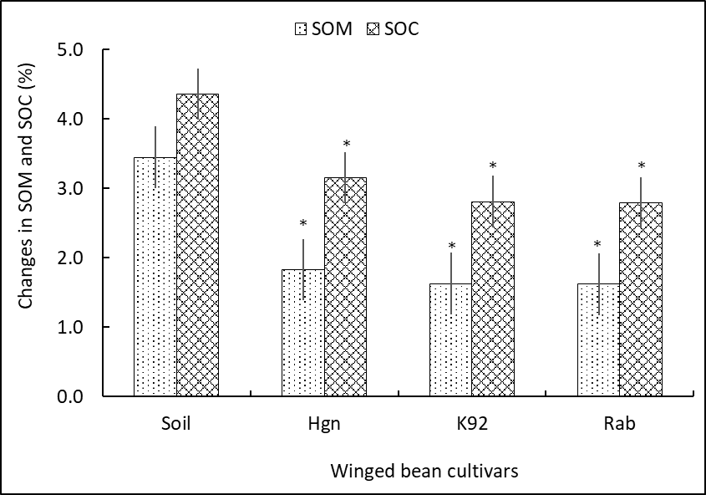
Figure 1. Changes SOM and SOC under three-winged bean cultivars. The values are mean ± standard error of four replicates (n=4). An asterisk shows a significant difference between the control (unplanted) and the treatment (planted) soils. The broken blue line is the SOC stock.

Overall, the decrease in SOM, SOC, and C stock was approximately the same amount, indicating that regardless of where the winged cultivars originated, the need for SOM, SOC, and C stock remains the same. This is an interesting result, shows that these three soil parameters are essential for winged bean production, as indicated by the decreases, and need to be considered. Interestingly, organic matter can only be supplemented externally as mulch, fallen leaves or root exudates (e.g., Michael et al., 2015; 2016; 2017; Michael, 2020b; Topas & Michael, 2023) as it affects SOC and the C stock as well as other important soil parameters such as pH and electrical conductivity which affect soil nutrient status and availability to plants (Michael, 2020a).
The changes in pH and electrical conductivity measured are shown in Figure 2. The pH decreased in all planted soils compared to the unplanted soil, and these changes were cultivar-dependent, although within the general pH range of 5.7 – 7.0. The pH changed by nearly 0.36 under Hgn and K92 (highland cultivars) and 0.34 under the Rab cultivar (lowland cultivar). The lowland cultivar caused the most significant decrease in pH, and the changes observed under the highland cultivars were the same, indicating that there is little difference in their soil pH requirements. The change in pH induced by the lowland cultivar being 0.2 again supports the notion that all winged bean cultivars' soil pH requirements are within a specific range.
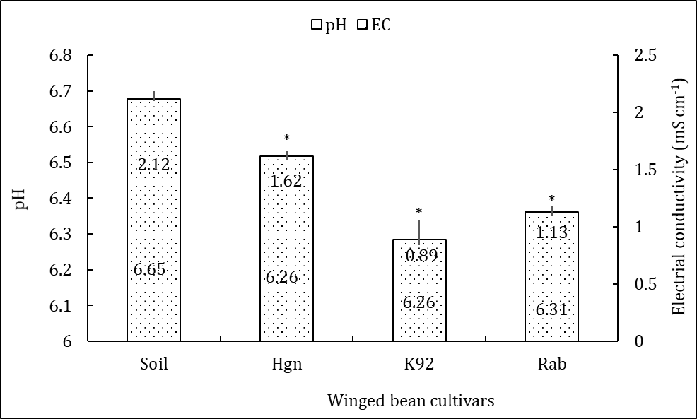
Figure 2. Changes in pH and electrical conductivity under three-winged bean cultivars. The values are mean ± standard error of four replicates (n=4). An asterisk shows a significant difference between the control (unplanted) and the treatment (planted) soils. The data values are pH on the bottom and electrical conductivity on the top, respectively.

The electrical conductivity (EC) reflected the changes in pH and soil nutrients measured (Figure 2). The EC was high in the unplanted soil, indicating good soil health and nutrient status. The EC decreased in the planted soil, indicating that the plants utilized the soil nutrients. The order of decrease in EC was K92>Rb>Hgn>Soil. As soil EC indicates the soil nutrient status, the results pointed out that K92 is the most soil nutrient-demanding cultivar of the three. This means that to produce this cultivar on a broader scale, it will require a high amount of nutrients in the form of chemical fertilizer. This is an issue for sustainable production compared to Hgn and Rab, which can be considered and recommended for wider production.
The soil's potential to hold water and retain moisture in the presence of plants is another important aspect to measure in crop production. The initial water-holding capacity (WHC) of the soil under natural conditions was approximately 38%. When used under greenhouse conditions for this study, it decreased to nearly 25%, resulting in a 12% loss in WHC. The basis of this loss is that soil samples were used processing, and the excess water added was allowed to drain freely, unlike the natural soil conditions. In the presence of the winged bean cultivars, the WHC continued to decrease by 5%, a trend consistent across all cultivars. The differences in the changes in WHC, being almost the same, indicate that the winged beans' influence on it is minimal due to varietal differences, but rather depends on soil conditions and the amount of water present. This observation was supported by the changes in soil moisture measured. The decrease in WHC resulted in a decrease in soil moisture, reflecting their direct relationship – the soil's ability to store water and the actual amount of it present in the soil at a given time. The overall decrease in soil moisture was nearly 5% and this consistent result showed that the requirement is the same for all cultivars. These results support a previous finding that winged beans are less tolerant to moisture stresses (Rachie, 1977) and suggest a high-water requirement as supported by the 5% decrease in moisture content (Figure 3).
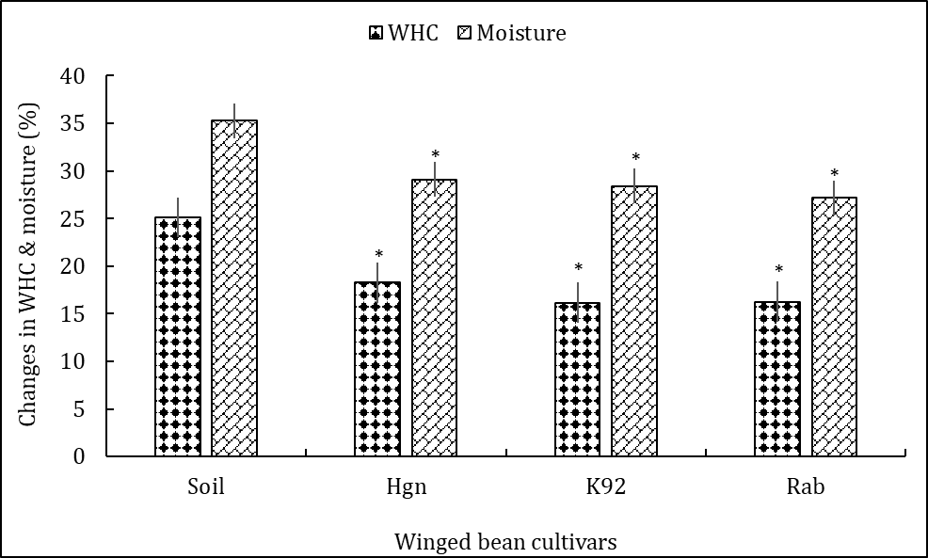
Figure 3. Changes in water holding capacity and moisture under three-winged bean cultivars. The values are mean ± standard error of four replicates (n=4). An asterisk shows a significant difference between the control (unplanted) and the treatment (planted) soils.

A compacted soil directly affects crop productivity by preventing plant roots from growing and reaching soil nutrients, while simultaneously removing oxygen and water from the soil, which further leads to a negative impact on crop growth and development. Understanding the soil bulk density (BD) and total porosity (TP) is crucial for managing the soil, as well as for understanding oxygen and water availability to plants. The results shown in Figure 4 indicate that the control soil was compacted, and therefore, the TP was less than 50%. This changed significantly when the winged bean cultivars were planted. The overall changes in BD were within a narrow range, with the lowest measurement being recorded under K92.
The opposite was true for TP, and a clear inverse relationship existed with BD. The TP was lower because bulk density was higher, with the highest measurement being recorded under Rab. The results, in principle, supported the common knowledge that the presence of plants reduced the BD and helped lessen the compactness of the soil as roots penetrated and loosened the soil. The improvement in porosity also depends on the type of roots produced by plants, with bigger roots, such as those of winged bean (tubers), being more effective than smaller roots (adventitious) of plants like grasses. These results indicate that, to a greater extent, K92 and Rab cultivars are more ideally suited to compacted soil than the Hgn. Under real-time production, the former cultivars would produce significantly larger tubers than the latter. That means the Hgn cultivar performs well under much less compacted or loose soil for optimal production.
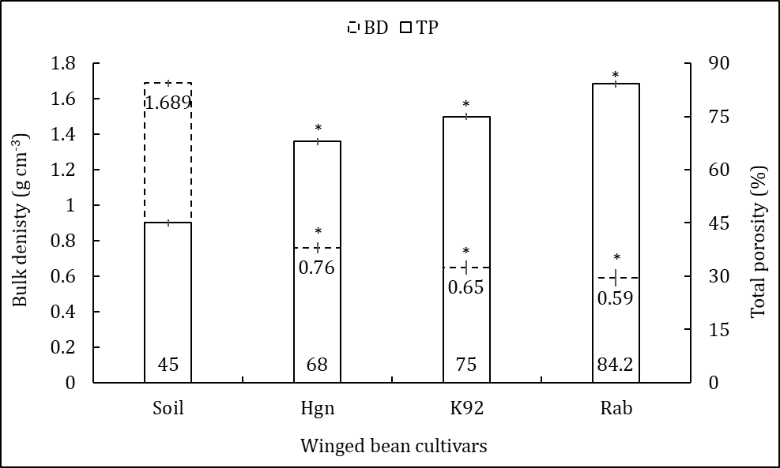
Figure 4. Changes in water holding capacity and moisture under three-winged bean cultivars. The values are mean ± standard error of four replicates (n=4). An asterisk shows a significant difference between the control (unplanted) and the treatment (planted) soils. The data values are listed in order, with bulk density at the top and total porosity at the bottom, respectively.

Given that the soil parameters that affect soil nutrient status and availability to plants have been assessed, the next immediate step is to assess the changes in soil nutrients so as to establish the cultivar-specific nutrient requirements. This background is important from two perspectives, one the nutrient use and addition into the soil, especially nitrogen, the winged bean being a legume which are important for production management. The results in Figure 5 showed that a cultivar-dependent changes in soil nutrient occurred when the winged beans were planted. The nitrogen content was fairly low in the unplanted soil and in the planted soil was high, indicating that nitrogen was added in the soil (Prasad et al., 2020; Tanzi et al., 2019; Chinnadurai & Devi, 2025). The highest amount of nitrogen was found under the Rab cultivar than the K92 and Hgn, demonstrating that the nutrient is needed by the Hgn cultivar more than the other two cultivars. The other two macronutrients, phosphorus and potassium contents were decreased instead, demonstrating the winged bean cultivars need them and more so of phosphorus by the Hgn and potassium by the K92 cultivar (highland cultivars) compared to Rab (lowland cultivar) for potassium (Figure 5).
The secondary macronutrients, magnesium and sodium, were utilized more extensively than calcium, as indicated by the measured concentrations (Figure 5). Comparatively, more magnesium was used by K92 and sodium by the Rab cultivar, when their uses were the same among the other two cultivars. The need for more sodium by the lowland cultivar is an adaptive mechanism, as most lowland soils have high magnesium and sodium contents, to which the cultivar is accustomed. The general observation is that the K92 cultivar appears to have a higher requirement for soil nutrients, and under typical crop production conditions, it will require more nutrient input for maximum output compared to its Rab cultivar counterpart.
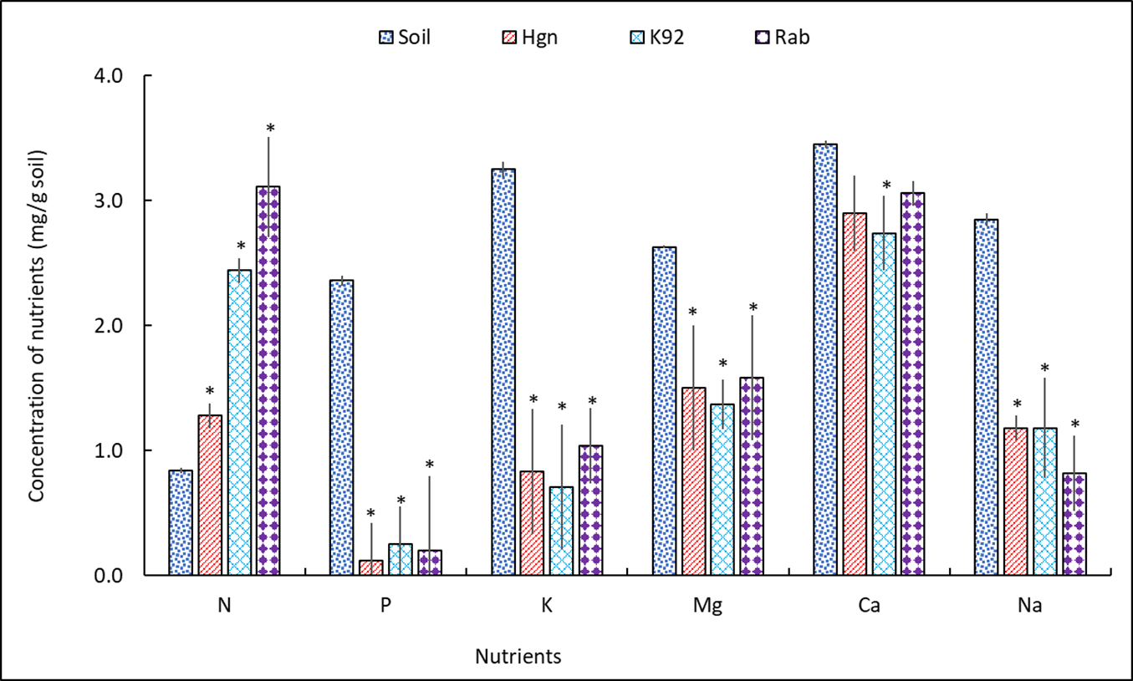
Figure 5. Changes in selected soil nutrients under three-winged bean cultivars. The values are mean ± standard error of four replicates (n=4). An asterisk shows a significant difference between the control (unplanted) and the treatment (planted) soils.

The Rab cultivar was the fastest-growing among the two highland cultivars (Table 2), which could be attributed to the lowland conditions under which the study was conducted, as shown by the stem length and leaf production, which were dependent on it. The longer the stem, the more leaves there were, and the lowland cultivar was leafier and longer compared to Hgn, which produced the second highest number of leaves. The total number of buds, flowers, pods, and seeds was directly dependent on the stem length. Comparatively, the larger the number of pods, the more seeds they produced, with the highest number of seeds recorded from Rab, K92, and Hgn (Table 2). Day length and temperature are two agroclimatic factors that affect the reproductive development of winged bean (Tanzi et al., 2019). One study in Ghana showed days to 50% flowering was between 40 to 130 days (Eagleton, 2022), planting in Australia using PNG varieties took 57 to 116 days irrespective of daylength and temperature variations (Eagleton, 1983), and others reported growing season of shorter than six months (Abe et al., 1988; Abe & Nakamura, 1987). In this study, daylength and temperature effects were considered minimal because of these study findings.

Table 2. Assessment of plant growth parameters.
Cultivars and plant growth parameters | Hgn | K92 | Rab
Stem (cm) | 110.4±1.4 | 106.6±1.2 | 115.4±1.2
Leaf (no.) | 75.5±1.3 | 63.5±1.2 | 82.3±1.4
Leaf length (cm) | 5.2±1.2 | 7.1±1.3 | 10.3±1.5
Buds (no.) | 6.3±1.5 | 4.1±1.2 | 9.6±1.2
Flowers (no.) | 3.2±1.3 | 6.3±1.4 | 10.5±0.2
Pods (no.) | 20.4±1.4 | 30.3±1.3 | 50±1.4
Seeds (no.) | 190.3±1.1 | 110.5±1.3 | 350±1.2
100 seed weight (g) | 50.2±1.7 | 39.5±1.6 | 60.2±1.3
The values are mean ± standard error of four replicates (n=4). Note that there was no production of tubers under the conditions under which the study was conducted.
A 1000-seed weight is a measurement taken to assess seed vigor and genetic potential, without the need for a genotype-by-environment trial to understand the seed's characteristics. The three-winged bean cultivars grown did not produce enough seeds to do that, and based on that, a 100-seed weight was determined. The results showed that the heaviest seeds were from the Rab cultivar, followed by the Hgn and K92 cultivars. The Rab cultivar is from the lowlands, and there was a perception that the lowland conditions under which the study was conducted favoured it more than the highland cultivars, giving it an advantage in the growth and production responses measured, shown in Table 2. The lesser above ground biomass production of the three cultivars somewhat agrees to Bourke’s (1975) observation that winged beans that originated in PNG have restricted vegetative growth compared to the germplasm originating from Southeast Asia (Thompson & Haryono 1980).

Conclusion

This study showed that there are few differences in cultivar requirements for soil parameters affecting general soil health and nutrient status, based on the agroecological zones of origin. The changes in soil organic matter, organic carbon, carbon stock, pH, electrical conductivity, water-holding capacity, and moisture, as well as bulk density, total porosity, and nutrients, were almost the same, with minor cultivar-specific differences. The changes in soil chemistry induced by the three-winged bean cultivars from two different agroecological zones, which were nearly the same, showed that these cultivars can be grown anywhere in PNG. These results further suggested that a high-performing cultivar like this can be promoted and even cultivated in the highlands.

Disclaimer
This paper is an extended version of a preprint document of the same author.
The preprint document is available in this link: https://www.researchgate.net/publication/398419063_Assessment_of_the_changes_in_soil_chemistry_induced_by_winged_bean_production_under_lowland_agroclimatic_conditions_in_Papua_New_Guinea
[As per journal policy, preprint article can be published as a journal article, provided it is not published in any other journal]

Disclaimer (Artificial intelligence)
Option 1:
Author(s) hereby declare that NO generative AI technologies such as Large Language Models (ChatGPT, COPILOT, etc.) and text-to-image generators have been used during the writing or editing of this manuscript.
Option 2:
Author(s) hereby declare that generative AI technologies such as Large Language Models, etc. have been used during the writing or editing of manuscripts. This explanation will include the name, version, model, and source of the generative AI technology and as well as all input prompts provided to the generative AI technology
Details of the AI usage are given below:
1.
2.
3.
References

- Abe, J., & Nakamura, H. (1987). Evaluation of winged bean in Okinawa. Japan Agricultural Research Quarterly, 21(2), 146 – 150. https://www.jircas.go.jp/sites/default/files/publication/jarq/21-2-146-152_0.pdf
- Abe, J., Nakamura, H., Hanada, T., Shimamoto, Y., & Nakata, D. (1988). Response of winged bean to temperature and photoperiod at different locations distributed from the tropics to the temperate zone. JARQ: Japan Agricultural Research Quarterly, 21(4), 308–313. https://www.jircas.go.jp/sites/default/files/publication/jarq/21-4-308-313.pdf
- Aipa, J., & Michael, P. S. (2018). Poultry manure application and fallow improves peanut production in a sandy soil under continuous cultivation. International Journal of Environmental & Agriculture Research, 4(2), 68–75. https://www.ijoear.com/V4-I2-68-75.pdf
- Bob, J., & Michael, P. S. (2022). Nutrient dynamics under unmanaged rubber, cocoa, and oil palm plantations in a sandy soil under humid lowland tropical climatic conditions. International Journal of Environment, 11(1), 46 – 61. https://doi.org/10.3126/ije.v11i1.45839
- Bourke, R. M. (1975). Evaluation of leguminous cover crops at Keravat, New Britain. Papua New Guinea Agriculture Journal, 26, 1–9. https://www.researchgate.net/publication/322287873_Evaluation_of_leguminous_cover_crops_at_Keravat_New_Britain/citations
- Chinnadurai, A. & Devi, P. R. (2025). Nutritional and functional composition of winged bean (Psophocarpus tetragonolobus): A review of its potential as a sustainable food resource. Journal of Food Composition and Analysis, 148 (4), 108523. https://doi.org/10.1016/j.jfca.2025.108523.
- Claydon, A. (1975). A review of the nutritional value of the winged bean Psophocarpus tetragonolobus (L.) DC. with special reference to Papua New Guinea. Science in New Guinea, 3, 103–114.
- Claydon, A. (1983). Potential of winged bean pods and their products in Papua New Guinea. Plant Food for Human Nutrition, 32, 167–177. https://doi.org/10.1007/BF01091337.
- Eagleton, G. (1999). Winged bean in Myanmar, revisited. Economic Botany, 53(3), 342–352. https://doi.org/10.1007/BF02866646
- Eagleton, G. (2022). A daylength-neutral winged bean (Psophocarpus tetragonolobus) for Southern Australian latitudes. Asian Journal of Agriculture, 6(2), 68 – 78. Doi: 10.13057/asianjagric/g060203.
- Eagleton, G. E. (1983). Evaluation of genetic resources in the winged bean (Psophocarpus tetragonolobus (L.) DC.) and their utilisation in the development of cultivars for higher latitudes [Doctoral dissertation, University of Western Australia]. https://doi.org/10.26182/5ed0a7988bedc
- Eagleton, G. E. (2019). Prospects for developing an early maturing variety of winged bean (Psophocarpus tetragonolobus) in Bogor, Indonesia. Biodiversitas Journal of Biological Diversity, 20(11), 3142–3152. https://doi.org/10.13057/biodiv/d201106
- Eagleton, G. E. (2020). Review: Winged bean (Psophocarpus tetragonolobus) cropping systems. Biodiversitas Journal of Biological Diversity, 21, 5927–5946. https://doi.org/10.13057/biodiv/d211258
- Eagleton, G. E., Tanzi, A. S., Mayes, S., Massawe, F., Ho, W. K., Kuswanto, K., Stephenson, R. A., & Khan, T. N. (2023). Winged bean (Psophocarpus tetragonolobus (L.) DC.). In M. Farooq & K. H. M. Siddique (eds.), Neglected and underutilized crops (pp. 437–486). https://doi.org/10.1016/B978-0-323-90537-4.00022-3
- Ekpenyong, T. E., & Borchers, R. L. (1980). The fatty acid composition of the oil of the winged bean (Psophocarpus tetragonolobus L.) seeds. Journal of the American Oil Chemists' Society. https://doi.org/10.1007/BF02673105
- Erskine, W., & Khan, T. N. (1980). Variation within and between land races of winged bean (Psophocarpus tetragonolobus (L.) DC.). Field Crops Research, 3, 359–364. https://doi.org/10.1016/0378-4290(80)90041-6
- Gajameragedera, S., & Ravindran, G. (1989). Compositional changes in winged bean [Psophocarpus tetragonolobus (L) DC] seed during maturation. Journal of the National Science Foundation of Sri Lanka, 17(2), 131–139. https://doi.org/10.4038/jnsfsr.v17i2.8216
- Kantha, S. S., & Erdman, J. W. (1984). The winged bean as an oil and protein source: A review. JAOCS, Journal of the American Oil Chemists' Society, 61(3), 515-525. https://doi.org/10.1007/BF02677021
- Karikari, S. K. (1972). Pollination requirements of winged beans (Psophocarpus spp. Neck) in Ghana. Ghana Journal of Agricultural Science, 5, 235–239.
- Khan, T. N. (1976). Papua New Guinea: a centre of genetic diversity in winged bean (Psophocarpus tetragonolobus (L.) D c.). Euphytica, 25, 693–705. https://doi.org/10.1007/BF000 41608.
- Khan, T. N. (1982). Winged bean production in the tropics. FAO Plant Production and Protection Paper 38. https://catalogue.nla.gov.au/Record/2025723
- Khan, T. N., & Erskine, W. (1978). The adaptation of winged bean (Psophocarpus tetragonolobus (L.) DC.) in Papua New Guinea. Australian Journal of Agricultural Research, 29(2), 281–289. https://doi.org/10.1071/AR9780281
- Khan, T. N., Bohn, J. C., & Stephenson, R. A. (1977). Winged beans: Cultivation in Papua New Guinea. World Crops, 29, 208–209. https://www.cabidigitallibrary.org/doi/10.1079/WCR19770037
- King, R. D., & Puwastien, P. (1987). Effects of germination on the proximate composition and nutritional quality of winged bean (Psophocarpus tetragonolobus) seeds. Journal of Food Science, 52, 106–108. https://doi.org/10.1111/J.1365-2621.1987.TB13982.X
- Kumar, V. K., & Rajalakshmi, R. (2023). Population diversity analysis of an underutilized legume, winged bean (Psophocarpus tetragonolobus (L.) DC.) using ISSR markers. Plant Gene. https://doi.org/10.1016/j.plgene.2023.100436
- Lenz, F., & Broughton, W. J. (1981). Growth, photosynthesis and transpiration in Psophocarpus tetragonolobus (L.) DC. cultivar UPS 99. Photosynthesis Research, 2, 259–268. https://doi.org/10.1007/BF00056263
- Lepcha, P., Egan, A. N., Doyle, J. J., & Sathyanarayana, N. (2017). A review on current status and future prospects of winged bean (Psophocarpus tetragonolobus) in tropical agriculture. Plant Foods for Human Nutrition, 72, 225–235. https://doi.org/10.1007/s11130-017-0627-0
- Lim, T. K. (2012). Edible medicinal and non-medicinal plants: Volume 2, fruits. Springer. https://doi.org/10.1007/978-94-007-1764-0
- Mahto, C. S., & Dua, R. P. (2009). Genetic divergence for yield contributing traits in winged bean [Psophocarpus tetragonolobus L. (DC)]. Indian Journal of Plant Genetic Resources, 22(3), 239–242. https://ispgr.in/index.php/ijpgr/article/view/2485
- Makeri, M. U., Abdulmannan, F., Ilowefah, M. A., Chiemela, C., Bala, S. M., & Muhammad, K. (2017). Comparative physico-chemical, functional and structural characteristics of winged bean [Psophocarpus tetragonolobus DC] and soybean [Glycine max.] protein isolates. Journal of Food Measurement and Characterization, 11(2), 835-846. https://doi.org/10.1007/s11694-017-9484-x
- Michael, P. S. (2019a). Current evidences and future projections: a comparative analysis of the impacts of climate change on critical climate-sensitive areas of Papua New Guinea. Sains Tanah - Journal of Soil Science and Agroclimatology, 16(2), 229–253. https://doi.org/10.20961/stjssa.v16i2.29731
- Michael, P. S. (2019b). Roles of Leucaena leucocephala (Lam.) on sandy loam soil pH, organic matter, bulk density, water holding capacity, and carbon stock under humid lowland tropical climatic conditions. Bulgarian Journal of Soil Science, 4(1), 33–45. https://doi.org/10.1079/BJSS2019.0004
- Michael, P. S. (2020a). Cogon grass biochar amendment and Panicum coloratum planting improve selected properties of sandy soil under humid lowland tropical climatic conditions. Biochar, 2(4), 489–502. https://doi.org/10.1007/s42773-020-00057-z
- Michael, P. S. (2020b). Effects of organic matter and live plants on sulfidic soil pH, redox and sulfate content under flooded conditions. Bulgarian Journal of Soil Science, 5, 34–49. https://www.cabidigitallibrary.org/doi/10.1079/BJSS20200005
- Michael, P. S. (2020c). Organic carbon and nitrogen amendment prevents oxidation of subsurface of sulfidic soil under aerobic conditions. Eurasian Soil Science, 53, 1743–1751. https://doi.org/10.1134/S1064229320120078
- Michael, P. S. (2020d). Simple carbon and organic matter addition in acid sulfate soils and time-dependent changes in pH and redox under varying moisture regimes. Asian Journal of Agriculture, 4(1), 23–29. https://doi.org/10.13057/asianjagric/g040105
- Michael, P. S. (2020e). Soil fertility status and sweet potato cultivation in composted mounds under humid lowland tropical climatic conditions. Sains Tanah Journal of Soil Science and Agroclimatology, 17(2), 144 – 151. https://doi.org/10.20961/stjssa.v17i2.43426

- Michael, P. S. (2020f). Soil fertility status and sweet potato cultivation in composted mounds under humid lowland tropical climatic conditions. Sains Tanah Journal of Soil Science and Agroclimatology, 17(2), 144–151. https://doi.org/10.20961/stjssa.v17i2.43426
- Michael, P. S. (2020g). Soil fertility status and sweet potato cultivation in composted mounds under humid lowland tropical climatic conditions. Sains Tanah Journal of Soil Science and Agroclimatology, 17(2), 144–151. https://doi.org/10.20961/stjssa.v17i2.43426
- Michael, P. S. (2020h). Soil fertility status and sweet potato cultivation in composted mounds under humid lowland tropical climatic conditions. Sains Tanah - Journal of Soil Science and Agroclimatology, 17(2), 8. https://doi.org/10.20961/stjssa.v17i2.43426
- Michael, P. S. (2021). Role of organic fertilizers in the management of nutrient deficiency, acidity, and toxicity in acid soils – A review. Journal of Global Agriculture & Ecology, 12, 19–30. https://ikprress.org/index.php/JOGAE/article/view/7286
- Michael, P. S. (2023). The importance of sustainable management of acid soils in the humid tropics under climate change and future research directions. ECC, 4, 39 – 50. http://doi.org/10.26480/efcc.01.2023.29.40
- Michael, P. S., & Peter, T. M. (2023). Sweet potato is a strategic root crop in Oceania: A synthesis of the past research and future direction. Sains Tanah Journal of Soil Science and Agroclimatology, 20(1), 51–65. https://doi.org/10.20961/stjssa.v20i1.77000
- Michael, P. S., Fitzpatrick, R. W., & Reid, R. J. (2016). The importance of soil carbon and nitrogen in amelioration of acid sulphate soils. Soil Use and Management, 32(1), 97–105. https://doi.org/10.1111/sum.12239
- Michael, P. S., Fitzpatrick, R. W., & Reid, R. J. (2017). Effects of live wetland plant macrophytes on acidification, redox potential and sulphate content in acid sulphate soils. Soil Use and Management, 33, 471–481. https://doi.org/10.1111/sum.12362
- Michael, P. S., Fitzpatrick, R., & Reid, R. (2015). The role of organic matter in ameliorating acid sulfate soils with sulfuric horizons. Geoderma, 225, 42–49. https://doi.org/10.1016/j.geoderma.2015.04.023
- Misra, P. S., Misra, G., Prakash, D., Tripathi, R. D., Chaudhary, A. R., & Misra, P. N. (1987). Assay of some nutritional and antinutritional factors in different cultivars of winged bean (Psophocarpus tetragonolobus (L.) DC) seeds. Qualitas Plantarum Plant Foods for Human Nutrition, 36(4), 367–371. https://doi.org/10.1007/BF01892358
- Mohanty, C. S., Pradhan, R. C., Singh, V., Singh, N., Pattanayak, R., Prakash, O., Chanotiya, C. S., & Rout, P. K. (2015). Physicochemical analysis of Psophocarpus tetragonolobus (L.) DC seeds with fatty acids and total lipids compositions. Journal of Food Science and Technology, 52(6), 3660–3670. https://doi.org/10.1007/s13197-014-1436-1
- Mohanty, C. S., Verma, S., Singh, V., & et al. (2013). Characterization of winged bean (Psophocarpus tetragonolobus (L.) DC.) based on molecular, chemical and physiological parameters. American Journal of Molecular Biology, 3(4), 187–197. https://doi.org/10.4236/ajmb.2013.34025
- Mu, X., Chen, Q., Chen, F., Yuan, L. & Mi, G. (2016). Within-leaf nitrogen allocation in adaptation to low nitrogen supply in maize during grain-filling stage. Frontiers in Plant Science, 7, https://doi.org/10.3389/fpls.2016.00699.
- Nangju, D., & Baudoin, J. P. (1979). Performance of winged bean (Psophocarpus Tetragonolobus (L.) DC.) in Nigeria. Journal of Horticultural Science, 54, 129–136. https://doi.org/10.1080/00221589.1979.11514860
- Okada, R., Kiyota, E., Moriyama, H., Fukuhara, T., & Valverde, R. A. (2017). Molecular and biological properties of an endornavirus infecting winged bean (Psophocarpus tetragonolobus). Virus Genes, 53, 141–145. https://doi.org/10.1007/s11262-016-1398-7
- Okezie, B. O., & Martin, F. W. (1980). Chemical composition of dry seeds and fresh leaves of winged bean varieties grown in the U.S. and Puerto Rico. Journal of Food Science, 45, 1045–1051. https://doi.org/10.1111/j.1365-2621.1980.tb07509.x
- Pellegrini, L., & Tasciotti, L. (2014). Crop diversification, dietary diversity and agricultural income: empirical evidence from eight developing countries. Canadian Journal of Development Studies, 35, 211–227. https://doi.org/10.1080/02255189.2014.898580
- Prasad, M. R., Ravi, P., & Surekha, K. 2020. Distribution of DTPA extractable micronutrients in soils of Central Telangana Region of Telangana. Current Journal of Applied Science and Technology, 39(48), :189–194. https://doi.org/10.9734/cjast/2020/v39i4831220.
- Pueppke, S. G. (1979). Purification and characterization of a lectin from seeds of the winged bean, Psophocarpus tetragonolobus (L.) DC. Biochimica et Biophysica Acta (BBA) - Protein Structure, 581(1), 63-70. https://doi.org/10.1016/0005-2795(79)90221-6
- Rachie, K. O. (1977). The nutritional role of grain legumes in the lowland humid tropics. In: Ayanabe A, Dart PJ (eds), Biological nitrogen fixation in farming systems of the tropics. Wiley, Amsterdam. https://hdl.handle.net/10568/175433.
- Rahman, M. M., Islam, A. M., Azirun, S. M., & Boyce, A. N. (2014). Tropical legume crop rotation and nitrogen fertilizer effects on agronomic and nitrogen efficiency of rice. The Scientific World Journal, 2014(1), 490841. https://doi.org/10.1155/2014/490841.
- Randall, P. J. (2015). Diagnosis of sulfur status of winged bean [Psophocarpus Tetragonolobus (L.) DC] by plant tissue analysis. Journal of Plant Nutrition, 38(2), 212–223. https://doi.org/10.1080/01904167.2014.934473.
- Reddy, P. P. (2015). Winged bean, Psophocarpus tetragonolobus. In Plant protection in tropical root and tuber crops (pp. 293–303). Springer India. https://doi.org/10.1007/978-81-322-2389-4
- Rüegg, J. (1981). Effects of temperature and water stress on the growth and yield of winged bean (Psophocarpus tetragonolobus (L.) DC.). Journal of Horticultural Science, 56, 331–338. https://doi.org/10.1080/00221589.1981.11515009
- Schulte, E. E., & Hopkins, B. G. (1996). Estimation of soil organic matter by weight loss-on-ignition. In F. R. Magdoff, M. A. Tabatabai, & E. A. Hanlon (Eds.), Soil organic matter: Analysis and interpretation (pp. 21–31). Soil Science Society of America. https://doi.org/10.2136/sssaspecpub46.c3
- Sriwichai, S., Laosatit, K., Monkham, T., Sanitchon, J., Jogloy, S., & Chankaew, S. (2022). Genetic diversity of domestic (Thai) and imported winged bean (Psophocarpus tetragonolobus (L.) DC.) cultivars assessed by morphological traits and microsatellite markers. Annals of Agricultural Sciences, 67, 34–41. https://doi.org/10.1016/j.aoas.2022.04.002
- Sriwichai, S., Monkham, T., Sanitchon, J., Jogloy, S., & Chankaew, S. (2021). Dual-purpose of the winged bean (Psophocarpus tetragonolobus (L.) DC.), the neglected tropical legume, based on pod and tuber yields. Plants, 10(8), 1746. https://doi.org/10.3390/plants10081746
- Tanzi, A. S., Eagleton, G. E., Ho, W. K., Wong, Q. N., Mayes, S., & Massawe, F. (2019). Winged bean (Psophocarpus tetragonolobus (L.) DC.) for food and nutritional security: synthesis of past research and future direction. Planta, 250, 911–931. https://doi.org/10.1007/s00425-019-03141-2
- Thompson, A. E., & Haryono, S. K. (1980). Winged bean: Unexploited tropical food crop. HortScience, 15(3), 233–238. https://doi.org/10.21273/HORTSCI.15.3.233
- Topas, M. P., Chung, R. Y., & Michael, P. S. (2024). Augmenting of primary and secondary macronutrients by chopped leucaena leaves used as organic matter in composted sweet potato mounds under tropical humid lowland conditions. International Journal of Environment, 13(1), 48–64. https://doi.org/10.3126/ije.v13i1.70632
- Varriano-Marston, E., Beleia, A., & Lai, C. C. (1983). Structural characteristics and fatty acid composition of Psophocarpus tetragonolobus seeds. Annals of Botany, 51, 631–640. https://doi.org/10.1093/oxfordjournals.aob.a086510
- Varshney, R. K., Graner, A., & Sorrells, M. E. (2005). Genic microsatellite markers in plants: features and applications. Trends in Biotechnology. https://doi.org/10.1016/j.tibtech.2004.11.005
- Wong, Q. N., Tanzi, A. S., Ho, W. K., Malla, S., Blythe, M., Karunaratne, A., Massawe, F., & Mayes, S. (2017). Development of gene-based SSR markers in winged bean (Psophocarpus tetragonolobus (L.) DC.) for diversity assessment. Genes, 8(3), 100. https://doi.org/10.3390/genes8030100
- Yang, S., Grall, A., & Chapman, M. A. (2018). Origin and diversification of winged bean (Psophocarpus tetragonolobus (L.) DC.), a multipurpose underutilized legume. American Journal of Botany, 105(5), 888–897. https://doi.org/10.1002/ajb2.1093.

