Antibiotic Susceptibility Pattern of Bacteria Isolated from Elechi Creek in Rivers State, Nigeria

ABSTRACT
Antibiotic Susceptibility Pattern refers to the ability of microorganisms to grow in the presence of an antimicrobial agent at a concentration that will normally kill or inhibit their growth. Antimicrobial resistance has become a major global threat, making treatment of infections tougher, especially with the high cost of treatment in humans and animals. This study was done to determine the Antibiotic Sensitivity Pattern and Multiple Antibiotic resistance index (MARI) of bacteria isolated from Elechi Creek. Two hundred and ten (210) samples were collected from five (5) points along the creek for a period of six (6) months. Bacterial Isolates were identified by standard microbiological methods. The isolates identified were Bacillus sp., Staphylococcus sp., Enterococcus sp., Pseudomonas sp., Vibrio sp., Proteus sp., Salmonella sp., Shigella sp., Escherichia coli, Enterobacter, Klebsiella sp. and Providencia sp. Antibiotic susceptibility testing was carried out using the disc diffusion technique. The organisms were tested against Cefuroxime, Gentamicin, Ceftriaxone, Erythromycin, Cloxacillin, Ofloxacin, and Augmentin for gram-positive Isolates. Cefuroxime, Gentamicin, Cefixime, Ofloxacin, Augmentin, Nitrofurantoin, Ciprofloxacin for gram-negative isolates. The isolates obtained showed 100% resistance to ceftazidine, cefuroxime, augmentin and cefixine. The MARI values ranged from 0.4 to 0.8 amongst the isolates. These results suggest that bacterial organisms isolated from Elechi Creek can contribute significantly to the spread of multi-antibiotic-resistant organisms. This could arise from indiscriminate use, causing an increased number of antibiotic-resistant strains in organisms. The study recommends close monitoring of antibiotic resistance in our environment and controlled use of antibiotics within the creek environment since the water serves as a source of domestic activity.

Keywords: Antibiotic Susceptibility Pattern, Bacteria, Elechi Creek, antibiotic-resistant, multi-antibiotic-resistant organisms

INTRODUCTION

Water is essential for the survival of living organisms and is commonly known as a universal solvent. It plays a vital role in physiological processes and has long been recognised for its significant religious, social, and economic importance within society (Ovonramwen et al., 2020). An antibiotic is a chemical substance which has the ability to decrease the growth of and also can eliminate the microorganisms (Sreelakshmi et al., 2020). There is a widespread global increase in antimicrobial resistance among organisms that pose significant health risks today. In many countries, the rapid rise in antibiotic resistance is becoming increasingly alarming (Haile et al., 2022). In a study, a strain of Bacillus flexus was isolated from an oil reservoir, and it was resistant to ampicillin, erythromycin, fosfomycin, fosmidomycin, gentamicin, teicoplanin, tetracycline and vancomycin. Another study reported that a strain of Bacillus pumilus isolated from air samples at high altitudes was resistant to ampicillin, ciprofloxacin, lincomycin and novobiocin (Anele et al., 2023). In Nigeria, antimicrobial resistance is a key public health priority on the national agenda (Achi et al., 2021). This surge in resistance is largely attributed to the loss of effectiveness of therapeutic and curative agents, primarily caused by the misuse and overuse of antibiotics (Javeed et al., 2011). The antibiotic susceptibility of bacterial isolates has steadily declined, resulting in a broad spectrum of antimicrobial resistance (AMR). A more recent FAO Action Plan on Antimicrobial Resistance 2021–2025 concluded that ‘the unchecked spread of antimicrobial resistance (AMR) is on track to make drug-resistant infections the cause of the next pandemic (EFSA Panel on Biological Hazards (BIOHAZ) et al., 2021). Efflux mechanisms are commonly used by microbes to alter and evade the action of certain antibiotics. However, many peer-reviewed studies have not fully accounted for the prevalence of multidrug-resistant bacterial isolates, largely due to inadequate documentation of various environmental sources, particularly aquatic ecosystems, which limits reference data for future research. These worsening trends have led to the introduction of mandatory laboratory testing before drug administration. Additionally, the misuse and overuse of antibiotics are widely recognised as major contributors to the spread of resistant species. Despite ongoing global efforts to enhance water quality, outbreaks of waterborne diseases continue to be reported (Hile et al., 2023). The bacteria commonly linked to these diseases include Escherichia coli, Legionella species, Pseudomonas aeruginosa, Aeromonas, and Mycobacterium species. Other waterborne pathogens are typically obligate pathogens, meaning they replicate only within an infected host. These include Campylobacter, Salmonella, Shigella, Escherichia coli, Acinetobacter species, Clostridium species, Bacillus anthracis, and Helicobacter pylori (Delgado-Gardea et al., 2016). Once inside human hosts, these pathogens are generally eliminated through antibiotic treatment. Over the years, antibiotics have been the most widely used antimicrobials for treating infectious diseases, effectively reducing morbidity and mortality rates (Chukwu et al., 2020). Antimicrobial Resistance (AMR) has emerged as a significant global challenge, causing a decline in effective treatment options for bacterial infections, which in turn reduces clinical success while driving up treatment costs and mortality rates (Oladipo et al., 2019). The inappropriate use of antibiotics is a major factor contributing to the development of AMR. After consumption, antibiotics are only partially metabolised by the body, resulting in substantial amounts being excreted in their original form or as active metabolites via urine and faeces. These residues enter wastewater treatment plants, which are not equipped to fully remove antibiotics. Consequently, these substances are released into the environment, including freshwater systems, through processes such as erosion, sewage runoff, or leaching (Grenni et al., 2018; Wang et al., 2022). The presence of antibiotic residues in the environment promotes the emergence of antimicrobial resistance in bacteria. These bacteria, known as Antibiotic Resistant Bacteria (ARB), carry Antibiotic Resistance Genes (ARGs) that can be transmitted to other bacteria through horizontal or vertical gene transfer (Peterson & Kaur, 2018). Hence, this study was carried out to assess the antibiotic sensitivity pattern of bacterial isolates obtained from Elechi Creek, Rivers State, Nigeria.
2. MATERIALS AND METHODS

2.1 Description of Study Area

Elechi Creek is close to Eagle Island, located on the southwest of Port Harcourt between longitude 04˚46'743"N and 007˚00'557"E; latitude 04˚48'217"N and 006˚48'989"E (Fig.1). It is bounded on the North by the Rivers State University, Nkpolu Oroworukwo area of Diobu. The Elechi Creek is a brackish water system influenced by tidal fluxes with an amplitude of about 1.20m, with a minimal current flow velocity of about 3m/s. It has mangrove vegetation with the dominant types being red mangroves (Rhizophora racemosa), white mangroves (Avicennia africana) and black mangroves (Laguncularia racemosa). The area is also inhabited by other plants (e.g. fern, Achrostichum aureum and grass, Paspalum varginatum). Aquatic habitats found in the area include mud skipper, Periophthalmus sp., Fidder crabs, Uca tangeri and Periwinkles, etc.
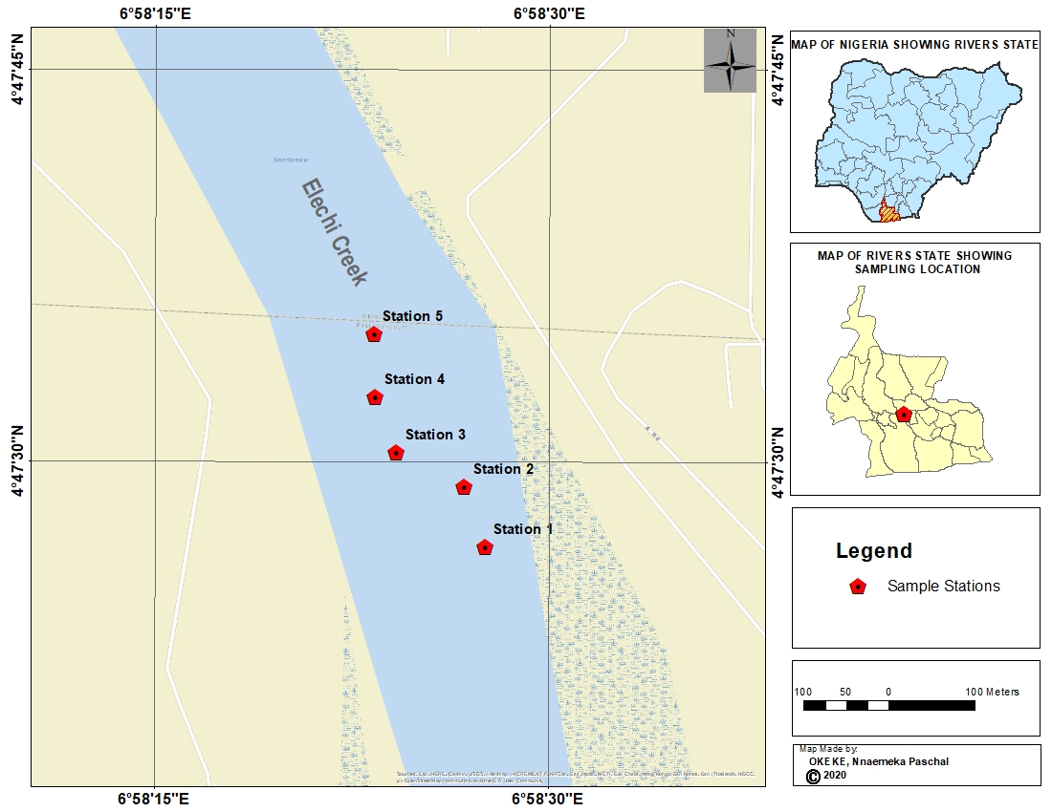
Figure 1: Map of Elechi Creek showing the Sampling Stations

2.2 Collection of Samples

A total of five (5) sampling stations were designated along the creek. Sampling stations were chosen approximately 6 to 10 meters from the creek banks and about 50 meters apart from each other (Fig. 1). Surface water, wastewater from industrial activities and sediment samples were collected using sterilised bottles. To collect the surface water and wastewater, each of the sample bottles was rinsed three (3) times with the appropriate sample before collection at a depth of about 30cm below the water surface in the opposite direction of the water flow (Meregini-Ikechukwu et al., 2020). The sediment samples were collected using a sterilised scoop and transferred into sterilised bottles. After the collection of samples, they were appropriately labelled and put in an ice pack cooler and transported to the laboratory for analysis. A total of 210 samples were collected; sampling was done twice a month from February to August.

2.3 Microbiological Analyses

The surface water, wastewater and sediment samples were aseptically subjected to a 10-fold serial dilution. 1 mL of surface water and wastewater samples was aseptically added to 9 mL of sterile normal saline and diluted to 10⁻⁵, respectively. 1 g of sediment samples was aseptically added to 9ml of sterile normal saline and diluted to 10⁻⁶. Aliquots (0.1 ml) of 10⁻³, 10⁻⁴ and 10⁻⁵ dilutions for water samples and 10⁻⁴ and 10⁻⁶ for sediment samples were inoculated onto surface-dried growth media. The inoculation technique used was the spread plate method, using a sterile bent glass rod. The inoculated plates were incubated at 37ºC for 24-48 hours, after which discreet colonies on plates were counted and expressed as colony-forming units and were sub-cultured repeatedly to obtain pure bacterial isolates for subsequent investigations (Meregini-Ikechukwu et al., 2020).

2.4 Preparation of Standard Bacterial Culture
Preparation of 0.5 McFarland standard: 1ml of concentrated sulphuric acid was added to 90ml of distilled water and was properly mixed to obtain a 1% v/v solution of sulphuric acid. Then 0.5g of dehydrated barium chloride (BaCl₂.2H₂O) was dissolved in 50ml of distilled water to prepare 1% w/v Barium Chloride Solution. Afterwards, 0.6ml of barium chloride solution was added to 99.4ml of the sulphuric acid solution and mixed properly. The prepared solution was then put in a capped tube and used to standardise the bacterial inoculum to be used. The standard was always agitated immediately before matching with the inoculums (CLSI 2020).

2.4 Antibiogram of the Isolates
Antibiotics profile of the isolates was determined using the disc diffusion method by (Kirby and Bauer), Multiple antibiotics sensitivity discs containing eight different antibiotics (Abtek Biologicals, Liverpool, UK) namely Gentamicin, Augmentin, Cefuroxime, Ofloxacin, Ceftazidime, Ceftriaxone, Cloxacillin and Erythromycin on each ring were used for the gram positive isolates, while Ceftazidime, Ceftriaxone, Cefuroxime, Gentamicin, Ofloxacin, Augmentin, Nitrofurantion, and Ciprofloxacin were used for gram negative isolates. Mueller Hinton agar plates were prepared according to the manufacturer’s instructions. The plates were dried at room temperature, and the standardised inocula were spread on the agar plates using sterilised swab sticks. The antibiotic discs were placed at the centre of the agar plate using sterilised forceps. The inoculated plates were then incubated at 37°C for 24hours. The diameter zone of inhibition was measured in millimetres. Organisms were classified as Sensitive, Intermediate or Resistant, based on the Clinical and Laboratory Standard Institutes (CLSI, 2020).
2.5 Genomic Identification
Molecular identification of the isolates was done using the Polymerase Chain Reaction (PCR) to determine the presence of the 16S rRNA sequence. This was done by first extracting the DNA, carrying out the PCR and sequencing the amplified DNA (amplicon).
2.5.1 D NA Extraction
DNA Extraction is simply the separation of DNA from proteins, membranes and other cellular material. Extraction and separation of DNA were carried out using the boiling method (Miller et al., 1999). A loopful of 24-hour-old pure culture of the bacterial isolates was transferred to Luria Bertani (LB) and incubated at 37°C for 24 hours. After 24 hours, the cells were washed by pipetting 5ml of the cultured broth into properly labelled Eppendorf tubes and filling to the mark with normal saline. This was centrifuged for 3 minutes at 14,000 rpm, after which the supernatant was decanted, leaving the DNA at the base. The DNA was washed with 1ml of normal saline and vortexed to properly mix, and then centrifuged again. This process was repeated three times. The cells were re-suspended in 500µl of normal saline and heated at 95 ⁰C for 20 minutes in a heating block to lyse the cells, after which it was fast cooled on ice and then centrifuged for 3 minutes at 14000rpm. The supernatant, which contained the DNA, was transferred to a 1.5 ml microcentrifuge tube and kept at 20 °C pending further reactions (Ribeiro et al., 2016).

2.5.2 DNA Quantification of Bacterial Isolates
Quantification of DNA was performed to purify and quantify the concentration of DNA present in the mixture. The extracted genomic DNA was quantified by using the Nanodrop 1000 Spectrophotometer. The Nanodrop spectrophotometer was connected to a computer which had the Nanodrop software installed. The software of the equipment was launched by double-clicking on the Nanodrop icon. The equipment was initialised using 2µl of sterile distilled water and blanked using 2 µl of Normal saline. To measure the concentration of the sample, 2µl of the extracted DNA was loaded onto the lower pedestal, and the upper pedestal was brought down to make contact with the DNA on the lower pedestal. Finally, the DNA concentration was measured by clicking the “measure” button displayed on the computer screen (Ribeiro et al., 2016).

2.5.3 16S rRNA Amplification of Bacterial Isolates
The ABI 9700 Applied Biosystems Thermal Cycler was used to amplify the 16srRNA. The 16srRNA region of the rRNA genes of the isolates was amplified using the forward primer, 27F: 5’AGAGTTTGATCMTGGCTCAG-3’ and Reverse Primer 1492R: 5’ CGGTTACCTTGTTACGACTT-3’ at a final volume of 25 µl for 35 cycles. The PCR cocktail was made up of 0.4 nM of pimers, X2 Dream taq Master mix (Inqaba, South Africa) and the template, which was the extracted DNA (50 ng). The Master mix was made up of Magnesium Chloride (MgCl₂), taq polymerase and DNTPs (Deoxyribonucleotides). The conditions for the reaction were Initial denaturation at 95°C for 5 minutes, denaturation at 95 °C for 30 seconds, annealing at 52°C for 30 seconds, extension at 72°C for 30 seconds and final extension at 72°C for 5 minutes. Resolution of the product was done on a 1% agarose gel at 120v for 15 minutes and viewed on a UV transilluminator.
2.5.4 DNA Sequencing of Bacterial Isolates
The amplified products were purified, and then the products were labelled using the BigDye Terminator Cycle Sequencing kit (Applied Biosystems). The sequencing was done at a final volume of 10µl; the components included 0.25µl BigDye terminator v1.1/v3.1, 2.5µl of 5x BigDye sequencing buffer, 10µM Primer PCR primer and 2-10ng PCR template per 100bp. The sequencing conditions were as follows: 32 cycles of 96ºC for 10 seconds, 55ºC for 5 seconds and 60ºC for 4 minutes.

2.5.5 Phylogenetic Analysis
The sequences obtained were edited using the bioinformatics algorithm called Trace edit. Using BLASTN, sequences similar to those obtained were downloaded from the NCBI (National Centre for Biotechnology Information) database. These sequences were further aligned using ClustalX. Using the Neighbour-Joining method in MEGA 6.0, the evolutionary history was inferred (Saitou and Nei, 1987). Evolutionary history of the analysed taxa was represented by the bootstrap consensus tree inferred from the 500 replicates (Felsenstein, 1985). Using the Jukes-Cantor method, the evolutionary distances were computed (Jukes and Cantor, 1969).

3. RESULTS AND DISCUSSION
The study was carried out to determine the antibiotic susceptibility pattern of bacterial isolates obtained from surface water, wastewater and sediment samples of Elechi Creek. The twelve genera of bacterial isolates identified from the surface water, wastewater and sediment samples were Bacillus sp., Staphylococcus sp., Enterococcus sp., Pseudomonas sp., Vibrio sp., Proteus sp., Salmonella sp., Shigella sp., Escherichia coli, Enterobacter, Klebsiella sp. and Providencia sp. The amplified 16S rRNA gene of the bacterial isolates, showing the bands and lanes of the genes, is presented in plate 1. Lanes E1 to E6 represent the 16SrRNA gene bands at 1500 base pairs, while lane L represents the 1000 base pair molecular ladder. Figure 2 represents the phylogenetic tree showing the evolutionary relationship of the six bacterial isolates identified molecularly. Tables 1 and 2 show the susceptibility, intermediate and resistance patterns of all the bacterial isolates from all the samples analysed. The isolates showed high resistance to Ceftazidime (30µg), Cefuroxime (30 µg) and Augmentin (30µg) for the gram-positive isolates. Similarly, the Gram-negative organisms exhibited high resistance to Ceftazidime (30µg), Cefuroxime (30 µg), Cefixime (5µg) and Augmentin (30µg). However, the isolates were susceptible to Ofloxacin (5µg) and Ciprofloxacin (5µg) for gram-positive isolates and were highly susceptible to Erythromycin (5µg) and Ofloxacin (5µg) for the gram-positive isolates. Table 3 presents the MAR (Multiple Antibiotic Resistance) Index of the isolates; index values greater than 0.2 are an indication of antibiotic abuse.

Table 1: Antibiotic Susceptibility Pattern of Gram-Positive Isolates
ISOLATES | CAZ | CRX | GEN | CTR | ERY | CXC | OFL | AUG | Probable Organisms
IS 1 | R | R | S | I | S | I | S | R | Bacillus sp.
IS 5 | R | R | S | R | S | I | S | R | Bacillus sp.
IS 7 | R | R | I | R | S | I | S | R | Bacillus sp.
IS 8 | R | R | I | R | S | I | S | R | Bacillus sp.
IS 12 | R | R | S | S | R | I | S | R | Bacillus sp.
IS 14 | R | R | I | S | S | R | S | R | Bacillus sp.
IS 19 | R | R | R | S | I | R | S | R | Bacillus sp.
IS 2 | R | R | S | I | S | I | S | R | Enterococcus sp.
IS 3 | R | R | I | S | S | I | S | R | Enterococcus sp.
IS 11 | R | R | S | I | R | I | S | R | Enterococcus sp.
IS 15 | R | R | I | R | S | I | S | R | Enterococcus sp.
IS 18 | R | R | R | R | I | R | S | R | Enterococcus sp.
IS 20 | R | R | R | I | S | I | S | R | Enterococcus sp.
IS 4 | R | R | I | S | S | I | S | R | Staphylococcus sp.
IS 6 | R | R | S | R | S | I | S | R | Staphylococcus sp.
IS 9 | R | R | S | I | I | I | S | R | Staphylococcus sp.
IS 10 | R | R | R | I | I | I | S | R | Staphylococcus sp.
IS 13 | R | R | S | S | S | R | S | R | Staphylococcus sp.
IS 16 | R | R | S | R | S | I | S | R | Staphylococcus sp.
IS 17 | R | R | I | R | I | I | S | R | Staphylococcus sp.
Key: Cefuroxime (30 µg), Gentamicin (10µg), Ceftriaxone (30µg), Erythromycin (5µg), Cloxacillin (5µg), Ofloxacin (5µg), Augmentin (30µg).
Table 2: Antibiotic Susceptibility Pattern of Gram-Negative Isolates from Elechi Creek
ISOLATES | CAZ | CRX | GEN | CXM | OFL | AUG | NIT | CPR | Probable Organisms
IS 1 | R | R | S | R | S | R | I | S | Klebsiella sp.
IS 15 | R | R | R | R | S | R | S | S | Klebsiella sp.
IS 20 | R | R | I | R | S | R | S | S | Klebsiella sp.
IS 30 | R | R | R | R | S | R | R | S | Klebsiella sp.
IS 2 | R | R | S | R | S | R | I | S | Shigella sp.
IS 23 | R | R | R | R | S | R | S | S | Shigella sp.
IS 34 | R | R | I | R | S | R | S | S | Shigella sp.
IS 3 | R | R | S | R | S | R | I | S | Vibrio sp.
IS 7 | R | R | S | R | S | R | R | S | Vibrio sp.
IS 16 | R | R | I | R | S | R | S | S | Vibrio sp.
IS 22 | R | R | R | R | S | R | S | S | Vibrio sp.
IS 4 | R | R | S | R | S | R | I | S | Proteus sp.
IS 9 | R | R | R | R | S | R | R | S | Proteus sp.
IS 17 | R | R | I | R | S | R | I | S | Proteus sp.
IS 25 | R | R | I | R | S | R | R | S | Proteus sp.
IS 28 | R | R | R | R | S | R | S | S | Proteus sp.
IS 31 | R | R | S | R | S | R | R | S | Proteus sp.
IS 35 | R | R | I | R | S | R | S | S | Proteus sp.
IS 37 | R | R | S | R | S | R | S | S | Proteus sp.
IS 40 | R | R | S | R | S | R | S | S | Proteus sp.
IS 5 | R | R | S | R | S | R | R | S | Enterobacter sp.
IS 13 | R | R | R | R | S | R | S | S | Enterobacter sp.
IS 36 | R | R | S | R | S | R | S | S | Enterobacter sp.
IS 8 | R | R | R | R | S | R | I | S | Providencia
IS 24 | R | R | R | R | S | R | R | S | Providencia
IS 33 | R | R | S | R | S | R | R | S | Providencia
IS 39 | R | R | S | R | S | R | S | S | Providencia
IS 6 | R | R | S | R | S | R | R | S | Escherichia coli
IS 11 | R | R | R | R | S | R | R | S | Escherichia coli
IS 18 | R | R | I | R | S | R | I | S | Escherichia coli
IS 26 | R | R | I | R | S | R | R | S | Escherichia coli
IS 29 | R | R | R | R | S | R | R | S | Escherichia coli
IS 32 | R | R | S | R | S | R | I | S | Escherichia coli
IS 38 | R | R | I | R | S | R | R | S | Escherichia coli
IS 12 | R | R | R | R | S | R | S | S | Salmonella sp.
IS 14 | R | R | R | R | S | R | S | S | Salmonella sp.
IS 21 | R | R | R | R | S | R | S | S | Salmonella sp.
IS 10 | R | R | R | R | S | R | R | S | Pseudomonas sp.
IS 19 | R | R | I | R | S | R | I | S | Pseudomonas sp.
IS 27 | R | R | I | R | S | R | R | S | Pseudomonas sp.
Key: Cefuroxime (30 µg), Gentamicin (10µg), Cefixime (5µg), Ofloxacin (5µg), Augmentin (30µg), Nitrofunantion (300µg), Ciprofloxacin (5µg)

The indiscriminate use of antibiotics over the years has been of a major concern hence therapeutic doses for treatment of infections with some of the antibiotics has led to an increased rate of antibiotic resistance from water and wastewater effluents (Ademola et al., 2009; Diwan et al., 2010). The isolates obtained showed 100% resistance to ceftazidine, cefuroxime, augmentin and cefixine. This also correlates with findings by Ogbonna et al. (2018); Adieze et al. (2015), who observed high antibiotic resistance in the various bacterial isolates obtained from their individual studies from similar environments and samples. This high resistance could be a result of the drug not being the right choice of treatment for infections caused by the bacterial population. Antibiotic resistance could also be a result of the isolates possessing resistance genes and exposure to environmental pollutants (Ram et al., 2008; Adebayo et al., 2012). The resistance exhibited by these isolates could be a result of the organism being able to evade the active component in the antibiotics or from fake drug production (Akinjogunla et al., 2009). As revealed by this study, the isolates also showed 100% susceptibility to ofloxacin and ciprofloxacin. They also showed 60% susceptibility to erythromycin, nitrofurantoin and gentamicin. These were in correlation with findings from studies by Ogbonna et al. (2018). The isolates showing the greatest resistance to the greatest number of antibiotics were identified as Pseudomonas, Klebsiella, Proteus, Providencia, Escherichia and Enterobacter species. This result is in consonance with reports of Bamigboye et al. (2014) and Foti et al. (2009), where, in different research, it was concluded that Gram-negative organisms have the highest rate of multiple antibiotic resistance. The isolates that showed more resistance were identified molecularly, and their result is represented in figures and plates, respectively. The figure is the percentage relatedness of one organism to another.

Table 3: Multiple Antibiotic Resistance (MAR) Index of Bacterial Isolates from Elechi Creek
Mar Index | Bacillus sp. | Staphylococcus sp. | Enterococcus sp. | Pseudomonas sp. | Klebsiella sp. | Proteus sp. | Providencia sp. | Escherichia coli | Salmonella sp. | Shigella sp. | Vibrio sp. | Enterobacter sp.
0.1 | 0(0.00) | 0(0.00) | 0(0.00) | 0(0.00) | 0(0.00) | 0(0.00) | 0(0.00) | 0(0.00) | 0(0.00) | 0(0.00) | 0(0.00) | 0(0.00)
0.2 | 0(0.00) | 0(0.00) | 0(0.00) | 0(0.00) | 0(0.00) | 0(0.00) | 0(0.00) | 0(0.00) | 0(0.00) | 0(0.00) | 0(0.00) | 0(0.00)
0.3 | 0(0.00) | 2(40.00) | 0(0.00) | 0(0.00) | 0(0.00) | 0(0.00) | 0(0.00) | 0(0.00) | 0(0.00) | 0(0.00) | 0(0.00) | 0(0.00)
0.4 | 2(28.57) | 3(60.00) | 1 (33.33) | 0(0.00) | 0(0.00) | 0(0.00) | 0(0.00) | 0(0.00) | 0(0.00) | 0(0.00) | 0(0.00) | 0(0.00)
0.5 | 4(57.14) | 0(0.00) | 1 (33.33) | 3(42.86) | 2 (50.00) | 5 (55.56) | 2(40.00) | 2 (28.57) | 0(0.00) | 2 (66.67) | 2 (50.00) | 1 (33.33)
0.6 | 1(14.29) | 0(0.00) | 0(0.00) | 3(42.86) | 1 (25.00) | 3 (33.33) | 2 (40.00) | 3 (42.86) | 3 (100) | 1 (33.33) | 2 (50.00) | 2 (66.67)
0.7 | 0(0.00) | 0(0.00) | 0(0.00) | 0(0.00) | 0(0.00) | 0(0.00) | 0(0.00) | 0(0.00) | 0(0.00) | 0(0.00) | 0(0.00) | 0(0.00)
0.8 | 0(0.00) | 0(0.00) | 1 (33.33) | 1 (14.29) | 1 (25.00) | 1 (11.11) | 1 (20.00) | 2 (28.57) | 0(0.00) | 0(0.00) | 0(0.00) | 0(0.00)
Note: MAR index values greater than 0.2 indicate high risk source of contamination where antibiotics are often used.

Bacillus sp. shows some presence at MAR indices 0.4 (28.57%) and 0.5 (57.14%), indicating that these isolates exhibit a moderate level of resistance. Bacillus species are known soil dwellers but have increasingly been isolated as opportunistic pathogens exhibiting resistance traits (Nicholson, 2002). The elevated MAR index here could suggest environmental exposure to antibiotics or biocides, consistent with findings by Logan and De Vos (2015), who highlighted that Bacillus species in contaminated sites tend to develop resistance. Staphylococcus sp. isolates appear predominantly at MAR indices 0.3 (40%) and 0.4 (60%), which is noteworthy since Staphylococcus aureus and related species are well-documented for multidrug resistance, including methicillin-resistant Staphylococcus aureus (MRSA) strains (Chambers & DeLeo, 2009). The observed data align with these studies, indicating significant resistance levels. Enterococcus sp. show resistance mainly at MAR 0.4 and 0.5 levels (33% each), which resonates with research showing vancomycin-resistant Enterococcus (VRE) prevalence in clinical and environmental samples (Weiner et al., 2016). Pseudomonas sp. isolates are detected at 0.5 (42.86%) and 0.6 (42.86%) MAR levels, supporting the extensive antibiotic resistance documented for Pseudomonas aeruginosa, an opportunistic pathogen known for its intrinsic and acquired resistance mechanisms (Strateva & Yordanov, 2009). Klebsiella sp., Proteus sp., and Providencia sp. demonstrate increasing resistance from 0.5 to 0.6 MAR index ranges, highlighting their roles as emerging multidrug-resistant pathogens in hospital and environmental contexts (Podschun & Ullmann, 1998; Fischer et al., 2019). Escherichia coli exhibits a broad resistance profile, with high MAR index readings at 0.6 (100%), suggesting that all isolates at this level possess multidrug resistance, a finding consistent with multiple studies on E. coli in both clinical and environmental samples (Pitout & Laupland, 2008). Salmonella sp. and Shigella sp. show presence at the 0.5 to 0.6 MAR ranges, aligning with reports of multidrug-resistant strains, particularly in foodborne outbreaks (Eng et al., 2015; Von Seidlein et al., 2006). Vibrio sp. and Enterobacter sp., while less frequent, also show nonzero records at MAR indices 0.5 and 0.6, reflective of their increasing role in antibiotic resistance surveillance (Farmer et al., 2010).

E1 E2 L E 3 E4 E 5 E6
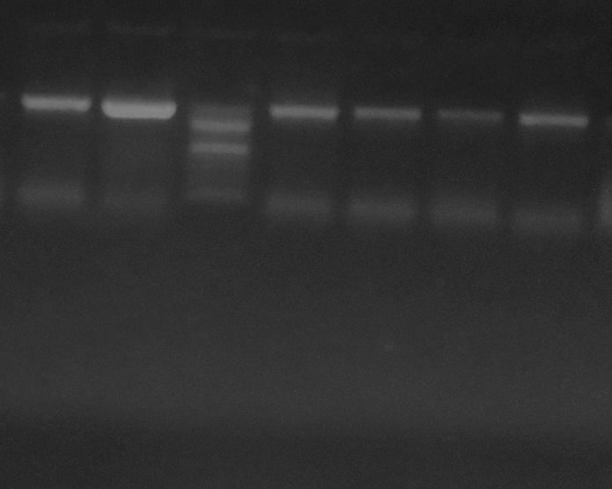
10100001000bp

Plate 1: Agarose gel pix showing the amplified 16S rRNA gene bands. Lanes 1-6 show the bands at 1500bp, while Lane L represents the 1000bp molecular ladder.

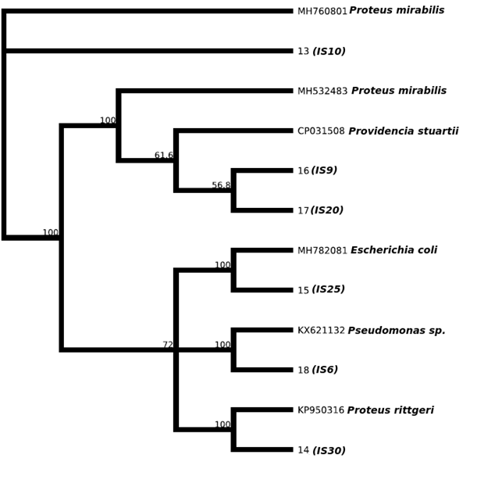
Fig. 2: Phylogenetic tree showing the evolutionary distance between the bacterial isolates

CONCLUSION
This study indicates that Elechi Creek is a carrier of pathogenic bacteria which is capable of transmitting antibiotic resistance genes to humans. The majority of the isolates exhibited resistance to Ceftazidime, Cefuroxime, Cefixime, and Augmentin. This indicates that the drugs are being abused, thus they have become ineffective in the treatment of infections caused by the bacterial isolates observed in this study, if the source of contamination is linked to the creek water. The resistance could also be due to the concentration at which the drug was used. The study recommends close monitoring of antibiotic resistance in our environment and controlled use of antibiotics within the creek environment since the water serves as a source of domestic activity.

COMPETEING INTERESTS
Authors declare that there are no competing interest.

Disclaimer (Artificial intelligence)
Option 1:
Author(s) hereby declare that NO generative AI technologies such as Large Language Models (ChatGPT, COPILOT, etc.) and text-to-image generators have been used during the writing or editing of this manuscript.
Option 2:
Author(s) hereby declare that generative AI technologies such as Large Language Models, etc. have been used during the writing or editing of manuscripts. This explanation will include the name, version, model, and source of the generative AI technology and as well as all input prompts provided to the generative AI technology
Details of the AI usage are given below:
1.
2.
3.

RFERENCES
- Ovonramwen, O.B. (2020). Physicochemical analysis of surface and ground water in Ugbomro and Iteregbi, Delta State, Nigeria. Journal of Applied Sciences and Environmental Management, 24(3), 511-517.

- Delgado-Gardea, M. C., Tamez-Guerra, P., Gomez-Flores, R., Zavala-Díaz de la Serna, F. J., Eroza-de la Vega, G., Nevárez-Moorillón, G. V., Pérez-Recoder, M. C., Sánchez-Ramírez, B., González-Horta, M. & Infante-Ramírez, R. 2016 Multidrug-Resistant Bacteria Isolated from Surface Water in Bassaseachic Falls National Park, Mexico. International Journal of Environmental Research & Public Health13(6), 597. https://doi.org/10.3390/ijerph13060597.

- .Hile, T. D., Dunbarb, S. G. & Sinclair, R. G. 2023 Microbial contamination analysis of drinking water from bulk dispensers & fast-food restaurants in the Eastern Coachella Valley, California. Water Science & Technology Water Supply 1-19. DOI:10.2166/ws.2023.200.

- Meregini-Ikechukwu P, Ogbonna David, Akani, Nedie. Water Quality Assessment of Elechi Creek Receiving Effluent Discharges from Industrial Activities in Port Harcourt, Nigeria. Journal of Advances in Microbiology. 2020;21-30. DOI:10.9734/jamb/2020/v20i830272

- Nicholson, W. L. (2002). Bacillus species are known soil dwellers but have increasingly been isolated as opportunistic pathogens exhibiting resistance traits.
- Logan, N. A., & De Vos, P. (2015). Bacillus species in contaminated sites tend to develop resistance.
- Chambers, H. F., & DeLeo, F. R. (2009). Staphylococcus aureus and related species are well-documented for multidrug resistance, including methicillin-resistant Staphylococcus aureus (MRSA) strains.
- Weiner, L. M., Webb, A. K., Limbago, B., Sickbert-Bennett, E., & Kallen, A. J. (2016). Vancomycin-resistant Enterococcus (VRE) prevalence in clinical and environmental samples.
- Strateva, T., & Yordanov, D. (2009). Extensive antibiotic resistance documented for Pseudomonas aeruginosa.
- Podschun, R., & Ullmann, U. (1998). Role of Klebsiella, Proteus, and Providencia as emerging multidrug-resistant pathogens in hospital and environmental contexts.
- Fischer, J., Rodriguez, C., & et al. (2019). Emerging multidrug resistance of environmental pathogens Klebsiella sp., Proteus sp., and Providencia sp.
- Pitout, J. D., & Laupland, K. B. (2008). Multidrug resistance in Escherichia coli in clinical and environmental samples.
- Eng, S. K., Pusparajah, P., Ab Mutalib, N. S., Ser, H. L., Chan, K. G., & Lee, L. H. (2015). Multidrug-resistant Salmonella and Shigella strains in foodborne outbreaks.
- Von Seidlein, L., Kim, D. R., Ali, M., Lee, H., Wang, X., Thiem, V. D., et al. (2006). Multidrug resistance in Salmonella and Shigella species.
- Farmer, J. J., Janda, J. M., & et al. (2010). Antibiotic resistance in Vibrio sp. and Enterobacter sp. in surveillance studies.
- Clinical and Laboratory Standards Institute (CLSI), 2020 Performance Standards for Antimicrobial Susceptibility Testing, 30th Edition, CLSI supplement M100, Wayne, PA, USA.

- Miller, J. R., & Cowles, R. S. (1990). Stimulo-deterrent diversion: A concept and its possible application to onion maggot control. Journal of Chemical Ecology, 16(11), 3197-3212.

- Bauer, A. W., Kirby, W. M. M., Sherris, J. C., & Turk, M. (1966). Antibiotic susceptibility
testing by a standard single disk method. American Journal of Clinical Pathology, 45, 493–496.

- Jukes, T. H., & Cantor, C. R. (1969). Evolution of protein molecules. In H. N. Munro
(Ed.), Mammalian protein metabolism (pp. 21–132). Academic Press.

- Ribeiro, J. C., Tamanini, R., Soares, B. F., de Oliveira, A. M., & de Godoi Silva, F. (2016). Efficiency of boiling and four other methods for genomic DNA extraction of deteriorating spore-forming bacteria from milk. Semina: Ciências Agrárias, 37(5), 3069–3078.

- Saitou, N., & Nei, M. (1987). The neighbor-joining method: A new method for reconstructing phylogenetic trees. Molecular Biology and Evolution, 4(4), 406–425.

- Anele, B. C., Immanuel, O. M., Uzor, B. C., George-West, O., Okerentugba, P., Ikeh, I. M., Stanley, H. O., & Samuel, J. (2023). Isolation and identification of antibiotic-susceptible bacteria from abattoir effluent in Port Harcourt, Rivers State, Nigeria. International Journal of Pathogen Research, 12(6), 144–152.

- Sreelakshmi, C. R., Moses, S. A., & Vincent, S. G. T. (2020). Environmental antimicrobial resistance (En-AMR) in surface water of Thiruvananthapuram City, Kerala. Asian Journal of Environment & Ecology, 12(4), 22–32.

- EFSA Panel on Biological Hazards (BIOHAZ), Koutsoumanis, K., Allende, A., Álvarez‐Ordóñez, A., Bolton, D., Bover‐Cid, S., ... & Peixe, L. (2021). Role played by the environment in the emergence and spread of antimicrobial resistance (AMR) through the food chain. Efsa Journal, 19(6), e06651.

