Original Research Article
Multivariate assessment of genetic diversity for fodder yield and related traits in diverse maize germplasm panel

Abstract
Understanding the multivariate structure of genetic variation in fodder maize is essential for developing high-biomass and climate-resilient cultivars. In this study, a diverse set of maize inbred lines from the CIMMYT Asia Association Mapping (CAAM) panel was evaluated across two contrasting seasons i.e., Rabi 2023 and Kharif 2024 to quantify phenotypic diversity for key fodder-related traits using principal component analysis (PCA). A total of 249 genotypes in Season 1 and 200 in Season 2 were phenotyped for biomass, canopy architecture and phenological traits. PCA revealed a highly consistent pattern of trait structuring during both seasons, with the first principal component dominated by vegetative vigour attributes, leaf area, leaf length, leaf width, plant height and both green and dry fodder yield, collectively explaining the largest share of variation (37.09). Flowering traits formed an independent phenological axis represented predominantly by PC2 in both seasons (18.84 and 17.41), demonstrating minimal correlation with biomass traits. Secondary components captured variation associated with stem diameter, leaf:stem ratio and subtle differences in canopy architecture. The stability of trait loadings and genotype placement during both seasons indicated limited genotype × environment interaction for major axes of variation. PCA biplots further revealed clear divergence among genotypes, separating high-biomass ideotypes from late-flowering. The strong and repeatable contribution of canopy expansion traits highlights their central role in fodder productivity and confirms their reliability as selection indicators. The study demonstrates substantial and structured genetic diversity within the CAAM panel and provides a robust multivariate framework for parental selection, heterotic grouping and ideotype design in fodder-oriented maize breeding.
Key words: Diverse panel, Diversity, Fodder, Maize and Principal Component Analysis.
1. Introduction
Maize (Zea mays L.) is one of the most genetically diverse and agronomically significant cereal crops, widely valued for its adaptability and multifunctional use in food, feed and industrial sectors. In many tropical and subtropical regions, fodder maize has gained prominence due to its high biomass yield and superior digestibility, making it an essential component of sustainable livestock production systems. The increasing demand for quality green fodder driven by dairy intensification and changing climate patterns, necessitates the efficient utilization of diverse germplasm resources to breed high-yielding, nutritionally superior fodder cultivars. The importance of exploring available variability for traits such as green fodder yield, dry matter content and structural attributes is well emphasized (Singh et al., 2023). Genetic diversity analysis forms the backbone of plant breeding because it helps reveal the extent of divergence among genotypes, the presence of distinct groups within a population and the potential of specific lines to serve as parents for generating heterotic combinations. For fodder maize, where multiple traits contribute collectively to biomass production and quality, diversity assessment becomes particularly important. Multivariate approaches are effective in understanding complex patterns of variation that are not easily captured through univariate analysis alone (Mengistu, 2021). Principal Component Analysis (PCA) is especially useful in this context because it simplifies large trait datasets into key components that explain most of the observed variation. This technique helps to identify trait combinations that drive diversity, locate genotypes with unique characteristics and visualize natural groupings within a germplasm collection. With the availability of germplasm from breeding programs, landraces and global gene banks, there is a strong need for systematic evaluation using robust statistical approaches. PCA-based divergence analysis not only identifies promising parents but also assists in forming broad-based breeding pools. Among the multivariate approaches, PCA offers a robust framework for interpreting trait interrelationships, making it a valuable tool for devising fodder-focused breeding strategies in maize (Mengistu et al., 2021). In this context, the present study aims to assess the extent and pattern of genetic diversity in a diverse maize germplasm panel using PCA for key fodder-related traits. This analysis is intended to guide the selection of genetically divergent accessions, enhance breeding efficiency and contribute to the development of maize varieties optimized for high biomass yield and improved forage quality.
2. Material and methods
The present investigation employed a genetically diverse maize germplasm panel, the CIMMYT Asia Association Mapping (CAAM) panel, provided by the International Maize and Wheat Improvement Center (CIMMYT), Asia Hub, Hyderabad, India. This panel comprises a wide array of tropical and subtropical maize accessions, representing extensive genetic variability. Phenotyping was conducted across two contrasting cropping seasons, Rabi 2023 and Kharif 2024 evaluating 249 and 200 genotypes, respectively, at the College of Agriculture, Shivamogga, using an alpha lattice design with two replications to ensure efficient control of field variability and all recommended agronomic practices were meticulously followed to achieve uniform crop establishment and protection. Phenotyping focused on fodder yield and associated phenological, morphological and yield-related traits. Subsequent analyses, including principal component analysis, and graphical visualization, were carried out in R using the FactoMineR package (Le et al., 2008This citation is Absent in the reference list).
3. Results and discussion
3.1 Principal component analysis
Principal component analysis (PCA) performed on the CAAM maize germplasm panel across two seasons revealed clear and biologically meaningful patterns in the contribution of fodder-related traits to total phenotypic variation. In Season 1 (Table 1 and Fig.1), the first four principal components out of 11 PCs have demonstrated eigen value greater than one, accounted for 75.11% of the total variability, with PC1 alone contributing 37.09%. This component was predominantly influenced by traits associated with vegetative vigour and biomass accumulation, such as leaf area per plant, green fodder yield, dry fodder yield, leaf width, leaf length and number of leaves per plant. The predominance of these traits on PC1 indicates that the primary axis of variation during this season was defined by canopy development and overall biomass production. In contrast, PC2 (18.84% variance) was strongly governed by flowering traits, particularly days to 50% tasseling and silking, forming a clear phenological axis independent of biomass attributes. Other components like PC3 and PC4 contributed marginally and were linked to stem diameter, leaf:stem ratio and other morphological traits, reflecting finer-scale differentiation among genotypes.
A comparable yet seasonally nuanced pattern emerged in Season 2 (Table 2 and Fig. 2), where the first five PCs with eigen value greater than one, together explained 74.62% of the variance. Although PC1 contributed a slightly lower share (22.52%) compared to Season 1, the traits dominating this axis were remarkably consistent, with leaf area, green fodder yield, stem diameter and plant height showing strong positive loadings. This again emphasized the central role of vegetative vigour in driving variability, despite changes in environmental conditions. PC2 was almost entirely defined by flowering traits, with days to tasseling and silking contributing more than 0.90, reaffirming the independence of phenology from biomass traits across seasons. PC3 further differentiated genotypes based on contrasting contributions of leaf dimensions and fodder yield components, indicating the influence of canopy architecture on productivity under the second season’s growing conditions.
Comparison of results across the two seasons revealed two stable and biologically robust trait groupings, one representing vegetative biomass and fodder productivity and the other representing phenological behaviour. The persistence of these two axes across contrasting environments suggests a strong genetic basis with minor environmental interaction, which is highly advantageous for breeding programs targeting stable fodder performance. High and consistent loadings of leaf area, leaf length, leaf width and leaf count across both seasons underscore their critical role in determining fodder yield, aligning with previous reports that highlight canopy size and photosynthetic surface area as major determinants of biomass accumulation. Similarly, the strong clustering of tasseling and silking traits on separate PCs during both seasons confirms that variation in flowering time remains largely independent of vegetative growth traits in the CAAM panel. This independence is particularly valuable, as it allows breeders to improve fodder yield without imposing unintended shifts in crop maturity, enabling synchronized adaptation to different agro-ecological zones. Stem diameter and leaf:stem ratio displayed moderate contributions on higher PCs in both seasons, indicating their role in secondary differentiation of germplasm rather than driving the major axes of variation. As these traits are key indicators of fodder yield and structural robustness, their moderate but stable influence suggests opportunities to improve biomass through careful parental selection. The PCA results demonstrate substantial genetic diversity within the CAAM panel, with clear trait gradients that can be exploited for trait-based selection and heterotic grouping. Similar method of analysis was done by Prasad et al. (2024), Fathima et al. (2023 This citation is Absent in the reference list), Devi et al. (2021), Mallikarjuna et al. (2021) and Al-Naggar et al. (2020).
3.2 PCA biplot analysis
The PCA biplots generated for both seasons (Fig. 3 and Fig. 4) provided a comprehensive visualization of the multivariate structure of the CAAM maize germplasm, clearly illustrating how genotypes and traits aligned along the major axes of variation. Across seasons, the biplots showed a distinct and consistent orientation of trait vectors, with leaf area per plant, green fodder yield, dry fodder yield, leaf width, leaf length, plant height and number of leaves clustering together and projecting strongly along the positive direction of PC1. This uniform vector alignment indicates that these traits collectively contributed the most to the variability captured by PC1 and act as the principal determinants of vegetative vigour and biomass productivity. The length and direction of these vectors reflect their strong positive interrelationships, confirming that genotypes with higher canopy development invariably exhibited superior fodder yield performance. The tight grouping of these trait vectors in both seasons underscores the stability of this biological relationship and demonstrates that canopy expansion traits function synergistically in determining overall plant productivity. Phenological traits, including days to 50% tasseling and silking, consistently pointed in a direction almost orthogonal to the biomass-related vectors, indicating their minimal contribution to PC1 and their independent role captured primarily by PC2. This separation highlights that flowering behaviour varies independently of vegetative biomass in the CAAM germplasm. The biplots also showed that genotypes positioned toward the direction of yield- and canopy-related vectors were those possessing higher leaf area, taller plant stature and greater biomass accumulation, whereas genotypes clustered near the phenology vectors represented later-flowering types without necessarily exhibiting high biomass potential. This spatial distribution of genotypes across quadrants reflects true biological divergence, demonstrating that high-yielding fodder types occupy a distinct multivariate space from maturity-driven genotypes. Across both seasons, the PCA biplots displayed consistent genotype clustering patterns, with groups forming around either biomass-dominated trait vectors or phenology-dominated vectors. The stability of these clusters between seasons indicates that the underlying genetic differentiation among genotypes remains robust across environments.
Genotypes in the PC1and PC2 quadrant typically combined vigorous canopy traits with relatively favourable flowering behaviour, whereas those in the negative PC1 region showed reduced leaf area, smaller canopy dimensions and lower fodder yields. The seasonal agreement in genotype placement demonstrates limited genotype × environment interaction for the major PCs, suggesting that biomass traits are primarily genetically controlled and less influenced by seasonal variation. The PCA biplots clearly depict the biological architecture of trait variation in the CAAM panel by showing that canopy expansion traits are the central drivers of fodder yield and that phenology operates as a largely independent axis of diversity. The spatial organization of genotypes and traits across the biplots provides strong evidence for the reliability of leaf area, leaf length, leaf width and plant height as stable, visually interpretable indicators of fodder productivity, offering breeders a powerful tool for identifying superior ideotypes based on multivariate performance rather than single-trait evaluation. The results were in accordance with Nyalugwe et al. (2019), Adu et al. (2019), Sharma et al. (2017), Jilo et al. (2017), Vashistha et al. (2016) and Nyalugwe, et al. (2016).
4. Conclusion
The PCA across two seasons revealed a clear and consistent structure of variation within the CAAM panel, dominated by two stable trait groups: vegetative biomass traits and phenological traits. Canopy-related attributes, leaf area, leaf length, leaf width, plant height and fodder yield components, consistently drove the first principal component in both seasons, confirming their central role in determining fodder productivity and their strong genetic stability across environments. Flowering traits, in contrast, formed an independent axis, indicating that phenology varies separately from biomass accumulation and can be modified without influencing fodder yield potential. Secondary traits such as stem diameter and leaf:stem ratio contributed moderately to higher components, highlighting their value for refining fodder quality and structural robustness. The PCA biplots further reinforced these patterns, showing distinct and seasonally stable clustering of genotypes around biomass- and phenology-driven axes, with minimal genotype × environment interaction for major PCs. The results demonstrate substantial genetic diversity within the CAAM panel and identify reliable trait combinations that can guide effective selection, parental grouping and ideotype development for enhancing maize fodder yield and stability.
References
Adu, G. B., Dzidzienyo, D. K., Alidu, H., Nketia, K. A., and Obeng-Antwi, K., 2019, Genetic divergence among maize (Zea mays L.) lines using principal component and cluster analyses. Journal of Agricultural Sciences, 64(3): 315-326.
Al-Naggar, A. M. M., Shafik, M. M., & Musa, R. Y. M. (2020). Genetic diversity based on morphological traits of 19 maize genotypes using principal component analysis and GT biplot. Annual Research & Review in Biology, 35(2), 68-85. https://doi.org/10.9734/arrb/2020/v35i230191
Devi, K. N., Ahlawat, T. R., Patel, A. I., and Patel, N. B., 2021, Genetic diversity among maize (Zea mays L.) inbred lines for methionine and yield associated traits. Indian Journal of Agricultural Sciences, 91(9): 1365-1371.
Sinana, H. F., Ravikesavan, R., Iyanar, K., & Senthil, A. (2023). Study of genetic variability and diversity analysis in maize (Zea mays L.) by agglomerative hierarchical clustering and principal component analysis. Electronic Journal of Plant Breeding, 14(1), 43-51. https://doi.org/10.37992/2023.1401.015 . This reference is absent in the Text
Jilo, A., Leta, T., Jaleta, A., and Worede, F., 2017, Principal component analysis of drought tolerance in maize (Zea mays L.) inbred lines. Journal of Plant Breeding and Crop Science, 9(10): 160-167.
Mallikarjuna, N., Goud, J. V., Sarika, G., and Suneetha, G., 2021, Principal component analysis in inbreds of maize (Zea mays L.). The Bioscan, 16(1): 53-58.
Mengistu, S. (2021). Maize Germplasm Characterization Using Principal Component and Cluster Analysis. American Journal of BioScience, 9(4), 122-127. https://doi.org/10.11648/j.ajbio.20210904.12.
Nyalugwe, N. N., Fanadzo, M., and Ogola, J. B. O., 2019Mismatch in the year mentioned in the Text, Principal component analysis of early-maturing maize hybrids evaluated across diverse environments in Malawi. Euphytica, 215(9): 153.
Prasad, Y., Kumar, K., Kumar, R., Prasath, S., Izhar, T., Sharma, P., and Dammame, S. V., 2024, Genetic diversity studies in maize (Zea mays L.) for green fodder yield and its quality traits. International Journal of Advanced Biochemistry Research, 8(6), 45-52.
Sharma, L., Choudhary, S. B., Verma, S. K., & Yadav, R. (2017). Collection, evaluation and phenotypic diversity assessment of maize (Zea mays) germplasm from North Eastern Himalayan region. Indian Journal of Agricultural Sciences, 87(6), 727-733. https://doi.org/10.56093/ijas.v87i6.70929
Singh, D. P., Jain, M., Goyal, M., & Sandhu, S. (2023). Genetic divergence studies of fodder yield and quality attributing characteristics in promising maize (Zea mays L.) composites. Range Management and Agroforestry, 44, 269-277. https://doi.org/10.59515/rma.2023.v44.i.028
Vashistha, R. K., Singh, R. K., Singh, A. K., and Sharma, J. P., 2016, Multivariate analysis for yield and quality traits in maize (Zea mays L.). Research in Environment and Life Sciences, 9(8), 1000-1004.

Table 1: Principal component analysis and vector loadings for fodder yield and related traits during Rabi 2023
PCs | PC1 | PC2 | PC3 | PC4
Eigen value | 4.08 | 2.07 | 1.10 | 1.01
Percentage of variance | 37.09 | 18.84 | 9.99 | 9.19
Cumulative percentage | 37.09 | 55.93 | 65.92 | 75.11
Eigen vectors
Days to 50% tasseling | -0.01 | 0.96 | 0.02 | -0.16
Days to 50% silking | -0.07 | 0.96 | 0.05 | -0.14
Plant height (cm) | 0.51 | 0.09 | -0.14 | -0.42
Number of leaves per plant | 0.57 | 0.22 | -0.08 | 0.15
Leaf length | 0.62 | -0.09 | -0.37 | 0.25
Leaf width | 0.69 | 0.12 | -0.34 | -0.03
Leaf area per plant | 0.89 | 0.09 | -0.39 | 0.16
Stem diameter | 0.62 | -0.05 | 0.60 | -0.18
Leaf : stem ratio | 0.00 | 0.36 | 0.29 | 0.80
Green fodder yield | 0.87 | -0.14 | 0.29 | -0.03
Dry fodder yield | 0.84 | -0.05 | 0.37 | -0.02

Table 2: Principal component analysis and vector loadings for fodder yield and related traits during Kharif 2024
PCs | PC1 | PC2 | PC3 | PC4 | PC5
Eigen value | 2.48 | 1.92 | 1.62 | 1.12 | 1.07
Percentage of variance | 22.52 | 17.41 | 14.72 | 10.19 | 9.77
Cumulative percentage | 22.52 | 39.93 | 54.65 | 64.85 | 74.62
Eigen vectors
Days to 50% tasseling | 0.26 | 0.91 | 0.15 | -0.03 | -0.03
Days to 50% silking | 0.29 | 0.91 | 0.13 | -0.04 | 0.00
Plant height (cm) | 0.38 | 0.01 | -0.01 | 0.65 | -0.20
Number of leaves per plant | 0.51 | 0.01 | 0.24 | 0.33 | 0.14
Leaf length | 0.48 | -0.31 | 0.44 | -0.31 | -0.57
Leaf width | 0.20 | -0.12 | 0.37 | -0.16 | 0.81
Leaf area per plant | 0.71 | -0.28 | 0.62 | -0.14 | 0.01
Stem diameter | 0.61 | 0.02 | -0.42 | -0.09 | 0.03
Leaf : stem ratio | -0.12 | -0.19 | 0.27 | 0.63 | 0.08
Green fodder yield | 0.73 | -0.10 | -0.54 | 0.11 | 0.04
Dry fodder yield | 0.48 | -0.20 | -0.51 | -0.15 | 0.15

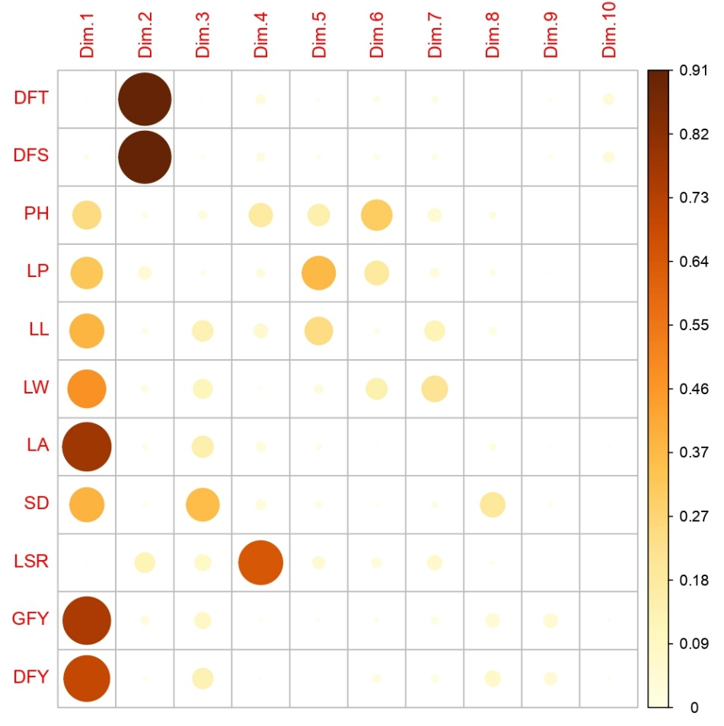
Fig. 1: Correlation plot depicting contribution of key fodder traits to principal components in a diverse maize germplasm panel during Rabi 2023

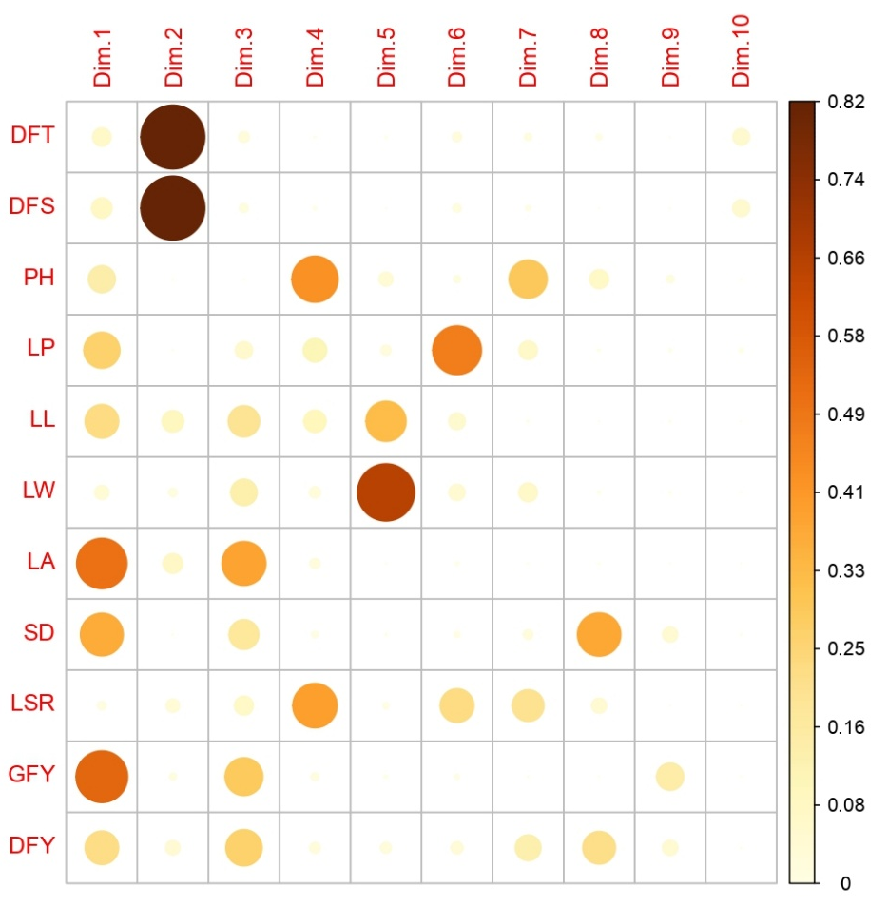
Fig. 2: Correlation plot depicting contribution of key fodder traits to principal components in a diverse maize germplasm panel during Kharif 2024

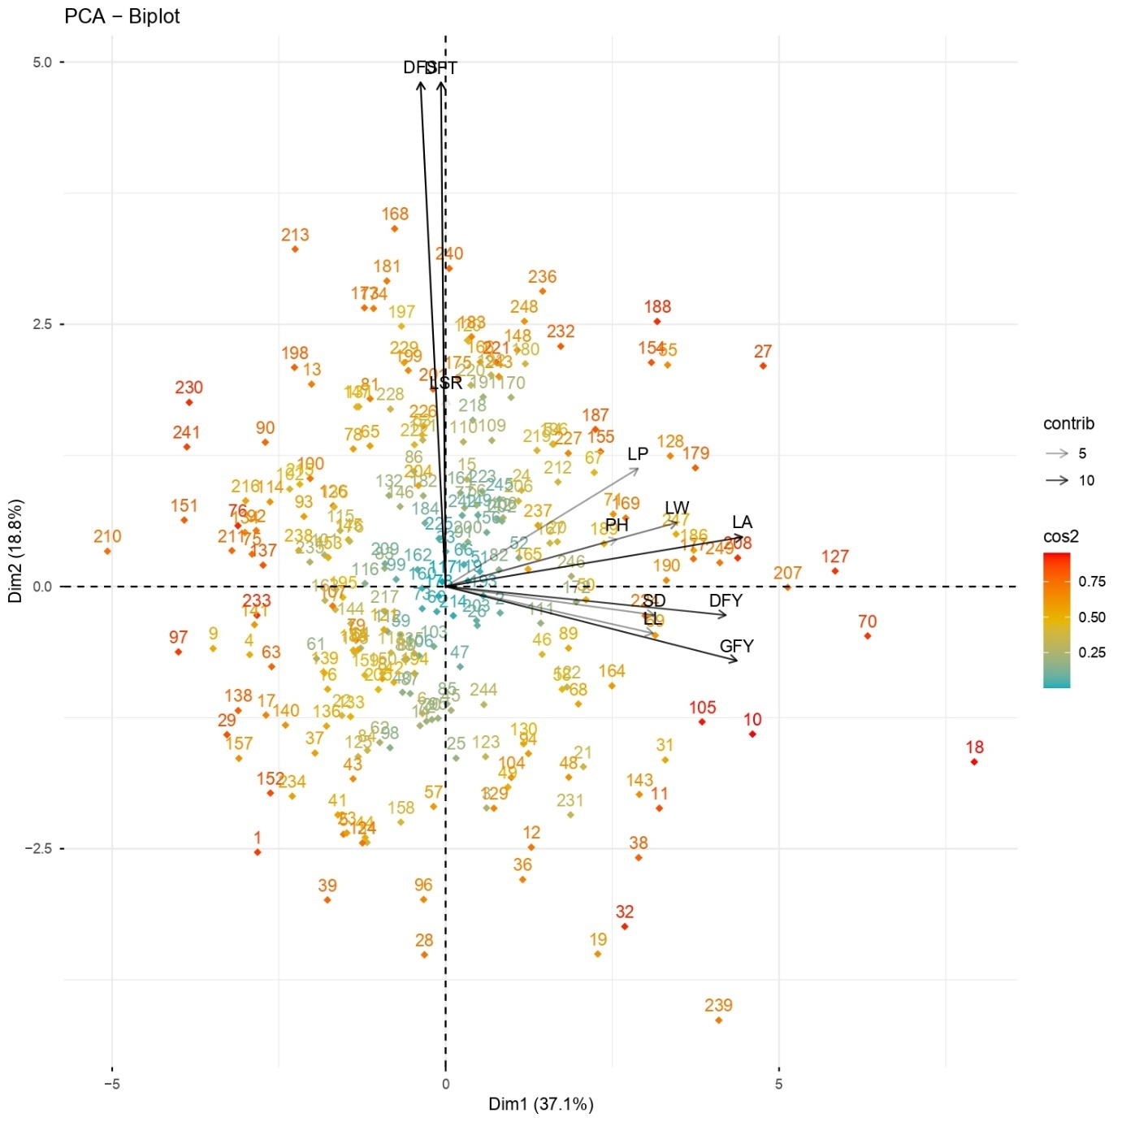

Fig. 3: PCA biplot illustrating diversity for fodder yield and related traits in maize germplasm panel during Rabi 2023

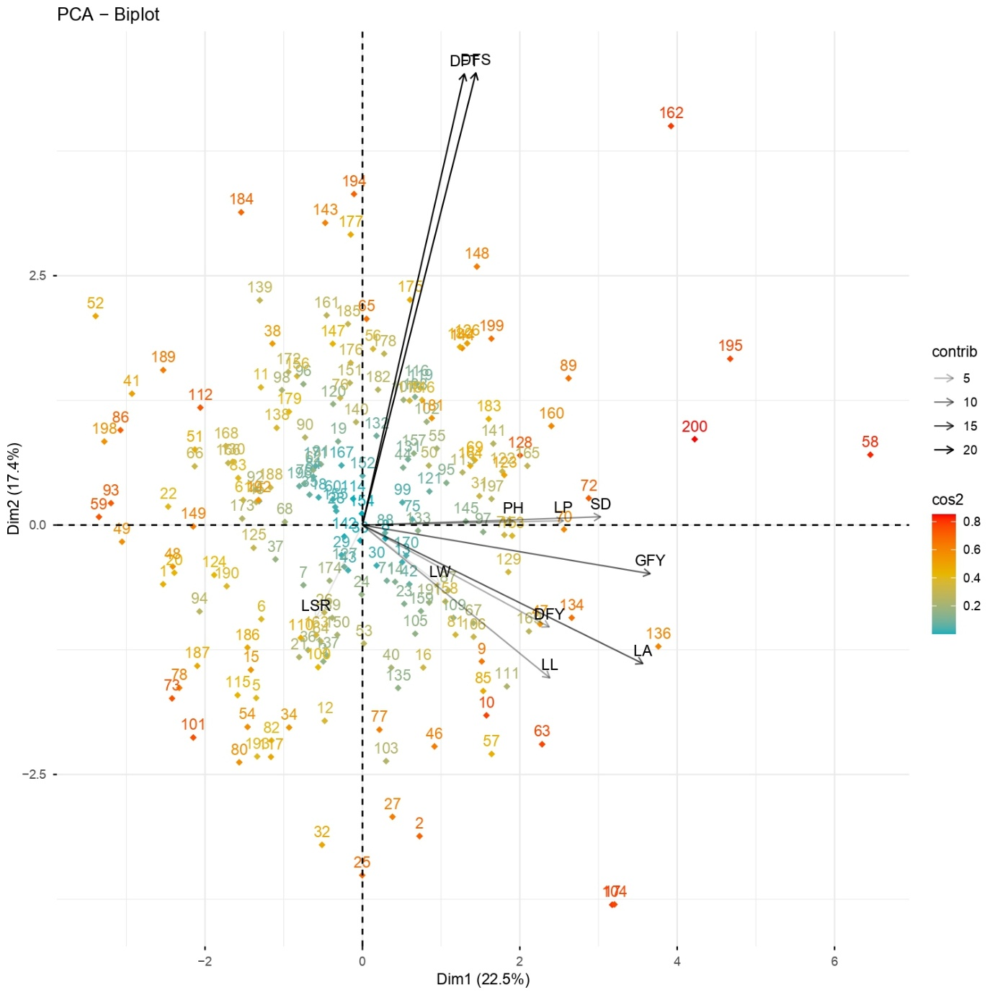
Fig. 4: PCA biplot illustrating diversity for fodder yield and related traits in maize germplasm panel during Kharif 2024

