Physicochemical and Enzymatic Profile of Fresh Kesar Mango (Mangifera indica L.) Pulp

Abstract
This study aimed to characterize the fundamental quality attributes of fresh, untreated Kesar mango pulp to support future processing and optimization studies. Fully ripened fruits were collected and analysed for physicochemical parameters (EC, TSS, viscosity, pH, moisture, titratable acidity, total acidity), nutritional components (vitamin-C, reducing sugars, carotenoids) and oxidative enzymes (PPO and POD) using standard analytical methods. The pulp exhibited high TSS (18.17 ± 0.06 °Brix), viscosity (570.33 ± 6.43 cP), moisture (90.12 ± 3.90%), and significant levels of vitamin-C (35.71 ± 1.58 mg/100 g) and carotenoids (9.62 ± 0.16 mg/100 g), confirming its strong nutritional and sensory quality. Higher values of PPO (36.40 ± 0.89 U/mL) and POD (31.20 ± 1.10 U/min/g) activities indicate susceptibility to enzymatic browning and highlight the need for effective inactivation strategies during processing. The findings establish a reliable benchmark for evaluating processing effects on Kesar mango pulp. Given the heat-sensitive nature of key nutrients, rapid and uniform techniques such as ohmic heating are recommended for preserving quality while achieving satisfactory PPO/POD reduction. Overall, this baseline dataset provides essential reference values for future process optimization, kinetic modelling, and value-addition studies involving Kesar mango.
Keywords: Kesar mango, physicochemical properties, enzymatic activity, mango pulp quality, ohmic heating.
- Introduction
Mango (Mangifera indica L.), a tropical fruit crop from the Anacardiaceae family, is one of the world's most frequently produced. According to genetic research, cultivated M. indica normally has 2n = 40 chromosomes. The fruit tree produces a drupe with an outer skin (epicarp), a juicy pulp (mesocarp), and a woody endocarp (stone) that encases the seed; the mesocarp texture (from buttery to fibrous) and biochemical composition (sugars, acids, pigments, enzymes) are important determinants of processing suitability and quality (Bally and Dillon, 2018; Vijayanand et al., 2015).
The Kesar mango, primarily cultivated in Gujarat's Saurashtra region where it is often marketed as Gir Kesar is a cultivar of significant economic and cultural importance. Renowned for its vibrant saffron-hued pulp, intense aroma, and distinct sweetness, it commands a premium position in both domestic and international markets. Recent metabolomic analyses substantiate its unique sensory profile, identifying a higher concentration of monoterpenes compared to other Indian cultivars (Tandel et al., 2023). The production of Kesar mangoes in districts like Junagadh, Gir Somnath, and Amreli significantly supports regional agro-economies and rural livelihoods, with regional branding (including a Geographical Indication tag) enhancing market value.
Mango pulp's nutritional and processing characteristics include total soluble solids (TSS), reducing sugars, organic acids (which define titratable acidity and pH), and vitamins such as vitamin C. Its color is mostly derived from carotenoids, which also have provitamin A action. Enzymes that catalyse browning and nutritional degradation, such as polyphenol oxidase (PPO) and peroxidase (POD), have a significant impact on product quality during processing. As a result, the intrinsic physicochemical and enzymatic profile of fresh pulp—including factors such as viscosity and sugar content that influence mouthfeel, pumpability, and shelf-stability; is critical for designing effective processing treatments (e.g., ohmic heating, agitation) and predicting product behaviour during storage (Sakhale et al., 2016; Vu et al., 2023).
India accounts for a significant share of global mango production; according to recent government estimates, mango production in India for 2024-25 is expected to be around 228.37 lakh metric tonnes, up from 223.98 lakh tonnes in 2023-24 (Anon, 2025 b). At the national level, India is the leading producer of mangoes and cultivates an extraordinarily diverse range of varieties. Gujarat's mango output has increased by approximately 21%, from 917.000 tonnes in 2021-22 to 1,115.000 tons in 2023-24 (Anon, 2025 a).
Despite these production strengths, the literature shows a lack of cultivar-specific, comprehensive baseline datasets that report the full range of physicochemical (EC, TSS, viscosity), nutritional (vitamin C, carotenoids, reducing sugar), and enzymatic (PPO, POD) parameters for fresh pulp of the Kesar variety of mango under control (untreated) conditions. Much of the published research focuses on agricultural production, by-product extraction (e.g., pectin from peel), or processing impacts (e.g., liquefaction), rather than thorough baseline characterisation (Sakhale et al., 2016; Davara et al., 2017). Therefore, the present study aims to quantify the baseline physicochemical, nutritional and enzymatic attributes of fresh Kesar mango pulp in a control condition; compare the measured values with available literature benchmarks for mango cultivars; and provide a reference dataset to support subsequent processing optimisation, kinetic modelling and value addition research focused on the Kesar cultivar in the Saurashtra region.

2. Materials and Methods

2.1 Sample Preparation
Fresh, fully ripened Kesar mangoes (Mangifera indica L.) were obtained from the Fruit Research Station, Lalbaug, Junagadh Agricultural University (JAU), Junagadh, Gujarat, India. The fruits were washed, manually peeled, deseeded, and pulped using a stainless-steel pulper machine as show in fig. 1. The homogenised pulp was collected in sterile, food-grade containers. All analyses were carried out within a few hours of pulp preparation to minimise any enzymatic or microbial deterioration.
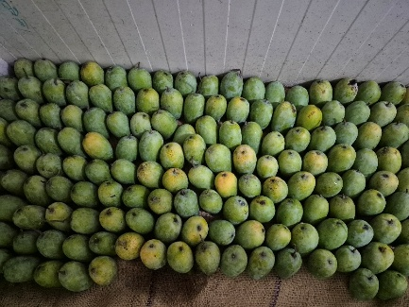  Mango | 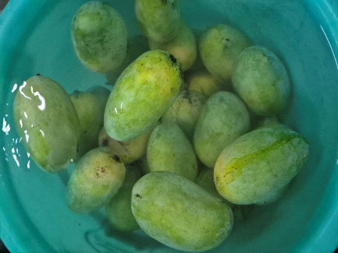  Washing | 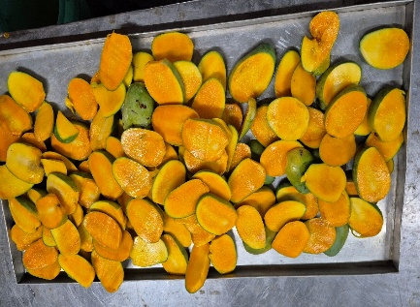  Cutting
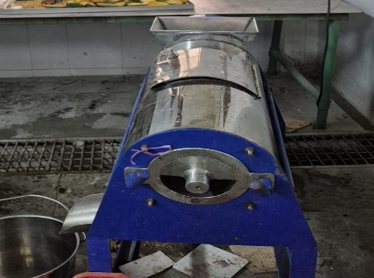  Pulper |   Pulp | 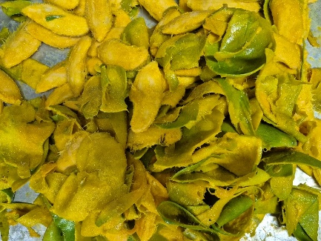  Waste
Fig. 1. Process flow for preparation of fresh Kesar mango pulp

2.2 Physicochemical and Nutritional Analyses
Electrical conductivity (EC), total soluble solids (TSS), viscosity, pH, titratable acidity (TA), total acidity, vitamin-C, reducing sugars and carotenoids were analysed following standard methods described by Ranganna (2001) and AOAC (2005). Moisture content is determined by method described by Yadav et al., (2025). Overview of biochemical tests performed on fresh Kesar mango pulp shown in fig 2.
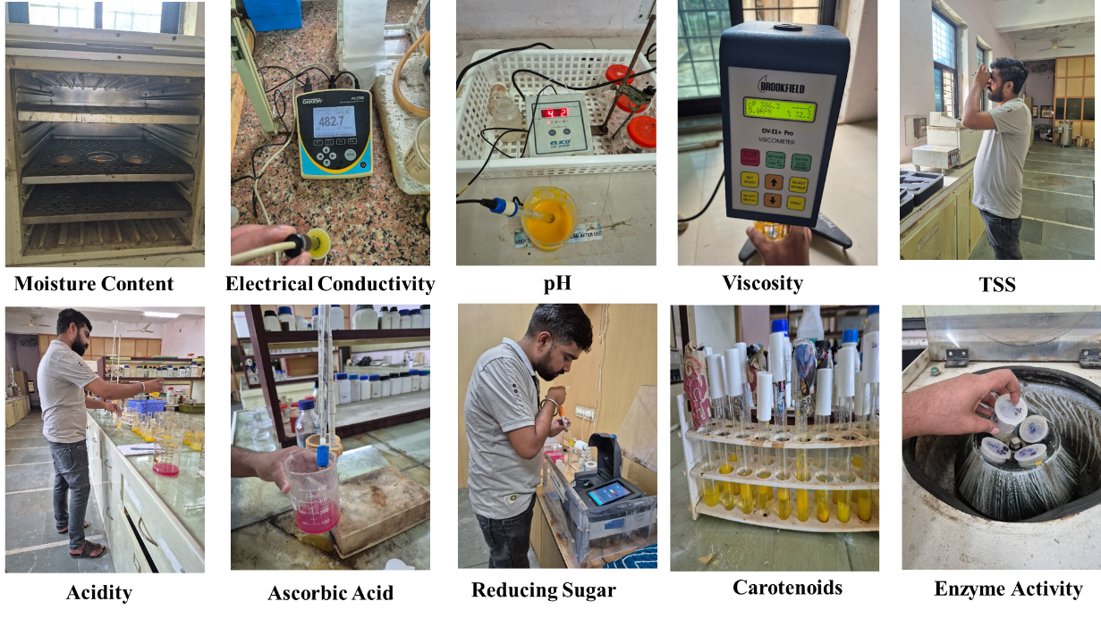
Fig. 2. Overview of biochemical test performed on fresh Kesar mango pulp

2.3 Enzyme Assays
Polyphenol oxidase (PPO) and peroxidase (POD) activities were determined spectrophotometrically using established protocols. PPO activity was measured with catechol as substrate at 420 nm following Makroo et al., (2017), while POD activity was quantified using guaiacol and hydrogen peroxide at 470 nm as described by Kumar et al., (2024).

3. Results and Discussion

3.1 Physicochemical attributes
The electrical conductivity (EC) of fresh Kesar mango pulp has been observed 298.27 ± 5.76 µS/m, reflecting the soluble ionic load typical of ripe mango pulp; similar increases in EC with fruit ripening and membrane breakdown (Tandel et al., 2023). The EC value here is consistent with observations that ionic mobility rises during ripening as cell membranes become more permeable (Barrón-García et al., 2021).
Total soluble solids (TSS) measured 18.17 ± 0.06 °Brix, indicating a high sugar content characteristic of ripe Kesar mango. This value aligns with recent measurements reported for Kesar and other premium varieties of mango where ripe pulp commonly ranges 16–22 °Brix (Tandel et al., 2023; Sakhale et al., 2016). Kesar mango is preferred due to its higher value of TSS, and it directly affects sensory sweetness and processing parameters (Sakhale et al., 2016).
The pulp viscosity (570.33 ± 6.43 cP) indicates a thick, semi-fluid rheology that favours puree and nectar applications. Comparable pulp viscosities have been reported in processing studies of some varieties of mango, where soluble pectin and cell-wall polysaccharides contribute to higher apparent viscosity (Sakhale et al., 2016; Shivaji, 2021). High viscosity also influences heat-transfer characteristics during ohmic heating and other thermal processing (Barrón-García et al., 2021; Kharadi et al., 2025).
The pH, titratable acidity and total acidity of fresh Kesar mango pulp has been observed 5.09 ± 0.09, 0.48 ± 0.01 % and 0.51 ± 0.02 % respectively. Similar results were found by Shivaji, 2021, supporting mild acidity that balances the high °Brix and contributes to flavour stability and microbial shelf life. The moisture content has been found 90.12 ± 3.90 % is typical of ripe mango pulps and comparable to values reported by Tandel et al., 2023.
The physicochemical profile (high °Brix, moderate acidity, high moisture, and elevated viscosity) confirms the high-quality sensory profile of Kesar mango pulp and supports its suitability for further processing. However, the combination of high moisture and moderate acidity points to a need for careful microbial and enzymatic control during processing and storage (Barrón-García et al., 2021).
Table 1. Physicochemical, nutritional, and enzymatic characteristics of Kesar mango pulp
Parameter | Mean ± SD | Parameter | Mean ± SD
EC (µS/m) | 298.27 ± 5.76 | PPO (U/mL) | 36.40 ± 0.89
TSS (°Brix) | 18.17 ± 0.06 | POD (U/min/g) | 31.20 ± 1.10
Viscosity (cP) | 570.33 ± 6.43 | Total Acidity (%) | 0.51 ± 0.02
Vitamin-C (mg/100 g) | 35.71 ± 1.58 | Titratable Acidity (%) | 0.48 ± 0.01
Reducing Sugar (%) | 5.78 ± 0.16 | pH | 5.09 ± 0.09
Carotenoids (mg/100 g) | 9.62 ± 0.16 | Moisture (%) | 90.12 ± 3.90

3.2 Nutritional composition
Vitamin-C content (35.71 ± 1.58 mg/100 g) is in line with recent cultivar-level analyses reporting ascorbic acid for Kesar in the ~30–45 mg/100 g range (Tandel et al., 2023; Shivaji, 2021). Because vitamin-C is heat-labile, this baseline is important for assessing nutrient losses during pasteurisation, ohmic heating, or storage (Barrón-García et al., 2021). The reducing sugar content (5.78 ± 0.16 %) shows that most of the starch in the ripe Kesar mango has already been converted into sugars. Similar results reported for ripe Alphonso and Kesar mangoes by Sakhale et al., 2016. Higher reducing sugars improve the natural sweetness of the fruit, but they may also promote browning reactions i.e. maillard reaction if exposed to high temperatures during processing.
The total carotenoid content (9.62 ± 0.16 mg/100 g) reflects the naturally deep orange colour of Kesar mango pulp. Earlier studies have shown that Kesar mango is rich in carotenoids, especially β-carotene and other provitamin-A compounds, which contribute to both its bright colour and nutritional benefits (Tandel et al., 2023). During processing, carotenoids can tolerate mild heat but are easily damaged by oxygen. Therefore, methods that reduce oxygen exposure—such as blanching in a low-oxygen environment or quick cooling—help protect both the colour and the provitamin-A value of the pulp (Zhang et al., 2025). Because Kesar mango pulp has high levels of both vitamin-C and carotenoids, it is considered nutritionally rich. The mild and quick heating methods or non-thermal and controlled thermal techniques are recommended to preserve these sensitive nutrients during processing (Barrón-García et al., 2021; Zhang et al., 2025).

3.3 Enzymatic activities
Polyphenol oxidase (PPO) activity and peroxidase (POD) activity has been observed 36.40 ± 0.89 U/mL and 31.20 ± 1.10 U/min/g respectively. This high value is typical for fresh mango and consistent with prior work showing the presence of active oxidative enzymes in pulp prior to inactivation steps (Makroo et al., 2017; Kumar et al., 2024). PPO catalyses phenolic oxidation leading to enzymatic browning, while POD contributes to oxidative stability and may be more heat-resistant than PPO in some fruit matrices (Kumar et al., 2024). Recent processing studies (e.g., ultrasound, combined thermal–nonthermal treatments) show that PPO can be reduced effectively with moderate intensity treatments, whereas POD often requires higher severity or combined processing strategies for full inactivation (Makroo et al., 2017; Zhang et al., 2025). These observations are important for designing ohmic heating and agitation assisted processing equipment’s for achieving sufficient PPO reduction will limit immediate browning, while managing POD is necessary for long term oxidative stability.

4. Conclusion
This study provides the basic physicochemical, nutritional, and enzymatic profile of fresh Kesar mango pulp. The high TSS, carotenoids, and vitamin-C levels show that the pulp is naturally rich in quality, while the higher PPO and POD values indicate that enzymatic reduction is important during processing. Based on these results, future processing methods should focus on protecting heat sensitive nutrients and reducing PPO/POD activity. Ohmic heating is a good option because its rapid and uniform heating, and has been shown to inactivate enzymes with less nutrient loss compared to traditional heating. Overall, these findings give a useful reference for setting processing conditions and developing high quality Kesar mango products.

References
Anonymous. (2025, July 21). Gujarat mangoes gain global fame: 3,000 tons exported in five years, Gir Kesar variety in high demand. Global-Agriculture.com. https://www.global-agriculture.com/news/gujarat-mango-variety-global-agriculture/
Anonymous (2025 b). Support to Mango Farmers (2025, July 22). Press Release. Ministry of Agriculture & Farmers Welfare, Government of India. (Press Information Bureau)
AOAC. (2005). Official Methods of Analysis of the Association of Official Analytical Chemists (18th ed.). AOAC International. https://www.aoac.org/
Bally, I. S. E., & Dillon, N. L. (2018). Mango (Mangifera indica L.) breeding. In Advances in Plant Breeding Strategies: Fruits: Volume 3 (pp. 811-896). Cham: Springer International Publishing. https://doi.org/10.1007/978-3-319-91944-7_20
Barrón-García, O. Y., Gaytán-Martínez, M., Ramírez-Jiménez, A. K., Luzardo-Ocampo, I., Velazquez, G., & Morales-Sánchez, E. (2021). Physicochemical characterization and polyphenol oxidase inactivation of Ataulfo mango pulp pasteurized by conventional and ohmic heating processes. LWT - Food Science and Technology. https://doi.org/10.1016/j.lwt.2021.111113
Davara, P. R., Dabhi, M. N., Rathod, P. J., & Bhatu, H. (2017). Isolation of pectin from Kesar mango peel using cation exchange resin. Advances in Food Science and Engineering, 1(1), 28-38. https://doi.org/10.22606/afse.2017.11004
Kharadi, G. S., Parmar, N. B., Gohil, G. D., & Thanki, D. S. (2025). Ohmic heating based food processing technology for enhancing product quality and process efficiency. Plant Archives, 25(Special Issue: ICTPAIRS-JAU, Junagadh), 398–404.
Kumar, R., Sharma, P., & Singh, A. (2024). Thermal and non-thermal inactivation kinetics of peroxidase in tropical fruit juices. Journal of Food Processing and Preservation https://doi.org/10.1111/jfpp.17245
Makroo, H. A., Saxena, J., & Rastogi, N. K. (2017). Ultrasound-assisted thermal inactivation of polyphenol oxidase and peroxidase in sugarcane juice. LWT – Food Science and Technology, 75, 355–360. https://doi.org/10.1016/j.lwt.2016.09.018
Ranganna, S. (1986). Handbook of Analysis and Quality Control for Fruit and Vegetable Products. Tata McGraw-Hill Publishing Company.
Sakhale, B. K., Pawar, V. N., & Gaikwad, S. S. (2016). Studies on effect of enzymatic liquefaction on quality characteristics of Kesar mango pulp. International Food Research Journal, 23(2). https://www.cabi.org/cabdirect/abstract/20163170001
Jadhav, P. S. (2021). Assessment of physico-chemical changes in mango fruit at different stages of growth and development (M.Sc. (Horticulture) thesis). Mahatma Phule Krishi Vidyapeeth, Rahuri. https://krishikosh.egranth.ac.in/handle/1/5810171845
Tandel, J., Tandel, Y., Kapadia, C., Singh, S., Gandhi, K., Datta, R., Singh, S., & Yirgu, A. (2023). Nontargeted metabolite profiling of the most prominent Indian mango (Mangifera indica L.) cultivars using different extraction methods. ACS Omega, 8(43), 40184-40205. https://doi.org/10.1021/acsomega.3c03670
Vijayanand, P., Deepu, E., & Kulkarni, S.G. (2015). Physico chemical characterization and the effect of processing on the quality characteristics of Sindura, Mallika and Totapuri mango cultivars. Journal of Food Science and Technology, 52, 1047–1053. https://doi.org/10.1007/s13197-013-1041-8
Vu, N. D., Nguyen, V. M., & Tran, T. T. (2023). Effects of pH, total soluble solids, and pectin concentration on color, texture, vitamin C, and sensory quality of mango fruit bar. International Journal of Food Science. https://doi.org/10.1155/2023/6618300
Yadav, S., Kumar, M., Kaur, P., Sidhu, G. K., & Singh, S. (2025). Comparative Analysis of Hermetically and Conventionally Stored Paddy (Basmati-1121). Journal of Biosystems Engineering. https://doi.org/10.1007/s42853-025-00283-y
Zhang, S., Li, Y., Wang, Y., & Zhang, Y. (2024). Effect of Processing on Mango Polyphenol Oxidase Structure and Activity. Journal of Agricultural and Food Chemistry https://doi.org/10.1021/acs.jafc.4c00444

