Effect of plant growth regulators on In-vitro propagation of Bambusa bambos

Abstract
The aim of this study was to rapidly multiply Bambusa bambos using plant tissue culture techniques to address the challenges associated with vegetative or seed propagation. In this experiment, plant growth regulators such as BAP (Benzylaminopurine), IBA (Indole-3-butyric acid), 2,4-D (Dichlorophenoxyacetic acid), and NAA (Naphthaleneacetic acid) were employed in the media for shoot induction, root formation and leaf callus culture. For callus induction, 3 mg/L of 2,4-D and 0.5 mg/L of NAA were used, but no callus induction was observed, with a 0% success rate. Additionally, 0.1% HgCl₂ solution was used as a disinfectant, resulting in 81.81% contamination-free cultures. For axillary bud proliferation from nodal explants, a combination of 4 mg/L BAP and 2 mg/L IBA was used, but the explant’s genus and species were unidentified. Out of 18 explants, only six showed satisfactory growth. A total of seven subculturing batches of B. bambos were cultured in shoot induction media with 4 mg/L BAP and 2 mg/L IBA. The success rates for contamination-free cultures in the different batches were as follows: Batch 01 – 80.00%, Batch 02 – 70.00%, Batch 03 – 66.66%, Batch 04 – 79.94%, Batch 05 – 60.00%, Batch 06 – 83.33%, and Batch 07 – 58.33%. These percentages reflect the success of contamination-free cultures only. For root induction, 4 mg/L IBA was used in the rooting media. Rooting was observed only in cultures where the shoots had grown to more than 5 cm. The success rates for root induction in these batches were: Batch 01 – 87.5%, Batch 02 – 66.66%, and Batch 03 – 84%.
Key words- Bambusa bambos, 2,4-Dichlorophenoxyacetic acid, Napthalene acetic acid, 6-Benzyl amino purine, Indole-3-butyric acid.

Introduction
Bamboo, botanically known as Bambusa bambos, is part of the grass family Poaceae, specifically within the subfamily Bambusoideae. It is recognized as the fastest-growing perennial, evergreen, arborescent plant (Kigomo, 1988). Bamboo includes 1,482 species spread across roughly 119 genera, which are further categorized into three tribes: Arundinarieae (temperate woody bamboos with 546 species), Bambuseae (tropical woody bamboos with 812 species), and Olyreae (herbaceous bamboos with 124 species) (BPG, 2012). Major bamboo species are found in Asia-Pacific and South America, with relatively fewer in Africa. Asia, in particular, accounts for around two-thirds of the global bamboo area (Bystriakova, 2003). Bamboo's vast species diversity enables it to thrive in a variety of environments (Goyal, 2013).
Bamboos exhibit a wide range of forms across different biogeographic regions, from dwarf herbaceous species in temperate climates to towering tropical woody species that can reach up to 20 meters (Bystriakova et al., 2004). Approximately 2.5 billion people are involved in bamboo production and consumption (Scurlock et al., 2000). In Asia, bamboo covers about 25 million hectares, with India leading at around 9 million hectares, followed by China with 6.4 million hectares. The remaining 10 million hectares are distributed among countries like Myanmar, Indonesia, Malaysia, Vietnam, Laos, Cambodia, the Philippines, Thailand, Japan, Bangladesh, South Korea, Sri Lanka, and Nepal (Ahmad, 2021). According to the Forest Survey of India (FSI), bamboo spans 8.96 million hectares, making up about 12.8% of the total forest area in the country. The total bamboo-bearing area in India is estimated at 15 million hectares, with Madhya Pradesh having the largest area at 1.84 million hectares, followed by Arunachal Pradesh (1.57 million hectares), Maharashtra (1.35 million hectares), and Odisha (1.12 million hectares) (ISFR, 2021). Compared to the ISFR 2019 estimates, the bamboo-bearing area in India has decreased by 1.06 million hectares, with Mizoram showing the greatest increase (1,085 square kilometers) and Madhya Pradesh seeing the largest decrease (2,473 square kilometers) (ISFR, 2021). Bamboo naturally grows in areas with annual rainfall between 1,200 and 4,000 mm and average temperatures ranging from 8 to 36°C (Ahmad, 2021).
Bamboo’s rapid growth and expansive root system enhance soil properties, control erosion, filter sediment, and make it suitable for rehabilitating degraded lands in a short span of time (INBAR, 2018; Gupta, 1979; Zhou, 2005; Sujatha, 2008). Soils under bamboo species tend to be strongly acidic, with pH levels ranging from 3.72 to 5.05 (Venkatesh, 2005).
Bamboo plays a critical role in human life, culture, industry and agriculture (Kigomo, 1988). The primary economic value of bamboo comes from its hardened culms, which are often used like timber (Chung & Yu, 2002; Scurlock et al., 2000). In addition to timber, bamboo's various parts have many uses, such as leaves for fodder, shoots for human consumption and culms for biomass, construction, textiles, and musical instruments (Hunter, 2003). Bamboo has earned the nickname “Green Gold” for its versatility and importance in the 21st century (Nirala, 2017). In the construction industry, it is used for scaffolding, bridges and buildings (Mera & Xu, 2014), while traditionally it serves as fuel, food, fencing, shelter and more. Today, bamboo is also utilized in the paper industry, as raw material in construction, and for producing engineered panels (Rahim, 2019). Commercially important bamboo species, such as Bambusa atulda, B. bambos, B. balcooa, B. nutans, B. vulgaris, Dendrocalamus asper, D. strictus, and Pseudoxytenanthera stocksii, have seen success in plant tissue culture (Raj, 2022).
The main challenges in traditional bamboo propagation (through vegetative or seed methods) include short seed viability, low germination rates, slow vegetative propagation, seed scarcity, and the risk of pests and diseases. Moreover, bamboo species have long flowering cycles, often spanning 30 to 120 years, making large-scale seed multiplication difficult (Thorpe, 1990). Plant tissue culture techniques were developed to optimize in vitro propagation for rapid multiplication, disease-free plant production, and conservation. This process involves growing plant tissues on controlled media, such as Murashige and Skoog medium, to encourage cell division and genetic reprogramming (Ahloowalia, 2002). Various types of explants, such as leaf, shoot and root cultures, are used in tissue culture to improve bamboo propagation.
The main objective of this study is to explore the rapid multiplication, disease-free propagation, and conservation of Bambusa bambos using plant growth regulators like BAP (Benzyl Amino Purine), IBA (Indole-3-butyric acid), 2,4-D (Dichlorophenoxyacetic acid) and NAA (Napthalene Acetic Acid). These plant growth regulators are used in shoot media, rooting media and leaf callus cultures to overcome the challenges posed by traditional bamboo multiplication methods, including seed scarcity, low germination rates, and long flowering intervals. Auxins like IBA and NAA, as well as cytokinins like BAP, play a crucial role in cell division, rooting, and shoot proliferation in tissue culture. The combination of BAP and NAA, specifically, has been extensively studied for its effects on plant growth and development (Neysa S. A., 2024).
MATERIAL AND METHOD-
Plant Material Source:
Bambusa bambos was used as the source for leaf culture, subculturing in shoot media and subculturing in root media. The plant material for leaf culturing was obtained from the shade house of the Department of Agricultural Biotechnology, College of Agriculture, CSK Himachal Pradesh Krishi Vishwavidyalaya, Palampur, India. Explants were collected from the campus of CSK Himachal Pradesh Krishi Vishwavidyalaya, Palampur, India, in 2024; however, the genus and species of the explants were unknown.
Preparation and Sterilization Process:
For leaf callus culture, young, healthy and disease-free leaves were selected, ensuring they were not infested with insects-pests. Extra care was taken to avoid damaging the leaf cells during the sterilization process. The sterilization/disinfection steps involved using 70% ethanol and 0.1% HgCl₂. Approximately 1 liter of autoclaved distilled water and other necessary tools were prepared for use within the Laminar Air Flow chamber. Before beginning work, the UV light and fan inside the chamber were switched on for a few minutes.
The leaves were first washed under running tap water 5-6 times, followed by 2-3 washes with distilled water. The leaves were then treated with a 0.2% Bavistin solution (0.2 g in 100 ml distilled water) for 20 minutes, followed by 2-3 more washes with distilled water. Next, the leaves were treated with 70% ethanol for 1 minute under the laminar airflow, and again washed with autoclaved distilled water. Afterward, they were disinfected with a 0.1% HgCl₂ solution (0.1 g HgCl₂ in 100 ml distilled water) for 2-3 minutes, followed by 5-6 washes with autoclaved distilled water. The sterilized leaves were now ready to be inoculated on Murashige and Skoog (MS) media.
For explant culture, healthy branches of the bamboo tree were selected, ensuring they were free from disease and pest damage. Only branches with diameters ranging from 0.5–1.5 cm, which were not hollow, were chosen. The branches were cut at a 45° angle, approximately 3.5 cm below the axillary bud, and 1–1.5 cm above the axillary bud at a 180° angle. Any minute hairs or rings on the nodes were carefully removed, and the explants were thoroughly cleaned.
Hormone Concentrations for Leaf Callus Culture:
The plant hormones 2,4-D and NAA were used in leaf callus culture. To prepare 1 liter of MS media, a 3 mg concentration of 2,4-D was mixed with ethanol or 1N NaOH (i.e., 3 mg of 2,4-D in 3 ml ethanol). Similarly, NAA was prepared by dissolving 0.5 mg of hormone in 0.5 ml ethanol solution (0.5 mg in 0.5 ml).
Hormone Concentrations for Shoot Culture:
For shoot induction in explants and subculturing plant material, the plant growth hormones BAP and IBA were used. To prepare 1 liter of MS media, 4 mg of BAP was mixed with 4 ml of ethanol or 1N NaOH (i.e., 4 mg of BAP in 4 ml ethanol/1N NaOH). This solution was used both for explant culturing and for subculture. Similarly, 2 mg of IBA was dissolved in 2 ml ethanol or 1N NaOH for 1 liter of MS media to be used for both explant culture and subculture.
Hormone Concentrations for Root Culture:
For root induction in subculture, IBA was used as the plant growth hormone. To prepare 1 liter of MS media, 4 mg of IBA was mixed with 4 ml of 1N NaOH (i.e., 4 mg of IBA in 4 ml 1N NaOH).
Murashige and Skoog Medium Preparation:
The Murashige and Skoog medium (MS media) provided macro elements (Stock I), microelements (Stock II), vitamins (Stock III), and iron (Stock IV). These stock solutions were vital for supplementing explants and subcultured plant material with necessary nutrients. The media was adjusted to a pH of 5.8 using a pH meter and adding either 0.1 N NaOH or HCl as required. Agar was used as the gelling agent to solidify the MS media for culturing. The media was autoclaved at 121°C for 15 minutes.
Observation and Data Recording:
Shoot development and regeneration were carefully observed, and data was recorded daily. After the initial observations, data was recorded at intervals of four days. Shoot regeneration was measured in centimeters.
RESULTS AND DISCUSSION
Effect of Plant Growth Regulators and HgCl₂ Concentration on Leaf Callus Culture
This study aimed to investigate the effect of specific concentrations of plant growth regulators (PGRs) on callus formation under in vitro conditions. For callus induction, a combination of 2,4-D (3 mg/l) and NAA (0.5 mg/l) was used. The culture was established in 22 test tubes, and observations were recorded daily for the first week. The final two observations were recorded at four-day intervals, resulting in a total of eight observations.
Despite regular monitoring, no callus formation was observed in leaf explants under the defined PGR concentrations. Instead, the explants began to exhibit browning, and a 0% callus induction rate was recorded, indicating that the selected concentrations of 2,4-D and NAA were ineffective in inducing callusing in leaf tissues under the given conditions.
Regarding surface sterilization, HgCl₂ at 0.1% concentration proved effective, with 81.81% of cultures remaining contamination-free after treatment duration of 2–3 minutes.
These findings align with the results reported by Mali (2020) in a completely randomized design with nine 2,4-D treatments ranging from 0 to 8 mg/l and three replications. According to the study, successful callus induction depends significantly on the choice of explants. The explants remained viable for only up to seven days, after which most succumbed to browning, potentially due to sensitivity to the sterilization process or suboptimal culture conditions.

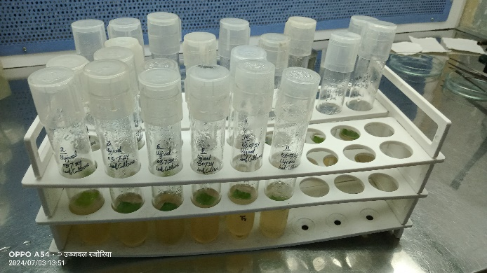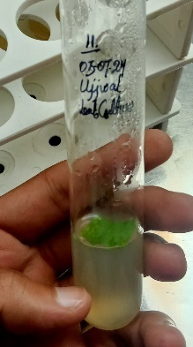
Fig. 01 Leaf Culture on Murashige and Skoogs medium on 03,July 2024.

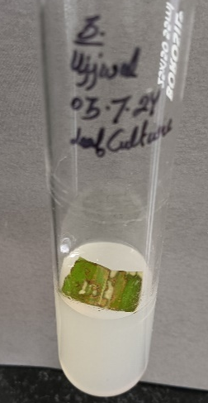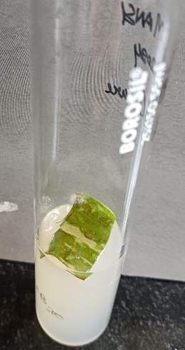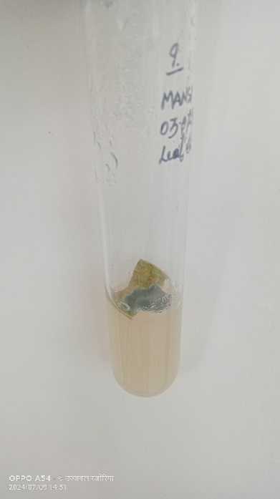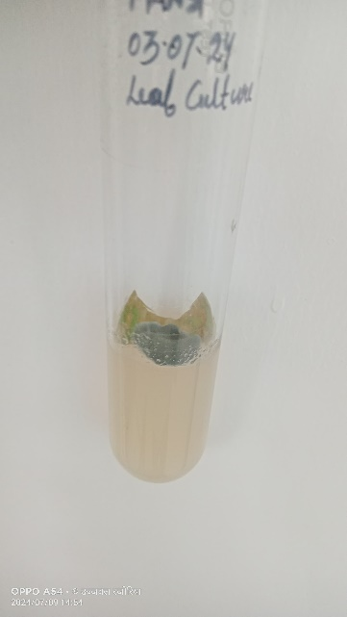
Fig. 02 Leaf stat turning into light brown to whitish color

Fig. 03 Dark green color contamination in leaf’s

Effect of Plant Growth Regulator Concentrations on Axillary Bud Proliferation in an Unknown Bamboo Species
In this study, the exact genus and species of the bamboo explants used were unidentified. Nodal explants were cultured under in vitro conditions to assess axillary bud proliferation, using 4 mg/L BAP and 2 mg/L IBA as plant growth regulators (PGRs). A total of 18 test tubes were inoculated. Observations were recorded over 12 time points—10 on consecutive days and 2 at four-day intervals.
Of the 18 cultured explants, axillary bud proliferation was observed in only 6. Nine explants were recorded dead, and three were lost to fungal contamination. Visible growth was noted beginning on the second day of culture, with initial signs such as swelling and light green coloration of axillary buds indicating active development. However, by the fifth day, four explants showed no visible change. On the sixth day, nine explants exhibited bud growth.
By the 12th day, eight of the growing explants had turned from dark green to faded light green, eventually becoming brown and dying, possibly due to tissue necrosis or stress under culture conditions. Axillary bud proliferation was sustained in only 7 explants, with an average height of 1.04 cm observed on the 12th day. By the 17th day, one additional explant had died, and contamination was observed in the culture media. The remaining six explants had an average shoot height of 1.9 cm. At the final observation on the 22nd day, these six explants reached an average height of 3.3 cm.
In summary, out of 18 explants, only six showed sustained, contamination-free growth with measurable axillary bud development. Nine explants died, and three were contaminated.
Muthukumaran et al. (2018) also reported high axillary bud proliferation responses in nodal explants of bamboo when treated with various PGR combinations. An 80% response rate was recorded with IAA (3 mg/L) and IAA + IBA (both at 3 mg/L), though the number of shoots was low. The highest response (100%) was achieved using BAP (3 mg/L), IBA (3 mg/L), and BAP + IBA (3 mg/L each), with BAP alone producing the greatest number of shoots (5 per explant), compared to 2–3 shoots in the other combinations.

Fig. 04. Average height of explants(cm)without any contamination.

Fig. 05.Iindividual height of explants (cm)

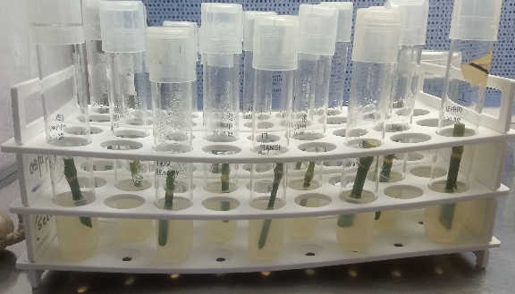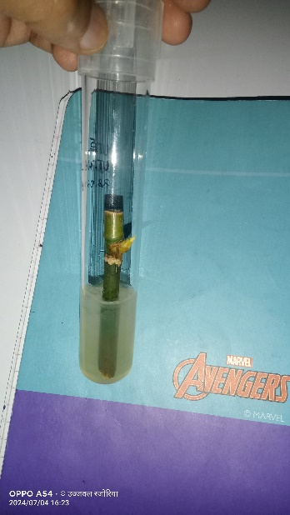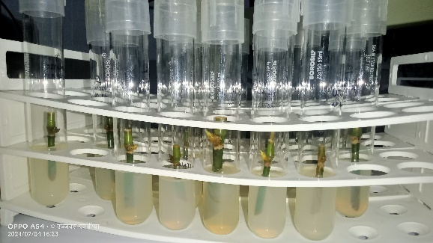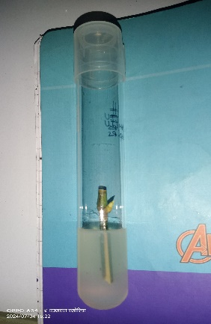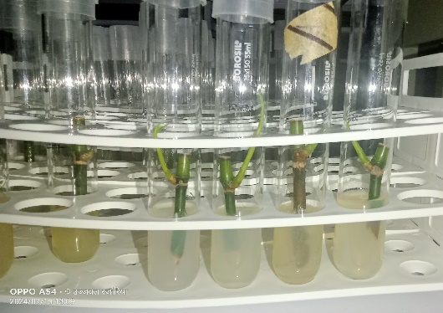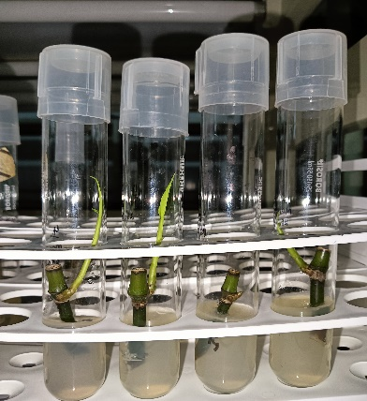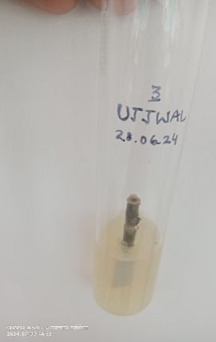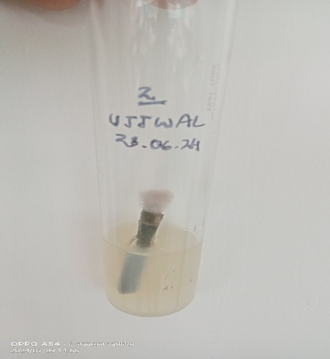
Fig. 10
Fig. 10
Fig. 09
Fig. 08
Fig. 07
Fig. 07
Fig. 07
Fig. 06
Fig. 06 Explants culture in 18 test tubes. Fig. 07 Growth observe in explants at 04,July 2024 auxiliary bud start turning into light green color.Fig. 08 Formation of shoots were observed on 15,July 2024. Fig. 09 Formation of leave was observed in one explant shoot which shoot length is 5.5 cm on dated 20,July 2024.Fig. 10 contaminated explants.

Effect of PGR concentration for shoot culture: Bambusa bambos was used for subculturing in a shoot induction medium, with a total of seven batches established. Out of these, six batches were subcultured in culture jars, while one batch was maintained in test tubes. The number of subcultures varied across batches, ranging from 5 to 19, specifically: 5, 10, 12, 19, 10, 12, and 12 in batches 1 to 7, respectively. The study was conducted using a defined concentration of plant growth regulators (PGRs) under in vitro conditions. For shoot culture subculturing, BAP at 4 mg/L and IBA at 2 mg/L were applied, and responses were recorded daily. For each batch, the final two observations were taken at four-day intervals. Shoot height measurements of the subcultured shoots were recorded on 10th July 2024, 15th July 2024, and 20th July 2024.
Batch-wise Observations on Shoot Subculturing of Bambusa bambos (Using BAP 4 mg/l and IBA 2 mg/l)
Batch 01 (14 June 2024):
A total of 5 subculture jars were prepared, of which 1 was contaminated. In the remaining 4 jars, shoot induction and growth began after the 4th day of subculturing (19 June). The average shoot height recorded was 3.1 cm on 10 July, 3.5 cm on 15 July, and 4.1 cm on 20 July. The slow growth observed was likely due to the fact that bunches of shoots were not transferred to the medium. (Fig. 12)
Batch 02 (18 June 2024):
Out of 10 subculture jars, 2 were contaminated and 1 exhibited shoot death, leaving 7 viable subcultures. Shoot induction started after the 5th day (23 June). The average shoot height recorded on 10 July, 15 July, and 20 July was 3.2 cm, 4.01 cm, and 4.4 cm, respectively. This batch involved culturing shoot bunches in the medium. (Fig. 13)
Batch 03 (19 June 2024):
A total of 12 subculture jars were used; 3 were contaminated, and 1 showed no growth response. Shoot induction began after the 5th day (25 June). The average height of the remaining 9 subcultures was 2.9 cm on 10 July, 3.4 cm on 15 July, and 3.7 cm on 20 July. (Fig. 14)
Batch 04 (20 June 2024):
Out of 19 subculture jars, 2 were contaminated, and 2 failed to show any growth. Shoot induction was observed after the 4th day (25 June). Average shoot heights of the 17 responsive cultures were 2.9 cm (10 July), 3.3 cm (15 July), and 3.6 cm (20 July). (Fig. 15)
Batch 05 (01 July 2024):
Among the 10 subculture jars, 2 were contaminated and 2 showed shoot death. Shoot induction was noted after the 6th day (08 July). The remaining 6 subcultures exhibited average shoot heights of 3.08 cm, 3.5 cm, and 4.03 cm on 10, 15, and 20 July, respectively. (Fig. 16)
Batch 06 (01 July 2024):
This batch consisted of 12 subcultures maintained in test tubes. One culture was contaminated, and one was dead. The remaining 10 cultures showed average shoot heights of 2.1 cm (10 July), 2.4 cm (15 July), and 3.1 cm (20 July). (Fig. 17)
Batch 07 (03 July 2024):
Out of 12 subculture jars, 5 were contaminated. No significant growth was observed in this batch, likely due to the selection of only 2–3 shoots per subculture, which may have been insufficient for proper induction and development.
In this shoot culture experiment, the plant growth regulators BAP (Benzylaminopurine) and IBA (Indole-3-butyric acid) were used to promote shoot growth in Bambusa bambos. Shoot height was observed and recorded across various batches (Fig. 11). The success rate for each batch was calculated based on the number of contamination-free cultures that exhibited growth. The following success rates were recorded:
- Batch 01: 80.00%
- Batch 02: 70.00%
- Batch 03: 66.66%
- Batch 04: 79.94%
- Batch 05: 60.00%
- Batch 06: 83.33%
- Batch 07: 58.33%
These percentages represent only the proportion of cultures that remained free from contamination and successfully showed growth.
The previous studies support the importance of using shoot clusters for better rooting and multiplication. Arya and Sharma (1998) reported that rooting in B. bambos was more effectively induced when clusters of 4–5 shoots were used instead of individual shoots. Similarly, Raihan (2016) attempted in vitro rooting by transferring clusters of 4–5 shoots into half-strength MS medium, both in liquid and gelled form, supplemented with various concentrations and combinations of auxins such as IBA and NAA. Furthermore, Panday (2013) found that the highest rate of shoot multiplication occurred on MS medium supplemented with 5.0 µM BAP alone or in combination with 0.1 µM GA₃

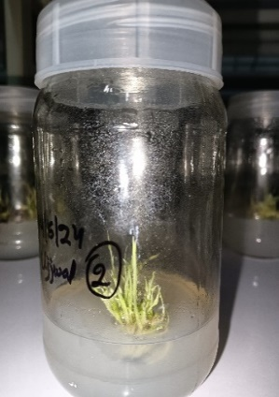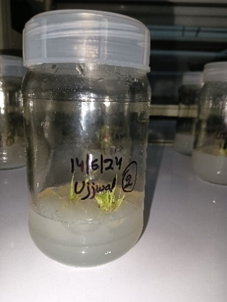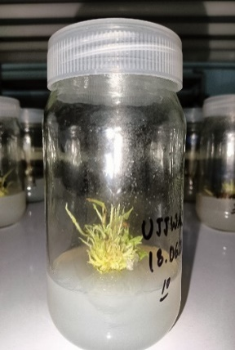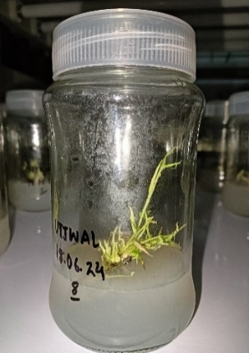
Fig. no 13
Fig. no 12
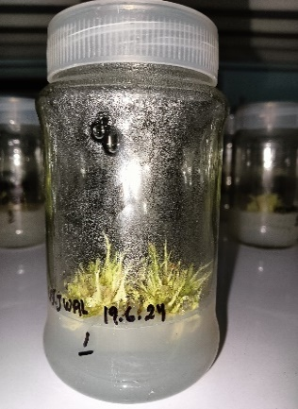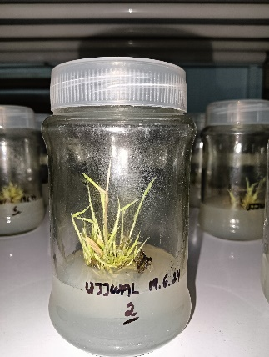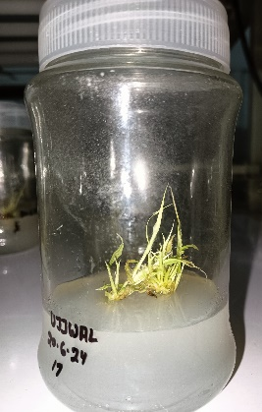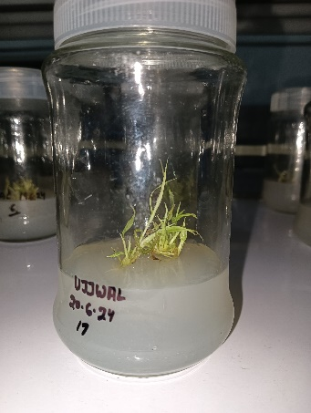
Fig. no 15
Fig. no 14
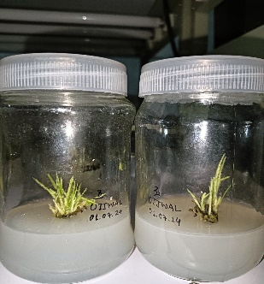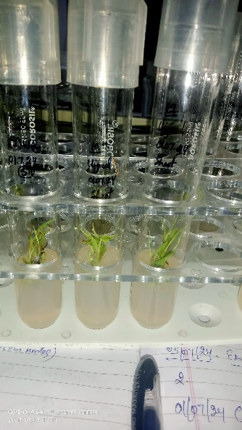
Fig. no 17
Fig. no 16
Fig.12 Slow growth of shoot bunches. Fig. 13. Culturing shoot bunches in the medium. Fig. 14 Average height of subcultures. Fig. 15 Average shoot heights of the 17 responsive cultures. Fig. 16 Remaining 6 subcultures exhibited average shoot heights. Fig. 17 Remaining 10 cultures showed average shoot heights

Effect of PGR on Subculturing in Root Medium
Subculturing of Bambusa bambos was carried out using a rooting medium supplemented with IBA at 4 mg/L. A total of three batches were cultured: two batches were subcultured in culture jars and one batch in test tubes. The number of cultures varied among batches—Batch 01 contained 8 cultures, Batch 02 had 6 cultures, and Batch 03 comprised 25 cultures.
This study was conducted using a single defined concentration of IBA (4 mg/L) to evaluate its effect on root induction under in vitro conditions. The rooting response of the cultures was observed and recorded daily throughout the experiment.
A total of three batches of Bambusa bambos cultures were subcultured in rooting medium supplemented with IBA at 4 mg/L. In Batch No. 01 (initiated on 26 June 2024), eight jars were used, out of which one culture was contaminated. Single stem segments were cultured, and initial shoot growth along with axillary bud activation was observed after 13 days of culture. Shoot height measurements were recorded on 10, 15, and 20 July, with average shoot heights for the seven uncontaminated jars being 3.9 cm, 3.9 cm, and 4.1 cm, respectively. In jars 01, 02, 03, 05, and 06, shoot height remained below 5 cm and no root induction was observed. However, root induction was recorded in jars 07 and 08 on 27 July, where the shoot height exceeded 5 cm, suggesting a correlation between adequate shoot elongation and root initiation.
In Batch No. 02 (initiated on 27 June 2024), six jars were cultured, out of which two became contaminated. Thirteen observations were recorded from the remaining four jars, with average shoot heights on 10, 15, and 20 July being 3.5 cm, 3.5 cm, and 4.4 cm, respectively. Root induction was observed only in jar 02, where the shoot height was 5.3 cm on 10 July and reached 7.5 cm by 20 July; no root development occurred in jars 03, 04, and 06 where the shoot height remained below 5 cm throughout the observation period.
In Batch No. 03 (initiated on 29 June 2024), 25 test tubes were used for subculturing. Three cultures were contaminated and one died, leaving 21 viable cultures for observation. Average shoot height on 10, 15, and 20 July was recorded as 3.1 cm, 3.6 cm, and 4.3 cm, respectively. Root induction was observed only in those test tubes where shoot height exceeded 5 cm. For instance, in test tube 20, shoot height was 5.7 cm on 10 July and 8.0 cm on 20 July, with clear root formation on 27 July. Similarly, in test tube 16, shoot height increased from 5.0 cm to 9.0 cm and rooting was well established by 27 July. In test tube 12, the shoot height was 5.5 cm on 10 July and 6.6 cm on 20 July; in test tube 06, it was 4.0 cm and 6.3 cm respectively—both showed initial root induction by 27 July.
These observations suggest that root formation occurred only in cultures with shoot heights greater than 5 cm, indicating that sufficient elongation is necessary for rooting under in vitro conditions with IBA. Across all three batches, shoot growth was always observed prior to root formation. The success percentage of uncontaminated cultures that showed shoot growth was 87.5% in Batch 01, 66.66% in Batch 02, and 84% in Batch 03. This highlights the effectiveness of IBA at 4 mg/L in supporting shoot elongation, though root induction was limited to shoots attaining sufficient height.
Previous studies reported significant rooting in B. bambos within 15–22 days when shoots were transferred to half-strength MS medium supplemented with 2.5 mg/L IBA and 2.5 mg/L NAA, achieving up to 86.67% rooting efficiency (Raihan I. R., 2016). Arya and Arya (2009) also recorded 80–85% rooting within 3–4 weeks on MS medium supplemented with 3.0 mg/L NAA or 10 mg/L IBA. In contrast, Pandey (2013) reported failure of rooting on MS medium with IAA or IBA alone at various concentrations (0.1 to 50.0 µM), although shoots rooted on NAA-supplemented media later became necrotic within 4 weeks.
According to the observations recorded from batch numbers 01, 02, and 03, root induction occurred only in those cultures where the shoot length exceeded 5 cm. Initial growth in all cultures was observed in the form of shoot elongation, and root development was evident only after the shoots attained a height of 5 to 8 cm, indicating a direct correlation between sufficient shoot growth and subsequent rooting. In this root culture experiment, only one plant growth regulator—Indole-3-butyric acid (IBA)—was used for root induction. The success percentage based on shoot growth in contamination-free cultures was 87.5% in batch 01, 66.66% in batch 02, and 84% in batch 03, representing the proportion of healthy cultures that exhibited visible shoot development. These findings support earlier studies where in vitro rooting in Bambusa bambos was successfully achieved using combinations of auxins.
Raihan I. R. (2016) reported significant rooting within 15–22 days when shoot clusters (4–5 shoots) were transferred to half-strength liquid and gelled MS media supplemented with 2.5 mg/L IBA and 2.5 mg/L NAA, resulting in 86.67% rooting efficiency. Similarly, Arya and Arya (2009) achieved 80–85% rooting within 3–4 weeks using MS medium fortified with either 3.0 mg/L NAA or 10.0 mg/L IBA. On the other hand, Pandey P. (2013) observed that shoots failed to root on MS medium containing various concentrations of IAA (0.1 to 50.0 µM) or IBA (0.1 to 50.0 µM) alone. Although shoots rooted on all tested concentrations of NAA (0.1 to 50.0 µM), the resulting roots became necrotic within four weeks, indicating limited viability under those conditions.
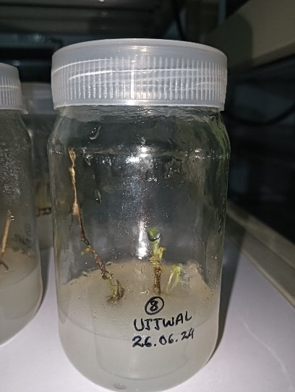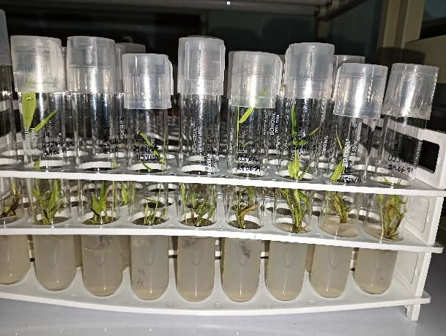
Fig. 18
Fig. 19
Fig.18 Plant explants showing early shoot development. Fig. 19 Plantlets in sterile test tubes

References-
Ahmad Z., Upadhyay A., Ding Y., Emamverdian A., Shahzad A., 2021. Bamboo: origin, habitat, distributions and global prospective. In book: Biotechnology Advances in Bamboo (pp.1-31).DOI:10.1007/978-981-16-1310-4_1
Aprilia M., Setiari N., Nurchayati Y., 2022. Callus development from potato (Solanum tuberosum) stem at various concentrations of benzylaminopurine. Biosaintifika J. of Biology and Biology Eduction, 14 (2): 219-225, DOI: 10.15294/biosaintifika.v14i2.35703
Arya, S. and Sharma, S. 1998. Micropropagation technology of Bambusabambos through shoot proliferation. Indian Forester. 124: 725-731.
Arya, I.D. and Arya, S. 2009. Propagation of bamboos through tissue culture technology and field plantation. 8th World Bamboo Congress Proceedings. 6: 132-144.
Bamboo Phylogeny Group [BPG] (2012) An updated tribal and subtribal classification of the bamboos (Poaceae: Bambusoideae). In: Gielis J, Potters G (eds) Proceedings of the 9th world bamboo congress, Antwerp, Belgium, pp 3–27
Bystriakova N, Kapos V, Lysenko I and Stapleton C., 2003. Distribution and conservation status of forest bamboo biodiversity in the Asia-Pacific region. Biodivers. Conserv. 12 (9): 1833– 1841. DOI:10.1023/A:1024139813651
Bystriakova N, Kapos V, Lysenko I. 2004. Bamboo biodiversity: Africa, Madagascar and the Americas. UNEP/Earthprint no. 19.
Chung K. F., Yu W. K., 2002. Mechanical properties of structural bamboo for bamboo scaffoldings. Engineering Structures 24:429–442.DOI:10.1016/S0141-0296(01)00110-9
Goyal A. K., Kar P., Sen A., 2013. Advancement of bamboo taxonomy in the era of molecular biology: a review.Narosa publication house, book: Biology of useful plants and microbes, Chapter 9, pp. 197-208.
Gupta, R. K. 1979, Bamboo plantations on denuded soils. India Farming. 29 (2), 3–5.
Hunter I. R. 2003. Bamboo resources, uses and trade: the future?. Journal of Bamboo and Rattan 2(4):319–326. DOI:10.1163/156915903322700368
https://www.inbar.int/bambooforlandrestoration/
India State of Forest Report (ISFR)- 2021, Bamboo resource of the country, Forest Survey of India (FSI), Chapter- 08, pp. 175-184.
Kigomo B. N. 1988. Distribution, cultivation and research status of bamboo in Eastern Africa. KEFRI Ecol Ser Monogr 1:1–19.
KasaharaH., 2015. Current aspects of auxin biosynthesis in plants. Biosci. Biotechnol. Biochem. 80, 34-42.DOI: 10.1080/09168451.2015.1086259
Low cost options for tissue culture technology in developing countries, Proceeding of a Technical Meeting organized by the Joint FAO/IAEA Division of Nuclear Techniques in Food and Agriculture and held in Vienna, pp 3
Mera F. E. T. and Xu C. 2014. Plantation management and bamboo resource economics in China.Ciencia y Tecnología 7(1), 1-12. DOI: 10.18779/cyt.v7i1.93
Muthukumaran P., Nachimuthu S., Abarna S., et al., 2018. Protocol for Induction of Multiple Shoot through Nodal Explants Culture of Bambusabambos for Biomass Production. Int. J. Life Sci. Scienti. Res.; 4(2): 1634-1638. DOI:10.21276/ijlssr.2018.4.2.2
Mali A. S., Chavan N. and Chavan N., 2020, In vitro callus induction of green bamboo. Int. J. Curr. Microbiol. App. Sci 9(10): 683-692. DOI:10.20546/ijcmas.2020.910.082
NiralaD. P., Ambasta N., and Kumari P., 2017. A review on uses of Bamboo including Ethno-Botanical importance,Int. J. Pure App. Biosci. 5(5): 515-523. DOI: http://dx.doi.org/10.18782/2320-7051.5398
Neysa S. A., 2024. Effect on addition of BAP and NAA growth regulator on Gamborg (B5) tissue culture medium to produce callus. DOI:10.5281/zenodo.12577940
Pandey P. (née Kapoor), Kapai V. Y., MuivahG. and Rao I. U., 2013. Physiological ageing during prolonged in vitro-culture of multiple shoots of Bambusabambos var. gigantea Bennet and Gaur, The Journal of Horticultural Science and Biotechnology, 88:4, 476-482. DOI: 10.1080/14620316.2013.11512994
Raihan I. R. and Roy S. K., 2016. Mass propagation of Bambusabambos (L.) Voss through in vitro culture, Jahangirnagar University J. Biol. Sci. 5(2): 15-26.
Raj N. 2022, NITI Aayog, Govt. of India: Commercial bamboo varieties and their production in different states of India, pp’s 36.
Scurlock J. M. O., Dayton D. C., Hames B., 2000. Bamboo: an overlooked biomass resource? Biomass and Bioenergy 19:229–244.DOI:10.1016/S0961-9534(00)00038-6
Sujatha, M. P., Tomas, T. P. & Sankar, S. 2008. Infuence of reed bamboo (Ochlandratravancorica) for soils of the western ghats in Kerala: A comparative study with adjacent non-reed bamboo areas. Indian. Forester. 134, 403–416.
Seghal H. and Joshi M., 2022. The journey and new breakthroughs of plant regulators in tissue culture. Advances in Plant Tissue Culture pp. 85-108. DOI:10.1016/B978-0-323-90795-8.00002-3
Thorpe TA (1990) The current status of plant tissue culture. In: Developments in crop science 19. Plant tissue culture: applications and limitations, Bhojwani SS (ed) Elsevier, Amsterdam, pp 1–33. DOI: https://doi.org/10.1016/B978-0-444-88883-9.50005-4

Venkatesh M. S., Bhatt B. P., Kailash K., Majumdar B. and Kundan S. 2005, Soil properties influenced by some important edible bamboo species in the North Eastern Himalayan region India, J. Bamboo and Ratton, Vol.4. No. 3, pp. 221-230. DOI:10.1163/156915905774309991
Rahim W.R.W.A and Idrus R. M., 2019. Importance and uses of forest product bamboo and ratoon: their value to socioeconomics of local communities, International J. of Academic Research in Business and Social Science 8(12). DOI:10.6007/IJARBSS/v8-i12/5252
Yan Y.-H., Li J.-L., Zhang X.-Q., Yang W.-Y. et al., 2014. Effect of naphthalene acetic acid on ad root development and associated physiological changes in stem cutting of Hemarthriacompressa. 9(3): 90700. DOI:10.1371/journal.pone.0090700
ZhouB. Z., Mao-Yi F., Jin-Zhong X., Xiao-sheng Y. &Zheng-caiL., 2005. Ecological functions of bamboo forest: Research and Application. J. Forestry Research. 16(2), 143–147. DOI:10.1007/BF02857909

