Original Research Article
Effects of Aqueous Extract of Newbouldia Laevis Leaves on the Pancreas of Lead Acetate-Induced Adult Wistar Rats

ABSTRACT
Lead is a heavy metal widely known for its toxic effects on various organs, including the pancreas. The search for plant-derived remedies has led to the evaluation of Newbouldia,laevis, a medicinal plant traditionally used in the management of several ailments. This study investigated the effects of aqueous extracts of Newbouldia laevis on the pancreas of lead acetate-induced adult Wistar rats. A total of five groups of rats were used. Group A served as the normal control, Group B received lead acetate only, Group C received lead acetate and Vitamin C, while Groups D and E received lead acetate with 200 mg/kg and 400 mg/kg of Newbouldia laevis extract, respectively. Histological examination was carried out using hematoxylin and eosin staining. Results showed that the control group exhibited normal pancreatic architecture with intact islets of Langerhans and pancreatic acini, while the lead acetate group showed severe degeneration and necrosis. The Vitamin C-treated group showed moderate regeneration with mild necrotic changes. Rats treated with 200 mg/kg of Newbouldia laevis showed mild regeneration with moderate necrosis, whereas those treated with 400 mg/kg showed marked improvement with active acini and distinct islets of Langerhans. In conclusion, Newbouldia laevis demonstrated a dose-dependent protective effect against lead-induced pancreatic damage.
- INTRODUCTION
Lead exposure remains a significant public health issue, especially in developing countries where environmental and industrial regulations are often poorly enforced [1,2,3]. Lead is a toxic heavy metal with no beneficial role in the body, yet it accumulates in tissues and impacts several organ systems, including the nervous, renal, reproductive, and endocrine systems [4,5]. Lead acetate is frequently used in research to model heavy-metal toxicity because it readily induces oxidative stress, disrupts cellular processes, and damages the structure of many vital organs [6,7]. The pancreas, essential for digestion and blood-glucose regulation, is particularly vulnerable. When its acinar cells or insulin-producing β-cells are damaged, insulin secretion can be impaired, resulting in metabolic imbalances and increasing the risk of diabetes [8,9].
Newbouldia laevis is an angiosperm belonging to the Bignoniaceae family. It is found in tropical West Africa [10]. It is called “Aduruku,” “Ogirisi,” and “Akoko” in the Hausa, Igbo, and Yoruba languages, respectively [11]. Different parts of the plant are used to treat inflammation, infections, ulcers, gastrointestinal issues, and respiratory conditions [12]. Phytochemical studies reveal that its leaves are rich in flavonoids, tannins, saponins, alkaloids, and phenolic compounds, many of which have potent antioxidant, anti-inflammatory, and cell-protective properties [13].
Several studies have demonstrated the protective role of medicinal plants against the adverse effects of toxic metals on humans and animals. Innih and Eluehike, [14] demonstrate that aqueous leaf extract of Newbouldia laevis (p. beaur) has an ameliorative effect on mercury chloride-induced liver damage in Wistar rats. Olugbenga et al., [15] show that Newbouldia laevis extract has the capacity to protect Wistar rats against mercury chloride-induced hepatotoxicity.
Despite its widespread traditional use, scientific evidence on how Newbouldia laevis affects the pancreas during lead toxicity remains limited. Understanding whether its aqueous leaf extract can safeguard or preserve pancreatic tissue is vital for validating its traditional applications and exploring its therapeutic potential. This study, therefore, investigates the histological effects of aqueous extracts of Newbouldia laevis leaves on the pancreas of adult Wistar rats exposed to lead acetate.
2. MATERIALS AND METHODS
2.1 Collection and Identification of Plant Material
Fresh leaves of Newbouldia laevis were collected from Okigwe, Imo State, Nigeria. The leaves were identified and authenticated with a herbarium voucher number in the Department of Plant Biology at Abia State University. The collection was in the early hours of the day to minimize moisture loss and preserve phytoconstituents. Sufficient quantities of leaves were harvested to ensure a continuous supply of extract for the duration of the experiment period.
2.2 Preparation of Plant Extract
The collected samples were thoroughly washed with clean tap water by rinsing with distilled water to eliminate dirt, dust, and microbial contaminants. They were spread out in a single layer and air-dried at room temperature (20-28°C) under a shade for 14 days until completely dry and crispy to the touch. This prevented direct exposure to the sunlight, which could degrade sensitive phytochemicals. The dried leaves were pulverized into a fine powder using a clean dry electric blender for 48 hours, after which they were filtered using cheesecloth.
The obtained extracts were then concentrated in vacuo using a rotary evaporator. The crude extracts were reconstituted to obtain a stock solution using distilled water as solvent. Each reconstituted crude extract was stored in small-capped plastic containers in a refrigerator at 4°C until used.
2.3 Experimental Animals
Twenty-five healthy adult Wistar rats (150–200 g) were procured from the animal House, Department of Anatomy, Abia State University, Uturu, Nigeria (12-hour light/dark cycle, free access to food and water). The animals were acclimatized for 14 days, during which lead acetate was administered every 48 hours as the toxicant, and treatment (either Newbouldia laevis or ascorbic acid) were given every 24 hours.

2.4 Experimental Design
The experiment consisted of three phases:
Stage 1: Four rats were used, each receiving doses of 100mg/kg and 800 mg/kg of the extract.
Stage 2: Two rats received 500 mg/kg and 200 mg/kg doses respectively.
Stage 3: Two rats received 3000 mg/kg and 5000 mg/kg doses respectively.
All administrations were done orally, and the animals were monitored for signs of toxicity over 7-day period. The number were recorded and used to calculate the LD₅₀ value using Lorke’s formula.
The twenty-five (25) adult Wistar rats were divided into two main sets: Ten (10) for acute toxicity determination, and Fifteen (15) for the main experimental study.
Rats were individually marked with colors for easy identification and grouped as follows:
Group A: served as the normal control
Group B: was induced with Lead acetate.
Group C: was induced with Lead acetate + ascorbic acid.
Group D: rats induced with Lead acetate + 200 mg/kg Newbouldia laevis extract
Group E: rats induced with Lead acetate + 400 mg/kg Newbouldia laevis extract
2.5 Tissue Collection and Histological Processing
On the 28th day of administration, rats were euthanized with chloroform, and the pancreas was extracted and fixed in 10% buffered formalin for 72 hours before being processed using the hematoxylin and eosin staining technique described by Drury and Wallington (1980). Processed tissue slides were evaluated using a Leica DM750 research microscope equipped with a digital camera (Leica ICC50). Tissue sections were digitally photographed at 200x and 400x magnification.

2.6 Data analysis
Data were subjected to statistical analysis using the SPSS Statistics software (Statistical Package for Social Science) (Version 25), and relevant statistical values were obtained. Final and initial weights of each group were compared using an independent Sample T-test. One-way analysis of variance (ANOVA) was carried out, and values were presented as mean ± SEM. The LSD post-hoc test was used. Values of P
3. RESULTS AND DISCUSSIONS
Table 1: Effects of aqueous extract of Newbouldia laevis leaves on the pancreas of lead acetate-induced adult Wistar rats
 | Initial weight | Final weight
Negative control | 72.2±7.23a | 102.27±11.2b
Positive control | 75.63±12.85 | 112.47±17.27b
Treated with Vitamin C | 82.07±8.50a | 108.90±13.52b
Treated with 200mg/kg of Newbouldia laevis leaves extract | 83.97±18.36 | 112.93±14.10b
Treated with 400mg/kg of Newbouldia laevis leaves extract | 70.30±2.2a | 102.80±6.59b
Values in the same row bearing the same letter of alphabet are not significantly different from each other (p>0.05).

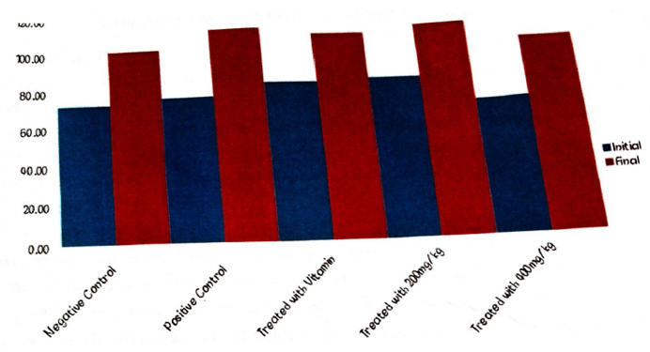
Fig 1: Comparative Histogram showing statistical distribution of initial and final body weight of the rats.
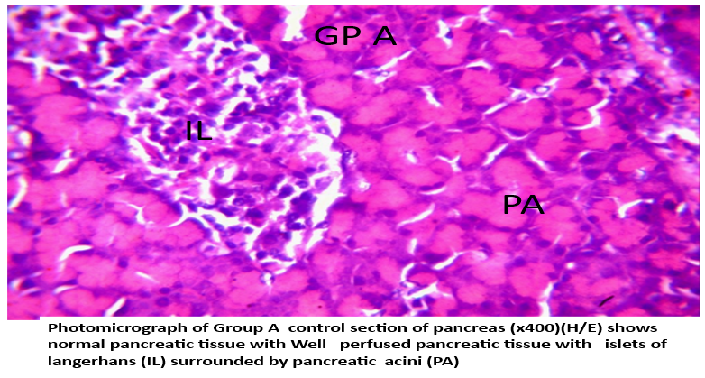 | 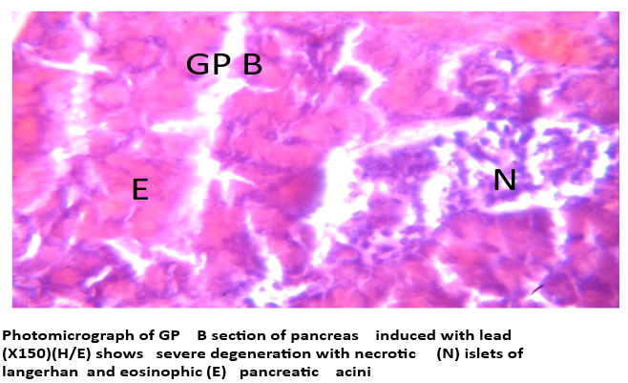
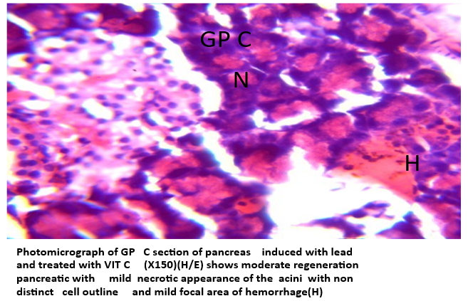 | 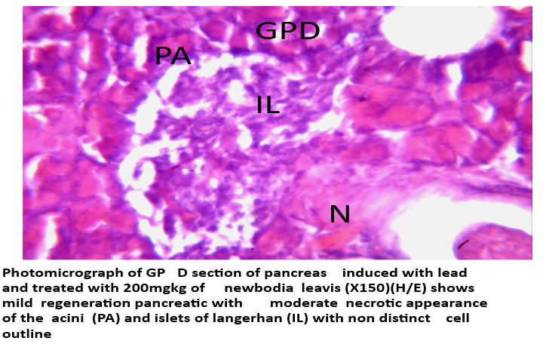
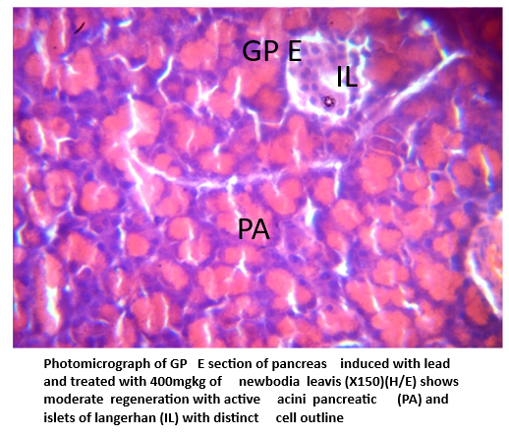

Fig 2: Histopathological images

The histological results obtained in this study provide strong evidence for the toxic effects of Iead acetate on pancreatic tissue, as well as the protective role of Newbouldia laevis leaf extract in reducing this damage. By comparing the control, lead-exposed, vitamin C-treated, and extract-treated groups, it becomes clear that Newbouldia laevis has a promising therapeutic potential that appears to increase with dose.
The control group (Group A) showed normal histoarchitecture, with well-organised pancreatic acini and intact islets of Langerhans. This normal appearance serves as the baseline for comparison and confirms that the method of housing and feeding did not negatively affect the pancreas. It further establishes that any alterations seen in the other groups were specifically due to lead acetate administration and not external factors.
The group exposed to lead acetate alone (Group B) showed severe histological disruption. The islets of Langerhans were necrotic, and the pancreatic acini displayed eosinophilic and degenerative changes. These findings confirm the destructive potential of lead on cellular structures, which is consistent with its known mechanism of action. Lead exposure has been shown in previous studies to increase the generation of reactive oxygen species (ROS), leading to oxidative stress, lipid peroxidation, mitochondrial dysfunction, and ultimately necrosis of sensitive tissues such as the pancreas [16]. The pancreas is particularly vulnerable because of its dual endocrine and exocrine roles, which require a high level of metabolic activity. The severe tissue breakdown observed in this group emphasizes the importance of developing protective strategies against lead toxicity.
In the vitamin C group (Group C), the histological features indicated moderate regeneration compared to the lead-only group. The acini and islets were better preserved, although areas of necrosis and haemorrhage were still visible. Vitamin C is widely recognized as a potent antioxidant that neutralizes ROS, protects membranes from peroxidation, and enhances tissue repair [17]. The partial recovery seen here supports these properties, yet the persistence of cellular damage suggests that while vitamin C offers protection, it may not be strong enough as a single therapy against severe lead-induced toxicity. This highlights the need for alternative or complementary agents with broader phytochemical activity.
The results from the Newbouldia laevis-treated groups provide such an alternative. At the lower dose of 200 mg/kg (Group D), the pancreas exhibited mild regeneration, but moderate necrosis was still evident in both the acini and the islets. Cell outlines remained indistinct, showing that the extract did not completely restore the tissue at this concentration. This indicates that while Newbouldia laevis does contain active compounds with antioxidant and anti-inflammatory properties, the dose was not sufficient to counteract the full toxic burden of lead. This finding also demonstrates that the effect of the extract is dose-dependent.
At the higher dose of 400 mg/kg (Group E), the improvement was far more significant. The photomicrographs showed clear regeneration with well-preserved pancreatic acini and islets of Langerhans. The cell outlines were distinct, and the general morphology closely resembled that of the control group. This suggests that at sufficient concentration, the phytochemicals in Newbouldia laevis are capable of effectively reversing oxidative damage, supporting cellular repair, and maintaining pancreatic architecture.
The difference between the 200 mg/kg and 400 mg/kg groups highlights the importance of dosage in herbal medicine. Comparing Newbouldia laevis with vitamin C, it is notable that the higher extract dose produced superior regeneration compared to vitamin C. This suggests that the plant may contain a combination of compounds that work synergistically, offering both antioxidant and anti-inflammatory effects beyond those provided by vitamin C alone. In addition, the improvement of islet morphology in the extract-treated groups is particularly important, as it indicates protection of pancreatic endocrine function, which plays a critical role in glucose metabolism and insulin regulation [18]. Protecting this aspect of the pancreas is vital, as lead-induced pancreatic damage has been linked to impaired insulin secretion and possible glucose intolerance.

These findings are consistent with earlier reports that Newbouldia laevis possesses strong medicinal properties, including antioxidant, antimicrobial, and anti-inflammatory activity [19,20, 21]. The histological evidence from this study supports these claims and suggests that the plant could be developed further as a natural protective agent against heavy metal toxicity.
In summary, the discussion reveals a clear pattern: lead acetate caused severe degeneration of pancreatic tissue; vitamin C ofered partial protection; Newbouldia laevis leaf extract produced a dose-dependent protective effect, with the higher dose (400 mg/kg) showing marked regeneration of pancreatic architecture. This strongly supports the therapeutic potential of Newbouldia laevis and provides a scientific basis for its further exploration as a phytomedicinal agent.

CONCLUSION
Lead acetate caused significant pancreatic damage, while vitamin C offered partial protection. In contrast, Newbouldia laevis leaf extract, particularly at 400 mg/kg, produced marked pancreatic regeneration and preserved islet structure, indicating strong protective and restorative potential against lead-induced pancreatic toxicity..
CONFLICT OF INTEREST
The authors declare no conflict of interest
REFERENCES
- Olufemi, A. C., Mji, A., & Mukhola, M. S. (2022). Potential Health Risks of Lead Exposure from Early Life through Later Life: Implications for Public Health Education. International Journal of Environmental Research and Public Health, 19(23), 16006. https://doi.org/10.3390/ijerph192316006
- Obeng-Gyasi, E. (2019). Sources of lead exposure in various countries. Reviews on Environmental Health, 34(1), 25-34. https://doi.org/10.1515/reveh-2018-0037
- World Health Organization. (2023). Exposure to lead: a major public health concern. Preventing disease through healthy environments. World Health Organization. https://www.who.int/publications/i/item/9789240078130
- Collin, M. S., Venkatraman, S. K., Vijayakumar, N., Kanimozhi, V., Arbaaz, S. M., Stacey, R. G. S., Anusha, J., Choudhary, R., Lvov, V., Tovar, G. I., Senatov, F., Koppala, S., & Swamiappan, S. (2022). Bioaccumulation of lead (Pb) and its effects on human: A review. Journal of Hazardous Materials Advances. https://doi.org/10.1016/j.hazadv.2022.100094
- Liu, D., Shi, Q., Liu, C., Sun, Q., & Zeng, X. (2023). Effects of Endocrine-Disrupting Heavy Metals on Human Health. Toxics, 11(4), 322. https://doi.org/10.3390/toxics11040322
- Ebrahimi, R., Ebrahimi, M., & Shakeri, M. (2023). Mitigating the adverse effects of lead and cadmium heavy metals-induced oxidative stress by phytogenic compounds in poultry. *Poultry*, *2*(2), 235-251. https://doi.org/10.3390/poultry2020017
- Assi, M. A., Hezmee, M. N. M., Haron, A. W., Sabri, M. Y. M., & Rajion, M. A. (2016). The detrimental effects of lead on human and animal health. Veterinary World, 9(6), 660–671. https://doi.org/10.14202/vetworld.2016.660-671
- Al-Suhaimi, E. A., Aljfary, M. A., & Khan, F. A. (2022). Endocrine pancreas and glucose metabolism. In E. A. Al-Suhaimi (Ed.), Emerging concepts in endocrine structure and functions (pp. 247-285). Springer Nature Singapore. https://doi.org/10.1007/978-981-16-9016-7_8
- Lenzen, S. (2021). The pancreatic beta cell: an intricate relation between anatomical structure, the signalling mechanism of glucose-induced insulin secretion, the low antioxidative defence, the high vulnerability and sensitivity to diabetic stress. ChemTexts, 7(2), 13. https://doi.org/10.1007/s40828-021-00140-3
- Okagu, I. U., Ndefo, J. C., & Agbo, M. O. (2021). Trado-Medical Uses, Chemical Constituents and Biological Activities of Newbouldia laevis (Bignoniaceae): A Review. Pharmaceutical Sciences, 28(1), 51-75. https://doi.org/10.34172/PS.2021.29
- Enenebeaku, C. K., Umerie, S. C., Nwankwo, M. U., & Enenebeaku, U. E. (2018). Anti-Snake venom Activities of the leaf extracts of Asystasia gangetica (L) and Newbouldia leavis (p. Beauv). World News of Natural Sciences, (16), 33-41. https://www.worldnewsnaturalsciences.com/volume-16-2018/
- Dailah, H. G. (2022). The ethnomedicinal evidences pertaining to traditional medicinal herbs used in the treatment of respiratory illnesses and disorders in Saudi Arabia: A review. Saudi Journal of Biological Sciences. https://doi.org/10.1016/j.sjbs.2022.103386
- Cock, I. E. (2015). The medicinal properties and phytochemistry of plants of the genus Terminalia (Combretaceae). Inflammopharmacology, 23(5), 203-229. https://doi.org/10.1007/s10787-015-0246-z
- Innih, S. O., & Eluehike, N. (2024). Effects of Newbouldia laevis (P. Beauv) Aqueous Leaf Extract on Liver Function and Histology in Mercury Chloride-Induced Wistar Rats. *Bulletins of Natural and Applied Sciences*, *1*(1), 153-161. https://www.bnas.com.ng/
- Olugbenga, M. A., Calmday-Ombo, D., & Innih, S. O. (2025). Effects of ethanol extract of Newbouldia laevis leaves on liver morphological changes in mercury chloride exposed Wistar rats. Scientia Africana, 24(1), 329-338. https://doi.org/10.4314/sa.v24i1.27
- Flora, G., Gupta, D., & Tiwari, A. (2012). Toxicity of lead: A review with recent updates. Interdisciplinary Toxicology, 5(2), 47-58. https://doi.org/10.2478/v10102-012-0009-2
- Ukaegbu, K., Allen, E., & Svoboda, K. K. H. (2025). Reactive Oxygen Species and Antioxidants in Wound Healing: Mechanisms and Therapeutic Potential. International Wound Journal, 22(5), e70330. https://doi.org/10.1111/iwj.70330
- Yin, J., Huang, Y., Wang, K., Zhong, Q., Liu, Y., Ji, Z., Liao, Y., Ma, Z., Bei, W., & Wang, W. (2024). Ginseng extract improves pancreatic islet injury and promotes β-cell regeneration in T2DM mice. Frontiers in Pharmacology. https://doi.org/10.3389/fphar.2024.1407200
- Rashed, K. (2021). Phytochemical and biological effects of Newbouldia laevis: A review. Plantae Scientia, 4(5), 208-213. https://doi.org/10.32439/ps.v4i5.208-213
- Bello, A. B., Suleiman, A., & Idris, A. D. (2023). Phytochemistry and Antibacterial Assessment of Ethyl acetate Leaf Extract of Newbouldia laevis. UMYU Journal of Microbiology Research, 8(1), 39-45. https://doi.org/10.47430/ujmr.2381.004
- Ugwuoji, E. T., Okoye, E. L., Ezeokoli, C. M., & Okoye, P. A. (2022). Comparative analysis of the antibacterial activities of leaf extracts of Bryophyllum pinnatum and Newbouldia laevis on clinical isolates from wound infection. Asian Journal of Plant and Soil Sciences, 7(1), 23-32. https://doi.org/10.56557/ajopss/2022/v7i187

