Original Research Article

Estimation of Hydrogeological Parameters and the Impact of Climate Variability on Groundwater Availability: Case of M’Bahiakro City (Central-East Côte d’Ivoire)

.
ABSTRACT

In the context of increasing climate variability in West Africa, this study evaluates the dynamics of groundwater in M’Bahiakro in relation to climatic conditions and aquifer characteristics. The data used include daily rainfall in M’Bahiakro (1971–2016), monthly temperature (1964–2015), and potential evapotranspiration (1971–1998) from the Bouaké station. The methodology combines the analysis of Nicholson indices, after removing the seasonal component using a low-pass Hanning filter, with hydrodynamic measurements of hydraulic conductivity, effective porosity, and groundwater flow velocities in four representative districts. The results show that Nicholson indices identify three climatic phases: 1944–1972 wet, 1973–1996 normal, and 1997–2016 dry, directly influencing aquifer recharge. The aquifers exhibit significant hydrodynamic heterogeneity: hydraulic conductivity ranges from 7.1 × 10⁻⁵ to 1.5 × 10⁻⁴ m/s, with permeable zones in N’guattakro and Koko and less permeable zones in Dougouba and Baoulekro. Effective porosity, ranging from 20 % to 40 %, promotes water storage and infiltration in sandy areas while limiting water movement in clay-rich sectors.The hydrological balance for 1971–1998 indicates that 34.85 % of rainfall contributes to groundwater recharge, while 62.07 % is lost through evapotranspiration and surface runoff remains low. Groundwater flow velocities, on the order of 10⁻⁵ m/s, reflect a slow circulation dynamic, which further decreases from 2012 onward due to declining precipitation and rising temperatures, reducing recharge and groundwater availability. These results highlight that groundwater availability depends on both the lithological characteristics of aquifers and climate variability, emphasizing the need for integrated and sustainable management of water resources in M’Bahiakro.

1. INTRODUCTION

Groundwater resources play a fundamental role in the socio-economic development of tropical regions, particularly in West Africa, where they often constitute the primary source of drinking water and irrigation (Jackson et al., 2001; Tirogo et al., 2023; Magaji et al., 2024). In Côte d’Ivoire, phreatic aquifers represent a crucial source of water for domestic, agricultural, and industrial uses. However, these resources are increasingly under pressure due to climate variability, population growth, and intensified agricultural activities (Foussou et al., 2022).
Climate variability, characterized by interannual and seasonal fluctuations in rainfall and temperature, directly affects groundwater recharge and, consequently, the availability of groundwater resources (Kotchon et al., 2019). In West Africa, several studies have highlighted a declining trend in precipitation since the 1970s, leading to reduced water table levels and alterations in aquifer hydrodynamic parameters (Kouakou et al., 2014; Tefera et al., 2025). The city of M’Bahiakro, located in the central-eastern part of Côte d’Ivoire, falls within the Sudanian-Guinean climatic zone, characterized by alternating dry and wet seasons. The region hosts the country’s first hydro-agricultural dam, covering approximately 450 hectares dedicated to irrigated rice cultivation, aimed at reducing food insecurity by increasing rice production (Kouassi et al., 2013; Bai et al., 2019). The implementation of this project has fostered rapid population growth, with a predominantly low-income population relying almost entirely on groundwater for drinking water, thereby increasing pressure on the phreatic aquifer and raising the risk of overexploitation (Kouamé et al., 2018). In M’Bahiakro, previous studies (Kouamé et al., 2012; 2018; N’cho et al., 2020; 2024) have mainly focused on the quantitative and qualitative evolution of the phreatic aquifer, without integrating an assessment of hydrodynamic parameters or the aquifer’s water availability. Hydrodynamic parameters, such as transmissivity, hydraulic conductivity, porosity, and storage coefficient, govern the behavior of aquifers and their capacity to sustainably supply water (Bear, 1979; Todd & Mays, 2005). Furthermore, water balance analysis allows for the assessment of effective groundwater availability and the aquifer’s response to climatic variations and anthropogenic withdrawals. Therefore, this study aims to support sustainable water resource management by improving the understanding of interactions between climate, human activities, hydrodynamic parameters, and groundwater availability in M’Bahiakro.
2. material and methods
2.1 Material
2.1.1 Study Area
The M’Bahiakro Department is located in the central-eastern part of Côte d’Ivoire, approximately 400 km from Abidjan. It belongs to the Iffou region within the Lacs District and covers an area of 5,538 km² (N’cho et al., 2020). It is bordered to the north by Dabakala, to the south by Prikro and Daoukro, to the east by Bocanda, and to the west by Bouaké. The town of M’Bahiakro, the departmental capital, is situated between longitudes 4°19’35’’ and 4°20’53’’ West and latitudes 7°26’30’’ and 7°28’12’’ North. It comprises four neighborhoods: Baoulekro, N’guattakro, Koko, and Dougouba (Figure 1). The relief consists of gently undulating plateaus with an average elevation of 300 meters, interspersed with shallow valleys that facilitate water flow. The hydrographic network is dominated by the N’Zi River, a tributary of the Bandama, which crosses the region and contributes to the recharge of phreatic aquifers. The climate is of the sub-equatorial type, with two rainy seasons and two dry seasons. Annual rainfall ranges between 1,100 and 1,500 mm, and the mean temperature is 27°C. The soils, primarily ferrallitic, are suitable for agriculture but prone to erosion. Vegetation consists of wooded savannas and open forests, which are declining due to human activities.

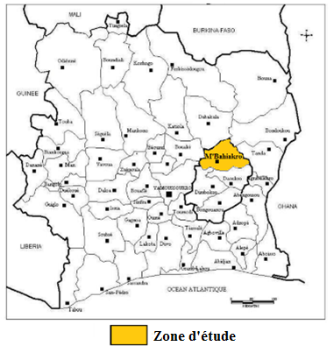

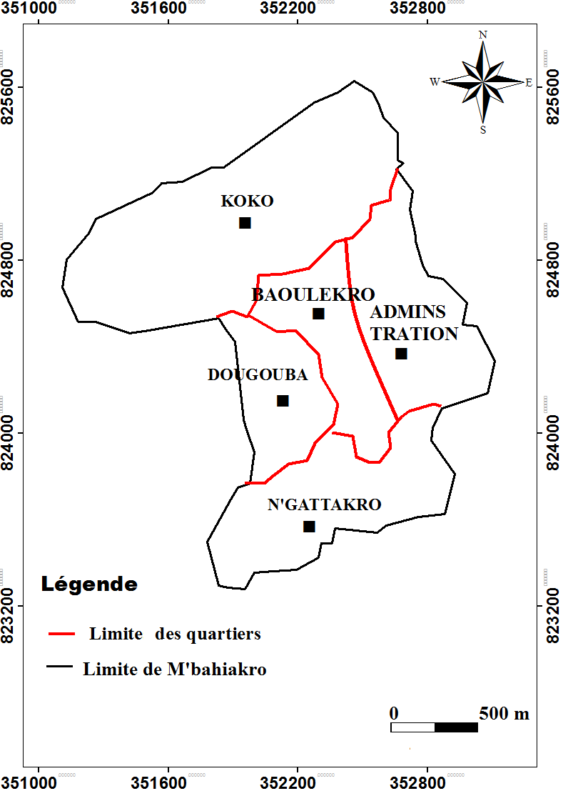
Study area

Neighborhood boundaries
Legend
Boundary of M’Bahiakro

Figure 1: Presentation of the Study Area

2.1.2 Data
The data collected for this study concern daily rainfall from 1971 to 2016 at the M’Bahiakro station, as well as monthly temperature (1964–2015) and evapotranspiration (1971–1998) data from the Bouaké station. The climatological data were provided by the Directorate of the Société de Développement et d’Exploitation Aéroportuaire, Aéronautique et Météorologique (SODEXAM).

2.2 Methods
2.2.1 Determination of Rainfall Trends
The analysis of the evolution of climatic variables was carried out using various methods, notably the Nicholson index and the second-order Hanning low-pass filter method. These approaches make it possible to highlight, at the spatio-temporal scale, periods of rainfall deficit and surplus.
2.2.1.1 Nicholson Index Method
The Nicholson Index method (Nicholson, 1998) is used to highlight rainfall, temperature, and streamflow trends (excess and deficit periods) within a time series. A positive value indicates a wet year, while a negative value indicates a dry year. The Nicholson Index is expressed by the following equation:
${ I}_{i}=\frac{X_{i}-\overline{X}}{δ} ($Éq.1$)$
where:
- $I_{i}$= Nicholson index for year i,
- $X_{i}$= observed value of the variable (rainfall, temperature, or discharge) for year i,
- $\overset{‾}{X}$= mean of the series,
- $δ$= standard deviation of the series.
2.2.1.2 Second-Order Hanning Low-Pass Filter Method
The second-order Hanning low-pass filter method helps to better distinguish deficit and excess periods in rainfall or streamflow series. Its principle is to smooth out small fluctuations in a time series to highlight long-term variations. In this case, the totals of annual rainfall or streamflow series are weighted using the following equations (Assani, 1999):
X(t)=0,06X_{(t-2)} +0,25X_{(t-1)} +0,38X_{t}+0,25X_{(t-1)} +0,06X_{(t-2)} $($Éq.2$)$
Pour 3 ≤ t ≤ (n-2)
where:
X(t): weighted total of rainfall or streamflow series at term t;
X(t-2) and X(t-1): observed totals of rainfall or streamflow series for the two terms immediately preceding term t;
X(t+1) and X(t+2): observed totals of rainfall or streamflow series for the two terms immediately following term t.
The weighted totals of the first two ([X (1), X (2)]) and the last two ([X(n-1), X(n)]) terms of the series are calculated using the following expressions (where n is the length of the series):
X1 = 0, 54X1 + 0, 46X2 (Éq.3)
X2 = 0, 25X1 + 0, 50X2 + 0, 25X3 (Éq.4)
X (n-1) = 0, 25X (n-2) + 0, 50 X (n-1) + 0,25X (n) (Éq. 5)
X (n) = 0,54X (n) + 0, 46 X (n-1) (Éq.6)
To better visualize the deficit and excess periods in rainfall or streamflow series, the moving averages were centered and standardized using the following formula (Assani, 1999):
${ Y^{'}}_{t}=\frac{X_{t}-m}{δ}$(Éq.7$)$
Where:
- (m): mean of the weighted moving average series;
- $δ$: standard deviation of the weighted moving average series.
Wet period: when the annual mean of rainfall or streamflow exceeds the mean observed over the reference period.
Normal period: when the annual mean is close to the mean of the observation period.
Dry period: when the annual mean of rainfall or streamflow is lower than that of the reference period.
2.2.2 Measurement of Hydrodynamic Parameters
The hydrodynamic parameters measured were hydraulic conductivity and effective porosity. Measurements were carried out at seven sites in the town of M’Bahiakro.
2.2.2.1 Hydraulic Conductivity
Hydraulic conductivity (K) represents the ability of a soil or rock to allow water to flow through it under the influence of a hydraulic gradient. It has the dimension of velocity and is expressed in m/s. It was determined in situ using a double-ring infiltrometer. The setup involves inserting the central metal cylinder, on which a Mariotte bottle is mounted, approximately 10 cm into the soil. To prevent lateral divergence of the water under the central cylinder, a second ring of larger diameter is inserted 2 to 3 cm around the first. A constant water level is maintained in the space between the two rings. After the infiltration rate stabilizes, the volume of water infiltrated (V) over a time period T is measured. The infiltration rate is then given by:
$q=\frac{V}{T}$(Éq.8$)$

By applying Darcy’s law, with infiltration occurring through a surface 𝑆 corresponding to the cylinder’s cross-section and for a hydraulic gradient equal to 1, the hydraulic conductivity is given by:
$K=\frac{V}{S×T}$(Éq.9$)$
Where:
- K: hydraulic conductivity (m/s),
- V: volume of water infiltrated (m³),
- S: cross-sectional area of the cylinder (m²),
- T : infiltration time (s).
Hydraulic conductivity measurements were carried out at seven sites in the town of M’Bahiakro (Figure 2).
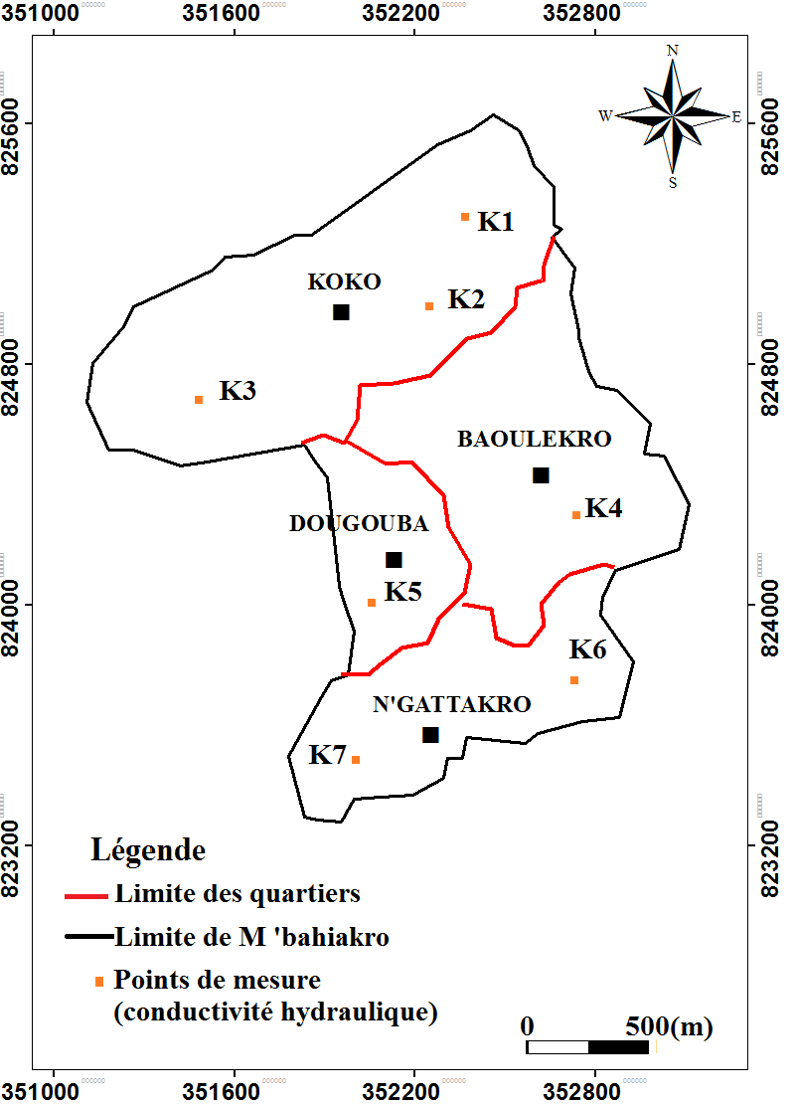
Legend

Neighborhood boundaries
Boundary of M’Bahiakro
Sampling points
Figure 2: Measurement points of hydraulic conductivity and effective porosity
2.2.2.2 Effective Porosity
Soil samples were collected in situ using a manual auger. The sampling process involves applying vertical pressure on the auger while rotating it clockwise. This movement allows the tool to gradually penetrate the soil and retain a representative amount of material. The extracted sample is carefully collected and stored in a labeled bag to ensure traceability.
In the laboratory, a representative soil mass of approximately 450 g was weighed using a precision balance. The samples were then moistened by adding known quantities of water until full saturation was reached. After a drainage period of 48 hours, the volume of gravitationally drained water was collected and measured using a graduated cylinder. These measurements allowed the estimation of the soil’s effective porosity. Effective porosity is determined using the following relationship:
$n_{e}\left(\%\right)=\frac{V_{d}}{V_{t}}×100$(Éq.10$)$

Where :
- nₑ: effective porosity (%),
- Vd: volume of gravitationally drained water (mL or cm³),
- Vt: total volume of the sample (mL or cm³).
2.2.3 Flow Velocity**
Flow velocities (Darcy velocities) were determined from seven flow lines, drawn in areas corresponding to the sites where hydraulic conductivity values were measured. For each flow line, two piezometric points are considered:
NPA: minimum piezometric level,
NPB: maximum piezometric level, separated by a distance (d) measured on the map.
The actual distance AB is calculated from the map scale using the following relationship:
$D_{AB}=\frac{d}{E}\text{ou encore}d=D_{AB}×E$(Éq.11$)$
Where :
- Dₐᵦ: actual distance (m),
- d: distance on the map (cm),
- E: map scale (1/50,000).
The flow velocity is then determined using the following equation:
$V=K×\frac{ΔH}{D}×n$(Éq.12$)$
Where:
- V: flow velocity (m/s),
- K: hydraulic conductivity (m/s),
- n: effective porosity,
- D: actual distance between two piezometric points (m),
- ΔH: difference in piezometric head between NPB and NPA (m).

2.2.4 Estimation of the Hydrological Balance Using the Thornthwaite Method
The hydrological balance of a basin or an aquifer allows for the assessment of water availability by integrating inputs (precipitation) and losses (evapotranspiration and runoff). In this study, the balance was estimated using the Thornthwaite method (1948), which is widely used for tropical and subtropical regions (Sharma, 1988; Omar et al., 2021; Tagne et al., 2023). The monthly results were then aggregated into annual data for the analysis of the hydrological balance.
2.2.4.1 Principle of the Method
The Thornthwaite method is based on the calculation of potential evapotranspiration (PET) from monthly mean temperatures and a local climate coefficient. The PET is then compared to precipitation to determine:
- Water surplus (precipitation > PET), available for infiltration and storage in the aquifer,
- Water deficit (precipitation < PET), corresponding to the water lacking to meet evapotranspiration needs,
- Net balance, which integrates aquifer recharge and surface runoff.
The calculation of potential evapotranspiration (PET) was performed using the following equation:
$ETP=16{(\frac{10⋅T_{m}}{I})}^{a}$(Éq.13$)$
Where:
- Tm: monthly mean temperature (°C)
- I: annual heat index
- a: empirical coefficient depending on I
The water deficit and surplus were calculated using the following equations:
$D=\text{PET}-P$if PET > P (Éq.14$)$
$E=P-\text{PET }$if P > PET (Éq.15$)$

where P represents monthly precipitation.
The reconstruction of the annual water balance was carried out as follows:
- Summation of monthly surpluses to estimate the effective recharge of the aquifer;
- Summation of monthly deficits to quantify periods of water stress.
3. RESULTS AND DISCUSSION
3.1 Results
3.1.1 Evolution of Rainfall
3.1.1.1 Annual Rainfall Variability
The analysis of Nicholson indices, after removal of the seasonal component using the Hanning filter, reveals three major climatic phases in M’Bahiakro between 1944 and 2016: a humid period (1944- 1972) with above-average rainfall, a normal phase (1973–1996) with values close to the mean, and a dry period (1997–2016) characterized by a significant rainfall deficit (Figure 3).

Figure 3: Interannual variation of rainfall in M’Bahiakro (1944–2016).
3.1.1.2 Interannual Temperature Variation
Figure 5 illustrates the annual evolution of temperature at the Bouaké station over the period 1964–2015. A general upward trend is observed, with an increase of about 0.5 °C per year. Between 1964 and 1972, temperatures remained generally below 26 °C, while from 1973 onward they exceeded this threshold. This warming trend intensified from the 2000s, reaching values close to 26.9 °C (Figure 4).

Figure 4: Interannual variation of temperature in Bouaké (1964–2015)

3.1.2 Hydrodynamic Characteristics
3.1.2.1 Hydraulic Conductivity
The hydraulic conductivity values of the surface layer generally range between 7.1 × 10⁻⁵ and 1.5 × 10⁻⁴ m/s. In the neighborhoods of Baoulekro and Dougouba, the measured conductivity is 7.1 × 10⁻⁵ m/s, while it reaches 1.5 × 10⁻⁴ m/s in N’Guattakro and 8.4 × 10⁻⁴ m/s in Koko (Figure 5).
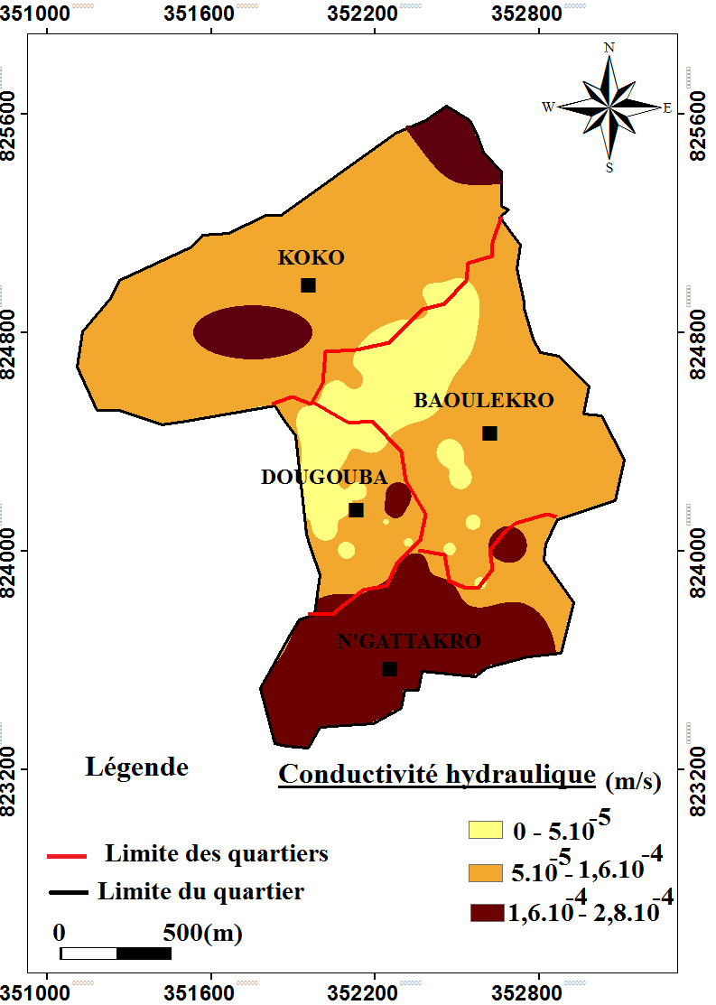

Legend
Hydraulic Conductivity
Neighborhood boundaries
Boundary of M’Bahiakro

Figure 5: Hydraulic Conductivity Map of M’Bahiakro
3.1.2.2 Effective Porosity
The effective porosity measurements reveal notable spatial variability among the different neighborhoods of M’Bahiakro (Figure 6). The observed values generally range between 20% and 31.9%. The highest porosity is recorded in N’Guattakro (31.9%), followed by Koko (29.5%). The neighborhoods of Dougouba and Baoulekro show lower values, with 24.5% and 24.1% respectively.

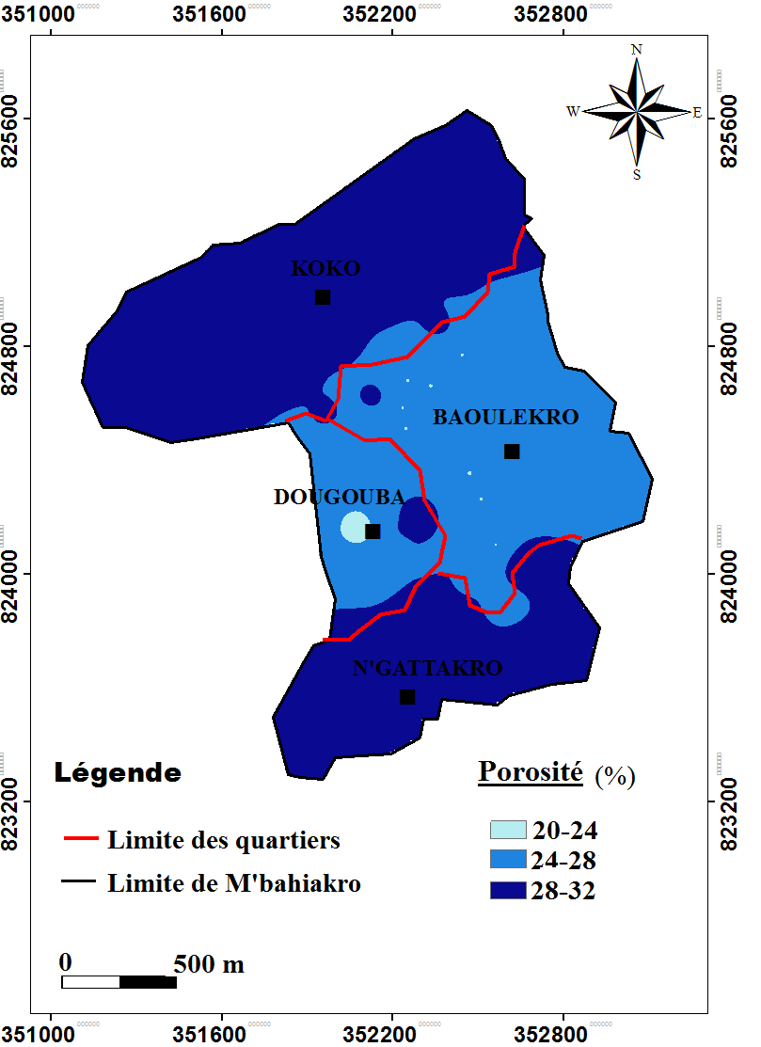

Legend
Effective Porosity
Neighborhood boundaries
Boundary of M’Bahiakro

Figure 6: Effective Porosity Map of M’Bahiakro

3.1.3 Flow Velocity
The estimated flow velocities for the years 2012, 2013, and 2015 remain relatively low, on the order of 10⁻⁵ m/s. A slight decrease in these values is also observed over the years, indicating a gradual slowdown in groundwater flow dynamics (Table 1).
Année | 2012 | 2013 | 2015
Vitesse de Darcy (m/s) | 16.10⁻⁵ | 18.10⁻⁵ | 19.10⁻⁵
Table 1: Groundwater Flow Velocity Values
3.1.4 Hydrological balance
The annual hydrological balance for the period 1971–1998 (table 2) shows an average rainfall of 1680.09 mm. Actual evapotranspiration (aet) is estimated at 1042.81 mm/year, representing 62.07% of total precipitation, while 37.93% of rainfall corresponds to mobilizable water. Surface runoff (q) is low, around 51.81 mm/year (3.08% of precipitation). In contrast, infiltration reaches 585.47 mm/year, or 34.85% of rainfall, providing a significant contribution to groundwater recharge.

Table 2: Summary of the hydrological balance (1971–1998) in m’Bahiakro

Parameters | M’Bahiakro
Rainfall (mm·yr⁻¹) | 1680,09
Actual evapotranspiration, AET (mm·yr⁻¹) | 1042,81
Runoff (mm·yr⁻¹) | 51,81
Infiltration (mm·yr⁻¹) | 585,47

3.2 Discussion
3.2.1 Evolution of Rainfall and Temperature
The analysis of Nicholson’s rainfall indices, after removing the seasonal component using the Hanning filter, reveals three major climatic phases in M’Bahiakro between 1944 and 2016, illustrating the progressive evolution of the rainfall regime and its connection with regional climate dynamics in West Africa. The first phase (1944–1972), a humid period, is characterized by above-average rainfall, which enhanced groundwater recharge and improved water availability.
The second phase (1973–1996), considered a normal period, shows rainfall values close to the long-term mean but with increased variability, alternating between wet and dry years and indicating a gradual shift from the previous regime. The last phase (1997–2016) is a dry period marked by a significant rainfall deficit and predominantly negative Nicholson indices, leading to reduced aquifer recharge and increased water vulnerability. These findings are consistent with the observations of Kouao et al. (2024) and Fossou et al. (2015). In parallel, data from the Bouaké meteorological station show a clear warming trend between 1964 and 2015 (Nicholson, 2005). The 1964–1972 period, relatively cool and stable, was favorable to infiltration, whereas from 1973 onward, temperatures frequently exceeded 26 °C (New et al., 2006), reaching nearly 26.9 °C in the 2000s (Sylla et al., 2016; Dosio et al., 2022). This warming increases evapotranspiration, limits groundwater recharge, and aligns with the “regional amplification” described by the IPCC (IPCC, 2013), directly affecting water availability and population vulnerability. Overall, these combined results highlight the dual impact of decreasing rainfall and rising temperatures on groundwater resources in M’Bahiakro, emphasizing the need for adaptive water-resource management strategies in the context of climate change.
3.2.2 Hydrodynamic Characteristics
The hydraulic conductivity values measured in the superficial layer of M’Bahiakro show significant spatial variability, ranging from 7.1 × 10⁻⁵ to 8.4 × 10⁻⁴ m/s across different neighborhoods. Low hydraulic conductivity values, around 7.1 × 10⁻⁵ m/s, were recorded in Dougouba and Baoulekro, while higher values were observed in N’guattakro (1.5 × 10⁻⁴ m/s) and Koko (8.4 × 10⁻⁴ m/s). According to Cui et al. (2008), hydraulic conductivity tends to be low in clay-rich formations and higher in sandy formations. These findings suggest that the aquifers in N’guattakro and Koko are predominantly sandy, favoring faster flow and improved groundwater recharge, whereas those in Baoulekro and Dougouba consist mainly of clays, resulting in limited permeability and restricted infiltration. García‑Gutiérrez et al. (2018) highlight that hydraulic conductivity directly affects the time required for water to infiltrate and reach the groundwater table, underscoring the importance of lithology and porosity in aquifer recharge dynamics. These patterns are consistent with the work of Bear (1979) and Domenico & Schwartz (1998), who note that hydraulic conductivity varies according to grain size distribution and the heterogeneity of surface formations, significantly influencing aquifer recharge and groundwater flow.
Effective porosity, representing the fraction of pore space that actively contributes to flow, also shows marked spatial contrasts in M’Bahiakro, ranging from 20% to 31.9%. N’guattakro (31.9%) and Koko (29.5%) exhibit the highest values, indicating a greater capacity for water storage and groundwater recharge. Conversely, Dougouba (24.5%) and Baoulekro (24.1%) display lower values, and the clays present-although porous-tend to limit water circulation, thereby slowing aquifer recharge (Todd & Mays, 2005; Domenico & Schwartz, 1998).
According to Banton and Bangoy (1997), the combined assessment of porosity and permeability allows for classifying soils according to their suitability for infiltration and recharge. Sandy areas such as N’guattakro and Koko are highly favorable for groundwater recharge, while clay-rich sectors like Dougouba and Baoulekro exhibit reduced potential. These observations also align with the findings of Simpson et al. (2006), which show that sandy and sandstone formations are highly permeable, whereas clays, silts, and unfractured granites restrict water flow. Furthermore, Cui et al. (2008) emphasize that hydraulic conductivity directly influences the time required for water to infiltrate down to the aquifer.
Overall, the spatial variability of hydraulic conductivity and effective porosity in M’Bahiakro reflects the lithological heterogeneity of the basin and governs the dynamics of the groundwater table. This heterogeneity must be considered in water resource management, as it determines zones that are favorable or unfavorable for recharge and influences water availability for domestic and agricultural uses.
3.2.3 Flow Velocity
The groundwater flow velocities estimated for the years 2012, 2013, and 2015 on the order of 10⁻⁵ m/s indicate a slow movement of water through the aquifers of M’Bahiakro. The slight decrease observed over time reflects a gradual slowdown of subsurface circulation, possibly linked to reduced recharge induced by climate variability, changes in the hydrodynamic properties of the medium, or increasing pressure on aquifers due to water extraction for domestic and agricultural purposes (Fan, 2015).
This low-flow dynamic implies that aquifers require more time to recharge after rainfall events, making them particularly vulnerable during prolonged periods of rainfall deficit. As a result, the water security of local populations is further weakened, as groundwater availability may significantly decrease during dry periods (Delle Rose, 2022). These observations highlight the need for integrated and cautious water-resource management, taking into account the slow recharge rates and the spatial and temporal variability of aquifer properties to prevent overexploitation and ensure sustainable groundwater supply for domestic and agricultural needs.
3.2.4 Hydrological Balance
The annual hydrological balance for the period 1971–1998 indicates that M’Bahiakro receives an average rainfall of 1680.09 mm, of which 62.07% is lost through actual evapotranspiration (1042.81 mm/year). This substantially limits the volume of water available for groundwater recharge and surface runoff (Penman, 1948; Thornthwaite, 1948; Oki & Kanae, 2006). Surface runoff remains low (51.81 mm/year, or 3.08% of rainfall), reflecting the basin’s moderate capacity to generate runoff, while infiltration (585.47 mm/year, 34.85% of rainfall) provides a significant contribution to aquifer recharge (Todd & Mays, 2005). These results indicate a relatively stable climatic context during this period, allowing aquifers to be regularly replenished and supporting water availability for domestic and agricultural uses (Delle Rose, 2022).
However, from 2012 onwards, analysis of rainfall, temperature, and groundwater flow velocity data reveals a progressive decline in aquifer recharge in M’Bahiakro. This decline results in reduced groundwater availability, underscoring the sensitivity of aquifers to climate variability. Rising temperatures increase evapotranspiration, while decreasing rainfall and low flow velocities slow down groundwater circulation (Todd & Mays, 2005; Fan, 2015; Delle Rose, 2022). These observations confirm that climate variability is a key factor influencing groundwater dynamics and vulnerability in M’Bahiakro.

CONCLUSION
The hydrological and hydrodynamic assessment in M’Bahiakro reveals that groundwater availability is closely linked to rainfall patterns, temperature variations, and aquifer properties. The aquifers of M’Bahiakro exhibit notable hydrodynamic heterogeneity. Hydraulic conductivity ranges from 7.1 × 10⁻⁵ to 1.5 × 10⁻⁴ m/s, with permeable zones in N’guattakro and Koko, and less permeable zones in Dougouba and Baoulekro. Effective porosity ranging between 20% and 40% is highest in the sandy areas of N’guattakro and Koko, promoting storage and infiltration, while the clay-dominated sectors of Baoulekro and Dougouba restrict water circulation. The 1971-1998 hydrological balance shows that 34.85% of rainfall contributes to groundwater recharge, while 62.07% is lost through evapotranspiration and surface runoff remains low. Groundwater flow velocities, on the order of 10⁻⁵ m/s, indicate a slow circulation dynamic, which has slowed even further since 2012 due to declining rainfall and rising temperatures-thereby reducing recharge and overall groundwater availability. Overall, these findings highlight the increasing vulnerability of groundwater resources in M’Bahiakro under the influence of climate variability, emphasizing the need for sustainable and adaptive water management strategies to ensure long-term water security for local populations.
These results highlight that groundwater availability depends both on the lithological characteristics of the aquifers and on climate variability, underscoring the need for integrated water-resources management in M’Bahiakro.
Limitations and Perspectives of the Study
Although this study provides essential insights into the dynamics of groundwater in M’Bahiakro, it presents several limitations:
- Data availability and continuity: The hydrological and climatic time series cover only specific periods (1971–1998 and 2012–2015), which restricts the analysis of long-term trends and the detection of major climatic shifts.
- Spatial representativeness of measurements: The hydraulic conductivity and effective porosity data come from only a few sites, which does not fully reflect the heterogeneity of aquifers at the regional scale.
- Empirical methods and unaccounted impacts: The methods used for the hydrological balance include approximations that may affect the accuracy of the estimates, and the study does not incorporate anthropogenic impacts such as groundwater abstraction, urbanization, or land-use changes.
- Perspectives for future studies: Integrating field data with climatic models (GCM, RCM) and hydrological models (SWAT, MODFLOW) would allow simulation of water fluxes, assessment of future groundwater recharge, and testing of sustainable management scenarios.
Thus, an integrated approach combining field observations, climate modelling, and hydrological simulation would provide a more comprehensive and forward-looking understanding of the vulnerability of groundwater resources in M’Bahiakro.

Ethical Approval
None
References
Assani, A. A. (1999). Analysis of the temporal variability of rainfall (1916–1996) in Lu-bumbashi (Congo–Kinshasa) in relation to certain indicators of atmospheric (Southern Oscillation) and oceanic (El Niño/La Niña) circulation. Sécheresse, 10 (4), 245–252.
Baï, R., Kouame, I.K., Kouassı, L.K., Konan, S.K. and N’Cho, H.A. (2019) Assessment of the Physicochemical Quality of Irrigation Water and Soil for Sustainable Irrigated Rice Cultivation: Case of Irrigated Perimeter of M’Bahiakro (Central-East of Côte d’Ivoire). Journal of Environmental Protection, 10, 1536-1552. https://doi.org/10.4236/jep.2019.1011091

Banton, O., & Bangoy, M. L. (1997). Hydrogéologie : Multi-Science environnementale des eaux souterraines (460 p.). Québec, Canada : Université du Québec.

Bear, J. (1979). Hydraulics of groundwater (567 pp.). McGraw-Hill.

Cui, Y.-J., Tang, A.-M., Loiseau, C., & Delage, P. (2008). Determining the unsaturated hydraulic conductivity of a compacted sand–bentonite mixture under constant-volume and free-swell conditions. Physics and Chemistry of the Earth, Parts A/B/C, 33(Supplement 1), S462–S471. https://doi.org/10.1016/j.pce.2008.10.017
Delle Rose, M. (2022). Sinkhole flooding and aquifer recharge in arid to dry sub‑humid regions: Sensitivity to climate change. Hydrology, 9(2), 25. https://doi.org/10.3390/hydrology9020025
Domenico, P. A., & Schwartz, F. W. (1998). Physical and chemical hydrogeology (2nd ed., 506 p.). New York, NY : John Wiley & Sons.
Dosio, A., Lennard, C., & Spinoni, J. (2022). Projections of indices of daily temperature and precipitation based on bias‑adjusted CORDEX‑Africa regional climate model simulations. Climatic Change, 170, article 13. https://doi.org/10.1007/s10584-022-03307-0
Fan, Y. (2015). Groundwater in the Earth system: Impacts of human‑water use and climate change. Water Resources Research, 51(6), 5173–5193. https://doi.org/10.1002/2014WR016861
Fossou, R. M., Douagui, A., Kouamé Kouassi, A., Guehi Aba, W., & Droh Gone, L. (2022). Variabilité de la pluviométrie et son incidence sur les ressources en eau souterraines : Cas du département de Tiassalé, Côte d’Ivoire. Revue Ivoirienne des Sciences et Technologies, 39, 128 146. http://www.revist.ci
Fossou, R. M. N., Lasm, T., Soro, N., Soro, T., Soro, G., De Lasmé, O. Z., Baka, D., Onetie, O. Z., & Orou, R. (2015). Variabilité climatique et son impact sur les ressources en eaux souterraines : cas des stations de Bocanda et de Dimbokro au Centre‑Est de la Côte d’Ivoire (Afrique de l’Ouest). Larhyss Journal, 21, 97‑120.
García‑Gutiérrez, C., Pachepsky, Y., & Martín, M. A. (2018). Technical note: Saturated hydraulic conductivity and textural heterogeneity of soils. Hydrology and Earth System Sciences, 22(7), 3923–3931. https://doi.org/10.5194/hess-22-3923-2018
IPCC (2013): Climate Change 2013: The Physical Science Basis. Contribution of Working Group I to the Fifth Assessment Report of the Intergovernmental Panel on Climate Change [Stocker, T.F., D. Qin, G.-K. Plattner, M. Tignor, S.K. Allen, J. Boschung, A. Nauels, Y. Xia, V. Bex and P.M. Midgley (eds.)]. Cambridge University Press, Cambridge, United Kingdom and New York, NY, USA, 1535 p.
Jackson, R. B., Carpenter, S. R., Dahm, C. N., McKnight, D. M., Naiman, R. J., Postel, S. L., & Running, S. W. (2001). Water in a changing world. Ecological Applications, 11(4), 1027–1045. https://doi.org/10.1890/1051 0761(2001)011[1027: WIACW] 2.0.CO;2
Kouakou, E., Koné, B., N’Go, A., Cissé, G., Ifejika Speranza, C., & Savané, I. (2014). Ground water sensitivity to climate variability in the White Bandama basin, Ivory Coast. SpringerPlus, 3, 226. https://doi.org/10.1186/2193-1801-3-226

Kouamé, I., Konan, S., Kouassi, L., Brou, D., Moussa, S., Savané, I., & Dago, G. (2012). Assessment of Wells Water Quality and Their Suitability for Drinking in M’bahiakro City (Côte d’Ivoire). International Journal of Conservation Science, 3, 289-300.
Kouamé, K. I., Kouassi, K. L., Konan, K. S., Baï, R., & N’Cho, A. H. (2018). Evolution quantitative et qualitative de la nappe phréatique de la ville de M’bahiakro (Centre‑Est, Côte d’Ivoire). Journal International Sciences et Technique de l’Eau et de l’Environnement, III (1), 264. https://jistee.org/volume-iii-2018/
Kouassi, K.L., Kouame, K.I., Konan, K.S., Dibi, B., Soumahoro, M., Kone, D. and Dago, G. (2013). Prospects for Minimizing the Potential Environmental Impacts of the Hydro-Agricultural Dam of M’Bahiakro (Côte d’Ivoire). Journal of Water Re source and Protection, 5, 847-853. https://doi.org/10.4236/jwarp.2013.59085
Kouao, J.-M., Tagnon, B., Koffi, B., Kouassi, A. M., Kouassi, K. A., & Gone, D. L. (2024). Variabilité climatique et tendances interannuelles récentes du climat en Afrique de l’Ouest : Cas de la Côte d’Ivoire. European Scientific Journal, ESJ, 34, 235. https://doi.org/10.19044/esipreprint.10.2024.p235
Kotchoni, D. O. V., Vouillamoz, J. M., Lawson, F. M. A., Adjomayi, P., & Boukari, M. (2019). Relationships between rainfall and groundwater recharge in seasonally humid Benin: A comparative analysis of long term hydrographs in sedimentary and crystalline aquifers. Hydrogeology Journal, 27, 447 457. https://doi.org/10.1007/s10040-018-1806-2

Magaji Ibrahim, M., Ibrahim, M., & Mubi Aisha, M. (2024). Groundwater storage variability in West Africa using gravity recovery and climate experiment (GRACE) and global land data assimilation system (GLDAS) data. EQA - International Journal of Environmental Quality, 64, 87–102. https://doi.org/10.6092/issn.2281-4485/20167

N’cho, H., Kouame, I., Koff, K., Kouassı, L., Konan, S., Baï, R., Sandu, A. and Sandu, I. (2020). Study of the Hydro-Chemical and Bacteriological Well Water Characteristics of M’Bahiakro (Central-Eastern Côte d’Ivoire). Journal of Geoscience and Environment Protection, 8, 32-46. doi: 10.4236/gep.2020.84003.
N’cho, H.A., Koffi, K., Konan, S.K., Ruth Baï., Innocent Kouassi Kouame., Lazare Kouakou Kouassi (2024). Simulation of the Nitrate Concentrations in Consumed Well Water Using the Error Gradient Backpropagation Neural Network: A Case Study: M’bahiakro (Central-Eastern Ivory Coast). Environ Model Assess 29, 855–869 (2024). https://doi.org/10.1007/s10666-024-09970-0
New, M., Hewitson, B., Stephenson, D. B., Tsiga, A., Kruger, A., Manhique, A., Gomez, B., Coelho, C. A. S., Masisi, D. N., Kululanga, E., Mbambalala, E., Adesina, F., Saleh, H., Kanyanga, J., Adosi, J., Bulane, L., Fortunata, L., Mdoka, M. L., & Lajoie, R. (2006). Evidence of trends in daily climate extremes over southern and west Africa. Journal of Geophysical Research: Atmospheres, 111(D14), D14102. https://doi.org/10.1029/2005JD006289

Nicholson, S. E., Kim, J., & Hoopingarner, J. (1988). Atlas of African Rainfall and Its In-terannual Variability. Department of Meteorology, Florida State University, Tallahassee, Florida, USA, 237 p.
Nicholson, S. (2005). On the question of the “recovery” of the rains in the West African Sahel. Journal of Arid Environments, 63(3), 615‑641.

Omar, G. M., Paturel, J.-E., Salles, C., Mahé, G., & Jalludin, M. (2021). Caractérisation hydro‑climatique, analyse comparative des termes du bilan hydrologique du bassin versant d'Ambouli (République de Djibouti). Proceedings of the International Association of Hydrological Sciences, 384*, 225–231. https://doi.org/10.5194/piahs-384-225-2021
Oki, T., & Kanae, S. (2006). Global hydrological cycles and world water resources. Science, 313(5790), 1068–1072. https://doi.org/10.1126/science.1128845

Penman H. L (1948). “Natural evaporation from open water, bare soil and grass” Proceedings of the Royal Society of London. Series A. Mathematical and Physical Sciences, 193:120-145.

Sharma, T. C. (1988). An evaluation of evapotranspiration in tropical central Africa. Hydrological Sciences Journal, 33(1), 31–40. https://doi.org/10.1080/02626668809491220
Simpson H., Brewster C et Myslik J. (2006). Comprendre les eaux souterraines, Fiche technique. 203p.
Sylla MB, Nikiema PM, Gibba P, Kebe I, Klutse NAB (2016). Climate change over West Africa: recent trends and future projections. Springer, New York. https ://doi.org/10.1007/978-3-319-31499 -03
Tagne, M. M., Simo-Tagne, M., Nwakuba, N. R., Effoudou-Priso, E. N., Ndam Ngoupayou, J. R., Mbessa, M., Tagne Tagne, A., & Kharchi, R. (2023). Influence of infiltrations on the recharge of the Nkoabang aquifer located in the Center Region, Cameroon: a Thornthwaite water-balance analysis. Earth, 4(1), 23–39. https://doi.org/10.3390/earth4010002

Tefera, M. L., Seddaiu, G., Carletti, A., & Awada, H (2025). Rainfall variability and drought in West Africa: challenges and implications for rainfed agriculture. Theor Appl Climatol 156, 41. https://doi.org/10.1007/s00704-024-05251-8

Thornthwaite, C. W. (1948). An approach toward a rational classification of climate. Geographical Review, 38(1), 55–94.

Tirogo, J., Jost, A., Biaou, A., Koussoubé, Y., Ribstein, P., & Dakouré, D. (2023). Impacts of climate change and pumping on groundwater resources in the Kou River basin, Burkina Faso. Comptes Rendus. Géoscience, 355(S1), 439‑464. https://doi.org/10.5802/crgeos.207
Todd, D. K., & Mays, L. W. (2005). Groundwater hydrology (3rd ed., 636 pp.). John Wiley & Sons.

